**REPORT**

MazeGenerator.java class should be run to start the program. A small window will be displayed to ask the user to input maze size (nxn). Default size is 50.

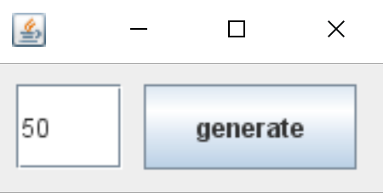

After clicking “generate” the window will disappear and generated maze GUI will be displayed

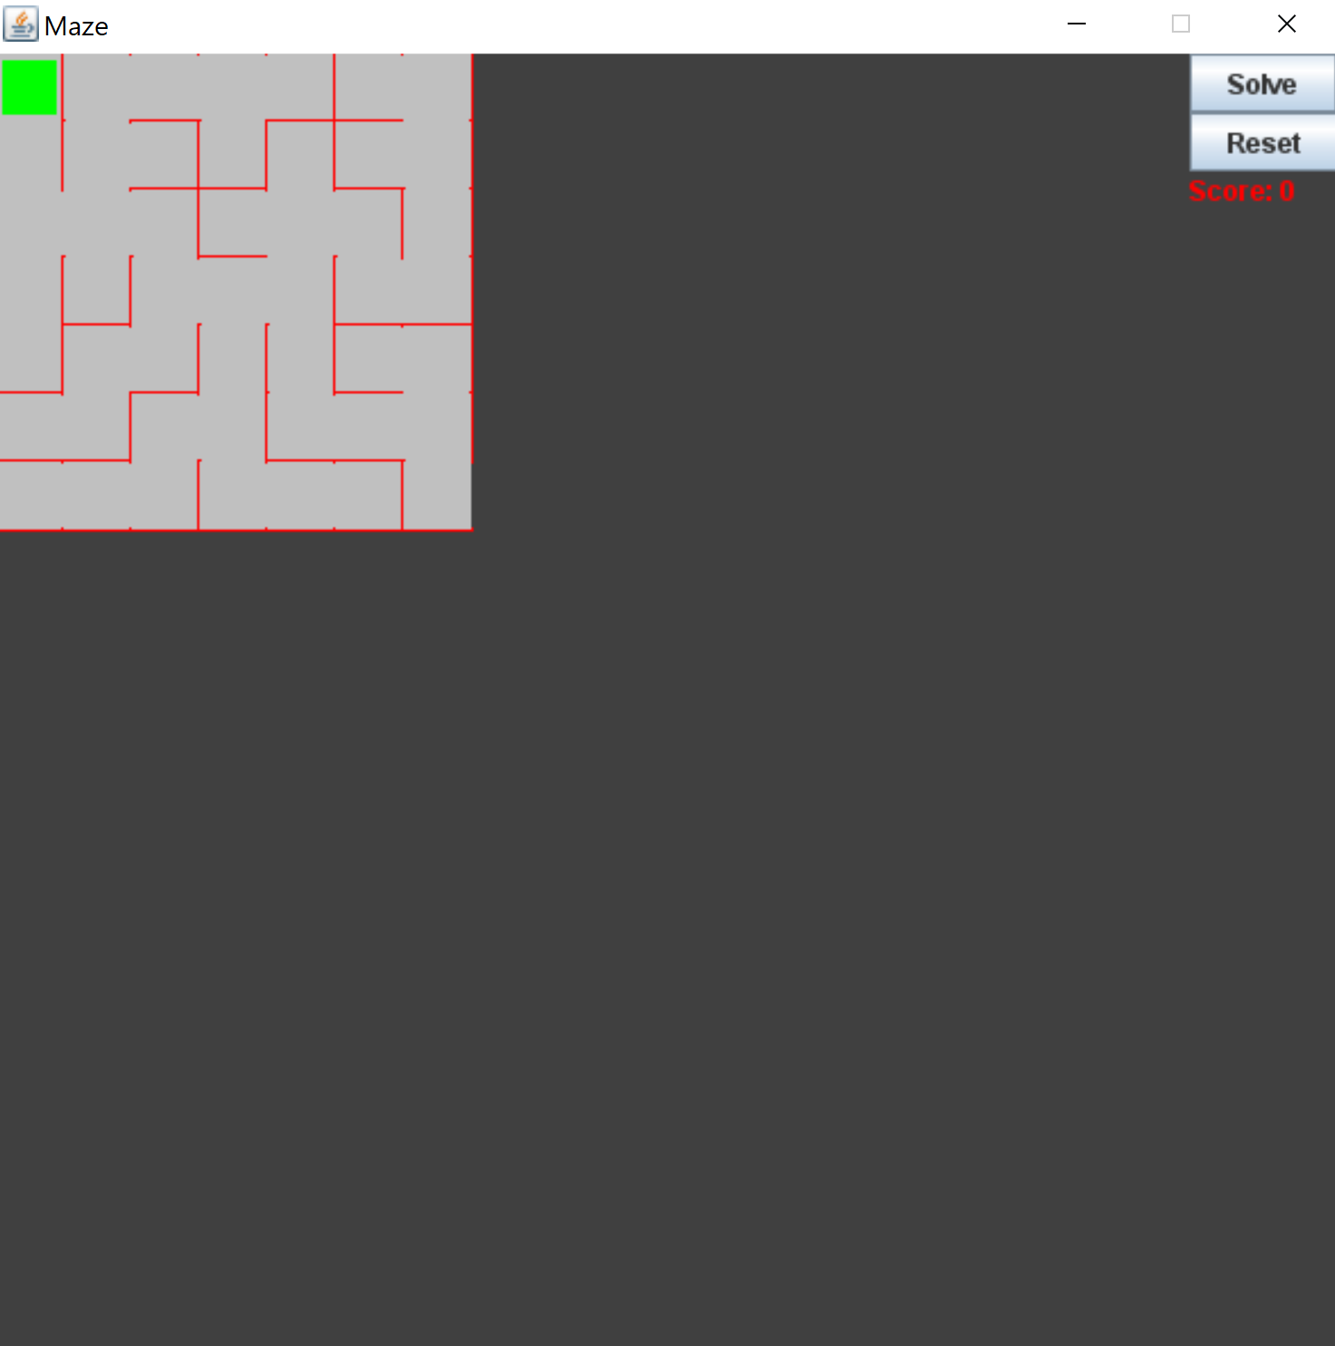

The user can move by using arrow keys and win the game by reaching bottom right cell. Additionally, user can click the “solve” button to see the solution.

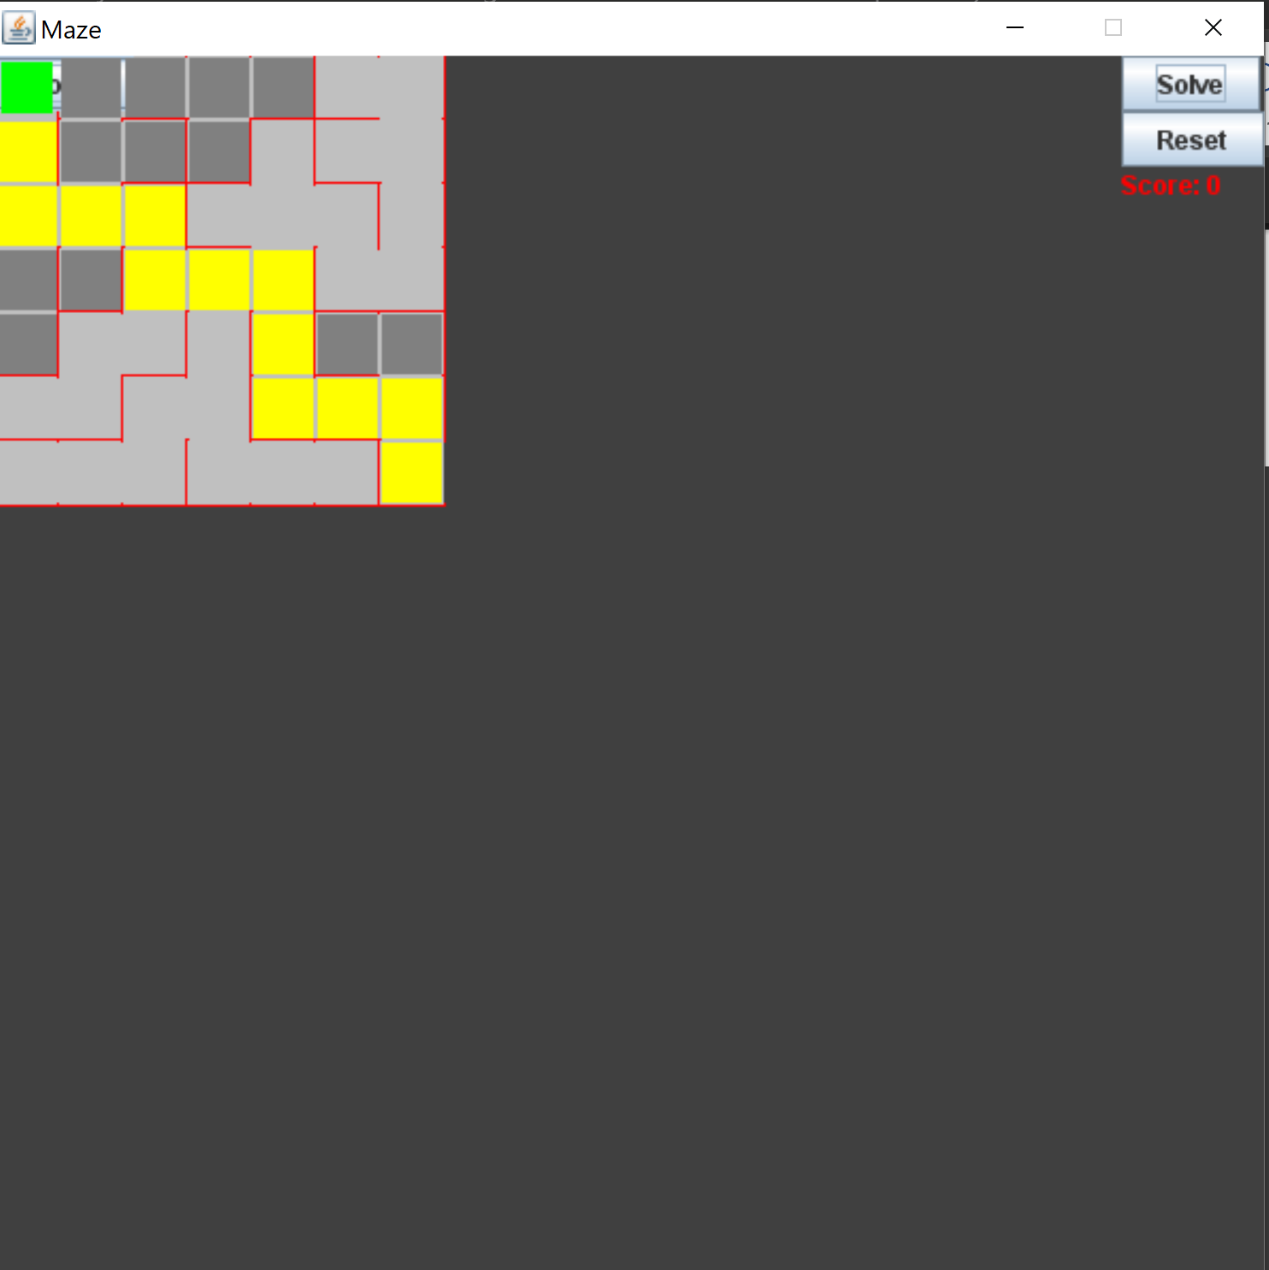

“Reset” button can be used to reset the maze

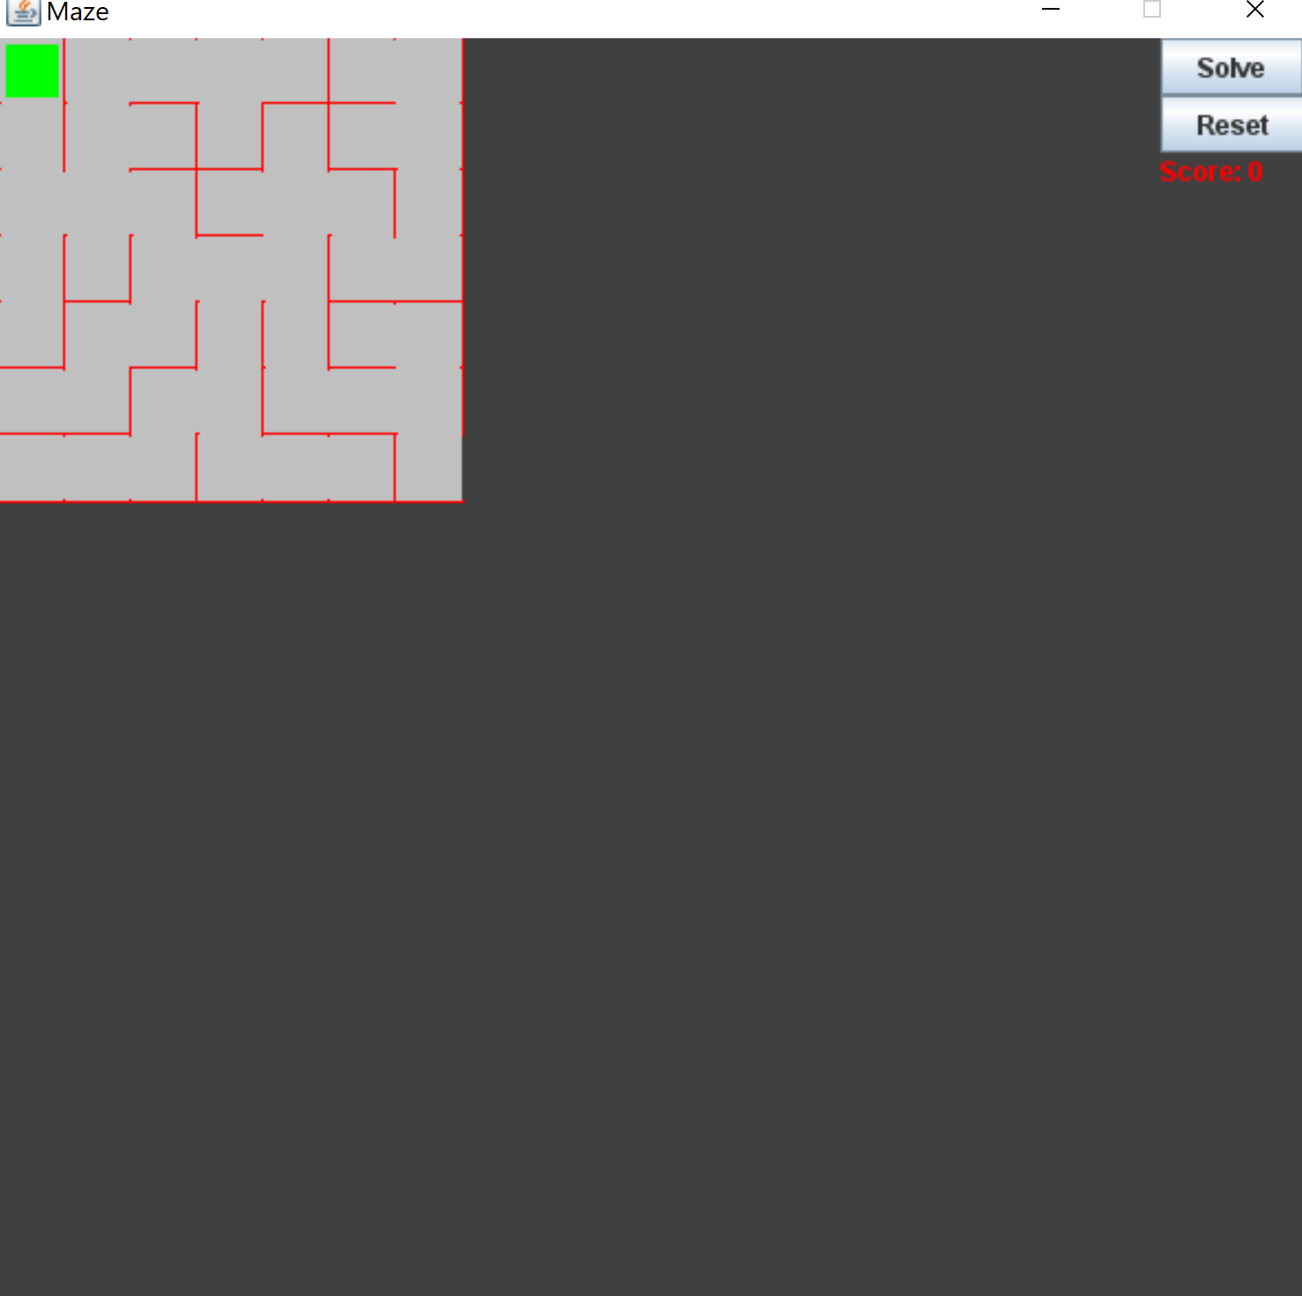

The implementation of the solution finding algorithm (DFS) allows us to find solution from any cell, so in order to find solution from a given cell the player should move to that cell and click “solve”

