LAB1-Initial Implementations on Skeleton Project

This LAB aims to give preliminary implementation basics on JAVA.

Topics covered:

* Importing a project from GitHub
* Analyzing a simple JAVA project folder structure
* Understanding entity classes
* Simple Interface implementation
* Queue and stack implementation on JAVA

# Import Project from GitHub

Please import [LAB1-JavaBasics](https://github.com/ealparslan/java-backend-labs/tree/master/LAB1-JavaBasics) project on GitHub repository on your Eclipse.

<https://github.com/ealparslan/java-backend-labs.git>

You may find many ways and tutorials online covering the usage of GitHub on Eclipse.

After successful import, you may able to build the project, run the main class (Controller). Actually the skeleton project is not implemented completely. So if you run the project in this initial state you take the output on console as:

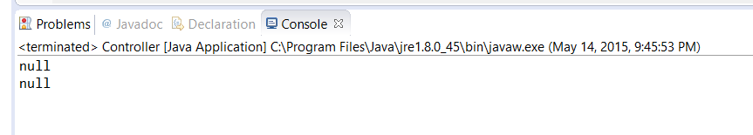

# Analyze the Folder Structure

Please notice that sources and resources folders are separate from each other. And also source folders are organized according to their usage areas into sub packages.

Please describe what a JAVA package is and how do we use it in our software projects in a single paragraph. (Submit package.txt)

# Entity Classes

In this project, for now, we have only one entity class. What is the name of this entity class? (Submit name_of_entity.txt)

You have to make some modifications in the entity class. Actual entity class is erroneous. Because it does not respect object oriented encapsulation. Redefine entity class with the same attributes respecting encapsulation. Make changes on code. (Recall the encapsulation ‘getters and setters’ via OOP tutorials.)

# Simple Interface Implementation

This project has two interfaces. One is for implementing a stack data structure, the other is for queue data structure. Interfaces are well defined. You may notice that there exist array based queue and stack classes which implements IStack and IQueue. For now, these classes are unimplemented. Please complete the implementation of these two concrete classes ArrayBasedQueue and ArrayBasedStack. You must use Array data structure on JAVA while implementing queue and stack. Make changes on code.

# Submit Online

Place your txt files and source code folder in a single zip named LAB1.zip and upload to the assignments section.