Design and Implementation of Automatic Gate Opening System using Microcontrollers

Erickson Mijangos, and Brandon Schoonover | Yitsen Ku PhD
Department of Electrical and computer | Department of Electrical and computer
California State University of Fullerton | California State University of Fullerton
Fullerton, CA 92831, USA | Fullerton, California, United States
{eamijangos@csu.fulleron.edu & brandonschoonover@csu.fulleron.edu} | joshuaku@fullerton.edu

Abstract – Automating gate open system, is a desired product to secure homes and businesses. The motivation of a automatic gate open system is to compare existing and older models. The system would consist of a microcontroller, and variety of sensor to make the system safe, and user friendly and easy for maintenance for the consumer along with the existing models such as CO-Z CG1400.

I. Introduction/Motivation
The automatic gate open system is designed to become safe, easy user experience, and extremely easy to maintain and troubleshoot. The CO-Z CG1400 has basic functionality but does not have basic safety features and basic maintenance. The proposed sliding gate opener will use the Texas instrument TM4C123GH6PM microcontroller to have safety features, easy user interface, and low-cost easy maintenance.

Throughout the design process of the automated gate system, three points of the product are made to ensure the system’s reliability.

A. Safety
Since the sliding gate is a heavy machine, safety features need to be added. An ultrasonic sensor or distance measuring sensor will be used to detect whether an object is moving between the gate as it closes to ensure safety. The microcontroller should know where the position of the gate is and be able to detect the distance of the gate change to able to stop or reverse the gate when an obstacle is in between during the closing process. This can improvise the older model’s safety features.

B. User Experience
An easy interface to open the sliding gate would make automation much easier for any consumer and provide real time status feedback which most gate openers lack. Along with using an IR remote to signal the gate to open/close, the status of the microcontroller should be display on the microcontroller to ensure that the system is responding based on input of the user. The user experience should be simple to use the gate system.

C. Maintenance and troubleshooting simplicity
The system will eventually wear itself over time and would be convenient to troubleshoot. The microcontroller should be to display the errors it encounters in LCD and have the consumer easily repair and replace parts. It would make consumers can easily fix compared to the other gates available in the market. The components can be easily bought from the consumer which makes the troubleshooting process simpler and avoid buying the entire product.

III. High level overview of gate system
The high-level overview of the system below in figure shows how the circuit is systematic setup.

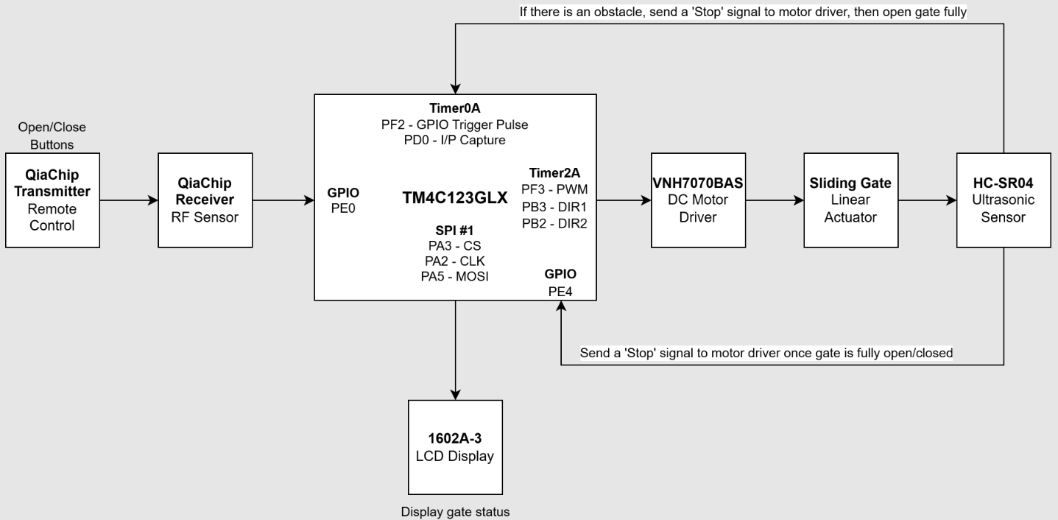
Figure 1: The high-level overview of the Autonomous Gate System.

The remote control and RF sensor used is from QiaChip, where the it can signal a ‘1’ or ‘0’ to the tiva c microcontroller where it can open and closed the gate. Once the Tiva C recieves the logical signal, it will send a signal to the LCD to display the gate to open or closed which varys which buttons were pushed. From there a PWM signal sent to the motor driver activate the linear actuactor to open the gate. The Ultrasonic sensor attached at the end of the gate is used as detection method by position where based on the position of the gate will determine whether the it still needs to open or close. As mentioned earlier, safety is a prioty where the ultrasonic sensor is used to detect an object is between the gate during the closing phase. Since the ultrasonic sensor continously measuring the distance during the closing phasing it will measure whether there is a large displacement in position. With a large displacement difference, it will detect an obstacle in between the gate during the closing phase. Once the gate distance is near zero from the sensor to the wall it will signal the Tiva C that gate has successfully closed and go back to a state of waiting the remote to signal to open the gate.

IV. the subcircuits of the gate system
Based on the high-level overview of the gate system the subcircuits of each block can be resemble at lower level consisting of sensors and additional components to make each external peripherals work along with the microcontroller. Figure 2 shows the lower level of the gate system with the subsystems/subcircuits labeled based upon on the high-level overview.

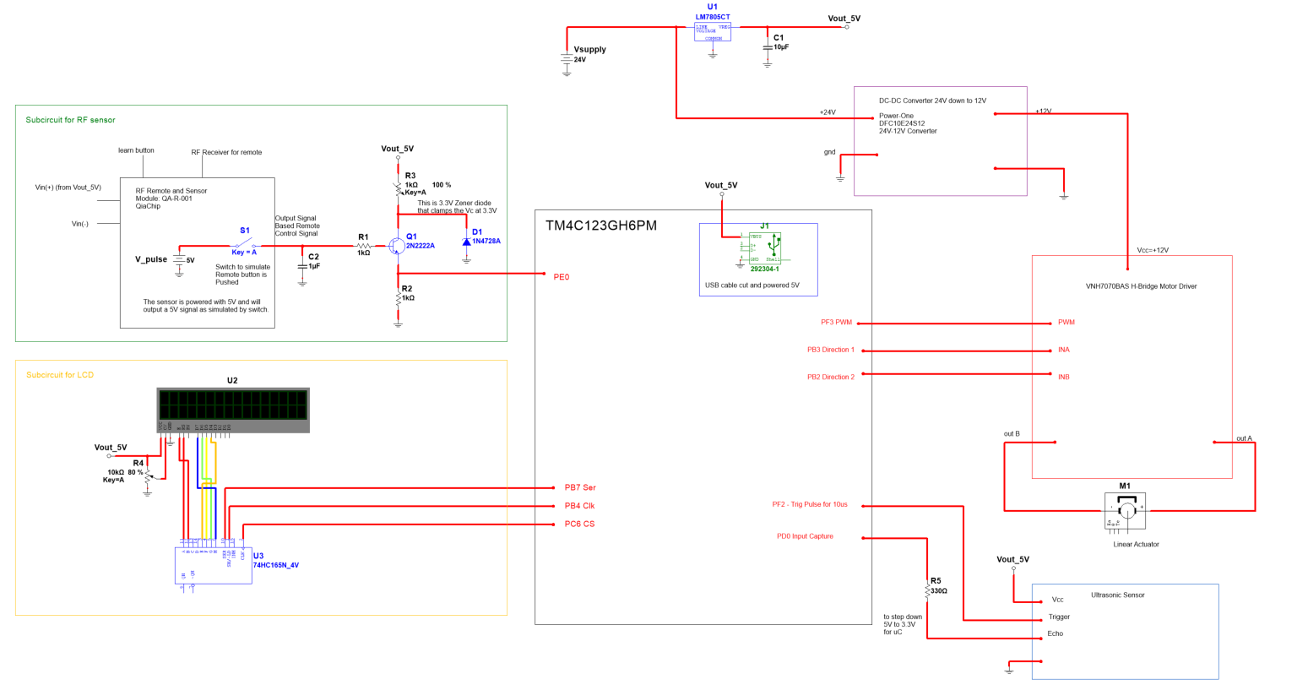
Figure 2: The lower level of the gate system consisting all components integrated to make the subystem operate.

Since the enitre system needs to power the RF reciever, Tiva C microcontroller, shift register, LCD Display, Ultrasonic sensor, and motor a 24V supply is used from a prebuilt AC-DC converter. A voltage regulator, zener diodes, DC-DC converter is used from the 24V supply to power the entire system.

A. Subcircuit For RF Sensor
The first subcircuit is the QiaChip RF remote and RF sensor to signal the Tiva C microcontroller as shown in Figure 3 a logical high or low.

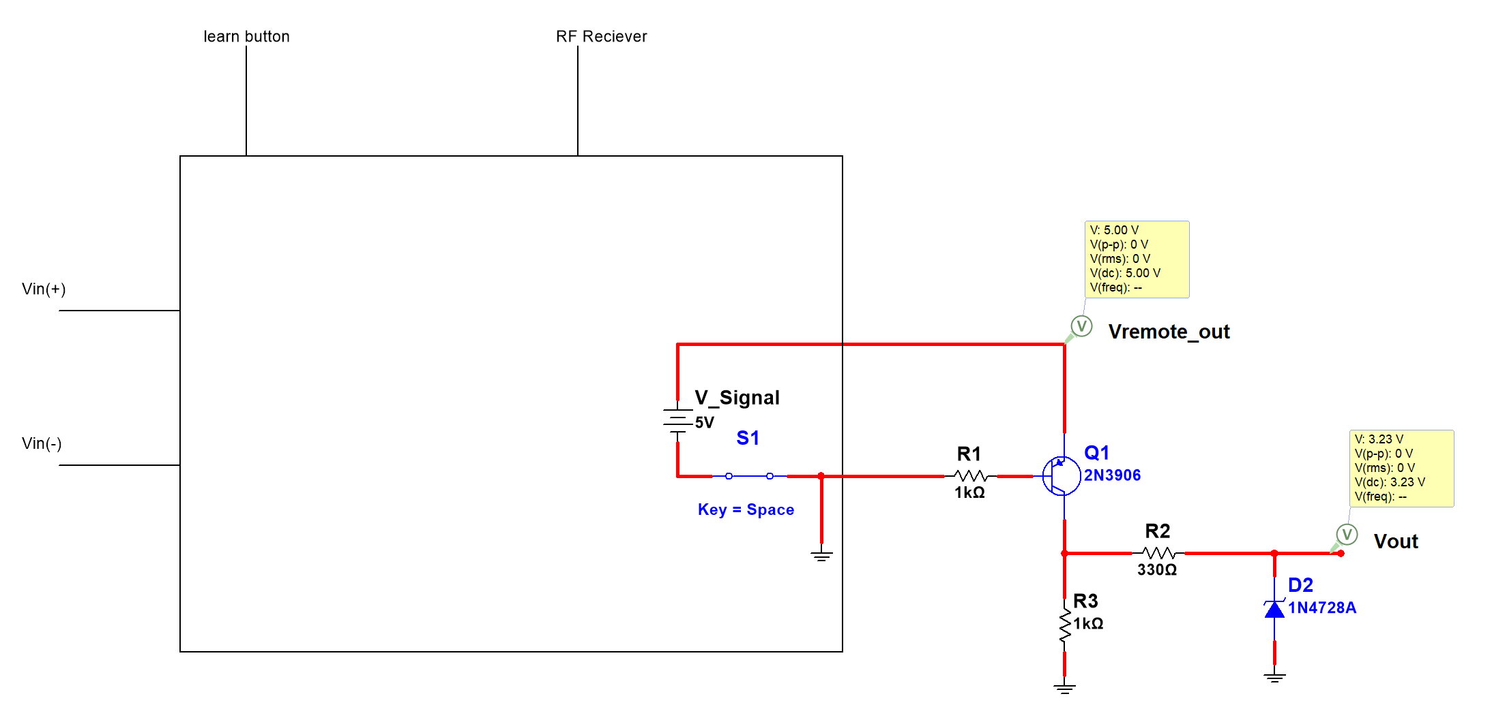
Figure 3: The QiaChip remote and RF sensor circuit.

Since Qia sensor is a module the inputs require is the RF receiver to detect a signal from the remote control, about a 5V supply to power the module which will output a signal to open/close the gate. Since the Qiachip receiver is power by 5V supply from the voltage regulator, the Tiva C can only handle 3.3V input. A simple BJT switch is used where can convert the 5V signal to 3.3V, since a 3.3V voltage regulator was not readily available, a simple voltage diver is used exept the zener diode is used to clamp the 5V down to 3.3V so that the BJT acts as a logic converter, converting the 5V down to a 3.3V signal for the Tiva C at Port E0.

B. Motor Driver
The motor driver is integrated to the linear actual as shown in Figure 4.

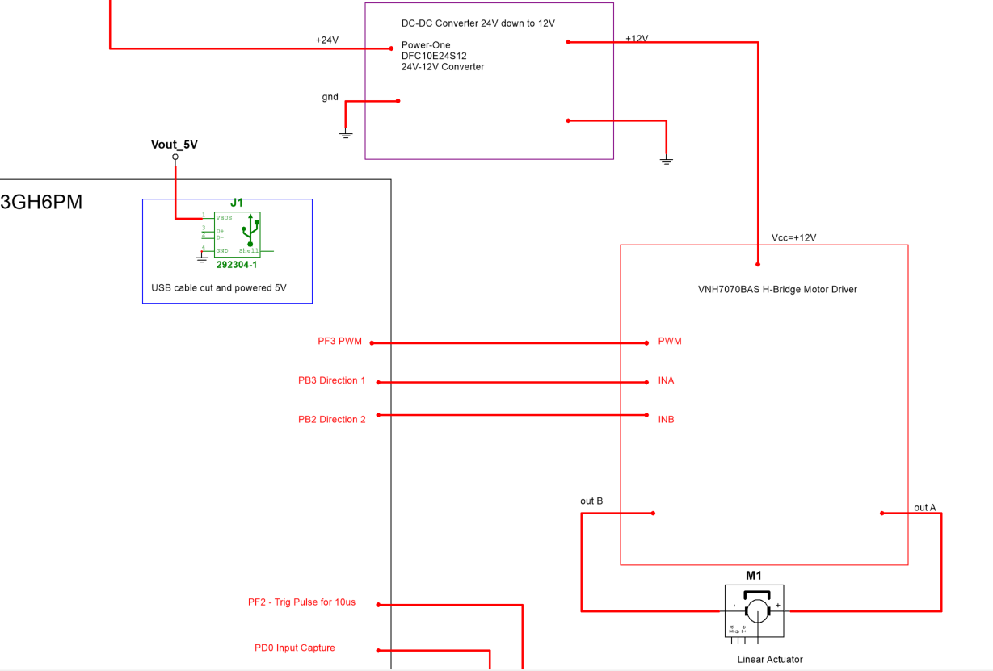
Figure 4: The H-Bridge Motor along with the linear actuator.

The purpose of adding the H-bridge motor driver is control the speed and direction of the linear actuator based upon the Pulse Width Modulation or PWM, and INA/INB to indicate the linear actuator to extend/retract the gate based upon the Tiva C commands. The Tiva C would use PWM using the Timer2A where it is constant controlling the linear actuator. The IN-A, and IN-B is signal ‘High’ to indicate the direction of the linear actuator. To power the linear actuator, it will require to draw a decent amount of current, so a DC-DC converter module is used to step down the 24V to 12V along with a capacitor bank to store the energy so that that more linear actuator can have current to extend/retract. A DC-DC converter would be more efficient since a 12V voltage regulator could heat up the as the linear actuator will draw to much current so switch mode DC-DC would be more power efficient to drive the linear actuator.

C. Ultrasonic Sensor
Since the gate needs method to detect whether it has closed or and obstacle is between the gate during the closing phase an ultrasonic sensor will more likely be a perfect candidate for detection. The ultrasonic sensor needs to be powered by 5V, but for the echo pin is where a signal that shows the amount of time it took for sound to return to the sensor needs to be step down to 3.3V since it is a 5V signal. A simple resistor about 220Ω can perform a simple voltage drop close 3.3V for the Tiva C to process the signal it received from the ultrasonic sensor. Below shows the setup of the ultrasonic sensor in Figure 5.

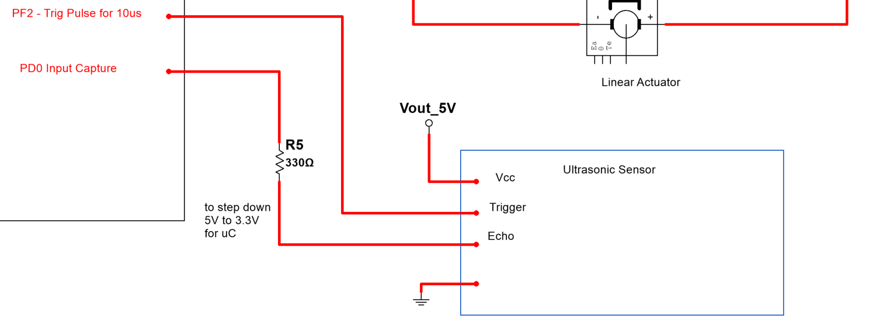
Figure 5: Ultrasonic sensor setup to the Tiva C microcontroller.

The ultrasonic sensor will during the opening and closing phase is constantly measuring the position of the gate, and also recording the displacement to track whether an object or not has been detect.

C. LCD Display
The LCD display as shown in Figure 6, is using SPI protocol to transmit the data to display on the status of the gate system.

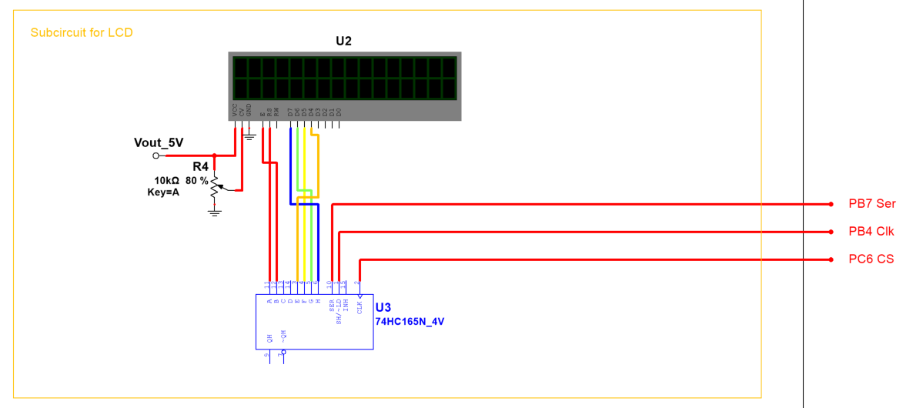
Figure 6: LCD display setup.

Since the display requires multiple pins, all the pins is stepdown to three since since shift register is used to link the pins of the LCD display. The Tiva C selects the device to communicate known as chip select, then the once the shft register is select a clock and serial data is send to the shift register. On the LCD the data collected from the ultrasonic sonic sensor can be displayed to keep track of the position of the gate. The displacement can also be displays the position the of the gate is constantly changing.

V. Experimentation results
The subcircuits consists of major components that would require testing for functionality, and specs that would be applicable to the gate system.
A. RF Sensor Test
The rf sensor from QiaChip as shown in Figure 7, is a smart sensor that can be programmed based on the learning button. The based on the manual as cited, the sensor has a processor that can store the behavioral response from the remote control such Momentary, Toggle, Latching, Time Delay, and Automatic Energized When Power On Mode (If relays are hooked). In Initialization, the previous behavior should be erased after pushing the learning button eight times. Afterwards the status LED should flash three times to indicate that processor does not have the previous behavior. For testing purposes, the Latching Mode is used so that the Tiva C microcontroller can capture the response of the remote control. According to the manual, Latch Mode will signal an output high when the ON button from the remote is pushed, and OFF button to signal LOW. For the processor to learn latching mode, the learning button must be pushed 3 times and afterwards wait for a few seconds and the sensor should have the LED turned on. For the remote the ON button should be pushed to signal the board and the OFF button also. As a result, the processor should have memorized the Latch Mode.
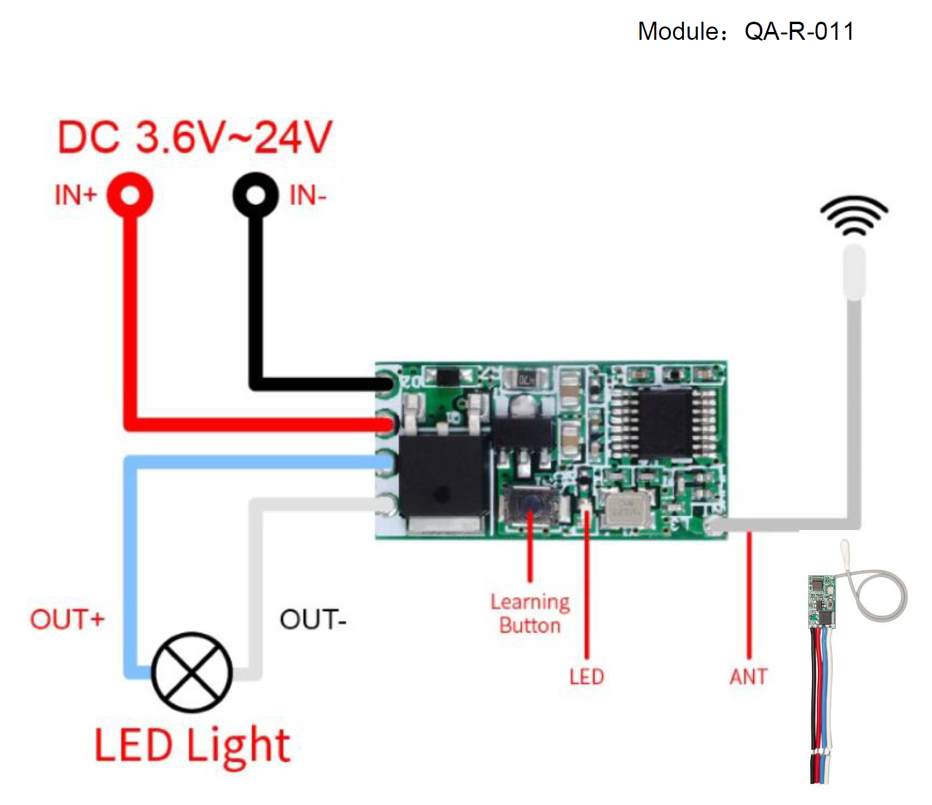
Figure 7: The QiaChip RF Sensor.
The sensor can be powered with the +5V supply from the Tiva C microcontroller, as a result the output is 5V when the button from the remote is pushed ON. The Tiva requires the 3.3V for the GPIO ports, so the circuit from Figure 3 is prototyped with parts as labeled. The configuration of the remote control is set up to turn on LEDs or energize a relay, so a PNP BJT is used to switch the output voltage. This configuration where the output voltage is tied to the collect prevents logic inversion and a 3.3V Zener Diode is in series 330Ω to step down from 5V to 3.3V. Figure 8-10 shows the test circuit setup, and the transient response of the sensor with the step-down circuit. The waveforms are labelled and set to the same division to reference both signals.
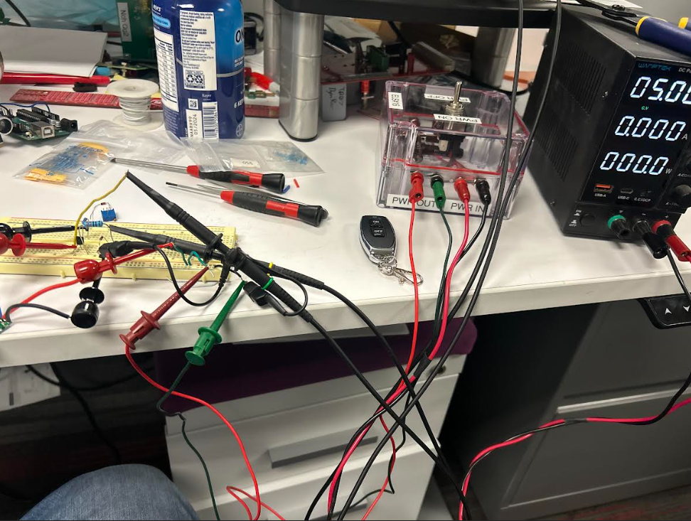
Figure 8: The test circuit set to test the RF sensor.
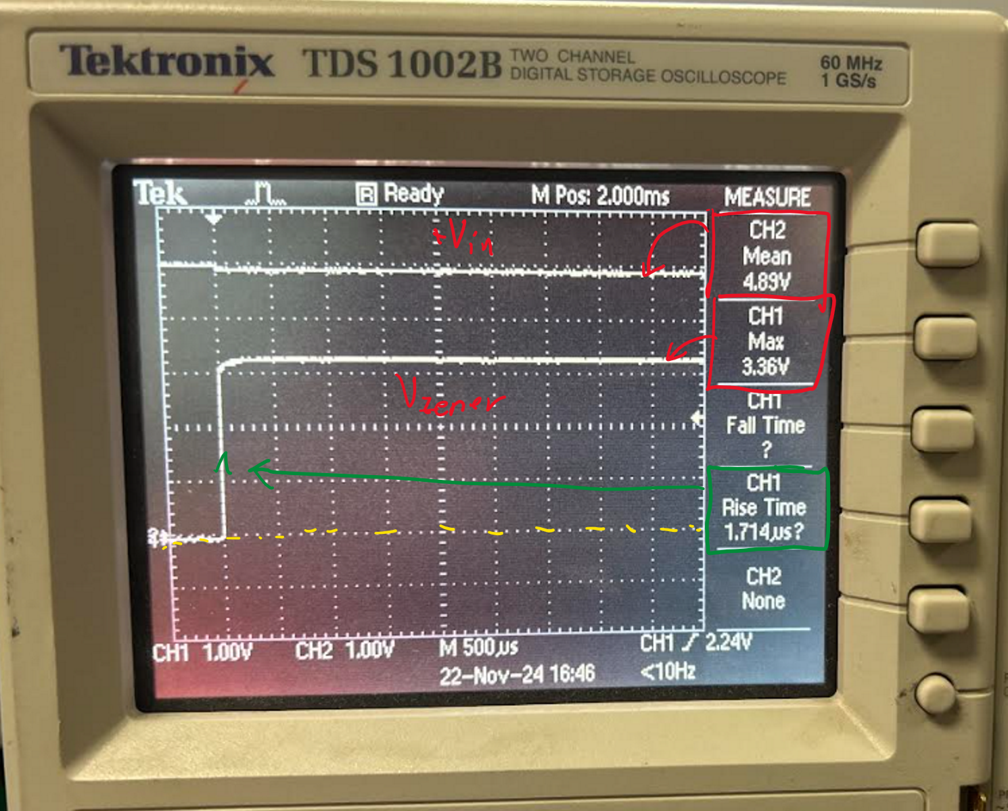
Figure 9: The turn on response, channel 1 is the output voltage from the Zener diode, and channel 2 is the Vin from the output voltage.
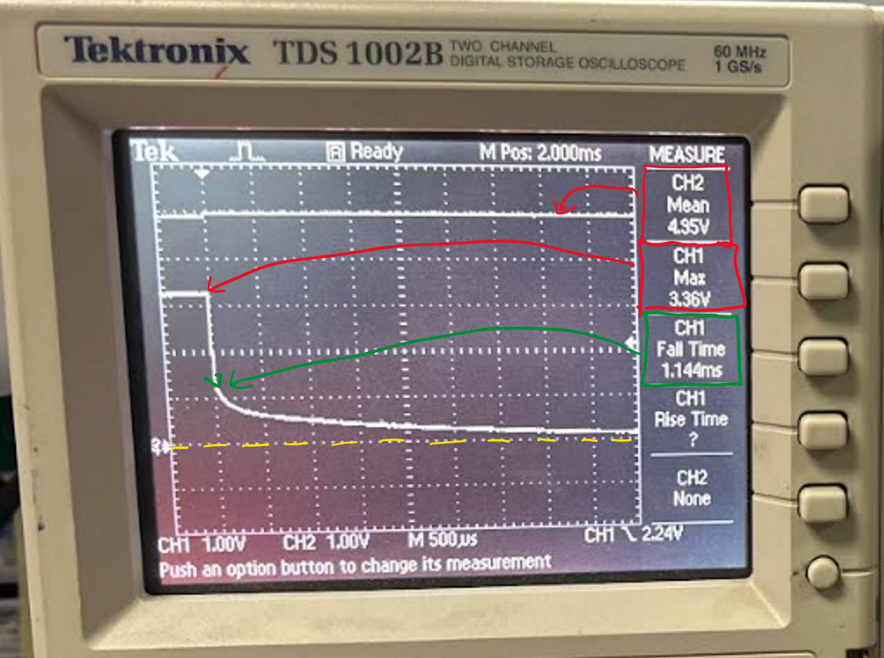
Figure 9: The turn off response, the channel setup are same.

B. Linear Actuator Test
The linear actuator from EcoWorthy will be used to open to the gate. Based on the specs of the linear it retracts about 25.4cm and has a extension/retraction speed of about 1cm/s (0.39in/s). To test the distance and consistency of its motion an Arduino with an ultrasonic sensor is used to measure the distance in 1 decimal place and can record the time at the instantaneous position. Using UART protocol for the Arduino, the data is extracted on a simple python script using the pySerial library and recorded the data on excel sheet using pywin32 library. The setup as shown in Figure 10, and the data extract processed in Figure 11 confirms that speed is able 1cm/s, along with the actuator having a linear motion with 12V supply (Had to add a moving averager of n=10 to clean up most of noise from the velocity calculated).

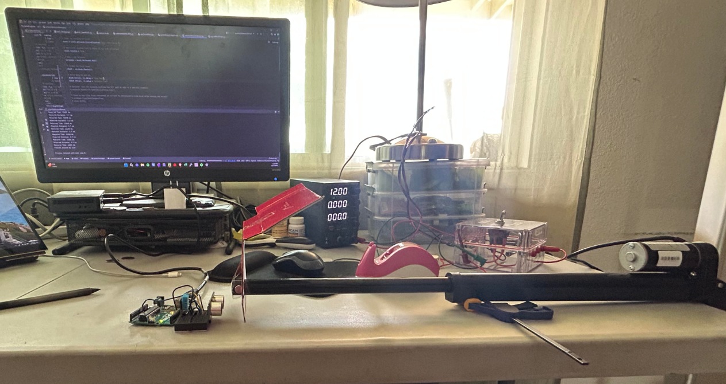
Figure 10: Setup of test with python script, arduino, and linear actuator setup to retract during test.
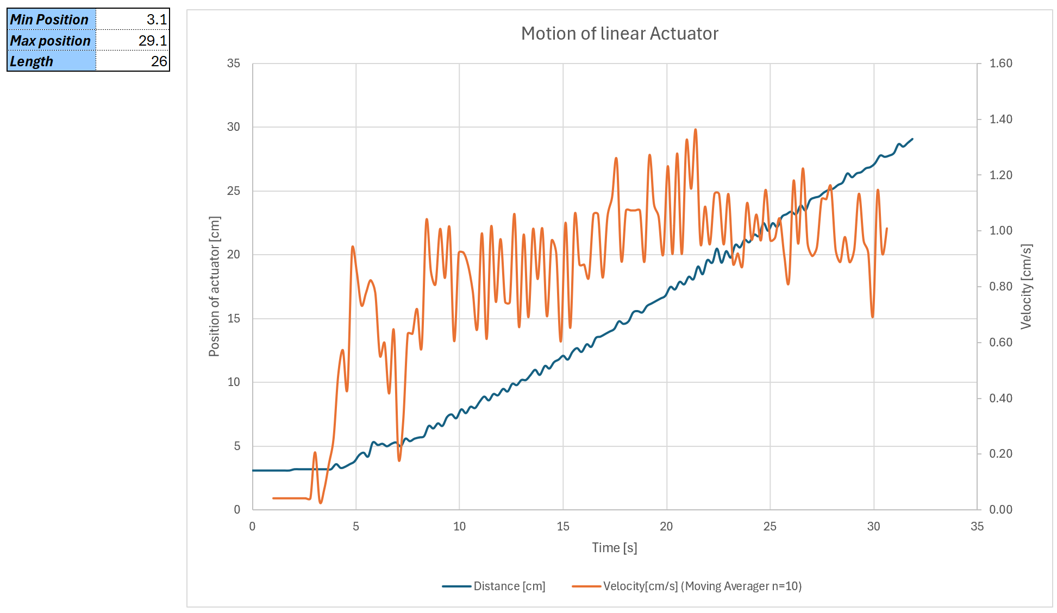
Figure 11: The position and velocity graph of the linear actuator motion.
C. DC-DC Converter Module
Since the since will be plugged into a 24V source, 12V is needed to run the motor a DC-DC converter module DFC10E24S12 is used. The max input voltage is 36V and can efficiently be stepdown to 12V with an output current of 900mA. In Figure 12 and 13, shows the a variable power supply set to 24V, and stepping down to a clean 12V as shown in the meter and scope.
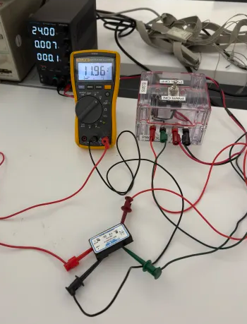
Figure 12: The DC-DC converter setup and results.
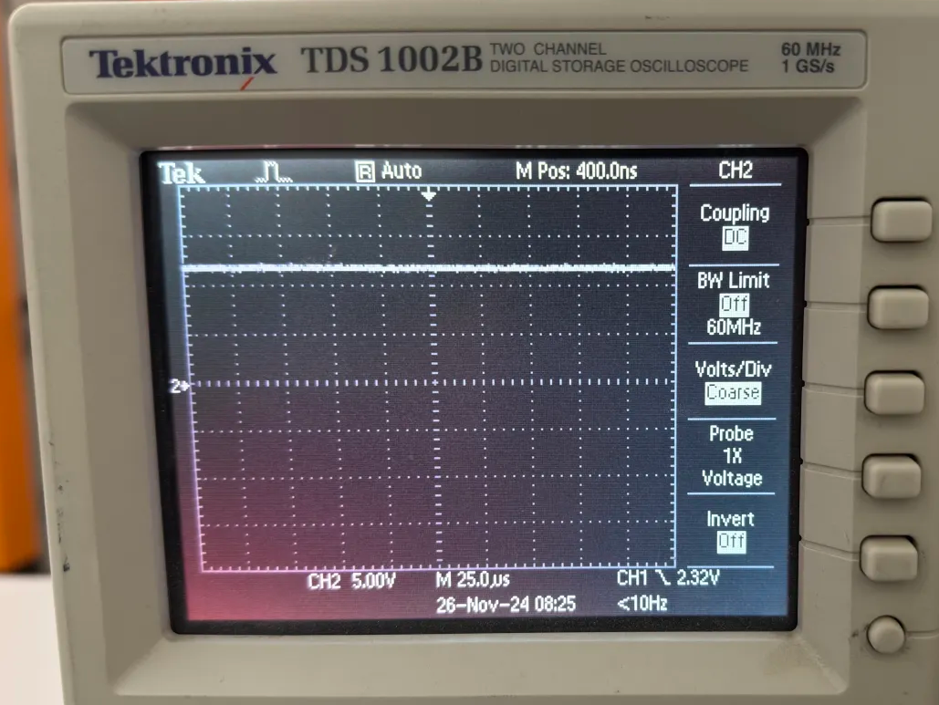
Figure 13: The waveform of a clean 12V output voltage.

D. Ultrasonic Sensor
The ultrasonic sensor is tested on the Tiva C microcontroller with the LCD display built-in on the EduBoard for testing purposes. In Figure 14, is the schematic of the LCD display and ultrasonic sensor, along the setup and waveforms confirming its operation.
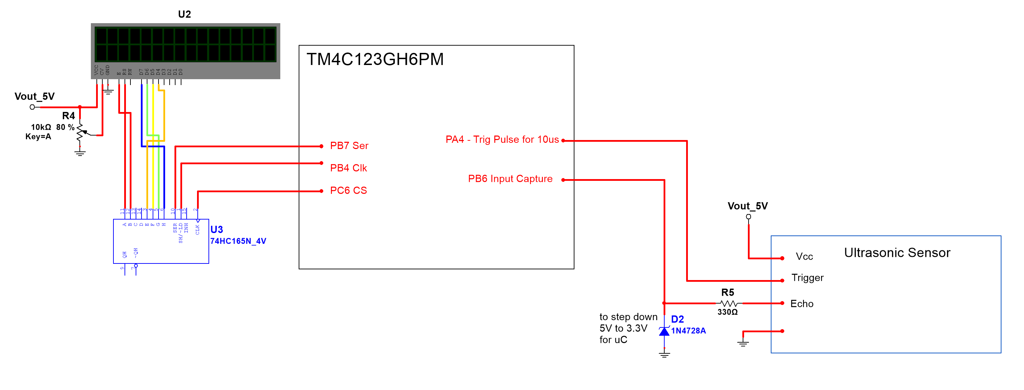
Figure 14: The schematic to test LCD and Ultrasonic sensor.
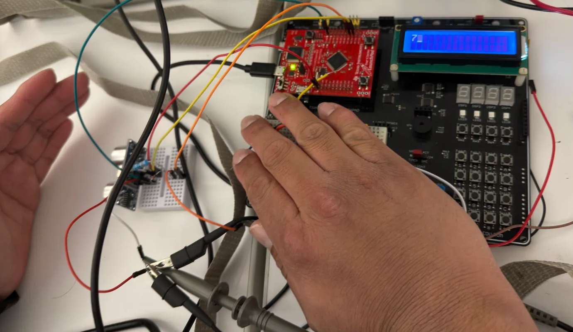
Figure 15: The ultrasonic sensor and LCD tested.
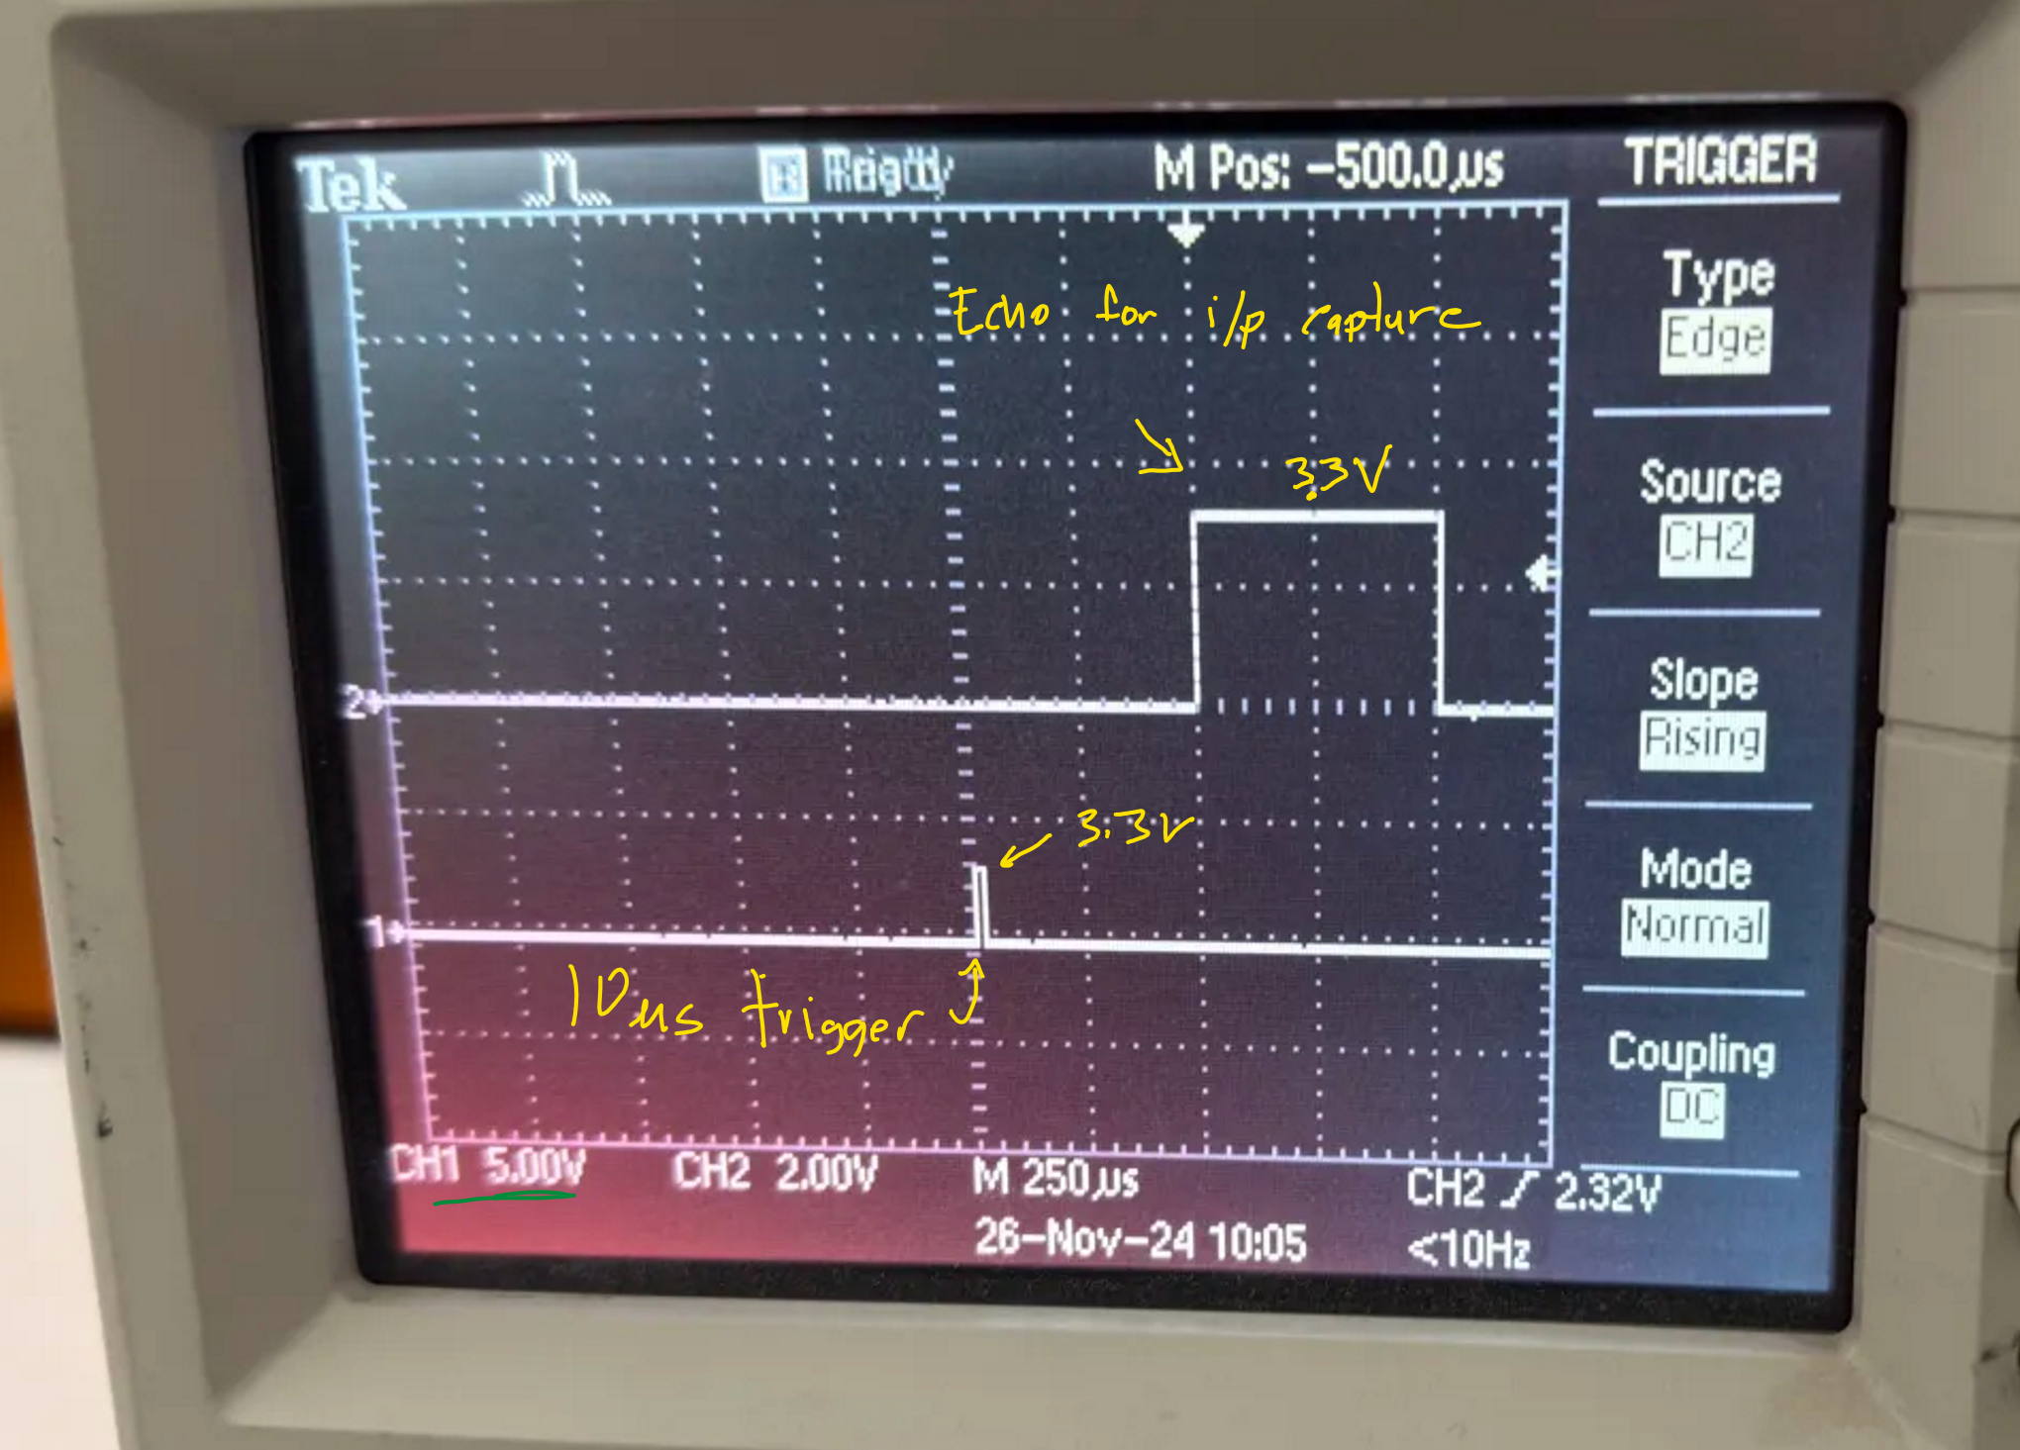
Figure 16: The waveform of the ultrasonic sensor trigger and echo sent to the input capture pin.
Based on the waveform, after it triggers a the ultrasonic sensor the echo is set high until the sound bounces back to the sensor which will set the echo pin low. The Tiva C is has input capture mode it detects a rising and falling edge and starts timing between those trigger events. The LCD returns a number which confirms that the Tiva C retrieved a measured distance.

E. H-bridge integration
With the success of the remote control to output a signal, it is hooked on Tiva C microcontroller to test the response. Along with the using the red and green LED built onto the Tiva C board it is hooked to the H-bridge to able to control the linear actuator as shown in Figure 17.
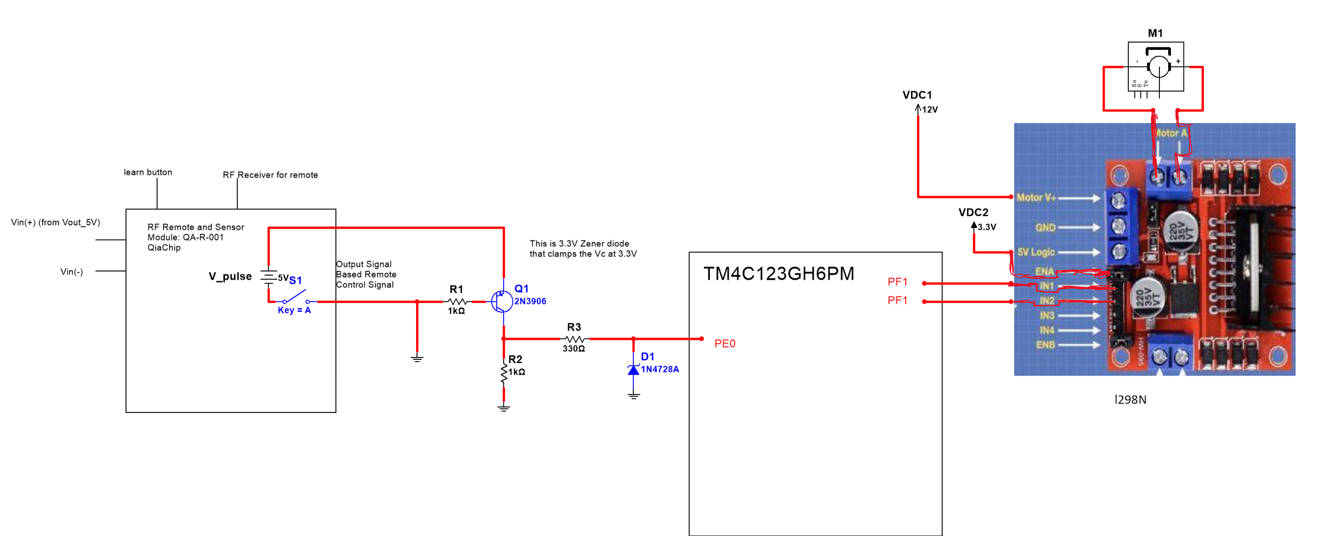
Figure 17: The schematic of testing the H-bridge based on the remote control signal.
After programming the Tiva C and setup the hardware as shown in Figure 18, 19, and 20 shows the setup, along with the logical waveforms labeled open/close that is signaled to the motor driver, and multimeter tied differentially on the linear actuator pins to check if the H-bridge change direction.
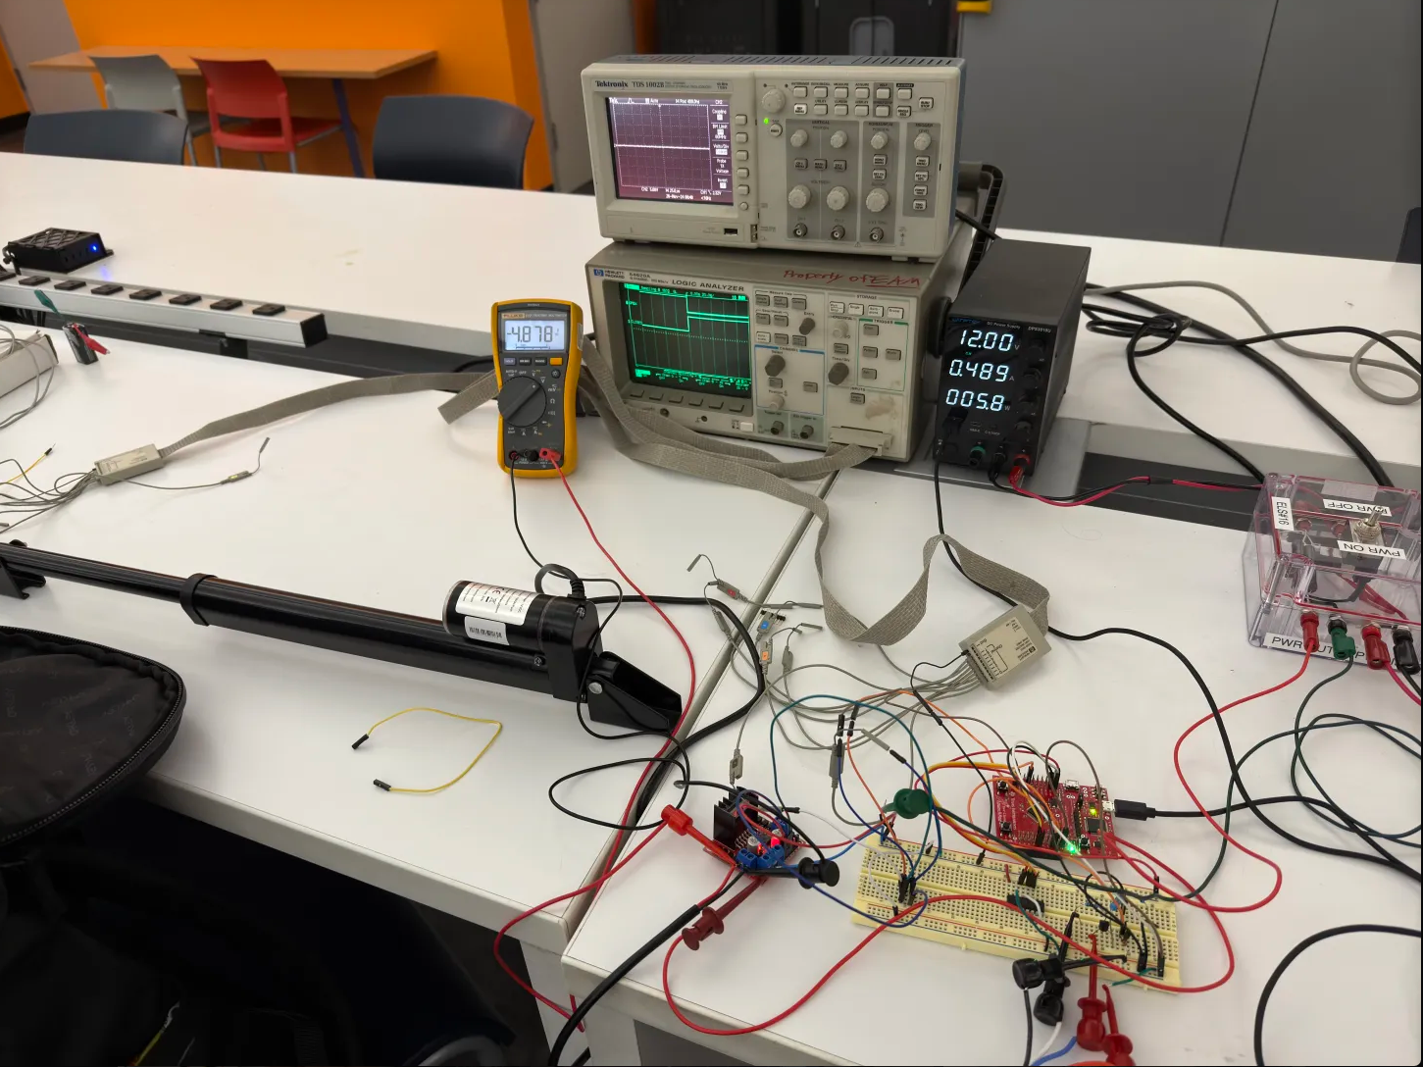
Figure 18: The test setup with the multimeter indicating direction of linear actuator and logic analyzer to view the logic signals controling the H-bridge.
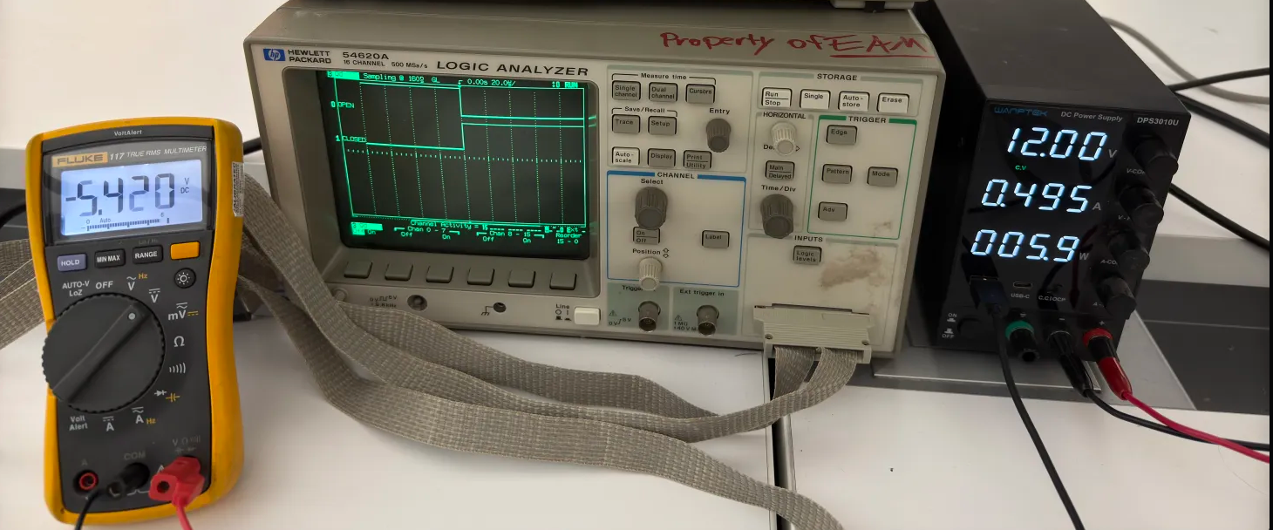
Figure 19: The open signal set low and closed signal set high. The multimeter reference the measured voltage on the motor and with negative voltage indicating that the motor is extending.
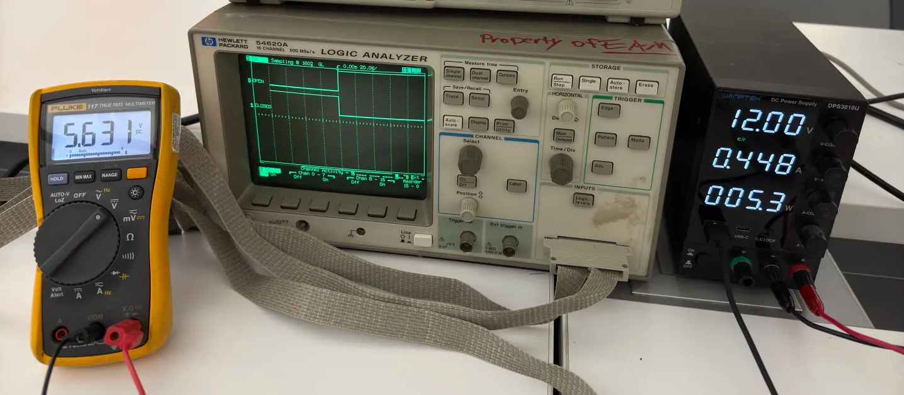
Figure 20: The open signal set high and close signal set low. The multimeter reference the measured voltage on the motor and with positive voltage indicating that the motor is retracting.
VI. Software implementation
Based on the equipment and test circuits operating properly the Tiva C will control all the peripherals by using Finite State Machine or FSM. The FSM keeps the certain peripherals under a specific state based upon the inputs it receives. Below in Figure 21 is the State Diagram of the entire systems behavior based upon the inputs from the remote-control signals, and position from the ultrasonic sensor. Another input that can contribute on changing states is the flags where varies on both remote-control signal and position measured. Snippets of the pseudocode are added to describe at high level, to change the state behavior.
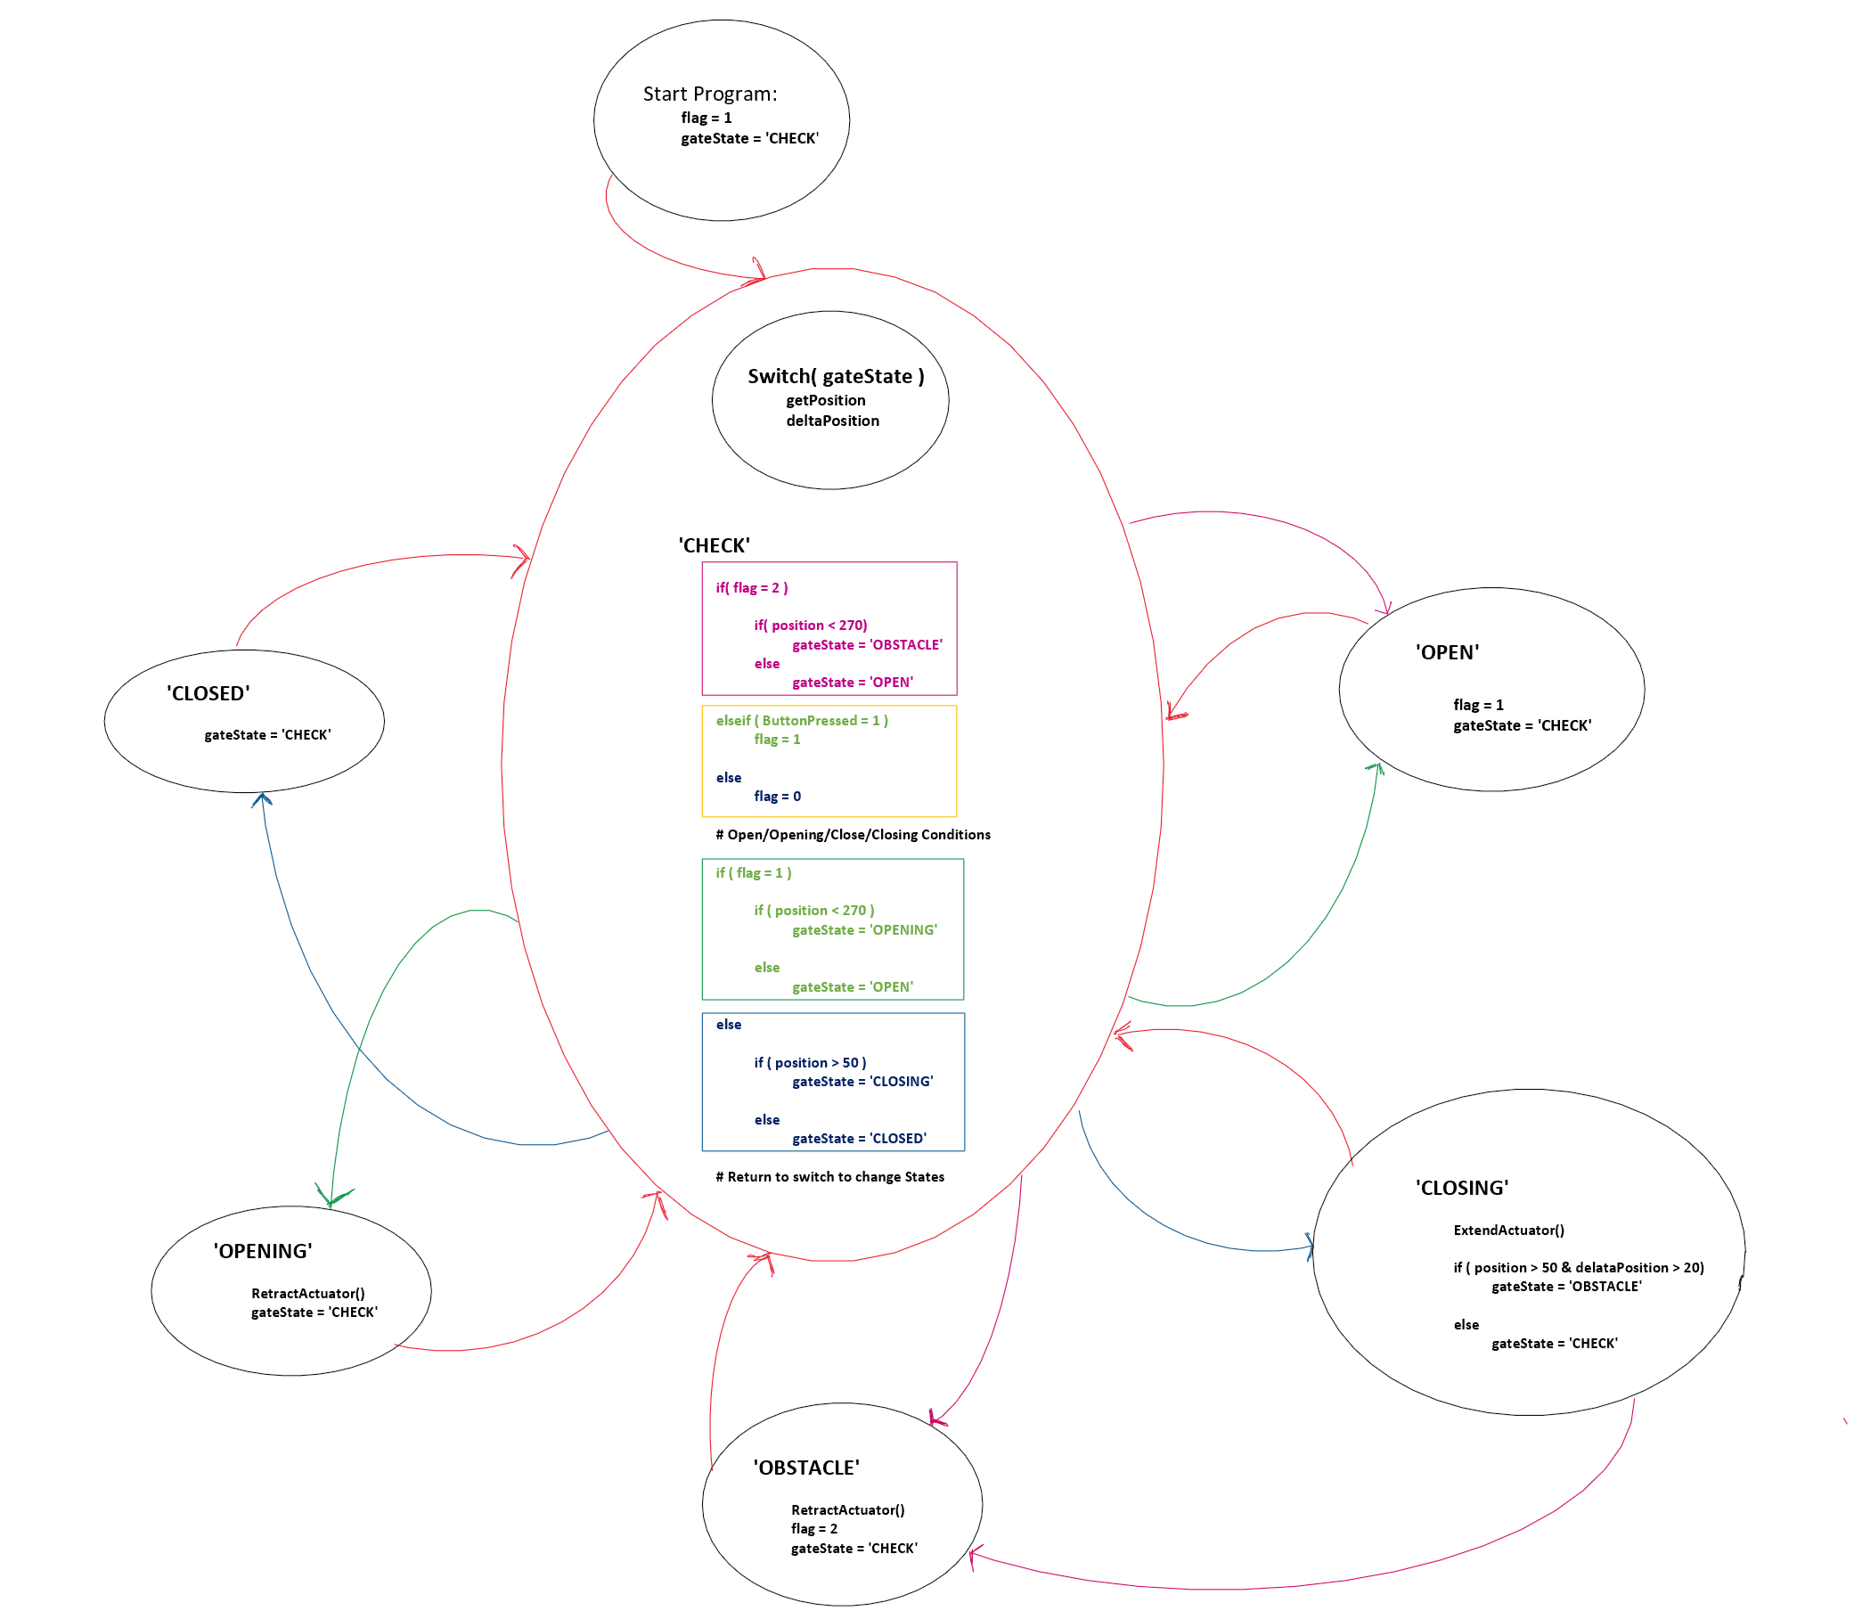
Figure 21: The FSM setup based on the inputs from the remote control signal and position measured from the ultrasonic sensor.
The states in the FSM including OPEN, OPENING, CLOSING, CLOSED, OBSTACLE, & CHECK. In Figure 22 shows the boundaries based on what the ultrasonic sensor measure to indicate the state it should fall in.
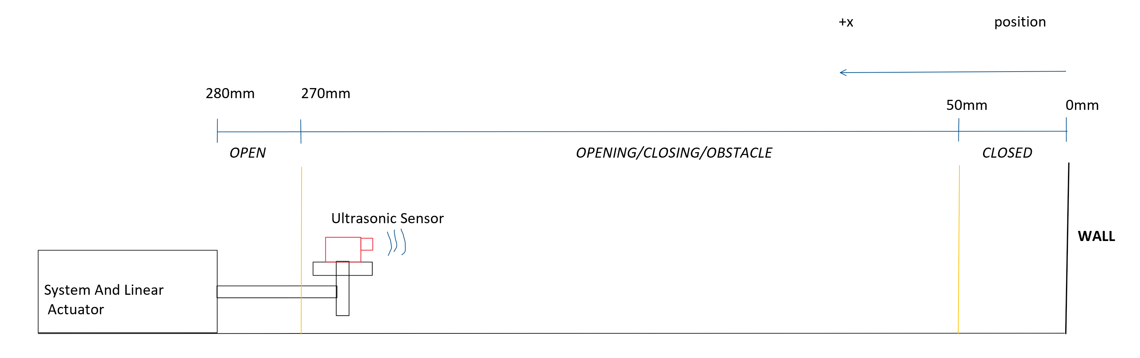
Figure 22: The boundaries to indicate the the state based on the measured reference position from the wall to the ultrasonic sensor.
For the OPEN state the ultrasonic senosr measures position above 270mm, which will consider the gate fully open with the remote signal latch to HIGH. When the close button is pushed from the OPEN state it will initiate the linear actuator to start closing the gate and switch the state to CLOSING and the . The remote control can be pushed to opening the gate during the CLOSING or CLOSED state and the ultrasonic sensor will measure the position to determine either of the two states. When the position is measured less than 50mm the state will fall under the CLOSED until the remote is signaled to open the gate. The OBSTACLE state, can occur during the CLOSING state the ultrasonic sensor detects a large displacement. The displacement is effective since it constantly measuring the gate position, but will also calculate the displacement. The limit for the displacement is set to max of 50mm, where if it measures the displacement beyond the limit it will trigger the state to become OBSTACLE and will start to open the gate until the reaches the OPEN.
VII. Issues encountered
Most of the implemented FSM for the automatic gate opener function properly just a few minor issues that can be improved upon on. Either a better H-bridge can designed from scratch whether the digital and analog system can be separated isolated such using the optocoupler or can buy H-bridge module. The H-bridge that used the L298N is extremely inefficient and had to use 100% to drive the linear actuator at fully speed. During the test, it is observed on the multimeter that average voltage passed the through the motor is about 6V. Most of the power is consumed by H-bridge driver which results in less output power through the motor.
Another issue encountered is the accuracy of the ultrasonic sensor. The ultrasonic sensor would read the position as an outlier. With the ultrasonic sometimes reading outliers it will trigger the FSM code to run into the state that it is not meant to jump into. If the ultrasonic sensor is still a desired sensor to measure position, either two ultrasonic sensors can be used to perform autocorrelation of measured the position signal or multiple samples can be collected to average or filter outliers to use as a final measurement. Other than improvising the algorithm or comparing errors, a better position measuring sensor can be that is less error prone to noise.
Lastly the system has issues with stationary objects based on the FSM algorithm provided. The algorithm can be improved where based on the drawing on Figure 22, the position can be compared to the relative distance between the sensor and the stationary object and the remaining distance between the stationary object to the wall.
VIII. Conclusion
The automated sliding gate opener as presented has a improvements over the CO-ZCG1400 model. The additional safety features would be a drastic improvement over the CO-Z CG1400, and easy user interface where the consumer would desire simplicity of a system. In today’s market maintenance and easy repairs based on the status provided from the microcontroller would be desirable and looking for components to repair a much simpler process.
The high-level overview of the gate system simplifies the process of choosing components to meet system requirements. The gate system can be controlled using an RF sensor, and ultrasonic sensor to detect gate position and obstacles during the closing process.

References
- CO-Z Palace, "Automatic Sliding Gate Opener," https://cozpalace.com/products/automatic-sliding-gate-opener-sgo-0000-00 (accessed Oct. 15, 2024).
- Qiachip, “Qiachip 433MHz Wireless Remote Control Switch Long Range Receiver Module 12V/24V and 433 MHz Transmitter for LED Light Switch,” [Online]. Available: https://qiachip.com/collections/all-products-1/products/qiachip-433mhz-wireless-remote-control-switch-long-range-receiver-module-12v-24v-and-433-mhz-transmitter-for-led-light-switch. [Accessed: 01-Dec-2024].

