Race Results Analysis

Elaine McVey

January 14, 2016

This analysis summarizes and compares race results by age and gender.

## Raw Data

The raw data used in this analysis is a set of individual race results including finish time, pace, age, and gender for each athlete. Bib number is the unique identifier, and event name is a free text description of the race.

|  |  |  |  |  |  |
| --- | --- | --- | --- | --- | --- |
| event_name | bib_number | age | gender | finish_time | pace |
| Spartan SC Beast - Sat Open | 303 | 34 | M | 117.1500 | 9.681818 |
| Spartan SC Beast - Sat Open | 5536 | 14 | M | 122.8000 | 10.148760 |
| Spartan SC Beast - Sat Open | 5535 | 34 | M | 122.8833 | 10.155647 |
| Spartan SC Beast - Sat Open | 7643 | 39 | M | 127.3333 | 10.523416 |
| Spartan SC Beast - Sat Open | 2548 | 43 | M | 128.6500 | 10.632231 |
| Spartan SC Beast - Sat Open | 1466 | 36 | M | 128.9000 | 10.652893 |

## Calculations

To compare across age and gender, ranks and percentiles within categories and age groups must be calculated.

|  |  |  |  |  |  |  |  |  |  |  |  |
| --- | --- | --- | --- | --- | --- | --- | --- | --- | --- | --- | --- |
| age | gender | finish_time | pace | age_cat | age_group | rank_overall | rank_agegrp | rank_gender | pct_overall | pct_agegrp | pct_gender |
| 34 | M | 117.1500 | 9.681818 | 30-34 | M_30-34 | 1 | 1 | 1 | 0.01 | 0.10 | 0.02 |
| 14 | M | 122.8000 | 10.148760 | under 18 | M_under 18 | 2 | 1 | 2 | 0.03 | 0.65 | 0.04 |
| 34 | M | 122.8833 | 10.155647 | 30-34 | M_30-34 | 3 | 2 | 3 | 0.04 | 0.20 | 0.06 |
| 39 | M | 127.3333 | 10.523416 | 35-39 | M_35-39 | 4 | 1 | 4 | 0.06 | 0.11 | 0.08 |
| 43 | M | 128.6500 | 10.632231 | 40-44 | M_40-44 | 5 | 1 | 5 | 0.07 | 0.14 | 0.10 |
| 36 | M | 128.9000 | 10.652893 | 35-39 | M_35-39 | 6 | 2 | 6 | 0.08 | 0.22 | 0.12 |

## Graphical Analysis

### Who participated

A total of 2260 women and 4866 men participated in Spartan SC Beast - Sat Open.

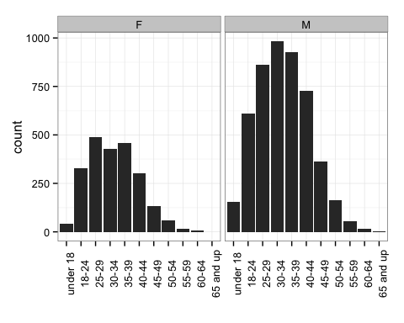

### Pace by gender

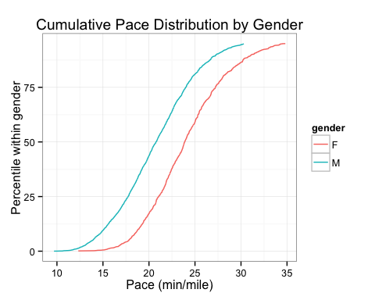

### Pace by age

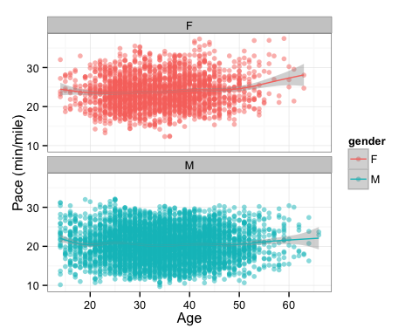

### Gender gap

Adjusting for gender, how do athletes in the same performance percentiles of their gender compare on pace? Is the gender gap consistent across the performance range?

|  |  |  |  |
| --- | --- | --- | --- |
| pct_gender | F | M | gap_gender |
| 1 | 14.51791 | 11.37755 | 3.140352 |
| 2 | 15.99365 | 12.39636 | 3.597295 |
| 3 | 16.75576 | 12.94580 | 3.809957 |
| 4 | 17.14517 | 13.31187 | 3.833298 |
| 5 | 17.64062 | 13.68733 | 3.953288 |
| 6 | 17.91598 | 14.00365 | 3.912324 |

