SPEC9001 - Applied Deep Learning
Lecturer = Robert Ross
Email = Robert Ross <robert.ross@TUDublin.ie>

Week 1 – Introduction

Applied Deep Learning – Introduction
- Applied Deep Learning
- Introduction
- Starting at 6:30
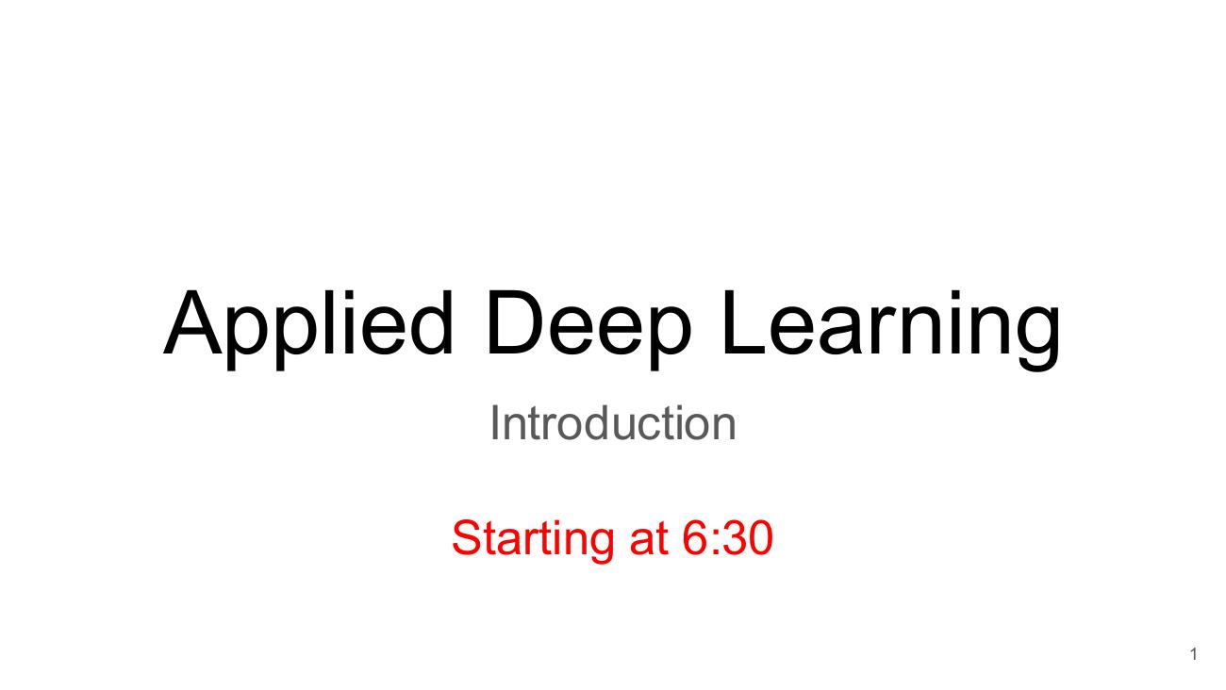

About Me – Robert Ross
- aka, Rob.
- Not, Sir, Professor, or any other honorific
- Senior Lecturer – School of Computer Science
- Lead – Cognitive Systems Research Group
- Director – Applied Intelligence Research Centre
- Active National Funding
- RI Funded Adapt Research Centre
- Enterprise Ireland Funded Innovation Partnerships and Com Funds
- Co-Leader, Precision-ALS Project for Motor Neuron Disease
- Research Areas:
- Situated Interactive Systems (Talking Robots / Games Characters)
- Applied Computer Vision Applications
- https://www.linkedin.com/in/robertjohnross/
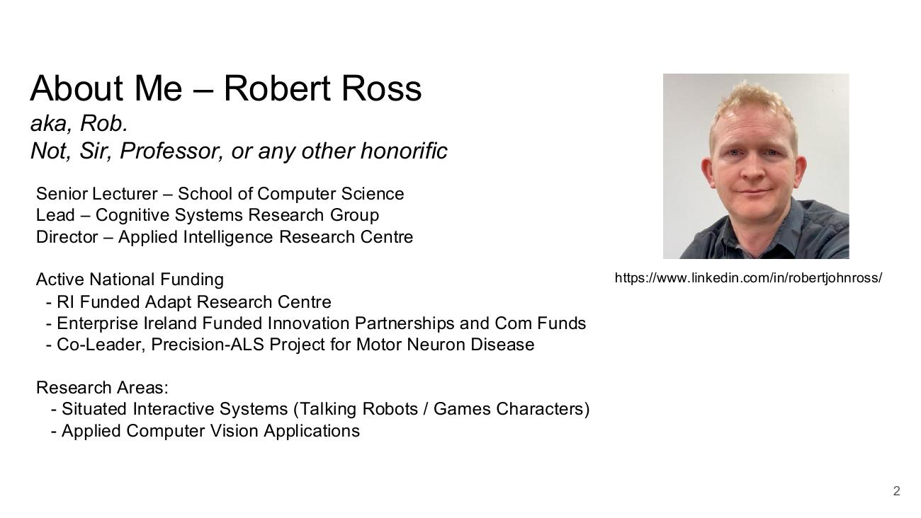

Agenda
- Jumping In
- Course Scope
- Prerequisites
- Course Structure
- Assignments and Assessment
- Coding
- Lab: Model Training with Collab and VS Code
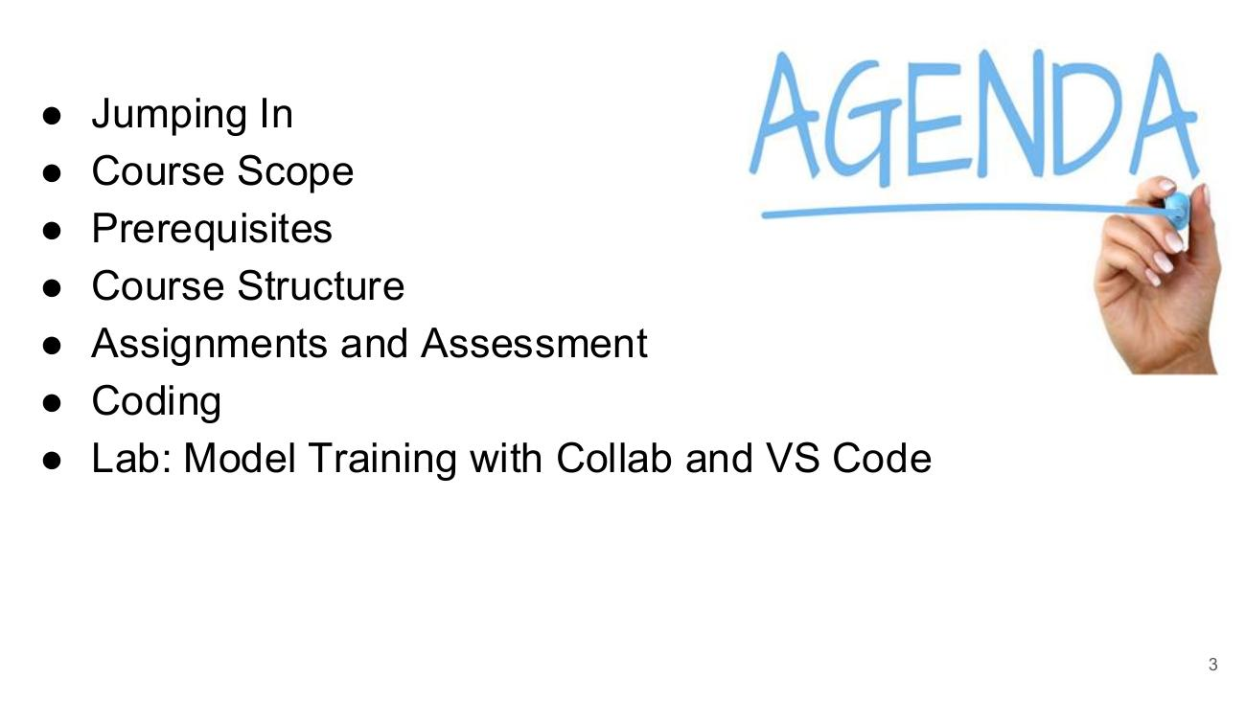

Module Overview and Learning Outcomes

Who is this module for?
- Anyone from either a Data Analytics or Advanced Software Development background who wants to develop a practical understanding of Deep Learning – covering the training and use of the most frequently used model types
- Diagram – Machine Learning: Input → Feature extraction → Classification → Output (Car / Not Car)
- Diagram – Deep Learning: Input → Feature extraction + Classification → Output (Car / Not Car)
- Colab notebook (Untitled47.ipynb):
- import torch
- import torchvision
- torch.__version__ → '2.0.0+cu118'
- torchvision.__version__ → '0.15.1+cu118'
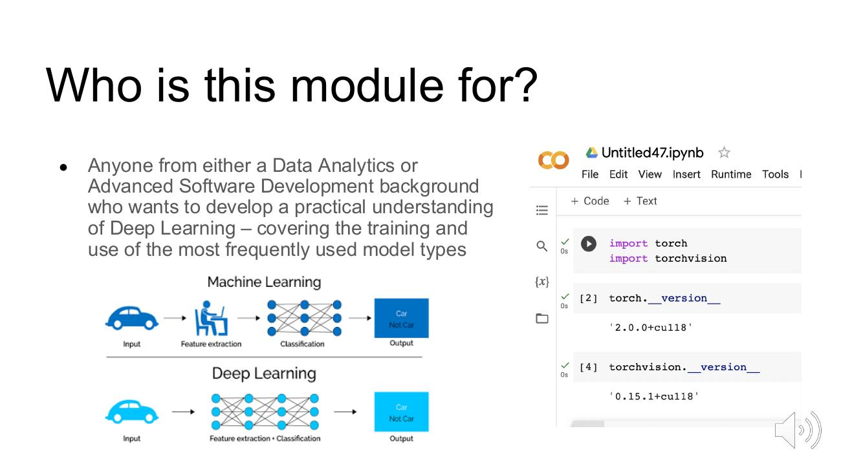

Module Background
- Deep Learning
- Applied Deep Learning
- Foundations of Deep Learning
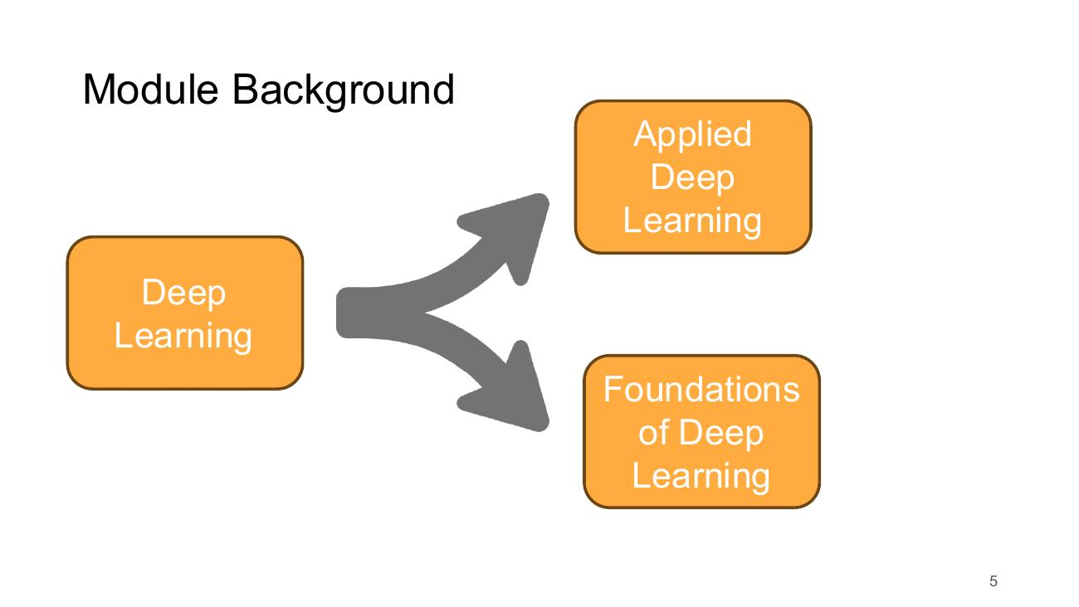

Learning Outcomes
- Understand the common elements and architectural constructions used in Deep Learning
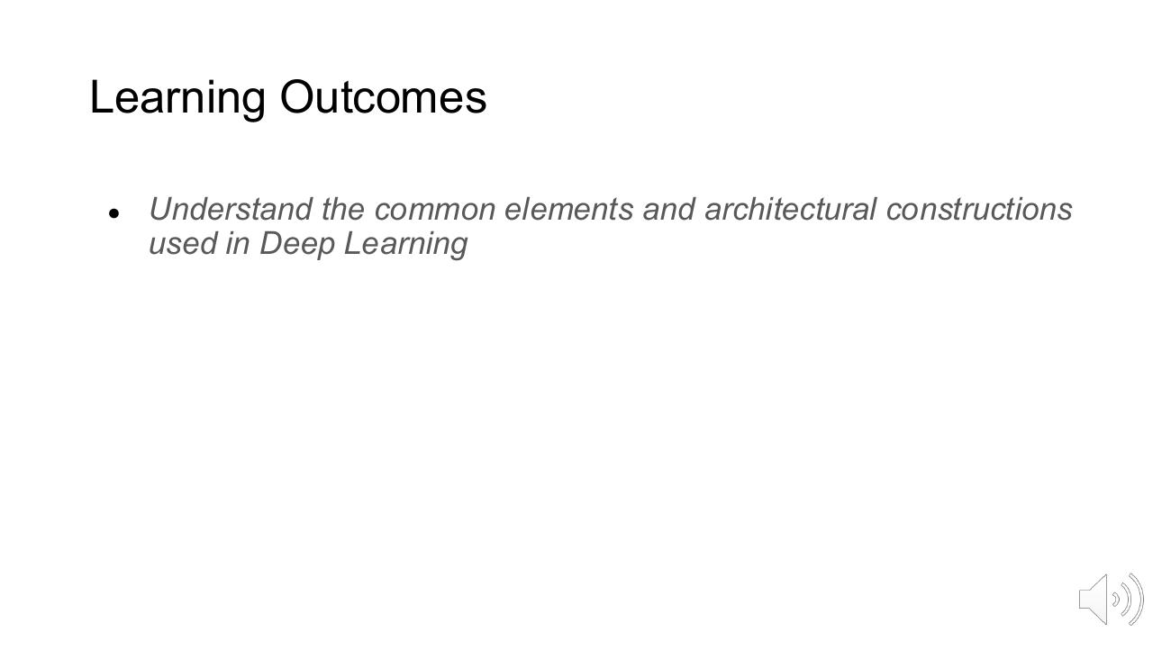

Learning Outcomes – Illustration: Neural Network and LSTM Elements
- Diagram: fully connected neural network (input X → hidden neurons → outputs Y0, Y1)
- Diagram: chain of LSTM cells (A) with inputs Xt, Xt+1 and hidden states ht-1, ht, ht+1 (σ, tanh gates)
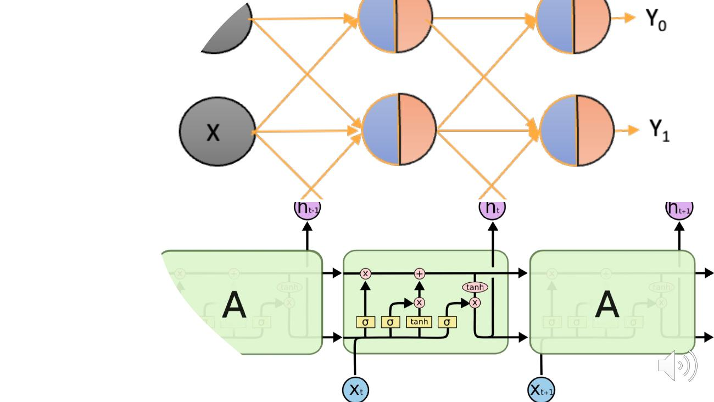

Learning Outcomes
- Understand the common elements and architectural constructions used in Deep Learning
- Apply and critique Deep Learning Architectures to typical deployments in areas such as image processing and text processing.
- (Current outcome shown in bold; earlier outcomes greyed out on the slide)
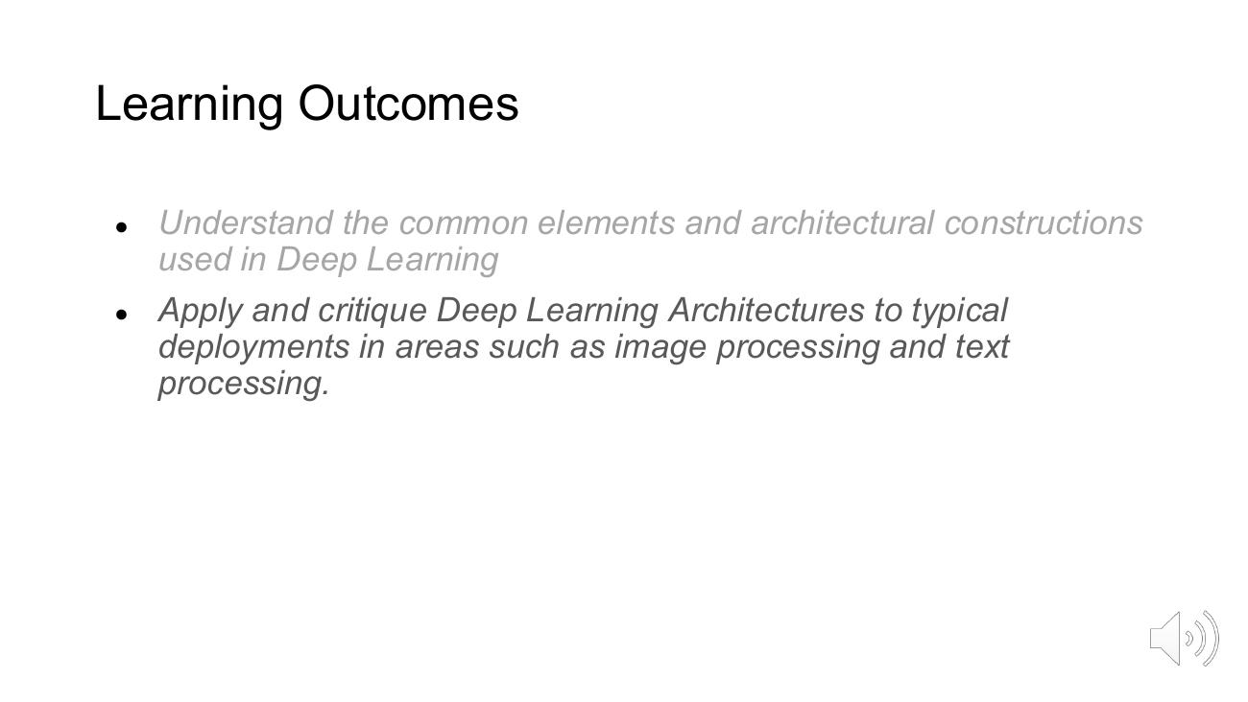

Learning Outcomes – Illustration: CNN Filters, BERT and GPT
- Convolutional filters on a 28x28 input (F1 and F2 3x3 weights producing 26x26 feature maps)
- BERT – Encoder
- GPT – Decoder
- Transformer architecture diagram (encoder and decoder stacks)
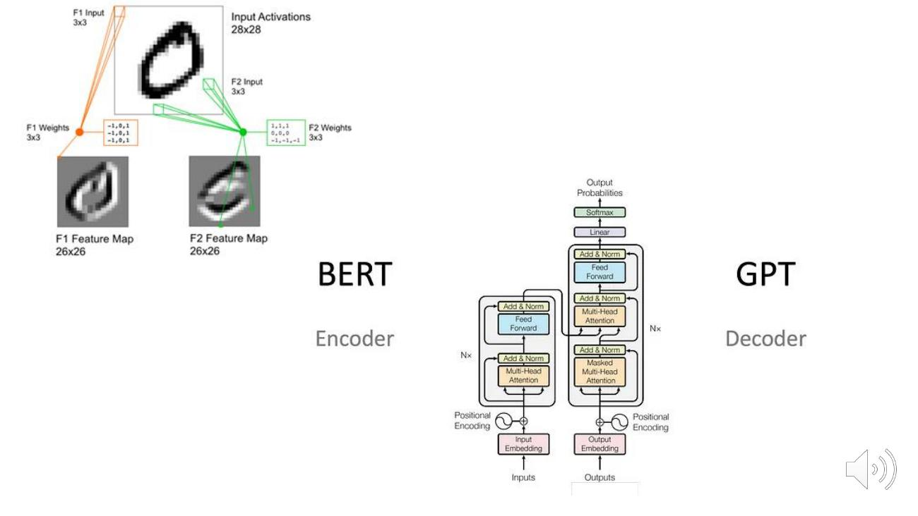

Learning Outcomes
- Understand the common elements and architectural constructions used in Deep Learning
- Apply and critique Deep Learning Architectures to typical deployments in areas such as image processing and text processing.
- Examine the challenge of representations and data types as used in the context of Deep Learning.
- (Current outcome shown in bold; earlier outcomes greyed out on the slide)
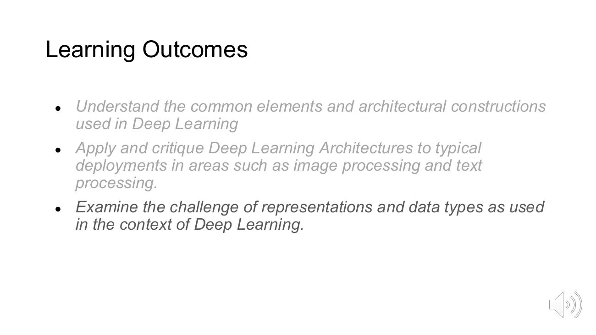

Learning Outcomes – Illustration: Representations
- One-hot encoding (vocabulary: cat, mat, on, sat, the)
- the => 0 0 0 0 1
- cat => 1 0 0 0 0
- sat => 0 0 0 1 0
- Embedding space with semantic clusters: body part, food, city, travel, feeling, relative
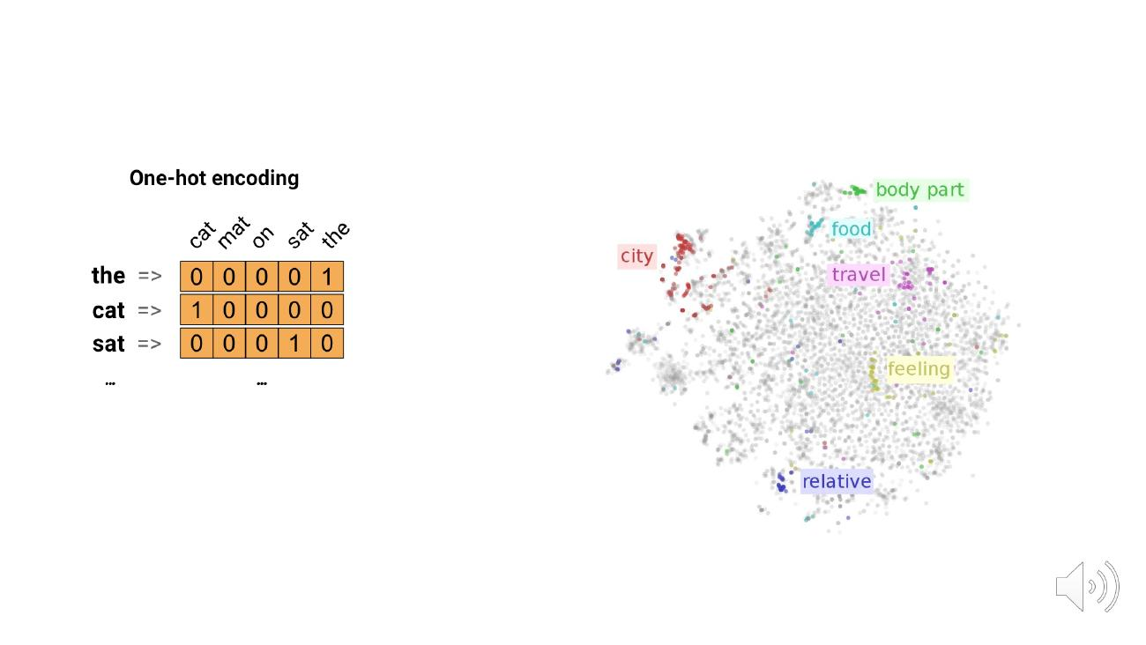

Learning Outcomes
- Understand the common elements and architectural constructions used in Deep Learning
- Apply and critique Deep Learning Architectures to typical deployments in areas such as image processing and text processing.
- Examine the challenge of representations and data types as used in the context of Deep Learning.
- Examine the challenge of overfitting and data bias in the context of Deep Learning solution development.
- (Current outcome shown in bold; earlier outcomes greyed out on the slide)
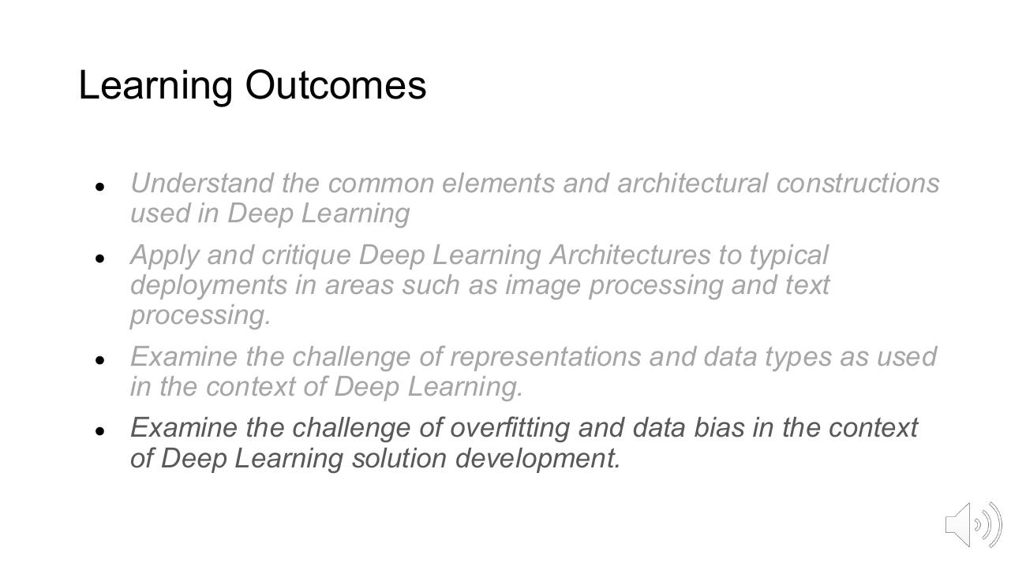

Learning Outcomes – Illustration: Overfitting
- Loss vs Steps graph: Train loss keeps falling while Test loss bottoms out and starts to rise (overfitting)
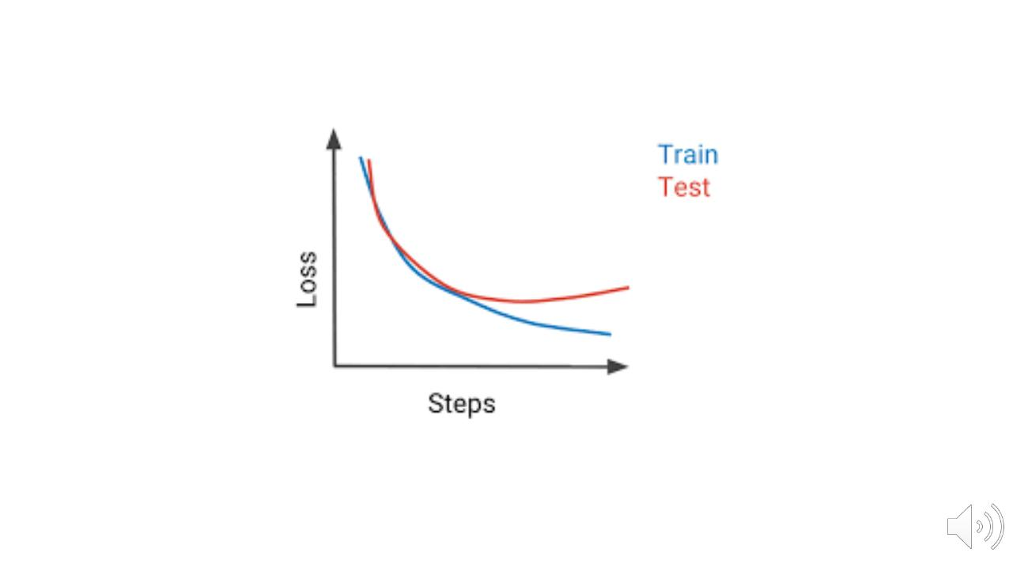

Learning Outcomes
- Understand the common elements and architectural constructions used in Deep Learning
- Apply and critique Deep Learning Architectures to typical deployments in areas such as image processing and text processing.
- Examine the challenge of representations and data types as used in the context of Deep Learning.
- Examine the challenge of overfitting and data bias in the context of Deep Learning solution development.
- Describe and critique common techniques for deploying and training deep neural networks.
- (Current outcome shown in bold; earlier outcomes greyed out on the slide)
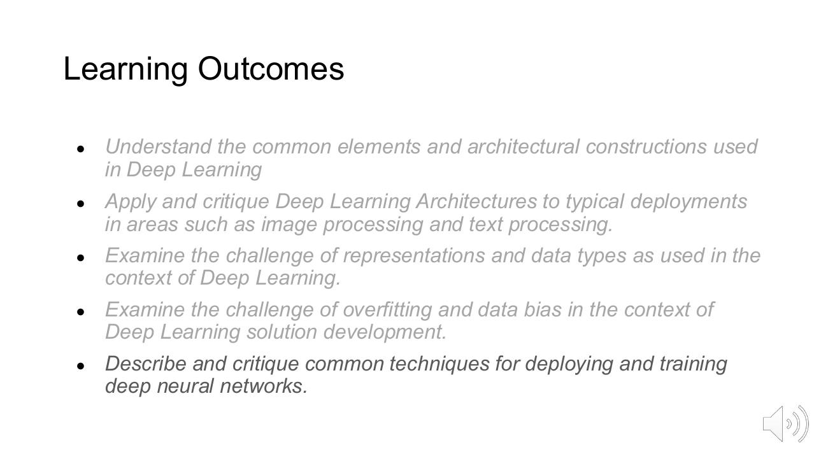

Learning Outcomes – Illustration: Hardware and MLOps
- GPU graphics card (hardware for training/deployment)
- MLOps = intersection of Machine Learning, DevOps and Data Engineering
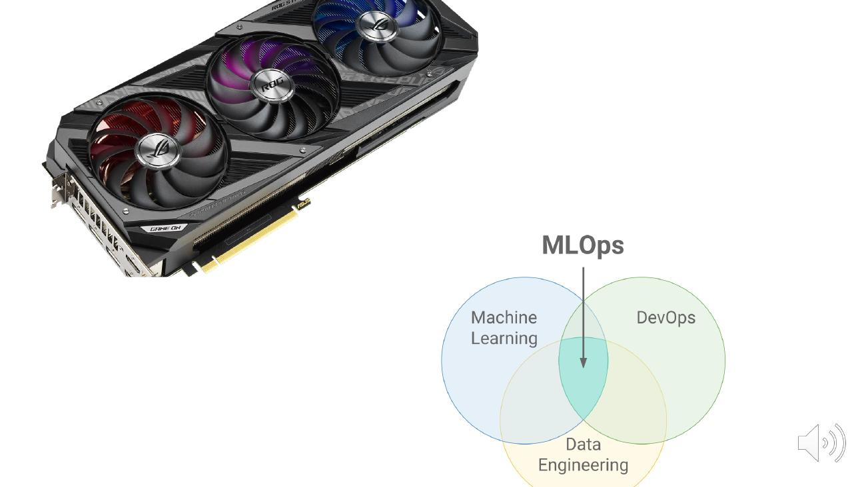

Jumping In

Jumping In: Mnist Data
- Sample MNIST handwritten digit images (28x28): 5, 0, 4, 1, 9, 2, 1, 3, 1
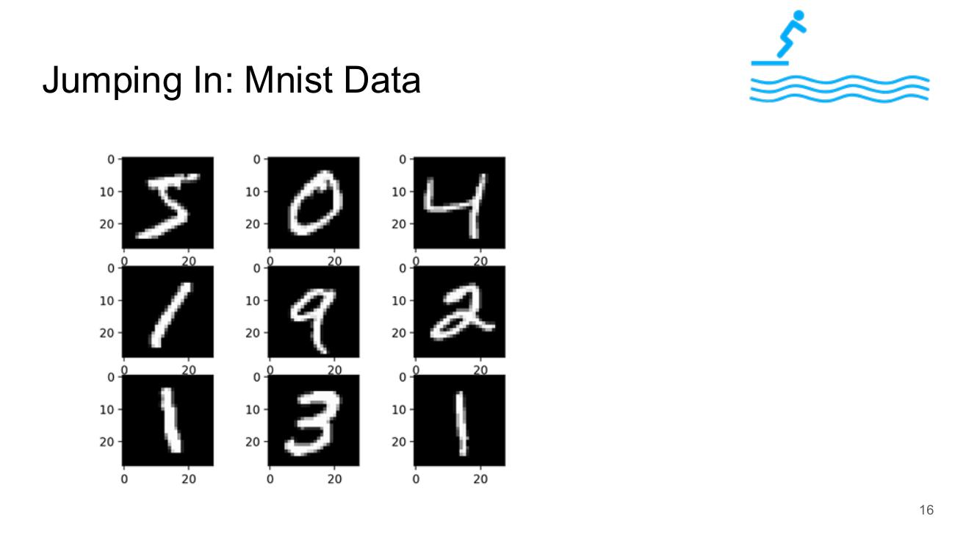

Jumping In: Accurate Digit Classification in 14 Lines
- import tensorflow as tf
- mnist = tf.keras.datasets.mnist
- (x_train, y_train),(x_test, y_test) = mnist.load_data()
- x_train = tf.keras.utils.normalize(x_train, axis=1)
- x_test = tf.keras.utils.normalize(x_test, axis=1)
- model = tf.keras.models.Sequential()
- model.add(tf.keras.layers.Flatten())
- model.add(tf.keras.layers.Dense(128, activation=tf.nn.relu))
- model.add(tf.keras.layers.Dense(128, activation=tf.nn.relu))
- model.add(tf.keras.layers.Dense(10, activation=tf.nn.softmax))
- model.compile(optimizer="adam", loss="sparse_categorical_crossentropy", metrics=["accuracy"])
- model.fit(x=x_train, y=y_train, epochs=5)
- test_loss, test_acc = model.evaluate(x=x_test, y=y_test,verbose=0)
- print('\nTest accuracy: ' + str(test_acc*100) + "%" )
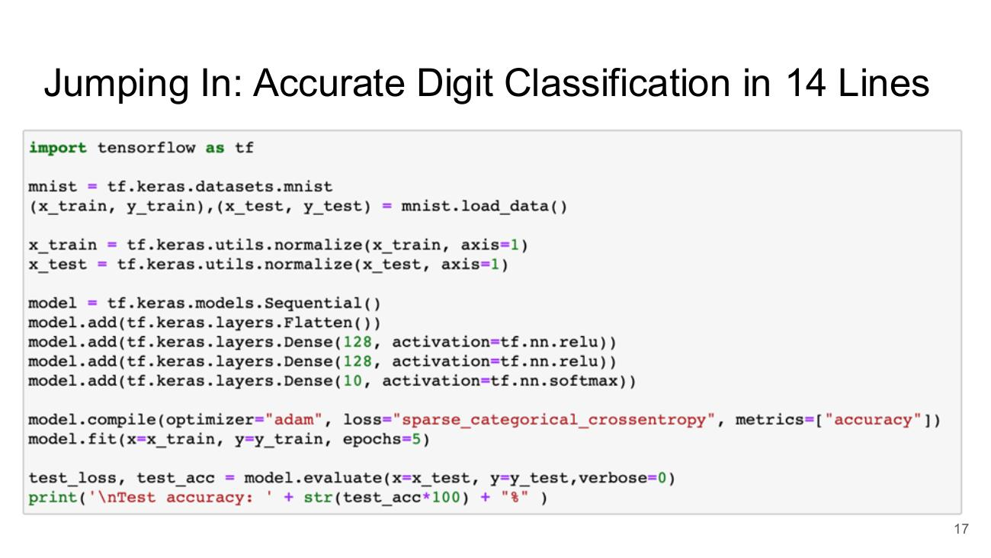

Jumping In: Training
- Epoch 1/5
- 1875/1875 [==============================] - 5s 2ms/step - loss: 0.4656 - accuracy: 0.8687
- Epoch 2/5
- 1875/1875 [==============================] - 3s 2ms/step - loss: 0.1113 - accuracy: 0.9657
- Epoch 3/5
- 1875/1875 [==============================] - 3s 2ms/step - loss: 0.0738 - accuracy: 0.9763
- Epoch 4/5
- 1875/1875 [==============================] - 3s 2ms/step - loss: 0.0491 - accuracy: 0.9857
- Epoch 5/5
- 1875/1875 [==============================] - 3s 2ms/step - loss: 0.0375 - accuracy: 0.9884
- Test accuracy: 97.28000164031982%
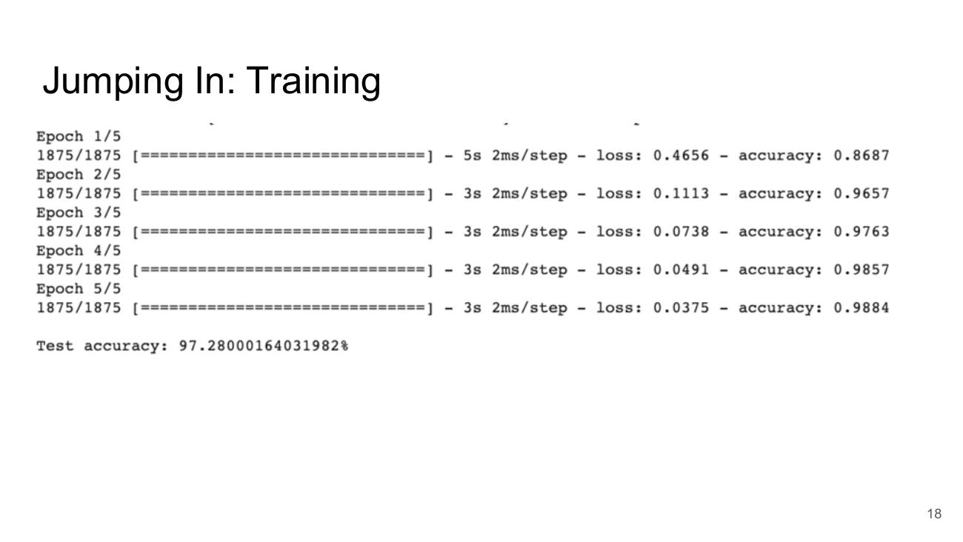

Jumping In: PyTorch Equivalent
- import torch
- from torchvision import datasets, transforms
- from torch import nn, optim
- train_loader = torch.utils.data.DataLoader(
- datasets.MNIST('./data', train=True, download=True, transform=transforms.ToTensor()),
- batch_size=64, shuffle=True)
- test_loader = torch.utils.data.DataLoader(
- datasets.MNIST('./data', train=False, download=True, transform=transforms.ToTensor()),
- batch_size=1000)
- model = nn.Sequential(
- nn.Flatten(), nn.Linear(28*28, 128), nn.ReLU(), nn.Linear(128, 10)
- )
- optimizer = optim.Adam(model.parameters(), lr=0.001)
- loss_fn = nn.CrossEntropyLoss()
- for _ in range(5):
- for x, y in train_loader:
- optimizer.zero_grad()
- loss = loss_fn(model(x), y)
- loss.backward()
- optimizer.step()
- correct = sum((model(x).argmax(1) == y).sum().item() for x, y in test_loader)
- total = len(test_loader.dataset)
- print(f'Test Accuracy: {100 * correct / total:.2f}%')
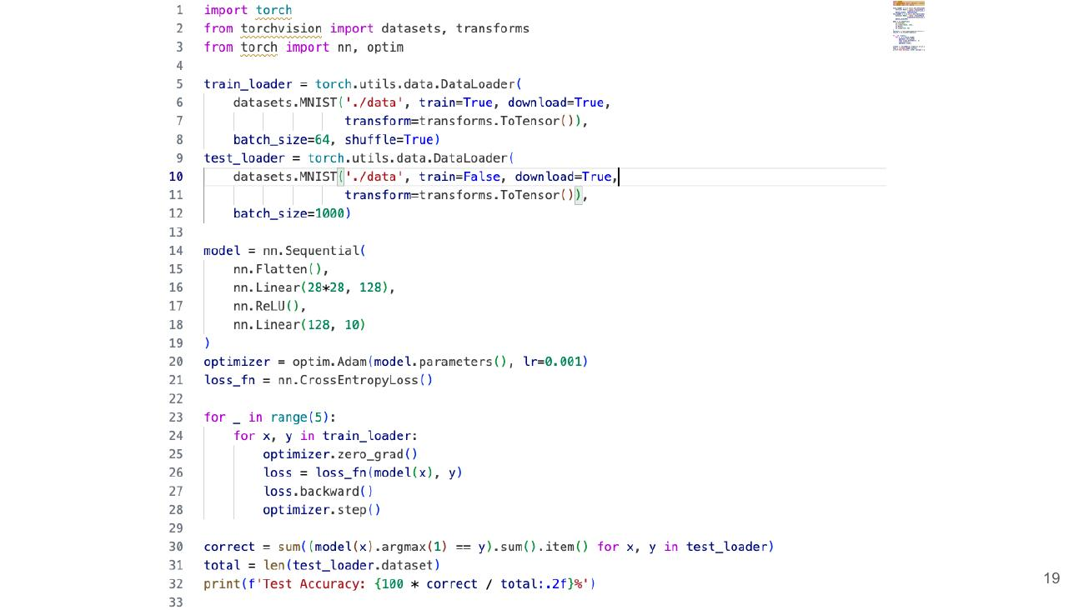

Course Scope

Course Scope
- Course Scope (section divider)
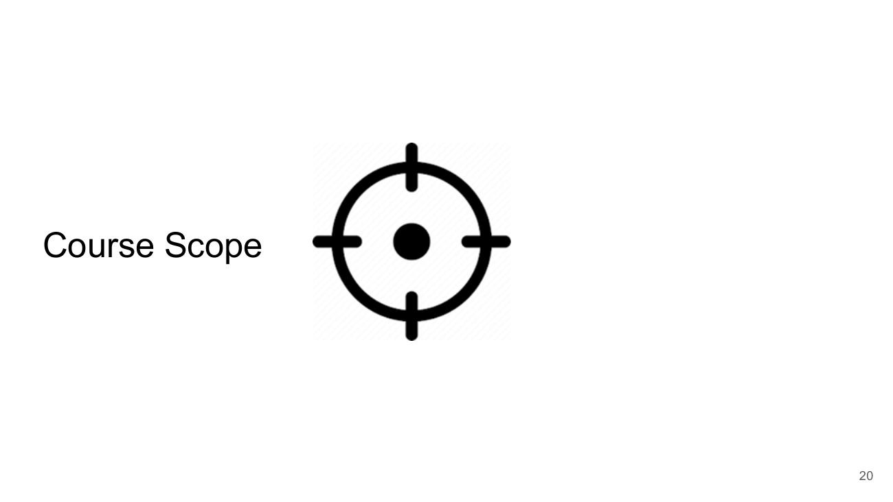

Course Scope
- Goal: Study key concepts in Deep Learning
- Emphasis on understanding and genuine skill building
- Making sure you know what is in front of you is correct and high quality
- (anyone can build a bad presentation)
- Example image: an overcrowded, text-heavy slide ‘How Rivers Are Formed’
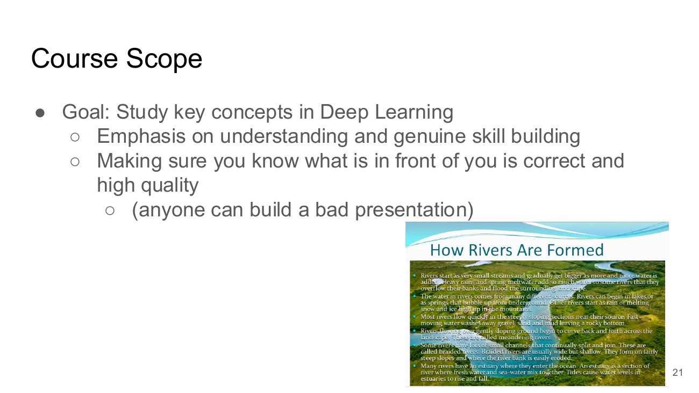

Days before OpenAI / Days after OpenAI
- Days before OpenAI: Developer coding – 2 hours; Developer debugging – 6 hours
- Days after OpenAI: ChatGPT generates Codes – 5 min; Developer debugging – 24 hours
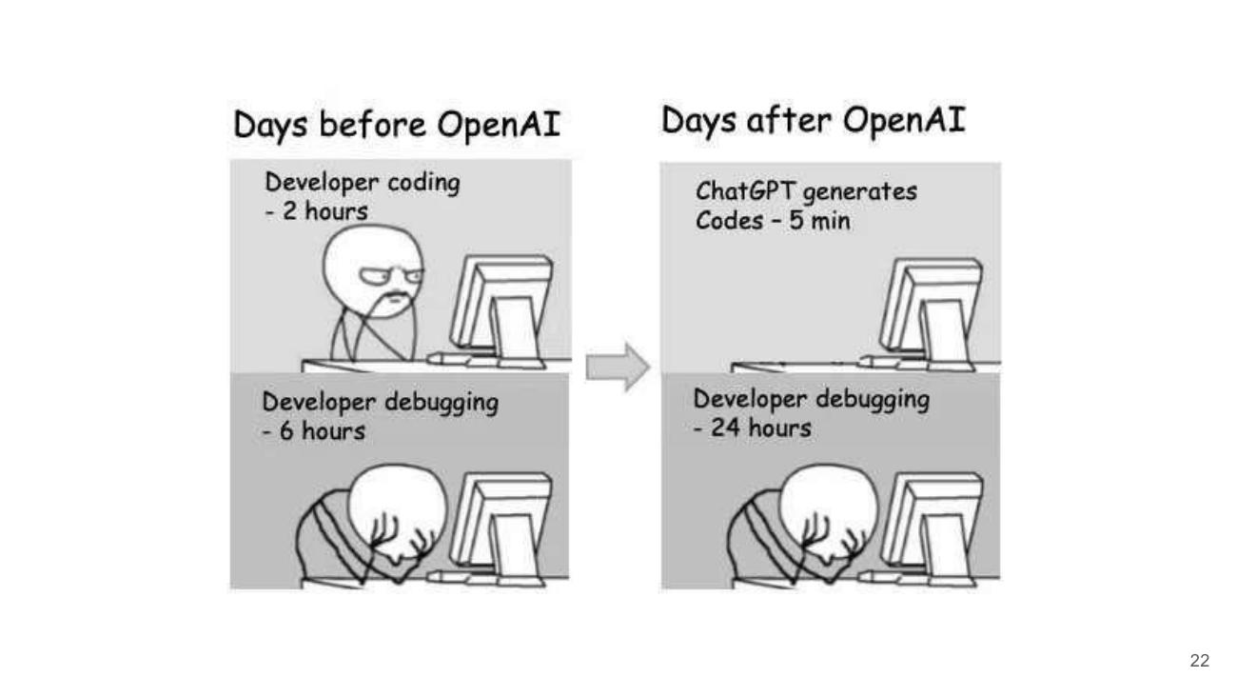

Course Scope
- Goal: Study key concepts in Deep Learning
- Emphasis on understanding and genuine skill building
- Lecture Notes:
- Slides with some Jupyter Notebooks (not 100% consistent!)
- Not Covered
- The history of neural networks
- The biological inspiration of neural networks
- Explainability, Ethics and other Human-Centric issues
- Learning Resources
- Course is mostly self contained
- Links to external resources will be given
- At MSc and PhD Level - Self directed study is assumed!
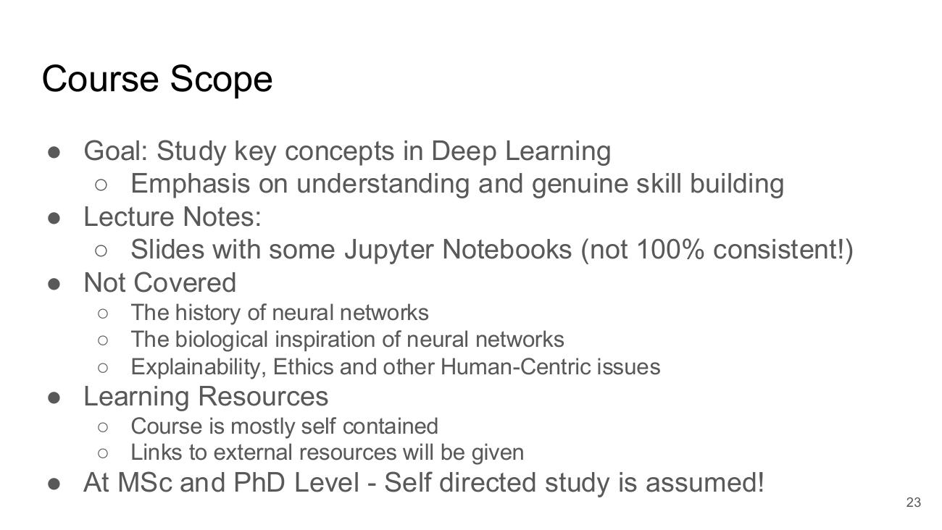

Prerequisites

Prerequisites
- Students should ideally have completed undergraduate or Masters level modules on:
- Artificial Intelligence or
- Machine Learning
- Taking Machine Learning as a co-requisite is acceptable but continued study is important
- Consult online resources
- Ask Gen AI for Assistance – but force yourself to learn!!!!
- Assignments to be coded in Python
- Laptop
- I strongly encourage all students to set up their own python environments to learn
- Lab Today on VS Code
- Willingness to interact
- We don’t all like groups, trust me! But they are a good way to learn.
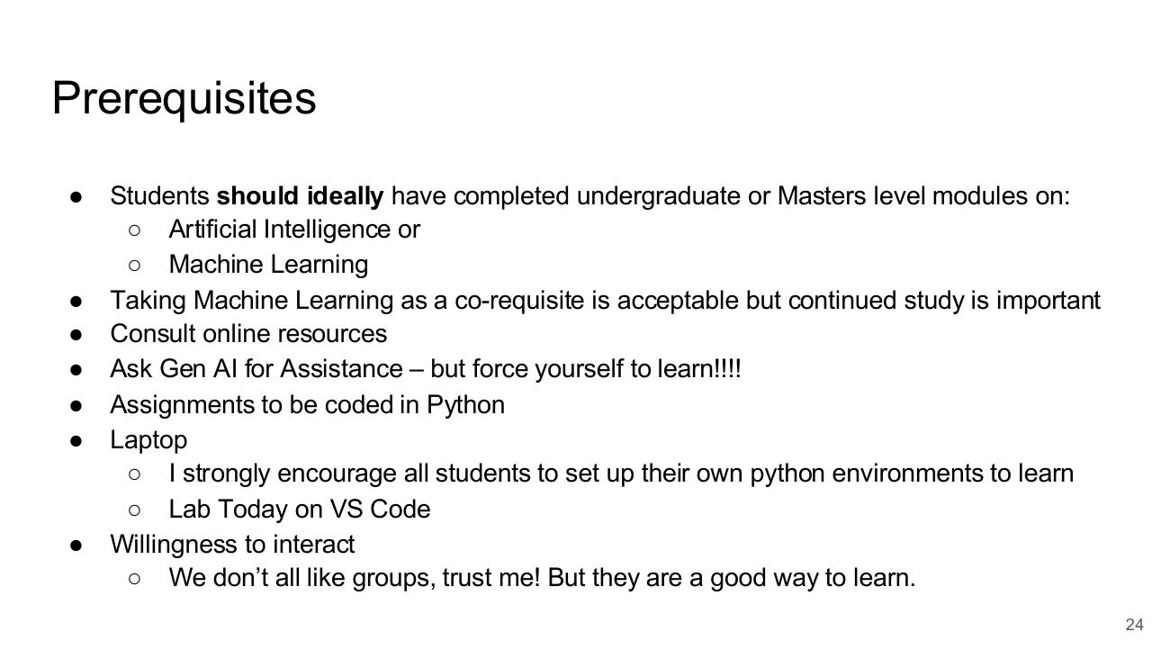

Course Structure

Course Structure
- Course Structure (section divider)


Week by Week (always subject to change)
- Week 1 – Introduction
- Week 2 – Neural Network Essentials
- Week 3 – Training and Loss Functions
- Week 4 – Better Activations
- Week 5 – Preventing Overfitting
- Week 6 – Convolutional Neural Networks
- Week 7 – Review Week (Bank Holiday)
- Week 8 – Text and Representations
- Week 9 – Recurrent Neural Networks
- Week 10 – Transformers
- Week 11 – Hardware for Training and Deployment
- Week 12 – Transfer Learning & Fine Tuning
- Week 13 – ML Ops and Project Management
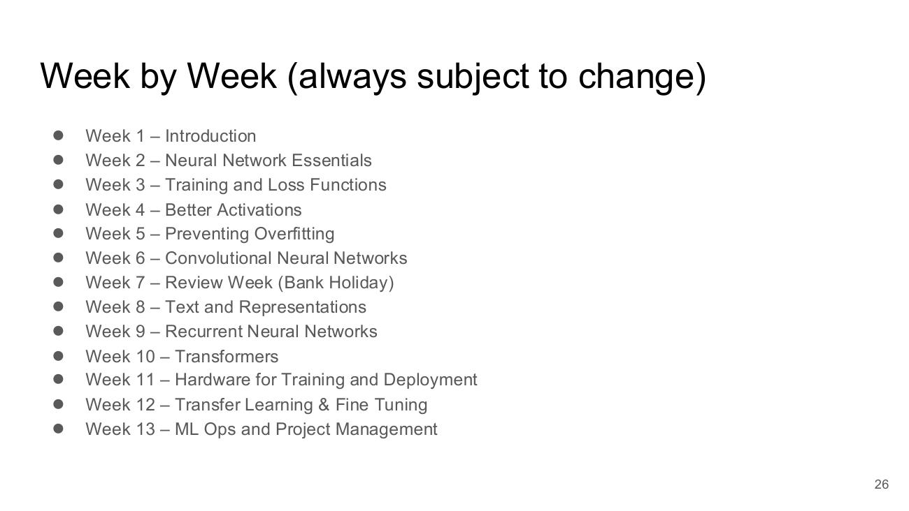

Week by Week (always subject to change)
- Week 1 – Introduction
- Week 2 – Neural Network Essentials
- Week 3 – Training and Loss Functions
- Week 4 – Better Activations
- Week 5 – Preventing Overfitting
- Week 6 – Convolutional Neural Networks
- Week 7 – Review Week (Bank Holiday)
- Week 8 – Text and Representations
- Week 9 – Recurrent Neural Networks
- Week 10 – Transformers
- Week 11 – Hardware for Training and Deployment
- Week 12 – Transfer Learning & Fine Tuning
- Week 13 – ML Ops and Project Management
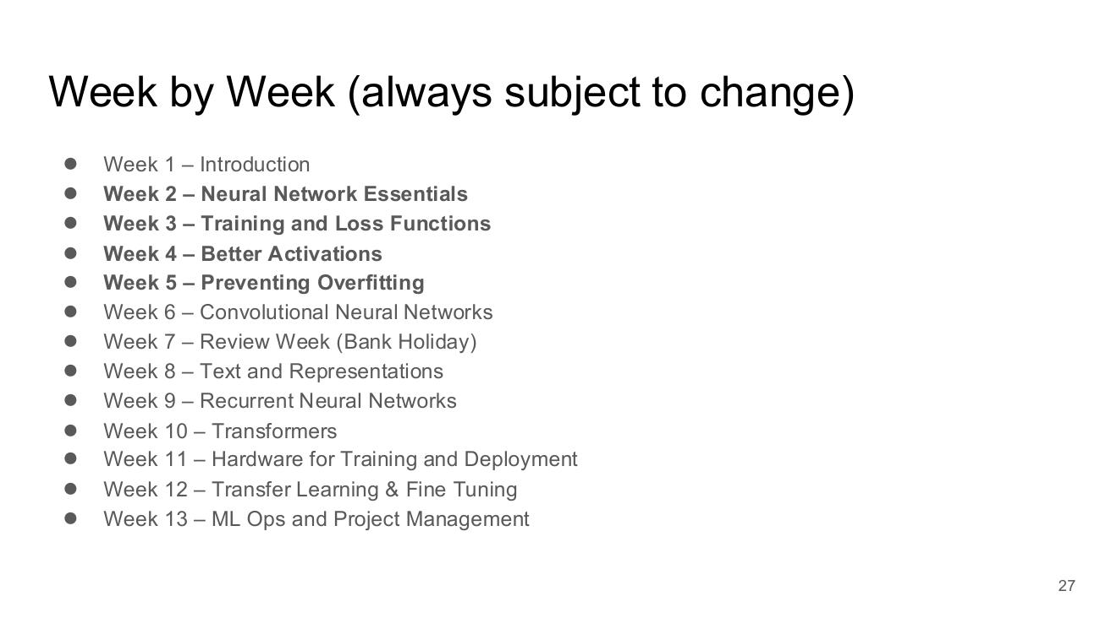

Basic Neural Networks
- Input Layer (X, X, X) → Hidden Layer → Output Layer (Y0, Y1, Y2)
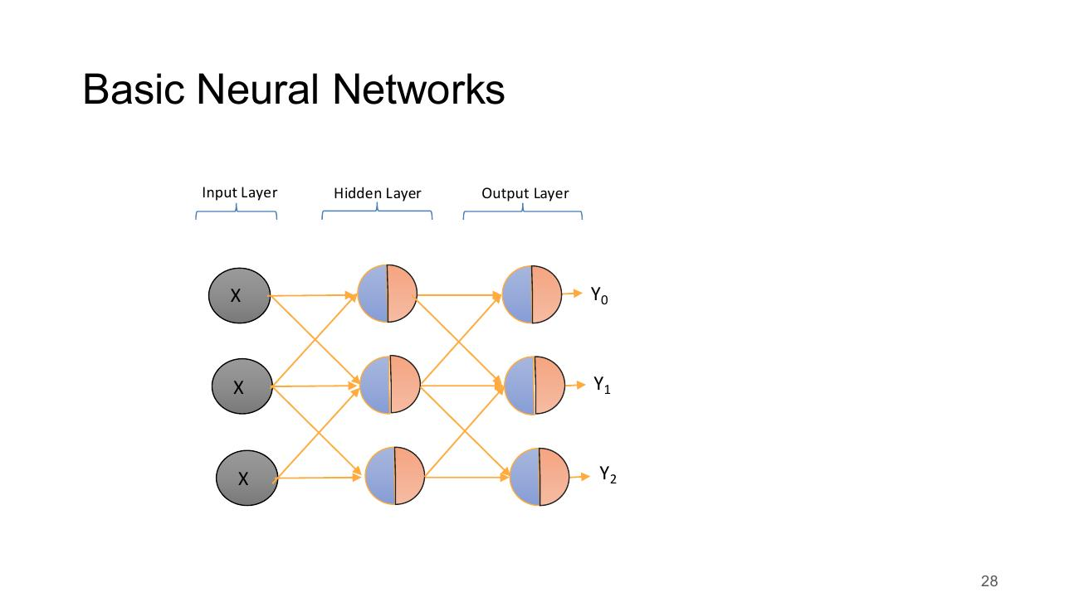

Week by Week (always subject to change)
- Week 1 – Introduction
- Week 2 – Neural Network Essentials
- Week 3 – Training and Loss Functions
- Week 4 – Better Activations
- Week 5 – Preventing Overfitting
- Week 6 – Convolutional Neural Networks
- Week 7 – Review Week (Bank Holiday)
- Week 8 – Text and Representations
- Week 9 – Recurrent Neural Networks
- Week 10 – Transformers
- Week 11 – Hardware for Training and Deployment
- Week 12 – Transfer Learning & Fine Tuning
- Week 13 – ML Ops and Project Management
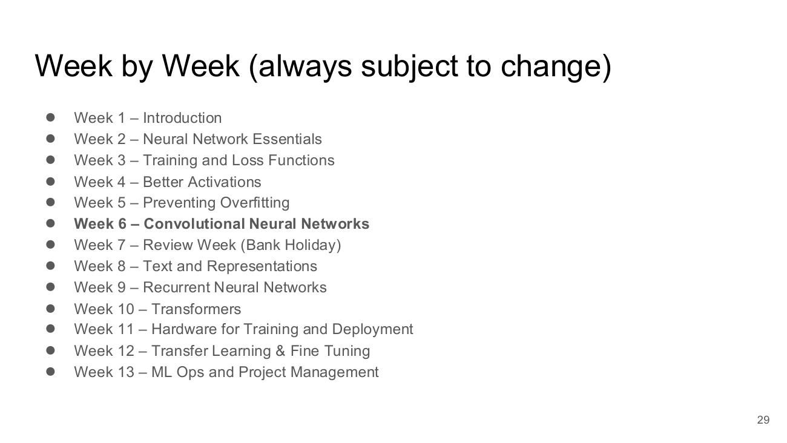

Edge Detectors, Filters and Features
- Input Activations 28x28
- F1 Input 3x3; F1 Weights 3x3 (-1,0,1 / -1,0,1 / -1,0,1) → F1 Feature Map 26x26
- F2 Input 3x3; F2 Weights 3x3 (1,1,1 / 0,0,0 / -1,-1,-1) → F2 Feature Map 26x26
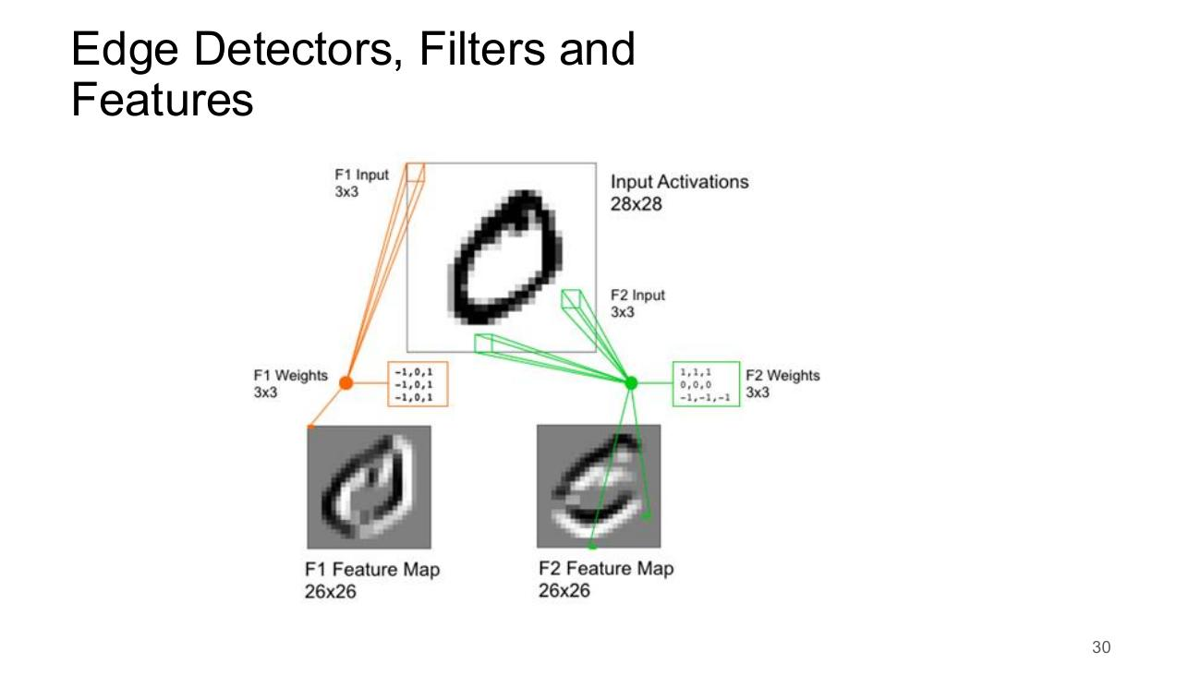

Week by Week (always subject to change)
- Week 1 – Introduction
- Week 2 – Neural Network Essentials
- Week 3 – Training and Loss Functions
- Week 4 – Better Activations
- Week 5 – Preventing Overfitting
- Week 6 – Convolutional Neural Networks
- Week 7 – Review Week (Bank Holiday)
- Week 8 – Text and Representations
- Week 9 – Recurrent Neural Networks
- Week 10 – Transformers
- Week 11 – Hardware for Training and Deployment
- Week 12 – Transfer Learning & Fine Tuning
- Week 13 – ML Ops and Project Management
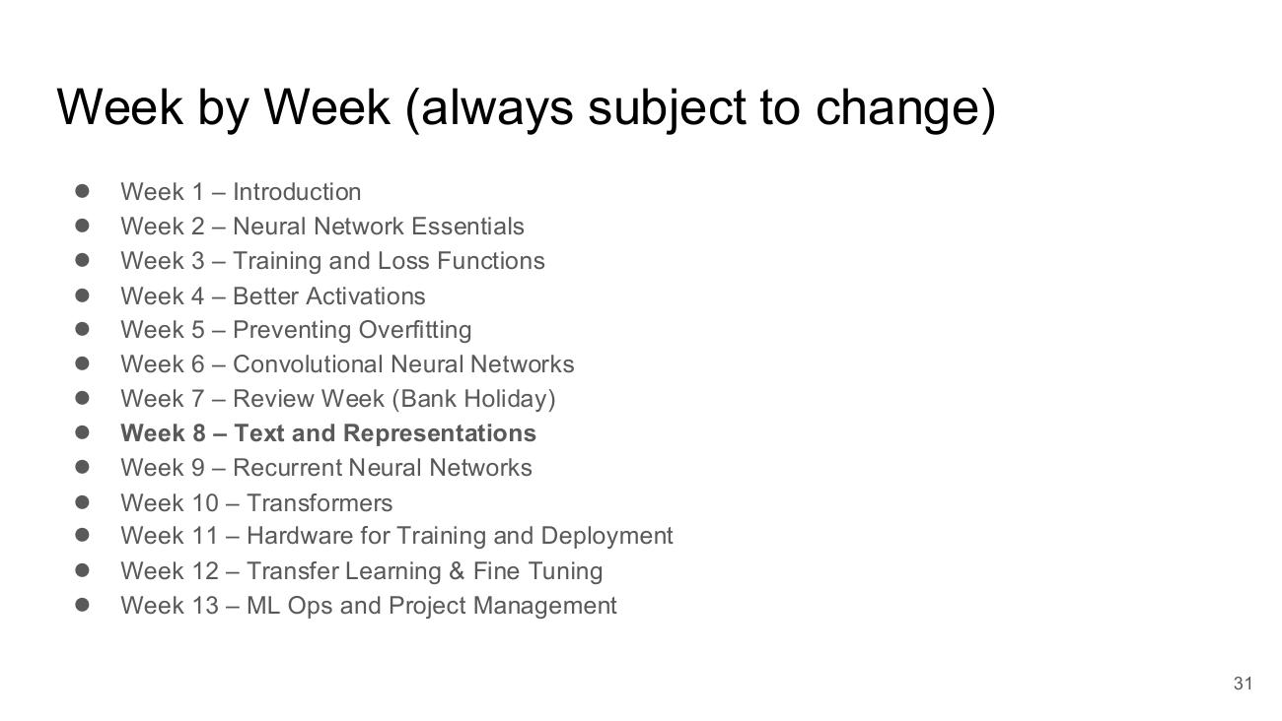

Meaning Spaces
- Word embedding visualisation with clusters: body part, food, city, travel, feeling, relative
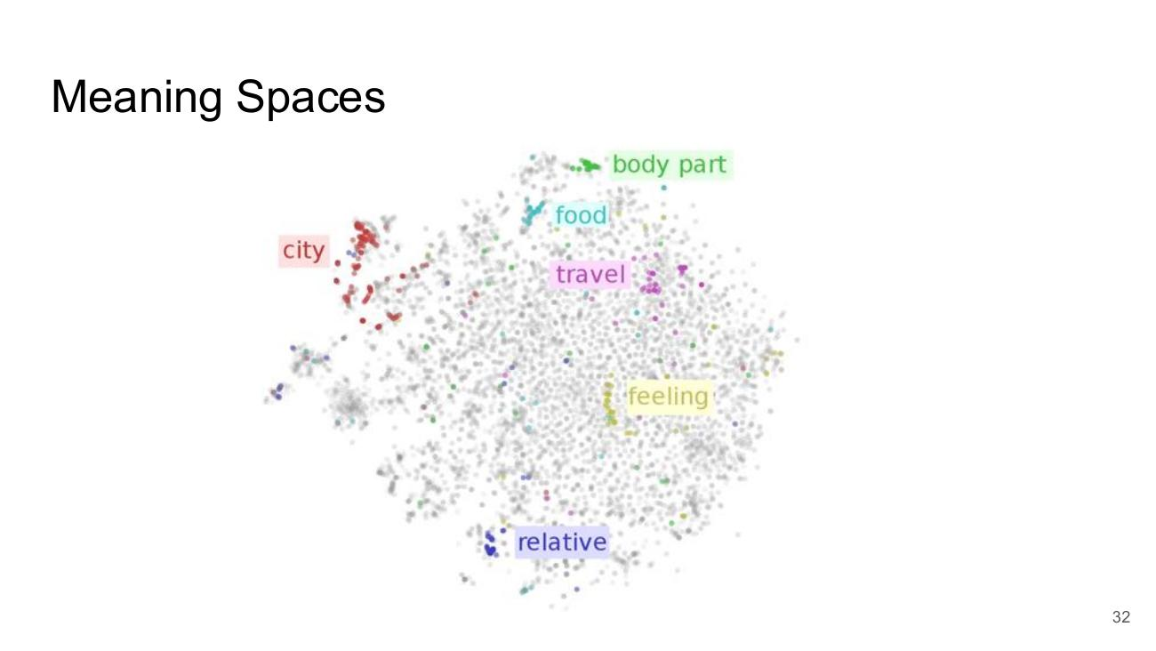

Week by Week (always subject to change)
- Week 1 – Introduction
- Week 2 – Neural Network Essentials
- Week 3 – Training and Loss Functions
- Week 4 – Better Activations
- Week 5 – Preventing Overfitting
- Week 6 – Convolutional Neural Networks
- Week 7 – Review Week (Bank Holiday)
- Week 8 – Text and Representations
- Week 9 – Recurrent Neural Networks
- Week 10 – Transformers
- Week 11 – Hardware for Training and Deployment
- Week 12 – Transfer Learning & Fine Tuning
- Week 13 – ML Ops and Project Management
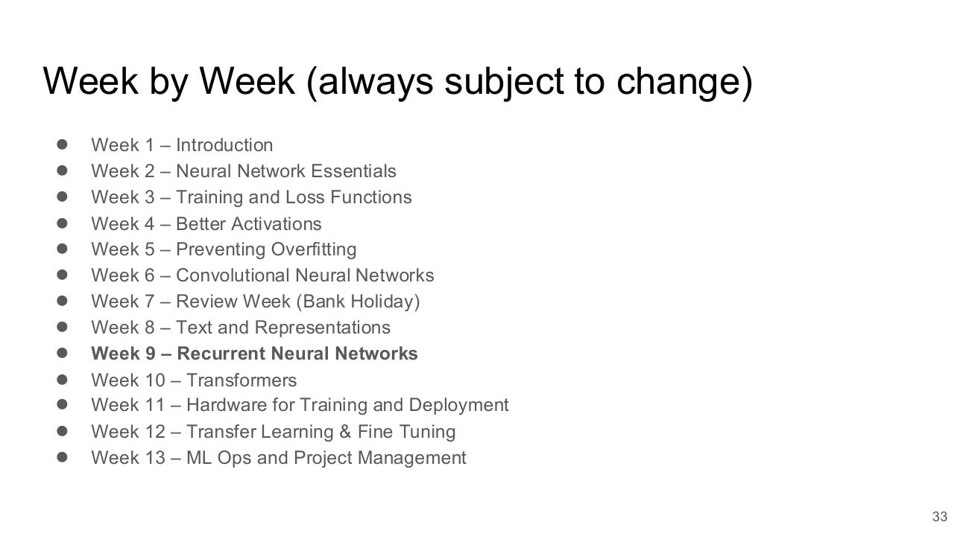

LSTM Based RNN
- Chain of LSTM cells (A) with inputs Xt-1, Xt, Xt+1 and outputs ht-1, ht, ht+1
- Legend: Neural Network Layer, Pointwise Operation, Vector Transfer, Concatenate, Copy
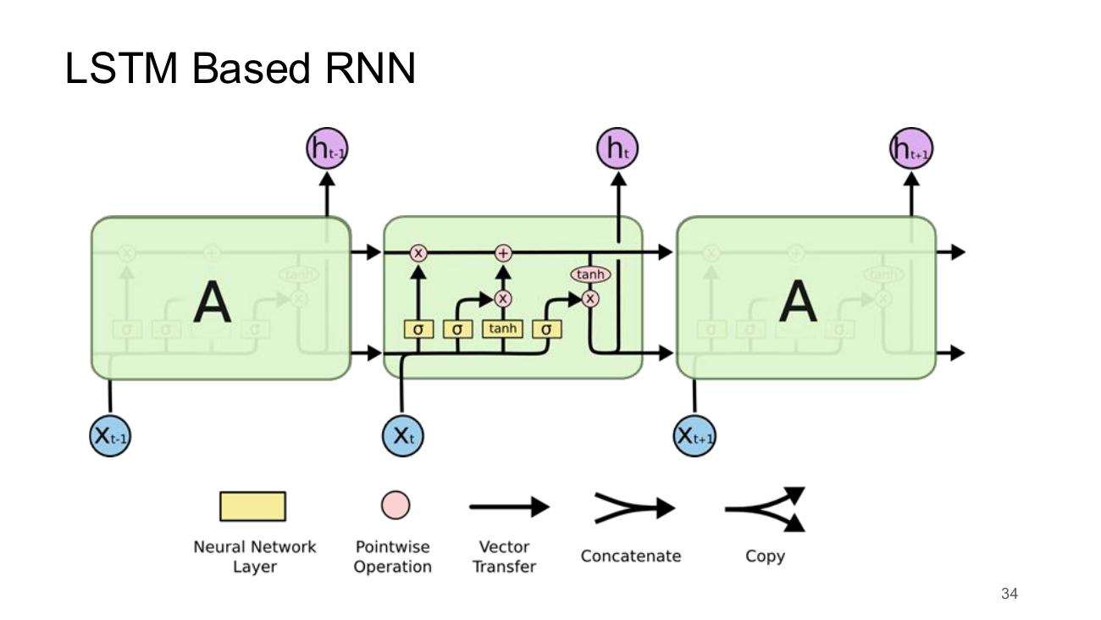

LSTM Applications - Translation
- Encoder (with Embed layer) reads ‘He loved to eat .’ → state S
- Decoder (with Softmax) outputs ‘Er liebte zu essen .’ from inputs NULL, Er, liebte, zu, essen
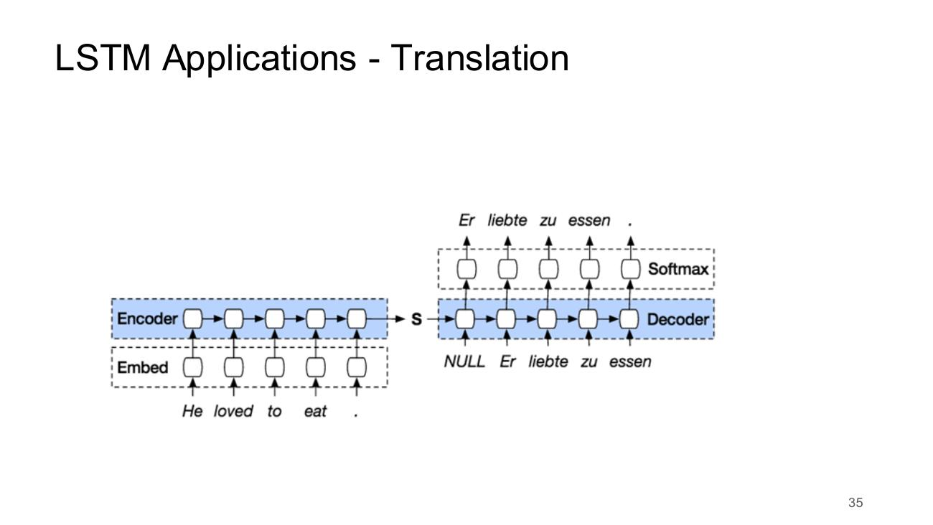

Week by Week (always subject to change)
- Week 1 – Introduction
- Week 2 – Neural Network Essentials
- Week 3 – Training and Loss Functions
- Week 4 – Better Activations
- Week 5 – Preventing Overfitting
- Week 6 – Convolutional Neural Networks
- Week 7 – Review Week (Bank Holiday)
- Week 8 – Text and Representations
- Week 9 – Recurrent Neural Networks
- Week 10 – Transformers
- Week 11 – Hardware for Training and Deployment
- Week 12 – Transfer Learning & Fine Tuning
- Week 13 – ML Ops and Project Management
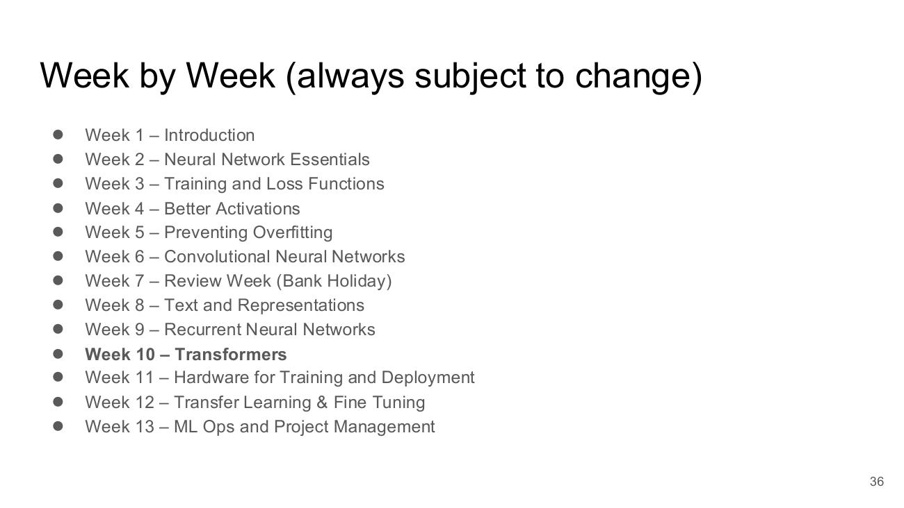

Transformers
- Image: cartoon ‘Sesame Street’ transformer robot
- Figure 1: The Transformer - model architecture
- Inputs → Input Embedding + Positional Encoding → Nx (Multi-Head Attention, Add & Norm, Feed Forward, Add & Norm)
- Outputs (shifted right) → Output Embedding + Positional Encoding → Nx (Masked Multi-Head Attention, Multi-Head Attention, Feed Forward, Add & Norm)
- → Linear → Softmax → Output Probabilities
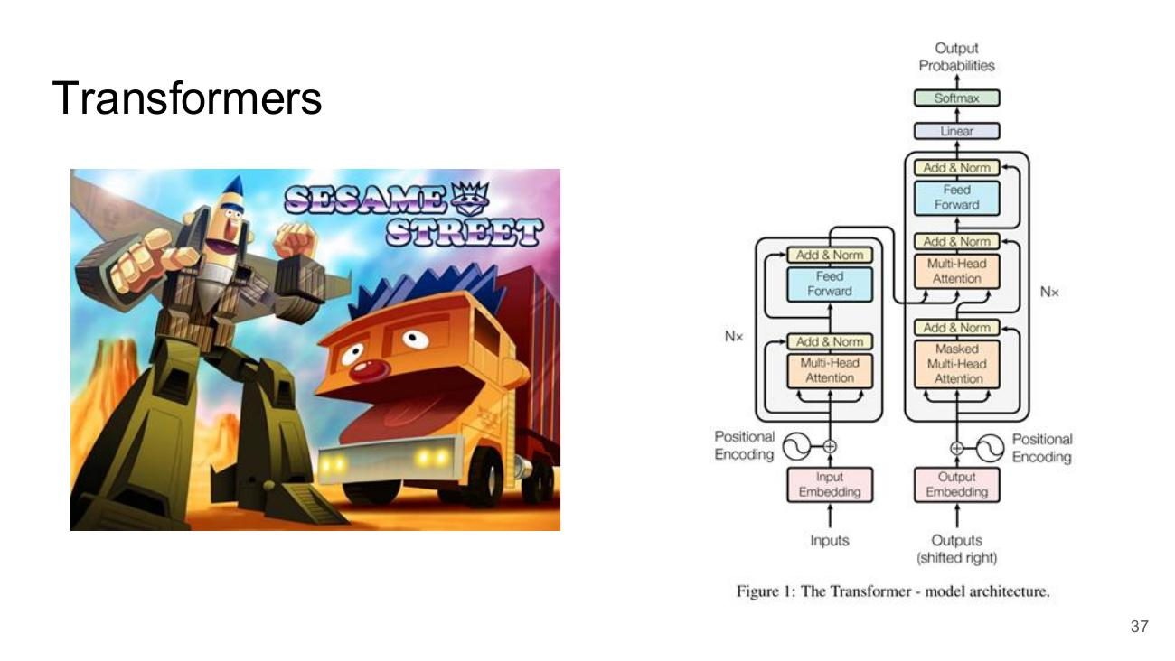

Week by Week (always subject to change)
- Week 1 – Introduction
- Week 2 – Neural Network Essentials
- Week 3 – Training and Loss Functions
- Week 4 – Better Activations
- Week 5 – Preventing Overfitting
- Week 6 – Convolutional Neural Networks
- Week 7 – Review Week (Bank Holiday)
- Week 8 – Text and Representations
- Week 9 – Recurrent Neural Networks
- Week 10 – Transformers
- Week 11 – Hardware for Training and Deployment
- Week 12 – Transfer Learning & Fine Tuning
- Week 13 – ML Ops and Project Management
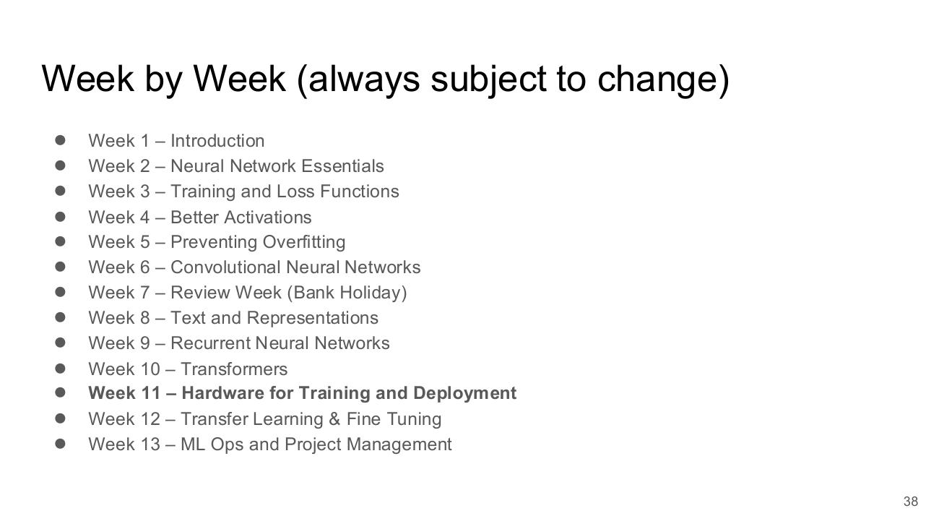

Hardware Optimization
- GPU (GTX 1080) image
- Quantization
- Floating point 3452.3194 → Integer 3452
- 32 bit (four bytes) → 8 bit (one byte)
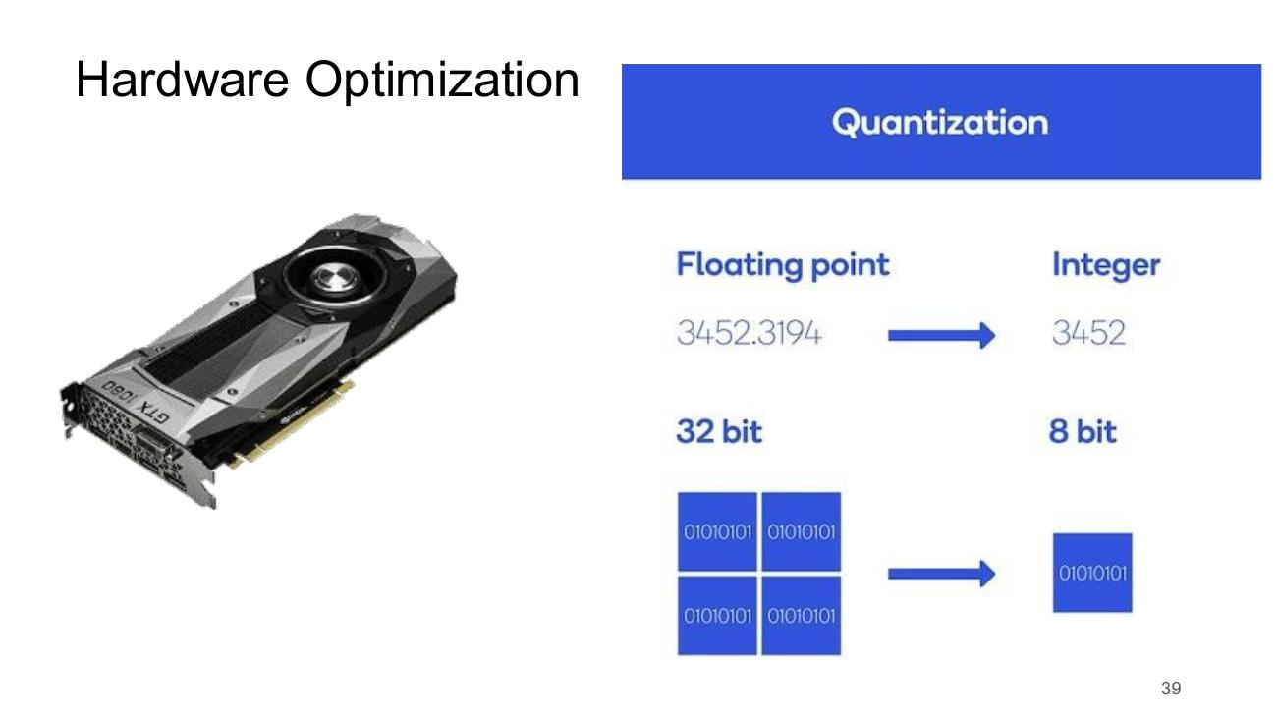

Week by Week (always subject to change)
- Week 1 – Introduction
- Week 2 – Neural Network Essentials
- Week 3 – Training and Loss Functions
- Week 4 – Better Activations
- Week 5 – Preventing Overfitting
- Week 6 – Convolutional Neural Networks
- Week 7 – Review Week (Bank Holiday)
- Week 8 – Text and Representations
- Week 9 – Recurrent Neural Networks
- Week 10 – Transformers
- Week 11 – Hardware for Training and Deployment
- Week 12 – Transfer Learning & Fine Tuning
- Week 13 – ML Ops and Project Management
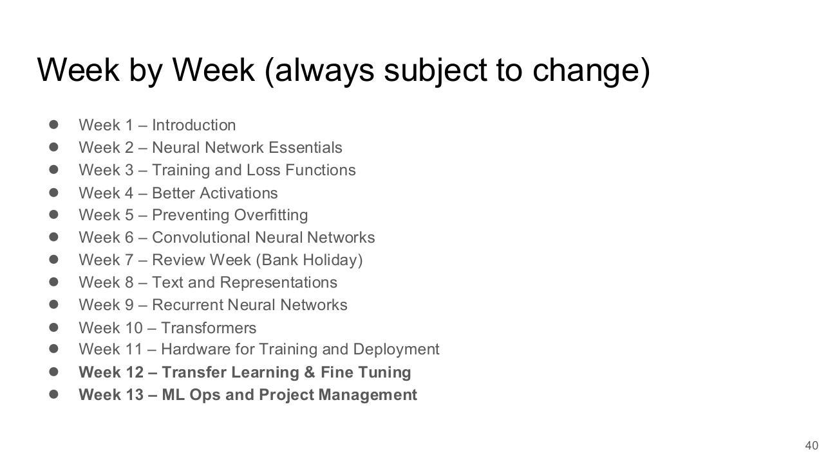

Delivery and Assessment

Delivery
- 5 ECTS
- Three hours contact per week
- A sometimes Flipped Classroom Model
- If you get notes in advance -- read them in advance!!!!
- Assessment
- End of Semester Exam: 50%
- Individual Project: 50%


Coding

Coding
- Python plus requested libraries and frameworks
- Use Virtual Environments -- pip, I suggest avoiding Anaconda
- Discussed in the Lab Session Today
- Examples
- Frameworks used
- Small amounts of code
- Sometimes Tensorflow / Sometimes PyTorch
- Server Environment
- Most code can be run locally
- Google Collab can generally be used for most experimental work
- VS Code + Github Copilot is probably what most will use if you have a reasonable machine
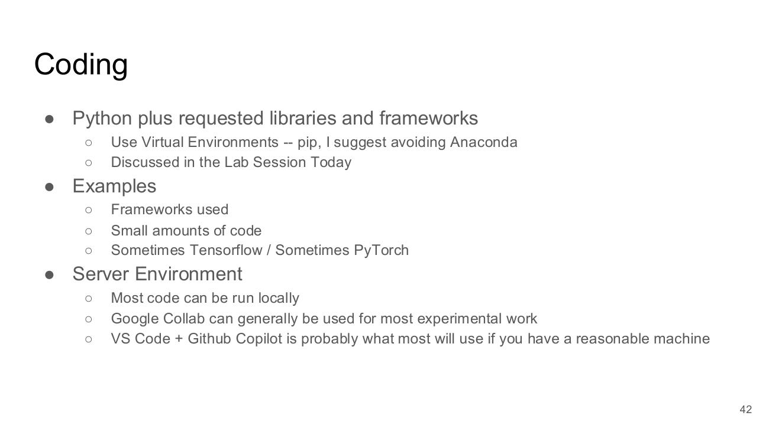

Content Presentation
- Content Presentation (section divider)


Lab

Lab for Weeks 1 and 2
- Part 1:
- Download the notebook for week 1.
- Upload it onto google Colab and execute content
- Switch Runtime model on Google Colab between GPU and CPU. Can you see any difference? Probably not for such a simple model.
- Part 2:
- Install Python 3.12 on your own machine
- Make sure Python is being added to your PATH
- Run python from the command line and verify the version
- Install VS Code / VS Codium and set up a project


LLMs/ChatGPT and a Generative Future – Keeping the Human in the Loop (Week 1B)

Introduction

LLMs/ChatGPT and a Generative Future
- LLMs/ChatGPT and a Generative Future
- Keeping the Human in the Loop
- Slides in here can be referenced as Slides Week 1B: 1 etc.
- Robert Ross, TU Dublin
- Cognitive Systems, TU Dublin


The Generative AI Landscape
- Icons linked together: audio (waveform), images (picture frame), music, code (terminal), games (Pac-Man), video


What is it?

What is it?
- We need to understand it to understand its strengths and limitations


A neural language model
- T=1
- Input (string of text): <start> The girl kicked
- Model (parameterized math functions)
- Output (text, one token at a time): the
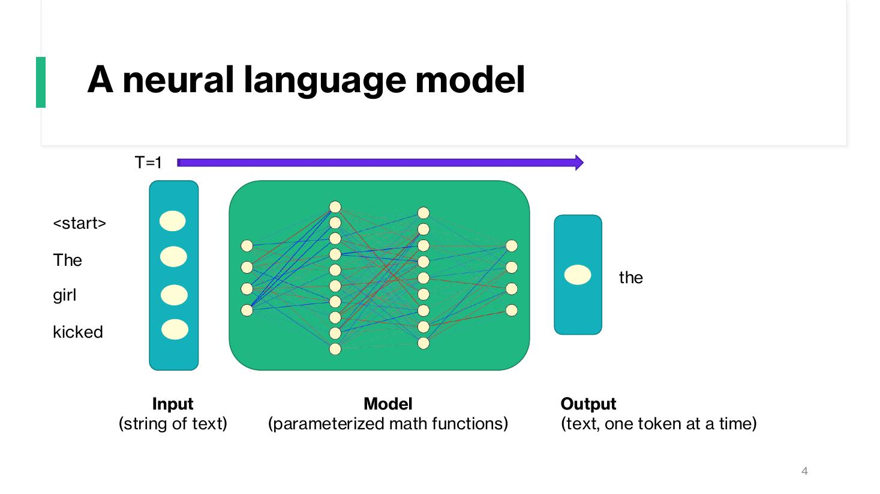

A neural language model
- T=2
- Input (string of text): The girl kicked the
- Model (parameterized math functions)
- Output (text, one token at a time): ball
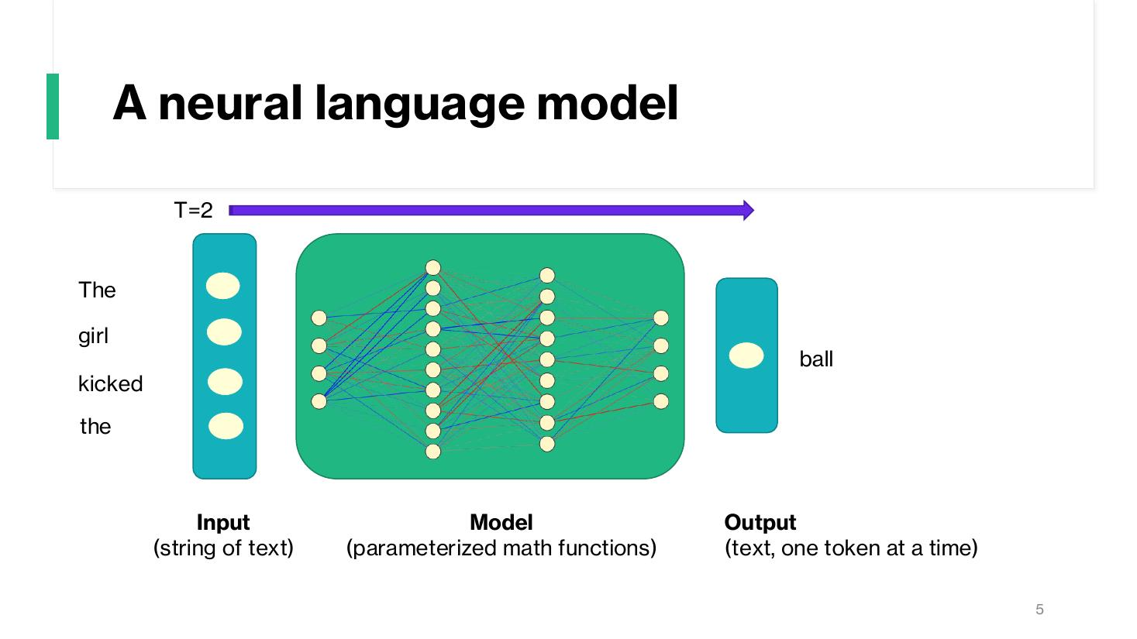

A neural language model (detail)
- Input (string of text): The girl kicked the
- Model (parameterized math functions)
- Output (text, one token at a time) – probability distribution:
- ball (0.1)
- boy (0.08)
- bucket (0.05)
- burn (0.0005)
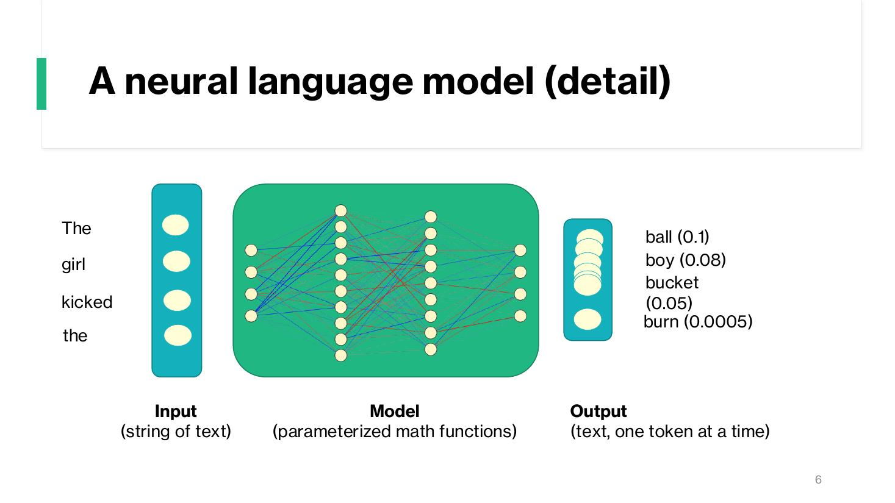

A large language model
- Input (string of text): The girl kicked the
- Model (parameterized math functions): GPT-3 – 175 Billion Parameters
- Output (text, one token at a time)
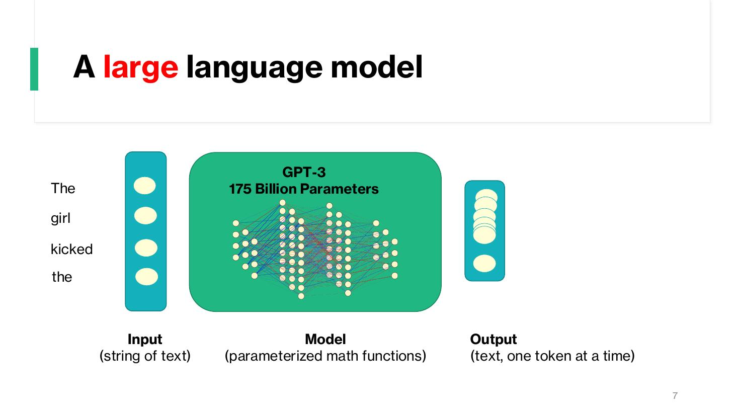

A conversational language model
- Input (string of text): What is your name?
- Model: GPT-3 – 175 Billion Parameters
- Output (text, one token at a time): my name is assistant
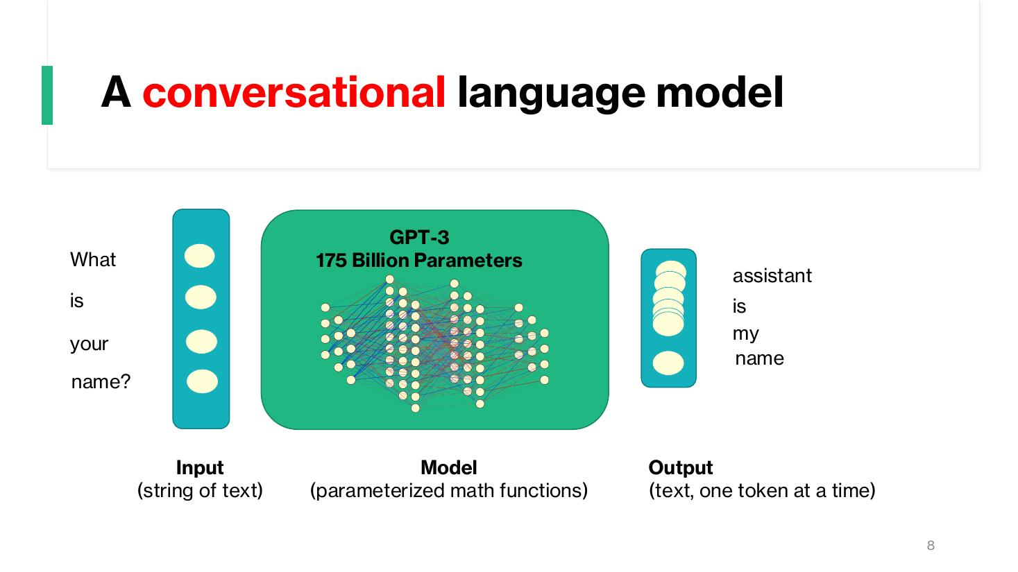

A ChatGPT like language model
- Input (string of text): <context> Tell me about CPUs?
- Model: GPT-3 – 175 Billion Parameters
- Output (text, one token at a time): The CPU or Central…
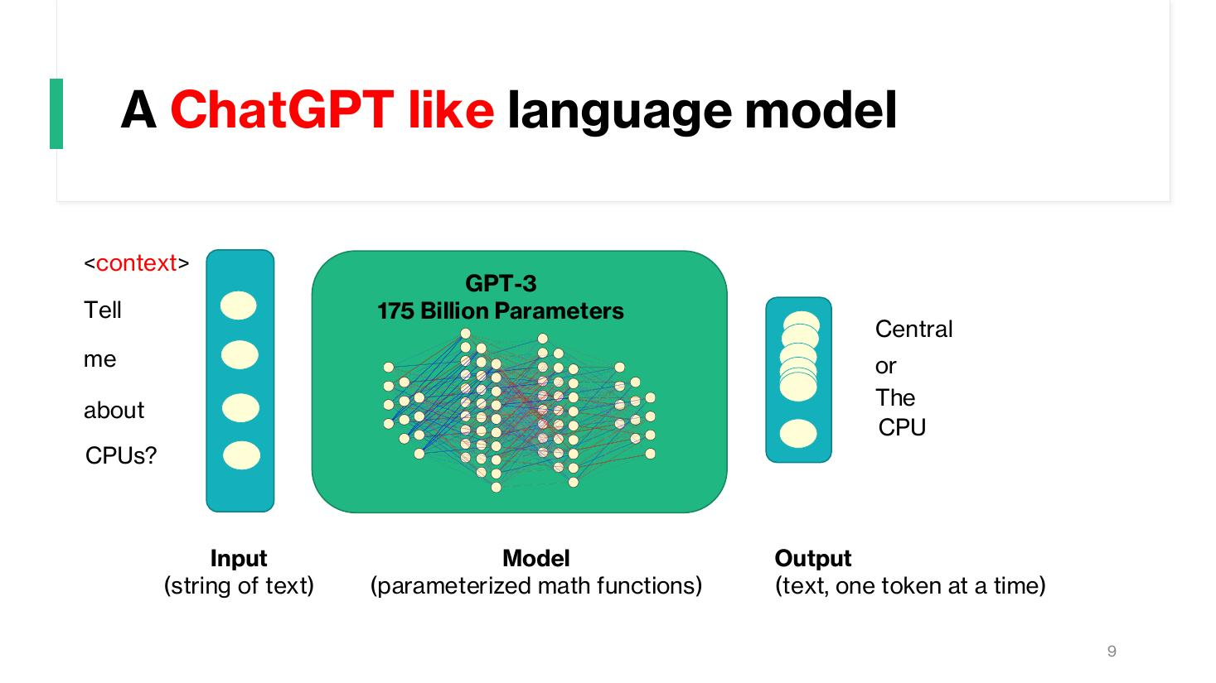

Aside: MODERN LLM ORIGIN: The Transformer Architecture
- Paper: ‘Attention Is All You Need’ – Ashish Vaswani, Noam Shazeer, Niki Parmar, Jakob Uszkoreit (Google Brain / Google Research), Llion Jones, Aidan N. Gomez (University of Toronto), Łukasz Kaiser, Illia Polosukhin
- Diagram: Inputs → Input Embedding + Positional Encoding → Nx (Multi-Head Attention, Add & Norm, Feed Forward, Add & Norm)
- Outputs (shifted right) → Output Embedding + Positional Encoding → Nx (Masked Multi-Head Attention, Multi-Head Attention, Feed Forward, Add & Norm) → Linear → Softmax → Output Probabilities
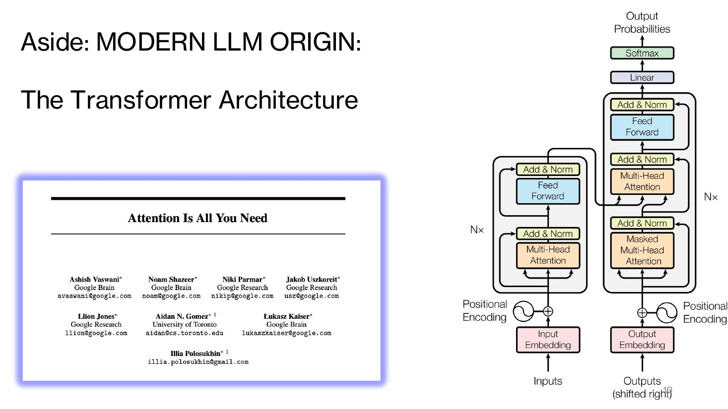

A ChatGPT like language model
- Input (string of text): <context> Tell me about CPUs?
- Model: GPT-3 – 175 Billion Parameters
- Output (text, one token at a time): The CPU or Central…
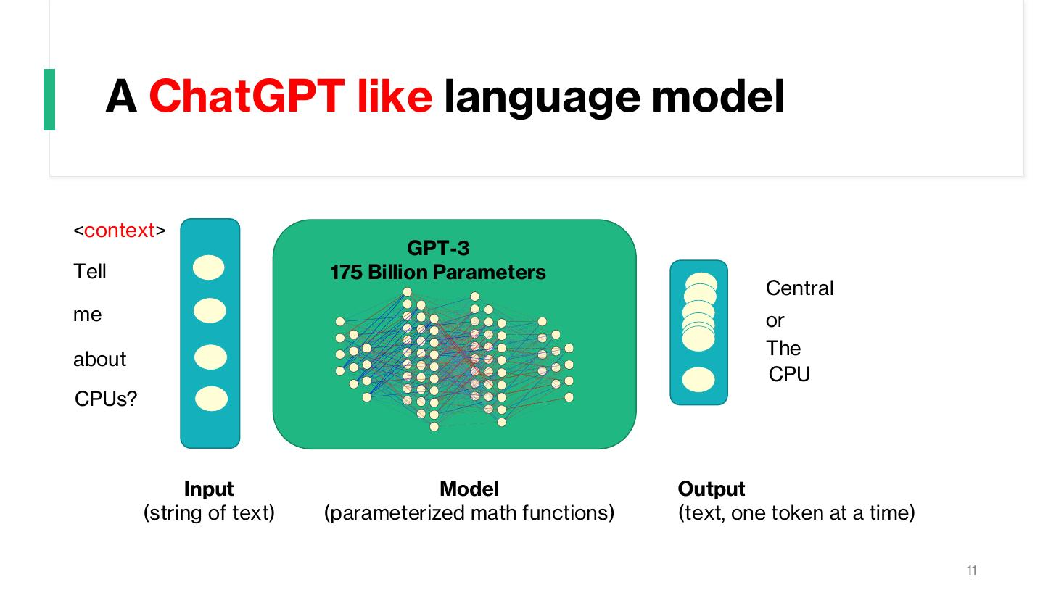

Putting some ‘safety’ in place…
- Pre-Filter – User Input
- LLM Core
- Post-Filter – System Output
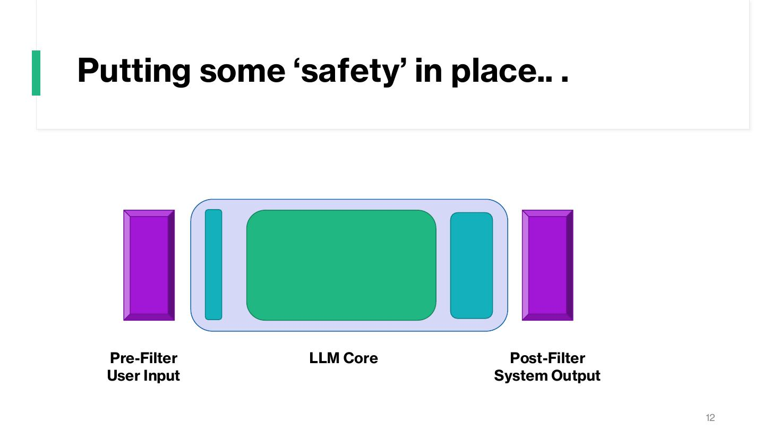

GPT-3 vs GPT-4 (Number of Parameters)
- GPT-3: 175.000.000.000 (small dot)
- GPT-4: 1.000.000.000.000.00 (large circle)
- Number of Parameters source of debate.
- https://www.researchgate.net/figure/The-comparison-between-GPT-3-and-GPT-4-based-on-the-number-of-parameters-used-in-their_fig3_369977556
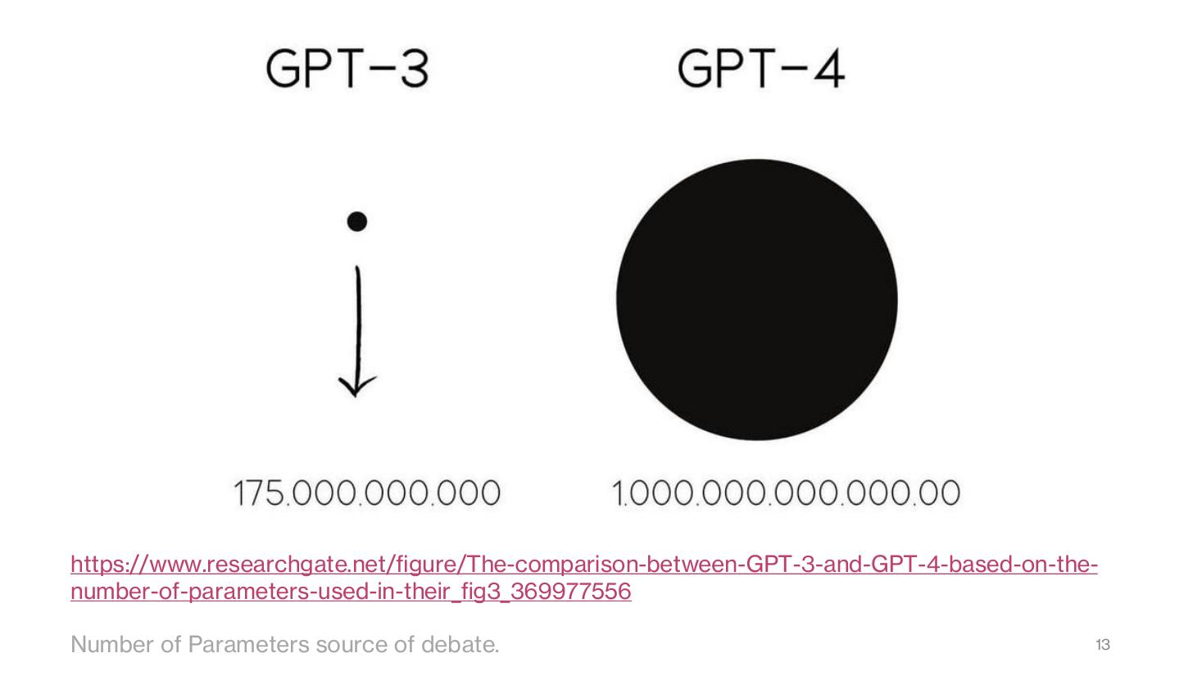

ChatGPT Lost Its Job to AI (tweet)
- terminally onλine εngineer (@tekbog): ‘i cant believe ChatGPT lost its job to AI’
- Last edited 2:19 PM · 27 Jan 25 – 5,141 Reposts, 290 Quotes, 39.2K Likes


Keeping the Human in the Loop

Keeping the Human in the Loop
- Development ⇄ Deployment (cycle)
- Ethics & Governance
- Personalisation
- Training
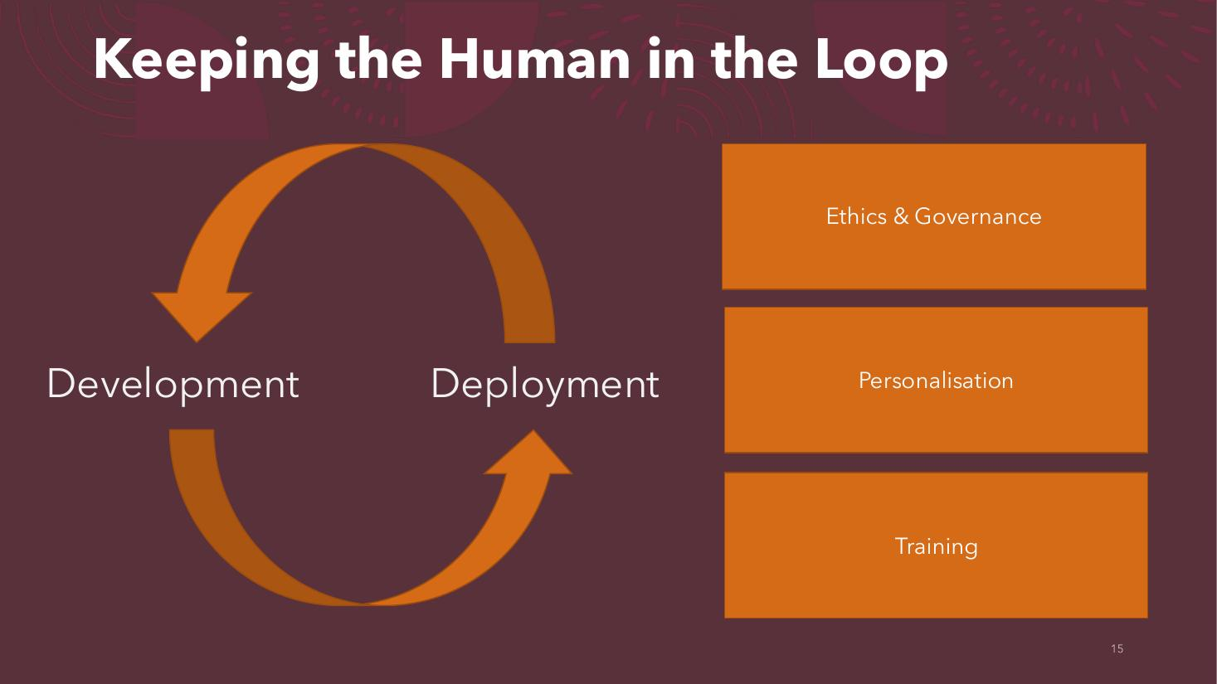

Keeping the Human in the Loop
- Development ⇄ Deployment (cycle)
- **Ethics & Governance** (highlighted)
- Personalisation
- Training
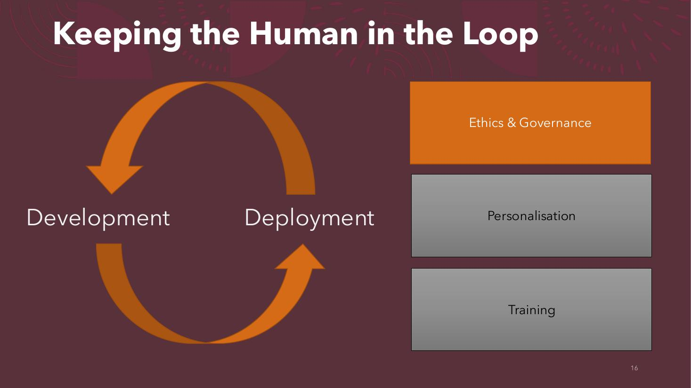

Ethics & Governance

Ethics & Governance
- EU flag
- The AI Act
- The Digital Services Act


Coimisiún na Meán
- Coimisiún na Meán (Ireland’s media regulator)
- Niamh Hodnett
- Online Safety Commissioner


Personalisation

Keeping the Human in the Loop
- Development ⇄ Deployment (cycle)
- Ethics & Governance
- **Personalisation** (highlighted)
- Training
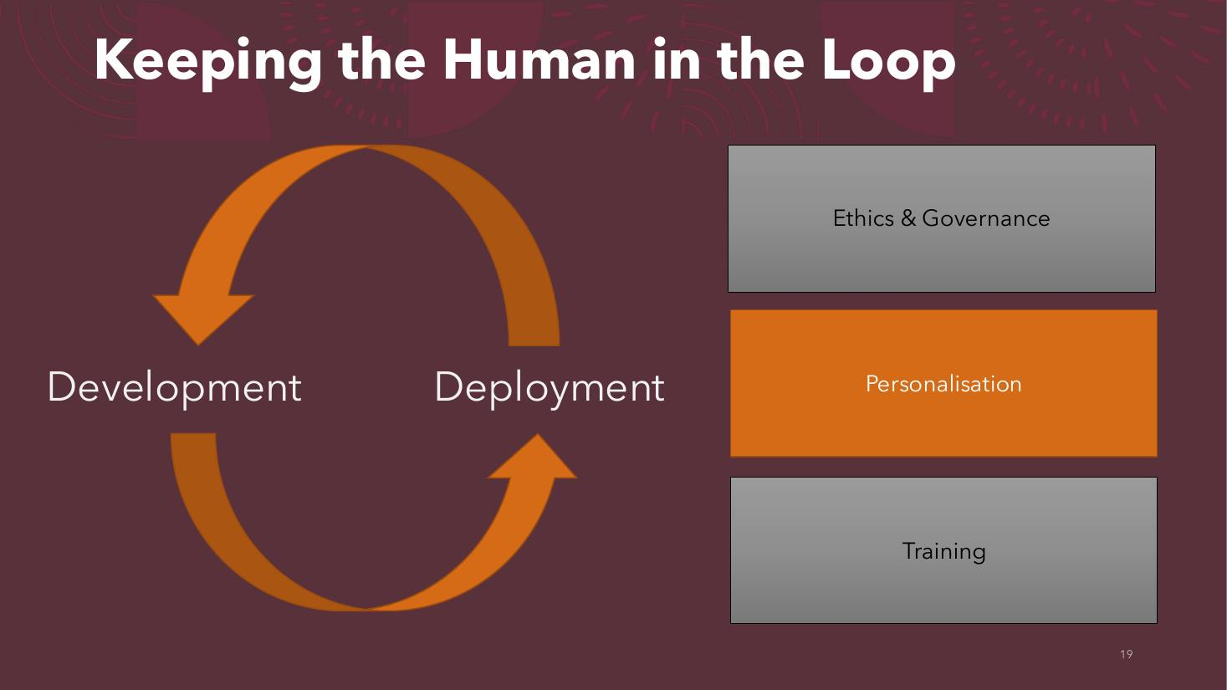

What role should conversational tech play?
- Tool (hammer and spanner icon) vs. companion/partner (two people icon)


Training

Keeping the Human in the Loop
- Development ⇄ Deployment (cycle)
- Ethics & Governance
- Personalisation
- **Training** (highlighted)
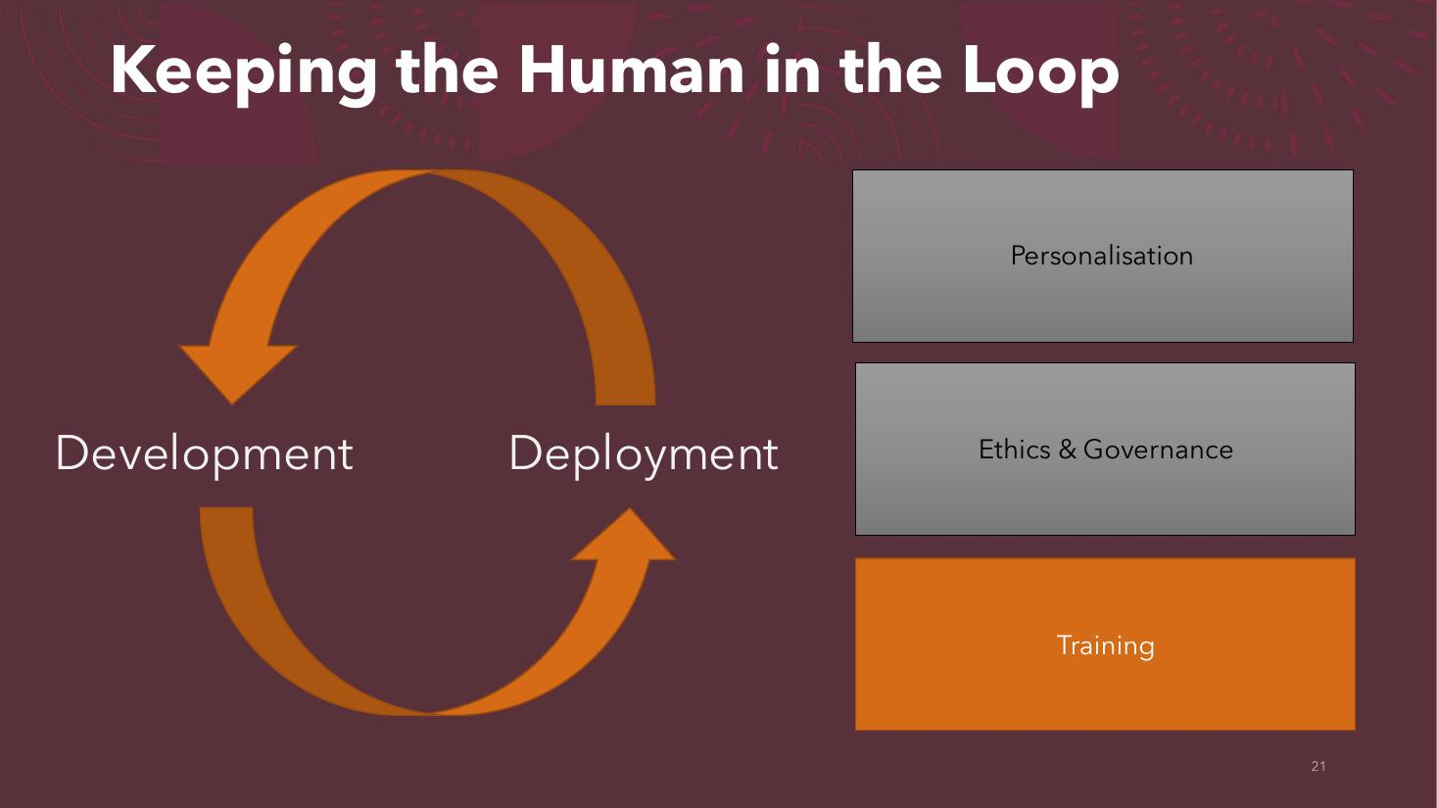

The Big Data Assumption
- Image: GPU cards on fire (compute cost of training on big data)


OpenAI ChatGPT
- Strengths:
- Code Writing
- Code Debugging
- Question Answering
- Write (ok?) Poetry
- Synthesising (mediocre) stories
- ….
- Weaknesses:
- No Built-in Embodiment
- Limited Personalisation
- Current Age of Data
- Lack of Naturalness
- A Generative Blur
- ….
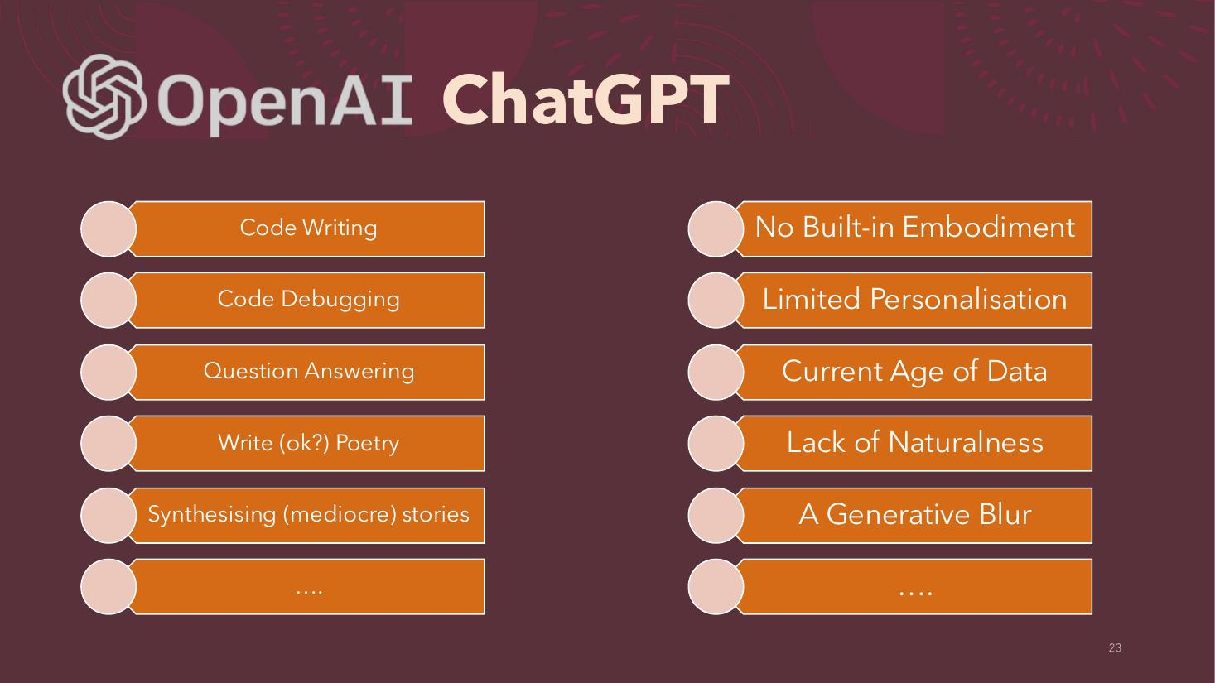

ChatGPT Training Process (RLHF – 3 Steps)
- Step 1 – Collect demonstration data and train a supervised policy.
- A prompt is sampled from our prompt dataset (‘Explain reinforcement learning to a 6 year old.’)
- A labeler demonstrates the desired output behavior (‘We give treats and punishments to teach…’)
- This data is used to fine-tune GPT-3.5 with supervised learning (SFT).
- Step 2 – Collect comparison data and train a reward model.
- A prompt and several model outputs (A, B, C, D) are sampled.
- A labeler ranks the outputs from best to worst (D > C > A > B).
- This data is used to train our reward model (RM).
- Step 3 – Optimize a policy against the reward model using the PPO reinforcement learning algorithm.
- A new prompt is sampled from the dataset (‘Write a story about otters.’)
- The PPO model is initialized from the supervised policy.
- The policy generates an output (‘Once upon a time…’)
- The reward model calculates a reward for the output.
- The reward (rk) is used to update the policy using PPO.
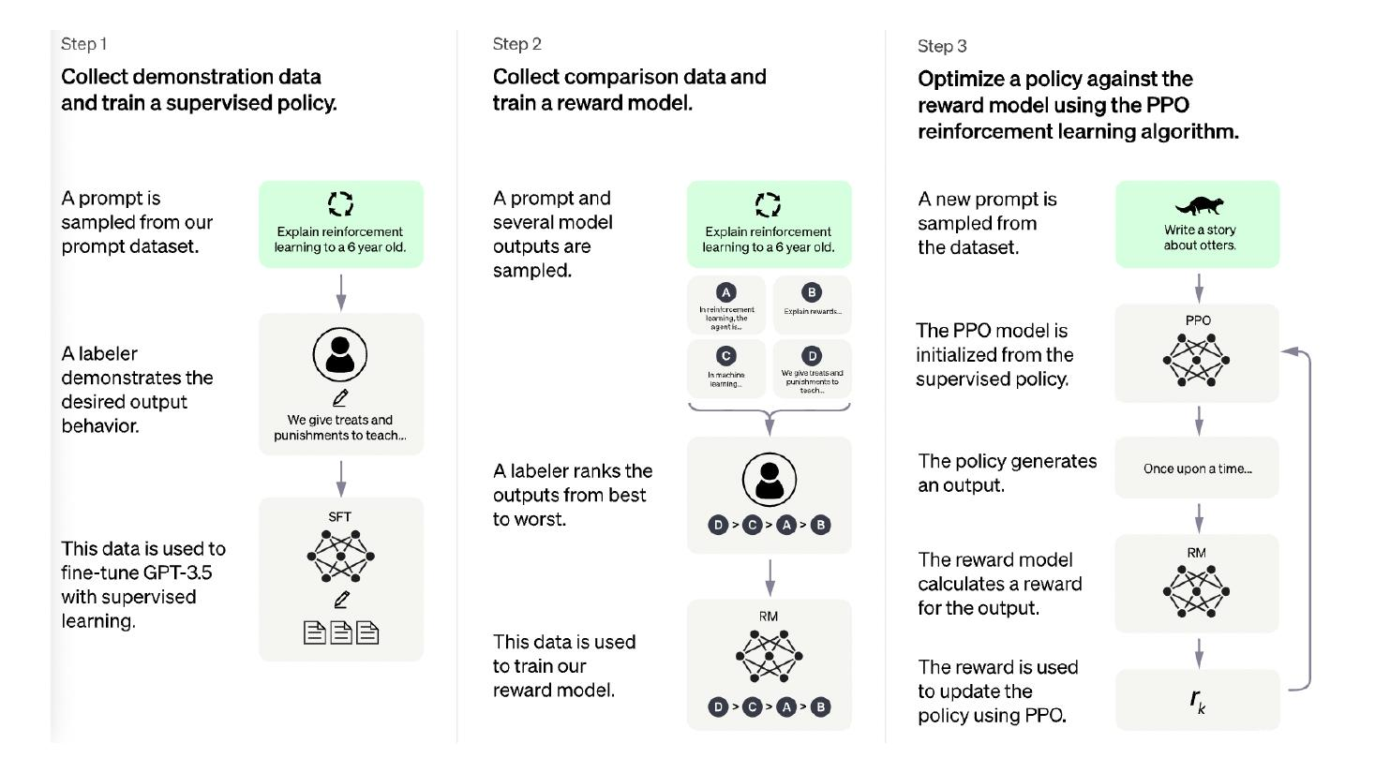

OpenAI
- OpenAI logo


Learning to summarize from human feedback - Training
- 1 Collect human feedback
- A Reddit post is sampled from the Reddit TL;DR dataset.
- Various policies are used to sample a set of summaries.
- Two summaries are selected for evaluation.
- A human judges which is a better summary of the post (‘j is better than k’).
- 2 Train reward model
- One post with two summaries judged by a human are fed to the reward model.
- The reward model calculates a reward r for each summary (rj, rk).
- The loss is calculated based on the rewards and human label, and is used to update the reward model: loss = log(σ(rj − rk)).
- 3 Train policy with PPO
- A new post is sampled from the dataset.
- The policy π generates a summary for the post.
- The reward model calculates a reward for the summary.
- The reward is used to update the policy via PPO.
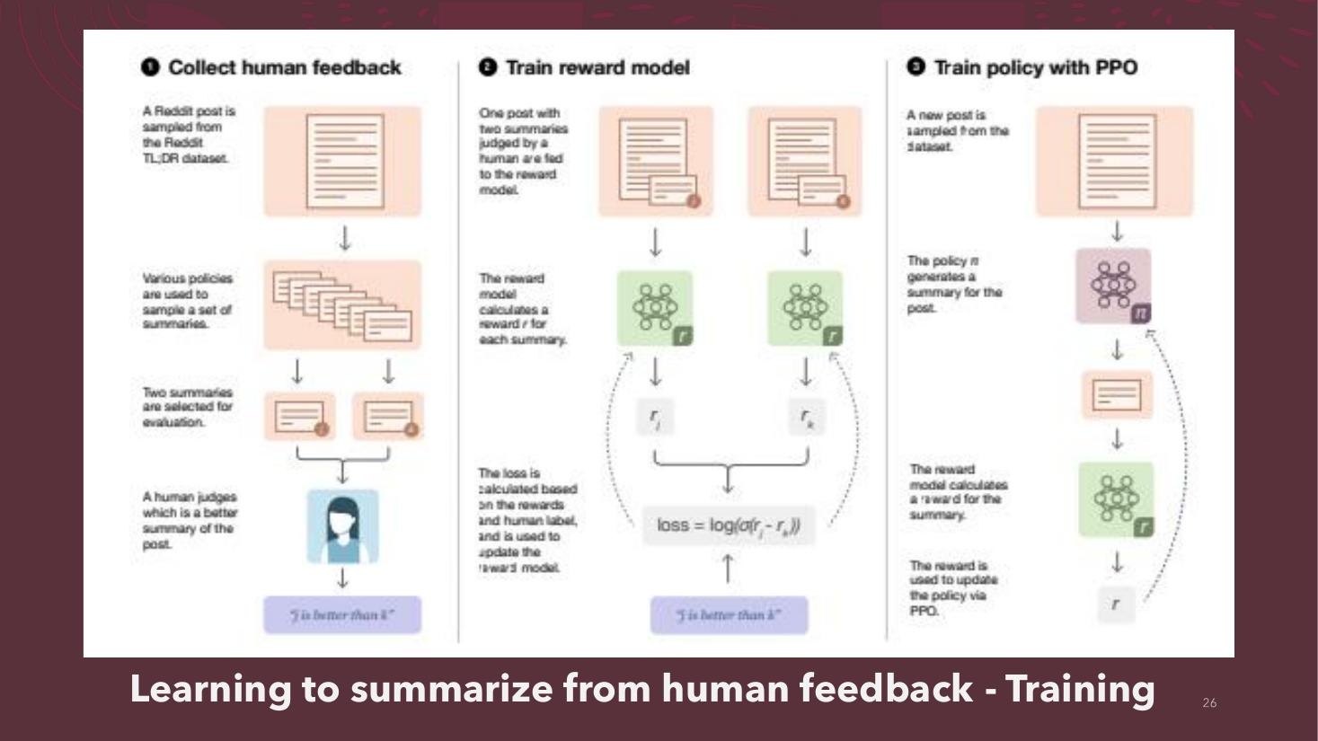

Aligning Language Models to Follow Instructions - Training
- Step 1 – Collect demonstration data, and train a supervised policy.
- A prompt is sampled from our prompt dataset (‘Explain the moon landing to a 6 year old’)
- A labeler demonstrates the desired output behavior (‘Some people went to the moon…’)
- This data is used to fine-tune GPT-3 with supervised learning (SFT).
- Step 2 – Collect comparison data, and train a reward model.
- A prompt and several model outputs are sampled (A Explain gravity…, B Explain war…, C Moon is natural satellite of…, D People went to the moon…).
- A labeler ranks the outputs from best to worst (D > C > A = B).
- This data is used to train our reward model (RM).
- Step 3 – Optimize a policy against the reward model using reinforcement learning.
- A new prompt is sampled from the dataset (‘Write a story about frogs’)
- The policy generates an output (‘Once upon a time…’)
- The reward model calculates a reward for the output.
- The reward (rk) is used to update the policy using PPO.
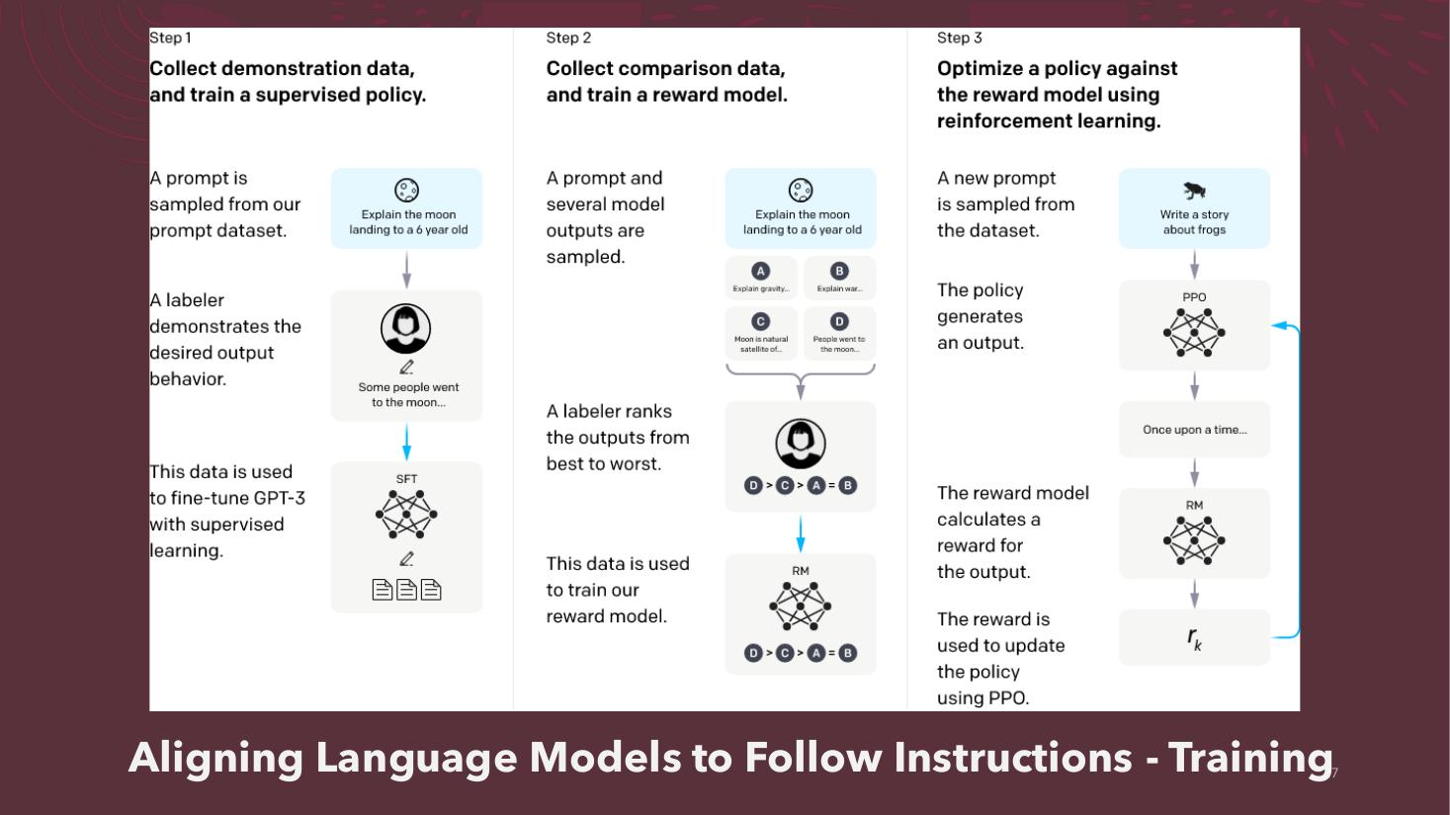

Learning to summarize from human feedback - Illustrative
- Graph: Fraction preferred to reference summaries vs Model size (1.3B, 2.7B, 6.7B, 12.9B)
- Human feedback: ~0.61 → ~0.70 (above reference line 0.5)
- Reference summaries: 0.5 (dashed line)
- Supervised learning: ~0.39 → ~0.43
- Pretrain only: ~0.22 → ~0.36
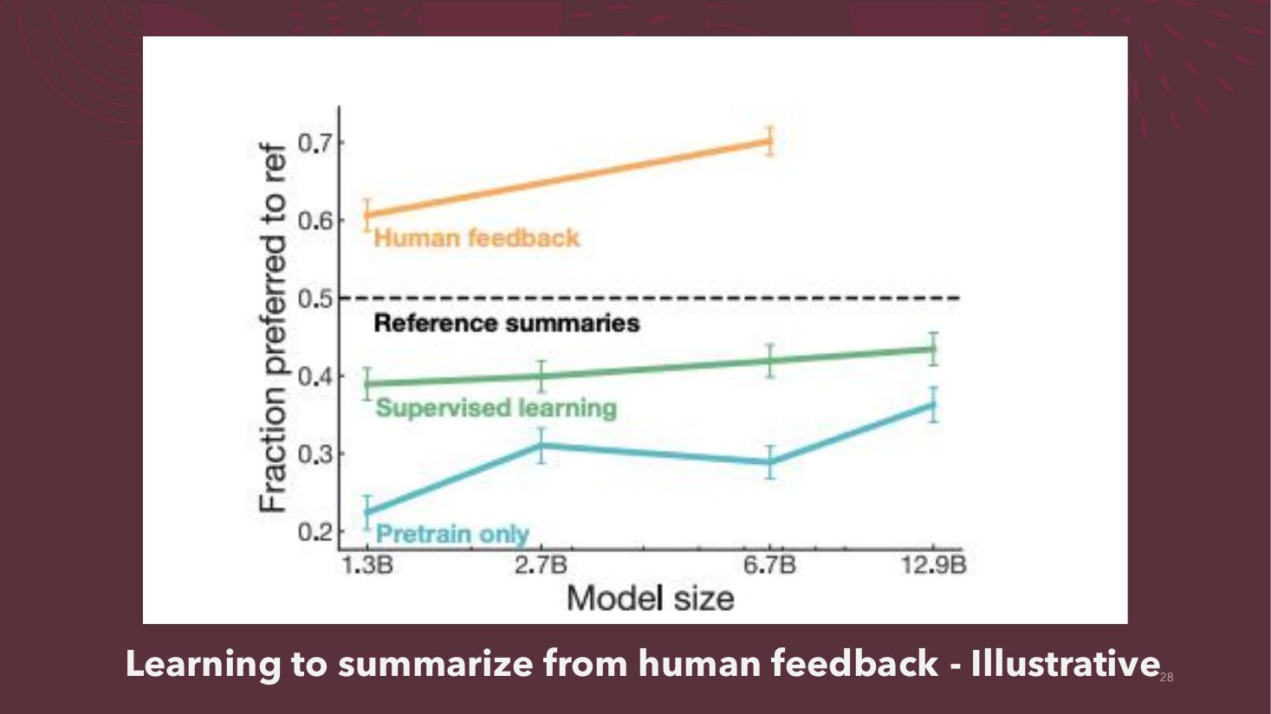

Aligning Language Models to Follow Instructions - Illustrative
- Graph: Likert score vs Model size (1.5B parameters, 6B, 175B)
- InstructGPT: highest (~4.8–5.2)
- Supervised Fine-Tuning: ~3.7–4.1
- GPT (prompted): ~2.7–3.6
- GPT: lowest (~2.2–2.3)
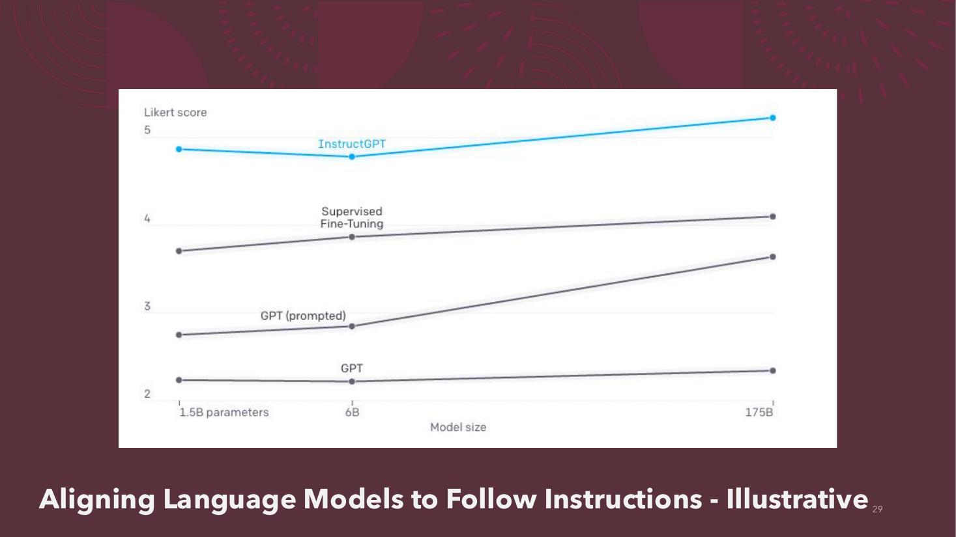

ChatGPT Training Process – Step 1 Highlighted
- (Same three-step diagram; Step 1 shaded)
- Step 1 – Collect demonstration data and train a supervised policy.
- A prompt is sampled from our prompt dataset (‘Explain reinforcement learning to a 6 year old.’)
- A labeler demonstrates the desired output behavior (‘We give treats and punishments to teach…’)
- This data is used to fine-tune GPT-3.5 with supervised learning (SFT).
- Step 2 – Collect comparison data and train a reward model.
- A prompt and several model outputs (A, B, C, D) are sampled.
- A labeler ranks the outputs from best to worst (D > C > A > B).
- This data is used to train our reward model (RM).
- Step 3 – Optimize a policy against the reward model using the PPO reinforcement learning algorithm.
- A new prompt is sampled from the dataset (‘Write a story about otters.’)
- The PPO model is initialized from the supervised policy.
- The policy generates an output (‘Once upon a time…’)
- The reward model calculates a reward for the output.
- The reward (rk) is used to update the policy using PPO.
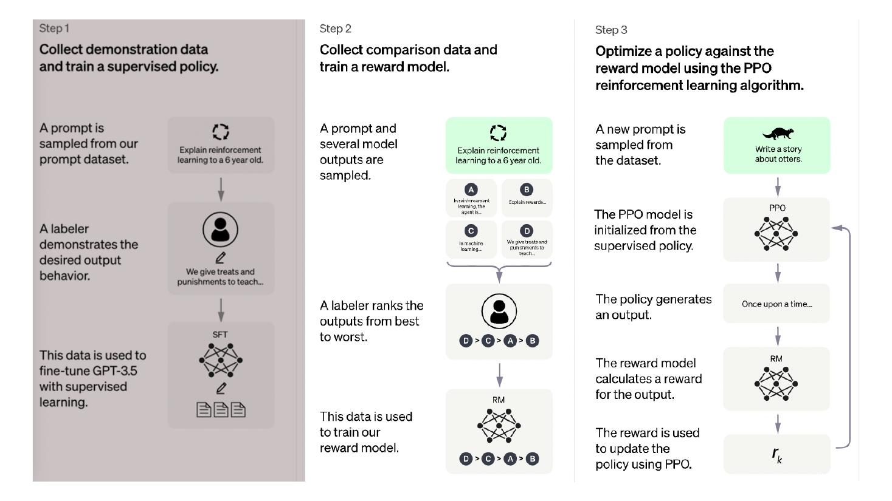

Reinforcement Learning
- Agent takes action At on the Environment
- Environment returns state St+1 and reward Rt+1 to the Agent (state St, reward Rt)
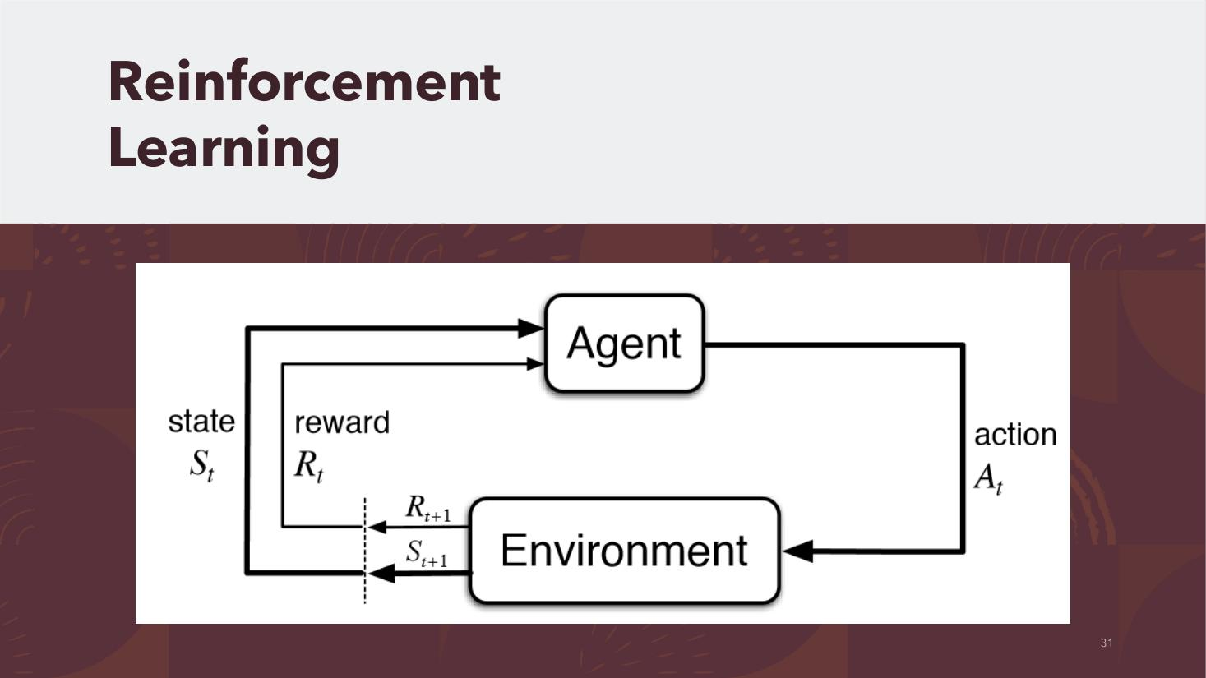

Illustrating Reinforcement Learning from Human Feedback (RLHF)
- Published December 9, 2022 (Hugging Face blog)
- Authors: Nathan Lambert (natolambert), Louis Castricato (lcastricato), Leandro von Werra (lvwerra), Alex Havrilla (Dahoas1)
- Event: Reinforcement Learning from Human Feedback: From Zero to ChatGPT – Tuesday 13 Dec, 5:30pm CET / 11:30 am ET
- Diagram: Prompts Dataset → Initial Language Model and Tuned Language Model (RL Policy) → Reward (Preference) Model rθ(y|x); KL prediction shift penalty −λKL DKL(πPPO(y|x) || πbase(y|x)); Reinforcement Learning Update (e.g. PPO) θ ← θ + ∇θJ(θ)
- Nathan Lambert
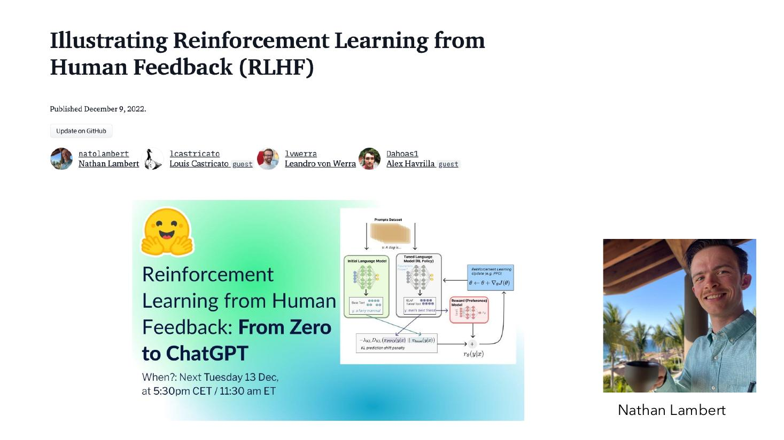

RLHF and Active Learning
- Active + With Teacher: Reinforcement Learning / Active Learning
- Active + Without Teacher: Intrinsic Motivation / Exploration
- Passive + With Teacher: Supervised Learning
- Passive + Without Teacher: Unsupervised Learning
- https://cnvrg.io/reinforcement-learning/
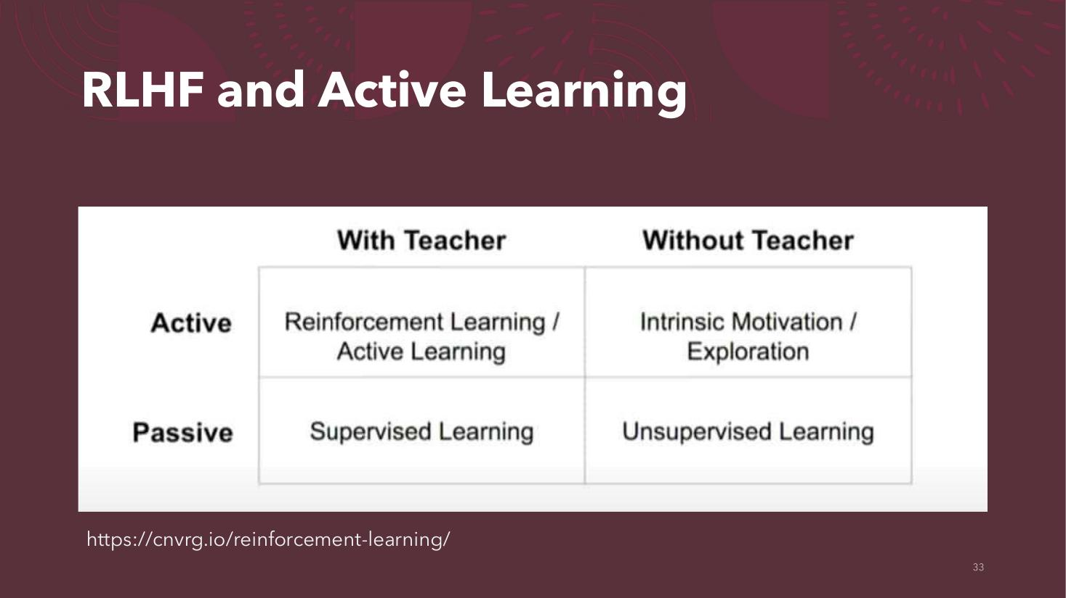

Questions and Challenges

Questions and Challenges….
- Questions and Challenges (section divider)


Questions and Challenges
- Can RLHF scale down to smaller budgets?
- How expensive is policy modification in light of new data?
- Do we really need reinforcement learning?
- How can we go beyond chat and information retrieval?
- Can we improve the quality of outputs?
- How do we put these models to work?
- What is the long-term impact of all this?
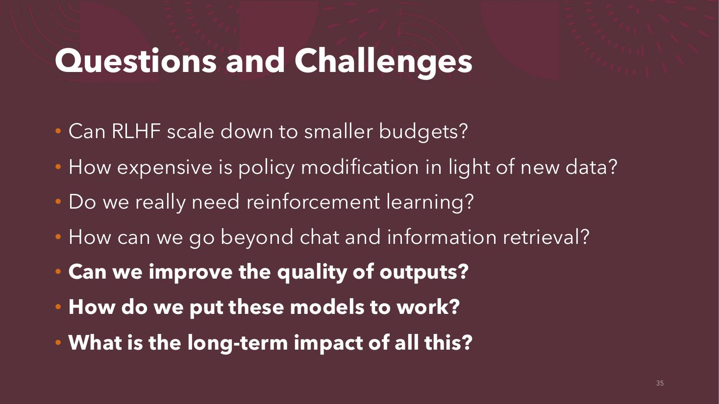

Improving the Quality of Outputs

Improving the Quality of Outputs
- Image: one orange balloon floating above a sea of grey balloons


LLMs on LSD*
- Reuters (Technology), February 11, 2023: Google cautions against 'hallucinating' chatbots, report says
- The Byte, Feb 17th: Microsoft stock falling as Bing AI descends into madness – ‘Well, this has been a disaster.’
- *LSD = Drug which causes hallucinations


Image Captioning Example
- Image: a dog leaping in mid-air over a grassy field
- Dog catching a frisbee
- Dog catching a Ball
- Dog jumping in a field
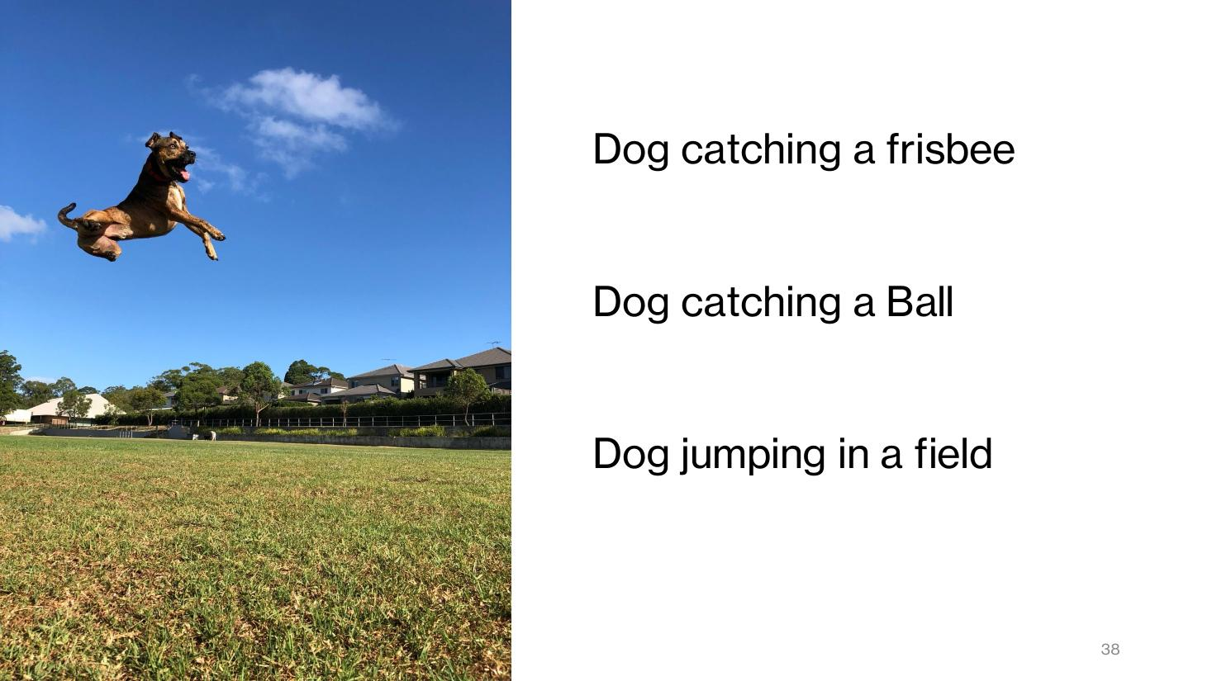

Aligning the LLMs
- Pre-Filter – User Input
- LLM Core
- Post-Filter – System Output
- Feedback loop (speech bubbles) from output back to input
- Domain Specific Examples
- Moralistic and ethical language
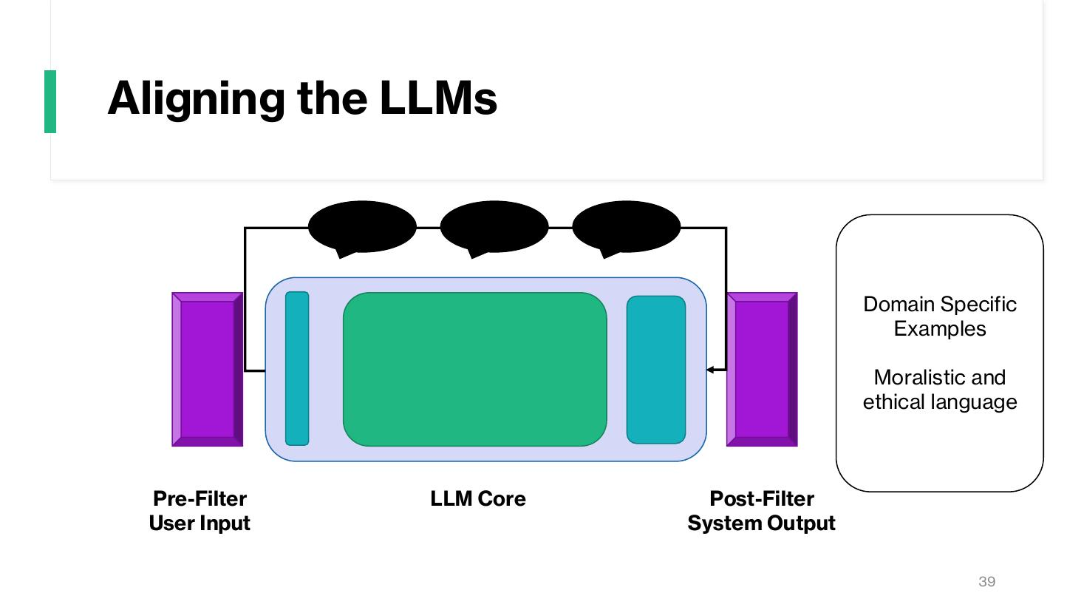

Training and Using Large LLMs

Training and Using Large LLMs
- Training and Using Large LLMs (section divider)


LLM Usage Modes
- LLM as an API
- Prompt Engineering
- Smart Application Development


Prompt Engineering Resources
- Finxter ChatGPT Prompting Cheat Sheet (OpenAI):
- Rule #1 – Instructions at beginning and ### or """ to separate instructions or context
- Rule #2 – Be specific and detailed about the desired context, outcome, length, format, and style.
- Rule #3 – Give examples of desired output format
- Rule #4 – First try without examples, then try giving some examples.
- Rule #5 – Fine-tune if Rule #4 doesn’t work
- Rule #6 – Be specific. Omit needless words.
- Rule #7 – Use leading words to nudge the model towards a pattern
- Bonus Prompt – Let ChatGPT Design the Optimal Prompt
- Coursera: Prompt Engineering for ChatGPT – Vanderbilt University, Dr. Jules White (4.9 rating, 28,627 already enrolled)
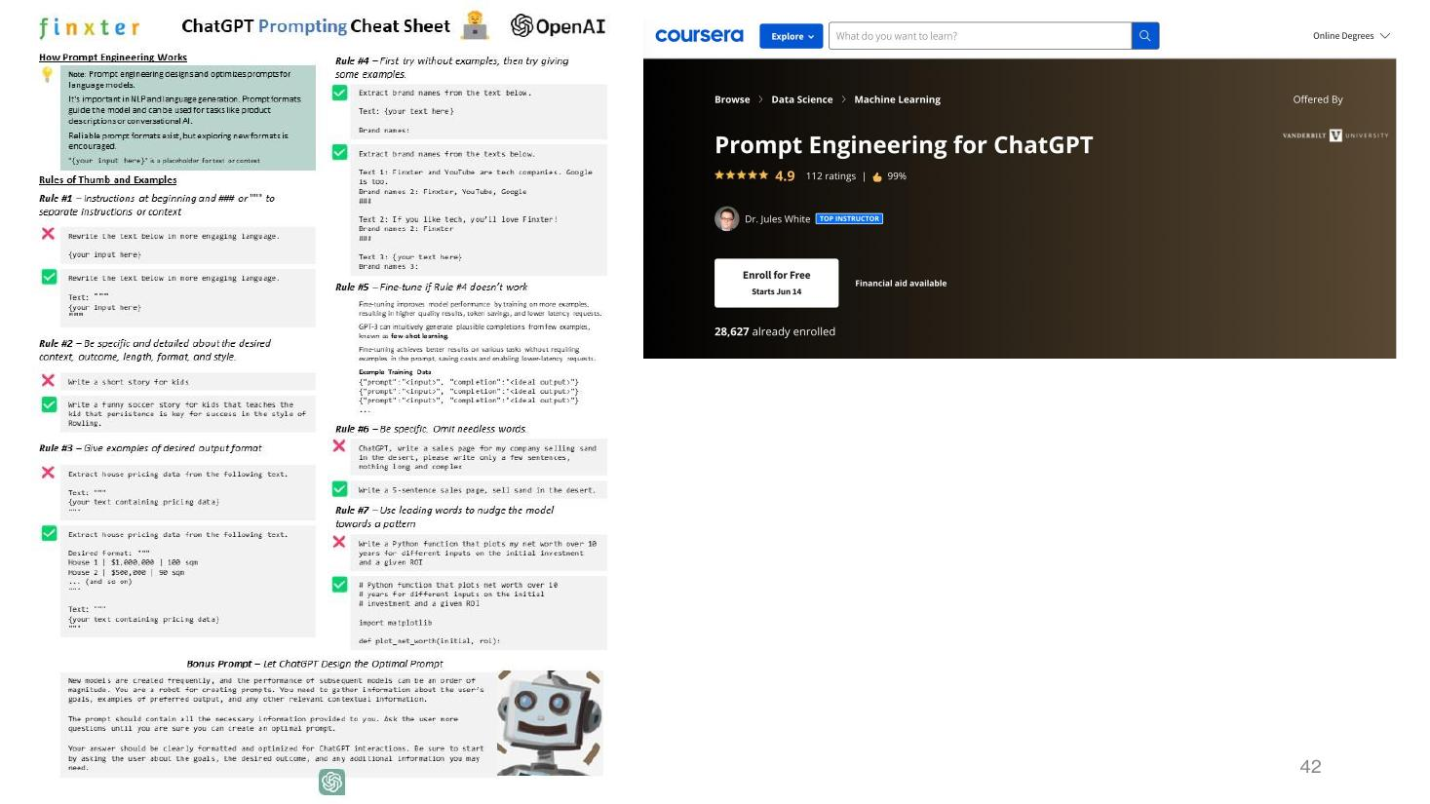

Prompt Engineering Guide – Topics
- Prompt Engineering - Introduction
- LLM Settings
- Basics of Prompting
- Prompt Elements
- General Tips for Designing Prompts
- Examples of Prompts
- Prompt Engineering - Techniques
- Zero-Shot Prompting
- Few-Shot Prompting
- Chain-of-Thought Prompting
- Self-Consistency
- Generate Knowledge Prompting
- Tree of Thoughts (ToT)
- Automatic Reasoning and Tool-use (ART)
- Automatic Prompt Engineer
- Active-Prompt
- Directional Stimulus Prompting
- ReAct Prompting
- Multimodal CoT Prompting
- Graph Prompting
- Prompt Engineering - Applications
- Program-Aided Language Models
- Generating Data
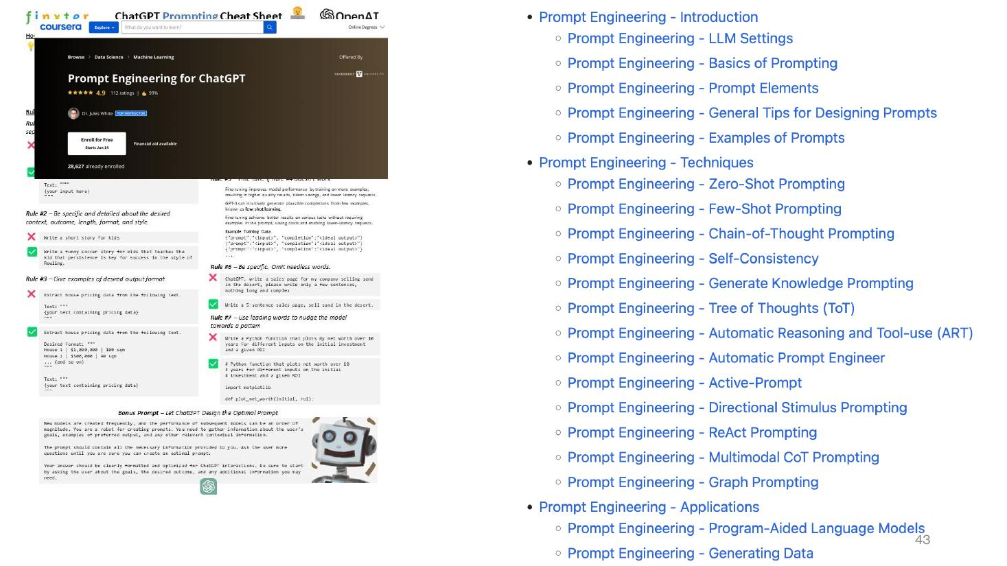

LLM Usage Modes
- LLM as an API
- Prompt Engineering
- Smart Application Development
- Few Shot vs. Zero Shot Prompting
- Chain of Thought Prompting
- Decomposition
- LangChain
- Fine-tuning LLM
- We can’t fine-tune the proprietary LLMs
- Is the Future Open?
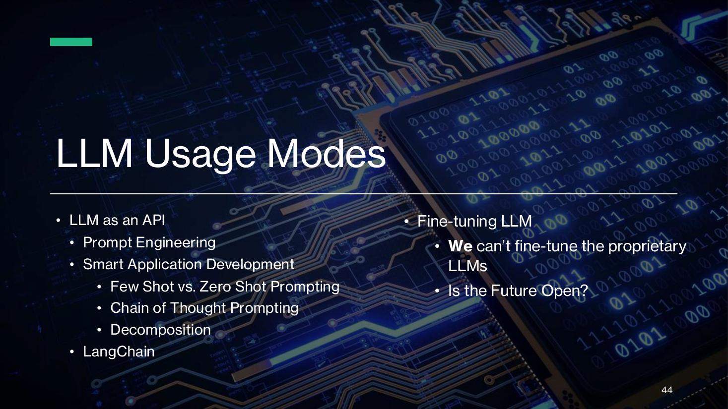

An Open LLM Future?
- BLOOM (a BigScience initiative): 176B params · 59 languages · Open-access
- Mistral AI
- Llama 3 (Meta)
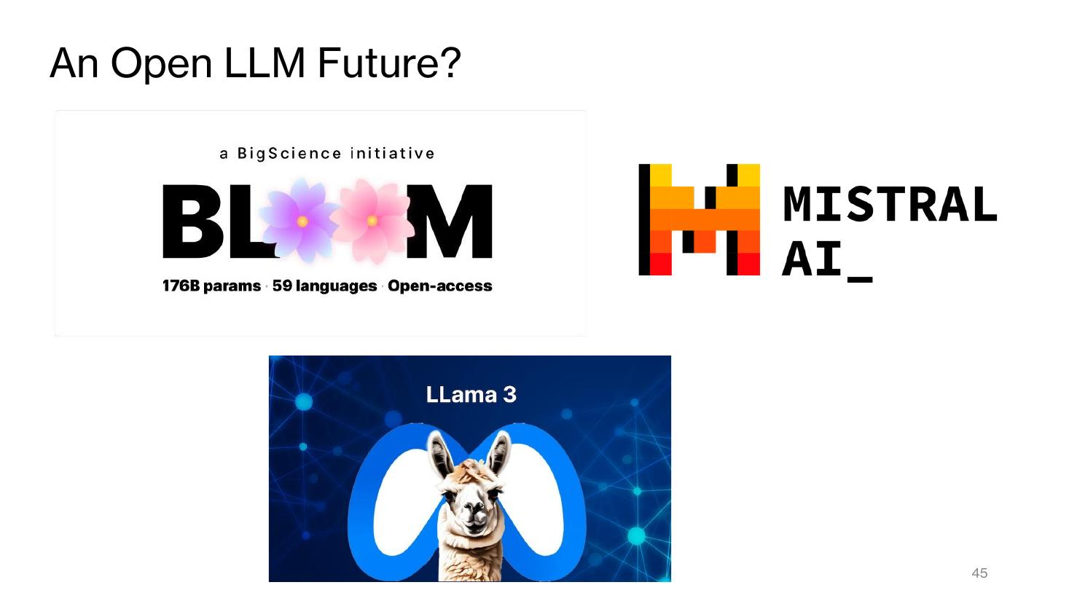

Open LLM Leaderboard (Hugging Face)
- Columns: Rank, Type, Model, Average, IFEval, BBH, MATH, GPQA
- 1. MaziyarPanahi/calme-3.2-instruct-78b – Avg 52.02%
- 2. dfurman/CalmeRys-78B-Orpo-v0.1 – Avg 51.24%
- 3. MaziyarPanahi/calme-3.1-instruct-78b – Avg 51.20%
- 4. MaziyarPanahi/calme-2.4-rys-78b – Avg 50.71%
- 5. newsbang/Homer-v1.0-Qwen2.5-72B – Avg 47.35%
- 6. Sakalti/ultiima-72B – Avg 46.58%
- 7. shuttleai/shuttle-3 – Avg 45.99%
- 8. rombodawg/Rombos-LLM-V2.5-Qwen-72b – Avg 45.91%
- 9. zetasepic/Qwen2.5-72B-Instruct-abliterated – Avg 45.29%
- 10. dnhkng/RYS-XLarge – Avg 45.13%
- 11. raphgg/test-2.5-72B – Avg 45.03%
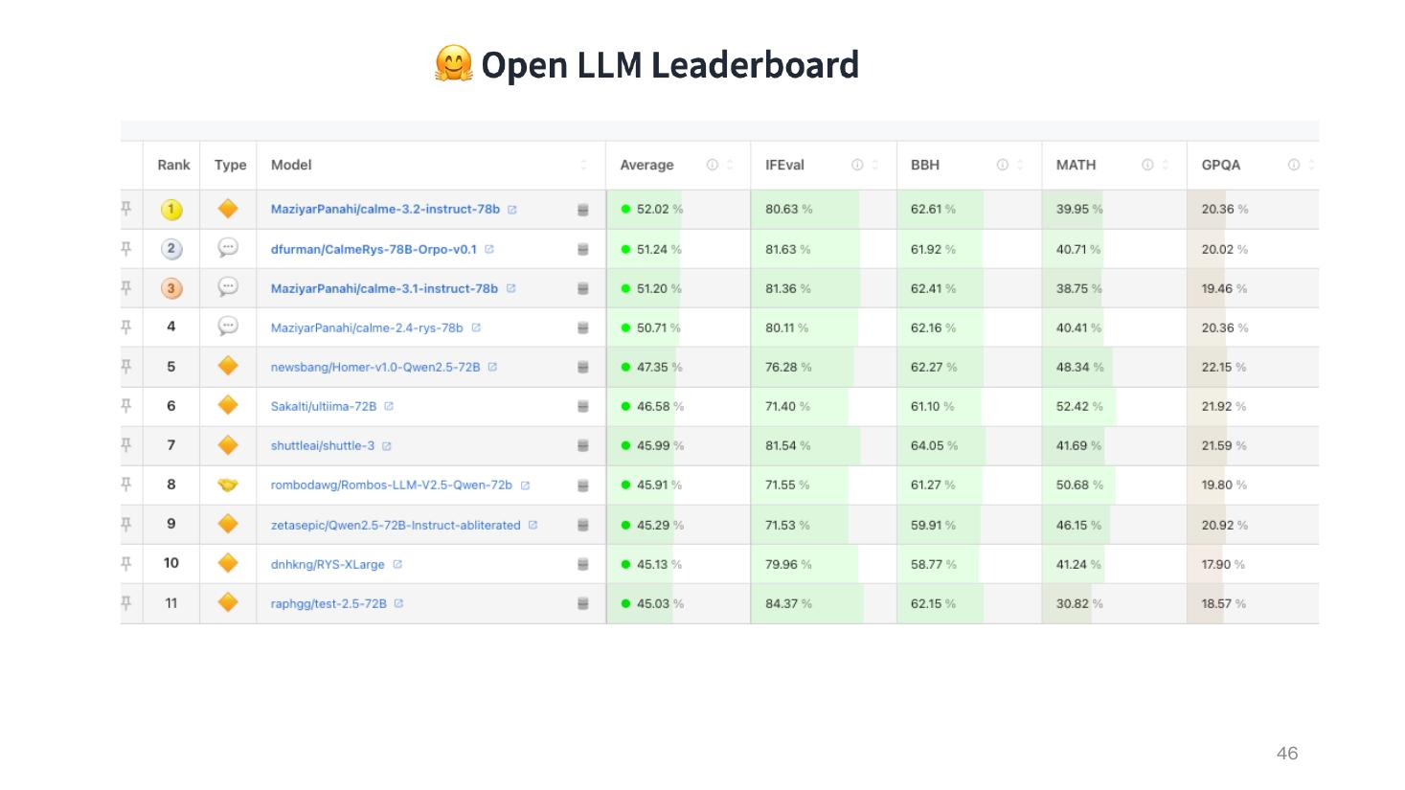

LLMs and the Future of Work

LLMs and the Future of Work
- Image: a humanoid robot with a laptop sitting in a waiting room


ICT and the service economy
- CNBC video: Will Robots… (‘Robots replacing fast-food workers’) – 1.3M views
- Two Cents video: Where Have… (‘where are the servers?’ – QR codes, digital ordering) – 61K views


Impact on Knowledge Economy
- Managers
- Creatives
- The Professions
- Engineers


Remember the Positives
- Democratization of Knowledge and Tutorage
- These tools have been the goal for many in educational AI for years!
- Thesis: Building a New Student Model to Support Adaptive Tutoring in a Natural Language Dialogue System – Yujian Zhou, PhD in Computer Science, Illinois Institute of Technology, Chicago, May 2000


References

Applied Deep Learning – Introduction
- Robert Ross, LinkedIn profile – https://www.linkedin.com/in/robertjohnross/ (About Me slide)

LLMs/ChatGPT and a Generative Future
- Vaswani, A., Shazeer, N., Parmar, N., Uszkoreit, J., Jones, L., Gomez, A. N., Kaiser, Ł., Polosukhin, I. – Attention Is All You Need (Transformer Architecture slide)
- ResearchGate figure: The comparison between GPT-3 and GPT-4 based on the number of parameters used in their… – https://www.researchgate.net/figure/The-comparison-between-GPT-3-and-GPT-4-based-on-the-number-of-parameters-used-in-their_fig3_369977556
- Learning to summarize from human feedback (OpenAI) – Training and Illustrative slides
- Aligning Language Models to Follow Instructions (OpenAI / InstructGPT) – Training and Illustrative slides
- Lambert, N., Castricato, L., von Werra, L., Havrilla, A. – Illustrating Reinforcement Learning from Human Feedback (RLHF), Hugging Face blog, December 9, 2022
- cnvrg.io – Reinforcement Learning – https://cnvrg.io/reinforcement-learning/
- Reuters, February 11, 2023 – Google cautions against 'hallucinating' chatbots, report says
- The Byte, Feb 17 (2023) – Microsoft stock falling as Bing AI descends into madness
- Finxter – ChatGPT Prompting Cheat Sheet
- Coursera – Prompt Engineering for ChatGPT, Vanderbilt University (Dr. Jules White)
- Prompt Engineering Guide – Introduction, Techniques and Applications topic list
- Hugging Face – Open LLM Leaderboard
- Zhou, Y. (2000) – Building a New Student Model to Support Adaptive Tutoring in a Natural Language Dialogue System, PhD thesis, Illinois Institute of Technology

Week 2 - Neural Network Essentials

Introduction

Deep Learning Course – Neural Network Essentials
- Deep Learning Course
- Neural Network Essentials


Recap - We can get results without knowing anything
- MNIST digit samples (5, 0, 1, 9, 1, 3)
- Colab screenshot: Gemini prompt – ‘build me a minimalist model to load the mnist digits and train a model to predict them with tensorflow. Just one train/test split is needed.’
- Gemini reply: ‘Sure, I can help with that! Here is the code to load the MNIST dataset, train a simple model, and evaluate its performance.’ (Accept & Run / Accept / Cancel)
- Generated code outline:
- Load the MNIST dataset – (x_train, y_train), (x_test, y_test) = mnist.load_data()
- Preprocess the data – x_train, x_test = x_train / 255.0, x_test / 255.0
- Build a simple model – Sequential([Flatten(input_shape=(28, 28)), Dense(128, activation='relu'), Dense(10, activation='softmax')])
- Compile the model – optimizer='adam', loss='sparse_categorical_crossentropy', metrics=['accuracy']
- Train the model – model.fit(x_train, y_train, epochs…)
- Evaluate the model – loss, accuracy = model.evaluate(…); print Test accuracy
- ‘Gemini can make mistakes so double-check it and use code with caution.’
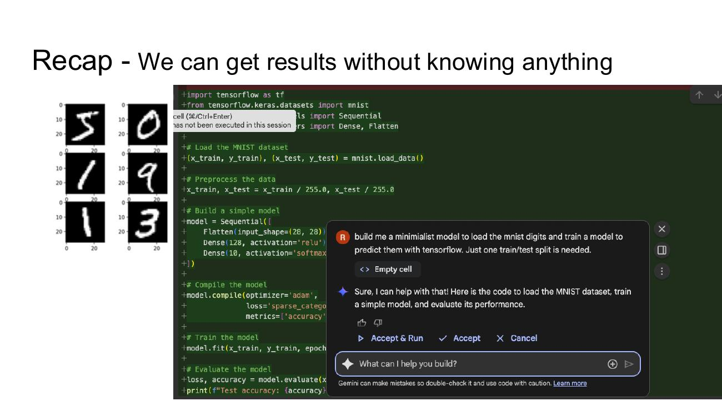

Goal: Develop Understanding / Interpretation
- Image: four heads – tangled thoughts gradually untangling into a light bulb
- Image Credit: https://www.google.com/url?sa=i&url=https%3A%2F%2Fspotonsolutions.com%2Fmonday-mo-knowing-vs-understanding-and-why-it-matters%2F&psig=AOvVaw38ZggrgKkNhbhTNHX4y60P&ust=1757921193385000&source=images&cd=vfe&opi=89978449&ved=0CBgQjhxqFwoTCPjtiPnc148DFQAAAAAdAAAAABAE
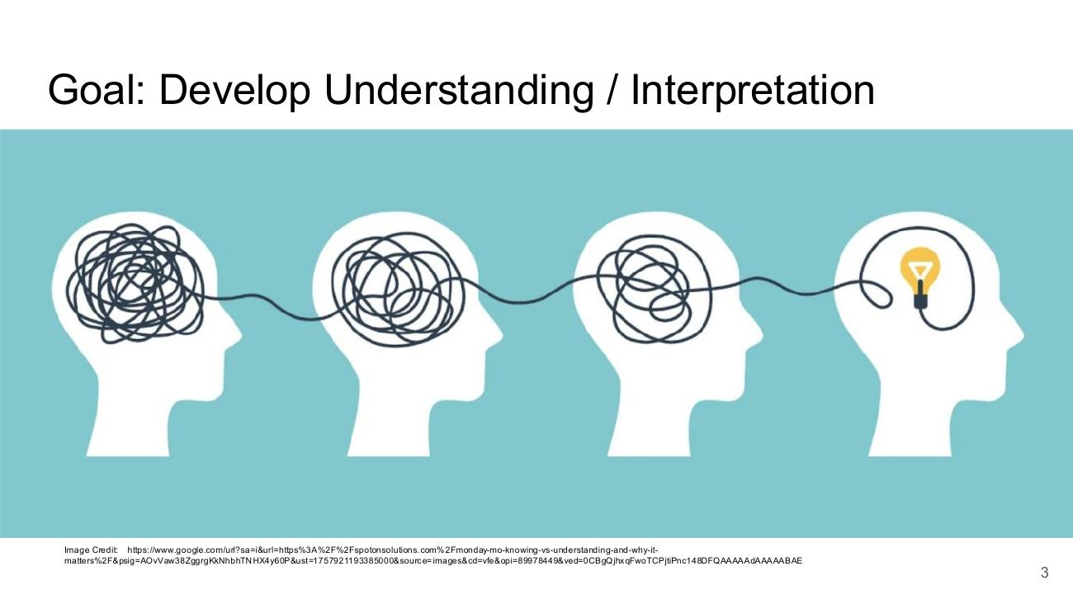

Context – Machine Learning Basics: Regression

Context – Machine Learning Basics
- Context – Machine Learning Basics (section divider)
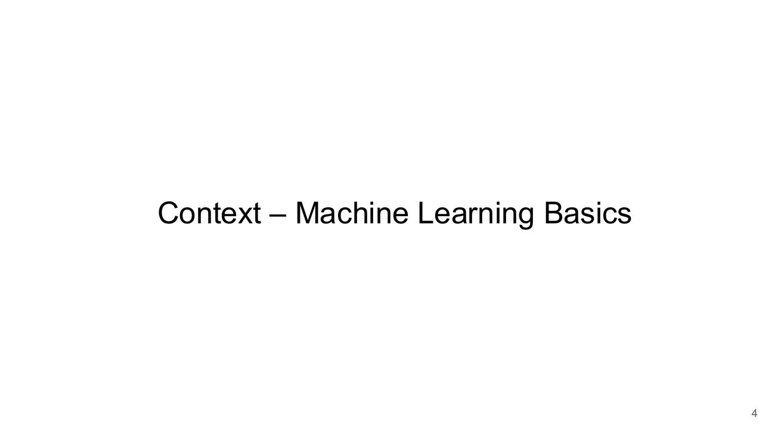

Regression Problem Example
- X = age = [ 1. 3. 4. 7. 10. 11. 14. 13.5 16. 18. 22. ]
- Y = height = [ 60. 90. 100.5 130. 128. 140. 160. 140. 165. 162. 155. ]
- Scatter plot: Height versus Age – Height (cm) vs Age (years)
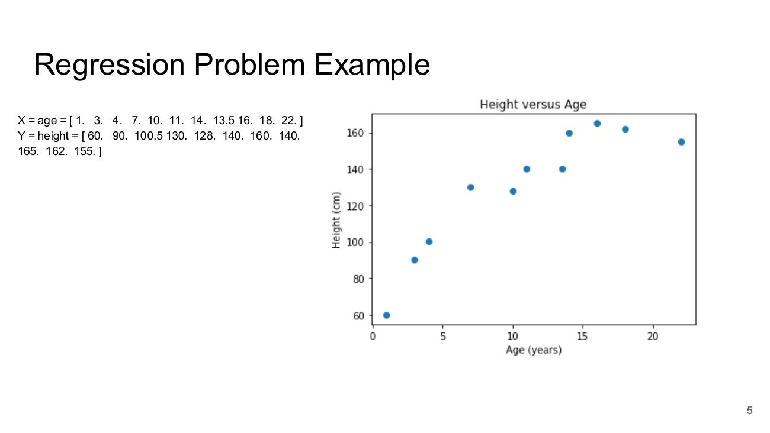

Regression and Classification
- **Handwaving Problem Statement:** Learn to predict a Target (output) for some Features (input) based on some training data
- Target = f(input)
- I need to figure out the function / model f
- Regression: Real Valued Target (a Number)
- Classification: A class target (binary, multiple types)
- Target = Y = Dependent Variable
- Features = X = Independent Variable
- Xi = ith input feature / variable
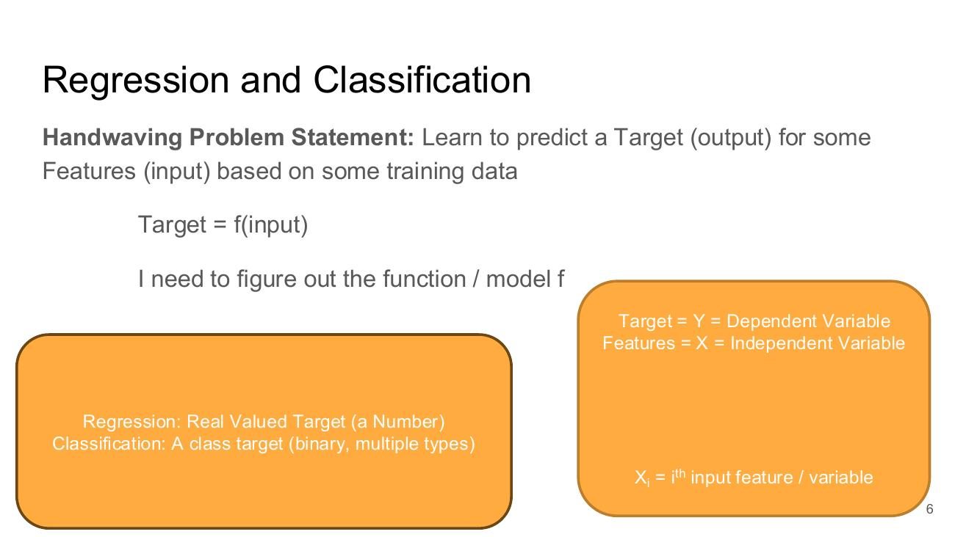

Regression Problem Example
- X = age = [ 1. 3. 4. 7. 10. 11. 14. 13.5 16. 18. 22. ]
- Y = height = [ 60. 90. 100.5 130. 128. 140. 160. 140. 165. 162. 155. ]
- Scatter plot: Height versus Age – Height (cm) vs Age (years)
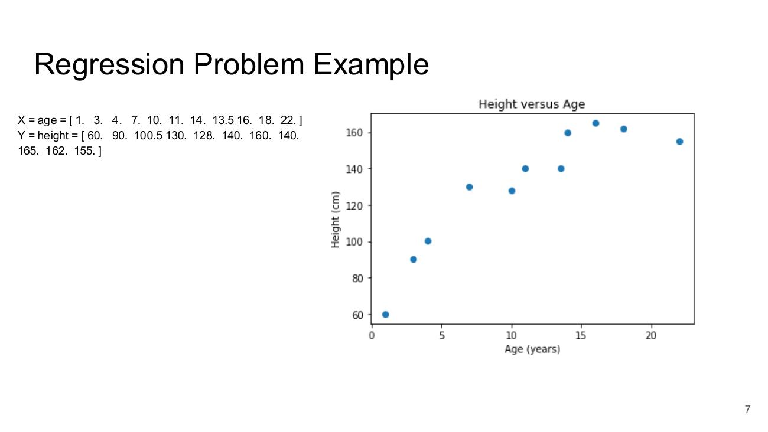

Intuitive Solution to the Problem
- What is the likely height of a 9 year old?
- Height versus Age plot with a red vertical line at age 9
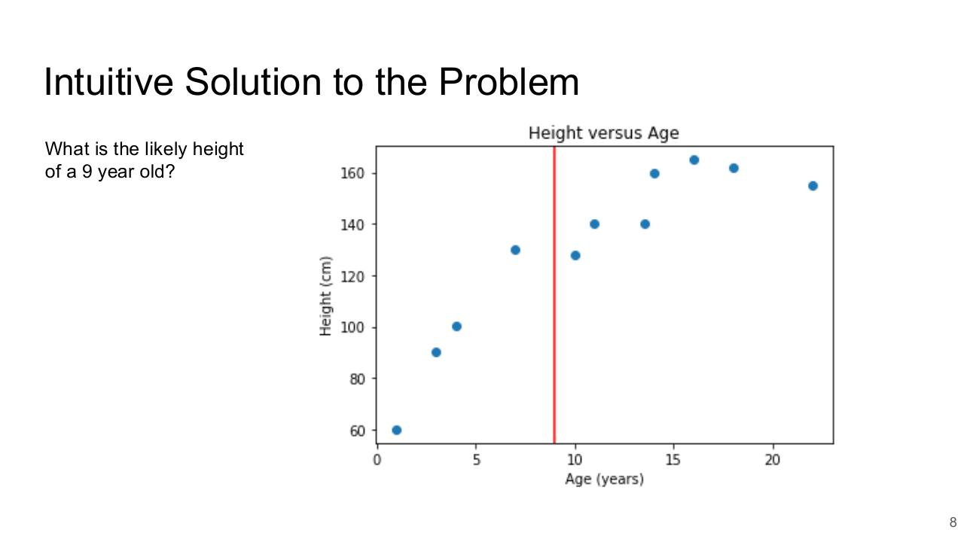

Linear Functions of Data
- f(x)
- We can parameterize a linear function to model the relationship between a Target and Feature / set of features..
- The most basic function we can fit to our example is a straight line of the form: Y = mX + c
- where X is our input, Y is our output, m defines the slope of the line and c defines the line's offset from the origin.
- While the notation above is the one we use in school, the version we use in Machine Learning is like this:
- hθ(x) = θ0 + θ1x

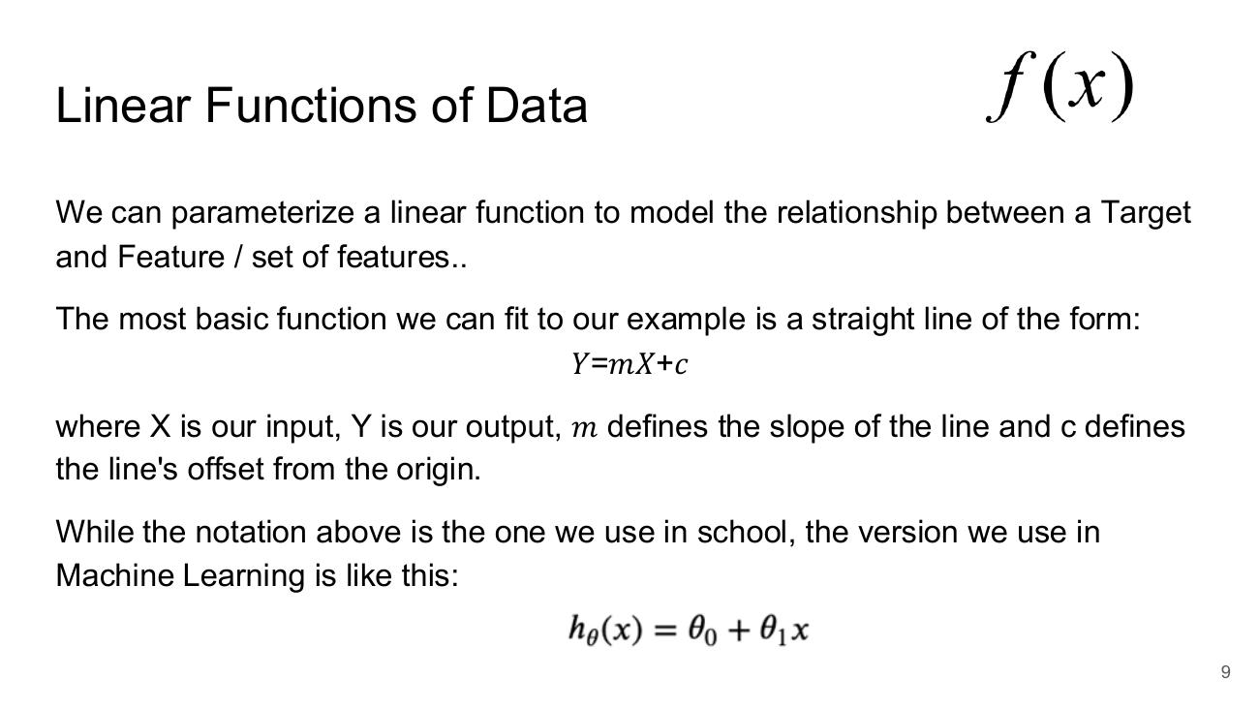

Example Functions against our Data
- Two Height versus Age plots with fitted straight lines:
- Y = 80 + 4X
- Y = 60 + 6X
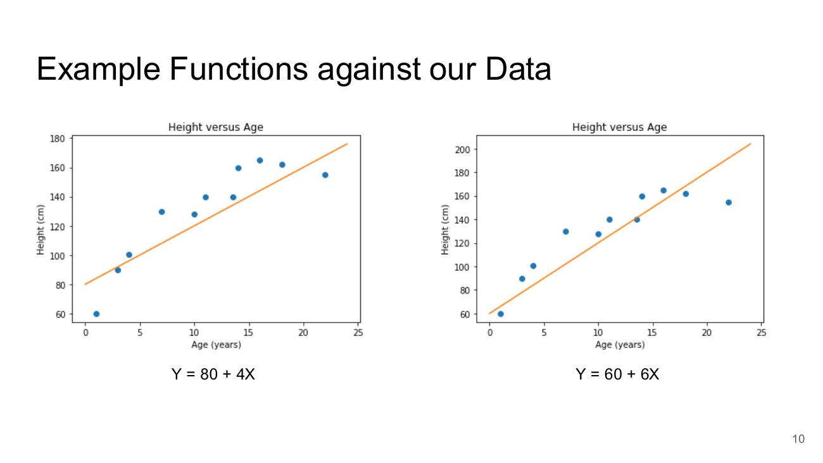

A Function with some higher order terms
- Height versus Age plot with a fitted curve
- Y = 50 + 15X − 0.68X² + 0.011X³
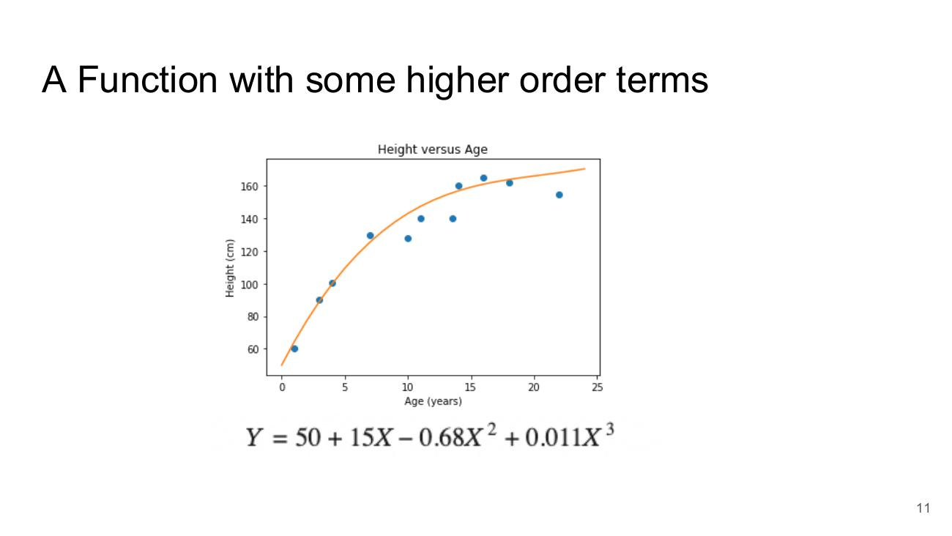

Classification

Classification Problem Statement
- Same as for Regression with the only difference being that our **Target variable is Binary** rather than real valued
- We wish to automatically fit a function that best fits the available training data.
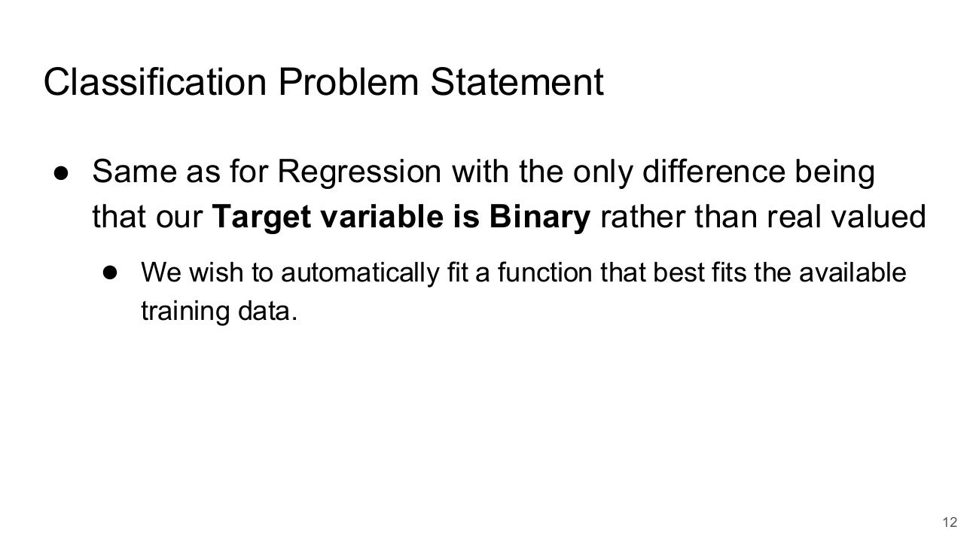

Classification - Example Problem
- Plot: Diagnosis of Type II Diabetes (0 or 1) vs Average Daily Sugar Consumption
- Values 5–20 → 0; values 30–60 → 1
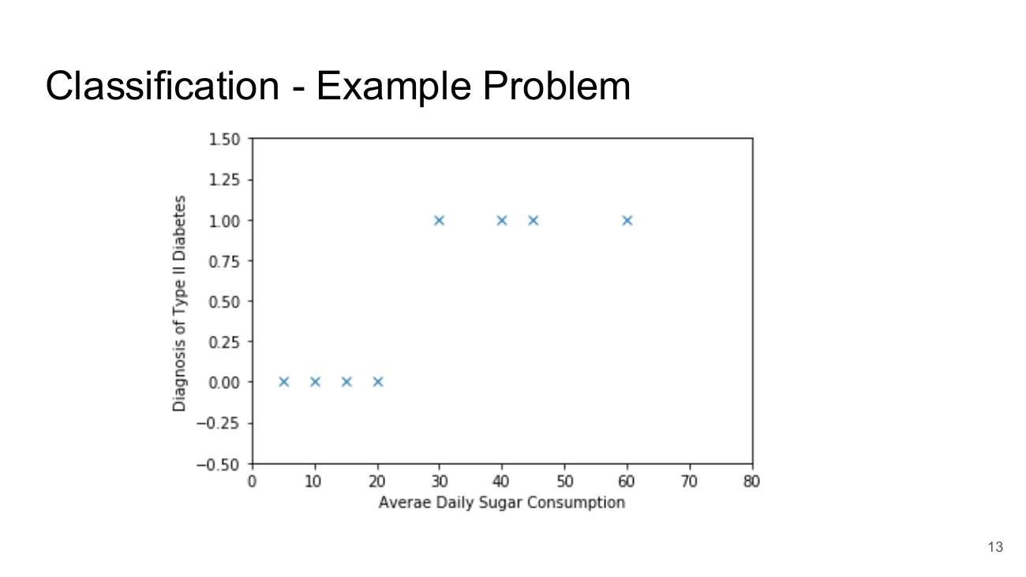

Modelling Binary Problem with Regression
- Straight regression line fitted to the binary diabetes data (x-axis: Average Daily Sugar Consumption, standardised)
- Line predicts values below 0 and above 1
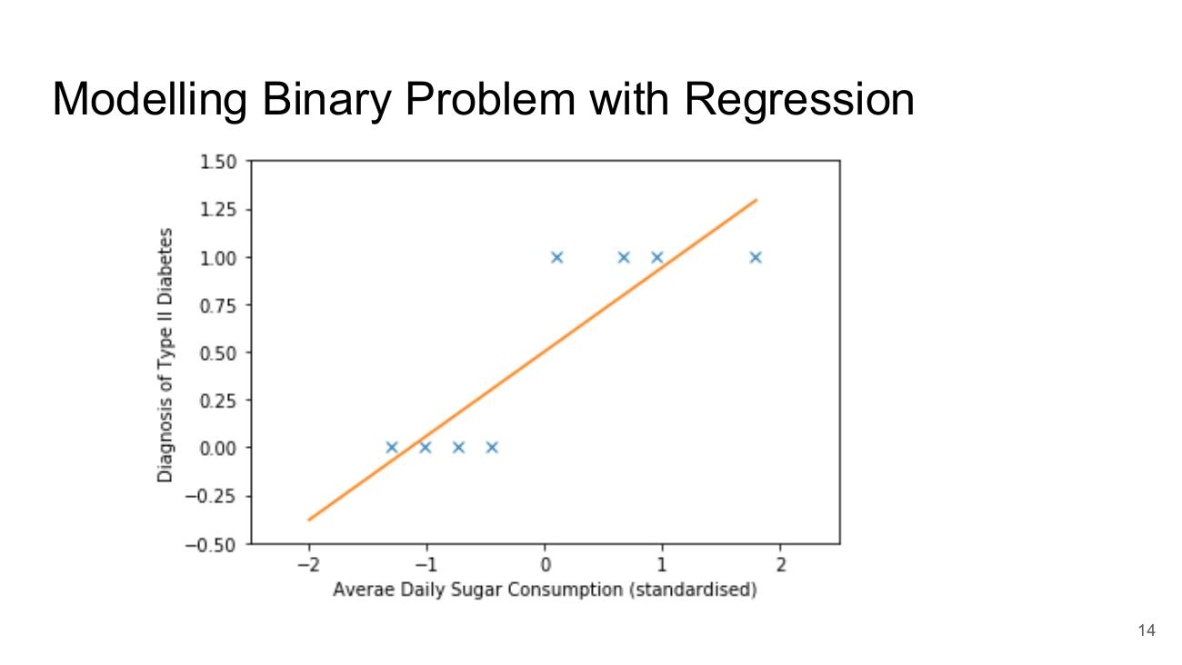

Modelling Binary Problem with Regression – eek!
- Higher-order polynomial fitted to the binary data – rises to 1 then plunges sharply below 0 after ~65 (poor fit)
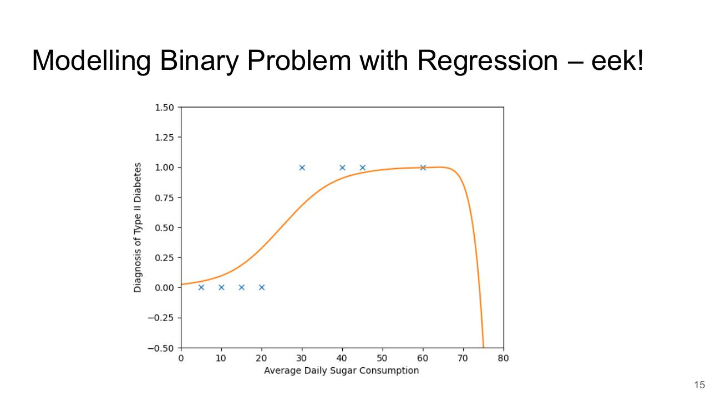

Modelling Binary Problem with Logistic Functions
- Logistic (S-shaped) curve fitted to the binary data – stays between 0 and 1, switching sharply around −0.5 (standardised)
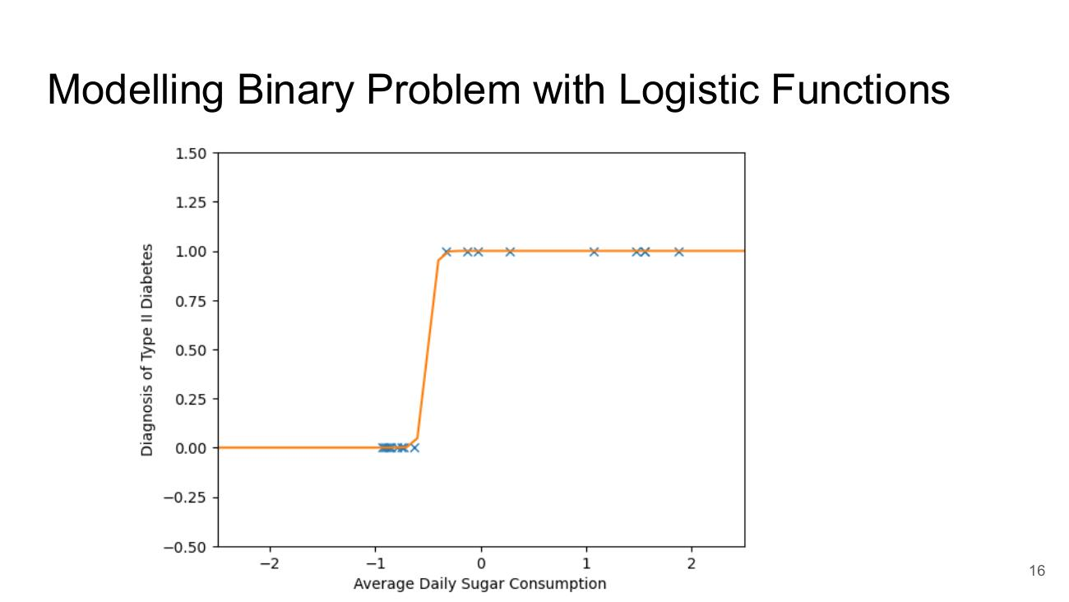

Logistic Function
- hθ(x) = 1 / (1 + e^(−z))
- z = θx = Σ (i = 0 to n) θi xi
- Plot: Function f(x) = 1 / (1 + exp(−(0 + x))) for x from −3 to 3
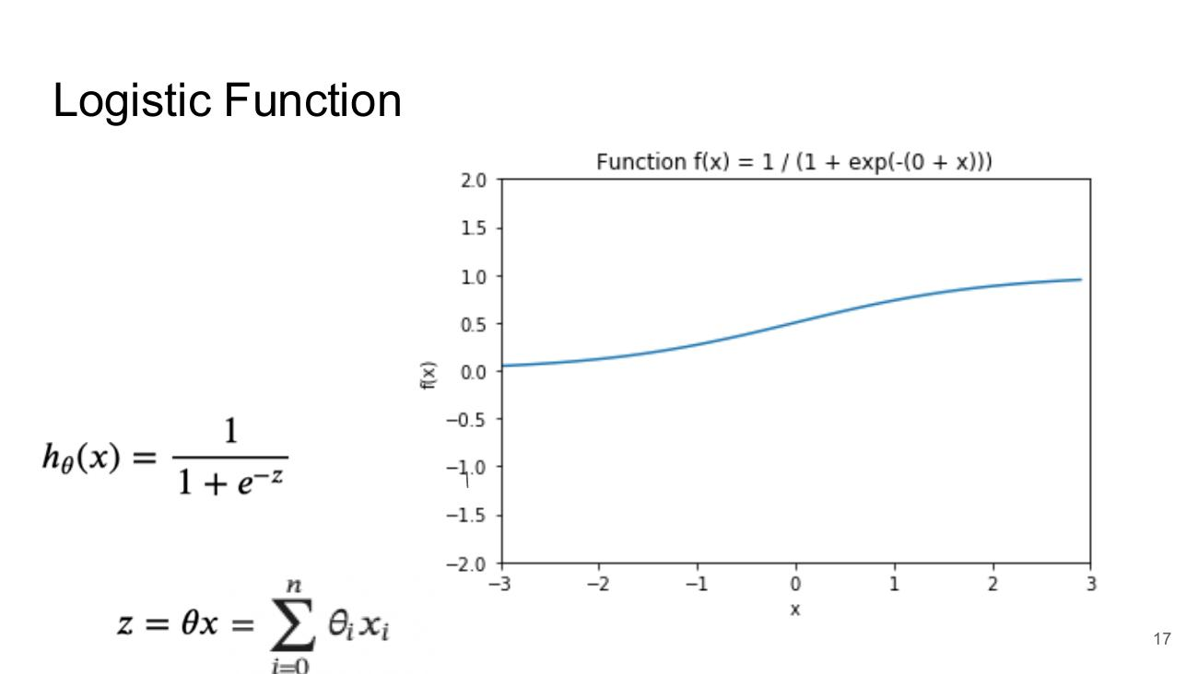

Varying the parameters
- Left plot: varying theta0 = 0, 1, 2, 3 – shifts the curve left/right
- Right plot: varying theta1 = 0.5, 1, 2, 4 – changes the steepness of the curve
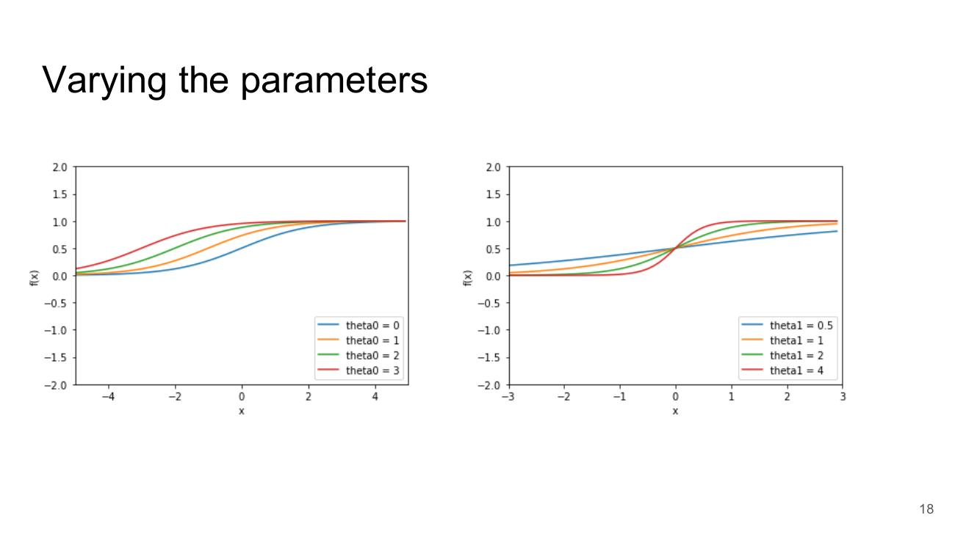

Logistic Fn as an Example of Sigmoid Functions
- Plot: 3 Sigmoid Functions
- f(x) = 1/(1 + np.exp(−z1)) (range 0 to 1)
- f(x) = tanh(x) (range −1 to 1)
- f(x) = x1 / (1 + abs(x1)) (range −1 to 1, flatter)
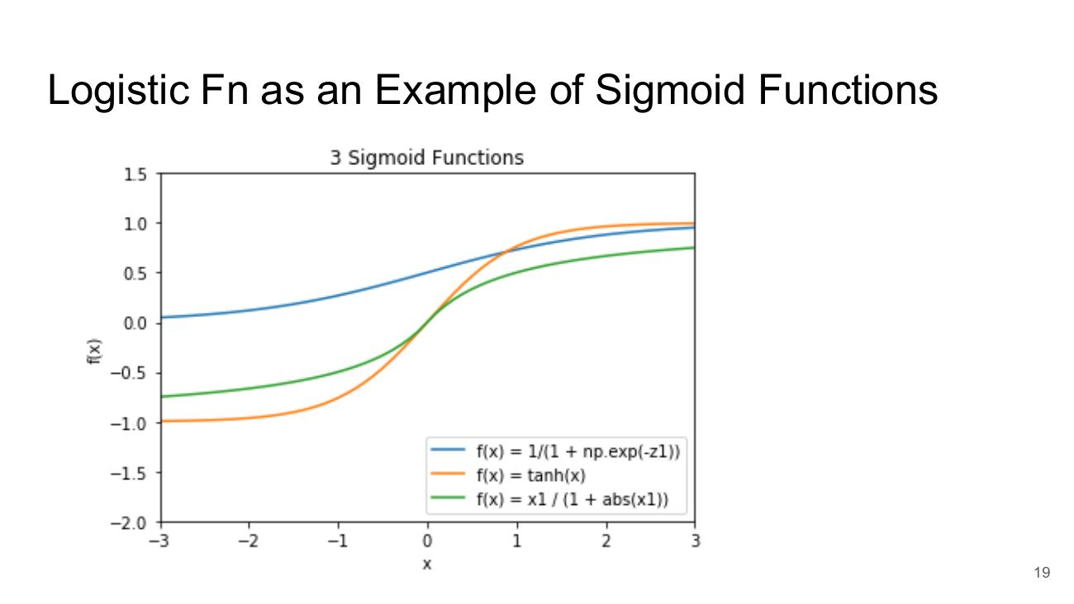

Aside: Alternative Visualisations
- Same diabetes data shown as a scatter plot and as a 1-D number line
- Average Daily Sugar Consumption – orange dots (class 0) on the left, teal dots (class 1) on the right
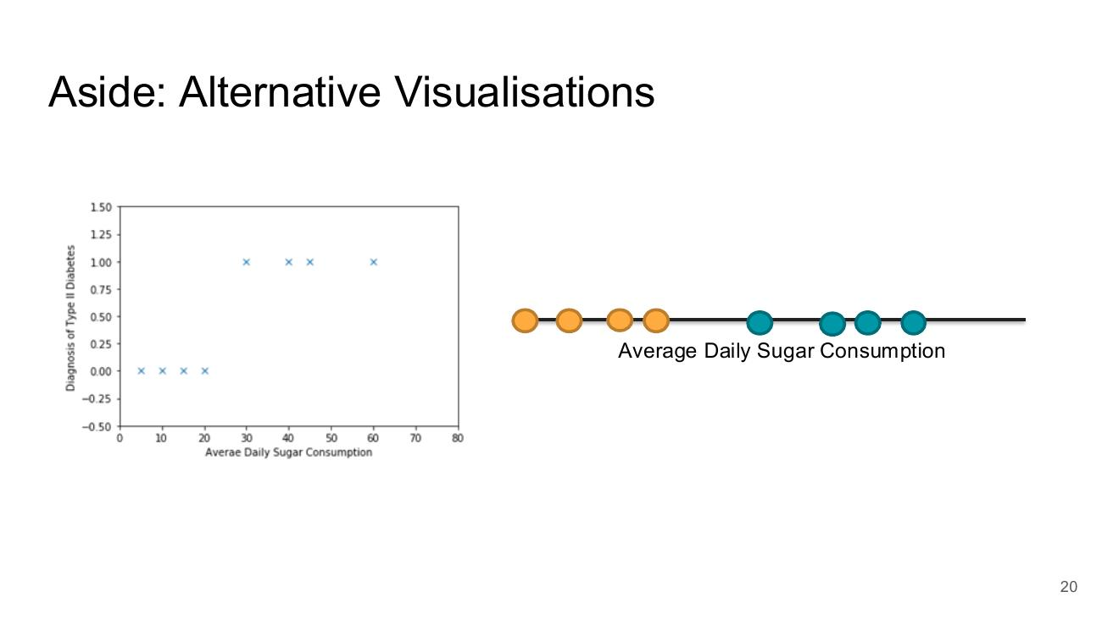

Alternate Visualizations
- 2-D feature plot (x1, x2) with two classes: red ‘−’ points on the left and blue ‘+’ points on the upper right
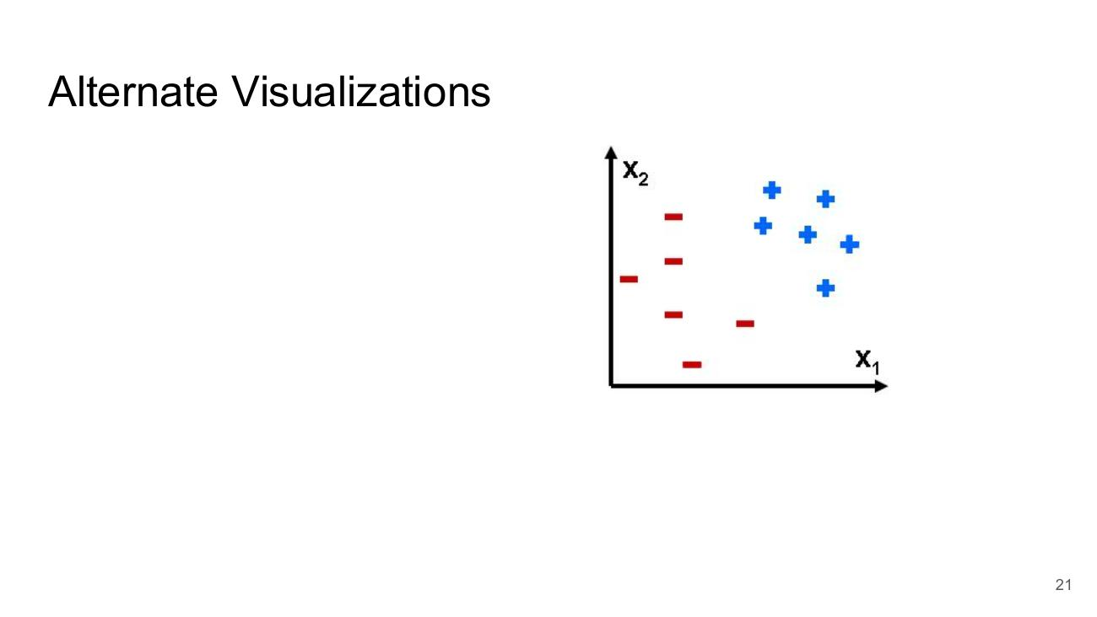

Measuring Error

Measuring Error
- Image: tangled measuring tapes (section divider)


The Error or Loss of our Functions
- Height versus Age plot with fitted line; vertical lines show the error (residual) between each point and the line
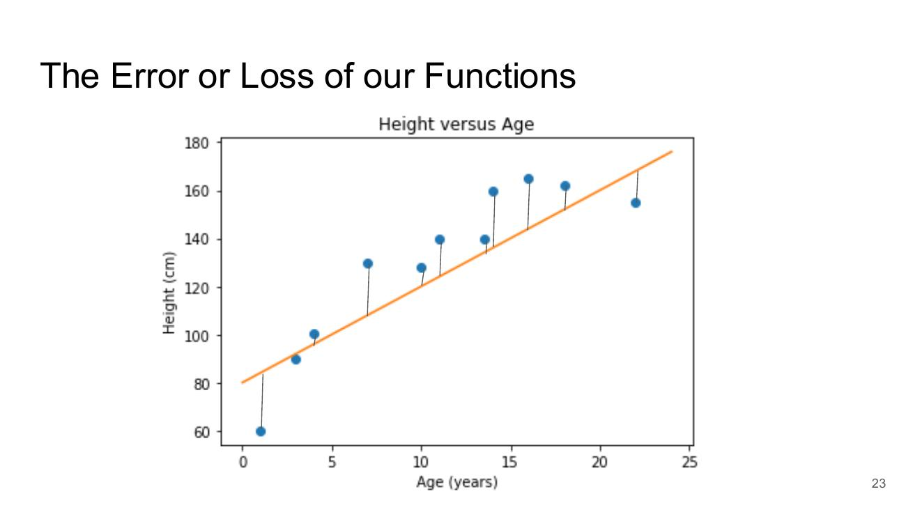

Sum of Squared Error
- J(θ0, θ1) = 1/(2m) Σ (i = 0 to m) ( hθ(x⁽ⁱ⁾) − y⁽ⁱ⁾ )²
- where
- θ0 and θ1 are the parameters of our model
- m is the number of training examples
- yⁱ is the ith target value
- xⁱ is the ith feature vector, and
- hθ is our model (hypothesis function of x) that we wish to evaluate.
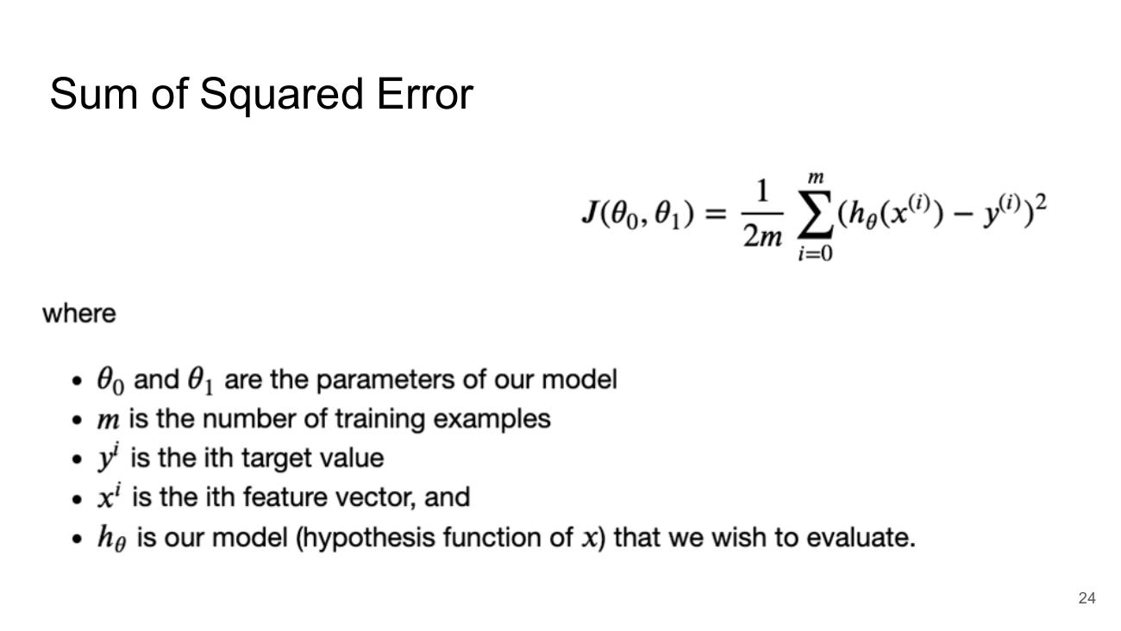

Visualising the Cost Function – The Error Surface
- 3-D surface plot of the cost over Theta0 (60–90) and Theta1 (3–8), cost up to ~1400
- Contour Plot of Cost Function – contour lines at 200, 400, 600, 800, 1000 (Theta0 vs Theta1)
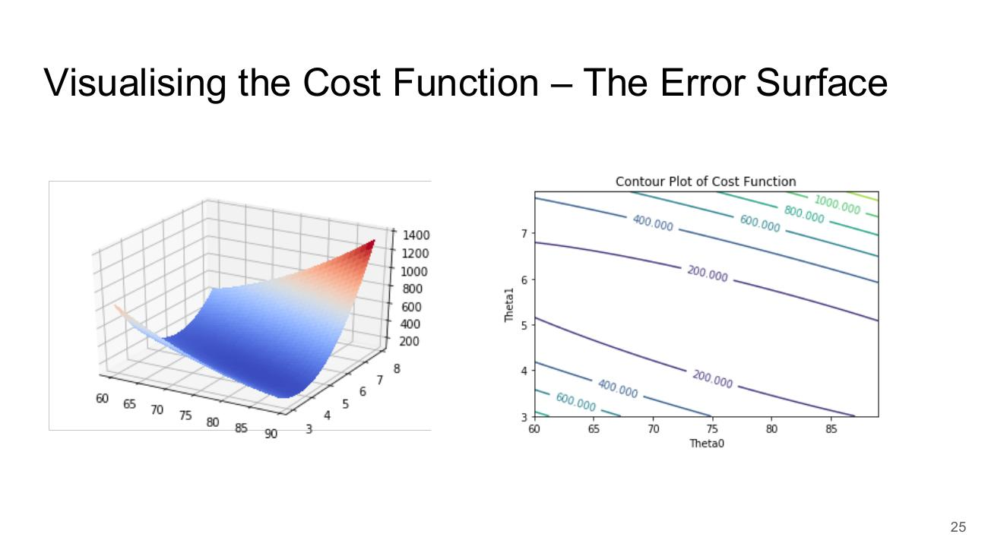

Towards Neural Solutions

Towards Neural Solutions
- Towards Neural Solutions (section divider)
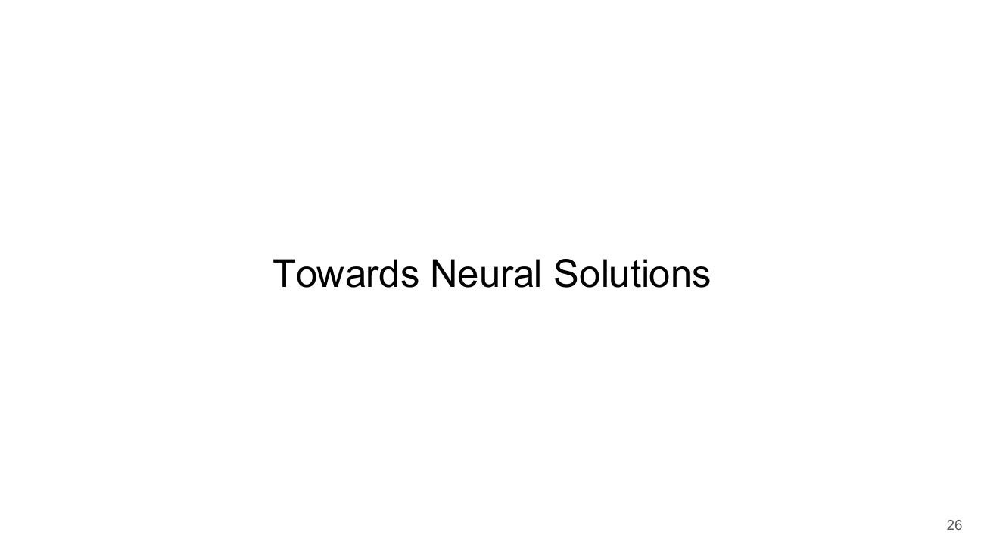

The Problem with Hand Crafted Features
- Hard work
- Combinatorial explosion
- Often a fishing expedition
- Image: fly fisherman casting in a river
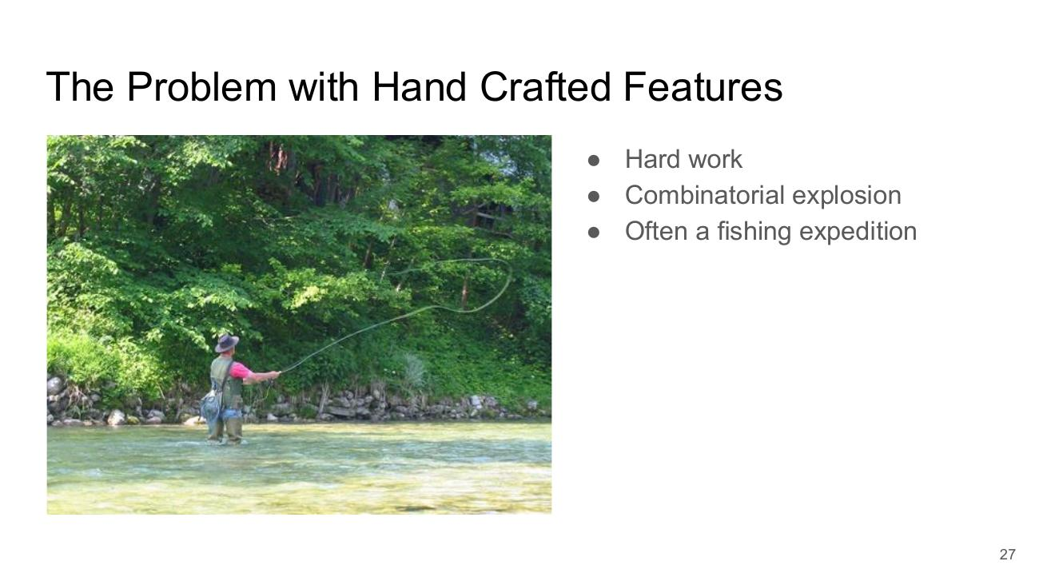

Avoiding Hand Crafted Features
- Machine Learning: Input → Feature extraction → Classification → Output (Car / Not Car)
- Deep Learning: Input → Feature extraction + Classification → Output (Car / Not Car)
- https://towardsdatascience.com/cnn-application-on-structured-data-automated-feature-extraction-8f2cd28d9a7e
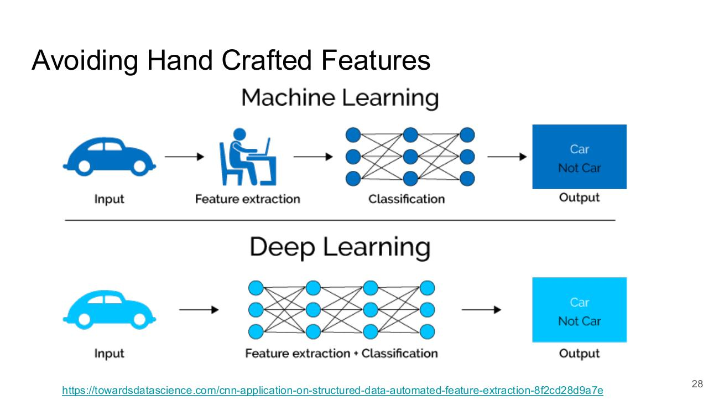

The Neuron

The Neuron
- Inputs x1, x2 → Body → Output hθ(x)
- Labels: Inputs, Weights, Body, Output
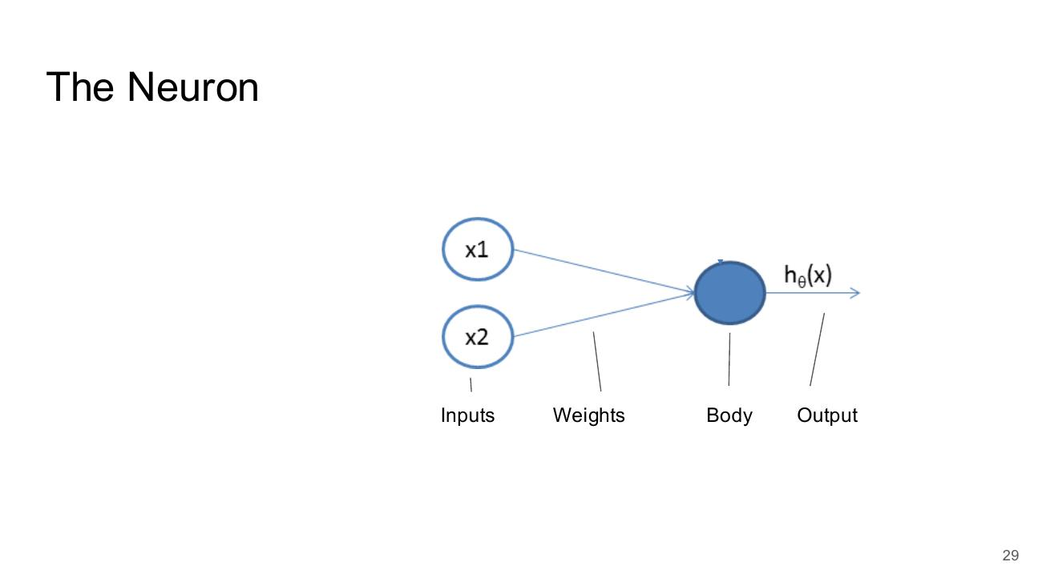

The Neuron
- The bias: extra input x0 added
- Inputs x0, x1, x2 → Body → Output hθ(x)
- Labels: Inputs, Weights & Bias, Body, Output
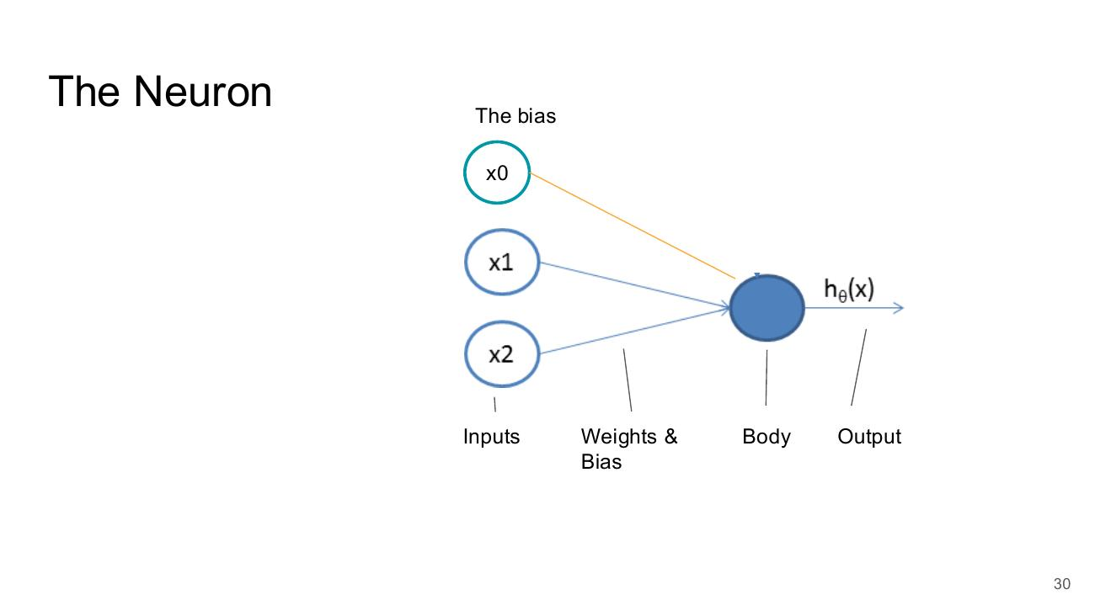

The Neuron
- The bias: x0 is always 1
- Inputs 1, x1, x2 → Body → Output hθ(x)
- Labels: Inputs, Weights & Bias, Body, Output
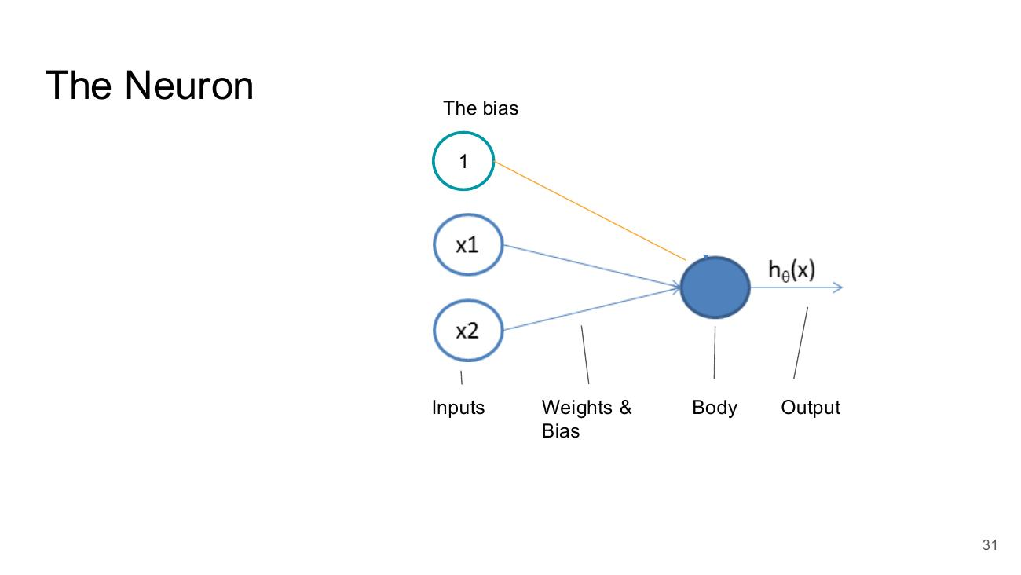

The Neuron
- Weights: x0 → 0.1, x1 → 0.55, x2 → −0.2
- Inputs x0, x1, x2 → Body → Output hθ(x)
- Labels: Inputs, Weights & Bias, Body, Output
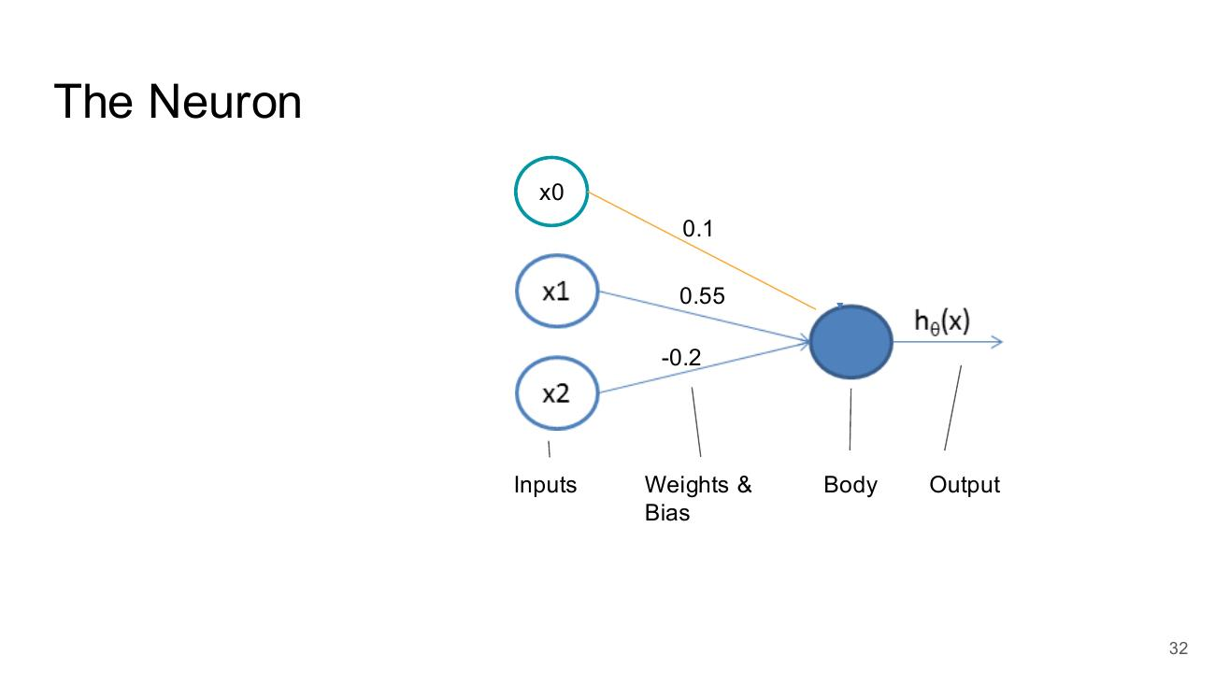

The Neuron
- Example input values: x0, 5, −1
- Weights: 0.1, 0.55, −0.2
- Labels: Inputs, Weights & Bias, Body, Output
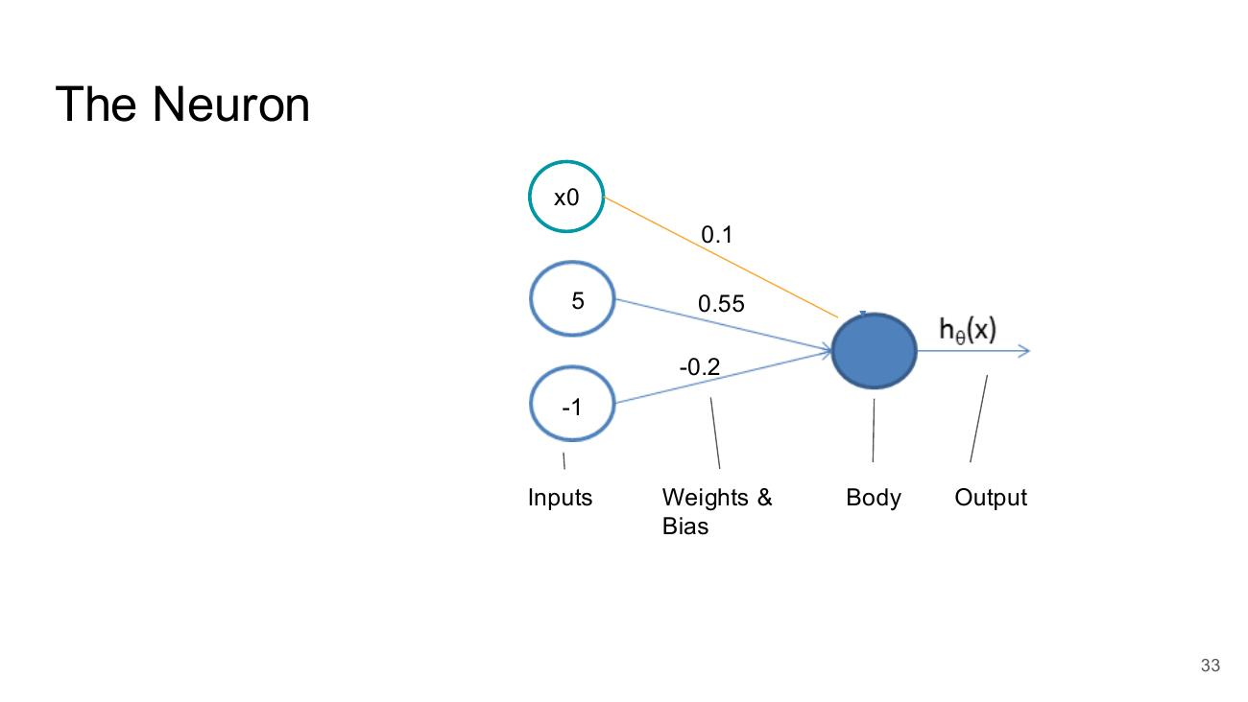

The Linear Neuron
- Inputs (x): 1, 5, −1; Weights & Bias (θ): 0.1, 0.55, −0.2; Body (z); Output hθ(x)
- hθ(x) = z = θx (Output = The Logit = The parameters × The Input)
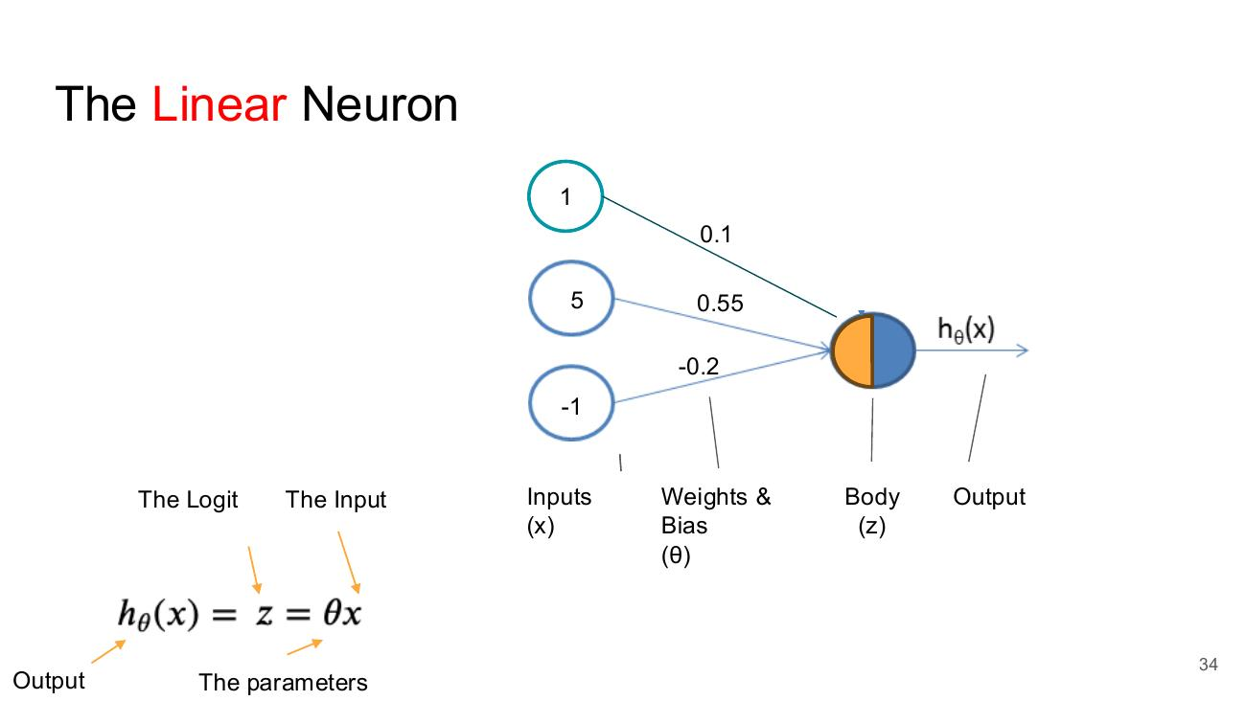

The Linear Neuron
- Inputs: 1, 5, −1; Weights & Bias: 0.1, 0.55, −0.2; Body; Output hθ(x)
- hθ(x) = z = θx (Output = The Logit = The parameters × The Input)
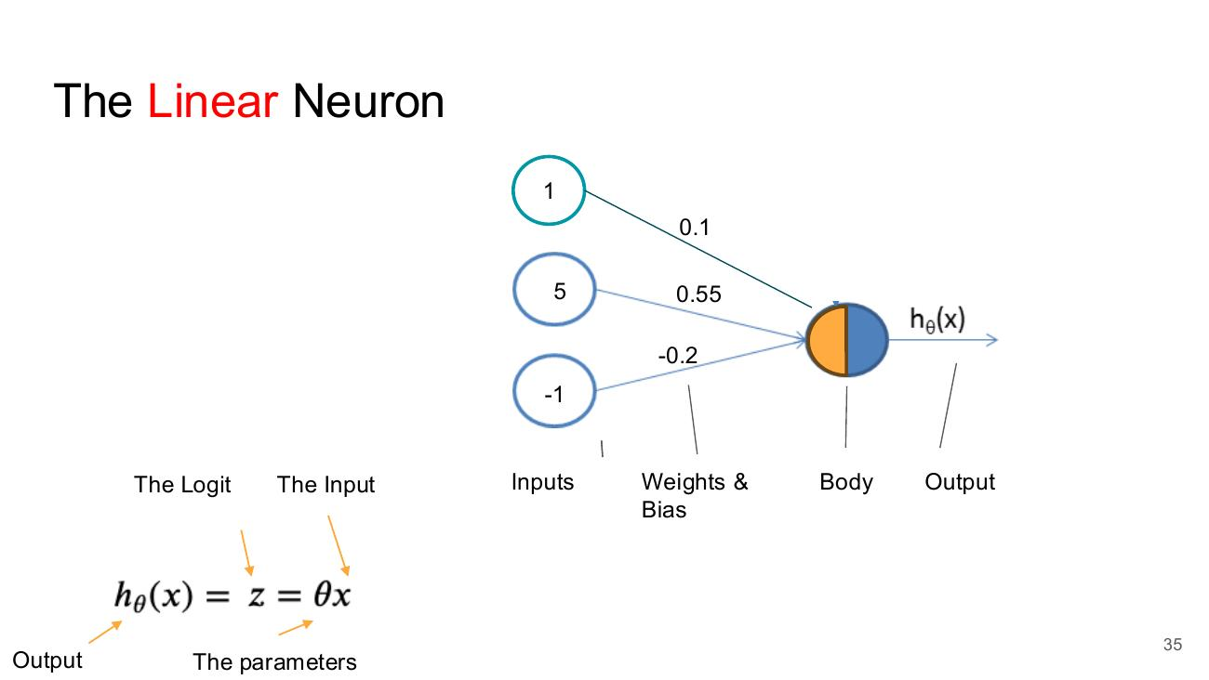

The Linear Neuron
- Inputs: 1, 5, −1; Weights & Bias: 0.1, 0.55, −0.2; Body; Output hθ(x)
- hθ(x) = z = θx = Σ (i = 0 to n) θi xi
- Output = The Logit = The parameters × The Input
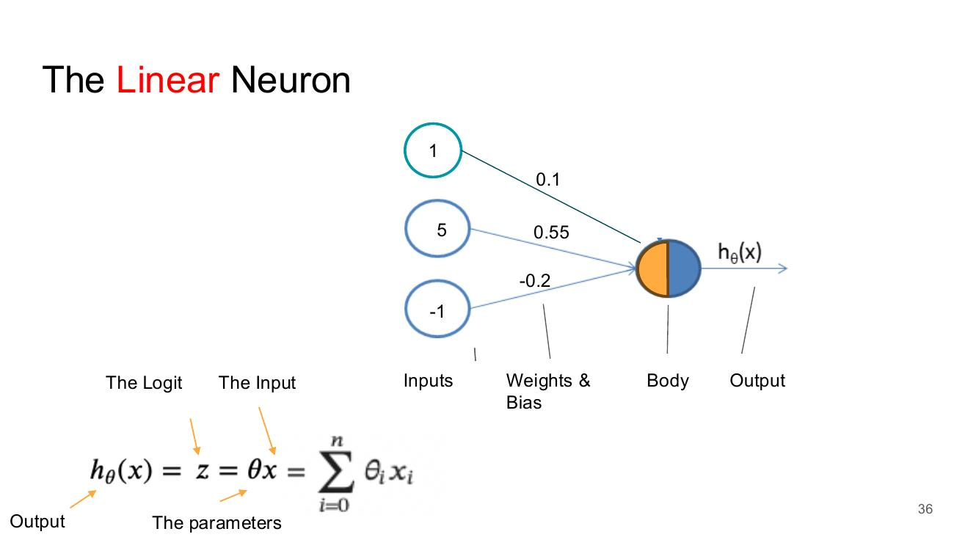

The Logistic / Sigmoid Neuron
- hθ(x) = 1 / (1 + e^(−z))
- z = θx = Σ (i = 0 to n) θi xi
- Inputs: 1, 5, −1 → Body → Output hθ(x)
- Labels: Inputs, Weights & Bias, Body, Output
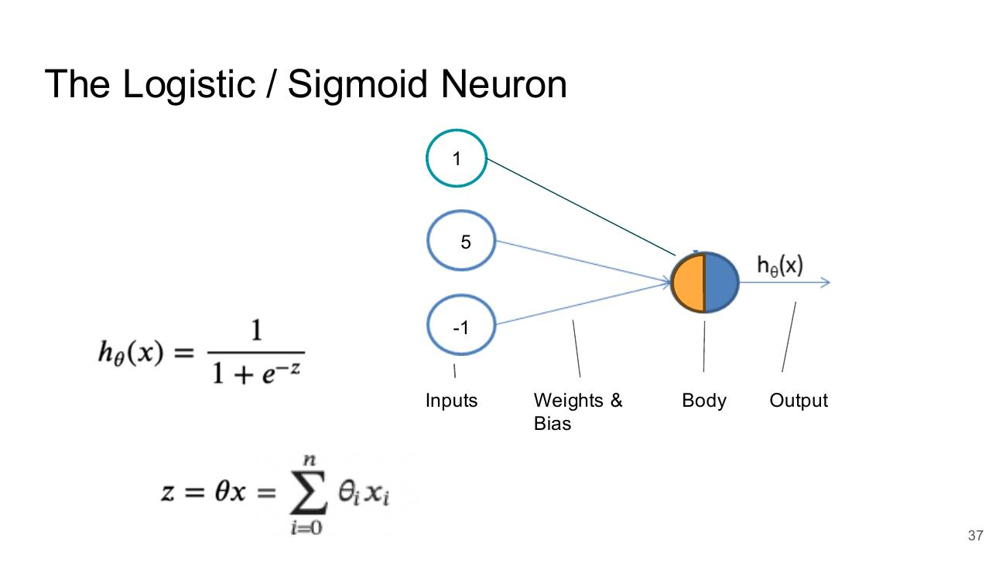

Hand Crafted Neurons

Some Hand Crafted Neurons
- AND neuron – weights: x0 = −30, x1 = 20, x2 = 20
- Truth table (x1, x2, θx, h(θx)):
- 0, 0, −30, 0
- 0, 1, −10, 0
- 1, 0, −10, 0
- 1, 1, 10, 1
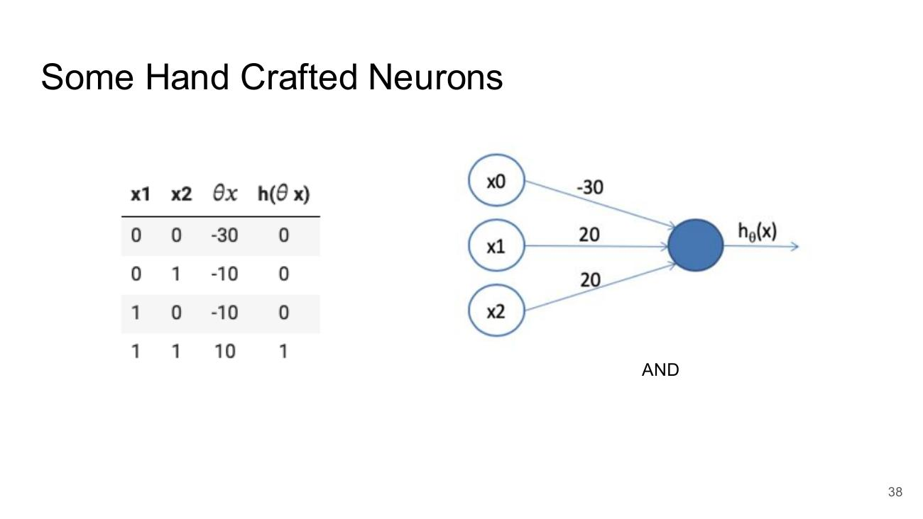

Some Hand Crafted Neurons
- OR neuron – weights: x0 = −10, x1 = 20, x2 = 20
- Truth table (x1, x2, θx, h(θx)):
- 0, 0, −10, 0
- 0, 1, 10, 1
- 1, 0, 10, 1
- 1, 1, 30, 1
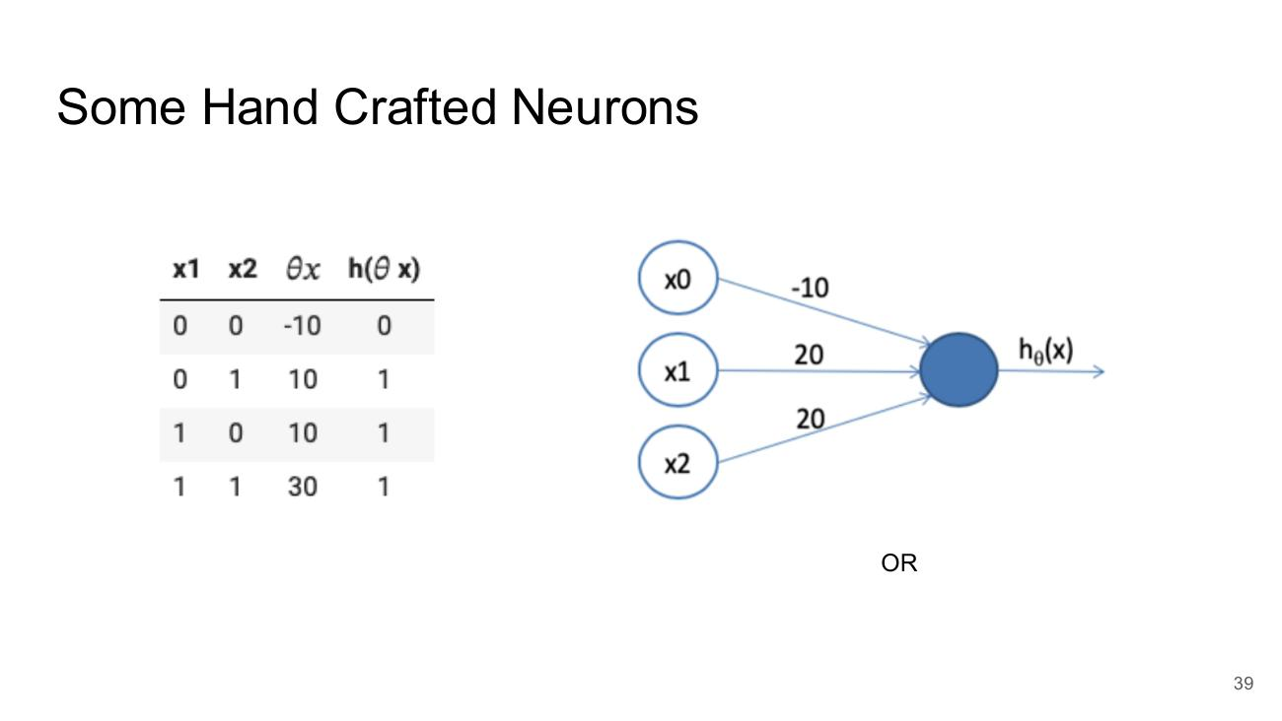

Some Hand Crafted Neurons
- NOT neuron – weights: x0 = 10, x1 = −20
- Truth table (x1, θx, h(θx)):
- 0, 10, 1
- 1, −10, 0
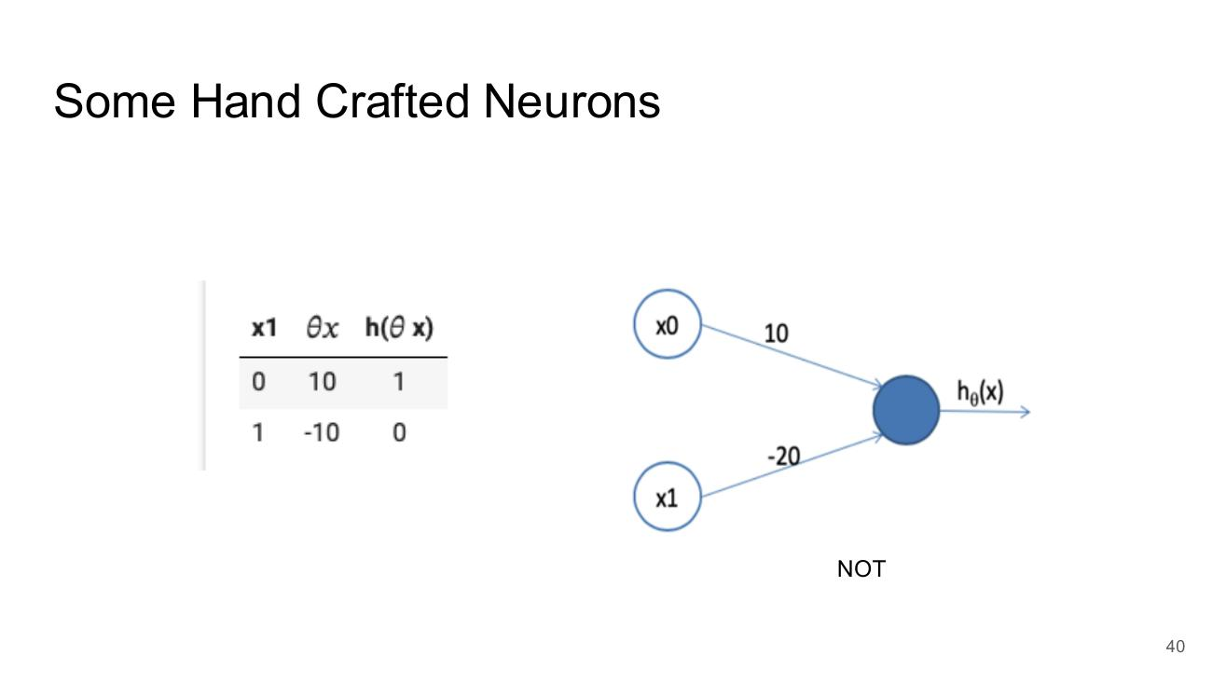

Building Something More Complicated
- XNOR truth table (x1, x2, x1 XNOR x2):
- 0, 0, 1
- 0, 1, 0
- 1, 0, 0
- 1, 1, 1
- Network: two NOT neurons and an AND neuron feed a second AND neuron, then an OR output neuron (weights such as 10, −20, −30, 20, −10)
- x1 XNOR x2 = (x1 AND x2) OR ((NOT x1) AND (NOT x2))
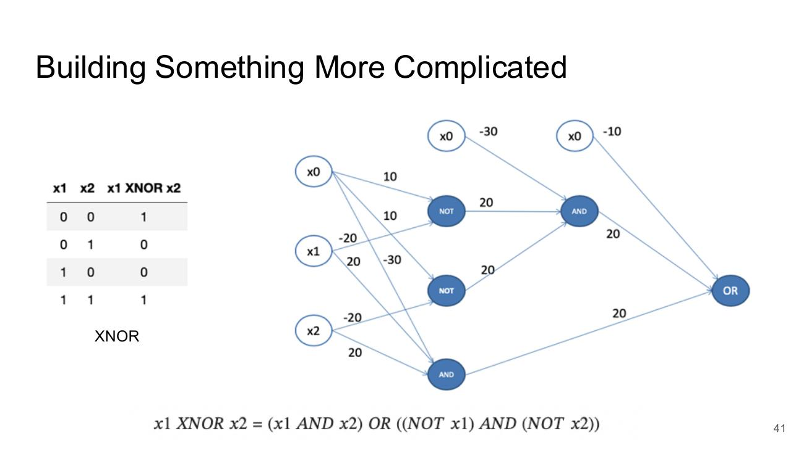

Feedforward Networks

Layers of the Network - Feedforward Networks
- Input Layer (3 nodes) → Hidden Layer (3 nodes) → Output Layer (1 node)
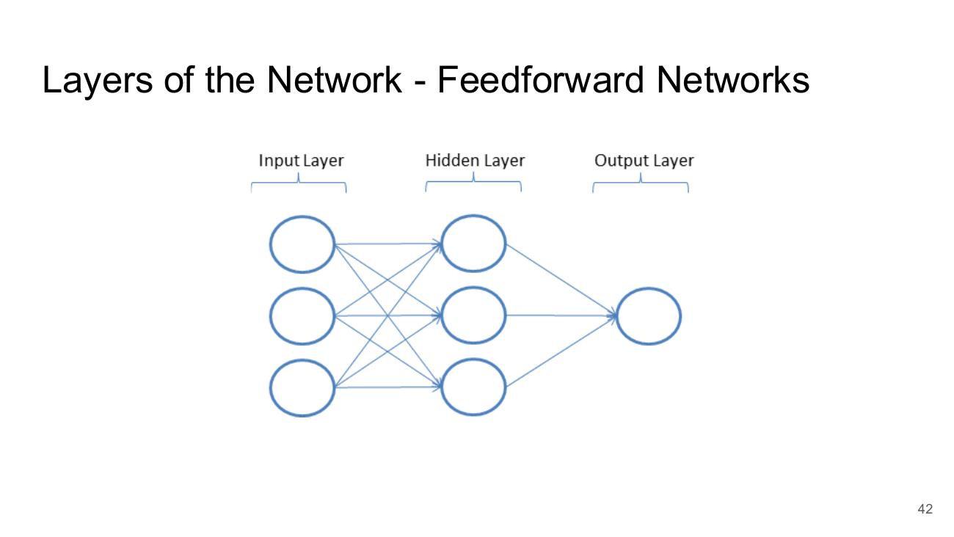

From Single to Multiple Targets
- Input Layer (5 nodes) → Hidden Layer (5 nodes) → Output Layer (3 nodes)
- Each hidden/output node split into z (logit) and a (activation)
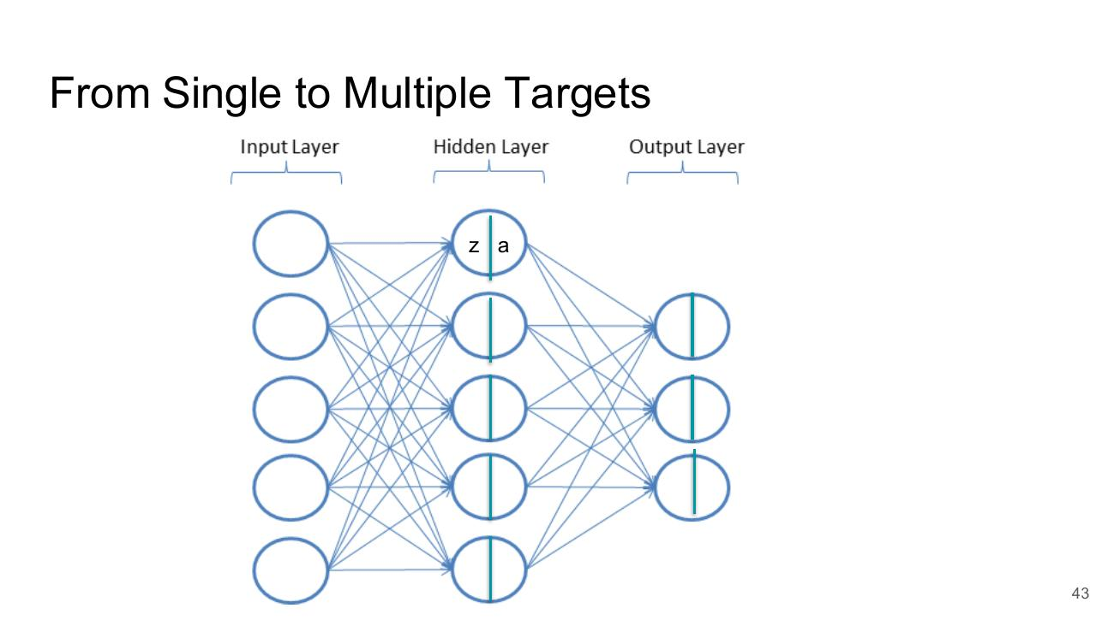

The Bias Unit
- Bias unit ‘data’ always 1
- The bias has a value - similar to a weight
- Output layer has no bias unit
- Bias is often not visualised
- Diagram: bias node ‘1’ at the top of the Input Layer and Hidden Layer; none in the Output Layer
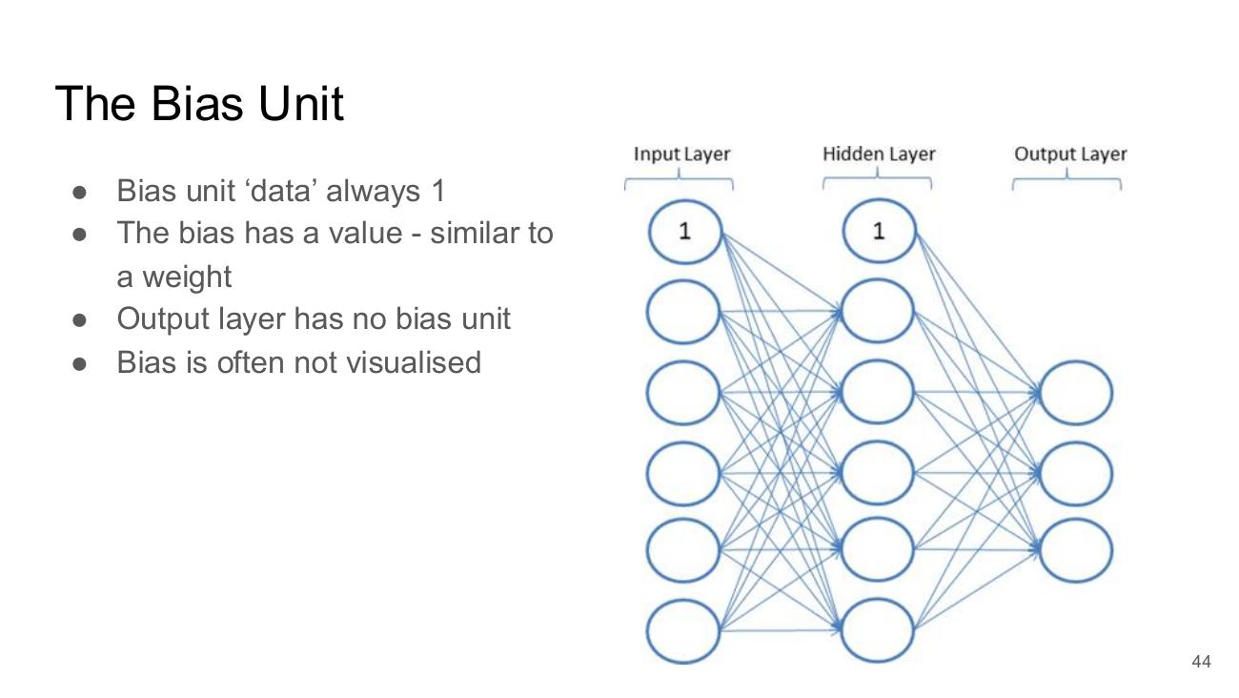

Deep Feedforward Networks
- Input Layer → several Hidden Layers (…) → Output Layer
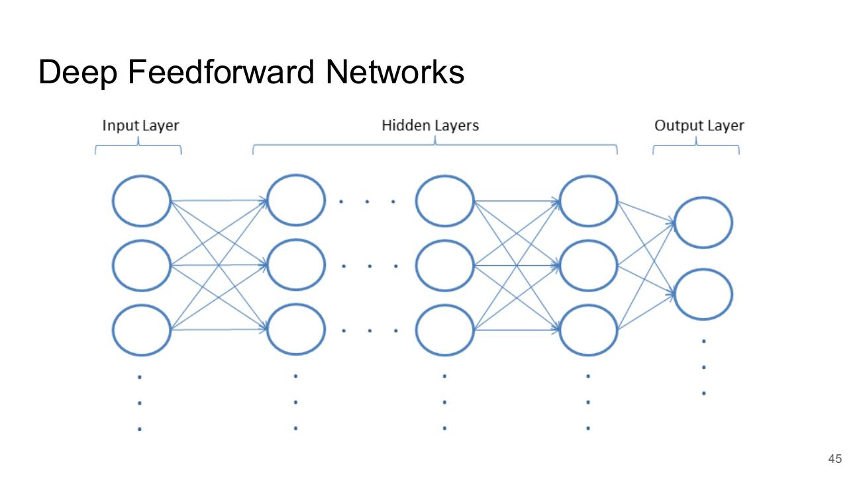

Aside: Note on Notation
- Data
- Data_Training = {(x⁰, y⁰), (x¹, y¹), (x², y²) … (x^(m−1), y^(m−1))}
- Nodes
- a = activation or h
- z = logit
- a^l_u (layer l, unit u)
- a⁰ refers to the vector of activation values for our input layer. This will correspond to our input vector x
- a^(L−1) refers to the vector of activation values for our output layer. This will be our output vector y.
- a¹ refers to the vector of activation values on our (first) hidden layer.
- a¹₀ refers to the activation value of the bias unit on our (first) hidden layer. This will always be 1.
- a¹₃ refers to the activation value of the 3rd (non-bias) unit in the (first) hidden layer as illustrated below.
- Weights
- θ⁰ refers to the weights emerging from the input layer
- θ^(L−2) refers to the layer of weights feeding in to the output layer
- θ¹ refers to the weights emerging from the (first) hidden layer
- θ¹₀,₁ refers to the weight from the bias unit in the (first) hidden layer to the first unit in the following layer
- θ¹₅,₂ refers to the weight highlighted in the figure below.
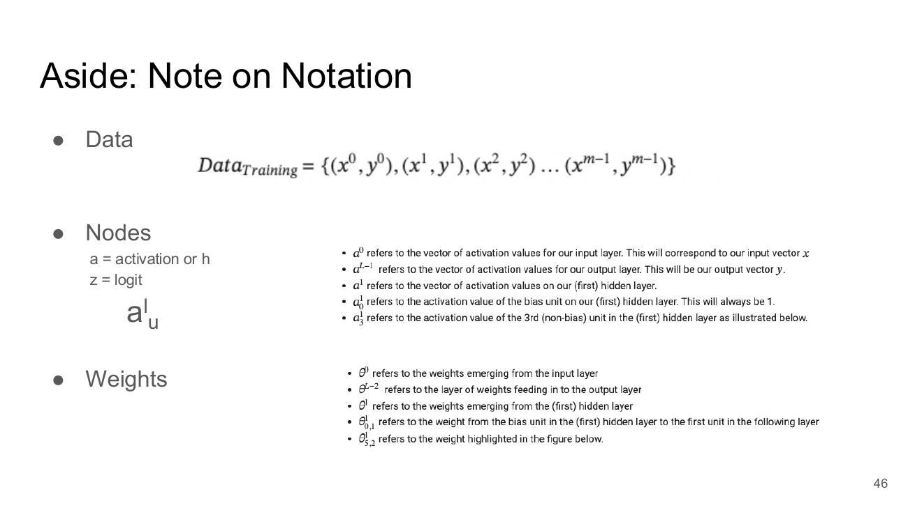

The Feedforward Algorithm
- For Each Layer from the First Hidden Layer to Output
- Calculate z = ( Input * Weights ) + Bias
- For first hidden layer input comes directly from input layer data
- Calculate Activation of neuron
- Sigmoid Function or maybe just a linear function
- Pass output through as input to next layer
- In the case of output layer we don’t have anywhere to pass the result but it can then be returned
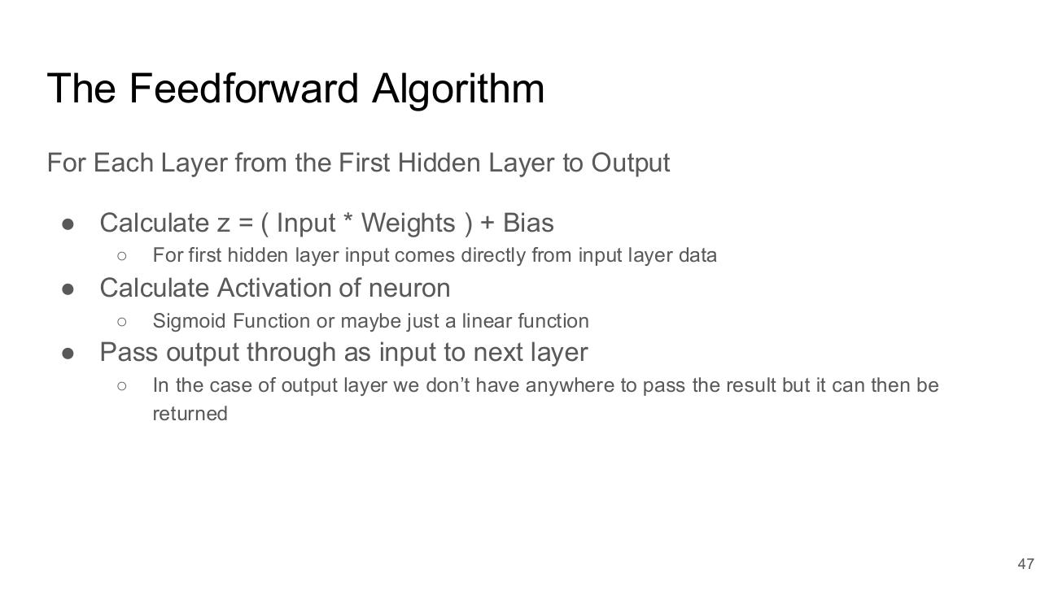

The Feedforward Algorithm
- Diagram: fully connected network (4 inputs → two hidden layers of 6 → 3 outputs)
- https://community.alteryx.com/t5/Data-Science-Blog/It-s-a-No-Brainer-An-Introduction-to-Neural-Networks/ba-p/300479
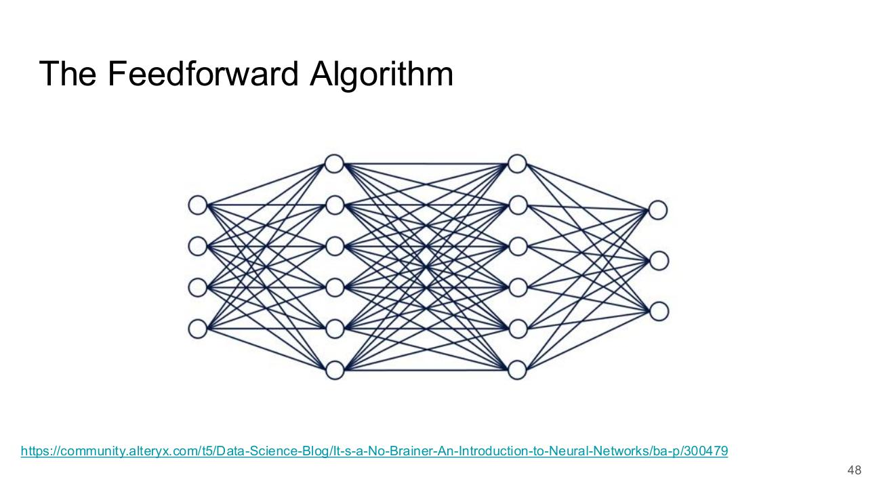

Network Design in Code

Network Design in Tensorflow - Functional
- model = keras.Sequential()
- model.add(layers.Dense(64, activation="sigmoid"), input_shape=(16,)))
- model.add(layers.Dense(32, activation="sigmoid"))
- model.add(layers.Dense(1))
- Using the Functional Model
- Useful when you might have different routes through your network, or any other place where you might need to combine multiple elements
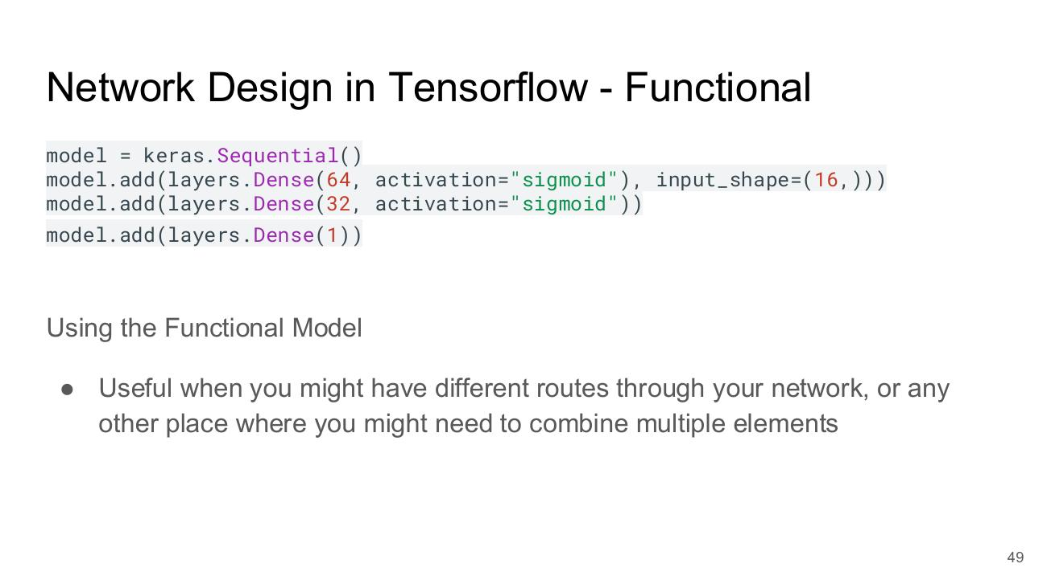

Functional Versus Sequential Models
- Sequential API: Input → Layer → Output (single path)
- Functional API: Input → two parallel Layers → merged → Output
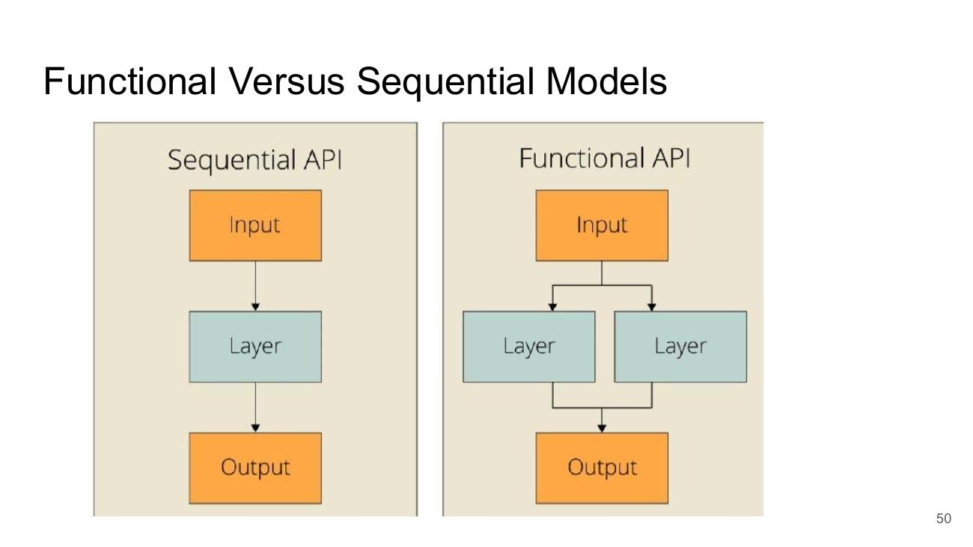

Example of Functional Model
- # Define the two distinct input layers
- # The shapes must match the number of features in each path
- input_A = keras.Input(shape=[5], name="wide_input")
- input_B = keras.Input(shape=[6], name="deep_input")
- hidden1 = layers.Dense(30, activation="relu")(input_B)
- hidden2 = layers.Dense(30, activation="relu")(hidden1)
- concat = layers.concatenate([input_A, hidden2])
- output = layers.Dense(1, name="output")(concat)
- model = keras.Model(inputs=[input_A, input_B], outputs=[output])
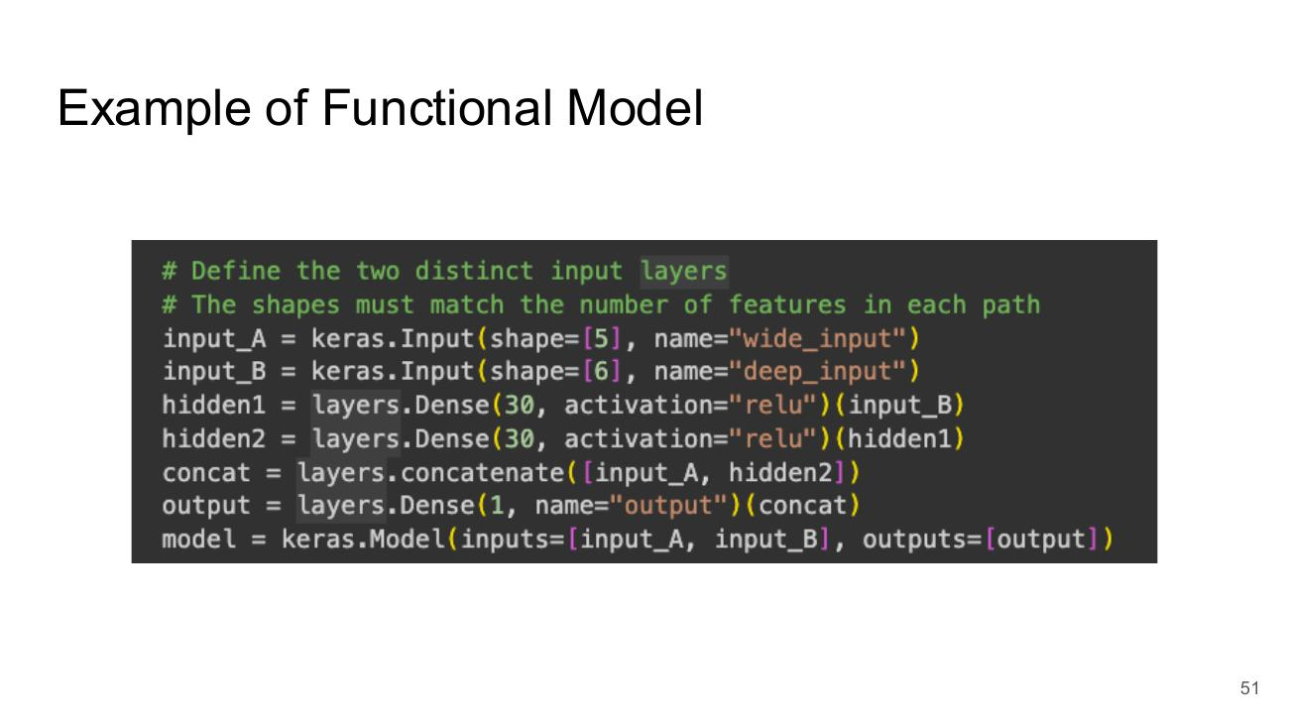

Sequential Vs Functional in Pytorch
- Sequential:
- import torch.nn as nn
- # A simple sequential model
- model = nn.Sequential(
- nn.Linear(784, 128),
- nn.ReLU(),
- nn.Linear(128, 10)
- )
- Functional-style (nn.Module):
- import torch
- import torch.nn as nn
- # A more complex functional-style model using nn.Module
- class MyModel(nn.Module):
- def __init__(self):
- super(MyModel, self).__init__()
- self.fc1 = nn.Linear(784, 128)
- self.relu = nn.ReLU()
- self.fc2 = nn.Linear(128, 10)
- def forward(self, x):
- # The data flow is explicitly defined
- x = self.fc1(x)
- x = self.relu(x)
- x = self.fc2(x)
- return x
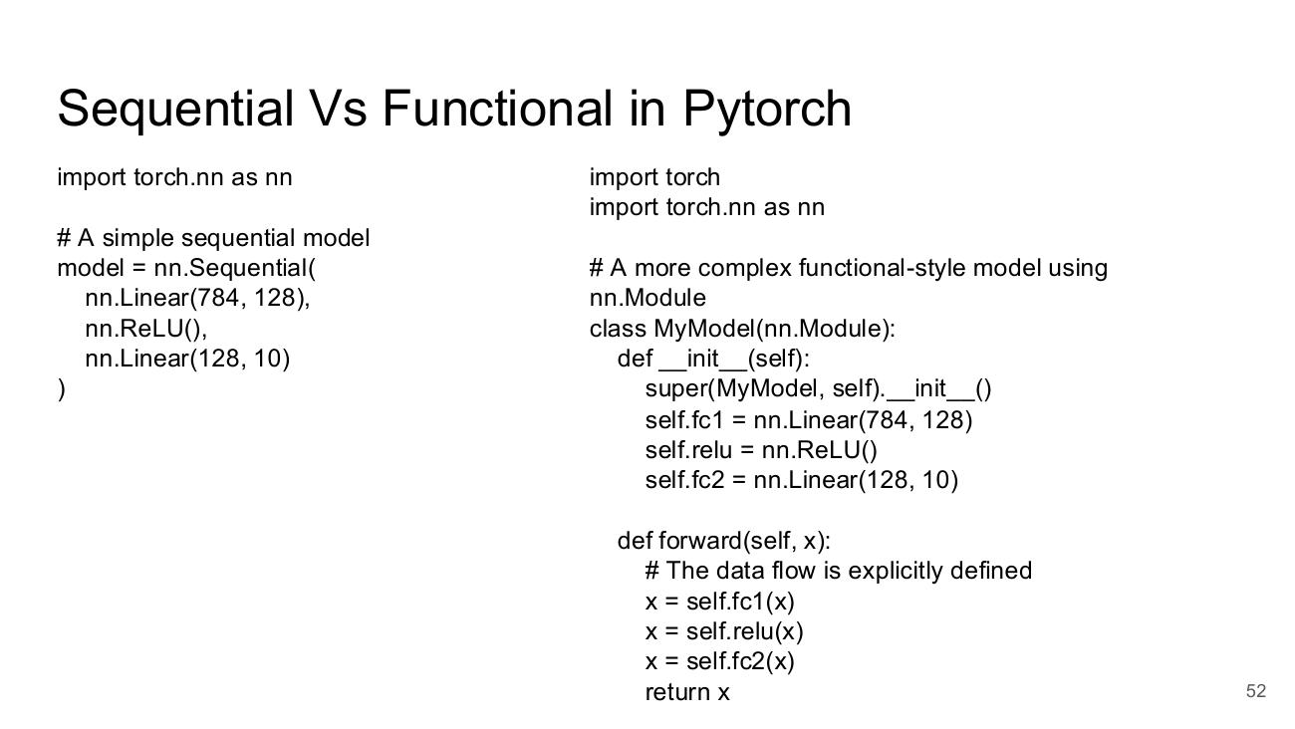

Lab Work

Lab Work
- See last week.
- You should be comfortable using both Collab but also VS Code supported by github-copilot on a local install.
- Review and execute the notebook for this week.
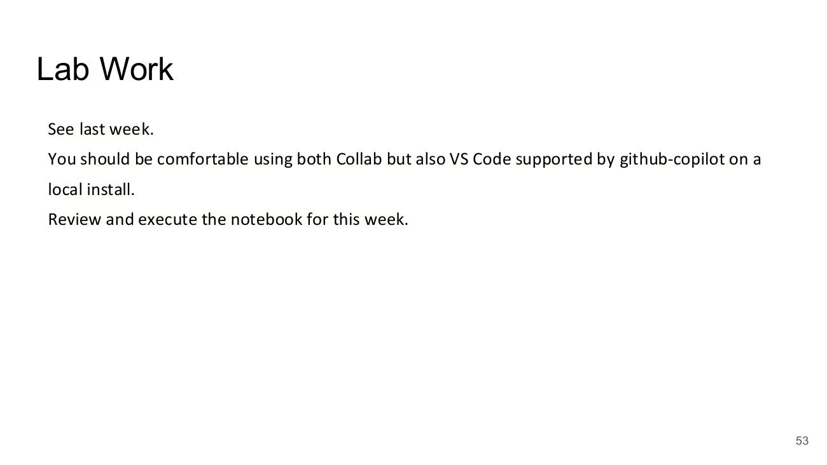

References

Neural Network Essentials
- Image credit (Goal: Develop Understanding / Interpretation) – spotonsolutions.com, ‘Monday Mo: Knowing vs Understanding and why it matters’ – https://www.google.com/url?sa=i&url=https%3A%2F%2Fspotonsolutions.com%2Fmonday-mo-knowing-vs-understanding-and-why-it-matters%2F&psig=AOvVaw38ZggrgKkNhbhTNHX4y60P&ust=1757921193385000&source=images&cd=vfe&opi=89978449&ved=0CBgQjhxqFwoTCPjtiPnc148DFQAAAAAdAAAAABAE
- Towards Data Science – CNN application on structured data: automated feature extraction – https://towardsdatascience.com/cnn-application-on-structured-data-automated-feature-extraction-8f2cd28d9a7e (Avoiding Hand Crafted Features)
- Alteryx Community – It's a No Brainer: An Introduction to Neural Networks – https://community.alteryx.com/t5/Data-Science-Blog/It-s-a-No-Brainer-An-Introduction-to-Neural-Networks/ba-p/300479 (The Feedforward Algorithm)

Week 3 - Network Training and Loss Functions

Introduction and Recap

Deep Learning Course – Network Training and Loss Functions
- Deep Learning Course
- Network Training and Loss Functions


Reminder: Network Architecture
- Input Layer → Hidden Layers (…) → Output Layer
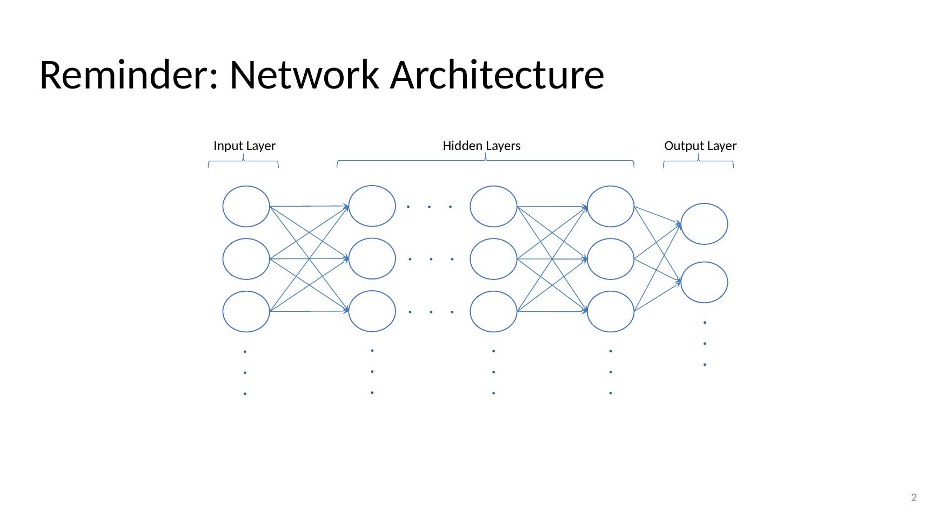

Logits and Activation Functions
- Network: Input Layer (X, X, X) → Hidden Layer → Output Layer → outputs Y0, Y1, Y2
- Each unit split into Logit (z) and Activation Function (a)
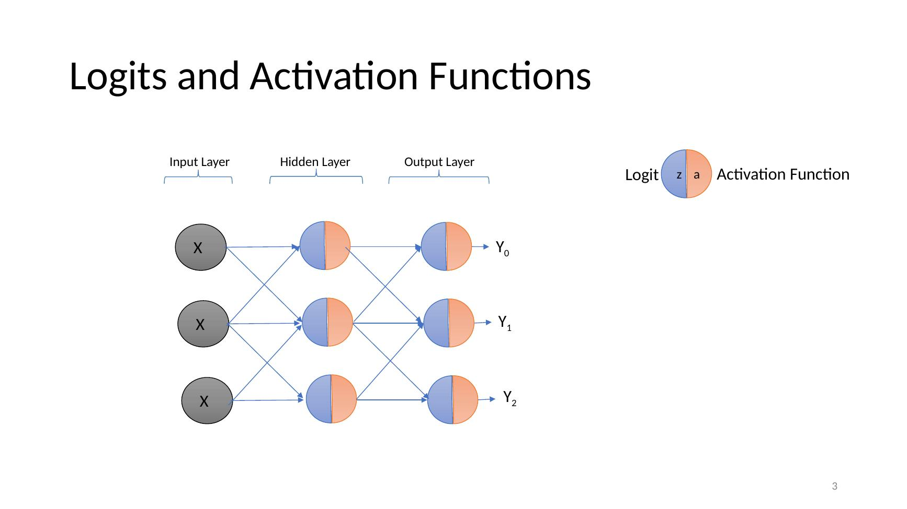

Forward Propagation
- Network: Input Layer (X, X, X) → Hidden Layer → Output Layer → outputs Y0, Y1, Y2
- Each unit split into Logit (z) and Activation Function (a)
- (Animated slide: signal flows forward from input to output)
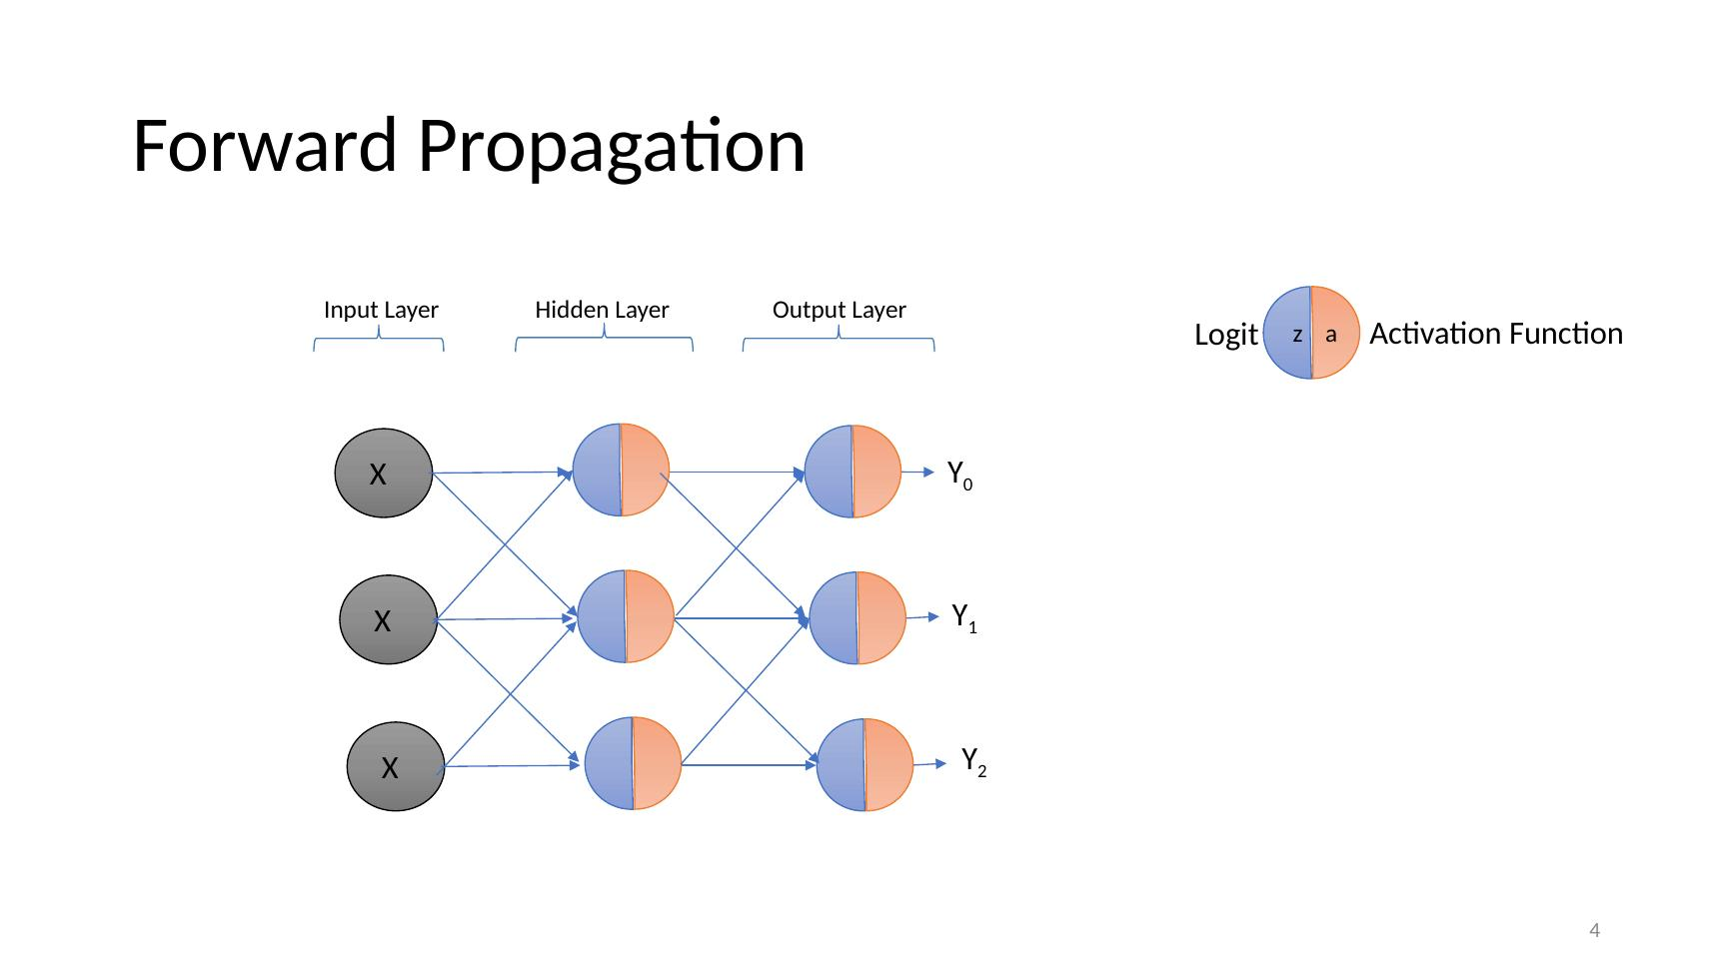

Recap:
- Regression and Classification as Fundamental Tasks
- Hand crafted parameters are OK, but let’s allow the Neural Network to learn the parameters instead
- Neural Networks: units, layers, weights, biases
- Generally, we supply the units and layers, and we allow the network to learn the weights and biases
- Signal flows from the input layer to the output layer through a ‘Feed Forward Algorithm’
- The input to a given unit is called a logit – product of values from last layer x parameters (weights and biases)
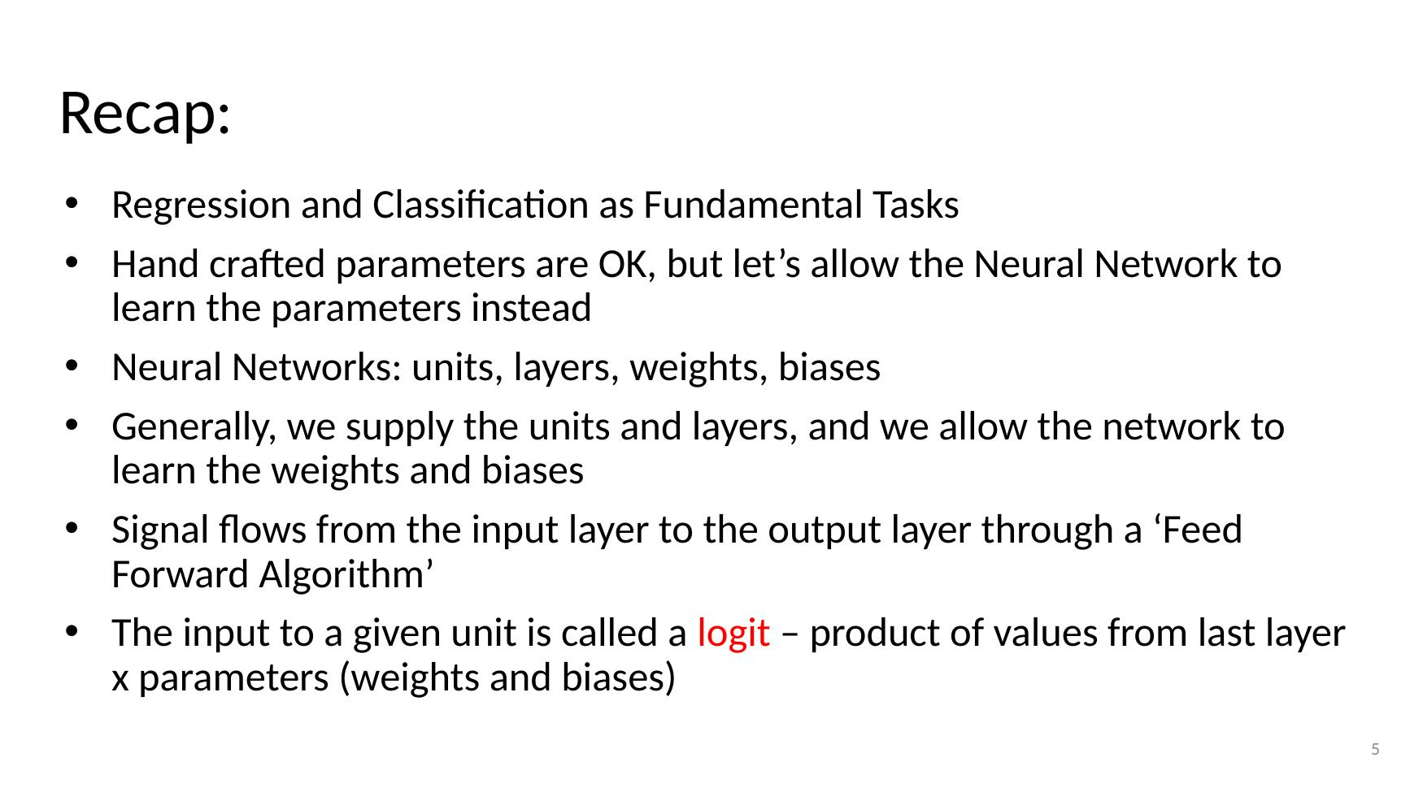

Questions
- For a given input, do we always compute the same output?
- What are the parameters of the network?
- What are the hyperparameters of the network?
- Given a layer of the network where the weights are all = 0, what can we say about the logit values of the following layer?
- Draw out an example feedforward network with more outputs than inputs? Why might a network like this make sense?
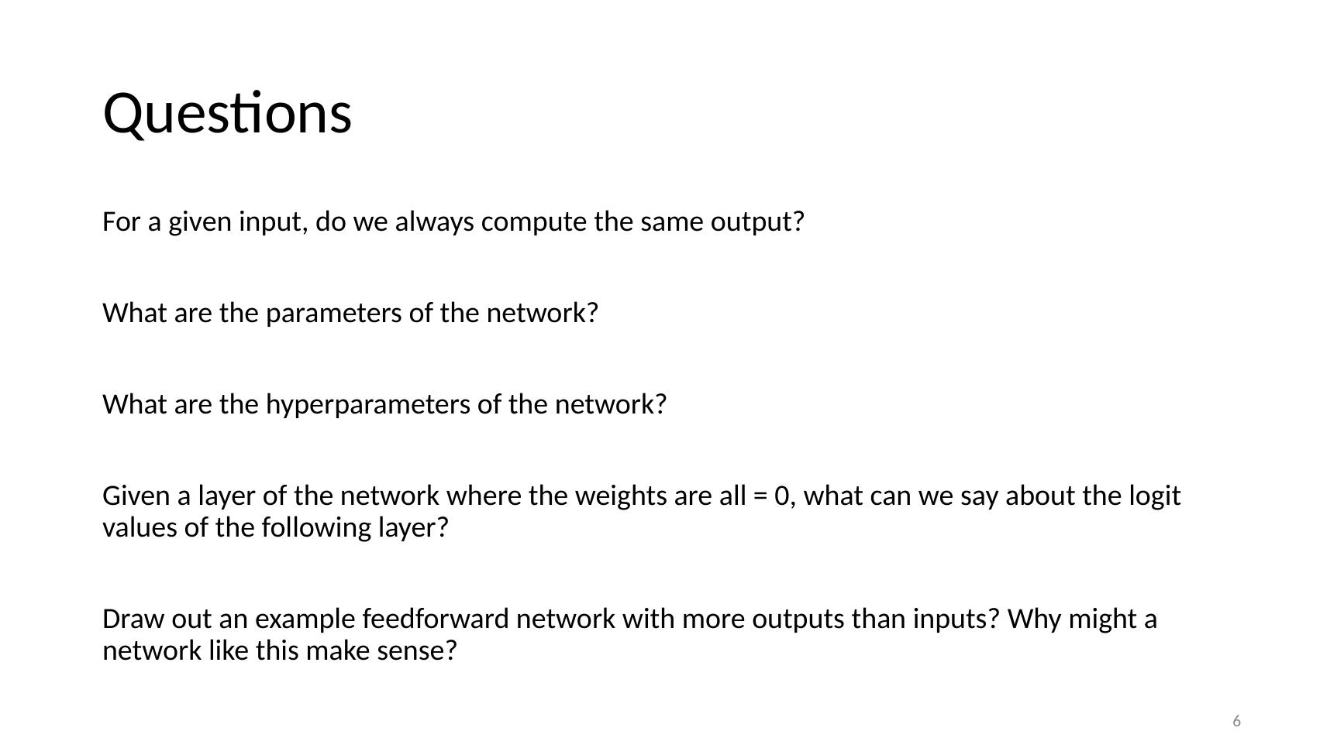

Backpropagation

Backpropagation
- Backpropagation (section divider)
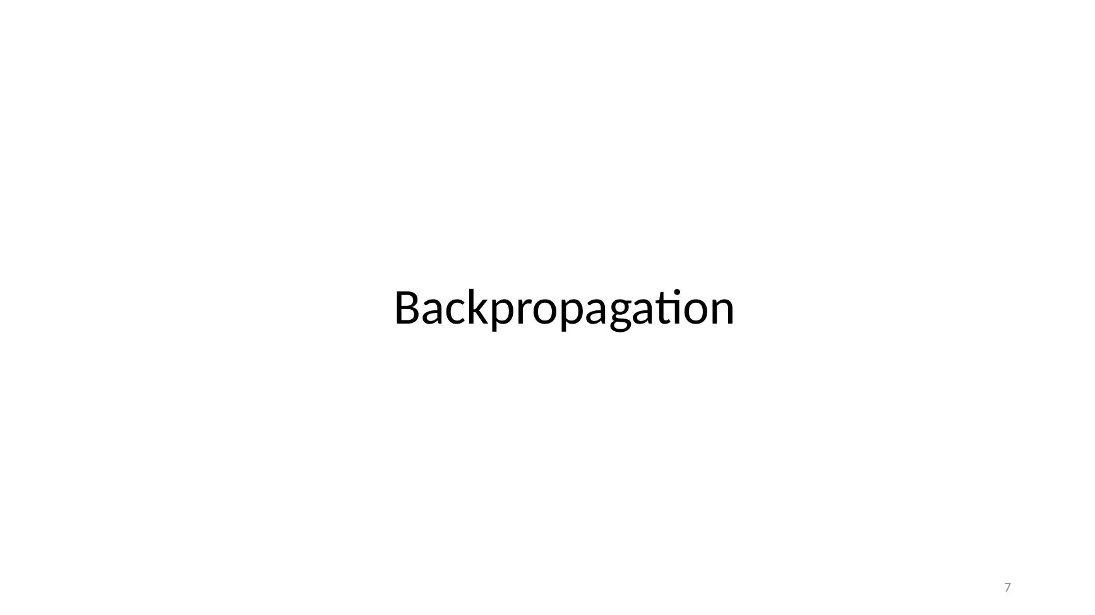

From Inputs to Loss
- Feed new data X1, X2, X3 → Input Layer → Hidden Layer 1 → Hidden Layer 2 → Output Layer → Y_pred
- Error = difference between Y_pred and Y
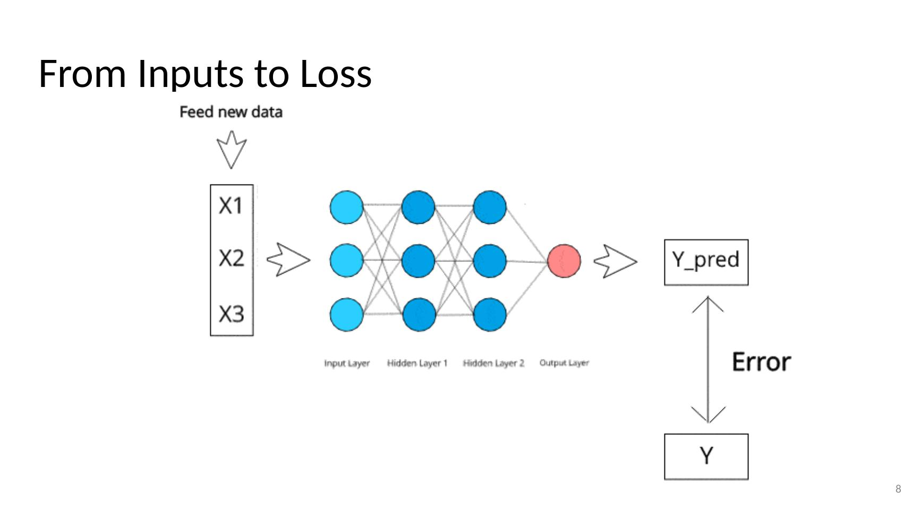

Learning the Parameters aka Training the Network
- Images: a simple bowl-shaped loss surface and a complex loss surface with many hills and valleys
- https://blog.paperspace.com/intro-to-optimization-in-deep-learning-gradient-descent/
- We cannot directly use optimisation as for Linear Regression and Logistic Regression
- Instead, we use optimisation alongside another algorithm that distributes the weight changes that are necessary
- This is the backpropagation algorithm
- Note that backpropogation gets the Gradient Descent bit ‘baked in’
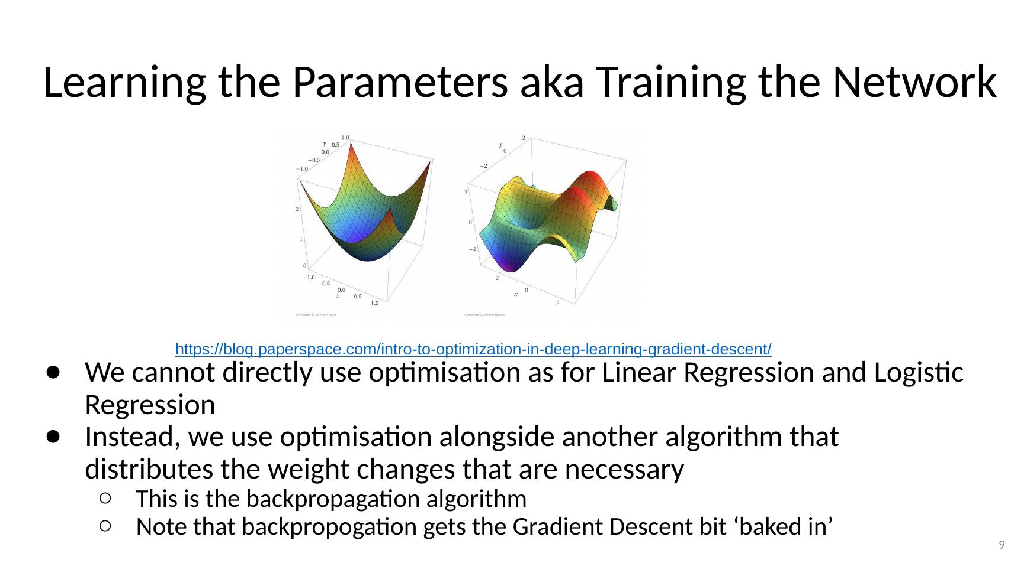

Backpropagation
- Diagram: bias unit 1 and error derivatives δ¹1, δ¹2 feeding δ²1 with weights 0.9, −0.5, 0.11; Sample Error Surface plot (Error vs Weight 1 and Weight 2)
- Idea 1: The recursive error derivative
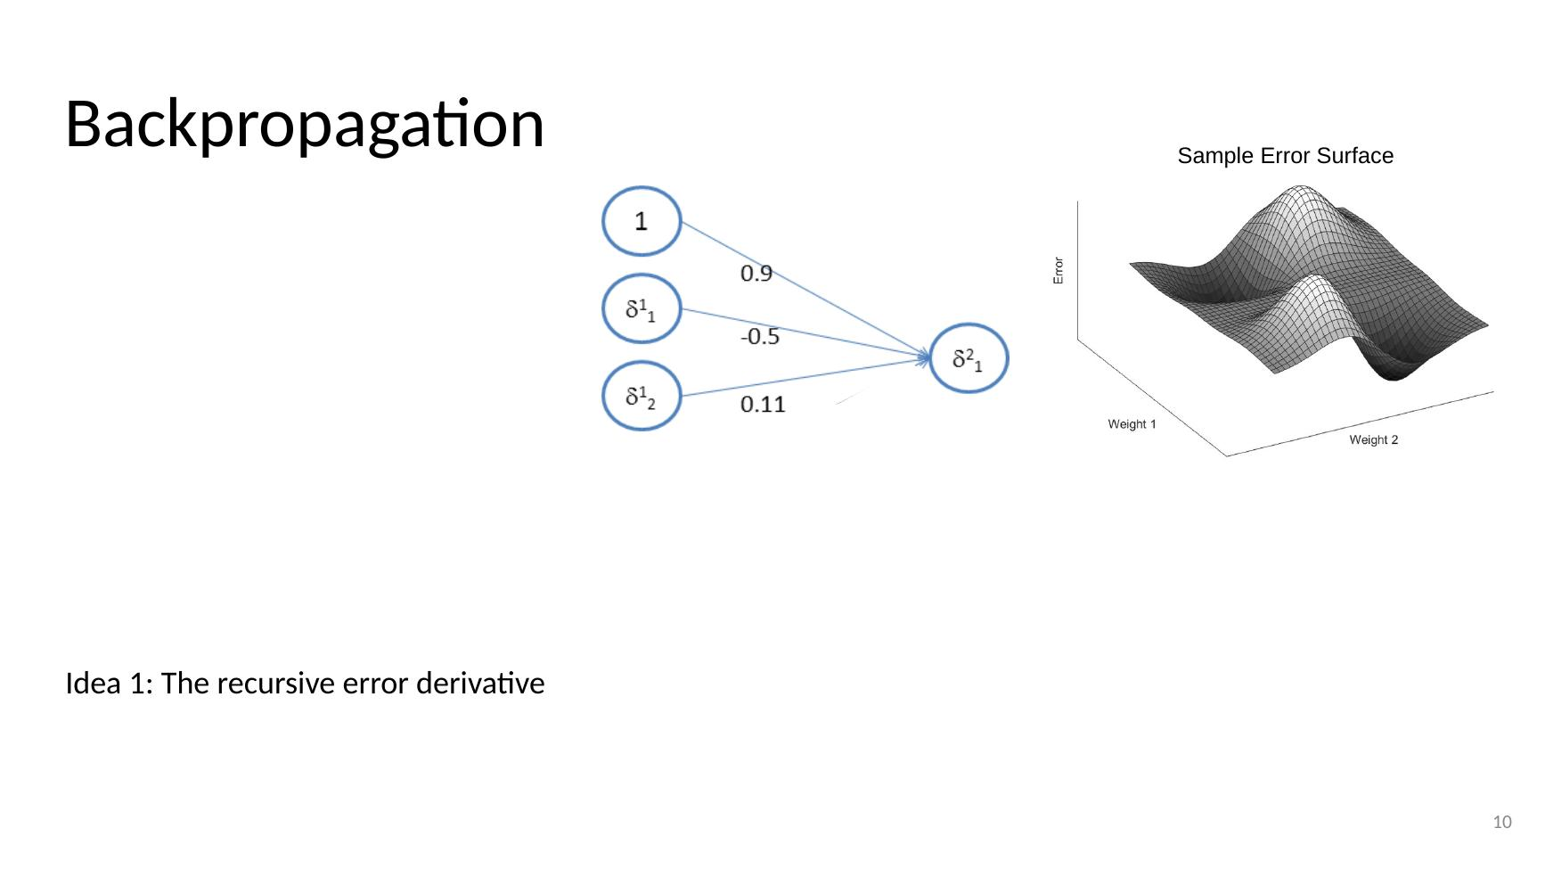

Backpropagation
- Diagram: bias unit 1 and error derivatives δ¹1, δ¹2 feeding δ²1 with weights 0.9, −0.5, 0.11; Sample Error Surface plot (Error vs Weight 1 and Weight 2)
- Idea 1: The recursive error derivative
- Error Derivatives: δˡ = (θˡ)ᵀ δˡ⁺¹ .× g′(zˡ)
- g′(zˡ) = aˡ (1 − aˡ)
- δ = ∂E/∂z
- ∂a/∂z = a(1 − a)
- Note, we tend to use g as the function name when it is being applied to (z). The function h on the other hand is often assumed to be applied to x, i.e., h(x), and has the logit calculation built in.
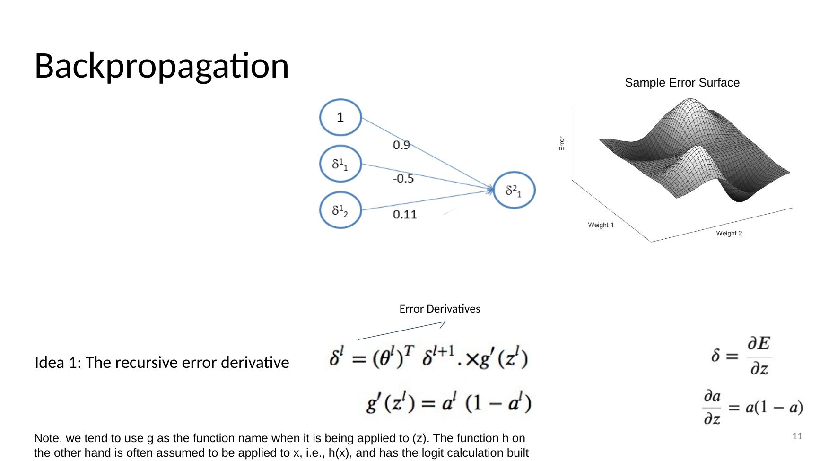

Backpropagation
- Diagram: bias unit 1 and error derivatives δ¹1, δ¹2 feeding δ²1 with weights 0.9, −0.5, 0.11; Sample Error Surface plot (Error vs Weight 1 and Weight 2)
- Idea 2: Output Layer Error Derivative
- δ = (a − y) .× g′(zˡ)
- g′(zˡ) = aˡ (1 − aˡ)
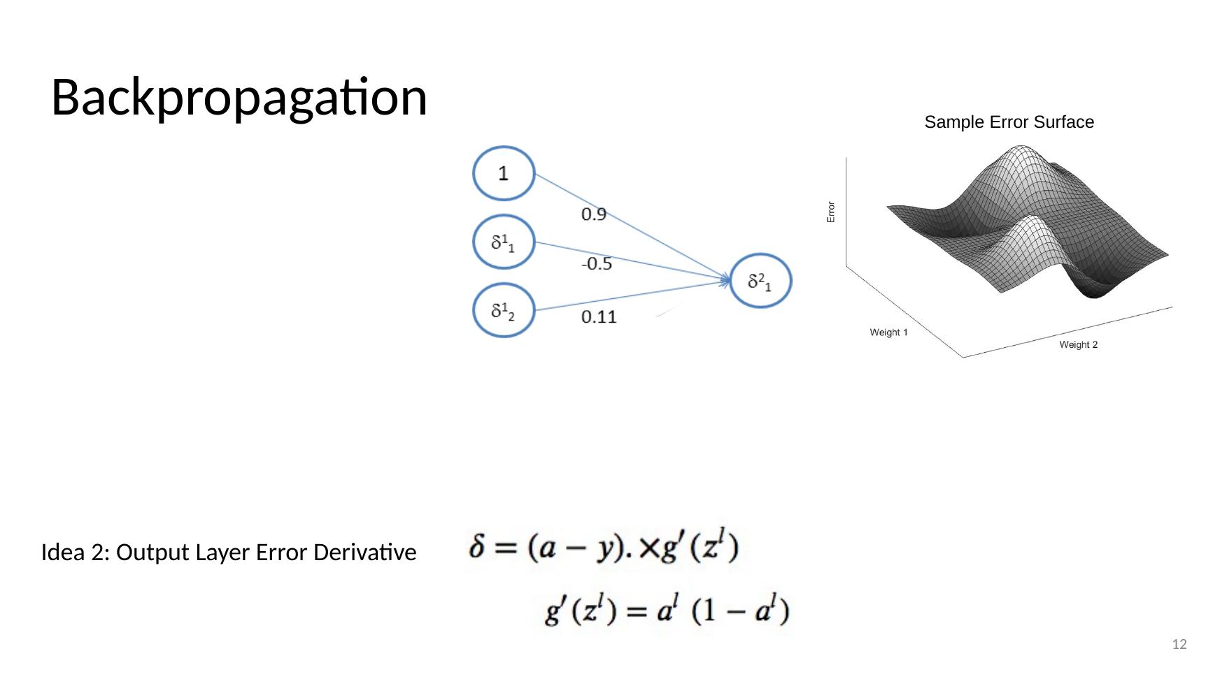

Backpropagation
- Diagram: bias unit 1 and error derivatives δ¹1, δ¹2 feeding δ²1 with weights 0.9, −0.5, 0.11; Sample Error Surface plot (Error vs Weight 1 and Weight 2)
- Idea 3: Weight Changes
- Δ^(l−1) = δ ai^(l−1)
- θ = θ + Δ
- Δ^(l−1) = ∂E/∂θi^(l−1)
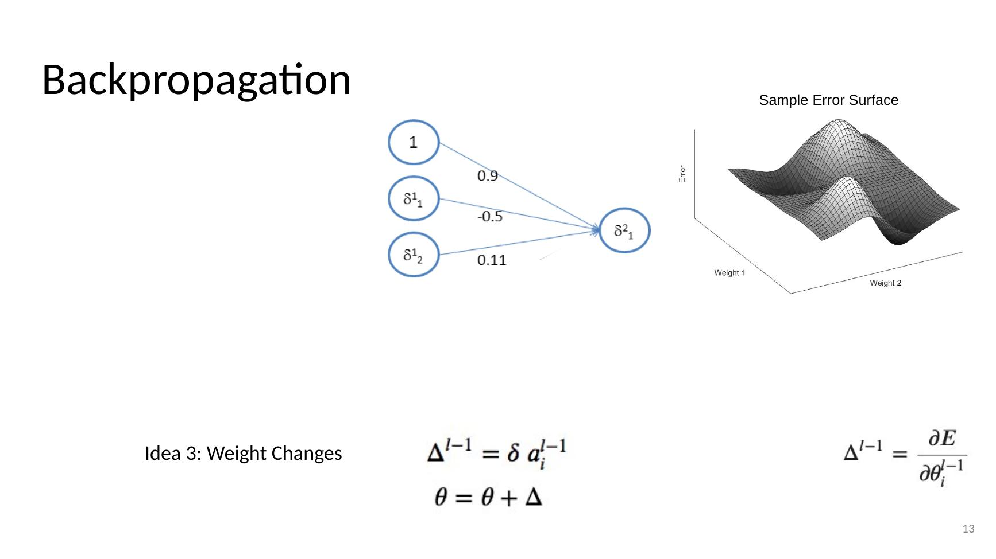

Backprop Overview
- Input Layer → Hidden Layers → Output Layer
- Calculate Error Derivative (not error) for final layer
- Calculate Error Derivative for prior layer - proportional to derivative in final layer, weights, and activation in prior layer
- Calculate weight updates to be made.
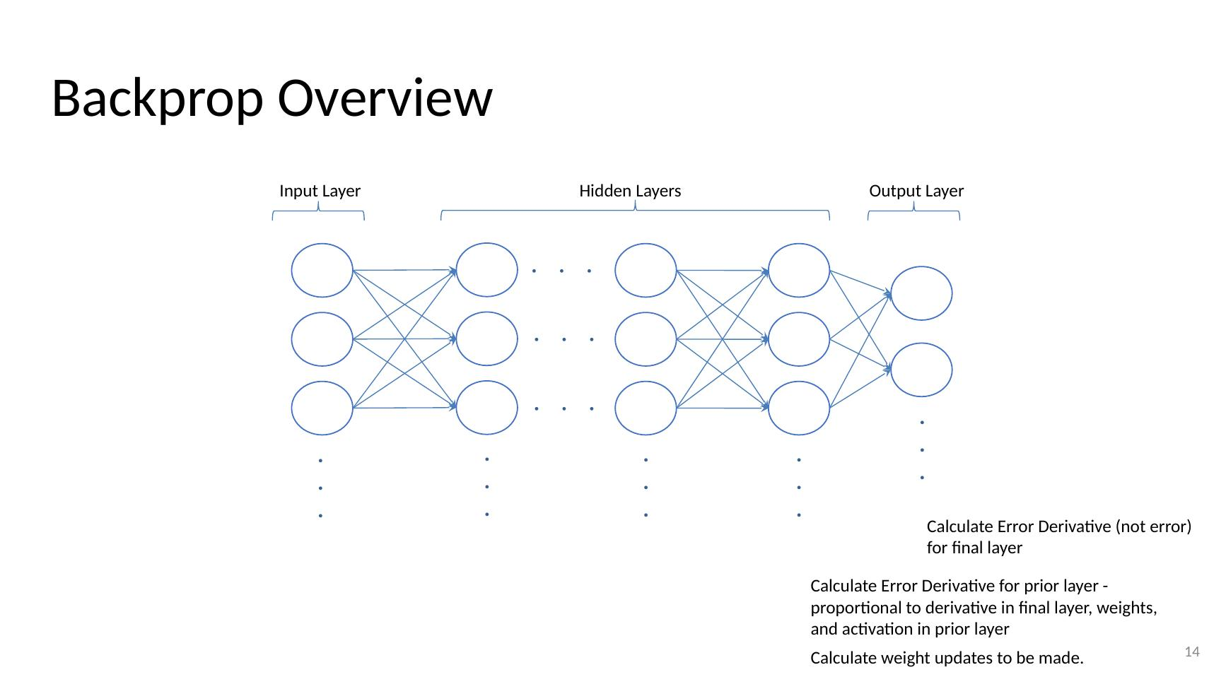

Backpropagation Algorithm

Backpropagation Algorithm
- For each instance i in the training data:
- Forward Propagate x[i] through the network
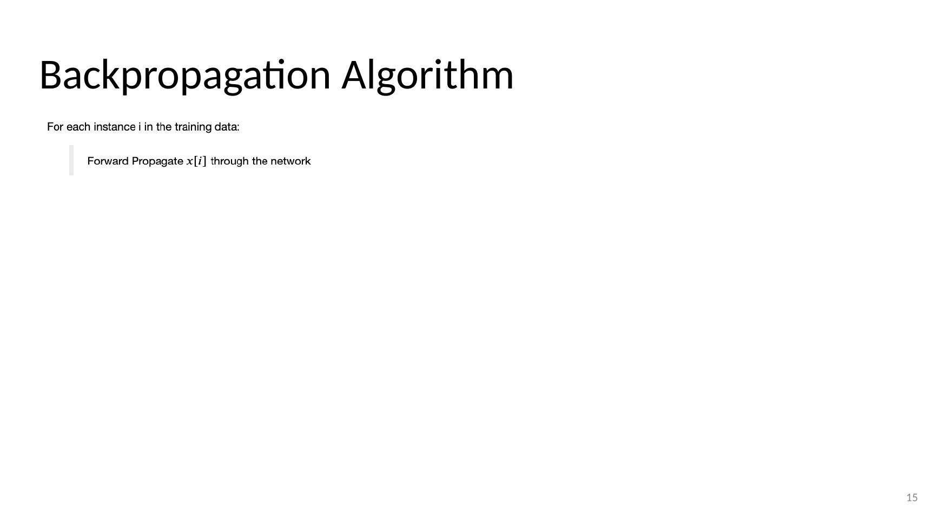

Backpropagation Algorithm
- For each instance i in the training data:
- Forward Propagate x[i] through the network
- Backpropagate Error Derivatives back through the network
- Calculate error derivative for final layer using δ = (a − y) (a(1 − a)) for y[i]
- δ = (a − y) (a(1 − a)) for y[i]
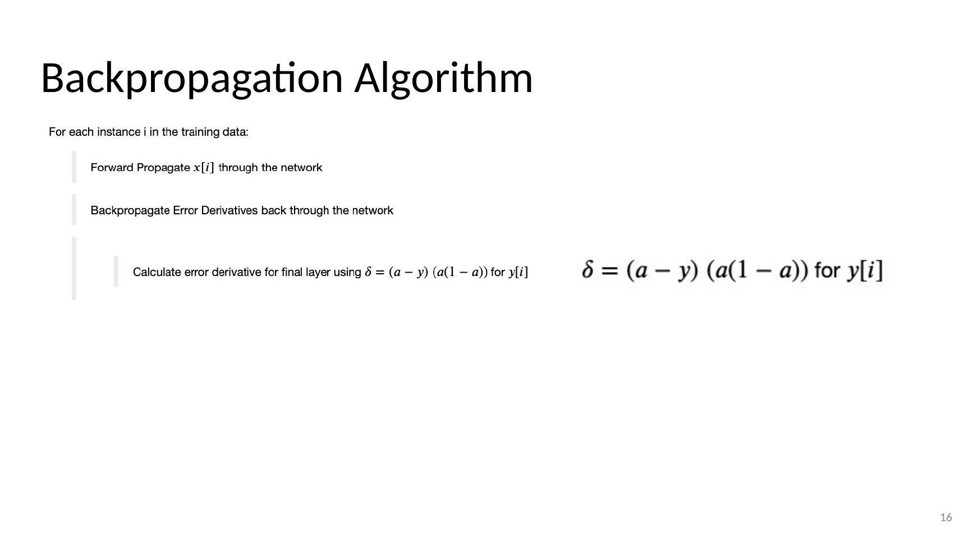

Backpropagation Algorithm
- For each instance i in the training data:
- Forward Propagate x[i] through the network
- Backpropagate Error Derivatives back through the network
- Calculate error derivative for final layer using δ = (a − y) (a(1 − a)) for y[i]
- Calculate error derivative for hidden layers using δˡ = Σj (δˡ⁺¹ θˡi) g′(zˡ)
- δ = (a − y) (a(1 − a)) for y[i]
- δˡ = Σj (δˡ⁺¹ θˡi) g′(zˡ)
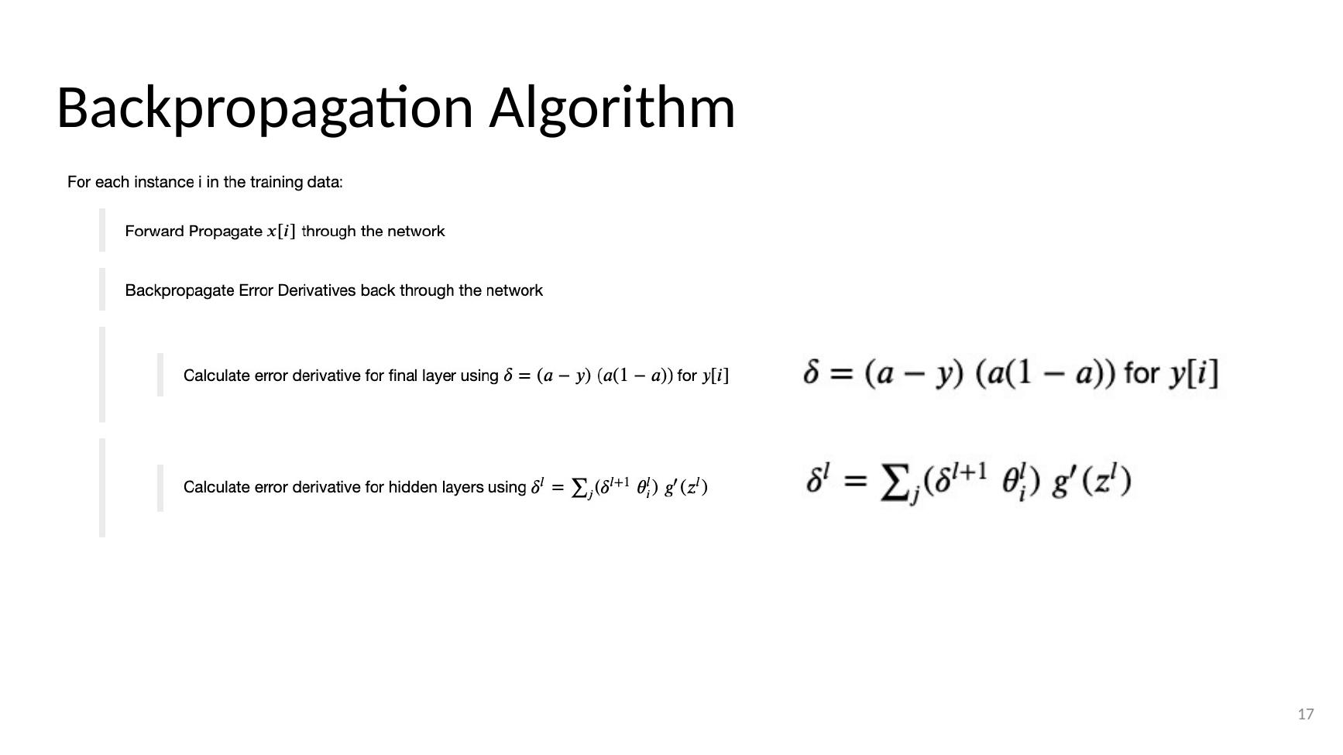

Backpropagation Algorithm
- For each instance i in the training data:
- Forward Propagate x[i] through the network
- Backpropagate Error Derivatives back through the network
- Calculate error derivative for final layer using δ = (a − y) (a(1 − a)) for y[i]
- Calculate error derivative for hidden layers using δˡ = Σj (δˡ⁺¹ θˡi) g′(zˡ)
- For each hidden layer accrue weight updates Δij⁽ˡ⁾ = Δij⁽ˡ⁾ + aj⁽ˡ⁾ δi⁽ˡ⁺¹⁾
- δ = (a − y) (a(1 − a)) for y[i]
- δˡ = Σj (δˡ⁺¹ θˡi) g′(zˡ)
- Δij⁽ˡ⁾ = Δij⁽ˡ⁾ + aj⁽ˡ⁾ δi⁽ˡ⁺¹⁾
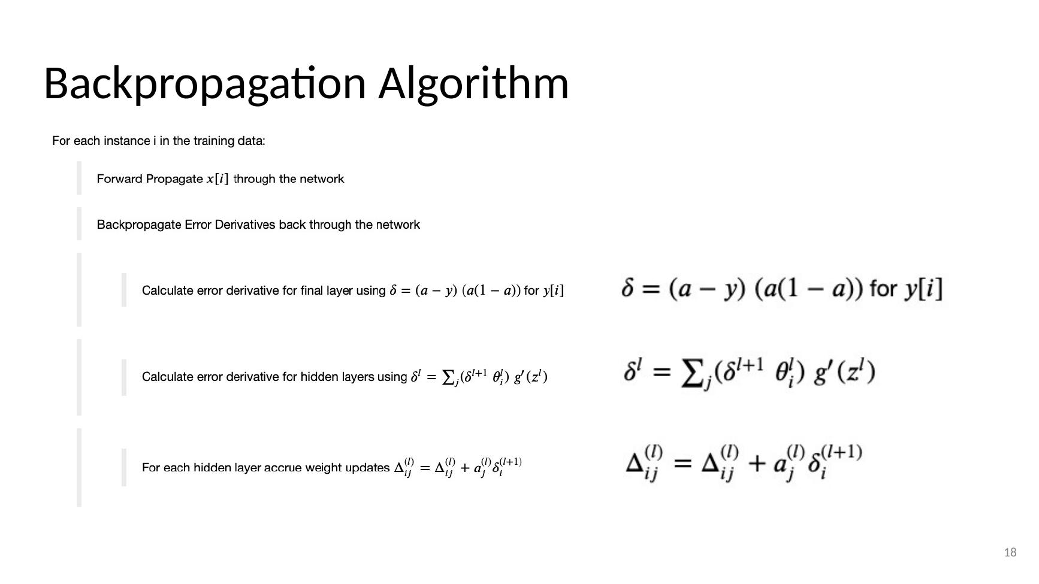

Backpropagation Algorithm
- For each instance i in the training data:
- Forward Propagate x[i] through the network
- Backpropagate Error Derivatives back through the network
- Calculate error derivative for final layer using δ = (a − y) (a(1 − a)) for y[i]
- Calculate error derivative for hidden layers using δˡ = Σj (δˡ⁺¹ θˡi) g′(zˡ)
- For each hidden layer accrue weight updates Δij⁽ˡ⁾ = Δij⁽ˡ⁾ + aj⁽ˡ⁾ δi⁽ˡ⁺¹⁾
- Update weights with accrued weight changes θ = θ + Δ
- δ = (a − y) (a(1 − a)) for y[i]
- δˡ = Σj (δˡ⁺¹ θˡi) g′(zˡ)
- Δij⁽ˡ⁾ = Δij⁽ˡ⁾ + aj⁽ˡ⁾ δi⁽ˡ⁺¹⁾
- θ = θ + Δ
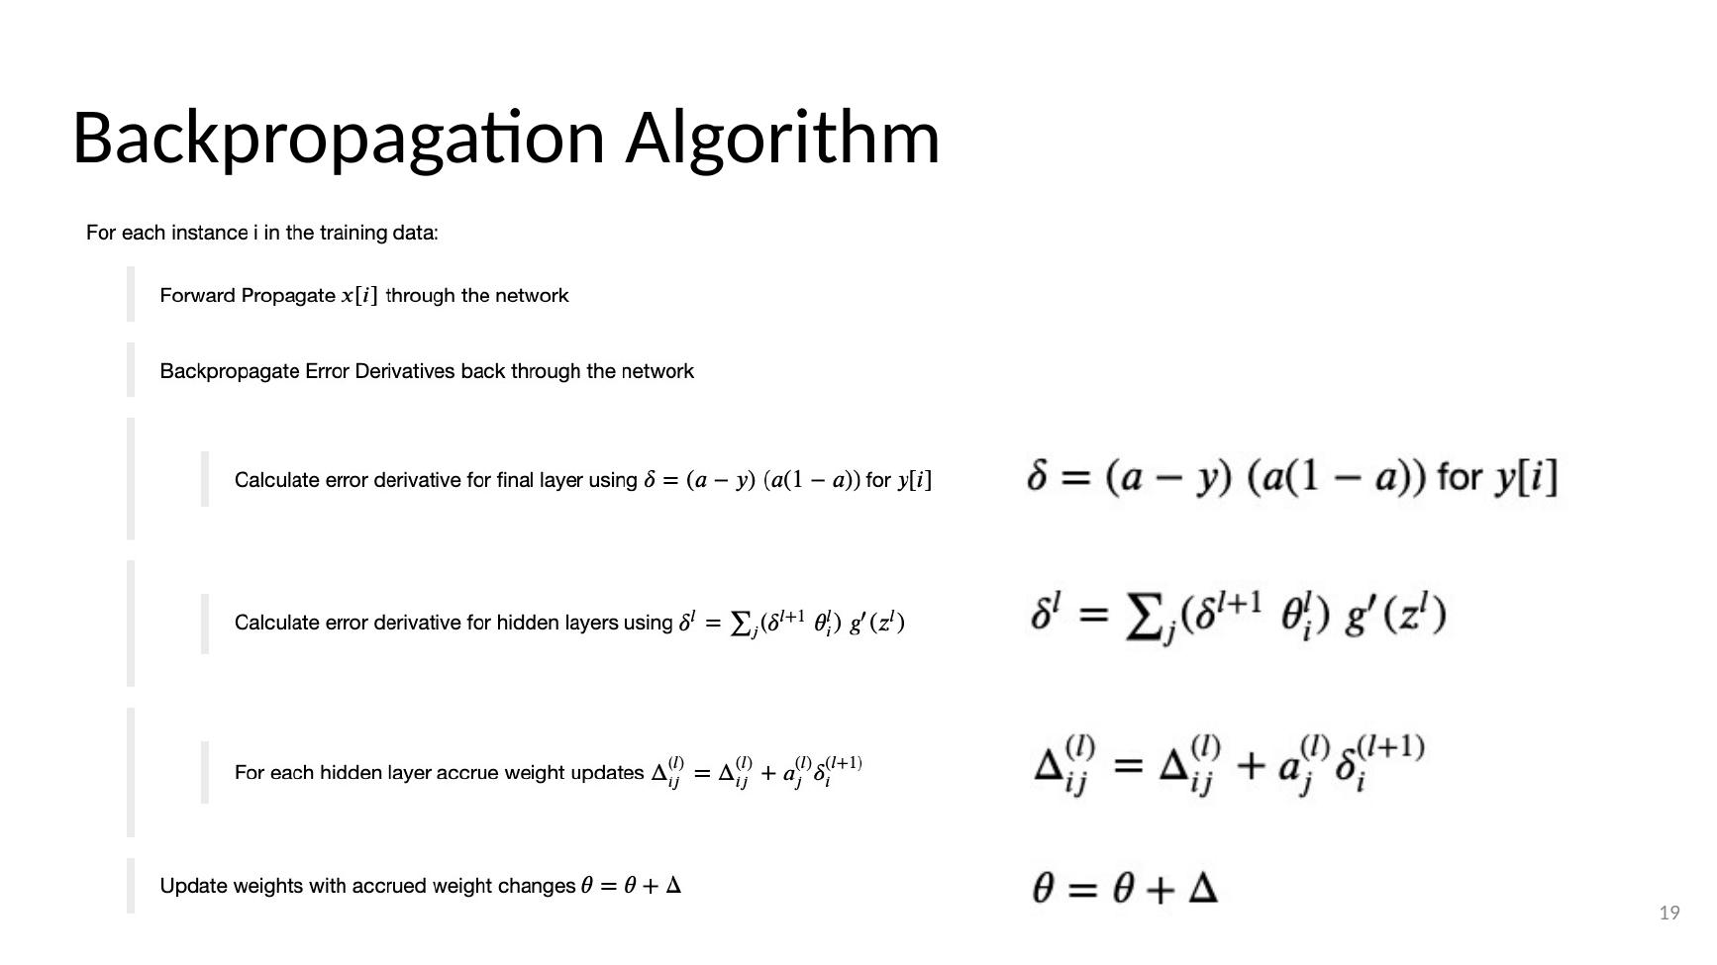

Training in progress… (Backpropagation Animation)
- Animation: handwritten 9 → 9; 784 input units → two hidden layers → outputs 0–9, with weights changing during training
- https://www.google.com/search?q=backpropagation&tbm=isch&tbs=itp%3Aanimated&hl=en&ved=0CAMQpwVqFwoTCIDx0LXVsOcCFQAAAAAdAAAAABAC&biw=1213&bih=608#imgrc=CufDRhQcARzdoM
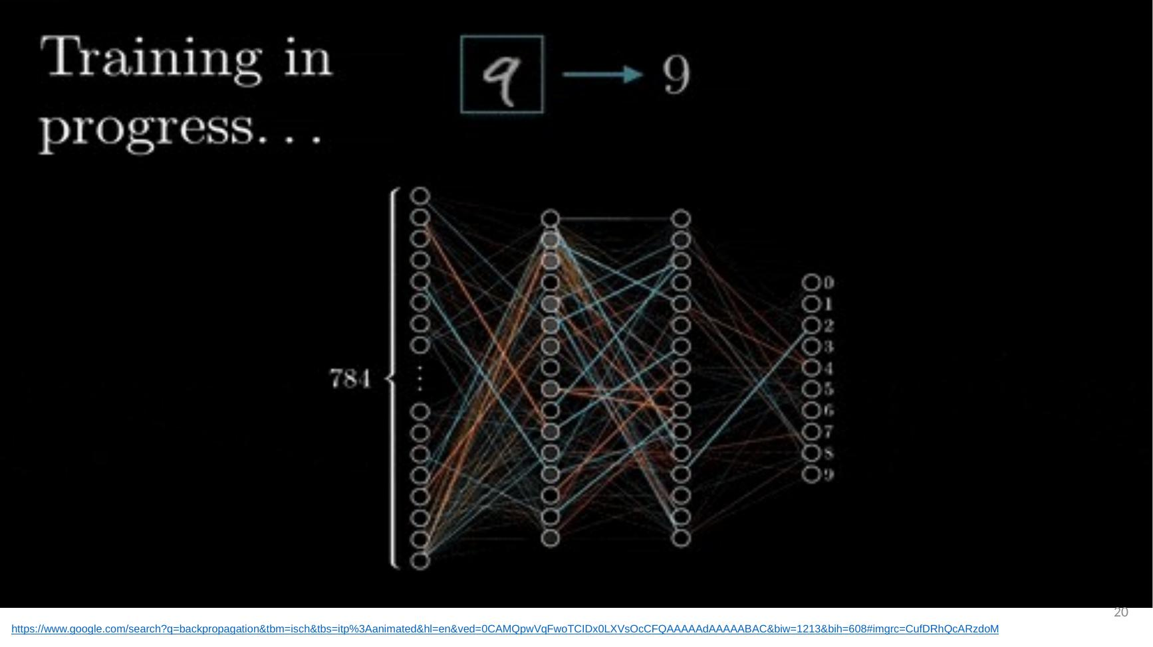

Deriving the Backpropagation Equations
- See the notebook!
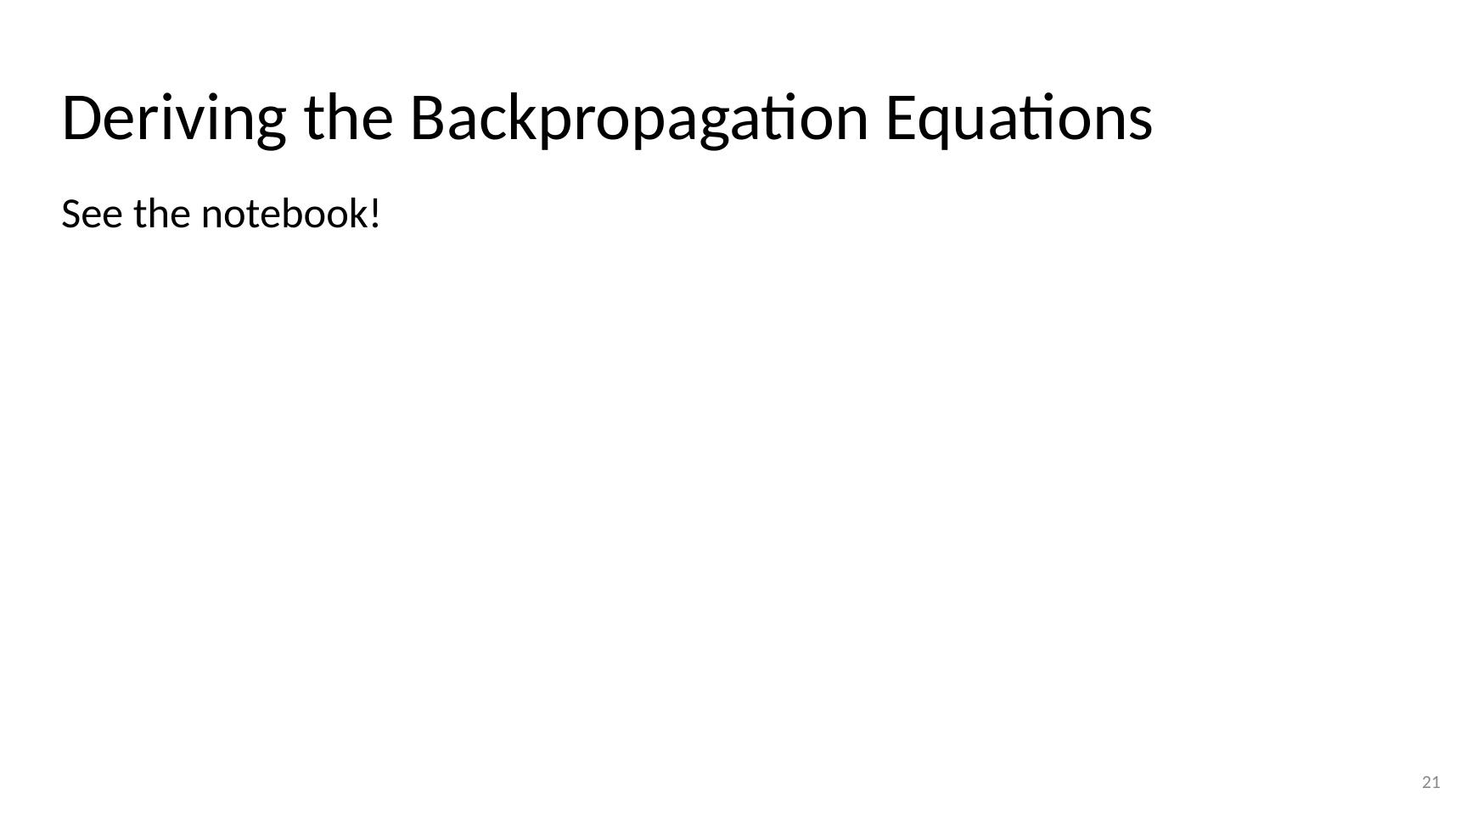

Do I need to know the derivations?
- In short, no. However, you should have an understanding of the terminology and ideas as presented in these slides. The derivations in the full notes will help you to understand the ideas at a much greater level of detail and clarity.
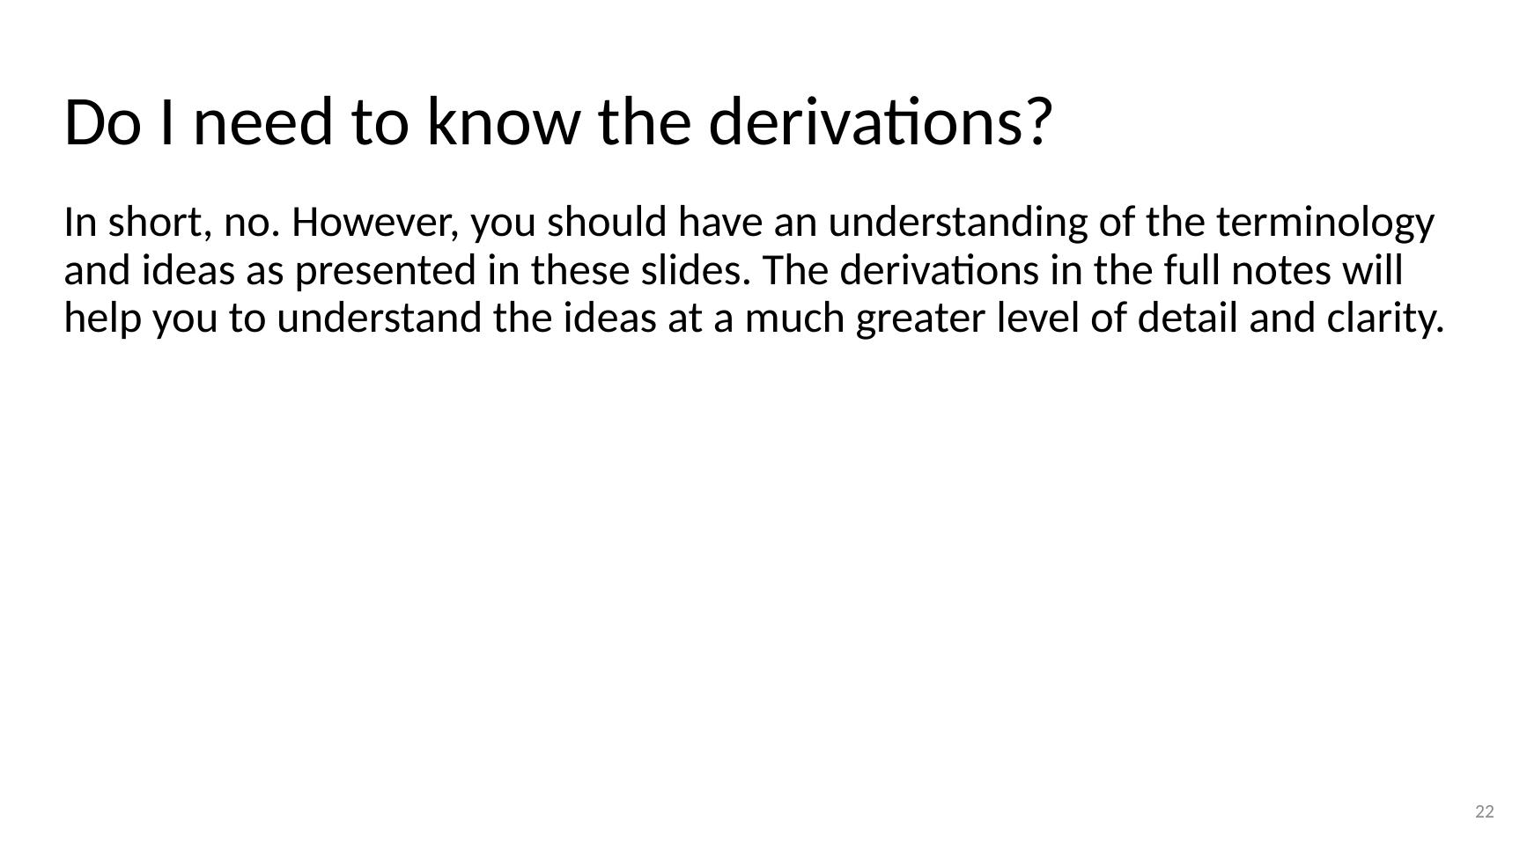

Backprop Assignment
- Split into small groups and discuss the following while keeping notes on the answers (20 mins):
- What is the relationship between Gradient Descent and Backprop?
- Do we need to calculate error for the backprop algorithm?
- What impact does backprop have on the input layer?
- What does it mean if a weight after training has a value close to 0 (relatively speaking)?
- Discuss the interaction between the backprop algorithm and network baiases.
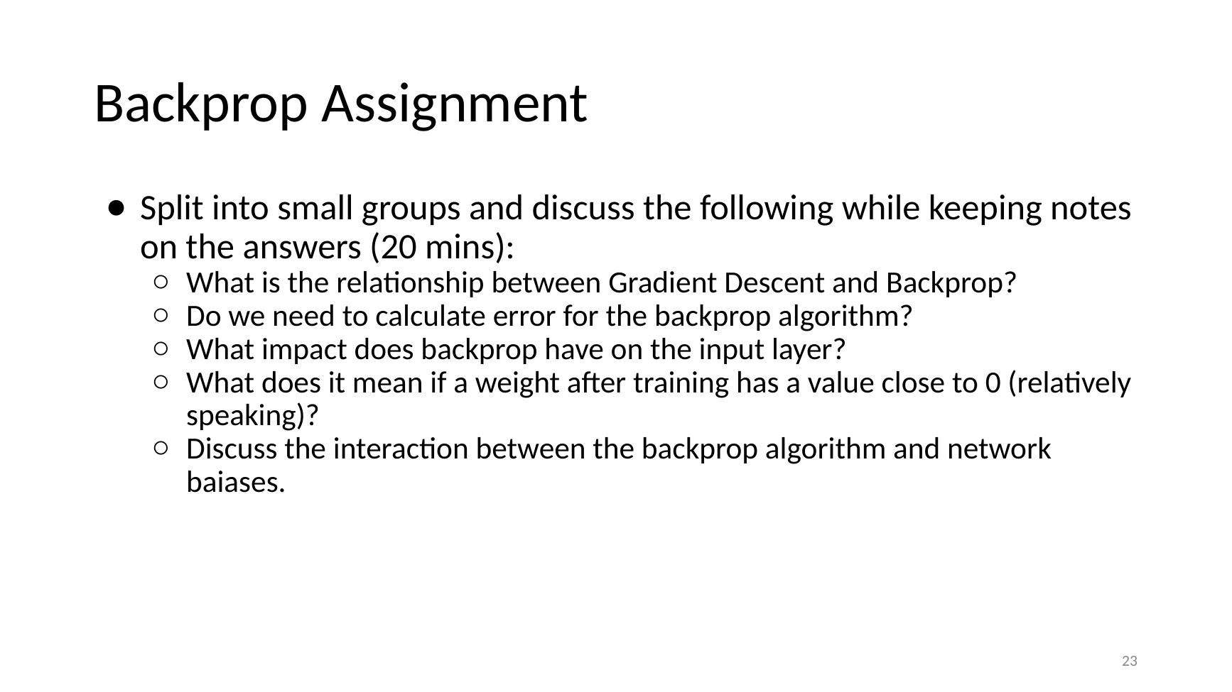

Losses for Neural Networks

Losses for Neural Networks
- Losses for Neural Networks (section divider)
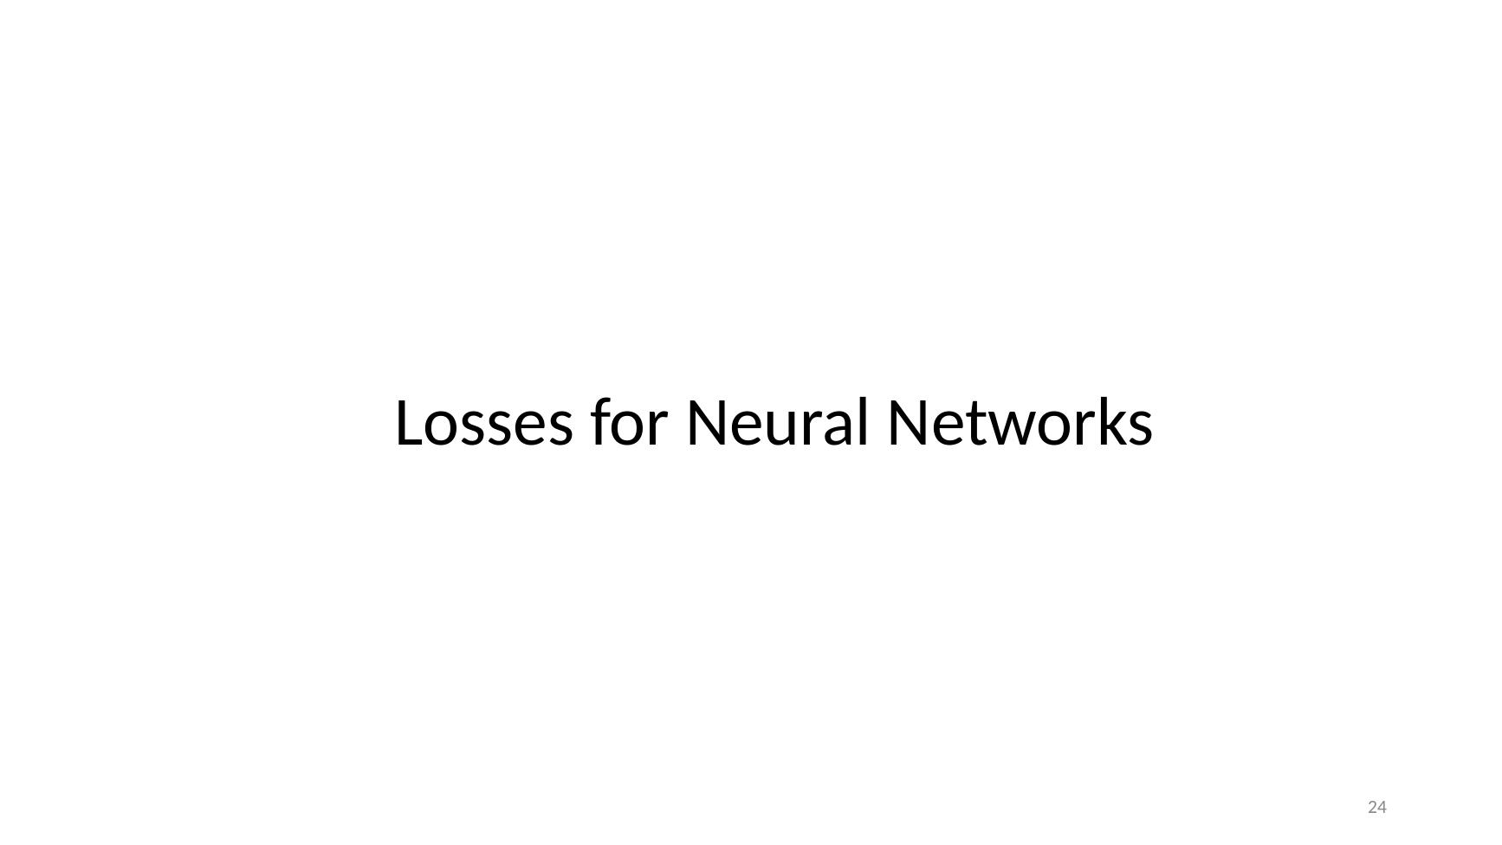

Note: We Used a Loss in Defn of Backprop
- Input Layer → Hidden Layers → Output Layer
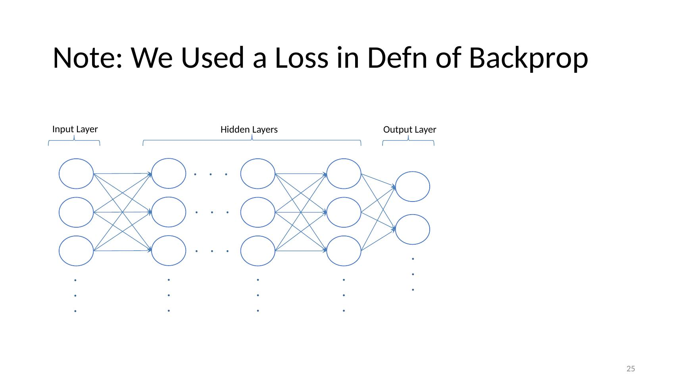

Calculating Errors – Real Valued Outputs
- Network: Input Layer (X, X, X) → Hidden Layer → Output Layer (single output unit)
- Example: predicted 8.7 vs target −10
- MSE = (1/n) Σ (i = 1 to n) (yi − ŷi)²
- Scatter plot with regression line: y = 0.5297x + 28.796 + error, r = 0.71 (vertical lines show errors)
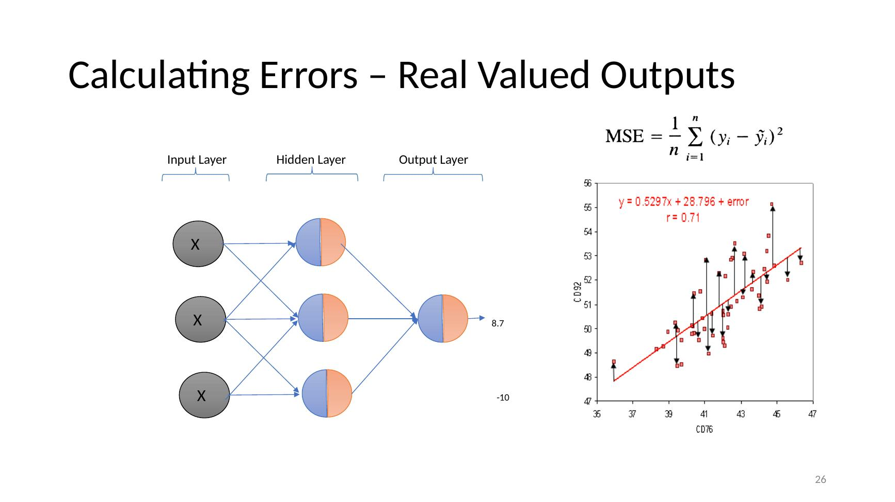

Problem
- Our definition of the backprop equations is dependent on the derivative of z which is given by a(1 - a)
- If we are using a sigmoid unit (classification) then the derivative is not very strong if we are very right or very wrong!
- Plot: f(x) = logistic(z) and f(x) = logistic′(z) – the derivative peaks at ~0.25 near 0 and flattens towards 0 at both ends
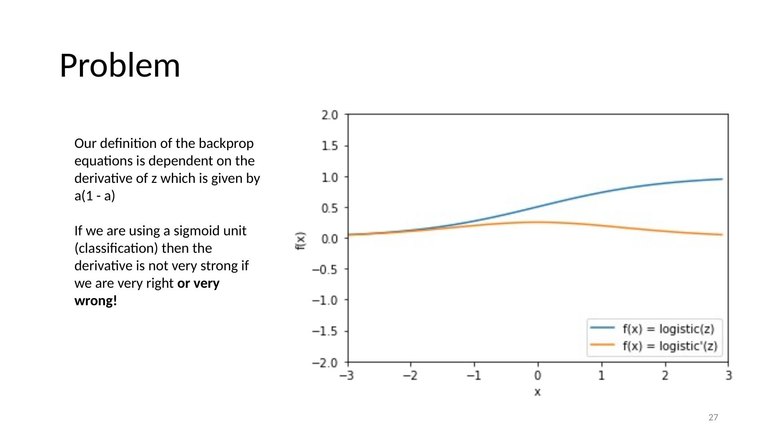

Cross Entropy Loss
- Plot: Logistic Cost Function where Y=1 – cost very high as h(x) → 0, falls to 0 at h(x) = 1
- Plot: Logistic Cost Function where Y=0 – cost 0 at h(x) = 0, very high as h(x) → 1
- cost_CELF(a, y) = −y log(a) + (1 − y) log(1 − a)
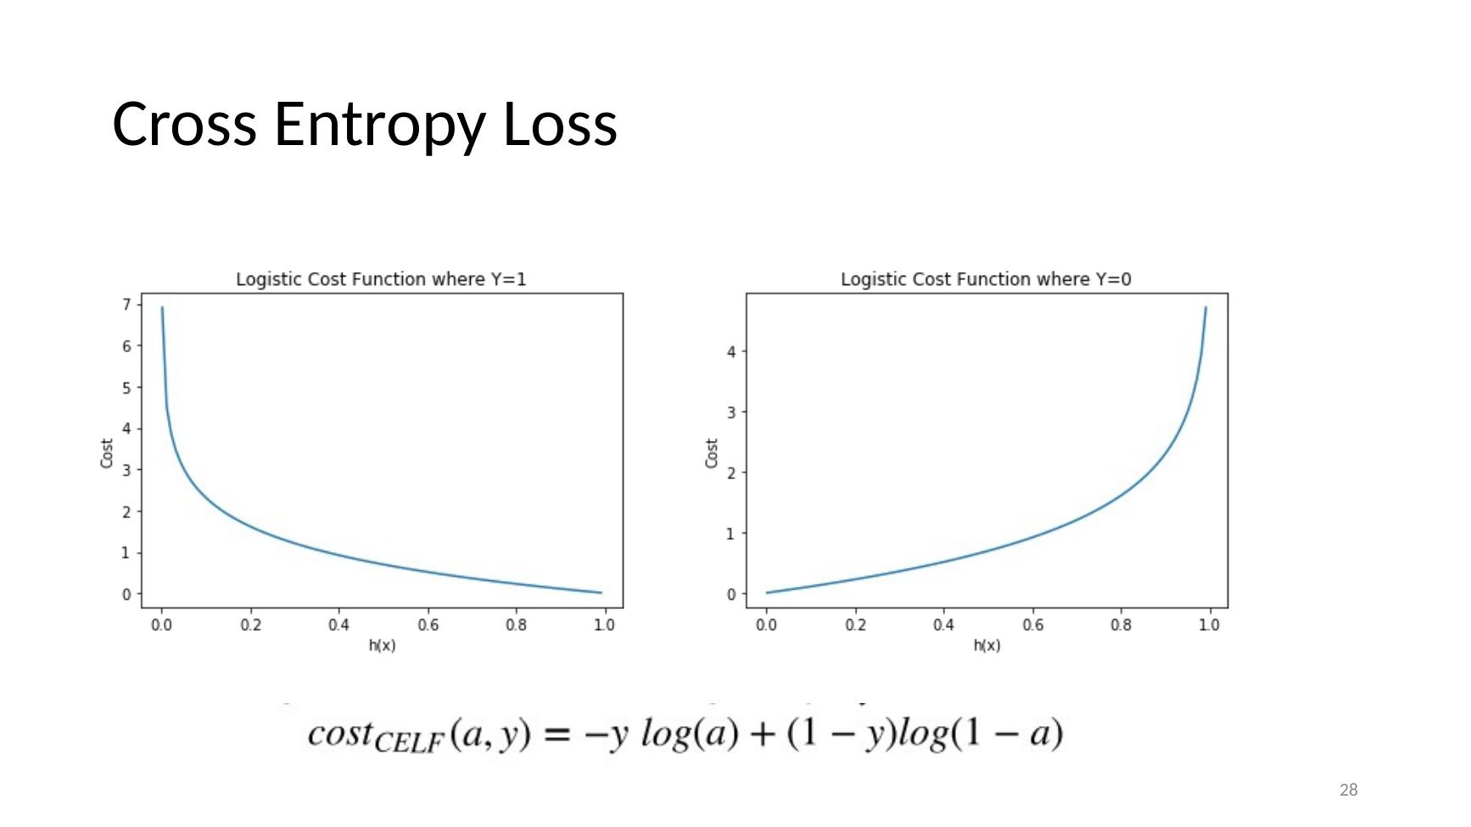

Key: Natural Log Between (0, 1]
- Plot: ln(x) by x for x from 0.05 to 1.00 – ln(x) ≈ −3 at 0.05, rising to 0 at 1.00 (always negative or 0 in this range)
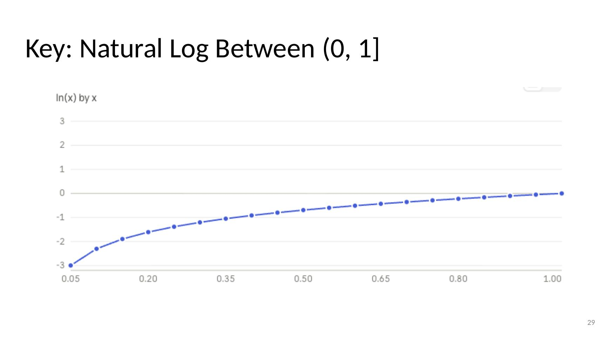

Cross Entropy Loss
- Plot: Logistic Cost Function where Y=1
- Plot: Logistic Cost Function where Y=0
- cost_CELF(a, y) = −y log(a) + (1 − y) log(1 − a)
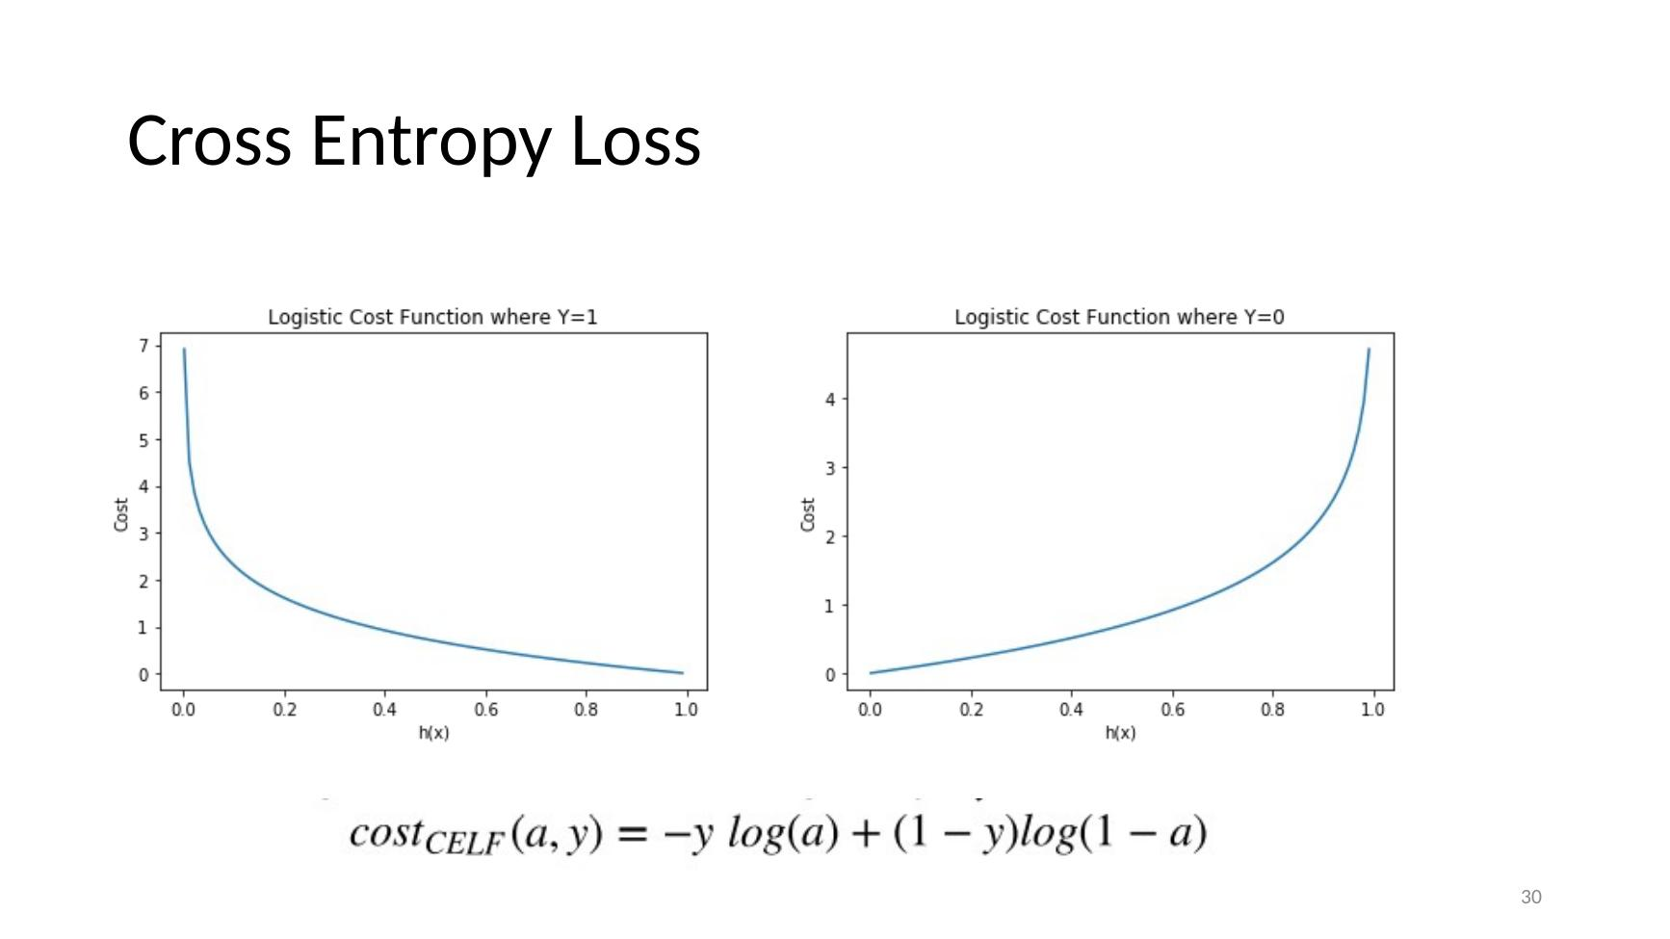

Calculating Errors – Binary Outputs
- Network: Input Layer (X, X, X) → Hidden Layer → Output Layer (single output = 0)
- Loss Function – Cross Entropy Loss Function
- cost_CELF(a, y) = −y log(a) + (1 − y) log(1 − a)
- Error Derivative (final Layer)
- ∂E/∂θi^(l−1) = (y − a) ai^(l−1)
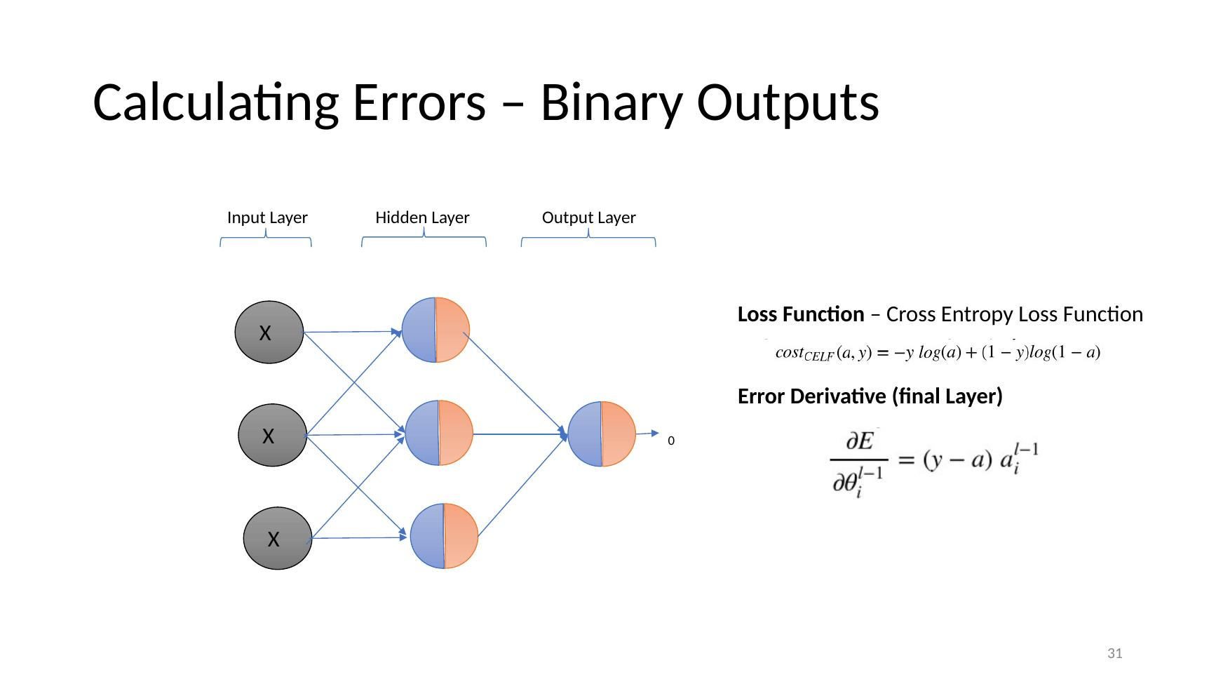

Cross Entropy Loss Function Performance
- Plot: loss vs training iterations (0–5000)
- Mean Square Error – starts ~0.5, falls slowly, reaches ~0 around 2000
- Cross Entropy Loss – starts ~2.8, drops sharply to near 0 by ~500
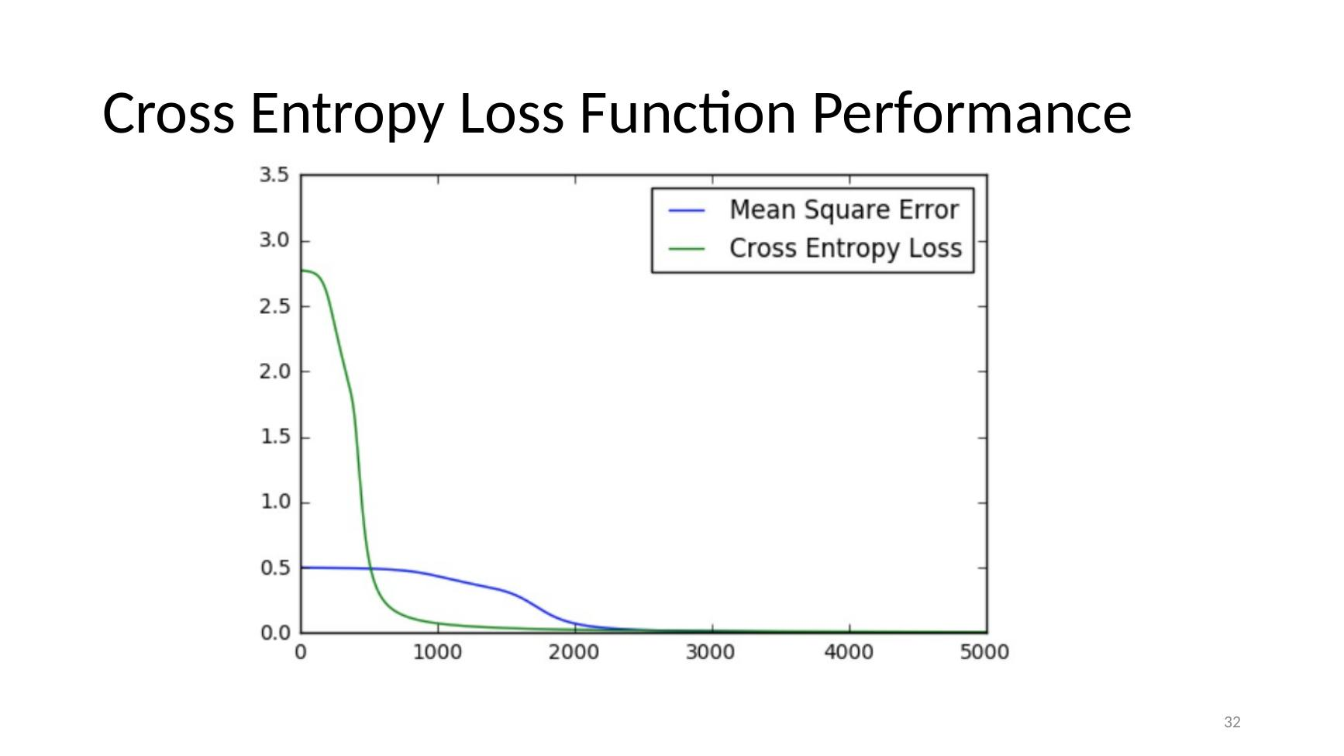

Multi-Label and Multinomial Outputs

Calculating Errors – Multi-Label Outputs
- Network: Input Layer (X, X, X) → Hidden Layer → Output Layer (three outputs: 1, 0, 0)
- Loss Function – Cross Entropy Loss Function
- cost_CELF(a, y) = −y log(a) + (1 − y) log(1 − a)
- Error Derivative (final Layer)
- ∂E/∂θi^(l−1) = (y − a) ai^(l−1)
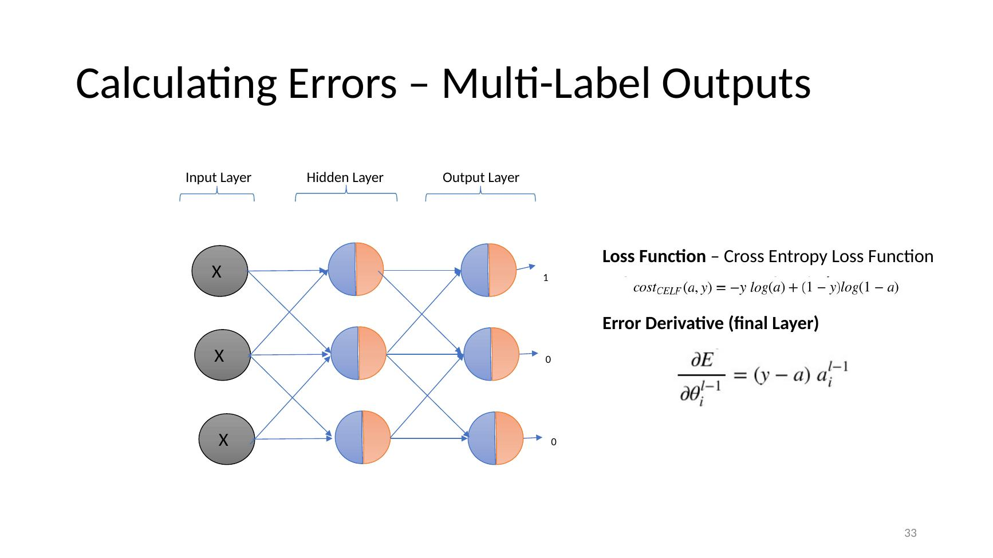

Calculating Errors – Multinomial Outputs
- Network: Input Layer (X, X, X) → Hidden Layer → Output Layer (three outputs: 0.8, 0.2, 0.1)
- Remember / Assumption – One positive outcome per instance. Everything else negative, e.g., figure out the type of animal in an image.
- Loss Function – Cross Entropy Loss Function
- cost_CELF(a, y) = −y log(a) + (1 − y) log(1 − a)
- We can use this but it isn’t great.

Multinomial: Softmax Activation Function
- Network: Input Layer (X, X, X) → Hidden Layer → Output Layer → outputs Y0, Y1, Y2
- If we know that we only have one possible ‘activation’ in a given layer, we can use a ‘Softmax Activation Layer’ To take advantage of this fact.
- ai = e^(zi) / Σ e^(zj)
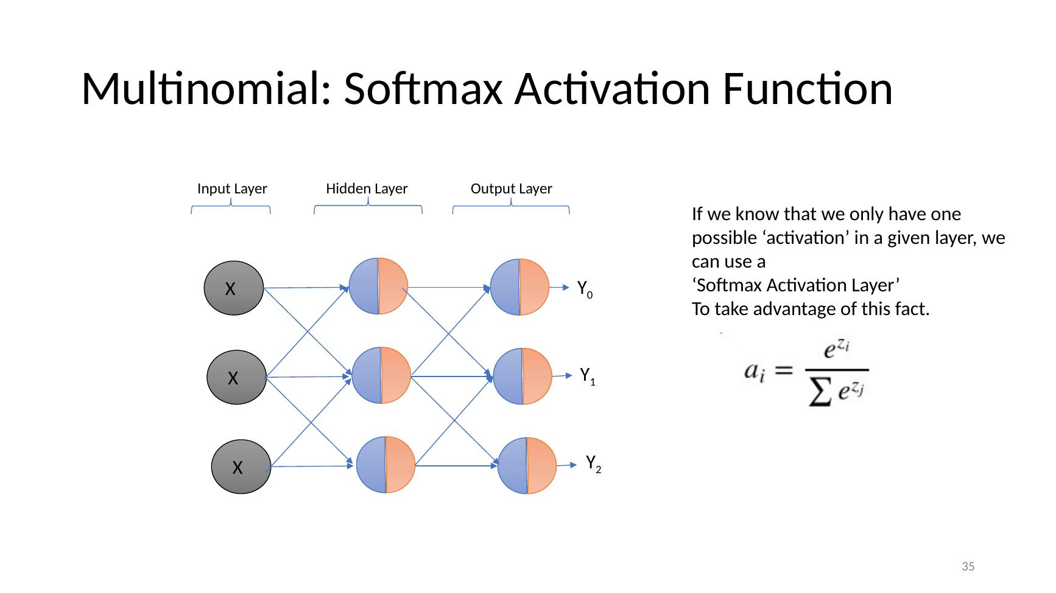

Softmax Activation Function
- Three plots of the same 7 values: Original Values (range ~−2 to 1), Max (only the largest = 1, rest 0), Softmax (all positive, summing to 1, largest ≈ 0.32)
- ai = e^(zi) / Σ e^(zj)
- ∂E/∂zi = y − a
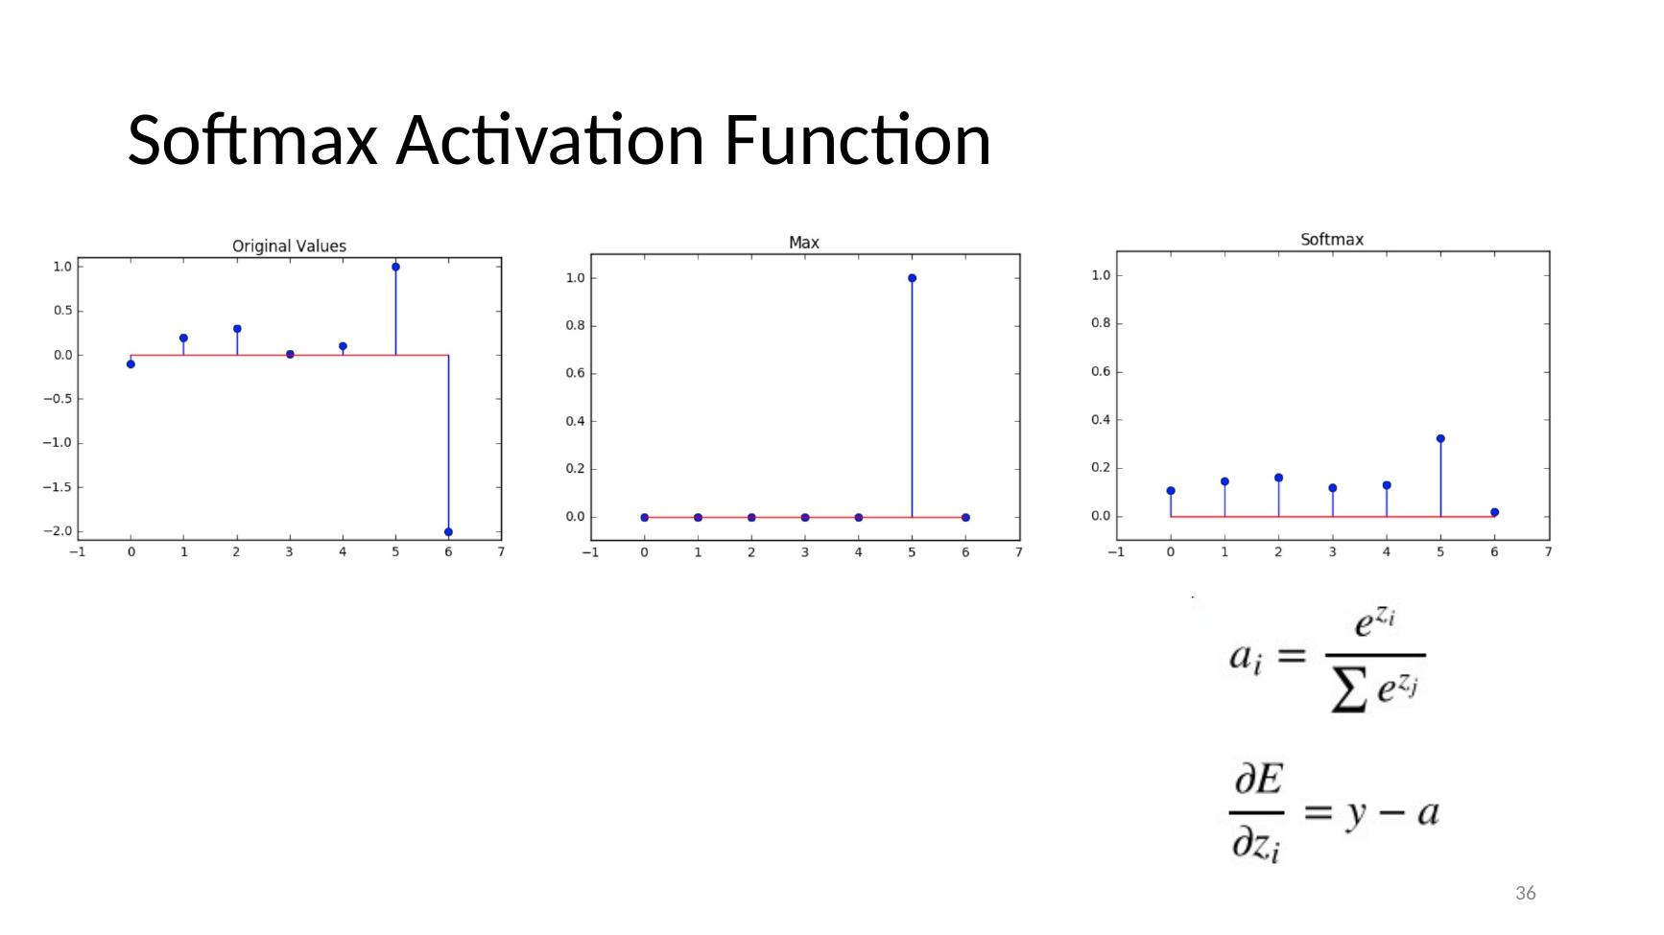

Tutorial Session Work

Tutorial Session Work: Loss Functions
- Split into smaller groups.
- As a group assign each person a loss function to investigate (look at Keras losses as a starting point) (10 mins)
- Individually investigate your loss in a Keras context (10 mins)
- Report back to the smaller group
- Have a group reporter enter details on the losses investigated into the form provided.
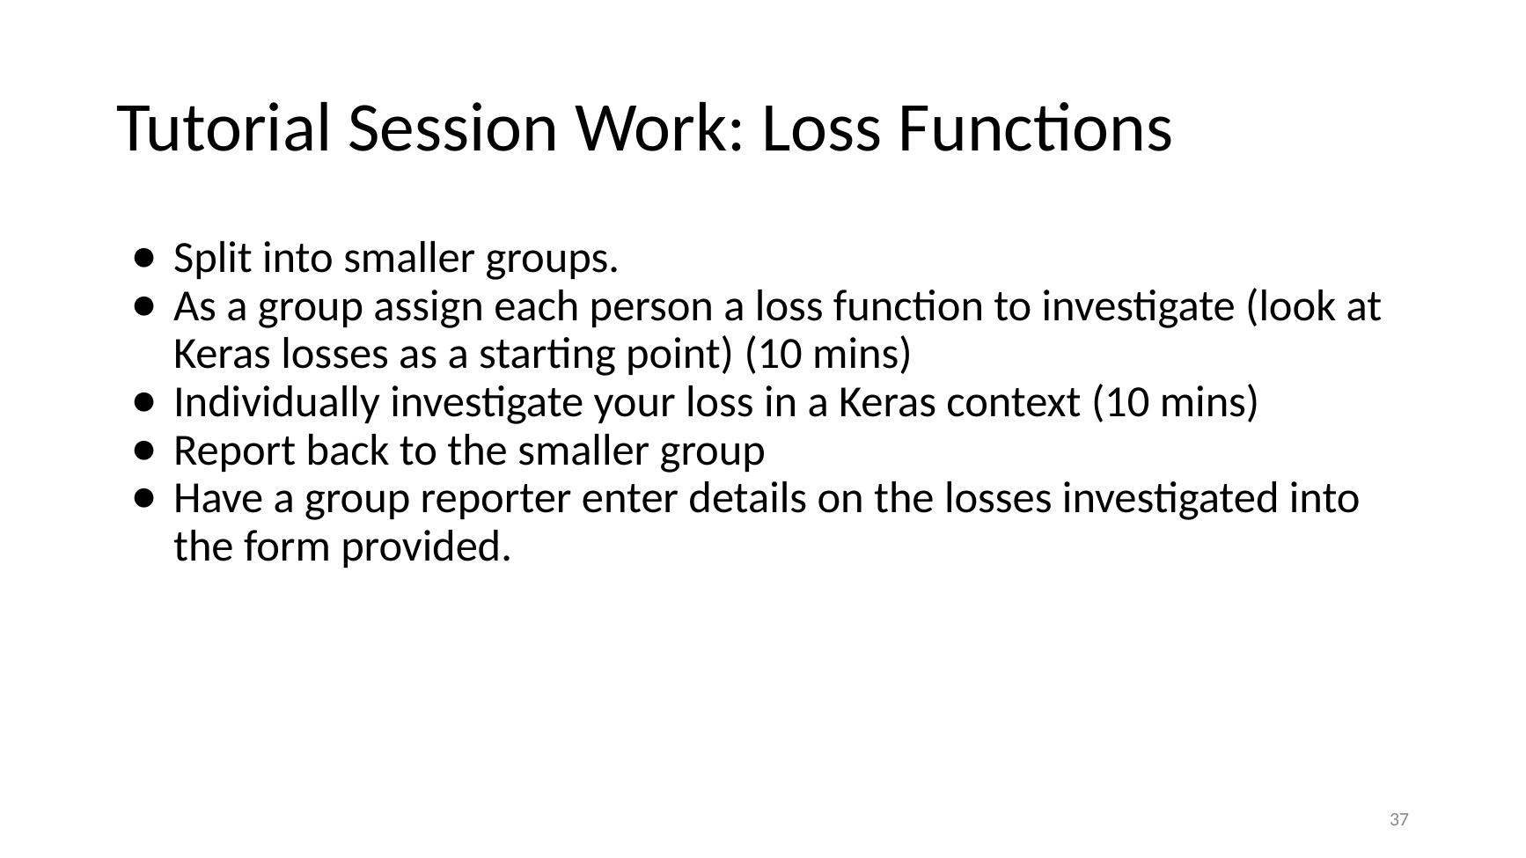

References

Network Training and Loss Functions
- Paperspace blog – Intro to optimization in deep learning: Gradient Descent – https://blog.paperspace.com/intro-to-optimization-in-deep-learning-gradient-descent/ (Learning the Parameters aka Training the Network)
- Google Images – animated backpropagation image search – https://www.google.com/search?q=backpropagation&tbm=isch&tbs=itp%3Aanimated&hl=en&ved=0CAMQpwVqFwoTCIDx0LXVsOcCFQAAAAAdAAAAABAC&biw=1213&bih=608#imgrc=CufDRhQcARzdoM (Training in progress animation)

Week 5 - Improving Performance

Introduction and Recap

Deep Learning Course – Improving Performance
- Deep Learning Course
- Improving Performance


Recap
- Recap (section divider)
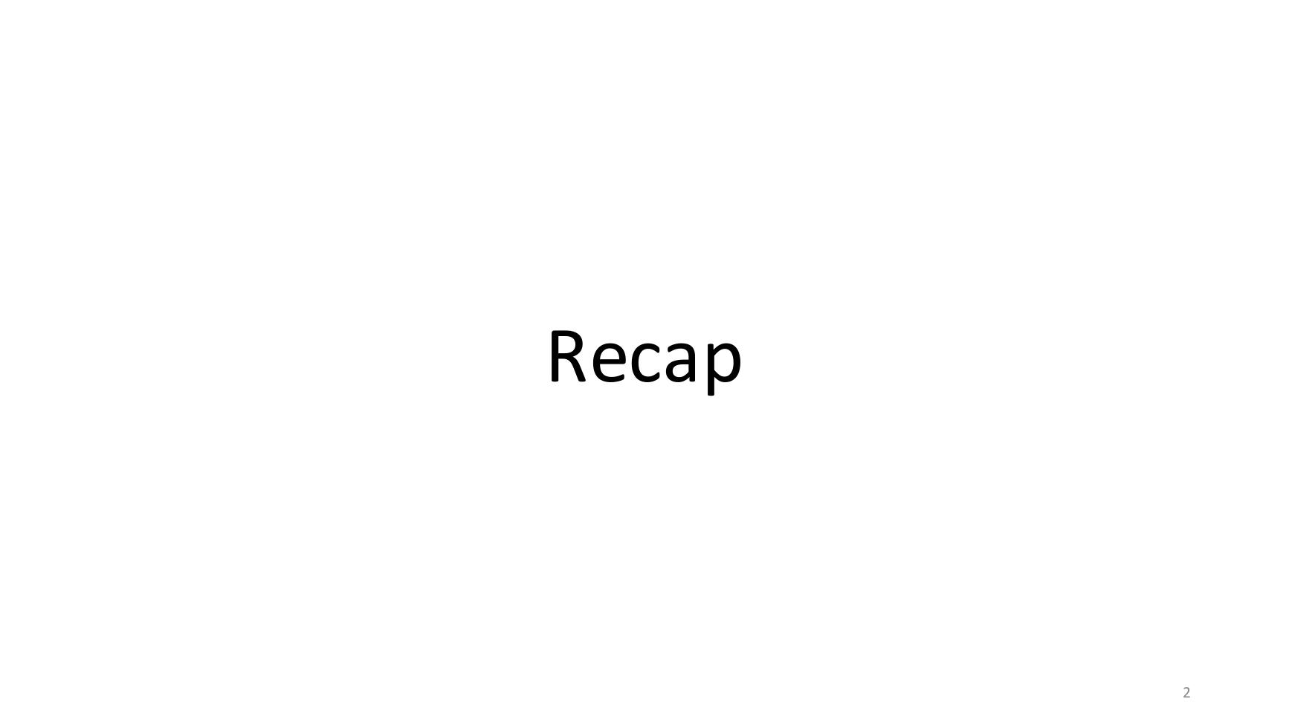

From Inputs to Loss
- Feed new data X1, X2, X3 → Input Layer → Hidden Layer 1 → Hidden Layer 2 → Output Layer → Y_pred
- Error = difference between Y_pred and Y
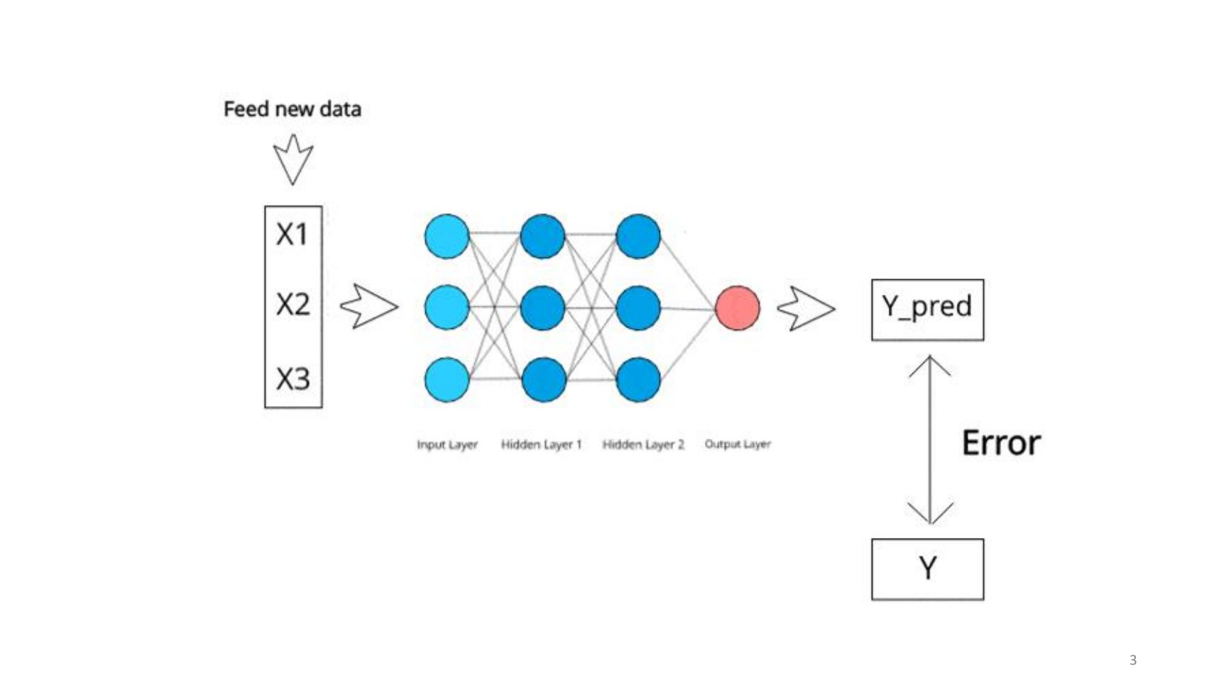

Calculating Errors – Real Valued Outputs
- Network: Input Layer (X, X, X) → Hidden Layer → Output Layer (single output unit)
- Example: predicted 8.7 vs target −10
- MSE = (1/n) Σ (i = 1 to n) (yi − ŷi)²
- Scatter plot with regression line: y = 0.5297x + 28.796 + error, r = 0.71 (vertical lines show errors)
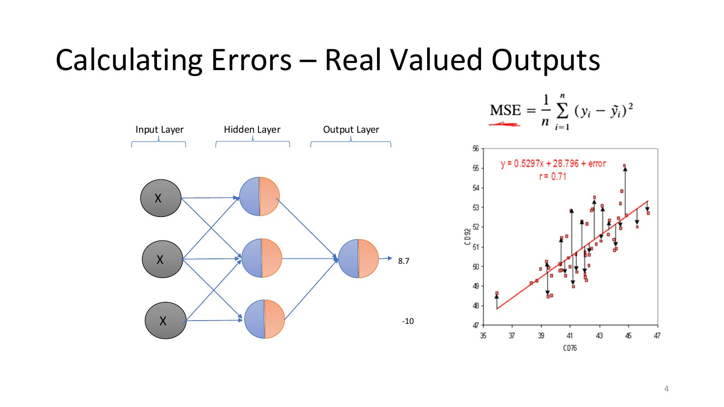

Cross Entropy Loss Function
- cost(hθ(x⁽ⁱ⁾), y⁽ⁱ⁾) = −y⁽ⁱ⁾ log(hθ(x⁽ⁱ⁾)) − (1 − y) log(1 − hθ(x⁽ⁱ⁾))
- Plot: Logistic Cost Function where Y=1 – cost very high as h(x) → 0, falls to 0 at h(x) = 1
- Plot: Logistic Cost Function where Y=0 – cost 0 at h(x) = 0, very high as h(x) → 1

Backpropagation Algorithm
- For each instance i in the training data:
- Forward Propagate x[i] through the network
- Backpropagate Error Derivatives back through the network
- Calculate error derivative for final layer using δ = (a − y) (a(1 − a)) for y[i]
- Calculate error derivative for hidden layers using δˡ = Σj (δˡ⁺¹ θˡi) g′(zˡ)
- For each hidden layer accrue weight updates Δij⁽ˡ⁾ = Δij⁽ˡ⁾ + aj⁽ˡ⁾ δi⁽ˡ⁺¹⁾
- Update weights with accrued weight changes θ = θ + Δ

Training in progress… (Backpropagation Animation)
- Animation: handwritten 9 → 9; 784 input units → two hidden layers → outputs 0–9, with weights changing during training
- 3Blue1Brown youtube channel general science stuff >>> https://www.google.com/search?q=backpropagation&tbm=isch&tbs=itp%3Aanimated&hl=en&ved=0CAMQpwVqFwoTCIDx0LXVsOcCFQAAAAAdAAAAABAC&biw=1213&bih=608#imgrc=CufDRhQcARzdoM

Today
- Alternative Application Functions
- Plots: f(x) = tanh vs f(x) = sigmoid; ReLU (theta1 = 1.0)
- Optimizers for Training
- Diagram: bowl-shaped Error surface over weights W1 and W2, with an arrow descending to the minimum

Alternative Activations – Outputs with Multiple Units

Alternative Activations
- Alternative Activations (section divider)

From outputs with single units!
- Network: Input Layer (X, X, X) → Hidden Layer → Output Layer (single output unit)
- Each unit split into logit (z) and activation (a)

Errors in Outputs with multiple Units!
- Network: Input Layer (X, X, X) → Hidden Layer → Output Layer (three output units)
- Each unit split into logit (z) and activation (a)

Errors in Outputs with multiple Units!
- Same photo (dog next to a potted plant) classified three ways:
- Binary Classification: Dog 0.9, Not Dog 0.1
- Multiclass Classification: Dog 0.5, Cat 0.09, Bus 0.01, Plant 0.4
- Multilabel Classification: Dog 0.8, Cat 0.2, Bus 0.04, Plant 0.7
- https://www.mathworks.com/help/deeplearning/ug/multilabel-image-classification-using-deep-learning.html

Multiclass (Multinomial) vs Multilabel
- Multiclass (Multinomial): three output units – ✗, ✗, ✓ (only one output can be correct)
- Multilabel: three output units – ✓, ✗, ✓ (several outputs can be correct at once)

Calculating Errors – Multi-Label Outputs
- Network: Input Layer (X, X, X) → Hidden Layer → Output Layer (three outputs: 1, 0, 0)
- Loss Function – Cross Entropy Loss Function
- cost_CELF(a, y) = −y log(a) + (1 − y) log(1 − a)
- Error Derivative (final Layer)
- ∂E/∂θi^(l−1) = (y − a) ai^(l−1)
- Total Loss =
- Averaged loss over all output nodes
- Error derivative is node by node.

Calculating Errors – Multinomial Outputs
- Network: Input Layer (X, X, X) → Hidden Layer → Output Layer (three outputs: 0.8, 0.2, 0.1)
- Remember / Assumption – One positive outcome per instance. Everything else negative, e.g., figure out the type of animal in an image.
- Loss Function – Cross Entropy Loss Function
- cost_CELF(a, y) = −y log(a) + (1 − y) log(1 − a)
- We can use this but it isn’t great.

Multinomial: Softmax Activation Function
- Network: Input Layer (X, X, X) → Hidden Layer → Output Layer → outputs Y0, Y1, Y2
- If we know that we only have one possible ‘activation’ in a given layer, we can use a ‘Softmax Activation Layer’ To take advantage of this fact.
- ai = e^(zi) / Σ e^(zj)

Softmax Activation Function
- Three plots of the same 7 values: Original Values (range ~−2 to 1), Max (only the largest = 1, rest 0), Softmax (all positive, summing to 1, largest ≈ 0.32)
- Problems with the max (argmax) function:
- 1. It is not differentiable
- 2. It does not give us a probability distribution over all the outputs
- ai = e^(zi) / Σ e^(zj)
- ∂E/∂zi = y − a

Softmax Uses
- Basic Use: output layers
- However, the softma layer is used extensively in hidden layers in other more complex architectures. Most notably the softmax layer is used extensively to implement the attention mechanism as used in transformers.

Questions
- Come up with your own examples of multilabel and multiclass classification?
- Can we use multinomial classification for multiple real valued outputs?
- Are softmax output calculations independent of each other?

Other Activation Layers

Other Activation Layers
- Other Activation Layers (section divider)

Hyperbolic Tangent Functions
- Logistic Activation Function + Derivative: g(z) = 1 / (1 + e^(−z)); g′(z) = a (1 − a)

Hyperbolic Tangent Functions
- Logistic Activation Function + Derivative: g(z) = 1 / (1 + e^(−z)); g′(z) = a (1 − a)
- HTAN Activation Function + Derivative: g(z) = (e^z − e^(−z)) / (e^z + e^(−z)); g′(z) = 1 − tanh²(z)

Hyperbolic Tangent Functions – another sigmoid
- Logistic Activation Function + Derivative: g(z) = 1 / (1 + e^(−z)); g′(z) = a (1 − a)
- HTAN Activation Function + Derivative: g(z) = (e^z − e^(−z)) / (e^z + e^(−z)); g′(z) = 1 − tanh²(z)
- Plot: f(x) = tanh (range −1 to 1, steeper) vs f(x) = sigmoid (range 0 to 1)

HTAN Performance
- Plot: Error reduction for Logistic function – error stuck near 2 until ~2800 iterations, then falls to ~0 by 5000
- Plot: Error reduction for Hyperbolic Tangent function – error drops to ~0 within a few hundred iterations

HTAN Performance - Cause
- Plot: f(x) = tanh′ (peaks at 1.0 at x = 0) vs f(x) = logistic′ (peaks at only 0.25)
- g′(z) = a (1 − a) (logistic)
- g′(z) = 1 − tanh²(z) (tanh)
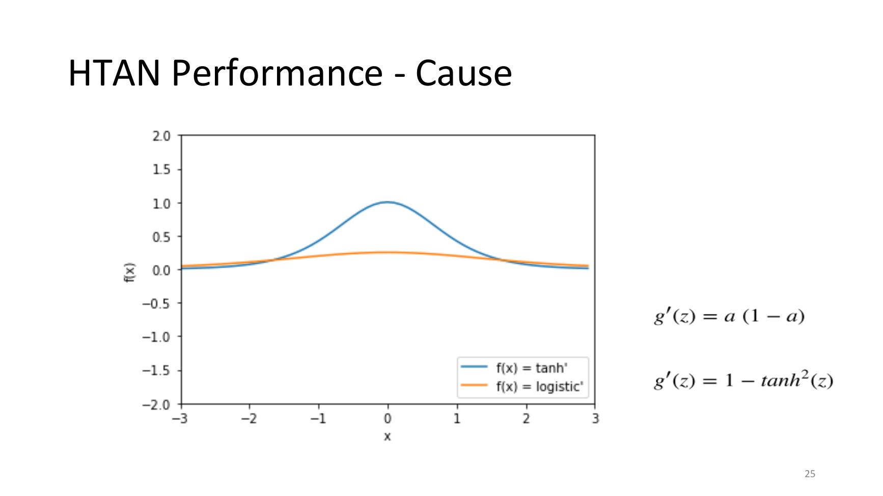

Can we do any better?
- Can we do any better? (section divider)

Rectified Linear Units
- Plots (theta1 = 1.0): ReLU – flat at 0 for x ≤ 0, then a straight line rising with slope 1; its derivative – a step from 0 to 1 at x = 0

Rectified Linear Units
- Plots (theta1 = 1.0): ReLU – flat at 0 for x ≤ 0, then a straight line rising with slope 1; its derivative – a step from 0 to 1 at x = 0
- g(z) = max(0, z)
- g′(z) = 0 if g(z) <= 0; 1 if g(z) > 0

Rectified Linear Unit Performance Cause
- Plot: theta1 = 1.0 (single logistic, levels at 1), sum of 5 logistics (levels at 5), sum of 20 logistics (keeps rising almost linearly to ~10)

Rectified Linear Unit Performance Cause
- Plot: theta1 = 1.0 (single logistic, levels at 1), sum of 5 logistics (levels at 5), sum of 20 logistics (keeps rising almost linearly to ~10)
- Also, the sparse network effecT!!!

Challenges with Rectified Linear Units
- Dying Relu Problem
- Too many negative outputs can force a relu to produce zero output. Once a zero output has been produced, it is difficult to move from that point.
- Particularly challenging when initialised close to 0 and high learning rates
- Plot: ReLU (theta1 = 1.0)

Beyond Rectified Linear Units – Leaky Relu
- f(x) = x if x > 0; αx if x ≤ 0
- Where alpha is a small number. Typically, 0.01
- Plot: ReLU (flat at 0 for negative x) vs Leaky ReLU (small negative slope for negative x)

Relu vs Leaky Relu
- Relu is still default. Dying Relu problem better addressed with good initial parameters and (low) careful control of the learning rate

Optimizers for Training

Optimizers for Training
- Optimizers for Training (section divider)

Optimization Methods
- Our goal is to reduce the error over time
- Diagram: bowl-shaped Error surface over weights W1 and W2, with an arrow descending to the minimum

Problems with Full Gradient Descent 1
- Selecting a learning rate
- Too low – A small learning rate requires many updates before reaching the minimum point
- Just right – The optimal learning rate swiftly reaches the minimum point
- Too high – Too large of a learning rate causes drastic updates which lead to divergent behaviors
- https://www.jeremyjordan.me/nn-learning-rate/

Problems with Full Gradient Descent 1
- Meandering towards the minimum
- Diagram: elongated elliptical contours – the gradient (red arrow) points across the valley rather than straight to the minimum (black arrow)

Problems with Full Gradient Descent 2
- Local minima
- Plot: curve labelled Global Maxima, Local Minima, Local Maxima, Global Minima
- 3-D surface with several peaks and valleys and its contour map (Start and End points) – ‘Final x = [0.2283 −1.6256], Objective = −6.5511’

Solutions
- Solutions (section divider)

Stochastic Gradient Descent
- Update after each individual example.
- -- this is in contrast to full gradient descent where we look at all of our examples and calculate a total loss before applying gradients
- Pros: Convergence is better
- Cons: Quite Expensive
- Contour plot (θ0 vs θ1): Stochastic Gradient Descent – a noisy, zig-zagging path towards the minimum

Stochastic Gradient Descent (with Batches)
- Happy middle ground.
- Save up losses from a number of examples (a batch) before applying the updates.
- Contour plot (θ0 vs θ1): Batch Gradient Descent – a smoother, more direct path towards the minimum

Improving Optimizers

Improving Optimizers
- Adjustable Learning Rates
- Diagram: contour plot with steps x0, x1, x2, x3, x4 getting smaller as they approach the minimum

Improving Optimizers
- Momentum
- Diagram: a ball rolling down the loss function (loss vs weight) carries enough momentum to roll past a small local minimum

Improving Optimizers
- Feature Specific Learning Rates
- Diagram: very elongated contours – multiple error rates (a different rate for each direction)

Improving Optimizers
- Principles
- Adjust Learning Rate
- Use some notion of momentum for overcoming local minima
- Keep a different error rate for each feature (dimension)
- Diagrams: momentum (ball rolling past a small local minimum); multiple error rates (elliptical contours)

State of Art Optimizers
- Key Examples
- Adam
- Adagrad
- RMSProp –These are all variations on a theme
- Using momentum
- Using multiple learning rates
- Adjusting learning rates on the fly
- Analytical Approaches (optional)
- LBFGS – Not seriously used in practical NN applications

Comparing Optimisers
- Plot: MNIST Multilayer Neural Network + dropout – training cost (log scale) vs iterations over entire dataset (0–200)
- Lines: AdaGrad, RMSProp, SGDNesterov, AdaDelta, Adam
- Adam reaches the lowest training cost; AdaGrad the highest

Group Assignment

Group Assignment
- Split into small groups:
- Within your group split in two, parts A and B. Part A should investigate Leaky RELU while part B should investigate clipping for RELU. Each group take 15 minutes to investigate their variety, and then two minutes each to inform the other half of the team.

References

Improving Performance
- Google Images – animated backpropagation image search – https://www.google.com/search?q=backpropagation&tbm=isch&tbs=itp%3Aanimated&hl=en&ved=0CAMQpwVqFwoTCIDx0LXVsOcCFQAAAAAdAAAAABAC&biw=1213&bih=608#imgrc=CufDRhQcARzdoM (Training in progress animation)
- MathWorks – Multilabel Image Classification Using Deep Learning – https://www.mathworks.com/help/deeplearning/ug/multilabel-image-classification-using-deep-learning.html (Errors in Outputs with multiple Units!)
- Jeremy Jordan – Setting the learning rate of your neural network – https://www.jeremyjordan.me/nn-learning-rate/ (Problems with Full Gradient Descent 1)

Video Recordings

- Week 1 – intro – 14th Sept 2026 – teams video embedded
  - Started 22:40… continue from there,,,
- Week 1 – Lab -not sure?
- Week 2 – intro – 21st Sept 2026 – teams video embedded
- Week 2 – Lab - half done .. don’t’ think did normalisation part.. maybe re check..
- Week 3– intro – 28th Sept 2026 – teams video embedded
- Week 3 - Lab
- Week 4 – intro – 5th Oct 2026 – teams video embedded
- Week 5 – 12th Oct 2026

