Natural Language Technology
Lecturer = Robert Ross

Email =

Week 1

Week 2

Week 3 – representing Text and Dialogue

Week 4 – Representing Text
- Remember, when I say ‘text’ I am using that term to refer to words, sentences, documents, or even speech.
- We need to somehow represent the text in an efficient way, and what is efficient depends on the task. For us we often want to perform tasks like similarity measurements

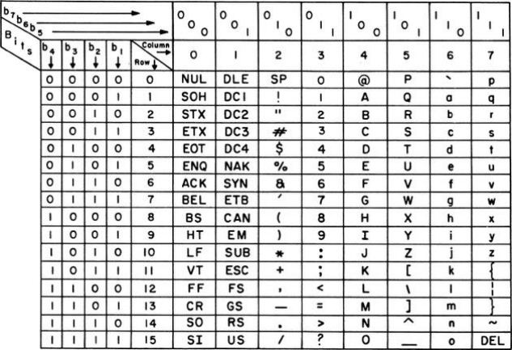
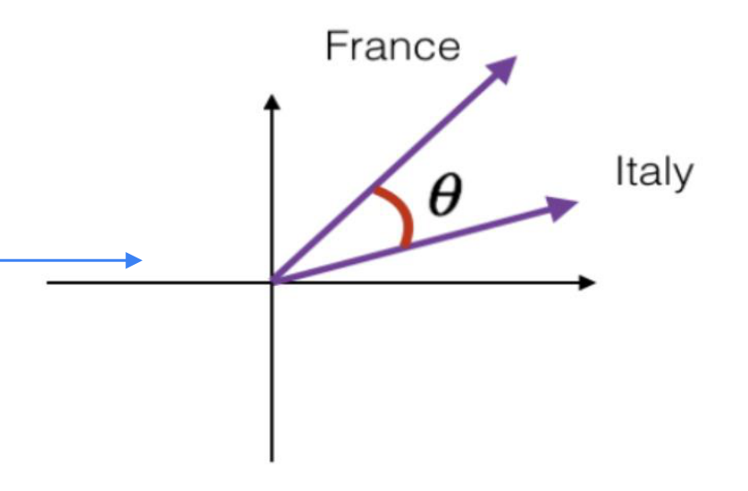

Today
- Giving symbols to thought
- Do we need to represent text?
- Text and computer encodings
- Bag of Words
- Word Counts
- TF-IDF
- Distributional Semantics
- Dialogue vs Non-Dialogic Text

Today
- Giving symbols to thought
- Do we need to represent text?
- Text and computer encodings
- Bag of Words
- Word Counts
- TF-IDF
- Distributional Semantics
- Dialogue vs Non-Dialogic Text
- Keep in mind that the stuff this week is important and very foundational. There are a lot of extra handouts for this week that talk through the detail.

Representing Text

Meaning and the Semiotics Triangle
- In linguistics and psychology, we usually distinguish between the concept, reference object, and symbol. This makes a lot of sense for humans.
- For computer systems, do we have a distinction between the concept and the symbol?
- Yes, we generally do
  - “Cat” vs “0.111,1.01,-0.55…”
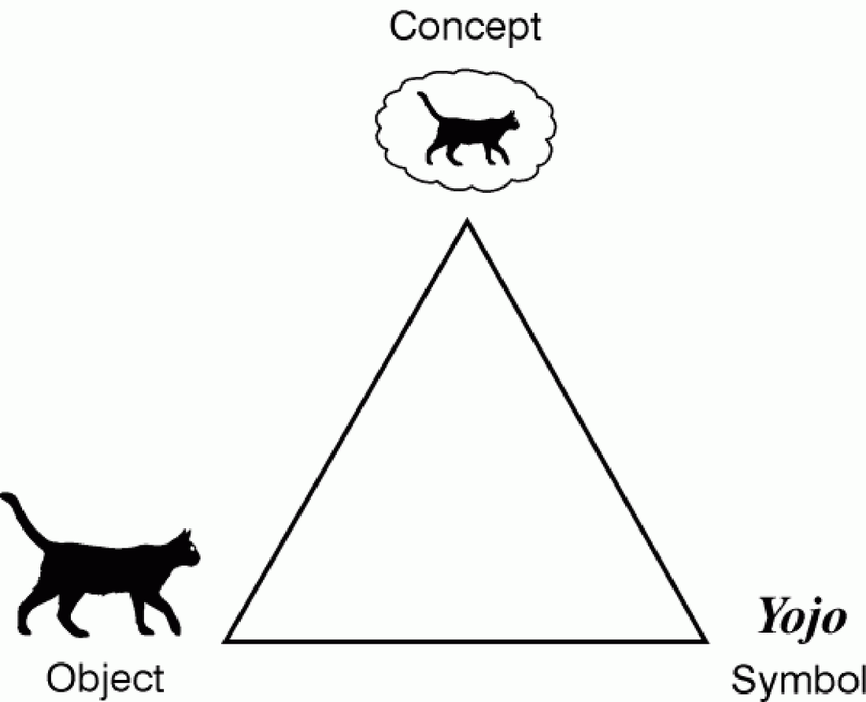

Elementary Representation of Text
- There is no perfect way to represent Text
- Outside of machine learning there has been an evolution of approaches over the years, but these approaches aren’t necessarily good for Machine Learning tasks
- What do UTF and ASCII do well? What do they do badly?
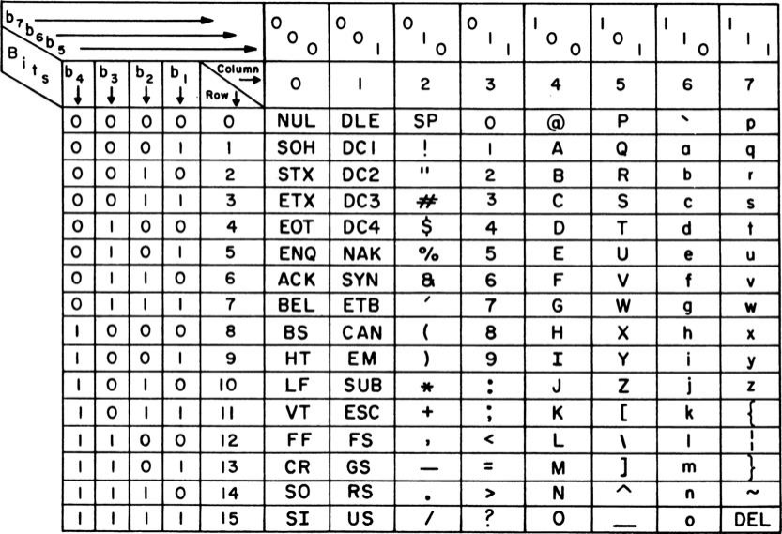
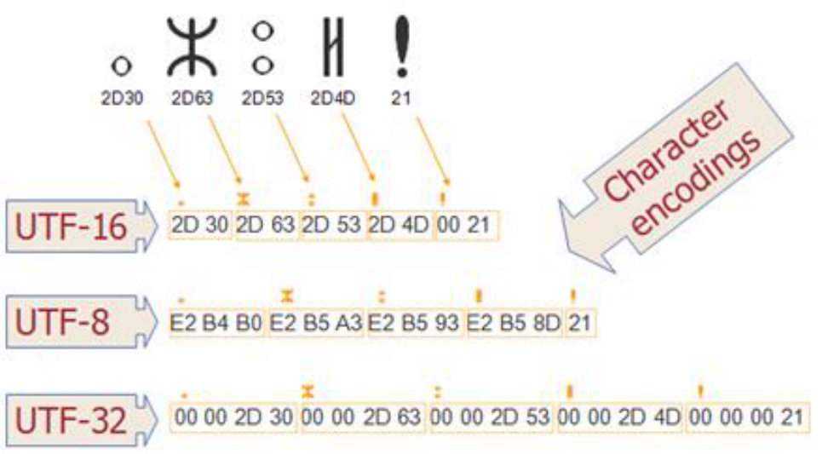

Standard Text Representations (ASCII and More)
- Pros:
  - Great representation for visualizing text
  - Great representation for editing text
  - Okay representation transmitting text
- Cons
  - System representations of text, e.g., ASCII, UTF8, capture the literal text but do not provide an information-centric representation of the information in the text.
  - They are also not a representation that is easy for machine learning style operations to be applied
  - Do not easily support search or comparison
  - Does not capture the ‘meaning’ of the text – they are not the concept
- ”The otter stood at the bank” has the same representation regardless of the meaning of the sentence.


Classical Text Representations

First: Text Processing Pipeline
- In classical NLP a set of documents, or corpus, was typically pre-processed a lot before being used.
- The diagram on the right illustrates these concepts along with the linked article. Please review.
- In modern systems not all these steps are always applied. However, they do still exist, and sometimes these steps are even applied by ‘representation pipelines’ without you realizing it.
- Note that a lemma is an actual word, whereas a stem is sometimes not a real word
- https://medium.com/predict/how-does-nlp-pre-processing-actually-work-8d097c179af1
- What are the pros and cons of such pre-processing?
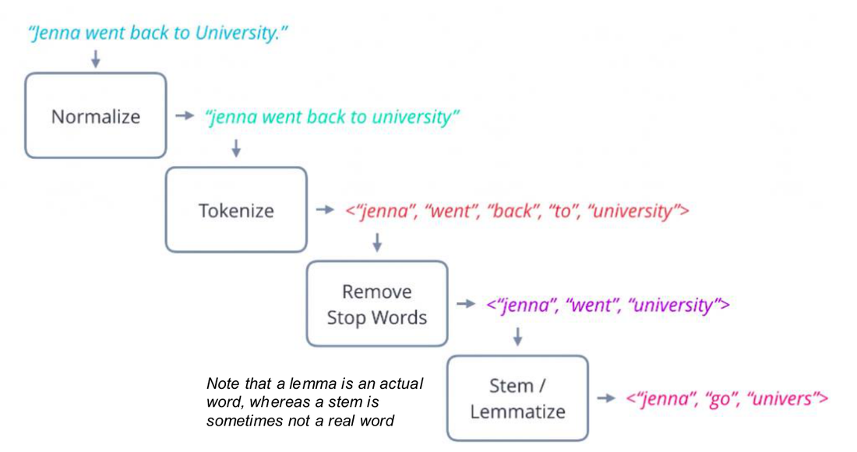

Representation Options
- One-Hot Encodings
- Bag of Words
- Count Frequencies
- TF-IDF
- Distributed Semantics

One Hot Encoding
- Each word is assigned its own bit in a vector. The length of a representation vector has to be the length of the vocabulary for your dataset.
- Each vector captures only one word, so this is a very sparse data set
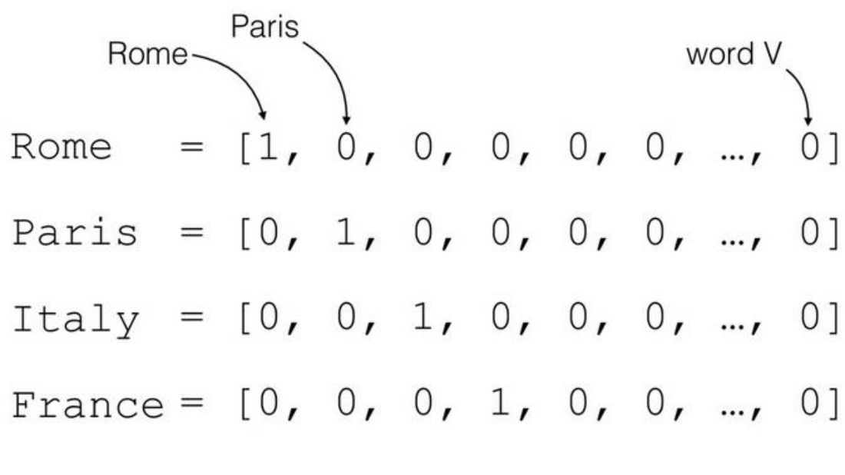

One Hot Encoded Document Representations
- Problems:
- Sparsity
- No semantic ‘meaning’
- Shape = n x m
  - n = size of vocab
  - m = number of words in sentence
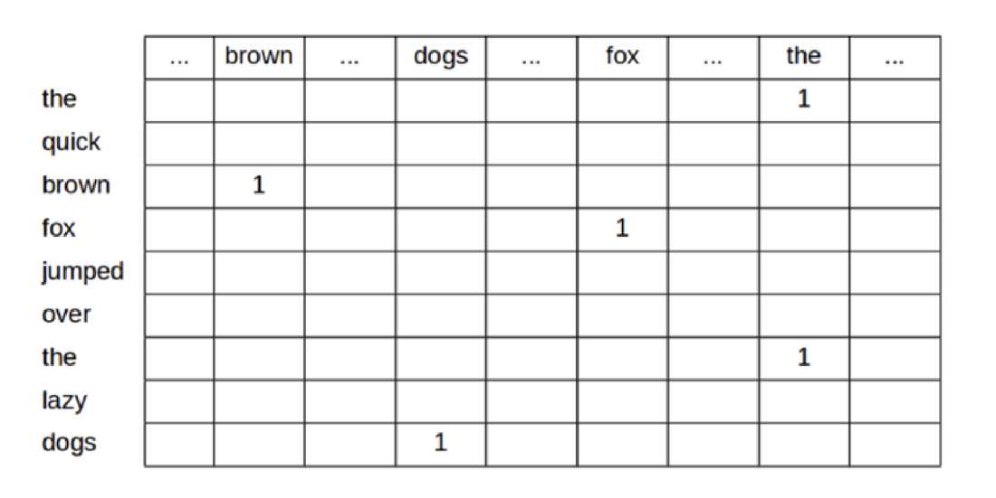

One Hot Representations
- Pros
  - Much better at capturing meaning than an ASCII style rep
  - We could actually use a pretty good spam filter based on this type of approach
- Cons:
  - Representations are super super big in their full form
  - Individual vectors are very long
  - Similarity between words is lost

Dense Representations
- While One Hot Encodings do look incredibly wasteful, keep in mind that we can compact these sparse representations in a very trivial way
- Dense representations just save the index of the token to be active and assume everything else is zeroed out
- 5477 7783 8777 12101
- The quick brown fox …
- 8777, 1101, 5477, 8777, ….
- This is sometimes called an index-based representation
- This is in fact quite similar to what UTF does – but at a word level rather than character
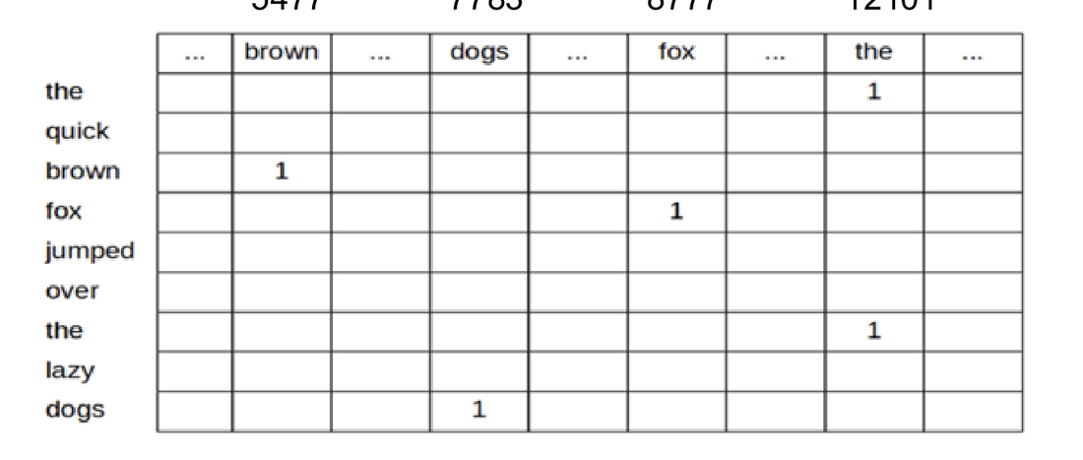

Bag of Words
- Bag of words still assigns a bit per word, but we are allowed to have multiple words active in the vector.
- This means that one vector can capture the meaning of any text – though not very accurately
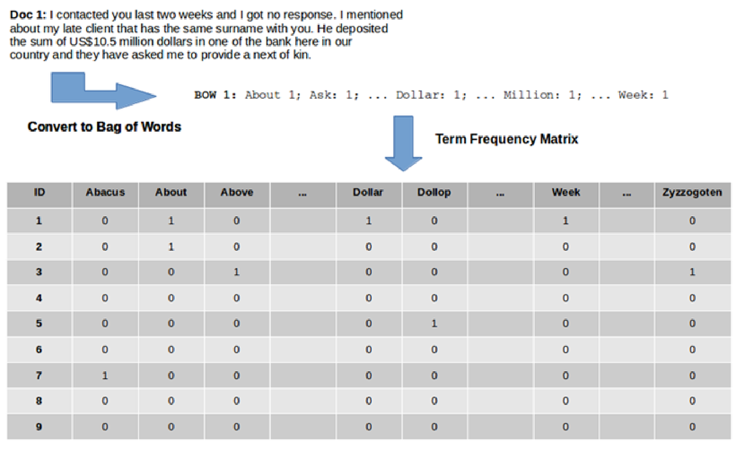

Bag of Words
- Pros
  - Much better at capturing meaning than an ASCII style rep
  - We could actually use a pretty good spam filter based on this type of approach
  - More compact than One Hot Encoding
- Cons:
  - Order of words lost
  - Vectors are long
  - Similarity between words is lost
  - All words given equal weight
  - Search is tough


How can we extend straight bag of words to account for some words more frequent than others?
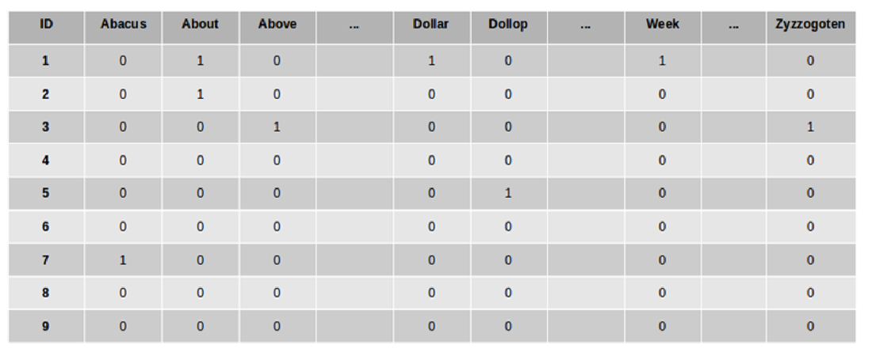

How can we extend straight bag of words to account for some words more frequent than others?
- 3
- Instead of just accounting for the presence of a token, capture the number of times that token was seen in the document – Term Frequency Vectors
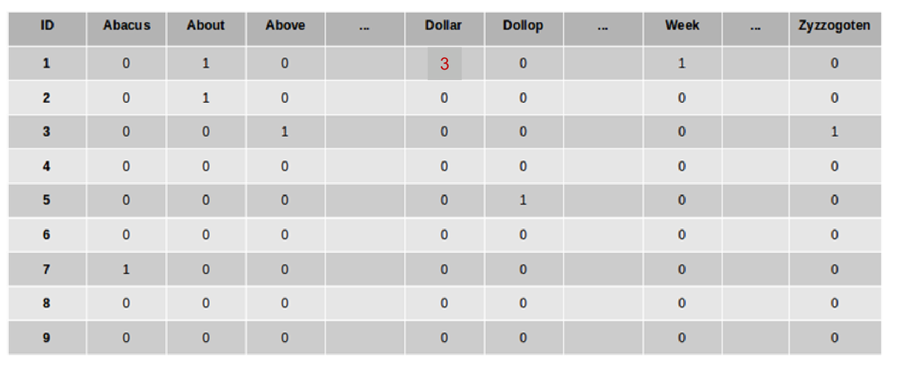

On Term-Frequency Vectors
- In terms of representing the raw word contents, Term-Frequency vectors seem to be a pretty good solution.
- However they can over emphasis the role of very frequently seen words across multiple documents in a corpus.
- Can we come up with a formulation which captures the relative influence of words in a given sentence – relative to their influence on other sentences in the same corpus????

Term Frequency / Inverse Document Frequency TF-IDF
- https://ted-mei.medium.com/demystify-tf-idf-in-indexing-and-ranking-5c3ae88c3fa0
- Instead of just acknowledging the presence of a word type (BOW) or the number of times it occurred in the document, Count Matrix, the TF-IDF measure accounts for how important a word seems to be in the document relative to other documents in a collection.
- Why log?
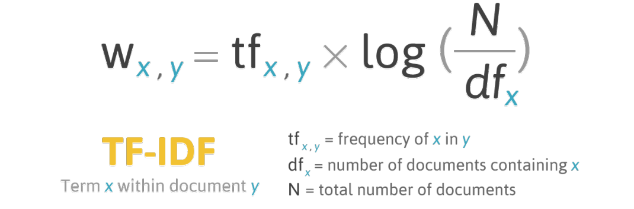
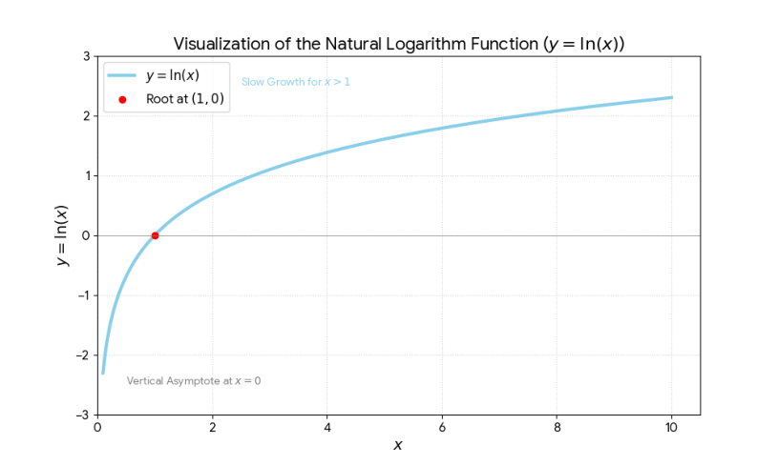

- A document vs A Aorpus
- A document can be a sentence / a web page >>> the unti we are mosr interested in
- Can use vecotrs to reopresented aany pf these… i.e. a whole web page if we really want to
- A cirpus is a collection of those docs
- A set fo docs we are indexing / set fo docs

Take a common word “the” and haven’t filtered it out wih stop words….
If use count freq style representation word !the” will appear a lot of times….
That’s useless when coming to clustering the docs… i.e. their little sematco groupsing… as the word “the” is gogn to appear everywhere…

If in medical domain… word “patient” will appear a lot…. So doesn’t have realy rich information value to us…
To capture that specialist knowledge frm a doc that has a meaning

Term frequency - inverse document frequency…
Used in all types of document frequency…
Occurred as an exam question….
For amy give doc we will represent that as a vector where for each word ni our cvocabulary we’ll find how many time sthe ord occurred in the document, then balance that ff in terms of how many times that word occurred in the whoel corpus…
>>> if it occurs a lti in a given document… and doesn’t occur in a corpus >>> gives u s strong indiciation that tsi word is a string representation of the meaning of the document….
i.e. the word “covid” >>> god indication the page may be about covid… as it appeard a lot fo times btu if look at covid over last year…. Did tno occur, so that doc may eb mostly about covid…..
if done in 2021… got every article about covid… >>> it wasn’t a godo information rich represnttatin of that document….

TF-IDF
- https://towardsdatascience.com/text-vectorization-term-frequency-inverse-document-frequency-tfidf-5a3f9604da6d
- The TF-IDF representation gives a lot of emphasis to rare words across the corpus – particularly when that rare word occurs a lot in an individual document
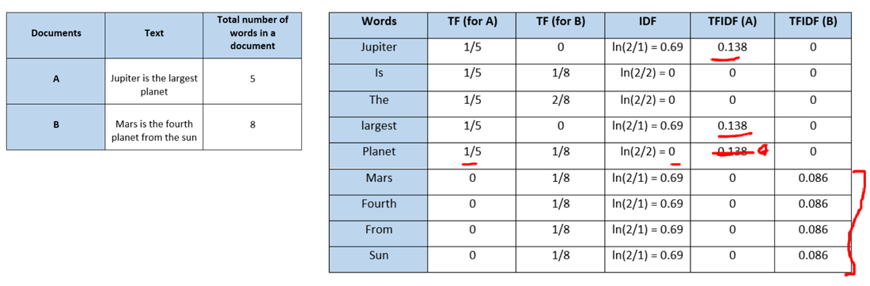

- 2 docs
- Jupiter I larget planet
- Mars is 4th planet from the sun
- Can now work thru and calculate TF-IDF values for each indy word in each doc….
- TF cacualted indy for each document that we have….
- Jupyter occurred once in doc A
- IDF = number of documents in the cirpis / number of times the word appard in the document…
- Calculate TF-IDF for first word in A…
- “is” 2/2 ??? goes to 1 = lgo of 1 = zero…. What does that mean… word is is occurring in very doc, so not a lto of information so tf-idf value is zero….
- If had bigger corpus… and coupek fo words….
- T gives us a measurement of how inortant word is ni document
- iDF = how incidental is that word
- same thing seems to be happening to “the” i.e. like stop words…
- if get to something like “large “ or planet” got relevance not all over the place so IDF value hasn’t shrumk back down to none…. So still get high information quotient for that.,..
- remaining words in the sentence…
- docuemtn B mars doesn’t occur ni all of the corpus elements >>> tfidf word ahs some meaning for us
  - same from 4th/sun aswell…
- will come back to tTIDF when looking at web search…
- gdo dtandard representation capturing meaning of documetns… .e. clustering documents together…
- docs that have similar meaning wil eb close to each other in the meaning space….
- Its good enough we can perform search
- Importsant for web search…
- Better than one -ohot encodings for web searh
- TIDF moving out and full vectorised meaning being used more… distributed representattinos…

Distributed Representations

A Better Approach: Index words is multi-dimensional space
- Instead of associating a word with just a single number in a single dimension (the traditional index), instead associate a given word with a point in a multi-dimensional space.
- Each dimension can be thought of as capturing an aspect of meaning
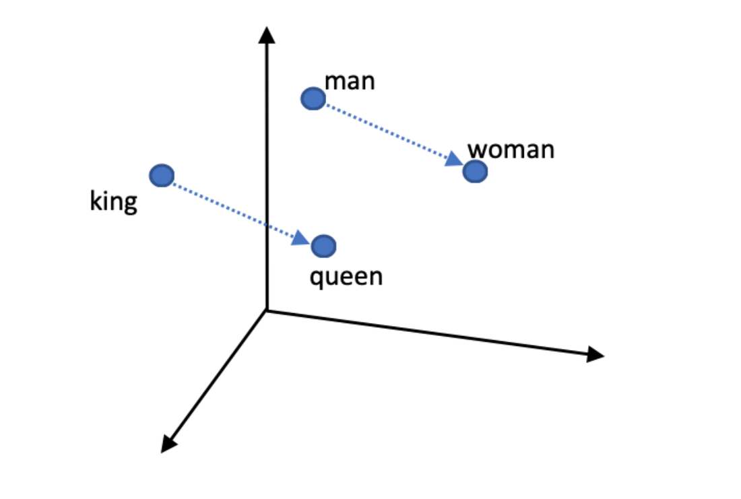

- Ides oen point that represents king
- One space represents woman
- Oen space reprssents queen
- And distance has a meaning….
- All words that represent cities in that space….
- Oen space for anmals
- One space for disease…
- Words that have similar meaning shared similar location in space…
- >> can make substitutions…. Can substitute puppy for dog and still ahs some meaning…
- Can be shown that within these meaning spaces can make transformations.. take idea of maleness and add royalty and get king as an entity.. and same for women and royalty,.,.. dodn’t work perfectly but key thing is different dimensions were actually truly capturing meaning…
- So have indy points but can transform points and move them around in space….

A better approach:
- A point in space is simply a set of coordinates, x,y,z.
- Similar words should live in a similar part of the space
- Dogs and puppies share a similar amount of dogginess, but will vary in terms of a young v old property
- But why stop at just 3 dimensions…
- cat
- run
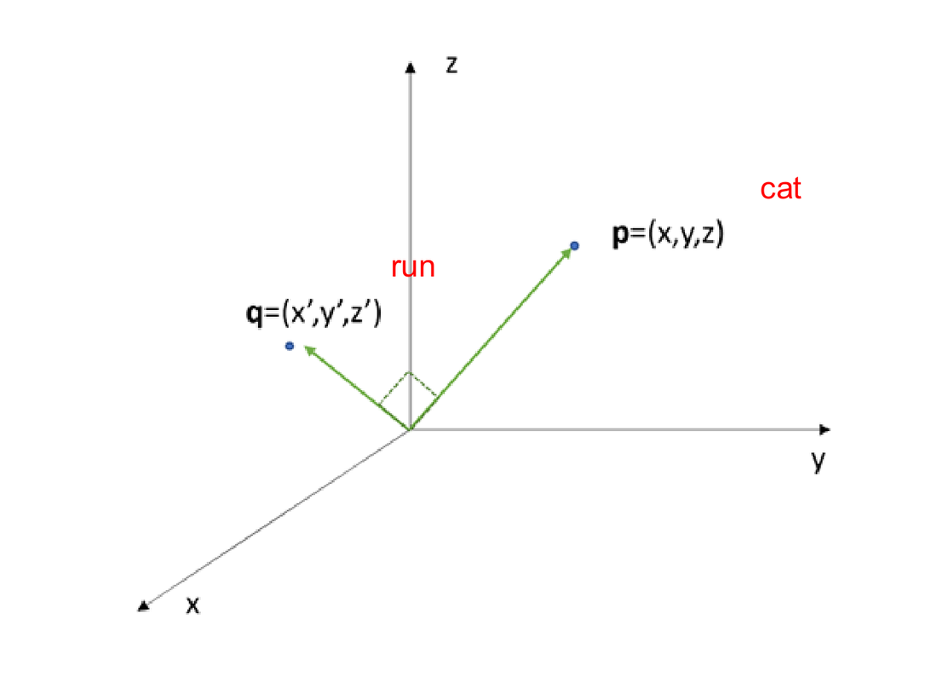
- Each point in our space is a vector or number
- Assign to a unique vector
- Can then start manipulating that space as we see fit.
- Interstgin how do we go form words to full sentences…. It gets interstign…
- Btu kernel of an idea it works well

- NOTE>>> it is not 3 dimensional spaces…. We talking about 128/256 dimensional space… and different reginos of that 256 dim space are captugin that information
- Have an area of the space that captures the idea…
- Indy dim within that space does not say in real world encodings… doesn’t capture something like maleness… dimension itself doesn’t capture the idea… but combinatinos sometimes do…. Dim 56 + dim 678+dim 58>>> combinatiosn encode the meaning…

Indexing in High (e.g., 128) Dimensional Space
- Basic idea still holds.
- Instead of representing words with a vector of 3 numbers; we represent words with vectors that are much bigger.


Distributed Representations (Word Based)
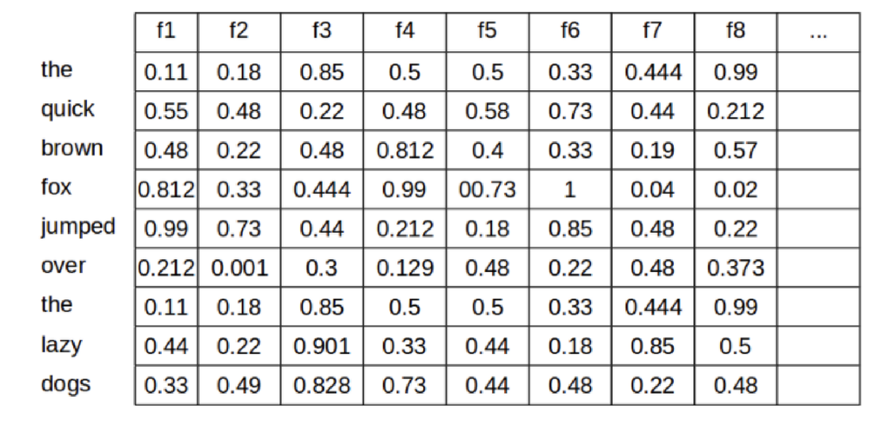
- Can very quickly build up by combining vecotrs in different ways….

Meaning Spaces
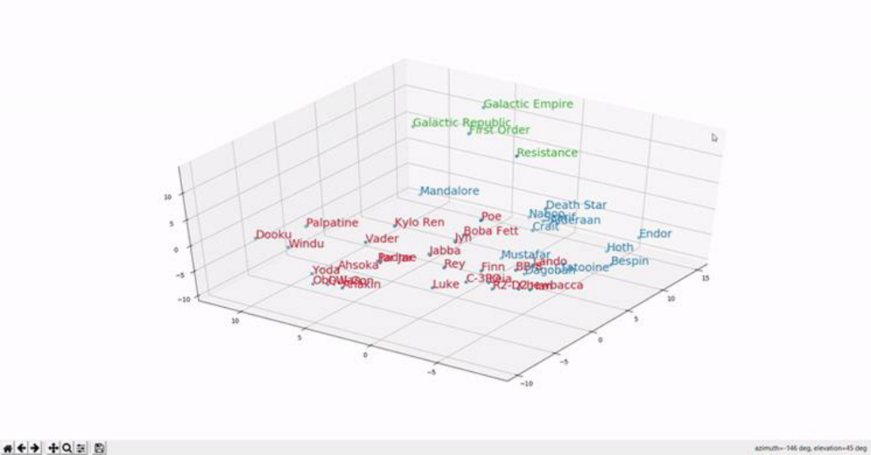
- Word vectors are not very commonly used any more…
- BUT word representation like GLOVE embedding (10/15 years old) even they ar multi dimensional….
- We often coalpse the mlti deimsianla space to try visualise ti….
- i.e. looking at shadow of a person…. We loose depth info btu is still interesting…
- manu7 packages… to loka t these embeddings.. a classic is TSNE!!!!
- Suggest use egemino to build up a TSNE style representation as part of the glove embeddingh space in the 3rd hour…
- Word withs ame meaning … find word bwith nbit of meaning… all have same point i.e. bank vs bank… so compacying them into single representations…
  - >>> Transformers!! >>> tal representation of workd “bank” in a glove sentence… transform t and adjust it so by time it got to outpur layer of ransformer the emanign of word bank had been adjusted… transformed slilghtly that had a unqie represenataion as appropriate sentence i.e. river bank… bank building…

Meaning Space
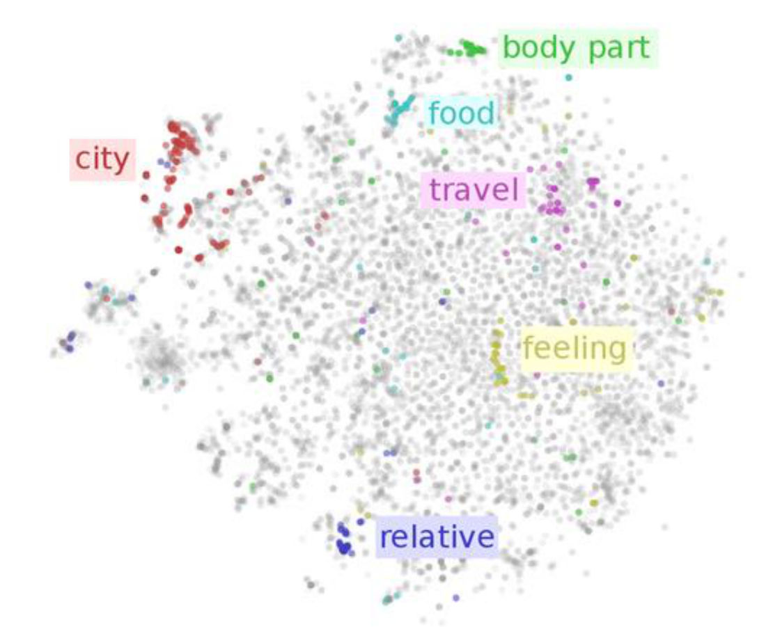

Calculating Similarity – Cosine Distance
- The great thing about distributed vectors or embeddings is that they provide us a way of easy calculating the similarity between vectors using a similarity measure called the cosine similarity.
- Basically, we calculate the cosine of the angle between the vectors for two words. If they are similar the cosine will approach 1.
- Remember that we are usually doing this for very high dimensional spaces, but the same idea still holds
- NB: Magnitude difference between vectors is ignored!
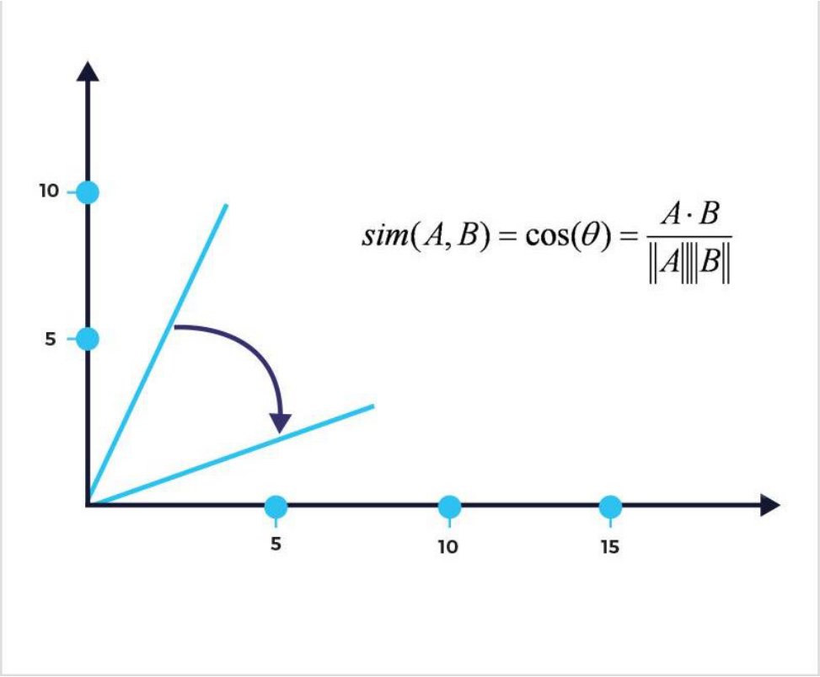
- Can take two vectors and measure similarty between them
- 1D/ 2D or multi dimensional…
- Get CoSine distance – how close they are too each other…. The angle between the vecotrs….at a basic level….
- Use cosine distance

Cosine Similarity in Detail
- https://memgraph.com/blog/cosine-similarity-python-scikit-learn
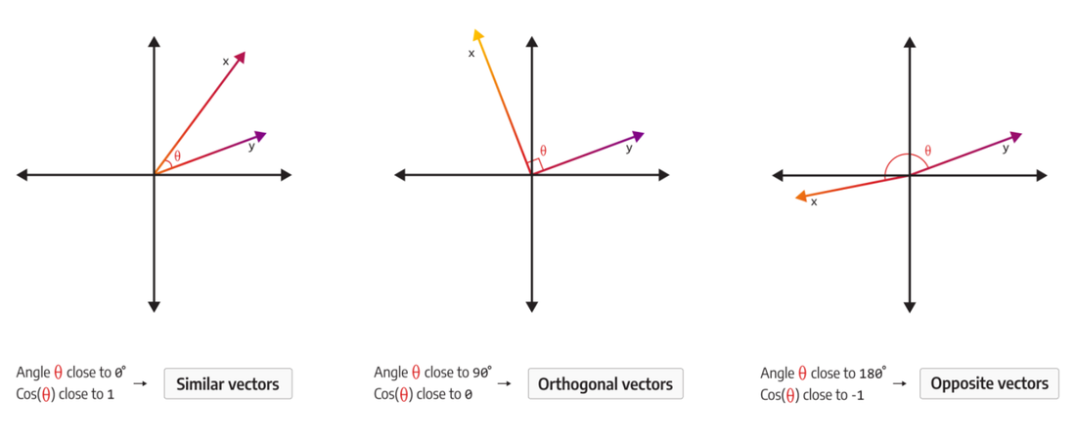
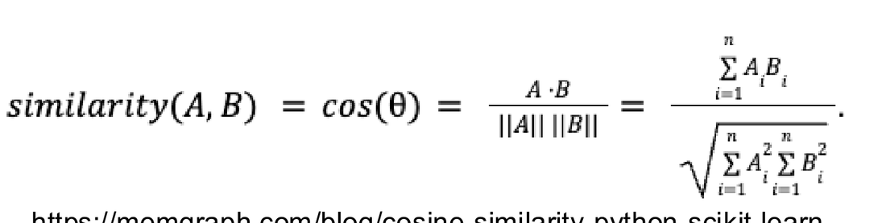

https://memgraph.com/blog/cosine-similarity-python-scikit-learn
- anything close to 1 =>>> two vectors ar very close to each other
- if orthogonal >> at 90degress to each other… >> = zero
- directly opposing each other.. goes to -1
- has a range -1 and 1
- -1 is complete oppositie…
- No mater how many representations cosine similarity boils it down to single number…
- Information retrieval…
- Clustering…. News aggregators… google news… may not any more.. clustering news articles together…
  - Highly dependent on measurement fo similarity….
  - Cosine similarity measurement
  - There are others btu tcosine is widest and most flexible that exists..

Cos Check
- What is cos(180)?
- What is cos(0)?
- What is cos(90)?

- Cosine 180 degress = -1
- Cosine 0 = 1

Where do the vectors come from?
- The specific vectors for individual words are usually learned from a corpus of documents through a machine learning process.
  - The actual process used for modern distributed embeddings are usually very complex and involve the combination of a number of tasks.
- The general approach can be illustrated with the skip-gram and
- The important thing to understand is that these vectors are learned from a training process which focuses on making sure these vectors are good for key tasks like document similarity measures, guessing the missing word, predicting the next word etc.
- Word2Vec - Skip-gram and Continuous BOW training
- The training of these models focuses on guessing missing words. Continuous Bag of Words is training to predict a single missing word. Skip-gram is trained to guess words that should surround a given word
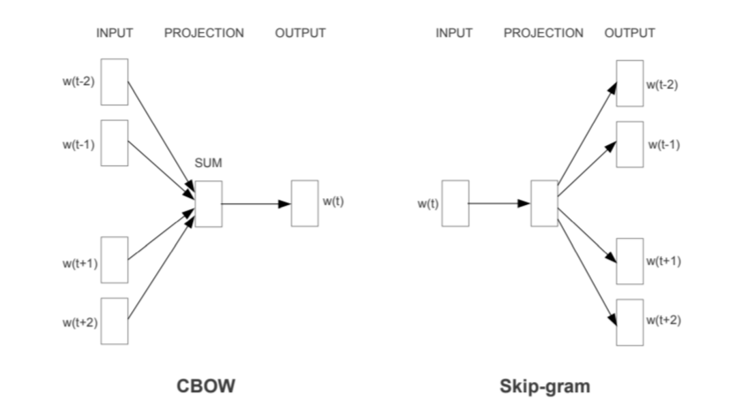
- Ifi you train a non trivial model to do the quick brown fo jumped over the garden fence
- Wha you get in a layer ina model is a good representation of the emanign of the missing word…..

- i.e. the quick brown……. < Blank > .. jumped over the lazy … < blank….>
- flip it around and use a skip gram model
- gie, give a wrd fox try to guess the representations of the words around it…>>> actually the representation of thw rod was even better….
- That’s roughly how these representatiosn ar learned…
- i..e leaving out worda as a task ie really powerful as a “self learning “ strategy, take a big corpus of text, do no labellgin no sorting, feed it into this algorithm and leave out middle words and move ono next bot of text, nto lots of traing with the data…

Feature | CBOW (Continuous Bag of Words) | Skip-Gram
Prediction Task | Predicts the center word from the surrounding context words. | Predicts the surrounding context words from the center word.
Training Speed | Faster to train. | Slower to train.
Performance | Better representation for frequent words. | Better representation for rare words (infrequent words).
Dataset Size | Often preferred for very large datasets where training speed is a major concern. | Often preferred for smaller datasets or when focusing on high-quality embeddings.
General Quality | Historically seen as slightly lower quality, but newer research suggests that with corrected implementations, it can be competitive with Skip-gram. | Often considered to produce higher quality embeddings, especially for capturing semantic relationships.
This is relevant!!!

From Words to Sentences / Documents
- These embeddings typically use a long vector to define a single word
  - How should we define a sentence based on word embeddings?
- There are many different approaches
  - Document = sum of word vectors
  - Document = average of word vectors
  - …
- While not being intuitive, these approaches do work surprisingly well
- See lab notes to see a typical implementation

- Approaches
  - Take vectros of eacj individual word >> sum them and average them…
  - Can build up a doc representation of a doc with 20 wors in it b taking average of all the different vectorea…
  - The averages are going to be farly unique int hat space i.e. in high dimension space….
  - Lwo dimensional space will tno work that well
  - Naive approaches….
  - End up with a vector which captures the meaning of the sentence..
  - Can combine them and similarity measure etc
  - Gets more interesting and powerfull is transformers….

Sentence and Document Embeddings
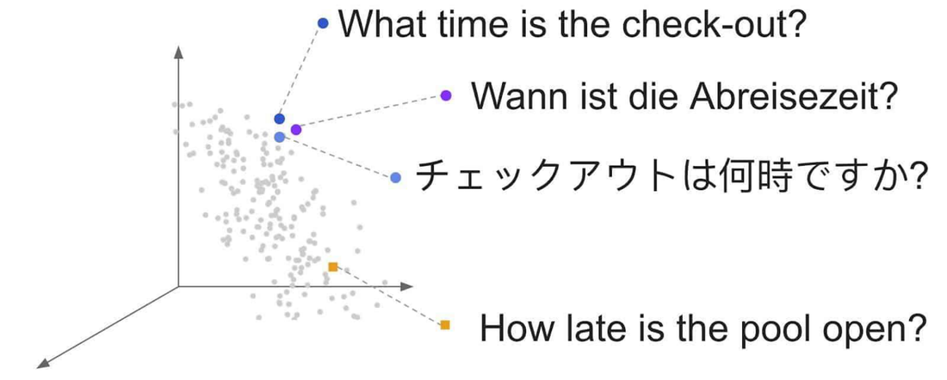

Sentence Embeddings
- Rather than being based on averages of word embeddings, modern sentence embeddings are trained specifically at the sentence level.

- Transformer style embeddings….
- Takes meaning of individual terma dn transforms it a little bit for each indy word give in a sentence context…
- Have meaning for individual words but meaning of that word in the sentence of how tis used…
- Trivial sense >> it’s a bank of a river instead of a bank of institution…
- BERT does more than that..
- Ocne tansfor meaning up the transformer… the reprsentatio assoc with abnk capturing not only if it’s a river or finacncila inst
- Also about action/ context / sued in a question / did ti have adjectives assoc whit it… so emanign gets a lto more sentence baked into it…
Sentence embedding vs word embeddings

Examples
- Build bag-of-words and TFI-IDF reps for the following two sentences:
  - The cat sat on the mat in Dublin
  - The cat ate some fish on the mat

Dialogue

- Can take a whole chat history and boil ti down to a vector…..
- Its agnostic inside the text
- Representations can dela with everytiing to do with words….
- Dialogue in particular in LLMs doalogues.. are inclredibly important…. Developing and testgin systems
- Agents… how natural is the agemt / personalsied agents…// style of conversations…
- Very few doing dialgues before but now.. everyen is doing them….
- What make sit different as a tupe of text….

Not all language is the same
- Each of these modalities will have their own specific characteristics


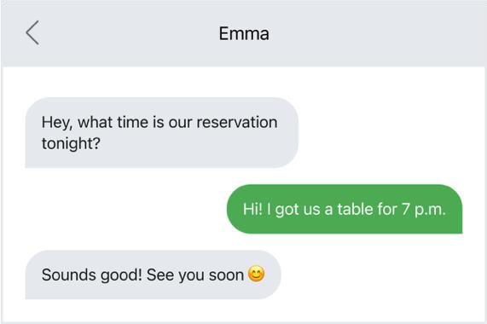

Conversation is very different to monologue………
Monologiue not there to ensure understanding… writing a b ook can’t do that / so pack as much in as possible..
Conversatin depends on more on idea of context…
What can we lave out that we thnk our interlocutor /our partner.. will get it..
If don’t get it face makes subtle adjustment to we know… they don’t’ get ti and adjust
Fluid and even when no physical reaction.. in text msg says what do
you mean?
- https://www.researchgate.net/figure/2-Main-differences-between-spoken-and-written-texts_tbl2_234662324
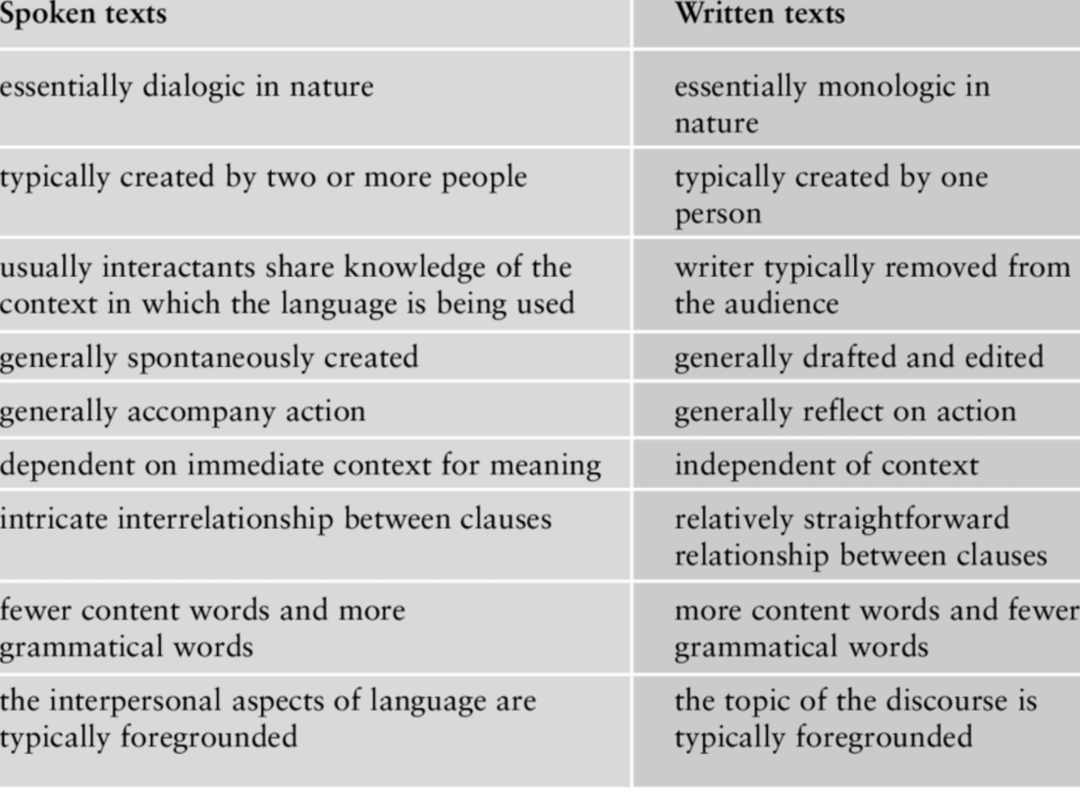
- https://www.researchgate.net/figure/2-Main-differences-between-spoken-and-written-texts_tbl2_234662324
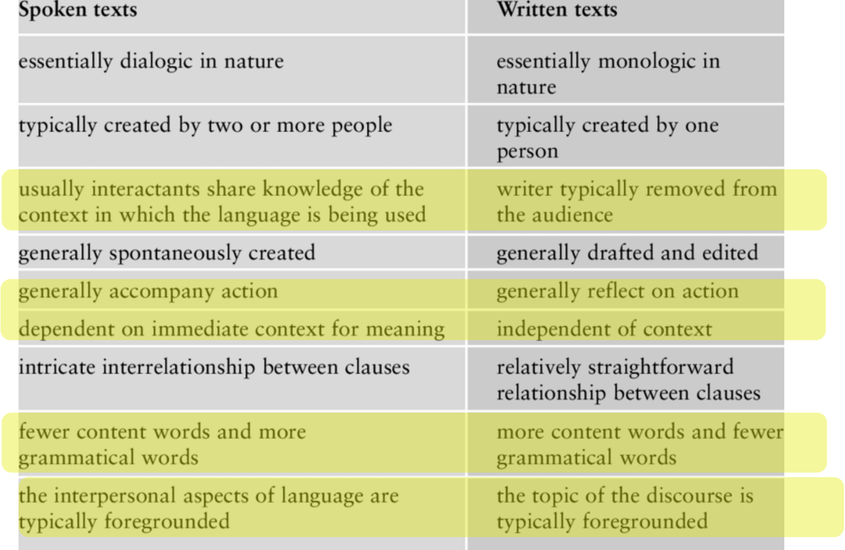
- Highlighted most important differences in yellow above.. at least most important for us…
- Actions
  - gestures / actions can communicate..c ant’ do that in written labgauge and neecd to be more explicit.
- Context…
  - Don’e thva esame access to information
- Style
  - Written etxt usually far more formal and structured in nature than conversational etxt.. becase we know less about oru audience… so write ni standard formalised way so people can understand it….
  - Hedge your best in terns of what oeople will understand…
- Interpersonal aspects
  - Types of text – wherether we’r just atlkgi sbout facts ro our relationsships to each pther…
  - Written etxt are far more basedabot facts and baking as mcuh infor in as possible..
  - Conversation usually base dmore on relationship between agents,,
  - Relevant in design of chatbots……
  - Chatbots most of traingn is ni pure text / monolingual / books / and how people interact with their chatbots form suer conversation is more like a conversation….
  - Fluid and relaxed.. but designers of conversational assitansts… challenge was the persona of those systems whether text producted by bots was factual ro creating relationship with suer….
  - They have defineitl gone with generating lots of text….
  - Where that’s most jarring using voice interface…. Have spoke voice that’s clalign out an esaay to you… and then would you like me to do somethgin else for you?
  - There is no universal how we present information , based on task at hand and the users we are dealing with….
- Written text vs spoken text…
  - Lost of different types of language and howe use language….
  - MSc encounter in dissertaions…. Texting and talking…
  - How we write tweets and linkedin updates….
  - Style / hoe much inf we’re pakcing in / toe of inro i.e. quick jolty or professional…
  - All can be repsrseted bty text
  - …
  - But those vector space representation are NOT just capturing the facts of the dog and the man.. theyt r are also capturing the tone .. sublties in speech are we positive or negatyive about something….
- Ho we represent etxt is more than fasct… all the different types of text we need to speak about…

Other Language Type Contrasts
- https://smalltalkbigresults.wordpress.com/tag/texting-vs-talking/
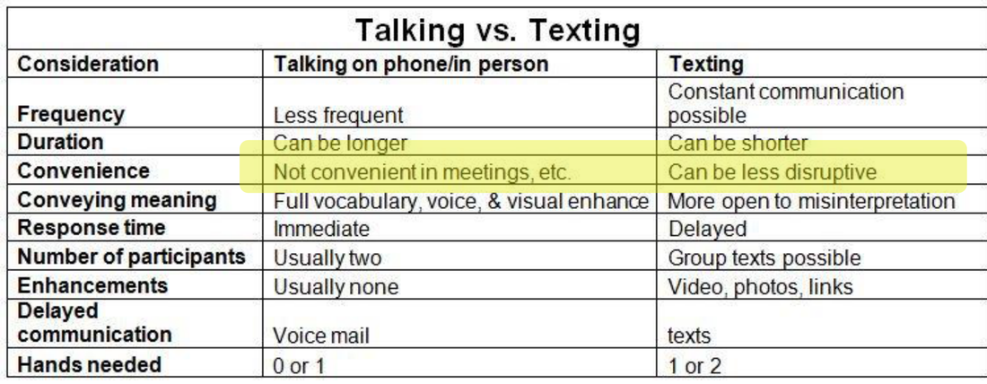

Lab - week 3 –
I will say gogole colab and run it…
Doesn’t need GPU access… not doing anthgni sophisticated….
Can eb done on CPU

Some Lab Work

References
- https://medium.com/predict/how-does-nlp-pre-processing-actually-work-8d097c179af1
- https://ted-mei.medium.com/demystify-tf-idf-in-indexing-and-ranking-5c3ae88c3fa0
- https://towardsdatascience.com/text-vectorization-term-frequency-inverse-document-frequency-tfidf-5a3f9604da6d
- https://memgraph.com/blog/cosine-similarity-python-scikit-learn
- https://www.researchgate.net/figure/2-Main-differences-between-spoken-and-written-texts_tbl2_234662324
- https://smalltalkbigresults.wordpress.com/tag/texting-vs-talking/

