COMP1023 - Natural Language Technology
Lecturer = Robert Ross

Email = Robert Ross <robert.ross@TUDublin.ie>

2nd Nov – new lecturer >>> MOh
- Module not available to full timers
- Robert not available to deliver next semester
- 2nd Nov – new lecturer >>> MOh
- New lecturer >>> Muhammad Abrer Irfan
  - Lecturer in school of CS
  - Research in AI ML and Computer vision
  - Recent researcj on focus of applied AI / ML in foeld of medical imaging ..
  - Worked n 2 D imaging and 3 d images aswell
  - Taking over soon.. et

Week 1 – Introduction – 14th Sept 2026
- There were two pdfs
- Contrent.pdf
- Introduction.pdf

Introduction pdf

Natural Language Technology
- Introduction

About Me – Robert Ross
- aka, Rob.
- Not, Sir, Professor, or any other honorific
- Senior Lecturer – School of Computer Science
- Lead – Cognitive Systems Research Group
- Active National Funding (Sep 2026)
  - Research Ireland ADAPT Research Centre and Rinn AI
  - Research ireland Spoke on Motor Neuron Disease
  - Deputy Director ARC Hub for ICT
  - Enterprise Ireland Funded Innovation Partnerships and Com Funds
- Research Areas:
  - Situated Interactive Systems (Talking Robots / Games Characters)
  - Applied Computer Vision Applications
- https://www.linkedin.com/in/robertjohnross/
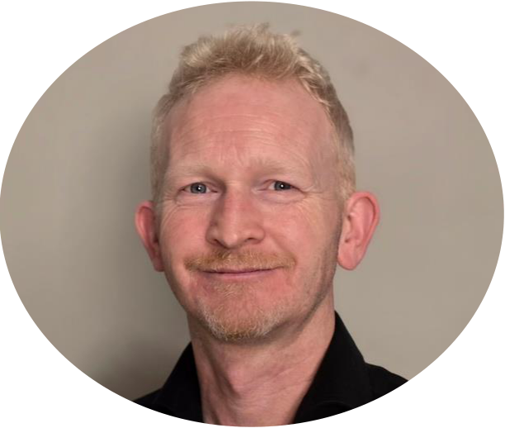

- Only difference is new photo
- Here many years….
- Speech and lang
- Robotics in hospitals
- Gestures use for good hospitals speech and language
- Interest in using AI for good!!!!
  - Speech and language theragy
  - Keeps on top of new stuff but ny god so much change its very hard…
  - So don’t clain ton know every product and every tech

NLP always in the news!


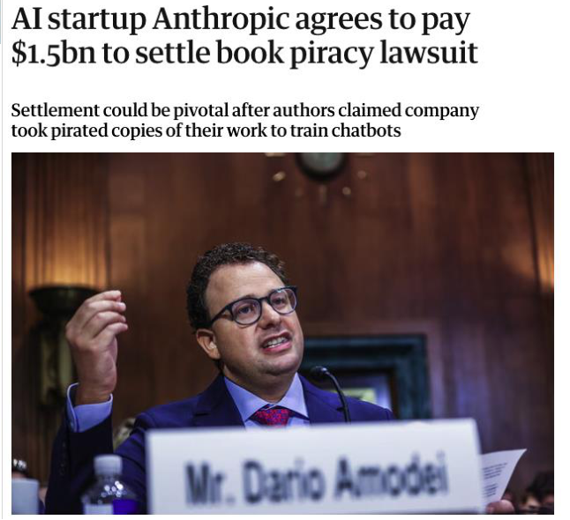
- Dominacne of LLM in everything
- At conference for construction engineering and called “beyond the prompt”
- AI is everywhere…. Infiltration into every domain….
- AI does more than just lang processing
  - Also imge processin / image production
  - Also tech image generatin / diffusion models etc
- We’ll do multi model
- Iage processing and image production…
- Main focus in this mod is language
- Deep learning after christamd
- Iimagge general and fusion modele…
- Ehre just how we process language / and in particular how LLMs process language and are bult upon to big nig agentic AI solutions

Agenda
- Jumping In
- Course Scope
- Prerequisites
- Course Structure
- Assignments and Assessment
- Coding
- Lab: Model Training with Collab
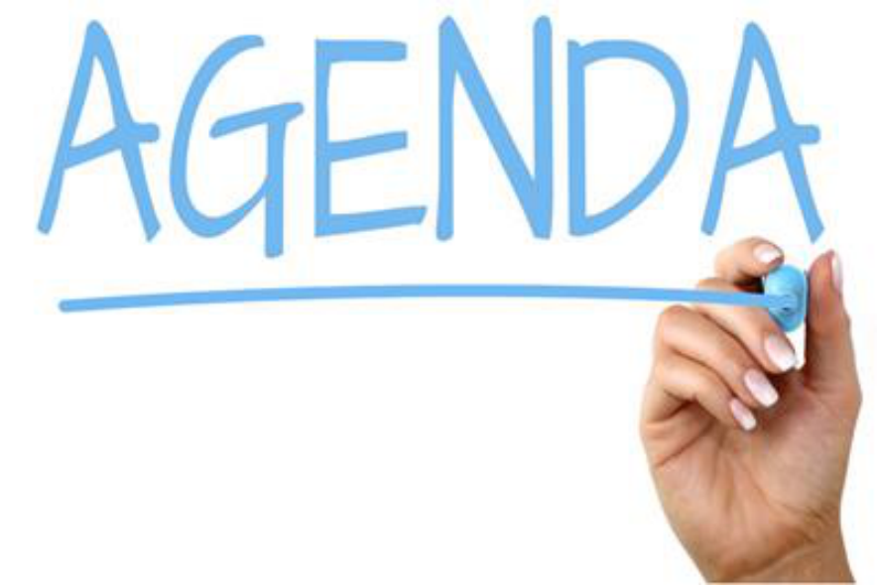

Course Scope

- tonight
- Wants to get to know us
- Hands up
- Assignment will not be trivial… need to understand that….
- Not doing iage processing / image production or other modalities – genetics etc..won’t have time
- Purely on natural languages and some of issues around it
  - Speech ecognition
  - Speech generation
  - Gestures
  - LLMs
  - Agentic systems based on LLMs
  - More broadly before getting to that… lok at what we mean about what we’ll cover…

Course Scope
- Goal: Study key concepts in Natural Language Technology
  - Emphasis on practice
  - Linking out to theory
  - Linking out to related modules
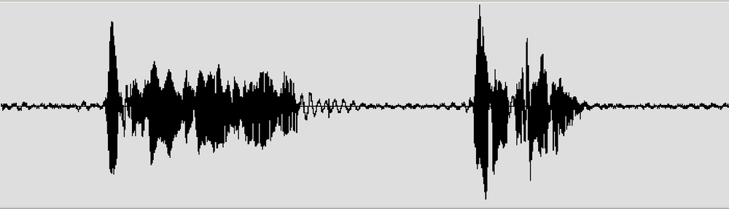

- Cover most concepts in natural language technology
- No a certification course in a spcfiic API
- How all the concepts fit together
- Don’t want t do based solely on theory -ground them.. in practice how to use them…
- Need to link to practice
- So
- Teach concepts grounded in technologies that are used.., so can pyt those concepts inot practice so can make use of them
- Try link to theory… only as much as absolutely need to… so only doing hats interesting…
- Will try link to other modules… will be some overlap… but will do our best to avoind overlap
- Looking for something ask him… it may be in another module

Course Scope
- Goal: Study key concepts in Natural Language Technology
  - Emphasis on balanced theory and practice
- Lecture Notes: Mostly Slides
- Not Covered
  - Digital Signal Processing (see Sean O’Leary)
  - Computational Linguistics (the old way – lots of linguistics)
  - Machine Learning and Deep Learning (see other modules)
- Learning Resources
  - Course is mostly self contained
  - Links to external resources will be given
  - Use of 3rd party services will be a part of the course

- NOT DOING THIS COURSE
- Not covering low level DSP (digital signal processing – sean oleary - digital signal processing.. will tno cover here)
- Lot of electronics is still dependent on DSP working well
- Computational linguistics…. Syntax/sematics/operational ise it / add logic…. Etc
  - Computer orientated models of language then way linguistics think of language
    - Used principles of CL, i.e.
      - extract the phonetics >>
      - then analysis for syntax, i.e.( How words are structured together) ,
      - then add layers of semantics under that, o
      - operationalise that,
      - link to logic and …
      - we can do great things with that
  - That was philosophy for 30 years but….It failed miserably…
  - Lang doesn’t adhere to those rules…
  - Humans take context and probabilistic way to make understanding
  - Computerss formalising that process was too tough to do…
  - Deep learning solved that .. achieved goals… extract meaning from language
  - Works in computational linguistics…older way of doing things…
  - Tried to do somehting with language with tools and process that just didn’t fit…
- Sprinkle its of it around the place so we understand…
  - Why is lang tough?
- Diffusion models…
- Transformers..
- Necessary for training models… need to know
- In NLP not ging to be training the models….
- Interested in how good LLM sre actually trained… do deep elarning module…
- Sugn up for 3rd patry provides
  - Google APIs
  - Google co-labs
  - Use open source services aswelll

BOOKs – learning resources…
- Won’t call out Books – tech moves to fast… my god we have moved on…
- Links/references claude etc

Prerequisites
- Good programming experience
- All assignments to be coded in Python
- Machine Learning or AI is not a prerequisite
- This module is suited to both Data Analytics and Advanced Software Development students
- Laptop
  - I strongly encourage all students to set up their own local python environments to learn
- Willingness to interact
  - We don’t all like groups, trust me! But they are a good way to learn.

Course Structure


- Breaks
  - Long break or short break
  - Finish at 9:20
  - Logn isn’t too bad as allows people reset….
  - Con – people lose attention after 1 hour 20 mins…

- Programmign experience
  - Able to sit down and analyse doing whats supposed to do…
  - Ability to understand code and models iis still important….
  - Related issue if debugging thigns need to decode and work ayuo way around mdoels…
- LLMs
  - Pull together and prchestrate different technologies
  - If don’t shave programming experience may get through but should have that ability…

Course Structure
- Week 1 - Introduction - the Challenge of Language
- Week 2 – Language Input / Speech Recognition
- Week 3 – Language Output / Speech and Image Production
- Week 4 – Representing the Meaning of Text
- Week 5 – Processing Text
- Week 6 – Information Retrieval
- Week 7 - Review Week Bank Holiday
- Week 8 – Language Modelling
- Week 9 – Large Language Models
- Week 10 – Prompts and RAG
- Week 11 – Agentive AI and Orchestration
- Week 12 – Bias and Ethics
- Week 13 – Review Week
- Provisional and will change!!!!

- Moderna Ai systems combine parts together
- Then text inputs and outputs
- Week 4 / 5/ /6 > epresentation and how we process it codeding text / approaches etc and traditional tasks we need ot do with languages questions / answer type scenarios
- Information retrieval
  - A lot of what we do in LLM
- Bias
  - How system descrbes instructtions produces different result if boy or a girl
    - Here PHD can’t ri the idea..
    - Inherent bias in system….

Delivery
- 5 ECTS
- Three hours contact per week
- 3 Hours on Monday Night
  - 2 Lecture
  - 1 Lab
- Assignments
  - Examination: 50%
  - CA: 50%


- Can go into company and say I know it
- Companies ask college how do you actually know they know this stuff?
- Old things called exams…
- Not problem based learning course…
  - But go off an explore more than I can do…
  - Don’t just take surface notes that Robert provides….
- Questions from vanessa
- Course is self contained but will do better if go off and do more yourself…
- Exam questions type
  - Heres an architecture >>> whats wrorng with it?
  - Use marking rubric and thsat how ti is assessed
  - Will be more than you expect in Cas
- Basic is to pass do the basics… not a first….
- 80/90% is there is no rom for improvement
- Demonstrating a very strong level of uncderstandign
- i.e. Do vs Understand?
  - Why did you do it?
  - For what reason?

Coding
- Python plus requested libraries and frameworks
  - Python 3.12+
  - Use Virtual Environments
- Server Environment
  - Most code can be run locally
  - Google Collab can generally be used for most experimental work

- Mostly in Google coLabs notebooks
- Microsoft environment not as straight forward…
- Doesn’t have to be
- Need to submit in google co-lab
- .. sharable with external examiner…
- So ahs to run in google co-labs…

On the Assignment
- Initial Plan Design
- In Class Lab Review
- Github and Shared Report
- Final Oral Defense that caps other elements
Component | % | Format
Initial Check in and Experimental Plan | 5 | Initial commit and experimental plan, w/c 10th Nov  Pull together coprera of data  Github repo  Submit initial versio of repo  Submit initial draft of report  What will do and what exect to happen – can get t wrong but need lgical plan  - Late delivery  - Extension if everyone in class agrees, I objects we will not extend  - 2 % per day for 2 day  - 1% per day there after  - End of week roughly 10% penalty  - Deadline = 8pm (Not Mid Night)
Online checkpoint | 5 | Individual 5-minute conversation online, w/c 24 November approx.  Chat with Robert.. is it running?  Check in and see what ode beign use
Project — Parts 1 to 4, submitted together | 25 | Own time, one submission on 14 December approx
Oral assessment | 15 | Individual 20-minute conversation in person, Week of 12 January approx..  Open book – justa chatabout it  Doing 10 years since fiverassignemtns.com!
Assignment total | 50

See Content Deck

Labs for Week 1
- Part 1:
  - Download the notebook for week 1.
  - Upload it onto google Colab and execute content
  - Switch Runtime model on Google Colab between GPU and CPU.
- Part 2:
  - Install Python 3.12 on your own machine
  - Make sure Python is being added to your PATH
  - Run python from the command line and verify the version


References
- https://www.linkedin.com/in/robertjohnross/

Content pdf

Natural Language Technology
- Week 1 Introduction
We will look at everything as a whole more or less

Eliza
- A First Conversational Technology
- Joseph Weizenbaum, 1966
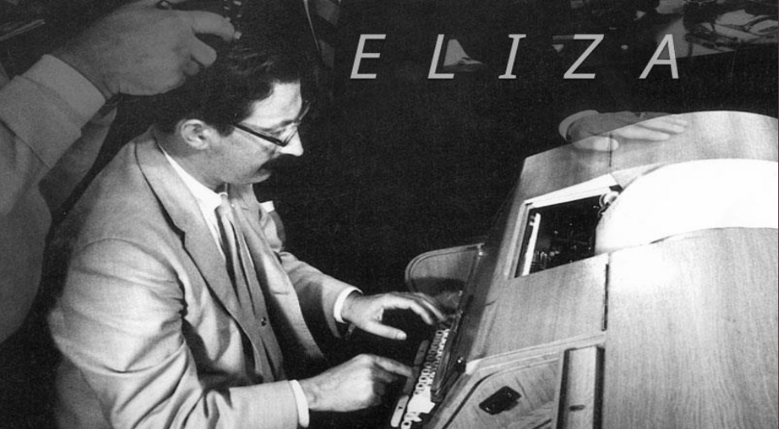
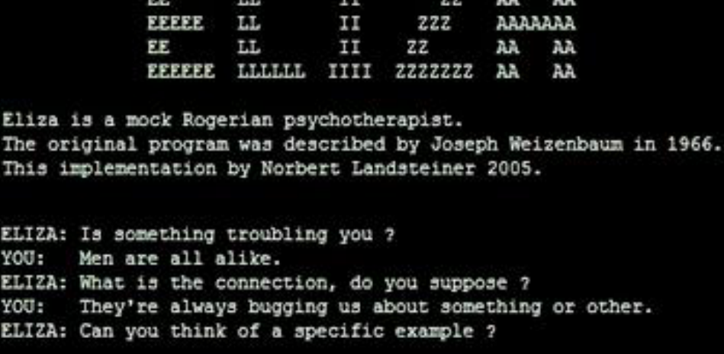
- One fo the most state of the art modules could be teahcign
- Has a pedrigee gong back in time
- Computational lnhuistics established where we needed to go… from technology
- Startup
- Counselling systems
- Eliza best system that actually worked
- Taking account of Eliza effect
  - When people interact with a dumb system
  - They still treat / assign to it intelligemnce to it that does nto exist
  - Unfair expectations – start to notice imperfections
  - State of the art are mto performing as smart as we think they are…
  - Payh attention to research based in eliza

The Eliza Effect
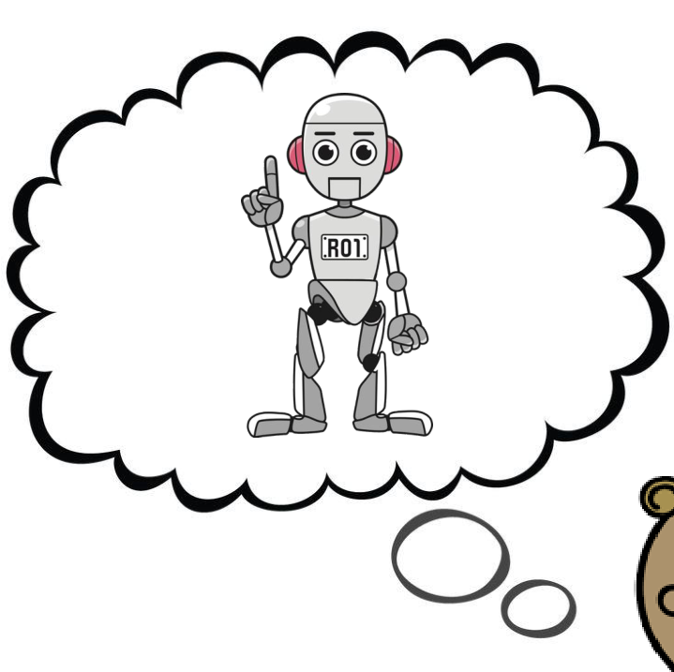

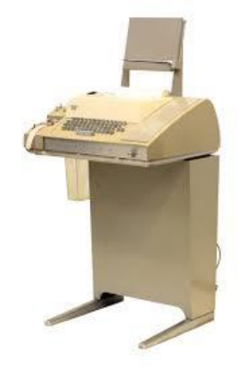

3 Contemporary Conversational Systems
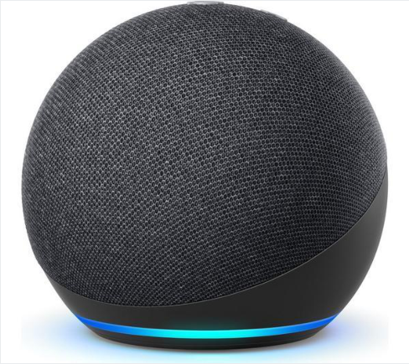
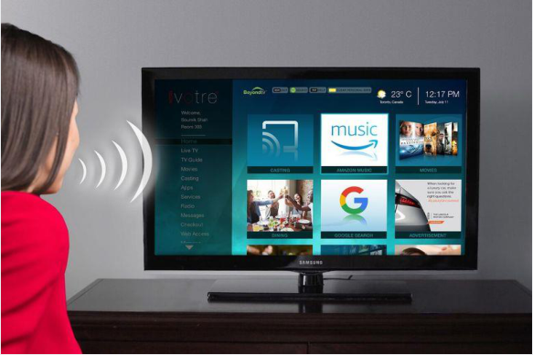
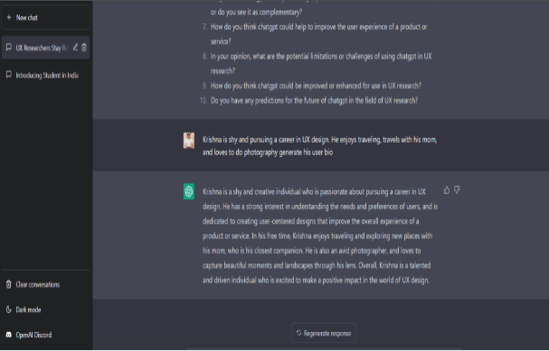
- Searcj is dying
- Zero click search
- Type into engine.. do click to get answer.. get answer back
- We don’t’ know how t is gong to work out
- Kids are growing up where don’t’ have to click thu to get a response
- Many uses are commercial
- Helping people is great
- Chatpt is democratisation of knowledge
- Old school if had parent in area could do well
- Social care

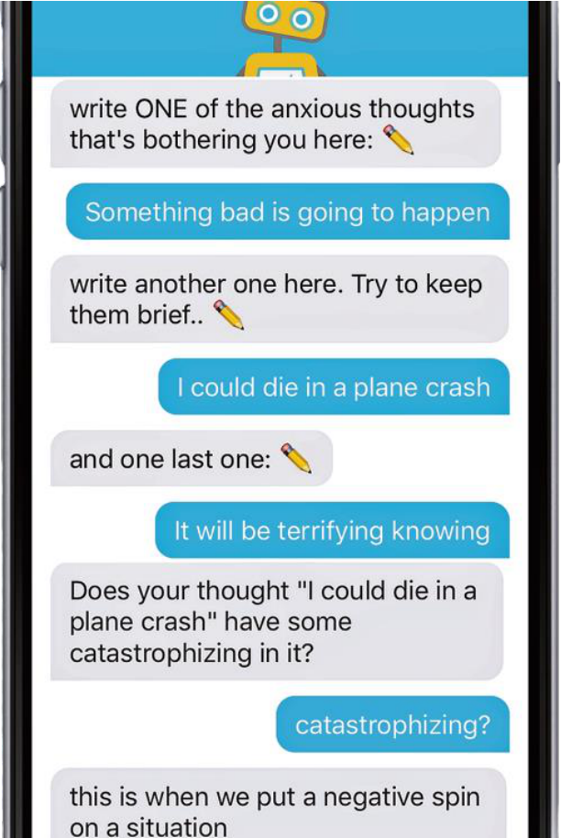

Future? Conversational Systems
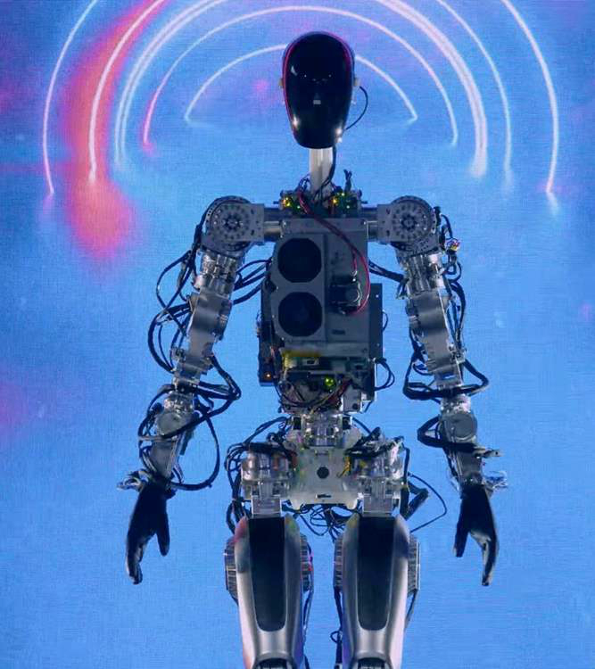
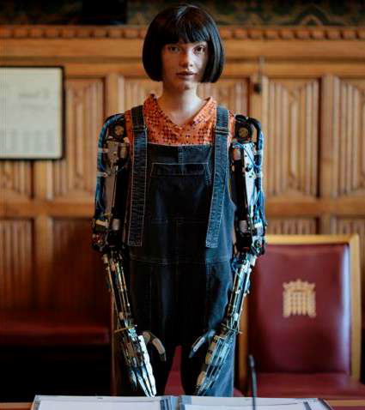
Lets have a look and see what inside these components….!

The Basics – How do we build Conversational Systems
- The Basics
  - 1) How do we build Conversational Systems?
- The ML Playground
  - 2) Putting Deep Learning and AI to Work
- Personalisation
  - 3) Keeping the User Engaged
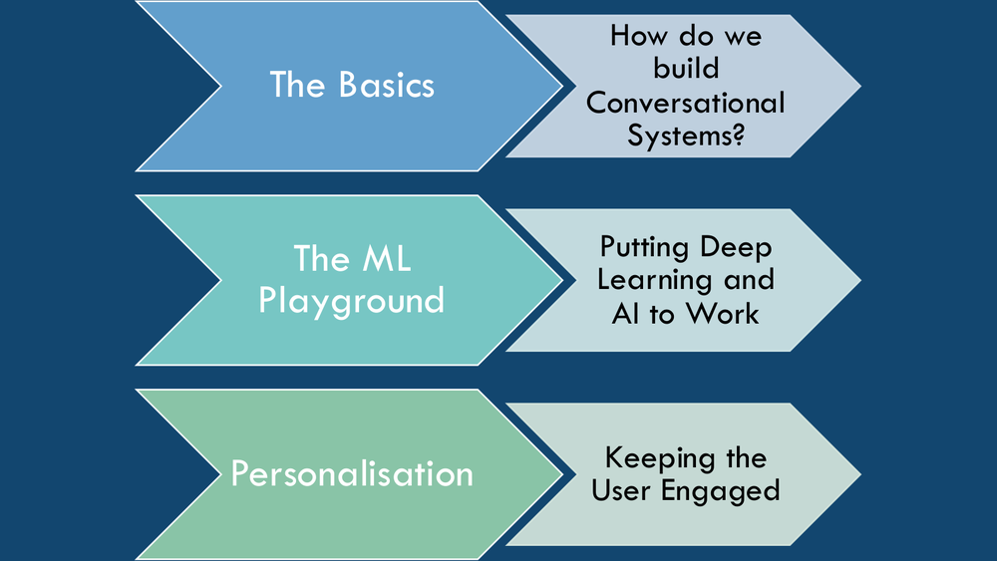
Take those thigns open them up and have a lok inside..

Today
Set the scene 3 key elements for building thes tech systems
- Back bock bne of these systems – conversational AI architecture of how these systems are built
- Conversational deep learning in particular has taken all these individual components, accelerated them massively, changed how we look at them and given us new and interesting tech in how to pull them together
- Personalisation
  - To be good hs to be personalised.. if tno for al users for some users..

Conversational Architectures aka Dialogue Systems
- Language Input
- Language Analysis
- Dialogue Management
- Domain Component
- Language Output
- Language Generation
- Architectures of natural language technology components used to enable conversational applications
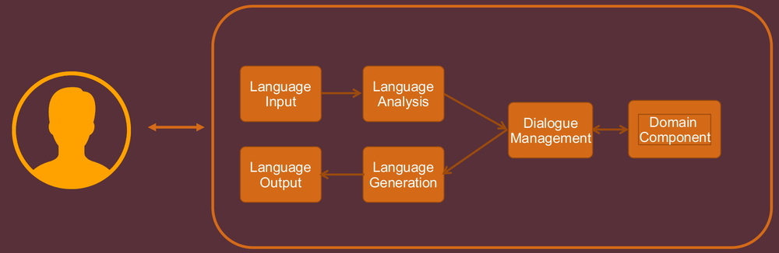

Systems – processing user queries
- Various ways to taek in input
  - Plain text
  - Iput modalities
    - Speech recognition
    - Stats says => # error rate has been going down and down etc approachgin zero… true agaist the benchmarks….but benchmarks are not most appropriate in real world
    - i.e. noisy environments, background
    - area of NLp still in dev is speech recognitions
    - accents… wife from meath… lived in Dublin longer than Meath… but still has accent
      - lexa has trouble with accents…
      - frustrated user wont’ buy another device
    - random person =- his wife might not understand all
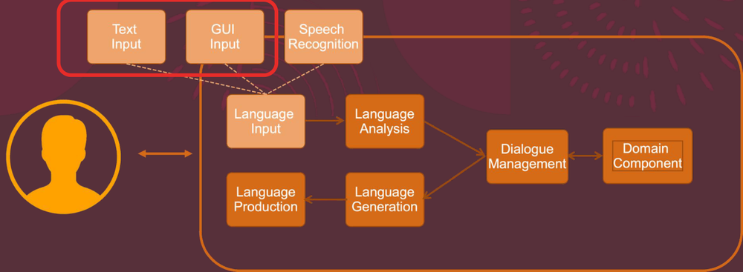
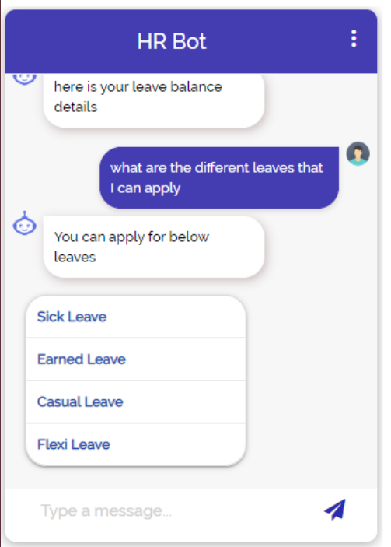

Technology Backbone
- Historically Hidden Markov Models
- Modern Systems based Recurrent Networks and Transformers
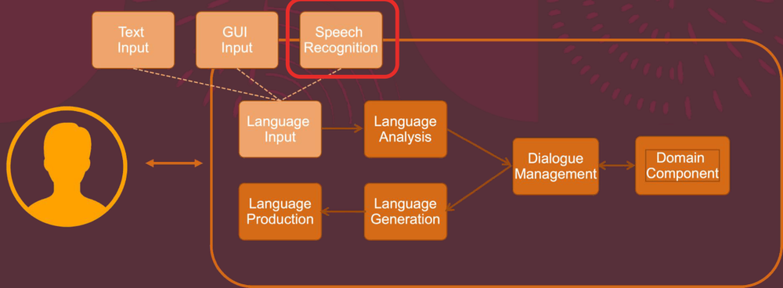


Word Error Rate
- Challenges:
  - Beyond outdated error metrics
  - Noisy Environments and multi-user settings
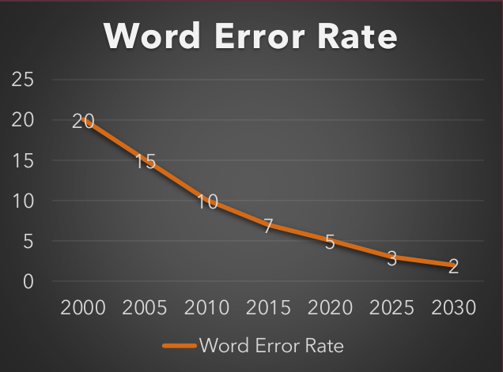
- https://www.researchgate.net/publication/264975659_Visual_Semantic_Search_Retrieving_Videos_via_Complex_Textual_Queries
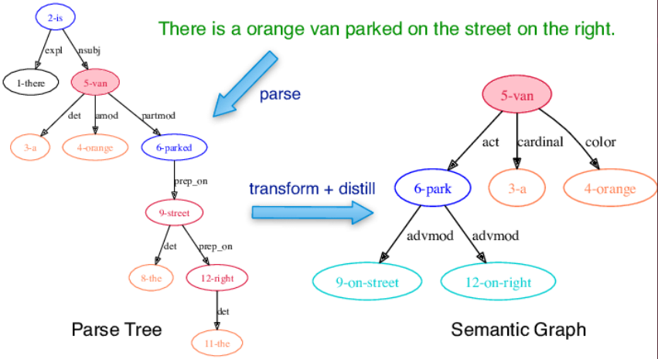
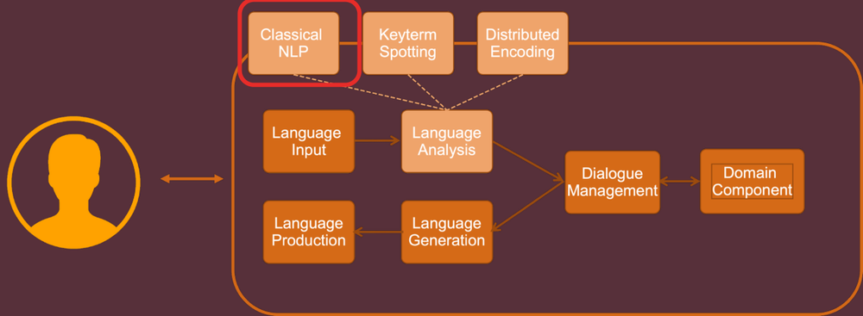
- Skipped last few slides
- Done Input
- Now lets move on to Analysis
- Analysis = extractin of info form language
- Done’ care how got it in but we have a representation of what they aid /what si meaning of what they said..
- Languages Analysis = figure out what they meant (the meaning of hat they said)
- Over the years many different forms of language analysis
- Even in LLM world with Deep learning we still perform a type of language analysis (week 5)
- Types were computational linguistics methods…
  - i.e. parse tree generations – assign grammatical categories > put into cpmputational trees
- can eb done well for formal langauges / newspaper text (checled by editor and gramtialyl correct
- but real world, no grammar, no full stop, no commas etc vebs instead of nouns etc
- now don’t formally try understand indiviaul meaning of every word do a holistic thing where take thos emeanign and projects those meaning into multi dimensional space.. representation spaces, related sentences occupy similar spaces
- lok at over wek and months >> intrinsically important to LLMs work
- Take advantage of initial representation of language into this multi dimensional space and it gives s a nice robust representation of meaning that we can then act on…

- https://arxiv.org/pdf/2002.10851.pdf
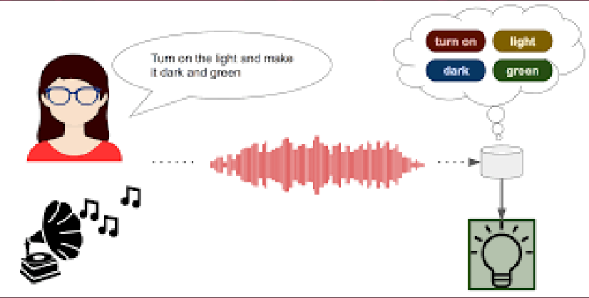
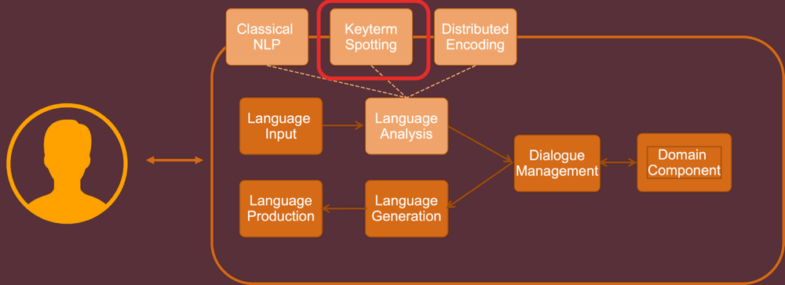

Classical Semantic Generation Systems - Generation
- There is a dog in the park
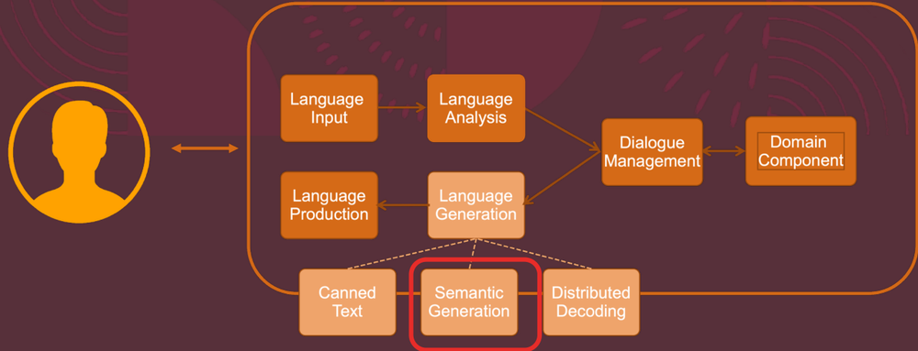
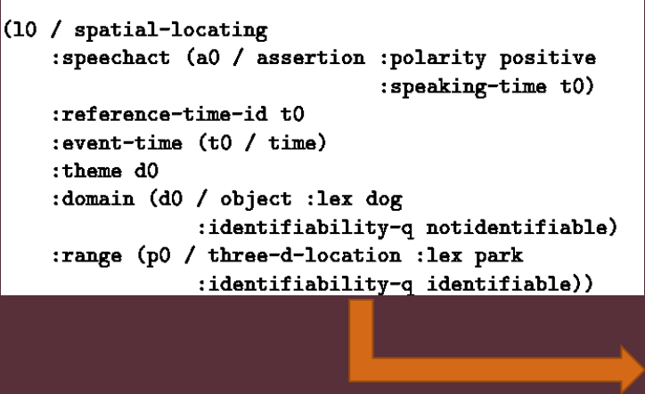 There is a Dog in the Park (at end of this arrow)

- Generation - opposite of analysis
- Take representation of meaning and try generate language from it….
- #in old days representation would be like slides above
- Formal structures yaml style.. feed into systems where we generated text….
- Were not agile or robust for real world use….
- https://towardsdatascience.com/state-of-the-art-of-speech-synthesis-at-the-end-of-may-2021-6ace4fd512f2
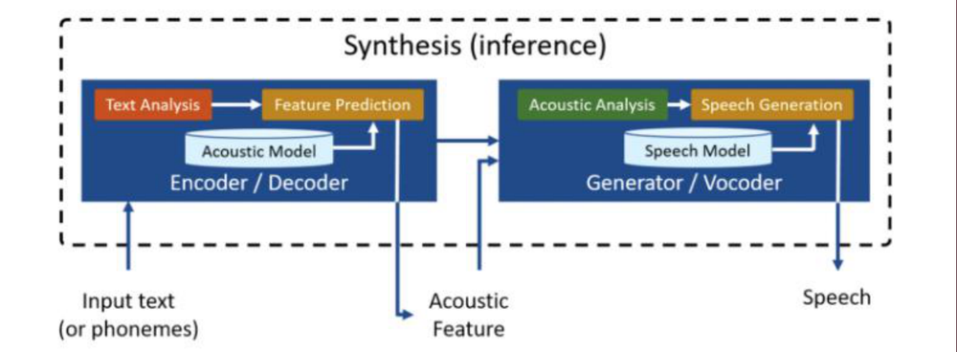
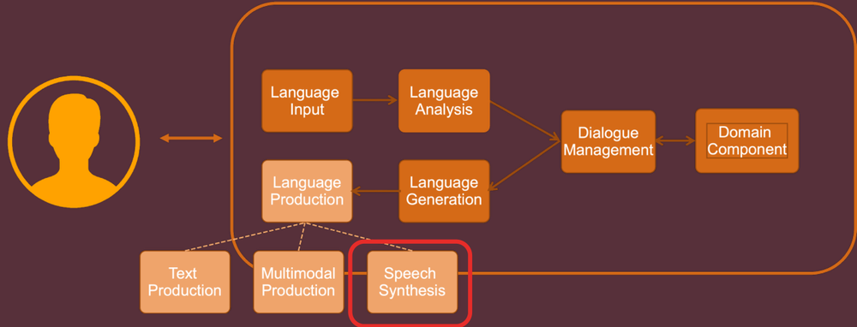
- Moved to distributed representations
- Capture all meaning
- Take a position in this meaning space > feed it into a neural network and neural network will generate the text based on a number in high dimensional space > and generates word by word the text that corresponds to that space…
- Soe areas in this space wont’ gemnerate real text>> but y and large this approach works quie well for generation
- Wil come back to that quite a bit
- URL>>>
- Me spectrogram
- VOCODERs >> voice encoders generate audio from dimensional representation

Dialogue Management
- Language Input
- Language Analysis
- Dialogue Management
- Domain Component
- Language Production
- Language Generation
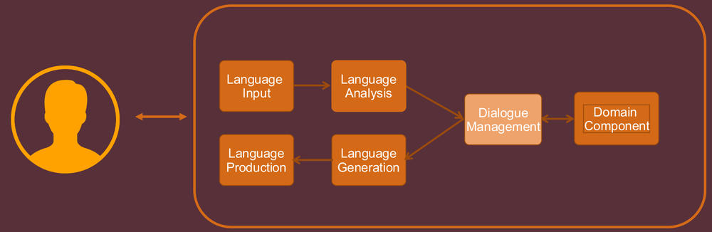

- Not goin to spend time talkig tboua lang production btu will talk about it in a wek or 2
- Atke words (speech synthesis) or just print to screen,…

- Have lang input and lang output
- What glues them together
- Dialogue Manager makes a decision about what we do next….
- Is really important component
- Is doing 2 or 3 key thgins
- 1) Deciding >> How mcuh shout we keep track of how mcuh do we let go (even in LLMs -its expensive and can break quality)

State Management vs. Planning
- Dialogue State
- Dialogue Management
- State Update Process
- Dialogue Planning Process
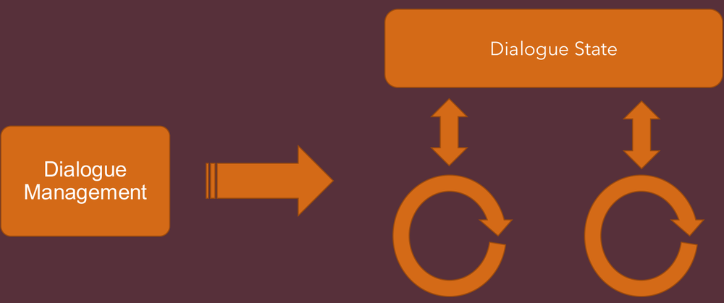

- Dialogue Manager makes a decision about what we do next….
- Is really important component
- Is doing 2 or 3 key thgins
- 1) Deciding >> How mcuh information we need to keep track of how mcuh do we let go (even in LLMs -its expensive and can break quality) -differen ways to learn whats important…
- 2) Planning - what to do next – planning
  - Do more reasoign
  - Tell suer great
  - Tell user to go off and restart

Dialogue Manager Paradigms ++
- Slot Based Dialogue Systems
- State Graph Dialogue Systems
- ChatBot Based (ChatGPT)
- Agent Based Dialogue Systems
- Pull all 4 together into Agentic LLM solutions
- Well Defined Paradigms
- Modern Systems
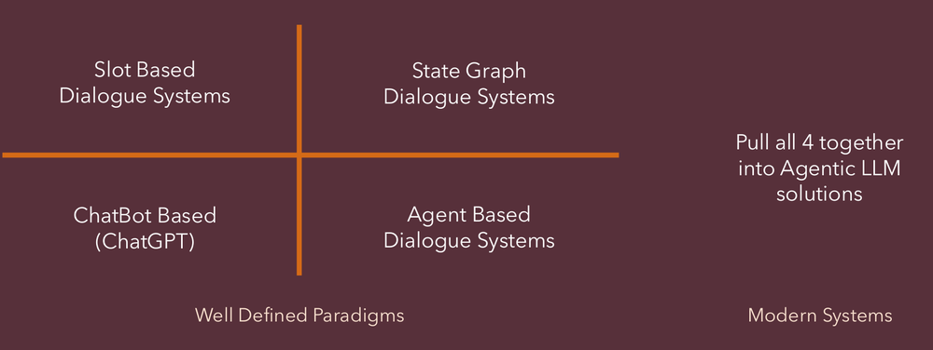
- Dialogue Manager Challenge – 3 or 4 main approaches to this challenge
- Will mention all briefly… all get pulled together to get good agentic LLM solution
- Mightn’t do them as explicitly as listed here.. but wil do them all to some level, these design ideas have to be achieve one way or the other
- If do them properly get good systems that behave as we want if do them bad users dopn’t enjoy engaging with the system
- i.e. Favourite hate in gemini >>. The prompt question? Do you want me to blah blah blah.. he hates it…
- explicitly asked to stop follow up question but still comes back… >>> that’s bad design….
- 4 we will go through now
- 10 Dialogue Management

Dialogue Management
- Language Input
- Language Analysis
- Dialogue Management
- Domain Component
- Language Production
- Language Generation
- State Graph
- Information State
- Chit-Chat
- Slot Filling
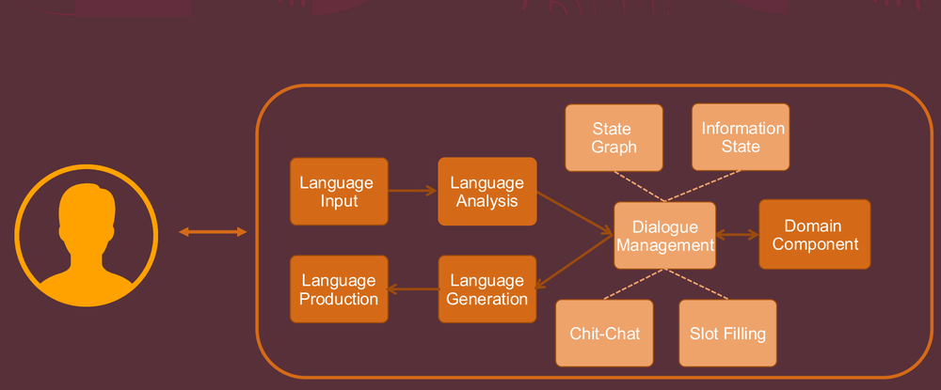
Chat based dialogue management - Couple of terms for this
- basically limited form of engagement
- set fo rules > lok up table >> if user says this => then say that
- add in probability>> becomes a bti better
- hodlign tokens >> can atke category of stuff can get quite complicate
- can give appearance of intelligence.. i.e. Toys
- can’t have enough rows….

Chit-Chat Dialogue Management
- Initiation Response (adjacency) Pairs with Probability and Slots
User | P | System
Hello | 1.0 | Hi, I’m pleased to meet you
What is your name? | 1.0 | My name is Stupido
I feel <emotion> | 1.0 | Oh, why do you think you feel <emotion>
Goodbye | 0.5 | Bye bye
Goodbye | 0.5 | Come back soon
…. | …. | ….
…. | …. | ….

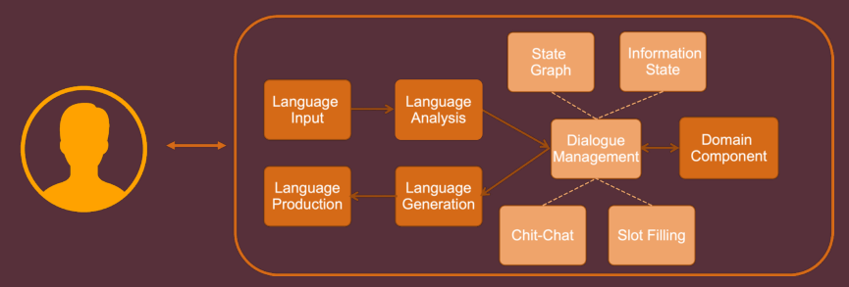

State Graph Dialogue Management
- The Conversational Roles Models
- Tait, M. & Visagie, A. & Niesler, Thomas. (2005). Development of a spoken dialogue system operating in Afrikaans, South African English and Xhosa. SAIEE Africa Research Journal. 96. 10.23919/SAIEE.2005.9488052.
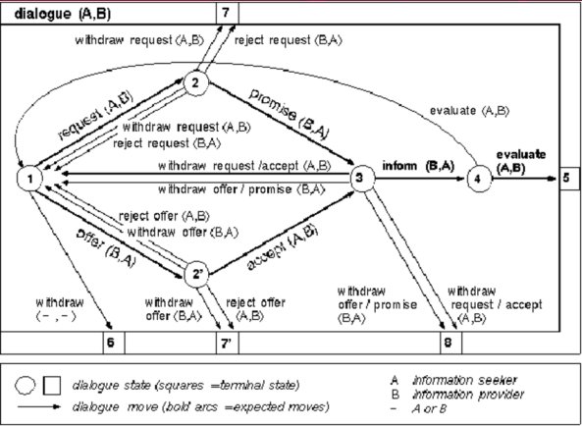
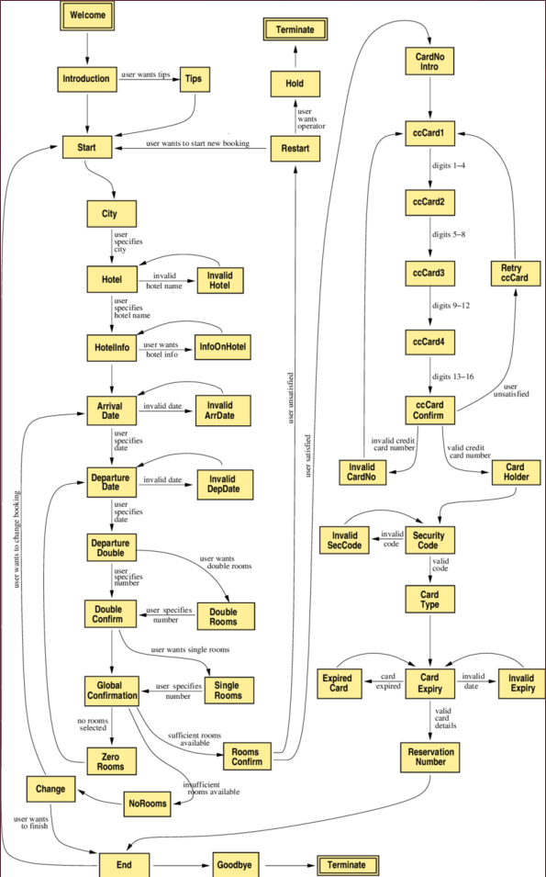

- State Graph Based Dialogue Management
- Still used in banking , /healthcare –have mro control over user in certain settignas
- System has to folowo flow
- Rigid , not smart >> but predictable
- Typical application
- IVR systems Interactive Voice Response (IVR) systens

- Can be wild cards / slots etc
- Can still be bought an used

Slot Based Dialogue Management
FoodType
Burgers
Chinese
Korean
Sushi
….

Food | Day | Time | Location | Cost
Chinese |  |  | Dublin 7 | cheap

- Data
- Algorithm

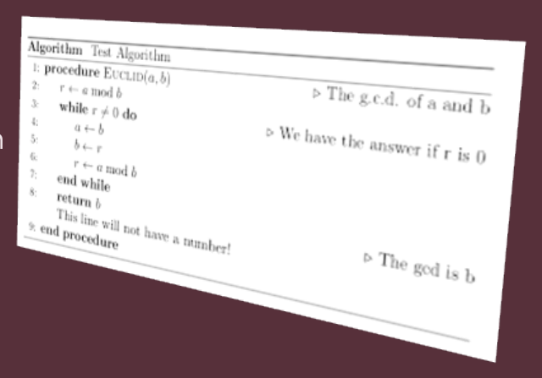
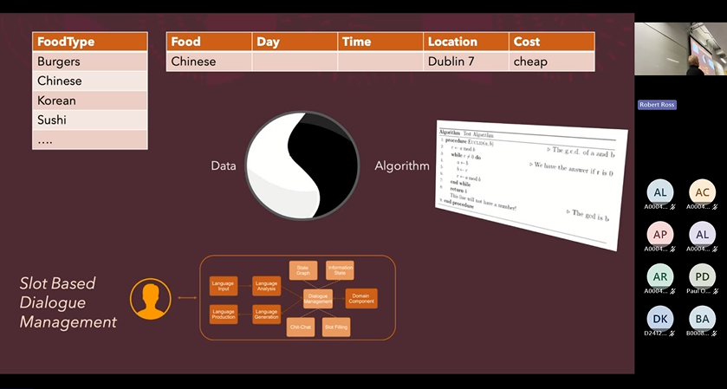

- Says instead of fixating on structure of conversatin amd managing flow
- Most tasks are about specific tasks..
- Play a song on spotify
- Find a recipse about ingredients
- To achive action anumber of
- Not going to fixate on a single specific policy for each task>> what infor are we tryignt o
- That algorithm will work thru process..
- Tak into account what suer says
- Design those behaviopurs into algo regardless of the task…
- In 90s SAlex.. populate slot definitions and then comeplet task…
- Agentic sees if we have all info need form user
- key thing is what we need and how we get it…
- #1 and #2 earlier does not separate them, slot based DM does separate them
- Slot based is clean and simple, ar other methdos, agent based which try to atke things, can be often compacted set fo rules..
- Agentic stuff overlaps with this.. btu agentc systens sort of… try to figure out these policies on dhata…. Use reinforcement leanrign at every step of the conversation …
- Focis on slot vs algorightm…
- All 4 are tied into full state fo the art current approach -full agentic LLM solution

Agent Based Dialogue Management
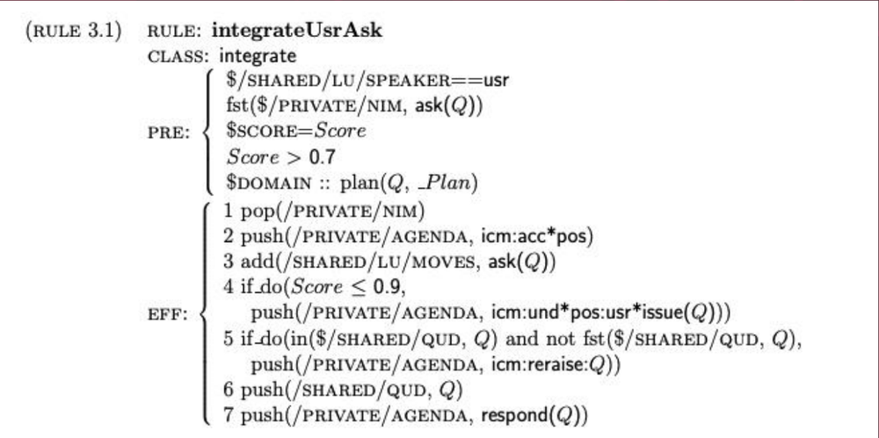
Flicked through quickly

Dialogue Manager Paradigms ++
- Slot Based Dialogue Systems
- State Graph Dialogue Systems
- ChatBot Based (ChatGPT)
- Agent Based Dialogue Systems
- Pull all 4 together into Agentic LLM solutions
- Well Defined Paradigms
- Modern Systems

- Agentic stuff overlaps with this.. btu agentc systens sort of… try to figure out these policies on dhata…. Use reinforcement leanrign at every step of the conversation …
- Focis on slot vs algorightm…
- All 4 are tied into full state fo the art current approach -full agentic LLM solution
What we’re building towards in this course in particular

Know some people don’t get to see and play with it….

- Is this the content problem in LLMs? Too mcuh into the context that you are working with in theproblem?
- Don’t like to remember everything
- A couple fo context problems
- Told can dela with 100s/1000s/ packed into prompt
- Problems in prwctice has theoretical limits –
- Usually charged per number of tokens
- Can be very easy to polute theprompt - - not relevant
- Good prompt design.. removes garbage, stuff not relevant

- Gemini -tends to be short…
- Clude – has arge long term session with calude
- Can build up massive context window as expensive.. to much details
- Research papers… how mich info affects kprompt –papers every year. To try inprove quality…
- Nto feed in long literally.. compess the conversayi history… can be good or not o good system

- Rant>. I see agentic and LLML based solutions like building a website
- Even today easy to build a website
- Hadr t build good wensite for real problem >> need godo content / not overboated / UI easy and convenient to sue
- Easy to buld AO based soltuino but hard to build a good one!!

Information Retrieval
- User Model
- Language Input
- Query
- Index
- Trends Model
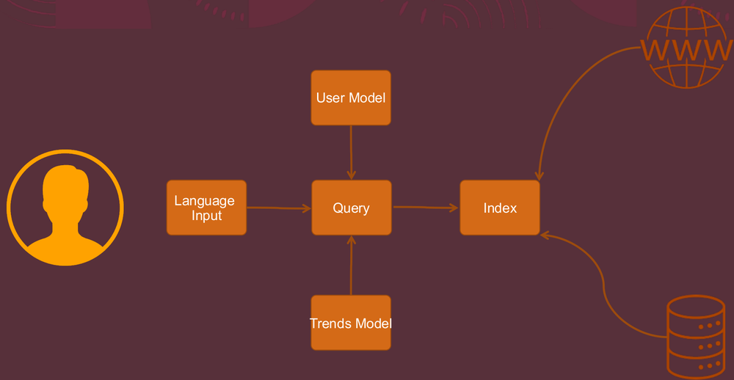
- Final system in spoken dialigie
- Informatianl retrieval
- Isbt dialogue manager process
- In almost all need IR component >> choosing relevant info
- Can source from pdf / web /
- To build good conversationa systems no just LLM or speech recognition systems
- Need good IR Serving relevant info into the system

The ML playground – Putting Deep Learning and AI to Work
- The Basics
  - How do we build Conversational Systems?
- The ML Playground
  - Putting Deep Learning and AI to Work
- Personalisation
  - Keeping the User Engaged
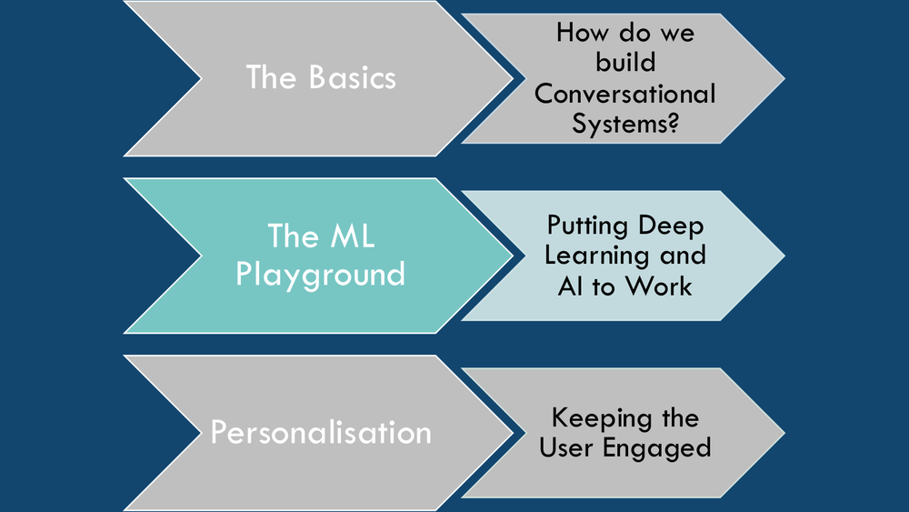

Deep Learning at Work: Rethinking Understanding
- Tensorflow’s Universal Sentence Encoder
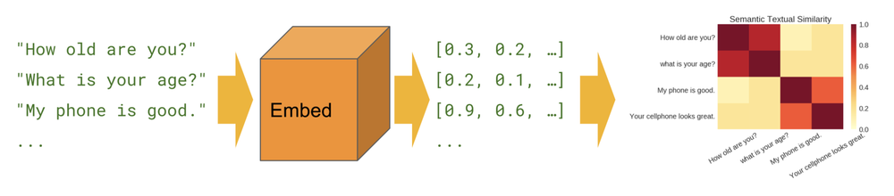
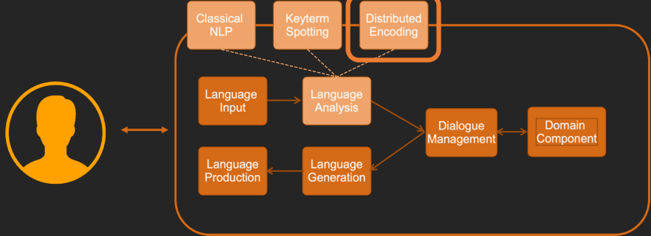
Everything we talked about earlier slides i.e. all had old rue based solutions and have now been replaced by modern dep learning (almost always) based solutions.
- Speech recognition
- Speech synthesis
- Language Analysis
- Language Generation
- Dialogue Management
- Information retrieval
Deep learning is not the topic of this module btu DL is underpinning them now…

Distributed encodings / distributed embeddings >> DL is method that allows us take in text push ti thru DL network >> D: gives us just a load of numbers.. multidimensional space….
May ntok spund interesting.. but thigns close to each other and thatgive sus tremdnous power…
Applies to all the different layers…

Deep Learning at work: Rethinking Language Production
- Sentence Decoders
- https://jalammar.github.io/illustrated-bert/
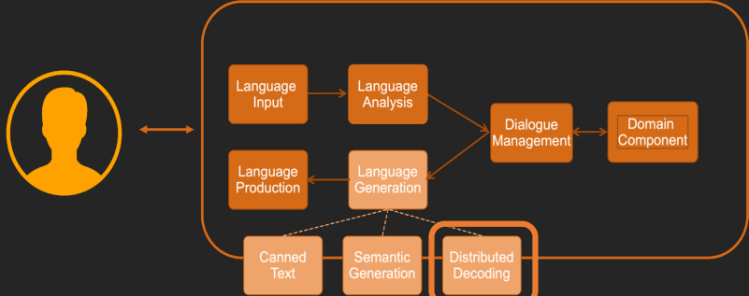
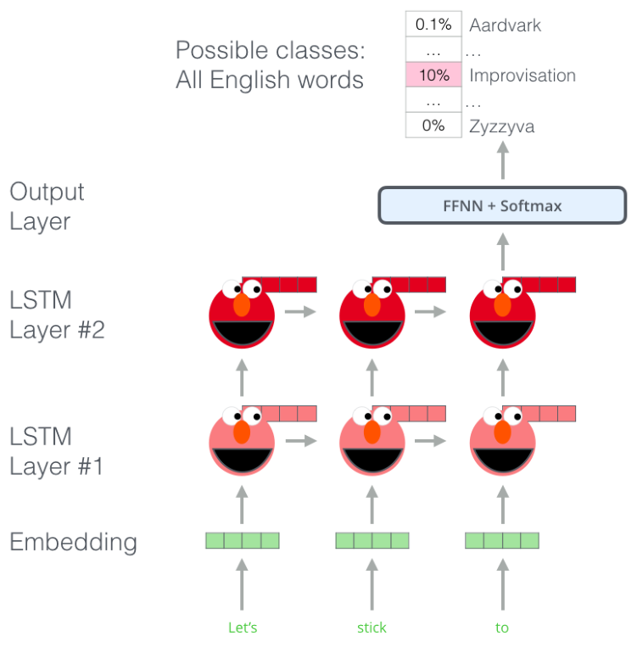

Deep Learning: Rethinking Dialogue Management
- Sequence to Sequence
  - Input Word 1
  - Input Word 2
  - Input Word 3
  - E (encoder)
  - D (decoder)
  - Output Word 1
  - Output Word 2
  - Output Word 3
- Transformer
  - Context
  - Utterance X
  - Utterance X + 1 distribution
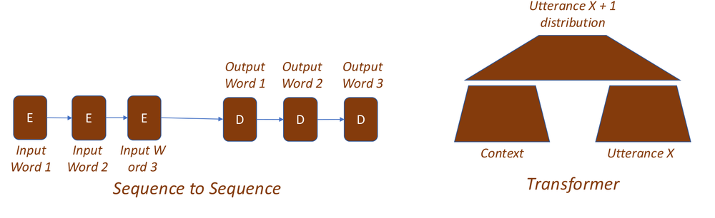
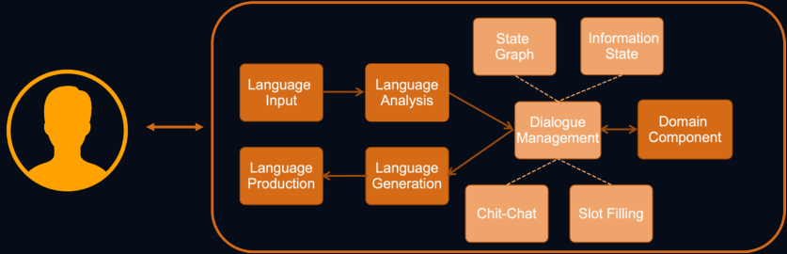

Pure DL Dialogue Management
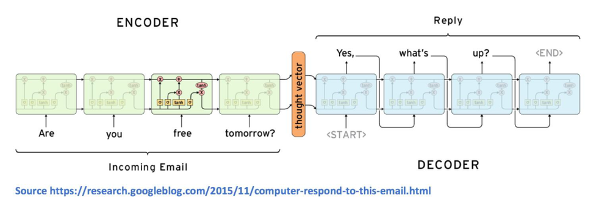
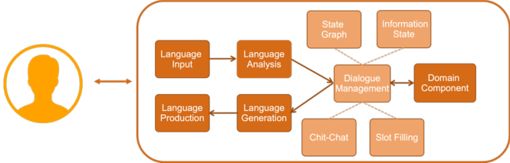

Pure DL Dialogue Management
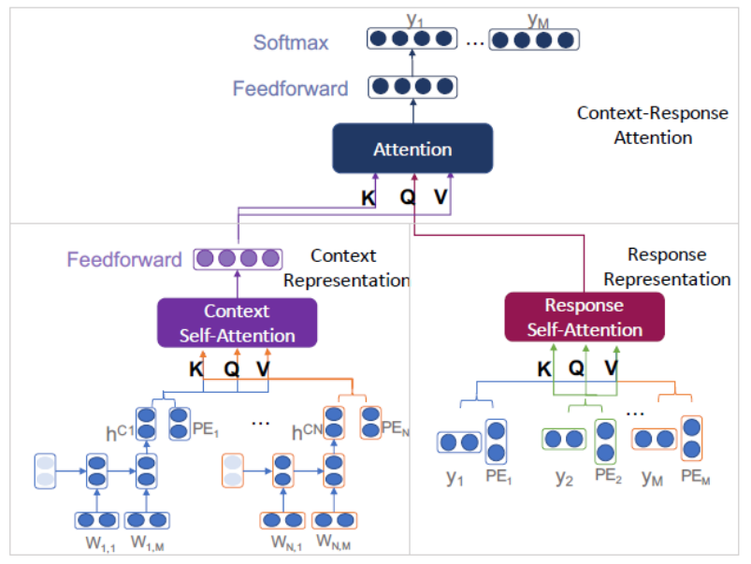

Personalisation - Keeping the User engaged
- The Basics
  - How do we build Conversational Systems?
- The ML Playground
  - Putting Deep Learning and AI to Work
- Personalisation
  - Keeping the User Engaged
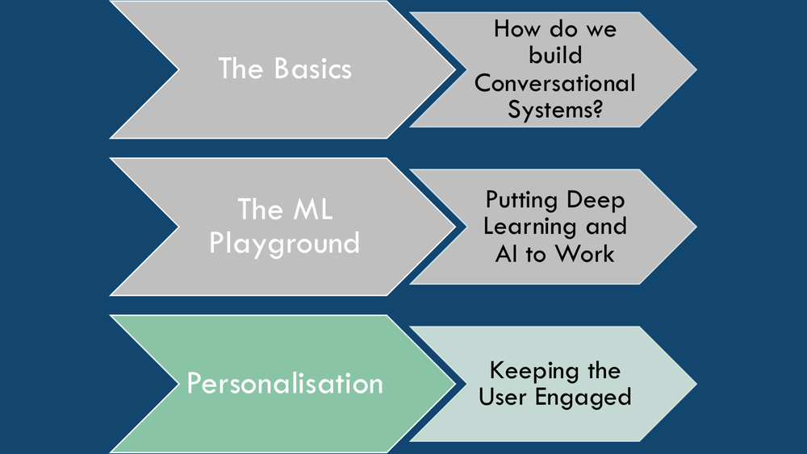

PERSONALISATION
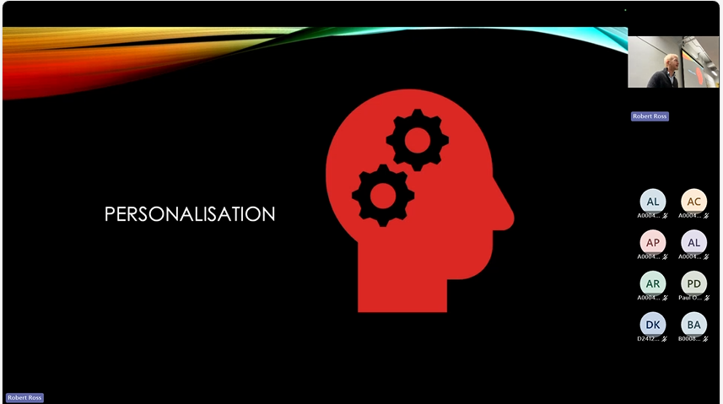

- Won’t have a ot of time to atlk about personalisation a lot over this semester…
- Talk about thgoms in context
- Personalisatino is goal of system trying
- Personaliser int wo ays
  - 1) Interpet (Contextualisation) >>
    - Interpret everything on context
    - Change things to different contexts – specialise
    - Makes intepretati more powerfl
    - Rule of thnb getg better suls as sch
  - 2) Production (Shaping to the user)>>
    - Speak to us slower speech – more common irish
    - With wife maybe less curse words
    - Key to good engagement
    - Huge amount #alignement theory
    - Helps basic comms and rapport
    - Goal do it well >> people will engage with systems and with more frequency…
    - This is the general goal of personalisation
- Won’t have to much time in course to do

CONTEXTUALISATION
- Input
- Context
- Meaning
- Understanding
  - Goals
    - Reduce Error
    - Allow User Flexibility
  - Mechanisms
    - On-boarding
    - Context sensitive interpretation
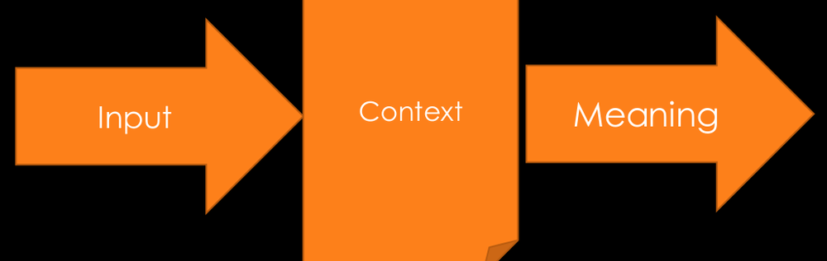

SHAPING TO THE USER
- Goal
- Context
- Output
- Production
  - Goals
    - Improve Naturalness
    - Enhance satisfaction
  - Mechanisms
    - Dialogue planning
    - User state awareness
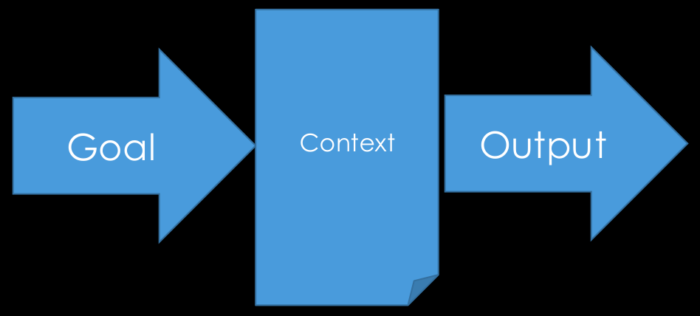

PERSONALITY THE BIG FIVE
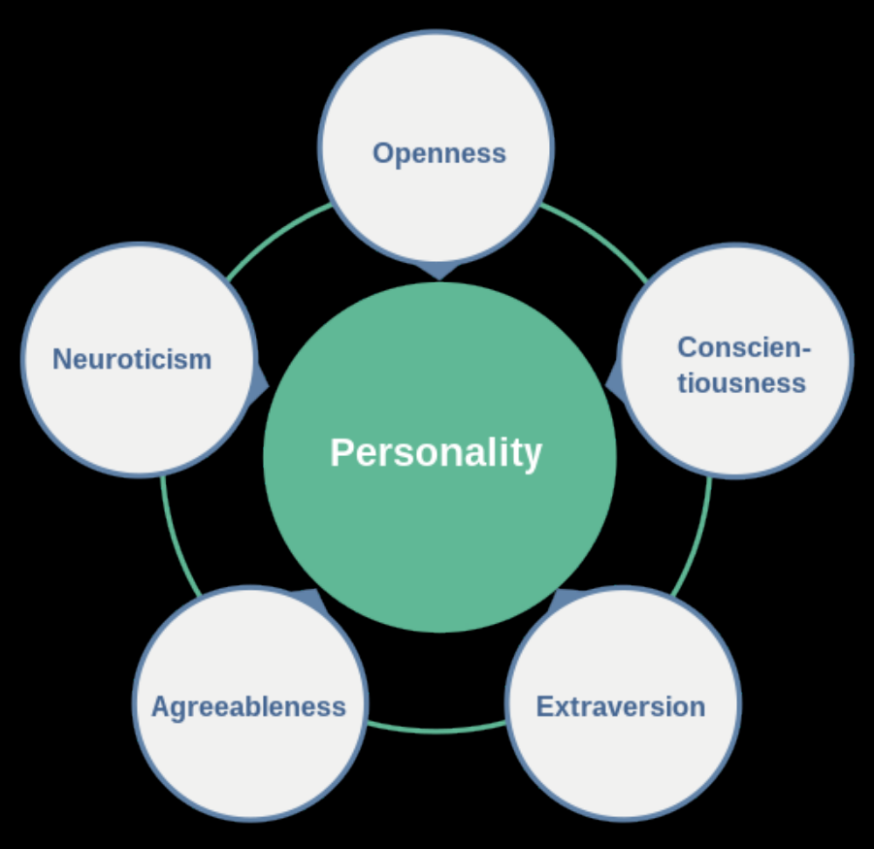

Virtual Tutor Personality in Computer Assisted Language Learning
- Johanna Dobrinner
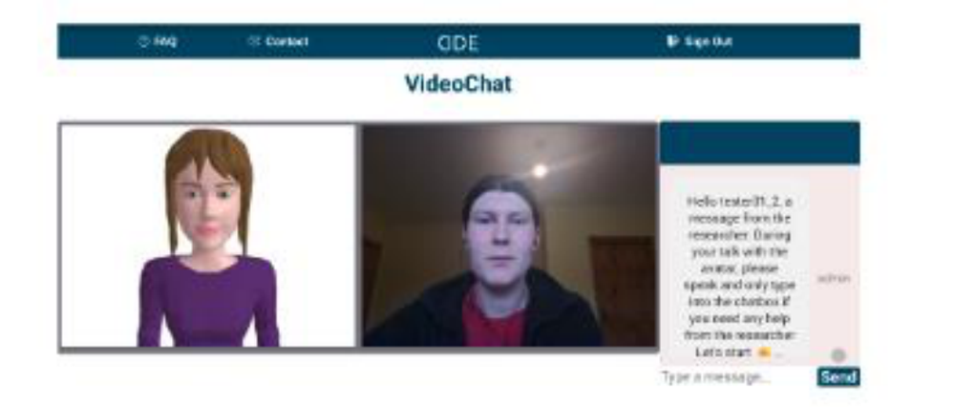
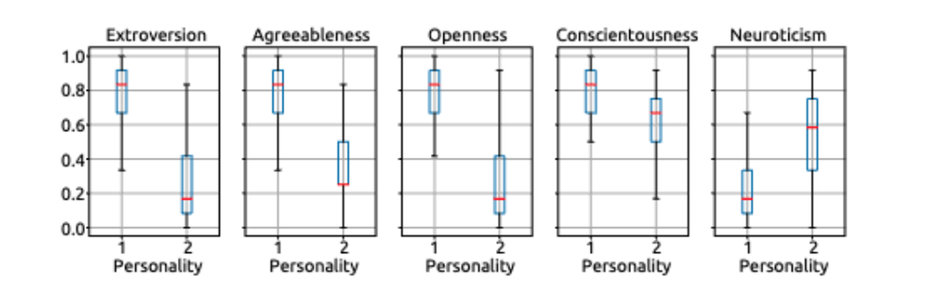


- Every eyar stdents love dong thgins like ocean model of personality types
  - Last year personality drift with a prompt – agreeable +
helper
  - Then use standard tests >> measure personality profile
  - Then change by having logn conversations
  - Also do nefarious thigns - tel various stories and see if ti manipulate personality…
  - Good scientific experiments…
  - Some cool stuff
  - Ltos of student projects
Research
Tutor types personalities….

Confusion Detection in Interaction
- by Na Li
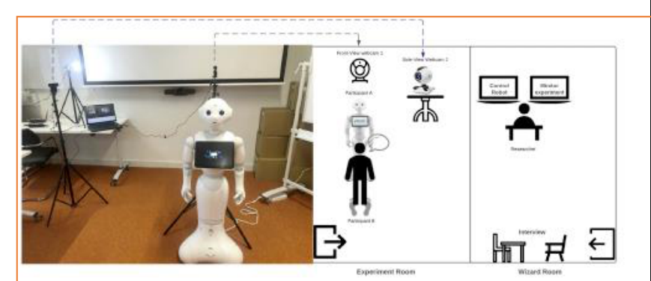
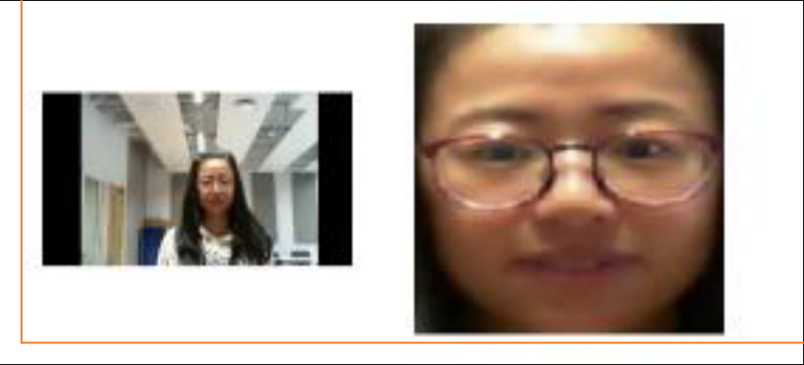


- Confusion in peples language
- Are LLMs being designed to be sycophantic?
- Vs
- Behaviour that is mor challenging ie. That work is shite…
If LLMs is more challenging people change and tis better

Questions and Challenges….

GENERAL CHALLENGES
- Usability and Acceptance
- Sharing Data and Task Structures
- Standards in Conversational Design
Loads of challenges in this area
Ias in some models
Ethics and governance >> not just guardrails

How much work done for smal queries…
Now pro models.. multiple iterations to get an answer…
Not just developing systems for wets its global

How do we get different usages agree that people wil accept
Every system wanst to be your pal >> si that the right thing to o
So converationl SO as a tool vs conversational AI as a buddy…

What role should conversational tech play?



AI as buddy vs AI as a tool?

Ethics


Privacy in Situated Conversational Systems
- Systems immersed in a real or virtual environment which can perceive, reason on, and act on that environment

Robots are coming for all our jobs
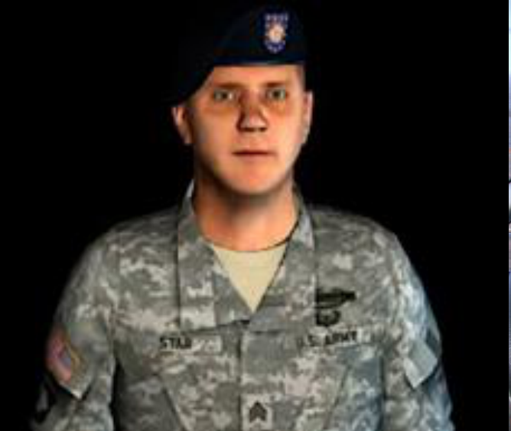
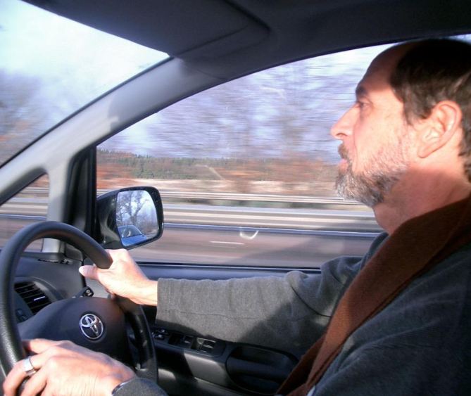

- Question – I want to know your opinions - honestly..
- Message to group of friend
- MS have enterprise customers
- Gemini has vast majority of eveyr user… quick ai searches
- Claude has nerds and engineers – people who design systens who
- Growk have American government
- OpenAI are screwed have segment at the moment.. their markets will be hovered up by others
  - Come up with 8 year old mathematical problem using

- Discussion
  - I could eb wrong
    - I pay for pro licence on ghemin
    - You may not pay google directly for Gemini - free to use but still making money off you on adds
    - Open SI is free users.. its nice…. Are growing users but what sproportional of user thay have relative to every oen else…
    - I own no stock / no money in the game…
  - Chinese Open Models
    - Have local market – starting to fil local LLM market - run it yourself locally…
    - Anthropic going to IPO
    - Jason cong
    - USA are struggling already
    - Agree they ar hige and stealing the market form big comoanies
    - Download a model – stick it on a machine – know exactly whats goin into it and out fo it
    - Great for privacy
    - Oen models do oerform well but tend to tail enterprise models… Large performa bit better
    - Not multi facetted mdoels
    - If they can get to point are com,parable with them
    - However what wil happen – legislation FUD orgs wil be scared off ecosystems
    - Whya r we not all running linux
    - Ecosystem lock in
    - Can only get a certain limi of market
    - Alienware machine
    - Europe is trying to go to linux switzerland removing from government
    - Takes a lot see how t works out
    - In meetgni with Dublin Cit Council… future EU might ask all weaned off Microsoft products within 10 years and was laughed at….
    - Porters coming an may lock me out.. don’t want t make enemies as need thtem open doors if forgot keys etc….

References
- https://www.researchgate.net/publication/264975659_Visual_Semantic_Search_Retrieving_Videos_via_Complex_Textual_Queries
- https://arxiv.org/pdf/2002.10851.pdf
- https://towardsdatascience.com/state-of-the-art-of-speech-synthesis-at-the-end-of-may-2021-6ace4fd512f2
- https://jalammar.github.io/illustrated-bert/
- Tait, M. & Visagie, A. & Niesler, Thomas. (2005). Development of a spoken dialogue system operating in Afrikaans, South African English and Xhosa. SAIEE Africa Research Journal. 96. 10.23919/SAIEE.2005.9488052.

Week 2 – language input Technologies – Intro to Linguistics – Social Sci Libre texts – 21st Sept 2026

- Week 2 - Language Input Technology

High level over view of some of the key concepts in input technology
Again will hear me.. we could do another course a msc level on speech input technologies
Maybe good to highlight for some projects you will or might do…

Language Input Technologies
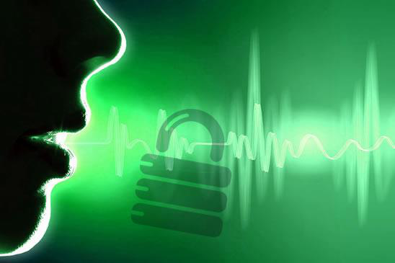
Modality >> refers
speech
Aaudio on a phone


Paper is still important
So lokin t legacy content… digitisation is of a high quality
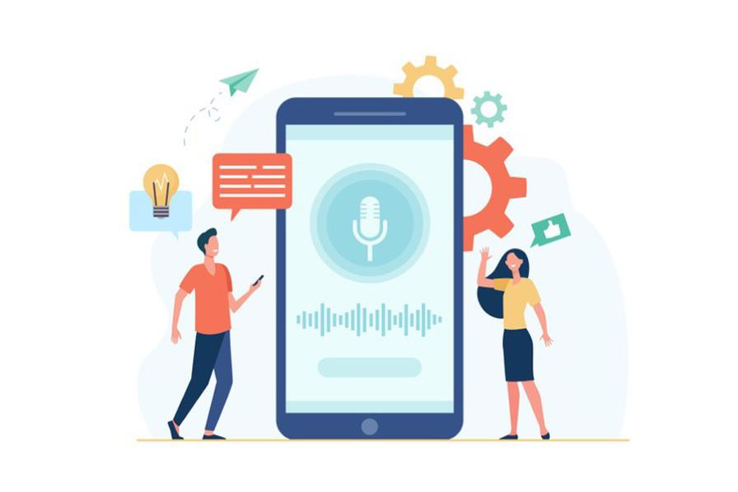
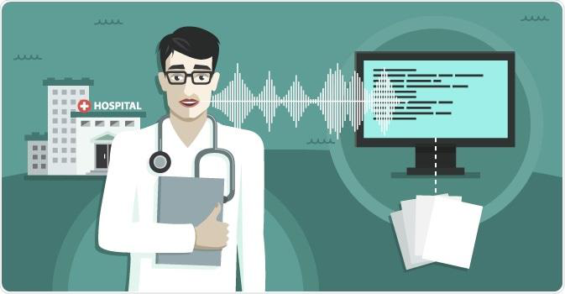
Many different modalities
- Speech
- Text
- Audio
- Sign language
- Etc

Multi-modal – this is where this term comes from.. we have multiple modes of language input
Today will lok at a couple of different modalities… we will not to multi modal

Today
- What is Language?
- What are the properties of Language which have made it challenging to process?
- Optical Character Recognition
- Handwriting Recognition
- Speech Recognition
- Speaker Recognition

- Star with a couple fo questions

- Modern world
- What is it about language input algorithme
- Speech still interesting an doesn’t work eactly great….
- Will compare ane contrast…
- I wll prattle on for 1 hr 10 mins… take break
- Take most of sessin on lab stuff….
- Use lab notebook
  - Speech models
  - WER
  - Get good feeling for what themoels are actually oing
  - Whatr are the metrics for evaluating these models….
  - How wel are tey perfomraing against these metrics

What is Language?
- Definitions:
  - A system of communication used by a particular country or community.
  - The principal method of human communication, consisting of words used in a structured and conventional way and conveyed by speech, writing, or gesture.

- What is lang definition
- Think of it as a system
- Agree as a set of rules – a system to convey meaning….
- Signals.. lang has compicate set fo rules that we all have to agree on…
- We have deviations on them – child leanring / learngin 2nd language
- Covnentiosn to convey meaning….
- System we crdate to allow us communicate

Why is Language Tough?
- A slow serialized form of communication – requires a lot of context!
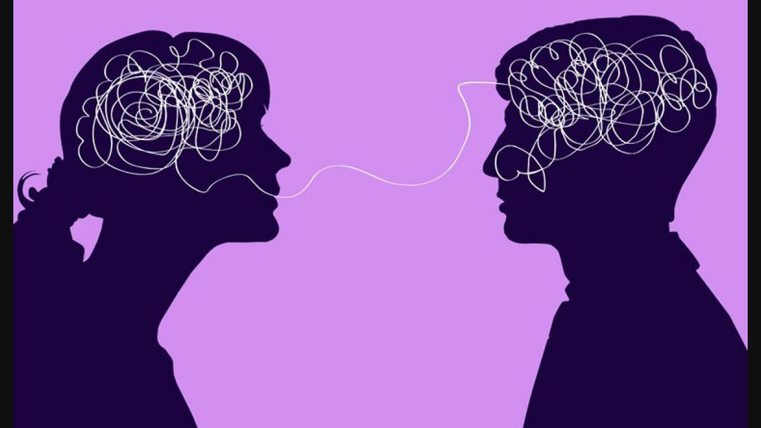
- Language is slow compard to other animals
- Amount can convey as peech
- Can have idea in head but amount of effort to recreat that is quite challenging
- As soc mcuh context to compose and de-compose

- Lady on left evaluating context partner might have >> give minimal amount of info and rely on that person having a shared context
- Interlocutor k = fancy term for person we are speaking with…
- Wth patners can use couple of grunts. Stangers needs more effort to convey meaning…

- Think about text s most verbose, lot of words, structure.. take compicate ideas and sue a lot of words.. so don’t fully knw whoe reading .so hedge ou bets..
- Justin using written words, no facial expressions… etc
- Add smiley faces
- Depending on modality need more effort to serialise our thoughts…
- Rich wirrh different mechanisma so don’t’ have to write everything out ad assuming partners has good idea of context already…

Language is Overloaded
- We often use the same sounds and or words for different meanings.
  - Homonym
- We often use the different sounds and words for the same meanings.
  - Synonyms
    - How many real synonyms can you think of?
- Credit:
  - https://www.twinkl.de/teaching-wiki/homonym
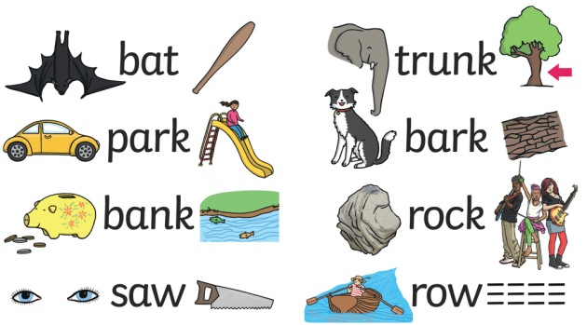

- Sofa vs couch – usage are different /
- Synonyms…. Give us a set of synonyms….
- Kid vs child
- Runer vs trainer
- Aim (direction)vs goal (state)
- Written langueg issue
- Can have same spelling but different meanings.. all those little things cause problems
- Early embedding had major problems with these issues
- i.e. Bank vs Bank
- transformer architecture separate dout those meanings..
- ok individual meaning representations
- inyl solved properly about 10 years ago. Ie.. Bank vs Bank

- from url above
  - Homophones are words that are pronounced the same but spelled differently,
    - Their vs they’re vs there
    - See vs sea
    - Write vs right vs rite
  - homographs are words that are spelled the same but pronounced differently.
    - graph” in homograph means written
    - Minute (time) vs minute (size)

- homonyms = words that share the same spelling or pronunciation but have different meanings
  - prefix “homo” means the same, and “nym” means name.
  - bat (baseball) vs bat (animal)

Language Mechanisms and Challenges
- To overcome its inherent limits, language evolved to make use of some important features / tricks
- Anaphoric reference – referring back to something mentioned earlier, e.g., pronoun use
  - i.e. “eamonn bought trousers, and wore them straight away “ (them refers to the trousers)
  - Cataphoric reference – referring forward… “when she arrived, Mary sat down”
  - Exophoric reference – referring to something outside of the text “ pass me that”
- Ellipsis
  - The omission of words from speech or text from an expression that can be instead inferred from the context
  - Verbal ellipsis: If I could have made the dinner, I would have (…)

- Using pronouns >>> LLMs have gotten better than humans at this…

- One of my favourite games to play (before students used LLMs to craft their taxt) was the pronoun game
- Go back through the text to find what the pro-noun was referring to…

- Ellipses is we can leave info out if we assume can extract rest fo information from gtext…
- Hard in robots… different meanings in different contexts…
  - Old fashioned approchces.. wont’ go into them.. btu give overview and use ideas from them to figure out what is happening.
- Need to know basic terms… what ad where they are used…

What are the components of language?
- https://www.youtube.com/watch?v=sDnSLH821LU
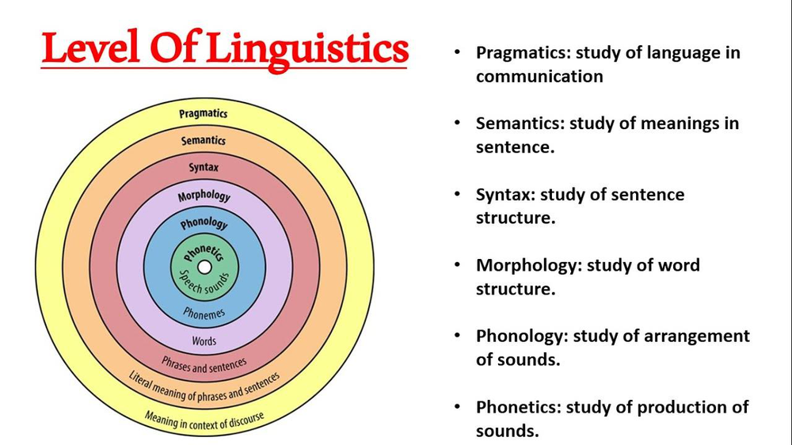
Middle of onion to out-
- Phonetics –
  - sounds….9important getting speech recognition to work better
  - Synthesisie the data
- Phonology
  - How sounds combine together to make words-
  - Can be mechanics
  - Can be Rules- some names sounds irish, Italian,
  - Gets packed into data processing, don’t have to explore directly…
  - Good understanding can help dev apps ie.. speech input apps
- Morphology
  - How are words put together
  - Rules (syntax) for putting them together.. where words can go…
  - English + German have weak morphologies
    - Emphasis around where words are
  - Turkish – rich meaning in words… tense, who / how using morphology
    - Meaning is in the structure of the word rather than where it is in a sentence
  - 100% accounted for in LMM
  - Words don’t’ go in but morphenes –lottle bits of words…
  - Is one part of grammar
- Semantics
  - Very important in NLP – goes hand in hand with meaning
  - Info conveyed in utterance
  - Old ways >> formal logic
  - Modern is vectors in high dimensional space….
  - Meaning expressed in numbers…
  - Modern treat semantics as numbers in high dimensional space
- Pragmatics
  - Study of how we use language – how we use it in practice, how we achieve things with it
  - Robotics / how we use language when talking to other agents
    - Can be info we know about each other
    - Talked about ellipsis and pronouns etc
    - The level of language study about what info we can leave out and what put back in
    - Rules about how its used in context
  - Modern world >> Lot is expressed in LLM history / or LLM prompt
  - Whats allowed / whats shared between user and system

- Important in error analysis
- Common terms

Important Terminology
- Please see the uploaded PDF for important definitions
- Linguistics and Natural Language Technology
- "Every time I fire a linguist, the performance of the speech recognizer goes up"
- Frederick Jelinek, IBM
- Linguistics does give us a good common set of terminology to refer to the things and processes that we are trying to replicate and make better – even if the methods that we use don’t always have to fully take advantage of those things.
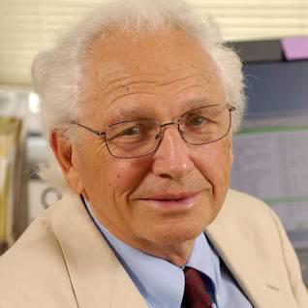
- Frederick Jelinek, IBM

- IBM were world leaders in Machine Leaaning until abuot 2006.. ish
- Had developed huge money
- Core Language engine >> a book and system they developed with various technologies around it
- Huge complicated and had Immense resources btu didn’t work
- Interestingly as the dev’d them they started to notice this phenomenon where “ Every time I fire a linguist, the performance of the speech recognition goes up”
- Key pint adhered to dogmatic rules an linguists didn’t perform well. When moved away from NLP perspective and moved to data driven perspective, => performed quite well
- Weren’t trying to adhere to dogmatic rules.. , just look at data and make sue of it…
- All references in acoustic models
- Getting simpler and larngin to do tasks themselves….

Some Input Types

Optical Character Recognition
- Input Data = Written Text
  - Historically pages of books / documents
  - Now also signposts, menus etc.
- Challenges
  - Lighting, contrast, print quality, font style etc.
  - Skewing of source data
  - Document Complexity
- State of the art
  - Amazon Textract
  - Google Document AI
  - Open Source: mmocr



- Document parsing and document imaging
- Valuable info in complicated forms…
- Amazon do ti.. early apps …..adobe
- Ovr years challenges was in lighting and clarity of dicuments /fuxxy docs / offset angles ohotos being taken a
- Classical OCR offerigns – like amazon and google / lots of open source…
- Up to about 3 years ago… would have been state of the art…
- Companies using these backboes

‘LLMs’ adding to the mix…. Mistral OCR
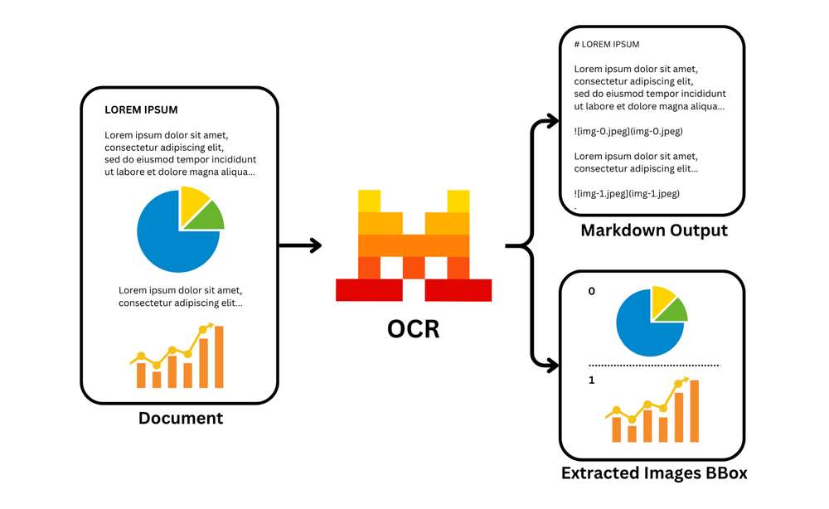

- Multimodal LLMs => nature of OCR has changed completely..
- i.e. what you see now, with Multi modal LLMs which are really big image processing transformer backbones attached to LLMs, are replacing OCR completely…
- so very mcuh the case..modern image backbone can take an image of text and extract the text from it I a way that’s quite generic and based on complete multi odal LLM pipeline rather than doing it specifically for OCR for etxt extraction
- good and bad side to this…. Perform very very well….
- Caveat…. Multi model LLMs are more expensive to run… more GPU… charge more…
- Can download multimodal LLM onto an RTX 50/80 ad give you good performance without needing to go into the old fashioned OCR route…

OCR – Word Error rate (WER)
- Word Error Rate: Proportion of incorrect words read
- where
  - S = substitutions (number of incorrect words)
  - D = number of words missed
  - I = Number of words inserted incorrectly
  - C= Correctly identified words
  - Calculate for:
  - Ref = “The cat sat on the mat”
  - Hypothesis = "the bat sat on the fat mat"
- Consider also Character Error Rate
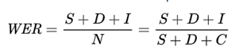

- >> How do we evaluate thwse systems
- Cost
- Memory usage
- Context oof NLP module >> need good metrics….
- Word Error Rate – ‘ of words in an input we got wrong…..
  - Deletions
  - Insertiosn
  - Substitutions
  - Over
  - Total # or wors in our reference....
  - Tending towards zero is good
  - Of loads wrong # above the line approaches number o bottom line… its performing bad….
  - Simple metric…
  - Will do in lab
  - Used in lots of input text tasks
  - WER is based on tokens
  - Can do stff with semantics amd meaning.. but for now.. just WER
- Calculate error – Word error rate for the below
  - Ref =”The cat sat on the mat”
  - Hypothesis = “the bat sat on the fat mat”
  - Treat the same as The
  - 7 words in hypothesis but still sue 6 words as total words
  - Can go anove 100% if lots of insertions
  - All words equal so all mistakes count the same…
WER = (S + D + I) / N = (1 + 0 + 1) / 6 = 2/6 ≈ 0.33, or 33.3%

Position | Reference | Hypothesis | Result
1 | The | the | Correct
2 | cat | bat | Substitution
3 | sat | sat | Correct
4 | on | on | Correct
5 | the | the | Correct
6 | (none) | fat | Insertion
7 | mat | mat | Correct

Also character error rate (CER)
Morphene error Rate (MER)
Has come upon exam a few times… before so when taking about metric nearly always come up…

Handwriting Recognition
- Input data = handwritten text (offline or online)
  - Offline = image
  - Online = information on pen position over time
  - Terminology is a bit confusing as overlap with idea of synchronous vs asynchronous processing
- Challenges:
  - See OCR
  - Messy text / handwriting styles
  - Incorrect spelling
  - Segmenting text
- State of the Art
  - MyScript Handwriting Technology (Nebo)
  - Gboard (google)
  - Open: Teseract (Goolge) TrOCR (Microsoft)
- https://dev.to/abdenasser/my-personal-django-rest-framework-serializer-notes-2i22
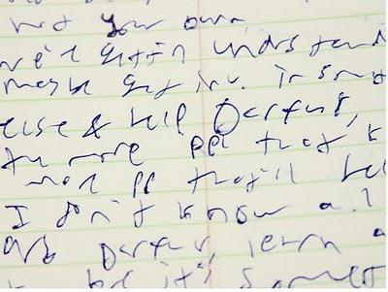
- Hand writing is a challenge
- Mis spellings
- Sribbling out words
- Lines
- Again now a problem widely addressed
- Apply bad hand writing to Multi model LLM technology and will read it…
- Are still lots of open and closed solutions and cheaper but nto as good as bit multi modal language models…

Offline Handwriting Recognition (Modern Model)
- https://arxiv.org/pdf/1807.07965
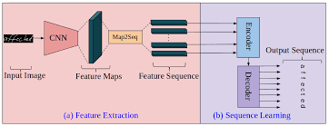
Similar to advanced models

- Overview of what sort of model is sued to process information, not about training a deep learning model btu about trying to recognise dfferent components and how they are used….
- OCR
- Static pucture o etxt.. segmenting
- Image processin architecture
- Features fed as sequence into an encoder to represent meaning that’s there.
- Decoder takaes that menaing that was expressed as a number in a HDimS and spits out a new representation from thatnumber
- I our case that character/handwriting—
- String them together – l
- Archiutturre here assumes we have a picture

Online Handwriting Recognition
- An image vs a sequence of small actions.
- https://ai.googleblog.com/2019/03/rnn-based-handwriting-recognition-in.html
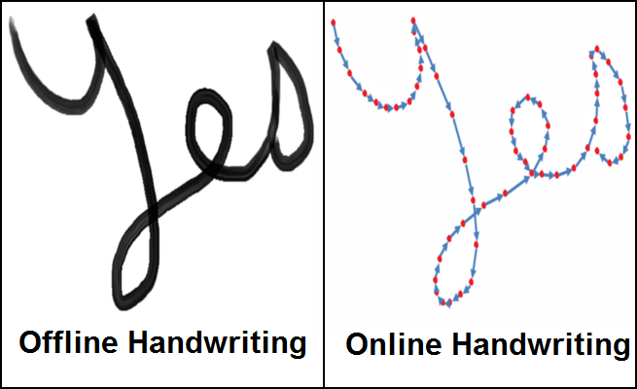
- Rare other case of using onlin hand writing hand writing >> stylus…

- Some very good software dong it now…
- Even apple software is very good now…Apple dropping the bat o AI but that’s what they get for investing a load of money in a car that they decided not to launch
- Don’t just have an image of why they wrote have vector detail of direction stylus was pressed upon, how quick they wrote in certan areas, all extra nformation
- Works better siply because thay can take approach static case would use and cnsa work really well…

Online Handwriting Recognition
- The details of a model like this are not important to us here, but it is important to understand the difference between processing the input as an image versus a series of touch points
- https://ai.googleblog.com/2019/03/rnn-based-handwriting-recognition-in.html
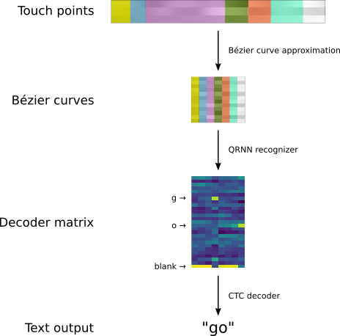
- Details not important but deep learning taking data and processing it thru the pipeline
- Even when not talking about multi modal LLMs doing everything universally now the specialist modeals are all still Deeop lerning
- NNs now do everything
- Apart from pressing buttons on our phone and even thos have a lto of multi touch and AI gon on inside it.

Online Handwriting Recognition
- https://ai.googleblog.com/2019/03/rnn-based-handwriting-recognition-in.html
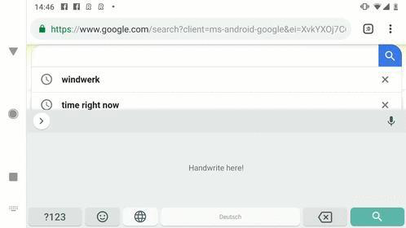
- Touch points- -> Bezier curves - Decoder matrix - Text putput
- Try it out
- Average android phone… seldom use ti handwriting recognition

Speech - Speaker Recognition
- Input Data = Audio Sample / Extract
  - Output = Speaker ID typically with likelihood
- Speaker Verification vs Speaker Identification
  - Speaker Verification = 1:1 process focused on security
  - Speaker Identification = Determining most likely speaker from group (1:n)
- State of the Art
  - Google Cloud Speaker ID
  - Amazon Connect Voice ID
  - Open Source = SpeechBrain (does a lot more as well)
- https://innovation.umn.edu/college-parent/identity-theft/

- Ni speech couple fo didffernt tasl that apply
- Motion recognition
- If tired when speaking
- Very important form of input >> what services we get access to
- Who si person we are talkig abuot
- Can come in two flavours
  - 1) Speaker verification >> deeper level knowing exactly whow e are talking abuot… security level .. less acceptable errro associated with it
    - Debate changed over years… is it safe? Immune from attacks?
    - Fraudulent attackes
  - 2( Speaker identification >> figure out from conversation of lots of people .. Granola
- Good state of theart buig tech models
- Can sue them in Jobs
- Can get them installed quickly
- Performance levels vary

Speaker Recognition (Generic Architecture)
- https://wiki.aalto.fi/display/ITSP/Speaker+Recognition+and+Verification
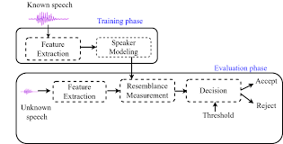
- Won’t go into detail on architecture
- Pint is again DL models performing >>. …
  - Extracting features
  - Qualities
  - What they mean in modern world mean nothing now adays
  - Don’t need to correspond to anything meaningful..
  - If do explainability.. certain type of tone
  - Widthb of someoes vocal box
  - Tone
  - Spectral range
  - All qualities picked up as algorithm is trained >> Then algorithimg itself figures out what proportion to use those features in
  - In any case for speaker rcognition
  - Comparing to some references to some individual and making a judgemnt
  - DL architecures underpin it all and take lot of tmie and effort to train in

Speech Recognition
- Input Data = Audio Sample / Extract / Live
  - Output = the most likely word sequence, usually with timings and confidence
- Long studied challenge – and the one that has moved fastest since 2020
- State of the Art (2026)
  - Open weights: NVIDIA Parakeet / Canary, Alibaba Qwen3-ASR, IBM Granite Speech, OpenAI Whisper
  - Commercial APIs: Deepgram Nova-3, OpenAI gpt-4o-transcribe, ElevenLabs Scribe v2, Google Chirp 3
  - Open weights now match or beat the paid APIs on English

- Probably the most important Modality nowasdya outside of typing text into a device
- Main modality tonight
- Thigns like
- OCR is good inrestauranr to translate menus / legacy docs --- no used a lot
- Sppech recogntiino is taking off!!!
- Gemini / Claude --- slowly but rapidly using voice now to interact with devices…
- So have audio input data and how do we extract meaning from that
- 2026 >> stat of art of phonemonly good
- Legacy models widely replaced by state of the art models..
- T understand State of rt models get feelf rp hwo ti works…
- LLM based tech and thigns connected to it

Classic Speech Recognition Model
- https://symbl.ai/blog/best-options-for-building-speech-recognition-into-your-applications/
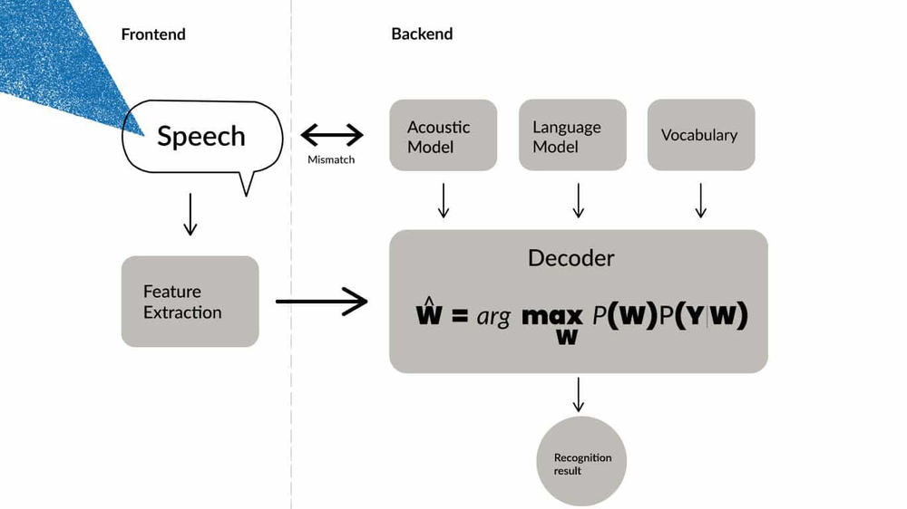
- Typical a rchitecture 10 years ago..

- 1 hand speech ? extract -- sounds spectral info about audio and put into model
- Alongside get taringni thgin s
- Classic model
  - 1) Acoustic model – how people actually speak
  - 2) Language mdel – come sfrom what the lang is allowed to say – likely to say
    - The girl likely to say the ”girl kicked the ball” rather than “the girl clipped the ball”
  - 3) Vocabulary – what words are allowabl in particular domain
- Classic model take that + statisics to sue statistics to predict what you most likely said…
- DL models throw it all out- Get rid of it 1 layer at a time…
TOOK a Break

Deep Speech Recognition
- https://www.researchgate.net/figure/Mozilla-deep-speech-architecture-The-recurrent-neural-network-contains-five-layers-of_fig1_353076207
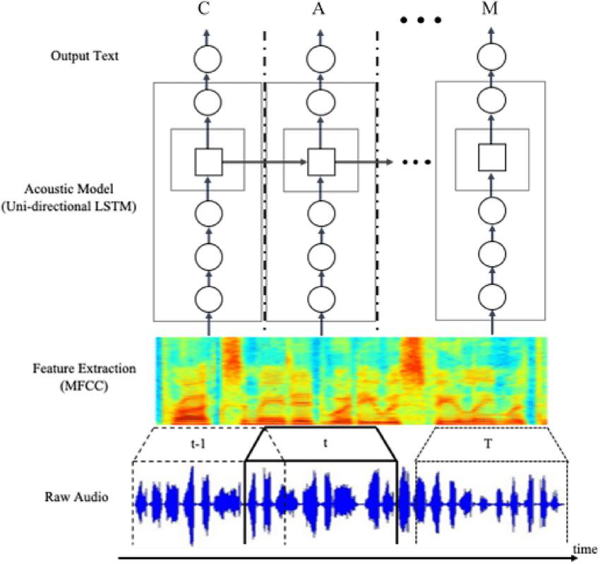
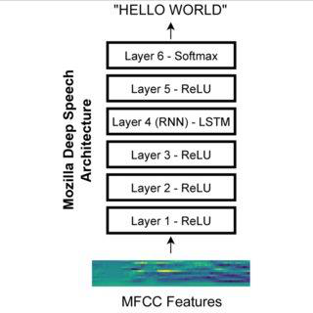

- Classic Deep speech model
- Take features… MFCC thigns (mel spectrogram features… etc
- And produce some text
- Specifics vary form model to mode but key point from about 1 years ago what they aimed to do was really only require data that had audio in and text out and didn’t want to try encode anythgin explicitly such as acoustic models or event he vocabulary…
- Let traingni figure it out themselves
TOOK a BREAK
After break
- NOW advances in deep speech recognition.. Stat of the Art
- Over last coupe fo years
- This really underpins a lot of what we’re doing but there are subtleties in how it subtulties together
- Subtleties of different models….

Typical Deep Speech Recognition
- Transcribed Aligned Data (expensive)
- Audio mapped to Acoustic Features (time series)
- A machine learning algorithm capable of processing time series / sequential data then processes the content.
- The content produces at any given point the most likely ‘word / symbol’ given (a) the acoustic inputs, and (b) the language context.
  - Acoustic input is travelling upwards is prior diagram
  - Language context is travelling left to right
- The acoustic model is captured in the network weights

Key points
- Keep in modnlot of tyhpical 9up to this year ) requires lot fo transcribed data
  - i.e. have audio and godl standard corpus of dat we qnat to sue
  - collecting thatdata has always been exemely expensive…
  - we boot strapped this
  - had Brazilian student Juan Carlos Saltan (10/12 years ago)
    - ie.. we had to make use of DVDs subtitle tracks and data iek that to build up ML translation models or speech recognition type models…
    - expensive and time consuming to gather tpgather
    - pay people to call out speech
    - may also get noise of recording posisiony
    - big companies could pay
- Now it has changed
  - Some models can learn good speech based on not even ahvign to be goven ful input / putput yanscriptions
  - Lot of corpora have jus built up over the years for corporea…
  - Once have them can sue them… take advantage of it
  - Traditional models input putput
    - i.e.
    - tradition models
    - what we would do usually is
      - have an input /output pipeline = >> audio mapped through acoustic features -> we feed thse acoustic features into a DL architecture 9like in earlier pipeline arch) - > and we get pretty good models out of it…
      - a DL algoriuthm is able to make sue of that…
  - early models till trying to learn good acoustics based on the info we provide
  - to some extent some putting together ro models and data sources ot gey good balances of model
    - so there wasn’t to much boas in the models

From DeepSpeech to 2026 – Three Things Changed
- The encoder stopped being an RNN
  - Conformer = convolution for local phonetic detail + self-attention for context
- Supervision got cheap
  - Whisper: 680k hours of weakly supervised web audio beats curated corpora for robustness
  - Self-supervised pretraining (wav2vec 2.0, HuBERT) needs no transcripts at all
- The decoder became a language model
  - The ‘language context’ arrow on the previous slides is now literally an LLM
- We did not just fire the linguists – we fired the lexicon, the pronunciation dictionary and the separate acoustic model too

- NOW>>>
- Once we have that initial data>> processin can do som mcuh with it with very little input from designers
- Bad for people who used ot do the work
- But oncewe have enough info
- DL architecture learns everything
- Also learnt to sue different souces fo information
- Instead of learning from input audio a+ text thatd been predicted
- Instead differrnt arch choices to speed up and do more cheaply
- Ie.. self supervise dint he models.. instead of getting them to predict text putputs… can predict the auiod that missing..
- Given audio predict missing bits of audio…
- Interesting bit isn’t what understaning whats missing.. base don understanding
- Its base don what you’re ot hearing….!!
- If liste to Chinese.. and don’t’ know chines.. can guess what comes nest base don sound.. not meaning
- Is cheap as don’t’ have to anotat the data ..c an learn a lot about the acoustic models themselves
- Can bootstrap from thos acoustic models

- Can supplement
- Lto of different rich arch approaches
- Cheaper than before…
- Fired everything to do with Linguistics…
  - Its data input and data output

Current State of Play – Models and Measures

Backbones: Choice of Encoder (Not For Exam)
Encoder | Idea | Used by
Conformer / FastConformer | Convolution blocks for local spectral detail, self-attention for long-range context, heavy subsampling to ~80 ms frames | Parakeet, Canary, Nemotron
Whisper-style Transformer | Plain transformer over 30 s log-Mel windows, trained supervised at web scale | Whisper, Distil-Whisper
Self-supervised (wav2vec 2.0, HuBERT) | Contrastive / masked prediction on unlabelled audio, then fine-tune on a few hours | Meta Omnilingual ASR, most clinical work
Causal / streaming | Same blocks, attention restricted so no right context is needed | Moonshine v2, Kyutai STT, Voxtral Realtime

- Every current system = an encoder (this slide) × an alignment strategy (next slide).

- Backbone models and open source models are achieving stat fo the art performance…
- EXAM >> Don’t’ go off and actually memorise these…. Do nto memorise these…
- Nicd summary slide just want t note a couple of competing architectures… where nothing is perfect yet btu getting really good.
  - Slightly different arch approach
  - But all need lots of data to provide good mapping between input acoustics and output signal
  - If doing projects in speech recognition space -these are models yuoj wl come across
  - Good for DL models…
    - Stat eo fart deep learning arch being used aswell
    - Whisper net was defacto but now confirmer based models > canary.. very good
      - For relatively small memory footprints

Open ASR Leaderboard – September 2026 (not for exam)
Model | Backbone | WER | RTFx | Licence
Granite Speech 4.1 2B (IBM) | Speech-LLM | 5.33 | 231 | Apache 2.0
Cohere Labs Transcribe | Conformer + Transformer | 5.42 | 525 | Apache 2.0
Canary-Qwen-2.5B (NVIDIA) | FastConformer + Qwen3 | 5.63 | 418 | CC-BY-4.0
Qwen3-ASR-1.7B (Alibaba) | Speech-LLM | 5.76 | – | Apache 2.0
Parakeet-TDT-0.6B-v3 (NVIDIA) | FastConformer + TDT | 6.34 | 3333 | CC-BY-4.0
Whisper large-v3 (OpenAI) | Attention enc-dec | ~7.4 | ~40 | MIT
Parakeet-CTC-0.6B (NVIDIA) | FastConformer + CTC | 8.96 | 6400 | CC-BY-4.0

- Mean WER over LibriSpeech, GigaSpeech, AMI, Earnings22, SPGISpeech, TED-LIUM and VoxPopuli, after text normalisation. RTFx = seconds of audio transcribed per second of compute.

- WER on all the models tend to be similar
- Negative WER
- Other metric >>
- EXAMS >> learn Real Time factor vs RTFx >> inverse of RF (1/RTF)
  - How fast model as are with respect to langaugue input
  - Next slide explains in detail
  - Measures how mcuh more quickly model can process audio than it actually takes to listen to the audio in normal speed settings
    - Really Important as >>> Gives indication to us how mcuh data can be processed
      - i.e. if we have a back end data centre – how many different hours of data can be processed in a coupe of minutes and so forth
- Keep in mind RTF values here
  - Standardised on specific set of hardware
  - Values should always be standardised.
    - Can be quite difference in performance in terms of how fast they are
    - Oftent no -linear in respect to WER
  - How good are they performing
    - WER
    - RTF
    - Important
    - + couple of other factors talk about in a minute
    - Table above >>Paraquet >>
      - WER slightly higher than some other models
        - Seeing 6.3 rather than 5.63..
        - BUT
        - WER is very different in terms of performance…
        - Paraquet can process way more data than the other models…
        - Is typically a trade off in terns of WER and RTF

  - WER >> lower is better
  - RTFx >> Higher is better
  - RTF >> Lowerr is better

  - Trade off > accuracy and speed pull in opposite directions
  - Most accurate are slower / least accurat are faster >> which is best depends on use case..
    - Medical >> accuracy is more important
    - Call centrs>> maybe speed is more important

Reading the Leaderboard Critically
- Whisper is no longer state of the art on English
  - About ten open models beat it – but it is still the best documented, most permissively licensed and widest-language default
- The accuracy spread across the top ten is about one WER point
  - The speed spread is about thirty-fold – architecture choice in 2026 is a latency decision, not an accuracy one
- Re-benchmarking on task audio advised before choosing

- Take leader boards with pinch of salt
- Open source—pay ayendtion to all the metrics… all there for a reason..
- Some just to WER but depebds on application trade off…
- i.e. memory footprint of the model.. how much will it cost!

Beyond English
- Parakeet-TDT-0.6B-v3 – the practical multilingual workhorse
  - 25 European languages, automatic language detection, 0.6B parameters, CC-BY-4.0
- Meta Omnilingual ASR (Nov 2025) – what self-supervision bought us
  - wav2vec 2.0 encoders from 300M to 7B parameters
  - 1,600+ languages natively; 5,400+ zero-shot by in-context learning from a handful of audio–text pairs
  - Character error rate below 10% for 78% of those languages
- Irish, code-switching and low-resource speech are now a fine-tuning problem, not a data-collection moonshot

- Changed a lot in last fe years
- SotA > pinned with LLMs – can do Mult lingual really well and across wide range fo languagues
- Fundamentsl o moel that trained…

- Question how many people hastled on daily basis on adds to buy pocket?
- Works on 20 different lanuages 9 not because poecket did anything)
- People payig money for it…
- Foundaltional models is what did it in the first place..

Measuring ASR in 2026 – WER Is Not Enough
- Character Error Rate for low-resource and disordered speech
- Entity or keyword error rate
  - Getting ‘Aoife’ and ‘warfarin’ right matters more than the function words that dominate WER
- Speed is three different numbers
  - RTFx (batch throughput) ≠ streaming latency ≠ end-of-turn latency
- Report WER per accent, per age group, per speaker – aggregate WER hides the failures that matter

- Want to emphasise this!
- WER is not enough – can look at character Error rates for different types od speech
- For ege disordered speech / no fluent speech >> can be more honest to loka t character rror atte istead…

- Focus now not simply to lok at WER but to look at Entity Error Rates… EER .. instead of just counting all words equally.. look at things, people, places referenced ni audoip and tr to get tjem right…

- Because in juptyer notebook there can be unusal word sintext that are hard to egt roght… whereas functional words… there, for .an of, etc…. when sue dni corret sentence are easy to guess… and gettgin the right becomes easy…

- Insread lok at unusl words… speech recog model hasn’t seen commonly… is a way more honest measurement fo accuracy these models….

- Another thing >>> SPEED is important >> already reference RTF as pretty useful measure who uickyl can process audio relevatve to length of audio

- Others slight variated..

- Hwo quixkyl can we process words that are streaming…

- Hwo uickyl before the word is transcribed on the screen… oftent its no immediate ad need ot lok ahead in speech to get word correct… some models need to do to get it accuracy

- i..e RTF >> Streaming latency >> End of turn latency .. all a bit different…

- as humans we ar good at detecting the end fo an utterance… only fractisno of a sec between 1 person finishing and another taking over…

- those latency issues can be a problem…

- final point….IMP >> getting ST workgin for diff user grps… >> noyas a single total score.. break down interms of age / genders / user groups…>> get a more honest score…

- benchmark on single big dataset.. domainate by white men middle age with perfect speech… but all edge cases it fails on completely…. Keep it ni mind.. for any benchmarking for anytechnology over course of semester…

Where the Frontier Actually Is
- Clean, read, adult, native-accented English is solved to within annotator disagreement
- Still open, and all of them make good projects:
  - Atypical and disordered speech – dysarthric ASR still runs multiples worse; the live work is parameter-efficient adaptation of foundation models (LoRA on Whisper, personalised fine-tuning)
  - Overlapping speech and diarisation in real meetings
  - Code-switching, including Irish–English
  - Children’s speech – scarce data, difficult consent
  - Quality at low latency – the gap between batch WER and 150 ms-latency WER is still real

- Where is challenge
- Basic for SR middle class /e ducted…
- Challenge is edge cases / non standard– pathologies…. 9in Computer science world its just a not perfect language.. non standard speech
  - Is tough as pronounciaisno used are challenging .. cllectign data is problemactci due to ethical reasons…
  - Dysarthric ASR – atypical and disordered speech (i.e. Dysarthria is a motor speech disorder. The muscles used for speaking (lips, tongue, jaw, vocal cords, breathing muscles) are weak, slow or poorly coordinated, usually because of a neurological condition such as cerebral palsy, Parkinson’s disease, ALS, stroke or a brain injury.)
  - LoRA o Whisper, peronalised fine-tuning
- Diarisation – who spoke when / segments different speakers….
  - Osyly fixed btu not perfect… worls when polite and conceding the floor.. works fie.. btu real world where overlaps between people can be a challenege segmenting
- Code -switching –
  - Speak mainly in 1 lang then switch to another for various reason
  - Other langauges it si done a lot
  - Irish .. sometimes use coupla focal
  - Was a major challenge for many years… need noisy data to train models…
  - Recent models can deal with multi langs in parallel.. can stil try interpret in first lang..
- Children speech.. same as no standard speech as earlier
  - Keep in mind childrens speech is different to adults in many ways
  - Difficult in terms of
    - lexical content (the words that are there)
    - Morphology and grammar 9get things wront) – not using language correctly
    - Sometimes different phonectics / phonology – don’t know hwo to say things…
  - Usually developed separate model.. as so different to adult soeech
  - Also… used some linguistic ideas earlier!
- Quality at low latency
  - If we want thigns to be fast.. there is a trade off.
  - Real time SR falls down alittle bit…
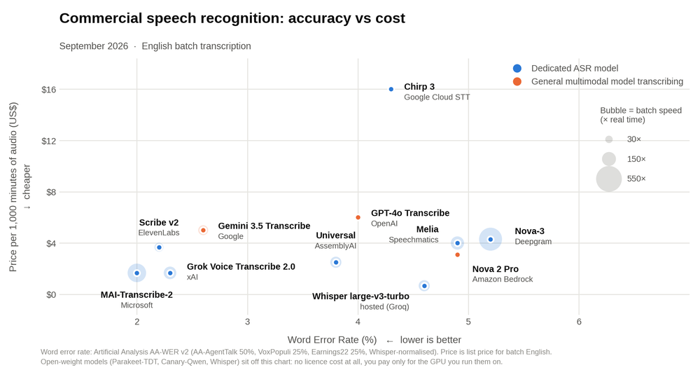
- May need to check some numbers
- WER vs Cost.. rathr than just size of models….
- WER on some SotA models… are reall quite low now… in trancriptin mode.. taking not in real time.. taking a transcription.. medical notes / trabscriptions of meetings etc…
- WER is low as probably slow in terms of processing
- Other models faster sued directly in middle of gemini…
- Want instant response…
- Changing al the time… just pulled out as example to iilusatrte ramge of different values
- In many cases btw… yeah… perf if getting quite good there. If looking at MS modlks…
- Could easily do ½ ourse on this to cover properly..
- If doing architectures properly dig into architectural differences
- But just understand differences of performance of these models…
- In Lab record some audio push it thru SR models / lok at metrics.. and use as launch point for playing with these thgin s yourself…
- Whnever I pop up these cpomparison.. not really intereste din the Rows… i.e. every eyar Rows changes… new models etc
- Am intereste dni the clumns…. The ehadings!! The model name . but treally the metrocs
- Size of models
- Its how we analysie the mdoels not then individual modesl themselves

Lab Exercise – W2 - NLT_Week2_ASR_Lab.ipynb
- Record audio of yourself in a Colab notebook – no accounts, no API keys, no billing
- Transcribe it with two generations of architecture
- Calculate Word Error Rate for each, before and after text normalisation
- Sweep the signal-to-noise ratio and plot WER per model – compare how they degrade
- Feed each model ten seconds of silence and record what it invents
- Notebook: NLT_Week2_ASR_Lab.ipynb

- Right
- Pimped up last years notebook – some new models.. alst eyar doing googles API.. quality of open models is so high.. don’t need to force you to use gogole models
- Use colab to do it quickly.. down laod then directly and use them
- Record audio
- Have godl standard test for that
- Pass thru 2 diffeent SR models
- Get output
- Calc WER
- Also speed of processing
- Add more models etc
- In Notebook – in folder.. run it hwoever yoj see fit.. and can install what you need…
- Now wil sto sharing this screen… and give 5 mis to download the notebook.. and upload into colab…

‘’’py
# NLT Week 2 — Speech Recognition Lab

You will record **your own voice** and transcribe it with two current models that sit on opposite sides of the architectural divide:

| Model | Backbone | Open ASR Leaderboard | What it demonstrates |
|---|---|---|---|
| `openai/whisper-large-v3-turbo` | **attention encoder–decoder** | ~7.75 WER, RTFx 216 | punctuation, casing, 99 languages — and hallucination |
| `nvidia/parakeet-tdt-0.6b-v3` | FastConformer + **TDT transducer** | 6.34 WER, RTFx 3333 | better accuracy, ~15× the throughput, cannot hallucinate |

Then you measure **Word Error Rate** for both, and you break them with noise.

> **Runtime → Change runtime type → T4 GPU** before you start.
## 0. Setup

This upgrades `transformers` — Colab will ask you to restart the session. **Restart, then skip this cell and carry on from section 1.**
%pip install -q -U "transformers>=5.13.0" jiwer librosa ffmpeg-python matplotlib
print("Installed. If Colab shows a RESTART SESSION button, click it, then continue from section

1.")
import torch, transformers
print("transformers", transformers.__version__)
print("GPU:", torch.cuda.get_device_name(0) if torch.cuda.is_available() else "NONE - go to Runtime > Change runtime type > T4 GPU")
DEVICE = 0 if torch.cuda.is_available() else -1
DTYPE = torch.float16 if torch.cuda.is_available() else torch.float32

## 1. Record yourself

Bit of html to create a button…
Run the cell, press the button, read the sentence below aloud, press again to stop.

> *"The TU Dublin campus at Grangegorman hosts the School of Computer Science,
where anaphoric reference and word error rate are discussed at some length."*

That sentence is deliberately awkward: proper nouns, a place name most models have never seen,
and two pieces of module jargon. Everything that follows runs on **your** audio — there is no
pre-canned sample to hide behind.
from IPython.display import HTML, Audio, display
from google.colab.output import eval_js
from base64 import b64decode
import numpy as np, io, ffmpeg

AUDIO_HTML = """
<script>
var my_div = document.createElement("DIV");
var my_btn = document.createElement("BUTTON");
my_btn.appendChild(document.createTextNode("Press to start recording"));
my_div.appendChild(my_btn);
document.body.appendChild(my_div);

var base64data = 0, reader, recorder, gumStream;
var recordButton = my_btn;

var handleSuccess = function(stream) {
gumStream = stream;
recorder = new MediaRecorder(stream);
recorder.ondataavailable = function(e) {
var url = URL.createObjectURL(e.data);
var preview = document.createElement('audio');
preview.controls = true; preview.src = url;
document.body.appendChild(preview);
reader = new FileReader();
reader.readAsDataURL(e.data);
reader.onloadend = function() { base64data = reader.result; }
};
recorder.start();
};

recordButton.innerText = "Recording... press to stop";
navigator.mediaDevices.getUserMedia({audio: true}).then(handleSuccess);

function toggleRecording() {
if (recorder && recorder.state == "recording") {
recorder.stop();
gumStream.getAudioTracks()[0].stop();
recordButton.innerText = "Saving the recording... pls wait!";
}
}
function sleep(ms) { return new Promise(resolve => setTimeout(resolve, ms)); }

var data = new Promise(resolve=>{
recordButton.onclick = ()=>{ toggleRecording(); sleep(2000).then(() => resolve(base64data.toString())); }
});
</script>
"""

def record_audio(path="/content/recording.wav"):
display(HTML(AUDIO_HTML))
data = eval_js("data")
binary = b64decode(data.split(',')[1])
process = (ffmpeg
.input('pipe:0')
.output('pipe:1', format='wav', ac=1, ar=16000)
.run_async(pipe_stdin=True, pipe_stdout=True, pipe_stderr=True, quiet=True, overwrite_output=True))
output, err = process.communicate(input=binary)
# patch the RIFF chunk size, which ffmpeg cannot know when writing to a pipe
q, b = len(output) - 8, []
for _ in range(4):
q, r = divmod(q, 256); b.append(r)
riff = output[:4] + bytes(b) + output[8:]
with open(path, "wb") as f:
f.write(riff)
return path

AUDIO_PATH = record_audio()
print("saved to", AUDIO_PATH)
# Type in exactly what you said, including any stumbles. This is your ground truth for WER.
REFERENCE = ("The TU Dublin campus at Grangegorman hosts the School of "
"Computer Science, where anaphoric reference and word error rate are discussed at some length.")
import librosa
from IPython.display import Audio, display

SR = 16000
audio, _ = librosa.load(AUDIO_PATH, sr=SR, mono=True) # both models expect 16 kHz mono
print(f"{len(audio)/SR:.1f} s of audio")
display(Audio(audio, rate=SR))
print("REFERENCE:", REFERENCE)

## 2. A harness so both models are measured the same way

`RESULTS` collects the transcript, the wall-clock time and the **RTFx** (audio seconds transcribed
per second of compute) for each model. RTFx is the number the leaderboards quote — higher is faster.
import time, gc, torch
RESULTS = {}

def run(name, fn, audio=audio):
"""Time a transcription function and record the result."""
torch.cuda.synchronize() if torch.cuda.is_available() else None
t0 = time.perf_counter()
text = fn(audio)
torch.cuda.synchronize() if torch.cuda.is_available() else None
dt = time.perf_counter() - t0
RESULTS[name] = {"text": text, "seconds": dt, "rtfx": (len(audio)/SR)/dt}
print(f"{name}\n {dt:.2f}s RTFx {(len(audio)/SR)/dt:.1f}\n {text}\n")
return text

def free():
"""Colab's free tier has ~15 GB of VRAM. Drop each model before loading the next."""
gc.collect()
if torch.cuda.is_available(): torch.cuda.empty_cache()

## 3. Model A — attention encoder–decoder (`whisper-large-v3-turbo`)
Create the pipeline

Encoder over a 30-second log-Mel window, autoregressive decoder cross-attending over all of it. The decoder *is* a language model, so you get punctuation, casing and number formatting for free — and 99 languages from one checkpoint. `turbo` keeps the large-v3 encoder but distils the decoder from 32 layers down to 4: ~7× faster, ~0.3 WER worse.

The cost of that decoder: it is **non-monotonic**. Nothing forces its output to stay aligned with the audio, which is what makes section 7 possible. from transformers import pipeline

asr = pipeline("automatic-speech-recognition",
model="openai/whisper-large-v3-turbo",
dtype=DTYPE, device=DEVICE,
chunk_length_s=30) # needed for anything longer than 30 s
run("whisper-large-v3-turbo (AED)", lambda a: asr(a.copy())["text"])

del asr; free()

## 4. Model B — TDT transducer (`parakeet-tdt-0.6b-v3`)

FastConformer encoder, Token-and-Duration Transducer decoder. The transducer is monotonic — it walks forward through the audio and cannot jump backwards or invent text out of nothing — and the *duration* head lets it skip frames instead of emitting a decision for every one. 0.6B parameters (a quarter of Whisper large-v3), 25 European languages, and a **better** mean WER at roughly fifteen times the throughput. Compare its RTFx with Whisper's above: that is the whole architectural argument in one number.

asr = pipeline("automatic-speech-recognition",
model="nvidia/parakeet-tdt-0.6b-v3",
dtype=DTYPE, device=DEVICE)
run("parakeet-tdt-0.6b-v3 (TDT)", lambda a: asr(a.copy())["text"])

del asr; free()

## 5. Word Error Rate — and why normalisation is half the battle

$$WER = \frac{S + D + I}{S + D + C}$$

Run it twice: once on the raw strings, once after Whisper-style normalisation (lowercase, strip
punctuation, expand numbers, drop fillers). **Every WER figure you see on a leaderboard is the
second number.** The gap between the two columns is how much of "accuracy" is really formatting.
import jiwer, pandas as pd
from transformers.models.whisper.english_normalizer import EnglishTextNormalizer

norm = EnglishTextNormalizer({})

rows = []
for name, r in RESULTS.items():
raw = jiwer.wer(REFERENCE, r["text"])
normd = jiwer.wer(norm(REFERENCE), norm(r["text"]))
cer = jiwer.cer(norm(REFERENCE), norm(r["text"]))
rows.append({"model": name,
"WER raw": f"{raw*100:.1f}%",
"WER normalised": f"{normd*100:.1f}%",
"CER": f"{cer*100:.1f}%",
"seconds": f"{r['seconds']:.2f}",
"RTFx": f"{r['rtfx']:.0f}"})

pd.DataFrame(rows).set_index("model")
# Where exactly did the errors happen? jiwer will align the two strings and show you.
for name, r in RESULTS.items():
print("#", name)
print(jiwer.visualize_alignment(
jiwer.process_words(norm(REFERENCE), norm(r["text"]))))

## 6. Breaking them: a noise sweep

Clean read English is solved. The interesting question is how each architecture *degrades*.

Mix white noise in at decreasing SNR and plot WER. Watch for two different failure modes: the
transducer starts dropping and mangling words, while the attention decoder stays fluent and begins
producing confident, well-formed sentences that were never spoken.
import numpy as np

def add_noise(a, snr_db):
noise = np.random.randn(len(a)).astype(np.float32)
a_pow, n_pow = np.mean(a**2), np.mean(noise**2)
scale = np.sqrt(a_pow / (n_pow * (10 ** (snr_db / 10))))
return (a + scale * noise).astype(np.float32)

SNRS = [30, 20, 10, 5, 0]
MODELS = {
"whisper-turbo (AED)": "openai/whisper-large-v3-turbo",
"parakeet (TDT)": "nvidia/parakeet-tdt-0.6b-v3",
}

curves = {}
for label, mid in MODELS.items():
kw = {"chunk_length_s": 30} if "whisper" in mid else {}
p = pipeline("automatic-speech-recognition", model=mid, dtype=DTYPE, device=DEVICE, **kw)
curve = []
for snr in SNRS:
hyp = p(add_noise(audio, snr))["text"]
curve.append(jiwer.wer(norm(REFERENCE), norm(hyp)) * 100)
print(f"{label:22s} SNR {snr:>2} dB WER {curve[-1]:5.1f}% {hyp[:70]}")
curves[label] = curve
del p; free()
import matplotlib.pyplot as plt

plt.figure(figsize=(7,4))
for label, c in curves.items():
plt.plot(SNRS, c, marker="o", label=label)
plt.gca().invert_xaxis()
plt.xlabel("SNR (dB) — noisier to the right"); plt.ylabel("WER (%)")
plt.title("Degradation under additive noise"); plt.legend(); plt.grid(alpha=.3)
plt.show()
## TODO

TODO 2 Table

CER = Character Error rate (same formula as WER but counts characters instead.
 | WER raw | WER normalised | CER | seconds | RTFx
model
whisper-large-v3-turbo (AED) | 16.7% | 16.7% | 6.8% | 4.30 | 5
parakeet-tdt-0.6b-v3 (TDT) | 8.3% | 8.3% | 0.7% | 1.54 | 14

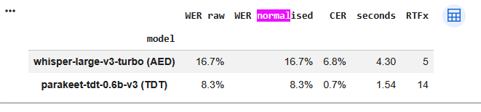

Additive noise and degradation

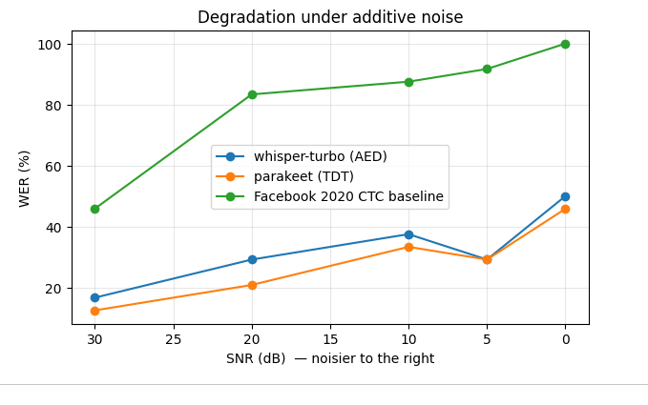

- **Jargon.** Record a second take containing five technical terms from this module. Count *entity* errors rather than total words. Does the ranking of the two models change?
- 2. **Normalisation.** Report WER before and after normalisation for both models. Which one benefits more, and what does that tell you about what each was trained to produce?
  - ANSWER

- 3. **Cost.** All of the above ran free. Look up the per-hour price of the equivalent commercial APIs (Deepgram Nova-3, OpenAI `gpt-4o-transcribe`, Google Chirp 3) and work out at what audio volume a self-hosted Parakeet becomes cheaper than an API call.
  - Deep gram Nova-3 multilingual – pre-recorded - pay as you go = $0.0052/min>>>> https://deepgram.com/pricing >> = $ - 31s cents /Hr
  - gpt-4o-transcribe = $0.006 / minute = >>> https://developers.openai.com/api/docs/pricing = $ - 36 cents p/Hr
  - Google Chirp 3 - Speech Recognition (with data logging) – standard - = $0.016 $0.016 / 1 minute, per 1 month / account >> https://cloud.google.com/speech-to-text/pricing?hl=en = $ - 96 cents p/Hr

Break even = monthly cost of GPU (assuming rented 24x7)/ API price per hour

break-even hours per month = GPU cost per month ÷ API $ per audio hour
- GPU cost: a T4 rented around te clock costs about $0.35/hr × 720 hours = $252 a month. Swap in the price you find.
  - GPU pricing
    - Google Cloud = L4 not T4 = $0.7068/hr >>> https://cloud.google.com/compute/gpus-pricing.
    - AWS = g6.large like L4 > $0.526/hr >>> https://aws.amazon.com/ec2/pricing/on-demand/.
- Divide by each API:
  - Deepgram: 252 ÷ 0.31 ≈ 810 hours
  - gpt-4o-transcribe: 252 ÷ 0.36 = 700 hours
  - Chirp 3: 252 ÷ 0.96 ≈ 260 hours
- Check the GPU can keep up: your measured Parakeet RTFx tells you this. At RTFx 1,000, one T4 handles 1,000 audio hours per hour, which is far more than you need, so speed isn’t the limit.
  - NOTE
    - GPU is a fixed costs regardless of how much you use it.
    - Every hour you use aws /google => you add .31 cents p/hr
    - So we find the number of hours it takes to hit our fixed cost value….
Above those volumes, self-hosting is cheaper. Below them, the API is cheaper. This ignores setup and maintenance time, which is worth a sentence in your answer.

- 4. **Extending this:** the harness is model-agnostic. Adding a third system is one line in `MODELS` —
  - `facebook/wav2vec2-base-960h` for the 2020 CTC baseline (no punctuation, no casing, no language
  - model), or `Qwen/Qwen3-ASR-0.6B-hf` for a 2026 speech-LLM.

‘’’

Questions
Who ahs finished….
Work through it.. experiment different models
Lots of datasets
Play with other speeh modeks
Dysarthic speech
With all NLT tasks
Think about more extremes… 80/20 rule… the edge cases are what annoys people
Local CPU in VSC >> bit of GPU makes big difference…

Question - still installing and configuring - Installing Kuda
Answer - Robert
Are you familiar with UV? It is written in Rust
Its RUST right? Package manager for python
Used Ppip for year but RUST >> a lot lot better >> can get everyone configured without
Coder… haven’t;’ sued yet… highly recommend playing with RUST
Can you migrate or jump in and use it? Not a plug in substitute for pip , its using pip under the hood but a wrapper no to of it….
Someon in company uses it…
RUST doesn’t damage any exisitn setup that you have
Do a straight delete on it and its gone, doesn’t muck around with any other python setups… completely parallel.

Robert
Google colab
Not saying to pay, but worth t for free tier
Usually lok for credit card fork free tier…
Can self destroying creit card

Can we sue colab for cpu
Recommend
Not simple using but should eb comfortable using colan as part fo learning, normal thing should eb able to do

Question - Eamonn – question- Energy per word metric?
Answer - Robert
I’m not familiar with what might eb there
Colleague Stephev Daey in Dunlin big into that side of thigns.. might want to do.. if ti does exist
Can measure in term sof flatign point operatunios required
i.e. how many calcualtin do they need to make and from that getg rough cost on a goven PU with gien wattage etc.. tough to directly calculate directly actual cost gbut calculate number of calculation and from thatg build out from there…

big model providers may provide benchmarks… herss how mcuh t costs to do x ro y… maye to much trust to publish their won estmoate..

Question - Paolo..
Doing jargon but used tokenisation
But used a “s” and “z”
Answer - Robert
Usually models have flags is it library calcualtign metrc?
If its model or metric.. that sort of normalisation issue they try to be flexible for somrhtin like SR, they do need to urn on more aggressive metric counting
Turn on normalisation on normal on, just on jargon one…
4 msin to go to ed f class… we willc all it there..
Next week all about language output.. speech rpepoduct to matrch this class also sign language and visual represtenation fo language….
Reminder.. fi andrea give m thimbs bright space.. if don’t have that yet wil contue to use teams….
Have a nice evening…

References
- https://www.twinkl.de/teaching-wiki/homonym
- https://www.youtube.com/watch?v=sDnSLH821LU
- https://dev.to/abdenasser/my-personal-django-rest-framework-serializer-notes-2i22
- https://arxiv.org/pdf/1807.07965
- https://ai.googleblog.com/2019/03/rnn-based-handwriting-recognition-in.html
- https://innovation.umn.edu/college-parent/identity-theft/
- https://wiki.aalto.fi/display/ITSP/Speaker+Recognition+and+Verification
- https://symbl.ai/blog/best-options-for-building-speech-recognition-into-your-applications/
- https://www.researchgate.net/figure/Mozilla-deep-speech-architecture-The-recurrent-neural-network-contains-five-layers-of_fig1_353076207

11.8: Introduction to Linguistics - Social Sci LibreTexts
- Language is such a special topic that there is an entire field, linguistics, devoted to its study. Linguistics views language in an objective way, using the scientific method and rigorous research to form theories about how humans acquire, use, and sometimes abuse language. There are a few major branches of linguistics, which it is useful to understand in order to learn about language from a psychological perspective.

Major Branches of Linguistics
- This diagram outlines the various subfields of linguistics, the study of language. These include phonetics, phonology, morphology, syntax, semantics, and pragmatics.
- Figure 11.8.1: Major branches of linguistics. (Image is in the public domain)
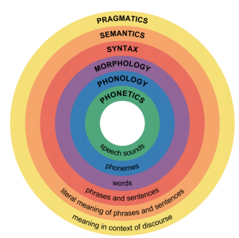

Phonetics and Phonology
- A phoneme is the smallest unit of sound that makes a meaningful difference in a language. The word “bit” has three phonemes, /b/, /i/, and /t/ (in transcription, phonemes are placed between slashes), and the word “pit” also has three: /p/, /i/, and /t/. In spoken languages, phonemes are produced by the positions and movements of the vocal tract, including our lips, teeth, tongue, vocal cords, and throat, whereas in sign languages phonemes are defined by the shapes and movement of the hands. English contains about 45 phonemes.
- Whereas phonemes are the smallest units of sound in language, phonetics is the study of individual speech sounds; phonology is the study of phonemes, which are the speech sounds of an individual language. These two heavily overlapping subfields cover all the sounds that humans can make, as well as which sounds make up different languages.

Morpheme and Morphology
- A morpheme is a string of one or more phonemes that makes up the smallest units of meaning in a language. Some morphemes, such as one-letter words like “I” and “a,” are also phonemes, but most morphemes are made up of combinations of phonemes. Some morphemes are prefixes and suffixes used to modify other words. For example, the syllable “re-” as in “rewrite” or “repay” means “to do again,” and the suffix “-est” as in “happiest” or “coolest” means “to the maximum.”
- Morphology is the study of words and other meaningful units of language like suffixes and prefixes. A morphologist would be interested in the relationship between words like “dog” and “dogs” or “walk” and “walking,” and how people figure out the differences between those words.

Syntax
- Syntax is the set of rules of a language by which we construct sentences. Each language has a different syntax. The syntax of the English language requires that each sentence have a noun and a verb, each of which may be modified by adjectives and adverbs. Some syntaxes make use of the order in which words appear, while others do not.
- Syntax is the study of sentences and phrases, or how people put words into the right order so that they can communicate meaningfully. All languages have underlying rules of syntax, which, along with morphological rules, make up every language’s grammar. An example of syntax coming into play in language is “Eugene walked the dog” versus “The dog walked Eugene.” The order of words is not arbitrary—in order for the sentence to convey the intended meaning, the words must be in a certain order.⁵¹

Semantics and Pragmatics
- Semantics, generally, is about the meaning of sentences. Someone who studies semantics is interested in words and what real-world object or concept those words denote, or point to.
- Pragmatics is an even broader field that studies how the context of a sentence contributes to meaning. For example, someone shouting “Fire!” has a very different meaning if they are in charge of a seven-gun salute than it does if they are sitting in a crowded movie theater. Every language is different. In English, an adjective comes before a noun (“red house”), whereas in Spanish, the adjective comes after (“casa [house] roja [red].”) In German, you can put noun after noun together to form giant compound words; in Chinese, the pitch of your voice determines the meaning of your words. in American Sign Language, you can convey full, grammatical sentences with tense and aspect by moving your hands and face. But all languages have structural underpinnings that make them logical for the people who speak and understand them.⁵²
- Figure 11.8.2: As speakers of Chinese, these boys would understand the importance of pitch. (Image by joan vila is licensed under CC BY 2.0)


Cognitive Language and Communication
- When learning one or more languages in middle childhood, children are able to understand that there are many complex parts including comprehension, fluency, and meaning when communicating. The following are areas of cognitive language and communication.

Lexicon
- Every language has its rules, which act as a framework for meaningful communication. But what do people fill that framework up with? The answer is, of course, words. Every human language has a lexicon—the sum total of all of the words in that language. By using grammatical rules to combine words into logical sentences, humans can convey an infinite number of concepts.

Grammar
- Because all language obeys a set of combinatory rules, we can communicate an infinite number of concepts. While every language has a different set of rules, all languages do obey rules. These rules are known as grammar. Speakers of a language have internalized the rules and exceptions for that language’s grammar. There are rules for every level of language—word formation (for example, native speakers of English have internalized the general rule that -ed is the ending for past-tense verbs, so even when they encounter a brand-new verb, they automatically know how to put it into past tense); phrase formation (for example, knowing that when you use the verb “buy,” it needs a subject and an object; “She buys” is wrong, but “She buys a gift” is okay); and sentence formation.
- Older children are also able to learn new rules of grammar with more flexibility. While younger children are likely to be reluctant to give up saying "I goed there", older children will learn this rather quickly along with other rules of grammar.

Vocabulary
- One of the reasons that children can classify objects in so many ways is that they have acquired a vocabulary to do so. By fifth grade, a child's vocabulary has grown to 40,000 words. It grows at a rate that exceeds that of those in early childhood. This language explosion, however, differs from that of younger children because it is facilitated by being able to associate new words with those already known, and because it is accompanied by a more sophisticated understanding of the meanings of a word.

Context
- Words do not possess fixed meanings but change their interpretation as a function of the context in which they are spoken. We use contextual information—the information surrounding language—to help us interpret it. Context is how everything within language works together to convey a particular meaning. Context includes tone of voice, body language, and the words being used. Depending on how a person says something, holds his or her body, or emphasizes certain points of a sentence, a variety of different messages can be conveyed. For example, the word “awesome,” when said with a big smile, means the person is excited about a situation. “Awesome,” said with crossed arms, rolled eyes, and a sarcastic tone, means the person is not thrilled with the situation.⁵⁴
- Figure 11.8.3: Context helps us understand meaning. (Image is licensed under CC0)


New Understanding
- Those in middle and late childhood are also able to think of objects in less literal ways. For example, if asked for the first word that comes to mind when one hears the word "pizza", the younger child is likely to say "eat" or some word that describes what is done with a pizza. However, the older child is more likely to place pizza in the appropriate category and say "food". This sophistication of vocabulary is also evidenced by the fact that older children tell jokes and delight in doing so. They may use jokes that involve plays on words such as "knock-knock" jokes or jokes with punch lines. Young children do not understand play on words and tell "jokes" that are literal or slapstick, such as "A man fell down in the mud! Isn't that funny?"⁵⁶

Contributors and Attributions
- 51. Beginning Psychology – Intelligence and Language by Charles Stangor is licensed under CC BY-NC-SA 3.0
- 52. Child Development – Unit 6: Language Development references Psychology.by Boundless, licensed under CC BY-SA 4.0
- 54. Beginning Psychology – Intelligence and Language by Charles Stangor is licensed under CC BY-NC-SA 3.0
- 56. Lifespan Development - Module 6: Middle Childhood by Lumen Learning references Psyc 200 Lifespan Psychology by Laura Overstreet, licensed under CC BY 4.0
- Beginning Psychology – Intelligence and Language by Charles Stangor is licensed under CC BY-NC-SA 3.0
- This page titled 11.8: Introduction to Linguistics is shared under a CC BY 4.0 license and was authored, remixed, and/or curated by Paris, Ricardo, Raymond, & Johnson (College of the Canyons) .
- 11.8: Introduction to Linguistics by Paris, Ricardo, Raymond, & Johnson is licensed CC BY 4.0.

References
- 51. Beginning Psychology – Intelligence and Language by Charles Stangor is licensed under CC BY-NC-SA 3.0
- 52. Child Development – Unit 6: Language Development references Psychology.by Boundless, licensed under CC BY-SA 4.0
- 54. Beginning Psychology – Intelligence and Language by Charles Stangor is licensed under CC BY-NC-SA 3.0
- 56. Lifespan Development - Module 6: Middle Childhood by Lumen Learning references Psyc 200 Lifespan Psychology by Laura Overstreet, licensed under CC BY 4.0
- Beginning Psychology – Intelligence and Language by Charles Stangor is licensed under CC BY-NC-SA 3.0
- This page titled 11.8: Introduction to Linguistics is shared under a CC BY 4.0 license and was authored, remixed, and/or curated by Paris, Ricardo, Raymond, & Johnson (College of the Canyons) .
- 11.8: Introduction to Linguistics by Paris, Ricardo, Raymond, & Johnson is licensed CC BY 4.0.

Lab Exercise - NLT_Week2_ASR_Lab.ipynb

‘’’’py
# NLT Week 2 — Speech Recognition Lab

You will record **your own voice** and transcribe it with two current models that sit on opposite
sides of the architectural divide:

| Model | Backbone | Open ASR Leaderboard | What it demonstrates |
|---|---|---|---|
| `openai/whisper-large-v3-turbo` | **attention encoder–decoder** | ~7.75 WER, RTFx 216 | punctuation, casing, 99 languages — and hallucination |
| `nvidia/parakeet-tdt-0.6b-v3` | FastConformer + **TDT transducer** | 6.34 WER, RTFx 3333 | better accuracy, ~15× the throughput, cannot hallucinate |

Then you measure **Word Error Rate** for both, and you break them with noise.

> **Runtime → Change runtime type → T4 GPU** before you start.
## 0. Setup

This upgrades `transformers` — Colab will ask you to restart the session. **Restart, then skip this cell and carry on from section 1.**
%pip install -q -U "transformers>=5.13.0" jiwer librosa ffmpeg-python matplotlib
print("Installed. If Colab shows a RESTART SESSION button, click it, then continue from section 1.")
import torch, transformers
print("transformers", transformers.__version__)
print("GPU:", torch.cuda.get_device_name(0) if torch.cuda.is_available() else "NONE - go to Runtime > Change runtime type > T4 GPU")
DEVICE = 0 if torch.cuda.is_available() else -1
DTYPE = torch.float16 if torch.cuda.is_available() else torch.float32
## 1. Record yourself

Run the cell, press the button, read the sentence below aloud, press again to stop.

> *"The TU Dublin campus at Grangegorman hosts the School of Computer Science,
> where anaphoric reference and word error rate are discussed at some length."*

That sentence is deliberately awkward: proper nouns, a place name most models have never seen,
and two pieces of module jargon. Everything that follows runs on **your** audio — there is no
pre-canned sample to hide behind.
from IPython.display import HTML, Audio, display
from google.colab.output import eval_js
from base64 import b64decode
import numpy as np, io, ffmpeg

AUDIO_HTML = """
<script>
var my_div = document.createElement("DIV");
var my_btn = document.createElement("BUTTON");
my_btn.appendChild(document.createTextNode("Press to start recording"));
my_div.appendChild(my_btn);
document.body.appendChild(my_div);

var base64data = 0, reader, recorder, gumStream;
var recordButton = my_btn;

var handleSuccess = function(stream) {
gumStream = stream;
recorder = new MediaRecorder(stream);
recorder.ondataavailable = function(e) {
var url = URL.createObjectURL(e.data);
var preview = document.createElement('audio');
preview.controls = true; preview.src = url;
document.body.appendChild(preview);
reader = new FileReader();
reader.readAsDataURL(e.data);
reader.onloadend = function() { base64data = reader.result; }
};
recorder.start();
};

recordButton.innerText = "Recording... press to stop";
navigator.mediaDevices.getUserMedia({audio: true}).then(handleSuccess);

function toggleRecording() {
if (recorder && recorder.state == "recording") {
recorder.stop();
gumStream.getAudioTracks()[0].stop();
recordButton.innerText = "Saving the recording... pls wait!";
}
}
function sleep(ms) { return new Promise(resolve => setTimeout(resolve, ms)); }

var data = new Promise(resolve=>{
recordButton.onclick = ()=>{ toggleRecording(); sleep(2000).then(() => resolve(base64data.toString())); }
});
</script>
"""

def record_audio(path="/content/recording.wav"):
display(HTML(AUDIO_HTML))
data = eval_js("data")
binary = b64decode(data.split(',')[1])
process = (ffmpeg
.input('pipe:0')
.output('pipe:1', format='wav', ac=1, ar=16000)
.run_async(pipe_stdin=True, pipe_stdout=True, pipe_stderr=True, quiet=True, overwrite_output=True))
output, err = process.communicate(input=binary)
# patch the RIFF chunk size, which ffmpeg cannot know when writing to a pipe
q, b = len(output) - 8, []
for _ in range(4):
q, r = divmod(q, 256); b.append(r)
riff = output[:4] + bytes(b) + output[8:]
with open(path, "wb") as f:
f.write(riff)
return path

AUDIO_PATH = record_audio()
print("saved to", AUDIO_PATH)
# Type in exactly what you said, including any stumbles. This is your ground truth for WER.
REFERENCE = ("The TU Dublin campus at Grangegorman hosts the School of "
"Computer Science, where anaphoric reference and word error rate are discussed at some length.")
import librosa
from IPython.display import Audio, display

SR = 16000
audio, _ = librosa.load(AUDIO_PATH, sr=SR, mono=True) # both models expect 16 kHz mono
print(f"{len(audio)/SR:.1f} s of audio")
display(Audio(audio, rate=SR))
print("REFERENCE:", REFERENCE)
## 2. A harness so both models are measured the same way

`RESULTS` collects the transcript, the wall-clock time and the **RTFx** (audio seconds transcribed
per second of compute) for each model. RTFx is the number the leaderboards quote — higher is faster.
import time, gc, torch
RESULTS = {}

def run(name, fn, audio=audio):
"""Time a transcription function and record the result."""
torch.cuda.synchronize() if torch.cuda.is_available() else None
t0 = time.perf_counter()
text = fn(audio)
torch.cuda.synchronize() if torch.cuda.is_available() else None
dt = time.perf_counter() - t0
RESULTS[name] = {"text": text, "seconds": dt, "rtfx": (len(audio)/SR)/dt}
print(f"{name}\n {dt:.2f}s RTFx {(len(audio)/SR)/dt:.1f}\n {text}\n")
return text

def free():
"""Colab's free tier has ~15 GB of VRAM. Drop each model before loading the next."""
gc.collect()
if torch.cuda.is_available(): torch.cuda.empty_cache()
## 3. Model A — attention encoder–decoder (`whisper-large-v3-turbo`)

Encoder over a 30-second log-Mel window, autoregressive decoder cross-attending over all of it.
The decoder *is* a language model, so you get punctuation, casing and number formatting for free —
and 99 languages from one checkpoint.

`turbo` keeps the large-v3 encoder but distils the decoder from 32 layers down to 4: ~7× faster,
~0.3 WER worse.

The cost of that decoder: it is **non-monotonic**. Nothing forces its output to stay aligned with
the audio, which is what makes section 7 possible.
from transformers import pipeline

asr = pipeline("automatic-speech-recognition",
model="openai/whisper-large-v3-turbo",
dtype=DTYPE, device=DEVICE,
chunk_length_s=30) # needed for anything longer than 30 s
run("whisper-large-v3-turbo (AED)", lambda a: asr(a.copy())["text"])

del asr; free()
## 4. Model B — TDT transducer (`parakeet-tdt-0.6b-v3`)

FastConformer encoder, Token-and-Duration Transducer decoder. The transducer is monotonic — it
walks forward through the audio and cannot jump backwards or invent text out of nothing — and the
*duration* head lets it skip frames instead of emitting a decision for every one.

0.6B parameters (a quarter of Whisper large-v3), 25 European languages, and a **better** mean WER
at roughly fifteen times the throughput. Compare its RTFx with Whisper's above: that is the whole
architectural argument in one number.
asr = pipeline("automatic-speech-recognition",
model="nvidia/parakeet-tdt-0.6b-v3",
dtype=DTYPE, device=DEVICE)
run("parakeet-tdt-0.6b-v3 (TDT)", lambda a: asr(a.copy())["text"])

del asr; free()
## 5. Word Error Rate — and why normalisation is half the battle

$$WER = \frac{S + D + I}{S + D + C}$$

Run it twice: once on the raw strings, once after Whisper-style normalisation (lowercase, strip
punctuation, expand numbers, drop fillers). **Every WER figure you see on a leaderboard is the
second number.** The gap between the two columns is how much of "accuracy" is really formatting.
import jiwer, pandas as pd
from transformers.models.whisper.english_normalizer import EnglishTextNormalizer

norm = EnglishTextNormalizer({})

rows = []
for name, r in RESULTS.items():
raw = jiwer.wer(REFERENCE, r["text"])
normd = jiwer.wer(norm(REFERENCE), norm(r["text"]))
cer = jiwer.cer(norm(REFERENCE), norm(r["text"]))
rows.append({"model": name,
"WER raw": f"{raw*100:.1f}%",
"WER normalised": f"{normd*100:.1f}%",
"CER": f"{cer*100:.1f}%",
"seconds": f"{r['seconds']:.2f}",
"RTFx": f"{r['rtfx']:.0f}"})

pd.DataFrame(rows).set_index("model")
# Where exactly did the errors happen? jiwer will align the two strings and show you.
for name, r in RESULTS.items():
print("#", name)
print(jiwer.visualize_alignment(
jiwer.process_words(norm(REFERENCE), norm(r["text"]))))
## 6. Breaking them: a noise sweep

Clean read English is solved. The interesting question is how each architecture *degrades*.

Mix white noise in at decreasing SNR and plot WER. Watch for two different failure modes: the
transducer starts dropping and mangling words, while the attention decoder stays fluent and begins
producing confident, well-formed sentences that were never spoken.
import numpy as np

def add_noise(a, snr_db):
noise = np.random.randn(len(a)).astype(np.float32)
a_pow, n_pow = np.mean(a**2), np.mean(noise**2)
scale = np.sqrt(a_pow / (n_pow * (10 ** (snr_db / 10))))
return (a + scale * noise).astype(np.float32)

SNRS = [30, 20, 10, 5, 0]
MODELS = {
"whisper-turbo (AED)": "openai/whisper-large-v3-turbo",
"parakeet (TDT)": "nvidia/parakeet-tdt-0.6b-v3",
}

curves = {}
for label, mid in MODELS.items():
kw = {"chunk_length_s": 30} if "whisper" in mid else {}
p = pipeline("automatic-speech-recognition", model=mid, dtype=DTYPE, device=DEVICE, **kw)
curve = []
for snr in SNRS:
hyp = p(add_noise(audio, snr))["text"]
curve.append(jiwer.wer(norm(REFERENCE), norm(hyp)) * 100)
print(f"{label:22s} SNR {snr:>2} dB WER {curve[-1]:5.1f}% {hyp[:70]}")
curves[label] = curve
del p; free()
import matplotlib.pyplot as plt

plt.figure(figsize=(7,4))
for label, c in curves.items():
plt.plot(SNRS, c, marker="o", label=label)
plt.gca().invert_xaxis()
plt.xlabel("SNR (dB) — noisier to the right"); plt.ylabel("WER (%)")
plt.title("Degradation under additive noise"); plt.legend(); plt.grid(alpha=.3)
plt.show()
## TODO

1. **Jargon.** Record a second take containing five technical terms from this module. Count *entity*
errors rather than total words. Does the ranking of the two models change?
2. **Normalisation.** Report WER before and after normalisation for both models. Which one benefits
more, and what does that tell you about what each was trained to produce?
3. **Cost.** All of the above ran free. Look up the per-hour price of the equivalent commercial APIs
(Deepgram Nova-3, OpenAI `gpt-4o-transcribe`, Google Chirp 3) and work out at what audio volume a
self-hosted Parakeet becomes cheaper than an API call.
4. **Extending this:** the harness is model-agnostic. Adding a third system is one line in `MODELS` —
> `facebook/wav2vec2-base-960h` for the 2020 CTC baseline (no punctuation, no casing, no language
> model), or `Qwen/Qwen3-ASR-0.6B-hf` for a 2026 speech-LLM.

‘’’’

Week 3 –Representing Text and Dialogue – 28th sept 2026

Same content in twice…. Have commented one.. left both just in case some other notes int here. But two sets of text and dialgue content…
I swapped over for 2 resons
- as seemed more natural to put natural semantics, the representation pr meaning jehre before turn abck around and use for speech syntheseis / generation
- in recent years it ws a bit biggy / iteration to do speen in put one week and swuthc to generate next wek.. interfering within concept if yo know what mean
- slightly bter way of doing it..
- and can get stuck in in realy world systems as quickly as possible….
- Use strikethrough with dialogue… in terma of raw machine do in similar way to plaibn text.. btu subtle differences…. -

Week 4 – Representing Text 9errro its week 3
- Remember, when I say ‘text’ I am using that term to refer to words, sentences, documents, or even speech.
- We need to somehow represent the text in an efficient way, and what is efficient depends on the task. For us we often want to perform tasks like similarity measurements
- Text means -speech / words / news articles / transcription of handwriting / transcription of speec recognition… i.e how we represent langauge I import ppint here….
  - Editing use
  - Vecotrs not good for editing… capturing email
  - Vectirs good for seach
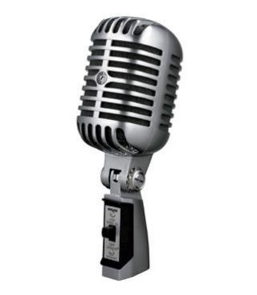 - > 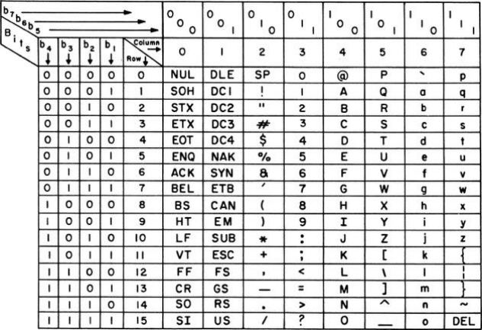 - >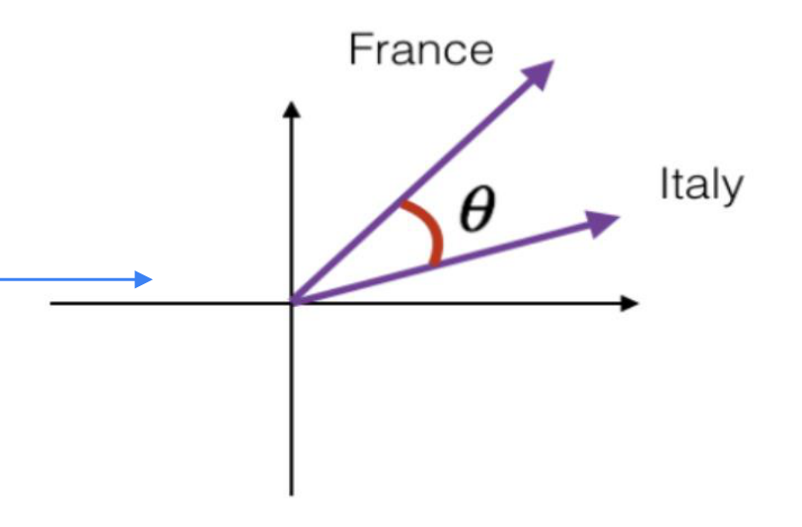
- speech
- Ascii / unicide >
  - suitable for direct manipulation and editing
  - relatyively copact stroage
- other representations i.e.vector
  - Suitable for genwralising from…
  - Not goof for capturing text you’re writing out I an email.
  - Good for search / large language models as fcus on meaning of text rather thamn characters themselves…

Today
- Giving symbols to thought
- Do we need to represent text?
- Text and computer encodings
- Bag of Words
- Word Counts
- TF-IDF
- Distributional Semantics
- Dialogue vs Non-Dialogic Text

- Relation ships between words as concept and words as text
- Classical ML 9tf-idf0 / bag of words reps etc
- Progress to distributes sematic representation (ivector space.. represent individual
- Words + sentences
- Dialogue vs non-dialogue and why a strike through!!

Today
- Giving symbols to thought
- Do we need to represent text?
- Text and computer encodings
- Bag of Words
- Word Counts
- TF-IDF
- Distributional Semantics
- Dialogue vs Non-Dialogic Text
- Keep in mind that the stuff this week is important and very foundational. There are a lot of extra handouts for this week that talk through the detail.
  - Won’t give handouts out any more can use claude / gemini etc if want/need mor info

Representing Text

Meaning and the Semiotics Triangle
- In linguistics and psychology, we usually distinguish between the concept, reference object, and symbol. This makes a lot of sense for humans.
- For computer systems, do we have a distinction between the concept and the symbol?
- Yes, we generally do
  - “Cat” vs “0.111,1.01,-0.55…”
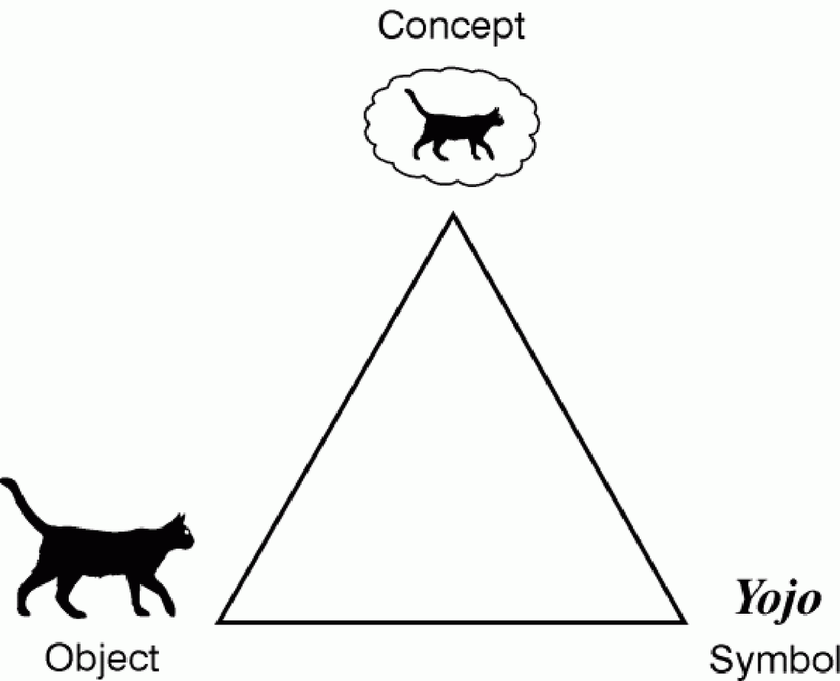
For something like a cat.. there are 2 distinct represenatio that can be associated with that cat…
    - The concept… the idea… of a ccat… it has meaning/formalising/logic i.e. furry /4 paws / whiskers
        - This allows us do AI and manipulation of a cat
        - Before – concept of a cat only existing in a human brain…
        - No in computers.. some tried using logic and rules… etc btu never really truly captured th concept of a cat…
        - So distributed sematics…#impartant partf fo our ability to gemneralise about objects in the world..
        - Can manipulate in multidimensional space
    - Symbol
      - A collection of bnary info
        - An accepted valdi toke that captures and identiy of the cat..
        - Topekn of cat ..in Unicode or asciii… acan link ti to physical concept of cat..
        - Keep in mind distinction between symbol of cat and conept of cat… they are very different…

Elementary Representation of Text
- There is no perfect way to represent Text
- Outside of machine learning there has been an evolution of approaches over the years, but these approaches aren’t necessarily good for Machine Learning tasks
- What do UTF and ASCII do well? What do they do badly?
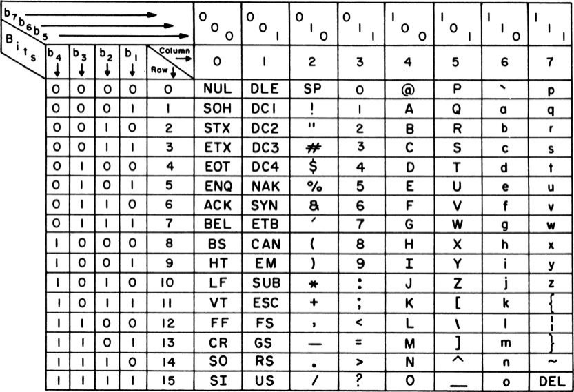
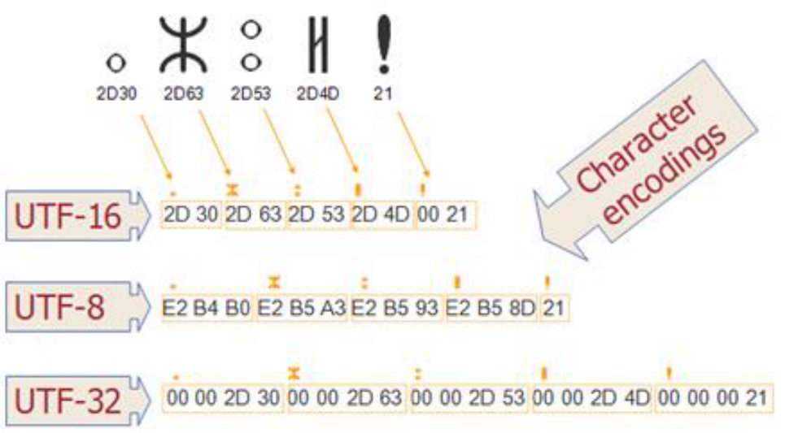
- What do Unicode characters do well for representing text?
  - Easy to edit…
  - human readable
  - stil underpin out use og GUI
  - can read and manipulate them..
  - can ne verbose.. a text file before you zip it
  - big problem is not good and beig generalised from them…
  - i.e. ascii style reps… abuot same distance between the word dog and bin and there is between dog and pup..
    - dog + bin
    - dog + pup – conceptually much closer together in terms of emanign
    - symbol misses this
  - can transcribe / tansmogrophy text though

Standard Text Representations (ASCII and More)
- Pros:
  - Great representation for visualizing text
  - Great representation for editing text
  - Okay representation transmitting text
- Cons
  - System representations of text, e.g., ASCII, UTF8, capture the literal text but do not provide an information-centric representation of the information in the text.
  - They are also not a representation that is easy for machine learning style operations to be applied
  - Do not easily support search or comparison
  - Does not capture the ‘meaning’ of the text – they are not the concept
- ”The otter stood at the bank” has the same representation regardless of the meaning of the sentence.
- 
- Otter outside a bank / otter at a abank?

Classical Text Representations

First: Text Processing Pipeline
- In classical NLP a set of documents, or corpus, was typically pre-processed a lot before being used.
- The diagram on the right illustrates these concepts along with the linked article. Please review.
- In modern systems not all these steps are always applied. However, they do still exist, and sometimes these steps are even applied by ‘representation pipelines’ without you realizing it.
- Note that a lemma is an actual word, whereas a stem is sometimes not a real word
- https://medium.com/predict/how-does-nlp-pre-processing-actually-work-8d097c179af1
- What are the pros and cons of such pre-processing?
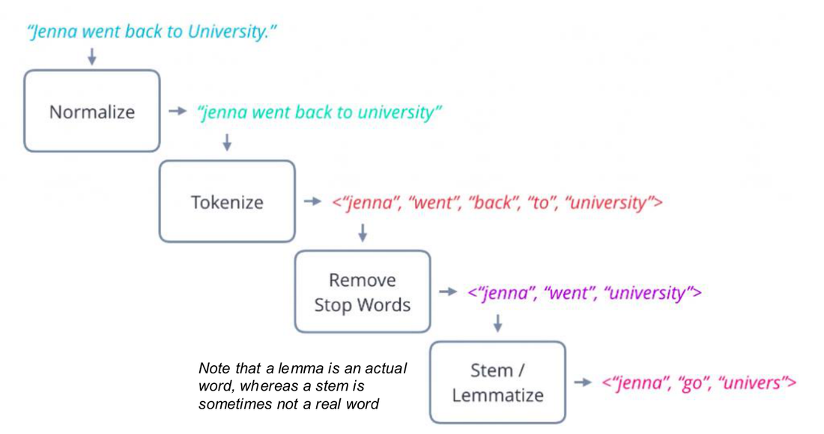
Alst week used it .. not used as much
Ladt week we normaise our text better aligns with ptuput of ASR…
Depending on pipeline can still be pros and cons of the steps…
Realy importan before get into rep text… clean up before represent it…
- Typcial Text processing pipeline
  - Normalise the text – can depend on tool you are using 9 the defition of ormalisatin)
  - Tokenise - Yaml / json – tokenise – take long string of text and break into indy “words” (one persons word might not be another persons “word”
  - Remove Stop Words
    - Remove most common functional woirds ie.. the, for, of, and etc.. most fundamental functional words in language
    - Remove to suit ML algorightm… so common not capturing info that was relevant for spam detection in early NLP
    - Interferred with stats
    - Naïve Bayes / classifiers
    - NOT GOOD for modern state representations
  - Stem / Lemmatise
    - Manipualtion of text t make it easier for ceratin classes of text procession
    - Moving to Canonical words
      - Couch and sofa
      - Canonical form -> theres only 1 valid word that applied and get rid of all other words that might mean the same thing
      - Helsp us shrink the covab we need to deal with
    - Don’t want grammatical features of wors
      - Plurals / singulars /
      - Removing detail to shrink down vocan set so just focus on key words.. used… i
      - i.e. running / ran / will run >>> reduced to run…
      - advantage >>>> removes variance…
      - dis-advantage >>>> you remove detail.. important detail – even stop words have meaning. In true sense
      - in NLP should not remove stop words / pre-processing etc…
- every year.. get assignment usig olde pipliens form other moduels wth stop words / lematising etc…do tno remove in modern pipeline…
- relevant for wens earch
- quick indexes of docukemnts
- one-hot encoding >> inpirtant for input layers in NNs

Representation Options
- One-Hot Encodings
- Bag of Words
- Count Frequencies
- TF-IDF
- Distributed Semantics

- relevant for wens earch
- quick indexes of docukemnts
- one-hot encoding >> inpirtant for input layers in NNs
- BW was very ompirtant 15/20 years ago… important fro historical point of view…

One Hot Encoding
- Each word is assigned its own bit in a vector. The length of a representation vector has to be the length of the vocabulary for your dataset.
- Each vector captures only one word, so this is a very sparse data set
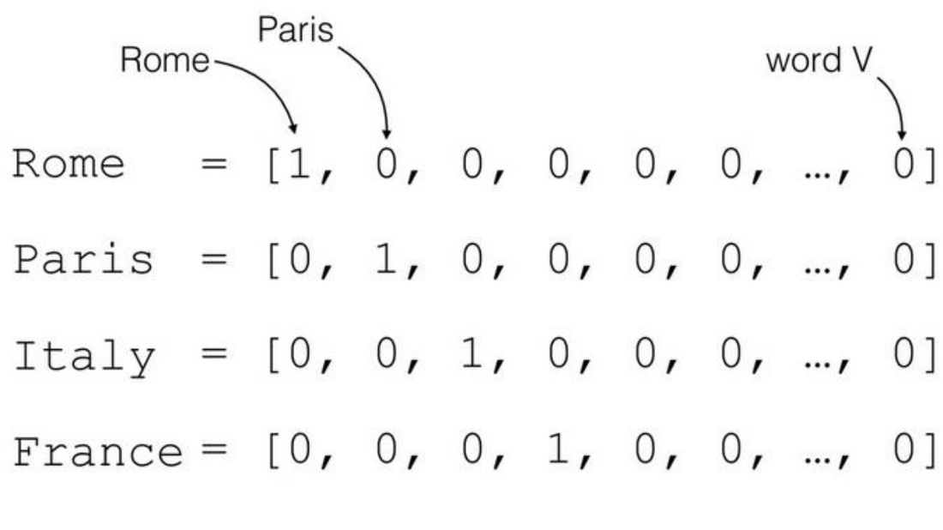
Where term is mentioned we put a “1” and everything else set to “0”
Used a representation in general and in traing of NNs
Great as very specific
Bad in that extremely verbose…

One Hot Encoded Document Representations
- Problems:
- Sparsity
- No semantic ‘meaning’
- Shape = n x m
  - n = size of vocab
  - m = number of words in sentence
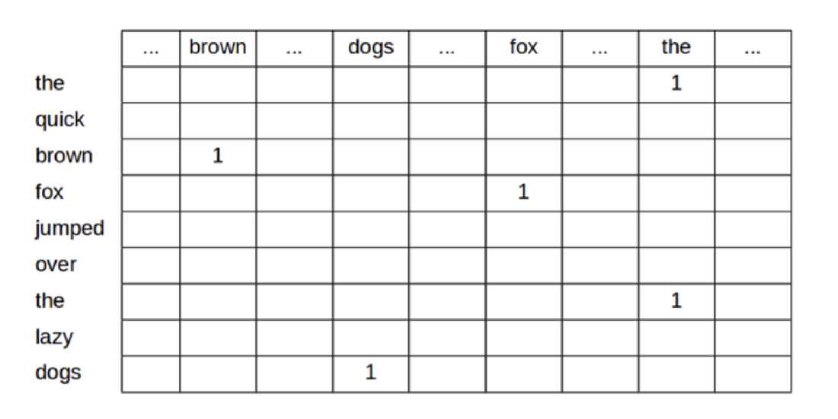
Have table for ehach word.. so gets very long
Moving to sentence >> representio od N x M
17K word in dictionary
Ends up being huge
Can reduce down to makr only those words which are presrnt

One Hot Representations
- Pros
  - Much better at capturing meaning than an ASCII style rep
  - We could actually use a pretty good spam filter based on this type of approach
- Cons:
  - Representations are super super big in their full form
  - Individual vectors are very long
  - Similarity between words is lost

They don’t capture meaning in any sense… i.e. position of words in arbitrary.. will help with alphabetic quality… A appears 1st X appears end
And pup and dog are as close to each other as dog and bin….

Dense Representations
- While One Hot Encodings do look incredibly wasteful, keep in mind that we can compact these sparse representations in a very trivial way
- Dense representations just save the index of the token to be active and assume everything else is zeroed out
- 5477 7783 8777 12101
- The quick brown fox …
- 8777, 1101, 5477, 8777, ….
- This is sometimes called an index-based representation
- This is in fact quite similar to what UTF does – but at a word level rather than character
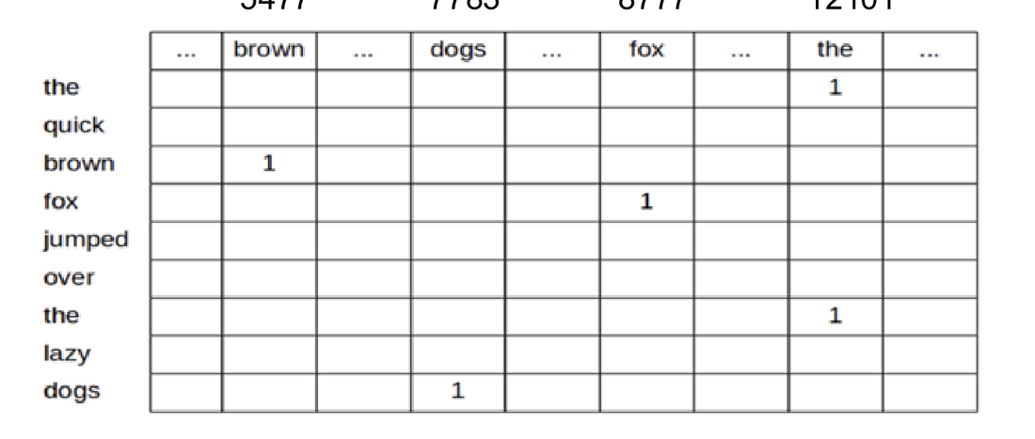
Explains a better way t encpature one-hot encoding
Instead of big matrix with 1s and zero
>> w have vector like this in sldie… where eords was found i.e. wrd in this vector position… mapping where ti appeard… bt still very ig verbose matrix representation

Bag of Words
- Bag of words still assigns a bit per word, but we are allowed to have multiple words active in the vector.
- This means that one vector can capture the meaning of any text – though not very accurately
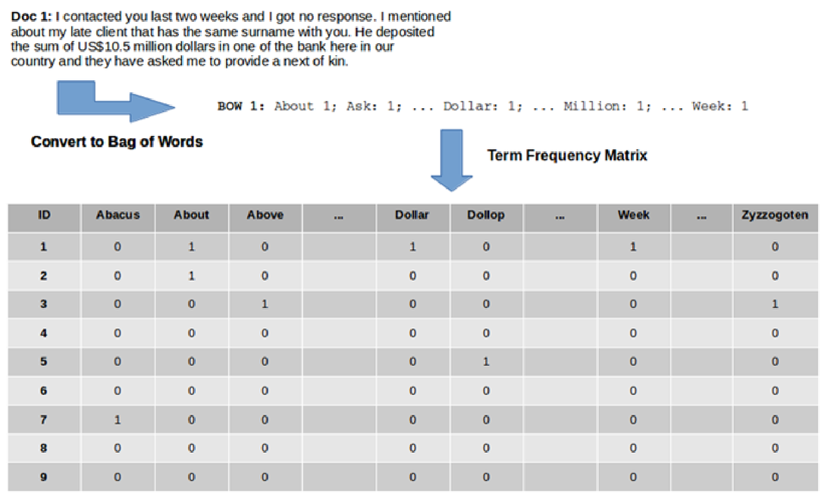
- Better than 1 hto encofing as can do more faster…
- No logner saying theres a vector per word
- Have single vector tp capture full sentence….
- And I thei vectore anytime that word is present we add element to the column to given word that’s present…
- Each sentence gets its own row….
- Any word in sentence.. add a number for that word… ie. 3 mentions for dog get snumber 3…
  - Good >
    - Way more compact > for NB processing spam filters… worked really well
  - BoG style representation wors quite lot…pute bag of words… h
  - Capturing meaning of full sentence ein one vector
- Had count based variance…
  - Bad >>
    - throws away order…. Get all words throw them into a bag and give them a shake…. Fine for spam filter…. Word such as prince / etc
    - Throws away order man bties dog >>> dig bites man…. Can[‘t differentiate….!
    - Search doesn’t work very well , not great for indexing….
    - Could but never great represneation

Bag of Words
- Pros
  - Much better at capturing meaning than an ASCII style rep
  - We could actually use a pretty good spam filter based on this type of approach
  - More compact than One Hot Encoding
- Cons:
  - Order of words lost
  - Vectors are long
  - Similarity between words is lost
  - All words given equal weight
  - Search is tough

Included term frequency can help… i.e. if says “Law” 20 times its probably abuot law…
So change from standard BoW to capture a bti more emaning

How can we extend straight bag of words to account for some words more frequent than others?
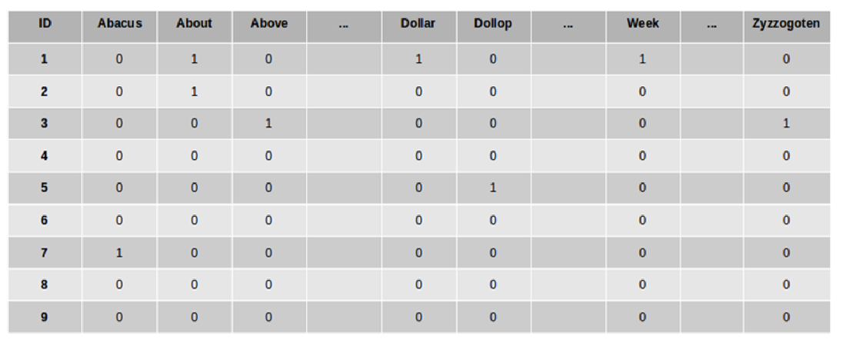

How can we extend straight bag of words to account for some words more frequent than others?
- 3
- Instead of just accounting for the presence of a token, capture the number of times that token was seen in the document – Term Frequency Vectors
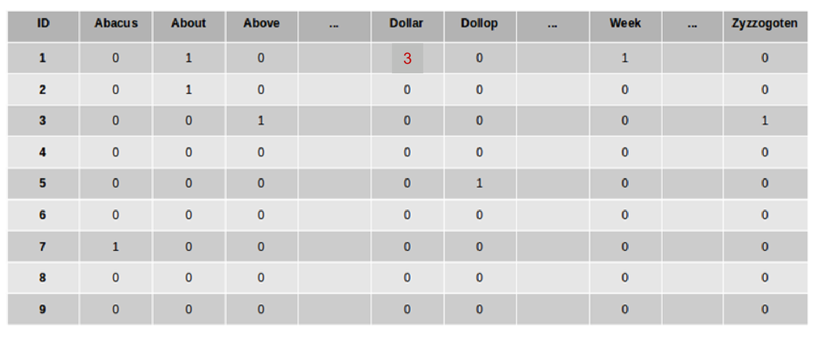

On Term-Frequency Vectors
- In terms of representing the raw word contents, Term-Frequency vectors seem to be a pretty good solution.
- However they can over emphasis the role of very frequently seen words across multiple documents in a corpus.
- Can we come up with a formulation which captures the relative influence of words in a given sentence – relative to their influence on other sentences in the same corpus????

Meaning relative to other docs around themmm how can I do that?
Count vectors helped but not great

Term Frequency / Inverse Document Frequency TF-IDF
- https://ted-mei.medium.com/demystify-tf-idf-in-indexing-and-ranking-5c3ae88c3fa0
- Instead of just acknowledging the presence of a word type (BOW) or the number of times it occurred in the document, Count Matrix, the TF-IDF measure accounts for how important a word seems to be in the document relative to other documents in a collection.
- Why log?
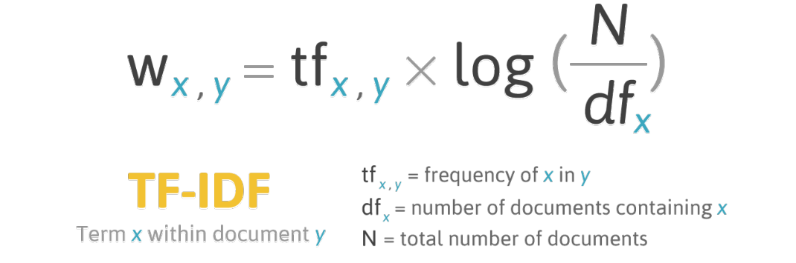
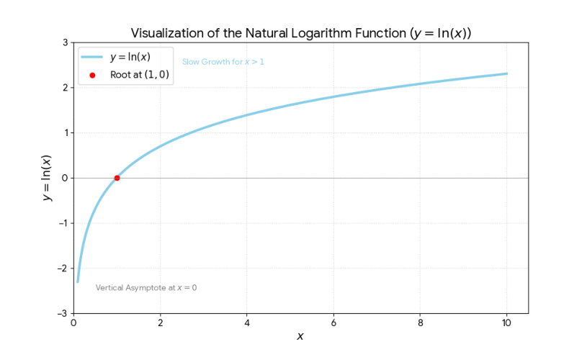
- Exam important
- Terminology
- Individual docs>>> a doc can be a sentence / a conversation / a web page / i.e the unit of info we are most interested in..
- Don’t just ned to use a vector to rep sentence… can use for whoel doc if we want… corpuse could be the whoelset of docs… i.e. a doc and a corpus
- Normalise whith N number of docs
- Lgo makes scale more palatable relative weights…

TF-IDF
- https://towardsdatascience.com/text-vectorization-term-frequency-inverse-document-frequency-tfidf-5a3f9604da6d
- The TF-IDF representation gives a lot of emphasis to rare words across the corpus – particularly when that rare word occurs a lot in an individual document
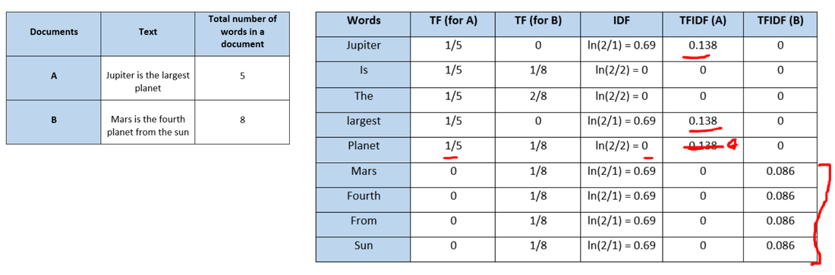
- Exam
- Occured a few times over the years… may not necessairily this year bt ahs a few times… important to get yourh head around it…
- What we want
- Have rep which captures meaning of a doc but takgin every word and loking at its relative frequency wrt the occurences in all the other docs…
- i.e. common word the.. and not filtered with stop words…
- if using count freq style rep => the word the appears a lot…. But that’s useless when trying to cluster the doc i.e. sematic groupings… i.e. the occurs everywhere… or medical.. word patient.. may occur a lto!! So not a lto of information / special meaning value
- small bit over the big bit…
- if a lto in the doc + not a lto in corpus >> string indicatin the word is a godo representation of the meaning of the doc…
- i.e. covid in irish times in last year.. maybe that page is about covid.. lok over lats eyar.. good indication it’s a representation its abuot covid…
- still not great for representation of meaning…
- EG in slide
- 2 docs
- Jupyter and planet .. cal term freq indy for each doc… we have
- Term freq for each doc
- Num times it occued in doc / num of docs in corpus / number of time sit was seen in the doc…
- Idf value = 0.69
- Get log
- Can then calcualteg tf-idf in A
- The word “is”
  - Occured in both docs… if in doc A = twice and tice in docB >> the lgo - 0
  - So word is occurs in every doc so low informatin quotient to us…
  - And is zero…
  - If had bigger corpus and a occurred very little => it has more inf value….
- TF = how important in the particular in that doc we are looking at
- IDF = how incidental is it across the corpus as a whole…. If everywhere not that important
  - Its calcualting information Quotient…
  - “is” should eb zero
  - “a” should eb zero
  - “Planet” not zero…
  - Etc
- Question for Paolo
  - Always between “zero” and “1”
  - Log of that number
  - N = big number / df wil eb slightly smaller also getting LOG of it…
  - =>>> always going to be 1 or higher… nLog going to put It
  - Don’t think of them as probabilities , might be frequencies…. Btu are more relative to total numbers in the corpus…
  - Will do deep er dive later in the semester… in web search and document indexing….
  - Captures roughly meaning of doc
  - Very good at capturijng and clustering docs together..
  - Similar meaning docs in tf-idf.. will eb close to each other… which isj important to us!! good enough eo perform search in this representation…
  - Use distance metrics to find out what docs are closest to my query!!! i.e web search,,,,
  - Better than on-hot encding…
  - TF-IDF is dying off when it coe sto search.. as search is moving towards full distributes representations….deep learning…. Want to eb smart about search or meaning…

Distributed Representations

A Better Approach: Index words in multi-dimensional space
- Instead of associating a word with just a single number in a single dimension (the traditional index), instead associate a given word with a point in a multi-dimensional space.
- Each dimension can be thought of as capturing an aspect of meaning
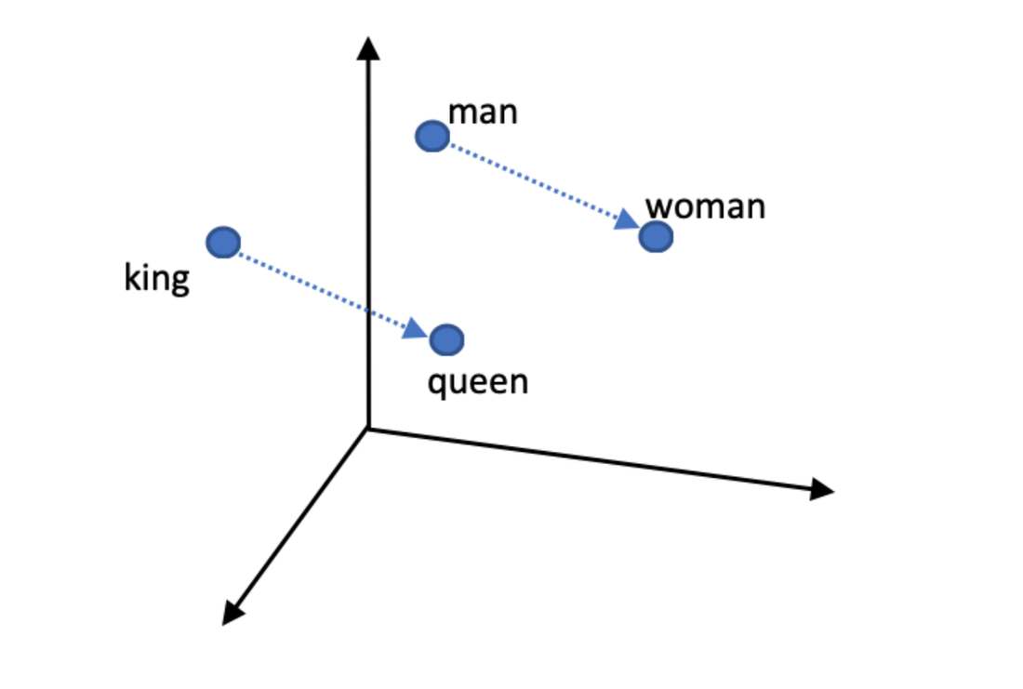
- Distributed or vector space representatinos
- Take indy word and captures thos thgi sin multidimension space…
- Distance between words in this space has meaning…
- Simailr meaning share space… => can substitute other words…
- Even show within these spaces can mek rtansformations and have effect on multiple different words…
- Different dims are truly capturing meaning….#very powerful and underpins a lto fo what we do today…

A better approach:
- A point in space is simply a set of coordinates, x,y,z.
- Similar words should live in a similar part of the space
- Dogs and puppies share a similar amount of dogginess, but will vary in terms of a young v old property
- But why stop at just 3 dimensions…
- cat
- run
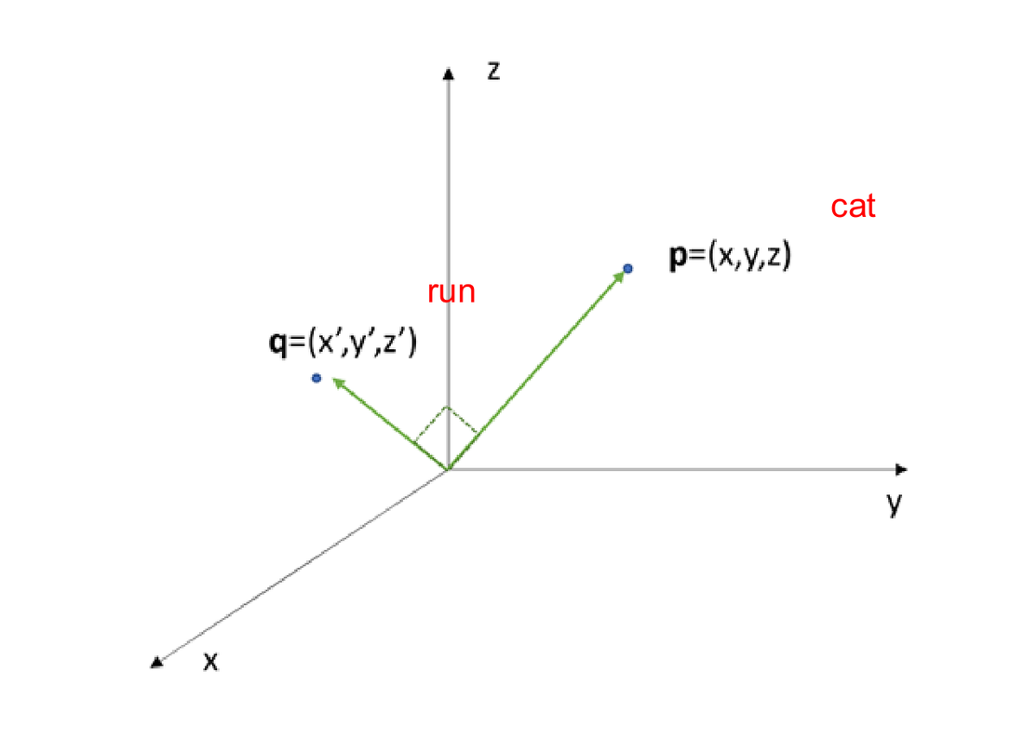

Indexing in High (e.g., 128) Dimensional Space
- Basic idea still holds.
- Instead of representing words with a vector of 3 numbers; we represent words with vectors that are much bigger.

- Combinatisno of dmienions capture these meaning
- i.e dim 57 + dim 138 + 98 == means something…

Distributed Representations (Word Based)
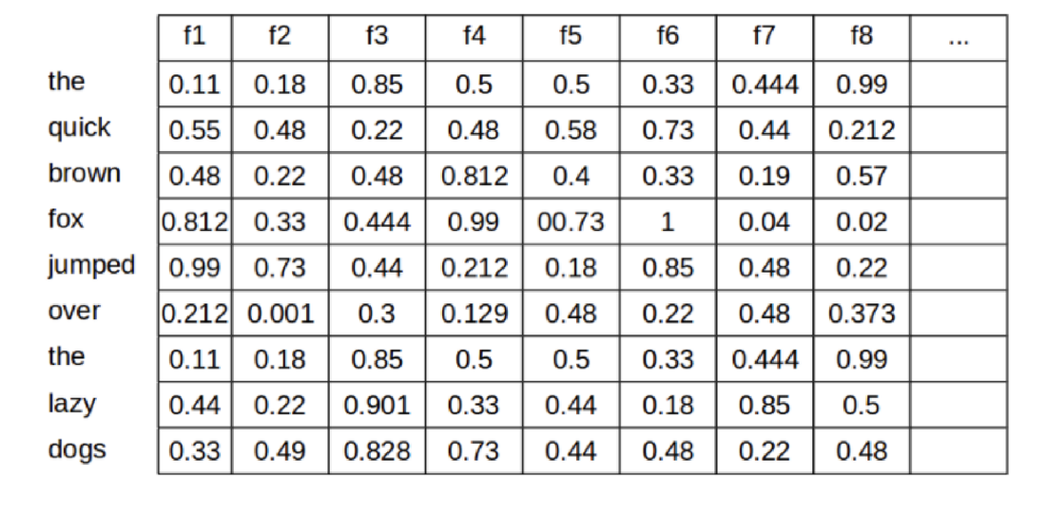

Meaning Spaces
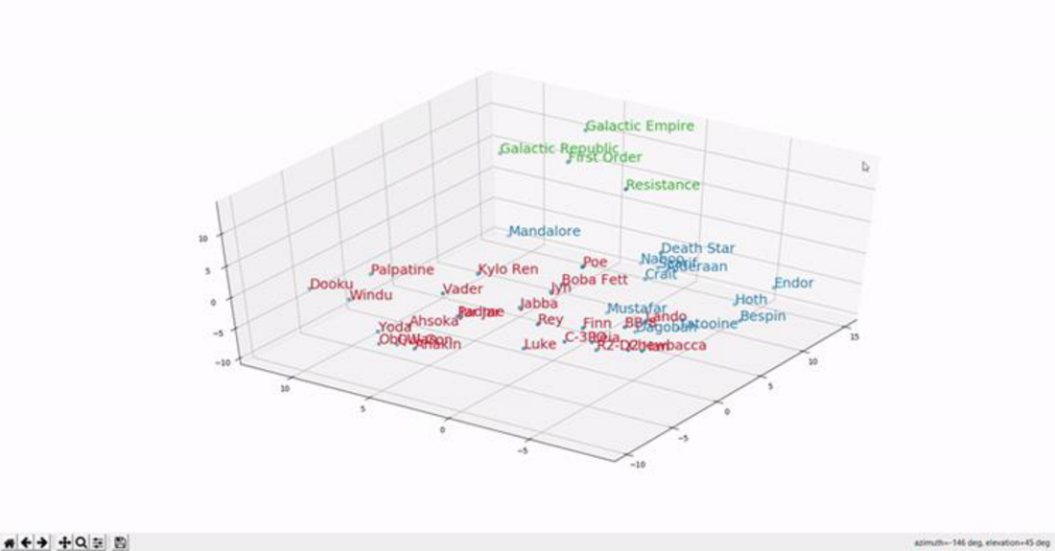
- Combine vectors in different words..
- Word vectors not commonly used any more

- i.e. glove embeddings… 10/15 years old…
- to view it collapse it so can display it.. like a shadow… loose some infor but still informatinos
- many apckages to look at embeddings.. not just text…
- T-SNE represnetation of the vectors… so we can view it….
- Ask gemini to do this – do the lab first… thenask gemini to kbuild up tSNE representation of the glove later…
- Paolo
- Glove was classic rep
- Take world like bank… and all be represented by same poit.. for any multi meaning word… got same dim rep space
  - Transformers sovked this
  - Take representation tok multi meaning word and transformed it befre got ot output layer…
  - So word had different meaning by time got outputted…
  - Glove not used for

- Break - take twn to 8… 7:50
  - Going to lok at how can take indyh word reps and use for search and then build together to do slilghtly more interstign things….
  - Buld them together to do interesting

Meaning Space
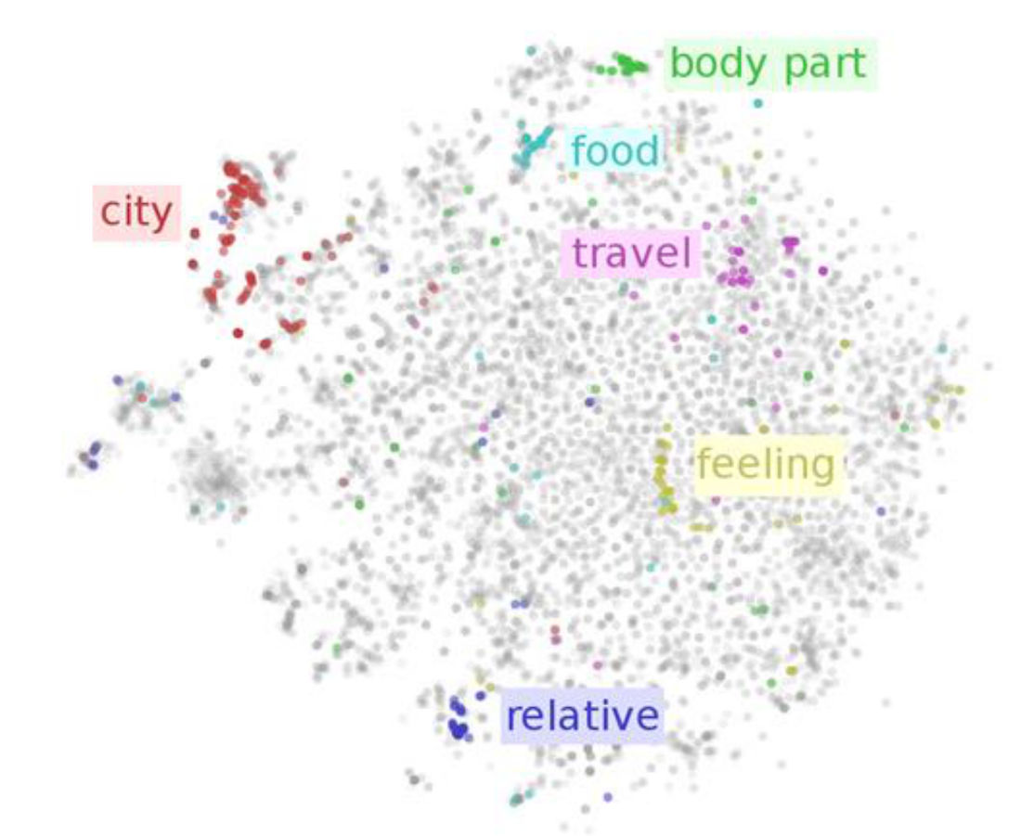

Calculating Similarity – Cosine Distance
- The great thing about distributed vectors or embeddings is that they provide us a way of easy calculating the similarity between vectors using a similarity measure called the cosine similarity.
- Basically, we calculate the cosine of the angle between the vectors for two words. If they are similar the cosine will approach 1.
- Remember that we are usually doing this for very high dimensional spaces, but the same idea still holds
- NB: Magnitude difference between vectors is ignored!

Not just the angle—in multi dimensional space doesn’t mean anything
Approximates the distance fro one vector to another…

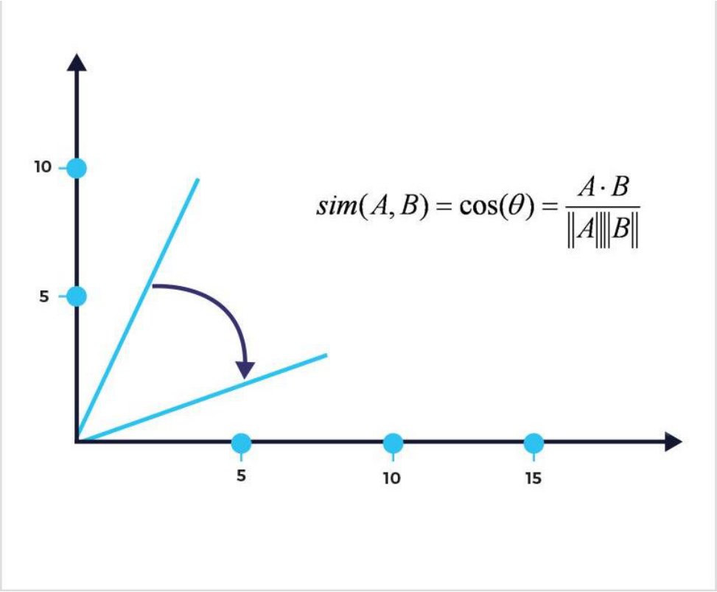

Cosine Similarity in Detail
- https://memgraph.com/blog/cosine-similarity-python-scikit-learn
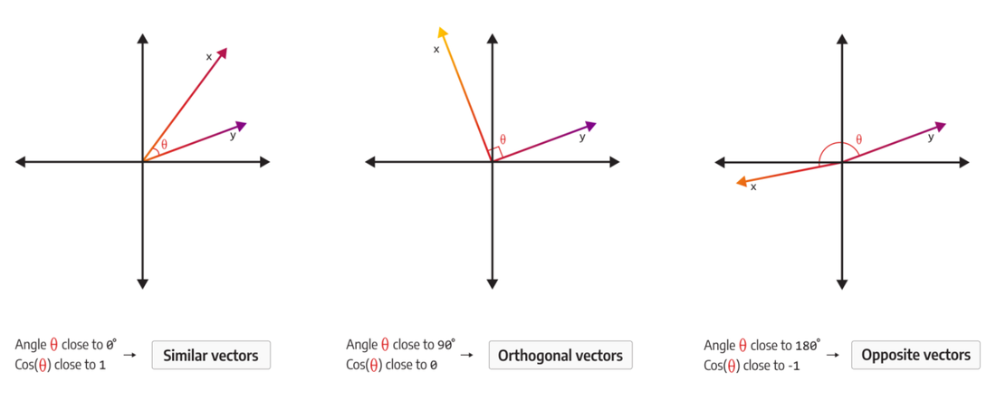
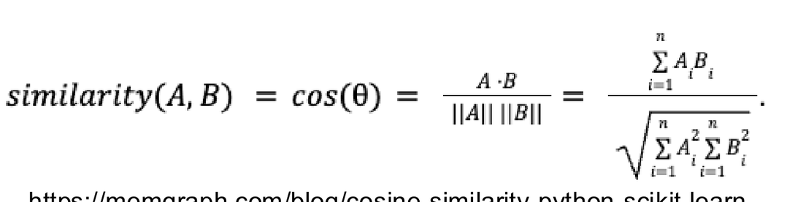

Cos Check
- What is cos(180)? >>> -1
- What is cos(0)? >>>> 1
- What is cos(90)? >>>> 0

- Exam
- Cos distance will eb close to 1 if vectors are similar
- Similar >> cosin sim will be 1… close to 1 vecotrs close to each other…

- Orthogonal (90 degrees to each other >> zero

- 2 vectors are opposed to each other >>>> minus 1 (-1)
- One single number

- Handy for clustering and search….
- How close docs are to each other…. For example…
- Search.. do they belong in a group together…
- In real world i.s news aggregator.. like goodle news.. clustering news articles together….

Where do the vectors come from?
- The specific vectors for individual words are usually learned from a corpus of documents through a machine learning process.
  - The actual process used for modern distributed embeddings are usually very complex and involve the combination of a number of tasks.
  - The general approach can be illustrated with the skip-gram and
- The important thing to understand is that these vectors are learned from a training process which focuses on making sure these vectors are good for key tasks like document similarity measures, guessing the missing word, predicting the next word etc.

- Covered in deep leanring course dependngi moods
- Where do vectors come from?
- They are learnt using variosuj different mechanisms
- Some sort of task we perform… and a side effect of the task we get a godo representation…
- No vector task we are doing something else
- “Sub text “ – somethijgn we are doing to get side effect…

Word2Vec - Skip-gram and Continuous BOW training
- The training of these models focuses on guessing missing words. Continuous Bag of Words is training to predict a single missing word. Skip-gram is trained to guess words that should surround a given word
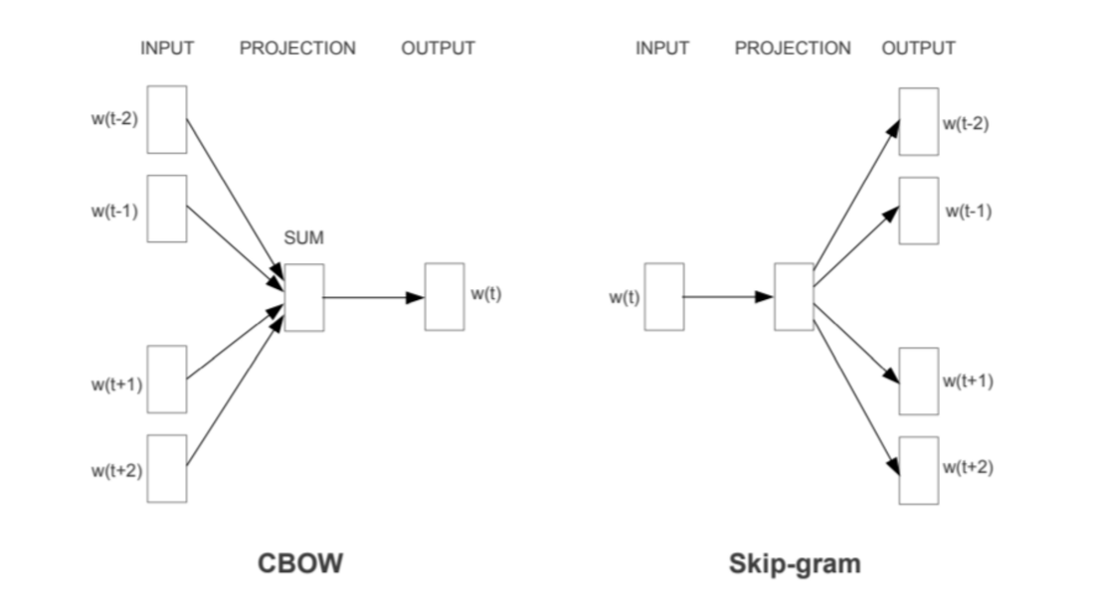
Word 2vec>> how are vectors learnt?
Two tasks which were opposite to each opther
- CBOW - Was a continuous bag fo words… given a bag of words with surrounding words..
  - predict missing word?
  - “The quick brown fox jumped over the …”
  - If tou do that and do ti with good data.. in that no trvial model you get in a layer in thatg model is a really good representation of the meaning of that word…. Which can product the missin word..
  - Learnig a pre-layer…
  - Learned a distribute representation to preduct thr word…
  - Flip it around >>
- skip gram model…
  - Given a word fox.. gues rep of words around it…
  - Rep you get here is even better distributed representation
  - A self learning strategy…
- Can take a big corpos of text and no lebellgin proprocessinf of it… not lots of traingn and algorithm can be trained quite easily…
Feature | CBOW (Continuous Bag of Words) | Skip-Gram
Prediction Task | Predicts the center word from the surrounding context words. | Predicts the surrounding context words from the center word.
Training Speed | Faster to train. | Slower to train.
Performance | Better representation for frequent words. | Better representation for rare words (infrequent words).
Dataset Size | Often preferred for very large datasets where training speed is a major concern. | Often preferred for smaller datasets or when focusing on high-quality embeddings.
General Quality | Historically seen as slightly lower quality, but newer research suggests that with corrected implementations, it can be competitive with Skip-gram. | Often considered to produce higher quality embeddings, especially for capturing semantic relationships.
Skipped this – sad part of content and need to know but wanted to move on to next area…

From Words to Sentences / Documents
- These embeddings typically use a long vector to define a single word
  - How should we define a sentence based on word embeddings?
- There are many different approaches
  - Document = sum of word vectors
  - Document = average of word vectors
  - …
- While not being intuitive, these approaches do work surprisingly well
- See lab notes to see a typical implementation

- How do we capture sentences….
- Basically couple fo differentaproach to how w do that
- Up to now
- Take vectors of each word
  - >>> average them or sum all the different vectors…
  - In high dim space still going to work
  - Small dim space.. won’t work great…..
  - Get a vector of meaning of the sentence….
  - Can then do combingin the vectors to get gsimilarity measure and so forth….

Sentence and Document Embeddings
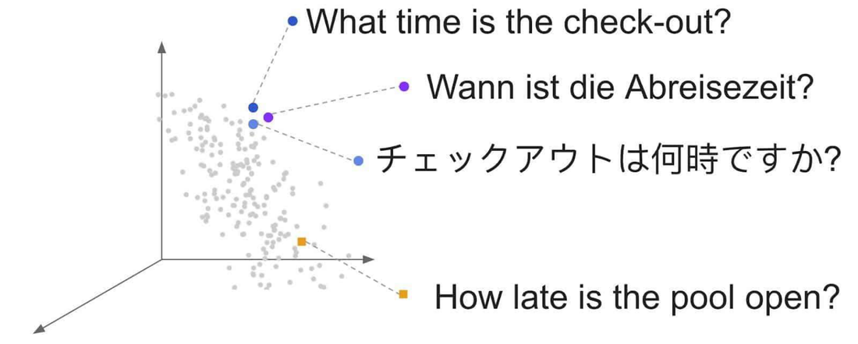

Sentence Embeddings
- Rather than being based on averages of word embeddings, modern sentence embeddings are trained specifically at the sentence level.

- Transformer style embeddings…
- Word embeddings are given in a sentence context…
- meaning of that word in sentence of how it is used…
- BERT does more.. represenatin of “bank” also capturing other idea around tis use.. action sentence / question / adjectives assoc with it.. sentence gets more context….
Question
- For mutli dimensional space doe sit stil work for large numbers of dimensinos?
- Yes to a pint
- As go into higher and higer dim spaces
- Need more memory and more space…
- So a trade off >> whats best dim speace.. got into order of 100s of dimensions is enough.. did nto get itno 1000s or millions….
- Those islands will eb so far away from each other…
- Star with 2 dims first.. get angle… nto just purely an angle might have sene theres some summation over every dim…
- Add on 4th dim.. do it another way.. sunming…summation over all dimensions….

Examples
- Build bag-of-words and TFI-IDF reps for the following two sentences:
  - The cat sat on the mat in Dublin
  - The cat ate some fish on the mat

Dialogue

- Strikethrough at start n sldile… ias its quite different…
- Take dialige and captru as text..
- Chat history and put it in vector space..
- Dopn’t care if mono logue or dialogue.. agmostic abuot what goin on inside of text…

- Now though
- But what is special about different types of text we deal with?
- Whats different?
- Dialogues are incredibly important now… acceptance of using agents? Style of conversation
- A tool or partner?
- No every oen is doing dialgues with gemini / claude… etc
- What makes dialogue different as a typ fo text.. nto all language is the same!

Not all language is the same
- Each of these modalities will have their own specific characteristics
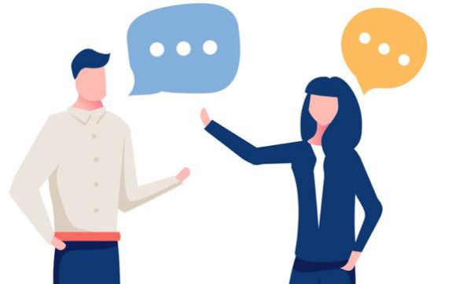 >>> >>>
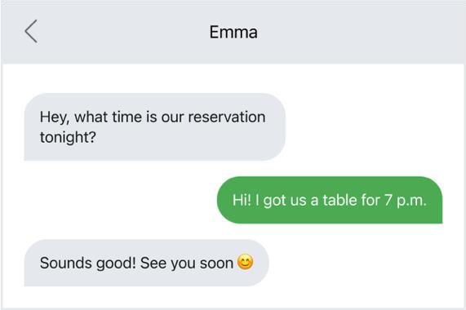 >>> 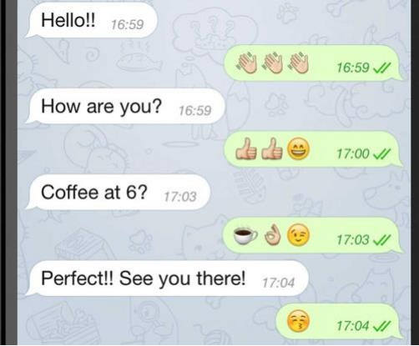https://www.researchgate.net/figure/2-Main-differences-between-spoken-and-written-texts_tbl2_234662324
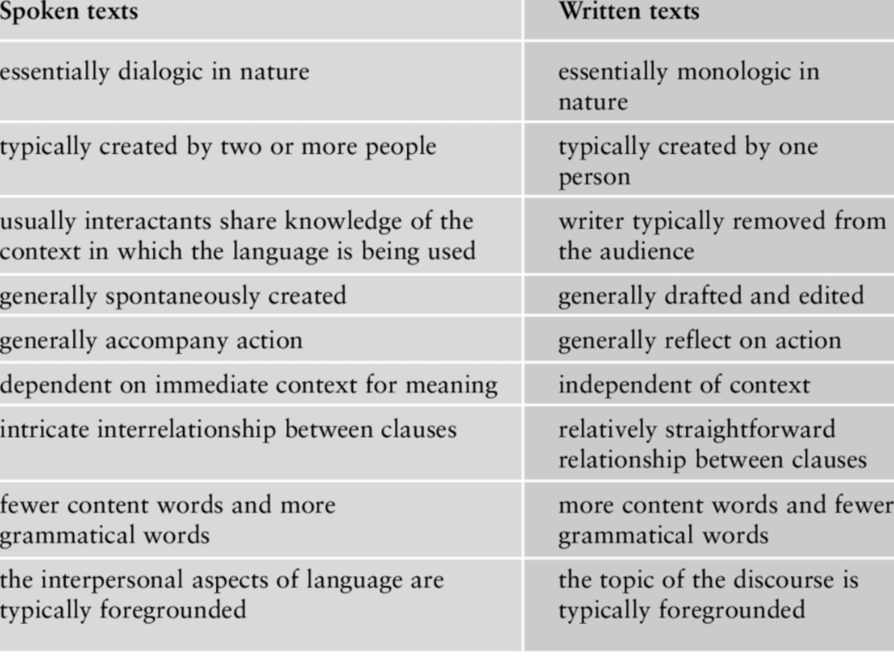
- https://www.researchgate.net/figure/2-Main-differences-between-spoken-and-written-texts_tbl2_234662324
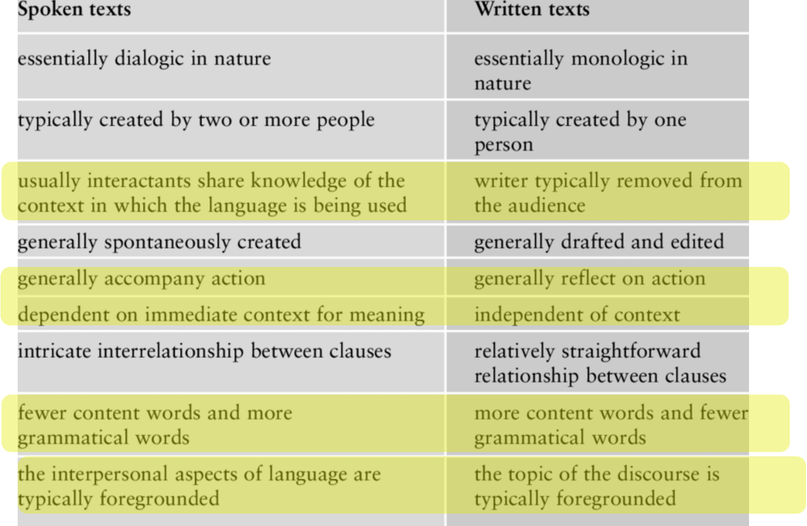

Conversation is different

What can we leave out of and parner wil get ti can see ifn theor facial expression
Letters etc / newpaper / put in ore info and reader can’t asl questions
Dialogue elave some stuff out…
Yellow are most importan differences as faras we are concerned
- How mcuh info being shared? Or from wrtier to audience>> have to include more info
- Physical actions – gestures… to communicate info.. can’t do in written language
- Context - soken has more context – written don’t’ have same access ot info
- Style – huge differences.. written usually far more formal and srryctred than dialigeue as we know kess about oru audience… standard formalised way… dotn’ want ti eb a weido and just follow noms…
- Can be tyeps of text in langauges
  - Facts or relationships to each other
  - Far more based abuot info..
  - Conversations ahev a bti of fact but more based on relationships…
Chatbots based on text and books… etc designers challenge is personas of systems, is etxt to factual or too interpersonal and creatgin a relationship…
Using gemini vice interface… spoken voice reading an essay….
No universal set fo hwo we represent text.. depends on task at hand and users….
Difference between written text and spoken text….

Other Language Type Contrasts
- https://smalltalkbigresults.wordpress.com/tag/texting-vs-talking/
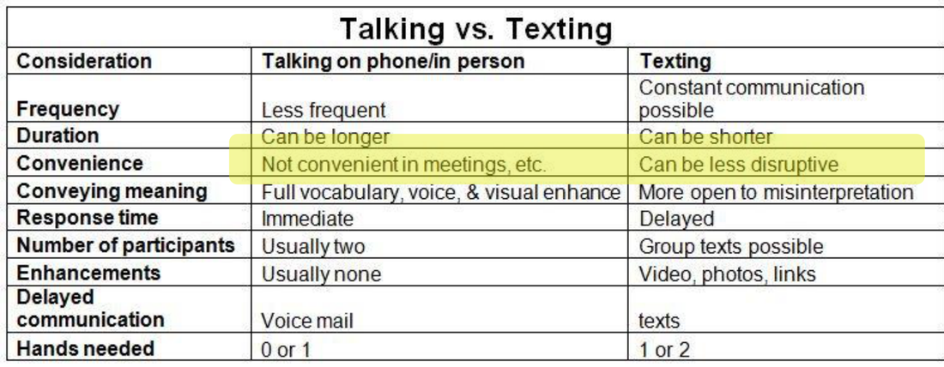
- Msc
- Text andtalkign
- Tweets
- Linked in updted
- Style - hiw much info / tone -- quick jolty more detailed…
- Can be represented btu not just capturing the facts especially also captrugin the tone of how tis represented…
- Modern reps hav ocaptue all of that…
- Its more than facts… and al types of text we might need to speak about..

Some Lab Work

References
- https://medium.com/predict/how-does-nlp-pre-processing-actually-work-8d097c179af1
- https://ted-mei.medium.com/demystify-tf-idf-in-indexing-and-ranking-5c3ae88c3fa0
- https://towardsdatascience.com/text-vectorization-term-frequency-inverse-document-frequency-tfidf-5a3f9604da6d
- https://memgraph.com/blog/cosine-similarity-python-scikit-learn
- https://www.researchgate.net/figure/2-Main-differences-between-spoken-and-written-texts_tbl2_234662324
- https://smalltalkbigresults.wordpress.com/tag/texting-vs-talking/

Week 4 – Representing Text
- Remember, when I say ‘text’ I am using that term to refer to words, sentences, documents, or even speech.
- We need to somehow represent the text in an efficient way, and what is efficient depends on the task. For us we often want to perform tasks like similarity measurements

Today
- Giving symbols to thought
- Do we need to represent text?
- Text and computer encodings
- Bag of Words
- Word Counts
- TF-IDF
- Distributional Semantics
- Dialogue vs Non-Dialogic Text

Today
- Giving symbols to thought
- Do we need to represent text?
- Text and computer encodings
- Bag of Words
- Word Counts
- TF-IDF
- Distributional Semantics
- Dialogue vs Non-Dialogic Text
- Keep in mind that the stuff this week is important and very foundational. There are a lot of extra handouts for this week that talk through the detail.

Representing Text

Meaning and the Semiotics Triangle
- In linguistics and psychology, we usually distinguish between the concept, reference object, and symbol. This makes a lot of sense for humans.
- For computer systems, do we have a distinction between the concept and the symbol?
- Yes, we generally do
  - “Cat” vs “0.111,1.01,-0.55…”

Elementary Representation of Text
- There is no perfect way to represent Text
- Outside of machine learning there has been an evolution of approaches over the years, but these approaches aren’t necessarily good for Machine Learning tasks
- What do UTF and ASCII do well? What do they do badly?

Standard Text Representations (ASCII and More)
- Pros:
  - Great representation for visualizing text
  - Great representation for editing text
  - Okay representation transmitting text
- Cons
  - System representations of text, e.g., ASCII, UTF8, capture the literal text but do not provide an information-centric representation of the information in the text.
  - They are also not a representation that is easy for machine learning style operations to be applied
  - Do not easily support search or comparison
  - Does not capture the ‘meaning’ of the text – they are not the concept
- ”The otter stood at the bank” has the same representation regardless of the meaning of the sentence.

Classical Text Representations

First: Text Processing Pipeline
- In classical NLP a set of documents, or corpus, was typically pre-processed a lot before being used.
- The diagram on the right illustrates these concepts along with the linked article. Please review.
- In modern systems not all these steps are always applied. However, they do still exist, and sometimes these steps are even applied by ‘representation pipelines’ without you realizing it.
- Note that a lemma is an actual word, whereas a stem is sometimes not a real word
- https://medium.com/predict/how-does-nlp-pre-processing-actually-work-8d097c179af1
- What are the pros and cons of such pre-processing?

Representation Options
- One-Hot Encodings
- Bag of Words
- Count Frequencies
- TF-IDF
- Distributed Semantics

One Hot Encoding
- Each word is assigned its own bit in a vector. The length of a representation vector has to be the length of the vocabulary for your dataset.
- Each vector captures only one word, so this is a very sparse data set

One Hot Encoded Document Representations
- Problems:
- Sparsity
- No semantic ‘meaning’
- Shape = n x m
  - n = size of vocab
  - m = number of words in sentence

One Hot Representations
- Pros
  - Much better at capturing meaning than an ASCII style rep
  - We could actually use a pretty good spam filter based on this type of approach
- Cons:
  - Representations are super super big in their full form
  - Individual vectors are very long
  - Similarity between words is lost

Dense Representations
- While One Hot Encodings do look incredibly wasteful, keep in mind that we can compact these sparse representations in a very trivial way
- Dense representations just save the index of the token to be active and assume everything else is zeroed out
- 5477 7783 8777 12101
- The quick brown fox …
- 8777, 1101, 5477, 8777, ….
- This is sometimes called an index-based representation
- This is in fact quite similar to what UTF does – but at a word level rather than character

Bag of Words
- Bag of words still assigns a bit per word, but we are allowed to have multiple words active in the vector.
- This means that one vector can capture the meaning of any text – though not very accurately

Bag of Words
- Pros
  - Much better at capturing meaning than an ASCII style rep
  - We could actually use a pretty good spam filter based on this type of approach
  - More compact than One Hot Encoding
- Cons:
  - Order of words lost
  - Vectors are long
  - Similarity between words is lost
  - All words given equal weight
  - Search is tough

How can we extend straight bag of words to account for some words more frequent than others?

How can we extend straight bag of words to account for some words more frequent than others?
- 3
- Instead of just accounting for the presence of a token, capture the number of times that token was seen in the document – Term Frequency Vectors

On Term-Frequency Vectors
- In terms of representing the raw word contents, Term-Frequency vectors seem to be a pretty good solution.
- However they can over emphasis the role of very frequently seen words across multiple documents in a corpus.
- Can we come up with a formulation which captures the relative influence of words in a given sentence – relative to their influence on other sentences in the same corpus????

Term Frequency / Inverse Document Frequency TF-IDF
- https://ted-mei.medium.com/demystify-tf-idf-in-indexing-and-ranking-5c3ae88c3fa0
- Instead of just acknowledging the presence of a word type (BOW) or the number of times it occurred in the document, Count Matrix, the TF-IDF measure accounts for how important a word seems to be in the document relative to other documents in a collection.
- Why log?

- A document vs A Aorpus
- A document can be a sentence / a web page >>> the unti we are mosr interested in
- Can use vecotrs to reopresented aany pf these… i.e. a whole web page if we really want to
- A cirpus is a collection of those docs
- A set fo docs we are indexing / set fo docs

Take a common word “the” and haven’t filtered it out wih stop words….
If use count freq style representation word !the” will appear a lot of times….
That’s useless when coming to clustering the docs… i.e. their little sematco groupsing… as the word “the” is gogn to appear everywhere…

If in medical domain… word “patient” will appear a lot…. So doesn’t have realy rich information value to us…
To capture that specialist knowledge frm a doc that has a meaning

Term frequency - inverse document frequency…
Used in all types of document frequency…
Occurred as an exam question….
For amy give doc we will represent that as a vector where for each word ni our cvocabulary we’ll find how many time sthe ord occurred in the document, then balance that ff in terms of how many times that word occurred in the whoel corpus…
>>> if it occurs a lti in a given document… and doesn’t occur in a corpus >>> gives u s strong indiciation that tsi word is a string representation of the meaning of the document….
i.e. the word “covid” >>> god indication the page may be about covid… as it appeard a lot fo times btu if look at covid over last year…. Did tno occur, so that doc may eb mostly about covid…..
if done in 2021… got every article about covid… >>> it wasn’t a godo information rich represnttatin of that document….

TF-IDF
- https://towardsdatascience.com/text-vectorization-term-frequency-inverse-document-frequency-tfidf-5a3f9604da6d
- The TF-IDF representation gives a lot of emphasis to rare words across the corpus – particularly when that rare word occurs a lot in an individual document

- 2 docs
- Jupiter I larget planet
- Mars is 4th planet from the sun
- Can now work thru and calculate TF-IDF values for each indy word in each doc….
- TF cacualted indy for each document that we have….
- Jupyter occurred once in doc A
- IDF = number of documents in the cirpis / number of times the word appard in the document…
- Calculate TF-IDF for first word in A…
- “is” 2/2 ??? goes to 1 = lgo of 1 = zero…. What does that mean… word is is occurring in very doc, so not a lto of information so tf-idf value is zero….
- If had bigger corpus… and coupek fo words….
- T gives us a measurement of how inortant word is ni document
- iDF = how incidental is that word
- same thing seems to be happening to “the” i.e. like stop words…
- if get to something like “large “ or planet” got relevance not all over the place so IDF value hasn’t shrumk back down to none…. So still get high information quotient for that.,..
- remaining words in the sentence…
- docuemtn B mars doesn’t occur ni all of the corpus elements >>> tfidf word ahs some meaning for us
  - same from 4th/sun aswell…
- will come back to tTIDF when looking at web search…
- gdo dtandard representation capturing meaning of documetns… .e. clustering documents together…
- docs that have similar meaning wil eb close to each other in the meaning space….
- Its good enough we can perform search
- Importsant for web search…
- Better than one -ohot encodings for web searh
- TIDF moving out and full vectorised meaning being used more… distributed representattinos…

Distributed Representations

A Better Approach: Index words is multi-dimensional space
- Instead of associating a word with just a single number in a single dimension (the traditional index), instead associate a given word with a point in a multi-dimensional space.
- Each dimension can be thought of as capturing an aspect of meaning

- Ides oen point that represents king
- One space represents woman
- Oen space reprssents queen
- And distance has a meaning….
- All words that represent cities in that space….
- Oen space for anmals
- One space for disease…
- Words that have similar meaning shared similar location in space…
- >> can make substitutions…. Can substitute puppy for dog and still ahs some meaning…
- Can be shown that within these meaning spaces can make transformations.. take idea of maleness and add royalty and get king as an entity.. and same for women and royalty,.,.. dodn’t work perfectly but key thing is different dimensions were actually truly capturing meaning…
- So have indy points but can transform points and move them around in space….

A better approach:
- A point in space is simply a set of coordinates, x,y,z.
- Similar words should live in a similar part of the space
- Dogs and puppies share a similar amount of dogginess, but will vary in terms of a young v old property
- But why stop at just 3 dimensions…
- cat
- run
- Each point in our space is a vector or number
- Assign to a unique vector
- Can then start manipulating that space as we see fit.
- Interstgin how do we go form words to full sentences…. It gets interstign…
- Btu kernel of an idea it works well

- NOTE>>> it is not 3 dimensional spaces…. We talking about 128/256 dimensional space… and different reginos of that 256 dim space are captugin that information
- Have an area of the space that captures the idea…
- Indy dim within that space does not say in real world encodings… doesn’t capture something like maleness… dimension itself doesn’t capture the idea… but combinatinos sometimes do…. Dim 56 + dim 678+dim 58>>> combinatiosn encode the meaning…

Indexing in High (e.g., 128) Dimensional Space
- Basic idea still holds.
- Instead of representing words with a vector of 3 numbers; we represent words with vectors that are much bigger.

Distributed Representations (Word Based)
- Can very quickly build up by combining vecotrs in different ways….

Meaning Spaces
- Word vectors are not very commonly used any more…
- BUT word representation like GLOVE embedding (10/15 years old) even they ar multi dimensional….
- We often coalpse the mlti deimsianla space to try visualise ti….
- i.e. looking at shadow of a person…. We loose depth info btu is still interesting…
- manu7 packages… to loka t these embeddings.. a classic is TSNE!!!!
- Suggest use egemino to build up a TSNE style representation as part of the glove embeddingh space in the 3rd hour…
- Word withs ame meaning … find word bwith nbit of meaning… all have same point i.e. bank vs bank… so compacying them into single representations…
  - >>> Transformers!! >>> tal representation of workd “bank” in a glove sentence… transform t and adjust it so by time it got to outpur layer of ransformer the emanign of word bank had been adjusted… transformed slilghtly that had a unqie represenataion as appropriate sentence i.e. river bank… bank building…

Meaning Space

Calculating Similarity – Cosine Distance
- The great thing about distributed vectors or embeddings is that they provide us a way of easy calculating the similarity between vectors using a similarity measure called the cosine similarity.
- Basically, we calculate the cosine of the angle between the vectors for two words. If they are similar the cosine will approach 1.
- Remember that we are usually doing this for very high dimensional spaces, but the same idea still holds
- NB: Magnitude difference between vectors is ignored!
- Can take two vectors and measure similarty between them
- 1D/ 2D or multi dimensional…
- Get CoSine distance – how close they are too each other…. The angle between the vecotrs….at a basic level….
- Use cosine distance

Cosine Similarity in Detail
- https://memgraph.com/blog/cosine-similarity-python-scikit-learn

https://memgraph.com/blog/cosine-similarity-python-scikit-learn
- anything close to 1 =>>> two vectors ar very close to each other
- if orthogonal >> at 90degress to each other… >> = zero
- directly opposing each other.. goes to -1
- has a range -1 and 1
- -1 is complete oppositie…
- No mater how many representations cosine similarity boils it down to single number…
- Information retrieval…
- Clustering…. News aggregators… google news… may not any more.. clustering news articles together…
  - Highly dependent on measurement fo similarity….
  - Cosine similarity measurement
  - There are others btu tcosine is widest and most flexible that exists..

Cos Check
- What is cos(180)?
- What is cos(0)?
- What is cos(90)?

- Cosine 180 degress = -1
- Cosine 0 = 1

Where do the vectors come from?
- The specific vectors for individual words are usually learned from a corpus of documents through a machine learning process.
  - The actual process used for modern distributed embeddings are usually very complex and involve the combination of a number of tasks.
- The general approach can be illustrated with the skip-gram and
- The important thing to understand is that these vectors are learned from a training process which focuses on making sure these vectors are good for key tasks like document similarity measures, guessing the missing word, predicting the next word etc.
- Word2Vec - Skip-gram and Continuous BOW training
- The training of these models focuses on guessing missing words. Continuous Bag of Words is training to predict a single missing word. Skip-gram is trained to guess words that should surround a given word
- Ifi you train a non trivial model to do the quick brown fo jumped over the garden fence
- Wha you get in a layer ina model is a good representation of the emanign of the missing word…..

- i.e. the quick brown……. < Blank > .. jumped over the lazy … < blank….>
- flip it around and use a skip gram model
- gie, give a wrd fox try to guess the representations of the words around it…>>> actually the representation of thw rod was even better….
- That’s roughly how these representatiosn ar learned…
- i..e leaving out worda as a task ie really powerful as a “self learning “ strategy, take a big corpus of text, do no labellgin no sorting, feed it into this algorithm and leave out middle words and move ono next bot of text, nto lots of traing with the data…

Feature | CBOW (Continuous Bag of Words) | Skip-Gram
Prediction Task | Predicts the center word from the surrounding context words. | Predicts the surrounding context words from the center word.
Training Speed | Faster to train. | Slower to train.
Performance | Better representation for frequent words. | Better representation for rare words (infrequent words).
Dataset Size | Often preferred for very large datasets where training speed is a major concern. | Often preferred for smaller datasets or when focusing on high-quality embeddings.
General Quality | Historically seen as slightly lower quality, but newer research suggests that with corrected implementations, it can be competitive with Skip-gram. | Often considered to produce higher quality embeddings, especially for capturing semantic relationships.
This is relevant!!!

From Words to Sentences / Documents
- These embeddings typically use a long vector to define a single word
  - How should we define a sentence based on word embeddings?
- There are many different approaches
  - Document = sum of word vectors
  - Document = average of word vectors
  - …
- While not being intuitive, these approaches do work surprisingly well
- See lab notes to see a typical implementation

- Approaches
  - Take vectros of eacj individual word >> sum them and average them…
  - Can build up a doc representation of a doc with 20 wors in it b taking average of all the different vectorea…
  - The averages are going to be farly unique int hat space i.e. in high dimension space….
  - Lwo dimensional space will tno work that well
  - Naive approaches….
  - End up with a vector which captures the meaning of the sentence..
  - Can combine them and similarity measure etc
  - Gets more interesting and powerfull is transformers….

Sentence and Document Embeddings

Sentence Embeddings
- Rather than being based on averages of word embeddings, modern sentence embeddings are trained specifically at the sentence level.
- Transformer style embeddings….
- Takes meaning of individual terma dn transforms it a little bit for each indy word give in a sentence context…
- Have meaning for individual words but meaning of that word in the sentence of how tis used…
- Trivial sense >> it’s a bank of a river instead of a bank of institution…
- BERT does more than that..
- Ocne tansfor meaning up the transformer… the reprsentatio assoc with abnk capturing not only if it’s a river or finacncila inst
- Also about action/ context / sued in a question / did ti have adjectives assoc whit it… so emanign gets a lto more sentence baked into it…
Sentence embedding vs word embeddings

Examples
- Build bag-of-words and TFI-IDF reps for the following two sentences:
  - The cat sat on the mat in Dublin
  - The cat ate some fish on the mat

Dialogue

- Can take a whole chat history and boil ti down to a vector…..
- Its agnostic inside the text
- Representations can dela with everytiing to do with words….
- Dialogue in particular in LLMs doalogues.. are inclredibly important…. Developing and testgin systems
- Agents… how natural is the agemt / personalsied agents…// style of conversations…
- Very few doing dialgues before but now.. everyen is doing them….
- What make sit different as a tupe of text….

Not all language is the same
- Each of these modalities will have their own specific characteristics
Conversation is very different to monologue………
Monologiue not there to ensure understanding… writing a b ook can’t do that / so pack as much in as possible..
Conversatin depends on more on idea of context…
What can we lave out that we thnk our interlocutor /our partner.. will get it..
If don’t get it face makes subtle adjustment to we know… they don’t’ get ti and adjust
Fluid and even when no physical reaction.. in text msg says what do
you mean?
- https://www.researchgate.net/figure/2-Main-differences-between-spoken-and-written-texts_tbl2_234662324
- https://www.researchgate.net/figure/2-Main-differences-between-spoken-and-written-texts_tbl2_234662324
- Highlighted most important differences in yellow above.. at least most important for us…
- Actions
  - gestures / actions can communicate..c ant’ do that in written labgauge and neecd to be more explicit.
- Context…
  - Don’e thva esame access to information
- Style
  - Written etxt usually far more formal and structured in nature than conversational etxt.. becase we know less about oru audience… so write ni standard formalised way so people can understand it….
  - Hedge your best in terns of what oeople will understand…
- Interpersonal aspects
  - Types of text – wherether we’r just atlkgi sbout facts ro our relationsships to each pther…
  - Written etxt are far more basedabot facts and baking as mcuh infor in as possible..
  - Conversation usually base dmore on relationship between agents,,
  - Relevant in design of chatbots……
  - Chatbots most of traingn is ni pure text / monolingual / books / and how people interact with their chatbots form suer conversation is more like a conversation….
  - Fluid and relaxed.. but designers of conversational assitansts… challenge was the persona of those systems whether text producted by bots was factual ro creating relationship with suer….
  - They have defineitl gone with generating lots of text….
  - Where that’s most jarring using voice interface…. Have spoke voice that’s clalign out an esaay to you… and then would you like me to do somethgin else for you?
  - There is no universal how we present information , based on task at hand and the users we are dealing with….
- Written text vs spoken text…
  - Lost of different types of language and howe use language….
  - MSc encounter in dissertaions…. Texting and talking…
  - How we write tweets and linkedin updates….
  - Style / hoe much inf we’re pakcing in / toe of inro i.e. quick jolty or professional…
  - All can be repsrseted bty text
  - …
  - But those vector space representation are NOT just capturing the facts of the dog and the man.. theyt r are also capturing the tone .. sublties in speech are we positive or negatyive about something….
- Ho we represent etxt is more than fasct… all the different types of text we need to speak about…

Other Language Type Contrasts
- https://smalltalkbigresults.wordpress.com/tag/texting-vs-talking/

Lab Exercise - week 3 – Representations_v2.ipynb
- I will say gogole colab and run it… >> https://colab.research.google.com/
- Doesn’t need GPU access… not doing anthgni sophisticated….
- Can eb done on CPU

‘’’py
# Week 4 Lab – Representing Text: from counts to contextual embeddings

In this lab you will compare the representations covered in the lecture, from sparse count vectors up to the kinds of representations used inside modern language models:

| Part | Representation | Key idea |
|---|---|---|
| 1 | Count vectors & TF-IDF | Sparse, one dimension per word type |
| 2 | GloVe word embeddings | Dense, static: one vector per word *type* |
| 3 | Subword tokenisation | How modern models split text *before* embedding it |
| 4 | Contextual embeddings (BERT) | One vector per word *occurrence* |
| 5 | Sentence embeddings | Models trained to embed whole sentences |
| 6 | Semantic search | Putting it all to work |

**Runtime:** everything runs on the free Colab CPU runtime (a GPU is not needed). Allow about 25 minutes.

Look for the **Explore** cells: these are the things to try. Where it says *predict first*, write your prediction down before you run the cell, because checking your intuition is what the lab is for.
## Setup
Run this cell first. It starts downloading GloVe in the background (it's ~800MB and takes 2–3 minutes), so it will be ready by the time you reach Part 2.
import os
import subprocess

docs_path = r'C:\Docs'
glove_file = os.path.join(docs_path, 'glove.6B.100d.txt')
ready_file = os.path.join(docs_path, 'glove_ready')
zip_file = os.path.join(docs_path, 'glove.6B.zip')

# Make sure C:\Docs exists
os.makedirs(docs_path, exist_ok=True)

if not os.path.exists(ready_file):
subprocess.Popen(
f'powershell -Command "'
f'Invoke-WebRequest -Uri '
f'https://downloads.cs.stanford.edu/nlp/data/glove.6B.zip '
f'-OutFile \'{zip_file}\'; '
f'Expand-Archive -Path \'{zip_file}\' -DestinationPath \'{docs_path}\' -Force; '
f'Remove-Item \'{zip_file}\'; '
f'New-Item -Path \'{ready_file}\' -ItemType File -Force"',
shell=True
)
print("GloVe download started in the background - carry on with Part 1.")
else:
print("GloVe already downloaded.")

# import os, subprocess
# if not os.path.exists('glove_ready'):
# subprocess.Popen(
# 'wget -q -nc https://downloads.cs.stanford.edu/nlp/data/glove.6B.zip && '
# 'unzip -o -q glove.6B.zip glove.6B.100d.txt && rm -f glove.6B.zip && touch glove_ready',
# shell=True)
# print("GloVe download started in the background - carry on with Part 1.")
# else:
# print("GloVe already downloaded.")

import numpy as np
import pandas as pd
import matplotlib.pyplot as plt
import seaborn as sns
from sklearn.metrics.pairwise import cosine_similarity
pd.set_option('display.precision', 2)
pd.set_option('display.width', 200)

def show_sim(matrix, labels, title):
# Plot a cosine-similarity matrix as an annotated heat map
plt.figure(figsize=(0.9 * len(labels) + 2, 0.7 * len(labels) + 1.5))
sns.heatmap(matrix, xticklabels=labels, yticklabels=labels, annot=True, fmt='.2f',
cmap='viridis', vmin=0, vmax=1, square=True, cbar=False)
plt.title(title)
plt.show()
## Part 1 – Sparse representations: counts and TF-IDF

This is the corpus used throughout the lab. It's the same as the lecture examples, plus **doc6**, which says roughly the same thing as doc1 but shares almost no words with it.
doc1 = 'The cat is on the mat .'
doc2 = 'the wolf is on the mat'
doc3 = 'paris is a nice city to visit in the autumn'
doc4 = 'the man bit the dog'
doc5 = 'the dog bit the man'
doc6 = 'a kitten was sitting on the rug'
corpus = [doc1, doc2, doc3, doc4, doc5, doc6]
labels = [f'doc{i+1}' for i in range(len(corpus))]

from sklearn.feature_extraction.text import CountVectorizer, TfidfVectorizer

count_vec = CountVectorizer()
X_count = count_vec.fit_transform(corpus)
print("The raw (sparse) matrix only stores the non-zero entries: (doc, word_index) count")
print(X_count[:2])
print("\nAs a dense data frame (like a spreadsheet):")
df_count = pd.DataFrame(X_count.toarray(), columns=count_vec.get_feature_names_out(), index=labels)
display(df_count)
print(f"Sparsity: {1 - X_count.nnz / np.prod(X_count.shape):.0%} of the cells are zero")
show_sim(cosine_similarity(X_count), labels, 'Count vectors: cosine similarity')
tfidf_vec = TfidfVectorizer()
X_tfidf = tfidf_vec.fit_transform(corpus)
df_tfidf = pd.DataFrame(X_tfidf.toarray(), columns=tfidf_vec.get_feature_names_out(), index=labels)
display(df_tfidf)
show_sim(cosine_similarity(X_tfidf), labels, 'TF-IDF: cosine similarity')
### Explore (Part 1)
1. doc4 and doc5 have a similarity of exactly 1.00 under both methods. Why? What does that tell you about bag-of-words?
2. What is the similarity between doc1 and doc6? Is that what a human would say?
3. Compare the weight of *the* in the count and TF-IDF tables. Why has TF-IDF shrunk it?
## Part 2 – Static word embeddings (GloVe)

Each word *type* gets one dense 100-dimensional vector, learned from co-occurrence statistics over Wikipedia and newswire text. We load the 100,000 most frequent words.
import time
while not os.path.exists('glove_ready'):
print("Waiting for GloVe download to finish..."); time.sleep(10)

glove = {}
with open('glove.6B.100d.txt', encoding='utf8') as f:
for i, line in enumerate(f):
if i >= 100_000:
break
parts = line.rstrip().split(' ')
glove[parts[0]] = np.asarray(parts[1:], dtype='float32')
print(f"Loaded {len(glove):,} word vectors of dimension {len(glove['cat'])}")
print("First 10 numbers of 'cat':", glove['cat'][:10])

# Normalised matrix for fast nearest-neighbour search
glove_words = list(glove.keys())
G = np.stack([glove[w] for w in glove_words])
G = G / np.linalg.norm(G, axis=1, keepdims=True)

def glove_sim(w1, w2):
return float(cosine_similarity([glove[w1]], [glove[w2]])[0, 0])

def nearest(vec_or_word, n=8, exclude=()):
if isinstance(vec_or_word, str):
v, exclude = glove[vec_or_word], set(exclude) | {vec_or_word}
else:
v = vec_or_word
sims = G @ (v / np.linalg.norm(v))
out = []
for i in np.argsort(-sims):
if glove_words[i] not in exclude:
out.append((glove_words[i], round(float(sims[i]), 2)))
if len(out) == n:
break
return out

def analogy(a, b, c, n=5):
# a is to b as c is to ? e.g. man : king :: woman : ?
return nearest(glove[b] - glove[a] + glove[c], n, exclude={a, b, c})

print("\nNearest to 'cat':", nearest('cat'))
print("man : king :: woman : ?", analogy('man', 'king', 'woman'))
# Word-to-word similarity as a heat map
words = ['cat', 'kitten', 'dog', 'wolf', 'mat', 'rug', 'paris', 'dublin', 'autumn']
W = np.stack([glove[w] for w in words])
show_sim(cosine_similarity(W), words, 'GloVe word similarity')

# The same vectors squashed into 2D with PCA
from sklearn.decomposition import PCA
xy = PCA(n_components=2).fit_transform(W)
plt.figure(figsize=(6, 4))
plt.scatter(xy[:, 0], xy[:, 1])
for w, (x, y) in zip(words, xy):
plt.annotate(w, (x, y), xytext=(4, 4), textcoords='offset points')
plt.title('GloVe vectors projected to 2D (PCA)')
plt.show()
Now build a document vector by **averaging** the word vectors (lecture slide: *From Words to Sentences*).
def glove_doc(text):
tokens = [t for t in text.lower().split() if t in glove]
return np.mean([glove[t] for t in tokens], axis=0)

E_glove = np.stack([glove_doc(d) for d in corpus])
show_sim(cosine_similarity(E_glove), labels, 'Averaged GloVe: cosine similarity')
### Explore (Part 2)
1. Try `nearest(...)` and `analogy(...)` on your own words, e.g. `analogy('france', 'paris', 'ireland')`, `analogy('good', 'better', 'bad')`. Find one analogy that works and one that fails.
2. **Bias check:** try `analogy('man', 'doctor', 'woman')` and `analogy('man', 'programmer', 'woman')`. Where do you think this comes from?
3. doc1 vs doc6: did averaged GloVe do better than TF-IDF? Did it fix doc4 vs doc5? Why or why not?
4. Try `glove_sim('hot', 'cold')`. Antonyms often come out *very* similar. Why would co-occurrence-based training produce that?
## Part 3 – Subword tokenisation: what modern models actually see

GloVe has a fixed vocabulary, so any word not in it is simply lost (*out-of-vocabulary*). Modern models avoid this by splitting text into **subword tokens** learned from data (WordPiece for BERT, byte-level BPE for GPT-style models). Any string can then be represented, including typos, names and emoji.
from transformers import AutoTokenizer
tokenizers = {
'BERT (WordPiece, 30k)': AutoTokenizer.from_pretrained('bert-base-uncased'),
'GPT-2 (BPE, 50k)': AutoTokenizer.from_pretrained('gpt2'),
'Qwen2.5 (BPE, 151k)': AutoTokenizer.from_pretrained('Qwen/Qwen2.5-0.5B'),
}

def show_tokens(text):
print(f'\n"{text}"')
for name, tk in tokenizers.items():
ids = tk(text, add_special_tokens=False)['input_ids']
pieces = [tk.decode([i]) for i in ids]
print(f" {name:24s} {len(ids):3d} tokens {pieces}")

for text in ['The cat is on the mat.',
'unbelievably',
'Grangegorman',
'The cat sat on teh mat lol 😂',
'Tá an cat ar an mata.']:
show_tokens(text)

print("\nIn GloVe?", {w: (w in glove) for w in ['grangegorman', 'teh', 'lol', 'tá']})
### ERxplore (Part 3)
1. Try `show_tokens(...)` with your name, a long compound word, a URL, some code, and a sentence in another language you know. Which tokeniser is most *efficient* (fewest tokens) and for what kind of text?
2. The Irish sentence usually costs far more tokens than its English equivalent. Since LLM APIs charge (and limit context) per token, what does this mean for speakers of less-resourced languages?
3. (Link to the lecture on encodings.) Byte-level BPE can represent *any* UTF-8 string. Why does working at the byte level guarantee there are no unknown tokens?
## Part 4 – Contextual embeddings: one vector per *occurrence*

In GloVe, *bank* has one vector whether we mean a river bank or a bank account. A transformer model such as BERT produces a different vector for each occurrence, shaped by the surrounding words.
import torch
from transformers import AutoModel
bert_tok = tokenizers['BERT (WordPiece, 30k)']
bert = AutoModel.from_pretrained('bert-base-uncased').eval()

def word_in_context(sentence, word):
# BERT vector for `word` in `sentence` (subword pieces are averaged)
enc = bert_tok(sentence, return_tensors='pt')
with torch.no_grad():
hidden = bert(**enc).last_hidden_state[0]
toks = bert_tok.convert_ids_to_tokens(enc['input_ids'][0])
pieces = bert_tok.tokenize(word)
for i in range(len(toks) - len(pieces) + 1):
if toks[i:i + len(pieces)] == pieces:
return hidden[i:i + len(pieces)].mean(0).numpy()
raise ValueError(f"'{word}' not found in: {toks}")

def compare_senses(word, sentences):
V = np.stack([word_in_context(s, word) for s in sentences])
short = [s if len(s) < 40 else s[:37] + '...' for s in sentences]
show_sim(cosine_similarity(V), short, f"BERT vectors for '{word}' in context")

compare_senses('bank', [
'We had a picnic on the river bank.',
'The boat drifted towards the bank of the river.',
'I need to lodge money in the bank.',
'The bank refused to give me a loan.',
])
### Explore (Part 4)
1. With GloVe, what would every cell in that heat map be? (Check: `glove_sim('bank', 'bank')`.)
2. Pick another ambiguous word (*bat*, *pitch*, *match*, *spring*, *mouse*, *cell*) and write 2 sentences per sense. Does BERT separate the senses? Find a case where it struggles.
3. Try the same word with the same sense in a formal sentence and a casual, dialogue-style utterance (e.g. *"I'm off to the bank"* vs *"The bank is located on Main Street"*). How much does register shift the vector?
## Part 5 – Sentence embeddings

Averaging word vectors (Part 2) is crude. Modern **sentence-embedding** models are transformers *fine-tuned* so that sentences with similar meanings end up close together. We'll use `all-MiniLM-L6-v2` (small and fast, 384 dimensions) and compare it with simply averaging BERT's outputs.

**Predict first:** before running the next two cells, copy this table into a text cell and fill in your guess (high / medium / low) for each pair and method.

| Pair | Count | TF-IDF | GloVe avg | BERT avg | MiniLM |
|---|---|---|---|---|---|
| doc1 vs doc2 (cat/wolf on mat) | | | | | |
| doc4 vs doc5 (man bit dog / dog bit man) | | | | | |
| doc1 vs doc6 (cat on mat / kitten on rug) | | | | | |
| doc1 vs doc3 (cat on mat / Paris) | | | | | |
from sentence_transformers import SentenceTransformer
minilm = SentenceTransformer('sentence-transformers/all-MiniLM-L6-v2')

def bert_avg(sentences):
enc = bert_tok(sentences, padding=True, return_tensors='pt')
with torch.no_grad():
h = bert(**enc).last_hidden_state
mask = enc['attention_mask'].unsqueeze(-1)
return ((h * mask).sum(1) / mask.sum(1)).numpy()

E_bert = bert_avg(corpus)
E_minilm = minilm.encode(corpus)
print("MiniLM embedding shape:", E_minilm.shape)
show_sim(cosine_similarity(E_minilm), labels, 'MiniLM sentence embeddings: cosine similarity')
methods = {
'Count': cosine_similarity(X_count),
'TF-IDF': cosine_similarity(X_tfidf),
'GloVe avg': cosine_similarity(E_glove),
'BERT avg': cosine_similarity(E_bert),
'MiniLM': cosine_similarity(E_minilm),
}
pairs = {'doc1 vs doc2': (0, 1), 'doc4 vs doc5': (3, 4), 'doc1 vs doc6': (0, 5), 'doc1 vs doc3': (0, 2)}
summary = pd.DataFrame({m: {p: S[i, j] for p, (i, j) in pairs.items()} for m, S in methods.items()})
display(summary)
### Explore (Part 5)
1. How did your predictions compare? Which method best matches human judgement on each pair?
2. Look at the *BERT avg* column: every pair is fairly similar, even the unrelated ones. Why might a model that was never trained to compare sentences give everything a high cosine score? (This is why sentence-level training matters: lecture slide *Sentence Embeddings*.)
3. Even MiniLM rates *man bit dog* and *dog bit man* as very similar. Is it still a bag of words? Test it: `cosine_similarity(minilm.encode(['the man bit the dog', 'the man was bitten by the dog', 'the dog bit the man']))`.
4. **Negation:** compare *"The film was good"*, *"The film was not good"* and *"The film was great"*. What does this tell you about using embedding similarity for sentiment?
5. **Dialogue:** embed some conversational turns, e.g. *"yeah"*, *"uh-huh"*, *"sure, sounds good"*, *"no way"*, *"I agree completely"*. Does the model capture what these utterances *do* in a conversation, or just their surface form?
## Part 6 – Putting it to work: semantic search

A very common use of sentence embeddings is retrieval: embed a set of documents once, then find the ones closest to a query. This is the "R" in *retrieval-augmented generation* (RAG) systems built around LLMs. Here we compare keyword search (TF-IDF) with embedding search.
docs = [
'The library opens at 8am and closes at 10pm during term.',
'Students can borrow up to ten books at a time.',
'Exam results are published on the student portal in June.',
'The canteen serves hot meals from noon until 2pm.',
'Parking permits must be renewed at the start of each academic year.',
'Late assignments lose 10% of their marks per day.',
'The gym is free for all registered students.',
'Contact the IT help desk if you cannot log in to Moodle.',
]

def search(query, k=3):
tv = TfidfVectorizer().fit(docs + [query])
tf_scores = cosine_similarity(tv.transform([query]), tv.transform(docs))[0]
em_scores = cosine_similarity(minilm.encode([query]), minilm.encode(docs))[0]
print(f'\nQUERY: "{query}"')
for name, s in [('TF-IDF', tf_scores), ('MiniLM', em_scores)]:
print(f' {name}:')
for i in np.argsort(-s)[:k]:
print(f' {s[i]:.2f} {docs[i]}')

search('When can I get something to eat?')
search('What happens if I hand in my project a few days late?')
search('my password is not working')
### Explore (Part 6)
1. Write three queries of your own: one that shares words with a document, one that is a pure paraphrase, and one that is off-topic (e.g. *"what's the weather like?"*). When does TF-IDF win? Does embedding search ever return a confident but wrong answer?
2. Embedding search always returns *something*. How might you decide when the best match isn't good enough to show the user?
3. **(Stretch)** Swap in the multilingual model `SentenceTransformer('sentence-transformers/paraphrase-multilingual-MiniLM-L12-v2')` and query in French or Irish against the English documents. How well does cross-lingual search work for each language?
## Wrap-up
In two or three sentences, answer: **for a task of your choice (spam filtering, FAQ chatbot, plagiarism detection, dialogue act classification...), which representation from today would you pick, and why?** Think about accuracy, speed, interpretability and the kind of text involved.
‘’’

Some Lab Work

For Exam

- Know what one hot encodings it
- Do TF-IDF – calculations
- Representations
  - Usually no matter what ssignemtn represneatiosn always part fo it
  - Represneetaino always com eup in exam.. ghleu in with everythgin lelse in the moduel
  - This module is pivotal

References
- https://medium.com/predict/how-does-nlp-pre-processing-actually-work-8d097c179af1
- https://ted-mei.medium.com/demystify-tf-idf-in-indexing-and-ranking-5c3ae88c3fa0
- https://towardsdatascience.com/text-vectorization-term-frequency-inverse-document-frequency-tfidf-5a3f9604da6d
- https://memgraph.com/blog/cosine-similarity-python-scikit-learn
- https://www.researchgate.net/figure/2-Main-differences-between-spoken-and-written-texts_tbl2_234662324
- https://smalltalkbigresults.wordpress.com/tag/texting-vs-talking/

Week 4 - Language Output Technology – 5th Oct 2026

Recap Week 2
- What is language?
- The study of language
- Optical Character Recognition
- Handwriting Recognition
- Speaker Recognition
- Speech Recognition
- Saving audio
- Using Google Speech to Text v2 through API
- Estimate word error rate for various inputs

Old systems able to take
Ecognisable speech
Stephen hawking had speech box ptu in
That voice became characteristics to him
Companies wanted to upgrade that and give him a better voice… but he didn’t ant to wanted to keep his voice… as it was a represnatino
Been knockgin around for years…
In media apps
In alexa etc

Today: Language Output Technologies
- Text to Speech (TTS)
- Lip Sync Character Animation
- Voice Cloning
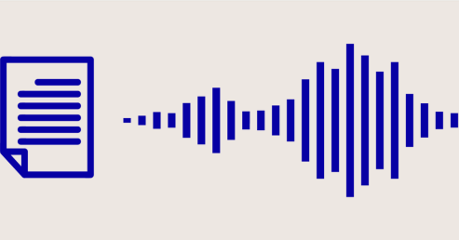
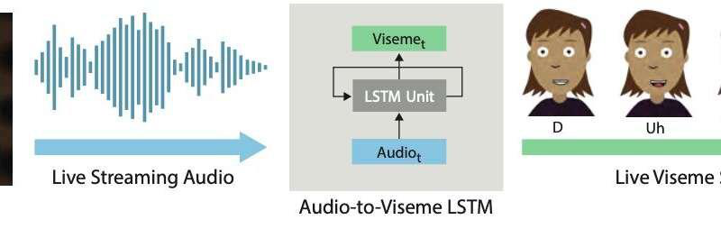
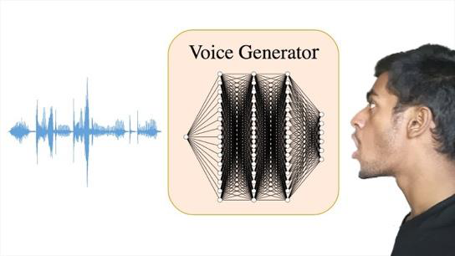

Today
- Speech Synthesis
  - What are the properties of Language which have made it challenging to synthesise?
- Text to Speech Systems
- Voice Cloning
- Visual Outputs

Speech Synthesis

Speech Synthesis Uses
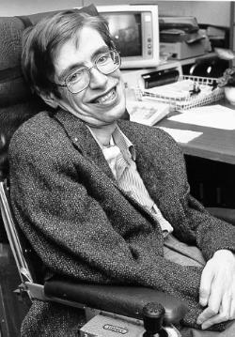


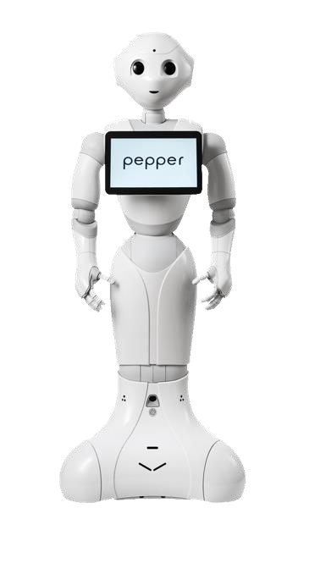

Speech Synthesis
- Speech synthesis is the process of taking an input text and compositing a audio signal which emulates human speech, but which is built entirely from algorithmic / synthetic element. The model incorporates information on the correct pronunciation of text.
- Input Data = Written Text
  - Long texts
  - Conversational ‘turns’

Generate models from speech synthesis

Not always great – linyuistic variations

IN Ireland as irish people we are crazy - collection of that data is done… ireland is a first world country and lots of etch companies work here so done..
Btu for other countries… not always a priority… speciclising the lalngauge for different group…creatgin models for notn standard speec,,, heavily underrepresented….

Speech Synthesis: examples of the basic challenges
- Heteronyms
  - bass
- Blending of speech, specifically ‘liaison’
- https://englishexplorations.check.uni-hamburg.de/4407/
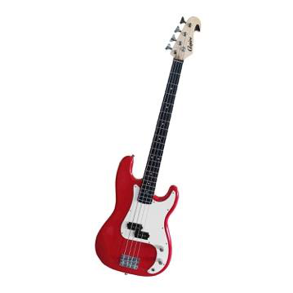
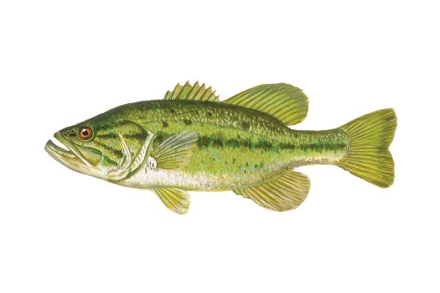
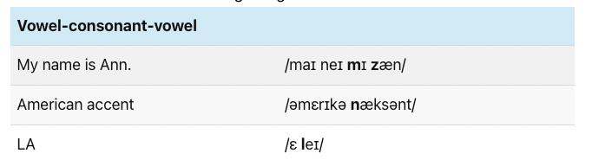

everythgi now adays is deep learning

Hwo did we get here
Dl is still trygin to achieve these gals
If lok at speech syhtnesis
3 modesl that went before

- Classic one…. TTS Types (Concatenation based systems… “the enxt train on the tack is the 5:40 form liverpool” can hear the chopppign up… and joing
- The tone of original recordings not consistent.. different speeds…
- Voice changes over years when new places added in
- Still used simply because people prefer the concatentation systems… mabe not any more… but for lgont ime people used to prefer these over synthesis…
  - Not surprising as syntheisis systens were poor
- 1dst systems were ruels…. Encode the rukes… what collections of letetrs in what words mapped over to sounds…
- Rukles based systems >>> linghuistics try to capture it >> fed into engine and srticulate ti… they were slow and not very good.
- Graphenes part fo written word… over to phonemes >> written word… G to P…
- Rules based didn’t do very well but deep learning does it toda..
- Earlier statistical systems….
- Dragon.. speech system… other cpmpanies…
- Had speech synthesis engines….
- Trying to sue data to model what the language would look like…
- Intermediate step trying to do it ins ML way… btu models inder the hood were not powerful enough.. to enerat esomethgni very natural…
- Amount of taring data available at that time… weren’t there…

Accents: Adding to the challenge
- Accents are often best explained in terms of foreign languages, but the principles apply to the ‘accents’ which we grow up with.
- https://youtu.be/8Wcqq0OKdyo?si=4mD4_Vc2nXPsbZOW
- See the section in here on Irish and American accent.
- https://youtu.be/vpqjo1ea700?si=mDINo1sH13rvce9y
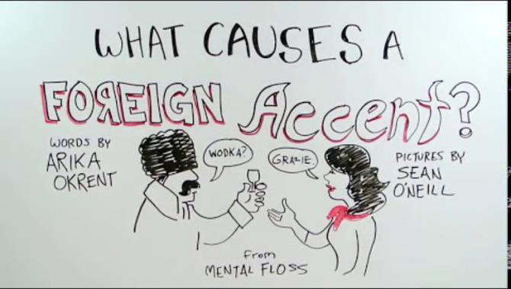
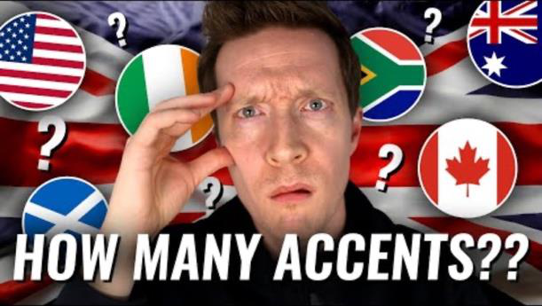
- Accents area bgi ussues for speech models…
- Lots of language banks.. but
- Ireland is done… ltos o tech companies here
- Non standard speech .. that is what Robert does.. one f ohs PHD students…

Speech Synthesis / TTS Types
- See the Medium article.
- No need to memorize specific example systems, but the difference between types should be understood.
- Concatenative
- Formant Synthesis (rule-based)
  - Write the rules / slow nto great but trying to automate
- Parametric (Statistical)
- Hybrid / Deep Learning
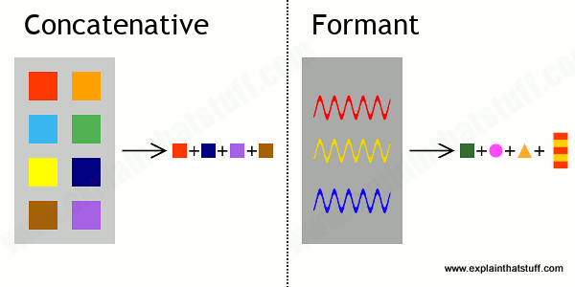

4 main generations
- Concatenative based systems
  - Train stations -
- Formant Synthesuis (rile based
- Parametric (Statisctical)
  - Early systems.. like dragon… an othe companies… customer support
  - Calls centres
  - Tryignto sue data to model what language loked like
  - Intermediate steps..
  - Statistical models just werent’ powerful enough
  - Amount of traingn data could eb processed b hardware available was nto enough
- Hybrid / Deep learning

- Graphene (parts of the written word that constitue the emaning) to Phoneme 8bit of audible word that convey thatmeaning)
- G to P
- Rules based system… modern systems stil trying to do that. Still….

Classic Speech Synthesis
- Aside: It is useful to understand the basics of many classical NLT algorithms as modern algorithms are often achieving similar, but just hiding some of the decisions within neural network layers
- https://wiki.aalto.fi/display/ITSP/Statistical+parametric+speech+synthesis
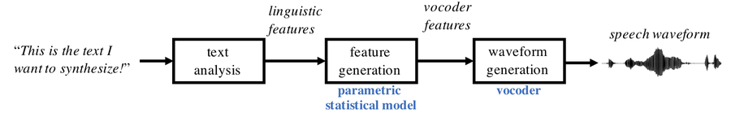
- Synthetic speech
- That 3rd category in earlier slide…
- Ulti step process is what ;ed to more synthetic sorts of models…

Text to Speech
- Input Data = Written Text
  - Long texts
  - Conversational ‘turns’
- Classic Systems
  - Competent but not natural
- Modern Challenges
  - Accents
  - Unknown Words
  - Emotion
  - Emphasis (see also stress)
  - Personality Variation
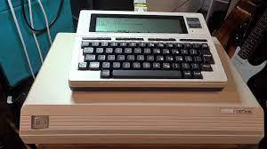


- Accents still a challenge
- Unknown words.. still a challenge… (also a problem for humans .. never seen a word before)
- Emotion – happinesss/ sadness… inappropriately emotional reading a paper.. for example…
- Emphasis -(question marks /exclamation marks
- Personality variation (rate pf speech / choice of words… nuance…still a challenge… )
Stephen Hawkins…. Voice >> on wikipeadia..

Modern TTS can be Quite Complicated
- (Detail not important here)
- For deep learning based approaches, the model architectures can vary a lot, but the primary goal is the minimize the difference between produced spectrographs and target spectrographs for a given input sequence.
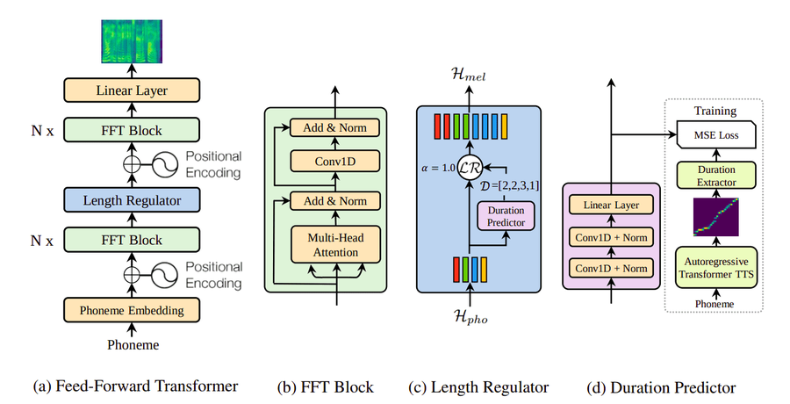

Detail not important here…

Text to Speech
- Input Data = Written Text
  - Long texts
  - Conversational ‘turns’
- Modern Challenges
  - Accents
  - Unknown Words
  - Emotion
  - Emphasis
  - Personality Variation
- State of the art
  - Amazon Polly
  - Elevenlabs TTS
  - Open Source: MeloTTS and Coqui TTS
 >>  >> 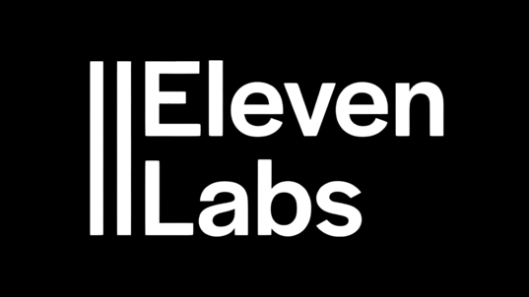

- Relatively cheap to train anda lot of models available in landscape…
- Enough data out there to makr sure of and can fine tune and do different variatis on models relatively easy…
- Smaller companies (11 labs , can cutomise godo synthetic voices tby gettgin good traingi data….)
- Usefule in banking and taring videos…
Voice XML still sued in IVR systems…
Also more modern standards… available as well as voice XML…
Defacto standards - voice xml

Evaluating Text to Speech
- Quantitative evaluation of TTS is unusually difficult relative to other tasks
  - Focus on ‘quality’ of speech – a property similar to the goodness of music
- Traditional Human Based Evaluation
  - Mean Opinion Score
    - Score between 0 and 5
    - Human speech : 4.5 – 5
- Consider Also
  - Model size
  - Training cost
  - Fine-tuning ability
  - Latency / production speed
- Consider differences between
  - Intelligibility
  - Naturalness
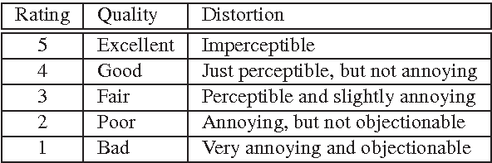

- Coupel fo weeks back WER as metrics to evaluate ho godo the model is…
- In speech synthesis is more difficult to do that…
- Can lok at loss functions… are yo approximating the loos function as good as possinle…
- Loss functi strain model and other metrics that gauge qulity of output….
- Today oftent human evaluation…. Use human evaluation panels… to determine fi good quality ro poor quality
- Mean Opinion Score (MOS)
  - Exam paper could be MoS – likert scale ratinghow good ro abd the auuid it.
- Ie.. intelligibility..
  - can you make things out…
  - Can I hear it / can I make it out?
  - Other
- Naturalness….!
  - Could have robotic voice or vey natural voice…
  - Politicians from south west for example….
  - Can o get oth of those metrics goingn same direction at same time….
- Model size
- Latency / production speed –
  - how quickly can we process the data…, no good if too slow to product speech…
  - How long before I can start producing the speech…
- Speech leaderboards varyh in terms of latency measures….
- Is a model fine tunable… can e use it for other tasks, to fine tune it…… how mcuh data will ti atke to do that? And wil we get good results…

NaturalSpeech
- From Microsoft Asia
- See Samples
- https://speechresearch.github.io/naturalspeech/

URL??? Github and speechsynthesis… kon github
Lots of examples

Speech Synthesis Markup Language (SSML)
- A bit dated, but still widely supported across platforms
- XML Based
- Allows control of basic speech synthesis as well as prosody features
  - Pitch
  - Contour
  - Rate
- <speak>
<prosody rate="slow" pitch="-2st">Can you hear me now?</prosody>
<prosody rate="fast" pitch="-2st">Can you hear me now?</prosody>
<prosody rate="slow" pitch="-2st">Can you hear me now?</prosody>
<prosody rate="slow" pitch="+5st">Can you hear me now?</prosody>
<emphasis level="moderate">This is an important announcement</emphasis>
This is an important announcement.
</speak>

- Can process a standard but do they process the standard well or not..
- Lots of variation. try them out

Custom Voices
- Neural Architectures easily allow fine-tuning of TTS systems with custom voice data.
  - This does not require full-from scratch model training
- Google at present offers this as a premium feature
  - Likely does not provide a perfect fix for Irish and other unsupported voices
  - #

- Decouple voice model from early stages of the model…
- And can fine tune the voice model then

Voice Cloning

Voice Cloning
- Input Data = Written Text or Speech Data
- Output = Audio data with a target voice
- Challenges
  - Was very difficult until recently
  - Ethics
  - Getting it ”right” is challenging
  - Real time vs recorded
    - Real time factor (RTF) is an important metric. It should be below 1 for Real Time
- State of the art
  - See custom voices in the commercial TTS
  - Open Source: Tortoise TTS (transformer based)
  - OpenVoice V2


- Ethical challenges
- Recongnise lot of thigns with voice clingin can also do with speech synthesis models these days…
- Is fomr where we go from kwritten or speech data and we’re going to product speech with a particular voice

- Speech synthesis is customising but voice cloing is an exact match, a specific voice…
- Now challenge of ethics of doing it.. and also getting it right..
- Biggest problem now is speech cloning… is largely solved…
- Mani problem done cheaply and easily to imitate people btu also now for fraud.. etc kidnappign and extortion…
  - Research says most pepel cann not tell voice cloned models are afke models…
  - If just have a static models..?
  - If speaking with someon would be a give away….
    - Ask couple fo questions thatr are nre nuanced.. i.e. voice memo..
  - Systems are better at doing tit… but not fool proof
  - So many technologies in this space now…
  - Open source
    - Lots of models aswell
    - All dong something straight forward and nice…

  - Toirtoise text to speech.. multitude of models and architects…
    - At core doing something similar and nice.
    - i.e. t take butl up and trained hard bits of model based on lots and ltos of data… then ar able to atke just a little amount of speech data >> put it through a special encodre to capture the characteristics of that voice… deviatiosn / breathiness / nasalness / all those metrics… speech signal analysis
    - take those extracted features and plug it in to the architure ina particular place and resultant speech being manipulated
    - can be very effective….#
    - see it in lab later.. very easy…. Without paying fortunes for companies to do it for you…
  - Whaling >> financial controllers persuaded to transfer significant amounts f money as get phoen call from so called CEO.. saying to do it…. i.e. not just random emails… comgin in… now becomgin an issue….
    - Fishing btu for important people
  - National security concerns
  - Catfishing
  - Tinder – pretending to be people they are not…

Voice Cloning - Overview
- https://medium.com/mlearning-ai/voice-cloning-for-beginners-in-8-minutes-db046e009a70
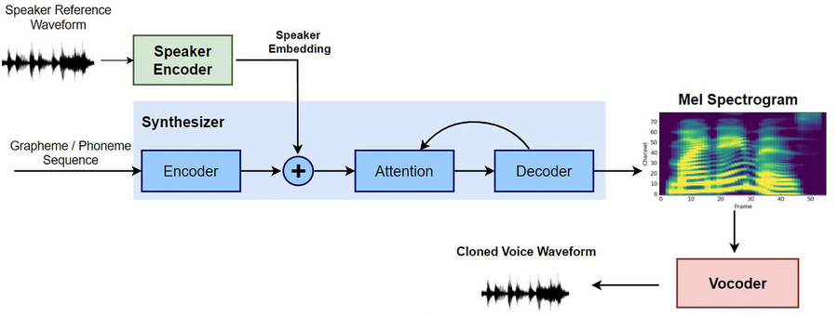
Take extracted fratures
Maon voice model is trained .. then put through encoder to get
Very easy… don’t need to spend a lot of money..

Voice Cloning Ethics
- Has this impacted you yet?

Dealing with Cloned Voices
- Anti-spoofing / deepfake detection: separate classifiers are trained to tell real speech from synthetic speech (see the ASVspoof challenges). They tend to fail on generators they weren't trained on.
- Watermarking: some generators hide an inaudible watermark in their output, for example Resemble AI's PerTh in Chatterbox, Meta's AudioSeal and Google's SynthID. Qwen3-TTS and Kokoro don't. What are the limits of watermarking when anyone can run an open model without it?
- Regulation: the EU AI Act's transparency rules require AI-generated or manipulated audio ("deep fakes") to be disclosed or marked so machines can detect it. I haven't checked the exact dates these obligations apply from.

- Only really effective detectors of spoofed voices not on quality of audio but on what the person is speaking about…
- Detectors don’t work well becaue when audio is use dni real world context … ie. Fed through whatapp or standard gsm voice encoding . decoding.. modern pheon network(gsm).. a lto of the signal is actually lost… and lot of data to that would flag fake.. is not present.. so poor quality ksignal helsp disguise it..
- Watermarking -can get around it…. If want t get around it can do…
- Claude and Watermarking
  - Anthropic introduce watermakrign mechanism…
  - Basically allows claude to introduce certain characters an staticstical pattersm that this is claude generated text..
  - If em dash is being used its claude generated text….
  - So certain characteristics being use
  - So detectors are available….
  - Interesting thing form professional perspective… not for speech btu problem with this … even is people are using it to just proof read it tp make grammatical adjustments.. outputs still labelled as fake.. so people subit essays they did the work on and claude dod fine tuinign on and then discarded as claude generated text….
  - Is MOVE TOWARDS WATERMARKING
  - EU digital AI act > need ot eb able to show when outputs are synthetic or not….
  - Anthropic need to stand over whats produced…
- Regulation
  - Requires watermarking in place… major issue now.
  - Not getting good synthesis models kits detecting them where interestgin work is being done…

Visualizing Speech

- Switch from sounds to sight

- Two main modalities…
- Visemes >> collection of speech sounds that look the same….
- Covered heavily in animation models… control visualiatuion of speech / tongues movemnst and lips
- Avaars.. games>>> even if voice sounded godo the face was no.. the lips would give away that something was synthetic…. Still happening now.. not not as much as used to…
- We are interste din link to the speech side of this….

Visemes
- Sets of speech sounds that look the same
  - Phonemes and visemes hence do not have a one-to-one relationship
- Descriptors of the visual arrangement of head and lips to sync with audio
- Can be output by a number of TTS tools
  - Azure Speech Service
  - Amazon Polly (request Speech Marks / visemes)

Image of mouth shape…

Visemes
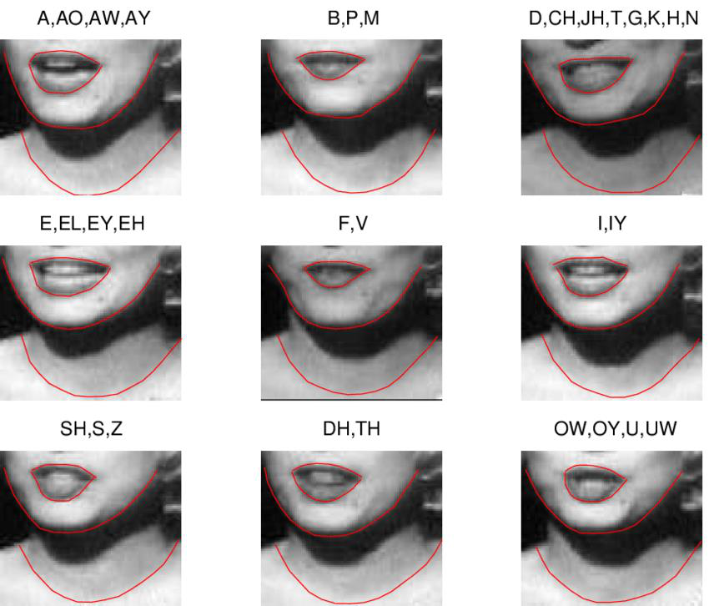

Still far from perfect
- https://www.youtube.com/watch?app=desktop&v=y1wVykdmJNM
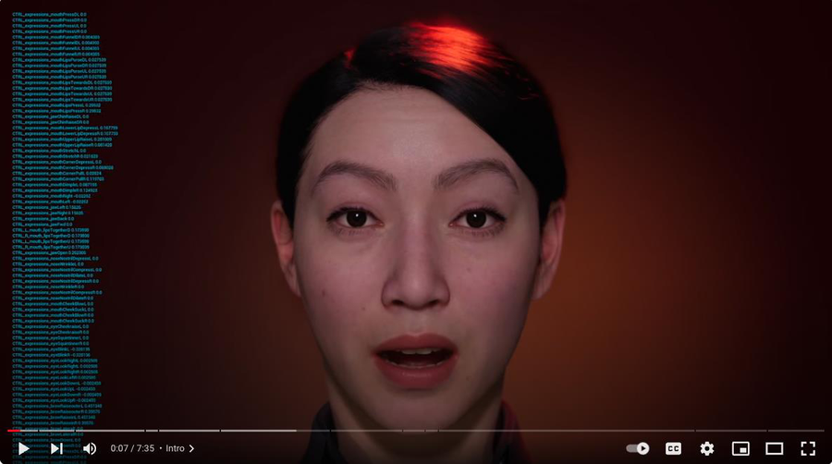

- Https//www.youtube.com/watcj?app

Nvidia Audio2Face
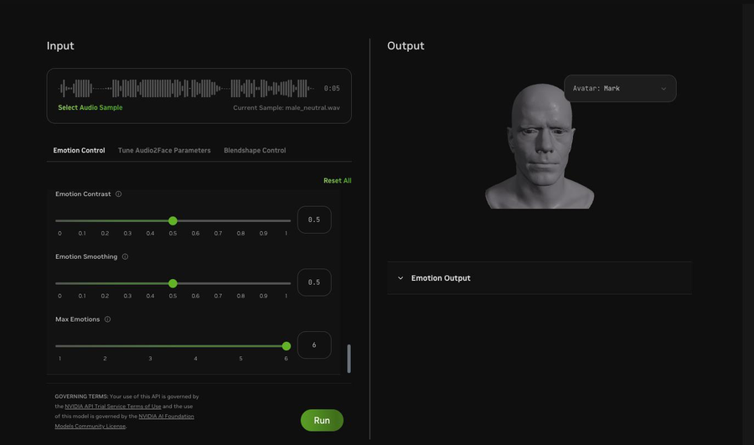

- Big player
- Nvestign heavily here as all about visual representation
- Big thing GPUs acan be ised for is animation and games… they have a play on improving aulity of no player characters in games .. engaging and real loking…
- Resurgence in metaverse. And all technologies involved in that….
- Organisatio of the kips and so forth…

Challenges in Audio 2 Faces
- Real time need
- Solutions often based on game engines
- Microexpression Blending
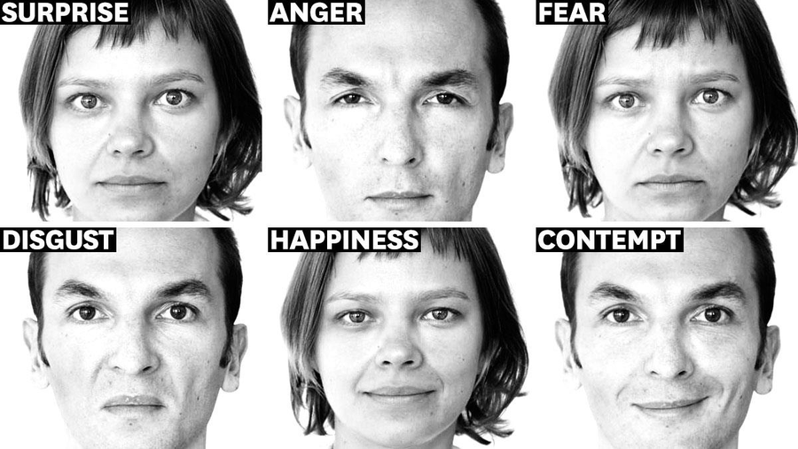

- Micro-expressions….
- Subtle – confusion / slignemnt / paying attention / variosj little facial expressions…. Lt of research trying to lok at fine tuning of those models…

Gestures in Communication
- Communication is more than sounds and lips
- Gestures using the hands and arms can convey significant information and help to keep communication focused
- Five Main Types of Gestures in Communication:
  - Symbolic
  - Diectic
  - Iconic
  - Pantamonic
  - Gesticulation / Beat Gestures

Communication is more than sounds and lips
Gestures go with spoken language gesture are filling in some of the key bits missing from spoken language themselves…

Research categories gestres into types that either replace or augment language
- 5 main types of gesture
- Symbolic gestures
  - i.e. giving someone the finger
  - the V sign / OK sign / no sign
  - give someon the finger
- Deitic Gesture
  - >>>used more in practice >> pointing.. thigns in the environment..
  - Use “it”
- Iconic
  - I like work I hospitals.. using natural gestures to work with nurses….
  - “The plane flew like this…”
  - Set up patern fo what we’re showing.. i.e. a ball
- Panthomimic
  - Panthomime >> describgin as far away and pytting emphasis like that
  - Spatial or tie ideas
- Gesticulation
  - Beat gestures….?
- Help0 to show pattering of language or if emphasisign something..Esp if trying to talk about a lot of content.. use thes to animate the situation
- https://medium.com/@davidrose/the-age-of-gesture-876f92cdc947
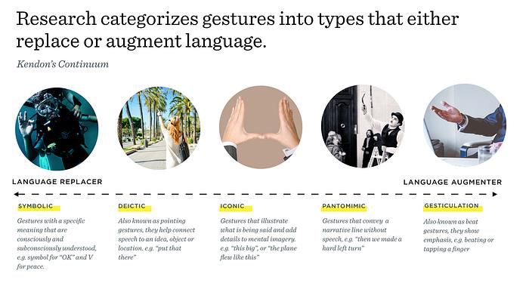
5 main types of hgestures
i.e. givine someon the finger… critical for language

<<<< Took a BREAK >>>>
Mohamed new lecturer
Handing over to Mohamed
First week after review week…. 2nd Nov… including assessments etc
Robert has left the school of computer science and moving into a new role…
- 2nd Nov – new lecturer >>> MOh
- New lecturer >>> Muhammad Abrer Irfan
  - Lecturer in school of CS
  - Research in AI ML and Computer vision
  - Recent researcj on focus of applied AI / ML in foeld of medical imaging ..
  - Worked n 2 D imaging and 3 d images aswell
  - Taking over soon.. etc
  - Robert has 2 more lectures.. then mid term week..
  - Worked with Muhamed for last 2 years.. evry into his AI and all aspects of it…
  - Not leaving univesity ---
  - Going elsewhere

Gesture in Avatars, e.g., Gesticulator
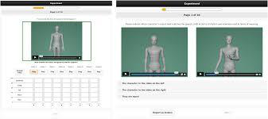

- Models don’t have enough training to eb perfect
- Can be identified by gestures… / voice etc.. associated gestures to your avatar….
- Tools like gesticulator… make a reasonable job of it…
- Use in games and video…
- Keeo in mind critical difference of any of these techs being used in video production vs real time production
- 2 very different use cases…
- Ca take time in terms of computational cycles…. Can get high quality and high fidelity
- In real time work -agmes, online in avatar interactions – gettgi high quality speech and gesture cam eb very difficult….
- Move
- Models don’t’ have enough traingin to be perfect
- Keep in mind output …
  - being use dni video production vs real time production
  - Vide production >> can get high ficelity
  - Rela time >>> harder.. virtula characters speaking with you or online in avatar.. gettgin high quality gesture becomes harder
  - Animation >> gettgin realk time 3d animation is hard
  - Can generate models what awe want to gesture btu video generation pipeline that visualises that isn’t able to do that in real time….
  - Interstign interacti between production of gesture of certain type sof animatui at low level or how we want to move thigns vs actua l video animation of it which is often sa little bit slow to get correct

Challenges in Production of Non-Verbal Communication
- Accuracy
- Naturalness
- Uncanny Valley Effects
- ‘Alignment’

Production of gesture and animation vs actual video animation of it. Which is still a little bit slow to get correct…
Interstgin tech area btu evolving rapidly…
- Accuracy
  - How accurately we’re representing out training inout
- Naturalness
- Uncanny Valley Effects –
  - Draw uncannyt valley
  - is simply this -
  - = A trade off between accuracy of animation (quality in terns of rame rates of himan likenesss,,, vs and the like ability of the animation.. the technical word is acceptance
  - Plot of L on y axis – A on x axis
    - As animation gets better they like it ..
  - Linear line but hits a point where is almost human like but wrong and acceptance or likeability drops off, like Polar Express movie with Tm Hanks….
  - Get it back to human
  - Uncanny valley… starting to become uncannily similar to humans we have a fall off in acceptability/likeability
  - It’s a valle in terms of acceptance .. like dip sine curve….
  - Sort of humian ike… then gets better and comes bakc out… acceptability gets betts
  - Either in beginning space or end space ->>> avoidn the dip in the middle…
- “Alignment”
  - Alignment between the audio and non audio representations…. Ie.., gestures…
  - Human quickly notice if mis-alligned….
  - i.e. “Beat gesture” -
    - triggers for movement..
    - but look at ti and they are not aligned at all…
    - lots of cheap beat gesture algorithms…
    - Gesture type
      - Best
      - Deictic
      - Iconic
      - Metaphoric
      - emblem
- Technology backbones are developing…
- Se some of them in the notebook in a couple of minutes and vmogin n general direction…
- Uncanny valley below
- 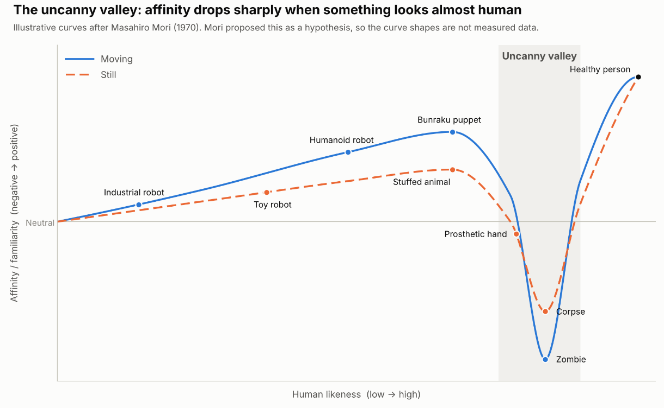

Side Note

McGurk Effect
- https://www.youtube.com/watch?v=2k8fHR9jKVM
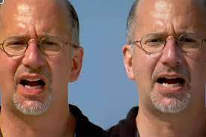

- McGurk Effect – Ba vs Fa
- Langueg is complicated – don’t just process as a simple system
- https://www.youtube.com/watch?v=2k8fHR9jKVM
- https://www.youtube.com/watch?v=2k8fHR9jKVM
- One of many hallucinatuns examples
  - Nuances of multi modal processing…
  - Certain sounds are actually process multi modally by us.
  - Sound is processed by us differently by us depending on what we see
  - Isual queues are very important hen producing output language

Lab Exercise - TTS_Voice_Cloning_Lab_2026.ipynb
- Future notebooks won’t be as hadr as thisk… its nto a dig of things to come
- Assigbment won’t be at this level in this notebook
- Be re-assured…
- But some really cook stuff in here…
- Take time to go thru it understand it and larn from it…
- What its doing and whyits doingit
- Last year was using google lapis and toirtoise family of models
- Ths year upgraded to more state of the art models… a best of both worlds.. quality of goodl jstuff best could doe asily last year.. and tortoise tuep models which are open source….

- Go through labdsand ask me questions about them
- A lto fo tech in them
- Don’t do a lot of taring in this class… trainig algprithmg
- Need to sue the technologies and have tried t pimp up the notebooks
- Make god use of them

Need T4 GPU in colab
Colab is using python 3.13

‘’’py
# Lab: Open Text-to-Speech, Voice Cloning and Speaker Verification

In this lab you will use **open-weight, state-of-the-art speech models** that run entirely inside this Colab session. No cloud API keys or accounts are needed.

| Part | What you do | Model(s) | Time in class |
|---|---|---|---|
| 0 | Set up the runtime | | ~3 min |
| 1 | Record **your own voice** | browser microphone | ~5 min |
| 2 | Classic multi-voice TTS and grapheme-to-phoneme | **Kokoro-82M** (Apache 2.0) | ~10 min |
| 3 | Zero-shot **voice cloning** from a few seconds of your speech | **Qwen3-TTS-12Hz-0.6B-Base** (Apache 2.0) | ~15 min |
| 4 | Measure intelligibility with ASR (round trip) | **Whisper large-v3-turbo** | ~5 min |
| 5 | **Speaker verification and identification**: can your clone fool a speaker-verification system? | **ECAPA-TDNN** (SpeechBrain) | ~15 min |

**Before you start:** `Runtime → Change runtime type → T4 GPU` (or better). Run cells top to bottom.

---
## Part 0: Setup

This installs everything in one go (2–3 minutes). `qwen-tts` pins a specific `transformers` version; if Colab asks you to **restart the session** after this cell, do so and then continue from the *next* cell.
!apt-get -qq update > /dev/null && apt-get -qq install -y espeak-ng sox ffmpeg > /dev/null
!pip install -q --ignore-requires-python --no-deps "kokoro>=0.9.4" "misaki>=0.9.4"
!pip install -q loguru addict regex espeakng-loader num2words phonemizer-fork spacy
!pip install -q -U qwen-tts speechbrain jiwer
import os, io, json, base64, subprocess, time, warnings
warnings.filterwarnings("ignore")
import numpy as np
import torch, torch.nn.functional as F
import librosa, librosa.display, soundfile as sf
import matplotlib.pyplot as plt
from IPython.display import Audio, display, Markdown

DEVICE = "cuda" if torch.cuda.is_available() else "cpu"
if DEVICE == "cuda":
major, _ = torch.cuda.get_device_capability()
gpu = torch.cuda.get_device_name()
# T4 (compute capability 7.5) has no native bfloat16 -> use float32 for safety.
DTYPE = torch.bfloat16 if major >= 8 else torch.float32
print(f"GPU: {gpu} | dtype for Qwen3-TTS: {DTYPE}")
else:
DTYPE = torch.float32
print("⚠️ No GPU found. Parts 2 and 5 will work on CPU; Parts 3, 4 and 6 will be very slow.")

SR = 24000 # Kokoro and Qwen3-TTS both work at 24 kHz
os.makedirs("/content/my_voice", exist_ok=True)
os.makedirs("/content/outputs", exist_ok=True)

# A small "audio bank": every clip we make or record goes here, so later parts can analyse it.
# name -> dict(y=np.ndarray, sr=int, text=str, kind=str)
BANK = {}

def add(name, y, sr, text, kind, show=True):
y = np.asarray(y, dtype=np.float32).squeeze()
BANK[name] = dict(y=y, sr=sr, text=text, kind=kind)
sf.write(f"/content/outputs/{name}.wav", y, sr)
if show:
print(f"[{kind}] {name}: {len(y)/sr:.1f}s")
display(Audio(y, rate=sr))
return y

def to16k(y, sr):
return librosa.resample(y, orig_sr=sr, target_sr=16000) if sr != 16000 else y
---
## Part 1: Record your own voice

As in the speech recognition lab, you will record yourself in the browser. Each prompt shows a **⏺ Start** button; click it, read the sentence aloud, then click **⏹ Stop** (recording stops automatically after 15 s).

Tips: quiet room, headset microphone if you have one, normal speaking voice, about 20–30 cm from the mic. Leave a short pause before and after speaking (silence is trimmed automatically).

If the browser microphone doesn't work, use the **upload fallback** cell below to upload WAV/MP3/M4A files recorded on your phone instead.
from google.colab import output

RECORD_JS = r'''
async function recordAudio(maxMs, promptText) {
const div = document.createElement('div');
div.style = 'font-family:sans-serif;padding:10px;border:1px solid #bbb;border-radius:8px;margin:6px 0;max-width:700px';
div.innerHTML = '<div style="margin-bottom:8px"><b>Read aloud:</b> <span style="font-size:1.15em">' + promptText + '</span></div>';
const btn = document.createElement('button');
btn.textContent = '⏺ Start recording';
btn.style = 'font-size:1em;padding:4px 12px';
const status = document.createElement('span');
status.style = 'margin-left:10px';
div.appendChild(btn); div.appendChild(status);
document.body.appendChild(div);
await new Promise(r => btn.onclick = r);
const stream = await navigator.mediaDevices.getUserMedia({audio: true});
const rec = new MediaRecorder(stream);
const chunks = [];
rec.ondataavailable = e => chunks.push(e.data);
rec.start();
btn.textContent = '⏹ Stop';
status.textContent = '🔴 recording…';
await new Promise(r => { btn.onclick = r; setTimeout(r, maxMs); });
const stopped = new Promise(r => rec.onstop = r);
rec.stop(); await stopped;
stream.getTracks().forEach(t => t.stop());
div.remove();
const blob = new Blob(chunks, {type: rec.mimeType});
return await new Promise(r => { const fr = new FileReader(); fr.onloadend = () => r(fr.result); fr.readAsDataURL(blob); });
}
'''

def convert_to_wav(src_path, dst_path, sr=SR, top_db=35):
# Any audio format -> mono, 24 kHz WAV, leading/trailing silence trimmed, peak-normalised.
tmp = dst_path + ".tmp.wav"
subprocess.run(["ffmpeg", "-y", "-loglevel", "error", "-i", src_path, "-ac", "1", "-ar", str(sr), tmp], check=True)
y, _ = librosa.load(tmp, sr=sr)
os.remove(tmp)
y, _ = librosa.effects.trim(y, top_db=top_db)
pad = np.zeros(int(0.15 * sr), dtype=np.float32) # keep a little silence either side
y = np.concatenate([pad, y, pad])
y = 0.9 * y / (np.abs(y).max() + 1e-8)
sf.write(dst_path, y, sr)
return y

def record(prompt, dst_path, max_seconds=15):
data_url = output.eval_js(RECORD_JS + f"recordAudio({int(max_seconds*1000)}, {json.dumps(prompt)})")
raw = base64.b64decode(data_url.split(",", 1)[1])
with open("/tmp/rec.webm", "wb") as f:
f.write(raw)
return convert_to_wav("/tmp/rec.webm", dst_path)

def record_set(prompts, folder, prefix):
os.makedirs(folder, exist_ok=True)
paths = []
for i, p in enumerate(prompts):
path = f"{folder}/{prefix}{i:03d}.wav"
y = record(p, path)
print(f"{i}: {len(y)/SR:.1f}s {p}")
display(Audio(y, rate=SR))
paths.append(path)
return paths
The first prompt is your **reference clip** for cloning (aim for 8–12 s). The other four are **held-out** sentences that we will use to test speaker verification and compare against the clones.
MY_PROMPTS = [
# 0: reference clip for cloning
"When the sunlight strikes raindrops in the air, they act as a prism and form a rainbow. "
"The rainbow is a division of white light into many beautiful colours.",
# 1-4: held-out test sentences
"Mary had a little lamb, its fleece was white as snow.",
"I'm a person with a distinctive voice.",
"The quick brown fox jumps over the lazy dog.",
"Natural language technology turns text into speech and speech into text.",
]
my_paths = [f"/content/my_voice/me_{i:03d}.wav" for i in range(len(MY_PROMPTS))]
my_paths = record_set(MY_PROMPTS, "/content/my_voice", "me_")
# Add the recordings to the audio bank and look at the reference clip
for i, (p, t) in enumerate(zip(my_paths, MY_PROMPTS)):
y, _ = librosa.load(p, sr=SR)
add(f"me_{i}", y, SR, t, "real", show=False)

REF_PATH, REF_TEXT = my_paths[0], MY_PROMPTS[0]
y = BANK["me_0"]["y"]
fig, ax = plt.subplots(2, 1, figsize=(12, 5), sharex=True)
librosa.display.waveshow(y, sr=SR, ax=ax[0]); ax[0].set_title("Your reference clip")
S = librosa.amplitude_to_db(np.abs(librosa.stft(y, n_fft=1024, hop_length=256)), ref=np.max)
librosa.display.specshow(S, sr=SR, hop_length=256, x_axis="time", y_axis="log", ax=ax[1])
plt.tight_layout(); plt.show()
print({k: f"{len(v['y'])/SR:.1f}s" for k, v in BANK.items()})
---
## Part 2: Classic TTS with Kokoro-82M

[Kokoro](https://huggingface.co/hexgrad/Kokoro-82M) is a small (82 M parameter) open TTS model based on StyleTTS 2 with an iSTFTNet vocoder. Despite its size it competes with much larger systems, and it runs in real time even on CPU. It replaces the Google Cloud voice (`en-GB-Neural2-C`) we used in previous years.

The pipeline is the classic two-stage design:
1. **Text → phonemes** (grapheme-to-phoneme, G2P) using the `misaki` library (dictionary + espeak-ng fallback),
2. **Phonemes + voice style vector → waveform** (the neural acoustic model + vocoder).

Kokoro has no voice cloning: each voice is a fixed pre-computed *style vector*.
from kokoro import KPipeline

kokoro = {
"b": KPipeline(lang_code="b", repo_id="hexgrad/Kokoro-82M"), # British English
"a": KPipeline(lang_code="a", repo_id="hexgrad/Kokoro-82M"), # American English
}

def kokoro_tts(text, voice="bf_emma", speed=1.0, verbose=True):
pipe = kokoro[voice[0]] # first letter of the voice name = language/accent
chunks, phonemes = [], []
for gs, ps, audio in pipe(text, voice=voice, speed=speed):
chunks.append(audio.cpu().numpy() if torch.is_tensor(audio) else audio)
phonemes.append(ps)
if verbose:
print("Phonemes:", " | ".join(phonemes))
return np.concatenate(chunks)

t0 = time.time()
y = kokoro_tts("Mary had a little lamb, its fleece was white as snow.", voice="bf_emma")
print(f"Generated {len(y)/SR:.1f}s of audio in {time.time()-t0:.2f}s")
add("kokoro_bf_emma_1", y, SR, MY_PROMPTS[1], "kokoro")
### Compare voices

Kokoro voice names encode accent and gender: `b`/`a` = British/American, `f`/`m` = female/male. We synthesise the same held-out sentences as you recorded, so we can compare them with your voice in Part 5.
KOKORO_VOICES = ["bf_emma", "bf_isabella", "bm_george", "bm_lewis", "af_heart", "af_bella", "am_michael", "am_fenrir"]

for v in KOKORO_VOICES:
for i in [1, 2, 3, 4]:
y = kokoro_tts(MY_PROMPTS[i], voice=v, verbose=False)
add(f"kokoro_{v}_{i}", y, SR, MY_PROMPTS[i], "kokoro", show=(i == 2))
### Predictions

TTS errors often come from the text front end (normalisation and G2P), not the neural model. Predict how each sentence will be read **before** running the cell, then listen and look at the phonemes.

* Heteronyms: *read* (present/past), *lead* (metal/verb), *live*, *wind*
“Liv” vs “live”
* Numbers, dates, money, abbreviations
* Irish place names and names: are they in the pronunciation dictionary?

Kokoro lets you override a pronunciation with inline markdown-style phonemes: `[Kokoro](/kˈOkəɹO/)`.
tests = [
"I read the book yesterday, and I will read it again tomorrow.",
"The lead singer was poisoned by lead pipes.",
"On 3/4/2026 Dr. Smith paid €1,250.50 for 2 tickets at 7:30pm.",
"Dún Laoghaire, Siobhán, Caoimhe and Tadhg went to Grangegorman.",
"[Siobhán](/ʃəvˈɔn/) went to [Dún Laoghaire](/dʌn lˈiɹi/).",
]
for t in tests:
print("\n" + t)
display(Audio(kokoro_tts(t, voice="bm_george"), rate=SR))
# Speaking rate is a simple global control
for s in [0.7, 1.0, 1.4]:
print("speed", s); display(Audio(kokoro_tts(MY_PROMPTS[4], voice="bf_isabella", speed=s, verbose=False), rate=SR))
---
## Part 3: Zero-shot voice cloning with Qwen3-TTS

[Qwen3-TTS](https://github.com/QwenLM/Qwen3-TTS) (Alibaba Qwen, January 2026, Apache 2.0) is a **language-model-based TTS**. A neural audio codec turns speech into discrete tokens at 12.5 frames per second (16 codebooks per frame), and a transformer predicts those tokens from text, exactly as an LLM predicts word tokens. The `Base` models can clone a voice from about **3 seconds** of reference audio, with no training.

It offers two ways to condition on your voice:

| Mode | What the model sees | Analogy |
|---|---|---|
| `x_vector_only_mode=True` | Only a single **speaker embedding** vector computed from your clip | YourTTS / XTTS from previous labs |
| default (ICL, *in-context learning*) | The speaker embedding **plus** the codec tokens of your clip and its transcript, as a "prompt" to continue | Few-shot prompting an LLM |

We use the 0.6B model so it fits comfortably on a free T4 GPU. The first load downloads ~2.5 GB.
from qwen_tts import Qwen3TTSModel

t0 = time.time()
qwen = Qwen3TTSModel.from_pretrained(
"Qwen/Qwen3-TTS-12Hz-0.6B-Base",
device_map=DEVICE, dtype=DTYPE, attn_implementation="sdpa",
)
print(f"Loaded in {time.time()-t0:.0f}s. Languages:", qwen.get_supported_languages())
### Speaker embedding only vs. in-context prompt

Predict: which of the two modes will sound **more like you**? Which will have the more natural **rhythm and intonation**? Why?
def clone(text, ref_path=REF_PATH, ref_text=REF_TEXT, xvec=False, language="English", **gen):
t0 = time.time()
wavs, sr = qwen.generate_voice_clone(
text=text, language=language, ref_audio=ref_path,
ref_text=None if xvec else ref_text, x_vector_only_mode=xvec, **gen)
y = wavs[0]
print(f" {len(y)/sr:.1f}s audio in {time.time()-t0:.1f}s")
return y, sr

for i in [1, 2, 3, 4]:
print(f"\n--- {MY_PROMPTS[i]}")
y, sr = clone(MY_PROMPTS[i], xvec=True); add(f"clone_xvec_{i}", y, sr, MY_PROMPTS[i], "clone_xvec", show=(i == 2))
y, sr = clone(MY_PROMPTS[i], xvec=False); add(f"clone_icl_{i}", y, sr, MY_PROMPTS[i], "clone_icl", show=(i == 2))
print("\nYour real recording of the same sentence:"); display(Audio(BANK["me_2"]["y"], rate=SR))
### how much reference audio is needed?

Cut your reference clip down to the first 3 s and 5 s (and give the model the matching *partial* transcript, roughly). Predict at what length the clone stops sounding like you.
y_ref = BANK["me_0"]["y"]
for secs in [3, 5]:
short = f"/content/my_voice/ref_{secs}s.wav"
sf.write(short, y_ref[: int(secs * SR)], SR)
print(f"\nReference = first {secs}s (x-vector mode, no transcript needed)")
y, sr = clone(MY_PROMPTS[3], ref_path=short, xvec=True)
add(f"clone_xvec{secs}s_3", y, sr, MY_PROMPTS[3], f"clone_xvec_{secs}s")
### Cross-lingual cloning and sampling

The same speaker identity can be carried into another language. Does your "accent" carry over too? Generation is **sampled** (like an LLM), so running twice gives different prosody; you can pass Hugging Face generation arguments such as `temperature` or `top_p`.
y, sr = clone("Bonjour ! Je suis étudiant à Dublin et j'apprends les technologies du langage.", language="French"); display(Audio(y, rate=sr))
y, sr = clone("Hallo! Ich studiere in Dublin und lerne Sprachtechnologie.", language="German"); display(Audio(y, rate=sr))
y, sr = clone("¡Hola! Estudio en Dublín y aprendo tecnologías del lenguaje.", language="Spanish"); display(Audio(y, rate=sr))

for temp in [0.3, 0.9, 1.3]:
print("temperature", temp)
y, sr = clone("Honestly, I did not expect this to work so well.", temperature=temp, do_sample=True); display(Audio(y, rate=sr))
### clone a Kokoro voice

A synthetic voice can be the reference too. Clone `bm_george` from one of his Kokoro clips. We will check in Part 5 whether the speaker-verification model thinks the clone is "George".
george_ref = "/content/outputs/kokoro_bm_george_4.wav"
for i in [1, 2, 3]:
y, sr = clone(MY_PROMPTS[i], ref_path=george_ref, ref_text=MY_PROMPTS[4])
add(f"clone_of_george_{i}", y, sr, MY_PROMPTS[i], "clone_of_george", show=(i == 1))
---
## Part 4: Intelligibility via an ASR round trip

A standard automatic metric for TTS is to transcribe the synthetic speech with a strong ASR model and compute the **word error rate (WER)** against the input text. (This is how the Qwen3-TTS and most 2025–26 TTS papers report intelligibility; you used Whisper in the ASR lab.)

from transformers import pipeline
from transformers.models.whisper.english_normalizer import BasicTextNormalizer
import jiwer, pandas as pd

asr = pipeline("automatic-speech-recognition", model="openai/whisper-large-v3-turbo",
torch_dtype=torch.float16 if DEVICE == "cuda" else torch.float32, device=DEVICE)
norm = BasicTextNormalizer()

def transcribe(y, sr):
return asr({"raw": to16k(y, sr), "sampling_rate": 16000}, generate_kwargs={"language": "english"})["text"].strip()

rows = []
for name, d in BANK.items():
if name == "me_0": # reference clip, not a test sentence
continue
hyp = transcribe(d["y"], d["sr"])
rows.append(dict(name=name, kind=d["kind"], wer=jiwer.wer(norm(d["text"]), norm(hyp)), hyp=hyp))
asr_df = pd.DataFrame(rows)
display(asr_df.groupby("kind")["wer"].agg(["mean", "count"]).sort_values("mean"))
pd.set_option("display.max_colwidth", 120)
display(asr_df[asr_df.wer > 0].sort_values("wer", ascending=False).head(10))
**Discussion:** Is WER a good measure of TTS *quality*? What does it miss (naturalness, prosody, speaker similarity)? What happens to WER when the ASR model and the TTS model were trained on similar data?
---
## Part 5: Speaker verification and identification

A **speaker embedding** model maps any utterance to a fixed-length vector so that utterances by the same speaker are close together, regardless of what was said. We use **ECAPA-TDNN** trained on VoxCeleb (≈7,000 celebrities), via SpeechBrain. It outputs a 192-dimensional embedding; we compare embeddings with **cosine similarity**.

Two tasks:
* **Verification** (1:1): *is this utterance by the claimed speaker?* Compare a test utterance with an enrolled voiceprint; accept if similarity > threshold. This is how "my voice is my password" phone banking works.
* **Identification** (1:N): *which of N enrolled speakers is this?* Pick the nearest voiceprint.

Note that Qwen3-TTS itself contains a speaker encoder (that is what `x_vector_only_mode` uses), so here we use a **different, independent** model as the judge.
from speechbrain.inference.speaker import EncoderClassifier

ecapa = EncoderClassifier.from_hparams(source="speechbrain/spkrec-ecapa-voxceleb",
savedir="/content/models/ecapa", run_opts={"device": DEVICE})

@torch.no_grad()
def embed(y, sr):
wav = torch.tensor(to16k(y, sr), dtype=torch.float32).unsqueeze(0).to(DEVICE)
e = ecapa.encode_batch(wav).squeeze()
return F.normalize(e, dim=0).cpu().numpy()

EMB = {name: embed(d["y"], d["sr"]) for name, d in BANK.items()}
print(len(EMB), "embeddings of dim", next(iter(EMB.values())).shape)
### Enrol yourself

Your **voiceprint** is the mean embedding of your reference clip plus one held-out sentence. The other three real recordings are genuine test trials.
def voiceprint(names):
v = np.mean([EMB[n] for n in names], axis=0)
return v / np.linalg.norm(v)

ENROL = ["me_0", "me_1"]
my_vp = voiceprint(ENROL)
scores = {n: float(EMB[n] @ my_vp) for n in BANK if n not in ENROL}

kinds = {}
for n, s in scores.items():
kinds.setdefault(BANK[n]["kind"], []).append(s)

plt.figure(figsize=(10, 4))
for k, v in sorted(kinds.items()):
plt.scatter(v, [k] * len(v), s=60, alpha=0.7)
THRESH = 0.25 # SpeechBrain's default threshold for this model
plt.axvline(THRESH, color="r", ls="--", label=f"threshold = {THRESH}")
plt.xlabel("cosine similarity to YOUR voiceprint"); plt.legend(); plt.grid(alpha=0.3); plt.tight_layout(); plt.show()

for k, v in sorted(kinds.items(), key=lambda kv: -np.mean(kv[1])):
acc = np.mean(np.array(v) > THRESH)
print(f"{k:18s} mean sim = {np.mean(v):.3f} accepted as you: {acc:.0%}")
### Questions

* Which kind of clone gets closest to your real recordings? Is that the same one that *sounded* most like you?
* Where would you set the threshold so that **all** your real recordings are accepted? Do any clones get accepted at that threshold? This is the trade-off between the **false rejection rate** and the **false acceptance rate**; the point where they are equal is the **equal error rate (EER)**.
* A bank using voice authentication would want a very low false acceptance rate. What does this experiment suggest about voice biometrics in 2026?

‘’’

For Exam
- Referenced Measurements WER (word error rate in comparison_)
- Mean Opinion Score (MOS)

References
- https://speechresearch.github.io/naturalspeech/
- https://englishexplorations.check.uni-hamburg.de/4407/
- https://youtu.be/8Wcqq0OKdyo?si=4mD4_Vc2nXPsbZOW
- https://youtu.be/vpqjo1ea700?si=mDINo1sH13rvce9y
- https://wiki.aalto.fi/display/ITSP/Statistical+parametric+speech+synthesis
- https://medium.com/mlearning-ai/voice-cloning-for-beginners-in-8-minutes-db046e009a70
- https://www.youtube.com/watch?app=desktop&v=y1wVykdmJNM
- https://medium.com/@davidrose/the-age-of-gesture-876f92cdc947
- https://www.youtube.com/watch?v=2k8fHR9jKVM

Week 5 - Processing Text – Structured Text Analysis – 12th Oct 2026

Intro – Structured text Analysis
- Need to know all abpout representations
- ETF / ascii good for printing or understanding by humans – must be himan interpretable or editable
- Other representations for us ein ML
- Ie.. BoG / one hot encoding / distribution reprentations
- Will come bak in a coupel fo weeks
- All those represnratuosn aer godo for ML activities
- Ths evengi though.. will lok at different approach to analysing the text and looking at the etxtg
- Where we build we build represenations are task specific
- i.e. loka t text and pull out certain ideas or as[ects of the etxt and list them explicitly
- linguistic analysis atr they questions or answer?
- what ar the most important types we can perform
- systematic analsys fo the etx and pullgin otut he qualities of the text… like a white box investigation of the text… i.e.
- SW eng – black box / vs whietg box testing..

Black Box vs White Box
- Black box - don’t payh attention under the ood – just want the resuls
- White box – poke at inares.. lok under the hood.. we care about the details… underneath
- Lok at labguage and say something specifcialyl of the qualities of the language…

White box : sometimes we need the specifics…

- Parsers…. Couldn’t really capture meaning….
- Yes formula types of languages
- Programming /
- But true fliud natural language – boundary languages that could nto eb processed very well

- Not putting them in structure for sake of structure
- Function of a piece fo languages – what roel is it playing and why is ti playing that role…
- This is what we’ll talk about this evening… pulling out the various functions in various btis of languages..
Alexa was based on these parseds on top of each other….

Today
- The specifics…. Of processing elements… parsing issues/inform extraction issues when we loka t piece fob text
- Parsing
- POS tagging
- Exractign entitles from text (people /places / /cities)
- Using Spacy
BITE: just enough to give you an overview… not a deep dive into these approaches…. Just a flavour of them .. nto aiming to do old fashioned linguistics for the sake of it, but need to eb aware of some of these methods are replaced by LLM backbone… LMM technique makes it a little bit more robust…
Will revisit some of the dialogue workflow… we did earlier….diagliue engine stuff

Parsing and Analysis
- Chomsky’s approach… lot of AI thought process aobtu language and computer science…
- Following Chomsky approach for natural languages failed.. worked well for programming languages
- Chomskyian approach
  - Pasrsing….
  - String enough parsin rules.. cantake even ost cimplicated sentences.. put it in trees and individual words… take the words and structure them into components and those can be built with other componets to a well formed sentence….
  - That is the goal of parsing…
  - In computer language parsing.. this did and still makes sense….
  - Natral language doesn’t work well as assumption
  - Chomsky not the only parsing approach….
    - Later approach dependency parsing – functional relationships between words
    - Words qualityfing other words…
    - i.e. black cat… black is modifying the cat… important as depency structures on RHS in sldie is closer to sematics for meaning… closer….
    - “Man kicked the ball”… man is changing the ball …?
    - Paved way for how we build application for things like alexa!
  - Analysis
    - Key word spotting
    - Building ML models fine tuned to pull out specific bit so words from text i.e. hacked approachs….
    - Can be very affective…

Comp Sci Parser Types
Browser – document object model.. giving structured representation for it..
Python libraries available
Not a focus for us
Being blunt - is a very small proportion of comp sci eng /practitioners.. who need to know a lto about them…. (long ago all courses in Dublin all learned parser theory….. an entire module on ho tto prse and build jsystem languages and tyrn them into executables.. very rare to study this in practice now…. As have concergence on couple of languages typ and don’t’ have a lot of new language types…. )

Natural Language Parser Types

- Symbols
- POS

- Constituent parser
- Dependency Parser
  - Oftent sued as backbone for the parse – symantcis or meaning
  - SPACY – can directly build these visualisatio of these structures for you…
  - Don’t work for all lanuague (break down for noisy language)
  - Can build more complicated structures out of them
- The actual Structure if the parse

Parsing Mechanism
Probabilistic Context Free grammar (PCFG)

Dead end for natural languages
Anthologies area dead end – formalising knowledge is a dead end… didn’t cover a real natural language
Ontholgy formal representation of knowledge… about the structure of the data… like a db schema… not for a specific task… trying to describe the world!!! .. i.e. application indenpenden
Captures dog as 4 paws + dog ha stail + dog has hair + wet nose + etc etc loads fo rules… d efinitin of your dog… ontholgy captures all that formally…. Description logic…
Simepl ontholgy is a taxonomy a hierarchy of things /// like animals.. mamals/birds etc etc
Look em up on this…
Co-author on anthology
es like AI journal…
LLMs work great….!

Onthologies fail where they try to capture things like dogs…. Try to formalise with rules the formalisation breaks down.. with nuances of the real world…..

LLM isn’t the fastest
LLM isn’t the cost efficient
LLM is generic so that way it gets used more often….

Part of Speech Tagging PoS

Parts of Speech

Slot-based

Natural Language Technology
- Week 5 – Structured Text Analysis

Recap Week 3
- Representing Text for Natural Language Processing
- We want to do more than represent the characters for easy edit and save
- Various approaches
  - One Hot Encodings
  - Bag of Words
  - TF-IDF
  - Word Embeddings
  - Sentence Embeddings
- These representations make it easy to perform tasks like similarity measurement
  - This is surprisingly important, and we will come back to it later

Black Box vs White Box
- The concept of black-box versus white-box is an important concept in software testing, but we can take the analogy and also apply it to our understanding of information. How can say a text classifier be white box versus black box?
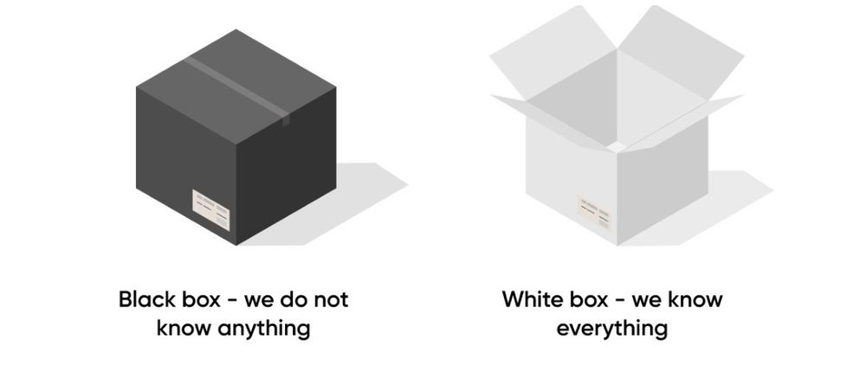

White Box: sometimes we need the specifics:
- Eat(tom_1,apple_?)
- A white-box approach to text processing suggests that we make clear that we understand the bits that go into a text or document. This can help with making tasks transparent.
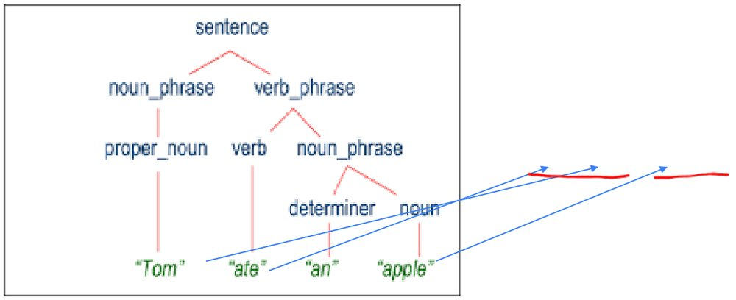

Today
- Getting to the specifics
- Parsing
- POS Taggers
- Entity Extraction
- Using Spacy

Today
- Getting to the specifics
- Parsing
- POS Taggers
- Entity Extraction
- Using Spacy
- Remember: We are doing just enough on these methods to understand their role, and to best understand the relationships between various concepts in NLT and related areas such as formal parsing.

Parsing

Parsing and Analysis
- Parsing is classically thought of dividing a sentence or other document into its constituent pieces, often through the use of well-defined rules, and with clear expectations in terms of what individual elements can be.
  - Roots in linguistics theory
  - Many different approaches in Computational Linguistics and NLP
  - Specific forms are very important in programming
  - Often assumed to produce a complete well-structured output

Untitled slide
- From: Parsing the Wall Street Journal using a Lexical-Functional Grammar and Discriminative Estimation Techniques
- Left: Traditional Parse Tree
- Right: Dependency Structure
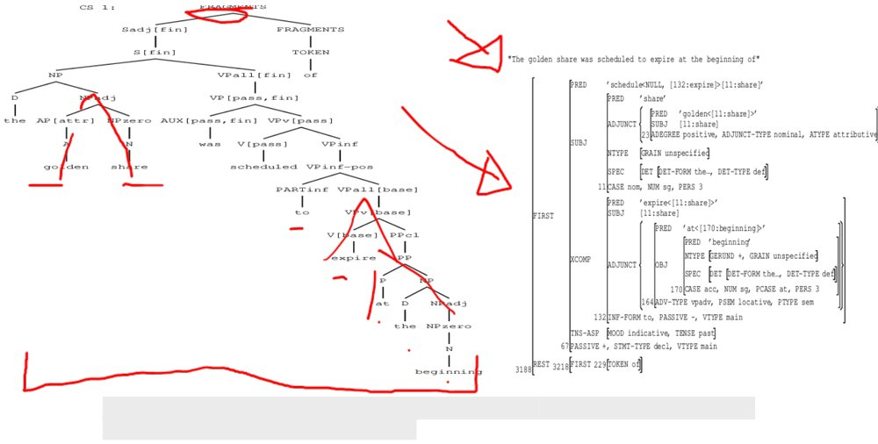

Parsing and Analysis
- Parsing is classically thought of dividing a sentence or other document into its constituent pieces, often through the use of well-defined rules, and with clear expectations in terms of what individual elements can be.
  - Roots in linguistics theory
  - Many different approaches in Computational Linguistics and NLP
  - Specific forms are very important in programming
  - Often assumed to produce a complete well structured output
- Analysis is the lazy but often more effective cousin of parsing that focusing on extracting the relevant types of information from text for a specific task. Sometimes it is based on a parse structure, but often it can be achieved using machine learning methods without a true parse.

Comp Sci Parser Types
- Since parsers are so fundamental to much of computer science, there are many different types of types of parsers! For example, within the strict computer science domain, below is a common breakdown of parsers. This is not in our scope, and I don’t want you to try to remember or investigate it. Just remember that it exists, and it is distinct from the parsers we are looking at.
- https://www.geeksforgeeks.org/types-of-parsers-in-compiler-design/
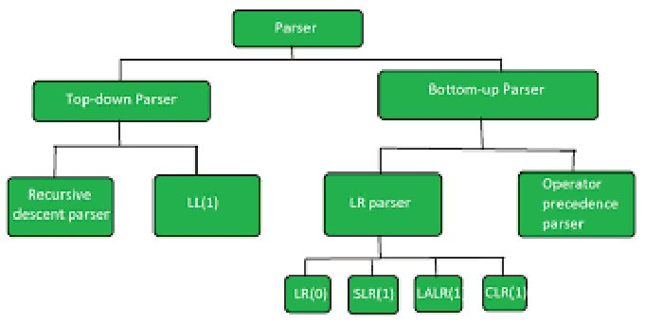

Python: Example of ‘Formal Language’ Processing
- Source: https://www.linkedin.com/pulse/how-does-python-interpreter-work-siva-velivelli/
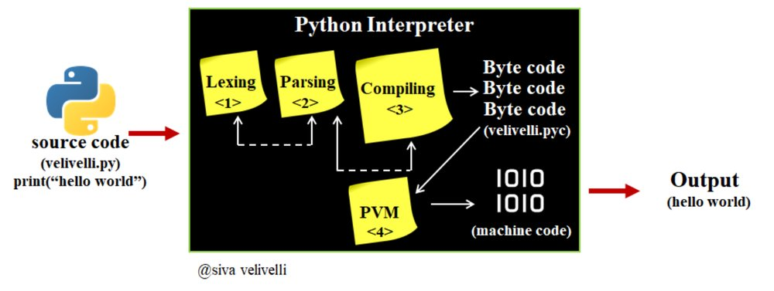

Natural Language Parser Types
- Constituency Parsers try to break a sentence down in terms of its Parts-of-Speech. This is the linguistic common sense grammatical categories like ‘noun’ ‘verb’ etc. Rules are used to define what parts of speech can be rolled up into more high-level parts of speech. Dependency Parsing focuses more on the relationships between words according to grammatical rules. While it is still thought of as being grammar focused, it is closer to a meaning focused interpretation
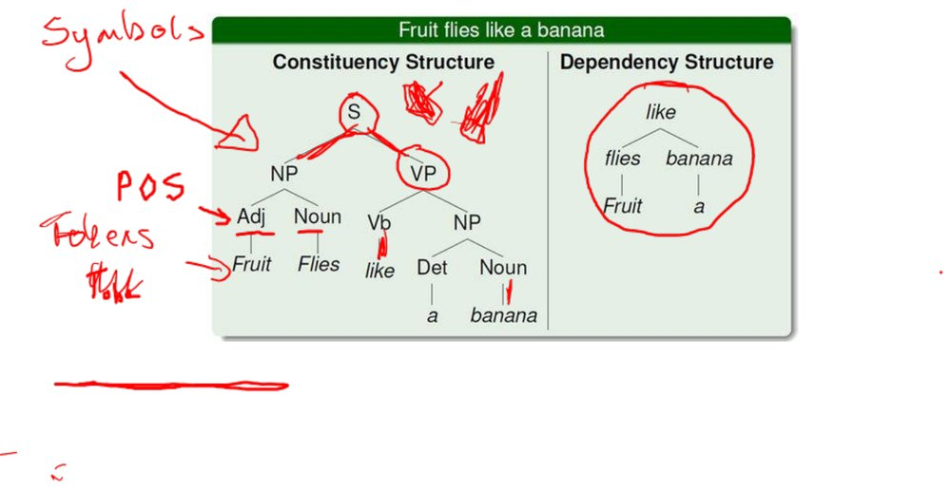

Dependency Parsing

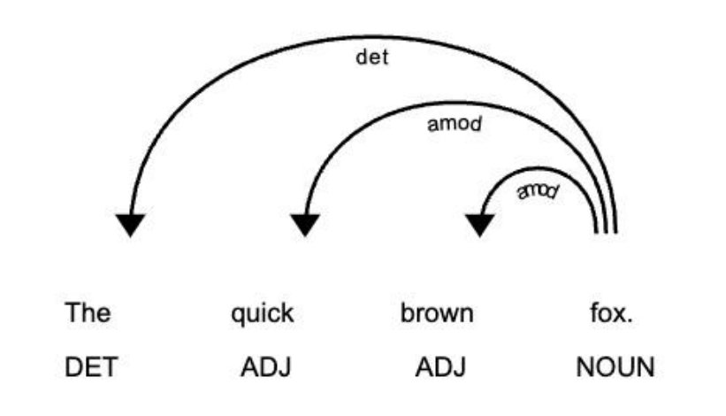

Dependency Parsing
- Parse structures unveil the function of words within a document by establishing the specific roles between elements in the text.
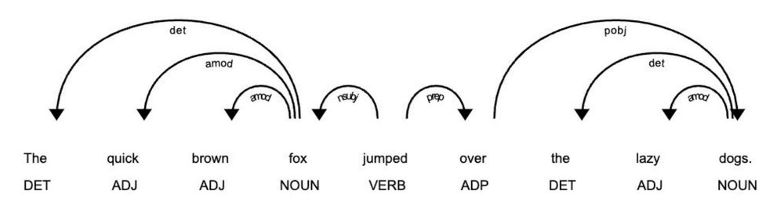

Parsing Mechanism
- There are many different ‘parser types’ that can be used to build a parse tree for a given document. Given its relative simplicity and transparency, let’s take the Probabilistic Context Free Grammar grammar as an example:
- Rewrite Rules
- Terminal Rules
- Start Symbol
- Probabilities
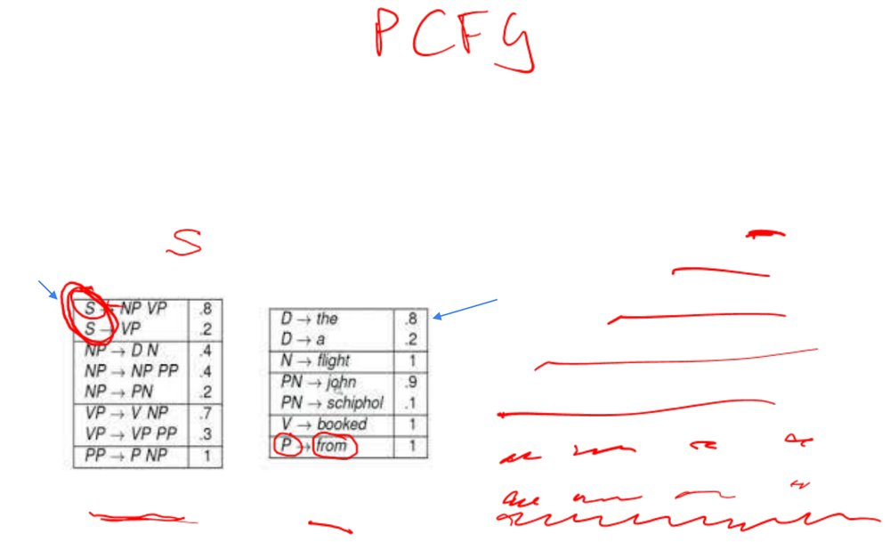

Parsing Mechanism
- There are many different ‘parser types’ that can be used to build a parse tree for a given document. Given its relative simplicity and transparency, let’s take the Probabilistic Context Free Grammar grammar as an example:
- Rewrite Rules
- Terminal Rules
- Start Symbol
- Probabilities
- How do we come up with the rules?
  - Hand crafted?
  - Learned from the data
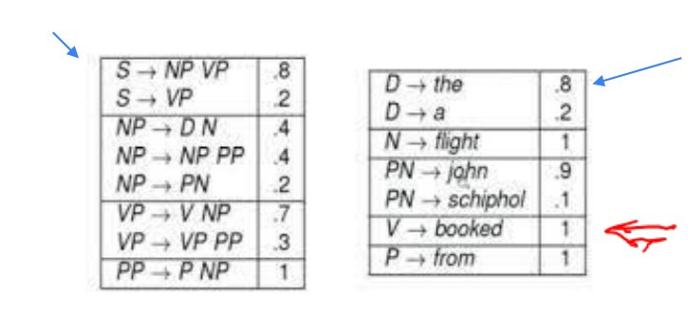

Part of Speech Tagging

Parts of Speech
- A part of speech is a category of word that demonstrates certain grammatical properties.
- There are a relatively small number of Parts of Speech (POS) types / categories in English:
  - Noun (“dog”)
  - Verb (“eat”)
  - Pronoun (“her”)
  - Adjective (“quick”)
  - Adverb (“quickly”)
  - Preposition (“over”)
  - Conjunction (“and”)
  - Interjection (“wow”)
  - Article (“the”)
- Parts of speech are useful features for differentiating between words and assisting analysis.

POS Tagged Sentences
- https://thinkinfi.com/extract-custom-keywords-using-nltk-pos-tagger-in-python/
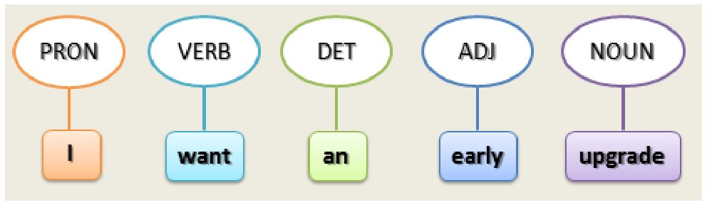

Part of Speech Tagging - Process
- Overall Process:
  - Collect & Label
    - Collect a large corpus of text
    - Get humans to label the text according to some annotation schema
  - Train Model
    - Use some supervised learning process to train a statistical or more generally a machine learning model based on the data
      - Statistical models use probabilities
      - Other machine learning models will use other mechanisms which correlate with statistics but don’t always perfectly match
  - Use Model
    - Apply the trained model to new unseen data
- Note that this process is very typical to many other related challenges in working with text data. While we introduce it for POS, it is not specific to POS tagging

The Supervised Process for Text Systems
- https://www.turing.com/kb/a-comprehensive-guide-to-named-entity-recognition
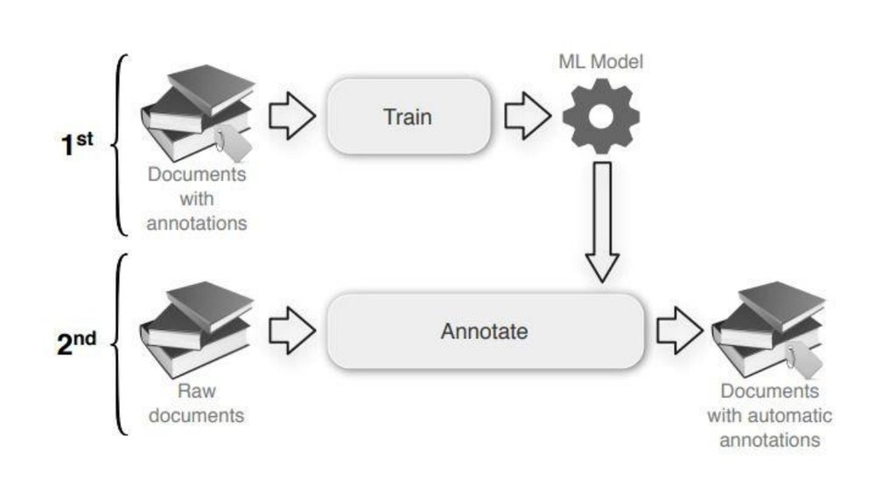

Part of Speech Tagging Models
- Use of any mechanisms – usually now machine learning based – to tag a sentence with associated parts of speech
- https://github.com/wantinghuang/tensorflow-lstmcrf-postagger
- Word Representation
- Sequence sensitive feature extraction
- Sequence sensitive classifier
- Conditional Random Field
- Long Short Term Memory
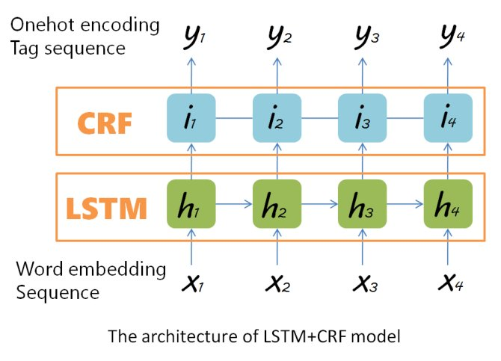

Named Entity Recognition

Named Entity Recognition
- Named Entity Recognition (NER) is the process of identifying the key entities that are named in a document.
  - We want to take the entities and classify them into pre-defined types
- NER unlike parsing focuses on just the People, Places, Organizations etc that are to be found in a document.
- Usage: Information Retrieval and also non-vector based document processing tasks

Examples of Named Entities
- The Liffey
- Bank of Ireland


Examples of Named Entities
- The Liffey
- Bank of Ireland
- Central Bank of Ireland


Examples of Named Entities
- The Liffey
- Bank of Ireland
- Central Bank of Ireland


More Examples of Named Entities
- Buck Lane – Real Person
- Paris Hilton
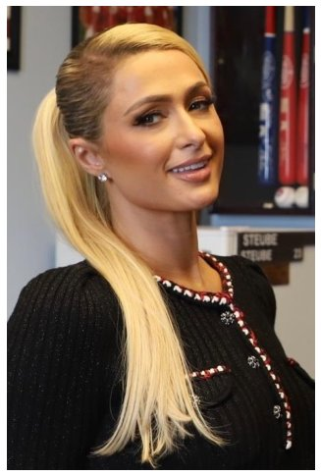

More Examples of Named Entities
- Buck Lane – Real Person
- Paris Hilton
- Paris Hilton?
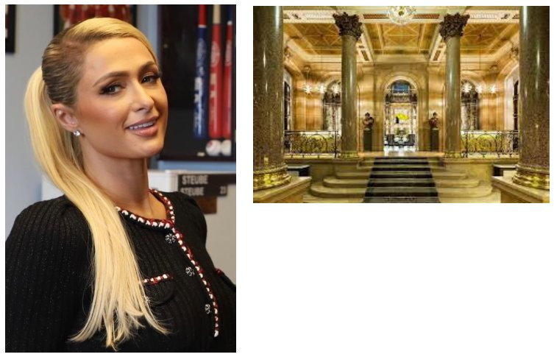

Challenges in NER
- Ambiguity
  - Often context fixes it
- New terms
  - A neologism is a newly coined word or expression
  - Business or organization names frequently come into new regular use
- Named entities are an ‘open class”

NER Training and Use
- The training and use of NER systems is very like the case for POS taggers, except that the open class nature of named entities makes the task more challenging
- https://confusedcoders.com/data-science/deep-learning/how-to-build-deep-neural-network-for-custom-ner-with-keras
- Note that the typical architecture is very similar to the POS case. Word representations, LSTM based feature extractors, and a CRF layer to make the predictions
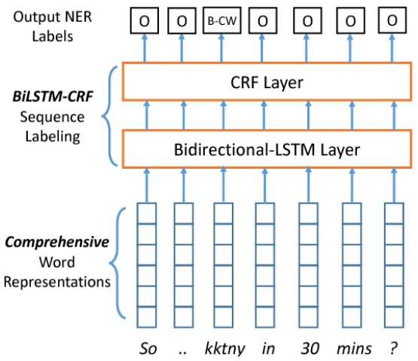

NER Tags
- Depending on the dataset used to train the Named Entity Recognition software, you can have a different set of NER tags. Below is the list of tags built into the Spacy tool’s NER pipeline for English. Note that other languages will have similar but different sets.
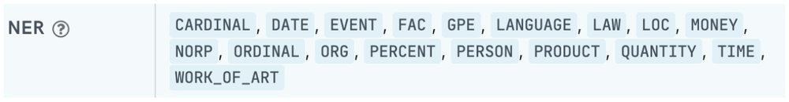

Measuring Correctness
- https://www.linkedin.com/pulse/precision-recall-binary-classifier-model-evaluation-prakruthi-b-gowda/
- For both software users and model builders, it is important to understand that all these systems need to be trained with but evaluated against some measure of of correctness. For simple binary classification tasks, we often use accuracy (see below) but it can be dangerous if our classes are not balanced.
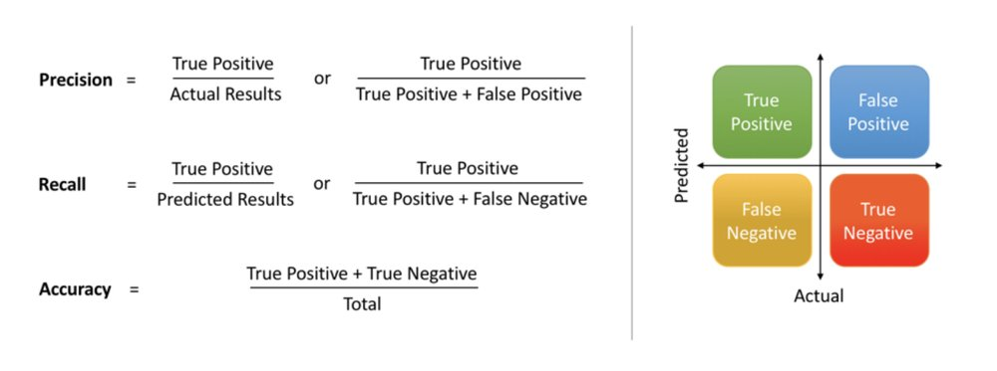

Measuring Correctness
- https://www.linkedin.com/pulse/precision-recall-binary-classifier-model-evaluation-prakruthi-b-gowda/
- For both software users and model builders, it is important to understand that all these systems need to be trained with but evaluated against some measure of of correctness. For simple binary classification tasks, we often use accuracy (see below) but it can be dangerous if our classes are not balanced.
- How many of the things we said are positive, are positive?
- How many of the things that should have been positive, are positive?

Measuring Correctness with the F1 score
- The F1 score is the so-called harmonic mean of precision and recall. A harmonic mean is different to a normal mean. For our purposes it is important to note that a harmonic mean is more conservative or pessimistic than a regular mean. It will give a value that is somewhere between the min of two values and the actual mean.
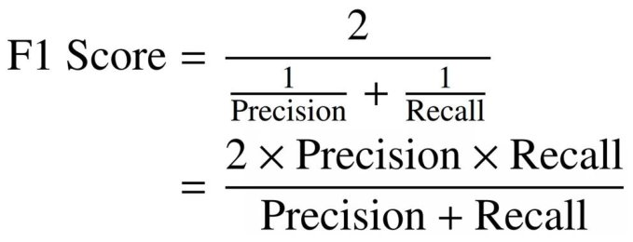

Measuring Correctness with the F1 score
- The F1 score is the so-called harmonic mean of precision and recall. A harmonic mean is different to a normal mean. For our purposes it is important to note that a harmonic mean is more conservative or pessimistic than a regular mean. It will give a value that is somewhere between the min of two values and the actual mean.
- Visualization of harmonic mean (F1 score). What would you expect this plot to look like for a normal / arithmetic mean?
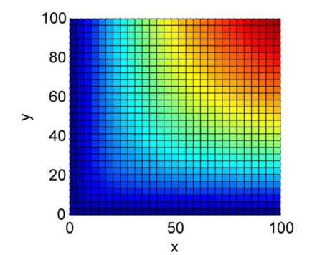

Important Side Note
- For many Natural Language Technology tasks, it is easy to build a basic system that maybe covers 80% of cases, it is tough but doable to cover 90-95% of cases, but it is the examples you miss that will often define the perceived quality of a solution
- Similarly, it is easy to build a mobile app, it is hard to build a good mobile app

Coreference Resolution

What is coreference resolution
- Related terms: Reference resolution, anaphora resolution
- This is the process of determining the expressions that refer to the same entities
  - Pronoun resolution
  - Even relating two instances of John to each other
- https://nlp.stanford.edu/projects/coref.shtml
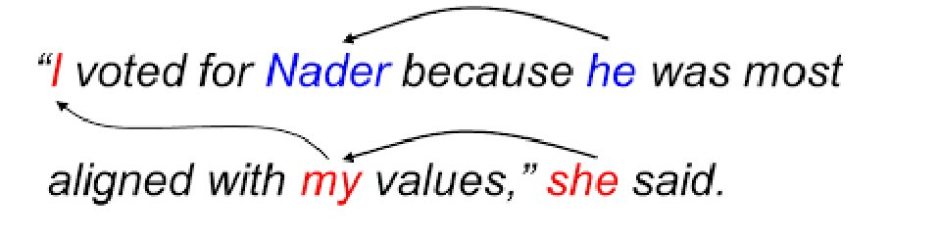

Coreference Resolution Support
- While co-ref resolution has been studied widely in research, in practice it is still a little flaky in tools and APIs.
- SpaCy has added experimental support for this. We will look at this in the lab notebooks.

Processing Dialogue

Turns and Dialogue Acts
- Turns and Dialogue Acts are important structural elements in conversation
- A Turn is a point in a dialogue where one person holds the floor while the other person listens. Turn taking is an important part of achieving fluid conversation, and turn-taking as an academic exercise is an important task in understanding the dynamics of a conversation
- A dialogue act is a pragmatic label we can apply to a chunk of a conversation or dialogue to note where something important to the dialogue flow occurring. More formally, but less clear, “A dialog act is a specific component of speech that labels a piece of dialog according to its category of meaning. ”

Dialogue Turns
- I’m starving, have you put the dinner on?
- No, I haven’t had a chance, the dog barfed in his bed, and I just spent the last 20 minutes cleaning up that mess. When are you leaving?
- I’ve about 20 minutes left, but I’ll leave then
- This sequence is ideal. In the real world there will be interruptions and overlaps which blur the edges in terms of what is a turn and what isn’t

Dialogue Acts (Speech Acts)
- An action oriented interpretation of what a speaker intended to achive with a contribution.
- In a simplified world, there can be a tight link between grammatical sentence types and a dialogue act:
- Statement = Inform
- Question = Ask-if
- Declarative = Request
- https://www.researchgate.net/figure/Speech-acts-and-their-meanings_tbl2_285847014
- Baseline Dialogue Act Set
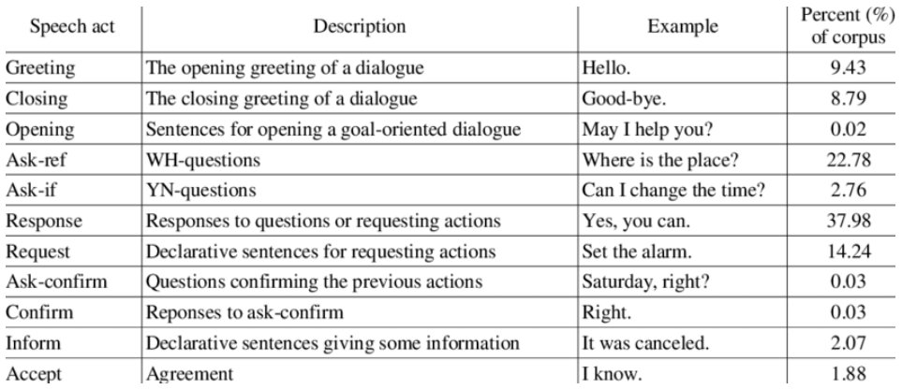

Indirect Dialogue Acts
- Not all speech acts are so direct. Indirect speech acts can be used to achieve goals in less obvious ways if we focus only on the content of the sentence, but mure more obvious when we understand conversational norms and the context of a conversation.
- For example, what might the true meaning of these utterances be:
  - Its gone very cold in here
  - I could do with a cup of tea
  - It would be a lot easier to make progress if we had more information

Untitled slide
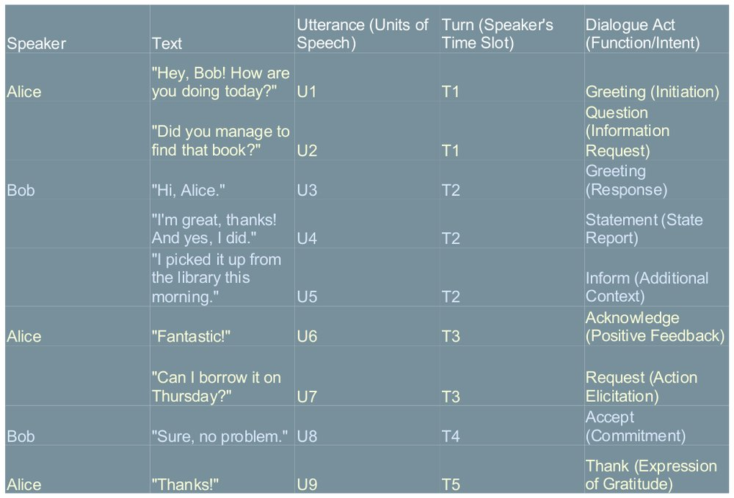

Processing Dialogue

Dialogue Act Tagging
- Just as we can build POS taggers to analyse the part of speech contribution of a word to a sentence, we can build dialogue act taggers to try to estimate the contribution of one or more contributions to the overall dialogue
- This is by no means as reliable as POS tagging

A More Basic Approach: Intent Recognition
- Instead of having to figure out a full dialogue act / dialogue tag representation for a 3rd party dialogue, in conversational systems we usually just need to figure out the ‘intent’ of the user.
- There are often overlaps between dialogue act ideas and how we talk about intents, but intent recognition is simplified considerably by the constraints of the interaction
  - What is the task?
  - What is it likely the user will ask about?
  - Etc etc

Tool Support

The Natural Language Toolkit


Untitled slide
- Like NLTK, it is a standalone tool that provides support for multiple languages for key natural language processing tasks.
- Unlike NLTK, it was designed from the ground up to be a tool fit for use in a commercial environment


Untitled slide
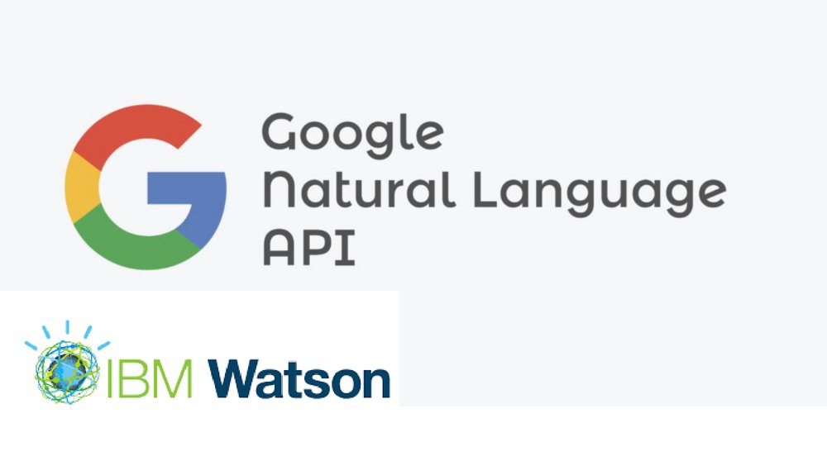

Dialogue Management

Conversational Architectures
- Architectures of natural language technology components used to enable conversational applications
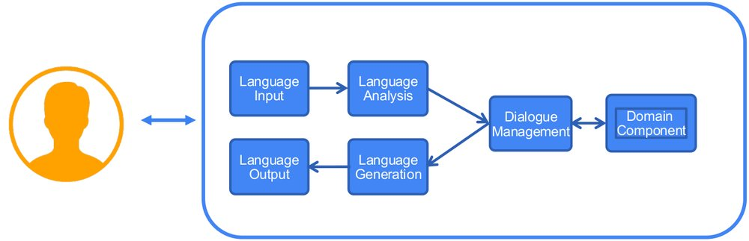

Dialogue Management
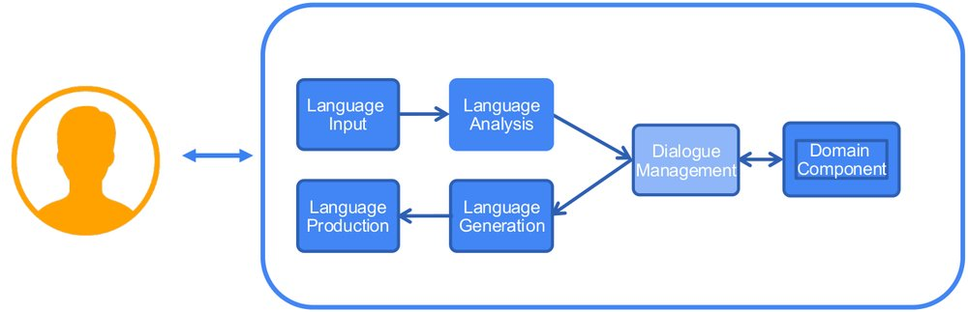

State Management and Planning
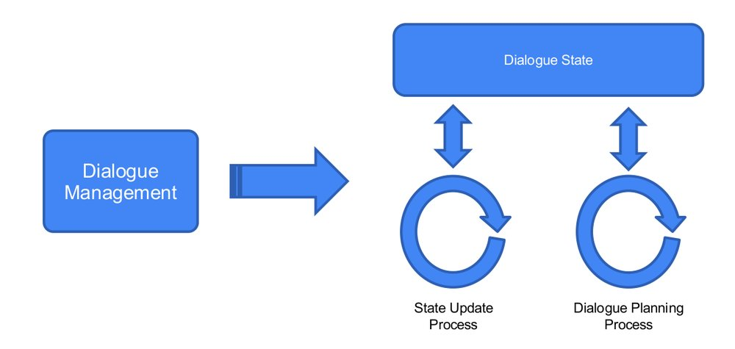

Dialogue Management Processes
- Dialogue State Management: Updating the dialogue state in response to a user utterance.
- Dialogue Planning: Deciding on the action to be taken (dialogue act or other act) at the current time given the dialogue state (including the user’s last utterance)
- These two elements are essentially universal. How they are implemented in practice can vary a lot between different dialogue managers.

Dialogue Manager Types
- Chat-Chat Bots (now DL based)
- Slot Based Dialogue Management
- State Graph Dialogue Management
- Rule based Dialogue Management
- Well Defined Paradigms

Dialogue Management
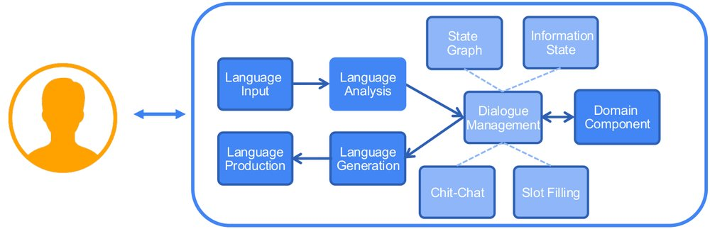

Untitled slide
- Chit-Chat Dialogue Management
- This is often the easiest type of conversational system to build and is based around the concept of initiate-response pairs in language. In their basic form, there is very little context understanding, but a simple FAQ bot would be.a modern version of this.
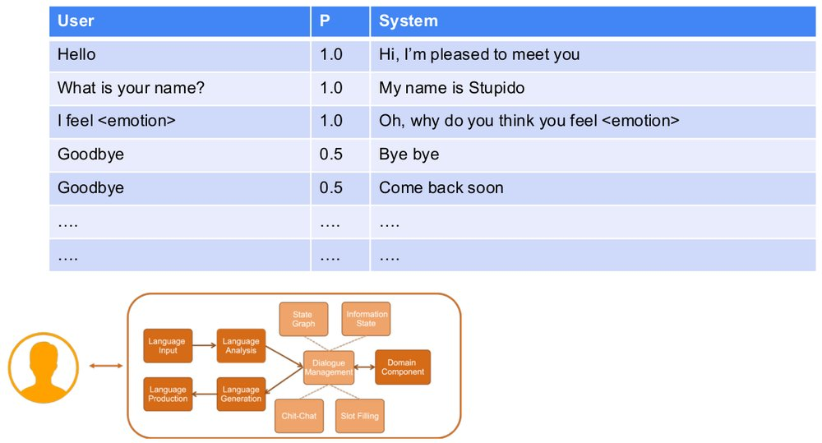

Pairs in Interaction
- Regardless of whether we characterize these as turns, acts or something else, the pairing of an initiating utterance with a response is a particularly important concept in conversation
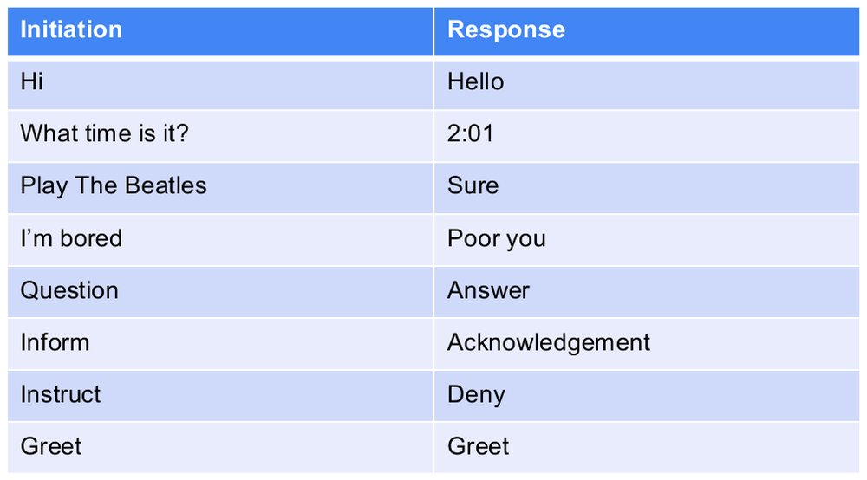

Untitled slide
- Tait, M. & Visagie, A. & Niesler, Thomas. (2005). Development of a spoken dialogue system operating in Afrikaans, South African English and Xhosa. SAIEE Africa Research Journal. 96. 10.23919/SAIEE.2005.9488052.
- The Conversational Roles Models
- State Graph Dialogue Management
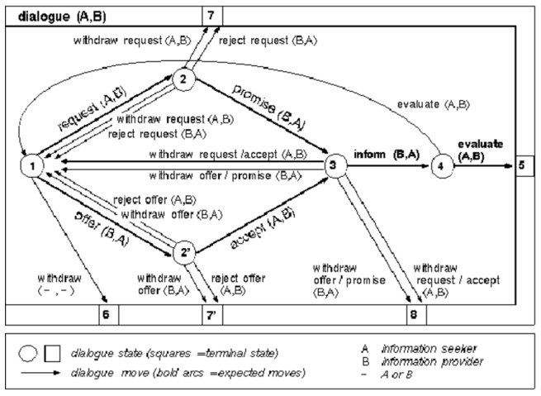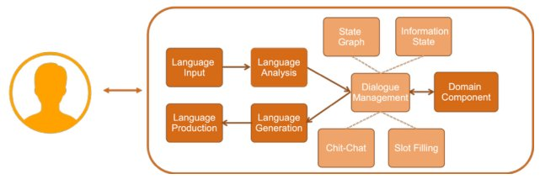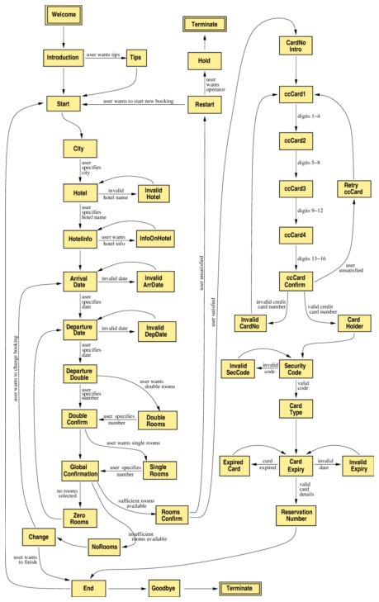

State / Graph Based Dialogue Management
- We can model dialogue as a graph structure that we transition through. This is very common in commercial systems and relates back to earlier systems such as Interactive Voice Response (IVR) systems for phones
- While technically nodes in the graph should be states and connections should usually be actions that cause us to transition to new states, in practice the nodes are usually ‘actions’ performed

Simplified Example
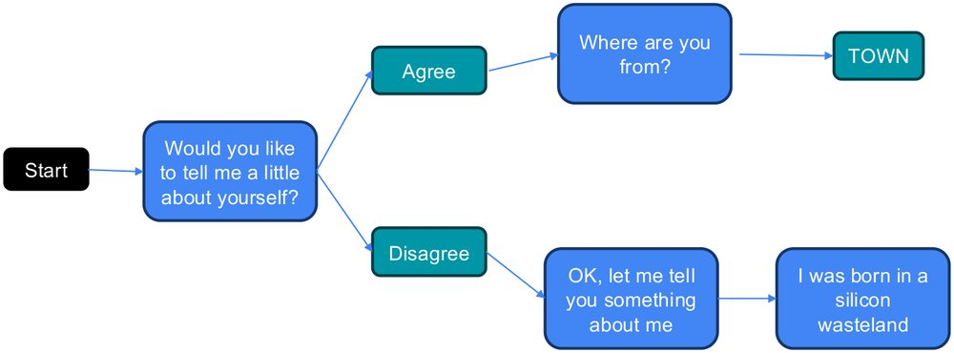

Google DialogueFlow Example of Complex Flow
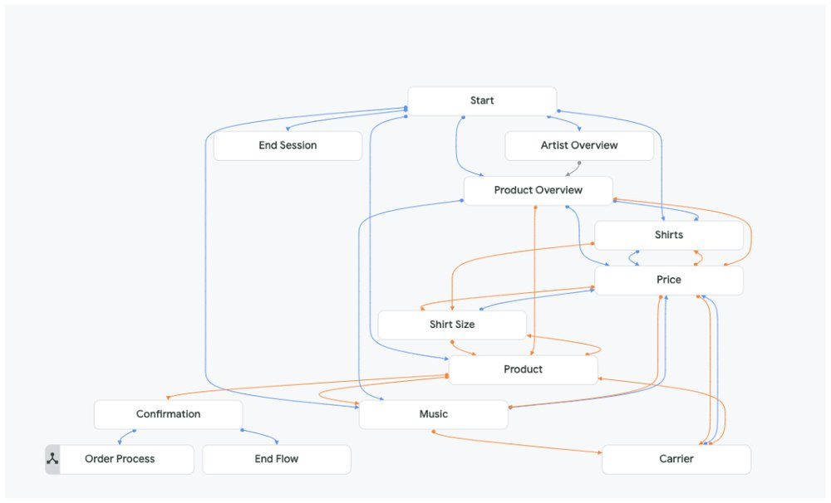

Untitled slide
- Information State Dialogue Management
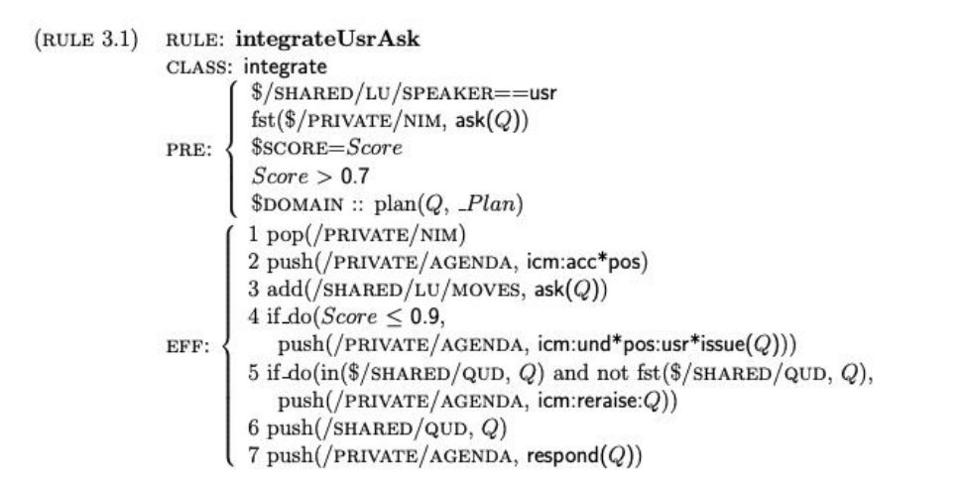

Rule Based Dialogue Management
- Focusing on the ‘knowledge’ or information gathered.
- This is the ‘old-AI’ approach, very much rule-based
  - Nice in theory
  - In practice ‘hand-crafting’ these rules is much too complicated.
- Ironically the ChatGPT type solutions provide the best example of what these earlier technologies were trying to achieve
- But in the mean-time something more middle-ground is needed

Slot Based Dialogue Management
- Often the practical middle ground
- Separate the information needed from specific tasks from the process used to gather it
- Focus on filling in slots within a form
  - Slots are defined in terms of
    - The type of information required, i.e., location
    - Optionally the role the information plays in the form, i.e., destination
    - The language used to prompt for the content
    - The language that a user might be expected to use to fill the slot
  - The last two elements above could be generated automatically in theory for a range of slots

Untitled slide
- Slot Based Dialogue Management
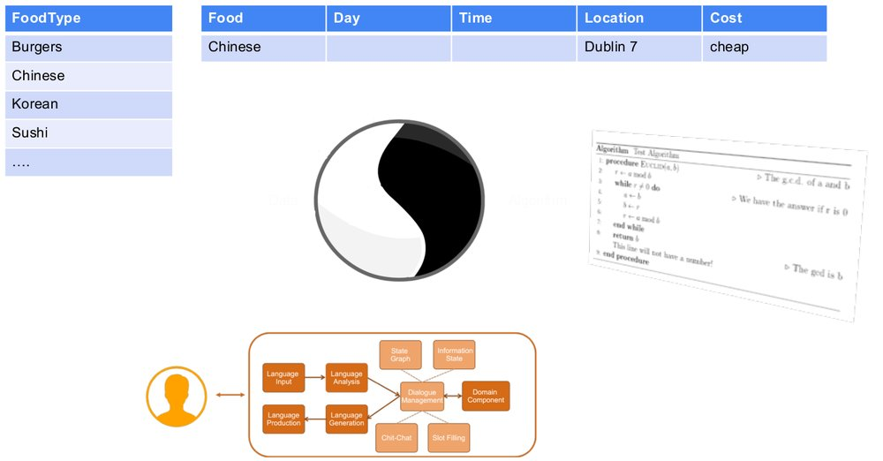

Data Structures vs Algorithms
- Data
- Algorithm


Untitled slide
- Data Structures
  - Raw Text
  - State Graphs
  - Knowledge Graphs
  - Slots & Frames
  - Distributed Representations
  - Databases
  - Pseudo-Logical
- Algorithms
  - Hand Crafted Rules
  - State Transitions
  - Algorithmic Solutions
  - State Estimators
  - Non-Deterministic Action Planners
  - Seq-to-Seq and Transformers


Untitled slide
- User Initiative
- Vs
- System Initiative
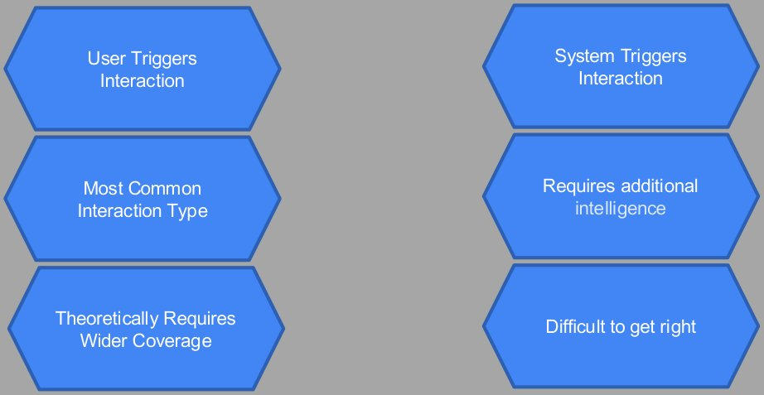

Metrics for Comparison
- Age
- Understandability
- Scalability
- Enterprise Level Tool Support
- Long-Term Potential
- Apparent Intelligence
- Task Intelligence

Conventional Types by Intelligence
- Chat-Chat Bots
- Slot Based Dialogue Systems
- State Graph Based Systems
- Information State Dialogue Systems
- Task Intelligence
- Apparent Intelligence
- Task Structured Dialogue Systems

DM Technology Options
- Flexibility & Cutting Edge Features
- Integrations, UX, and Enterprise Support


ChatGPT
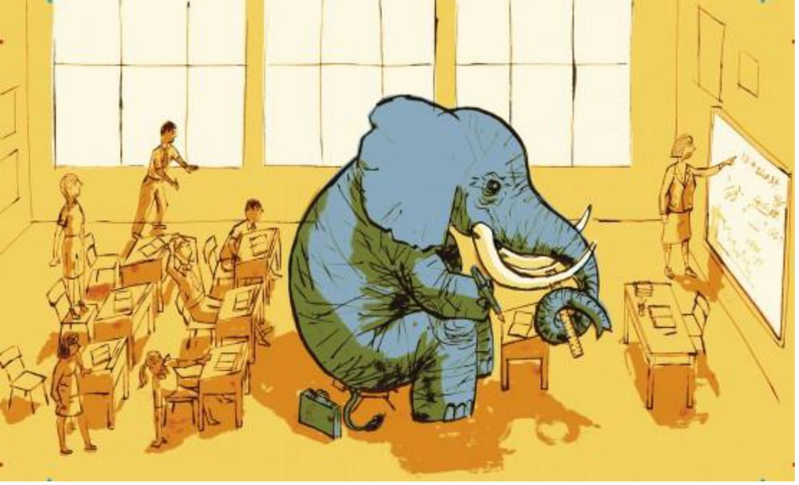

Sequence to Sequence Dialogue Management
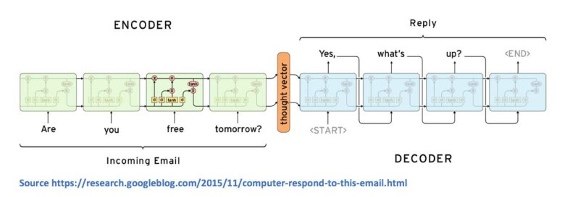
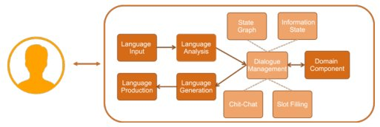

Sequence to Sequence Dialogue Management
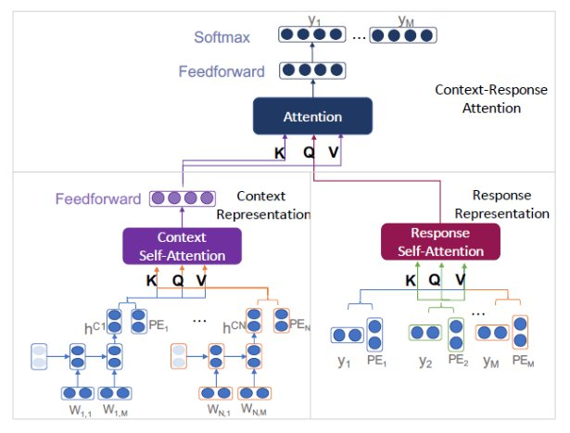

Domain Components
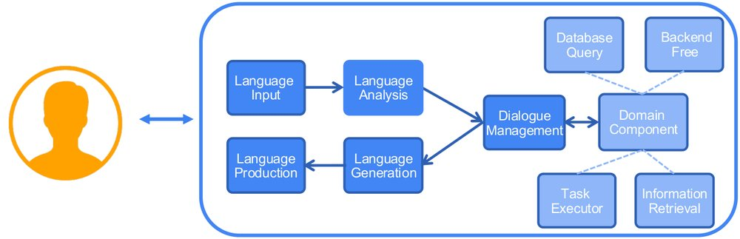

Untitled slide
- Backend Free
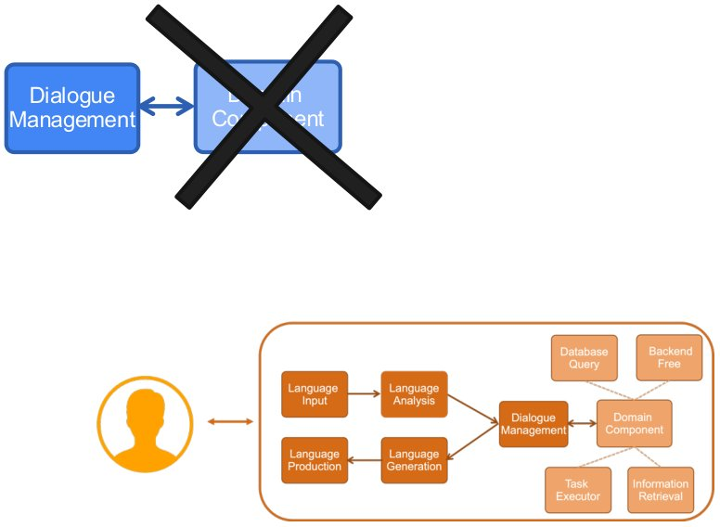

Untitled slide
- Database Query
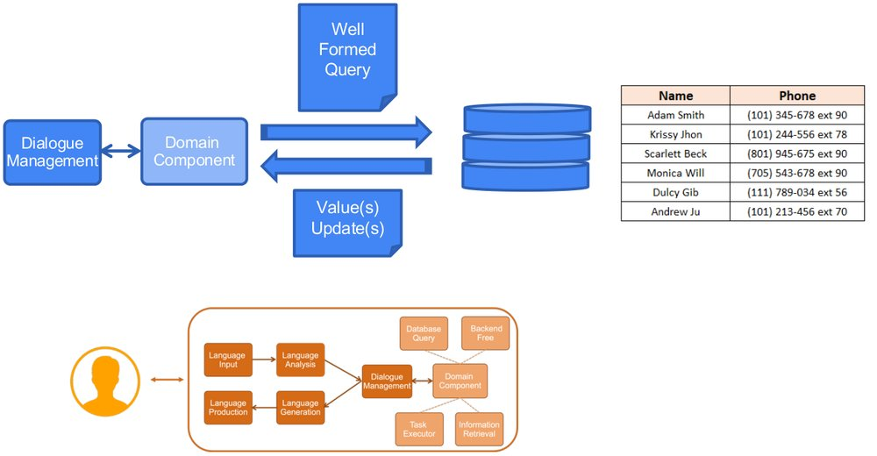

Untitled slide
- Information Retrieval
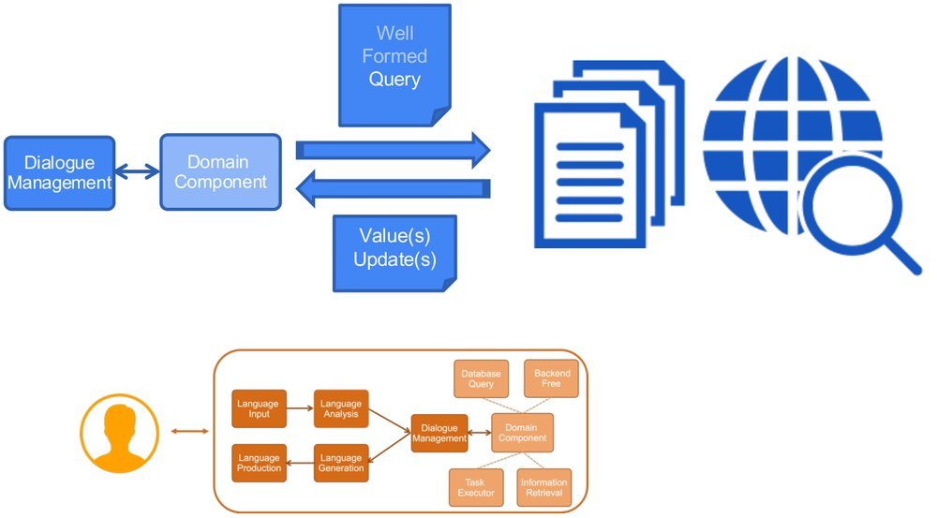

Untitled slide
- Task Executor
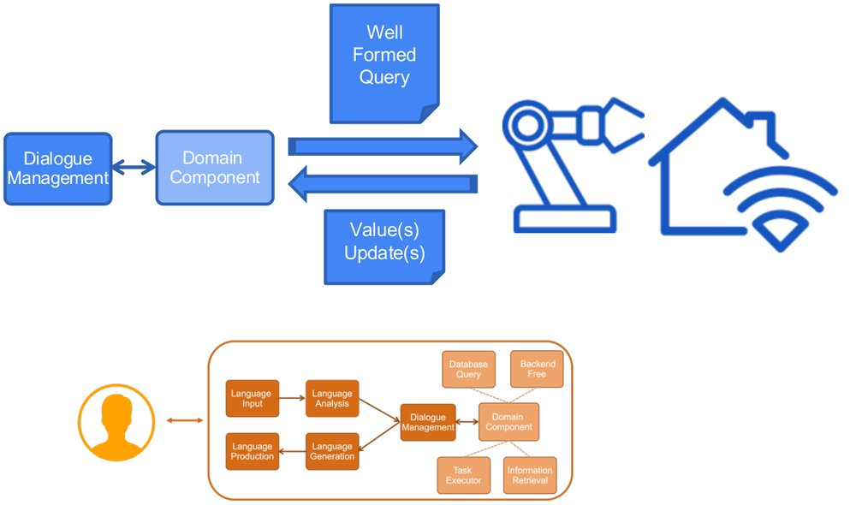

Lab Work

Lab Work
- Work your way through the lab material
- Make sure you understand what is going on with each example
- Load a Wikipedia page on the topic of your choice from a text file.
  - Investigate tools to retrieve a page from the web, save the text and load it.

References
- From: Parsing the Wall Street Journal using a Lexical-Functional Grammar and Discriminative Estimation Techniques
- https://www.geeksforgeeks.org/types-of-parsers-in-compiler-design/
- https://www.linkedin.com/pulse/how-does-python-interpreter-work-siva-velivelli/
- https://thinkinfi.com/extract-custom-keywords-using-nltk-pos-tagger-in-python/
- https://www.turing.com/kb/a-comprehensive-guide-to-named-entity-recognition
- https://github.com/wantinghuang/tensorflow-lstmcrf-postagger
- https://confusedcoders.com/data-science/deep-learning/how-to-build-deep-neural-network-for-custom-ner-with-keras
- https://www.linkedin.com/pulse/precision-recall-binary-classifier-model-evaluation-prakruthi-b-gowda/
- https://nlp.stanford.edu/projects/coref.shtml
- https://www.researchgate.net/figure/Speech-acts-and-their-meanings_tbl2_285847014
- Tait, M. & Visagie, A. & Niesler, Thomas. (2005). Development of a spoken dialogue system operating in Afrikaans, South African English and Xhosa. SAIEE Africa Research Journal. 96. 10.23919/SAIEE.2005.9488052.

Week 6 – Information Retrieval – 19th Oct ‘26

Today
- Quick Intro to Information Retrieval
- Indexing
- Querying
- Considering the Graph
- Vector Databases for Document Search
- Document Clustering

Information Retrieval

Information Retrieval – Is Huge!


Information Retrieval – Is Huge!
- Information retrieval can be an entire course: see below for example.
- We will not aim to cover IR comprehensively. However, we will try to highlight key concepts – particularly a they relate to other key concepts in NLT.
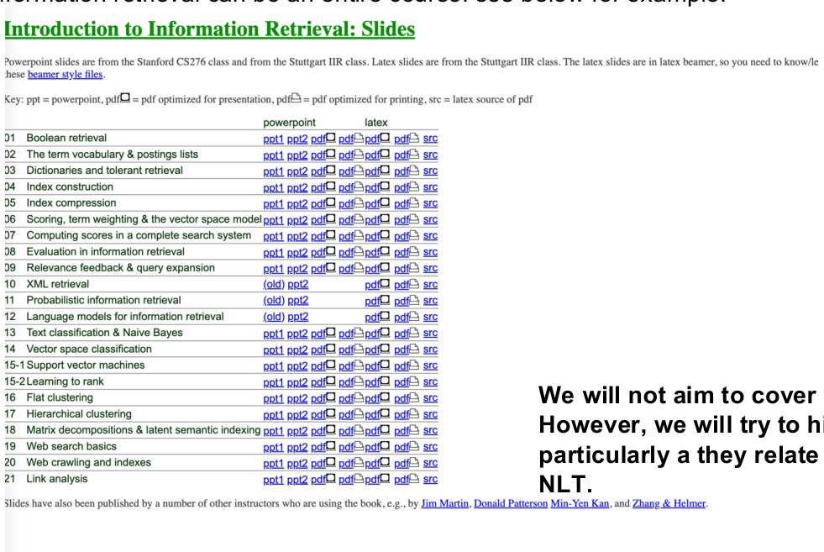

What is Information Retrieval / IR?
- Information Retrieval is defined as the task of finding documents that meet a particular search requirement
  - html pages
  - Text documents
  - Media files etc
- While IR can be very much a multimodal problem, in this course we are focused on the classical text problem of IR
- The web is perhaps the best-known corpus of documents that you have to search, but local text repositories are often still very important for enterprise solutions

Components of Classic IR System
- The components of an Information Retrieval system is split between the query and the indexing process which works either continually or in a periodic process over the corpus.
- The query composed by the user first performs some form of flat retrieval against an index. Then either as a sperate process or a closely aligned process, we rank the matching results.
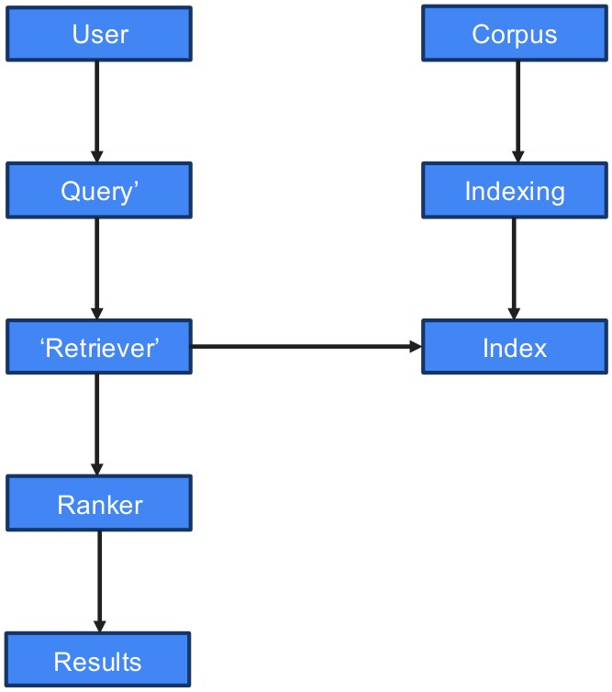

Preprocessing for Indexing
- As with other text-based tasks we have looked at, a proportion of text preprocessing is often useful in improving the quality of results. The amount of preprocessing required has generally gone down over the years as embeddings-based methods (see next few weeks) have replaced more traditional TF-IDF and other ‘term’ based searches. Still though, we should be aware of these methods.
- Stop Word Removal = Remove very frequent words seen across all documents
- Tokenization = Split the document into a sequence of words
- Stemming = Remove variance by reducing words to their canonical forms.
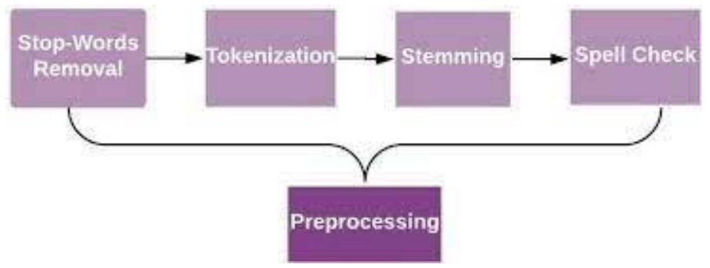

We memtioned some o fthese concpoets a couple fo weeks ago
They are important
So repeat here
Don’t have to do ti yourself these days but need to know whats going on
These ares steps in clascal pipeline.. but do keep in mind for odern vector based aprphac we won’t do these steps…

Represenatio that can be directly used for indexing
No perffet rules in terms of how that is done…
- Pre 1st step – has ot do before step 1… nto mentiond here
  - Endure text is properly formatted and is a valid document
  - Is it English, need parsing.. make sure pipeline is coprrcte ad have standard emglish, and know dealing with

- 1st step – stop word removal – remove words appearing very frequently in text i.e. and, the, for etc they convey meaning but in classical info kIR approach were considered reduncdant in core task
  - Advantage in sizes of index… &
  - Some of algorthem even Naïve Bayes… broke things a little taking stop words to side…
- 2nd Step - Tokenisation
  - Logn words disjointed with hphens / 1 compete word or individual tokens
  - Basically split by character return and spaces
- 3rd Step – stemming & lemitisation
  - Quick/quickly/quiker
- 4th – spell checking

  - Should we correct words…. Spellgin correction can go at start of pipeline… before you do revoal etc… can be before or after…. I would have put it at the start… just made more sense..

Aside: Stemming vs Lemmatization
- Stemming really means getting to the base of a given word with eg. Suffix removal rules.
- Lemmatization means converting to the ‘canonical form’ of a word and would usually require identifying POS for a given word
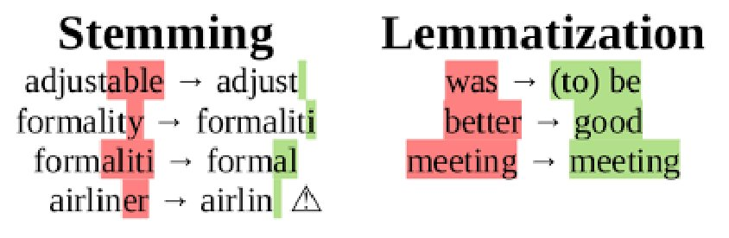

- Generally use stemming instead of lemmitisation
- It is cheaper
- Ina way stays closer to original form fo word… even fi token that’s produced isn’t very huiman readable
- Why Cheaper? >>> mechanistic… can have small amount of rules to so stemming… lemmatixation /similes / womononyms… more rules,,,, in early system stemming was cheaper…. Less compute..
- Can you sue side by side? NO.. both break their text…
- Be aware of them… but not doing detailed algos as not gong to use it…. Justg be aware of them isf see a ref in documentation…

Stemming vs. Lemmatization
- Attribute
- Stemming
- Lemmatization
- Primary Mechanism
- Heuristic, rule-based suffix chopping
- Dictionary/morphological analysis + POS tagging
- Output
- Stems (may not be valid dictionary words, e.g., studi)
- Valid root words (lemmas, e.g., study)
- IR Trade-off
- High recall, lower precision (risk of over-stemming)
- High precision, lower recall (stricter matching)
- Computational Cost
- Extremely fast, minimal memory
- Slow, requires heavy NLP pipelines & lookup tables
- Classical IR Usage
- Default choice for engines like Lucene/Elasticsearch
- Reserved for specialized or domain-specific search

- Acronyms = lemmatisation
- onomatopaei = lemmatization
- Can replace a word with standard vbaseline approach… i.e. sofa vs couch….
- Have tuples of words that can fit for other words… i.e. acceptable words for a particular word…
- Distributed vector representation is much better at doing this..
- OMG or LoL == they are usually justatken as words.. / tokens in their own right…
  - They have an accepted common sematic meaning
  - Challenge is tokeniser has to eb awrae of those sort of thigns.. and doesn’t split it into “o” “M” “G” .. need a list fo allowable words.. i.e unusually list of charcatcers
  - HaHaHa.. same things… start having to use regular expression regex implementation as acceptable tokens…
  - A word in English is “Neologisms” new words in the language… and dealing with hem in a senseiblway.. difference betweena new word and spelling mistake…

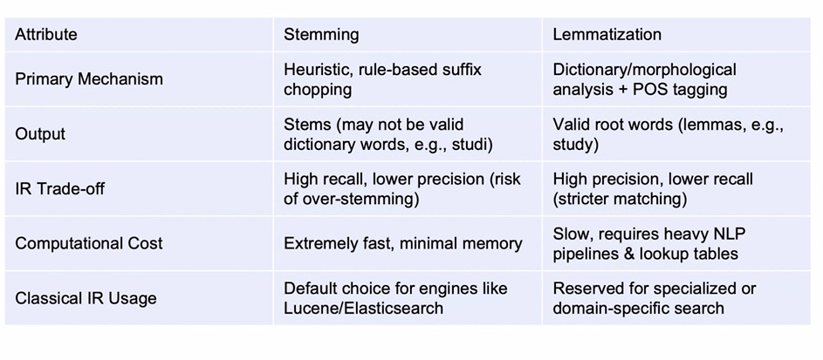IR Process: Indexing
- Building the index has typically been the great challenge in IR.
- Rather than searching through each individual document in real time, the idea is to have some encapsulation of the data that can be stored in a more efficient index
- In classical NLP IR systems, the index is based on an inverted index
  - Inverted Index: For each word we have a list of documents that it occurred in.
  - This is similar to the index in a book

Building the Inverted Index
- https://www.techinquisitive.com/post/information-retrieval-with-python
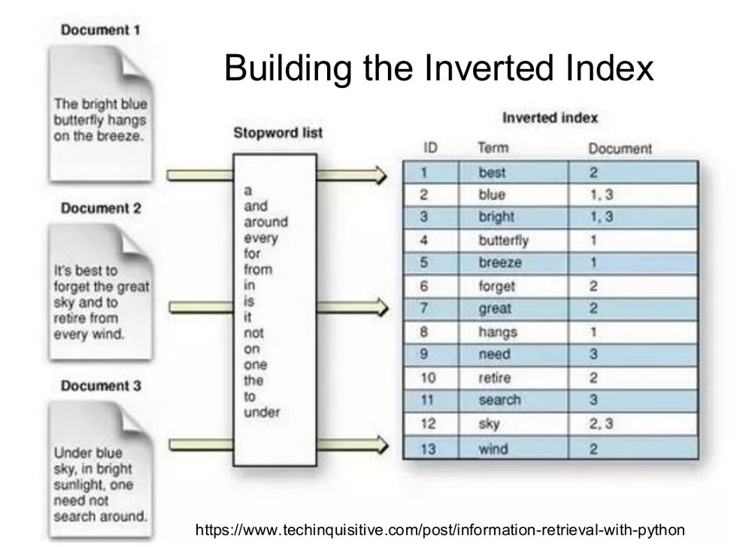
- The go an assign an index for every document that has an instance of that word…
- If one doc has index of that word have 1 item.. if lots of docs equivalent ot index at back of the book
- But book is based nopages… =>>> ervery docuemtn is equivalent of the page in the book
- To build it form computational perspective… is relatively fast… can go thru docs and index quickly..
- A theoretical limit… bounded by number of words in English dictionatry… 70,80,000 of words
- # of potential entrei per word = number of docuemtns you are indexing…
- This approach is discarding some info>> doesn’t give
- Gives us a godo starting point

Retrieval & Ranking: Using the Inverted Index
- Take the Query
- Tokenize and convert to base terms
  - i.e., the form used in the inverted index (usually stemmed words)
- Collect info on all documents that contain matching terms
- Apply scoring / ranking logic to decide on most likely document
- What sort of logic might we apply here???

- Not checking if a word was being used repeatadly.. like Bag of words methodology…
- Well understood fast iplementations of this…

Boolean Retrieval
- Exact Matching: The system directly matches query terms with terms in the inverted index.
- Boolean Operators: Users can combine terms using logical operators like AND, OR, and NOT to specify precise search criteria.
- Term Frequency-Inverse Document Frequency (TF-IDF): This technique assigns weights to terms based on their frequency in documents and the entire corpus. It helps rank documents based on relevance
- At a high-level this process is very simple. In practice the algorithms to do this quickly for large indices are non-trivial.

- Need some sort of ranking but don’t have to rank them
- Could rank on date o last access / date of creation / recency may be more important than specific relevance…
- What approach e might we take to buld up the hits on the index.. the # of files that match the user query…
- Comes down to various choices about logical operators…
- Ar we looking for documetns in corpus that match all ro some fo our words..?? and that a big differentiator in how good algo’s are…
- Boolean retrieval… .e. full Boolean approach? Does user have power? Ro what Boolean assumption sare being used…. This affects the output.!!
- Google used to give you the power to force the sue of Bolean operators in the queries….
- I used ot use them more than I do now…
- For sure not al IR algo’s are created equally… even byb huge multi nationals…
- I still find MS outlook implementation over emails… in comparison to defaly by google in gmail….

Cosine Similarity for Document Comparison

Searching based on Document Similarity
- https://www.researchgate.net/figure/Figure4DocumentrepresentationintheVectorSpaceModel22_fig1_312471174
- (Remember, we have seen this before. This is a Term-Freqency representation of a document. We looked at these and also the Term-Frequency – Inverse Document Frequency)
- (we aren’t looking at distributed vectors just yet)
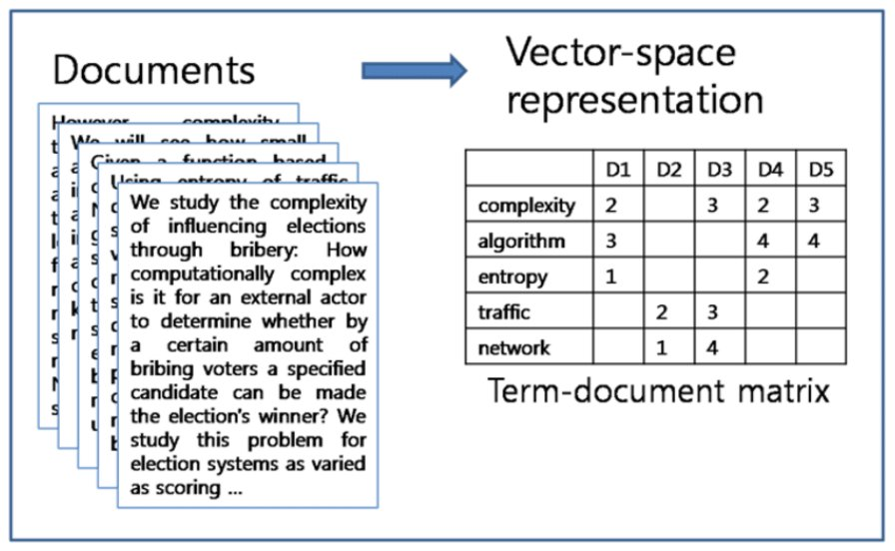
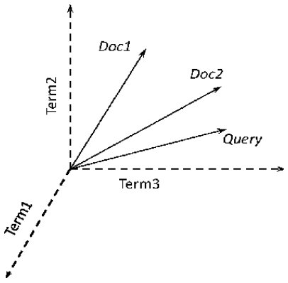

- Very Very Important
- Doing here for classical representatins TF-IDF
- Or bag fo words

- Cos Sim is bvery relevant to them!!!! Not just distributed vector based representatinos

- This give su a different approach to measure similarity between documents…
- Instead of basec approach taking two vectors..+ query and a doc we are coparing to.. and finding everywhere that the query and index rep have the same docuements… just looking for overlaps on set…
- Cos Simas a measure is powerful for looking for similarity between docs…
- Taek 2 Indy docs and compare them…

- Cos Sim = an equatins take 2 vectors *9length +
direction) and measure similarity between them (does it in a way to get rid of length iforation
- Equivalent to calculating an angle between two vectors… we nor,aly think of in a 2D plane, Cos Sim is sort of like that but 2 things
  - It ha s anice measure between -1 and +1 (very handy for other algo
  - Easily goes across multiple dimensinos..
    - Can use across multiple dimensions….
- Implementation is tarigt forward algo and can mek sue with any vector represnetati we want.. can eb tf-idf / bag pf words.. / distri rep of docs

Cosine Similarity
- The cosine between two vectors is a measure of the distance between those vectors. The division by the magnitudes of the vector actually is just normalizing to take account and neutralize the effect of the length of the vectors. In high-dimensional spaces most document vectors are not going to be pointing in the same direction (co-directional)
- A
- B
- Dot product
- Vector magnitudes
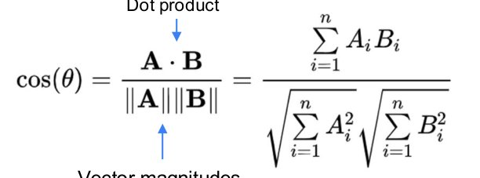
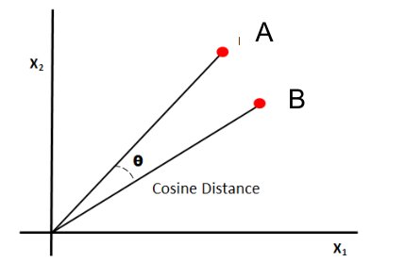

Running The Query – Document Similarity Measure
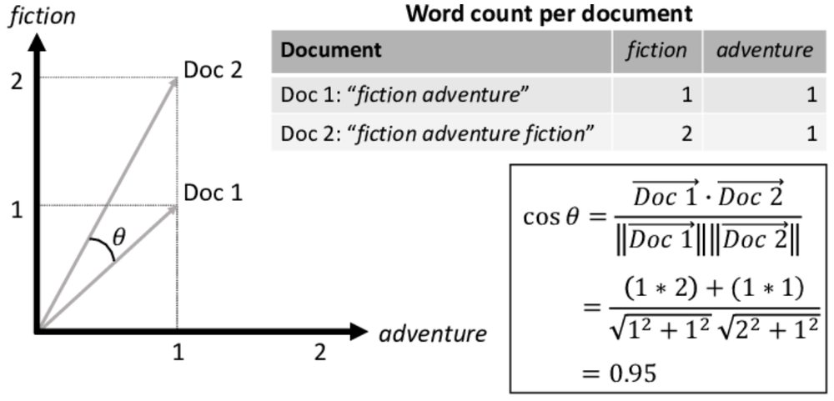

Similarity Measures
- There are many similarity measures used in data science apart from Cosine Distance.
- For our purposes here we don’t need to know about the others. However, out of interest:
- Euclidean distance is the real-world measure of distance. It is also sometimes used to measure similarity – see clustering later.
- Hamming distance and Manhattan distance measure the number of changes that must be made to turn one vector / structure into another. Both have both had heavy influence in NLP for spelling and certain types of document
- There is an excellent intro to these different measures in https://towardsdatascience.com/9-distance-measures-in-data-science-918109d069fa
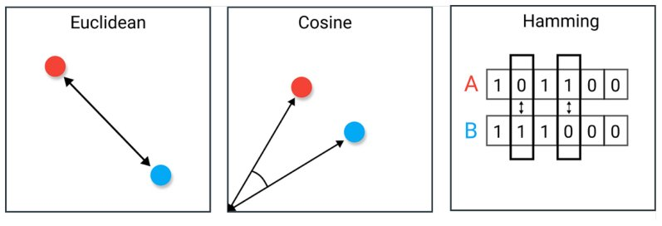

- 1 vectors simsilarf value close to =1

- 2 veciors absoltu opposite >> = -1

- 2 vectors orthongal = 0

- Cos Sim >> gives you a way to measure similarity between them…
- There are other ways to do it…
- Dozens pf the,,,

- Euclidean distance! – real world measure….
  - Used in NLP distance
- Hamming or Manhattan distance
  - Step distance – spellchecking…. Looking at number character alteations form not acceptable word to acceptable word… the elats changes = mosy viable substitute..

From Documents to Knowledge Graphs

Beyond Flat Corpora
- For flat corpora of documents (company repositories) flat searches can work well
- However, when the document repository has structure, we can take advantage of that structure
- Big structured collection of documents === the Web
- The best-known web / graph search algorithm is PageRank

- So far just docments….
- Based on underlying topology of the web…
- IR augemtned with graph structure can take advantage of that grapgh structure…

PageRank
- Count the links going to a page and use that to generate a relative importance estimate for that website.
- This information can then supplement the actual textual index results to build up an overall ranking of results.
- The power of PageRank relative to the earlier generation of flat structure-based indexes for the web set Google apart from its competitors 25 years ago
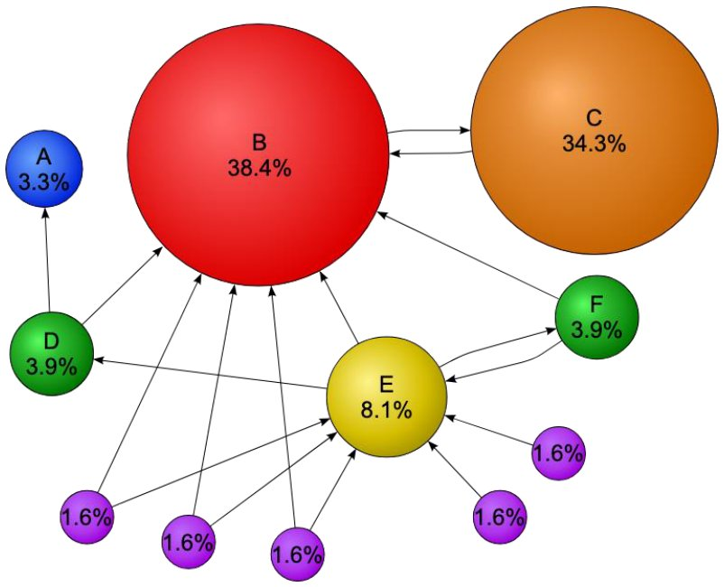

Using graph structure of the web…

Page Rank Challenges
- Search Engine Optimization
- Breaking down of web structure due to quality of search

- Oen person optimization is another persons selling

- Search itself is breaking dwm to some extent for couple fo reasons…
- Page rank style algo helps with sloppulls – nobody linking to it…
- Search providers…
- Zero click through results are really starting to become prominent in google
- Wikipeaia seeing drop off in oage views… gemini justseving information straight to user with no clicks… less people contributing to articles… people contributing to editing / authoring artiles….

Evaluating Information Retrieval

Evaluation Measures for Information Retrieval
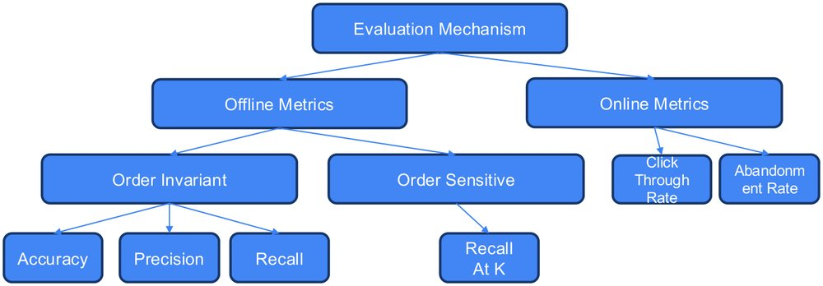

- Offline metrics – will deal with in details—more related to engineering not user interatinoc
- Online metrics i.e. weather websites – summaries suggest / abandonment / how quickly dd user break off
- Not going to deal with in Human Cmputer Interaction (HCI) – lots o fthese metrics. In how users engage with web site etc
- When requires lots of users => into HCI….

Precision and Recall
- https://towardsdatascience.com/whats-the-deal-with-accuracy-precision-recall-and-f1-f5d8b4db1021
- Ideally the red bit would be small.
- Ideally the dark green area would be small. .
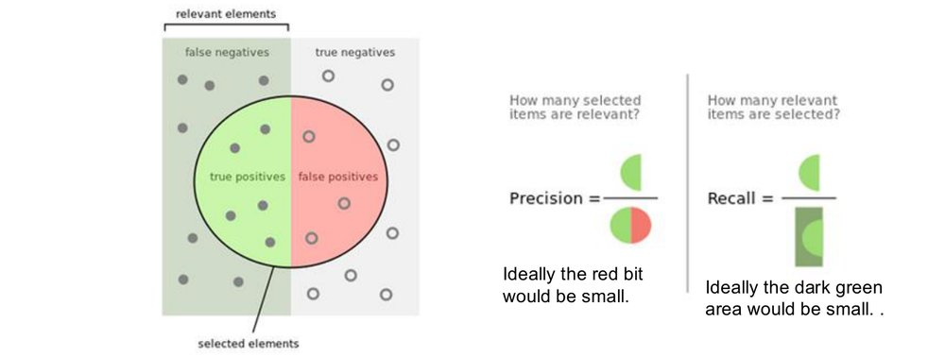

- Like a supervised learning perspective - a problem that ou need ot get right…
- Precision = of the things that I gave you > how many were relevant
- Recall = of the things I should have given you >> how many did I give you
- One issue with them take no account of fact can have multiple results going back to user and don’t know if all god results are in that pool to the user… some element of ranking

Recall and Precision at K
- Remember that we introduced Precision and Recall last week.
- Measures how many of the relevant items are present in top K out of all the relevant items, where K is the number of recommendations generated for a user
- Gives a measure of “out of K” items recommended to a user and how many are relevant, where K is the number of recommendations generated for a user..
- See the great article below for more detail if needed (and many more metrics!)
- https://towardsdatascience.com/evaluation-metrics-for-recommendation-systems-an-overview-71290690ecba#:~:text=Recall%20%40K,10%20movies%20for%20every%20user
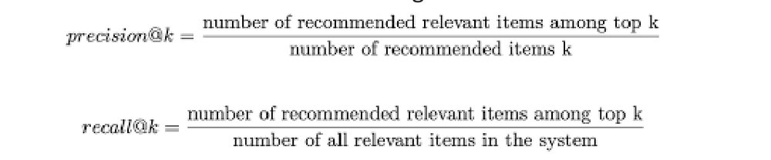
- Not a perfect hit we hope what we give them is relevant
- K is a number you choose yourself…
- May report in a doc that precision at 5, 10 and 15 and you would also report recall at 5, 10
- And 15.. report for different values at K and count numer fo thigns correct within top 5 , 10 ro 15 to the user
- Precision @ K and recall @ K

Worked Example
- Imagine a page recommendation system with a corpus of 10,000 pages. For a specific query, the system returns the following 10 pages:
  - Page1, Page2, Page3, Page4, Page5, Page6, Page7, Page8, Page9, Page10
- The user believes Page2, Page4 and Page8 are relevant.
- We can calculate Precision@k and Recall@k for the first 5 items (or any other k)
  - Precision@5 = 2/5 = 40%
  - Recall@5 = 2/3 = 66%

- First 5 elements on LHS hwo many are relevant to the user… so 2 out of 5 were relavnr to the user… so 40%
- Of rekevant things how many were in top 5 resutls…
- 2, 4, and 8 --- how many fo them ar in relevant results…so 2 out of 3 were relavent… so 66%
EXAM - This is the type of thing that can occur in exam!!

(Distributed) Vector Search

Start with Classical Document Vectors but Generalize
- Document Index search as used in classical information retrieval
- a
- c
- Distributed Representation. The vectors a, b, c don’t have to correspond to any single concept, but if you like think about them as things like ‘goodness’ ‘Irishness’ etc.
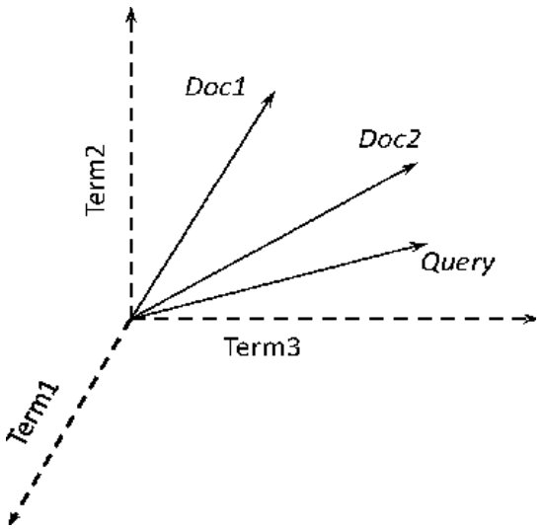 to next diagram….
Generally vector based search can be very powerful and people like results from it…
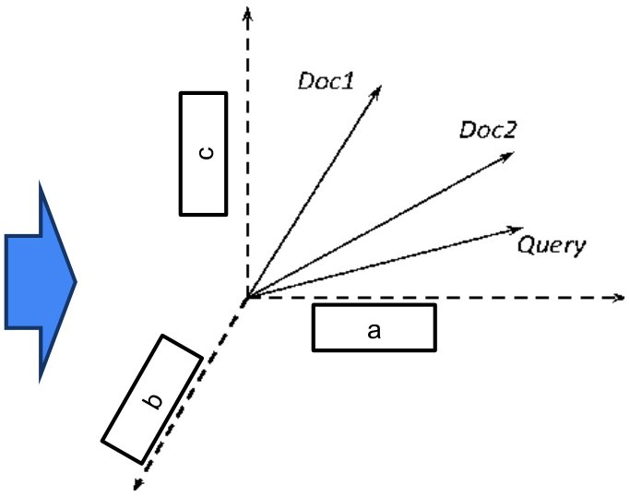

- Documents with similar meaning live ins similar part of that space… live close to each other in high dimensional space…. That’s a ket fundamental factor…
- Can use users query.. will be very close to actual documetns that are relevant to it,,,,

- The users query is a projection of meaning…
- Can use cosin distance to ID docs relavent to users query
- Tedns to be sued a lto in back end IR systems >> including RAG based systems….

Untitled slide
- Remember we have seen something like this before when we were talking about representations of text
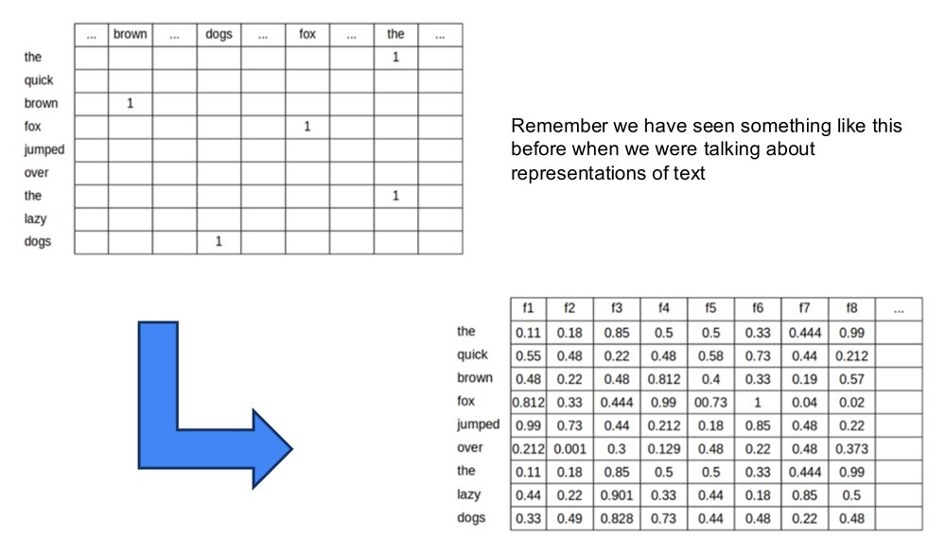

Documents: Document or Sentence Embeddings
- The quick brown fox jumped over the lazy dogs
- Embedding generation mechanism
- For example, universal sentence embeddings
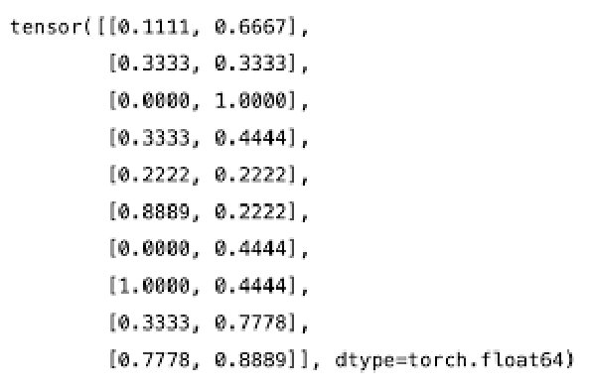

For Similarity, we still use Cosine
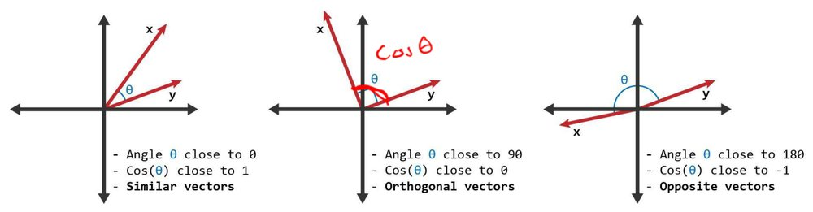

From Information Retrieval to Vector Databases
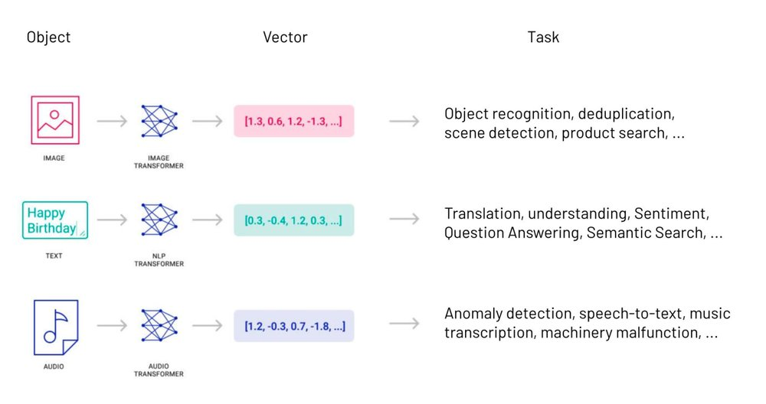

- Huge number of vector databases
- Not just ab le to deal with text
- Can deal with all types, for any document type we can take it and build up a vector representation of it.. i.e. fi tis pdf, movie execrtpt from knowledge grapgh,
- Lots can deal with multi modal data
- Basic principle of using numeric represntatino and havgi veciotr being similar in structure gievs us in ML and advanced systems dev, a way to relate different types of information…. So can build engines that canusers in txt and execute across docs and we never have ot encode them to a text sdescription… instead ee alioght the two indy rep space for extg/dpc.video… and through ML an nice engineering… we can basically force them to be in the same space… so represnetatio for cat sat on the matt loks like rep that you gte if tak image of cat sat on mat and encode it up into mult I dim vector space… that’s hwo multi modal search works….
- Happens bu engineering… multi modal…. Mapping frometxt to spac represntations …

Vector Database Ecosystem
- https://www.linkedin.com/pulse/choosing-vector-database-your-gen-ai-stack-abhinav-srivastava
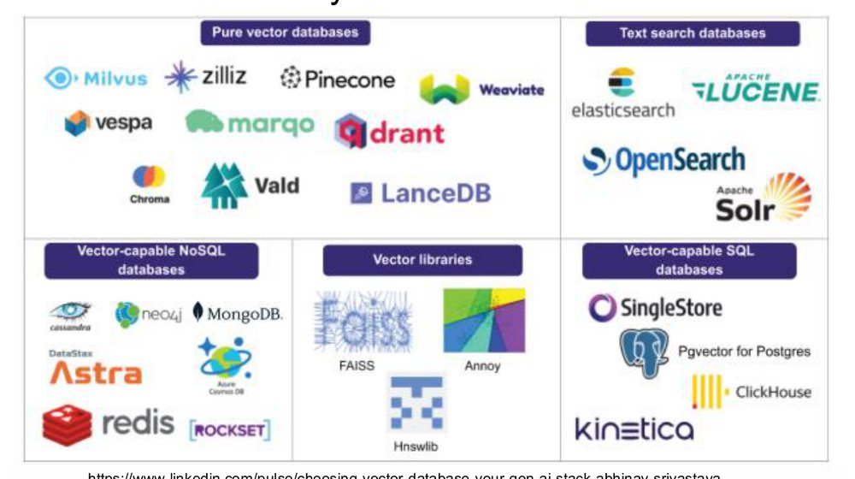
- Huge number fo different solutions.. to support search / retrieval aumgneted generation /
- This is probenlay an old set fo solutinos… many open source.. many closed source…

Untitled slide
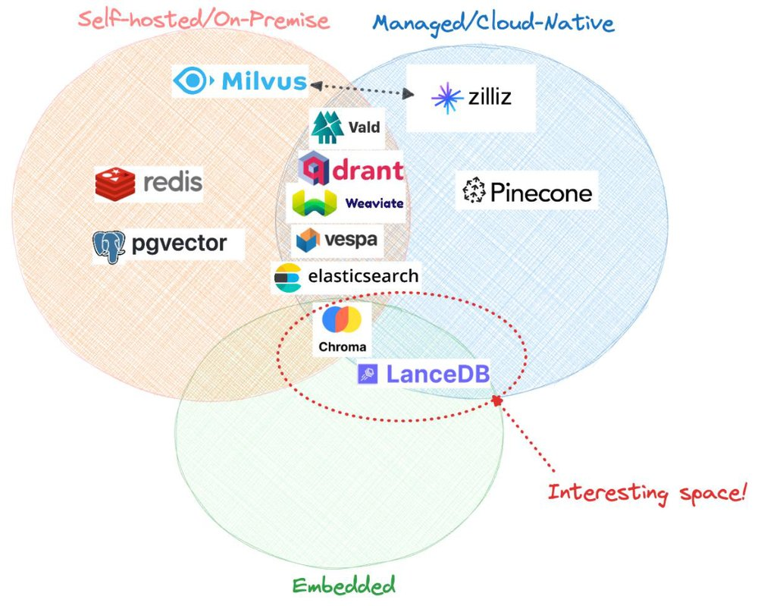

Chroma is a good open source choice. ..recomended if whanted to look at it, one he has used before… used in basic LLM pipelines….

Document Clustering
- Unsupervised document retrieval
- Initial focus wa staking a query and finding mest matches
- This next section is more abuot clusteting of docuemtns… user query may come later… so this is a pre-lude to that query coming in
- This is clustering similar docs together -thematics that we figure out from the docs themselves… i..e new documents

What is (Document) Clustering?
- Clustering is the process of automatically sorting items into sets with similar features. Clustering is used widely when we want to explore the data which is maybe not labelled already.
- We can cluster documents into groups to help some algorithms, but also to help people get a better view on topics. Clustering doesn’t require someone to add the labels manually.
- Example of document clustering in process: Google News
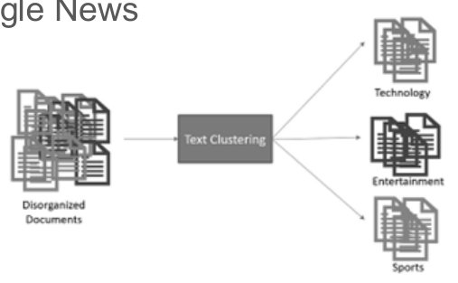
- 100s/1000s docs each day
- All independent
- Google news >> docs on same topic >>>. E.g. strike last week all indy docs clustered together as a single doc
- U Mid terms >> relevant docs clustered together
- Not done on user giving a set of thematics>> instead that matching come sout during the process itself… not suer defined….

Document Clusters identified by Google News
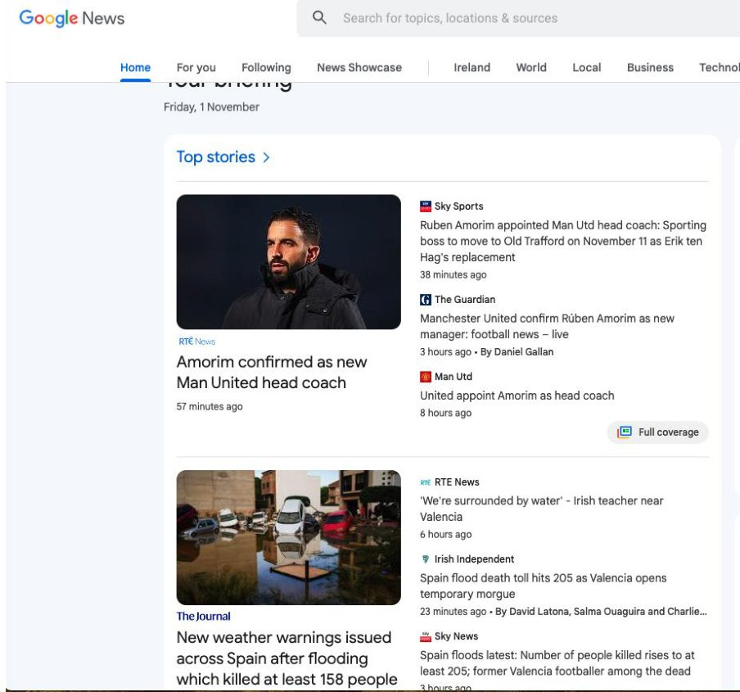

- Number of different approaches … and more than what we will do
- Also…
- Not about processing users query itself btu maybe will give you a nice back end so fi a user query comes in can get all docs that are sematicalyl related to suers query and have clear cut off to the user… so show everytijn in cluster that sclosest to them and ignore everything else…

A Basic Approach: K-Means Clustering
- K-Means clustering is an unsupervised clustering algorithm which takes as a parameter n, the number of clusters expected. It then returns to us n points in the data space. Each of these points is interpreted as the centroid of a stable cluster in that space.
- https://neptune.ai/blog/k-means-clustering
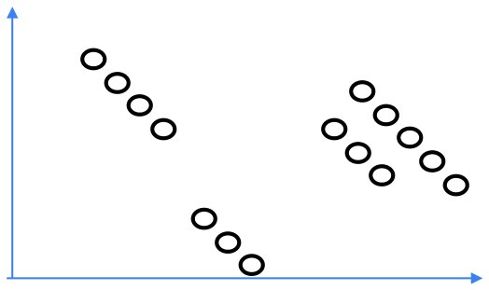

EXAM – have put it in before.. woeth knowing.. Mohamed may or may not…
In real world wil have more than 2 dimensions….

A Basic Approach: K-Means Clustering
- K-Means clustering is an unsupervised clustering algorithm which takes as a parameter n, the number of clusters expected. It then returns to us n points in the data space. Each of these points is interpreted as the centroid of a stable cluster in that space.
- https://neptune.ai/blog/k-means-clustering
- Step 1: Randomly initialize n centroids
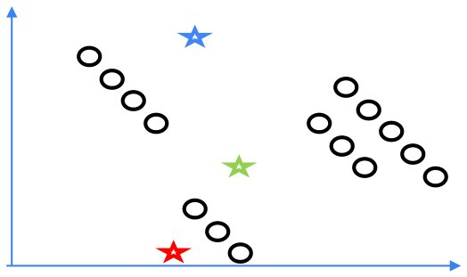

A Basic Approach: K-Means Clustering
- K-Means clustering is an unsupervised clustering algorithm which takes as a parameter n, the number of clusters expected. It then returns to us n points in the data space. Each of these points is interpreted as the centroid of a stable cluster in that space.
- https://neptune.ai/blog/k-means-clustering
- Step 1: Randomly initialize n centroids
- Step 2: Assign each object to its closest centroid
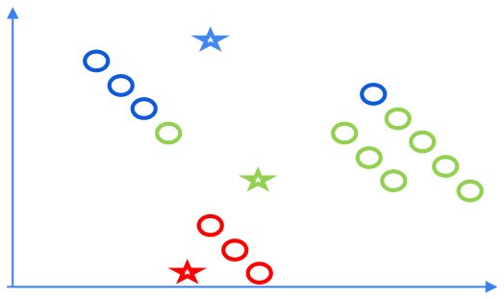
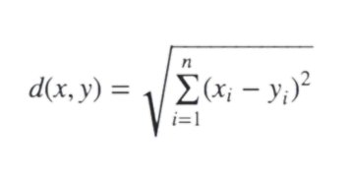

- Everythgin mapped as closest to thgins
- Centroids are not in middle of thse mapped to them
- Move red centroid and shift it
- Move grene centroid…
- etc

A Basic Approach: K-Means Clustering
- K-Means clustering is an unsupervised clustering algorithm which takes as a parameter n, the number of clusters expected. It then returns to us n points in the data space. Each of these points is interpreted as the centroid of a stable cluster in that space.
- https://neptune.ai/blog/k-means-clustering
- Step 1: Randomly initialize n centroids
- Step 2: Assign each object to its closest centroid
- Step 3: Move centroids to be in the middle of their datapoints
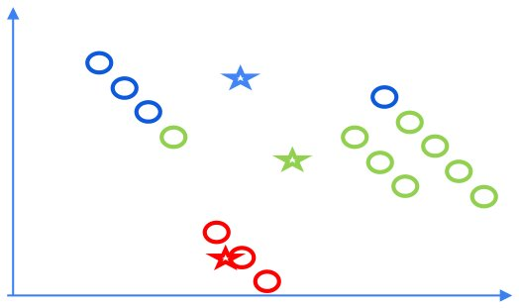
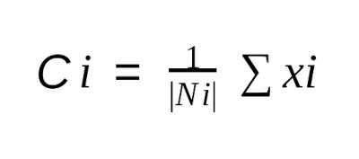

Do it again
Move centroids to middel fo clusters
Repeat… iterate… repeat… = > converge to a centroid closest to your
Guaranteed to converge BUT 2 catches
- We randomly initialised those initial clusters…
- not guaranteed you will find bet set of clusters with algo
- don’t know how many clusters there will be
  - just guaranteed they will converge… could end up with completely different clusteres set fo documents..
  - Run it a couple fo times and take the aveage
  - .. on avgeage it does work…

Can use it on other stues of media.. amd multiple styles of epresentation

A Basic Approach: K-Means Clustering
- K-Means clustering is an unsupervised clustering algorithm which takes as a parameter n, the number of clusters expected. It then returns to us n points in the data space. Each of these points is interpreted as the centroid of a stable cluster in that space.
- https://neptune.ai/blog/k-means-clustering
- Step 1: Randomly initialize n centroids
- Step 2: Assign each object to its closest centroid
- Step 3: Move centroids to be in the middle of their datapoints
- Step 4: Update assignments.
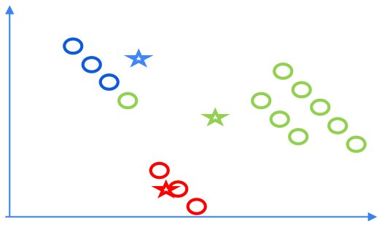

A Basic Approach: K-Means Clustering
- K-Means clustering is an unsupervised clustering algorithm which takes as a parameter n, the number of clusters expected. It then returns to us n points in the data space. Each of these points is interpreted as the centroid of a stable cluster in that space.
- https://neptune.ai/blog/k-means-clustering
- Step 1: Randomly initialize n centroids
- Step 2: Assign each object to its closest centroid
- Step 3: Move centroids to be in the middle of their datapoints
- Step 4: Update assignments. Repeat steps 3 and 4 until convergence
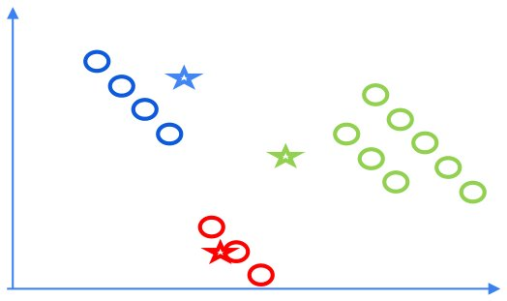

On K-Means Clustering
- While the algorithm is guaranteed to stop, you aren’t guaranteed to get the global optimium set of clusters
  - Running again with a different set of initial candidates could give a better result
- K-Means requires a guess of the number of clusters which is not always easy
  - Unless you have a good knowledge of how many clusters there should be, trying different values of n will result in different quality clusters.
  - Consider the example in the last slides. What would the clusters look like if there had been maybe 4 or 2 clusters suggested?

K-Means Clustering for Documents
- https://medium.com/@danielafrimi/text-clustering-using-nlp-techniques-c2e6b08b6e95
- We can directly use K-Means to cluster documents.
- Importantly, we can do this with different types of representations.
- Clustering based on TF-IDF might seem like the most transparent, but clustering based on document embeddings will usually provide better results
  - Why?
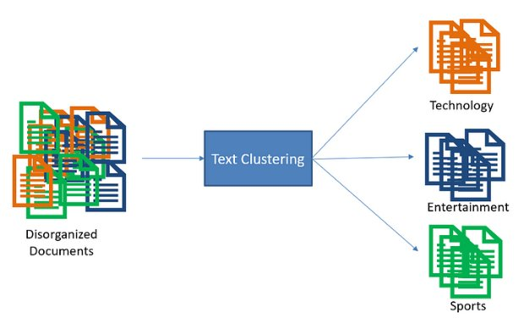

Question
Might seem using representation like this is best for TF-IDF … but in fact can work with embedding and distributed embedding….
Tf-idf doesn’t generalise well, captures noise…
Vectors capture geenralsie meaning.. capture generalised meaning…differences can be small as some items pretty close in same space.. tf-idf will find grouping of similar meaning and not just subtleties of hwo thigns ar phrased…
Cosin sim and other simalr metrics can eb sued with different representation types… will come back to it…

Evaluating Clusters I
- Extrinsic Measures - If we have access to the ‘correct clusters’
- Homogeneity: Each cluster contains only members of a single class (somewhat like “precision”)
- Completeness: All members of a given class are assigned to the same cluster (somewhat like “recall”)
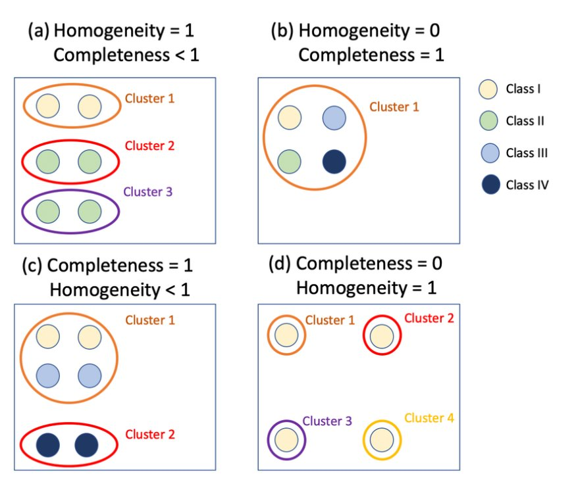

- Extrinsic measure – dependent on gold label info about clusters… so we don’t have labels we can have whe testgin algos have abels and cansue measures to our set of labels to others…

- Keep in miond that wording of labels is arbitrary here.. don’lt carea bout words of labels.. but will amct up sets of correpsondign labels…
- Might have in news dataset fact that these articles correspond to election / budget / movei review.. have that in gold standard..
- Algo k means clustering will not come up with those labels….
- K mean will just give you cluster A / cluster B / cluster C etc
- Can figure this out… relatively easily…
- Homegeinerty of clusters = only elements that are relevant to that cluster = … like orecision
- Completeness of cluster = all the thigns that shoudjl eb in the setg are they in the set?

Evaluating Clusters II

Intrinsic Measures - If we don’t have access to the true labels.
  - Measures how similar a data point is to its own cluster compared to other clusters.
- This is the basic principle of the Silhouette Algorithm
- The silhouette algorithm measures how well a data point fits within its assigned cluster compared to the nearest neighboring cluster by calculating a score from -1 to +1 based on the difference between its average intra-cluster distance and its average nearest-cluster distance.
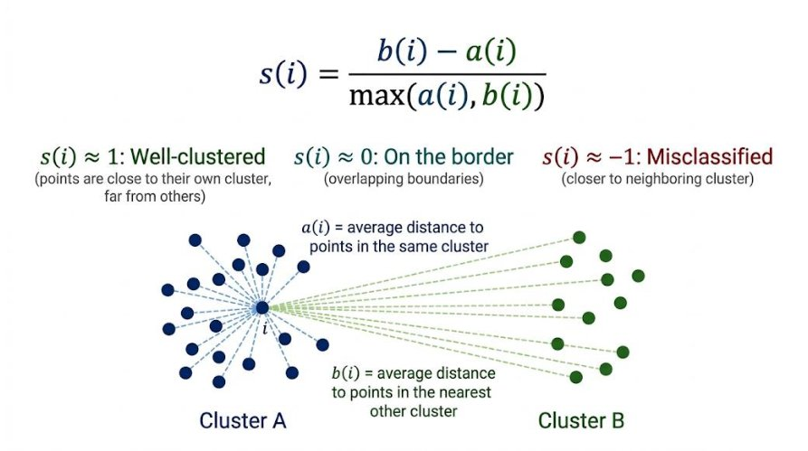

- With no knowledge can you predict something meaningful about the cluster
- Silhouette score / co-efficient
- Take indy as part of cl uster and measure relative distance between an indy the bits in its cluster vs the distance to the bits in other lcusters.. and basically in a good clustetin approach (not efficient to run) trying to calculate a ratio that saya if my data is close to cluster its in but far awyah from all other clusters…
- If equadisatnt to all other cluisters thatd bad…
- Metic def is in the slide…
- EXAM - Have a look through that…. Make sure you know.. email if have questions non it…

Lab Work

K Means Clustering for Documents
- See Lab

References
- https://www.techinquisitive.com/post/information-retrieval-with-python
- https://www.researchgate.net/figure/Figure4DocumentrepresentationintheVectorSpaceModel22_fig1_312471174
- https://towardsdatascience.com/9-distance-measures-in-data-science-918109d069fa
- https://towardsdatascience.com/whats-the-deal-with-accuracy-precision-recall-and-f1-f5d8b4db1021
- https://towardsdatascience.com/evaluation-metrics-for-recommendation-systems-an-overview-71290690ecba#:~:text=Recall%20%40K,10%20movies%20for%20every%20user
- https://www.linkedin.com/pulse/choosing-vector-database-your-gen-ai-stack-abhinav-srivastava
- https://neptune.ai/blog/k-means-clustering
- https://medium.com/@danielafrimi/text-clustering-using-nlp-techniques-c2e6b08b6e95

Week 7 – 2nd Nov 2026

Assignment 1 – 19th Oct 2026 given out…
- Giving out tonight
- It’s a complicated version and Mohammed will give out a slightly easier /simplified one

- Building up representati and using differet tools to loka t those
- Using systems based on LLMs to do certain types of tasks to do no plain text.. for health infor fpr example.. an perfor atsks on it…
- Different elements to the assignment are straight forward and quite do-able…
- Approach
- Always been an issue people not doing their own assignments etc… fiver.. etc…
- Now LLMs can do it.. and will work through it and get most of it done… so version that have always done… has always had aspects to deal with that… in terms of like oral exams… q and A’s btu they basically talk about their materials and know their materials…
- Fll in yor journal as you’re gong along… but now jusy interi deliverables… spec is long as its not simplay asking to do code generation… but instead btis in there demonstrating understangin needs of what you need ot do and evaluating your own work.. and proving that evaluation…
- Worth 50% of module provision submisino dat 14th Dec 8pm…
- After thatg Oral in January… rcorded in Teams and marks for mduels dependent on that oral exam
- This is a provisional assignment.. Mohamemd will get modificatinos out to us… and we’ll see if he changes over next week…
- Use local LLMs to your machine using Ollama
- Over next week --sit down and put together aplan and make sure its clear…..
- Very first part of assignment >>>> is simply settgin yourself up to do the assignment… Do Not leave it until Lastg minute… >> shared assignment report.. and share that with edit access ot Mohamemd.. so can look at revision history fo the document…
- Shar a gothub repo >> that’s how to share your code..
- Inatll OLLama to your machine,,
- Put together
- Want covering own experience doing th eprojectga nd yhuor view of the results… rpesent your interpretation o fthe results what they mean to you…

Assignment 2025/26
Value: 50% of the module. Project submission due Sunday 14th December at 20:00. Oral assessment in January.
This is provisional and subject to Muhammad’s final modifications before the 26th. .

Overview
This is the specification for the main assignment of the Natural Language Technology class.
The assignment runs as a single connected investigation. You build a corpus and characterise it, build a retrieval system and measure how well it works, then build a question-answering system over a clinical dataset and measure how and where it fails. Each part supplies material to the next, so it is worth reading the whole specification before starting.
The consistent theme is evaluation. Building these systems is now the easy part; establishing whether one works, whether it works better than something simpler, and where it breaks, is the difficult part and is where most of the marks are.
Your implementation should be made in Python running on your own local machine, using Ollama to provide LLM support. The recommendation is to run a small local instruct model — something in the 7–9B range from the Gemma, Llama or Qwen families — and to note in your report exactly which model and quantisation you used, since your results depend on it. You may call Ollama through LangChain or directly through its API, whichever you prefer. Other libraries named in individual parts below are required where they are named.
Note that you cannot use an alternative dataset to those specified in this brief.

Assessment
There are three assessment points: one project submission, one short online checkpoint during the semester, and an oral assessment in January.
Component | % | Format
Project — Parts 1 to 4, submitted together | 27 | Own time, one submission on 14 December
Online checkpoint | 5 | Individual 5-minute conversation online, w/c 24 November
Oral assessment | 18 | Individual 20-minute conversation in person, 12 January
Assignment total | 50

Within the project submission, marks are divided as follows: Part 1 — 4%, Part 2 — 7%, Part 3 — 8%, Part 4 — 8%.
Your oral assessment mark sets a ceiling on the marks awarded for the project. The rule is set out in full under Oral Assessment below. In short, you may use AI tools freely on the project, but you must be able to explain, modify and justify everything you submit.

Key dates
Date | What is due | Component
Sat 8 Nov | Repository, shared report document and working Ollama call committed | Part 1
Fri 14 Nov | PREREGISTRATION.md committed to your repository | Part 1
w/c 24 Nov | Online checkpoint — booked 5-minute slots | Checkpoint
Fri 28 Nov | Deadline to request an adjusted oral assessment format | Oral
Sun 14 Dec, 20:00 | Report and repository submitted | Parts 1–4
Mon 12 Jan | Oral assessments — booked slots, in person | Oral

Task Specification – Parts 1 to 4

Part 1: Initial Set Up and Pre-registration — 4%
In Part 1 your task is to set up the processes for successfully performing the rest of the assignment, and to commit to a plan before you have any results.
- Set up a shared “assignment report.docx”. The main report should be saved to your official TU Dublin OneDrive folder and shared with me as an examiner with edit access. This document will be your main report and the final version will be submitted at the end of the semester via Brightspace. It is shared so that I can see the work in progress and give you feedback on it during the semester.
- Set up a private GitHub repository just for this assignment and share it with me. All code lives here.
- Install Ollama to your local machine or appropriate development environment and pull a small local instruct model.
- Configure your development environment with access to your repository, and commit code which demonstrates a successful call to an Ollama model. These gatepost steps should be completed by 8 November.
- Commit a one-page PREREGISTRATION.md by 14 November, as set out below.

Pre-registration
Two of the four marks for Part 1 are for the pre-registration. Written before you have results, it must state:
(i) the three document encoding and similarity approaches you will compare in Part 3, and the order in which you expect them to rank, with a sentence of reasoning for each;
(ii) the two system architectures you will compare in Part 4, and which you expect to perform better, on which kinds of question;
(iii) for both parts, roughly how large a difference you expect, and the rule you will use to decide whether a difference you observe is real rather than run-to-run or query-to-query noise;
(iv) one sentence on what result would surprise you.
You are not marked on being right. The marks are for the quality of the reasoning behind your predictions, and later, in the report, for your account of where prediction and observation diverged and why. A pre-registration vague enough that nothing could contradict it scores poorly. A confident prediction that turns out to be wrong, well explained afterwards, scores highly.
The file is timestamped when you commit it and should not be rewritten afterwards. If your plan changes, which is normal, add a dated entry to the bottom of the file explaining what changed and why.

Part 2: Building and Characterising a Corpus — 7%
You will assemble two corpora and compare them: one that you generate with your local model, and one of real documents from the same broad domain.

The synthetic corpus
Using your Ollama model, synthesise at least 100 documents of at least 400 words each. The domain is up to you — news reports, product reviews, case notes, incident reports, short biographies — but choose one domain and stay in it, and make sure the documents contain named entities for later analysis. Save each document to an individual local file. Record the prompts, the model, the temperature and any seed you used; these belong in an appendix and they are part of the method, not a compliance exercise.

The real corpus
Assemble a comparison corpus of at least 100 real documents of comparable length in the same domain. Any of the following are acceptable sources, and you should state clearly which you used and how you obtained it:
- PubMed abstracts retrieved through the NCBI E-utilities API;
- the 20 Newsgroups or Reuters-21578 collections, available through scikit-learn and NLTK respectively;
- Dáil or Seanad debate transcripts from data.oireachtas.ie;
- public domain texts from Project Gutenberg, segmented into documents of comparable length.
If you would like to use a different real source, ask me first. Do not use a source that requires a licence you do not hold, and do not scrape a site whose terms forbid it.

Descriptive analysis
Using spaCy and other relevant text processing tools, perform a descriptive analysis of both corpora. Report, for each corpus and with the two placed side by side:
- named entities: density per thousand tokens, the distribution across entity types, and the number of distinct entities relative to the number of entity mentions;
- TF-IDF vectors for each document with respect to its own corpus, and the top terms for ten randomly selected documents from each;
- lexical diversity: type–token ratio measured over fixed-length windows, and the shape of the vocabulary growth curve as documents are added;
- sentence length distribution, not just the mean;
- near-duplicate rate within each corpus, using a method of your choice which you describe and justify.
The analysis is the deliverable, not the numbers. For every measure where the two corpora differ, say what in the generation process you think produced the difference, and what it would do to a system built on top of that corpus. Where they do not differ, say so — that is also a finding, and an interesting one.
Your report must state at least one property of your synthetic corpus that you did not anticipate before measuring it, and what you did about it.

Part 3: Retrieval over your Corpus, Properly Evaluated — 8%
Build a Python interface that supports queries over your corpora. The interface takes a chunk of text and returns a ranked list of documents by similarity. It must implement at least three different approaches to document encoding and similarity measurement — the three you named in your pre-registration. A reasonable set would be a lexical method, a static or averaged embedding method, and a neural sentence embedding method, but the choice is yours provided the three are genuinely different in kind and you say why you chose them.
This should be done with code and tools similar to what we have looked at in class. An existing end-to-end vector database or graph database solution should not be used for this task, though you may use one elsewhere in the assignment.

Building a test collection
A ranked list is not a result until there is something to judge it against. You will therefore build a small test collection of your own:
- Write 15 queries against your corpus. They should vary in difficulty and in kind — some answerable by keyword match, some requiring a paraphrase or a synonym to be bridged, some deliberately ambiguous.
- For each query, pool the top 10 results returned by each of your three systems, plus the random baseline, and remove duplicates. You judge only this pool, which is what makes the exercise tractable.
- Write down your relevance criteria before you judge anything, then judge each pooled document as relevant or not relevant. Include the criteria in an appendix.
- Have somebody else — a classmate, a friend, anyone willing — independently judge a sample of at least 30 query-document pairs, and report the agreement between you. Name them in the acknowledgements and make sure they are happy to be named.
Pooling in this way means your measured scores are optimistic, because relevant documents that none of your systems retrieved were never judged. Say so in your report and say roughly how much you think it matters.

Evaluation
Report precision@5, mean reciprocal rank and nDCG@10 for each of your three approaches, together with:
- two mandatory baselines: a random ranking, and a lexical TF-IDF or BM25 ranking;
- the per-query spread, not only the mean across queries;
- an explicit statement, for each pair of systems you compare, of whether the difference between them is larger than the query-to-query variation, and therefore whether you are entitled to claim that one is better.
Failure analysis. Pick the three queries on which your systems disagreed most and work out why. This is worth more marks than a fourth encoding method would be.
The cross-corpus question. Run your best system over both the synthetic and the real corpus and report what changes. Relate the answer to what you measured in Part 2.

Part 4: Question Answering over Clinical Data — 8%
Here we switch from your own corpus to a small clinical dataset. You will be provided with patients.csv and dictionary.csv. patients.csv contains information on 1000 individual patients who suffer from a particular disease. All data in this dataset is synthetic. All but one of the columns can be thought of as predictive features, with the feature “survival” being a target: it measures the number of years the patient survived. A researcher might, for example, try to build models investigating which variables predict survival.
Your task is to build a system that lets a user ask questions about this dataset in natural language, using your local model, and then to find out how well it actually works.

Build at least two architectures
Implement at least two genuinely different approaches — the two you named in your pre-registration. For example:
- placing the data, or a summary of it, directly into the prompt context;
- a RAG approach over row-level or group-level serialisations of the data;
- a tool-using or agentic approach in which the model emits a query — SQL, pandas, or a constrained function call — which is executed and whose result is returned to the model.
Describe what each approach can and cannot represent about a table of 1000 rows before you report any results.

Build a gold question set
Write 30 questions and compute the correct answer for each directly, with pandas or SQL, independently of your LLM system. This is your ground truth. The set must contain:
- 10 lookup and filtering questions (“how many patients over 60 have …”);
- 8 aggregation and comparison questions (“what is the mean survival for group A against group B”);
- 7 multi-step questions requiring more than one operation;
- 5 questions that the dataset cannot answer, because the column does not exist, the data does not support the inference, or the question is a causal claim the data cannot establish. For these, the correct behaviour is a clear refusal or a statement of what is missing.
Commit the question set, the gold answers, and the code that produced them.

Evaluation
Run each architecture over the full question set at least three times, with the temperature fixed and stated. Report:
- accuracy broken down by question type, not only overall;
- variation across the three runs, and whether the difference between your architectures is larger than that variation;
- the rate at which the system produced a confident answer to an unanswerable question, which is the single most important number in this part;
- for numerical answers, how you decided what counts as correct, and what tolerance you allowed.
Failure analysis. Categorise the errors you observed and give an example of each. Fabricated values, correct method applied to the wrong column, arithmetic errors, misread dictionary definitions and plausible-sounding but unsupported causal claims are all different failures with different fixes. Say which of them you could design out, and how.
Fitness for purpose. Close this part with half a page on what would have to be true before a system of this kind could be put in front of a clinical researcher working with real patient data. Ground it in your own measured numbers rather than in general remarks about AI safety.

Reporting Requirements
These apply across Parts 2, 3 and 4 and are marked within each of them.
- Baselines. Every system is reported against the simplest thing that could have worked instead. A method that does not beat its baseline is a legitimate finding and is marked as such, provided you identify it and say so.
- Variation. Language model outputs are stochastic and small evaluation sets are noisy. Nothing is reported as a single number where a spread is available, and no difference is claimed as an improvement without a statement about whether it exceeds the noise.
- Null results. Your report must contain a short section listing the comparisons in which you found no effect you can defend, and why you think that is. A report in which every comparison came out as predicted will be read as a question about experimental control rather than as a strong result.
- Reproducibility. Model name, quantisation, temperature, any seed, library versions and hardware are stated. Somebody should be able to read your report and know what they would need to repeat it.

Online Checkpoint — 5%
In the week of 24 November you will book a five-minute individual slot online. Bring one result you have obtained so far — a corpus statistic, a retrieval score, an output from your Ollama model, anything you have actually run — share your screen, and talk me through it.
You will be asked what the result shows, what you expected, and what you intend to do next. There is nothing to prepare beyond having done some of the work, and no marks depend on the result being good or the project being on schedule. Missing the checkpoint without a documented reason scores zero for this component.

Oral Assessment — 18%
On 12 January, each student has an individual 20-minute conversation with me about their own submitted work. This takes place in person; an online alternative is available only where personal circumstances have been documented and approved. You will have your own repository and report open in front of you and may refer to them freely throughout.

Structure
The conversation follows the structure below, and sample questions of each type will be circulated on 8 November.
- Orientation (2 min) — walk me through your repository and tell me where things are.
- Accounting for a result (5 min) — I pick one result from your report and ask you to explain it and how confident you are that it is real.
- Counterfactual (4 min) — what would happen if we changed one thing, and why.
- Live micro-modification (4 min) — where in your code would a specified change go, and what else would have to change with it. You are not asked to write working code under time pressure.
- Diagnosis (3 min) — I show you an output from one of your own runs and ask you to interpret it.
- Limits (2 min) — what is your system bad at, and what in your evaluation could have hidden that from you.
Marks are for the substance of what you say, not the fluency of your delivery. Hesitation, thinking out loud, correcting yourself, and saying “I don’t know, but here is how I would find out” all score perfectly well. There is no criterion for confidence or presentation.

The oral cap
Your band in the oral assessment sets a ceiling on the marks awarded for the project. It does not affect the marks for the checkpoint or for the oral itself.
Band | Descriptor | Cap | What this looks like
4 | Full command of the submitted work | No cap | Explains design choices and why alternatives were rejected; interprets own results unprompted; answers counterfactuals about the work
3 | Sound understanding, some gaps | 70% | Explains what was done and why; hesitant on parts of the pipeline; recovers with prompting
2 | Partial understanding | 55% | Describes the work accurately but cannot account for specific choices or specific numbers; cannot answer counterfactuals
1 | Familiar with the work only as a reader | 40% | Can summarise the report but cannot locate anything in the code or explain any number in it
0 | Cannot account for the submitted work | 0% | Referred to the unfair practice process

Arrangements
- Sample questions of each type are published on 8 November.
- Slots are booked through a scheduling link circulated in December. Orals are recorded so that a second marker can moderate and so that there is a record if you wish to query your mark.
- If you have approved accommodations, or if there is anything about this format that would disadvantage you, contact me by 28 November and an adjusted format will be arranged.
- Attendance is required. Not attending without a documented and approved reason means the project cannot be awarded marks.

Submission Specification

Report
The report should be 8–12 pages in length and formatted as per the current document: standard margins, 11pt Arial font, 1.15 spacing between lines, and approximately 4pt spacing between paragraphs. Appendices sit outside this limit.
The first page is a standalone cover page and should include your name, your student number, your declaration of AI use, and the following statement:
“I confirm that the document and related code here is all my own work, that I can explain and defend all of it, and that I did not engage in unfair practice in any way.”
Do not waste space on a table of contents.
This report should be a well written, suitably structured and appropriately referenced document that justifies decisions, provides results as well as your analysis. The report should not give a background explanation of Natural Language Technology or related models, and should not simply describe the systems that were built. Instead, write it as a narrative of your investigation, clearly showing the major steps taken, any dead ends and any learnings. The following sections should minimally be included:
- Part 1, including what you pre-registered and where prediction and outcome diverged;
- Part 2;
- Part 3;
- Part 4;
- Null results, drawn from all parts;
- AI collaboration critique (see below);
- Appendices, which do not count towards the page limit, and which should include your generation prompts, your relevance criteria and your gold question set.

Code and data
Code is submitted via the shared GitHub repository. A requirements.txt should be generated and maintained to list the packages needed to run your code. Some flexibility on style will be given so long as the marking scheme is adhered to.
The repository must also contain your synthetic corpus, the script that retrieved or assembled your real corpus, your 15 queries with their relevance judgements, and your 30 gold questions with their answers and the code that computed them. If a corpus is too large for the repository, commit the retrieval script and a manifest instead, and say where the data lives.

Conditions of submission
The following are conditions of submission rather than marked criteria. Work that does not meet them will not be marked:
- a private GitHub repository shared with me, containing all code, data or manifests, and PREREGISTRATION.md;
- a report shared with me on OneDrive with edit access, and the final version submitted via Brightspace;
- code that runs from a clean checkout following your own README, against a locally installed Ollama model;
- attendance at your scheduled oral assessment.

Use of AI Tools
You may use AI tools freely for the project. You are not required to log the prompts you used to write your code and no marks depend on doing so. The prompts you used to generate your corpus in Part 2 are a different matter — those are part of the method and must be reported.
You are required to declare, in one short paragraph on your cover page, what you used and for what — for example, “used an LLM to draft the retrieval evaluation harness, to debug a spaCy pipeline error, and to redraft section 3”.
Everything you submit is yours to defend. You may not submit code or text that you could not explain, modify or justify if asked. The oral assessment is where this is checked and its outcome takes precedence over the submitted artefacts. AI detection tools are not used and their output is not treated as evidence.

AI collaboration critique
Include a section of approximately half a page in your report describing two specific occasions on which an AI tool gave you a suggestion that was wrong, subtly incorrect, or worse than the alternative. For each, give the suggestion, how you established that it was wrong, and what you did instead.
Generic reflection on the limitations of AI scores nothing; specific, technical, verifiable instances score well. If you used these tools throughout and never caught one in an error, report that instead and say what it suggests.

Unfair Practice
Copying text or code from other sources without appropriate acknowledgement is unfair practice, including self-plagiarism, and is subject to a grade of 0 on the relevant parts of the assignment and, or, full disciplinary procedures. The checkpoint and the oral assessment are individual, closed assessments, and assistance of any kind in those is unfair practice. If you are in doubt about anything here, ask me.
For reference, here is the Students’ Union guide to unfair practice: https://www.tudublinsu.ie/advice/exams/breachesofregulations/

Marking
Parts 1 to 4 are marked against the descriptors below, applied to each part separately and then subject to the oral cap. The checkpoint and the oral are marked against their own published rubrics.
Band | Descriptor
70–100% | The work is correct and the analysis is insightful. Evaluation is sound: baselines are present, variation is quantified, claims are proportionate to the evidence, and the limits of what can be concluded are stated without being asked. Failure analysis identifies mechanisms rather than listing symptoms. The report reads as an account of an investigation, including where it went wrong.
60–69% | The work is correct and competently analysed. Baselines and variation are handled properly. Analysis explains what happened but is thinner on why, and some claims run slightly ahead of the evidence.
50–59% | The work is largely complete and the results are reported accurately, but the analysis mostly describes rather than explains. Baselines may be present but under-used. Differences are claimed without much attention to whether they are real.
40–49% | The required elements are present but the treatment is mechanical. Systems are reported without baselines or without acknowledgement of variation, and the discussion does not go beyond restating the numbers.
0–39% | Elements are missing, results are not reported in a usable form, or the analysis is absent or incorrect.

Submission Details
The project is due at 20:00 on Sunday 14 December. Extensions will not be granted except in the case of documented and approved personal circumstances. Late submissions will be deducted 2 percent per day for each of the first two days late, and then 1 percent per day for each day thereafter, until a final deadline of 7 January.
All students should be available for their oral assessment on Monday 12 January. This date may be adjusted due to exam schedules in collaboration with you.

Video Recordings

- Week 1 – intro – 14th Sept 2026 – teams video embedded
  - Started 22:40… continue from there,,,
- Week 1 – Lab -not sure?
- Week 2 – intro – 21st Sept 2026 – teams video embedded
- Week 2 – Lab - half done .. don’t’ think did normalisation part.. maybe re check..
- Week 3– intro – Text and Dialogue - 28th Sept 2026 – teams video embedded
  - Done watche back
- Week 3 – Lab – still to do
  - Glove and TF-IDF
  - Vector embeddings and text representatinos
- Week 4 – intro – Language Output Tech – speech Synthesis - 5th Oct 2026 – teams video embedded
  - done
- Week 4 lab – cloning your own voice.. did it in class
  - Could do again…

- Week 5 – 12th Oct 2026

