Assignment 1 – Part 1 – Conceptual Design

This assignment will create a database schema for a provided scenario. Yu can read through the document form start to finish and it will go through the process logically from start to finish. You can go to different sections based on the headers if you wish to look at a particular area.

Our City Bikes
A bike rental company

Business Requirements – Initial Specification
A public rental bike company (OurCity Bikes) has hired you to design their database. Their initial requirements are:
- The Company owns a number of bicycles and stations across the city.
- Each bicycle and station are identified using an ID.
- Each station has a number of parking slots which can be available or unavailable (in use). The stations also have characteristics associated with them, for example whether you can pay with card or not.
- Users of the scheme have to register in order to obtain their bike card.
- The company needs to identify each trip across the city to calculate charges (Charges apply after 30 minutes of continuous use). User will have stored their payment details at registration so the charges can be processed automatically.

Business Requirement - Nouns and Verbs/Adjectives outline
The following is an outline of the initial spec with nouns and verbs highlighted to help us identify the entities and relationships for our database entities
- The Company owns a number of bicycles and stations across the city.
- Each bicycle and station are identified using an ID.
- Each station has a number of parking slots which can be available or unavailable (in use).
- The stations also have characteristics associated with them, for example whether you can pay with card or not.
- Users of the scheme have to register in order to obtain their bike card.
- The company needs to identify each trip/trip across the city to calculate charges (Charges apply after 30 minutes of continuous use).
- User will have stored their payment details at registration so the charges can be processed automatically.
Green = noun
Blue = verb/adjective

Entities
The following is a list of possible entities. Potential entities not being used in the initial database design are struckthrough and highlighted in red.
- Company (only 1)
- Bicycle Definition
- Bicycle Rental Copies
- Stations
- City (only 1)
- Parking slots
- User
- Bike card
- Charges
- Trip – is transactional so will be a result of user taking a bike, hence removing, expect to return as bridge entity between bike instances and user

Relationship Table
The following table outlines how the various entities are related to each other.
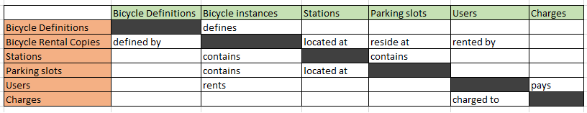

Rough ER Diagram
The following rough ER Diagram provides a high level overview of the entities, attributes, relationships and primary keys.
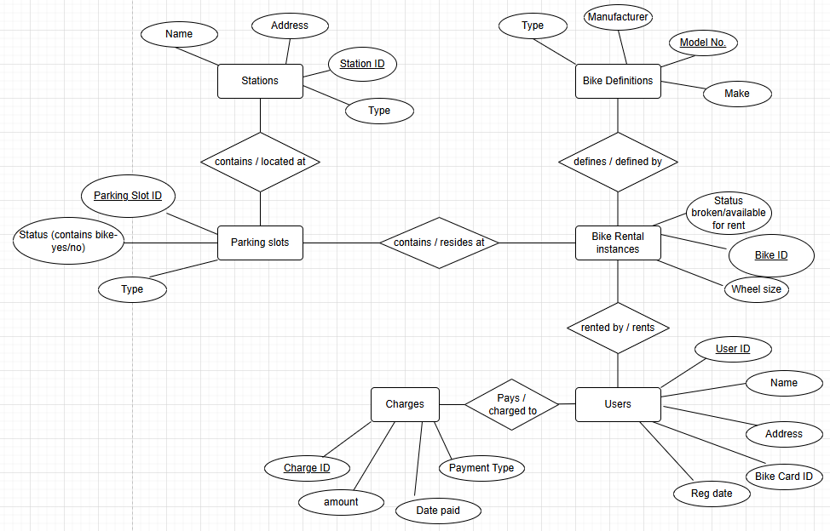

Primary Keys
The following is a list of proposed Primary Keys(PKs). PKs must be uniquely identifiable to allow us uniquely identify the associated data.
- Stations entity = Station ID
- Parking slots entity = Parking slot ID
- Bike Definition = Model No.
- Bike Rental Instances = Bike ID
- User = User ID
- Charges = Charge ID

Fully Keyed – ER Diagram
The following is a fully keys, ER diagram. It contains entitles, attributes, Primary and Foreign Keys, cardinality, identifying and non-identifying relationships.
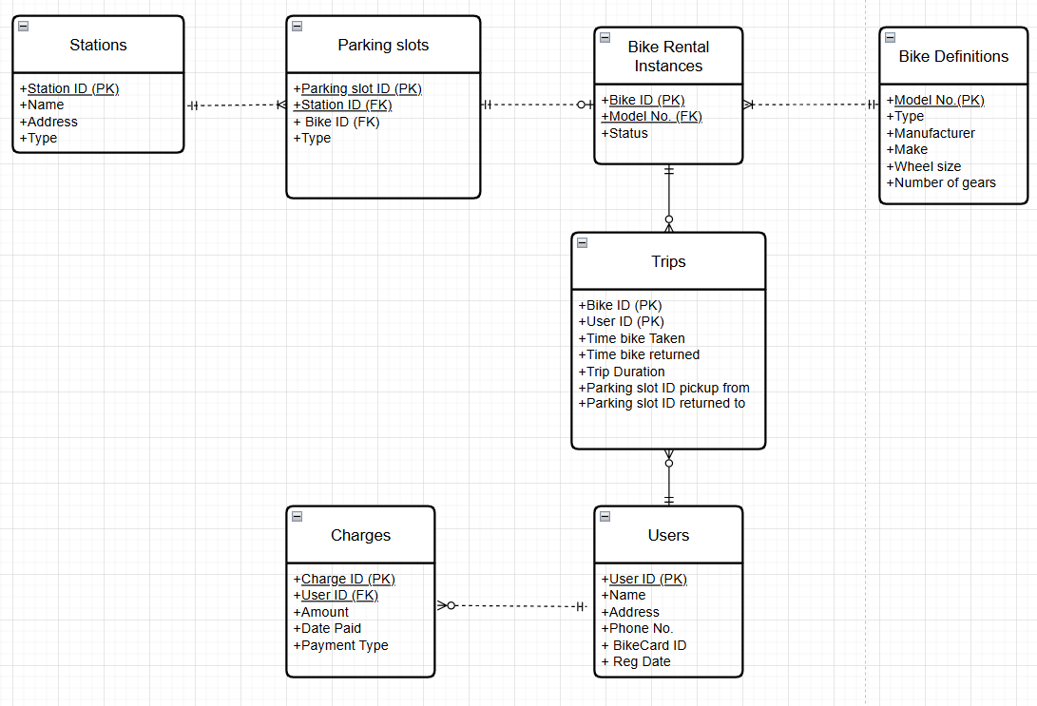

Assumptions
The following is a list of assumptions that helped us define requirements and details during our design.
- Company only operates in one city – hence no need to have entity for city
- Stations are different to parking slots – stations contain parking slots
- Need to retain historical data for Trips and Charges for reference and query.
- Registration - There is no registration fee payable by users.
- Registration - requires submission of payment details and a reg ID is then issues along with a Bike card which has its own unique identifier. Users will tap the Bike card against a card reader at a station to identify themselves before taking a bike.
- Registration - renewal is required annually.
- Registration - There is no charge to register but a payment method is required i.e. credit card, bank card.
- Registrations- no group registrations or IDs are allowed. Individuals only.
- User - A user may have no charges, and may never pay a charge if trips are under charging duration period, charges must be associated with a single user.
- Parking slot – Is occupied attribute is included as real time detail of availability of parking slots and number of bikes available is continuously being required by users, so they can determine quickly where they can pick up and return a bike. This attribute should speed up this process.
- Parking slots - all have same slot + bike connection type allowing any bike to be docked at any parking slot.
- Parking slots - At any particular time a parking slot can only host one bike, we do not need to keep historical data on which parking slot a bike was historically located. Parking slots will have periods of time when they do not have any bike, as such containing a bike is optional
- Parking slots – will have Bike ID as an additional FK – will be empty(null) if no bike is present at parking slot. This will allow us locate a Bike and also allow us know if a parking slot is available or occupied quickly. Quick data in relation to this is essential for customers to allow them know where they can pick up and return a bike.
- Staff. We have not included any data on staff. Staff are not directly associated with users, bikes, stations or transactions. Once a user is registered and has their bike card, all transactions are automated and involve no interaction with staff. As such it is assumed they will be managed separately in a HR database.
- Bike instances – status – this is whether a bike is available for use or not. It could be for a variety of reasons, currently in use, theft, damaged.
- Bike Instances to Parking slot – cardinality, we assume we are not interested in historical locations of bikes, i.e. which parking slots they have been located at, as such we have a one and only 1 relationship.
- Trips – a User may be set up and never rent a bike, hence the optionality between user and trip. Also a bike instance may exist but never be used on a rental, hence the optionality there. This may be low likelihood but still a possibility.
- Trips - A trip will have one and only one trip charge but may not have any charge if it is under the time charging period, so it is optional relationship with charges.
- Charges - There is no group or bulk charging of trips allowed. Charges are applied on a per trip basis to individual users.
- Charges - Users may pay with different methods including credit card, debit card, revolut etc. But all stations have the same payment methods available and any charges are applied automatically to the bank cards provided during registration.
- Charges - A charge must have a trip associated with it and can only have one trip associated with it. Historical records of trips and charges must be maintained.

Purpose of Database
- What is the purpose of the database?
  - Purpose of database = To manage and track trips of bicycles by users and any payments for the use of those bicycles.
  - As such we will not include the following in our database:
    - Staff details
    - Maintenance, bike break down details (it could be a valid requirement to include this but as it is not mentioned in the initial spec we will not include at this stage.

Limitations
- Doesn’t take account of maintenance
- Doesn’t take account of staff
- If there was to be a change in charging model, such as distance travelled being included in charge calculation, would need to revisit the database design
- No account has been made for different bike types i.e. electrical vs normal push pedal

Improvements
- Group bookings – how would be manage, trips and charging if we had a company as a customer allowing its employees use the bikes.
- Maintenance management of the bikes – how to track broken/stolen bikes and maintenance

