Part 2 Logical Design
The following is the part 2 of assignment 1. It will outline the steps for normalization of the information presented

Provided detail
Below is the provided detail, a student details form.
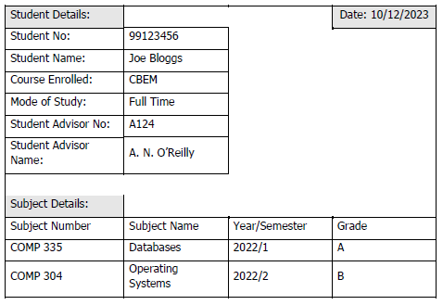

Step 1: Place in UNF.
To place in UNF we have to do the following
- Identify the name of the entity.
- Identify all attributes
- Identify repeating attributes.
- Select the primary Key
- Identify if there are any calculable values, those which don’t need to be recorded as attributes in the database
Student will be the most appropriate name of the Entity, and the values from the student record form will translate into attributes.

Entity and Attributes - UNF
Student(Stud No., Stud name, course enrolled, Mode of study, Student Advisor No., Stud Advisor name, Subj Num, Subj name, Year/semester, Grade)

Blue= Entity
Black, bold underlined = PK
Green = repeating groups

Process Reasoning:
- Subj Num, Subj name, Year/semester, Grade attributes can all contain multiple values, as such they are repeating groups.
- Stud No. will be a unique identifier, as such that will be appropriate to sue as a Primary Key (PK).
- There are no calculable values

Assumptions:
No assumptions required at this stage.

Result
The data is now in Unormal.ised form (UNF)

Step 2: Place in 1NF.
To place in 1NF we have to do the following
- Remove repeating Groups
- Identify a PK in removed repeating group
We will remove repeating groups from UNF data to place in 1NF

Entity and Attributes – 1NF
Student-1(Stud No., Stud name, course enrolled, Mode of study, Student Advisor No., Stud Advisor name)

Student-subject-data-1(Stud No. Subj Num, Subj name, Year/semester, Grade)

Process Reasoning:
- Repeating groups have been removed
- Subject Number is a unique value and as such this is suitable to identify, however we need a unique identifier to identify the grade with the student and as such we will move the Stud No. over to the student subject data -1 table to make a composite Primary Key of Stud No, + Subj No.)

Step 3: Place in 2NF
To place in 2NF we have to do the following
- Identify and remove Partial dependencies i.e. every non key attribute has to be fully dependent on the primary key
We identify the partial dependencies in the first table
- Student-1(Stud No., Stud name, course enrolled, Mode of study, Student Advisor No., Stud Advisor name)

Partial dependencies

Table 1 – Partial dependencies present

Student-1(Stud No., Stud name, course enrolled, Mode of study, Student Advisor No., Stud Advisor name)
- There are partial dependencies in Table 1
  - “Stud Advisor name” is partially dependent on “Student Advisor No.”

Table 2 –
Student-subject-data-1((Stud No. Subj Num), Subj name, Year/semester, Grade)
- There are no partial dependencies in table 2

Entities and Atrributes – 2NF

Student-2(Stud No., Stud name, course enrolled, Mode of study, Student Advisor No., Stud Advisor name)

Advisor-2(Student Advisor No, Student Advisor name)

Student-subject-data-2((Stud No. Subj Num), Subj name, Year/semester, Grade)

Process Reasoning:
- We use the Student Advisor No. as the Primary Key in the new table Advisor-2. This is a unique value which will allow us uniquely identify the student advisor
- No Partial dependencies in student subject data table, hence that stays as it is

Step 4: Place in 3NF
To place in 3NF we have to do the following
- Identify and remove Transitive dependencies i.e. every non key attribute has to be fully dependent on the primary key

Transitive dependencies

Table 1
Student-2(Stud No., Stud name, course enrolled, Mode of study, Student Advisor No., Stud Advisor name)
- There is a transitive dependency in table 1
  - “Mode of study” has a transitive dependency on course enrolled. Not all course will offer the same mode of study. It will be course dependent.

Advisor-2(Student Advisor No, Student Advisor name)

Student-subject-data-2((Stud No. Subj Num), Subj name, Year/semester, Grade)

- Mode of study is also partially dependent on course enrolled. Not all course will offer the same mode of study. It will be course dependent.

Assumptions:
- Mode of study will have a dependency on course as enrolled as not all courses will offer full time or part time study.

