Our City Bikes
A bike rental company

Business Requirement - Nouns and Verbs/Adjectives outline
- The Company owns a number of bicycles and stations across the city.
- Each bicycle and station are identified using an ID.
- Each station has a number of parking slots which can be available or unavailable (in use).
- The stations also have characteristics associated with them, for example whether you can pay with card or not.
- Users of the scheme have to register in order to obtain their bike card.
- The company needs to identify each trip/trip across the city to calculate charges (Charges apply after 30 minutes of continuous use).
- User will have stored their payment details at registration so the charges can be processed automatically.
Green = noun
Blue = verb/adjective

Entities
- Company (only 1)
- Bicycle Definition
- Bicycle Rental Copies
- Stations
- City (only 1)
- Parking slots
- User
- Bike card
- Charges
- Trip – is transactional so will be a result of user taking a bike, hence removing

Assumptions
- Company only operates in one city – hence no need to entity for city
- Stations are different to parking slots – stations contain parking slots
- Parking slot available / unavailable – this is recorded to allow users know where they can return a bike
- Trip – duration – calculated at run time
- Need to retain historical data for trips and charges

Parking slots all have same slot+bike connection type allowing any bike to be docked at any parking slot? Do we need different parking slot type?
Parking slot two types one to charge electric bikes and one for normal bikes?
- Users pay with different methods including credit card, debit card, nfc cards, institution, revolut, boi, aib
- There are two bike types available for rent
  - electrical and
  - non-electrical
- Each type of bike requires its own type of parkinG slot and as such there are two types of parking slots,
  - Electrical
  - non-electrical
- There is no registration fee payable by users.
- Registration requires submission of payment details and a reg ID is then issues along with a Bike card which has its own unique identifier.
- Registration is required annually.
- At one particular time a user can only borrow one bike at a time but these are transactional records and over time user will rent many bikes.
- At one particular time a parking slot can only host one bike, we do not need to keep historical data on which parking slot a bike was historically located. Parking slots will have periods of time when they do not have any bike, as such containing a bike is optional
- A user can have no charges, may never pay a charge if trips are under charging duration period, charges must be associated with a single user, no group registrations or IDs are allowed.
- A trip will have one and only one trip charge but may not have any charge if it is under the time charging period, so it is optional relationship with charges.
- A charge must have a trip associated with it and can only have one trip associated with it. Historical records of trips and charges must be maintained.
- There is no group or bulk charging of trips allowed. Charges are applied on a per trip basis.
- Staff. We have not included any data on staff. Staff are not directly associated with users, bikes, stations or transactions. Once a user is registered and has their bike card, all transactions are automated and involve no interaction with staff. As such it is assumed they will be managed separately in a HR database.

New
- Park slots – status – contains bike yes /no. This must be recorded to allow users know whether bike is available for rent or parking slot is free to return bike. Bike present yes/no is recorded in db and availability of slot or bike is calculated in real time then using software.

Relationship Table

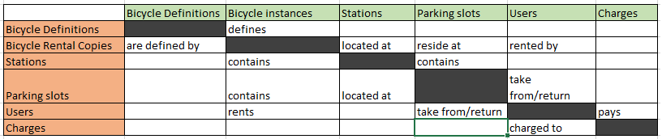

Rough ER Diagram

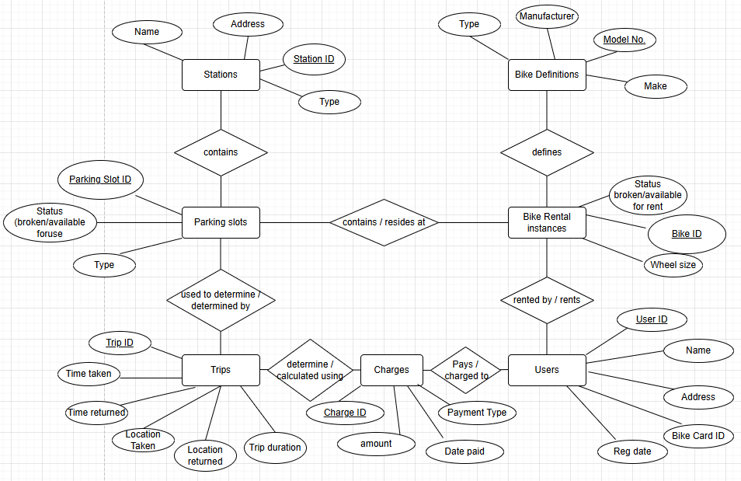

Improvements
Group bookings – how would be manage, trips and charging.

