TU 257 Information Systems

2024-25

Assignment 2: Case Study Report – Airline Booking System

Student name: Eamonn Kelly

Student ID: D24127620

Date: 22nd Dec 2024

Part A – Conceptual Design
The following is the conceptual design for Part A of the assignment. I have chosen to do Airline booking system.

Design Description and Requirements
Some key requirements for an online airline booking database:
- Flight Information:
- Store detailed information about flights, including flight number, departure and arrival locations, aircraft type, and seat capacity.
- Maintain historical data on past flights for reporting and analysis.
- Customer Information:
- Capture and store customer details, including names, contact information, and payment preferences.
- Booking Records:
- Record details of each booking, linking customers to specific flights.
- Payment Processing:
- Store payment details securely

Assumptions:
The following is a full list of assumption
- An Aircraft may have 0 flights associated to it or it can have many Flights.
- Each Flight must have 1 and only 1 Aircraft allocated to it.
- An Aircraft Model can have 0 or many Aircraft associated with it.
- An Aircraft must have 1 and only 1 Aircraft Model associated with it.
- Each Maintenance event must have 1 and only 1 Aircraft associated to it.
- Each Aircraft can have 0 or many Maintenance events.
- Each Maintenance event must have 1 and only 1 Airport assigned toit. This is the location where the maintenance takes place. Aircraft maintenance events always take place in an airport.
- Each Airport can have 0 or many Maintenance events. Typically maintenance events will take place at designated locations where the skills, tools, services and staff are available to perform the.
- Each Airport can and 0 or many Aircraft associated with it.
- Each Aircraft can have 0 or 1 only Airport associated with it. This is to allow us effectively know where the aircraft is currently located. If there is no airport listed the aircraft is currently in mid flight.
- Each Airport can have 0 or many Staff associated with it.
- Each Staff member must have 1 and only 1 Airport associated with them. This is the working location of the staff member and is required for contractual purposes. This is true even if the staff are flight staff and spend their working day in the air or travelling to different airports. Within the airport are office, aircraft, runway, warehouse, maintenance depot but this level of detail is not deemed required or essential to track. Location can be calculated or inferred by job title.
- Each Aircraft can have 0 or many Flights allocated to it.
- Each Flight must have 1 and only 1 Aircraft associated with it, even if there is a stop over or transfer on a flight. Any second or continuing flight would be a separate flight and be treated as such.
- Each Flight has 1 starting(departure) airport and also has 1 ending(arrival) airport. Hence we have two relationships between Flights and Airports to represent this.
  - Each Flight must have 1 and only 1 departure airport
  - Each Flight must have 1 and only 1 arrival airport
  - Each Airport can have 0 or many departure flights
  - Each Airport can have 0 or many arrival flights
- Each Staff member can have 0 or many Flight_Staff instances associated with them. The Flight_Staff entity is a bridging entity which represents staff allocation to flights, effectively a roster for the staff who are allocated to different flights. It has an identifying relationship between itself and Staff and Flights, it cannot exist without these two entites.
- Each Flight must have 1 or many Flight_Staff allocated to it. Each aircraft may have minimum requirements for staff to be onboard before it can safely fly as per regulations. These staff numbers can be calculated from the table data and to ensure flights can take place as per regulations and appropriately skilled staff can be allocated to flights in this entity.
- Each Flight must have 1 booking by may have many Bookings
- Each Booking must have 1 and only 1 Flight associated with it.
- The Customer_Bookings entity is a bridging entity to allow multiple customers be associated with the same Booking. This facilitates Group bookings for the airline booking system. It has an identifying relationship between itself and Bookings and Customers, it cannot exist without these two entites. Group Booking are limited to 10 persons max, just so it is not open ended from a security, systems and aircraft capacity point of view.
- Each Booking must have 1 and but could have many Customer_Bookings associated with it.
- Each Customer can have 0 or may have many Customer_Bookings associated with them. A customer only has a relationship with a flight through a booking.
- Each Customer can have 0 but may have 1 Payment_Method associated with them.
- Each Payment_Method can have 0 but may have many Customers associated with it.
- Airport ID > is a 3 or 4 character text based code. It is an industry standard identifier. Hence we use a VARCHAR data type.
- Available seats it a calculation on stored data. It is based off number of seat_capacity attribute in Aircraft and seat_number allocations in Bookings. The remainder being the available seats. It is not stored in the database. It is also a value that could change quite regularly. Including available seats would also create transitive dependencies across tables which we would need to address and given we have a max number of entities allowed, it is best not to store this but calculate at run time.
- No account of Ghost fights, where no customers are on board is accounted for. Assuming empty flights (ghost flights) flying with no one on board due to contractual obligations does not occur in the airline.
- Price >> is recorded in Bookings so users can refer to it and haveit available historically. The value in real time though may change periodically based on updated calculations and algorithms.
- Distance between airports (dep and arrival ) will have impact on fuel required for flight. This could be calculable data presented to the pilots.
- FLIGHTS >> Departure and arrival airports cannot be the same airport, dep and arrival must be different
- Bookings > seat_number attribute. It can be null as seat number not chosen/allocated until user checks in, so can make booking and leave as null until check in time. It can be used in reports to identify where someone is sitting, or available seats through calculated query.
- Bookings > price attribute >>> we assume all pricing is done in euros, as such we will not include any currency conversion or support for other currencies
- No discounting data is stored. Must be calculated if needed.

Conceptual design ER diagram including main entities and cardinality

Below is out rough ER diagram containing entities, primary keys cardinality.

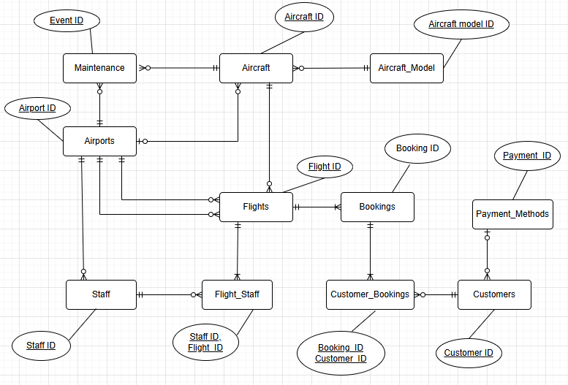

Conceptual design Final ER diagram full list of attributes and PKs/FKs

Below is out fully attributable ER diagram containing entities, primary keys, foreign keys, optionality and cardinality, relationships, full list of attributes and the associated data types.

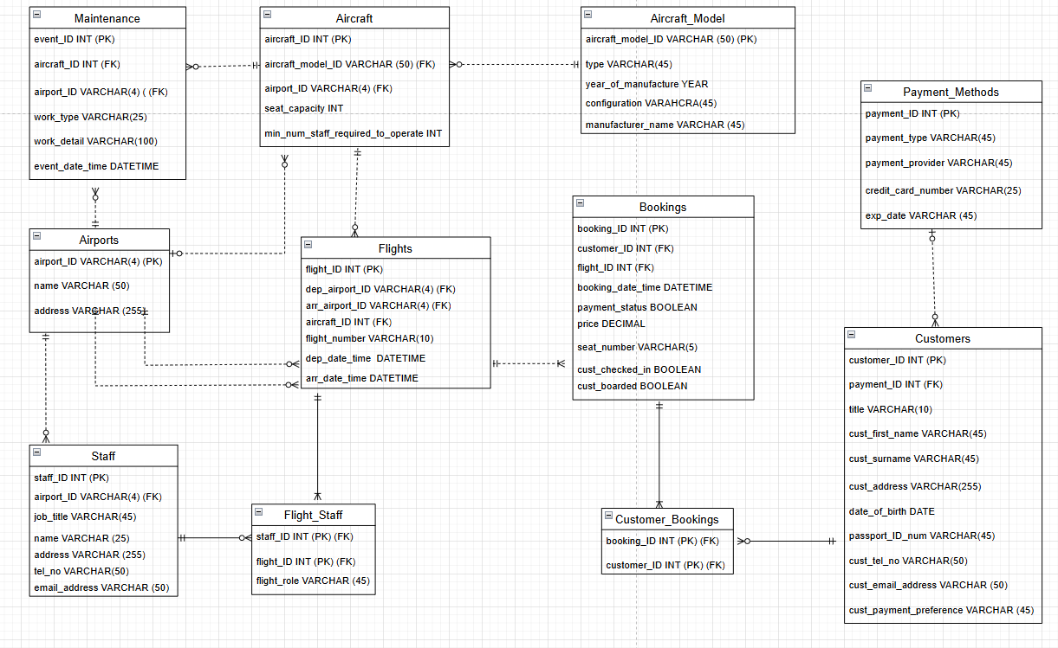

Part B – Conceptual Design

Screenshots of typical data
The following is a screenshot of typical customer data that a customer might be required to provide.

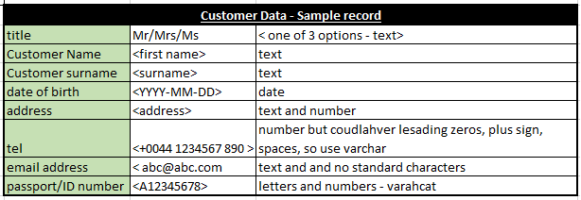

Normalization process
Our Entities and attributes are already in 3NF. We will outline that is the case now. Below are our tables and attributes.

Maintenance(event_ID (PK), aircraft_ID (FK), airport_ID (FK), work_type, work_detail, event_date_time)

Aircraft(aircraft_ID (PK), aircraft_model_ID (FK), airport_ID (FK), seat_capacity, min_num_staff_required_to_operate)

Aircraft_Model(aircraft_model_ID (PK), type, year_of_manufacture, configuration, manufacturer_name)

Airports(airport_ID (PK), name , address)

Flights(flight_ID (PK), dep_airport_ID (FK), arr_airport_ID (FK), aircraft_ID(FK), flight_number, dep_date_time , arr_date_time)

Bookings(booking_ID (PK), customer_ID (FK), flight_ID (FK), booking_date_time, payment_status, price, seat_number, cust_checked_in, cust_boarded)

Staff(staff_ID (PK), airport_ID (FK), job_title, name, address, tel_no, email_address)

Flight_Staff(staff_ID (PK) (FK), flight_ID (PK) (FK), flight_role)

Customers(customer_ID (PK), payment_ID (FK), title, cust_first _name, cust_surname, cust_address, date_of_birth, passport_ID_num, cust_tel_no, cust_email_address), cust_payment_preference)

Customer_Bookings(booking_ID (PK) (FK), customer_ID (PK) (FK))

Payment_Methods(payment_ID (PK), payment_type, payment_provider, credit_card_number, exp_date)

1NF
The tables are in 1NF already and no changes are needed. as all tables have a primary keys and all attributes have atomic values i.e. there are no rep[eating groups, or not attributes contain multiple values.

2NF
The tables are already in 2NF and no changes are needed. There are two tables with composite Primary keys which could contain partial dependencies, listed below. No partial dependencies exist in these two tables so as such we are at 2NF.

Flight_Staff(staff_ID (PK) (FK), flight_ID (PK) (FK), flight_role)

Customer_Bookings(booking_ID (PK) (FK), customer_ID (PK) (FK))

3NF
The tables are already in 3NF and no changes are needed. There are no transitive dependencies across any of the attributes in each table. Each attribute is wholly dependent on the primary key, not dependent on any other no primary attribute.

As such no changes are needed as part of the normalization process and the normalization process is complete, as we are at 3NF.

Solution
To get the tables to 3NF the table attributes must have no transitive dependencies, i.e. they do not depend on other attributes in the table, but are dependent solely on the primary key.

Physical design

Creation of schema
Included FK constraints in tables and ensured data referential integrity in the sample data

Sample of Basic Queries

SQL Queries

SUB QUERies Type

VIEW

index

