Information Systems CMPU4061 – 2024-25

Week 1-

18th Sept 2024

Course Overview

Continuous Assessment 100%
  - 1 Quiz 20% Week 7 – 30th Nov 6:30 to 8pm(25 to 30 Qs)
  - 1 Assignment 30% - When?
  - 1 Case study 50% - When?

Dr. Marisa Llorens-Salvador
  - Email always best channel:
  - marisa.llorens@tudublin.ie
  - Discussion Forums on VLE (Brisghtspace)

Module Summary :
This module provides the learner with fundamental skills to design information systems, focusing on the design and implementation of database systems.

The aims of the module are:
  - Enable the student to create new relational databases by devising a high-level conceptual data model.
  - Transform data model into a relational schema
  - Implement the relational schema correctly and robustly in SQL

Learning Outcomes

Reading list
- Alice Rischert 2019. Oracle SQL by example.
- Thomas M. Connolly, Carolyn E Begg 2015 Database Systems
- MYSQL: SQL Database Programming for Beginners. Kevin Lioy. 2019
- Many other books and online resources that will be discussed and shared as we progress through the module

Module software
- BrightspaceSynchronous sessions
- Asynchronous sessions (videos + guided exercises)
- Socrative, chat and break out rooms in Bongo for participation
- SQLite, MySQL, draw.io, MongoDB

Who is in the class?
- Socrative mobile download
- Socrative room TUDUBLINMARISA
- Answer a few questions about your previous experience

Extra light resources
- Podcasts
- SQL games
- Research papers

Summary of lecture
- Contact details
- Introduction to the module
- Details of delivery, software and assessment
- Short survey

Introduction to Databases
- What is a database?
- Why use databases (Databases vs. Spreasheets)
- Types of Databases
- DBMS
- Database Design and models
- Software

What is a database?

- A database is a structured collection of records.
- Database:
  - Collection of related data
    - Represents some aspect of the real world.
    - Logically coherent collection.
    - Built with a specific purpose in mind.
    - Could be anywhere - notebook, spreadsheet, Access, Oracle, … could be manual/could be computerised.
  - Data:
    - Raw facts (building blocks of information).
    - Unprocessed information.
  - Information:
    - Data processed to reveal meaning.
  - A Database consists of columns (attributes) and rows (records).
  - Database Management System (DBMS)
    - add, remove, update records
    - retrieve data that match certain criteria
    - cross-reference data in different tables
    - perform complex aggregate calculations

Why Study Databases?

- They touch every aspect of our lives.
- Explosion of unstructured data on the web:
  - Large document collections.
  - Image databases, streaming media, social media

Applications:
  - Banking: All transactions
  - Airlines: Reservations, schedules
  - Universities: Registration, grades
  - Sales: Customers, products, purchases
  - Manufacturing: Production, inventory, orders, supply chain
  - Human Resources: Employee records, salaries, tax deductions
  - Telecommunications: Subscribers, usage, routing
  - Computer Accounts: Privileges, quotas, usage
  - Records: Climate, stock market, library holdings

Databases versus spreadsheets
- Easier and more efficient manipulation of data
- Avoid redundancy

Single table database
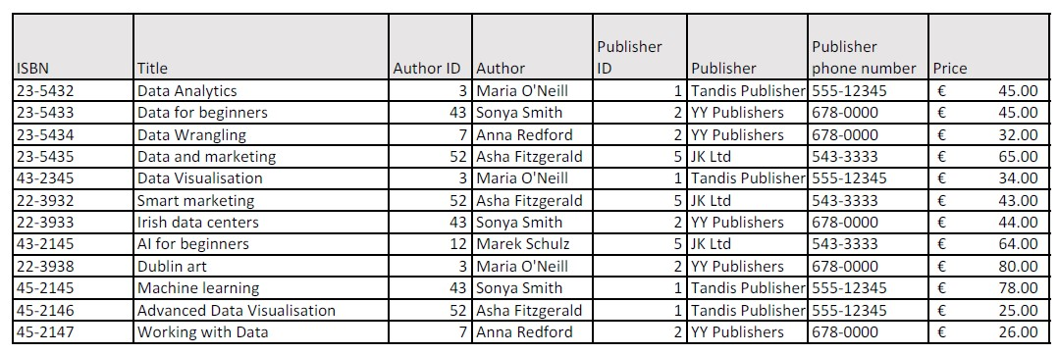

Disadvantage of a single table database
- Redundancy of data
- Problem with complex data
- Problems in updating in bulk (new phone number)
- Problems in adding incomplete data (new publisher)
- Problems in removing group of data (all books from the publisher)

Several tables- Books

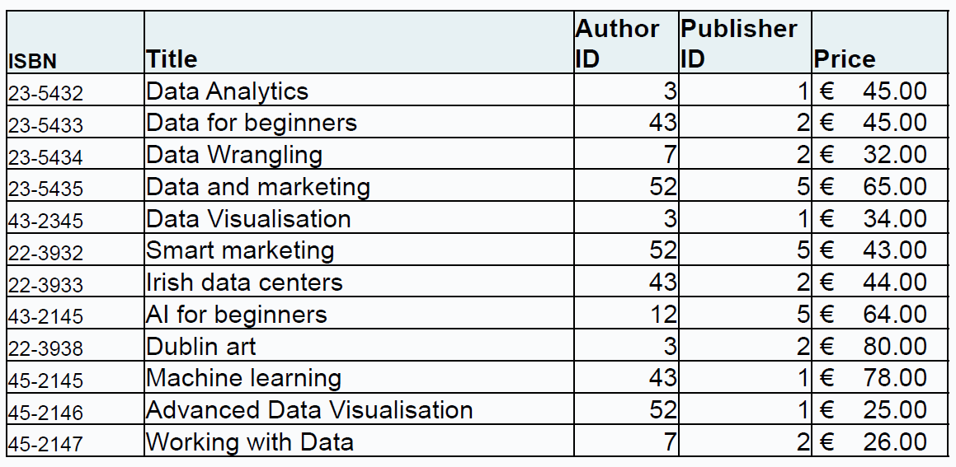

Several tables- Authors

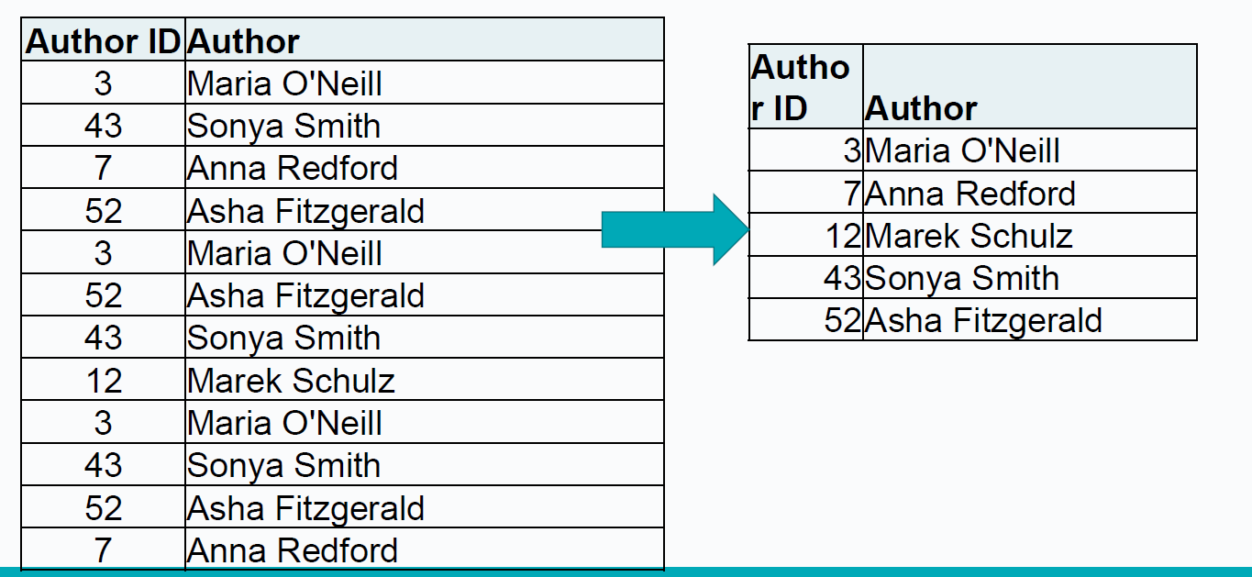

Several tables- Publishers

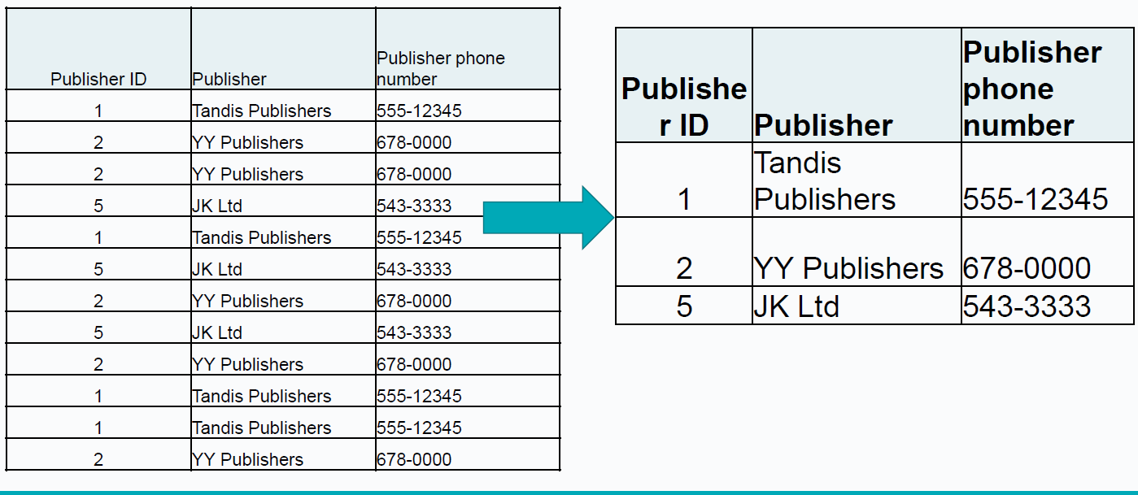

Relationships in a database example

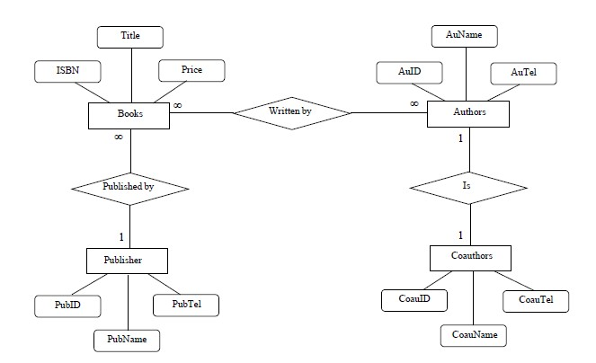

Relationships

Rather than books table have separate table of – who wrote each of the books.. I think….
Relationship table…connects different information… connecting different tables in some way…just can’t be confusion or ambiguity needs a unique identifier
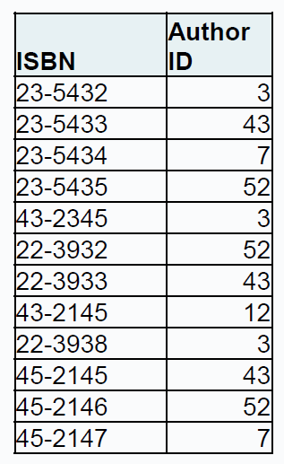

Types of Databases

Can be classified by location…

Centralized:
- Supports data located at a single site.

Distributed:
- Supports data distributed across several sites.
  - Often used to store historical data.
  - Structure is quite different.

Can be classified by use…

Transactional (or Production):
- Supports a company’s day-to-day operations.

Data Warehouse:
- Stores data used to generate information required to make tactical or strategic decisions.
- Often used to store historical data.
- Structure is quite different.

Can be classified by relational model…

Relational:
- SQL.

NonRelational:
- NonSQL.

Database Management Systems (DBMS)

General purpose software for
  - Definition
  - Construction
  - Manipulation of databases
The DBMS manages the interaction between the end user and the database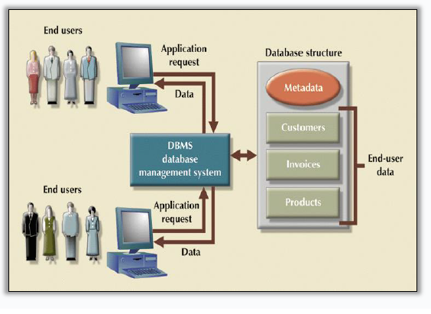

Characteristics of DBMS
- Data is…
  - integrated
  - shared
  - persistent
  - self-describing
- Abstraction
  - Program-data independence.
- Allows multiple views of the data

DBMS Functions

DBMS performs functions that guarantee integrity and consistency of data:
- Backup & Recovery Management
- Data Integrity Management
- Database Access Languages & Application Programming Interfaces
- Database Communication Interfaces

Database Design
- Database design deals with how to design a database.
- Importance of good design:
  - Poor design results in unwanted data redundancy.
  - Poor design generates errors leading to bad decisions.
- Practical approach:
  - Focus on principles and concepts of database design.
  - Importance of logical design.

Data Models
- Specify concepts that are used to describe the database. These can be categorised as:
  - High Level (Conceptual):
  - Representational (Logical):
  - Low Level (Physical):

Roles in the Database Environment
- Database Administrator (DBA)
  - Authorizing access to the database.
  - Coordinating and monitoring its use.
  - Acquiring software and hardware as needed.
  - Solving problems such as breach of security or poor system performance
- Database Designers/Modellers: (this is us)
  - Identifying the data to be stored and structure to be used, identify constraints.
  - Design structural and functional aspects.
- Application Programmers:
  - Develop and implement end-user requirements.
- End Users:
  - Access to the database: querying, updating, generating reports
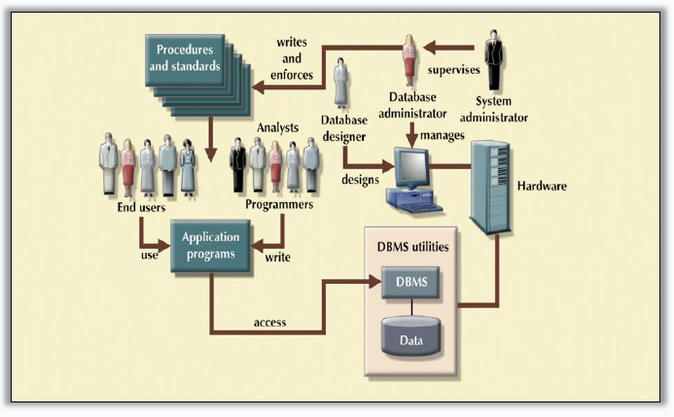

Software
- MS Access
- Cassandra
- Microsoft SQL Server
- Neo4j
- Oracle RDBMS
- phpMyAdmin
- MySQL
- SQLite (airbus pilots use this ---)
- PostgresSQL
- MongoDB (probably just a demo)
- Redis


Summary
- What is a database
- Why use databases (Databases vs. Spreasheets)
- Types of Databases
- DBMS
- Database Design and models
- Software

Lab>>

Week 2

Relational Database Principles

Lesson 2 – 25th Sept 2024

TU257

Lesson Outline
- Design Process
- Conceptual Model - Entity Relation model
  - Entities
    - Attributes
  - Relationships

Design Process

Data Models
- Specify concepts that are used to describe the database. These can be categorised as:
  - High Level (Conceptual):
    - Concepts at user level: entities/classes, attributes, relationships/associations
    - Rough ER Diagram + Key Based ER Diagram
  - Representational (Logical):
    - Relational, network, hierarchical – may be record based, object-oriented
    - Normalised model
  - Low Level (Physical):
    - Details of physical data storage; formats, access paths, ordering
    - Implemented model

Database Design

- Database design deals with how to design a database.
- Importance of good design:
  - Poor design results in unwanted data redundancy.
  - Poor design generates errors leading to bad decisions.
- Practical approach:
  - Focus on principles and concepts of database design.
  - Importance of logical design.

Major Steps in Database Design

- Requirements Analysis:
  - Talk to the potential users.
  - Understand what data is to be stored, and what operations and requirements are desired.
- Conceptual Database Design:
  - Develop a high-level description of the data and constraints
- Logical Database Design:
  - Convert the conceptual model to a schema in the chosen data model of the DBMS.
  - For a relational database, this means converting the conceptual to a relational schema (logical schema).
- Schema Refinement:
  - Look for potential problems in the original choice of schema and try to redesign.
- Physical Database Design:
  - Direct the DBMS into choice of underlying data layout (e.g., index/clustering) in the hope of optimising the performance
- Applications and Security Design:
  - How will the underlying database interact with surrounding applications.

Conceptual Database Design

- Goal: Specification of database schema
- Methodology:
  - Use E-R model to get a high-level graphical view of essential components of enterprise and how they are related

- 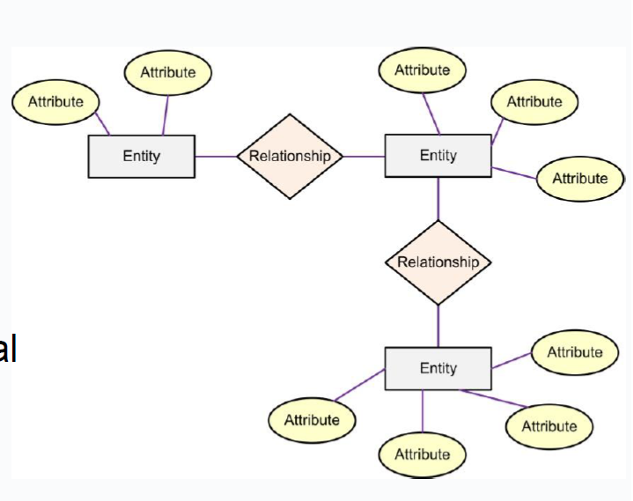

E-R Model

- Entity-Relationship (ER) Model is based on the notion of real-world entities and relationships among them. While formulating real-world scenario into the database model, the ER Model creates entity set, relationship set, general attributes and constraints.
- ER Model is best used for the conceptual design of a database.
- ER Model is based on:
- Entities and their attributes.
- Relationships among entities.

Entities

- Entity
  - An entity in an ER Model is a real-world entity having properties called attributes. These are used to describe a particular entity (e.g. name, RSI#, height).
- An entity corresponds to a person, place, thing, event, or concept about which you are interested in recording data i.e.
  - Person: EMPLOYEE, STUDENT, PATIENT,
  - Place: STORE, WAREHOUSE, COUNTY,
  - Object: MACHINE, BUILDING, CAR,
  - Event: SALE, REGISTRATION, RENEWAL,
  - Concept: ACCOUNT, COURSE, WORK CENTRE

E-R Diagrams: Entities
- An entity is any object in the system that you want to model and store information about
  - Individual objects are called entities.
  - Groups of same type objects are entity types or entity sets.
  - Entities are represented by rectangles (either with round or square corners)
- Entities are equivalent to database tables in a relational database, with each row of the table representing an instance of that entity.
- Entities are abstract concepts, each representing one or more instances of the concept in question.
- Each entity is represented by a box within the E-R Diagram.

E-R Diagrams: Entities: Type vs. Instance

- Entity Type (Entity Class):
  - Entities can usefully be classified into entity types.
  - Collection of similar entities, about which we want to store similar information.
- Instance:
  - An entity is an instance of an entity type, e.g. Joe Bloggs may be an instance of the employee entity type.
- You model entity types, not individual instances.
- However, the term ‘entity’ is often used to refer to both entity type and instance.

E-R Model: Attributes

- All the data relating to an entity is held in its attributes i.e. an attribute is a property of an entity.
- Every attribute is defined by its set of values called domain
  - name may be a 20 character string;
  - PPS# is seven-digits plus a letter;
  - Student ID may be a char with a letter followed by 8 digits;
  - Price may be a float number with 2 decimal places.

E-R Diagrams: Attributes

- Attributes can be…
  - simple or composite
  - single-valued or multi-valued

Composite Attributes

- Composite attributes are further divided in a tree like structure.
- Every node is then connected to its attribute. That is, composite attributes are represented by ellipses that are connected with an ellipse.
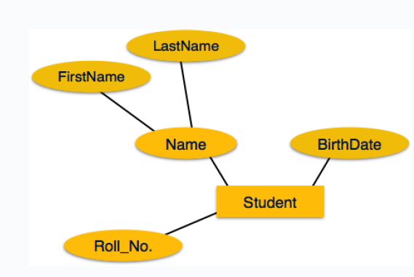

Multivalued Attributes

- Multivalued attributes are depicted by double ellipse
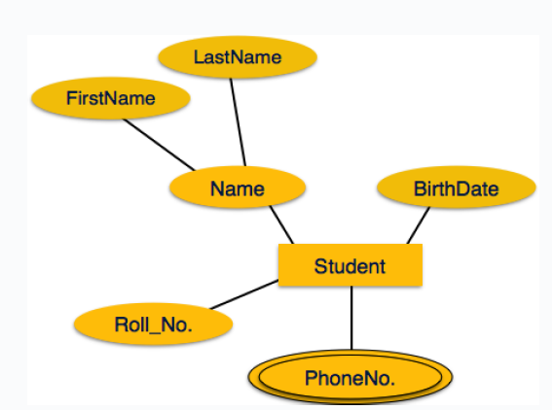

ER-Model: Keys
- Identifier/key:
  - A minimal set of attributes for an entity set, such that each entity in the set can be uniquely identified.
  - In some cases, there may be a single attribute (such as PPS#) which serves as a key, but in some models you might need multiple attributes as a key (‘Bob from Accounting’).
  - There may be several possible candidate keys. You will generally designate one such key as the primary key.
- Characteristics of Identifiers:
  - Will not change in value.
  - Will not be null.
  - No intelligent identifiers (e.g. containing locations or people that might change).

ER-Model: Relationship

- Relationship− The logical association among entities is called relationship.
- Relationships are mapped with entities in various ways.
- Mapping cardinalities define the number of associations between two entities.

Tips on building E-R diagrams

Nouns
- are clues to the entities of a business
  - Start by describing the work that is done in the project or department or area of interest, then
  - pull out nouns in the sentences as potential candidates for entities. e.g. “My address book contains addresses and telephone numbers for both friends and businesses.”
- Nouns are clues to the entities of a business

Verbs and adjectives
- Verbs and adjectives sometimes help to get at relationships between entities e.g. ‘friends have addresses’

Notation
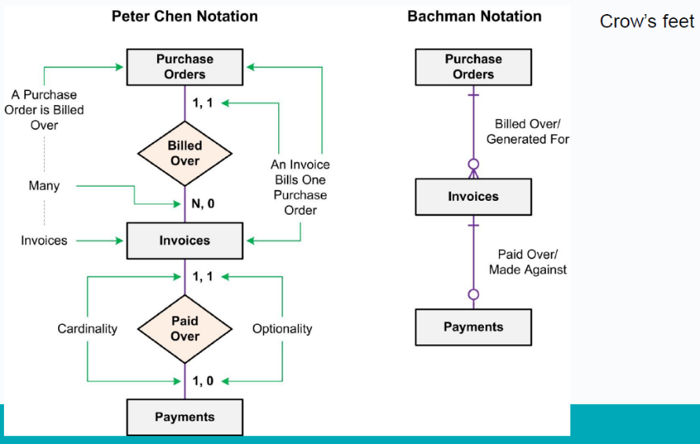
- Entities are drawn in boxes.
  - entities should be expressed in the plural.
- The existence of a relationship between two entities is drawn as a line connecting the entities.
- Verbs may be placed on the relationship lines that describe what the relationships mean e.g. ‘Purchase Orders are billed over Invoices’, where‘
    - ‘Purchase Orders’ and ‘Invoices’ are related entities,
and
    - ‘billed’ is the verb describing the relationship
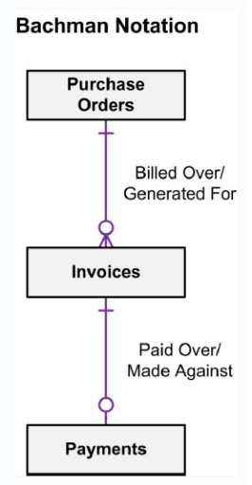

Attributes
- Attributes can be shown on ER models:
  - They appear inside ovals and are attached to their entity.
  - Note that entity types can have a large number of attributes. If all are shown then the diagrams would be confusing. Only show an attribute if it adds information to the ER diagram, or clarifies a point.
- Lists of attributes can be developed as you go.
  - An attribute is a single piece of information that is descriptive of an entity, e.g. friends name, friends e-mail.
  - 

- 31

Exercise
- A restaurant owner hires you to create a database for their business. They need to keep track of customer details (for marketing purposes). A good management of orders, food items, menus, payments and different types of staff is necessary in order to obtain a database that will allow the owner to control all aspects of their business.
- Can you discuss the requirements and come up with a list of entities and attributes that will be required for the DB?
- Write your final lists. One member of the group will present them to the whole class.

E-R Diagrams: Relationships
- A relationship is an association among two or more entities.
  - The relationship must be uniquely identified by the participating entities.
- Relationships are represented by lines between entities.

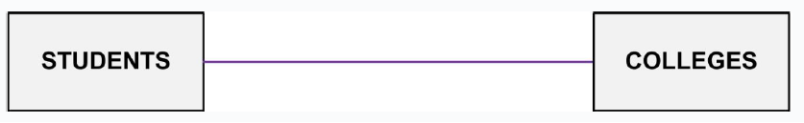
- A relationship can also have descriptive attributes, to record additional information about the relationship (as opposed to about any one participating entity).
- In this case, one can infer that a student may attend a college, or that a college may enroll students.
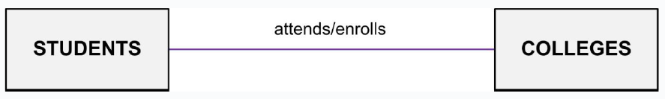

E-R Diagrams: Optionality and cardinality

- Symbols at the ends of the relationship lines indicate the optionality and the cardinality of each relationship.
  - Optionality expresses whether the relationship is optional or mandatory.
  - Cardinality expresses the maximum number of relationships.

Optionality is of two types…

Mandatory Relationship:
Associated with every instance of the first entity there will be at least one instance of the second entity.

Optional Relationship:
  - There may be instances of the first entity, which are not associated with any instance of the second entity.
    - For example, employee-spouse relationship has to be optional because there could be unmarried employees. It is not correct to make the relationship mandatory.

Cardinality is of three types…

One-to-one Relationship:
    - An instance of the first entity is associated with only one instance of the second entity. Similarly, each instance of the second entity is related to one instance of the first entity.
    - One entity from entity set A can be associated with at most one entity of entity set B

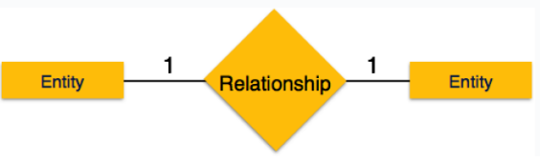 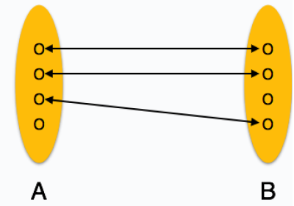38
Peter chen notation

One-to-many Relationship:
- One instance of the first entity is related to many instances of the second entity, while an instance of the second entity is associated with only one instance of the first entity.

- One entity from entity set A can be associated with more than one entities of entity set B however an entity from entity set B, can be associated with at most one entity.
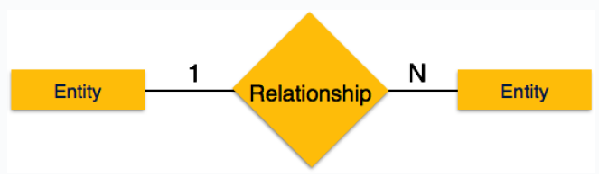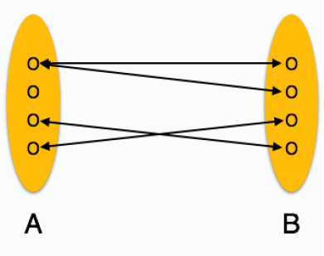
Peter chen notation

Many to One Relationship:
- More than one entity from entity set A can be associated with at most one entity of entity set B, however an entity from entity set B can be

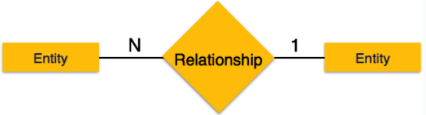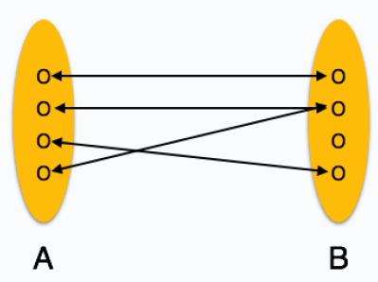
Peter chen notation

Many-to-many Relationship:
- An instance of the first entity is related to many instances of the second entity and the same is true in the reverse direction also.
- One entity from A can be associated with more than one entity from B and vice versa.

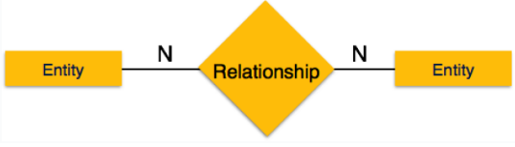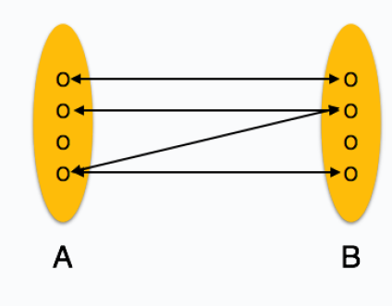
Peter chen notation

E-R Diagrams: Optionality and cardinality
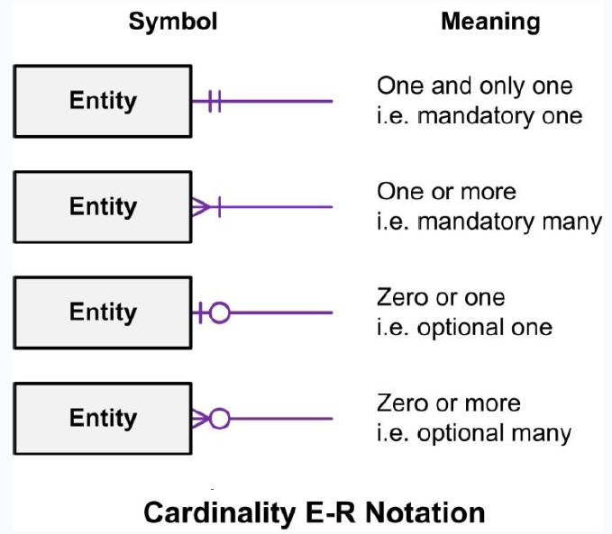
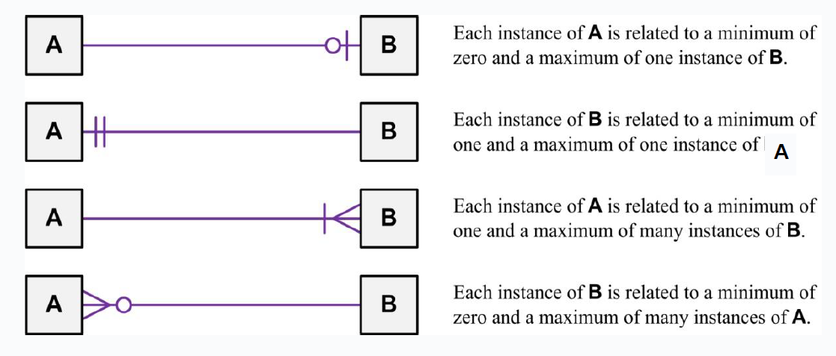
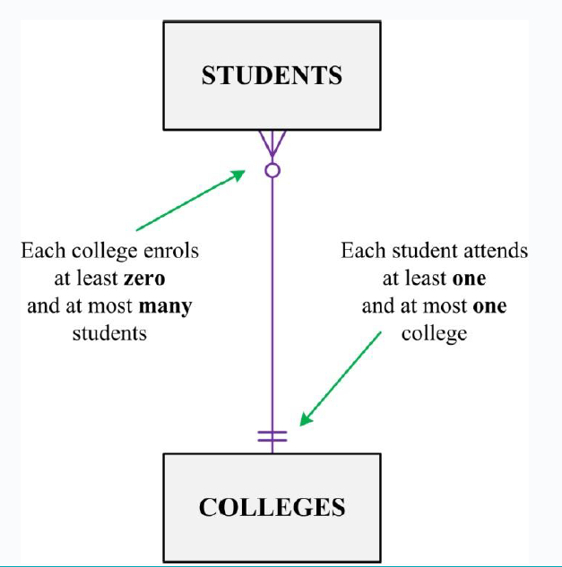

Tips
- DO NOT start diagramming first!
  - Write down the entities.
  - Write down the attributes for each entity.
  - Select the identifying attribute(s) for each entity.
- Draw a rough draft of the E-R diagram. Show entities and relationships only.
  - Add cardinalities.
  - Add attributes.

The ERD Modelling Process

- Initially…
  - Identify obvious entities (i.e. Person, Place, Object, Event, Concept)
  - Identify obvious relationships
  - Identify properties of entities
    - Underline Primary key property
- Refine the Model
  - The initial entities and relationships may not be sufficient
- Then…
  - Decide on Relationship Constraints
    - Cardinality Ratios
    - Optionality constraints
  - Check for completeness
    - Has all the required information been represented

Summary: Constructing an E-R model

- Identify Entities
- List the Initial Attributes of Each Entity
- Mark the Primary Keys
- Define the Relationships
- Describe the Cardinality & Optionality of the Relationships
- Complete list of attributes

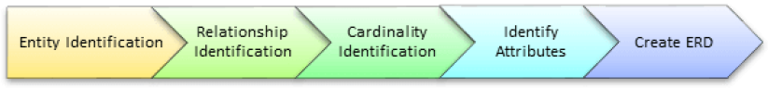

Step 1) Entity Identification

- We have three entities
  - Student
  - Module
  - Professor

Step 2) Relationship Identification

- We have the following two relationships
  - The student is assigned a module
  - Lecturer delivers a module

Step 3) Cardinality Identification
- From the problem statement we know that,
  - A student can be assigned multiple modules
  - A lecturer can deliver only one module
- 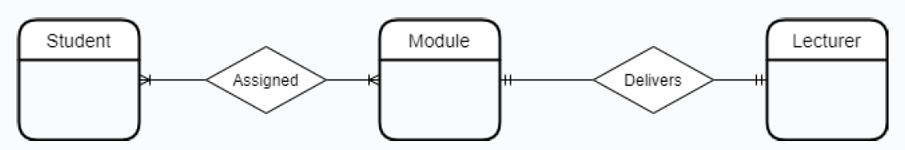

Step 4) Identify Attributes

Name Semester
Surname Credits
Student ID ….
Course ID

Revise
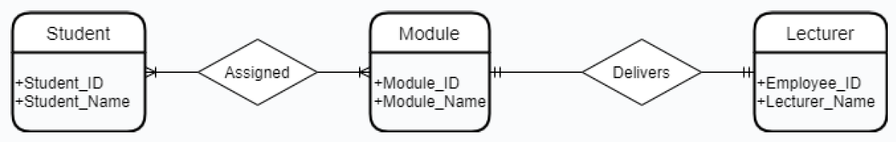

Thanks and reference

- Edmund Nevin for earlier versions of these lecture notes
- https://www.tutorialspoint.com/dbms/er_diagram_representation.htm

Week 3

ER Diagrams

Lesson 3 Information Systems

2nd Oct 2024

Lesson Outline

- Foreign Keys
- Many to many relationships and Bridge Entities
- Identifying relationships
- Degree of a relationship
- Key Based ER Diagram

Foreign Key

- A foreign key is a reference to a key in another table.
- A foreign key is a set of attributes of one table, say R2, whose values are required to match values of some candidate key of another table, say R1

Example PKs

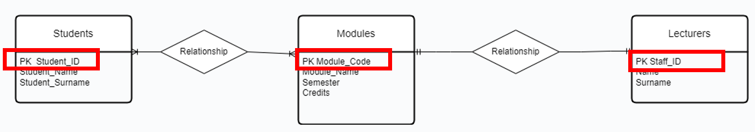

Foreign Key One to One v1
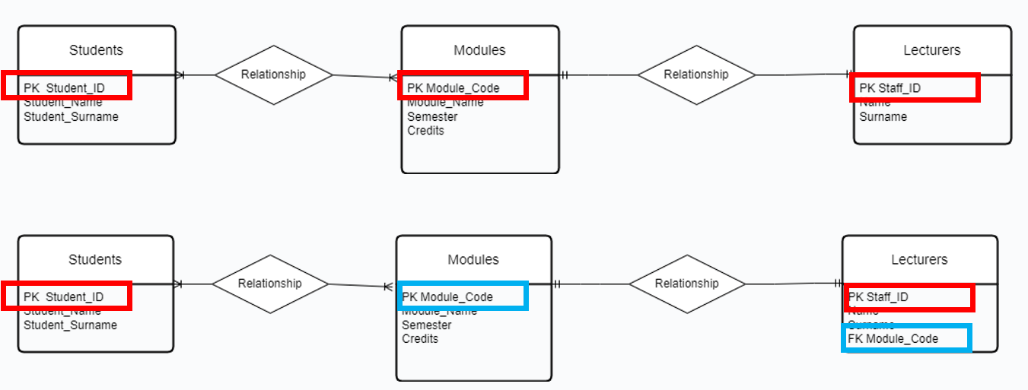
    - PK module_code goes across as FK to Lectureres
    - 1 to 1 relationship >

Foreign Key One to One v2

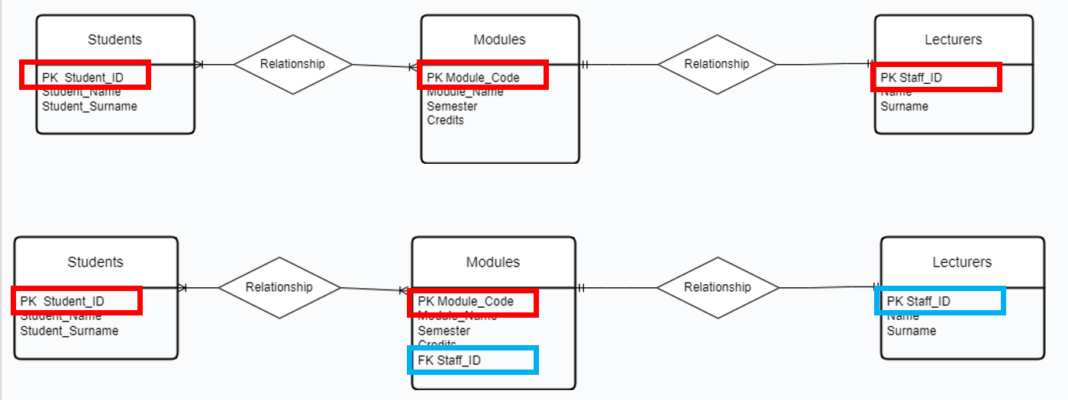
    - PK staff_ID goes across as FK to Modules
    - 1 to 1 relationship >
    - Can do v1 or v2- only slight difference in efficienct depending on what people are mostly searching for
    - Would not have FK on both sides- as causing redundancy, (i.e not repeating ) or could have values not matching

Modified Example Foreign Key One to Many
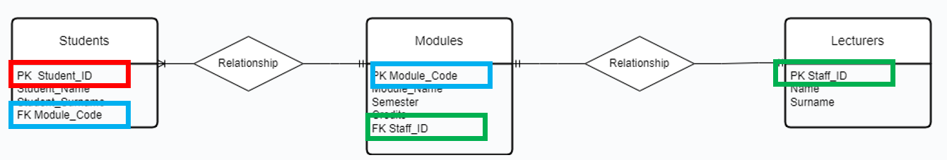
- Case where students can only register for one module.
- PK from the one side becomes FK on the many side

Exam tip>>> PK from 1 side becomes FK on the many side

Foreign Key Many to Many

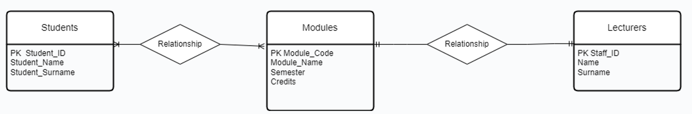

- Case where students can register for more than one module.
- When modelling many to many relationships, no FKs can be used directly in the original entities.
- A new entity has to be created.

Many to Many Relationships Associative (Bridge) Entities

- When an instance of an entity may be related to multiple instances of another entity and vice versa, that is called a ‘many-to-many’ relationship.
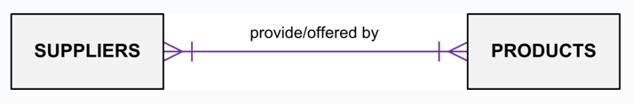
- While this relationship model is perfectly valid, it cannot be translated directly into a relational database design.

Many to Many Relationships Associative (Bridge or Weak) Entities

- While this relationship model is perfectly valid, it cannot be translated directly into a relational database design.
- In order to build a relational database that captures this relationship, it is necessary to build a bridge between the two entities that uniquely expresses each relationship instance.
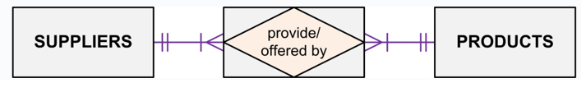

Example Student-Module-Lecturer Week 2
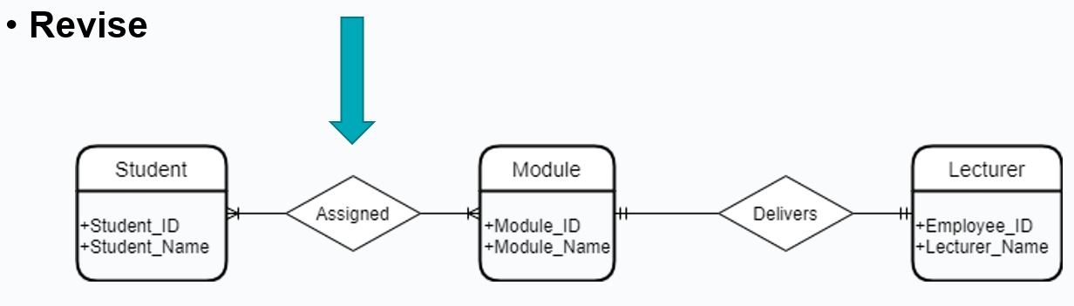

Associative (Bridge) Entities

- Many-to-many relationships can cause lots of trouble.
- Get rid of them by defining an intermediate third entity.

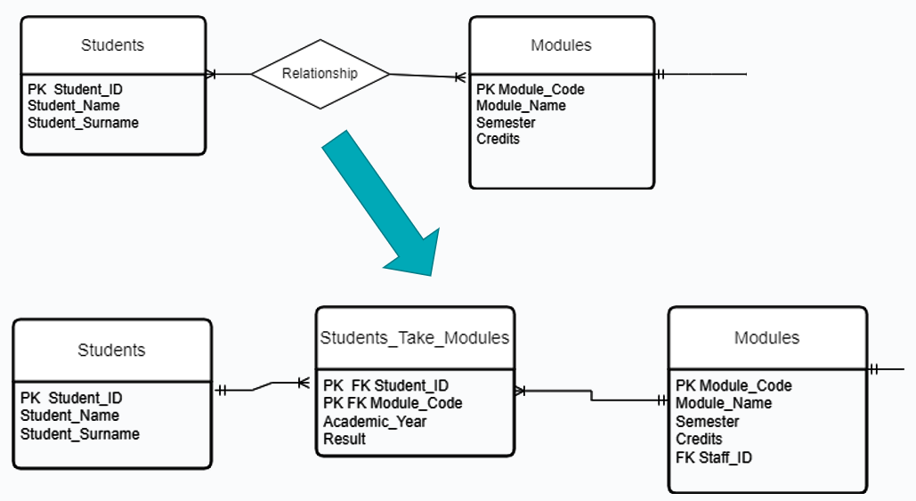

Assumption >> a student can only take a module once, not two years wioth different result

Example

Revise
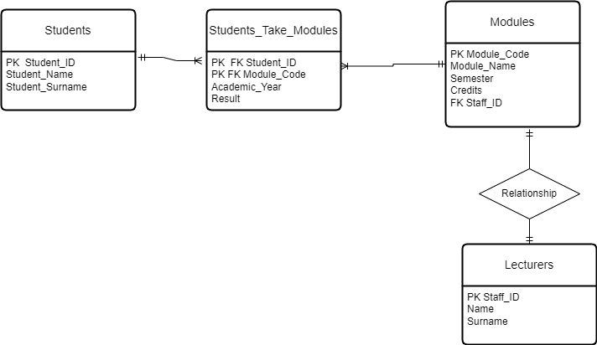

Practice
- Open the db provided University.db

- Browse the data in the different tables.
- Identify PKs and FKs.
- Perform the following queries in the “Execute SQL” Tab
  - SELECT * FROM students
  - SELECT LastName FROM Lecturers
  - SELECT * FROM Modules

Identifying Relationships – New section

- An identifying relationship means that the child table cannot be uniquely identified without the parent.
- For example, you have this situation in the intersection table used to resolve a many-to-many relationship where the intersecting table's Primary Key is a composite of the left and right (parents) table's Primary Keys.
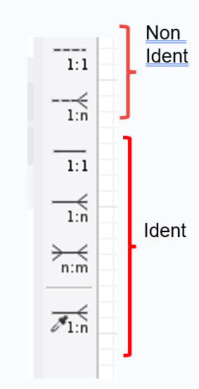

Identifying and non identifying relationships

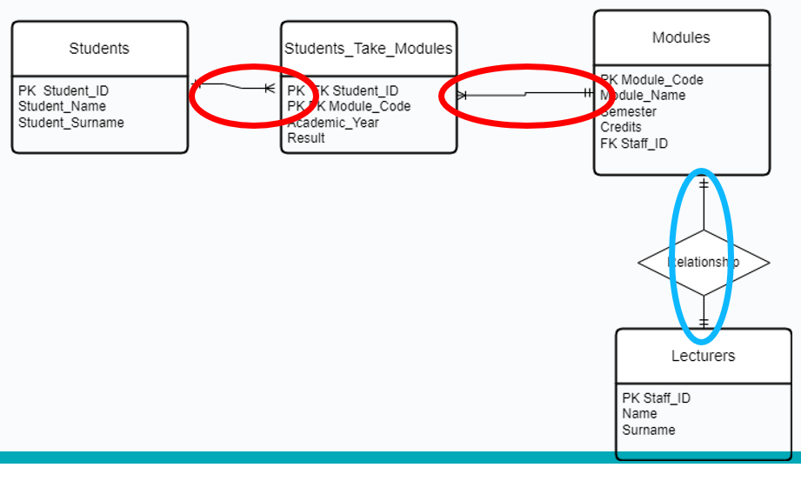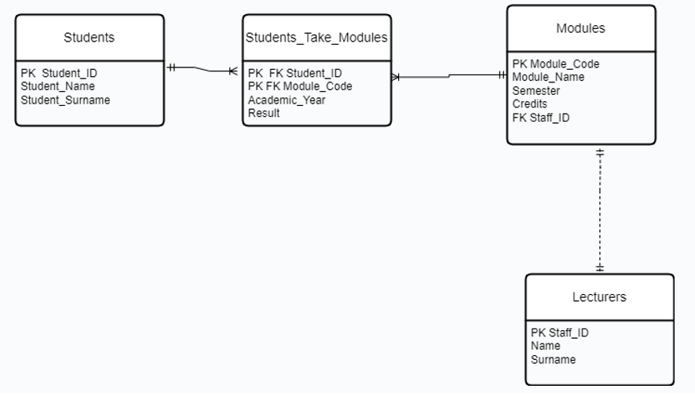

Degree of a relationship- New section

- The number of participating entities in a relationship is known as the degree of the relationship.

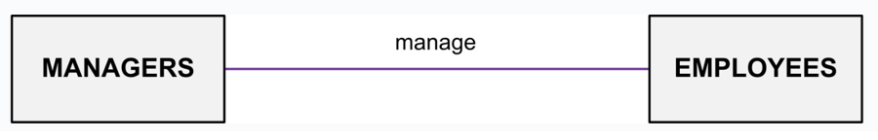

Unary Relationships
- Unary relationships are also known as a recursive relationship.
  - Instances of entities may have relationships with other instances of the same entity.
  - These relationships may be drawn with relationship lines that begin and end connected to the same entity.
- Unary relationships are also known as a recursive relationship.
  - It is a relationship where the same entity participates
more than once in different roles.
  - In the example, employees are managed by employees.
- If you wanted more information about who manages whom, you could introduce a second entity type called manager.

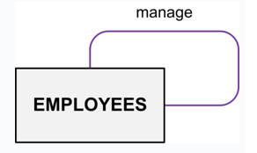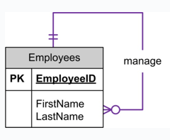

Example
- For example, Suppose in a classroom, we have many students who belong to a particular club-like dance club, basketball club etc. and some of them are club leads. So, a particular group of student is managed by their respective club lead. Here, the group is formed from students and also, the club leads are chosen from students.
- So, the ‘Student’ is the only entity participating here.

- We can represent this relationship using the E-R diagram as follows:

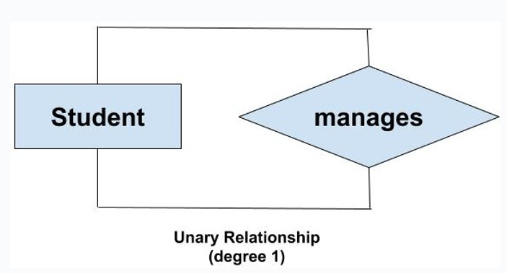

Binary Relationships
- If there are two entity types involved it is a binary relationship type.
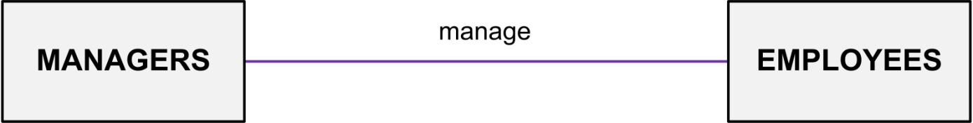

Ternary Relationship
- If there are three entity types involved it is a ternary relationship type.

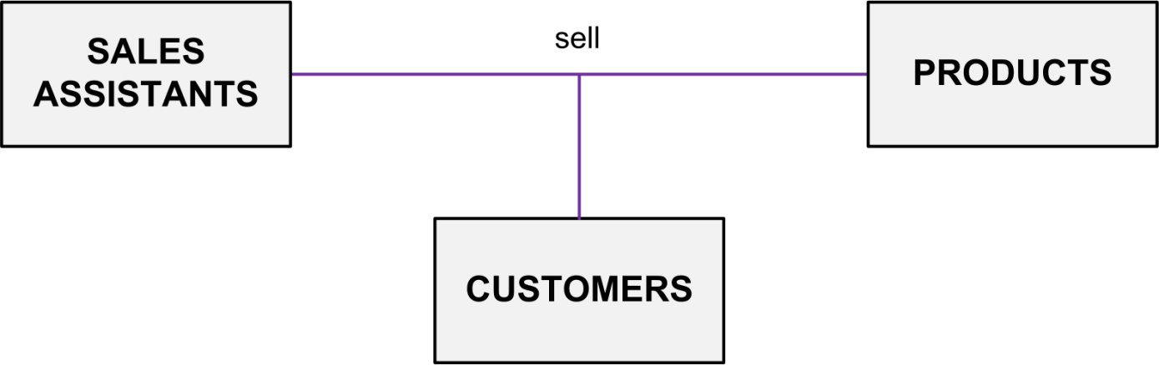

Example 1
- The University might need to record which teachers taught which subjects in which courses.

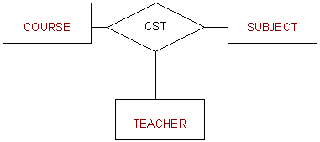

Example 2

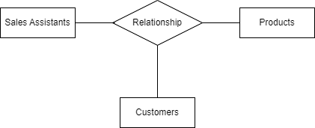

Replacing Ternary Relationships

- When ternary relationships occurs in an ER model they should always be removed before finishing the model.
- Sometimes the relationships can be replaced by a series of binary relationships that link pairs of the original ternary relationship.
- This can result in the loss of some information
i.e. It is no longer clear which sales assistant sold a customer a particular product.

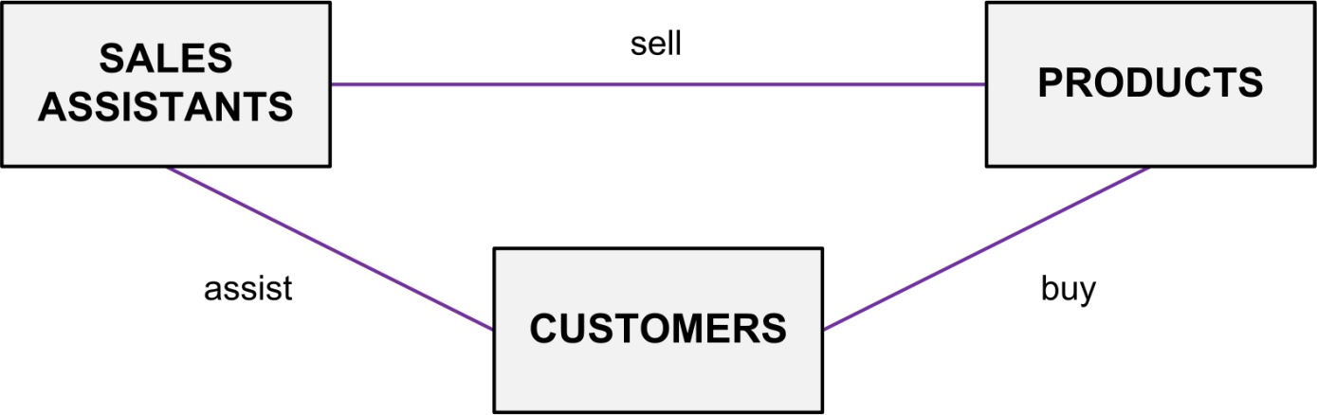

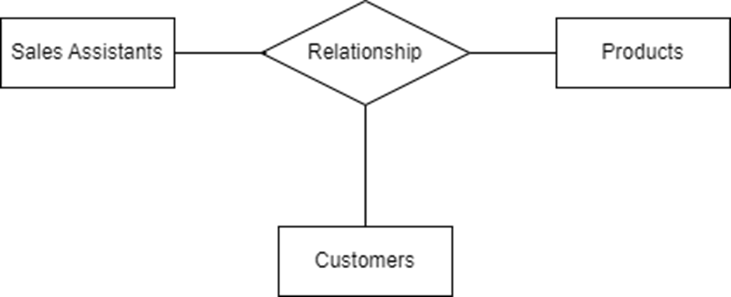

Try replacing the ternary relationship with an entity type and a set of binary relationships.

- Relationships are usually verbs, so name the new entity type by the relationship verb rewritten as a noun.
- The relationship ‘sell’ can become the entity type ‘SALES’.
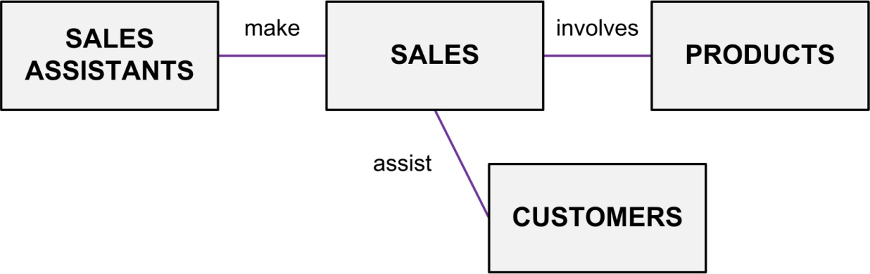


ERD Example: Ternary Relationships

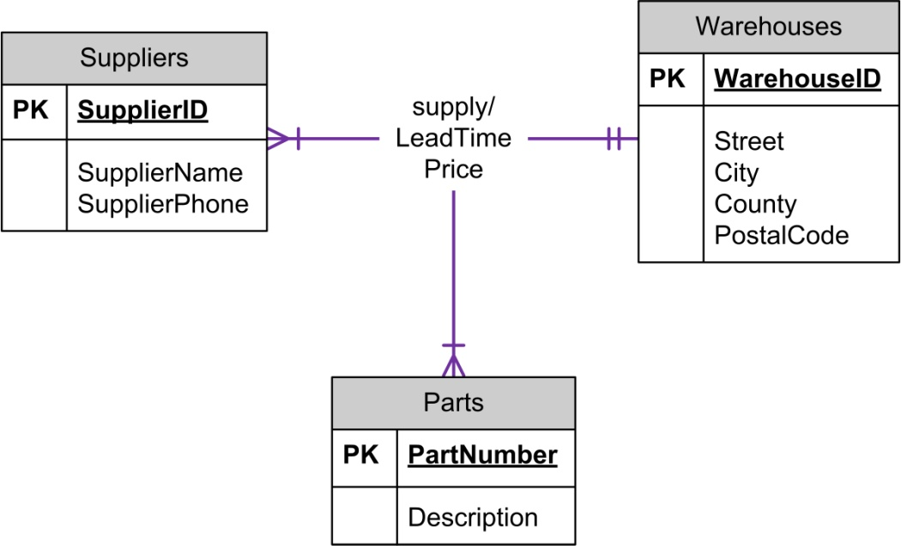

ERD Example: Ternary Relationship Converted

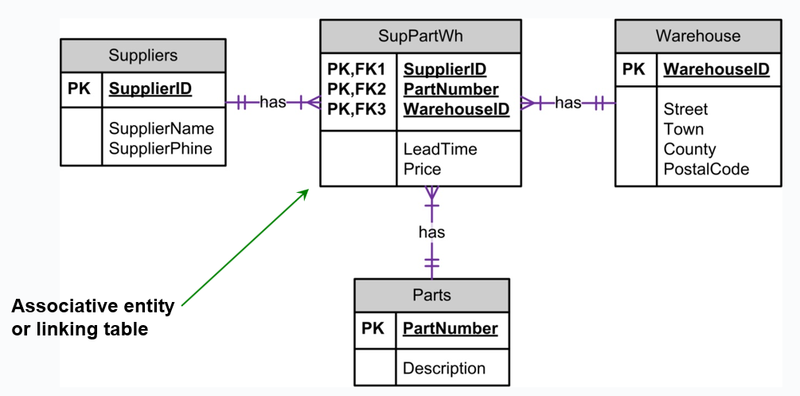

ERD Example: Relationship Attributes

- Relationship Attributes:
  - Some relationships can have attributes just as an entity can have attributes.
  - Generally, this occurs with a many-to-many relationship.
- Rule-of-thumb:
  - If you have an attribute on a 1:N relationship, you probably have something wrong.
  - Attribute should go on one of the entities.

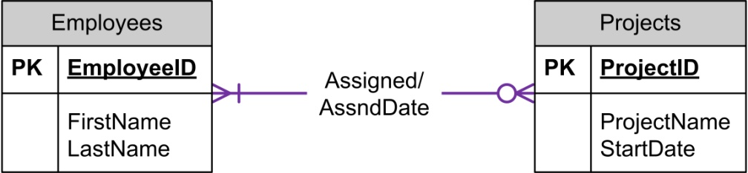

ERD Example: Multiple Relationships
- Multiple Relationships - more than one relationship between the same entity types.
  - These are depicted in the ERD with multiple relationship lines connecting the two entities.

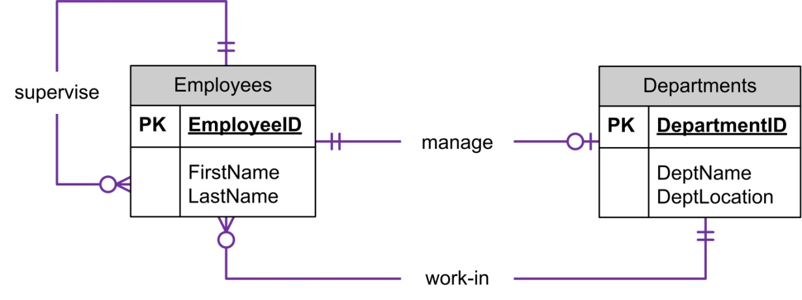

Key Based ER Diagram

Solution lab 2 exercise 2

Exercise Scenario
Prepare an ER diagram for a real estate company that lists property for sale. The following describes the organisation:
- The company has a number of sales offices in several counties.
- Attributes of sales office include Office_Number (identifier/key) and Location.
- Each sales office is assigned one or more employees.
- Attributes of employee include Employee_ID (identifier/key) and Employee_Name.
- An employee must be assigned to only one sales office.
- The firm lists property for sale.

Nest Step

- The company has a number of sales offices in several counties.
- Attributes of sales office include Office_Number (identifier/key) and Location.
- Each sales office is assigned one or more employees.
- Attributes of employee include Employee_ID (identifier/key) and Employee_Name.
- An employee must be assigned to only one sales office.
- The firm lists property for sale.

Nest Step

- Attributes of property include Property_ID (identifier) and Location.
- Components of Location include Address, City, County, and Postal_Code.
- Each unit of property must be listed with one (and only one) of the sales offices.
- A sales office may have any number of properties listed.
- Each unit of property has one or more owners.
- Attributes of owners are Owner_ID (identifier) and Owner_Name.
- An owner may own one or more units of property.
- An attribute of the association between property and owner is Percent_Owned.

Nest Step

- Attributes of property include Property_ID (identifier) and Location.
- Components of Location include Address, City, County, and Postal_Code.
- Each unit of property must be listed with one (and only one) of the sales office.
- A sales office may have any number of properties listed.
- Each unit of property has one or more owners.
- Attributes of owners are Owner_ID (identifier) and Owner_Name.
- An owner may own one or more units of property.
- An attribute of the association between property and owner is Percent_Owned.

Entities
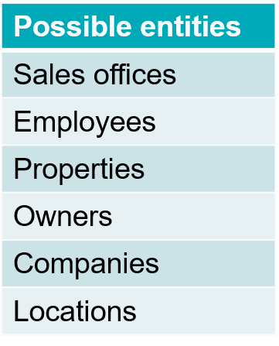
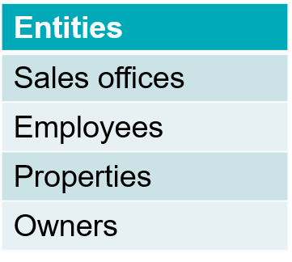

Attributes
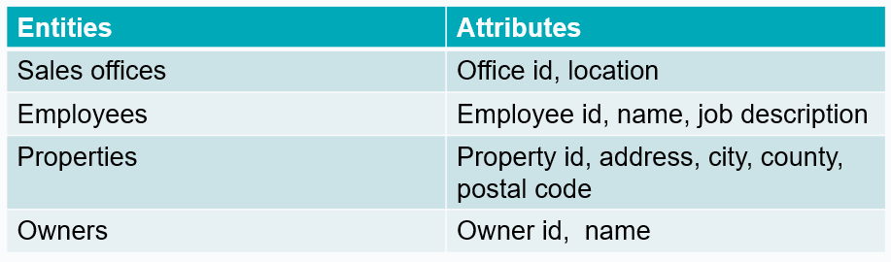

Relationships
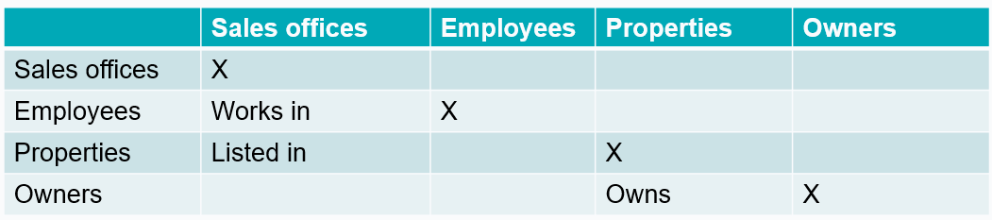

Rough ER Diagram with PKs
Exam TIP – get marks for rough ER diag (below)
Have to go thru all the steps but in this dig need cardinality+ PKs + All Entities/

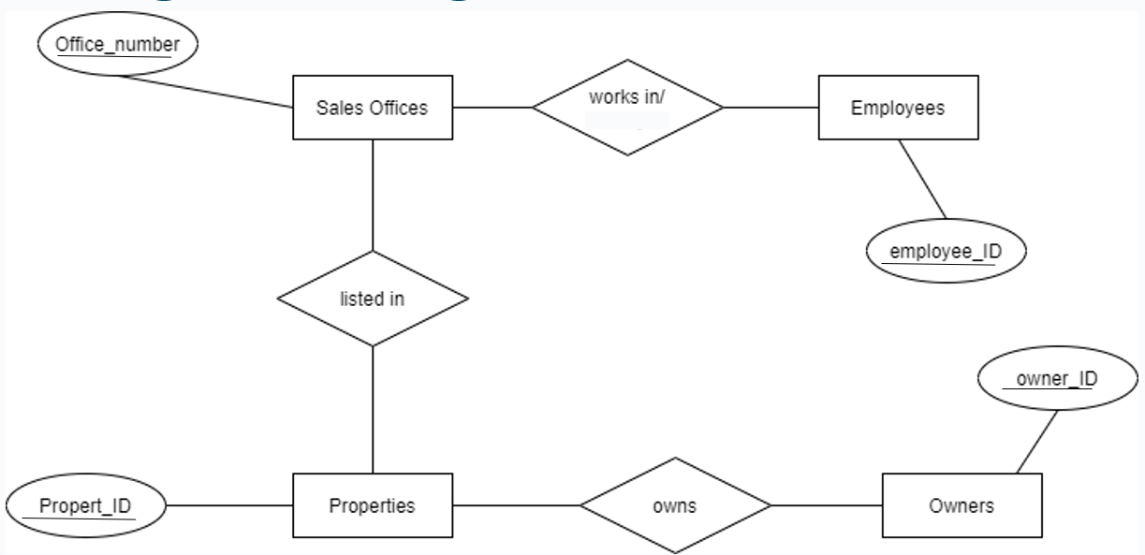

Rough ER Diagram with cardinality

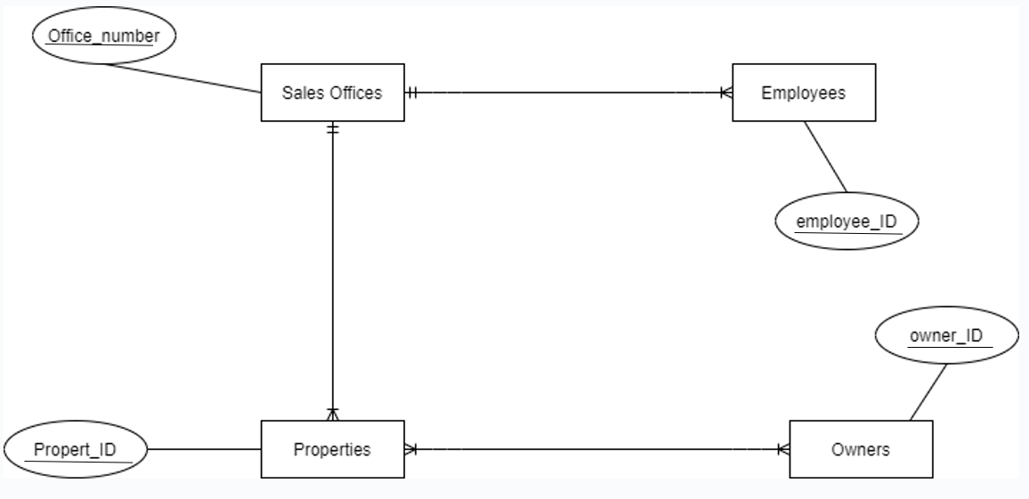

Rough ER Diagram *

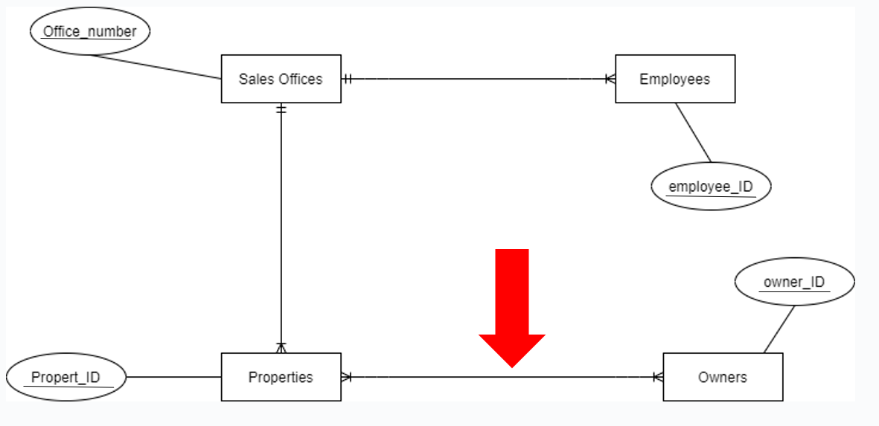

Rough ER Diagram with weak entities

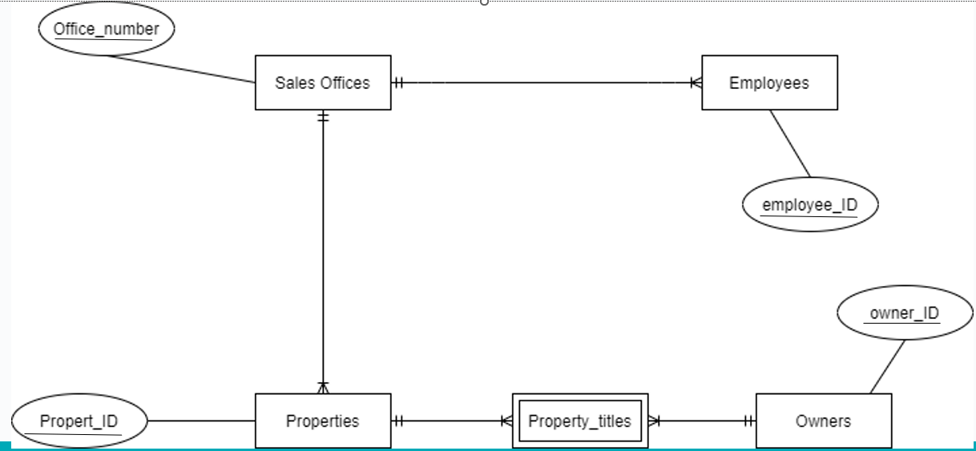

Rough ER Diagram – Non-Identifying

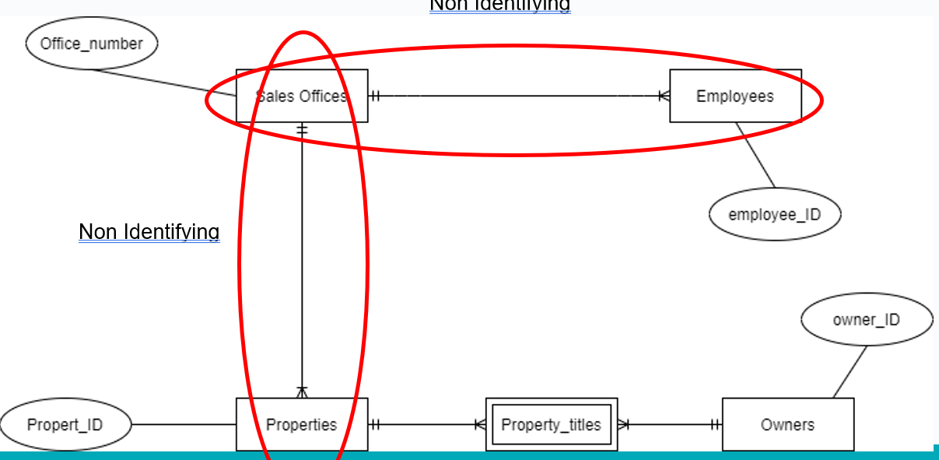

Rough ER Diagram-Identifying

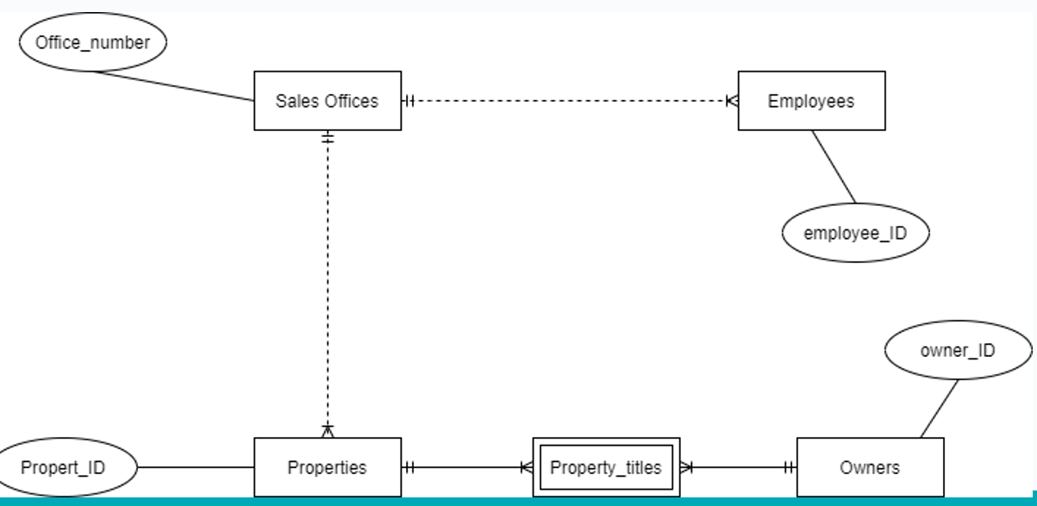

Solution lab 2 exercise 2 version 1

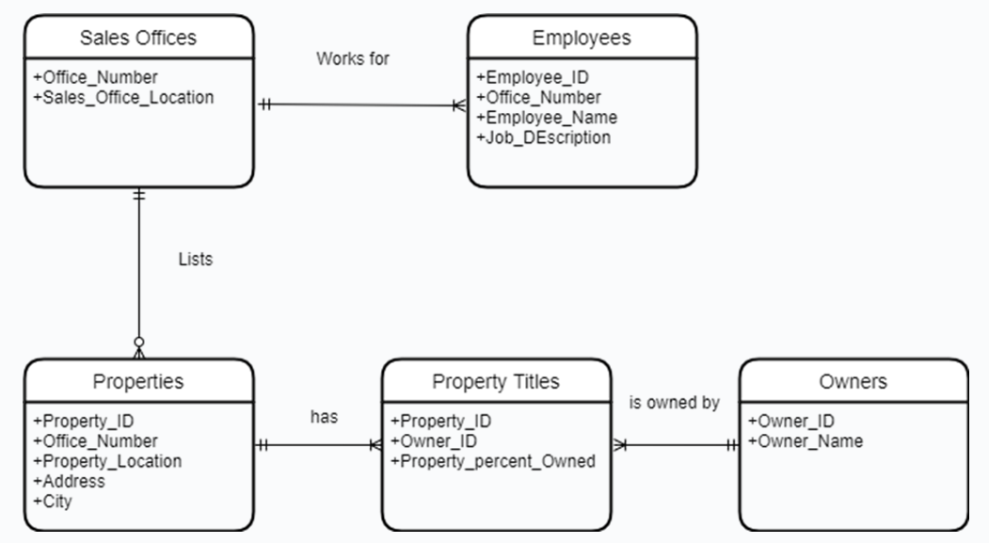

Solution lab 2 exercise 2 version 1 - PKs

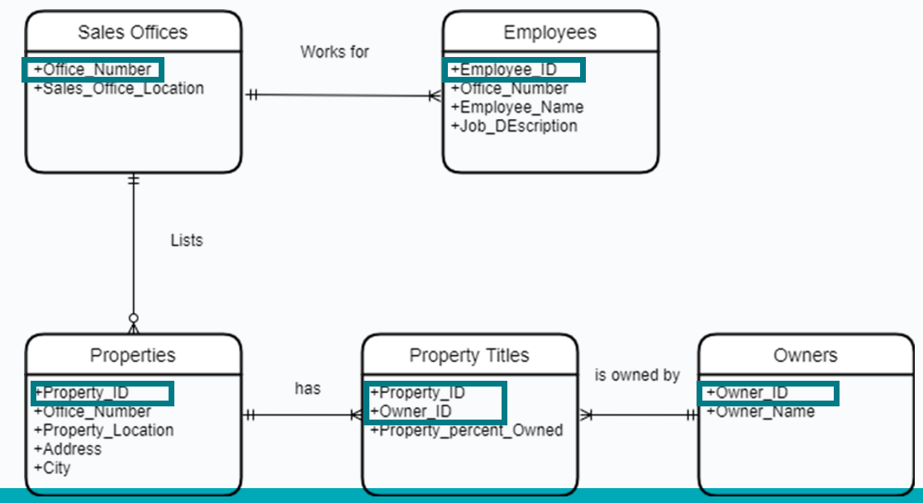

Solution lab 2 exercise 2 version 1 - FKs

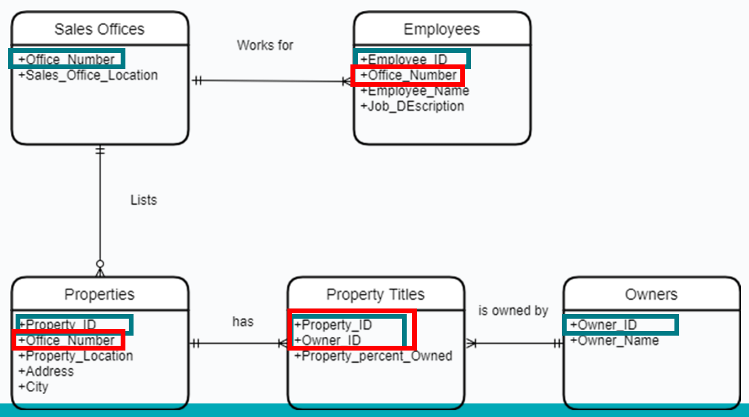

Solution lab 2 exercise 2 extra information

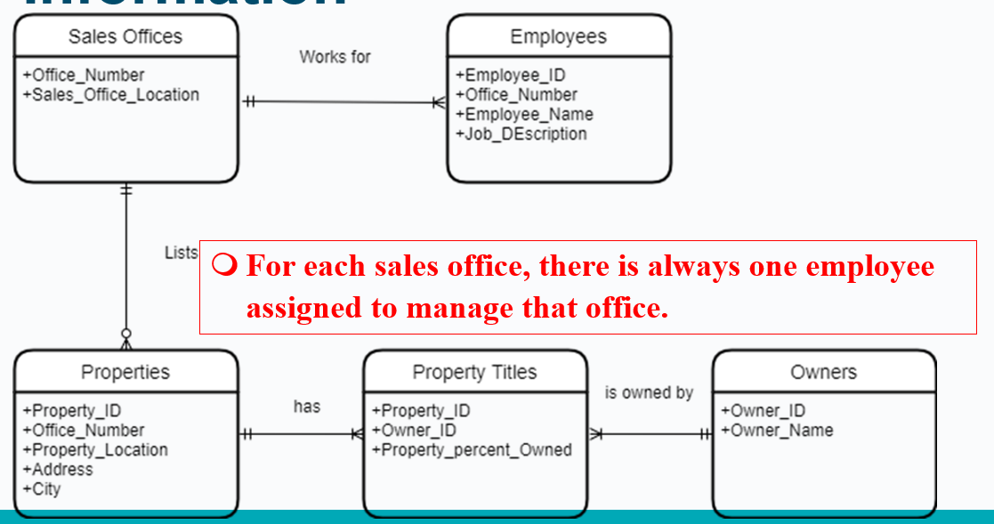

Solution lab 2 exercise 2 version 2

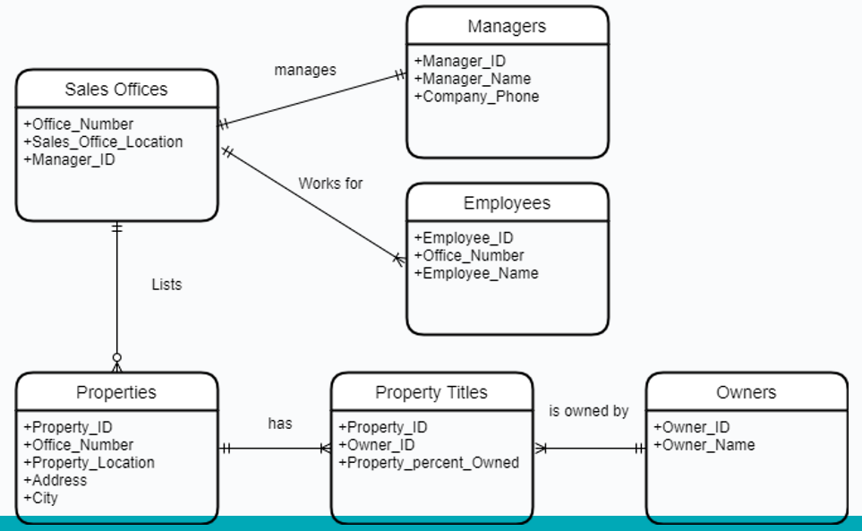

Solution lab 2 exercise 2 version 3

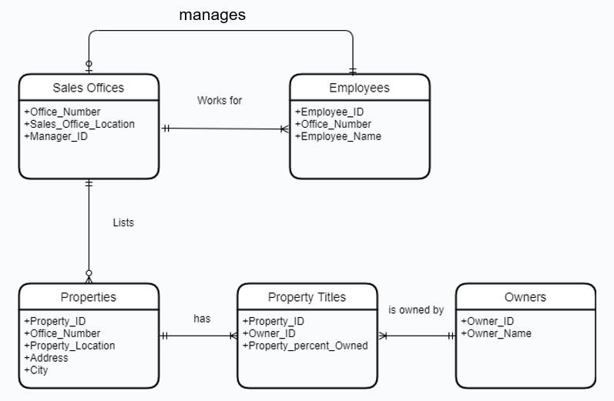

Key Based ER Diagram

Exam tip – need the below in hand off
- No many to many relationships
- Bridge entities used if required
- PKs defined
- FKs defined

Solution lab 2 exercise 2 version 1 - Key based ER diagram

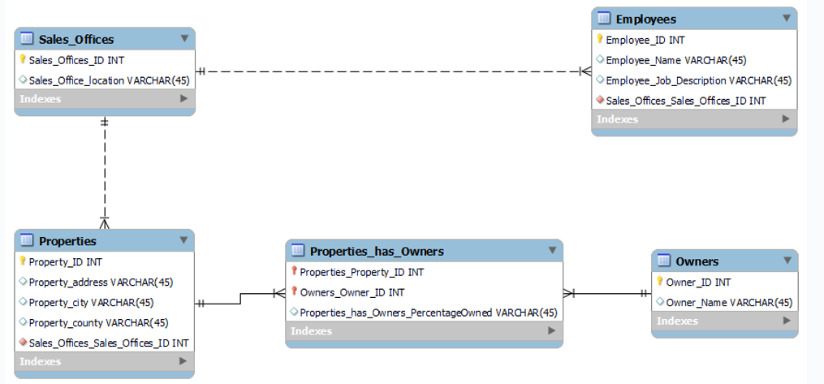

Foreign Key

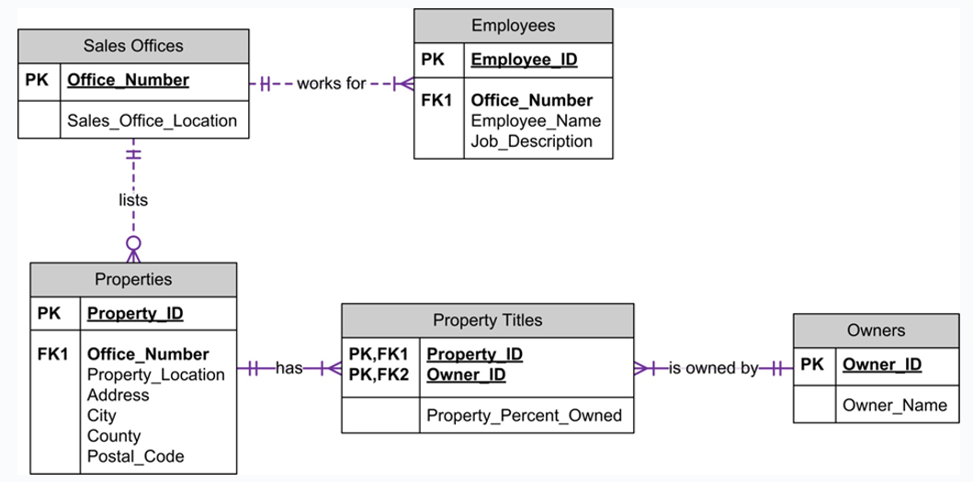

Solution lab 2 exercise 2 version 3 - Key based ER diagram
Sql modeller
Yellow key =PK
Red diamond symbols = FK
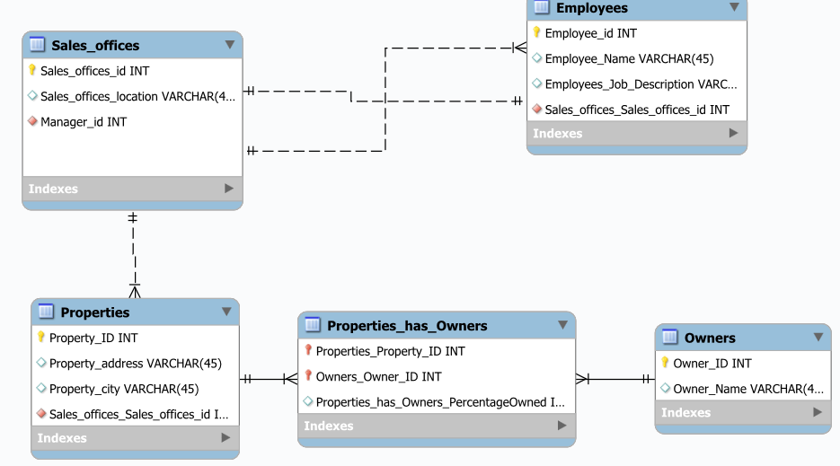

Lab 3 description

Business Requirements
A company has several departments. Each department has a supervisor and at least one employee. Employees must be assigned to at least one, but possibly more departments. At least one employee is assigned to a project, but an employee may be on holidays and not assigned to any projects.

Work flow

- Step 1: Identify Entities
- Step 2: Find Relationships
- Step 3: Draw Rough ER Diagram
- Step 4: Fill in Cardinality
- Step 5: Define Primary Keys
- Step 6: Draw Key-Based ERD (eliminating many to many relationships, include FKs)
- Step 7: Identify Attributes & Step 8: Map Attributes
- Step 9: Draw Fully Attributed E-R Diagram
- Step 10: Revise and update list of assumptions

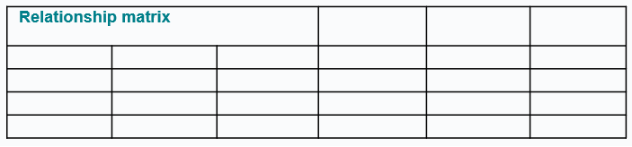

Thanks

- Edmund Nevin for earlier versions of these lecture notes

Week 4 –

Keys and Constraints

9th^{d} Oct 2024 – TU257

Lesson Outline
- Introduction to Logical Design
  - Identifiers/keys
  - Constraints
  - Referential actions
  - Data anomalies
  - Introduction to normalization

Data Models

- Specify concepts that are used to describe the database. These can be categorised as:
  - High Level (Conceptual)
  - Representational (Logical)
  - Low Level (Physical)

Database Terminology

Tables/relation

- What is a Table/Relation?
  - Single valued cells (groups and arrays are not allowed to be values).
  - All entries in any attribute are of the same kind.
  - Each column must have a unique name.
    - Note: The order of the columns is not significant.
  - No two rows are identical.
    - Note: The order of the rows is not significant.

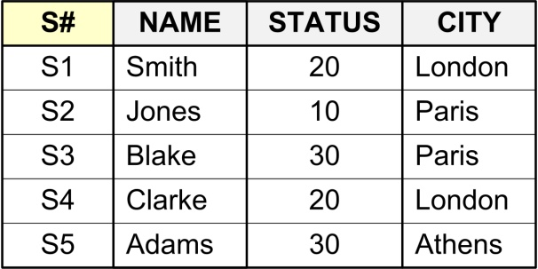

Relation/Tuple/Attribute

- Relation: Relation (in relational model) is not the same as relationship (in ER model)
- Tuple: Row
- Attribute: A property or characteristic of an entity or relationship type that is of interest to the enterprise
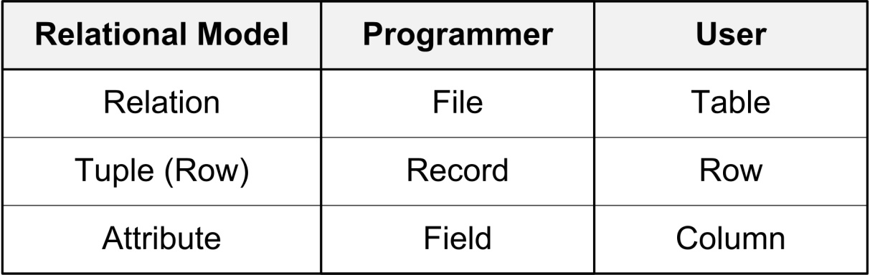

Correspondence with ER Diag
- Correspondence with ER Diagram:
  - Relations (tables) correspond with entity types.
  - Rows correspond with entity instances.
  - Columns correspond with attributes



Integrity
- Integrity:
- The accuracy and correctness of data.
- DBMS enforce integrity.
- A constraint is any rule governing static values of attributes that is precise enough so that you can ascertain whether or not it is true.

Identifiers/keys

Definition

- A key is one or more attributes (together) that uniquely identifies a tuple or row.
- Primary Key: The column or set of columns that uniquely identifies any given row.
  - Would a name be a good primary key?
  - Would a social insurance number be a good primary key?
  - The value in the primary key can never point to more than one row in the table.

Keys Notation

- A table and its primary key can be described by writing the columns within parentheses, and underlining the primary key:
STUDENTS (StudentID, Name, Address, PhoneNumber, DOB)

/Keys Types

- Types of key:
  - Single vs. Combination/Composite Key
  - Superkeys
  - Candidate Keys
    - Primary Keys vs. Alternative Keys
  - Foreign Keys

Single
  - STUDENTS (StudentID, Stu_Name, Address, PhoneNumber)
  - MODULES (ModuleID, Module_Name)

Combination
  - STUDENT_MODULE_REGISTRATION (StudentID, ModuleID, year, semester)

Keys Superkey
- Superkey:
  - An attribute or set of attributes that uniquely identify rows in a table.
  - i.e. two distinct rows are always guaranteed to have distinct superkeys.

Example Superkeys

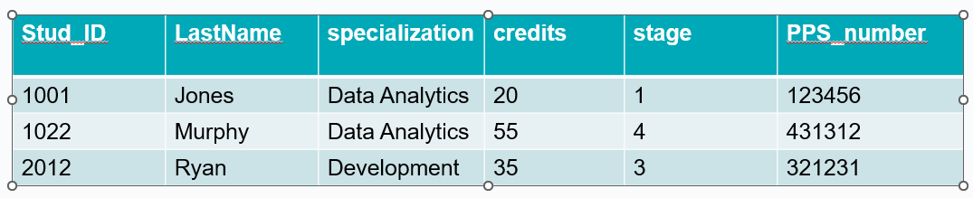
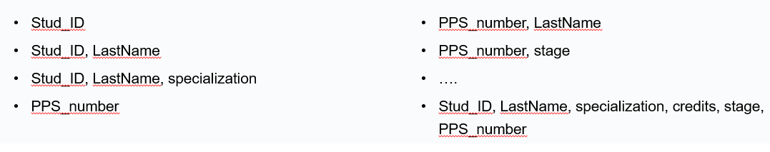

Candidate Key

- Candidate Key:
  - A minimal superkey
  - i.e. a superkey for which you can say that no proper subset of it is also a superkey.

Example superkeys and candidate keys

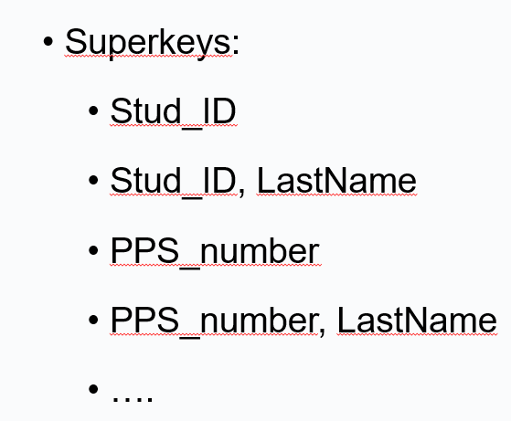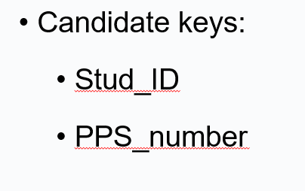

Primary
- Primary Key and alternative keys:
  - Exactly one candidate key must be chosen as the primary key, and the others are alternative keys.
  - Primary keys and alternative keys are both candidate keys.

Foreign

- Foreign Key:
  - A foreign key is a reference to a key in another table.
  - A table’s primary key is used to establish relationships with other tables.
  - This is achieved by including the primary key of one table as the Foreign Key of another.
Exam tip >> always feedback about FK being in wrong place… try get right… most common mistake in this module…

Keys

- The general rule of thumb is to take the primary key of the one side of the relationship and include it in the table of the many side of the relationship.
  - From 1 to many….Take PK from 1 and move to Many as FK

Non-prime Attributes:
  - An attribute that does not occur in any candidate key.

Constraints

Constraint Classification

- Type (Domain) Constraint: Define or constrain values that may be assigned to an attribute.
  - e.g. Define a type WEIGHT
  - real numbers.
  - legal values in [0, 1000]
- Entity Integrity Constraint: Every row must have a non-null value for the primary key.
  - If it is a composite key, no part of the key may be null.
    - Null: Term used to describe a missing value for an attribute in a particular row.
      - It is not the same as zero

- Referential Integrity constraint:
  - A rule that states that either each foreign key value must match a primary key value in another relation or the foreign key value must be null.

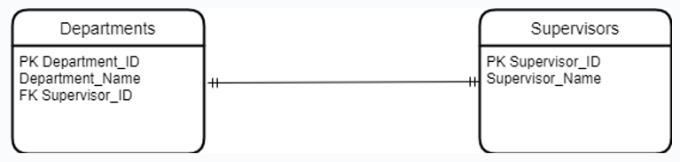

Practical Example University 2


Practice
- Try to add the following data to the table Student_takes_modules:
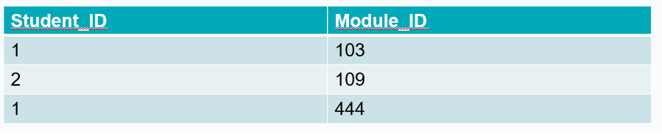
- What happened?

Referential Actions

Referential Actions ON DELETE

- When you delete a tuple from a table, say R1, that is referenced by another table, say R2, if the primary key (K#) value of R1 exists in R2, there are several choices of referential actions:
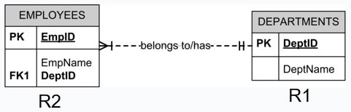

Referential Actions ON DELETE
- ON DELETE CASCADE
  - The corresponding tuples in R2 will be deleted too.
- ON DELETE RESTRICT
  - The deletion of the tuple from R1 is rejected.
- ON DELETE NO ACTION
  - The tuple is deleted from R1, but no action to R2.
  - The referential integrity is violated.

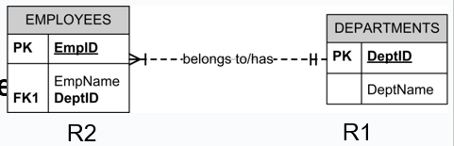

Referential Actions ON UPDATE

When you update a tuple from a table, say R1, that is referenced by another table, say R2, there are similar choices of referential actions:
ON UPDATE CASCADE
ON UPDATE RESTRICT
ON UPDATE NO ACTION

Example: Referential Integrity



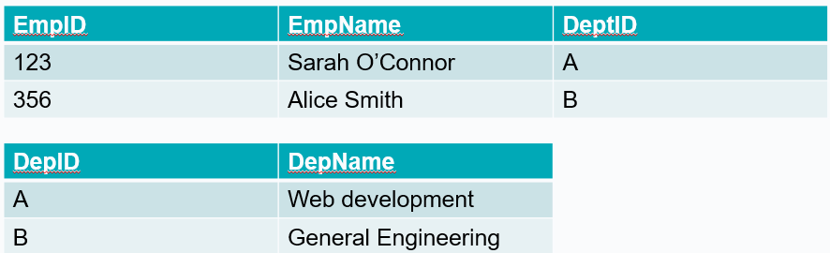

Example: Referential Integrity: ON DELETE CASCADE



d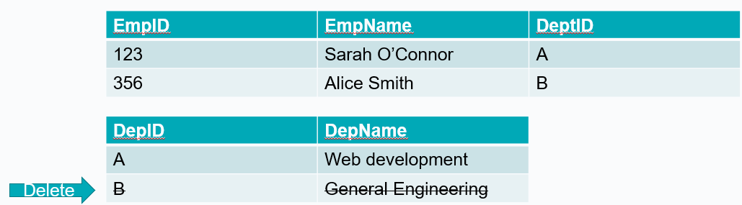

Example: Referential Integrity ON DELETE CASCADE

d

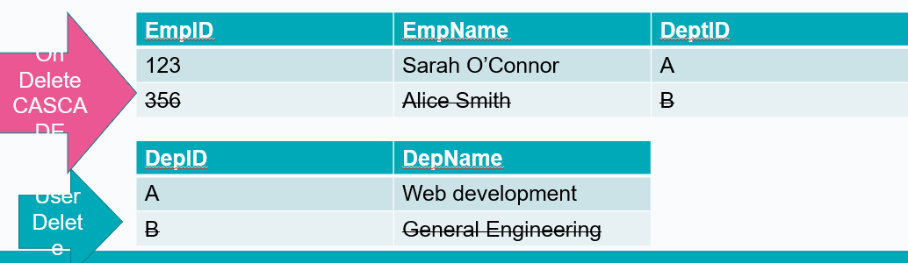

Example: Referential Integrity: ON DELETE RESTRICT



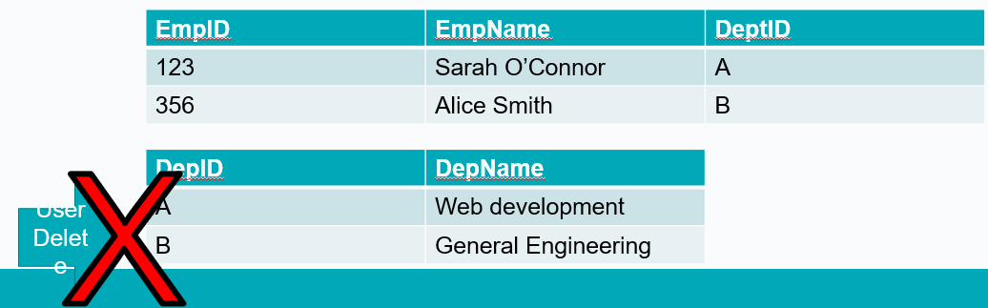

Example: Referential Integrity: ON DELETE NO ACTION



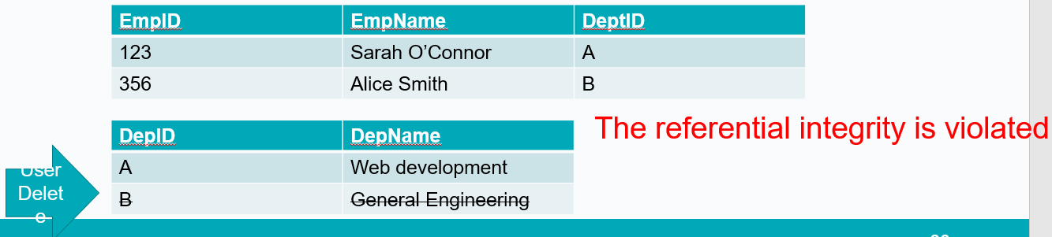

Referential Integrity: ON DELETE NO ACTION Different DBMS

- In MySQL:
  - NO ACTION is equivalent to RESTRICT.
- Omitting the clause is the same as specifying RESTRICT or NO ACTION.
  - In SQLite:
  - If an action is not explicitly specified, it defaults to "NO ACTION".

Practical Example University 2

- Add the following constraint:
  - FOREIGN KEY("StudentID") REFERENCES "students"("StudentID") ON DELETE CASCADE
- Delete student 1
  - Look at the Student_takes_module table to see the effect

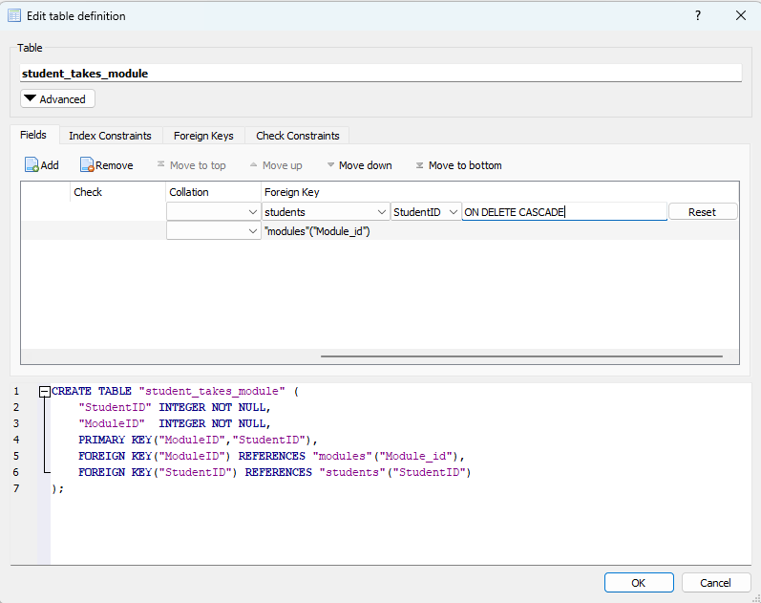

Practical Example University 2





Normalisation

Definition

- The process of designing a database in the most efficient way possible.

- A technique for designing relational database tables to minimise duplication of information and, in doing so, to safeguard the database against certain types of logical inconsistency.

- More highly normalised tables greatly simplify development and maintenance of the database and contribute to its extensibility.
- Properly executed, the normalisation process eliminates uncontrolled data redundancies,
  - thus eliminating the data anomalies, and
  - the data integrity problems that are produced by such redundancies.
- Normalisation does not fully eliminate data redundancy. Instead, it produces the carefully controlled redundancy that lets you properly link database tables.

Definitions relevant to normalisation
- Data anomalies
- Repeating groups
- Dependencies
  - Functional and fully functional
  - Partial
  - Transitive

Data Anomalies
- The most common anomalies considered when data redundancy exists are:
  - Update anomalies
  - Insert anomalies
  - Deletion anomalies
- All these can easily be avoided through data normalisation.

Example: Data Anomalies

The following relation contains staff and department details.
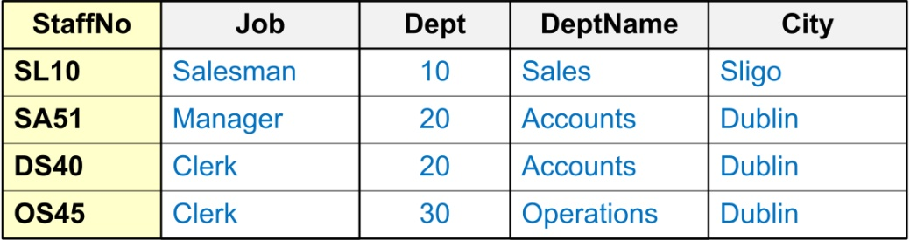

Such ‘redundancy’ could lead to the following ‘anomalies’
Insert Anomaly: You could insert a new staff member and add incorrect details for the Department.
Update Anomaly: You could change the name of the ‘Dept’ that SA51 (‘StaffNo’) works in without simultaneously changing the ‘Dept’ that DS40 (‘StaffNo’) works in.
Deletion Anomaly: By removing employee SL10 (‘StaffNo’) you have removed all information pertaining to the ‘Sales Dept’ (‘Dept’, ‘DeptName’ & ‘City’).

Stages of Normalisation
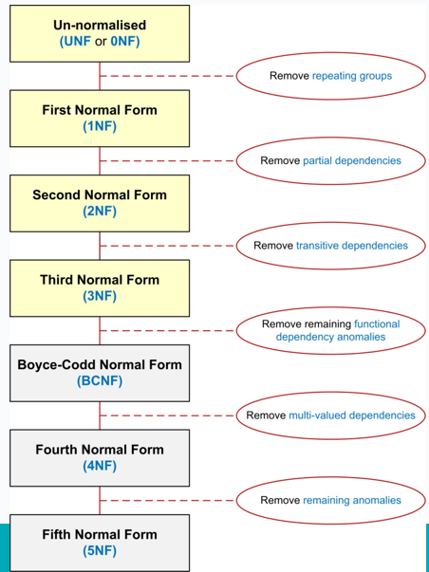

Recap: Purpose of Normalisation

- To avoid redundancy by storing each ‘fact’ within the database only once.
- To put data into a form that conforms to relational principles
  - single valued attributes,
  - each relation represents one entity, i.e. No Repeating Groups
- To put the data into a form that is more able to accurately accommodate change.
- To avoid certain updating ‘anomalies’.
- To facilitate the enforcement of data constraints.

Normalisation: Relational Model

In order to comply with the relational model it is necessary to
- Remove repeating groups, and
- Avoid redundancy and data anomalies by removing partial and transitive functional dependencies.
All attributes in a table must be ‘atomic’, and solely dependant fully upon the primary key of that table.

Thanks

- Edmund Nevin for a earlier versions of these lecture notes

Lab 4 - Scenario

A university library needs a new DBMS. The system needs to handle users borrowing and returning books and keep track of the overall status of the library. The library is located across several sites and all students can borrow up to 10 books at a time from any of the sites. For some popular books, the library keeps multiple copies across different sites to facilitate students’ access. Details of site manager, authors and publishers are also kept.
Exam tip – check out student book cardinality she calls it out in video and will be the same in asssignment with user to bike or bike loan/object

Lab 4 -Requirements

- Extra requirements:
  - Each site has one manager and managers can only manage one site.
  - Assume books only have one author (for now).
- Pay attention
  - A copy of the book is different to the generic book
  - Decide what information is needed in the database and what can be calculated at a later stage

Week 5

Normalisation
- UNF
- 1NF
- 2NF
- 3NF

Definition

- The process of designing a database in the most efficient way possible.
  - A technique for designing relational database tables to minimise duplication of information and, in doing so, to safeguard the database against certain types of logical inconsistency.
  - More highly normalised tables greatly simplify development and maintenance of the database and contribute to its extensibility.
- Properly executed, the normalisation process eliminates uncontrolled data redundancies,
  - thus eliminating the data anomalies, and
  - the data integrity problems that are produced by such redundancies.

Stages of Normalisation
- Unnormalised
  - Remove repeating groups
- 1NF
  - Remove partial dependencies
- 2NF
  - Remove transitive dependencies
- 3NF

Repeating Groups
- A repeating group is an attribute (or set of attributes) that can have more than one value for a primary key value.
- Repeating Groups are not allowed in a relational design, since all attributes have to be ‘atomic’ - i.e. there can only be one value per cell in a table.
- Example: The following relation contains staff and department details and a list of telephone contact numbers for each member of staff.

Example 1
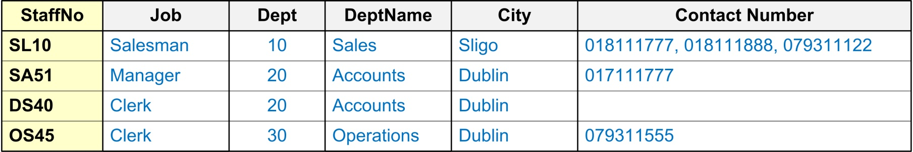

---------------------------------------------------------------------------------------------------------------------------

Example 2

--------------------------------------------------------------------------------------------------------------------------------

Example 3


Invoice Number | ClientID | OrderDate | ProductID | Product Name | Quantity | Price | total
1234 | 432 | 2023-01-01 | 43,23,455,23 | Table, Chair, Pillow, Cushion | 1,6,4,4 | 900,190,42,25 | 900,1140,168,100

Dependencies
- Functional Dependency:
  - Fully Functional Dependency
  - Partial Functional Dependency
- Transitive Dependency

Functional Dependency
- Formal Definition: Attribute B is functionally dependent upon attribute A (or a collection of attributes) if a value of A determines a single value of attribute B at any one time.
- In other words, attribute B has a functional dependency on attribute A if, for each value of A, there is exactly one value of attribute B.

Formal Notation A → B
- This should be read as ‘A determines B’ or ‘B is functionally dependent on A’. A is called the determinant and B is called the object of the determinant.
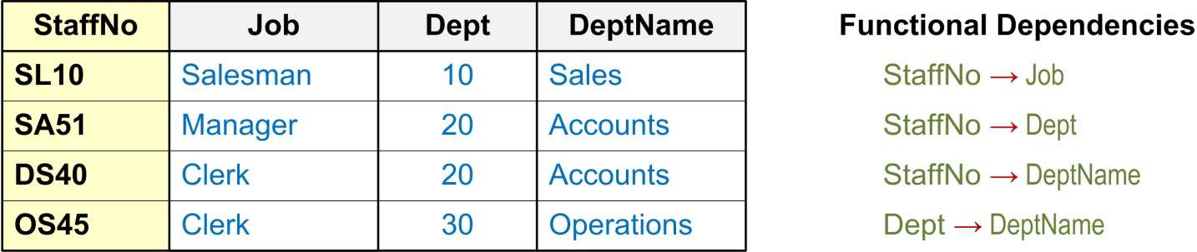

Example

Dept → DeptName
This should be read as ‘Department determines DepartmentName’
or
‘DepartmentName is functionally dependant on Department’.

Dept → DeptName



Full Functional Dependency
- An attribute is fully functional dependent on a set of attributes X if it is…
  - functionally dependent on X, and
  - not functionally dependent on any proper subset of X
  - Only relevant for composite determinants
  - Only of relevance with composite determinants.
  - All the attributes of the composite determinant (Course# and Subject_Code) are needed to determine the Subject Type

Example 1

Course# | Subject_Code | Subject_Type
ICA40299 | ICAITB060A | Core
ICA40299 | ICAITU018B | Elective
ICA40199 | ICAITU018B | Core

Partial Functional Dependency
- This is the situation that exists if it is necessary to only use a subset of the attributes of the composite determinant to identify its object uniquely.

Example 1
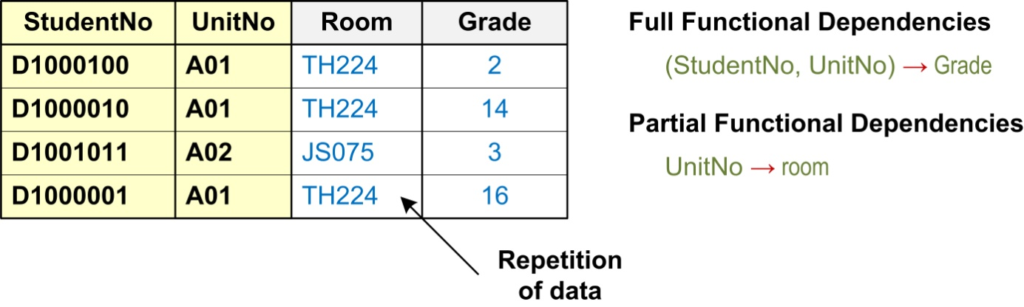

Transitive Dependency
- A transitive dependency exists when there is an intermediate functional dependency.
- A condition in which an attribute is dependent on another attribute that is not part of the primary key.
  - i.e. an indirect functional dependency,
  - one in which X → Z only by virtue of X → Y and Y → Z

Formal Notation
    - If A → B and B → C, then it can be stated that the following transitive dependency exists: A → B → C

Example 1
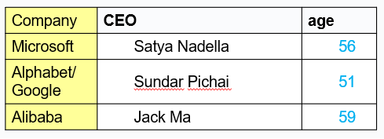
If company → CEO and CEO → age, then it can be stated that the following transitive dependency exists:
company → CEO → age

Normal Forms

When is a table in 1NF?
- A table is in 1NF when…
  - All the key attributes are defined (no repeating groups in the table) and when,
  - All remaining attributes are dependent on the primary key
  - Note: A table in 1NF still may contain partial dependencies, i.e., dependencies based on only part of the primary key.

When is a table in 2NF?
- A table is in 2NF when
  - it is in 1NF and,
  - it includes no partial dependencies.
Note: A table in 2NF still may contain transitive dependencies, i.e., dependencies based on attributes that are not part of the primary key.

When is a table in 3NF?

- A table is in 3NF when…
  - it is in 2NF, and…
  - it contains no transitive dependencies.

Un-normalised Normal Form (UNF or 0NF)
- Un-normalised Normal Form (UNF or 0NF)
  - Definition: A relation is un-normalised when it has not had any normalisation rules applied to it, and it suffers from various anomalies.
  - This only tends to occur where the relation has been designed using a ‘bottom-up approach’ i.e. the capturing of attributes to a ‘universal relation’ from a screen layout, manual report, manual document, etc...

Example: Logical Design (‘Bottom-up’ Approach)
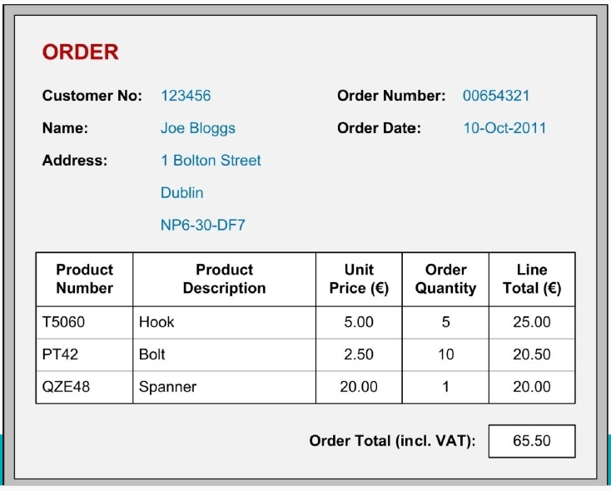

Example: Place in UNF
    - Gather attributes in the following schema form:
    - Entity( non-repeating attributes (repeating attributes)* )
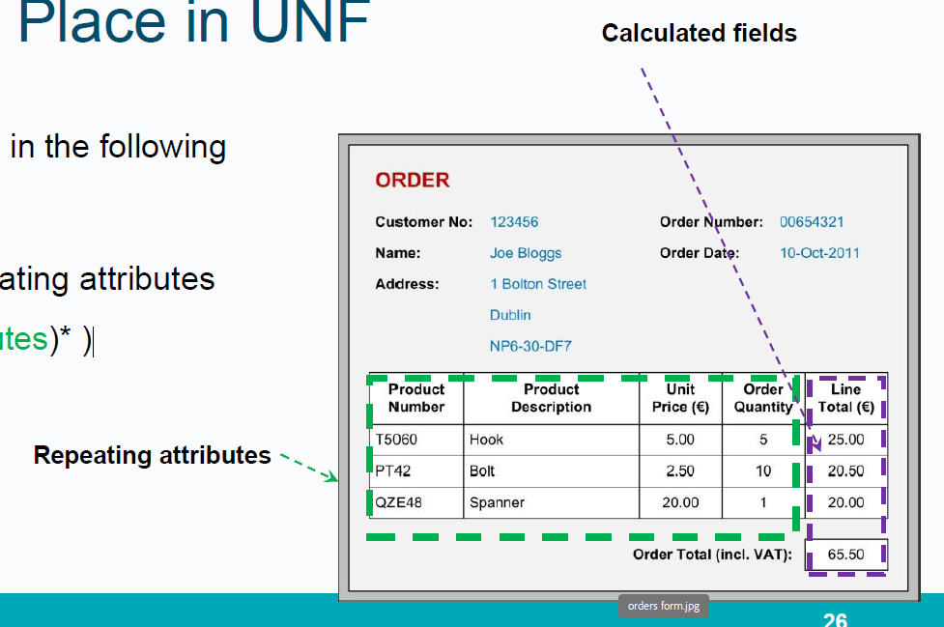

Example: Place in UNF
Entity( non-repeating attributes (repeating attributes)* )
- Un-normalised Normal Form (UNF or 0NF)

Orders( cust_no,cust_name,cust_add, order_no, order_date,(product_no, prod_desc_unit_price, order_qty, line_total)*, order_total )

First Normal Form (1NF)

Definition:
- A relation is in 1NF if, and only if, all its underlying attributes contain ‘atomic’ values only.
- Remove repeating groups into a new relation

ORDERS (order_no, order_date, cust_no, cust_name, cust_add,
(prod_no, prod_desc, unit_price, ord_qty, line_total)*, order-total)

Example: UNF to 1NF
- Remove the outermost repeating group (and any nested repeated groups it may contain) and create a new relation to contain it. Rename original to indicate 1NF.
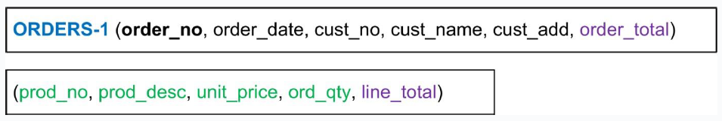

- Add to this relation a copy of the PK of the relation immediately enclosing it.
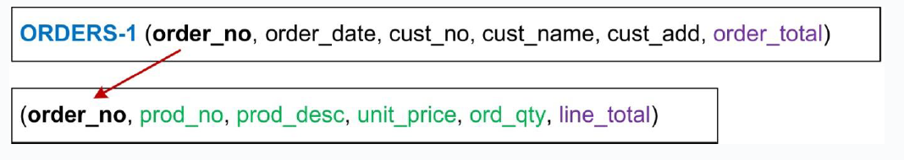

- Name the new entity (appending the number 1 to indicate 1NF).

- Determine the PK of the new entity.

Note on choosing PK

- Foreign Keys as part of a composite key can be used as PKs
- A single Foreign key is usually not suitable as Primary Keys as they allow duplication
- Alternatives:
  - Find a field that uniquely identifies each record in the table
  - Add a new field (auto-incrementing integer) to act as the primary key.

Second Normal Form (2NF)

Definition:
- A relation is in 2NF if, and only if, it is in 1NF and every non-key attribute is fully dependent on the primary key.
- Remove partial functional dependencies into a new relation.
- Check each relation individually.

Second Normal Form (2NF) First relation check

Only one single primary key. No partial dependencies.

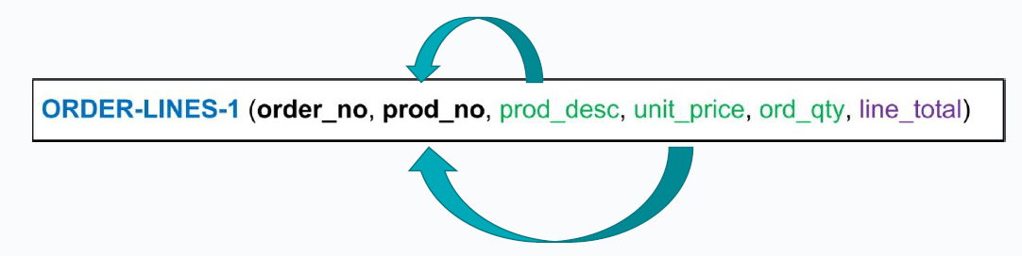
Composite primary key. Partial dependencies found.
-------------------------------------------------------------------------------------------------------------

Example: 1NF to 2NF

- Remove the offending attributes that are only partially functionally dependent on the composite key, and place them in a new relation.

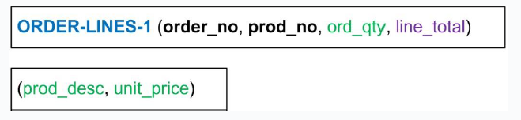
------------------------------------------------------------------------------------------------------------------------------

- Add to this relation a copy of the attribute(s) which determines these offending attributes. These will automatically become the primary key of this new relation…
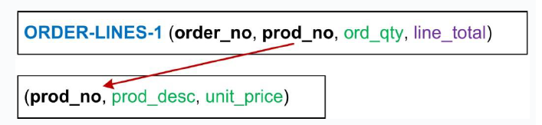

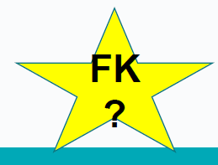
---------------------------------------------------------------------------------------------------------------------------
- Name the new entity (appending the number 2 to indicate 2NF).
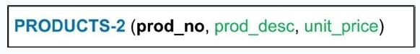

- Rename the original entity (ending with a 2 to indicate 2NF).
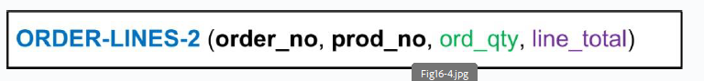

Third Normal Form (3NF)

Definition:
- A relation is in 3NF if, and only if, it is in 2NF and every non-key attribute is non-transitively dependent on the primary key.
- Remove transitive dependencies into a new relation

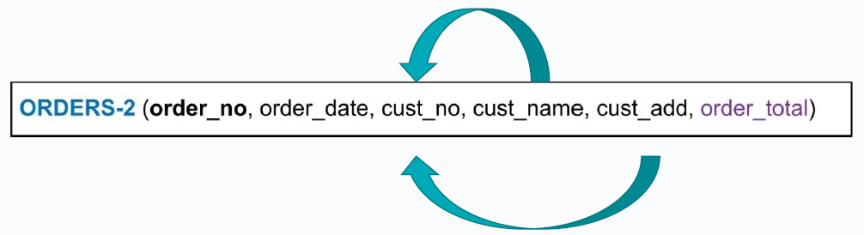
Cust_no is not part of the primary key
------------------------------------------------------------------------------------------------------------------------------

Example: 2NF to 3NF

- Remove the offending attributes that are transitively dependent on non-key attributes, and place them in a new relation.

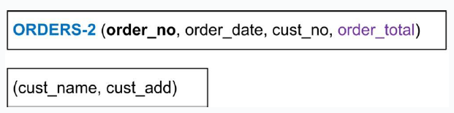
------------------------------------------------------------------------------------------------------------------------------------

- Add to this relation a copy of the attribute(s) which determines these offending attributes. These will automatically become the primary key of this new relation…
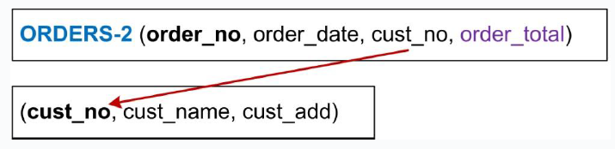

-----------------------------------------------------------------------------------------------------------------------------------
- Name the new entity (appending the number 3 to indicate 3NF).
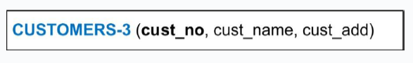

- Rename the original entity (ending with a 3 to indicate 3NF).

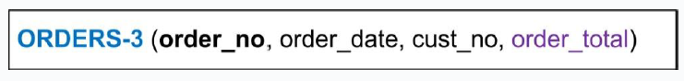

Example: Relations in Highest Normal Form
- Logical Schema:
  - ORDERS-3 (order_no, order_date, cust_no)
  - CUSTOMERS-3 (cust_no, cust_name, cust_add)
  - PRODUCTS-3 (prod_no, prod_desc, unit_price)
  - ORDER-LINES-3 (order_no, prod_no, ord_qty)
Note! Calculated fields are removed

Example: E-R Diagrams

Basic E-R Diagram

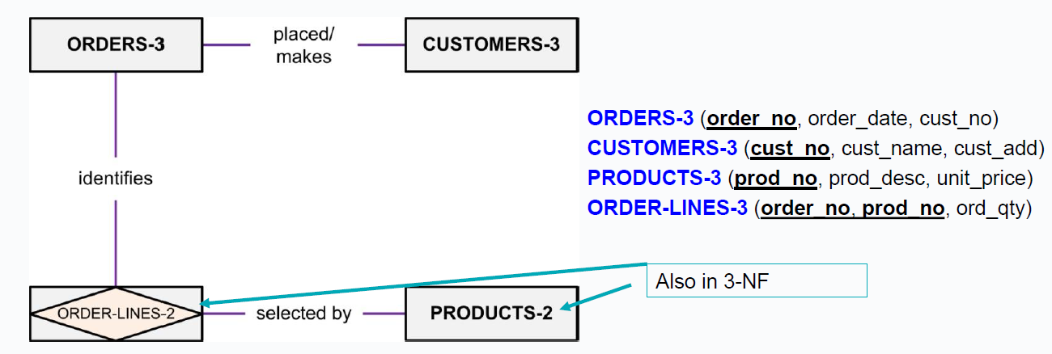

Fully-Attributed Key-Based E-R Diagram

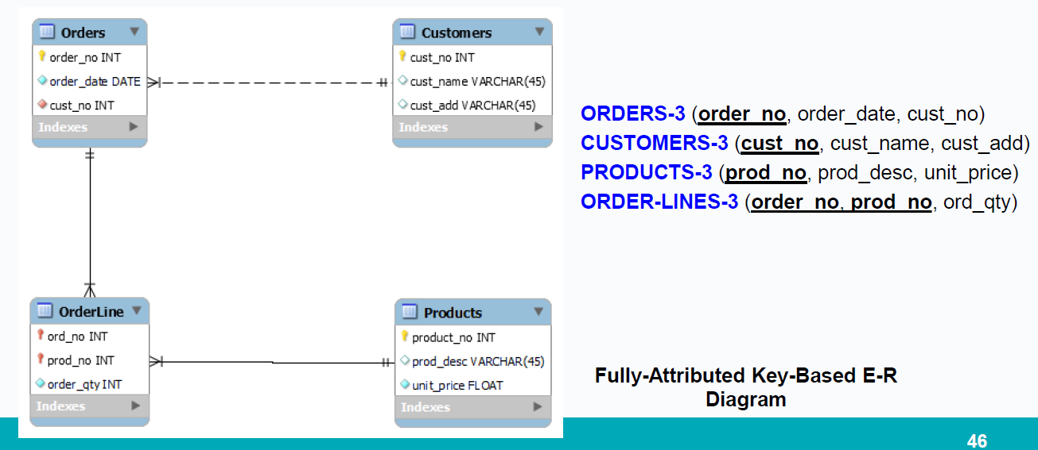

Normalisation Example

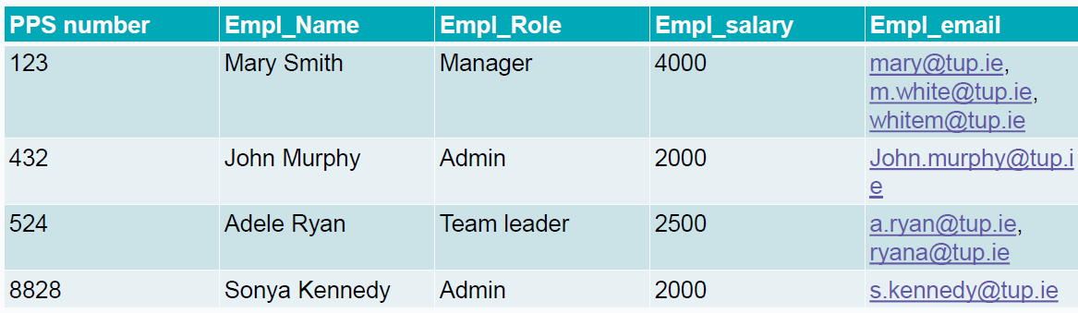
-----------------------------------------------------------------------

- Salary depends on role
- PK PPS number
--------------------------------------------------------

- What normal form is this table in?

Plan for next few weeks
  - Week 6Revision class
  - Lab SQLite 1

  - Week 7Quiz
  - No Lab

  - Week 8Submission of Assignment
  - Lab SQLite 2

Thanks

- Edmund Nevin for a earlier versions of these lecture notes

Week 6

Review - TU257
23rd Oct 2024

Data Models

- Specify concepts that are used to describe the database. These can be categorised as:
  - High Level (Conceptual)
  - Representational (Logical)
  - Low Level (Physical)

Conceptual model
- Identify
  - Entities
  - Relationships
  - Attributes
- Create an ER diagram where the structure of database can be easily understood
- Document all requirements and assumptions

ER Diagrams Process Flow
- Requirements
  - Rough ER Entities
  - Relationships
  - Basic
- Key based ER diagram Remove many to many relationships
  - Identify all PKs
  - Identify FKs
- Fully Attributed ER diagram
- Along the way identify assumptions and write them down

Design Tips

- Meaningful Tables
  - Each row contains one instance of entity or relationship
  - What’s in this table?
- Separate column for independently accessed data
  - Name, Surname, Address
- Each cell contains only one piece of data
  - Phone number
  - Add extra if exact number or separate into own table
- Each table has a key
  - One PK
  - Could have more candidate keys
  - PK cannot be NULL
- Tables are related using foreign keys (FK)
  - Referential integrity constraint
- Minimize empty cells
  - Columns with many NULL values should be placed in separate table
  - This new table will only contain entries for non null values
  - Optional relationships
- Many to many relationships
  - Remove and create bridge entity
- Document requirements and assumptions

Logical Model
- Relational model
- Normalization process
  - Reduce redundancy
  - Avoid data anomalies
  - Avoid logical inconsistencies
  - Increase efficiency

  - 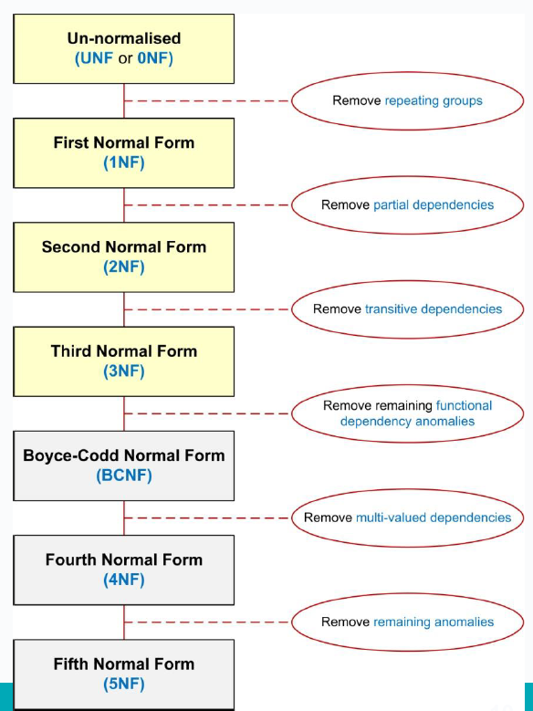

How it all Fits Together

“Use an entity relation diagram (ERD) to provide the big picture, or macro view, of an organization’s data requirements and operations. This is created through an iterative process that involves identifying relevant entities, their attributes and their relationships.”
“Normalization procedure focuses on characteristics of specific entities and represents the micro view of entities within the ERD.”
https://opentextbc.ca/dbdesign01/chapter/chapter-12-normalization/

Review exercises - week 4 Lab
A university library needs a new dbms. The system needs to handle users borrowing and returning books and keep track of the overall status of the library. The library is located across several sites and all students can borrow up to 10 books at a time from any of the sites. For some popular books, the library keeps multiple copies across different sites to facilitate students’ access. Details of site manager, authors and publishers are also kept.

Extra requirements:
Each site has one manager and managers can only manage one site.
Assume books only have one author (for now).

Entities

Initial List:
- Books
- Authors
- Publishers
- Library_Sites
- Managers
- Users
- Library

- Did we cover everything?
- Should everything stay on the list?
- How do we solve the issue with more than one copy of the same book?

Entities - Ctd

Initial List:
- Books
- Authors
- Publishers
- Library_Sites
- Managers
- Users
- Library
- Book_objects

  - Did we cover everything?
  - Should everything stay on the list?
  - How do we solve the issue with more than one copy of the same book?

Find Relationships

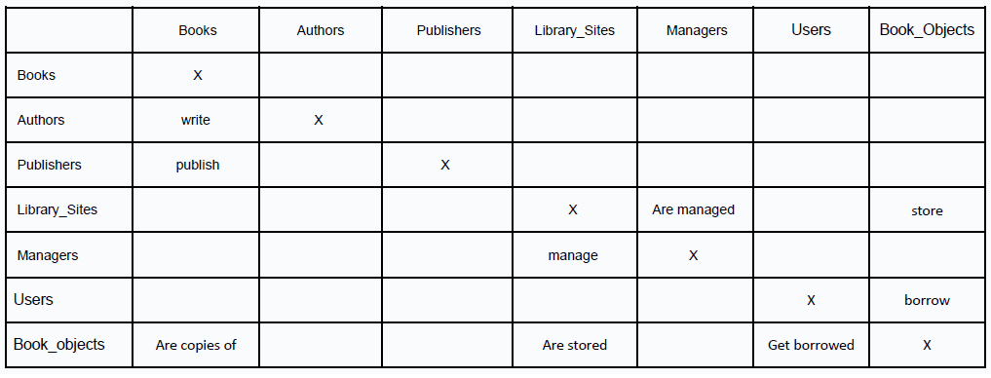

Rough ER Diagram

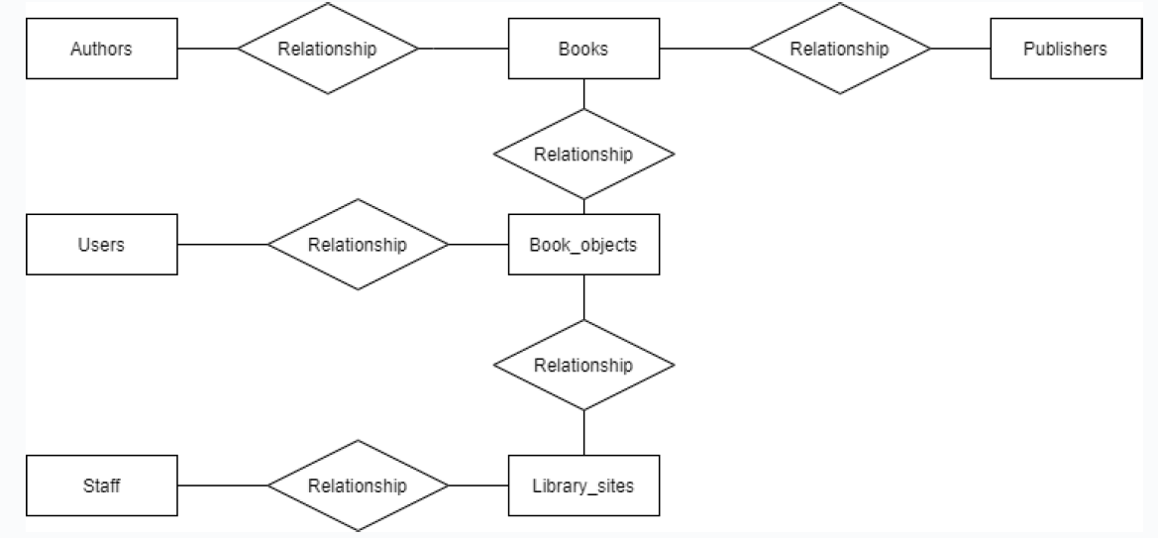

Rough ER Diagram – relationships

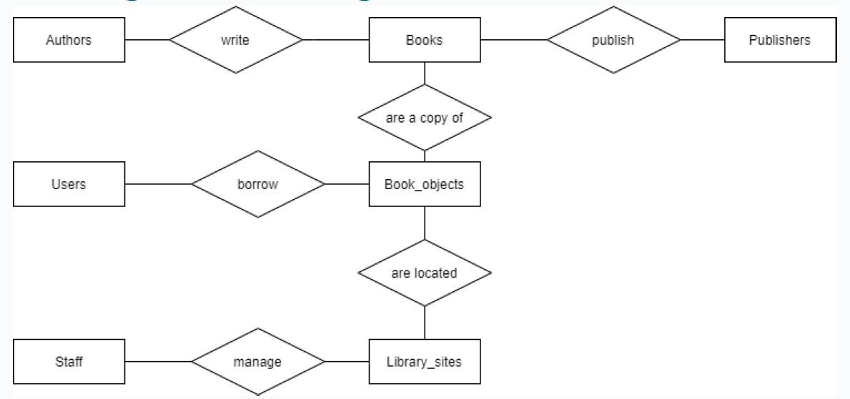

Rough ER Diagram – cardinality

  - 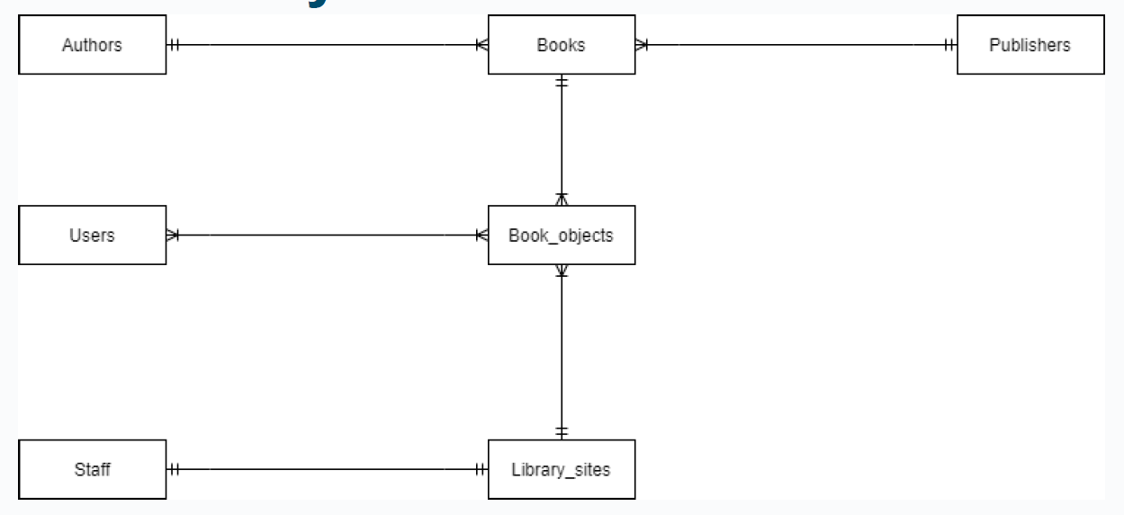

Primary Keys

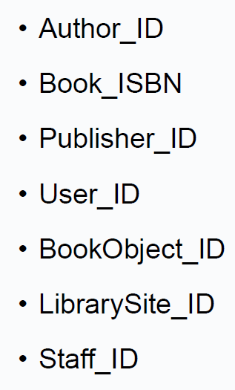

Key based ER diagram

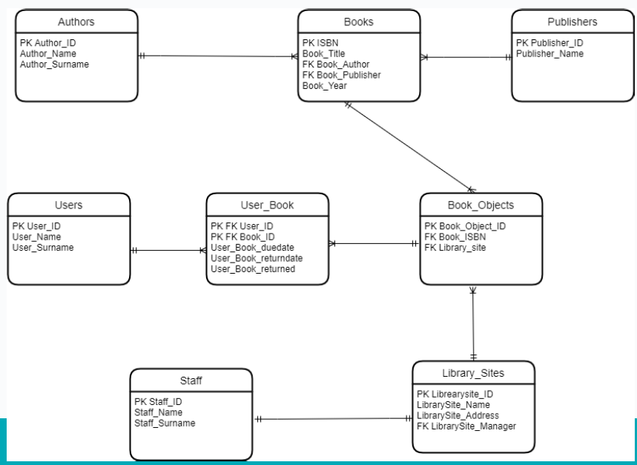

Fully Attributed ER Diag



Questions
- What is the aim of this system?
- Do we need information about staff?
- What about books written by more than one author?
- What if we want to know if a book is available?

  - Exam Tip what if we wanted to check if a book is available? >> can calculate at run time on query using python code…. Don’t store any info query at run time

Exam Tip – assignment - review of library ex – require qs at end

Discussion

- Design should match a specific purpose, do we need the managers included?
- In order to include more than one author per book, we have a many to many relationship with an extra bridge entity
- To check if a book is available we are not going to add anything to the schema, we will use code to calculate how many of the copies are available.
- Extra issues
- Real world - Different editions of the same book have different ISBN.

  - Exam Tip > are many of the same bike considered copies?
  - entity that contaoins characteristics of the bike electric/# of gears/ etc same as books and book objects
review of library ex – require qs at end

Review exercises Assumptions

A car rental company needs a new DBMS. The company needs to deal with customers’ details, reservations and returns. A customer can book several cars but each reservation is made to only one customer. A fleet of cars is stored at each location and cars have to be picked up and returned to the same location

Sample Solution 1

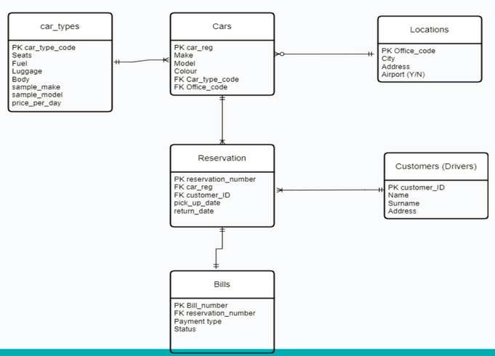

Assumptions 10 minutes breakout room

We went into break out room to discuss assumptions

Assumptions - solutions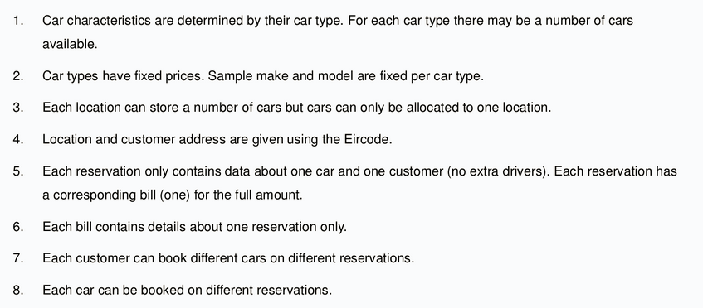

Sample Solution 2

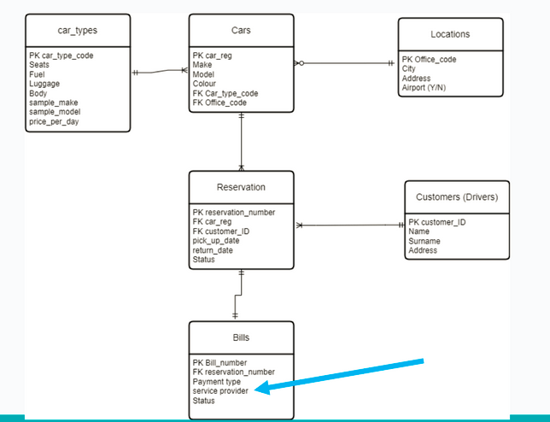

Assumptions – Updated

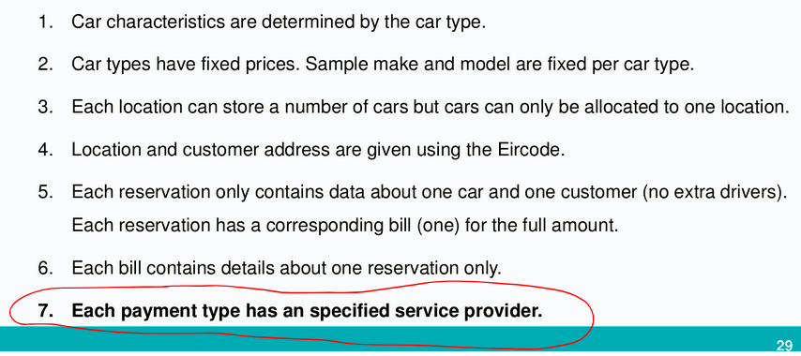

  - Exam Tip - assumptions – if not called pout explicitly in initial blurb/description >> must add as assumption – call out everything in cardinality/relationship between entities…
- exam tip – service provide – entity included in Bills entity in cars rental example…. Attribs = payment type + provider + status >>> assumption each payment type has a specified service provider == >> this results in a transitive relationship … “service provider” always dependant on “payment type” (normalon question) >> who is FK???? Payment type become sPK in new paymewnt prodier entity and we move that over toBill sentit as a FK….in ( 90 mins in lecture week 6 video)
reservation entity >> has status attrib (this tracks rental status pr payment status)

Normalisation

CARS(car_reg, make, model, colour, car_type_code, office_code)
CAR_TYPES(car_type_code, seats, fuel, luggage, body, sample_make, sample_model, price_per_day)
LOCATIONS(office_code, city, address, airport)
RESERVATIONS(reservation_number, car_reg, customer_ID, pick_up_date, return_date, status)
BILLS(bill_number, reservation_number, payment_type, service_provider, status)
CUSTOMERS(customer_ID, name, surname, address)

Normalisation 1 NF

No repeating groups. Each relation checked.
CARS1(car_reg, make, model, colour, car_type_code, office_code)
CAR_TYPES1(car_type_code, seats, fuel, luggage, body, sample_make, sample_model, price_per_day)
LOCATIONS1(office_code, city, address, airport)
RESERVATIONS1(reservation_number, car_reg, customer_ID, pick_up_date, return_date, status)
BILLS1(bill_number, reservation_number, payment_type, service_provider, status)
CUSTOMERS1(customer_ID, name, surname, address)

Normalisation 2 NF

No partial dependencies as no composite key used. Each relation checked.
CARS2(car_reg, make, model, colour, car_type_code, office_code)
CAR_TYPES2(car_type_code, seats, fuel, luggage, body, sample_make, sample_model, price_per_day)
LOCATIONS2(office_code, city, address, airport)
RESERVATIONS2(reservation_number, car_reg, customer_ID, pick_up_date, return_date, status)
BILLS2(bill_number, reservation_number, payment_type, service_provider, status)
CUSTOMERS2(customer_ID, name, surname, address)

Normalisation 3 NF

No transitive dependencies in the following relations:
CARS3(car_reg, make, model, colour, car_type_code, office_code)
CAR_TYPES3(car_type_code, seats, fuel, luggage, body, sample_make, sample_model, price_per_day)
LOCATIONS3(office_code, city, address, airport)
RESERVATIONS3(reservation_number, car_reg, customer_ID, pick_up_date, return_date, status)
CUSTOMERS3(customer_ID, name, surname, address)

Normalisation 3 NF

Transitive dependency found between service provider and payment_type.
From assumptions: Each payment type has an specified service provider.
BILLS2(bill_number, reservation_number, payment_type, service_provider, status)

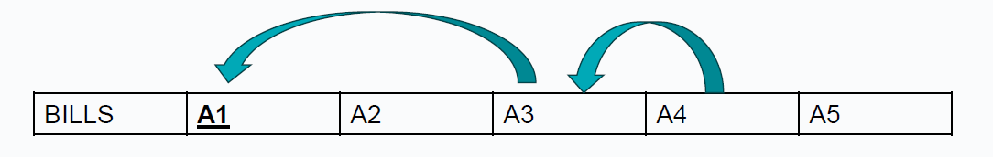

Normalisation 3 NF
Transitive dependency found between service provider and payment_type.
From assumptions: Each payment type has an specified service provider.
BILLS2(bill_number, reservation_number, payment_type, status)
PAYMENT_PROVIDER(payment_type, service_provider)

Sample Solution 2 after normalisation

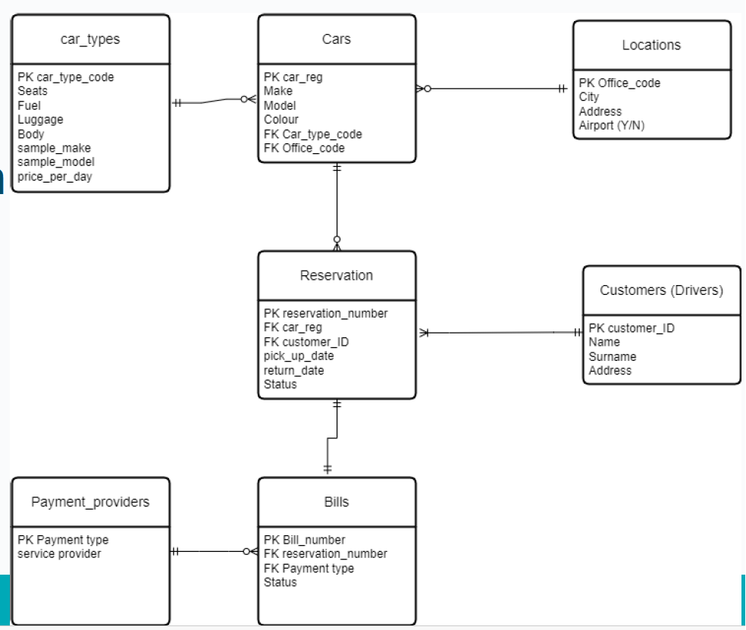

- Optionality also reviewed
- List of assumptions should be updated

Normalisation examples

Week 5 - Lab 5 exercise 1
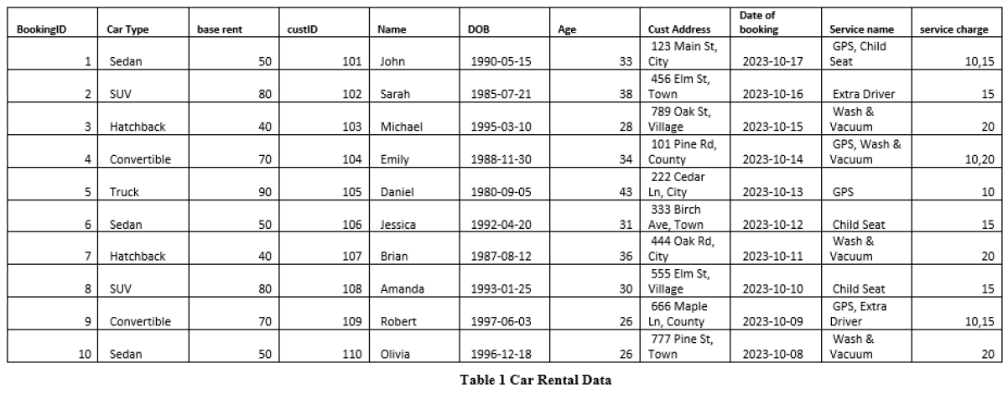

Step 1 - UNF
CARRENTAL(BookingID, car_type, base_rent, cust_ID, Name, DOB, Age, Cust_address, date_booking, service, service_charge)
- Unnormalised as more than one element in services.
CARRENTAL(BookingID, car_type, base_rent, cust_ID, Name, DOB, Cust_address, date_booking, (service, service_charge)*)

Step 2 - 1NF
- To convert to 1NF (remove repeating groups)
  - CARRENTAL1(BookingID, car_type, base_rent, cust_ID, Name, DOB, Cust_address, date_booking)
  - SERVICES1 (BookingID, service, service_charge)

Step 3 – 2NF
- To convert to 2NF (remove partial dependencies)
- No composite key so already in 2NF
  - CARRENTAL2(BookingID, car_type, base_rent, cust_ID, Name, DOB, Cust_address, date_booking)

- To convert to 2NF (remove partial dependencies)
- Partial dependency found (service_charge depends on service but not on bookingID)
  - SERVICEBOOKING2 (BookingID, service)
  - SERVICEDETAILS2(service, service_charge)

Step 4 – 3NF

- To convert to 3NF (remove transitive dependencies)
- Transitive dependencies found
  - CARRENTAL2(BookingID, car_type, base_rent, cust_ID, Name, DOB, Cust_address, date_booking)

- To convert to 3NF (remove transitive dependencies)
- Transitive dependencies found
  - CARRENTAL3(BookingID, car_type, cust_ID, date_booking)
  - CARDETAILS(car_type, base_rent,)
  - CUSTOMER3(cust_ID, Name, DOB, Cust_address)

- To convert to 3NF (remove transitive dependencies)
- No transitive dependencies found
  - SERVICEBOOKING3 (BookingID, service)
  - SERVICEDETAILS3(service, service_charge)

Finally…
- CARRENTAL3(BookingID, car_type, cust_ID, date_booking)
- CARDETAILS(car_type, base_rent,)
- CUSTOMER3(cust_ID, Name, DOB, Cust_address)
- SERVICEBOOKING3 (BookingID, service)
- SERVICEDETAILS3(service, service_charge)

ER Diag – Fully Keyed

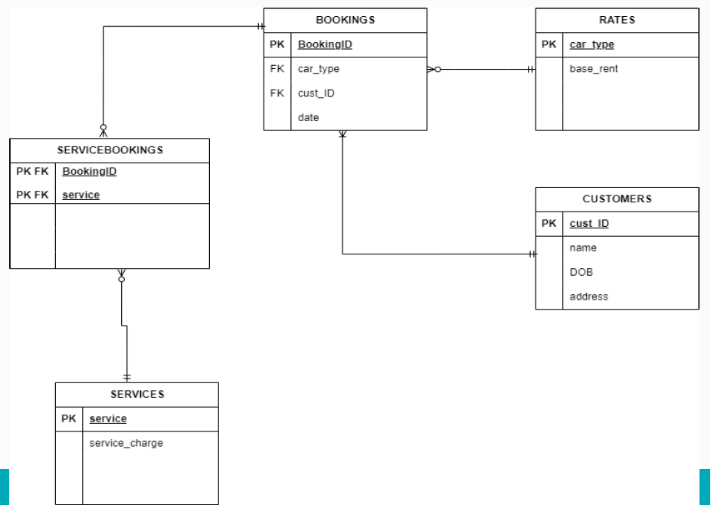

Week 5 - Exercise 2 LAB 5

Scenario
Consider a company keeping track of projects, employees and departments.
WORK(proj_Name, proj_manager, empl_id, hours, empl_name, budget, startDate, salary, empl_manager, empl_dept, rating)
Convert our table into a db 3NF.

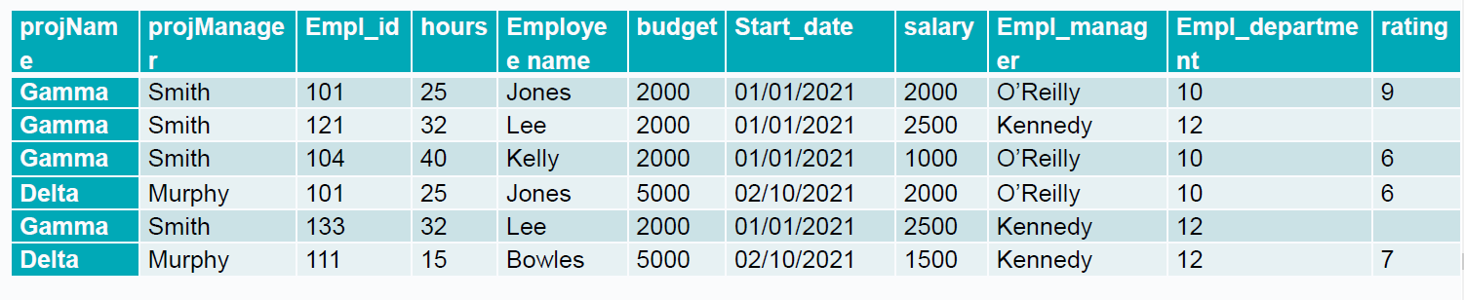

Requirements
- Each project has a unique name.
- Employee and manager names are not unique
- Many employees can work in each project and each employee can be assigned to more than one project.
- Hours refers to the number of hours an employee is assigned to a particular project.
- Budget and start_date refer to the total budget for the project and project start date.
- Salary refers to the employee’s salary.
- Empl_manager refers to the name of the employee’s manager, which may be different to the project’s manager.
- Empl_department refers to the employee’s department. Department names are unique and the employee’s manager is the employee’s department manager.
- Rating refers to the employee’s performance in a specific project.

UNF

WORK(proj_Name, proj_manager, empl_id, hours, empl_name, budget, startDate, salary, empl_manager, empl_dept, rating)

1NF

WORK(project_name, project_manager, empl_id, hours, empl_name, budget, startDate, salary, empl_manager, empl_dept, rating)

- Identify Remove repeating groups

WORK((project_name, project_manager, budget, startDate)*, hours, (empl_id, empl_name, salary, empl_manager, empl_dept)*, rating)

-------------

WORK((project_name, project_manager, budget, startDate)*, hours, (empl_id, empl_name, salary, empl_manager, empl_dept)*, rating)

- Remove repeating groups
- Choose PK
-------------

PROJECT1(project_name, project_manager, budget, startDate)
WORK1(project_name, empl_id, hours, rating)
EMPLOYEE1(empl_id, emply_name, salary, empl_manager, empl_dept)

2NF

-------------

- Identify Partial dependencies

PROJECT1(project_name, project_manager, budget, startDate)
WORK1(project_name, empl_id, hours, rating)
EMPLOYEE1(empl_id, emply_name, salary, empl_manager, empl_dept)

-------------

- No composite Key=>No Partial dependencies

PROJECT1(project_name, project_manager, budget, startDate)
EMPLOYEE1(empl_id, emply_name, salary, empl_manager, empl_dept)

-------------

- No Partial dependencies
- Hours and rating depend on both the project_name and the empl_id
WORK1(project_name, empl_id, hours, rating)

-------------

PROJECT2(project_name, project_manager, budget, start_date)
EMPLOYEE2(empl_id,empl_name, salary, empl_manager, empl_department)
WORK2(project_name, empl_id, hours, rating)

3NF

- Identify Transitive dependencies
PROJECT2(project_name, project_manager, budget, start_date)
EMPLOYEE2(empl_id, empl_name, salary, empl_manager, empl_department)
WORK2(project_name, empl_id, hours, rating)

-------------

- Transitive dependencies
  - empl_department-> empl_manager
EMPLOYEE2(empl_id,empl_name, salary, empl_manager, empl_department)

-------------
Transitive dependencies empl_department-> empl_manager

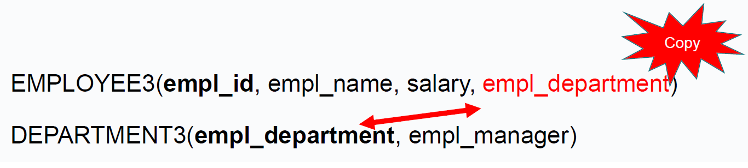
------

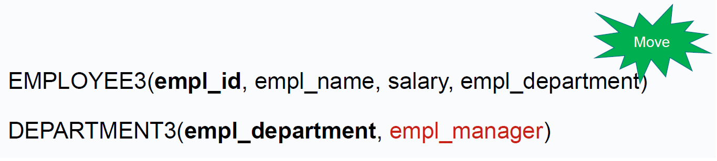
----
EMPLOYEE3(empl_id, empl_name, salary, empl_department)
DEPARTMENT3(empl_department, empl_manager)
PROJECT3(project_name, project_manager, budget, start_date)
WORK3(project_name, empl_id, hours, rating)

QUESTIONS?

