Information Systems CMPU4061 – 2024-25

Week 1

Course Overview

Continuous Assessment 100%
  - 1 Quiz 20% Week 7 – 30th Nov 6:30 to 8pm(25 to 30 Qs)
  - 1 Assignment 30% - When?
  - 1 Case study 50% - When?

Dr. Marisa Llorens-Salvador
  - Email always best channel:
  - marisa.llorens@tudublin.ie
  - Discussion Forums on VLE (Brisghtspace)

Module Summary :
This module provides the learner with fundamental skills to design information systems, focusing on the design and implementation of database systems.

The aims of the module are:
  - Enable the student to create new relational databases by devising a high-level conceptual data model.
  - Transform data model into a relational schema
  - Implement the relational schema correctly and robustly in SQL

Learning Outcomes

Reading list
- Alice Rischert 2019. Oracle SQL by example.
- Thomas M. Connolly, Carolyn E Begg 2015 Database Systems
- MYSQL: SQL Database Programming for Beginners. Kevin Lioy. 2019
- Many other books and online resources that will be discussed and shared as we progress through the module

Module software
- BrightspaceSynchronous sessions
- Asynchronous sessions (videos + guided exercises)
- Socrative, chat and break out rooms in Bongo for participation
- SQLite, MySQL, draw.io, MongoDB

Who is in the class?
- Socrative mobile download
- Socrative room TUDUBLINMARISA
- Answer a few questions about your previous experience

Extra light resources
- Podcasts
- SQL games
- Research papers

Summary of lecture
- Contact details
- Introduction to the module
- Details of delivery, software and assessment
- Short survey

Introduction to Databases
- What is a database?
- Why use databases (Databases vs. Spreasheets)
- Types of Databases
- DBMS
- Database Design and models
- Software

What is a database?

- A database is a structured collection of records.
- Database:
  - Collection of related data
    - Represents some aspect of the real world.
    - Logically coherent collection.
    - Built with a specific purpose in mind.
    - Could be anywhere - notebook, spreadsheet, Access, Oracle, … could be manual/could be computerised.
  - Data:
    - Raw facts (building blocks of information).
    - Unprocessed information.
  - Information:
    - Data processed to reveal meaning.

  - A Database consists of columns (attributes) and rows (records).
  - Database Management System (DBMS)
    - add, remove, update records
    - retrieve data that match certain criteria
    - cross-reference data in different tables
    - perform complex aggregate calculations

Why Study Databases?

- They touch every aspect of our lives.
- Explosion of unstructured data on the web:
  - Large document collections.
  - Image databases, streaming media, social media

Applications:
  - Banking: All transactions
  - Airlines: Reservations, schedules
  - Universities: Registration, grades
  - Sales: Customers, products, purchases
  - Manufacturing: Production, inventory, orders, supply chain
  - Human Resources: Employee records, salaries, tax deductions
  - Telecommunications: Subscribers, usage, routing
  - Computer Accounts: Privileges, quotas, usage
  - Records: Climate, stock market, library holdings

Databases versus spreadsheets
- Easier and more efficient manipulation of data
- Avoid redundancy

Single table database
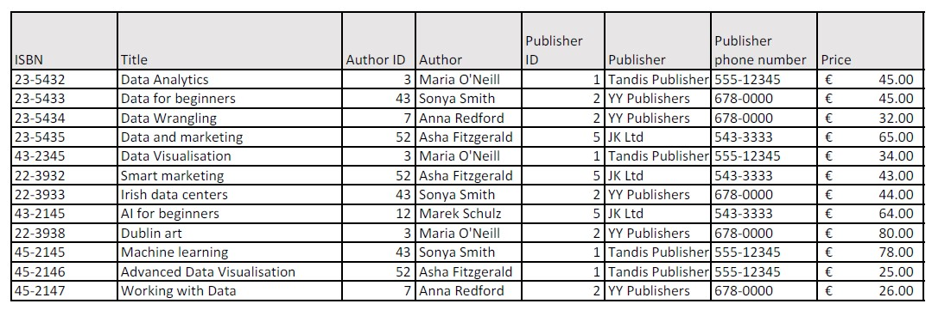

Disadvantage of a single table database
- Redundancy of data
- Problem with complex data
- Problems in updating in bulk (new phone number)
- Problems in adding incomplete data (new publisher)
- Problems in removing group of data (all books from the publisher)

Several tables- Books

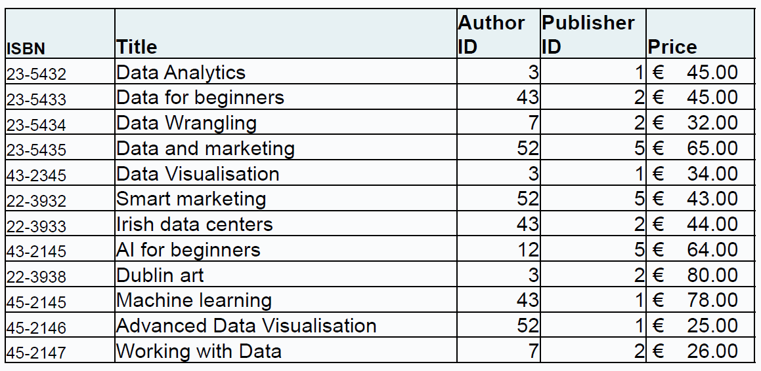

Several tables- Authors

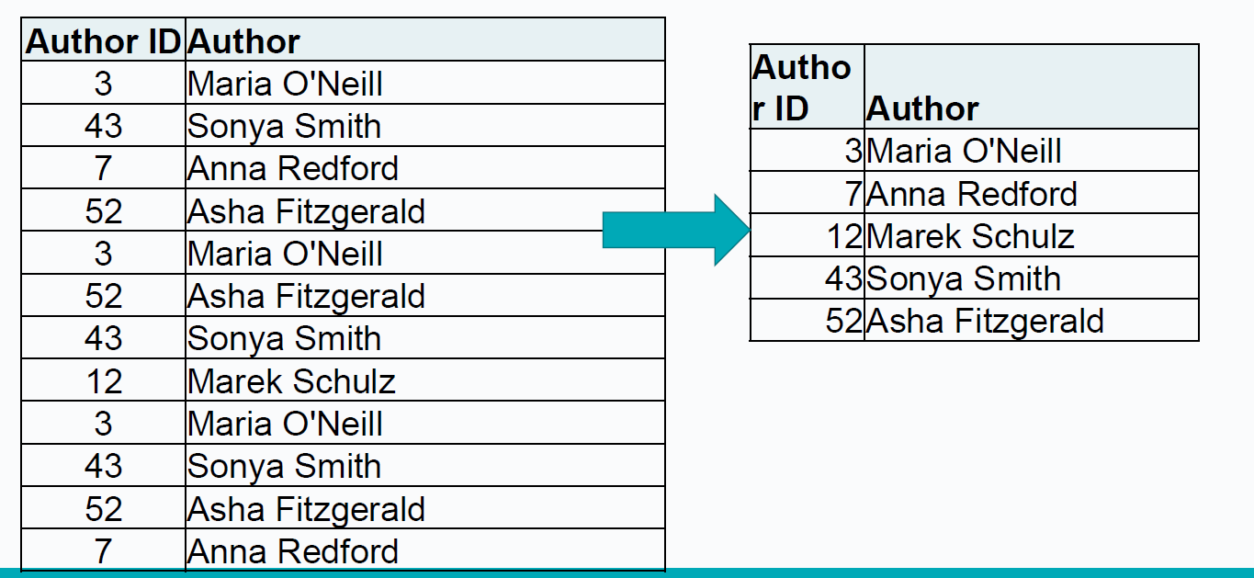

Several tables- Publishers

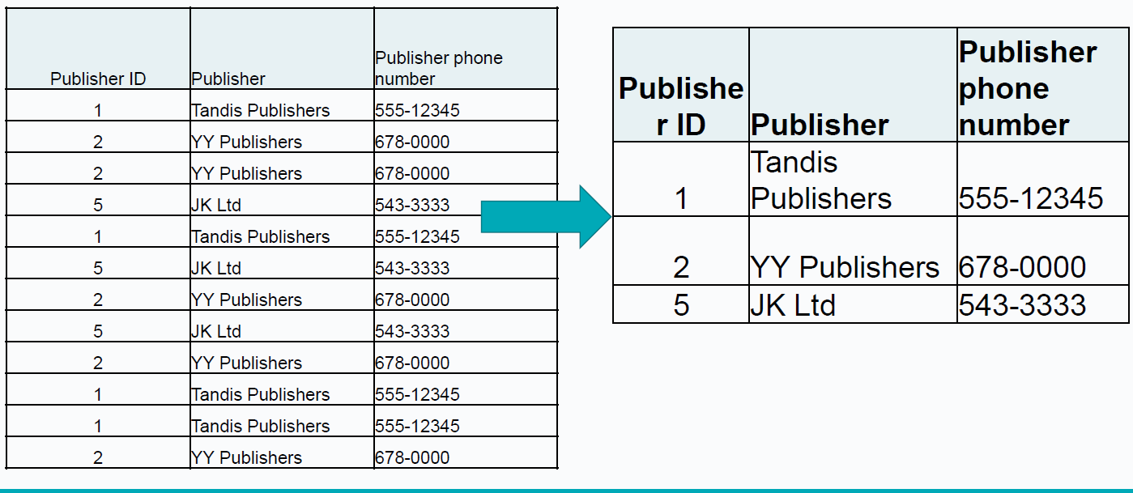

Relationships in a database example

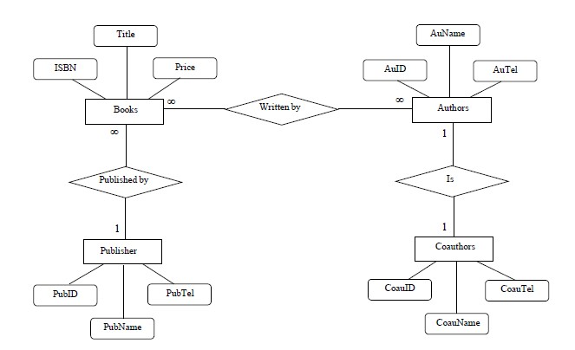

Relationships

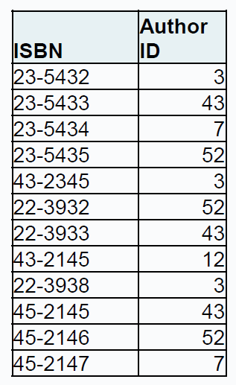

Types of Databases

Can be classified by location…

Centralized:
- Supports data located at a single site.

Distributed:
- Supports data distributed across several sites.
  - Often used to store historical data.
  - Structure is quite different.

Can be classified by use…

Transactional (or Production):
- Supports a company’s day-to-day operations.

Data Warehouse:
- Stores data used to generate information required to make tactical or strategic decisions.
- Often used to store historical data.
- Structure is quite different.

Can be classified by relational model…

Relational:
- SQL.

NonRelational:
- NonSQL.

Database Management Systems (DBMS)

General purpose software for
  - Definition
  - Construction
  - Manipulation of databases
The DBMS manages the interaction between the end user and the database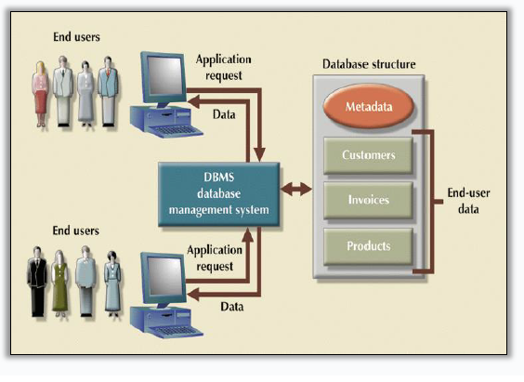

Characteristics of DBMS
- Data is…
  - integrated
  - shared
  - persistent
  - self-describing
- Abstraction
  - Program-data independence.
- Allows multiple views of the data

DBMS Functions

DBMS performs functions that guarantee integrity and consistency of data:
- Backup & Recovery Management
- Data Integrity Management
- Database Access Languages & Application Programming Interfaces
- Database Communication Interfaces

Database Design
- Database design deals with how to design a database.
- Importance of good design:
  - Poor design results in unwanted data redundancy.
  - Poor design generates errors leading to bad decisions.
- Practical approach:
  - Focus on principles and concepts of database design.
  - Importance of logical design.

Data Models
- Specify concepts that are used to describe the database. These can be categorised as:
  - High Level (Conceptual):
  - Representational (Logical):
  - Low Level (Physical):

Roles in the Database Environment
- Database Administrator (DBA)
  - Authorizing access to the database.
  - Coordinating and monitoring its use.
  - Acquiring software and hardware as needed.
  - Solving problems such as breach of security or poor system performance
- Database Designers/Modellers:
  - Identifying the data to be stored and structure to be used, identify constraints.
  - Design structural and functional aspects.
- Application Programmers:
  - Develop and implement end-user requirements.
- End Users:
  - Access to the database: querying, updating, generating reports
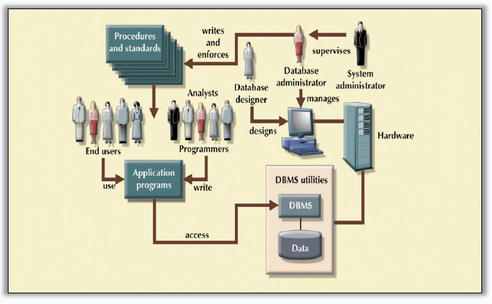

Software
- MS Access
- Cassandra
- Microsoft SQL Server
- Neo4j
- Oracle RDBMS
- phpMyAdmin
- MySQL
- SQLite
- PostgresSQL
- MongoDB
- Redis


Summary
- What is a database
- Why use databases (Databases vs. Spreasheets)
- Types of Databases
- DBMS
- Database Design and models
- Software

Week 2

Relational Database Principles

Lesson 2 – 25th Sept 2024

TU257

Lesson Outline
- Design Process
- Conceptual Model - Entity Relation model
  - Entities
    - Attributes
  - Relationships

Data Models
- Specify concepts that are used to describe the database. These can be categorised as:
  - High Level (Conceptual):
    - Concepts at user level: entities/classes, attributes, relationships/associations
    - Rough ER Diagram + Key Based ER Diagram
  - Representational (Logical):
    - Relational, network, hierarchical – may be record based, object-oriented
    - Normalised model
  - Low Level (Physical):
    - Details of physical data storage; formats, access paths, ordering
    - Implemented model

Database Design

- Database design deals with how to design a database.
- Importance of good design:
  - Poor design results in unwanted data redundancy.
  - Poor design generates errors leading to bad decisions.
- Practical approach:
  - Focus on principles and concepts of database design.
  - Importance of logical design.

Major Steps in Database Design

- Requirements Analysis:
  - Talk to the potential users.
  - Understand what data is to be stored, and what operations and requirements are desired.
- Conceptual Database Design:
  - Develop a high-level description of the data and constraints
- Logical Database Design:
  - Convert the conceptual model to a schema in the chosen data model of the DBMS.
  - For a relational database, this means converting the conceptual to a relational schema (logical schema).

- Schema Refinement:
  - Look for potential problems in the original choice of schema and try to redesign.
- Physical Database Design:
  - Direct the DBMS into choice of underlying data layout (e.g., index/clustering) in the hope of optimising the performance
- Applications and Security Design:
  - How will the underlying database interact with surrounding applications.

Conceptual Database Design

- Goal: Specification of database schema
- Methodology:
  - Use E-R model to get a high-level graphical view of essential components of enterprise and how they are related

- 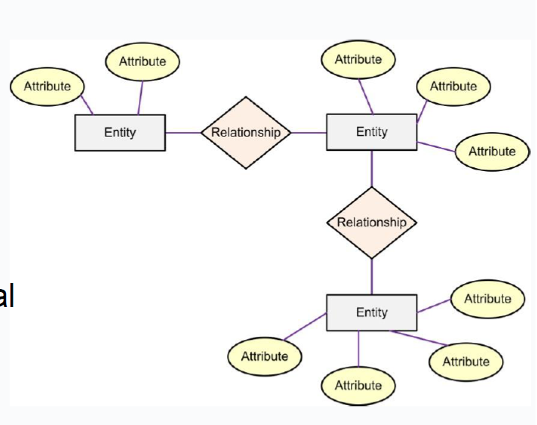

E-R Model

- Entity-Relationship (ER) Model is based on the notion of real-world entities and relationships among them. While formulating real-world scenario into the database model, the ER Model creates entity set, relationship set, general attributes and constraints.
- ER Model is best used for the conceptual design of a database.
- ER Model is based on:
- Entities and their attributes.
- Relationships among entities.

Entities

- Entity
  - An entity in an ER Model is a real-world entity having properties called attributes. These are used to describe a particular entity (e.g. name, RSI#, height).
- An entity corresponds to a person, place, thing, event, or concept about which you are interested in recording data i.e.
  - Person: EMPLOYEE, STUDENT, PATIENT,
  - Place: STORE, WAREHOUSE, COUNTY,
  - Object: MACHINE, BUILDING, CAR,
  - Event: SALE, REGISTRATION, RENEWAL,
  - Concept: ACCOUNT, COURSE, WORK CENTRE

E-R Diagrams: Entities
- An entity is any object in the system that you want to model and store information about
  - Individual objects are called entities.
  - Groups of same type objects are entity types or entity sets.
  - Entities are represented by rectangles (either with round or square corners)
- Entities are equivalent to database tables in a relational database, with each row of the table representing an instance of that entity.
- Entities are abstract concepts, each representing one or more instances of the concept in question.
- Each entity is represented by a box within the E-R Diagram.

E-R Diagrams: Entities: Type vs. Instance

- Entity Type (Entity Class):
  - Entities can usefully be classified into entity types.
  - Collection of similar entities, about which we want to store similar information.
- Instance:
  - An entity is an instance of an entity type, e.g. Joe Bloggs may be an instance of the employee entity type.
- You model entity types, not individual instances.
- However, the term ‘entity’ is often used to refer to both entity type and instance.

E-R Model: Attributes

- All the data relating to an entity is held in its attributes i.e. an attribute is a property of an entity.
- Every attribute is defined by its set of values called domain
  - name may be a 20 character string;
  - PPS# is seven-digits plus a letter;
  - Student ID may be a char with a letter followed by 8 digits;
  - Price may be a float number with 2 decimal places.

E-R Diagrams: Attributes

- Attributes can be…
  - simple or composite
  - single-valued or multi-valued

Composite Attributes

- Composite attributes are further divided in a tree like structure.
- Every node is then connected to its attribute. That is, composite attributes are represented by ellipses that are connected with an ellipse.
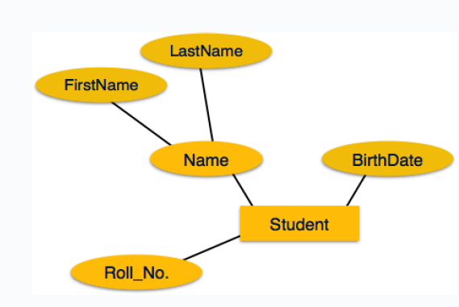

Multivalued Attributes

- Multivalued attributes are depicted by double ellipse
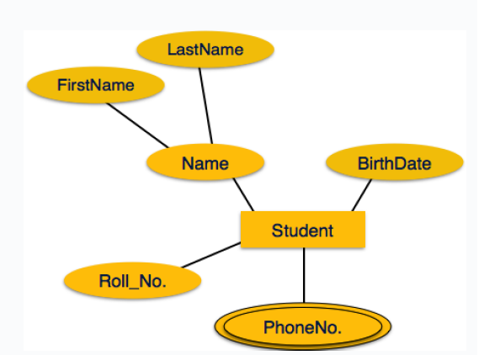

ER-Model: Keys
- Identifier/key:
  - A minimal set of attributes for an entity set, such that each entity in the set can be uniquely identified.
  - In some cases, there may be a single attribute (such as PPS#) which serves as a key, but in some models you might need multiple attributes as a key (‘Bob from Accounting’).
  - There may be several possible candidate keys. You will generally designate one such key as the primary key.
- Characteristics of Identifiers:
  - Will not change in value.
  - Will not be null.
  - No intelligent identifiers (e.g. containing locations or people that might change).

ER-Model: Relationship

- Relationship− The logical association among entities is called relationship.
- Relationships are mapped with entities in various ways.
- Mapping cardinalities define the number of associations between two entities.

Tips on building E-R diagrams

Nouns
- are clues to the entities of a business
  - Start by describing the work that is done in the project or department or area of interest, then
  - pull out nouns in the sentences as potential candidates for entities. e.g. “My address book contains addresses and telephone numbers for both friends and businesses.”
- Nouns are clues to the entities of a business

Verbs and adjectives
- Verbs and adjectives sometimes help to get at relationships between entities e.g. ‘friends have addresses’

Notation
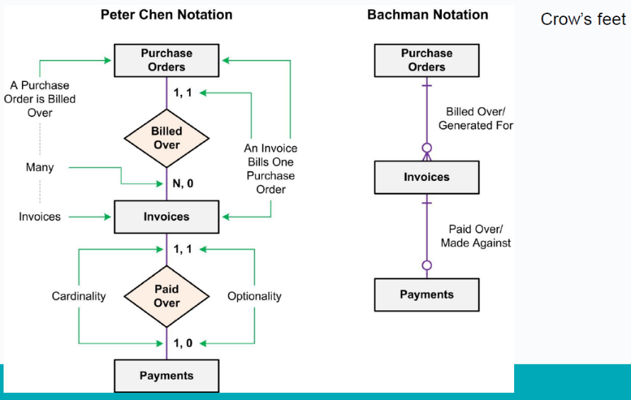
- Entities are drawn in boxes.
  - entities should be expressed in the plural.
- The existence of a relationship between two entities is drawn as a line connecting the entities.
- Verbs may be placed on the relationship lines that describe what the relationships mean e.g. ‘Purchase Orders are billed over Invoices’, where‘
    - ‘Purchase Orders’ and ‘Invoices’ are related entities,
and
    - ‘billed’ is the verb describing the relationship
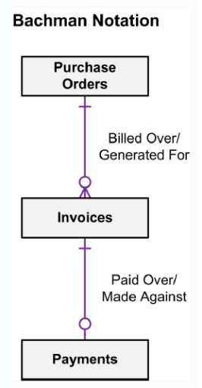

Attributes
- Attributes can be shown on ER models:
  - They appear inside ovals and are attached to their entity.
  - Note that entity types can have a large number of attributes. If all are shown then the diagrams would be confusing. Only show an attribute if it adds information to the ER diagram, or clarifies a point.
- Lists of attributes can be developed as you go.
  - An attribute is a single piece of information that is descriptive of an entity, e.g. friends name, friends e-mail.
  - 

- 31

Exercise
- A restaurant owner hires you to create a database for their business. They need to keep track of customer details (for marketing purposes). A good management of orders, food items, menus, payments and different types of staff is necessary in order to obtain a database that will allow the owner to control all aspects of their business.
- Can you discuss the requirements and come up with a list of entities and attributes that will be required for the DB?
- Write your final lists. One member of the group will present them to the whole class.

E-R Diagrams: Relationships
- A relationship is an association among two or more entities.
  - The relationship must be uniquely identified by the participating entities.
- Relationships are represented by lines between entities.

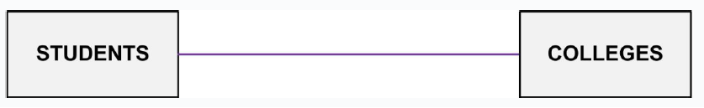
- A relationship can also have descriptive attributes, to record additional information about the relationship (as opposed to about any one participating entity).
- In this case, one can infer that a student may attend a college, or that a college may enroll students.
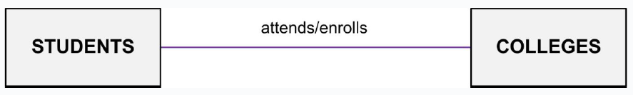

E-R Diagrams: Optionality and cardinality

- Symbols at the ends of the relationship lines indicate the optionality and the cardinality of each relationship.
  - Optionality expresses whether the relationship is optional or mandatory.
  - Cardinality expresses the maximum number of relationships.

Optionality is of two types…

Mandatory Relationship:
Associated with every instance of the first entity there will be at least one instance of the second entity.

Optional Relationship:
  - There may be instances of the first entity, which are not associated with any instance of the second entity.
    - For example, employee-spouse relationship has to be optional because there could be unmarried employees. It is not correct to make the relationship mandatory.

Cardinality is of three types…

One-to-one Relationship:
    - An instance of the first entity is associated with only one instance of the second entity. Similarly, each instance of the second entity is related to one instance of the first entity.
    - One entity from entity set A can be associated with at most one entity of entity set B

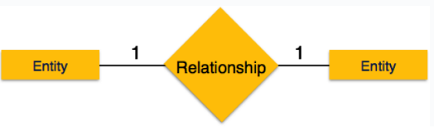 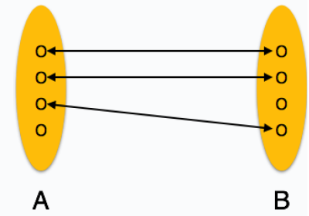38

One-to-many Relationship:
- One instance of the first entity is related to many instances of the second entity, while an instance of the second entity is associated with only one instance of the first entity.

- One entity from entity set A can be associated with more than one entities of entity set B however an entity from entity set B, can be associated with at most one entity.
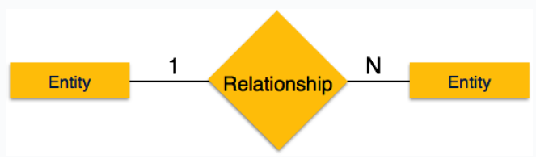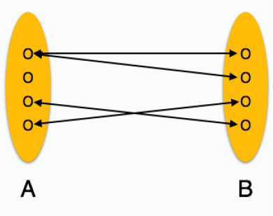

Many to One Relationship:
- More than one entity from entity set A can be associated with at most one entity of entity set B, however an entity from entity set B can be

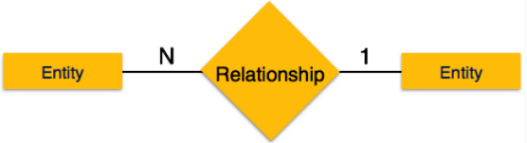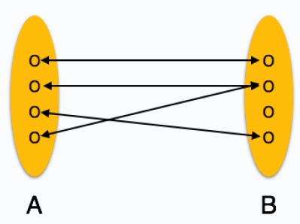

Many-to-many Relationship:
- An instance of the first entity is related to many instances of the second entity and the same is true in the reverse direction also.
- One entity from A can be associated with more than one entity from B and vice versa.

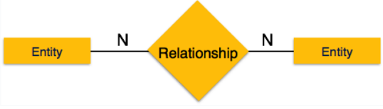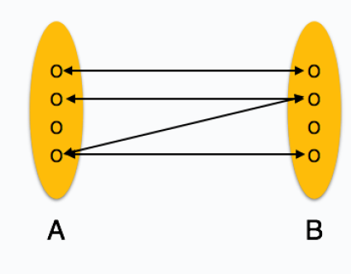

E-R Diagrams: Optionality and cardinality
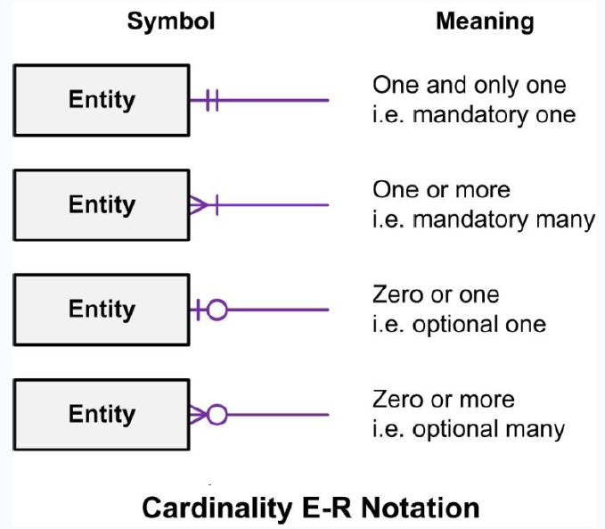
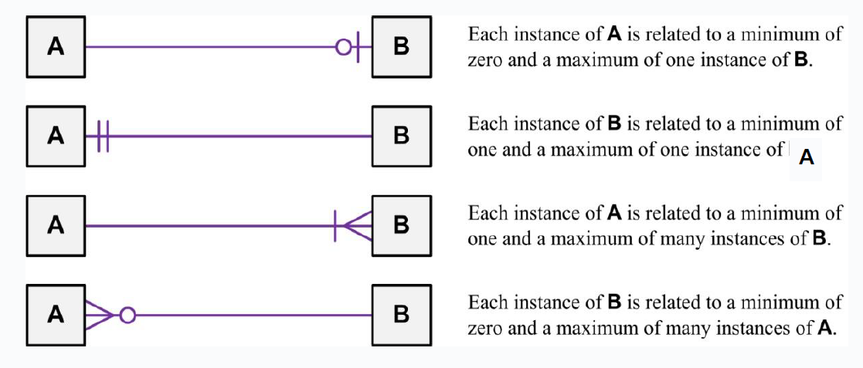
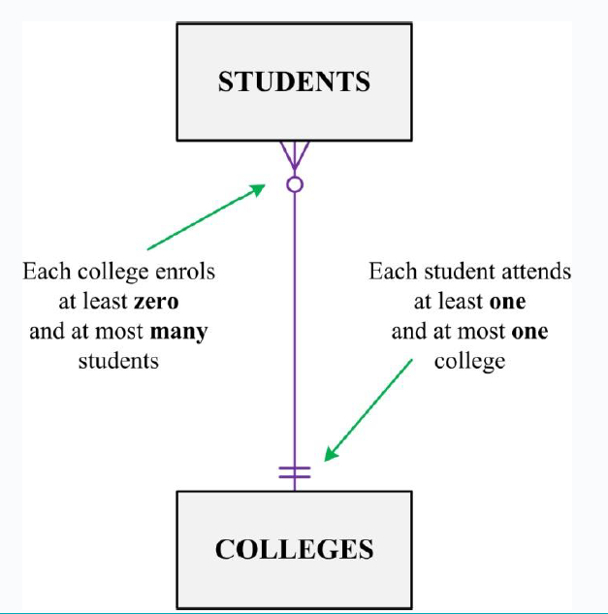

Tips
- DO NOT start diagramming first!
  - Write down the entities.
  - Write down the attributes for each entity.
  - Select the identifying attribute(s) for each entity.
- Draw a rough draft of the E-R diagram. Show entities and relationships only.
  - Add cardinalities.
  - Add attributes.

The ERD Modelling Process

- Initially…
  - Identify obvious entities (i.e. Person, Place, Object, Event, Concept)
  - Identify obvious relationships
  - Identify properties of entities
    - Underline Primary key property
- Refine the Model
  - The initial entities and relationships may not be sufficient
- Then…
  - Decide on Relationship Constraints
    - Cardinality Ratios
    - Optionality constraints
  - Check for completeness
    - Has all the required information been represented

Summary: Constructing an E-R model

- Identify Entities
- List the Initial Attributes of Each Entity
- Mark the Primary Keys
- Define the Relationships
- Describe the Cardinality & Optionality of the Relationships
- Complete list of attributes

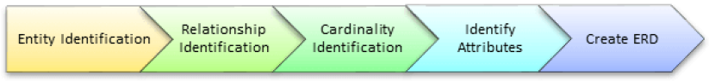

Step 1) Entity Identification

- We have three entities
  - Student
  - Module
  - Professor

Step 2) Relationship Identification

- We have the following two relationships
  - The student is assigned a module
  - Lecturer delivers a module

Step 3) Cardinality Identification
- From the problem statement we know that,
  - A student can be assigned multiple modules
  - A lecturer can deliver only one module
- 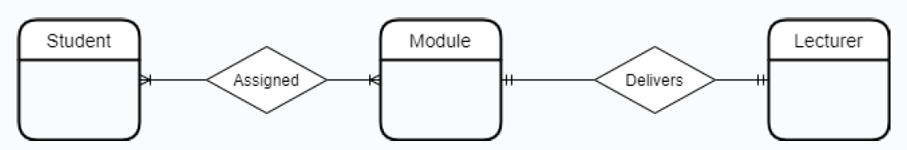

Step 4) Identify Attributes

Name Semester
Surname Credits
Student ID ….
Course ID

Revise
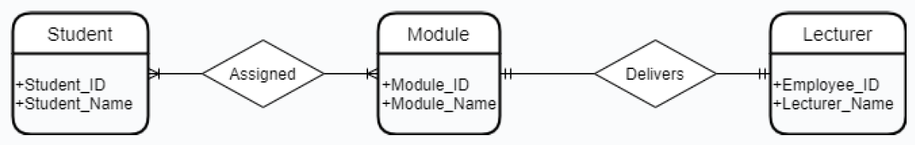

Thanks and reference

- Edmund Nevin for earlier versions of these lecture notes
- https://www.tutorialspoint.com/dbms/er_diagram_representation.htm

Week 3

ER Diagrams

Lesson 3 Information Systems

2nd Oct 2024

Lesson Outline

- Foreign Keys
- Many to many relationships and Bridge Entities
- Identifying relationships
- Degree of a relationship
- Key Based ER Diagram

Foreign Key

- A foreign key is a reference to a key in another table.
- A foreign key is a set of attributes of one table, say R2, whose values are required to match values of some candidate key of another table, say R1

Example PKs

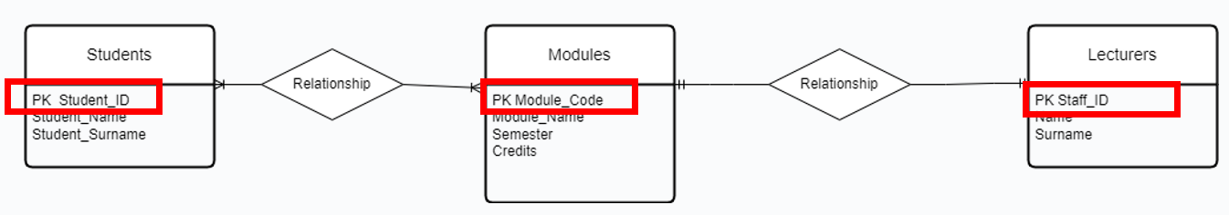

Foreign Key One to One v1
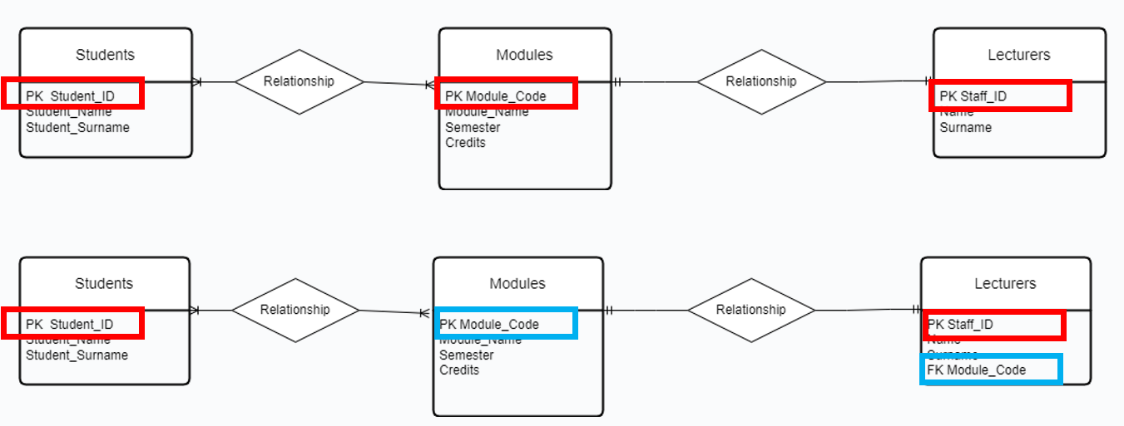

Foreign Key One to One v2

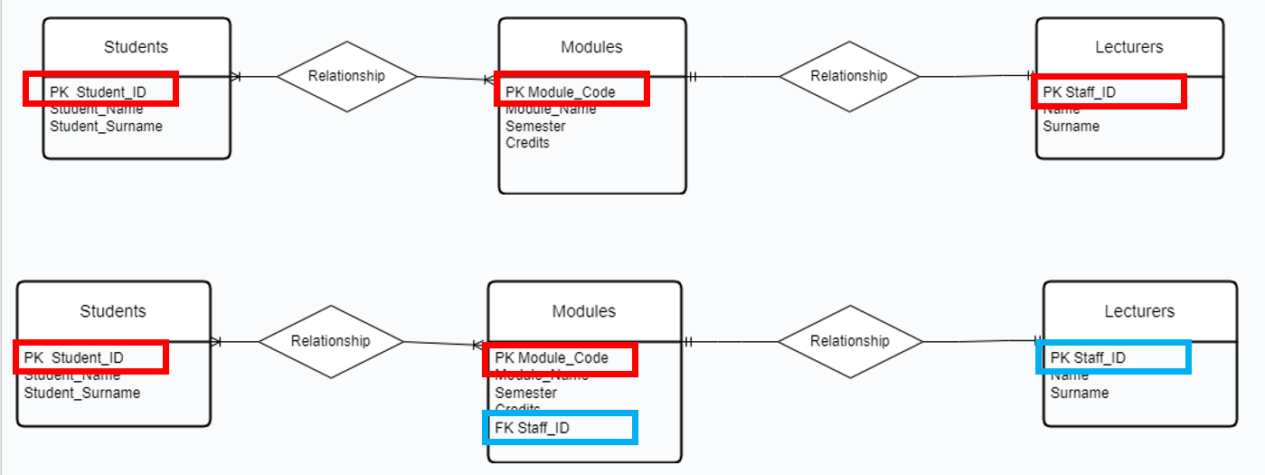

Modified Example Foreign Key One to Many
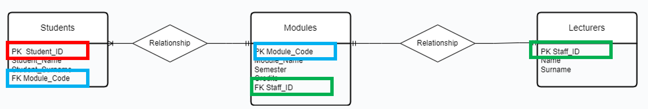
- Case where students can only register for one module.
- PK from the one side becomes FK on the many side

Foreign Key Many to Many

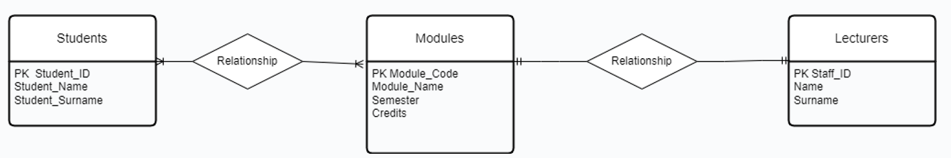

- Case where students can register for more than one module.
- When modelling many to many relationships, no FKs can be used directly in the original entities.
- A new entity has to be created.

Many to Many Relationships Associative (Bridge) Entities

- When an instance of an entity may be related to multiple instances of another entity and vice versa, that is called a ‘many-to-many’ relationship.
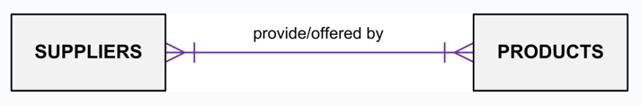
- While this relationship model is perfectly valid, it cannot be translated directly into a relational database design.

Many to Many Relationships Associative (Bridge or Weak) Entities

- While this relationship model is perfectly valid, it cannot be translated directly into a relational database design.
- In order to build a relational database that captures this relationship, it is necessary to build a bridge between the two entities that uniquely expresses each relationship instance.
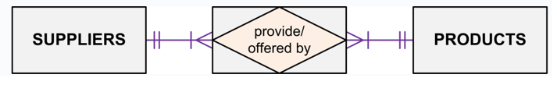

Example Student-Module-Lecturer Week 2
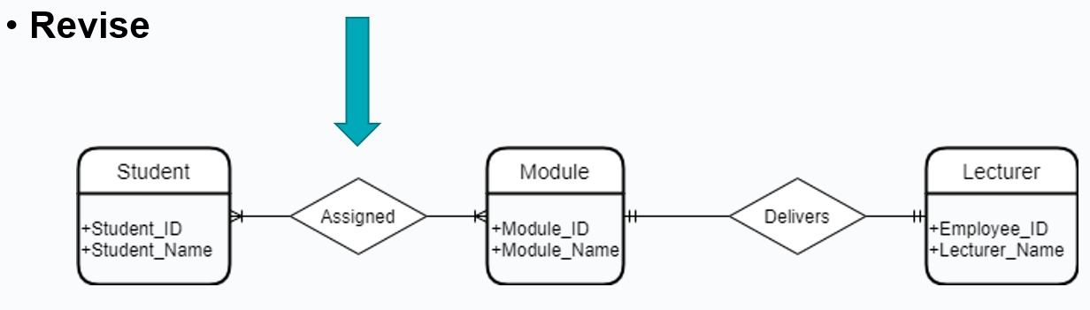

Associative (Bridge) Entities

- Many-to-many relationships can cause lots of trouble.
- Get rid of them by defining an intermediate third entity.

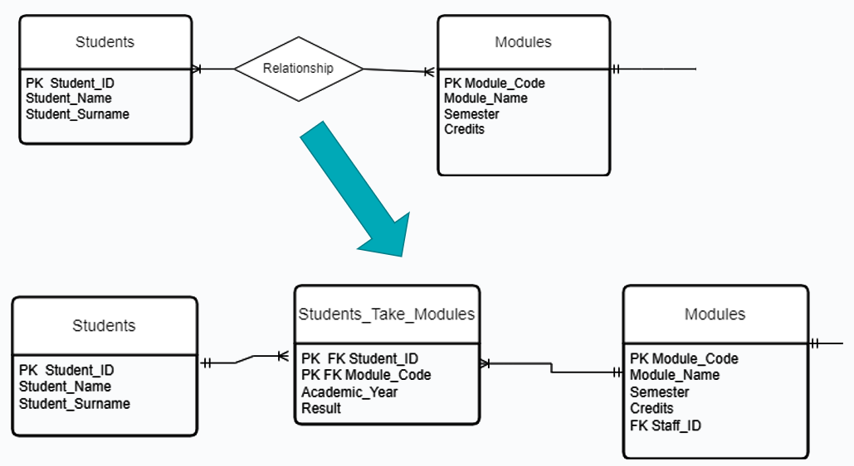

Example

Revise
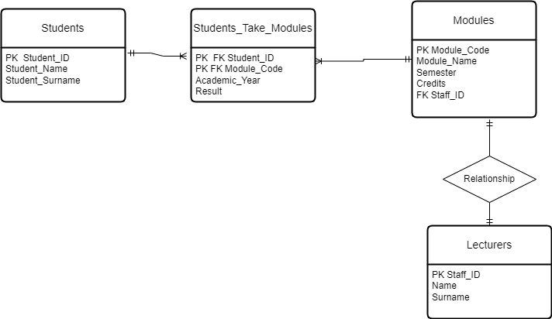

Practice
- Open the db provided University.db

- Browse the data in the different tables.
- Identify PKs and FKs.
- Perform the following queries in the “Execute SQL” Tab
  - SELECT * FROM students
  - SELECT LastName FROM Lecturers
  - SELECT * FROM Modules

Identifying Relationships – New section

- An identifying relationship means that the child table cannot be uniquely identified without the parent.
- For example, you have this situation in the intersection table used to resolve a many-to-many relationship where the intersecting table's Primary Key is a composite of the left and right (parents) table's Primary Keys.
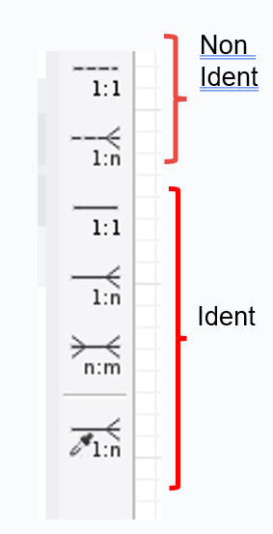

Identifying and non identifying relationships

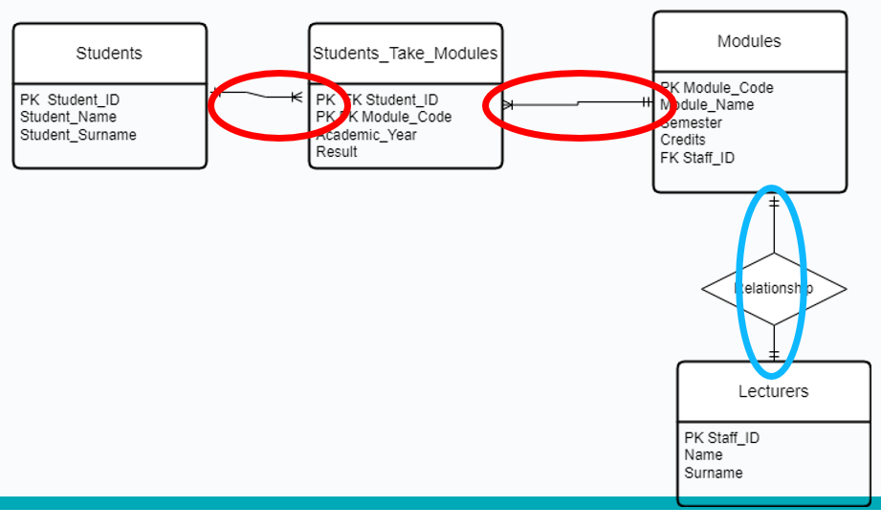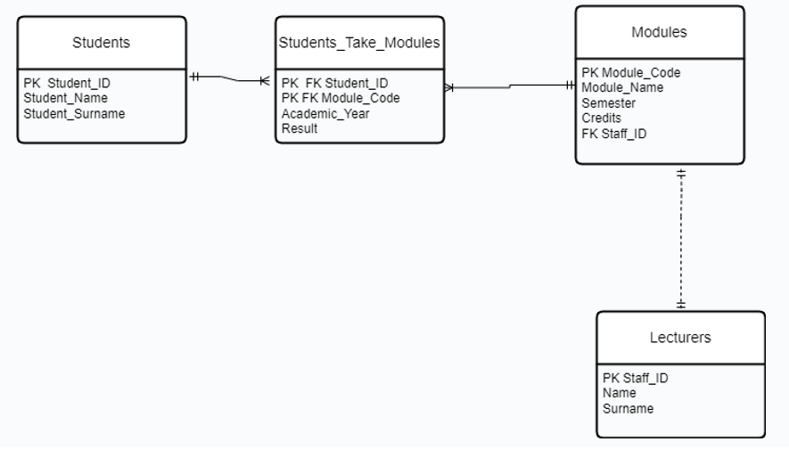

Degree of a relationship- New section

- The number of participating entities in a relationship is known as the degree of the relationship.

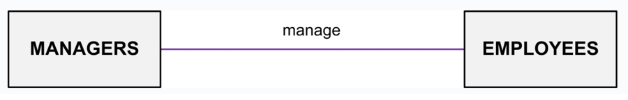

Unary Relationships
- Unary relationships are also known as a recursive relationship.
  - Instances of entities may have relationships with other instances of the same entity.
  - These relationships may be drawn with relationship lines that begin and end connected to the same entity.
- Unary relationships are also known as a recursive relationship.
  - It is a relationship where the same entity participates
more than once in different roles.
  - In the example, employees are managed by employees.
- If you wanted more information about who manages whom, you could introduce a second entity type called manager.

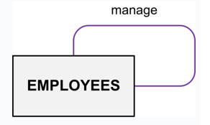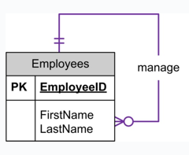

Example
- For example, Suppose in a classroom, we have many students who belong to a particular club-like dance club, basketball club etc. and some of them are club leads. So, a particular group of student is managed by their respective club lead. Here, the group is formed from students and also, the club leads are chosen from students.
- So, the ‘Student’ is the only entity participating here.

- We can represent this relationship using the E-R diagram as follows:

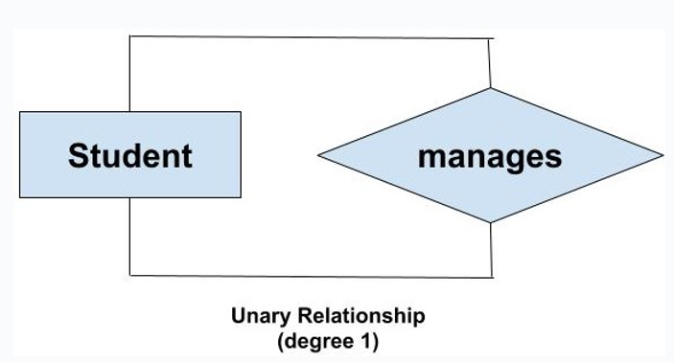

Binary Relationships
- If there are two entity types involved it is a binary relationship type.
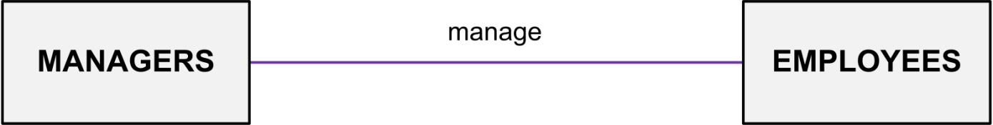

Ternary Relationship
- If there are three entity types involved it is a ternary relationship type.

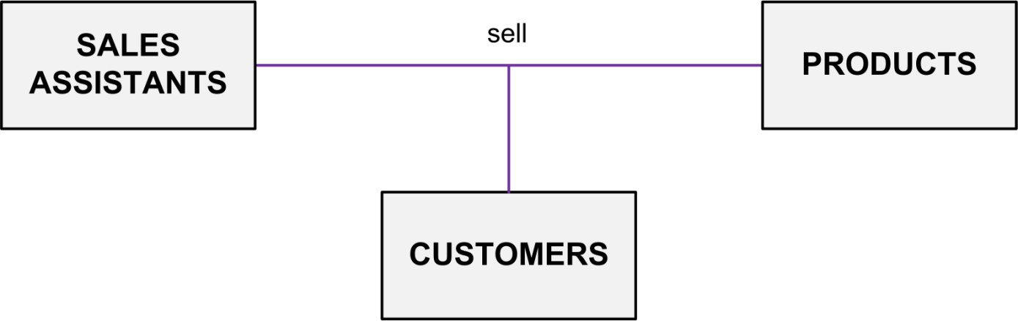

Example 1
- The University might need to record which teachers taught which subjects in which courses.

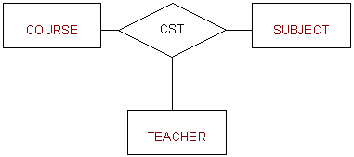

Example 2

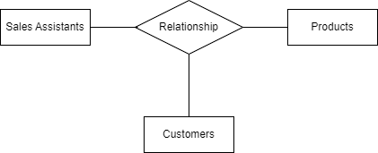

Replacing Ternary Relationships

- When ternary relationships occurs in an ER model they should always be removed before finishing the model.
- Sometimes the relationships can be replaced by a series of binary relationships that link pairs of the original ternary relationship.
- This can result in the loss of some information
i.e. It is no longer clear which sales assistant sold a customer a particular product.

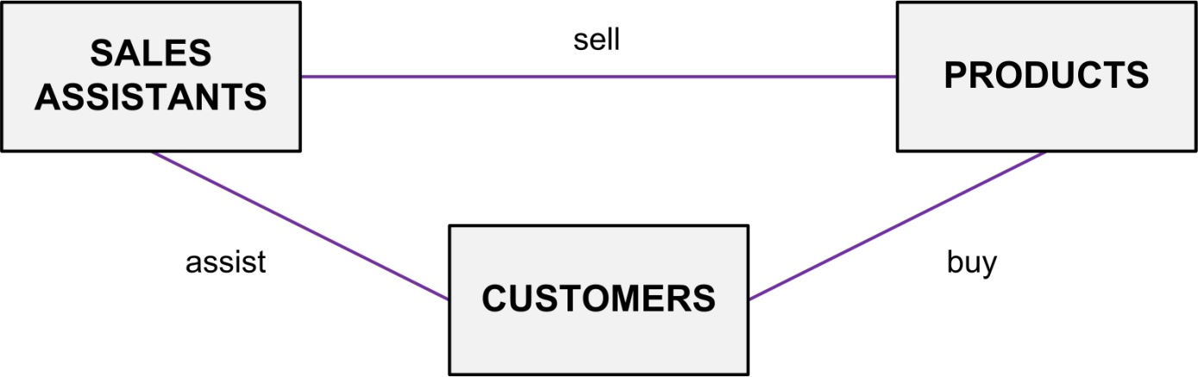

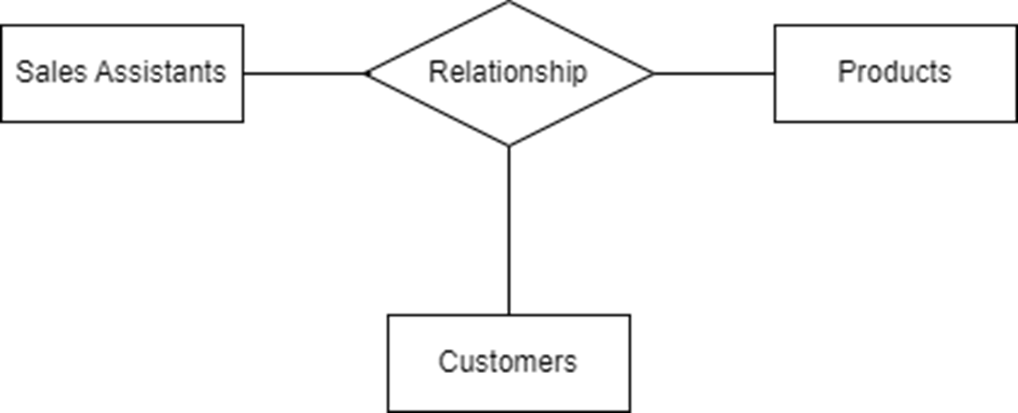

Try replacing the ternary relationship with an entity type and a set of binary relationships.

- Relationships are usually verbs, so name the new entity type by the relationship verb rewritten as a noun.
- The relationship ‘sell’ can become the entity type ‘SALES’.
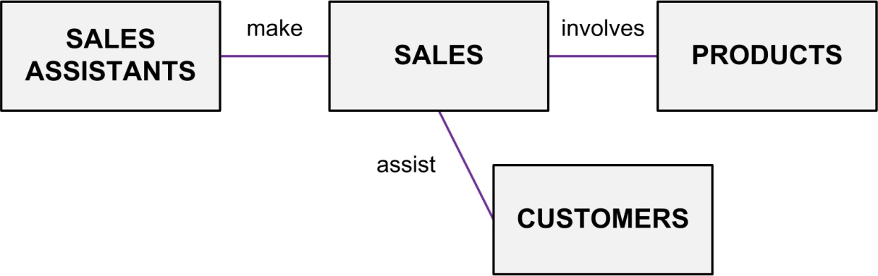


ERD Example: Ternary Relationships

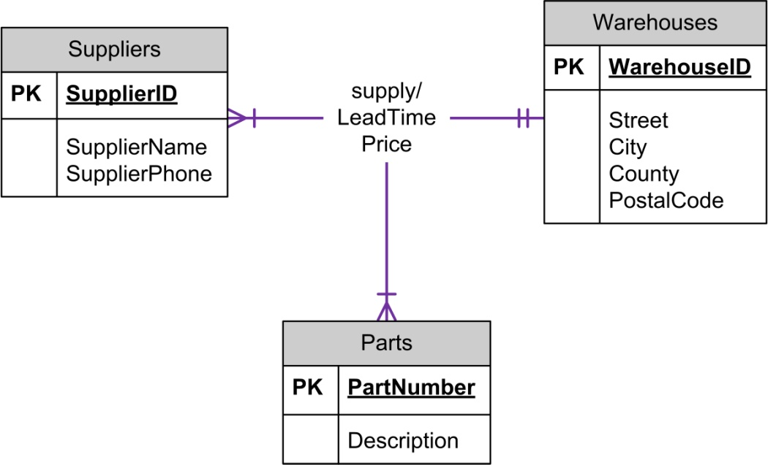

ERD Example: Ternary Relationship Converted

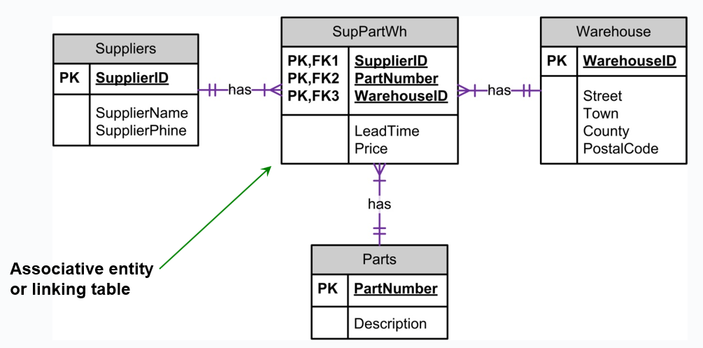

ERD Example: Relationship Attributes

- Relationship Attributes:
  - Some relationships can have attributes just as an entity can have attributes.
  - Generally, this occurs with a many-to-many relationship.
- Rule-of-thumb:
  - If you have an attribute on a 1:N relationship, you probably have something wrong.
  - Attribute should go on one of the entities.

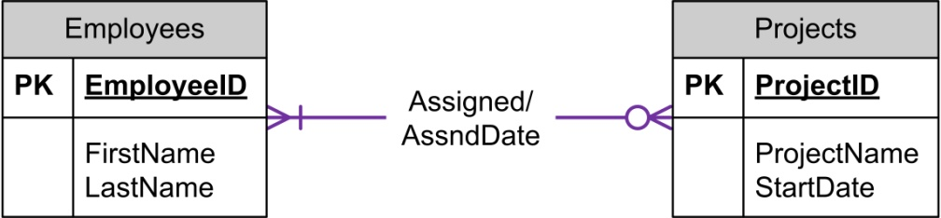

ERD Example: Multiple Relationships
- Multiple Relationships - more than one relationship between the same entity types.
  - These are depicted in the ERD with multiple relationship lines connecting the two entities.

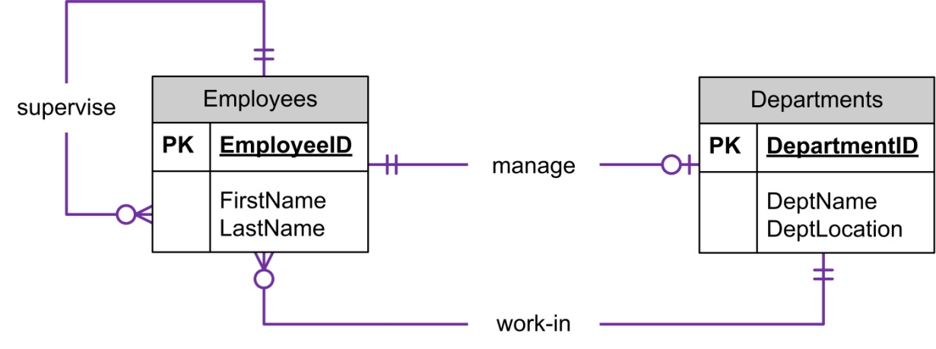

Key Based ER Diagram

Solution lab 2 exercise 2

Exercise Scenario
Prepare an ER diagram for a real estate company that lists property for sale. The following describes the organisation:
- The company has a number of sales offices in several counties.
- Attributes of sales office include Office_Number (identifier/key) and Location.
- Each sales office is assigned one or more employees.
- Attributes of employee include Employee_ID (identifier/key) and Employee_Name.
- An employee must be assigned to only one sales office.
- The firm lists property for sale.

Nest Step

- The company has a number of sales offices in several counties.
- Attributes of sales office include Office_Number (identifier/key) and Location.
- Each sales office is assigned one or more employees.
- Attributes of employee include Employee_ID (identifier/key) and Employee_Name.
- An employee must be assigned to only one sales office.
- The firm lists property for sale.

Nest Step

- Attributes of property include Property_ID (identifier) and Location.
- Components of Location include Address, City, County, and Postal_Code.
- Each unit of property must be listed with one (and only one) of the sales offices.
- A sales office may have any number of properties listed.
- Each unit of property has one or more owners.
- Attributes of owners are Owner_ID (identifier) and Owner_Name.
- An owner may own one or more units of property.
- An attribute of the association between property and owner is Percent_Owned.

Nest Step

- Attributes of property include Property_ID (identifier) and Location.
- Components of Location include Address, City, County, and Postal_Code.
- Each unit of property must be listed with one (and only one) of the sales office.
- A sales office may have any number of properties listed.
- Each unit of property has one or more owners.
- Attributes of owners are Owner_ID (identifier) and Owner_Name.
- An owner may own one or more units of property.
- An attribute of the association between property and owner is Percent_Owned.

Entities
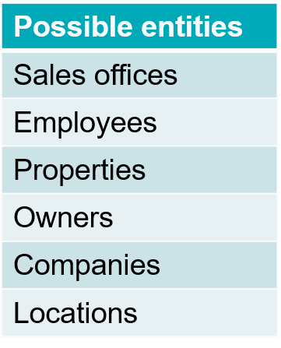
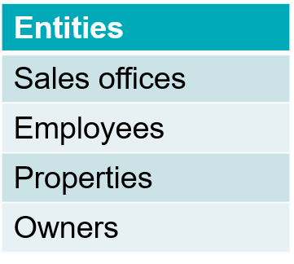

Attributes
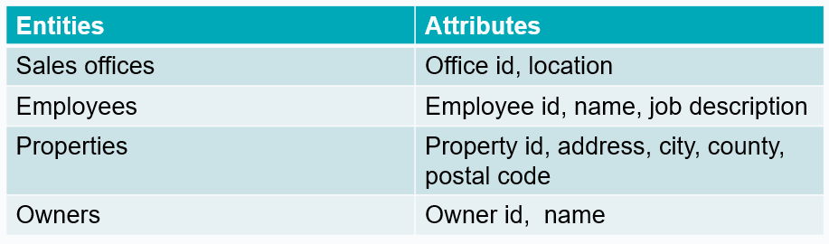

Relationships
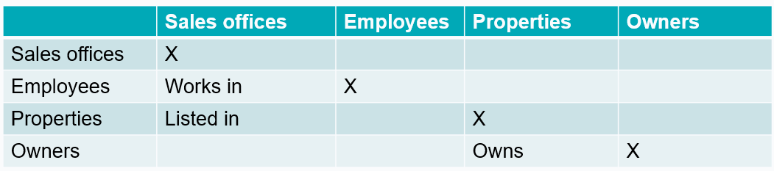

Rough ER Diagram with PKs

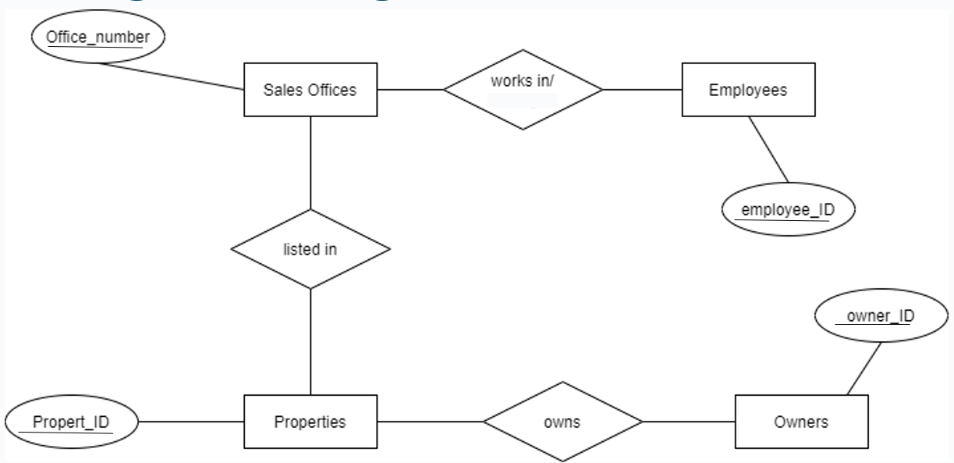

Rough ER Diagram with cardinality

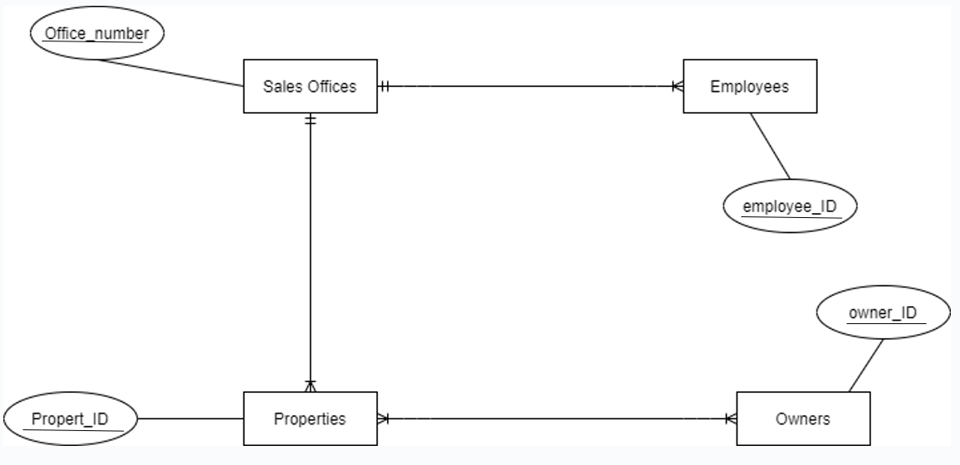

Rough ER Diagram *

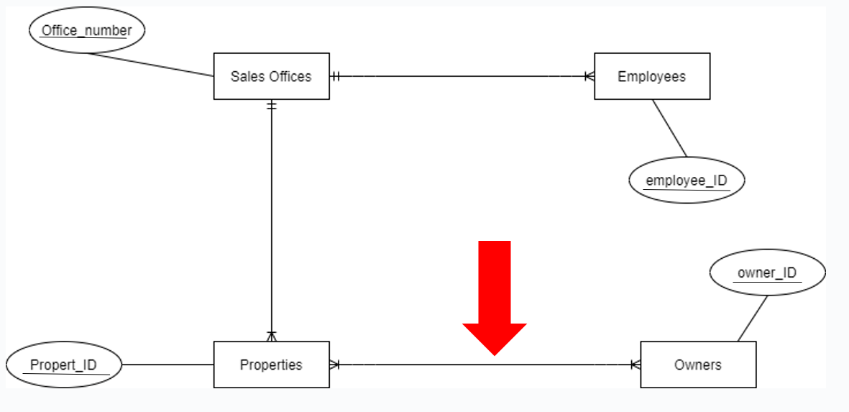

Rough ER Diagram with weak entities

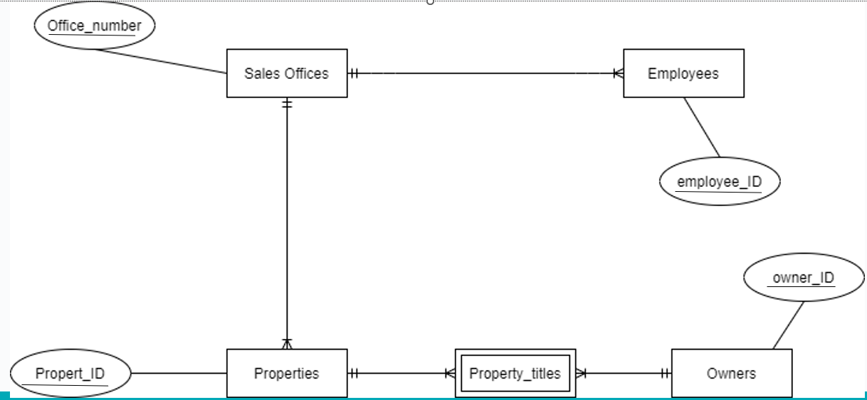

Rough ER Diagram – Non-Identifying

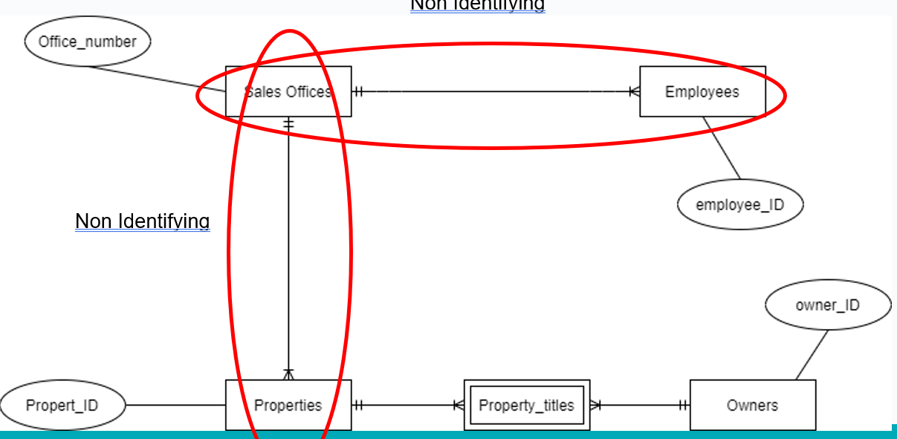

Rough ER Diagram-Identifying

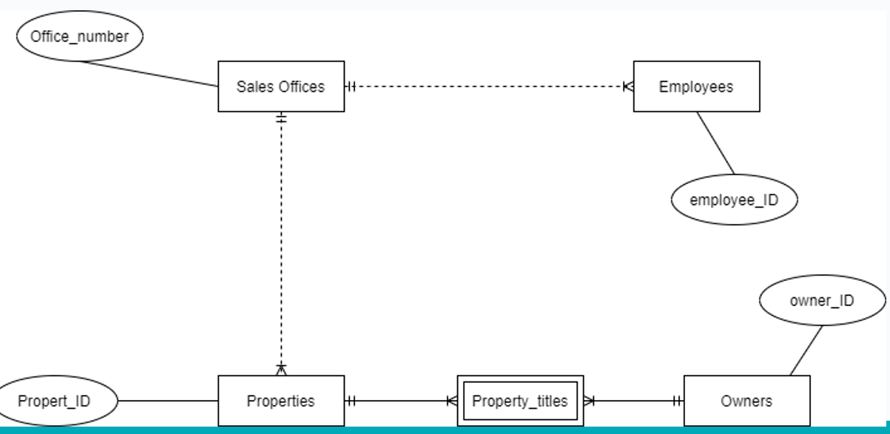

Solution lab 2 exercise 2 version 1

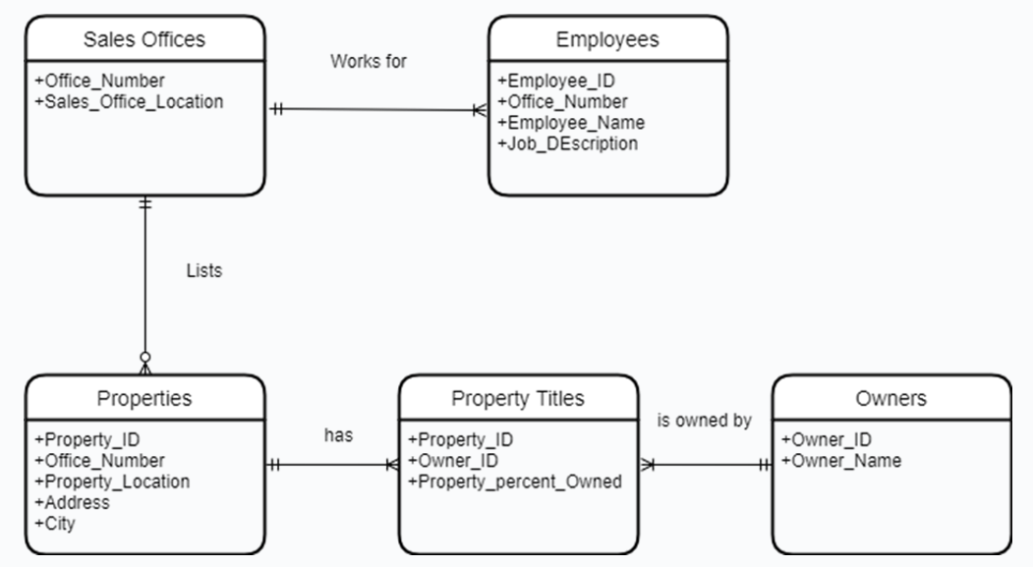

Solution lab 2 exercise 2 version 1 - PKs

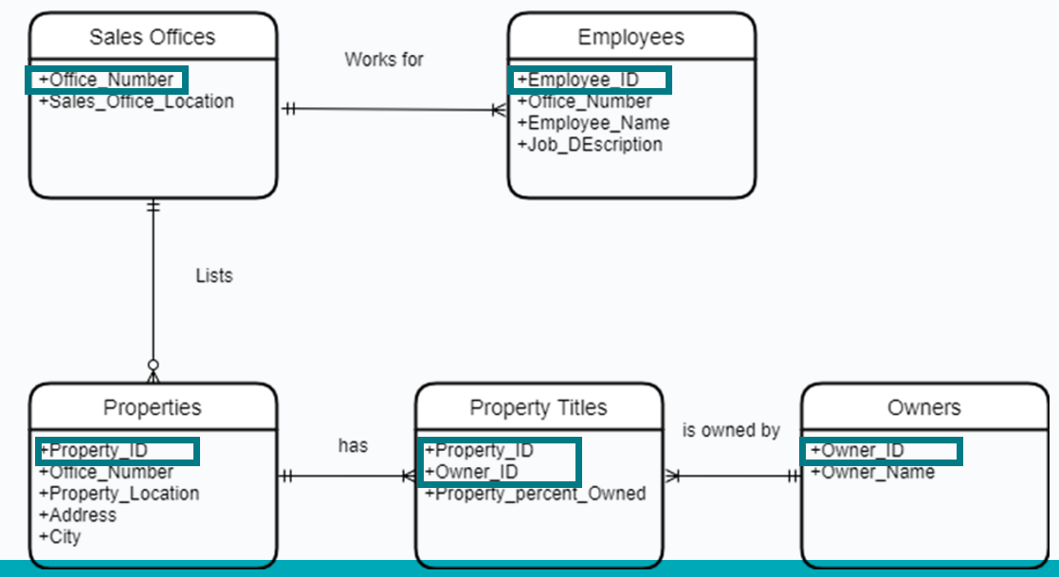

Solution lab 2 exercise 2 version 1 - FKs

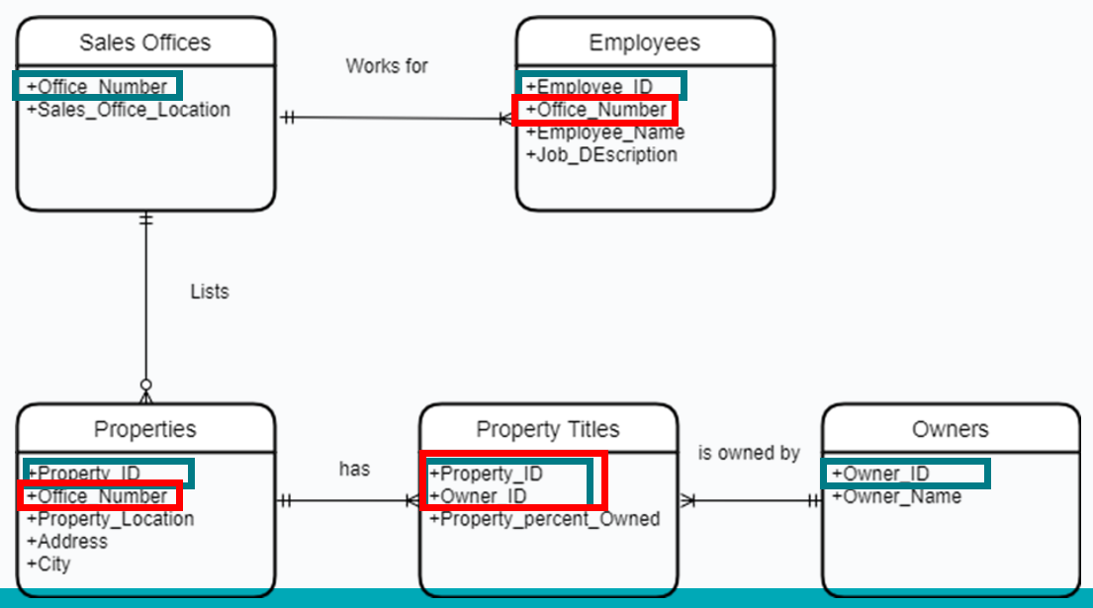

Solution lab 2 exercise 2 extra information

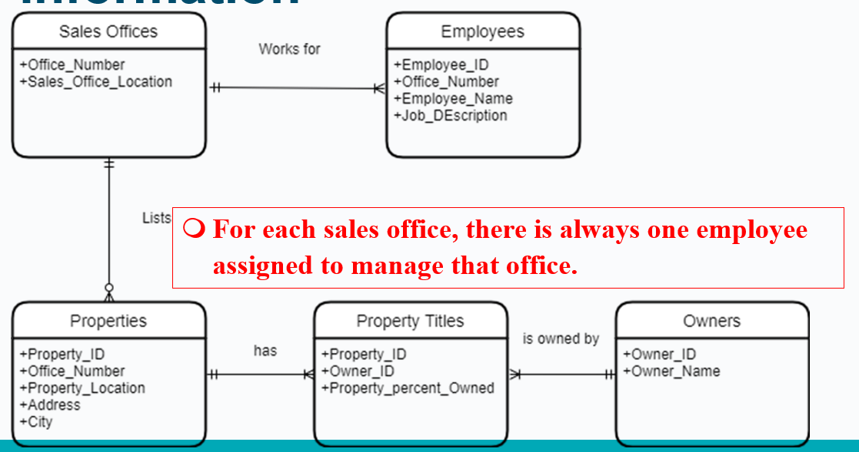

Solution lab 2 exercise 2 version 2

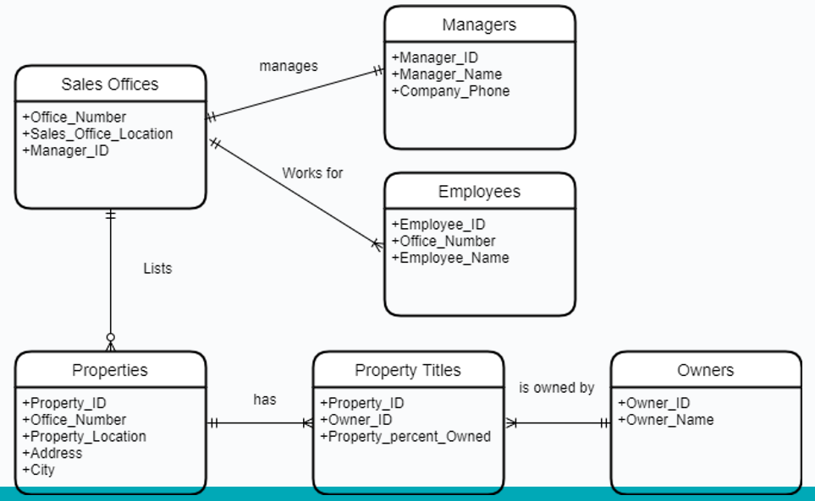

Solution lab 2 exercise 2 version 3

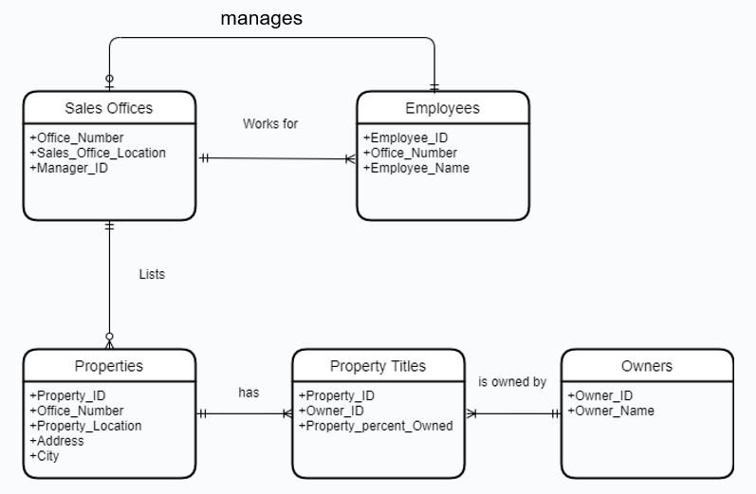

Key Based ER Diagram

- No many to many relationships
- Bridge entities used if required
- PKs defined
- FKs defined

Solution lab 2 exercise 2 version 1 - Key based ER diagram

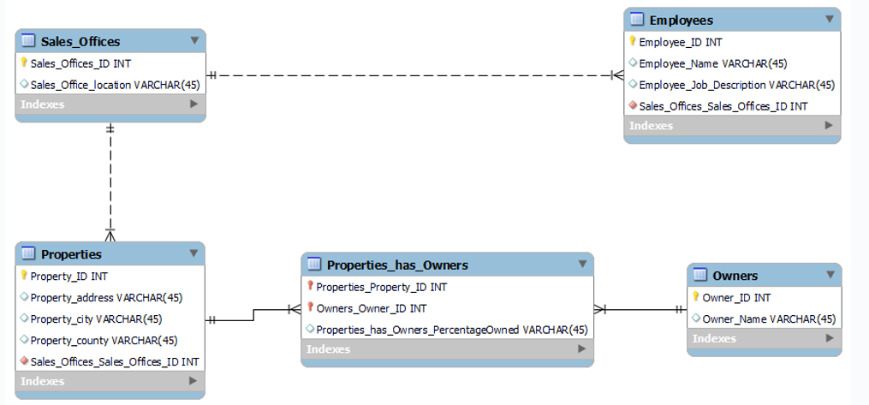

Foreign Key

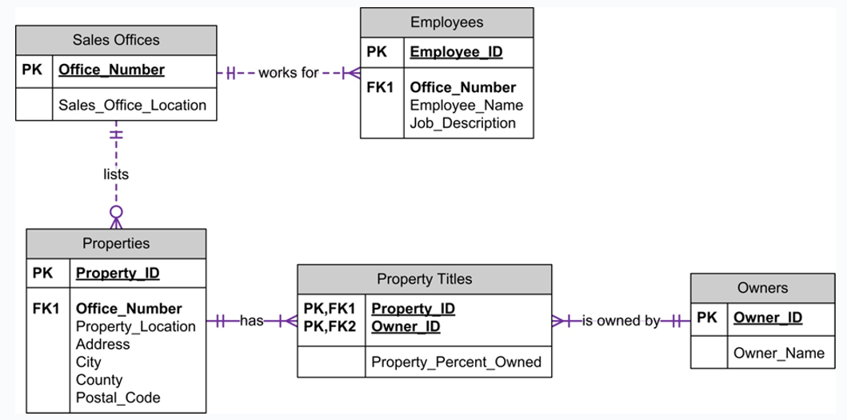

Solution lab 2 exercise 2 version 3 - Key based ER diagram

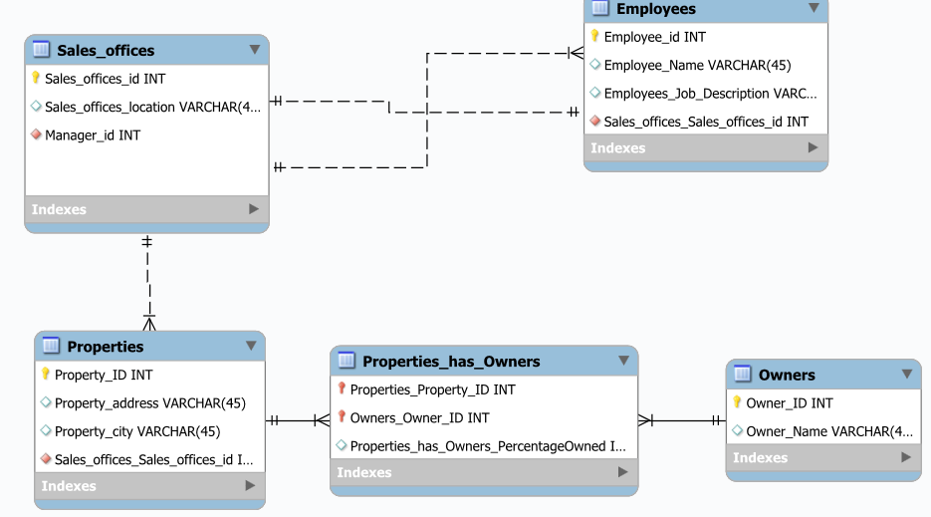

Lab 3 description

Business Requirements
A company has several departments. Each department has a supervisor and at least one employee. Employees must be assigned to at least one, but possibly more departments. At least one employee is assigned to a project, but an employee may be on holidays and not assigned to any projects.

Work flow

- Step 1: Identify Entities
- Step 2: Find Relationships
- Step 3: Draw Rough ER Diagram
- Step 4: Fill in Cardinality
- Step 5: Define Primary Keys
- Step 6: Draw Key-Based ERD (eliminating many to many relationships, include FKs)
- Step 7: Identify Attributes & Step 8: Map Attributes
- Step 9: Draw Fully Attributed E-R Diagram
- Step 10: Revise and update list of assumptions

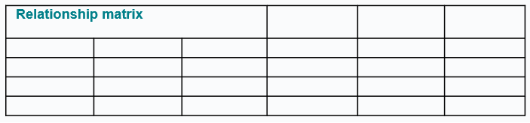

Thanks

- Edmund Nevin for earlier versions of these lecture notes

Week 4 –

Keys and Constraints

9th^{d} Oct 2024 – TU257

Lesson Outline
- Introduction to Logical Design
- Identifiers/keys
- Constrains
- Referential actions
- Data anomalies
- Introduction to normalization

Data Models

- Specify concepts that are used to describe the database. These can be categorised as:
  - High Level (Conceptual)
  - Representational (Logical)
  - Low Level (Physical)

Database Terminology

Tables/relation

- What is a Table/Relation?
  - Single valued cells (groups and arrays are not allowed to be values).
  - All entries in any attribute are of the same kind.
  - Each column must have a unique name.
    - Note: The order of the columns is not significant.
  - No two rows are identical.
    - Note: The order of the rows is not significant.

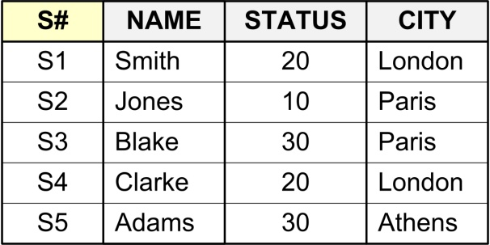

Relation/Tuple/Attribute

- Relation: Relation (in relational model) is not the same as relationship (in ER model)
- Tuple: Row
- Attribute: A property or characteristic of an entity or relationship type that is of interest to the enterprise
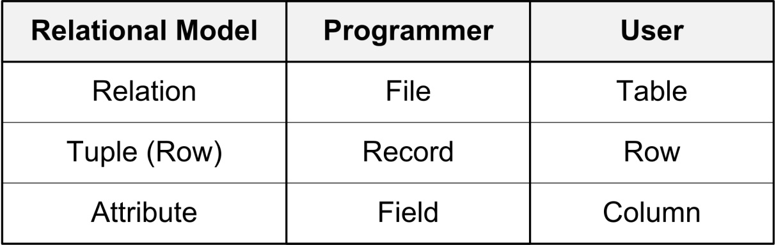

Correspondence with ER Diag
- Correspondence with ER Diagram:
  - Relations (tables) correspond with entity types.
  - Rows correspond with entity instances.
  - Columns correspond with attributes



Integrity
- Integrity:
- The accuracy and correctness of data.
- DBMS enforce integrity.
- A constraint is any rule governing static values of attributes that is precise enough so that you can ascertain whether or not it is true.

Identifiers/keys

Definition

- A key is one or more attributes (together) that uniquely identifies a tuple or row.
- Primary Key: The column or set of columns that uniquely identifies any given row.
  - Would a name be a good primary key?
  - Would a social insurance number be a good primary key?
  - The value in the primary key can never point to more than one row in the table.

Identifiers/Keys Notation

- A table and its primary key can be described by writing the columns within parentheses, and underlining the primary key:
STUDENTS (StudentID, Name, Address, PhoneNumber, DOB)

Database Terminology-4

Week 5

Normalisation
- UNF
- 1NF
- 2NF
- 3NF

Definition

- The process of designing a database in the most efficient way possible.
  - A technique for designing relational database tables to minimise duplication of information and, in doing so, to safeguard the database against certain types of logical inconsistency.
  - More highly normalised tables greatly simplify development and maintenance of the database and contribute to its extensibility.
- Properly executed, the normalisation process eliminates uncontrolled data redundancies,
  - thus eliminating the data anomalies, and
  - the data integrity problems that are produced by such redundancies.

Stages of Normalisation
- Unnormalised
  - Remove repeating groups
- 1NF
  - Remove partial dependencies
- 2NF
  - Remove transitive dependencies
- 3NF

Repeating Groups
- A repeating group is an attribute (or set of attributes) that can have more than one value for a primary key value.
- Repeating Groups are not allowed in a relational design, since all attributes have to be ‘atomic’ - i.e. there can only be one value per cell in a table.
- Example: The following relation contains staff and department details and a list of telephone contact numbers for each member of staff.

Example 1
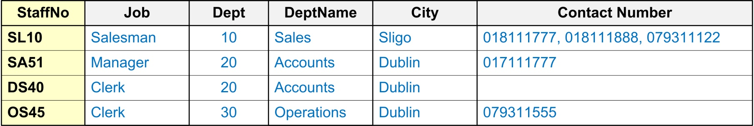

---------------------------------------------------------------------------------------------------------------------------

Example 2

--------------------------------------------------------------------------------------------------------------------------------

Example 3


Invoice Number | ClientID | OrderDate | ProductID | Product Name | Quantity | Price | total
1234 | 432 | 2023-01-01 | 43,23,455,23 | Table, Chair, Pillow, Cushion | 1,6,4,4 | 900,190,42,25 | 900,1140,168,100

Dependencies
- Functional Dependency:
  - Fully Functional Dependency
  - Partial Functional Dependency
- Transitive Dependency

Functional Dependency
- Formal Definition: Attribute B is functionally dependent upon attribute A (or a collection of attributes) if a value of A determines a single value of attribute B at any one time.
- In other words, attribute B has a functional dependency on attribute A if, for each value of A, there is exactly one value of attribute B.

Formal Notation A → B
- This should be read as ‘A determines B’ or ‘B is functionally dependent on A’. A is called the determinant and B is called the object of the determinant.
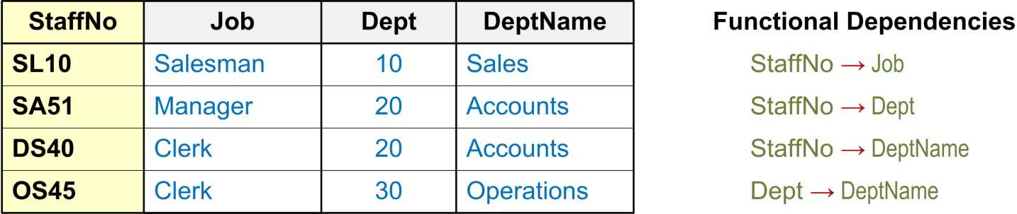

Example

Dept → DeptName
This should be read as ‘Department determines DepartmentName’
or
‘DepartmentName is functionally dependant on Department’.

Dept → DeptName



Full Functional Dependency
- An attribute is fully functional dependent on a set of attributes X if it is…
  - functionally dependent on X, and
  - not functionally dependent on any proper subset of X
  - Only relevant for composite determinants
  - Only of relevance with composite determinants.
  - All the attributes of the composite determinant (Course# and Subject_Code) are needed to determine the Subject Type

Example 1

Course# | Subject_Code | Subject_Type
ICA40299 | ICAITB060A | Core
ICA40299 | ICAITU018B | Elective
ICA40199 | ICAITU018B | Core

Partial Functional Dependency
- This is the situation that exists if it is necessary to only use a subset of the attributes of the composite determinant to identify its object uniquely.

Example 1
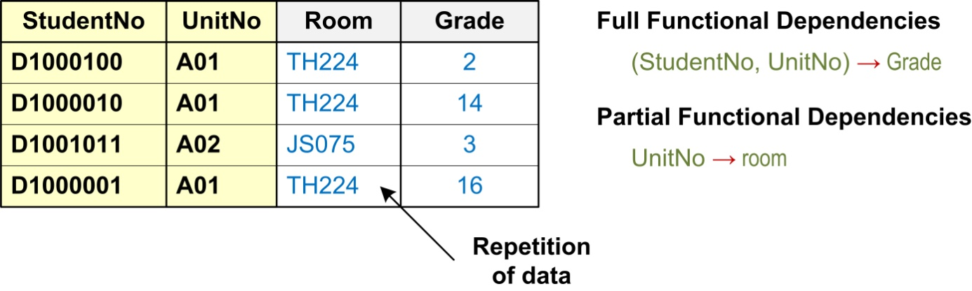

Transitive Dependency
- A transitive dependency exists when there is an intermediate functional dependency.
- A condition in which an attribute is dependent on another attribute that is not part of the primary key.
  - i.e. an indirect functional dependency,
  - one in which X → Z only by virtue of X → Y and Y → Z

Formal Notation
    - If A → B and B → C, then it can be stated that the following transitive dependency exists: A → B → C

Example 1
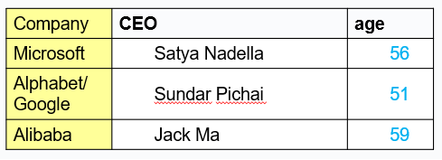
If company → CEO and CEO → age, then it can be stated that the following transitive dependency exists:
company → CEO → age

Normal Forms

When is a table in 1NF?
- A table is in 1NF when…
  - All the key attributes are defined (no repeating groups in the table) and when,
  - All remaining attributes are dependent on the primary key
  - Note: A table in 1NF still may contain partial dependencies, i.e., dependencies based on only part of the primary key.

When is a table in 2NF?
- A table is in 2NF when
  - it is in 1NF and,
  - it includes no partial dependencies.
Note: A table in 2NF still may contain transitive dependencies, i.e., dependencies based on attributes that are not part of the primary key.

When is a table in 3NF?

- A table is in 3NF when…
  - it is in 2NF, and…
  - it contains no transitive dependencies.

Un-normalised Normal Form (UNF or 0NF)
- Un-normalised Normal Form (UNF or 0NF)
  - Definition: A relation is un-normalised when it has not had any normalisation rules applied to it, and it suffers from various anomalies.
  - This only tends to occur where the relation has been designed using a ‘bottom-up approach’ i.e. the capturing of attributes to a ‘universal relation’ from a screen layout, manual report, manual document, etc...

Example: Logical Design (‘Bottom-up’ Approach)
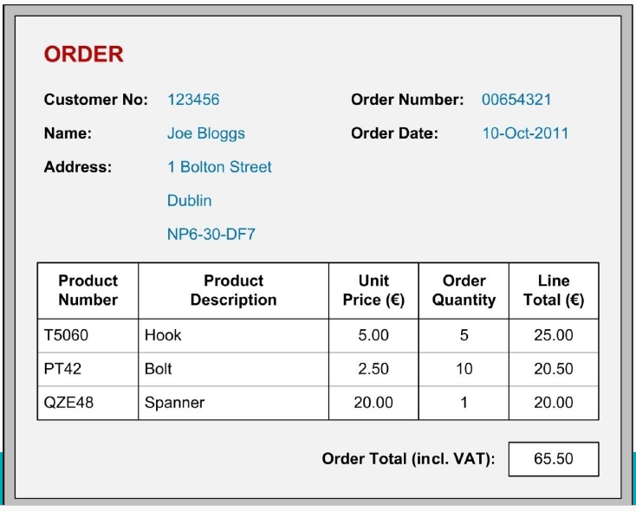

Example: Place in UNF
    - Gather attributes in the following schema form:
    - Entity( non-repeating attributes (repeating attributes)* )
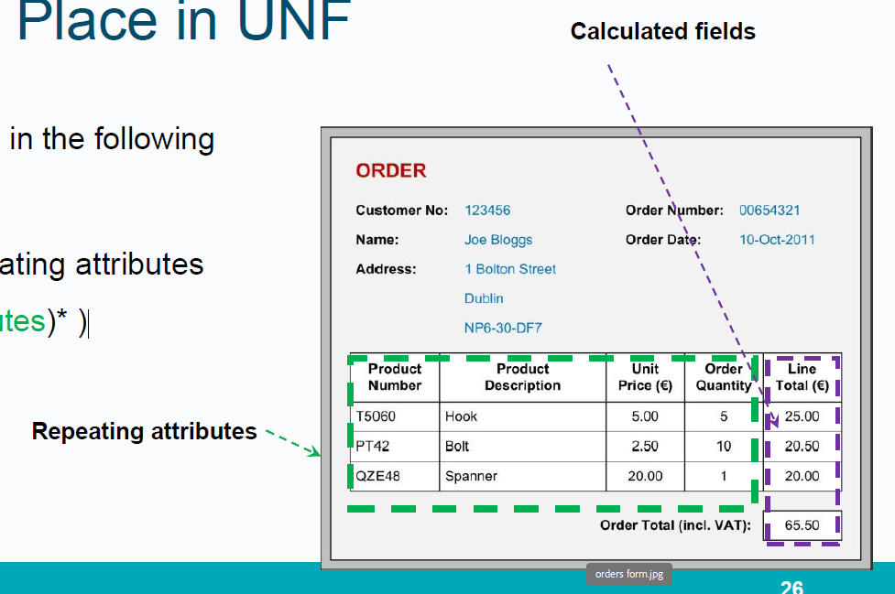

Example: Place in UNF
Entity( non-repeating attributes (repeating attributes)* )
- Un-normalised Normal Form (UNF or 0NF)

Orders( cust_no,cust_name,cust_add, order_no, order_date,(product_no, prod_desc_unit_price, order_qty, line_total)*, order_total )

First Normal Form (1NF)

Definition:
- A relation is in 1NF if, and only if, all its underlying attributes contain ‘atomic’ values only.
- Remove repeating groups into a new relation

ORDERS (order_no, order_date, cust_no, cust_name, cust_add,
(prod_no, prod_desc, unit_price, ord_qty, line_total)*, order-total)

Example: UNF to 1NF
- Remove the outermost repeating group (and any nested repeated groups it may contain) and create a new relation to contain it. Rename original to indicate 1NF.
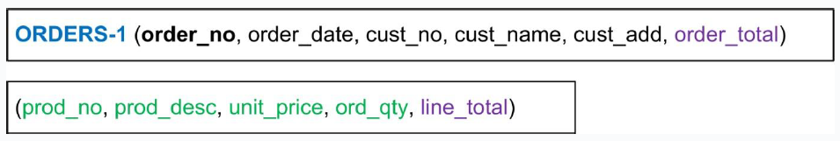

- Add to this relation a copy of the PK of the relation immediately enclosing it.
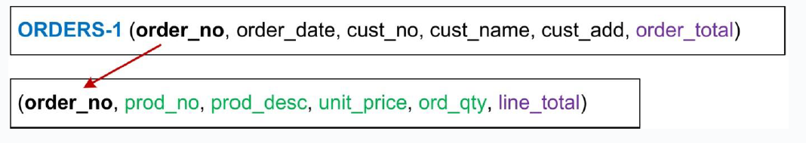

- Name the new entity (appending the number 1 to indicate 1NF).

- Determine the PK of the new entity.

Note on choosing PK

- Foreign Keys as part of a composite key can be used as PKs
- A single Foreign key is usually not suitable as Primary Keys as they allow duplication
- Alternatives:
  - Find a field that uniquely identifies each record in the table
  - Add a new field (auto-incrementing integer) to act as the primary key.

Second Normal Form (2NF)

Definition:
- A relation is in 2NF if, and only if, it is in 1NF and every non-key attribute is fully dependent on the primary key.
- Remove partial functional dependencies into a new relation.
- Check each relation individually.

Second Normal Form (2NF) First relation check

Only one single primary key. No partial dependencies.

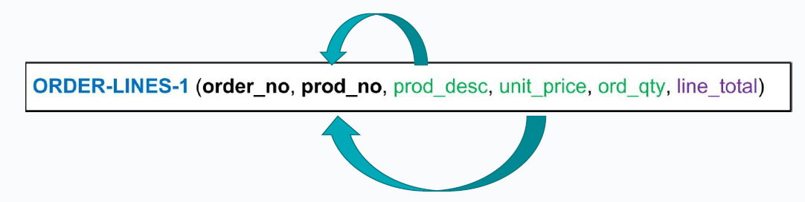
Composite primary key. Partial dependencies found.
-------------------------------------------------------------------------------------------------------------

Example: 1NF to 2NF

- Remove the offending attributes that are only partially functionally dependent on the composite key, and place them in a new relation.

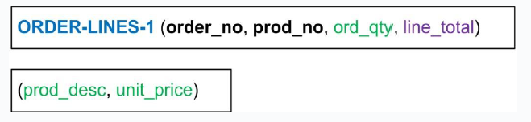
------------------------------------------------------------------------------------------------------------------------------

- Add to this relation a copy of the attribute(s) which determines these offending attributes. These will automatically become the primary key of this new relation…
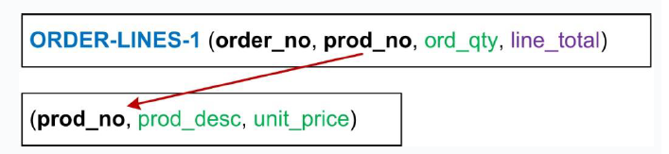

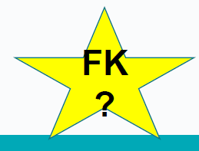
---------------------------------------------------------------------------------------------------------------------------
- Name the new entity (appending the number 2 to indicate 2NF).
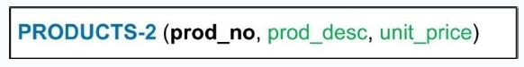

- Rename the original entity (ending with a 2 to indicate 2NF).
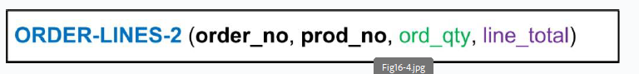

Third Normal Form (3NF)

Definition:
- A relation is in 3NF if, and only if, it is in 2NF and every non-key attribute is non-transitively dependent on the primary key.
- Remove transitive dependencies into a new relation

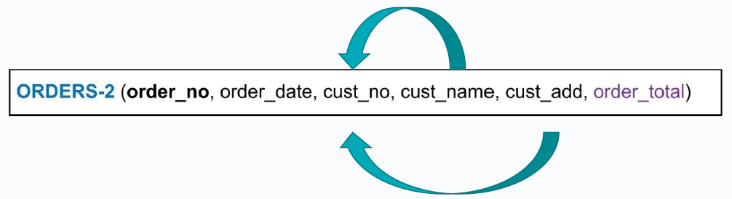
Cust_no is not part of the primary key
------------------------------------------------------------------------------------------------------------------------------

Example: 2NF to 3NF

- Remove the offending attributes that are transitively dependent on non-key attributes, and place them in a new relation.

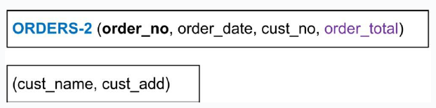
------------------------------------------------------------------------------------------------------------------------------------

- Add to this relation a copy of the attribute(s) which determines these offending attributes. These will automatically become the primary key of this new relation…
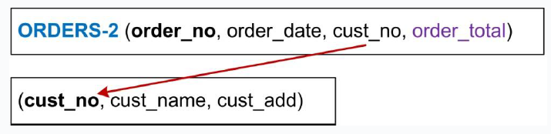

-----------------------------------------------------------------------------------------------------------------------------------
- Name the new entity (appending the number 3 to indicate 3NF).
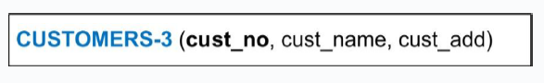

- Rename the original entity (ending with a 3 to indicate 3NF).

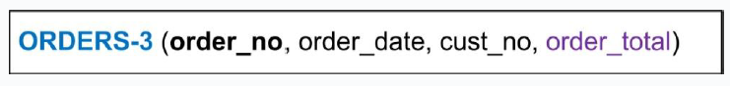

Example: Relations in Highest Normal Form
- Logical Schema:
  - ORDERS-3 (order_no, order_date, cust_no)
  - CUSTOMERS-3 (cust_no, cust_name, cust_add)
  - PRODUCTS-3 (prod_no, prod_desc, unit_price)
  - ORDER-LINES-3 (order_no, prod_no, ord_qty)
Note! Calculated fields are removed

Example: E-R Diagrams

Basic E-R Diagram

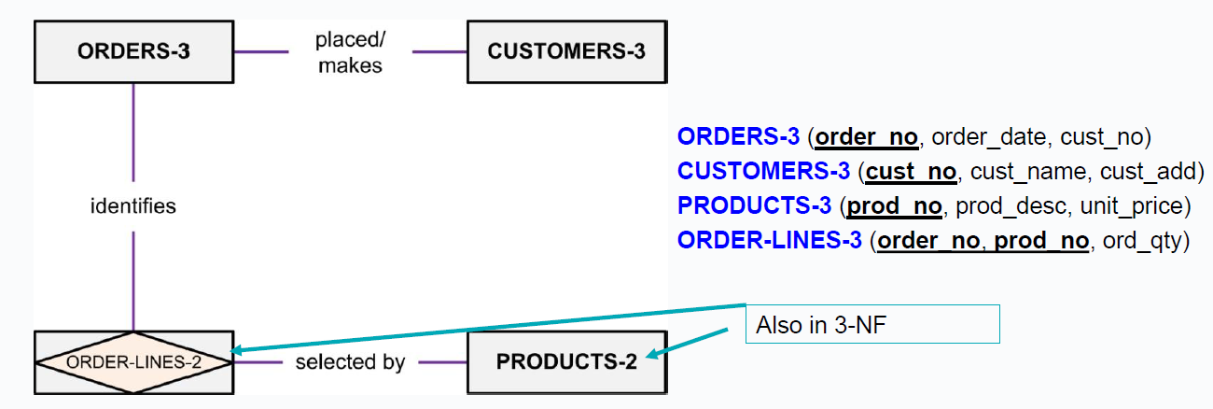

Fully-Attributed Key-Based E-R Diagram

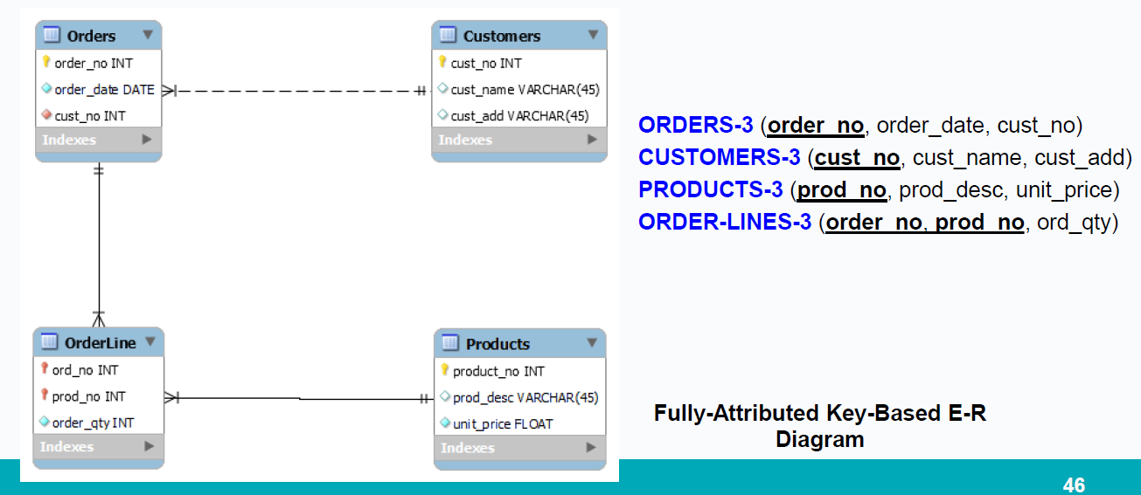

Normalisation Example

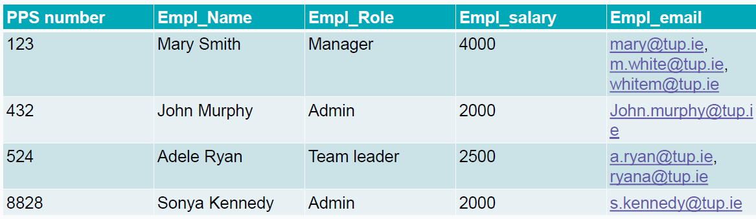
-----------------------------------------------------------------------

- Salary depends on role
- PK PPS number
--------------------------------------------------------

- What normal form is this table in?

Plan for next few weeks
  - Week 6Revision class
  - Lab SQLite 1

  - Week 7Quiz
  - No Lab

  - Week 8Submission of Assignment
  - Lab SQLite 2

Thanks

- Edmund Nevin for a earlier versions of these lecture notes

