MATH9102: Fundamentals of Data Analysis –
Describing Your Dataset
Deirdre Lawless
5 ECTS
100% Continuous Assessment

Week 1

Welcome

What is the module About?

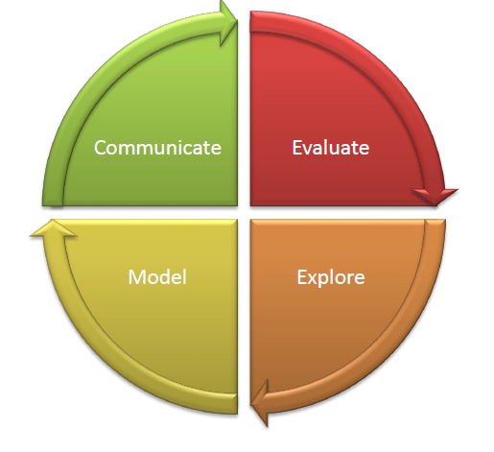

- Equip learners with core principles and tools to analyse complex data
- Critically evaluate data quality and suitability
- Use numerical, graphical, and computational techniques
- Build and evaluate predictive models to uncover patterns and trends
- Present clear, evidence-based insights

How will I learn?

Interactive
Hands-on R lectorials (lecture + programming demo +practice)
Real-world data Assessment used during through authentic examplesproject work

How class sessions will run
BEAK
Present a
bit
Demo a
bit
Practice a
bit
Break

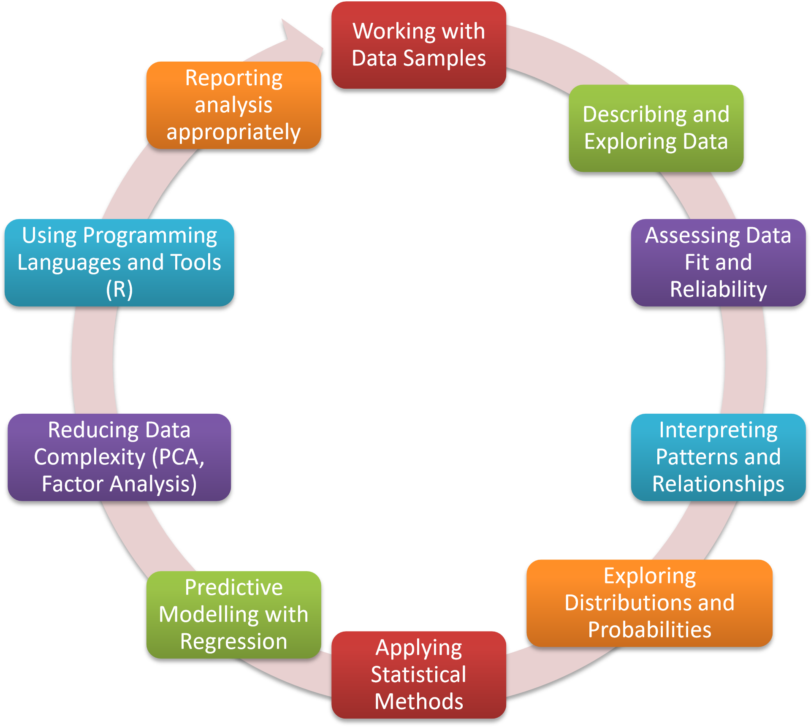

- Critically evaluate fundamental data analysis concepts.
- Apply advanced numerical and graphical techniques to explore and summarize datasets.
- Assess the suitability of datasets for use in data science workflows and justify methodological choices based on these assessments.
- Select and apply appropriate methods for exploring data and identifying meaningful patterns or relationships.

Module Learning Outcomes

- Inerpret and synthesize analytical outcomes to extract meaningful insights and support evidence-informed decision-making.
- Design, implement, and critically assess models for predicting outcomes based on data patterns.
- Apply and evaluate data reduction techniques to enhance interpretability and modelling performance.
- Communicate insights clearly and effectively through wellstructured reports that demonstrate analytical depth, clarity of interpretation, and actionable recommendations.
- Demonstrate proficiency in using appropriate programming tools and languages to develop, implement, and communicate end-to-end data science workflows, including data preparation, analysis, modelling, and results presentation.

Locating Module Material

While waiting for Brightspace to be setup, material can be located at this link:https://tinyurl.com/FundDA-2025



- Within Brightspace module:
  - ◦ Material for Lectures/Labs
    - ◦ Organised by week number
    - ◦ Lecture notes (pdf) (generally available in advance of class)
    - ◦ Lab exercise and solutions (solutions to exercises will be published after the classes are completed) ◦ Generally, will be available in advance of classes
  - ◦ Please Note:
  - ◦ Presentations used during class sessions are intended to be a supplement to attending class not a replacement
- ◦ Continuous Assessment
  - ◦ Links to specs, submission boxes, rubrics etc
- ◦ Datasets Used
  - ◦ Useful Resources
- While waiting for Brightspace to be setup, material can be located at this link: https://tinyurl.com/FundDA-2025

Practical Component

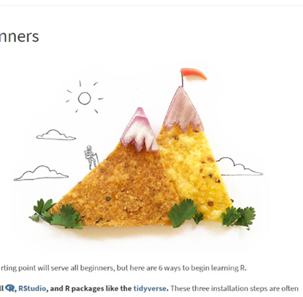

- R and R studio will be used during the classes
- Getting started with R and RStudio > https:..education.rstudio.com/learn/beginner

GitHub

- GetyourselfsetupwithaGitHubStudentDeveloperPack-https://education.github.com/pack
  - Lotsoffreetools
  - Lotsoffreeresources
  - ExtratimeforusingCodespacesforfree

Code Provided to Support Learning
    - This is a module in how to conduct a data analysis
      - ◦ We will be using R as a tool
    - This is not a module in how to use R
      - ◦ That should be covered in Working with Data
    - This is not a module about visualisation
    - Fancy graphs are covered in Data Visualisation

  - You will learn how to:
    - ◦ Design an analysis
    - ◦ Describe your data (using appropriate visuals)
    - ◦ Conduct relevant statistical tests
    - ◦ Build simple predictive models
    - ◦ Evaluate the findings in the context of your analysis
    - ◦ Express your findings appropriately
  - You will be provided with R code snippets which implement some of the above

Datasets
- A range of datasets will be used throughout the module to illustrate concepts
- You will be provided with these datasets or details of where to find and download them as needed

Some Books

- Peter Bruce,Peter C. Bruce,Andrew Bruce,Peter Gedeck. (2020), Practical Statistics for Data Scientists, 2nd. O'Reilly Media, p.0, [ISBN: 978-1492072942].
- https://datapot.vn/wp-content/uploads/2023/12/datapot.vn-Practical-Statistics-forData-Scientists.pdf?srsltid=AfmBOopXEOEs6uamO_ogfXsNiiAurw8LY3A_uVTQHVRL4hORSwvVTiC
- Hadley Wickham,Mine Çetinkaya-Rundel,Garrett Grolemund. (2023), R for Data Science, 2nd. O'Reilly Media, p.0, [ISBN: 978-1492097402].
- https://digitallibrary.tsu.ge/book/2019/september/books/R-for-DataScience.pdf
- Mike McGrath. (2023), R for Data Analysis in Easy Steps, 5th. In Easy Steps, p.0, [ISBN:
978-1840789980].
- Multiple copies in the Grangegorman library (Park House)

Asessment
- 100% continuous assessment

Phase ONE (40% of module marks):
- You will choose a dataset
- You will apply your learning from the module to construct an appropriate statistical description of selected concepts in this dataset and construct an appropriate report.
- There will be requirements w.r.t the types of statistical variable you should use.
- You will then conduct an initial statistical analysis of a selected concepts represented in this dataset and construct an appropriate report.
- There will be requirements w.r.t the types of statistical tests you should use.
- Put together a plan for phase TWO.
- You will be required to submit your report, your R code, your dataset.

Phase TWO (60% of module marks):
- You will build, analyse and report on:
- A linear regression model (using the same dataset as phase one)
- A logistic regression model (using the same dataset as phase one)
- Build a second linear/logistic model and compare to the model previously built (using the same dataset as phase one)
- Dimension reduction – using a second dataset provided to you

How to succeed in the module

- Focus on learning the process of conducting a data analysis:
- ◦ What are you trying to discover or show?
    - ◦ Figure out a question you are trying to answer/theory you are trying to test
- ◦ What data do you need to collect?
- ◦ Once you have data, how do you describe the data you have?
    - ◦ You need to explain this to whoever will be the consumer of your work ◦ What analysis should you conduct?
    - ◦ You need to know the types of statistical tests and models you need and how to explain the outcomes to your consumer
- ◦ How do you interpret your analysis?
    - ◦ You need to know how to interpret the outcomes of the analysis and present these to your consumer
- ◦ How will you present your findings?

- Work steadily through the material
  - ◦ Keep up
  - ◦ Make use of the lab time allocated to work on CA
- Make your own notes
  - ◦ On the topics we cover in class
    - ◦ On how to use the software
    - ◦ Make comments in your scripts/output and save it somewhere
- Don’t be afraid to ask questions
  - ◦ Of me, of each other, on the web…
- Keep going…

Contact

    - In person:
      - ◦ During class.
    - ◦ Email:◦ deirdre.lawless@tudublin.ie

Probability v Statistics Vs Daya Science

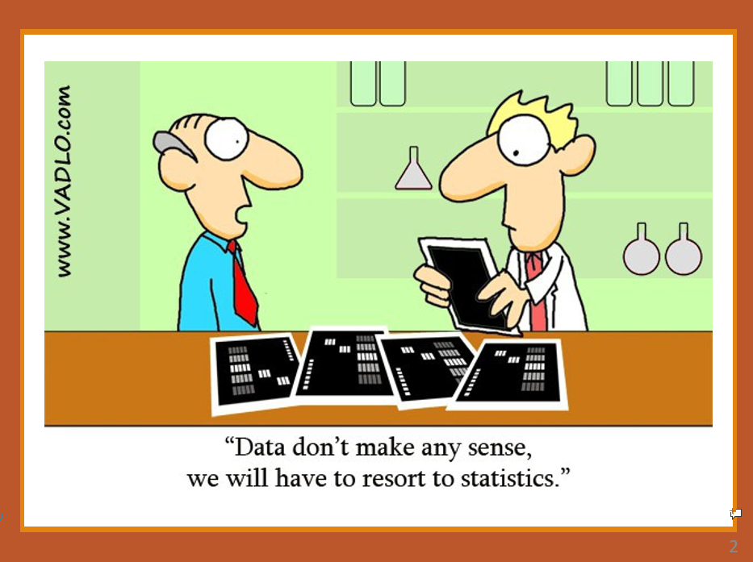

1 >>>

- A person goes to a casino and encounters their first dice game. A sixsided dice is used.

- If the person is a probabilist:
- ◦ They would think the dice is six sided
- ◦ If each side is equally likely to land face up, then the probability of
    - getting a particular face of the dice is
    - 1/6
- ◦ Using probability theory, they will be confident they can predict the likelihood that they will guess right
    - (or wrong)

2 >>>>

person goes to a casino and encounters their first dice game. A six-sided dice is used. If the person is a statistician

- They would see the dice and think:
- The dice is six-sided. It could be that each side is equally likely to land face up.
- BUT – the dice might be loaded (some sides more

- They would:
- Observe rolls for a while and record outcomes.
- Compare observed frequencies with what would be
- expected if the dice were fair.
- Use statistical tests (e.g., chi-squared) to check whether results are consistent with fairness.
- Once they had enough evidence,they could confidently decide whether to accept or question the fairness assumption.
- If consistent, they rely on probability theory to make predictions.

The dice is six-sided. It could be that each side is

3 >>>>

- A person goes to a casino and encounters their first dice game. A six-sided dice is used. If the person is a data scientist :
- Instead of immediately assuming each face has a probability of 1/61/61/6, they will want to collect data.
- They might roll the dice 100 times, record the outcomes, and build a dataset.
- OR
- They may source a dataset recording the outcomes of other people rolling a dice 100 times.
- The data scientist will then apply some statistical testing.
- They may apply a statistical test (e.g. chi-squared test) to check whether the observed frequencies significantly deviate from the expected uniform distribution.
- If the p-value is large, they conclude the dice is fair (at least no evidence against fairness).
- If small, they suspect the dice is biased and might explore which face(s) occur more often.
- The data scientist will then try to build a model The probabilist assumes fairness, but the data scientist may model probabilities empirically:
- 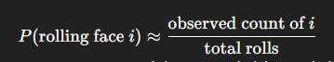

- Over many rolls, this estimate converges toward the true underlying probability distribution.

Summary
Probabilist | Theory-first. Works with mathematical models and assumptions about randomness. | Assumes the die is fair → each face has probability 1/61/61/6. Uses probability theory to compute chances of winning/losing.
Statistician | Inference and validation. Designs experiments, collects data, and applies formal methods to test if the probabilist’s assumptions hold. | Rolls the die many times, uses a chisquared test to check if outcomes deviate from fairness. Reports whether data provides evidence for or against bias.
Data Scientist / Data Analyst | Data-first, applied, and exploratory. Gathers large datasets, explores patterns, builds predictive models, and communicates insights. | Collects thousands of dice rolls, visualises frequency distributions, estimates probabilities empirically, simulates casino outcomes, and advises on betting strategies if bias is found.

The relationship

- Probability provides the framework → what the model of fairness looks like. Statistics provides the bridge → testing whether reality (data) aligns with the framework.
- Data Science/Analysis provides the application → exploring data at scale, finding patterns, and generating actionable insights.
- Together, they form a theory–inference–application pipeline: Theory (probability) Inference (statistics) Application (data science/analysis)

What is Data Science
What is  Data  Science? | The science of extracting knowledge and insights from data by combining statistics with computing, machine learning, and domain expertise

What is Data Analysis
What is  Data  Analysis? | The process of inspecting, cleaning, and modelling data, using statistical methods to discover useful information and support decision-making.

What can Statistics Do?

- Make datamore manageable6, 1, 8, 3, 5, 4, 9

- What can statistics do?
- •We can calculatean average(5.147…)
- •We can state the range (1 to9)
- •We can create a visualizationof it
- Provide us with evidence from the data that allows us to draw conclusions from the data
- Group of numbers #1: 6, 1, 8, 3, 5, 4, 9
  - Average is 5.14
- Group of numbers #2: 8, 3, 4, 2, 7, 1, 4
  - Average is 4.25
- Allows us to compare groups of data
- Allows us to do this objectively and quantitatively

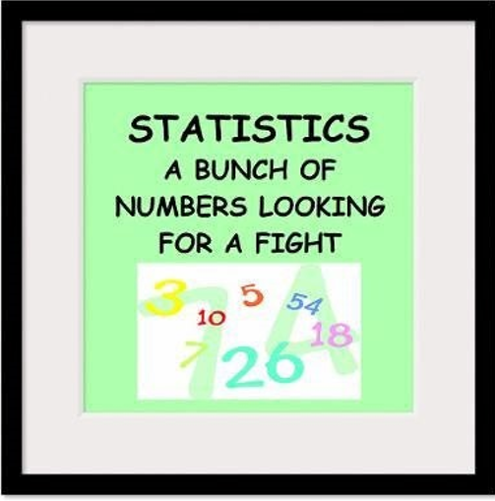

Example

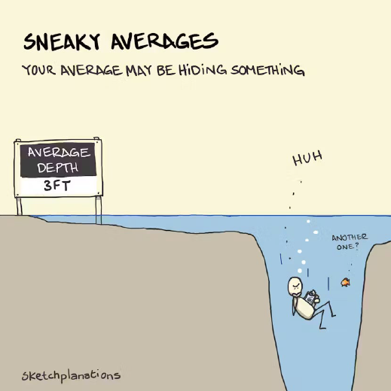

- Averages summarise data into a single value, making complex information easier to compare.
- But while they simplify, they also hide variation — and sometimes what’s really going on.
- Suppose you run a delivery service and have a mean delivery time of one day;
- it could be that most deliveries are actually a few hours, while just a few have people waiting for a week.

- A figure of mean incomes might mask the fact that most people have low salaries, while a few are millionaires.
- Sometimes a different measure of central tendency, like the median, can provide a clearer picture.

- But you also need other statistics to give you the full picture – variance, std deviation, range etc.
- You need to "Spend time with your data."
- Sometimes it's the only way to know what's happening for sure.

The Process (Source Andy Field)

Initial Obsevation

- ◦Observe the real world
- ◦Experience the real world
- ◦Read related research
- ◦……
- The Process

Conceptual Framework

  - System of:
    - concepts,
    - assumptions,
    - expectations,
    - beliefs, and
    - theories that supports and informs your research
  - A key part of your design
  - A conception or model of what is out there that you plan to study, and of what is going on with these things and why a tentative theory of the phenomena that you are investigating
  - going on with these things and whya tentative theory of the phenomena that you are investigating
  - Influences your design and in particular the data you need to collect/use

Conceptual Framework – Why is it important?
- Bernd Heinrich
- Spent a summer conducting detailed, systematic research on ant lions
  - ◦Small insects that trap ants in pits they have dug.
- When he conducted his analysis, he found his results were very different to other researchers…
  - ◦A good thing ? Was his research revolutionary?
- Repeated experiments following summer
  - Found that he and his team had misunderstood ant lion behaviour
  - ◦In particular the time frame involved
  - Missed specific behaviour that impacted the results
- “Even carefully collected results can be misleading if the underlying context of assumptions is wrong”
- Source: Maxwell, J. A. (2005). Conceptual framework: What do you think is going on? Qualitative research design: An interactive approach (3rd. ed., pp. 39-72

Generating and Testing Theories

Theory
  - ◦A hypothesized general principle or set of principles that explains known findings about a topic and from which new hypotheses can be generated.
  - ◦e.g. Computer Science attracts students with strong mathematical ability

Hypothesis
  - ◦A prediction from a theory.
  - ◦States an assumed relationship between concepts of interest.
    - ◦E.g. the number of people applying for an MSc in Computer Science will have basic mathematical ability greater than the general level in the population.
    - ◦We want to test our hypothesis/hypotheses to see if they hold in the world that we are modelling based on our observations/data.

Identify the variables

- From your theory and hypotheses, you will be able to identify the
- items that can be observed or changed or manipulated or calculated or simulated.
- Example:
- If we are interested in researching the impact part-time work has on students' study time, we might state a hypothesis:
- The number of hours a student spends working for their employer impacts the number of hours spent on working independent study
- What are the variables?
  - ◦Number of hours spent working
  - Number of hours spent independently studying
- A variable is anything that can take on a different quantity or quality
  - ◦It is anything that can vary.

Example Theory

- The use of stimulants positively impact PSI students’ level of alertness, mental and physical activation, or readiness to respond.
- ◦We have a theory that the combination of caffeine and sugar as stimulants can increase these levels.
  - ◦Caffeine, in particular, is known to block adenosine receptors in the brain, reducing feelings of fatigue and increasing alertness and concentration.
  - ◦We choose Coca Cola as a suitable stimulant.
  - ◦We decide on the dosage levels, timings etc.
etc.

Example Hypothesis:Consumption of Coca-Cola improves a PSI student’s ability to concentrate during lectures

- VARIABLE ONE
  - ◦ Coca-Cola consumption
  - ◦The proposed cause
  - ◦A predictor variable
  - ◦Could be a manipulated variable (in experiments)
  - ◦Independent Variable

- VARIABLE TWO
  - ◦A student’s ability to concentrate in the hypothesis above
  - ◦The proposed effect
  - ◦An outcome variable
  - ◦Measured not manipulated (in experiments)
  - ◦Dependent Variable

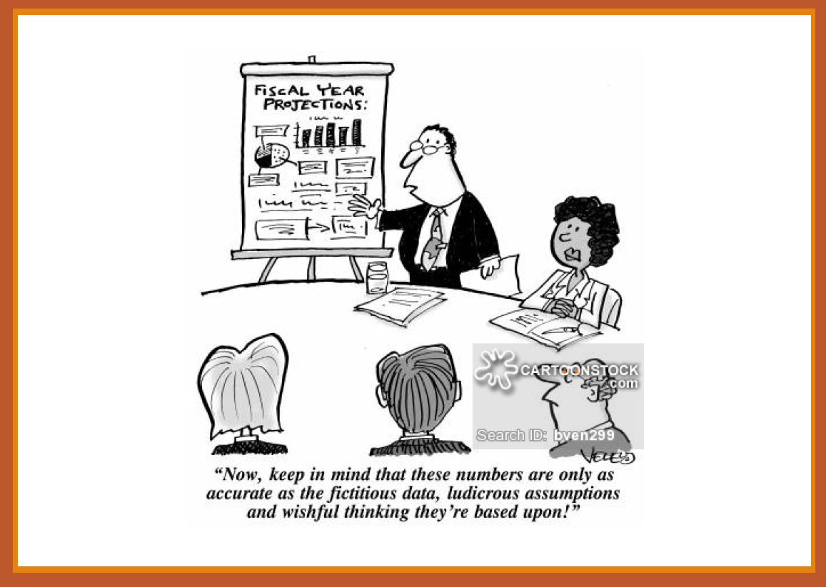

The Process

Collect the Data

- The information about different variables is referred to as data
- When the data relative to some specific variables is collected and organised, we refer to the collection as a dataset.
- Datasets are collected and organised around specific observations or instances in the world we are interested in.
- ◦E.g. we are interested in 40 students who are studying PSI in Dublin at MSc level, we collect their age, previous education level and their confidence level studying mathematics
- ◦The dataset would be made up of 40 observation or cases.
- ◦Each case should include a measurement for each of our values of interest.

Measure the Variables

- Once we have identified the variables we need, we need to decide their statistical type

Types of Variable (In Statistical Analysis)

- QUANTITATIVE
- Involves measurement
- ◦ Data in numerical form
- ◦ bjective and results in unambiguous conclusions
- ◦ 5.14 versus 4.25
- ◦ 5% versus 50%
- ◦ 1 hour versus 24 hours

- QUALITATIVE
- Describes the nature of something
- ◦ Often evaluative and ambiguous
- ◦ “Good” versus “Bad”
- ◦ Right” versus “Wrong”
- ◦ “A Lot” versus “A Little”
- ◦ May be numerical
- ◦
- e.g. 1 = Group 1, 2 = Group 2

Qualitative, or Attribute, or Categorical, Variable

- A variable that categorizes or describes an element of a population.
- Identifies basic differentiating characteristics
- of the population
- Note:

  - ◦ Category values can be numerical e.g., 1 for Urban and 2 for Rural, 1 for Blue Eyes, 2 for Brown Eyes
BUT

  - ◦ Arithmetic operations, such as addition and averaging, are not meaningful for data resulting from a qualitative variable.

Qualitative Datatype - Nominal

  - E.g. Country of Origin: 1=Ireland, 2=India, 3=China, 4=……..; Type of
  - residence: A=House, B=Apartment, C=Other
  - Categories should be
  - ◦ mutually exclusive
  - ◦ You must be able to assign every case in your dataset into one of the categories but only one category

  - AND
- ◦ collectively exhaustive
  - You have to have a category for every case in your dataset.

  - Example
- ◦ Suppose we are collecting data using a survey
- ◦ We want to collect information about respondents Religious Belief. We decide the categories.
  - We decide to have categories for Catholic, Protestant, Jewish, Muslim, Hindu and Other
  - What would we do if a respondent was an atheist?

Qualitative Datatype - Ordinal
Categorises but also introduces some order to the categories
- E.g.
- ◦
  - Ranking: 1st, 2nd, 3rd
  - Answer: Strongly Disagree, Disagree, Agree, Strongly Agree

- Suppose in our survey we want to collect information about respondents’ highest level of educational achievement.

- We decide to include the categories:
  - completed some primary level, completed primary level, completed some second level, completed second level, completed a primary degree, completed a post-graduate degree

- Here there is an inherent notion of order
  - Those who respond that they completed primary have less education that those that have completed a primary degree

Quantitative variable
- A variable that quantifies an element of a population.

Discrete
  - have values that are counted

Continuous
  - ◦takes on any value within a range, and the number of possible values within that range is infinite
- Observations or measurements take on numerical values

- Note:
  - ◦Arithmetic operations such as addition and averaging, are meaningful for data resulting from a quantitative variable.

Quantitative variable – General Types

Discrete
  - ◦Isolated points along a number line
  - ◦Usually counted
  - ◦Can only take certain values
  - ◦E.g. rolling a dice, #students attending class

Continuous
  - ◦Variable that can be any value in a given range
  - ◦Usually measured
  - ◦E.g. heights of students attending class, time spent concentrating in class

Levels of measurement – Interval Datatype

Interval
◦ Data can be ordered but there is meaning between the values of order
◦ Values are measure on a scale and the difference between the points on the scale are the interval

Key points
◦ There are equal intervals between the values
◦ The intervals are fixed and constant
◦ There is no true zero point
◦ Allows comparison between the data values
◦ While you can add and subtract interval data, you cannot meaningfully multiply or divide it.

Example:
◦ Temperature in Celsius or Fahrenheit.
◦ Zero degrees doesn’t mean the absence of temperature; it’s just another point on the scale.

Interval Datatype
Interval
◦
- Example:
- ◦ Suppose I ask all the students in the class to tell me what time you usually wake in the morning (hours and minutes 24-hour clock format, nearest quarter hour)
  - ◦ The measurement type is interval:
  - ◦ The interval is 15 mins
  - ◦ The difference between 9:00 and 9:15 is the same as the difference between 18:00 and 18:15
  - ◦ But 0:00 is not a true zero - it is a valid time, it is not the absence of time.

Levels of measurement – Ratio Datatype
Ratio
- ◦ All the properties of interval
- ◦ Plus
  - ◦ Can take any value within a given range
  - ◦ But it is not restricted to fixed increments
  - ◦ It can be measured with increasing precision
  - ◦ Has a true zero
  - ◦ Represents the absence of the concept
- ◦ You can find the ratio - it makes sense to say for example one value is twice as large as another

- Example:
  - ◦ Weight is an example of ratio data.
    - ◦ A weight of 0 kilograms means the absence of weight
    - ◦ And you can meaningfully say that 10 kg is twice as heavy as 5 kg.
- ◦ In a survey of students on how much they spend on buying lunch in the university café:
  - ◦This could be any value 7.01, 14.02, 10.56, 63.09
    - ◦ We can say 14.02 is twice as much as 7.01, 63.09 is 9 times as much as 7.01
  - ◦ But also, a student may spend 0 which is this case represents the absence of spending

Key Note
- You don’t need to have every possible value of a variable represented in your dataset

BUT

- It should be possible for that value to be included if it exists in the world you are modelling

Quiz

https://www.med.soton.ac.uk/stats_eLearning/typesofdataquiz/index.html

Collect the data
Collect data that will provide evidence you
can test to see if your idea is valid
You can use data you have already collected – but you should not fish or dredge it to generate your hypothesis
◦Your theory and hypotheses should make sense in the real world

What data am I interested in/do I need?
- Data Analysis is usually carried out with a SAMPLE
- Population
  - ◦The entire set of individuals or objects of interest or the measurements obtained from all individuals or objects of interest
  - ◦The world you are interested in and trying to build a model of.
  - ◦Two kinds of populations:
  - ◦finite or infinite.
- Sample
  - ◦A portion, or part, of the population of interest

Population
- The entire set of individuals or objects of interest or the measurements
- obtained from all possible individuals or objects of interest
- The world you are interested in and trying to build a model of.
- ◦E.g., All registered voters in Ireland.
- But the population is constantly changing.
- ◦E.g. All registered voters in Ireland
- ◦People are dying and being removed, turning 18 and being added
- It is also usually incredibly large
- ◦E.g. as of 2024 there are 3.4 million registered voters in Ireland.
- ◦If you want to collect information about every single one of them, how do you do it, how long would it take?
- So it is difficult to work with the full population

Sample
- A portion of your population.
- E.g., we may choose to work with a sample of 2000 registered voters in Ireland.
- But we need to decide which voters?
- What do we need the sample to achieve?
- ◦It will be a proxy for the population so it should be representative of that population
- ◦If Sample is not representative, it is biased

- Need to understand the nature of the population before collection/creating/choosing the sample
- Need the collection of the sample to provide the same opportunities for all possible values of a variables to appear as they would in the population.

Population v Sample
- ◦Example
  - survey
  - ◦You want to survey every customer who has purchased something from the company in the past calendar year
  - ◦That’s the population
  - ◦But could you logistically contact all of these customers? (Unlikely)
  - ◦And if you could, would they all respond? (Unlikely)
  - ◦In this case you would work with a sample.
  - ◦You need to make it representative.
  - ◦You are working for a retail company, and you want to conduct a customer satisfaction

Population v Sample - 2

- ◦Example◦
- You are working for a retail company, and you want to conduct a customer satisfaction survey
- ◦You want to survey every customer who has purchased something from the company in the past calendar year ◦That’s the population

- ◦But could you logistically contact all of these customers? (Unlikely)◦And if you could, would they all respond? (Unlikely)

- ◦In this case you would work with a sample.
- ◦You need to make it representative.

Sample
- Factors influencing the accuracy of a sample’s ability to represent a
- population:
- ◦
- Size
- ◦
- Randomness
- Biased Sampling Method:
- ◦
- A sampling method that produces data which systematically differs from the population from which it is taken.
- Aim for a Simple Random Sample
- ◦
- A sample of n measurements from a population is a subset of the population selected in such a manner that every sample of size n from the population has an equal chance of being selected
- ◦
- Some things to note:
- ◦
- Researcher bias should not occur in the sample selection
- ◦
- May not always reflect the diversity of the population

Sample - 2

- In an ideal situation, the entire population should be studied but this is almost impossible. Majority of studies are performed on limited subjects drawn from the concerned population known as “sample population”.
- The data obtained is analysed and conclusions are drawn which are extrapolated to the population under study.
- Sample size - The number of cases n◦E.g. n = 90

- Too small a sample◦May not lead to conclusions that are valid for the population

- Too large a sample◦Wasteful if a smaller sample would do
- ◦May have ethical implications dependent on the type of experiment/observation being undertaken

- How do decide on sample size is something we will talk about
- Sample

Data Collection: What to Measure?

- Hypothesis:
  - Consumption of Coca-Cola improves a student’s ability to concentrate.

- •Variable One
  - •The proposed cause
  - •A predictor variable
  - •A manipulated variable (in experiments)
  - •Coca-Cola consumption in the hypothesis above
- •Variable Two
  - •The proposed effect
  - •An outcome variable
  - •Measured not manipulated (in experiments)
  - •A student’s ability to concentrate in the hypothesis above

Data Collection: Measurement Error

Masurement Error
- •(also referred to as observational error)
- •The discrepancy between the actual value we’re trying to measure, and the number we use to represent that value.

There are always random errors

- •We need to expect them and handle them in our reporting

- Example:
  - ◦Suppose you are measuring the weight of 100 athletes
    - ◦The scale you use is 0.1 kg out
    - ◦ This is a systematic measurement error of 0.1kg
    - ◦However,
    - ◦If our scale is accurate but our athletes all have different levels of hydration or are wearing different types of clothes
    - ◦Then we still have a measurement error – this is random

Data Collection: Validity

Whether an instrument measures what it set out to measure.

Content validity
◦
- Evidence that the content of a test corresponds to the content of the construct it was designed to cover

Ecological validity
◦
- Evidence that the results of a study, experiment or test can be applied, and allow inferences, to real-world conditions.

Data Collection: Reliability
Degree to which an indicator is a consistent measuring device

- The ability of the measure to produce the same results under the same conditions.

- Test –Retest Reliability
- The ability of a measure to produce consistent results when the same entities are tested at two different points in time.

Confounding Variables
- Sometimes we are interested in establishing relationships/differences and then inferring cause and effect1

- This can be complicated by confounding variables
  - Variables which may or may not directly measured which has influence on other variables in the study

- Two variables are confounding when one cannot be distinguished from the effects of another

  - E.g. amount of petrol and time used to commute to work, it is likely that level of congestion will be a factor
- We won’t actually be able to 100% demonstrate cause and effect – we will look at this issue later.

What could the confounding variables be for our Coca-Cola hypothesis?

- Hypothesis:
  - Consumption of Coca-Cola improves a student’s ability to concentrate.

- •Variable One
  - •Coca-Cola consumption in
- •Variable Two
  - •A student’s ability to concentrate

The Process

Important Step - Describing your data
- Must describe before analyzing

- Need to include sufficient detail that your consumer can
- See what you are basing your analysis/conclusions on
- Understand anything that may constrain those analysis/conclusions

- You are trying to present information about a large body of data so that
- your consumer can understand it without having to view every individual case you have collected
    - Usually start with a picture and
    - Include some meaningful numbers to summarise and illustrate variability

Summarizing v Analyzing

Descriptive Statistics
  - Describing the population and the sample
  - Summarizing

Inferential Statistics
  - Inference from sample to population
  - Inference from statistic to parameter

Getting Started With Statistical Study
Need to decide the nature of the study and then decide what individuals or objects are of interest
- We must understand our population
  - ◦The data we need to collect
    - ◦Its structure and values, how it can be measured/represented
- ◦
  - Sample
    - ◦Representativeness and size
  - ◦Be able to describe it simply
    - ◦Using the appropriate statistics for the variables of interest
  - ◦Be able to represent it visually
    - ◦Using the appropriate type of graph for variables of interest
- The we will be able to analyse it appropriately
  - ◦Using the appropriate statistical tests to draw inference

Week 2

Week 3

Hypothesis Testing

The general Linear statistical Model

Inspecting and Preparing Data
Was last pdf mod run through before lab

Paranetric tests

Goals of missing data

References
Xls with links to all content – week 1 to week 3 and assessment
https://tinyurl.com/FundDA-2025

Books

Completed –
- Week 1
  - Classroom recording
  - Labs and exercises
- Week 2
  - Classroom recording
  - Labs and exercises
- Week 3
  - Classroom recording
  - Labs and exercises
- Week 4
  - Classroom recording
  - Labs and exercises

