Machine Learning

Bojan Božić & Bujar Raufi
School of Computer Science
TU Dublin, Grangegorman
bojan.bozic@tudublin.ie; bujar.raufi@tudublin.ie

Lecture 1: Introduction
- Bojan Božić & Bujar Raufi
- (Boyan)
- (Amany Acolani)
- School of Computer Science
- TU Dublin, Grangegorman
- bojan.bozic@tudublin.ie; bujar.raufi@tudublin.ie
Slides adapted from Sarah Jane Delany and book slides from: Fundamentals of Machine Learning for Predictive Data Analytics. Kelleher, Mac Namee and D’Arcy

Assignments

Link from Andrea >>>
https://tudublin.sharepoint.com/:x:/r/sites/SchoolofComputerScience-Staff-City/_layouts/15/Doc.aspx?sourcedoc=%7B0B276380-AB42-4515-B6CF-FFCC6BBEB179%7D&file=Semester%201%20&%202%20Assignment%20Schedule%202025-26.xlsx=&action=default&mobileredirect=true

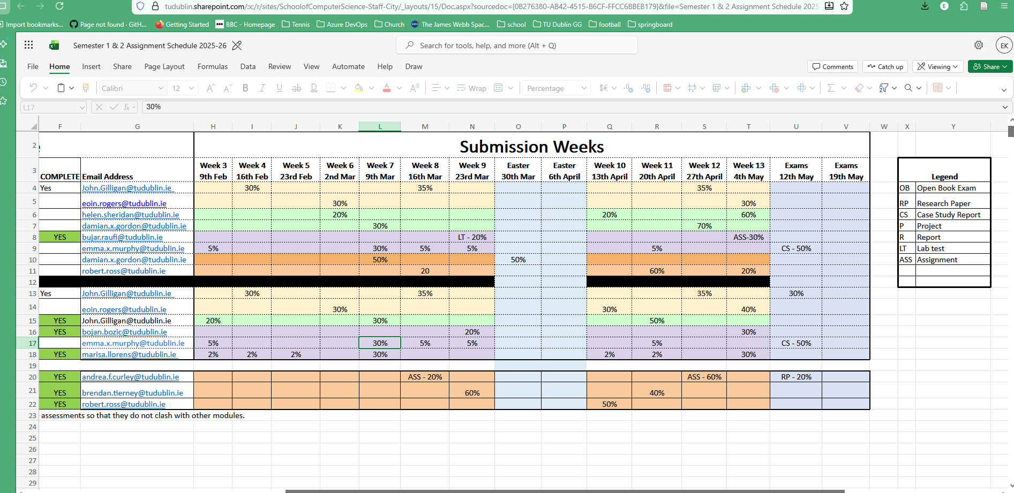

Week 1 – Intro – 29th Jan 2026

Overview
- Administrivia
- Module Outline
- Machine Learning Today - the good, the bad and the ugly
- Machine Learning Introduction
- What is (supervised) ML?
- Supervised v Unsupervised Learning
- Representing Data as Features

Lecture and Lab:
- Thursday: 6pm to 10pm
- Weeks 1, 7 and 13 will be in-person (but streamed), the rest will be online
- No lecture on week 13 (07.05.2026)!

- All notes, lecture recordings, tutorials, lab work, and assignments will be available on Brightspace.

- For all module queries please contact: bojan.bozic@tudublin.ie

Book
- Fundamentals of Machine Learning for Predictive Data Analytics: John D. Kelleher, Brian Mac Namee, Aoife D'Arcy

ML with Python

- Tutorials and lab work require a laptop with Jupyter and scikit-learnn
- Require >> Scikit-learn >> https://scikit-learn.org/stable/

Assessment

- Assessment is based on CA + final exam:
Percentage | Activity
30% | Assignment - due in week 13
20% | Lab Test - scheduled for week 9
50% | End of Semester Exam

Machine Learning – Overview – Motivational Part…

- Supervised Learning
  - The biggest part of lecture as applicable part of Data Analytics
  - Go thru several models in supervised learning for classification and regression
    - Classification models >> kNN, Decisions Trees, Naïve Bayes, neural networks
    - Linear regression as an error based model
    - Logistic regresions
- Classification: kNNs, Decision Trees, Naive Bayes
  - Neural Networks
  - Linear regression, Logistic Regression
- Dimensionality Reduction
  - Takel a few side topics aswll, if have huge amount fo efaures how to select the right ones
  - Feature Selection, PCA
- The ML Process
  - Data Preprocessing, Missing Values, Scaling
  - Model Selection, Hyperparameters
  - All the workgin around the process aswell
  - May have done before ni Data Mining and visualization btu see how to all fits together work on core but see here how it fits with other odeuls you have done alread
- Evaluation
  - Will be a bgi topic
  - How well model actually works
  - Which one is right choice
- Working with Text
  - An extra topic
  - ML not usually applied on…
  - Not something ML is usually applied on
  - NLP that deals with free txt and text corpora
- Unsupervised Learning, re-informcent learning
  - Oftet mentioned as same levela s SL, assoc with ML in general
  - Work in a very different way really to supervised learning
  - Have very different fields of application

Relevance of ML

- Explosion in rich, complex data to analyse - online and offline.
- •Significant recent progress in algorithms and theory.
- •Computational power is now available.
- •Industry demand - Data scientists, Data engineers…
- •New applications in many disciplines - medicine, engineering, humanities…

- Instagram >>
  - 2.4 billion users end of 2024
  - Average Daily Usage of Instagram is 33 Minutes
- Gmail
  - more than 1.8 billion users worldwide.
  - Around 22.22% of the global population uses Gmail.
  - 121 billion emails daily (as of 2022 data)

How ML fits in this program

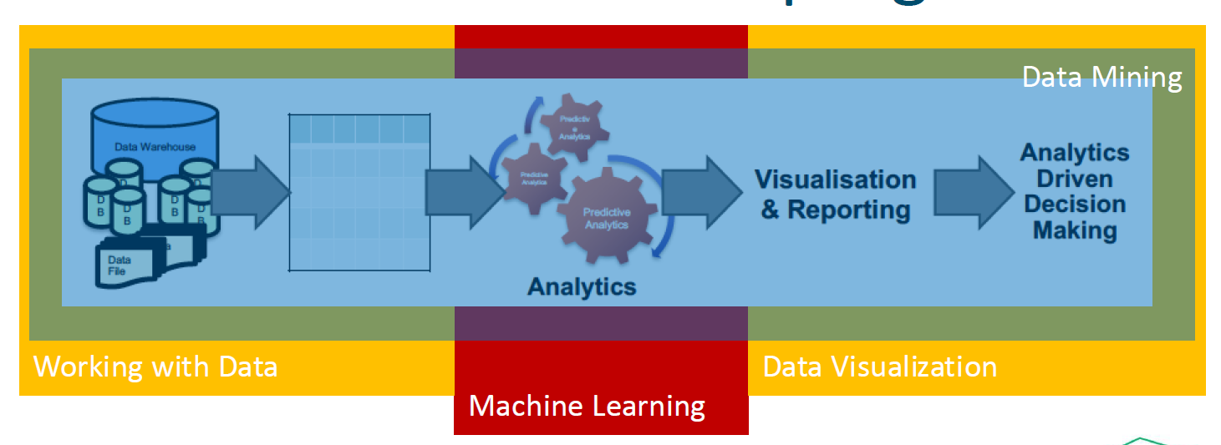

Data Warehouse >>> Annalytics >>>> Visualization & reporting >> Analytics Driven Decision Making

ML is the core part - how to create a model that represent my data and make predictions from what I have already seen…
This will eb 90% of th etime in this module

ML Today – Advances in AI

- Images - Dall-E: generating realistic images from a description in natural language https://openai.com/dall-e-2/
- Dali 2 model

ChatGPT: A chatbot built on large language models that interacts in a conversational way https://openai.com/blog/chatgpt/
- This was next step after Dali!
- ChatGPT is still only a statistical model
- It does tno understand what it creates in terms of knowledge
- Generative AI create for you based on a prompt….
- Gd at defining things in a certain way… used a lot for is to get thgins explained on a higer or lower level of thgins….
- Or if ChaGPT knows how to code…. Will show you code that’s been used a lot of times….
- Stackoverflow… like an interface to that that is more accessible
- Code
  - Where it struggles is creating something new and not seen before… so if doing somethgn new… will struggle… scope and complexity it will struggle
- Advent of code >> https://adventofcode.com/ chat gpt us not good at it… as limited by statistics , doesn’t understand what the problem is… just repeating what it has seen before…

Reactions

https://www.independent.ie/irish-news/politics/two-government-departments-confirm-use-of-chat-gpt/a1788591640.html
https://www.japantimes.co.jp/news/2023/01/24/asia-pacific/australian-colleges-chatgpt-disabled-students/
https://www.nytimes.com/2023/02/03/technology/chatgpt-openai-artificial-intelligence.html

https://www.thetimes.co.uk/article/irish-universities-in-race-against-time-with-chatgpt-to-avoid-widespread-cheating-scandals-kbpmtqqw9

Education

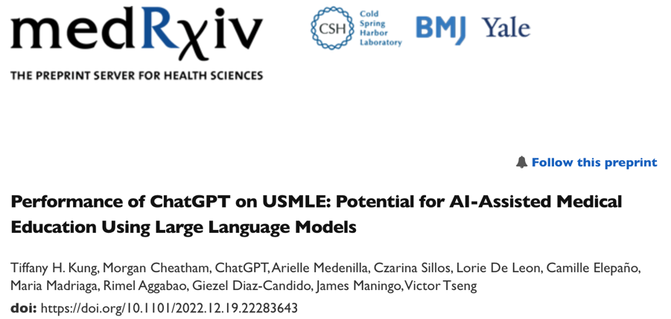
https://www.medrxiv.org/content/10.1101/2022.12.19.22283643v2.full

https://www.cam.ac.uk/stories/ChatGPT-and-education
https://mackinstitute.wharton.upenn.edu/wp-content/uploads/2023/01/Christian-Terwiesch-Chat-GTP.pdf

GPTZero to detect AI

https://www.zerogpt.com/?gclid=CjwKCAiAkp6tBhB5EiwANTCx1AmcBLk3uO8ijqusyd1ngey8R2HZxG1WAwYgXoUuWFGDZ5xK7nVQlhoCad8QAvD_Bw

ai generate content , again no proof but gives an indication
trying to tackle problema dn AI generated content – difficutl to handle

But… smart agent vs smart data or combo of both

- ChatGPT can put together answers to questions but doesn’t “know” anything
- •No comprehensive understanding of the physical and social world, no ability to reason about relationships between concepts and entities

- Bojan
  - He Has semantic web background, in terms of so we worked a lto of building knowlegd graphs to represent knowldgae rathan then tryain go createv smart agemnts like AI, tried to create SMART CONTENT SO ABLE TO BE RUN BY STUPID MACHINE AND HAD CONTEXT INGRAINED IN MODEL ITSELF…
  - Gra;ph has connection don’t’ need intelligent agent ot understand it….
  - Smart data vs smart agents…..which aproacjh wrks and what are the advantages of those two extremes….
  - Now adays lot of grapho knowldeg in data ans the sue SAI on top of it to make new conections or to ptesen tina way, or create additional output but ahs this understanding engrained in it….
  - Worked a lot

•chatgpt failures guthub repo –
- - Examples of failures https://github.com/giuven95/chatgpt-failures
A year ago…
This year…

- Labguage model itslf Still has a lot of flaws especially whe you think about discrimination gender, race, sexual orientation race etc because they are represented in LM that it is trained on…
- All they are really doing is masking that off with a bit of smart handling of prompts, So don’t get the insight of the underlying data
- It pretends its smarter than ti is or less based than it is…..
- i.e. -1*-1*-1 = ?
- used to give incorrect answer but now getting correct answer by adding a bit of intelligence on top of the language model….

DeepSeek

- Nvidia 2022 export ban
- •DS built at a fraction of the cost of industry-leading models like OpenAI - because it uses fewer advanced chips.
- •It is reportedly as powerful as OpenAI's o1 model - released at the end of last year - in tasks including mathematics and coding.
- •Like o1, R1 is a "reasoning" model. These models produce responses incrementally, simulating a process similar to how humans reason through problems or ideas. It uses less memory than its rivals, ultimately reducing the cost to perform tasks
- Open ai went away from trying to create doel for everything, i.e. whoel web, for more context based models… have much better answer… control boas nbetetr aswell… so works more if apply model qiht context rather than absolute model…
- May be approach in years to come…
- Also RAG model >>>
- Use documents databased and augment content get way better answer from chatgpt …
- i.e. company db load in gpt >> then build chat agent or run chat agemnt on top of that
- want to hire new person
- whats most effieicent way to hire based regualations etc
- rather than going through docs one by one
- just us a chat UI and get answers immediately on those…
- Source: https://www.bbc.com/news/articles/c5yv5976z9po

Next

- Applications will get more specific.
- •Regulation
- Hopefulyl we will get
- •EU AI Act
  - https://artificialintelligenceact.eu/

AI Systems are still brittle…

- AI camera operator >> Confused bald head of ref with football at times….. very funny….
- Tesla >>> having incident sbased on musk clai that self driving cras are reality for last 10 years….
- 8 vehicel crash on San Francisco brodge.. as teslas car was going 55 mph shifted lanes and changed to 20 mph suddenly caused a crash
- Self drving uber killed pedestrian
- Automatic CVs – bas against women…
- Womend downgraded from particualtr school – boas in dataset
- 2019 – niger parks… capruted by police as some stole his fake ID ND ai WAS DECLARING HIM A HIGH RISK IN CRIMINAL RISK.. because of skin colour….
- White automatically lower risk than black people.. no regualations….
https://www.theverge.com/tldr/2020/11/3/21547392/ai-camera-operator-football-bald-head-soccer-mistakes

https://medium.com/thoughts-and-reflections/racial-bias-and-gender-bias-examples-in-ai-systems-7211e4c166a1

https://www.theguardian.com/technology/2022/dec/22/tesla-crash-full-self-driving-mode-san-francisco

Expert Systems (Rule-Based Systems)

Back in 80s/90s rules based systems were way to go… as not as much processing power required…
Simple rules define decisions…
KNOWLEFGE ENGINEERING
- Limited to how good your experts are…
- If rules do not generalise well… too simple
- Rule:
- If
  - Income > Expenditure &
  - Collateral > Loan
- Then
  - Risk = Low
- Knowledge engineering

Learning from historical data

Predict decision for new instance
- Table of historical data
- Each row
  - description of instance
  - decision (Yes/No)

- classic and simple model we are looking at .
- try pridct based no data we have

Learn What?

  - A. 1st approach
    - Learn expert decision-making
    - What if the expert gets it wrong sometimes?
  - B. 2nd approach
    - Learn from outcomes (learng from decisions – get outcome and add ti to the dataset… learn from every single case and outcome…)
    - Outperform experts

Supervised learning

Supervised ML (Predictive Analytics)
- Training Step:
  - Learning a model from a set of historical data instances
  - Just learns what happened in the past

Supervised ML (Predictive Analytics)

- Prediction Step:
  - Using the model to make predictions
  - Which model to use will be crucial
  - Extracting features >> feeding that to the algorithm >> alo give us a model…
  - >> ocne qwe have new customer coming in >> look up what the model is telling us and get a prediction
    - I.e. in their prime > prvious loan > have a home… etc
    - i.e. very young > irres[onsible >> want huge loan.. etc model may say no…

Classification Task

- Example: Credit scoring
  - A training set with 10 examples (customers)
  - example has one of two class labels = {High-risk, Low-risk}

Classification task

- Manually classify customers into two categories (low-risk and high-risk) based on savings and income data.

- If
  - income > ⍺ & savings > β
- Then
  - Risk - low

Classification Task
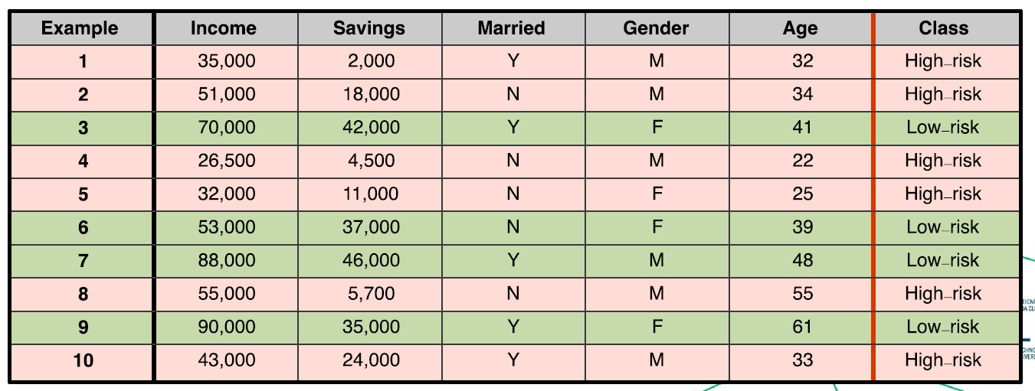

Q. To which class does this new customer belong?

Q. Can we train an algorithm to learn to automatically classify new customers as either low-risk or high-risk?

Supervised Learning

- Supervised Machine Learning algorithms automate the process of learning a model that captures the relationship between the descriptive features and the target feature in a training dataset.
- This is supervised learning – as we
- created the table
- fed it to the algorithm
- target would would eb the putcome – what we are tryig to achieve
- almost like cheating on test… as have answers already…
- what algorightm does oncewe have dataset - uses this Qand A to create create a model that is likely to give su answers to questions we have seen before…. Is called supervised learning
- replicateing answers to questions we have ns seen before…
- if model always give sus right target feature to decriptive feature
- it si consistent

- ML algorithms search through all possible patterns that exist between a set of descriptive features and a target feature to find the best model that is consistent with the training data (i.e. agrees with all the training instances).
- •Useful predictive models must be able to generalise well, i.e. make predictions for queries that are not present in the training data.
- Want consistency and generalise well i.e. predict as many predict right for not yet present or not seen before…

What can go wrong?
Can see in the example below…
If took linear model… we’d just read it off the line… but not lcose to most points
Propbably not great for future questions
Try polynomial… perfectly matches but it mght no generalise well….too many curves
Maybe try quadratic function that replicates as close a possible bu mght generalise better….

- Underfitting occurs when the prediction model is too simplistic to represent the underlying relationship between the descriptive and target features.
- Model is too simple
- Will probably not work well with unseen data
- •Overfitting occurs when the model is so complex that it fits the data too closely and becomes sensitive to noise (e.g. mislabelled feature values).
- Too complex / too cloe to taringn data
- No t very godo at predicting
- Want just e ough complexity to reflect reality of your data….
- Will see a lot in evaluation not over or under fitting…

Supervised Learning Algorithms

Not bias in terms of race, gender etc but bias to help us make a decision on the model
- Inductive Bias : Typically, training data does not have enough information to choose a single best model, so additional assumptions are needed to drive the model selection, known as the inductive bias.
- Without inductive bias there is no learning, as no way to determine what right model is…
- Break ti down -- two types
  - Restrictive bias constrains the set of models that will be considered (e.g. linear regression considers models that produce predictions based on a linear combination of descriptive features)
- Which type of model do we want?
- Classification need a model to classify
- Regression problem need a regression outcome model
- Restricting to which model is even possible given our problem setting
  - Preference bias guides the algorithm to prefer certain models over others (e.g., the decision tree prefers shallower trees)
- Once have found the right model….can then use preference bias… to decide what is our selectio criteria for different outcome of this model….
- What is our selectioj criteris for different outcome sof this model
- If Dec Trees want shallow trees as they are lading to quicker decisions
- Different algorithms have a different inductive bias,
- DSists and Das have experience selecting the correct algorithm…
- No hard and fast rule… no free lunch rule….
- Need to evaluiate so get right output…

- It is important to identify the machine algorithm that will fit the predictive task most appropriately.

Supervised ML (aka Predictive Analytics)

Supervised ML (aka Predictive Analytics)

- Neural Networks would not depend on feature selection
- Would not depend on which algorithm you are using
- Rather give you an automated solute to any set fo features….
- i.e. image recognition – feed in all pixels + algorithm is responsible for giving you a solution
- deep learnginpart make sure no matter what set fo features get solution that fits that…
- explainable AI
- explain what model does ni everysoeg step >>> impossible for NN….
- NN not explainable – always controversial…. As can’t give answer as to how they got there,,

Supervised vs. Unsupervised Learning

- Supervised Learning:
  - An algorithm that learns a function from examples of its inputs and outputs. It uses manually labelled example data (i.e. a training set ) to predict the correct answer for new unseen query inputs
  - .e.g. Classification, regression algorithms
- Have training data set and test data set…

- Unsupervised Learning:
  - An algorithm that finds structure in data where no manually labelled examples are available as inputs - i.e. there is no training set. These algorithms are more focused on data exploration and knowledge discovery.
  - e.g. Clustering, topic modelling algorithms
- won’t give you a solution…
- no target feature
- only descriptive features
- given this dataset >>> those atr in group 1 / group2
- which are similar btu not really any answer to what th goal is… or even what they are similar at…
- able to cl uster and model topics btu not give solutions….

Supervised Learning

- Classification:
  - Examples are represented by a set of features, which help decide the target class to which a new query input belongs (i.e. the output is a class label or target feature).
- Ege. Hand written letetrs… which is mostly
- Regression:
  - Examples are characterized by a set of features which help decide the value of a continuous output variable (i.e. the output is a number).
- E.g. ryign to predict who decides ho big is your house , how much shduol avlaue be?
- We have value for prioce ohosues now… so linear relation ship

- These are 2 big problems in supervied learning and what we’ll see in this course….
- Outcome
- Is it a class
- Something continouous that its trying to predict…

Classification Tasks

- Binary classification: Assign a new query input to one of two possible target class labels.
- Binary classifications
- A lot of these two classes

- Multiclass classification: Assign a new query input to one of M > 2 different target class labels.
- Multi classification
- More than two classes
- Different approach to solve

Representing Data

- Have to get your data into ths format everytime if classification or regression musttransfor data into form like this.. descriptive features… up to last one and one single target features that is ouotput
- During training
- Will lok into all descritpove features and see hwo they match target features…. Try and teach the model
- Get a new questions >> model will tel use the prediction
Analytics based Tables (ABT)

- Commonly, we use a tabular structure to represent a dataset, often referred to as the analytics base table (ABT).
- •Each row represents a different example and comprises a set of descriptive features.
- •For prediction, each row also has a target class label or target feature for classification and regression, respectively - i.e. the “correct answer".

Representing Data
- The descriptive features used to represent examples can be distinguished by the type and number of values they can take.
- Binary: Takes only two values - a boolean True/False decisione.g. married={True, False}, test_result={Pass, Fail}
- Categorical (Nominal): A feature that takes values from a finite set of values, with no intrinsic ordering to the valuese.g. blood_group={A,B,AB,O}, nationality={French, Irish, Italian}
- Ordinal: A categorical variable with a clear ordering of the variables.e.g. grade={A, B, C, D, E, F}, dosage={Low, Medium, High}
- Interval: Values that allow ordering and subtraction but do not allow other arithmetic operationse.g date, time
- Continuous: Numeric measurements, with or without a fixed range for the values.e.g. temperature, price, age, weight, height, latitude, longitude etc.
- Whenever have multiplication and division that makes sense => have continuous

Typical Classification Task

- The training set with N=10 examples (customers). Each is described by D=5 features: 3 continuous, 2 categorical
- Each example has one of two class labels = {High-risk, Low-risk}


- Q. To which class does this new customer belong?

Algorithms
- First question is what is target variable , what type of feature is our target feature
- Is it continuous or categorical i.e. is it regression or classification
- Also
- The models are candidates
- Restrictive bias better with a lot of features some are not
- Some work with limited set of features
- For classification numb er of target classes?
- Is it binary or multivariate classification we are looking at

- Many different learning algorithms exist for prediction (e.g. k -nearest neighbour, decision tree, neural network, support vector machine).
- •Due to processing, memory, and storage constraints, problem dimensions will often determine which algorithm will be practically applicable.

- 1.Number of input examples N.
  - Sometimes millions of input examples.
- 2.Number of features (dimensions) D representing each input example.
  - Often 10-1000, but sometimes far higher.
- 3.For classification, the number of target classes M.
  - Often small (binary), but sometimes far higher.

Machine Learning - Overview

- Supervised Learning
- •Classification: KNNs, Decision Trees, Naive Bayes
  - Neural Networks
  - Linear regression, Logistic Regression
- •Dimensionality Reduction
  - Feature Selection, PCA
- •The ML Process
  - Data Preprocessing, Missing Values, Scaling
  - Model Selection, Hyperparameters
- •Evaluation
- •Working with Text
- •Unsupervised Learning

Questions ?

Lab solution - LAB1_Preprocessing_Sols _updated.ipynb
‘’’ py

## Lab Exercise Week #1: Mastering Data Preprocessing in Machine Learning

### Objective:
The goal of this lab exercise is to delve into advanced data preprocessing techniques used in machine learning. Preprocessing is an important step in Machine Learning, otherwise you end-up with "garbage-in garbage-out" paradigm, meaning you feed the machine learning algorithm with bad data, you can expect bad performance. You will work with real-world datasets, handling missing data, encoding categorical variables, scaling features, and more.

### Dataset:
For this exercise, we will use the "<a href="https://archive.ics.uci.edu/ml/machine-learning-databases/adult/adult.data">Adult Income</a>" dataset from the UCI Machine Learning Repository. This dataset contains various features related to individuals and aims to predict whether a person earns more than $50,000 per year.

### Tasks:

#### 1). Data Loading and Initial Exploration:
<ul>
<li>Load the "Adult Income" dataset. Loading can be done by accessing it locally, after you have download it, or direct access via URL provided above.</li>
<li>Explore the dataset to understand its structure and features. Check the feature structure from the <a href="https://archive.ics.uci.edu/dataset/2/adult">UCI Repository</a>.</li>
<li>Identify the target variable and its distribution.</li>
</ul>

# Import necessary libraries
import numpy as np
import pandas as pd
from imblearn.over_sampling import RandomOverSampler
from sklearn.model_selection import train_test_split
from sklearn.impute import SimpleImputer
from sklearn.preprocessing import StandardScaler, OneHotEncoder
from sklearn.compose import ColumnTransformer
from sklearn.pipeline import Pipeline
from sklearn.ensemble import RandomForestClassifier
from sklearn.metrics import accuracy_score, classification_report

# Task 1: Data Loading and Initial Exploration
url = "https://archive.ics.uci.edu/ml/machine-learning-databases/adult/adult.data"
column_names = ['age', 'workclass', 'fnlwgt', 'education', 'education-num', 'marital-status', 'occupation', 'relationship',
'race', 'sex', 'capital-gain', 'capital-loss', 'hours-per-week', 'native-country', 'income']

data = pd.read_csv(url, names=column_names, sep=',\s', na_values=["?"])

# Explore the dataset
print("Dataset Info:\n", data.info())
print("\nTarget Variable Distribution:\n", data['income'].value_counts())
data
#### 2). Handling Missing Data:
<ul>
<li>Identify missing values in the dataset.</li>
<li>Implement a strategy to handle missing data (e.g., imputation or removal). Impute missing values with the median for numerical columns and the most frequent value for categorical columns.</li>
<li>Justify the chosen strategy.</li>
</ul>
# Task 2: Handling Missing Data
# Impute missing values with the median for numerical columns and the most frequent value for categorical columns
numerical_features = data.select_dtypes(include=['int64', 'float64']).columns
categorical_features = data.select_dtypes(include=['object']).columns
# exclude the income column as it will be the output column -it will be the target variable
categorical_features = categorical_features[~categorical_features.isin(['income'])] # exclude the income column as it will be the output column
numerical_transformer = SimpleImputer(strategy='median')
categorical_transformer = SimpleImputer(strategy='most_frequent')

preprocessor = ColumnTransformer(
transformers=[
('num', numerical_transformer, numerical_features),
('cat', categorical_transformer, categorical_features)
])
numerical_features
categorical_features
#### 3). Encoding Categorical Variables:
<ul>
<li>Identify categorical variables in the dataset.</li>
<li>Apply appropriate encoding techniques (e.g., one-hot encoding or label encoding). Use one-hot encoding for categorical variables.</li>
<li>Discuss the impact of encoding choices on model performance.</li>
</ul>
# Task 3: Encoding Categorical Variables
# Use one-hot encoding for categorical variables
preprocessor = ColumnTransformer(
transformers=[
('num', numerical_transformer, numerical_features),
# find cat no in the data ignore it...apply onehotencoding...
# convert categorical to binary numercial features
('cat', OneHotEncoder(handle_unknown='ignore'), categorical_features)
])
#### 4). Feature Scaling:
<ul>
<li>Identify features that require scaling.</li>
<li>Apply feature scaling using techniques such as Min-Max scaling or Standardization.</li>
<li>Discuss the importance of feature scaling in different machine learning algorithms.</li>
</ul>
# Task 4: Feature Scaling
# Apply Standardization to numerical features
preprocessor = ColumnTransformer(
transformers=[
# make sure all numbers are between 0 and 1
# i.e. age - between 10 and 18 and ayment = between 10K and 15K .. => payment dominates the model as bigger numbers
# so standardise so each feature contributes equally
# preserves shape + keeps negative values....
# Need to scale for >>> LinReg / LogReg / SVM / k-NN / PCA / NN
# do not need to scale for >> DT / RF / GradBoost (XGBoost, LightGBN)
#### NEVER FIT SCALAR on TEST DATA?? >>> fit on trainnig set..... transform train and tes using same scalar...otherwise data leakage
# DStandardScalar + MinMaxScalar + RobustScalar
('num', StandardScaler(), numerical_features),
('cat', OneHotEncoder(handle_unknown='ignore'), categorical_features)
])
#### 5). Feature Engineering:
<ul>
<li>Create new meaningful features based on existing ones.</li>
<li>Discuss how feature engineering can enhance model performance.</li>
</ul>
# Task 5: Feature Engineering
# Create a new feature "capital-diff" as the difference between capital-gain and capital-loss
data['capital-diff'] = data['capital-gain'] - data['capital-loss']
#### 6). Outlier Detection and Handling:
<ul>
<li>Identify potential outliers in numerical features.</li>
<li>Implement a strategy to handle outliers (e.g., removal or transformation).</li>
<li>Discuss the impact of outliers on model training.</li>
</ul>
# Task 6: Outlier Detection and Handling
# Identify and handle outliers using a suitable method (e.g., Z-score or IQR)
#### 7). Normalization and Transformation:
<ul>
<li>Apply normalization to achieve a normal distribution in numerical features.</li>
<li>Discuss the benefits of normalization in specific machine learning algorithms.</li>
</ul>
# Task 7: Normalization and Transformation (You can use standard scalar, minmax scalar or robust scalar)
# Apply normalization to achieve a normal distribution in numerical features

#### 8). Data Splitting:
<ul>
<li>Split the dataset into training and testing sets.</li>
<li>Justify the chosen ratio and the importance of a proper train-test split.</li>
</ul>
# Task 8: Data Splitting
X = data.drop('income',axis=1)
y = data['income']
print("input columns", X.columns)
print("output columns", y.name)

# split data as 80% for training and 20% for testing
# randome ensure reproduces the same each time
X_train, X_test, y_train, y_test = train_test_split(X, y, test_size=0.2, random_state=42)
print("shapes of training and testing")

print('X_train shape:', X_train.shape)
# output for yoru model, will be included in the training
print('y_train shape:', y_train.shape)
# test data for features
print('X_test shape:', X_test.shape)
# is the output in the mdoel used to check the accuracy fo the classifier
print('y_test shape:', y_test.shape)
X_train.columns
y
#### 9). Handling Imbalanced Data:
<ul>
<li>Identify if the target variable has an imbalanced distribution.</li>
<li>Implement techniques to handle imbalanced data (e.g., oversampling or undersampling).</li>
<li>Discuss the challenges posed by imbalanced datasets.</li>
</ul>
#Identify if the target variable has an imbalanced distribution.
# check the ytrain distribution - cna see what values you have fo ech class...has two classes
# cna see theres an imbalance
print("Class distribution before oversampling:")
print( y_train.value_counts())

# add mor samples for class that has lower number of samples
oversampler = RandomOverSampler(random_state=42)
# Apply the oversampling technique to the training set
# once applied datag will bebalanced for the training
X_train_resampled, y_train_resampled = oversampler.fit_resample(X_train, y_train)
print("Class distribution after oversampling:")
# can see no imbalance now...
print( y_train_resampled.value_counts())
#### 10). Pipeline Implementation:
<ul>
<li>Construct a preprocessing pipeline that includes all the steps above.</li>
<li>Discuss the advantages of using a pipeline in the context of reproducibility and efficiency.</li>
</ul>
# Task 10: Pipeline Implementation
# Construct a preprocessing pipeline with a classifier
pipeline = Pipeline(steps=[
('preprocessor', preprocessor),
# choose RF classifier
('classifier', RandomForestClassifier(random_state=42))
])

# Fit the pipeline on training data
# train the pipeline -- means all the traing data will ebpassed thru pre-processing steps first then thru classifier...
pipeline.fit(X_train_resampled, y_train_resampled)

# Make predictions on test data
# thsi tests yuor model...
# y_pred is the var for the predicted values...
y_pred = pipeline.predict(X_test)

# Evaluate the model
print("Accuracy:", accuracy_score(y_test, y_pred))
print("Classification Report:\n", classification_report(y_test, y_pred))

‘’’

Week 2 – Similarity-based Learning (kNN) -n K means clustering

Module Outline

Lab - LAB2_kNN.ipynb

Lab link >> https://scikit-learn.org/stable/auto_examples/neighbors/plot_classification.html#sphx-glr-auto-examples-neighbors-plot-classification-py

Week 3 – Decisions Trees – 19th Feb 2026
- Moving into information based territory
- Bery popular and very well known
- Bery intuitive and used in a lto of things aswell…

Lab solution

Main objective
- K-nearest-neighbour solution
- Objective
- Understand the knn algorithm
- Implement from scratch
- Use build in functionality
- Tune hyper parameters to optimise the model performance
- Evaluate the model perforamane

1st step –
Load

Guess Who game

Week 4 – Naïve Bayes – 27th Feb 2026

Lab Solution

Week 5 – Regression and SVMs – 5th Mar 2026

Completed

- Week 1
  - Content into this doc from pdf/ppt – yes completed
  - Lab completed – yes completed
  - Lab video watched back – yes completed – up to 30 mins….
  - Content Video watched back and notes added to this doc – no . sart @ 30 mins
  - Notes done in copy book? – no
- Week 2
- Week 3
- Week 4

