SPEC9998 - Research design & proposal writing

Helen Sheridan
Email = "Helen.Sheridan@TUDublin.ie" <Helen.Sheridan@TUDublin.ie>
- Lecture Dates
  - Sat 26th September
  - Sat 17th Oct
  - Sat 14th Nov
  - Sat 5th Dec
Assignment Dates

Start time of lecture

Week 1
Start time >> 9:30am?

Pdf 1 – about this Module

Week 1: About the Module

Module descriptor – formal doc syllabus outline

APPROVED
SPEC 9998: Research Design and Proposal Writing
Module Details
Module Code: | SPEC 9998
Module Long Title: | Research Design and Proposal Writing APPROVED
Version: | 1
Indicative NFQ level: | Level 9
Valid From: | Jan 2020 ( January 2020 )
Language of Instruction: | English

ECTS Credits::
5

Module Type
Community Engaged Learning

Current Coordinator:: | Luca Longo
Module Coordinators: | Luca Longo ( 27 February 2020 to --- )
School Responsible: | School of Computer Science
Campus: | City Campus

Module Overview
MSc graduates in Computing and Computer Science will need to remain up to date with new innovations, which may be applicable to their chosen area of specialism. To achieve this, students must be able to undertake research using appropriate sources in an ethical and professional manner and present their research findings in an appropriate form. This module develops the student’s ability to effectively take a research project from a research question through to a successful resolution. This will involve covering topics such as research management, qualitative and quantitative research techniques, and research writing and presentation. The module will culminate in the preparation of a research dissertation proposal.

Indicative Syllabus
Using the existing body of knowledge:
- Identification of subject area experts
- Identifying current state of knowledge and key issues
- Identifying researchable issues
- Evaluating published sources for their relevance and quality in relation to the chosen topic
- Constructing a literature review relevant to a given research question
- Critically reviewing a source within a written literature review

Formulating a research programme:
- Planning and organising a research project
- Comparing and contrasting the use of a variety of research methodologies for research topic within the student’s discipline
- Comparing and contrasting the use of a variety of data collection methods within the student’s discipline, including qualitative, quantitative and mixed methods
- Comparing and contrasting the use of a variety of analysis and evaluation methods within the student’s discipline
- Ethical Frameworks and gaining ethical approval

Preparing a research proposal:
- Proposal structure
- Articulating aims, research question, hypotheses and objectives
- Identifying evaluation methods for designed solution
- Requirements of an MSc Dissertation
- Requirements of a good MSc Dissertation proposal

Learning and Teaching Methods
The module is designed to be delivered within a blended learning model, employing mixed modes (online and face to face) of learning, teaching and assessment.
TU059 will be delivered primarily in a face-to-face mode while TU060 will be delivered in a blended mode.
This module will involve student-based learning methods to allow students to learn by practice as much as possible. Material may be presented in the form of lectures, seminars and videos however all contact periods will be opportunities to discuss and clarify the material and to put it into a more cogent and coherent framework. Students will be expected to use library and Internet-based information sources extensively. Students will be encouraged to be pro-active in their approach to learning. All students will be required to present problems, discuss solutions, and work independently or in groups. Students will be encouraged to think and reason for themselves and develop the critical skills needed at this level. Considerable emphasis will be placed on developing the student’s ability to effectively construct a research proposal which can be executed successfully as an MSc Dissertation project demonstrating an ability to identify a feasible area of research, an appropriate research programme including an evaluation strategy and an ability to present these in an appropriate form. Students will be expected to develop independence in, and responsibility for their own learning.

Indicative Syllabus
No indicative content

Learning Outcomes
Upon successful completion of this module the learner will be able to
#
MLO1 | Critically evaluate and synthesise literature relevant to a proposed research question
MLO2 | Choose and justify a research design to address a specific research question
MLO3 | Choose and justify appropriate data collection methods for a specific research question
MLO4 | Choose and justify appropriate analysis and evaluation methods for a specific research question
MLO5 | Prepare and present a realistic and feasible research proposal

Requisites
Requisite Type | Module Title |  | Type
No requisites exist.
Module Content & Assessment
Assessment Breakdown |  | %
Other Assessment(s) |  | 100.00%
Assessments
No Formal Examination

Other Assessment(s)
Assessment Type | Practical Assignment | % of Total Mark for Module | 20
Indicative Week | Week 5 | Learning Outcomes | 1,2,3
Semester | Semester 1 & Semester 2 | Assessment Threshold: | None
Assessment Role | Individual | Assessment Authenticity | Not Online
Pass/Fail | No
Assessment Description
- construction of preliminary research question through a literature review
- construction of a preliminary research hypothesis
- formation of a preliminary set of research activities
- identification or formation of a dataset
Assessment Type | Practical Assignment | % of Total Mark for Module | 20
Indicative Week | Week 10 | Learning Outcomes | 1,2,3,4
Semester | Semester 1 & Semester 2 | Assessment Threshold: | None
Assessment Role | Individual | Assessment Authenticity | Not Online
Pass/Fail | No
Assessment Description
- refinement of research question through an extended literature review
- refinement of the research hypothesis
- formation of a refined set of research activities
- refinement of a dataset
Assessment Type | Practical Assignment | % of Total Mark for Module | 60
Indicative Week | Week 1 | Learning Outcomes | 1,2,3,4,5
Semester | Semester 1 & Semester 2 | Assessment Threshold: | None
Assessment Role | Individual | Assessment Authenticity | Not Online
Pass/Fail | No
Assessment Description
Preparation of final research proposal following the work conducted on the previous two assignments.
This is a major piece of work that should show how the research question is grounded on an extended literature review. It should also clearly present a strong research hypothesis followed by the description of an experiment with clear research objectives and research activities to reach each of them. The student should consider ethical practices for research, plagiarism and cite bibliographic elements properly and correctly. The research proposal should generally follow the scientific method.
Module Activity
Full Time hours per semester
Activity Type | Duration (Hours)
Lecture | 24
Self Directed | 76
Hours (up to 100 for 5 ECTS credits) | 100.00

Recommended Reading List
Recommended Book Resources
M. Ling Pan. Preparing Literature Reviews, [ISBN: 9781936523399].
Jonathan Lazar,Jinjuan Heidi Feng,Harry Hochheiser. (2010), Research Methods in Human-Computer Interaction, John Wiley & Sons, p.447, [ISBN: 978-0-470-72337-1].
Anthony M. Graziano,Michael L. Raulin. (2013), Research Methods, Prentice Hall, p.0, [ISBN: 0205907695].
Thomas S. Kuhn. (2012), The Structure of Scientific Revolutions, University of Chicago Press, p.263, [ISBN: 9780226458113].
John D. Barrow. (1991), Theories of Everything, Oxford University Press, USA, p.248, [ISBN: 0198539282].
Karl Raimund Popper. (2002), The Logic of Scientific Discovery, Psychology Press, p.548, [ISBN: 9780415278447].
Karl Raimund Popper. (2002), Conjectures and Refutations, Psychology Press, p.614, [ISBN: 9780415285940].
Imre Lakatos. (1980), The Methodology of Scientific Research Programmes: Volume 1, Cambridge University Press, p.262, [ISBN: 0521280311].
Paul Feyerabend. (1993), Against Method, Verso, p.308, [ISBN: 0860916464].
Steve Fuller. (2004), Kuhn Vs. Popper, Columbia University Press, p.174, [ISBN: 9780231134286].
Steven Gimbel. (2011), Exploring the Scientific Method, University of Chicago Press, p.426, [ISBN: 9780226294834].

Supplementary Book Resources
Michael P. Marder. (2011), Research Methods for Science, Cambridge University Press, p.234, [ISBN: 978-0-521-14584-8].
Mark R. Leary. (2013), Introduction to Behavioral Research Methods, Pearson Higher Ed, p.399, [ISBN: 9781292033631].
John W. Creswell,J. David Creswell. (2022), Research Design, SAGE Publications, p.340, [ISBN: 9781071817964].
Adelheid A. M. Nicol,Penny M. Pexman. (2010), Displaying Your Findings, Amer Psychological Assn, p.191, [ISBN: 1433807076].
Johnny Saldana. (2021), The Coding Manual for Qualitative Researchers, Sage Publications Limited, p.400, [ISBN: 9781529731743].

This module does not have any journal article/paper resources
This module does not have any other resources
Review
Module Extra Information

Editor(s)
Editor
Dympna O Sullivan
Luca Longo

Module Modalities
No Module Modalities

Affiliated Programmes
Programme Code | Programme Title | Programme Version
TU059 | Master of Science in Computer Science | 1
TU059 | Master of Science in Computer Science | 2
TU060 | Master of Science in Computer Science | 1
TU060 | Master of Science in Computer Science | 2

Status Log
Initial Status | End Status | User | Date | Comment
Quality Office | Approved | Grainne Hurley | 27/Mar/2024 16:35
Head of School | Quality Office | Paul Doyle | 21/Mar/2024 01:48
Draft | Head of School | Luca Longo | 14/Mar/2024 16:06
Head of School | Draft | Brian Keegan | 14/Mar/2024 15:31 | Legacy School title needs (cc) to be updated - HoD
Draft | Head of School | Luca Longo | 13/Mar/2024 16:47
Head of School | Draft | Dympna O Sullivan | 14/Apr/2022 16:30
Draft | Head of School | Luca Longo | 04/Mar/2020 11:33
 | Draft | Luca Longo | 27/Feb/2020 16:24 | New Module Created

Pdf 1 – about this Module

- On a scale of Bette Davis how are you feeling today?


- M.Sc in Data Science
- TU059Level 9
- ECTS: 5

About this module
- Staying up to date within your area of specialisation is vital
- Fast changing nature of computer science
- Achieved through appropriate research
- Research question to conclusion (research project / proposal)


About this module
- Research management
- Qualitative & quantitative research techniques
- Research writing & presentation
- Final output: Research dissertation proposal
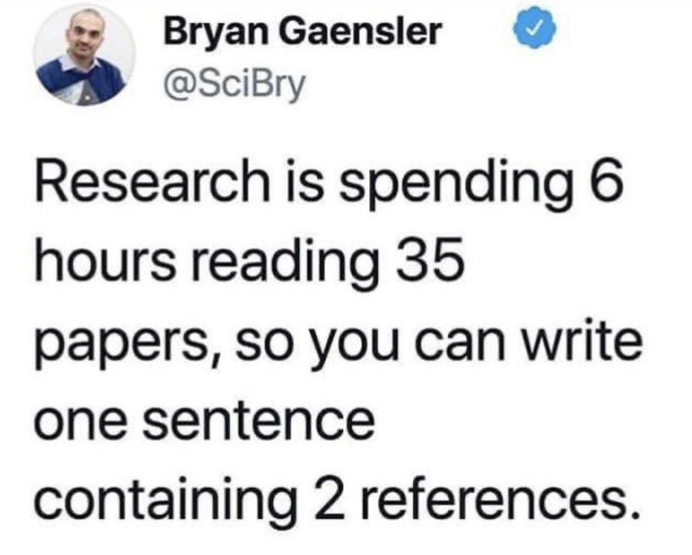

Stage 1: Building on what’s already known
- Who are the key researchers and experts in my area?
- What do we already know about this topic, and what are the big debates or problems?
- How can I find issues or topics that are actually researchable for a project like mine?


Stage 1: Building on what’s already known
- How do I decide if a paper or article is trustworthy and relevant to my research?
- How do I bring all the studies I’ve read together into a clear story that relates to my research question?
- How do I go beyond summarising a paper to actually critiquing it?
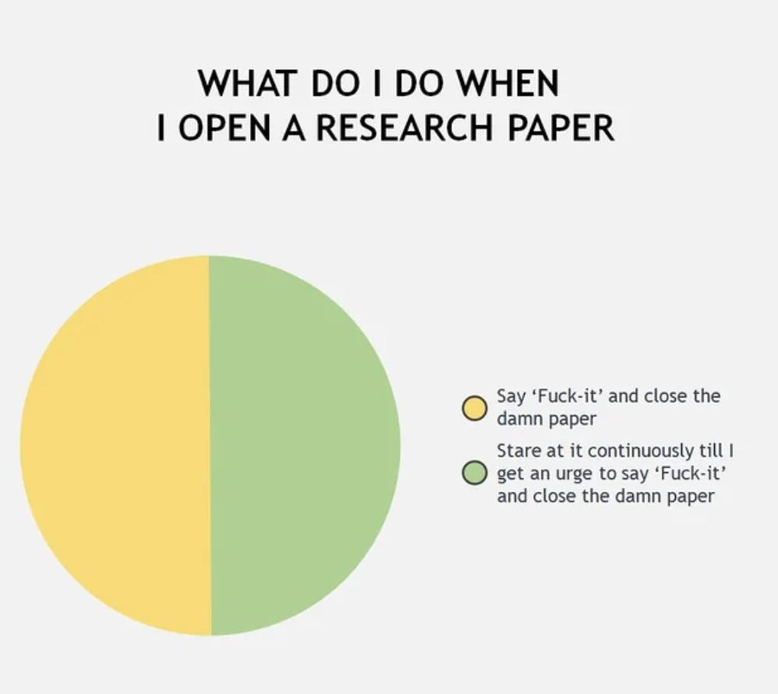

Stage 2: Planning your research proposal
- How do I plan and organise my research project so it’s realistic and manageable?
- What research approaches can I use in Data Science, and which one best fits my project?
- What are the different ways I can collect data (quantitative, qualitative, or both), and which makes sense for my study?


Stage 2: Planning your research proposal
- What analysis and evaluation methods could I use, and how do I choose the right ones?
- What ethical issues do I need to think about in my research, and how do I get approval to do my project?


Stage 3: Preparing your research proposal
- What sections should my research proposal include?
- How do I clearly explain my aims, research question, hypotheses, and objectives?
- How do I decide on the best way to evaluate whether my solution or approach works?


Stage 3: Preparing your research proposal
- What exactly is expected in an MSc dissertation?
- What makes a strong MSc dissertation proposal that will get approved?


How will we learn in this module?
- Each class is split into two parts:
- A 50-minute lecture to introduce concepts, tools, and examples
- A short break
- A hands-on task where you apply what you just learned
- The tasks are practical and based on real research activities in Data Science & Software Development
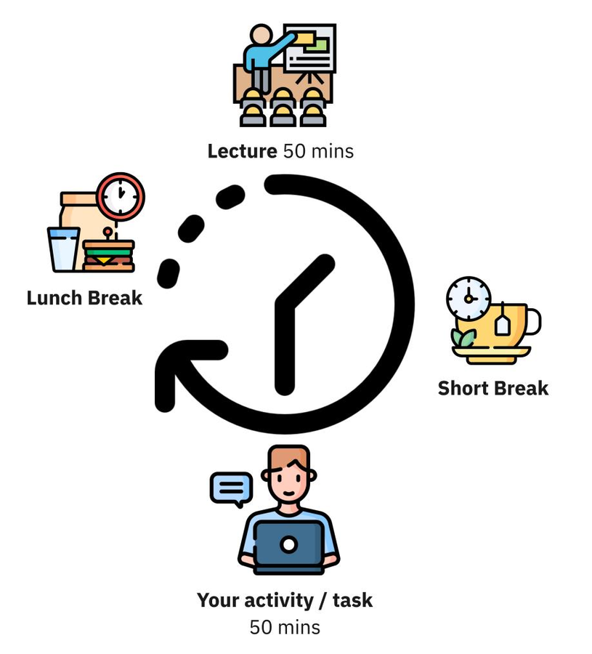

How will we learn in this module?
- Every task is designed to feed directly into your graded assignments — so the work you do in class helps you build your proposal step by step
- By the end of the module, you’ll have already developed most of the material needed for your final research proposal
- This structure is intended to keep sessions interactive, relevant, and directly connected to your MSc dissertation preparation
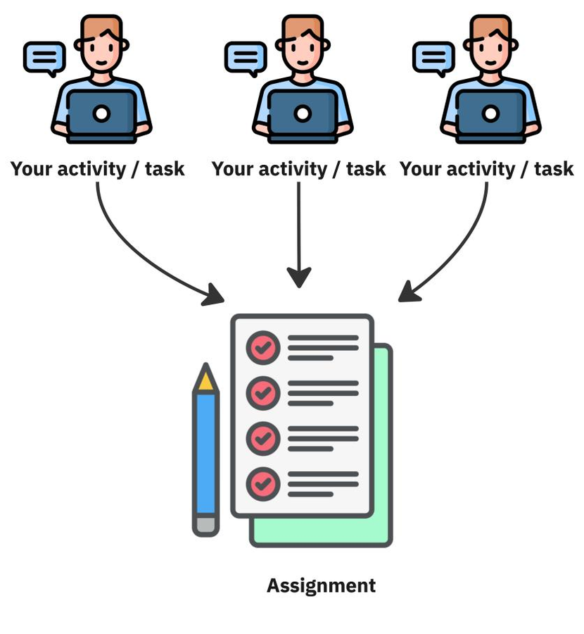

How will we learn in this module?
- You will learn by practice as much as possible – not just listening to lectures.
- Classes may include lectures, seminars, videos, and discussions to explore and clarify ideas.
- You’ll be expected to use library and online resources widely to support your work.
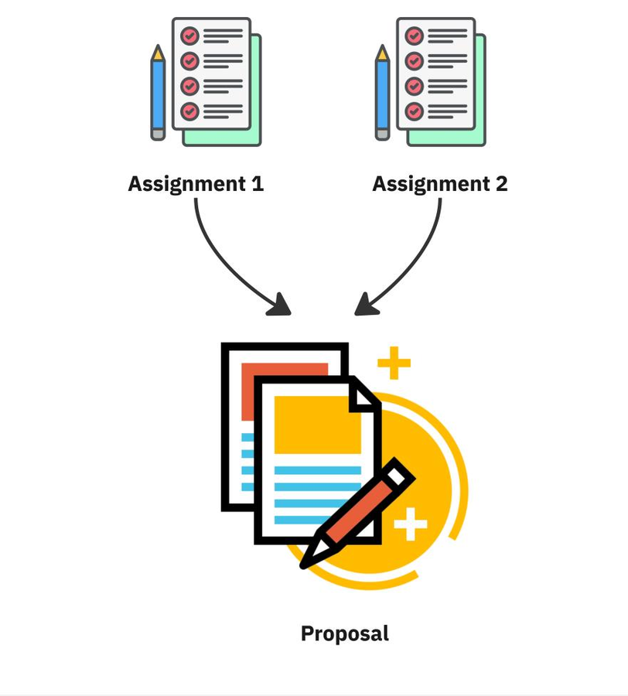

How will we learn in this module?
- You will present problems, discuss solutions, and work independently or in groups.
- The focus is on developing your ability to plan and write a strong research proposal for your MSc dissertation.
- You’ll be encouraged to take responsibility for your own learning and build the critical thinking skills needed at this level


What assignments will we do?
- Assignment 1: 20% Short tasks which will be covered in class and finished at home plus short abstract
- Assignment 2: 20% More comprehensive description of your work with methodology and evaluation techniques plus more developed literature review
- Final research proposal: 60% Final proposal building on first two assignments.


What assignments will we do?
- Assignment 1: 20% handed out 26th Sept 26. Handed up 17 Oct 2026
- Assignment 2: 20% Handed out 17th Oct 2026 26. Handed up 14th Nov 2026
- Final research proposal: 60% Final proposal building on first two assignments handed out 14th Nov 2026. Draft for peer review 5th Dec 2026. Final version handed up 6th Jan 2027.
- Subject to change

Where can I find more information?
- All lecture notes and assignments will be on Brightspace
- I will include a further information section which will include further reading, videos, interesting links
- Full module descriptor will be included

Lecture slides Research Methodology

Introduction to Research: The research question
- RESEARCH DESIGN & PROPOSAL WRITING
- SPEC 9998 (20258C)
- TU060

What will we cover in this lecture?
- Assignments vs Research (with examples)
- Why research questions matter?
- Good vs bad research question examples
- How to write effective research questions (steps + formulas)
- Where to research (literature & dataset sources)
- Real-world case studies (Pop culture, education & media)
- Workshop task instructions

Assignments vs Research
- Assignments:
- Apply a method on a dataset
- Produce results to show understanding
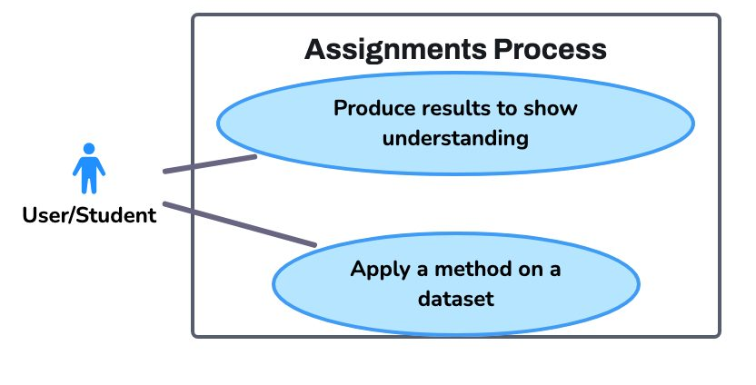

Assignments vs Research
- Research:
- Start with a novel question/hypothesis
- Justify with literature
- Select dataset(s) and methods deliberately
- Evaluate rigorously
- Contribute new knowledge
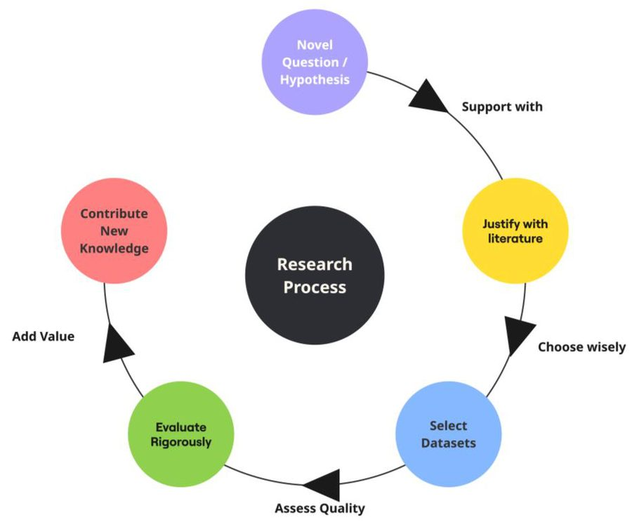

Assignments vs Research
- Examples:
- Assignment: Train a decision tree on Titanic dataset to predict survival
- Research: How do resampling strategies affect fairness in survival prediction models?
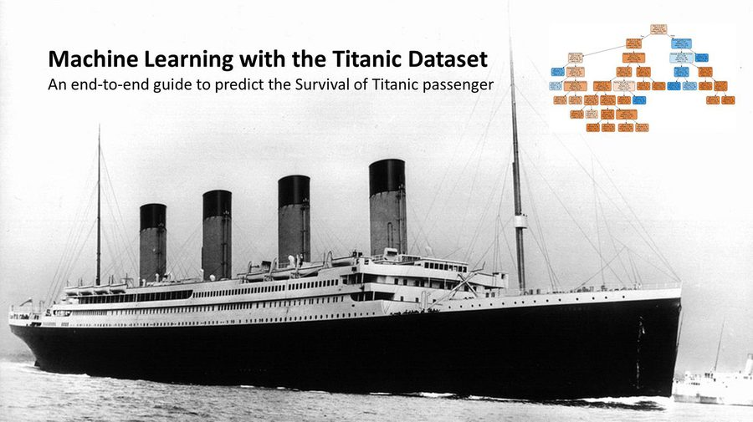

What is a Research Question?
- A research question anchors your project:
- Guides dataset choice, methods, and evaluation
- A good research question is:
- Clear & focused
- Testable & measurable
- Feasible with MSc resources
- Novel (not already solved)


What is a Research Question?
- Avoid vague or broad questions:
- Overly broad: How does AI affect society?
- Vague: Is big data useful in healthcare?
- Fishing expedition: What patterns exist in this dataset?
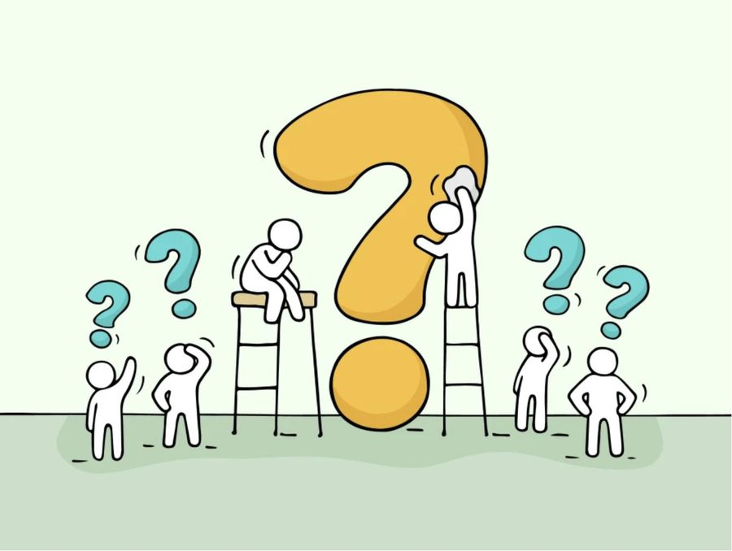

Examples of Good Research Questions
- Finance: Can ensemble models improve early detection of credit card fraud in imbalanced datasets?
- Health: How effective are LSTMs compared to logistic regression in predicting hospital readmissions?
- Social media: Does misinformation spread faster than facts on Twitter (X), and can it be predicted?

How to Write an Effective Research Question
- Steps:
- 1. Start broad →narrow to a problem
- 2. Review literature →what’s known?
- 3. Spot the gap →what hasn’t been answered?
- 4. Frame a clear, testable question

How to Write an Effective Research Question
- Formulas:
- What is the effect of [X] on [Y] in [context]?
- How does [method] compare to [alternative] for [problem]?
- To what extent can [features] predict [outcome]?

How to Write an Effective Research Question
- Examples:
- Too broad: How can we detect fraud?
- Better: How effective is SMOTE resampling in improving Random Forest classification of fraud?


How to Write an Effective Research Question
- Examples:
- Too broad: “Can AI improve healthcare?”
- Better: “How does using LSTM models improve early detection of heart disease compared to logistic regression using patient time-series data?”
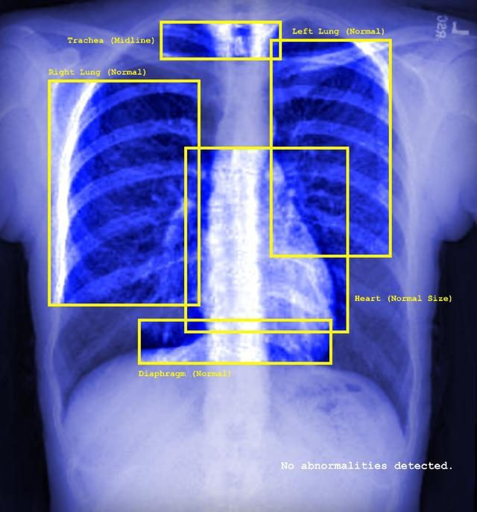

How to Write an Effective Research Question
- Examples:
- Too broad: “Why does fake news spread online?”
- Better: “To what extent can engagement features (likes, retweets, follower count) predict the virality of misinformation on Twitter?


How to Write an Effective Research Question
- 1. What is the effect of [X] on [Y] in [context]?
- “What is the effect of feature selection techniques on model accuracy in predicting customer loan defaults?”
- Why it works: It’s measurable, testable, tied to data analytics practice (feature selection is a real-world task).
- Datasets: Kaggle Loan Prediction Dataset (widely used for ML competitions), UCI Statlog (German Credit Data) dataset, Open Banking or Finance datasets from data.gov.ie or data.europa.eu

How to Write an Effective Research Question
- 2. How does [method] compare to [alternative] for [problem]?
- “How does a decision tree model compare to a random forest model for predicting hospital readmissions using patient health records?
- Why it works: Clear comparison, methodologically rigorous, grounded in DA for healthcare (patient readmissions = real world problem).
- Datasets: UCI Diabetes Readmission Dataset (predicts if a patient will be readmitted within 30 days) or Kaggle Healthcare Datasets: Search for "hospital readmission" or "patient health records."

How to Write an Effective Research Question
- 3. To what extent can [features] predict [outcome]?
- “To what extent can social media engagement features (likes, retweets, follower count) predict the virality of misinformation on Twitter (X)?”
- Why it works: Investigates predictive power of specific features, highly relevant socially and analytically.
- Datasets: Twitter API data, Kaggle fake news datasets.

Where to Research
- Academic Literature:
- Google Scholar, IEEE Xplore, ACM Digital Library, Scopus
- ScienceDirect, SpringerLink
- Taylor & Francis
- TU Dublin Library


Where to Research
- Datasets as Inspiration:
- Kaggle (competitions, datasets)
- UCI ML Repository
- Government open data portals (data.gov, EU, CSO)
- APIs (Twitter, World Bank)


Where to Research
- Tip: Use literature first, dataset second
- Avoid fishing expeditions
- What is a fishing expedition?
- Finding a dataset first and formulating or fishing for a solution before researching, writing a research question, hypothesis and short literature review. You need to understand the problem, domain and gaps in the research first before identifying a dataset.


Case Study 1: Swifties Shake the Earth – “SwiftQuake Dublin” & Beyond
- Context: During Taylor Swift’s 2024 Eras Tour in Dublin, scientists from University College Dublin set up seismometers around the Aviva Stadium. Instead of tracking earthquakes, they measured the vibrations caused by tens of thousands of fans dancing, cheering, and singing in unison. Researchers wanted to see if these crowd-generated tremors could be captured, compared across locations, and studied like seismic events.
- Research Question (inferred): Can fan activity at a concert trigger measurable seismic events—and how far do such tremors travel?
- Source: PCT Punjabi
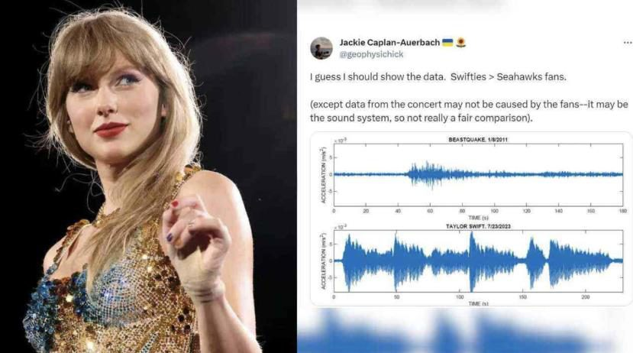

Case Study 1: Swifties Shake the Earth – “SwiftQuake Dublin” & Beyond
- What happened:
- Researchers placed dozens of seismometers around Dublin during the concerts.
- The instruments captured vibrations from fans dancing, clapping, and singing in unison.
- Data from different locations showed how the tremors travelled through the city.
- Scientists cross-checked the seismic spikes with videos of specific songs and crowd moments.
- They found the strongest “SwiftQuakes” during high-energy tracks like Shake It Off.
- The tremors were detectable up to 100 km away, showing how powerful collective fan activity can be.
- Why it's powerful:
- A quirky yet data-rich real-world project combining analysis with science communication.
- Highlights citizen science, public engagement, reproducibility, and creative methodologies.
- Raises cool ethical/interpretive questions (e.g., does celebrity influence public participation in science?)
  - References: Discover magazine & Phys.org

Case Study: Predicting Student Dropout Using Learning Platforms
- Context: Universities now track student activity on online platforms like Moodle, Blackboard, or Canvas (these are called Learning Management Systems or LMS). Every click, video view, quiz attempt, and forum post creates a digital record. Researchers wondered if these “digital traces” could predict which students might struggle or drop out.
- Research Question (inferred) Can data from online learning platforms, combined with student grades and background information, predict who is at risk of dropping out?


Case Study: Predicting Student Dropout Using Learning Platforms
- What Happened
- Researchers collected data from multiple sources:
  - LMS logs (logins, video views, forum activity)
  - Academic data (grades, attendance)
  - Demographic info (e.g., age, major)
- They used machine learning models (classification, regression, clustering) to analyze patterns.
- The models successfully identified students likely to drop out weeks before it happened.
- This gave universities the chance to intervene early (e.g., provide support, tutoring, or mentoring).
- Why It’s Powerful
- Shows how multiple datasets (online activity + academic + demographic) give stronger predictions than one dataset alone.
- Has real-world impact: keeping students in education and supporting equity.
- Raises ethical questions: Should universities track everything students do online?
- Reference (open access) Staneviciene et al, 2024

Activity 1: Research Question
- Part 1 (10 min): Brainstorm 3 broad areas of interest
- Tip: Look at the Sustainable Development Goals for ideas. Use online repositories from slide 18 to do a quick literature search. Take part in the SDG pick-a-mix challenge (https://wordwall.net/resource/4140746/sustainable-development-goals-sdgs).
- Part 2 (20 min): Draft 1 research question per area
- Tip: Look at the formulas for writing an effective research question on slides 15 to 17. Write a "too broad" version of your three research questions as examples of what not to do.
- Part 3 for next week's class (20 min): Exchange with a peer & critique clarity/feasibility
- Tip: Find a classmate and go through each other's research questions.. Check for clarity, format and feasibility. Use the scoring sheet supplied if you feel it will help.
- Deliverable: Shortlist of 3 draft research questions

Sustainable Development Goals
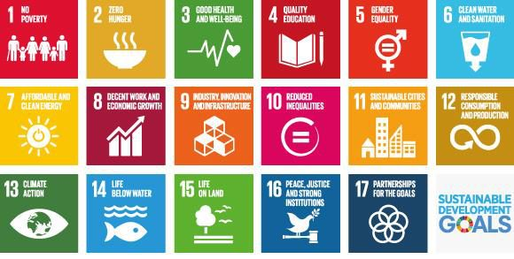

Score sheet for Research Questions
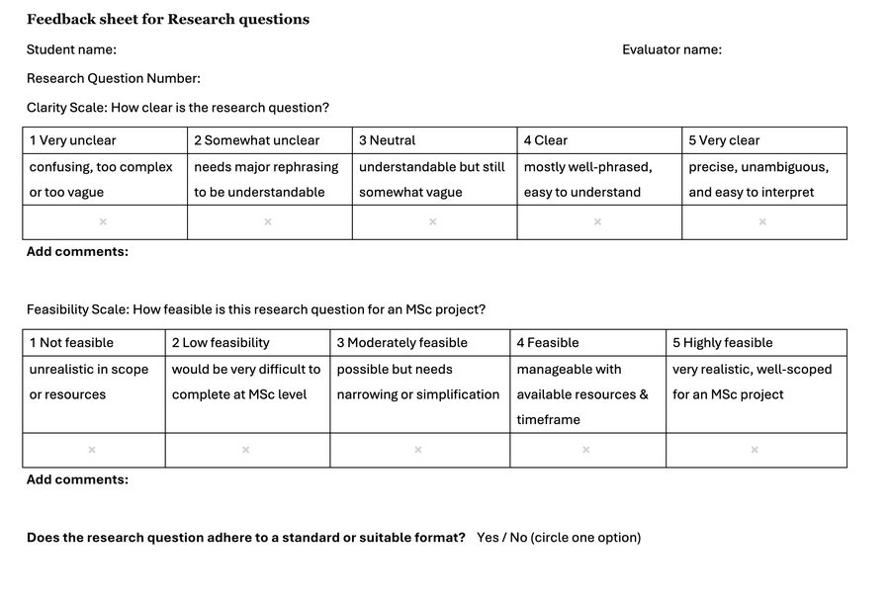

Introduction to Research: The hypothesis
- RESEARCH DESIGN & PROPOSAL WRITING
- SPEC 9998 (20258C)
- TU060

Why hypotheses matter?
- Turn your question into a testable prediction
- Keeps your research focused
- Helps define what “success” looks like
- Makes your project measurable + rigorous

What is a hypothesis?
- A statement (not a question) you can test with data
- Predicts a relationship between variables
- Must be:
- o Testable
- o Measurable
- o Falsifiable (could be proven wrong)

Hypothesis vs Research Question
- Research Question: Can adding time-of-day features improve the detection of fraudulent credit card transactions in imbalanced datasets?
- Hypothesis: “Including time-of-day as a feature will increase recall for fraud detection models compared to models trained without it."
- Is the hypothesis
- o Testable
- o Measurable
- o Falsifiable (could be proven wrong)

Hypothesis vs Research Question
- Research Question: Does misinformation spread faster than facts on Twitter (X), and can it be predicted?
- Hypothesis: “Tweets classified as misinformation will be shared (retweeted) at a significantly higher rate within 24 hours than fact-based tweets, and machine learning models can predict this pattern with above-chance accuracy.”
- Is the hypothesis o Testable o Measurable o Falsifiable (could be proven wrong)

Hypothesis vs Research Question
- A hypothesis that cannot be proven wrong is called non-falsifiable. It sounds scientific, but there’s no possible result that would contradict it.
- Example 1
- “Including time-of-day features may improve fraud detection performance.”
- Why it’s non-falsifiable:
- “May” allows any outcome
- Improvement is undefined
- You can’t disprove “may”

Hypothesis vs Research Question
- A hypothesis that cannot be proven wrong is called non-falsifiable. It sounds scientific, but there’s no possible result that would contradict it.
- Example 2
- “Time-of-day is an important feature for fraud detection.”
- Why it’s non-falsifiable:
- “Important” is subjective
- No metric
- No comparison

Hypothesis vs Research Question
- “A hypothesis must be written so that the data could prove it wrong. If no possible result would contradict it, then it isn’t a scientific hypothesis.”

Hypothesis vs Research Question
- ““Adding time-of-day features will provide useful insights into fraud.”
- What result would prove this wrong?

Hypothesis Format
- If [X] changes, then [Y] will change (in this way).
- [Method A] will outperform [Method B] for [dataset/problem].
- Adding [data/features] will improve prediction of [outcome].
- Your next activity will be to take your research questions from the previous activity and design a series of hypotheses.
- One research question could have more than one hypotheses.

1 RQ = multiple hypothesis
- Research Question Does misinformation spread faster than facts on Twitter (X)?
- Hypothesis 1 (Positive prediction):
- “Misinformation tweets are shared significantly more often within 24 hours than fact-based tweets.”
- Hypothesis 2 (Alternative angle):
- “Fact-based tweets will generate more sustained engagement (likes and comments over a week) than misinformation tweets.”

Common pitfalls
- Choosing a hypothesis too ambitious for MSc scope
- Forgetting to tie it back to available datasets
- Writing something untestable or too abstract

What is the null hypothesis?
- The Null Hypothesis (H₀) is just the idea that nothing special is happening.
- It’s the default position we assume until the data gives us strong evidence otherwise.
- Imagine you have a new weight-loss tea.
- Null Hypothesis (H₀): The tea has no effect — people lose the same weight as if they drank normal tea.
- Alternative Hypothesis (H₁): The tea does make a difference — people lose more weight.
- You test it with data.

What is the null hypothesis?
- If the tea group loses a lot more weight, you reject H₀.
- If not, you keep H₀ (you don’t say it’s “true,” just that you don’t have enough proof against it)
- Data Analytics Example
- Question: Can adding time-of-day features improve the detection of fraudulent credit card transactions in imbalanced datasets?
- H₀: There is no difference — adding time of day features makes no difference in fraud detection
- H₁: There is a difference — adding time of day features improves fraud detection perform better.
- If your test shows adding time of day features improves fraud detection, you reject
- H₀

What is the null hypothesis?
- "The Null Hypothesis = “no effect / no difference” is our starting point. We only reject it if the evidence is strong enough"

Activity 2: Hypotheses
- Part 1 (10 min): Turn Questions into Hypotheses
- Pick 1 or more research questions from the first activity.
- Write two possible hypotheses that could answer it:
  - Null hypothesis (predicts no effect/difference)
  - Hypothesis (predicts the effect)
- RQ: “Do LSTMs predict hospital readmissions better than logistic regression?”
- H₀: “There is no difference in accuracy between the two models.”
- H₁: “LSTMs will achieve higher accuracy than logistic regression.”

Activity 2: Hypotheses
- Part 2 (10 min): Refine for Testability
- Check: Is your hypothesis…
  - Clear? Write one or two sentences why
  - Measurable? Write one or two sentences why
  - Falsifiable (could data prove it wrong)? Write one or two sentences why
- Rewrite if it’s too vague.
- Too vague: “Adding more data improves prediction.” Better: “Adding customer transaction history improves the accuracy of credit card fraud detection by at least 5% compared to using demographic data alone.”
- Null Hypothesis: Adding customer transaction history does not improve the accuracy of credit card fraud detection compared to using demographic data alone.


Activity 2: Hypotheses
- Part 3 (10 min): Peer Exchange & Challenge
- Swap with a partner.
- Ask:
  - Can I imagine a piece of software /dataset/test that would check this?
  - Is it too broad, too narrow, or just right?
  - Is the null hypothesis clearly stated?
- Suggest one way to make their hypothesis stronger.
- Deliverable:
  - At least 1 research question
- At least 1 null hypothesis (H₀)
- At least 1 testable hypothesis (H₁)

Week 3 – Introduction to Research: Human Centered Considerations
- RESEARCH DESIGN & PROPOSAL WRITING
- SPEC 9998 (20258C)
- TU060

What is a human centered research?
- Human-centered research puts people, their needs, and their contexts at the core of the research process, not just the data or the algorithm.
- Why It Matters for Computer Scientists:
- Ensures research solves real-world problems, not just theoretical ones.
- Builds trust in data science outcomes (critical for AI/ML adoption).
- Reduces risk of unintended harm (bias, discrimination, misuse).
- Makes research more impactful, informs policy, and improves lives.
- Key Question:
- “Who benefits from my research, and how will they use the results?”

Connecting Human Needs to your Research Questions
- Your Process So Far:
- Research Question → Hypotheses →Human Centered Considerations →Literature & Data
- Now Add:
- Stakeholders: Who is impacted?
- Human Goals: What do they need? What are their pain points?
- Real-World Impact: How could this research change decisions, policies, or behaviour?
- Risks & Ethics: Who could be harmed? How can we prevent harm?
- This information will be contained in your abstract & introduction

Connecting Human Needs to your Research Questions
- Example:
- RQ: To what extent do interpretable machine-learning models for credit risk prediction achieve comparable predictive performance to black-box models, while improving user trust and perceived transparency, relative to a logistic regression baseline?
- Hypothesis (H1): Interpretable models (e.g. decision trees, generalized additive models) will achieve no statistically significant difference in accuracy compared to black-box models (e.g. random forests, gradient boosting), relative to a logistic regression baseline.
- Human Element:
  - Stakeholders: Loan applicants, risk officers, regulators.
  - Benefit: Improved transparency supports user understanding and regulatory auditability.
  - Risk: However, prioritising interpretability over model capacity may reduce performance for certain populations, highlighting a trade-off between transparency, accuracy, and fairness..

When it goes wrong
- Detroit 2020: Robert Williams wrongly arrested for theft
- Police had a blurry, low-quality CCTV still.
- AI Facial recognition software matched to his expired driver’s license photo
- Databases of driver’s license photos, mugshots, surveillance images etc. Typical one-to-many matching algorithm
- What could go wrong?


What went wrong?
- Image was blurry / low quality;
- The driver’s license photo was expired
- The surveillance image was from poor camera footage;
- The technology has known higher error rates for people of colour (skin tone, face features) in many systems;
- Overreliance on the matched result without sufficient additional verification (e.g., no strong alibi used until later)
- Who are the stakeholders?
- What is the impact on them?

Key lessons
- Facial recognition technology is not infallible, especially with low-quality input images or when demographic representation in training data is uneven.
- The importance of transparency: officers should know (and disclose) the uncertainty/confidence, image quality, reliability, etc.
- Policies & ethics matter: using AI leads is OK if corroborated. Doing so alone (without checks) is dangerous.
- Human impact is real: wrongful arrests aren’t just technical failures, they affect people’s lives, families, trust, legal rights.

Activity 3: Considering Human Impact
- Part 1 (10 min): Stakeholder Map
- Task: On a large sheet, list everyone affected by your research question. Use the circle, target layout: most to least affected. Or https://miro.com/templates/research- methods-design-thinking/ or https://miro.com/miroverse/simple-stakeholder-map-how-might-we/
- Prompt: Who uses the data? Who is impacted by the predictions/insights? Examples for fraud detection:
- Bank customers
- Fraud analysts
- Regulators
- Model developers
- Tip: Think beyond direct users — consider indirect stakeholders (society, policy-makers, etc.)

Activity 3: Considering Human Impact
- Part 2 (15 min): How Might We.......?
- Task: For each key stakeholder, write at least one How Might We (HMW) question.
- Examples:
- HMW help loan applicants understand why their application was rejected?
- HMW support fraud analysts to trust model outputs faster?
- HMW give regulators evidence that the model is fair?
- This ties your research question and / or hypotheses to human needs.

Activity 3: Considering Human Impact
- For Homework (20 min): Real world impact
- Task: Sketch or bullet-point:
- HMW help loan applicants understand why their application was rejected?
- Problem in the real world
- People affected
- What success looks like if your hypothesis is supported
- Risks/harms if your hypothesis is wrong

Activity 3: Example
- For Homework (20 min): Real world impact example for explaining decisions of a decision support system for loan approval
- Task: Sketch or bullet-point:
- HMW help loan applicants understand why their application was rejected?
- Problem in the real world:
- Applicants who are rejected for loans rarely get actionable feedback. They don’t know what to change to get approved next time. This creates frustration, lowers customer loyalty, and may lead to accusations of unfair treatment. Banks also lose potential repeat business.

Activity 3: Example
- For Homework (20 min): Real world impact example for explaining decisions of a decision support system for loan approval
- People affected (use your stakeholder map):
- Applicants: Need guidance to improve their chances and financial health.
- Banks / Credit Providers: Need to maintain fairness, transparency, and compliance with lending regulations.
- Customer Support Teams: Spend time explaining rejections manually (costly and inconsistent).
- Regulators: Interested in equal credit opportunity and avoiding discrimination.

Activity 3: Example
- For Homework (20 min): Real world impact example for explaining decisions of adecsions support system for loan approval
- What success looks like if your hypothesis is supported
- The AI model + datasets accurately identify top reasons for loan rejection (e.g., credit score, debt-to-income ratio).
- Generate a simple dashboard or report that shows actionable advice.
- Applicants would theoretically have clear steps to take (pay off debt, raise score by X points).
- Customer support workload decreases because applicants have answers upfront

Activity 3: Example
- For Homework (20 min): Real world impact example for explaining decisions of a decision support system for loan approval
- Harms if your hypothesis is wrong
- Data quality issues: Model trained on biased or incomplete data might give wrong advice.
- Fairness risks: Model might reflect past discriminatory lending patterns.
- Over-simplification: Advice might be too generic or not actually feasible for applicants (e.g., “earn more money”).
- Trust issues: If advice doesn’t work, customers may lose trust in the bank.

Week 4 – Introduction to Research: Literature Map
- RESEARCH DESIGN & PROPOSAL WRITING
- SPEC 9998 (20258C)
- TU060

Good Journals?
- Association for Computing Machinery (1947)
- world's first scientific and educational computing society
- 170 local chapters and 35 Special Interest Groups (SIGs)
- publish a large number of specialized journals, magazines, and newsletters
- Institute of Electrical and Electronics Engineers (eye-triple-e)
- professional organization for the advancement of technology
- publishes a number journals
- IEEE Transactions on Knowledge and Data Engineering


ACM SIGs
- SIGACCESS - Accessible Computing
- SIGACT - Algorithms and Computation Theory
- SIGAda - Ada Programming Language
- SIGAPP - Applied Computing
- SIGARCH - Computer Architecture
- SIGART - Artificial Intelligence
- SIGBED - Embedded Systems
- SIGCAS - Computers and Society
- SIGCHI - Computer-Human Interaction
- SIGCOMM - Data Communication
- SIGCSE - Computer Science Education
- SIGDA - Design Automation
- SIGDOC - Design of Communication
- SIGecom - Electronic Commerce
- SIGEVO - Genetic and Evolutionary Computation
- SIGGRAPH - Computer Graphics and Interactive Techniques
- SIGIR - Information Retrieval SIGITE - Information Technology Education
- SIGKDD - Knowledge Discovery in Data
- SIGMETRICS - Measurement and Evaluation
- SIGMICRO -Microarchitecture
- SIGMIS – Management Information Systems
- SIGMM - Multimedia
- SIGMOBILE - Mobility of Systems, Users, Data and Computing
- IGMOD - Management of Data
- SIGOPS - Operating Systems
- SIGPLAN - Programming Languages
- SIGSAC - Security, Audit and Control
- SIGSAM - Symbolic and Algebraic Manipulation
- SIGSIM - Simulation and Modeling
- SIGSOFT - Software Engineering
- SIGSPATIAL - SIGSPATIAL
- SIGUCCS - University and College Computing Services
- SIGWEB - Hypertext, Hypermedia and Web

IEEE Transactions
- IEEE Computational intelligence and AI
- IEEE Transactions on Computers
- IEEE Transactions on Dependable and Secure Computing
- IEEE Transactions on Knowledge and Data Engineering
- IEEE Transactions on Parallel and Distributed Systems
- IEEE Transactions on Pattern Analysis and Machine Intelligence
- IEEE Transactions on Services Computing
- IEEE Transactions on Software Engineering
- IEEE Transactions on Visualization and Computer Graphics
- IEEE Transactions on Affective Computing
- IEEE Transactions on Haptics
- IEEE Transactions on Information Technology in Biomedicine
- IEEE Transactions on Learning Technologies
- IEEE Transactions on Mobile Computing
- IEEE Transactions on Multimedia
- IEEE Transactions on Nano bioscience
- IEEE Transactions on Very Large Scale Integration (VLSI) Systems
- IEEE/ACM Transactions on Computational Biology and Bioinformatics
- IEEE/ACM Transactions on Networking

Research Sites?
- Google Scholar
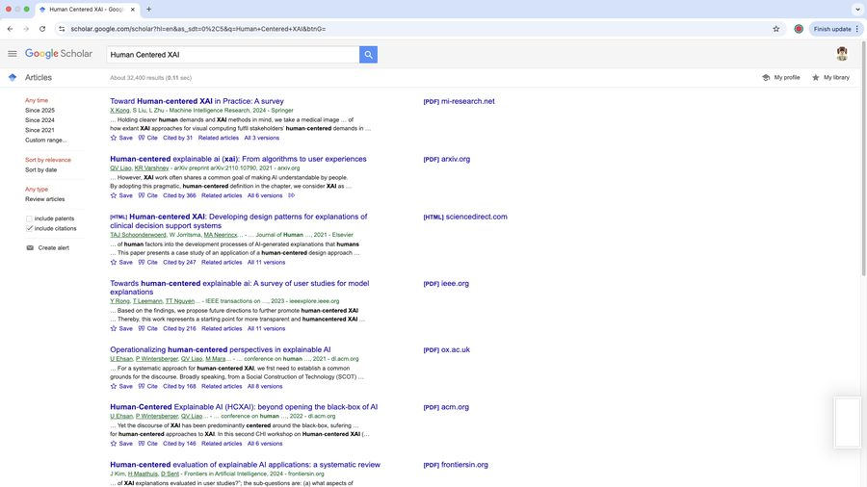

Research Sites?
- https://arxiv.org/archive/cs
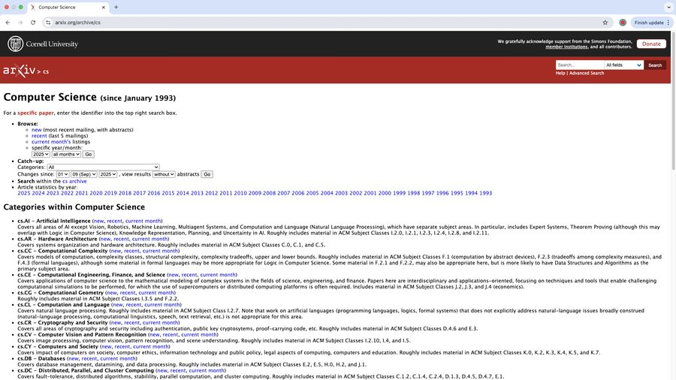

Research Sites?
- https://www.sciencedirect.com/
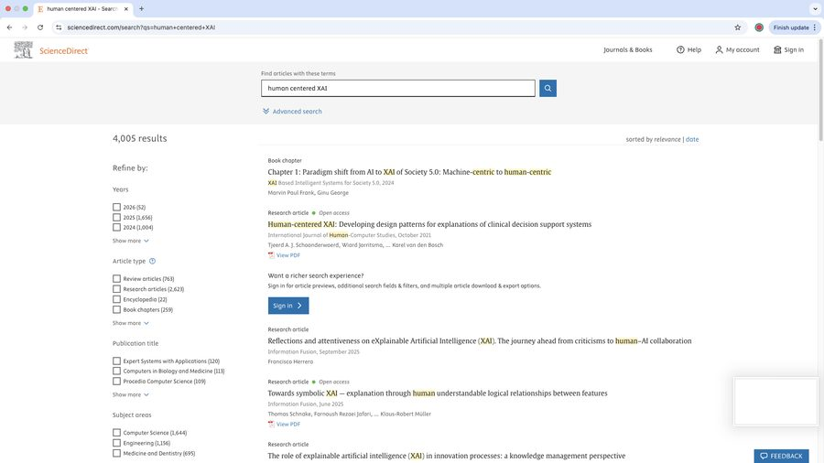

Research Sites?
- https://link.springer.com/
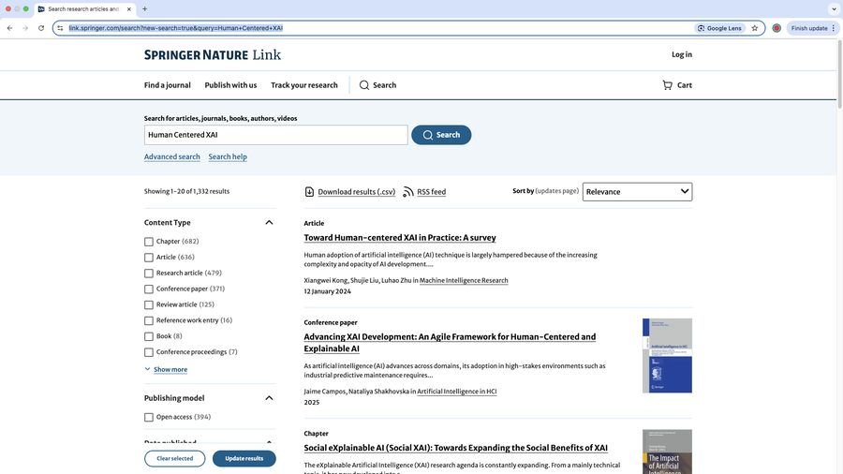

Research Sites?
- https://www.scopus.com/
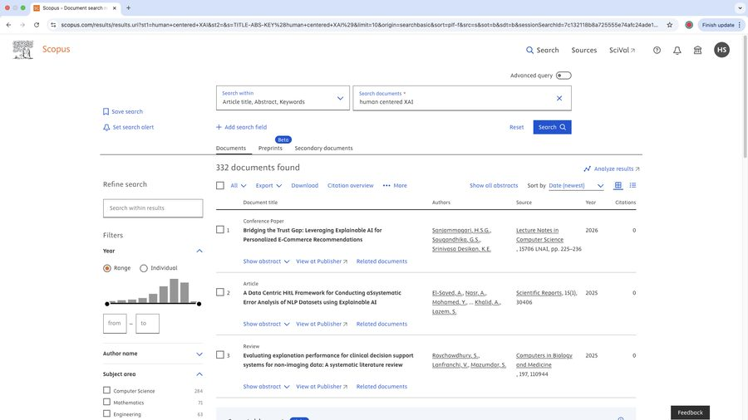

Literature Comprehension
- The Damian Gordon literature check sheet will help
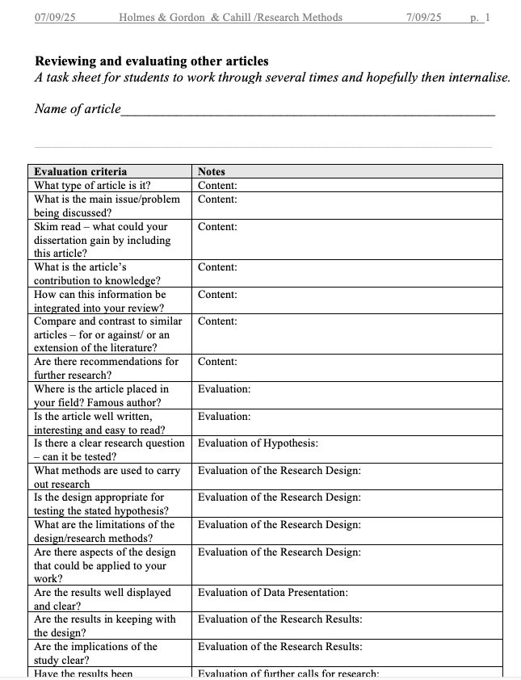

Literature Map
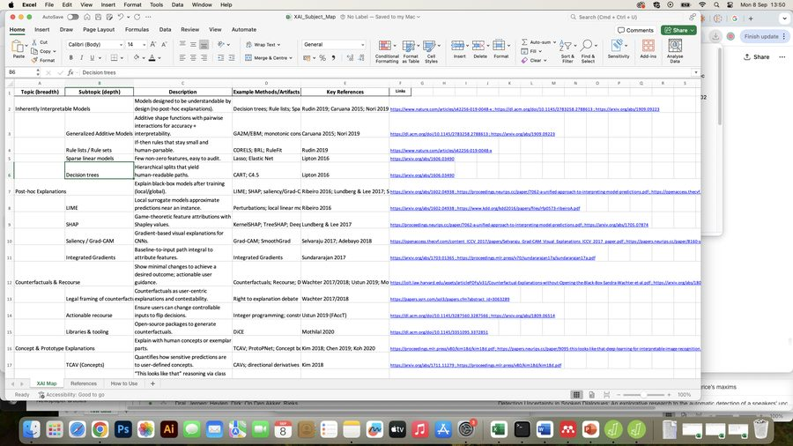

Literature Map
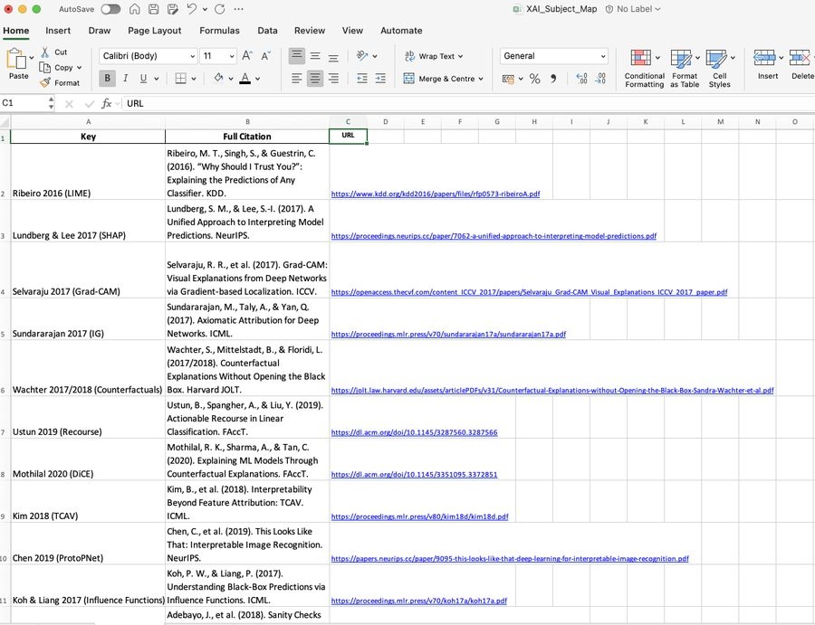

Week 5 – Introduction to Research: The Abstract
- RESEARCH DESIGN & PROPOSAL WRITING
- SPEC 9998 (20258C)
- TU060

The Abstract: What is it?
- A short summary of your proposed project
- Explains: what you want to study, why it matters, how you will do it, and what you expect to find
- Usually 150–250 words

The Abstract: Good proposal abstract
- Clearly state your research question and why it’s important
- Briefly mention datasets and methods you will use
- Explain expected results or outcomes (what you hope to show)
- Be concise and easy to read — one idea per sentence

The Abstract: What to avoid
- Being too vague — be specific about your approach
- Giving excessive background — save that for the literature review
- Writing as if you already have results (use “will” or “plan to”)
- Including things not related to your project

The Abstract: Good Example
- Credit card fraud represents a significant global financial challenge, resulting in substantial losses for financial institutions and customers each year. Fraud detection models frequently struggle with highly imbalanced datasets, which can lead to fraudulent transactions being missed. Prior research indicates that feature engineering can improve predictive performance, and temporal patterns, such as time of day, may provide useful behavioural signals. However, limited work has systematically evaluated the specific impact of incorporating time-of-day features using publicly available datasets.
- This project examines whether adding a time-of-day feature improves fraud detection performance. Two open datasets will be used, including the Kaggle Credit Card Fraud dataset and EU banking transaction statistics. Time-based features will be derived from transaction timestamps and incorporated into decision tree models. Models will be trained both with and without the engineered time-of-day feature, using identical train–test splits to ensure fair comparison.
- Performance will be evaluated using recall, precision, and F1-score, with particular emphasis on recall due to the high cost of undetected fraudulent transactions. Differences in model performance will be analysed to determine whether the inclusion of time-of-day information produces statistically and practically meaningful improvements for real-world fraud detection applications.

The Abstract: Bad Example
- Fraud is a big problem for banks and customers, and I want to use data science to help solve it. I will use machine learning to look for fraud patterns in data and see what happens. Hopefully, the results will be good and show a better way to stop fraud.
- Why is the good example good?
- Why is the bad example bad?

Week 5 – Datasets: sourcing & evaluating
- RESEARCH DESIGN & PROPOSAL WRITING
- SPEC 9998 (20258C)
- TU060

Data set sources
- Kaggle – Large collection of datasets + starter notebooks
- Hugging Face – Text, image, and audio datasets; easy to load in Python
- UCI (University of California Irvine) ML Repository – Classic datasets for teaching/benchmarking
- Open Data Portals – data.gov.ie, EU data portal, World Bank, UN, WHO
- Public APIs – OpenWeather, Google Trends, Yahoo Finance, Twitter/X API
- Tip: Always check data licensing and ethics (GDPR, anonymisation).


Evaluation Criteria
- Size – Is the dataset large enough for reliable results?
- Bias – Does it fairly represent all groups or regions?
- Completeness & Quality – Check for missing values, duplicates, outdated data.
- Ethics & Privacy – Ensure data is anonymised and legal under GDPR.
- Licensing & Access – Confirm it’s free or permitted for research use.

Why use 2 datasets?
- Robustness, comparison ......?
- Credit Scores + Demographics: Predict loan approval likelihood.
- Traffic + Accident Reports: Model accident hotspots by time/day.
- Hospital Records + Weather Data: Study impact of heatwaves on ER visits.
- Crop Yield Data + Satellite Images: Predict agricultural productivity.

Dataset Task:
- Task 1 (30 minutes) Data Matrix:
- Draw a list with sections: available now, need/essential, nice to have on the left. Give examples for each research question / hypotheses. Remember you are using at least two datasets
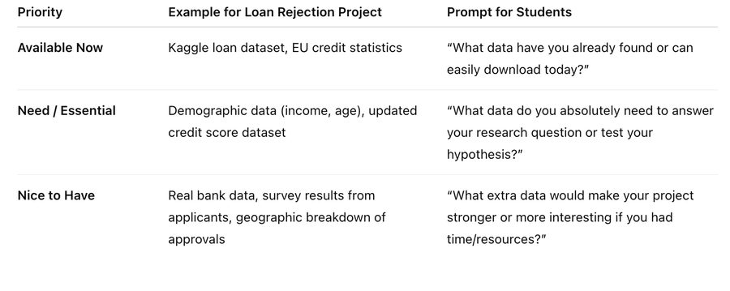

References
- Source: PCT Punjabi (Swifties case study image/article)
- References: Discover magazine & Phys.org (Swifties case study)
- Staneviciene et al, 2024 (open access) (student dropout case study)
- SDG pick-a-mix challenge: https://wordwall.net/resource/4140746/sustainable-development-goals-sdgs
- Stakeholder map templates: https://miro.com/templates/research-methods-design-thinking/ and https://miro.com/miroverse/simple-stakeholder-map-how-might-we/
- Google Scholar
- arXiv Computer Science: https://arxiv.org/archive/cs
- ScienceDirect: https://www.sciencedirect.com/
- SpringerLink: https://link.springer.com/
- Scopus: https://www.scopus.com/
- Damian Gordon literature check sheet: “Reviewing and evaluating other articles” (Holmes & Gordon & Cahill, Research Methods, 07/09/25)

Assignment 1

CA 1 ASSIGNMENT BRIEF
Course | TU060 MSc. Data Science / Advanced Software Development
Module | Research design & proposal writing
Academic Year | 2026
Lecturer | Helen Sheridan
Assignment Title | Research question, hypothesis, human centred considerations and abstract
Weight | 20%
Date issued | 26/09/2026
Submission Deadline | 17/10/2026 Parts 1 – 4 (research question, hypotheses, real world impact, literature map and data matrix and written abstract of 150 to 250 words)

Submission Format
- Word document: submit a word document via Brightspace. An assignment link will be set up in Brightspace for you from 17/02/2026
- Submit parts 1 – 4 on the hand up deadline October 17th 2026

Assignment Brief and Guidance
Scenario
You are required to write a research proposal for your MSc. Perhaps the most important part of this proposal is developing your initial idea and presenting this idea in a suitable research format. Through a series of in class lectures you will be brought through the necessary steps to think creatively about the problem you wish to solve for your dissertation. This assignment will give you a solid foundation to begin your research and to start thinking about what will sustain your interest, what makes a suitable research project and how you might begin your research process. This assignment has 4 parts.

Part 1: Research Question & Hypothesis:
Include your chosen research question and hypotheses (one or more). By the assignment deadline you should have chosen one research question.
Real World Impact:
- Problem in the real world
- People affected
- What success looks like if your hypothesis is supported
- Risks/harms if your hypothesis is wrong

Part 2: Literature Map:
Include your literature map. This will be a work in progress at this stage. You may show this in your preferred way (Excel table, mind map, diagram etc)
Part 3: Data Matrix
Include your data matrix
Draw a list with sections: available now, need/essential, nice to have on the left. Give examples for each research question / hypotheses. Remember you are using at least two datasets (slide 112 - 113)
Part 4: Abstract
The goal of the activity is to produce an abstract, so write a first-draft of your abstract answering these six questions. The abstract should be 150 to 250 words.
- What is the area of study? (1 – 2 sentences)
- What is the problem being tackled? (1 -2 sentences)
- What does the literature say? (1 –2 sentences)
- How will you tackle the problem?* (2 - 3 sentences)
- How will you implement the solution?* (2- 3 sentences)
- What evaluation will you do?* (2 - 3 sentences)

* These may still be work in progress but based on your literature review so far what are your initial ideas for these
Grading matrix
This assignment is worth 20% of the overall module grade. Marks are divided equally across four parts. Each part focuses on clarity, relevance, and connection to your research question and hypothesis.
Part | Weight | Criteria | Max. Marks | Learner mark
Part 1: Research Question & Real-World Impact | 25% | • Clear, focused research question & at least one testable hypothesis (10)  • Identifies real-world problem, stakeholders, and why it matters (10)  • Notes potential risks/harms if wrong (5)  Sub Total 25 | 10  10  5
Part 2: Literature Map | 25% | • Includes relevant sources (academic/credible) covering breadth of topic (10)  • Organised in a clear, logical format (mind map, table, diagram) (10)  • Shows initial grouping into themes (5)  Sub Total 25 | 10  10  5
Part 3: Data Matrix | 25% | • Lists datasets under Available / Need / Nice to Have (10)  • Includes at least two datasets or clear plan for two (10)  • Clear link between data and research question (5)  Sub Total 25 | 10  10  5
Part 4: Abstract | 25% | • Answers all six questions briefly (10)  • Logical flow and clarity (10)  • Uses appropriate terminology (5)  Sub Total 25 | 10  10  5
Final Marks 100
Total: 100 marks (20% of overall module grade)

