Scientific research and Literature -SPC9997
email: John Gilligan
John.Gilligan@tudublin.ie

- TO DO: check out PHD options with Lucas!! – l
- http://lucasrizzo.com/
- https://lucasrizzo.com/index.php?action=proposal
- Contact = lucas.rizzo@tudublin.ie (outside of class hours)

Assignment 2 –
- Week 2 morning part 1 – recording 50 mins - in class exercise >
  - Fatema >> I manged to find two papers related in topic https://pdfs.semanticscholar.org/39d3/f048ee088cba9883b9aa15b5cb7b725edd96.pdf https://www.idpublications.org/wp-content/uploads/2014/11/IMPACT.pdf
  - Victor >> s https://ieeexplore.ieee.org/abstract/document/10843688 https://ieeexplore.ieee.org/document/11341693 https://link.springer.com/article/10.1007/s00521-024-10724-y https://ieeexplore.ieee.org/abstract/document/10962890 https://ieeexplore.ieee.org/document/11344020/
    - Ethics for EU – areas to look at people to talk to.

      - EU fairness - https://ascnet.ie/ethics4eu-website/
      - Damien Gordon
      - David Sullivan
      - People who
      - FATE Principles – fairness /accountability / transparency / explainability
      - IBM fairness 360
        - https://research.ibm.com/blog/ai-fairness-360
        - Has tools for taking dataset in AI measures how fair it was and balanced
      - Google has fairness – balance in datasets / representation in datasets
      - Lot fo fairness webesites from the big ones – many resouces / literature available
      - Can try automate the process of establishgin fairness and bias
  - Dara PARKES-Kenna
    - >>I found two papers in relation to hate speech detection, using BERT: Hierarchical Abusive Language Classification Using Customized BERT https://www.researchgate.net/profile/Emmanuel-Anthony-12/publication/400249693_Hierarchical_Abusive_Language_Classification_Using_Customized_BERT/links/697c7c0842f94d1212a52be3/Hierarchical-Abusive-Language-Classification-Using-Customized-BERT.pdf NLPeace@GermEval Shared Task 2025: Fine-Tuned BERT vs. Prompted LLMs for German Hate Speech Detection https://aclanthology.org/2025.konvens-2.28.pdf And then one in relation to XAI of hate speech detection: Towards Explainable Hate Speech Detection https://aclanthology.org/2025.findings-acl.667.pdf
      - What is definition of hate speech
      - Strength or weakness of these papers is the definition
      - Hate speech dataset available –
      - Vanessa did a paper on hate speech assignment 1
      - Ireland couldn’t introduce legislation on hate speech as couldn’t agree definition of hate speech
      - Context related
      - From vanessa >> https://dl-acm-org.tudublin.idm.oclc.org/doi/10.1145/3603163.3609040
      - X AI of hate speech detection could be focus of your work…
      - Could be do-able…. Impact of explanations of hate speech

    - Methods used go addres them make sense
    - Conclusion make sense
    - What are you looking for
    - Read a paper
    - What use is it for me and my research
    - What we’re reading for is to tr ID opportunities for further research
  - Presentation 5 – Me
    - CSSD
    - SFR
    - News paper dataset

Assignment - 3 - due 26th April
- Systematic review
  - Eg for micros services > https://ieeexplore.ieee.org/document/10910708
  - https://pmc.ncbi.nlm.nih.gov/articles/PMC12153147/
  - Often see PRISMA protocol
  - What search
  - What databases
  - How many records we generated
  - What was next number
  - How did you filter down to manageable set
  - What thematic analysid did you do?
  - If interest in certain topic put in “systematic review < subject topic> ”
  - Systematic IDs temes topics, sub themes
  - Similar to scoping review but scoping
    - Is about Trying to ID some scope criteria
    - E.g. where in a lifecycle was this approach applied
    - Scoping reviews are systematic btu more for context or range of topic
  - What is a Systematic Review
    - https://guides.library.uab.edu/systematicreviewsnew ..
- Narrative review
  - Can be called comprehensive review
  - 2025 will be a lot better than 2015 review
- Due 26th April 2026 @ 23:59 via Brightspace
- Will hopefully have you narrowing in on your project

Week 1 – Lect 1 - Overview and Intro – Sat 24th Jan 2026 - Morning

Module Assessment
100% Continuous Assessment:
Provisional Will be finalised next week
- 20%: Group work and student Presentations about Research Methods in their specialism – ASD, DA, (SF)
- 30%: Individual Annotated Bibliography
- 50%: Individual Literature Review

Module Schedule
This Years Finalised next week
Week | Day | Notes:
1 | 11-09-2017
2 | 18-09-2017
3 | 25-09-2017
4 | 02-10-2017
5 | 09-10-2017
6 | 16-10-2017 | Student Presentations
7 | 23-10-2017 | Student Presentations
8 | 30-10-2017 | Review week
9 | 06-11-2017
10 | 13-11-2017 | Annotated Bibliography due
11 | 20-11-2017
12 | 27-11-2017
13 | 04-12-2017 | Literature Review due

- Week 1 – Sat 24th Jan 2026 > 9 :30am + 1:30 am
- Week 2 – Sat 7th Feb 2026 > 9 :30am + 1:30 am
- Week 3 – Say 7th Mar 2026 > 9 :30am + 1:30 am
- Week 4 - Sat 18th Apr 2026 > 9 :30am + 1:30 am

Contact the Lecturer
Contact the Lecturer
Dr. John Gilligan
Email: john.gilligan@tudublin.ie

Acknowledgements
Thanks to previous course lecturer Dr Diana Carvalho E Ferreira for these resources
Many thanks to Deirdre Lawless and Damian Gordon, who originally developed the module.

Online Resources
Webcourses: SPEC9997-FT: Scientific Research and Literature
- Self enrolment
General Noticeboard: http://ditmsc.blogspot.ie/

Section 1 - Module Description
MSc in Computing graduates will need to remain up to date with new innovations in computing, which may be applicable to their chosen area of specialism.
To achieve this, students must be able to undertake research using appropriate sources in an ethical and professional manner and present their research findings in an appropriate form.
The major focus of this module will be on what research is, the different types in the student’s discipline, how to locate relevant research and then how to write correctly.

Module Description -2
This module develops the student's ability to effectively research and present their research findings by introducing them to the research process; equipping them with an understanding of computing research sources and how to use them critically and ethically and how to present their findings in an acceptable form.

Learning Outcomes
- Demonstrate an understanding of the different types of research methodologies that could be used in their discipline, recognising ethical considerations.
- Select, develop and apply appropriate search strategies to locate literature relevant to a range of given topics in their discipline, using relevant literature resources and digital technology, for the purposes of developing a literature review.
- Select, categorize and evaluate research material, in order to identify the current state of knowledge and key issues in a research topic, and demonstrate this via an annotated bibliography.
- Author a document with an appropriate standard of language, presentation, style and referencing.

Module Content – Intro to Sci res
What is scientific research?
Primary versus secondary research.
Underlying philosophical assumptions of research and how these influence the student’s discipline, particular research problems and choice of research methods.
Purpose and nature of quantitative research, qualitative and mixed methods research within the student’s discipline.
Analysing and evaluating examples of quantitative, qualitative and mixed methods research from the student’s discipline.
Understanding plagiarism and its implications.
Ethical principles in research: minimise harm, autonomy, informed consent, right to privacy, accuracy and protection of data, limitations of use of data.

Module Content - Literature Searching:
The concept of the body of knowledge.
Research sources, types and pedigree.
Literature search strategies.
Sourcing published sources using digital technology.
Referencing and citation of different types of sources, using appropriate referencing systems.
Reference management tools.

Module Content - Report Writing:
Different types of reports: basic structure; language and style; including images, data, and visualisations.
Quoting, paraphrasing, summarising.
Proofreading.
Checking work for plagiarism using specialized software.

Learning and Teaching Methods
Student-centred learning methods to allow students to learn by practice as much as possible.
Lectures with opportunities to discuss and clarify the material and to put it into a more cogent and coherent framework.
Use library and internet based information sources extensively and pro-actively.
Present problems, discuss solutions and work independently and in groups.
Construct a report (or position paper) demonstrating critical thinking, appropriate use of literature and their ability to express these appropriately in a written form.
Develop independence and responsibility for their own learning.

Questions?

Activity
Split into 10 groups
10 Research problems How would you go about researching it?

Research Topics

1: Where in Dublin are traffic accidents most likely to occur?
2: How successful are Onl;ne courses in delivering programming skills
3: IS first year more difficult than other years at college?
4: How hot is the sun?
5: What is the heaviest element?
6 Which is the fastest java script framework?
7 What students are most likely to succeed in the IT business
8: How do we attract more females into computer science?
9. This app is easier to use than the other one
10 peer mentoring is the best way to teach computin.

Section 2 -Introduction to Research

What is Scientific Research?
Research is a systematic, formal, rigorous and precise process employed to gain solutions to problems or to discover and interpret new facts and relationships. (Waltz and Bausell, 1981).
Research is the process of looking for a specific answer to a specific question in an organized, objective, reliable way. (Payton, 1979).
Research is systematic, controlled, empirical and critical investigation of hypothetical propositions about the presumed relations among natural phenomena. (Kerlinger, 1973).
Research is the pursuit of truth with the help of study, observation, comparison and experiment; the search for knowledge through objective and systematic method of finding solutions to a problem (Kothari, 2006).
- Note Research is Systematic and Its Purpose is Reliable New Knowledge

What is Scientific Research? - Ctd
A process to create knowledge.
Most researchers design a piece of research to answer a question or address a problem.
They begin by working out what data is needed and then focus on how to obtain that data.
Obtaining the data can involve a number of techniques, such as questionnaires, observation, experiments, as well as making use of secondary data.
However, the selection of techniques used to obtain data, along with procedures to analyse it, represents only the final decision about the overall research design.

Scientific Method of Inquiry
The scientific method of inquiry is characterized by the following convictions:
- that the process must be objective to reduce bias in methods and interpretation of results.
- that the process should be systematic in that it ought to involve certain standard procedures.
- enquiry should be conducted through a process of systematic observation that can be verified by experience (empiricism).
- There should be careful recording, documenting, archival and sharing of all data and methodology (full disclosure) to make it available for scrutiny by other researchers, thereby allowing them to verify results by attempting to reproduce them.

Basic Types of Research
- Categories of Research
  - Qualitative and quantitative research
  - Basic and applied research
  - Descriptive and analytical research

- Classification of research can be based on different considerations.
  - The nature of the dominant data (qualitative or quantitative),
  - The purpose of the research (applied or basic) or
  - The type of analysis that will be carried out (descriptive or analytical).

  - Most research has elements of all the categories.

Qualitative and quantitative research
- Qualitative research deals with designs techniques and measure that do not produce discrete numerical data. It involves extensive narrative data in order to gains insights into phenomena. Data analysis includes the coding of the data and production of verbal synthesis (inductive process). Examples include historical research, ethnographic research, participant observational research and the case study.
- Quantitative research includes designs, techniques and measures that produce discrete numerical or quantifiable data. Data analysis is mainly statistical (deductive process). It is characterized by:
- causal-comparative
- correlational
- experimental
- descriptive research

Quantitative versus Qualitative
Quantitative Research Strategy
- Aims to assess a pre-stated theory, typically using hypothesis testing (Deductive Reasoning)
- Tries to Avoid Researcher bias on the outcome
- Quantitative data facilitates statistics
- Data based on ‘closed’ responses

Qualitative Research Strategy
- Aims to create a novel theory (Inductive Reasoning)
- Not so worried about researcher bias. Indeed they often become an inherent part of the study - ethnography
- Qualitative data Narratives, Histories, complex statements or opinions
- allow ‘open’ responses

Basic and applied research
- Basic research (also called fundamental or pure research) is mainly concerned with generalizations and the formulation of theory.
- Basic Research focusses on very specific problems for example the boiling point of a liquid or the stress tolerance on metallic products

- Applied research is designed to solve practical problems of the society. It can be argued that the goal of applied research is to improve the human condition.
- An example of Applied Research might be the impact of early school leaving on job prospects

Action Research
- Action research is a unique form of applied research. It is a reflective process of progressive problem solving.
- Also called "practitioner research" because of the involvement of the actual practitioner in real life.
- Action implies that the practitioner is involved in the collection of data, analysis, and the interpretation of results.
- The researcher is also involved in implementing results of the research and is thus well placed to judge the effectiveness of the interventions.

Reductionist
- noun
  - a person who analyses and describes a complex phenomenon in terms of its simple or fundamental constituents.
- Adjective
  - analysing and describing a complex phenomenon in terms of its simple or fundamental constituents.

Descriptive and analytical research
- Descriptive research attempts to determine, describe, or identify what is. It uses description, classification, measurement and comparison to describe a situation.
  - The intent is often synthesis, which pulls knowledge or information together
- The main characteristic is that the researcher has no control over the variables. He only reports the situation as it is at the time. The term ex-post facto is usually used for descriptive research studies in social sciences. The survey method is commonly used in descriptive research.

- Analytical research attempts to explain why and how. It usually concerns itself with cause–effect relationships among variables. The researcher attempts to analyze the situation and make critical evaluation.
  - attempts to establish why something occurs or how it came to be
- All disciplines generally engage in both

Methodology Defined & Described
- Methodology and Method are often (incorrectly) used interchangeable

- Methodology – the study of the general approach to inquiry in a given field
- Method – the specific techniques, tools or procedures applied to achieve a given objective

  - Research methods in economics include regression analysis, mathematical analysis, operations research, surveys, data gathering, etc.

The Process of Research
- The process is initiated with a question or problem or the establishment of these
- Next, goals and objectives are formulated to deal with the question or problem
- Then the research design is developed to achieve the objectives
- Results are generated by conducting the research
- Interpretation and analysis of results follow

The Research Onion Metaphor
Adapted from Saunders et al., 2009; https://onion.derby.ac.uk/ >> https://www.researchgate.net/profile/Mark-Saunders-10
https://www.researchgate.net/profile/Aleksandras-Melnikovas/publication/333388233_Towards_an_explicit_research_methodology_Adapting_research_onion_model_for_futures_studies/links/5d47c8404585153e593cfbec/Towards-an-explicit-research-methodology-Adapting-research-onion-model-for-futures-studies.pdf?_sg%5B0%5D=started_experiment_milestone&origin=journalDetail&_rtd=e30%3D
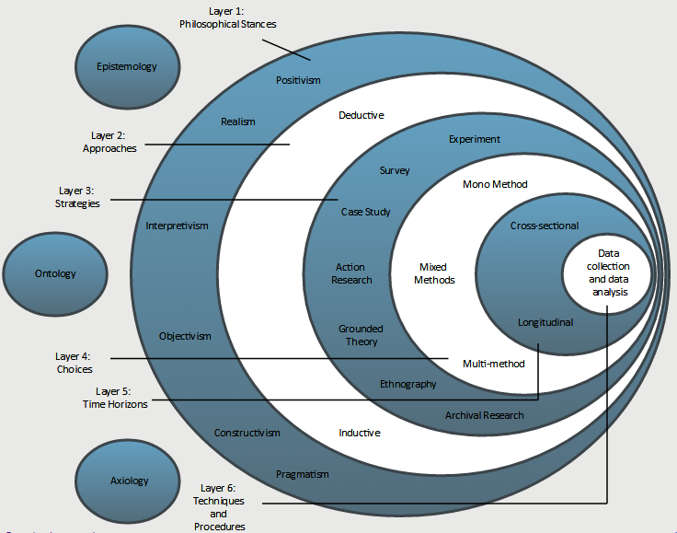

Philosophies

Philosophies - Epistemology

- Epistemology is concerned with addressing the facts by asking for a definition of what is acceptable knowledge in a field of research and what information is known to be true due to rigorous testing and treated as fact.
- This philosophy is most commonly used in “hard” scientific research as it searches for facts and information that can be proved without doubt rather than changeable situations and opinions.

Philosophies - Ontology
- Ontological philosophy is concerned with the nature of reality.
- It requires researchers to ask themselves how they think the world operates, how society is constructed and how this influences everything around us.
- Ontology talks about the difference between reality, our perception of reality and how this influences people’s behaviour.

Philosophies - Axiology

- Axiology allows the researcher to understand and recognise the role their values and opinion play in the collection and analysis of the research as opposed to eliminating or trying to balance the influence of it.
- For example, if the researcher is a vegetarian and they are researching the availability and range of vegetarian food in hotels this must be declared in their research.
- How this shapes the investigation of the issue and results analysis will need to be detailed according to the approach chosen.

Layer 1: Philosophical Stances
Adapted from Saunders et al., 2009; https://onion.derby.ac.uk/
It is the researcher’s understandings and associated decisions in relation to these outer layers that provide the context and boundaries within which data collection techniques and analysis procedures will be selected.

Epistemology / Ontology / Axiology

- Epistemology = How do we know what we know? (how is knowledge generated)
- Ontology = What is reality? What exists?
- Axiology = What role do values play?

POSITIVISM (from Epistemology)
- Positivism generates hypotheses (or research questions) that can be tested and allows explanations that are measured against accepted knowledge of the world we live in.
- This position creates a body of research that can be replicated by other researchers to generate the same results.
- The emphasis is on quantifiable results that lend themselves to statistical analysis.

REALISM (from Epistemology)
- Realism is similar to positivism in its processes and belief that social reality and the researcher are independent of each other and so will not create biased results.
- However, where they differ is that realism thinks that scientific methods are not perfect.
- It believes that all theory can be revised and that our ability to know for certain what reality is may not exist without continually researching and leaving our minds open to using new methods of research.
- Realism may therefore use several types of research methods to triangulate results in their search for a more reliable outcome.

INTERPRETIVISM (from Epistemology)
- Interpretivism refers to approaches emphasizing the meaningful nature of people's participation in social and cultural life.
- Researchers working within this tradition analyse the meanings people confer upon their own and others' actions and take the view that cultural existence and change can be understood by studying what people think about, their ideas, and the meanings that are important to them.

OBJECTIVISM (from Ontology)
- Objectivism recognises that social phenomena and their meanings exist separately to social actors.
- An example of social phenomena could be heavy rain and social actors are people wanting to have a picnic outside.
- The rain exists, it is real and would be acknowledged by everyone to exist and is therefore independent to the people who have had their day out ruined by it.
- In your research this may be how a law (the social phenomenon) impacts on a group of people (social actors).

CONSTRUCTIVISM (from Ontology)
- Constructivism argues the opposite to objectivism. It is a standpoint that believes social phenomena are actually constructed by social actors.
- So, if you had a constructive ontological worldview you would believe that, for example, a new law is the product of the behaviour of the group of people it now has an impact on.

PRAGMATISM (from Ontology)
- Pragmatism argues that both constructivism and objectivism are valid ways to approach research.
- Pragmatism allows a researcher to view the topic from either or both points-of-view regarding the influence or role of social actors and uses these to create a practical approach to research.
- This may be used to find solutions to problems.

Axiology

Layer 2: Approaches
Adapted from Saunders et al., 2009; https://onion.derby.ac.uk/

DEDUCTIVE
- Deductive means that you start with a statement/hypothesis or question and your research sets out to answer it.
- Questions and hypothesis may be derived from informed speculation about the topic, that the researcher believes can be answered or tested.
- The thought process of deduction moves from theory to the research question, to data collection, findings and a rejection or confirmation of the hypothesis or answer to the question.
- This could lead onto a revision of the theory and often starts the process over again.

INDUCTIVE
- Inductive means that you are researching to create theory.
- The process moves in the opposite direction to the deductive approach, where the focus is not the existing theory.
- This means the research goes from research question to observation and description, to analysis and finally theory.
- Therefore if little research exists on a topic then an inductive approach may be the best way to proceed.

Inductivism:
- General statements (theories) have to be based on empirical observations, which are subsequently generalized into statements which can either be regarded as true or probably true.
- The classical example goes from a series of observations:
- Swan no. 1 was white,
- Swan no. 2 was white,
- Swan no. 3 was white,…
- to the general statement: All swans are white.


Deduction vs Induction – Steps Graphic

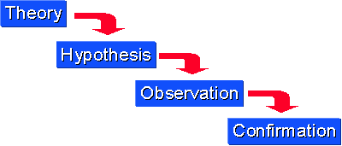
Deduction

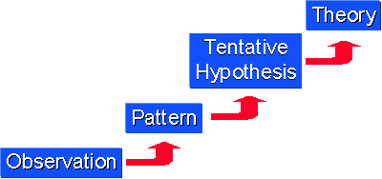
Induction

Approaches – general (Induction vs deduction)
- Deduction
  - Observe phenomena and record them.
  - Study data recorded for possible patterns and regularities.
  - Seek explanation(s) to such patterns where they exist.
    - This is where a theory that explains what has been discovered can emerge.
  - strong evidence for conclusion.

- Induction
  - Movement from a theory to specific observations
  - On the basis of a theory, an investigator predicts certain phenomena.
  - Next, the investigator observes and collects data to ascertain whether the phenomena occur as predicted.
  - Links premises to conclusions.

Approaches – involvement of both

- Scientific Research involves both deduction and induction.
  - May start with a theory and deduce certain phenomena that the researcher then sets out to observe.
  - If successive observations do not fit the theory, then the theory can be revised and, ultimately, rejected.
  - Observations then lead to a new theory through induction.
- However, single projects will often use just use one approach
  - Time-frame, resources…

Choice of Research Strategy… Epistemology and Ontology
- Based on:
  - Epistemology (How should we be attempting to assess knowledge?)
    - Positivism = explain a phenomena
    - Interpretivism = understand a phenomena
  - Ontology (Does the data exist in a tangible or an intangible form?)
    - Objectivism = explain independent external outcomes
    - Constructionism = understand how social factors interact

Choice of Research Strategy…
- Study in the natural sciences often requires
  - a positivistic epistemology
  - and
  - an objectivistic ontology
- Study in the social sciences often requires
  - an interpretive epistemology
  - and
  - a constructionist ontology

- However, it is occasionally possible to combine these strategies by coding qualitative data quantitatively (i.e. Athlete = 1 ; Non-Athlete = 2)

Layer 3: Strategies
Adapted from Saunders et al., 2009; https://onion.derby.ac.uk/

Strategies - EXPERIMENT
- Experimental designs are more rigid in their structure and process to enable the research to be replicated.
- These designs test the causal effects of phenomena on a group compared to a control group who are not subjected to any phenomena.
- The causal effect is from the independent variable on the dependent variable.
- Experimental strategies generate data that can be statistically analysed.
- Aims to examine the results of an experiment against the expected results and usually involves the consideration of a relatively limited number of factors.

Strategies - SURVEY
- A survey strategy is often associated with a deductive approach.
- It offers the researcher a highly economical way of collecting large amounts of data to address the who, what, where, when and how of any given topic or issue.
- This strategy can generate both rich (words) and statistical data.
- Surveys involve sampling a representative proportion of the population.
- Surveys often produce quantitative data that can be analysed empirically, to examine causative variables.

Strategies – CASE STUDY
- Case study design involves extensive study of one or more individuals or cases in a real-life context.
- The data that is collected may include: watching aspects of their behaviour or of the setting, interviews with participants and record searching.
- The goal is to establish the key features and draw generalisations, offering an insight into the specific nature of any example, and establish the importance of culture and context in differences between restricted cases.

Strategies – ACTION RESEARCH
- This strategy is characterised as a problem-solving approach to a specific research problem within a community of practice.
- As part of this search for a solution the strategy allows the researcher to be part of the organisation or case study that requires the solution. It allows for collaboration between the topic organisation and the researcher.
- The process of Action Research moves from a clear objective to diagnosis of the problem and generation of a list of actions to solve the problem and establishing that it corresponds to the best approach.
- It tends to involve reflective practice, which is a systematic process by which the professional practice and experience of the practitioners can be assessed.

Strategies – GROUNDED THEORY
- Grounded Theory uses inductive methods to predict and explain behaviour to build theory.
- This starts with data being collected from observation, theory and predictions being generated from that data and then those predictions being tested.
- This strategy, although generating new theory, is still grounded by existing theory and literature on the topic.
- Its use is common in the social sciences.

Strategies - ETHNOGRAPHY
- Ethnography is rooted in anthropology, which is the study of others from a detached point-of-view.
- However, ethnography requires the researcher to be a part of the community or situation they are researching.
- It aims to understand the differences of meaning and importance or behaviours from their perspective.
- This may be time consuming for the researcher to achieve full integration into a social scene to experience and document long-term changes in actions and opinions.

Strategies – ARCHIVAL RESEARCH
- this strategy centres its data collection on existing data sets or archive documents.
- This allows for exploratory, explanatory or descriptive analysis of changes tracked over a long period of time.
- However, the accuracy and breadth of information available may be an issue for a researcher relying solely on this type of secondary data.

Layer 4: Choices
Adapted from Saunders et al., 2009; https://onion.derby.ac.uk/

Choices – QUANTITATIVE / QUALITATIVE
- Choices regarding HOW you wish to use quantitative and qualitative methods in your research.
- Quantitative and qualitative research methods do not have a layer of their own in the research onion diagram, as they should be continually considered as you travel through to the centre.

Choices – QUANTITATIVE / QUALITATIVE
- Quantitative research involves numbers. It is concerned with quantity and measurements. Relies heavily on statistical data collected through empirical observation or from statistical digests.
- Analysed through the use of statistical tools with a view to testing hypotheses and offering explanations
- Qualitative research is concerned with rich data such as personal accounts, opinions and description. Relies more on data that are in the form of words rather than numbers.
- Categorized into themes and evaluated with a view to describing or discovering phenomena.

Choices – MONO-METHOD
- Mono-method research is when either quantitative or qualitative data is collected rather than a combination of both.
- This may be due to the demands of the philosophy, philosophical choices and strategies employed.
- It could also be used to research an opposing view to existing mono-method research.

Choices – MULTI-METHOD
- When multiple types of qualitative or multiple types of quantitative data are collected
- But only one choice: quantitative or qualitative

Choices – MIXED-METHODS
- Mixed-methods research is when the researcher uses both quantitative and qualitative methods in data collection and analysis.
- It can be argued that by combining both types of research, the limitations of each individual method can be offset and gaps of data can be filled or predicted.
- You should decide whether you will use them equally or with one more dominant than the other.

Layer 5: Time Horizons
Adapted from Saunders et al., 2009; https://onion.derby.ac.uk/

Time Horizons – CROSS-SECTIONAL
- Cross-sectional designs can use qualitative and/or quantitative research and they measure an aspect or behaviour of many groups or individuals and at a single point in time.
- Short-term study.

Time Horizons – LONGTITUDINAL
- Longitudinal designs can also use qualitative and/or quantitative research but they study events and behaviours using concentrated samples over a longer period of time.

Layer 6: Techniques and Procedures
Adapted from Saunders et al., 2009; https://onion.derby.ac.uk/

Data collection and analysis – METHODS AND TOOLS

METHODS
- Methods are the ways in which you will actually design and collect data.

TOOLS
- You may also consider the tools for the effect.

Data collection and analysis – QUESTIONNAIRE

METHODS
- Questionnaire
- // survey

TOOLS
- Paper
- Online
  - Survey Monkey
  - Google Forms

ANALYSIS
- STATISTICAL
- SPSS
- Excel

Data collection and analysis - INTERVIEW

METHODS
- Interview
- // survey

TOOLS
- Face to face
- Remote
  - Telephone
  - Skype

ANALYSIS
- Words and meaning
  - Content, themes, discourse
- Coding
- Selective quoting
- Profile building

Data collection and analysis – OBSERVATIONAL SURVEY

METHODS
- Observational survey

TOOLS
- Cameras
- Note taking software
- OneNote

ANALYSIS
- Frequency of occurrence of events
- Statistical
- Context/profile/qualitative

Data collection and analysis - EXPERIMENT

METHODS
- Experiment
  - ComparativE
    - Descriptive Statistics
  - Correlational
    - Regressions
      - Numeric data
    - Classification Models
      - Categorical data

TOOLS
- Excel
- SPSS
- Programming
  - Matlab
  - R
  - Python
- Machine LearninG
  - Decision Trees
  - SVM
  - ANN
  - Bayes Classifiers
  - K-nearest neighbours

ANALYSIS
- Statistical

Data collection and analysis – FORMAL MODELLING

METHODS
- Formal Modelling
  - Analytical
    - Mathematical
  - Stochastic
    - Simulation
- // experiment

TOOLS
- Mathematics editors
- Simulation Packages
  - GPSS

ANALYSIS
- Statistical

Data collection and analysis – PILOT CASE

METHODS
- Pilot case
  - Prototype
  - Proof of concept
- // case study, action research

TOOLS
- Software Development and Deployment
  - OOP
    - Java, C++…
  - Web
    - HTML, CSS, JavaScript, PHP…
  - SQL databases
    - MySQL, Oracle…
  - NoSQL
    - MongoDB
  - Mobile
    - Android, iOS…

ANALYSIS
- Lessons learned
- Feasibility
- Context

Data collection and analysis – PROJECT MONITORING

METHODS
- Project monitoring
  - Agile
  - Waterfall
  - RUP
- // case study, action research

TOOLS
- CASE tools
  - Visio
- Generic Packages
  - Microsoft Project
  - Gantt charts
- Specific methodologies
  - SCRUM
    - Burndown charts
    - Sprint backlog
    - Sprint review

ANALYSIS
- KPIs

Data collection and analysis – SYSTEMATIC LITERATIRE REVIEWS

METHODS
- Systematic literature reviews
- // archival research

TOOLS
- Reference managers
  - Zotero
    - https://www.zotero.org/
    - https://www.youtube.com/watch?v=mP5AzJHXfIA
  - Mendeley
    - https://www.mendeley.com/
  - EndNote
- Note taking software
  - OneNote

ANALYSIS
- Annotated bibliographies

Activity
Use last week’s sample paper and, in groups, place the study within the layers of the “research onion”:
- Data collection and data analysis
- Quantitative and/or qualitative choices
- Strategies
- Inductive or deductive approaches
- Philosophical stances

Section 3 - Literature Survey, Literature Comprehension & Literature Review

What is the Literature Review

What is the Literature Review? – The Finished Product
- The ‘finished product’
  - i.e. chapter(s) in your dissertation
  - Extensive reference to relevant research in your area
  - Sets the scene for why did you do the things you did in the way you did them

What is the Literature Review? – The process
The ‘process’
- Conducting a review of the literature
- On-going activity, not just at start of the research process
- Helps formulate your research question
- Helps identify approaches or experimentation
- Later helps with analysis and evaluation

Why do I need a Literature Review? - (Process)
- Finding out what is happening in your area of research is a vital step along your journey to discovery
- To find and understand how leading researchers in your field have tackled similar problems and the results they obtained, shortcomings they observed and methodologies they employed
- = goals of the literature review process.

Why do I need a Literature Review? - (Product)
- It shares with the reader other studies closely related to your work
- It relates your work to the larger, on-going dialogue in the literature
- It introduces terminology and definitions to clarify how terms are being used in the context of your work
- It shows how your study is filling in gaps and extending prior studies
- It provides a framework for establishing the importance of your study
- It provides a benchmark for comparing the results of your study with other findings

The Literature Review
- To made things clear, we divide the Literature Review into three parts:
- Literature Survey
- Literature Comprehension
- Literature Review
- Collecting the literature
- Understanding the literature
- Reviewing the literature
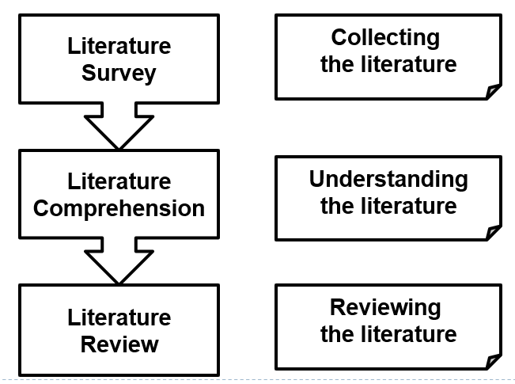

The Literature Survey/Search
- ‘a systematic and thorough search of all types of published literature in order to identify as many items as possible that are relevant to a particular topic’
- Gash, S. (2000) Effective Literature Searching for Research 2nd Ed., Aldershot: Gower Publishing Ltd

Literature Survey
- Identifying and acquiring
  - the research papers,
  - textbooks,
  - web-sites,
  - theses, etc.
- to get a comprehensive overview of the research that has been done in the area that you are investigating.

Sources of Information
- Books
  - Textbooks, specialist collection books, reference books
- Journal Articles
  - Peer-reviewed academic articles
  - Each journal has a specific focus
- Review articles
- Reports
- Theses/dissertations
- Conference Proceedings
- Media
- Social Media

Evaluating the Source
- Usefulness
- Credibility
- Bias

Usefulness – Given Your Purpose
Given Your purpose:
- What will this source add to your research project?
- Will it help support a major point?
- Demonstrate you have researched thoroughly?
- Help establish your own credibility as a conscientious researcher?
- Help establish there is a gap in existing research?

Usefulness – is it really relevant?
- Is it really relevant?
  - Or are you simply listing sources to meet a quota?
- Consider the level of specialization:
  - General sources can be helpful when you are beginning your research, but you may need more specialized or more current resources.
  - Ask yourself: “Who was this source written for? A general audience? A more specialized group?”
  - How does this resource fit with your audience and purpose?

Credibility

Definition:
- 1. capable of being believed; believable: a credible statement.
- 2. worthy of belief or confidence; trustworthy: a credible witness.

Credibility is important!
- If your research is flawed, so is your argument.
- If you use credible sources, you can believe them, and your readers can believe you.

How do I Know if my Sources are Credible? – whats credible?
- Most books you find via your library are credible.
- Most large newspapers are credible.
  - Guardian
  - Irish Times etc.
- Scholarly journals are usually credible.
  - IEEE Transactions, ACM, Emerald, SAGE, Taylor and Francis, Elsevier, Springer, etc.
- Most government publications are credible.
- Reputable organizations are usually credible.
- Most information from colleges is credible.
  - .edu websites

How do I Know if my Sources are Credible? – can rule out….
You can automatically rule out:
- Wikipedia
- Blogs
- Twitter
- Facebook
- Personal sites

Using the Internet for Research
- The internet offers the BEST information on MANY topics.
- The internet offers the WORST information on MOST topics.
- You can use internet resources for research papers, but you have to be careful.

Credibility – publisher, author, sponsor
- Consider the credentials of the publisher or sponsor:
  - What can you learn about the newspaper or sponsor of the source?
    - For example, is it a newspaper known for integrity or is it a tabloid?
    - Is it a popular source, or is it sponsored by a professional organization or academic institution?
    - Is the book published by a company you recognize or can locate easily on the web?
- Consider the credentials of the author:
  - An author’s credentials usually included as part of the publication.
  - When researching, does the author’s name come up in other sources? He may be influential in his field

Credibility - date of publication
Date of the publication:
- Recent publication dates may be more useful in the sciences or other fields where change is frequent and current information is essential.
- However, in the Humanities, the most authoritative works may be the oldest.
- Publications dates on the web are difficult to assess, which explains why most citation and referencing schemes suggests recording the date you accessed the information instead of a publication date.

Credibility – the source accuracy / cross ref
Accuracy of the source:
- Can you locate other sources that corroborate this source?
- In other words, can you find other sources that have similar information or support parts of what you find in this source?
Cross-references to the source:
- Is the source cited in other works?
- If you see the source cited other places, notice what another author says about the source. Another’s comments may give you insight into the credibility.

What is Bias?
- According to Webster's Dictionary online:
- Bias is defined as:
  - an inclination of temperament or outlook; especially: a personal and sometimes unreasoned judgment: PREJUDICE

Bias – stance of the source
Consider the stance of the source:
- It’s important to identify the source’s point of view (bias).
- Would the author have a reason to slant the information?
- Omit essential facts or details?
- Identifying the source is the first step towards evaluating whether the source’s bias would be a concern.
- For instance, would the source be trying to convince you of an idea? Sell something? Call you to action?
- Do any of those purposes call the information in the source into question?

Looking for Bias – academic, business, self-promotion
In academic or business politics
- Relationships between the author and publications
- Author and other authors
- Publications and sponsors
In self-promoters
- Authors of books, websites, or various written works promote their works (ignoring other relevant work)

Red Flags for Source Credibility
- Anonymity
  - No author or sponsoring entity
- Negative reviews by other sources
- Misspelled words and poor grammar
- Vague or sweeping generalizations
- One-sided viewpoint that does not address an opposing side
- Numbers or statistics presented without an identified source for them
- Absence of source documentation when the discussion clearly needs such documentation
- You cannot find any other sources that present the same information or acknowledge that the same information exists (lack of corroboration)
- Intemperate tone or language
  - E.g. “will never work“, “could not possibly work”
- Overclaims
  - “Billions in revenue can be saved by implementing this solution."
- Sweeping statements of excessive significance
  - "This is the most important idea ever conceived!"
- Conflict of Interest
  - "Welcome to the Company X. To read our report, ‘How Product Y can work for you,' click here."

Good Sources?
- Journal Papers
- Conference Papers
- Textbooks
- Other Books
- Company Whitepapers
- Company Websites
- Blogs
- Wikis
Credibility HANDLE WITH CARE
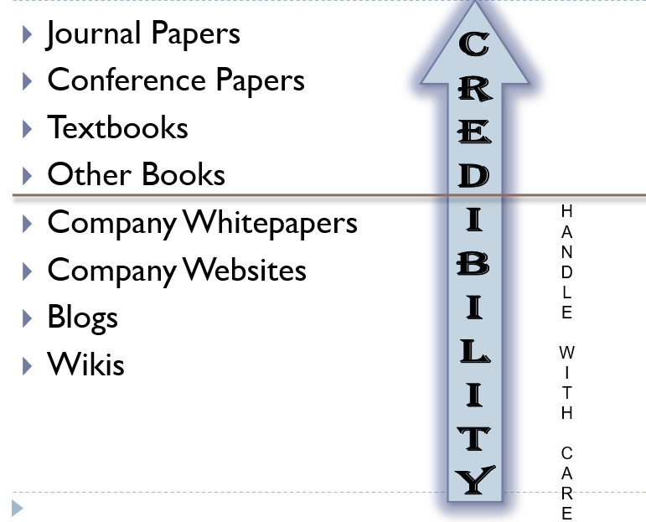

Is it C.R.A.P.?
- Currency
  - How recent is the information?
  - Is it current enough for your topic?
- Reliability
  - Does the creator provide references or sources for data or quotations?
  - What is the publisher’s interest (if any) in this information?
  - Are there advertisements on the website?
  - Is the creator/author trying to sell you something?
- Authority
  - Who is the creator or author?
  - What are their credentials?
  - Who is the publisher or sponsor?
  - Are they reputable?
- Point of View
  - Is this fact or opinion?
  - Is it biased?
  - Is it balanced?

Literature Survey
- A focused survey technique is recommended to ensure you ‘hit the ground running’
- If you know the exact domain of your research it makes sense to initially focus your search on papers that relate (almost) exactly to your own research, rather than spending a great deal of time reading every paper under the sun that seems remotely relevant.
- Recording the sources you have found and read is also of vital importance

Keywords - Literature Survey
- A vital step is to identify
- KEYWORDS


How do Keywords Help?
- Keywords help you narrow your results
- Find connections between concepts
- Saves you time
- Find results that you can use (relevant)
- Research is NOT a one-shot process
- The better your keywords, the better your results will be

Keyword Tips
- Keep a list as you conduct your research
- Use different spellings and variations of a word
  - education, educational, educators, educating
- Use synonyms (words that mean the same thing)
- Use related terms (word that have something to do with your concept, e.g. education ~ teachers)

Example
- What are the pros and cons of social media use by college students?
  - Key Concept > college students
    - Synonyms &Related Terms > undergraduate / university students / education
  - Key Concept > social media
    - Synonyms &Related Terms > facebook / snap chat / twitter / instagram

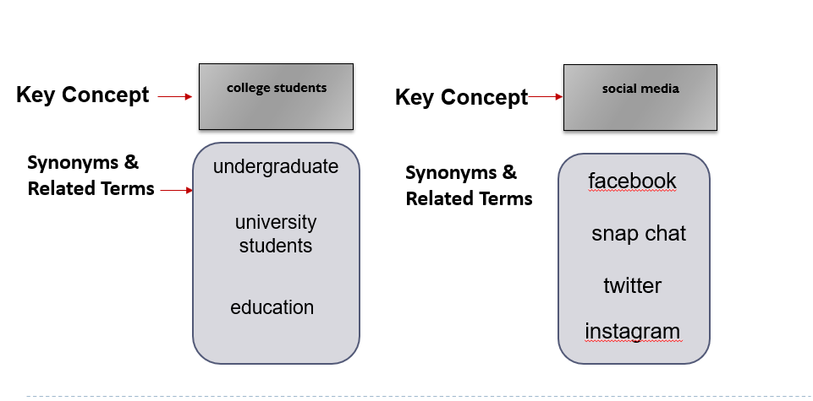

Boolean Connectors - AND
- AND is a Boolean connector word used to combine two concepts.

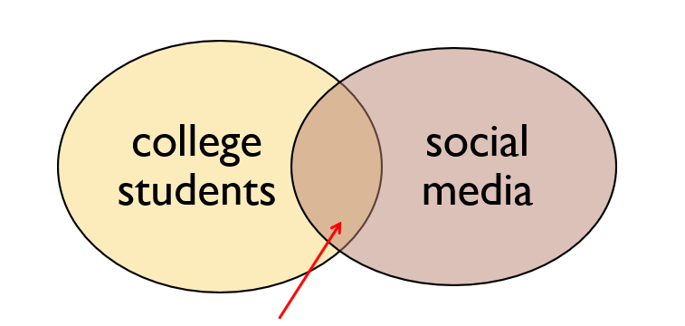

- AND narrows down your search because your results will contain articles that have both concepts together, not just one.

Boolean Connectors - OR
- OR is a Boolean connector word that is used when you have synonyms.

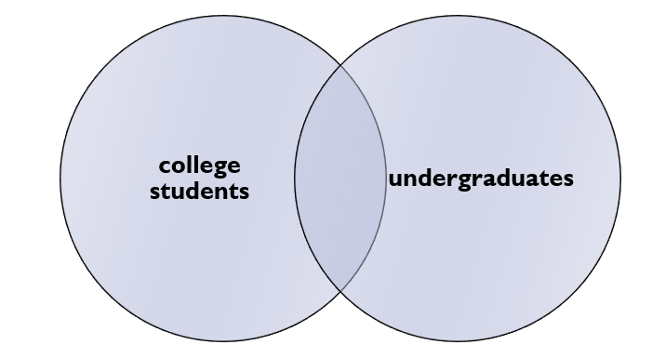

- OR broadens your search because your results will contain articles that any of the terms.

Boolean Connectors – OR usage
- Use OR for synonyms (of coke)
 OR  OR 

Synonym Finders
- VisuWorld online graphic dictionary http://www.visuwords.com/
- Thesaurus.com http://thesaurus.com/
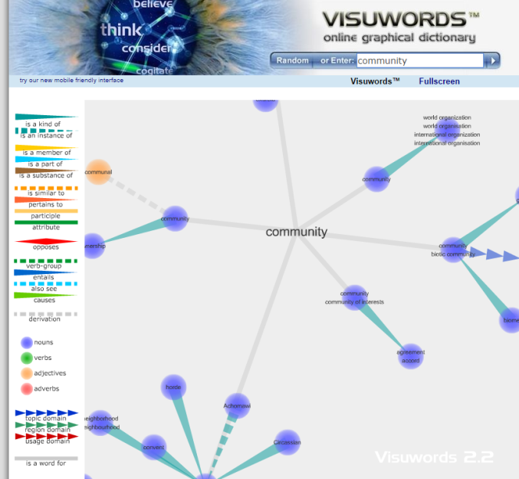



Coming up with your Search Terms
- Search terms are often subject keywords
  - Can also be names, formulae, significant numbers, depending on what you are searching for and the sources you are using.
- Defining your search terms:
  - Define the subject in one sentence, for example:
    - The effectiveness of using visualisation to improve knowledge sharing in non-profit organisations
  - Split this sentence into concepts
    - discard words which merely describe the relationship between one concept and another, for example:
      - Visualisation Knowledge Sharing Non-profit organisations
  - For each of the concepts think of synonyms
  - (words with similar meaning) or related terms that would be useful.
  - Look up your terms in the thesaurus and this will tell you related or preferred terms

Coming up with your Search Terms
- Use these terms in your search.
  - The way that you input and combine terms will depend on the source that you are using.
- Look up your terms in the thesaurus and this will tell you related or preferred terms, for example:
  - Visualisation; Visualization; Representation; Graphical
  - Knowledge; Information;
  - Knowledge Sharing; Knowledge Management; Knowledge Transfer; Communities of Practice
  - Non-profit organisations; Government; Non-commercial; Voluntary; Educational

Identify some Keywords for this Topic
- What is the Effect of Regular Playing Of First Person Shooter Games on Secondary School Results?
- Effect >>>>
- Secondary school >>>
- Games >>>>

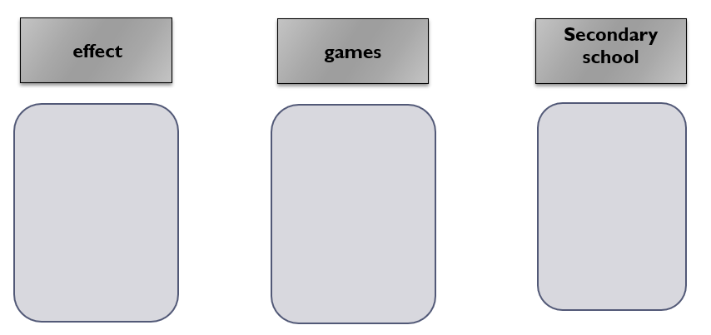

Limitations of Search Engines
- Information 'hidden' from search engines
  - Many sources of academic information, including important journals, are hidden from search engines
  - In particular older references may be less likely to be on the web.
- Quality of information
  - Search engines can lead you to incorrect information, or information at the wrong level.
  - Google scholar is better in this respect, but still has the other limitations.
- Quantity of information
  - A particular journal article reference can turn up many times in a search engine results set, whereas in a database search it would only appear only once.
- Limited search options
  - Keyword type searching is the main search facility on search engines.
  - Databases can offer additional options, including controlled vocabulary searching (using a thesaurus, subject headings) and citation / cited reference searching.
  - For some subjects, specialised search options may also be available

Research Sites – within section 3

Digital Libraries
- Organized collections of digital information.
  - Combine the structuring and gathering of information with the digital representation of that information.
- Managed collection of information, with associated services
- Many communities involved in digital libraries, each with quite different
  - concepts, emphasis, approach, agenda
- Very high significance for the future of libraries

What is a Digital Library?
- A digital library is a networked collection of digital objects – text, still images, moving images, sound, data – with arrangement, search features, and metadata that allow for discovery and presentation, supporting research and teaching, and with attention paid to architecture, persistence, longevity, and digital preservation.

Locations / sources

Springer
http://www.springer.com/computer?SGWID=0-146-12-150008-0
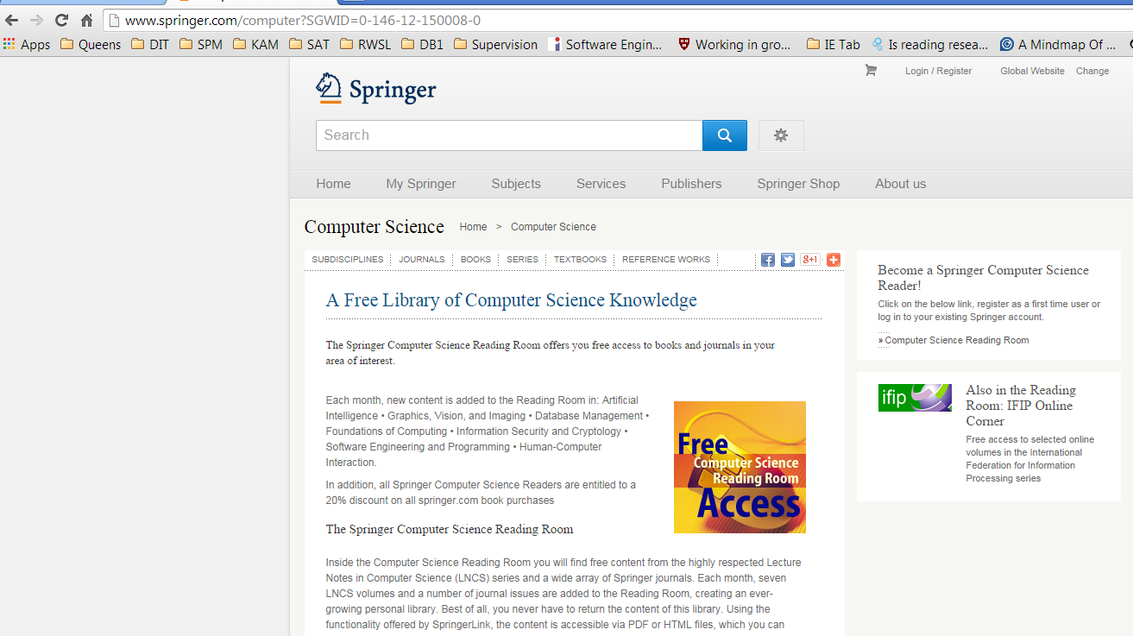

ACM Digital Library
http://dl.acm.org/
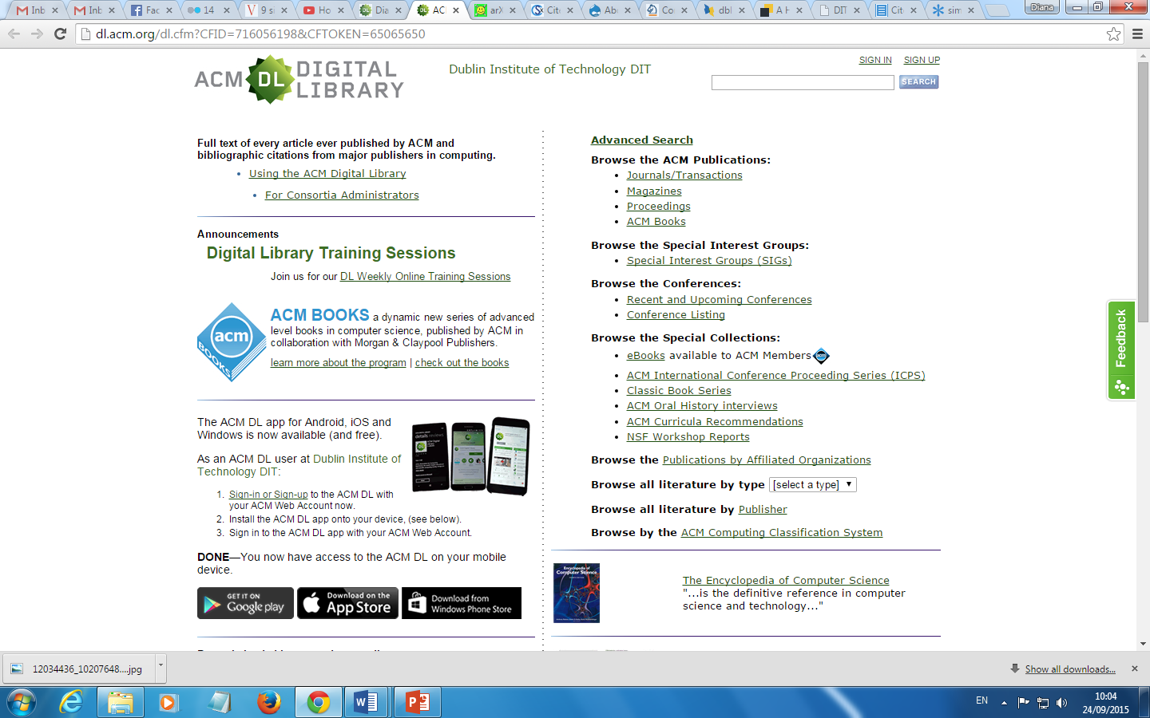

Who are ACM?
- The Association for Computing Machinery, or ACM, is a learned society (academic association) for computing.
- It was founded in 1947 as the world's first scientific and educational computing society.
- ACM is organized into over 170 local chapters and 35 Special Interest Groups (SIGs), through which it conducts most of its activities.
- Many of the SIGs, like SIGGRAPH, SIGPLAN, SIGCSE and SIGCOMM, sponsor regular conferences which have become famous as the dominant venue for presenting new innovations in certain fields.
- The groups also publish a large number of specialized journals, magazines, and newsletters.


ACM Journals
- Computing Reviews
- Computing Surveys
- Journal of Data and Information Quality (JDIQ)
- Journal of Experimental Algorithmics (JEA)
- Journal of the ACM (JACM)
- Journal on Computing and Cultural Heritage (JOCCH)
- Journal on Educational Resources in Computing (JERIC) -- Discontinued, replaced by Transactions on Computing Education (TOCE)
- Journal on Emerging Technologies in Computing Systems (JETC)
- ACM Letters on Programming Languages and Systems (LOPLAS) (No Longer Published)
- Transactions on Accessible Computing (TACCESS)
- Transactions on Algorithms (TALG)
- Transactions on Applied Perception (TAP)
- Transactions on Architecture and Code Optimization (TACO)
- Transactions on Asian Language Information Processing (TALIP)
- Transactions on Autonomous and Adaptive Systems (TAAS)
- Transactions on Computation Theory (TOCT)
- Transactions on Computational Logic (TOCL)
- Transactions on Computer-Human Interaction (TOCHI)
- Transactions on Computer Systems (TOCS)
- Transactions on Computing Education (TOCE) -- Replaces Journal on Educational Resources in Computing (JERIC)
- Transactions on Database Systems (TODS)
- Transactions on Design Automation of Electronic Systems (TODAES)
- Transactions on Economics and Computation (TEAC)
- Transactions on Embedded Computing Systems (TECS)
- Transactions on Graphics (TOG)
- Transactions on Information and System Security (TISSEC)
- Transactions on Information Systems (TOIS)
- Transactions on Intelligent Systems and Technology (TIST)
- Transactions on Interactive Intelligent Systems (TiiS)
- Transactions on Internet Technology (TOIT)
- Transactions on Knowledge Discovery from Data (TKDD)
- Transactions on Management Information Systems (TMIS)
- Transactions on Mathematical Software (TOMS)
- Transactions on Modeling and Computer Simulation (TOMACS)
- Transactions on Multimedia Computing, Communications and Applications (TOMM)
- Transactions on Parallel Computing (TOPC)
- Transactions on Programming Languages and Systems (TOPLAS)
- Transactions on Reconfigurable Technology and Systems (TRETS)
- Transactions on Sensor Networks (TOSN)
- Transactions on Software Engineering and Methodology (TOSEM)
- Transactions on Spatial Algorithms and Systems (TSAS)
- Transactions on Speech and Language Processing (TSLP)
- Transactions on Storage (TOS)
- Transactions on the Web (TWEB)
- IEEE/ACM Transactions on Audio, Speech and Language Processing (TASLP)
- IEEE/ACM Transactions on Computational Biology and Bioinformatics (TCBB)
- IEEE/ACM Transactions on Networking (TON)

ACM SIGs (Special Interest Groups)
- SIGACCESS - Accessible Computing
- SIGACT - Algorithms and Computation Theory
- SIGAda - Ada Programming Language
- SIGAPP - Applied Computing
- SIGARCH - Computer Architecture
- SIGART - Artificial Intelligence
- SIGBED - Embedded Systems
- SIGCAS - Computers and Society
- SIGCHI - Computer-Human Interaction
- SIGCOMM - Data Communication
- SIGCSE - Computer Science Education
- SIGDA - Design Automation
- SIGDOC - Design of Communication
- SIGecom - Electronic Commerce
- SIGEVO - Genetic and Evolutionary Computation
- SIGGRAPH - Computer Graphics and Interactive Techniques
- SIGIR - Information Retrieval
- SIGITE - Information Technology Education
- SIGKDD - Knowledge Discovery in Data
- SIGMETRICS - Measurement and Evaluation
- SIGMICRO - Microarchitecture
- SIGMIS - Management Information Systems
- SIGMM - Multimedia
- SIGMOBILE - Mobility of Systems, Users, Data and Computing
- SIGMOD - Management of Data
- SIGOPS - Operating Systems
- SIGPLAN - Programming Languages
- SIGSAC - Security, Audit and Control
- SIGSAM - Symbolic and Algebraic Manipulation
- SIGSIM - Simulation and Modeling
- SIGSOFT - Software Engineering
- SIGSPATIAL - SIGSPATIAL
- SIGUCCS - University and College Computing Services
- SIGWEB - Hypertext, Hypermedia and Web

Please Note: You have limited access to ACM Digital Library via DIT.Student memberships available for purchase.

DBLP
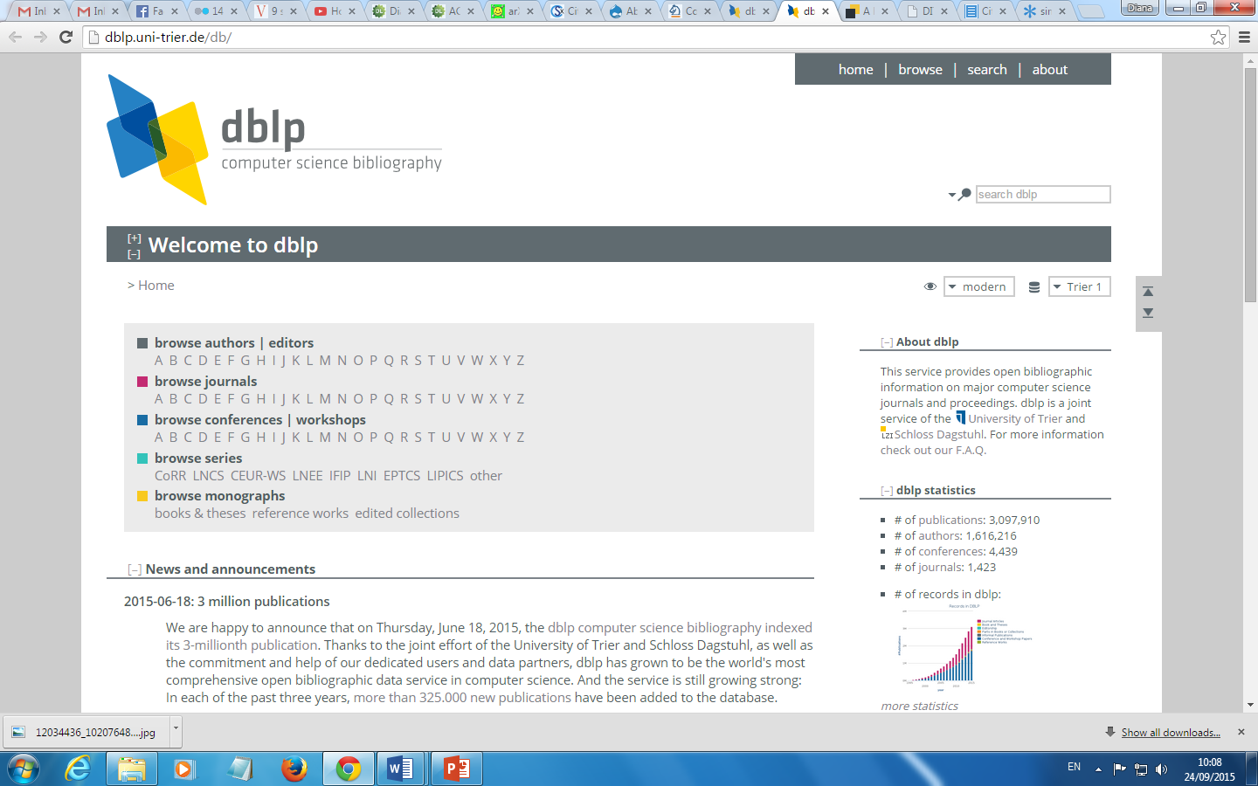

Databases
Academic Search Complete
- http://www.dit.ie/library/databases/
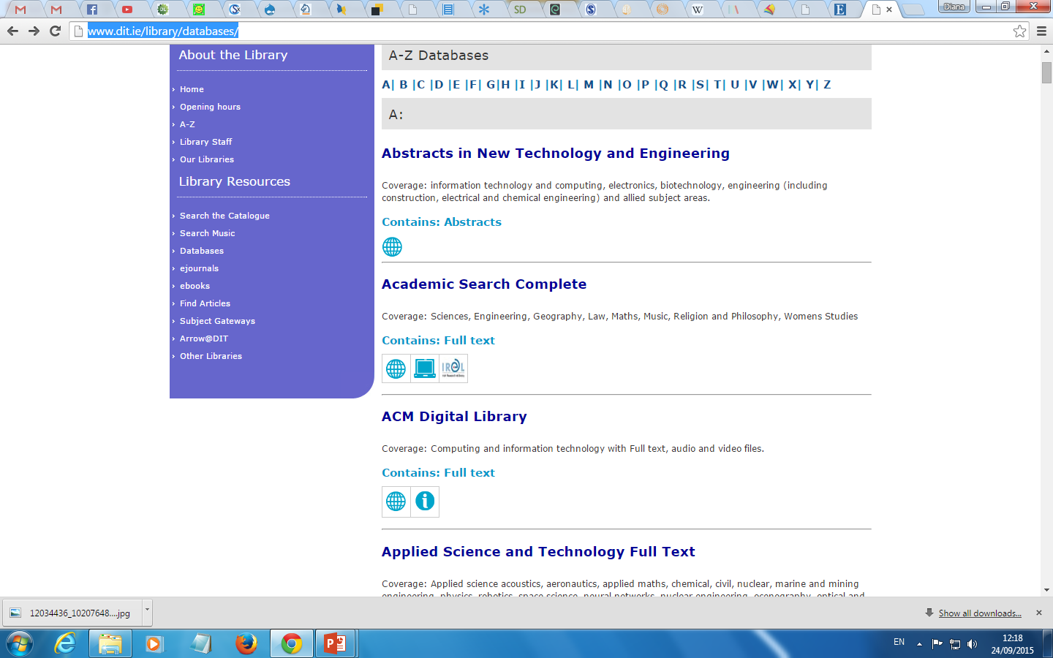

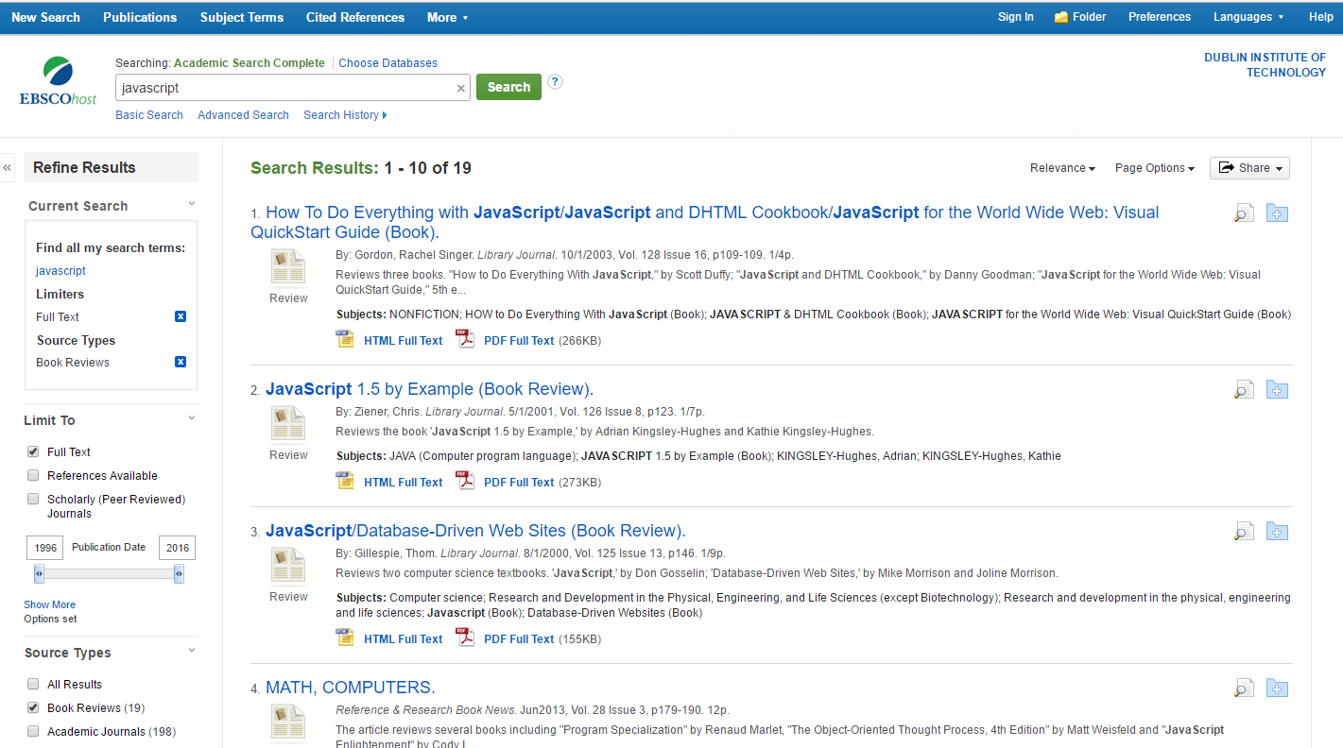

Databases
http://www.sciencedirect.com/science/bookbshsrw/sub/infosys
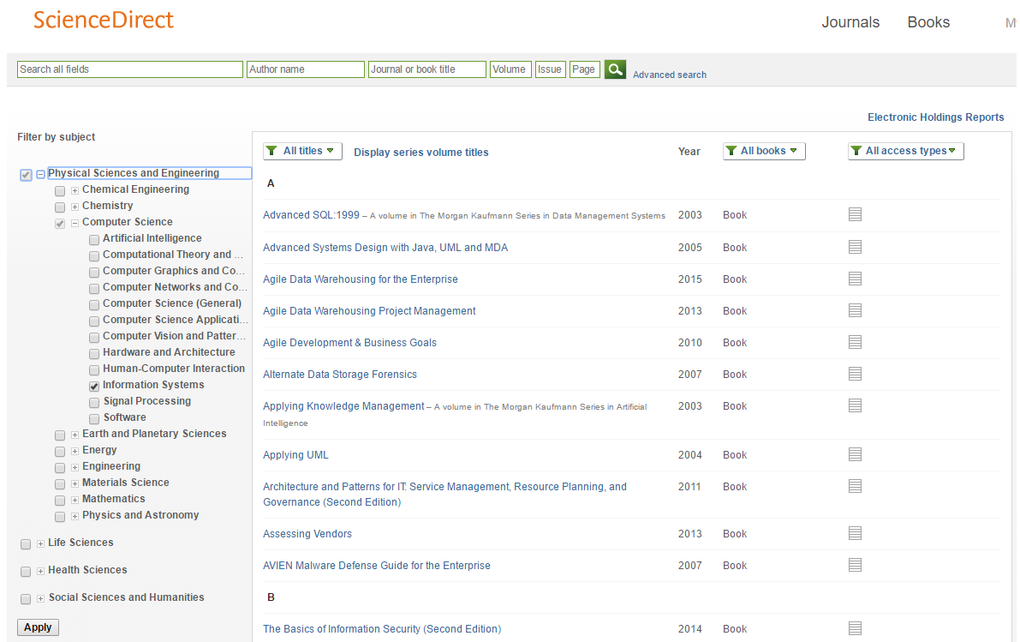

Search Engines: Google Scholar
Operators and search help
- http://support.google.com/websearch/bin/answer.py?hl=en&answer=136861
Google Search Tools and Filters
- https://support.google.com/websearch/answer/142143?hl=en&ref_topic=3180167
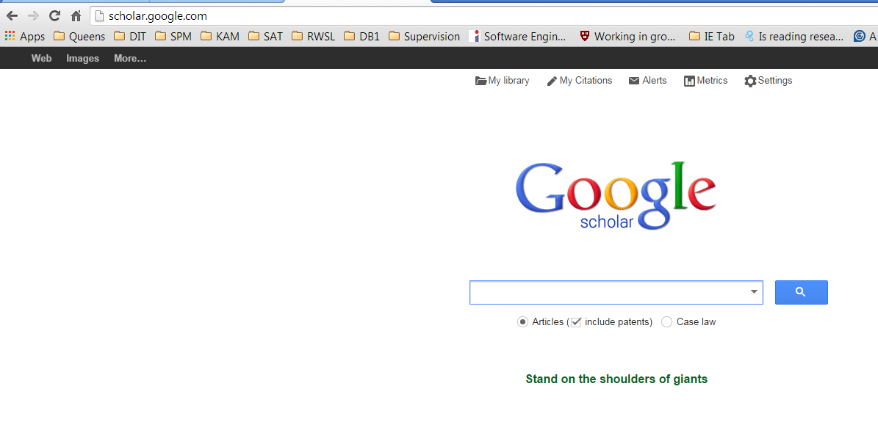

Google Scholar
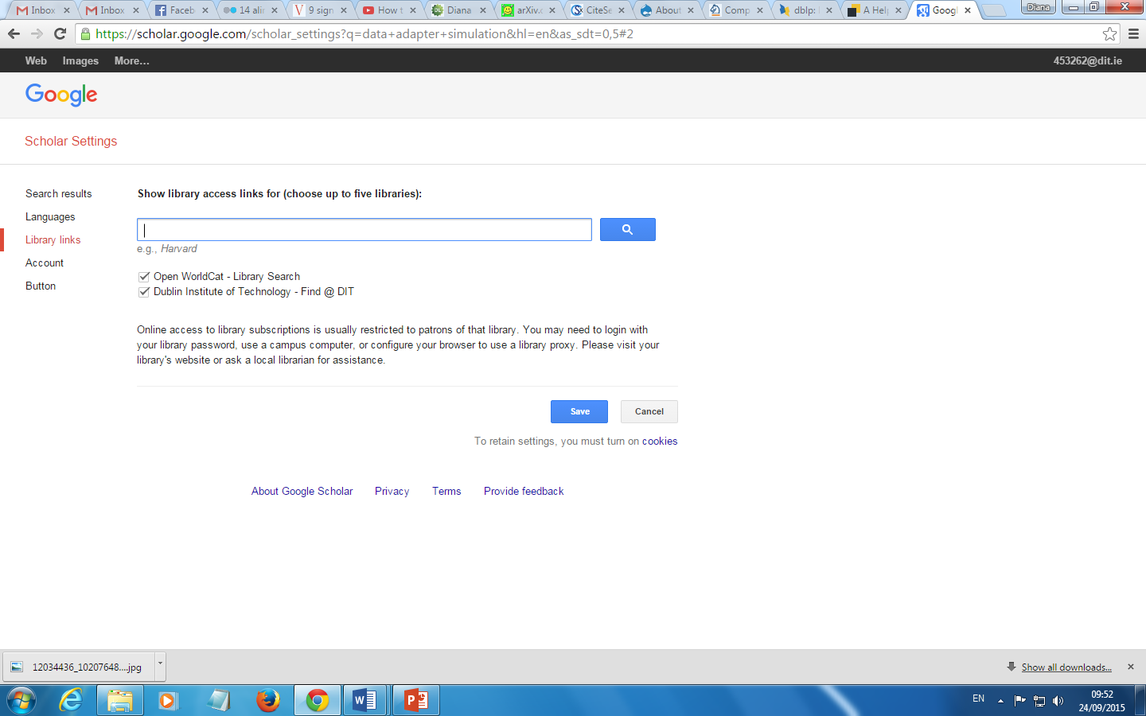

Google Scholar
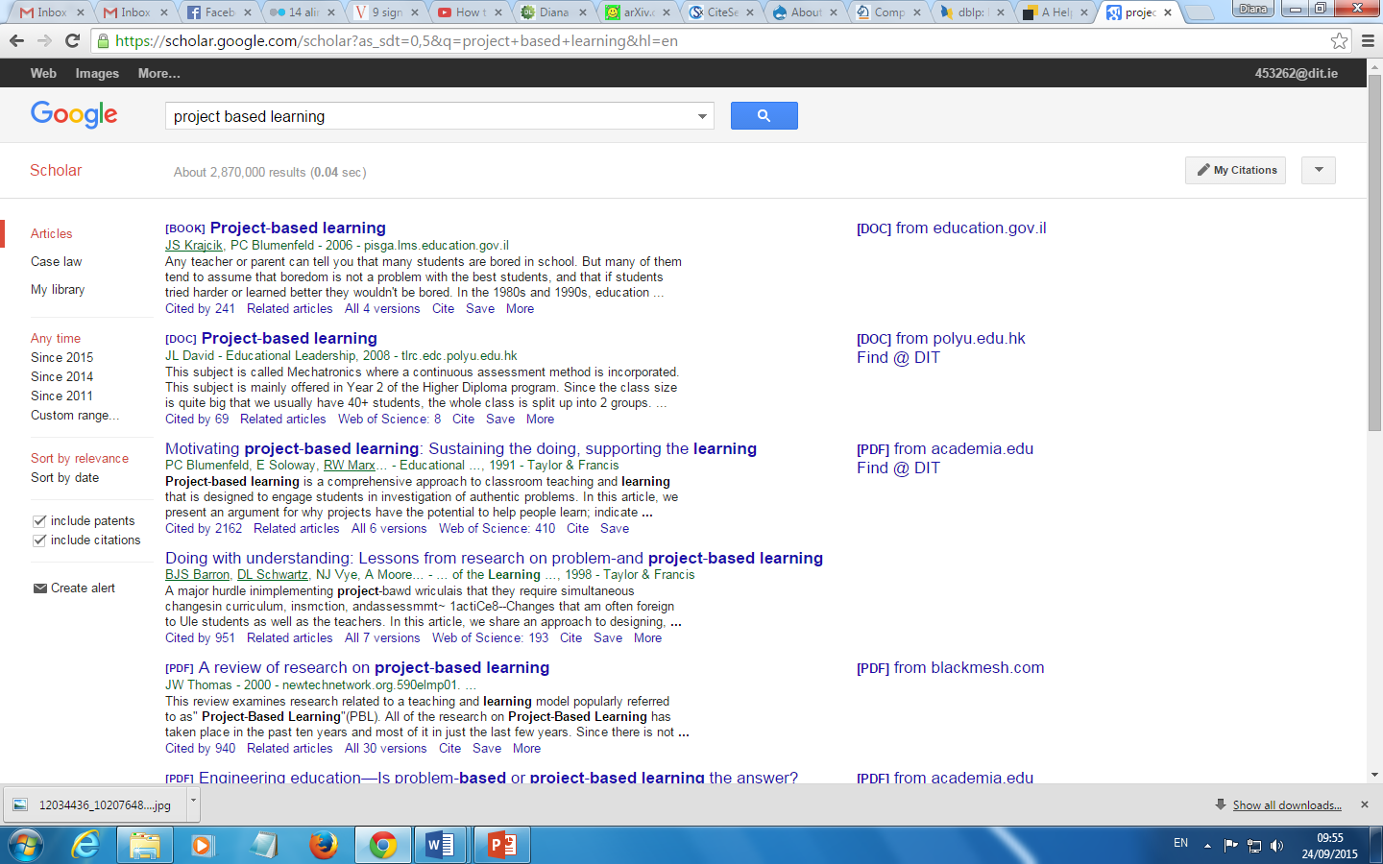

Literature Survey – record your search details!!!
- list all the keywords you’ve tried
- record ideas you have about your research
- record details of reading you have done and what you think of it.
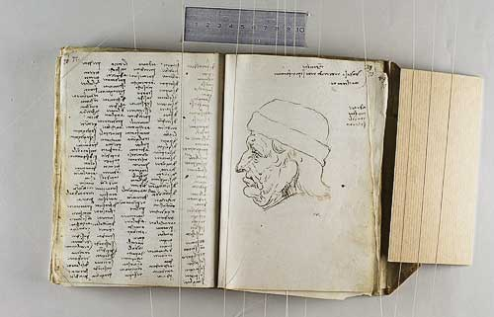

IEEE
- Another significant group are IEEE (Institute of Electrical and Electronics Engineers) called “eye-triple-e” is a professional organization for the advancement of technology, it also publishes a number journals,
- You have full access to the IEEE digital library via the DIT Library


IEEE Transactions
- IEEE Computational intelligence and AI
- IEEE Transactions on Computers
- IEEE Transactions on Dependable and Secure Computing
- IEEE Transactions on Knowledge and Data Engineering
- IEEE Transactions on Parallel and Distributed Systems
- IEEE Transactions on Pattern Analysis and Machine Intelligence
- IEEE Transactions on Services Computing
- IEEE Transactions on Software Engineering
- IEEE Transactions on Visualization and Computer Graphics
- IEEE Transactions on Affective Computing
- IEEE Transactions on Haptics
- IEEE Transactions on Information Technology in Biomedicine
- IEEE Transactions on Learning Technologies
- IEEE Transactions on Mobile Computing
- IEEE Transactions on Multimedia
- IEEE Transactions on Nanobioscience
- IEEE Transactions on Very Large Scale Integration (VLSI) Systems
- IEEE/ACM Transactions on Computational Biology and Bioinformatics
- IEEE/ACM Transactions on Networking

Emerald Journals
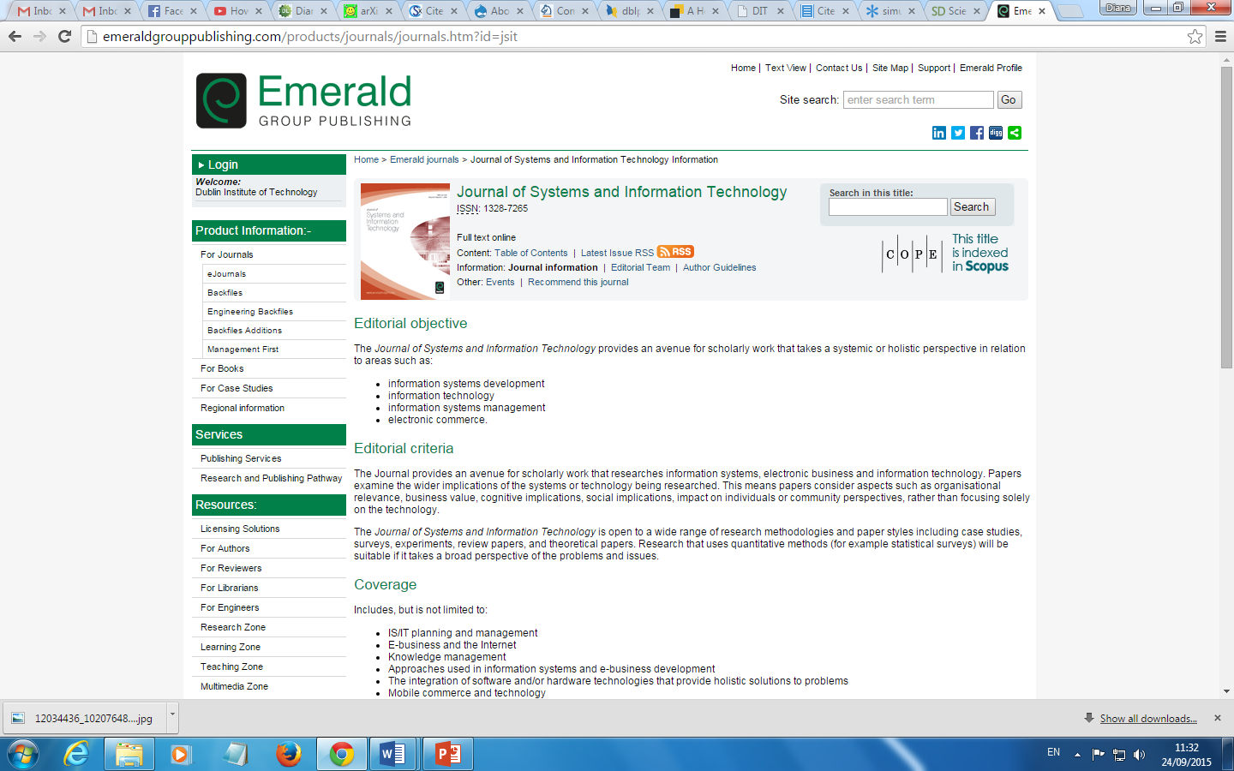

SAGE (online.sagepub.com)
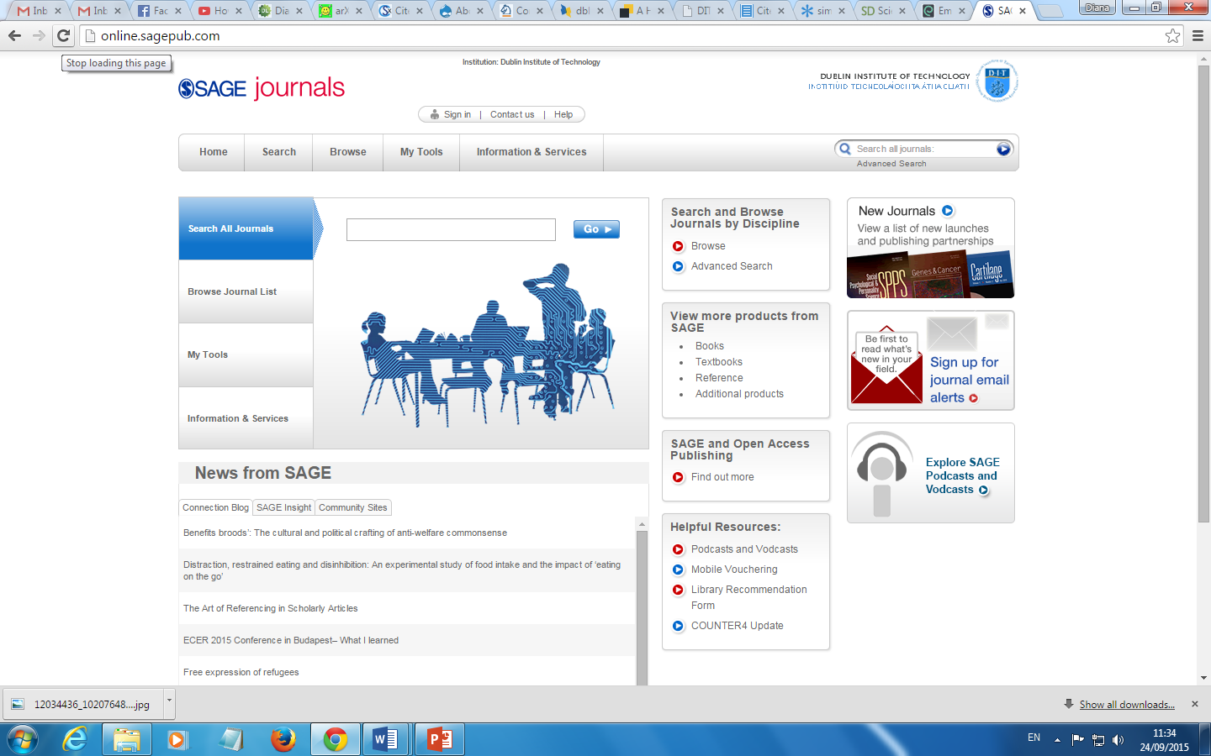

Journal Credibility?
- As you start to find out more about an area you will start to see that there are certain journals that people researching in the area target
- There are numerous ways of measuring its ‘quality’
- Using its ranking via the journal citation reports (available via DIT)
  - JCR distills citation trend data for 7,600+ journals from more than 25 million cited references every year
    - Science Edition and Social Science Edition released annually
    - Science Edition covers 5,928 journals in 171 subjects
    - Social Science Edition covers 1,716 journals in 55 subjects
  - What can we do with the JCR?
    - Compare a selection of journals in terms of their impact
    - Find related journals
    - Identify review journals
    - View citation information for subject categories

Journal Credibility?
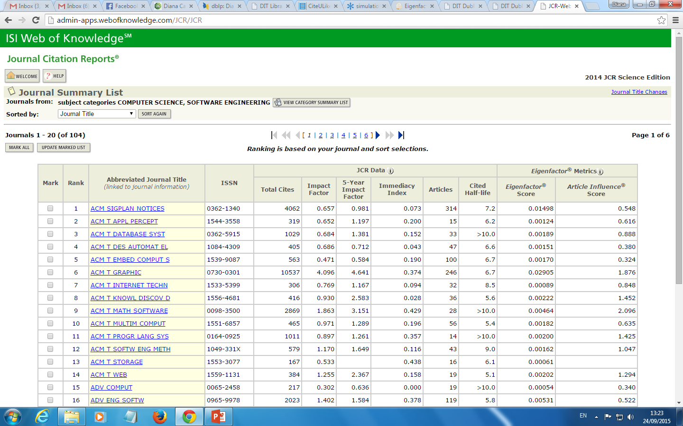

Journal Credibility?
- The sponsor
  - ACM and IEEE are highly regarded sponsors
- Look at the number of citations papers you are interested in have (using Google Scholar or something like CiteSeer)
- Look at the people who are on the editorial/review panel
- Look at how long it has been in existence (how many volumes, how many issues per volume)

Peer Review
What does peer-reviewed mean?
- When you submit a research paper, a number of people will read the paper and give feedback/corrections on it.
- The people who review it will be as expert as you are in the field of research (and as such are your peers).
- Some conferences only get one person to review a paper, others get two, others more – the more people that review conference papers, the more prestigious the conference is, since the papers in it are bound to be of very quality.
- Journal papers are normally reviewed by several people, and are considered very credible.

Conference Credibility?
- How do you identify the top level conferences in computer science?
- Look at sponsor
  - Again ACM and IEEE sponsored conferences are well regarded
    - BUT international conferences are more highly regarded than local ones
- Look at how long it has been running
- Look at the people involved in the committees
- Look at the original call for papers
  - What type of topics were of interest?

Sources
Microsoft Academic Search
http://academic.research.microsoft.com/ v
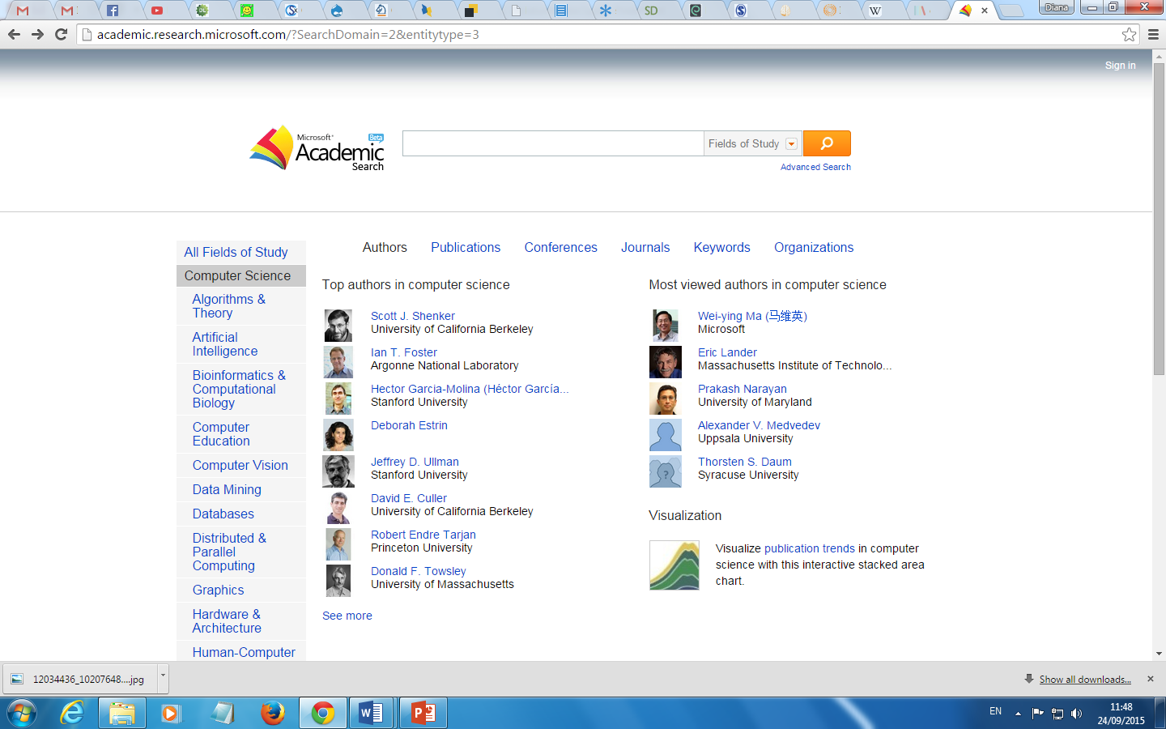

Computer Science Conference Rank
http://www.core.edu.au/index.php/conference-rankings
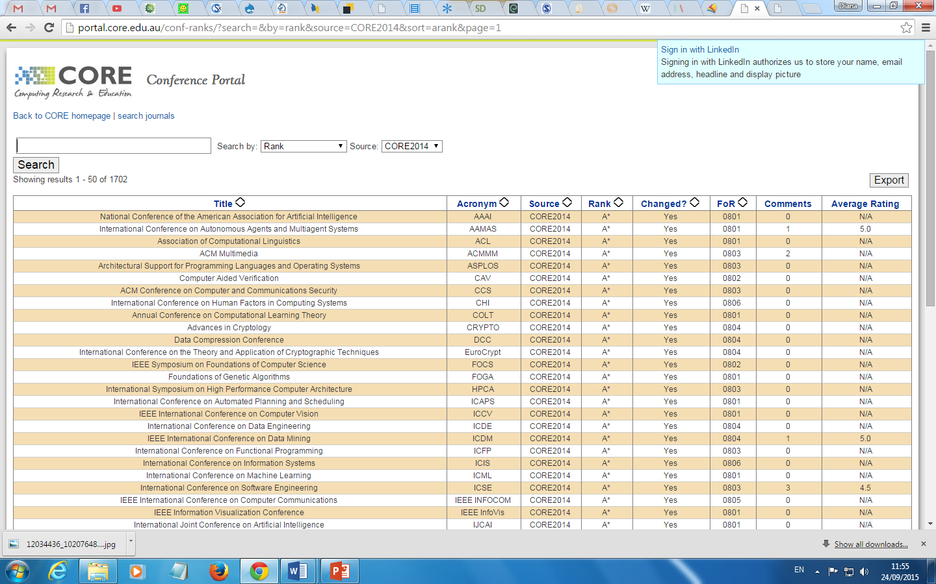

Snowball Technique
- As you read you will redefine your focus through searches
- You will become familiar with authors and texts commonly cited and start to look for specific papers
- Snowball technique is when you follow up references from bibliographies of texts you read
- Keep a record

DIT Library
http://www.dit.ie/library/subjects/computerscience/postgraduates/
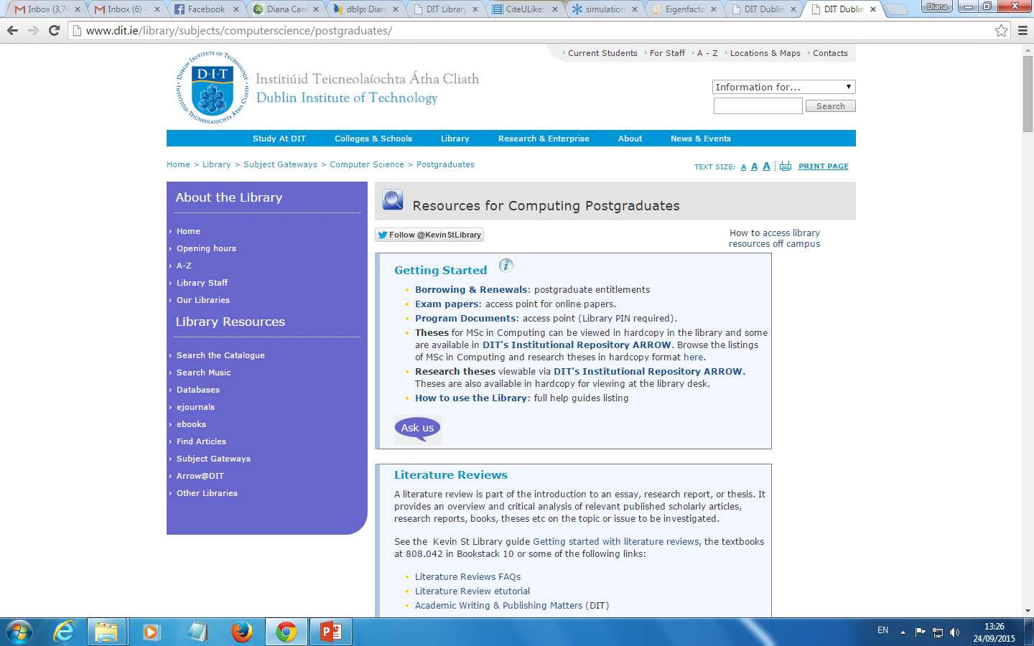

Accessing resources from outside DIT
- You will need your DIT Library pin
- If you access a resource directly (without going through a DIT library link) you will be using the Shibboleth system
- For this you will need your DIT username and password
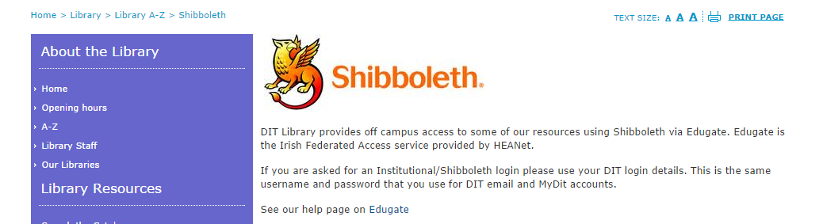

DIT Library
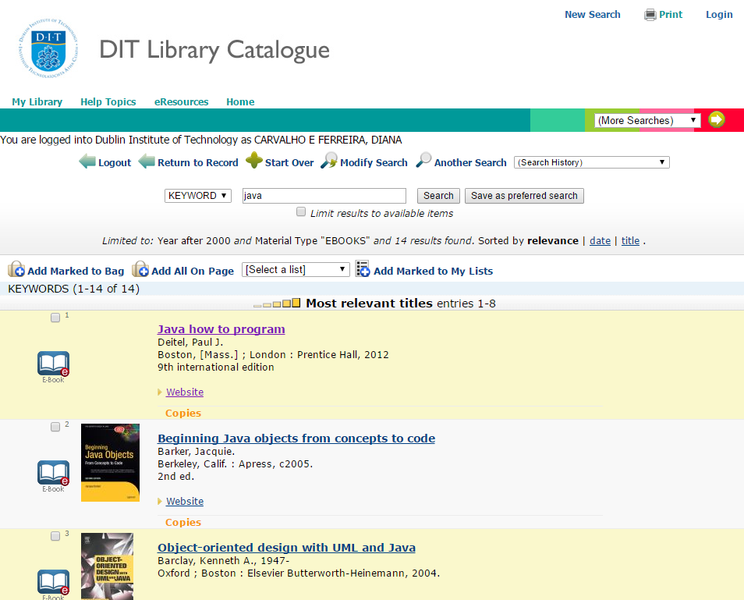

Activity
- Think of a topic of your interest
- List some keywords that will help you locate relevant material
- Refine your list and complete the search worksheet (Steps 1-4)
  - Template on webcourses
  - An example is included in pdf
- Investigate a number of resources (available via the DIT Library) using your keywords
  - Summon (http://dit.summon.serialssolutions.com/#!/)
  - Google Scholar (remember to setup your library access in the settings)
  - Academic Search Complete (use the advanced search option)
  - ScienceDirect (use the advanced search option)
- Complete the search worksheet (Steps 5-7)
- Discussion: which were the most effective resources for your topic?

References (collected)
- Gash, S. (2000) Effective Literature Searching for Research 2nd Ed., Aldershot: Gower Publishing Ltd
- VisuWorld online graphic dictionary http://www.visuwords.com/
- Thesaurus.com http://thesaurus.com/
- http://www.springer.com/computer?SGWID=0-146-12-150008-0
- http://dl.acm.org/
- http://www.dit.ie/library/databases/
- http://www.sciencedirect.com/science/bookbshsrw/sub/infosys
- http://support.google.com/websearch/bin/answer.py?hl=en&answer=136861
- https://support.google.com/websearch/answer/142143?hl=en&ref_topic=3180167
- http://academic.research.microsoft.com/
- http://www.core.edu.au/index.php/conference-rankings
- http://www.dit.ie/library/subjects/computerscience/postgraduates/
- Summon (http://dit.summon.serialssolutions.com/#!/)

References (collected)
Adapted from Saunders et al., 2009; https://onion.derby.ac.uk/
  - springer >> http://www.springer.com/computer?SGWID=0-146-12-150008-0
  - ACM Digital Library >> http://dl.acm.org/
  - DBLP >> https://dblp.org/
  - Databases >> Academic Search Complete
    - dit >>> http://www.dit.ie/library/databases/
    - sciencedirect >> http://www.sciencedirect.com/science/bookbshsrw/sub/infosys
- Search Engines: Google Scholar
  - Operators and search help
    - http://support.google.com/websearch/bin/answer.py?hl=en&answer=136861
  - Google Search Tools and Filters
    - https://support.google.com/websearch/answer/142143?hl=en&ref_topic=3180167
  - IEEE >>>
    - https://www.ieee.org/
    - https://ieeexplore.ieee.org/Xplore/home.jsp
  - Emerald Journals >>> https://www.emerald.com/
  - SAGE (online.sagepub.com) >>> https://journals.sagepub.com/
  - Number of citations >> CiteSeer) >>> https://citeseerx.ist.psu.edu/
  - Microsoft Academic Search > http://academic.research.microsoft.com/
  - Computer Science Conference Rank >> http://www.core.edu.au/index.php/conference-rankings
  - DIT Library >> http://www.dit.ie/library/subjects/computerscience/postgraduates/

Section 4 – Citation and referencing

Aim of Session
- To decide when to quote, paraphrase or summarize other work
- To describe the main features of proper citation and referencing
- To recognize the APA6 style
- To use reference management software and validate its output

Using Sources in Your Work
- Provides evidence and examples to support your arguments, propositions, opinions or findings
- Establishes credibility
- Providing a map to reader of where your work fits
- And what its based on
- Allows reader to locate, review and test evidence and examples used
- Or to use it for their own purposes
- Gives recognition to work which you’ve benefited from
- Demonstrates that you have considered relevant work in the area

Using Sources in Your Work
- To support what you are saying
- Introduce someone’s work or opinion, in order to discuss it
- Show differences between other peoples’ work or opinions
- Show differences between your own work and that of others
- Provide examples

Using Sources in Your Work
Ways of doing it:
- Quote
- Paraphrase
- Summarise

Two Things You Need To Know
- Citing
- Acknowledging within the text/content of your work the source or sources you are using to build an argument or support an opinion.
- Do this when
  - You want to take a section of a source.
    - Put it in quotations, cite with page numbers and reference
  - You want to paraphrase or present a summary of information taken from a source(s).
    - Rewrite, cite and reference.
- Because
  - You want to support an argument
  - You want to show another point of view

Two Things You Need To Know - Referencing
- Referencing
  - When you cite someone’s work, you must include the full details of where to find the original text.
  - You do this by including a reference list, usually at the end of your submission.
  - Each reference details
    - The Author(s) Name
    - The Year of Publication
    - The Correct Title
    - Where the source can be located – Details of Publication
- This enables the reader of your work to locate any sources and read them for themselves.

Citing and Referencing
- Performed as a pair
- If you cite
- You must include the full detail in your reference list

Handling Common Knowledge
- Any knowledge that is so well known that it can be found in numerous sources does not have to be cited.
  - A large number of programming languages use compilers to translate source code to machine executable code. However, some are translated into a form which can be interpreted when needed to form machine code.
- If however you want to state arguable facts and figures, you will need to cite a source to support your argument:
  - A large number of programming use compilers to translate source code to machine executable code. However, some are translated into a form which can be interpreted when needed to form machine code, as this is more efficient in a mobile world (Jams, 2010).

Using Sources in Your Work – To report
- To report
  - Facts, figures, definitions, etc.

- Citation:
- Standish (2009) showed that only 32% of all software projects were deemed successful.

- Reference:
  - Standish (2009). Standish Chaos Report 2009. Retrieved October 1, 2011, from http://www.standishgroup.com/
- Format for Website:
  - Author(s) (Year). Title Of Site In Italics With Each Word Capitalised. Retrieved month day, year from URI

Using Sources in Your Work
- To acknowledge
  - You are using some particular approach
- Citation:
  - The process of developing a literature review used in this lecture is that by Diana Ridley (2008).
- Reference:
  - Ridley, D. (2008). The Literature Review: A Step-by-Step Guide for Students (4th ed). Sage Publications Ltd.
- Format for Book:
  - Author(s) (Year). Name Of Book In Italics With Each Word Capitalised (edition if relevant). Location (if available): Publisher.

Using Sources in Your Work
Support for your opinion - Quotation:
Citation:
- The Waterfall model is still one of the most recognised models of software development. However, as Boehm (2006) states, “by the end of the 1970’s, problems were cropping up with formality and sequential waterfall processes” (p.70).
- Reference:
- Boehm, B. (2006). A View of 20th and 21st Century Software Engineering. Proceedings Of The 28th International Conference On Software Engineering (ICSE’06). New York, NY: ACM New York.
- Format for published conference paper:
- Author(s) (Year). Title of Paper. Proceedings of Title Of Conference In Italics With Each Word Capitalised. Place of Publication (if known): Name of Publisher.

Using Sources in Your Work
- Direct quote (page number(s) must be included)
  - This "avoids the presence of diverse peaks of the same protein" (Cueto-Rojasa, Pereza, Perez-Sancheza, Ocampo-Juareza, & Medina-Rivero, 2010, p. 1021).
- Reference:
  - Kingsley, M., Penas-Ruiz, C., Terry, C., & Russell, M. (2014). Effects of carbohydrate-hydration strategies on glucose metabolism, sprint performance and hydration during a soccer match simulation in recreational players. Journal of Science and Medicine in Sport, 17(2), 239-243. doi:10.1016/j.jsams.2013.04.010
  - Format for journal article:
  - Author, A. A., Author, B. B., Author, C. C., Author, D. D., & Author, E. E. (Year). Title of article. Title of Journal, Volume, pp-pp. doi:xx.xxxxxxxxxx

Quoting
- Use if: the author(s) is Authoritative and you can’t think how you would paraphrase and retain the meaning
- Use sparingly: it is about your thinking
- Comment on the quote afterwards
- Short quotes
  - Run into your text with quotation marks and citation
- Long quotes
  - Start on separate line, Indented
  - You can leave out words and replace with ellipsis (…)
  - Include the citation
- In APA6, quotes require page numbers in the citation!

Summarise and Paraphrase
- Paraphrase
  - Extract meaning of a short section or paragraph
  - Keep it short
  - Use your own words
  - Make it shorter than the original
  - Include the citation
- Summarise
  - State in short
  - Make sure you cover key points – leaves out detail
  - Use your own words
  - Include the citation

Using Sources in Your Work
- Support for your opinion – Paraphrase
- Citation (multiple sources)
  - It is recognised that there are problems in using rigid, formal approaches to software development such as the Waterfall model (Boehm, 2006; Green & DiCaterino,1998).
    - Citations in alphabetical order
- Support for your opinion – Summary
- Citation
  - Boehm (2006) presents a review of the discipline of software engineering, tracing its development over the past 60 years. (…)

Referencing Styles
- The APA6 Style
  - For your dissertation and assignments
    - http://www.lib.latrobe.edu.au/referencing-tool/apa-6
    - https://owl.english.purdue.edu/owl/resource/560/03/

- Reference List versus Bibliography
  - A reference list consists of all sources cited in the text of a paper, listed alphabetically by author’s surname.
  - A bibliography, however, may include resources that were consulted but not cited in the text.
- APA6 calls for a Reference List.

How to Cite
- The correct way to cite
  - Work by one Author is (Smith, 2005)
  - Work by 2 Authors is (Smith & Jones, 2005)
    - Use the word "and" between the authors' names within the text, and use “&” in the parentheses.
  - Work by 3-5 Authors is (Smith et al., 2005)
    - On the first time, list all the authors.
    - E.g. (Smith, Jones, Sun, Berry & Harlow, 2005)
    - “et al.” is an abbreviation of “et alia”, so the full stop is necessary. And, as it is a foreign phrase, it must always be in italics.
  - Works by the same Author(s) in the same year
    - Distinguish by adding a, b, c etc. after the year
    - E.g. (Boehm, 2006a; Boehm, 2006b)

How to Cite/Reference
- What if I read something which cites a source I haven’t read myself? And I want to refer to it?
- E.g.
  - X’s theory of y (1999) as cited in (Z, 2000) states that….
- Do not use this too often

Reference Management Software
- Zotero > http://www.zotero.org/
- Mendeley > http://www.dit.ie/library/endnote/
- Endnote > http://www.dit.ie/library/endnote/
- Overview of Zotero
  - https://www.youtube.com/watch?v=mP5AzJHXfIA
- Zotero Add-In for MS Word
  - https://www.youtube.com/watch?v=imSxa5MbXrc
- CAUTION: the tools are not foolproof and need your verification!

Activity
- Download and install Zotero
- Import the sources you found with your keyword search strategy into Zotero.
- Create a document with a few citations (APA6) from:
  - Journal articles
  - Books/Chapters
  - Conference papers
  - Webpages
- Create automatic References with Zotero
- Verify them against
  - http://www.lib.latrobe.edu.au/referencing-tool/apa-6

Section 5 - Plagiarism

Aim of Session
- To identify what plagiarism is
- To analyse some common causes
- To recognize why it is important not to plagiarise
- To become aware of the DIT policy on plagiarism
- To remember how to avoid plagiarism

What is Plagiarism?
- You use someone else’s words, work or ideas and present them as your own
- Without acknowledging them
- Can be intentional or unintentional
- It is important to note however, for postgraduate study, that
  - You will build on other people’s work BUT
  - You must acknowledge it

Plagiarism - Definition
“… is regarded as either intentionally or unintentionally the 'passing off' of others' work as one's own. This includes the using of others' ideas, information presented or accessed in either visual or audio formats and asking or paying another to produce work.”(DIT, 2014)

Fair Use
- A work may be used by anyone for the purposes of research or private study without the permission of the author, provided the use is conducted in a way which does not prejudice the rights of the copyright owner.
- The work may also be used for criticism or review or for reporting current events, with the same provision
- Fair use provides for the legal, unlicensed citation or incorporation of copyrighted material in another author's work

Why is Plagiarism a Serious Issue?
- Part of what you are learning is
  - To appreciate and acknowledge the work of others in your discipline
  - The correct way to use the work of others in your discipline
    - In order to be able to participate in your discipline in as professional manner
    - Using appropriate academic techniques
- All your actions are conducted in relation to the body of knowledge
- You are interacting with the ‘body of knowledge’ and using it to build your work
  - You must acknowledge those whose shoulders you are standing on
- Ethical behaviour is an essential skill in life
  - Not just academic life

What is the School Looking For?
- We are Not interested
  - Focusing on issues not relevant to your programme of study
  - Putting unnecessary barriers in your way
  - Making your life difficult
- We are interested in
  - Educating a community of professionals
  - Who respect their discipline and its practitioners
  - Who can project their thoughts and ideas in a professional manner
  - Building on the work of others ethically
  - Contribute back to the body of knowledge so that others can benefit

In This Plagiarism - Scenarios

Is this Plagiarism? – scenario 1
- Copying and pasting text without acknowledging its source.

  - Yes
  - No
- You must always acknowledge where you got any text you have included that has been copied and pasted from any type of source.

Is this Plagiarism? – scenario 2
- Copying and pasting text and acknowledging its source.
  - Yes
  - No
- Not only must to acknowledge the source, if it is a direct copy and paste you should treat it as a quote or, alternately, create a paraphrase.

Is this Plagiarism? – scenario 3
- Copying and pasting text, putting it in quotation marks, citing with page number and including the correct reference
  - Yes
  - No
- This is the correct way to include text copied and pasted directly from a source.

Is this Plagiarism? – scenario 4
- Copying some of the author’s sentence(s) - either by mixing the author’s phrases with your own without using quotation marks or by putting some synonyms into the author’s sentence structure without acknowledging its source.
  - Yes
  - No
- If you are paraphrasing you must use your own words. It must be sufficiently different from the original – if not, you should quote the text.

Is this Plagiarism? – scenario 5
- Restating the authors views in your own words with a citation at the end, e.g. (Smith, 2006)
  - Yes
  - No
- This is the correct way to paraphrase.

How to Recognize Plagiarism?
- “Word-for-word plagiarism is committed when a writer takes a sequence of 7 or more words from another source, but fails to identify the quoted passage, fails to provide the full in-text citation crediting the author(s), and fails to provide the bibliographic reference.”
- Examples, Practice:
  - https://www.indiana.edu/~plag/examples.html

How to Work Correctly?
- Be familiar with the institute guidelines
- Ask your lecturer about the style required for individual assignments
- Make notes when you are reading (where things come from)
- Always give credit for ideas or data that are not your own
- Manage your time
- Read your work before you submit it

Unacceptable Excuses

Unacceptable Excuses - 1
- I ran out of time…
- I asked for an extension and wasn’t allowed...
- Why is this unacceptable?
  - Part of what you are being assessed on is your ability to submit work
    - On time
    - In a professional and ethical manner
    - In the form requested

Unacceptable Excuses - 2
- No one ever explained the policy…
- I didn’t know I had to cite and reference…
- Why is this unacceptable?
  - On registration you are expected to make yourself aware of all Institute guidelines and regulations
  - It is your responsibility to be adhere to all Institute guidelines and regulations
  - Individual lecturers do not have to explicitly restate all institute policies
  - Ignorance is not an acceptable excuse

Unacceptable Excuses - 3
- I didn’t understand what it meant…
- I didn’t realise I was doing it…
- Why is this unacceptable?
  - You are responsible for your own conduct and the work you submit
  - You are expected to have a clear understanding of academic practice - if anything is unclear you must ask
  - You are responsible for the work that you submit for marking
  - It is your responsibility to fully understand what plagiarism is and to ensure that you do not commit plagiarism (intentionally or unintentionally)

Unacceptable Excuses - 4
- I worked on it with someone else…
- Why is this unacceptable?
  - If you are working with someone else you both have responsibility for the finished work.
  - If plagiarism has occurred, you will both be held responsible

Unacceptable Excuses - 5
- I showed this work to my lecturer/supervisor before I submitted it and s/he didn't comment on it…
- Why is this unacceptable?
  - This is not part of the lecturer/supervisor role
    - Lecturers will assume that anything you submit in draft form will be corrected
    - Correct citation and referencing is something your lecturers/supervisors will assume that you will be doing before you submit.
- If you submit a draft the lecturer/supervisor will provide guidance on content, approach – they will not examine it in the same way as a submission

Unacceptable Excuses - 6
- I didn’t think it mattered (or I would get caught)…
- Why is this unacceptable?
  - It matters
  - You are very likely to be found out.
    - Lecturers have been marking material for a lot longer than you have been creating it!
- It’s not worth it.
  - Make sure you are aware of the possible penalties
    - http://www.ditsu.ie/education/exams/cheating/

Unacceptable Excuses - 7
- But I worked really hard on it…
- Why is this unacceptable?
  - You didn’t do what was asked of you
  - You didn’t work smart
  - You didn’t operate in the same way as everyone else who submitted
  - You had an advantage over those who spent time correctly citing and referencing

Unacceptable Excuses -8
- It was ok for another assignment…
- Someone else did the same thing and no action was taken…
- It wasn’t a problem in my last college…
- Why is this unacceptable?
  - The policies of the Institute are clear and publicly available
  - You have to take responsibility for your academic behaviour

Unacceptable Excuses - 9
- I’m not a native English speaker…
- Why is this unacceptable?
  - Admission to the Programme requires a pre-defined level of proficiency in English
  - That level is considered adequate for you to successfully complete your studies

Before You Submit
- Would you be confident that no one could accuse you of plagiarism?
- DIT General Assessment Regulations
  - http://www.dit.ie/qualityassuranceandacademicprogrammerecords/student-assessment-regulations/general/

In Case of Suspicion – Lecturer actions
- The lecturer may utilise their own professional judgement firstly to resolve the matter.
- However some cases may be so severe they have to be dealt with through the Institute Policy.
  - If a lecturer suspects that plagiarism has occurred, they shall notify school management
  - School management will inform the student of the concern and arrange a meeting (within 10 working days)
  - At the end of this meeting the Head of Department/Assistant Head of School and the lecturer will consider the case, make an academic decision and choose one of the following options:
    - The matter has been resolved.
    - To resolve the matter the student may need to resubmit the work in question.
    - The matter is not resolved.
    - If the matter is not resolved (option iii) the Head of Department/Assistant Head of School will report should promptly report the case to the Head of School who in turn will request the Faculty Administrator to move the case to the Panel of Enquiry.
    - Details of Panel of Enquiry are outlined in the General Assessment Regulations.

SafeAssign on Webcourses
- SafeAssign Originality Report
  - https://help.blackboard.com/Learn/Instructor/Assignments/SafeAssign/SafeAssign_Originality_Reports
- In this module, you’ll be granted 3 attempts to submit your assignments.
- You’ll have access to the SafeAssign originality report.
- You may review the report, correct your paper, and resubmit twice, up until the assignment due date.

- If you plagiarize, you’ll get zero.

References (collected)
https://www.indiana.edu/~plag/examples.html
http://www.ditsu.ie/education/exams/cheating/
http://www.dit.ie/qualityassuranceandacademicprogrammerecords/student-assessment-regulations/general/
https://help.blackboard.com/Learn/Instructor/Assignments/SafeAssign/SafeAssign_Originality_Reports

References (collected)
Standish (2009) showed that only 32% of all software projects were deemed successful.
Standish (2009). Standish Chaos Report 2009. Retrieved October 1, 2011, from http://www.standishgroup.com/
The process of developing a literature review used in this lecture is that by Diana Ridley (2008).
Ridley, D. (2008). The Literature Review: A Step-by-Step Guide for Students (4th ed). Sage Publications Ltd.
The Waterfall model is still one of the most recognised models of software development. However, as Boehm (2006) states, “by the end of the 1970’s, problems were cropping up with formality and sequential waterfall processes” (p.70).
Boehm, B. (2006). A View of 20th and 21st Century Software Engineering. Proceedings Of The 28th International Conference On Software Engineering (ICSE’06). New York, NY: ACM New York.
Kingsley, M., Penas-Ruiz, C., Terry, C., & Russell, M. (2014). Effects of carbohydrate-hydration strategies on glucose metabolism, sprint performance and hydration during a soccer match simulation in recreational players. Journal of Science and Medicine in Sport, 17(2), 239-243. doi:10.1016/j.jsams.2013.04.010
Boehm (2006) presents a review of the discipline of software engineering, tracing its development over the past 60 years. (…)
http://www.lib.latrobe.edu.au/referencing-tool/apa-6
https://owl.english.purdue.edu/owl/resource/560/03/
X’s theory of y (1999) as cited in (Z, 2000) states that….
https://www.youtube.com/watch?v=mP5AzJHXfIA
https://www.youtube.com/watch?v=imSxa5MbXrc
Verify them against http://www.lib.latrobe.edu.au/referencing-tool/apa-6

Week 2 – Literature Comprehension - Literature Survey, Literature Comprehension & Literature Review - – 7th Mar 2026

- John gave a link to a question about explaiabnility from a student who wants to sue that as a topic
- Question from Victor
- Explainability >> https://xaiworldconference.com/2026/
- Will throw in CHAP and LIME rathe than explainability
- Look at conferences on explainability to get more info
- How do you validate that
- Talk to >> Helen Sheridan & Peterson Jean as they ar doing research in this area I the school Helen in TUDublin and Peterson was but has moved to?
- Luca Longo

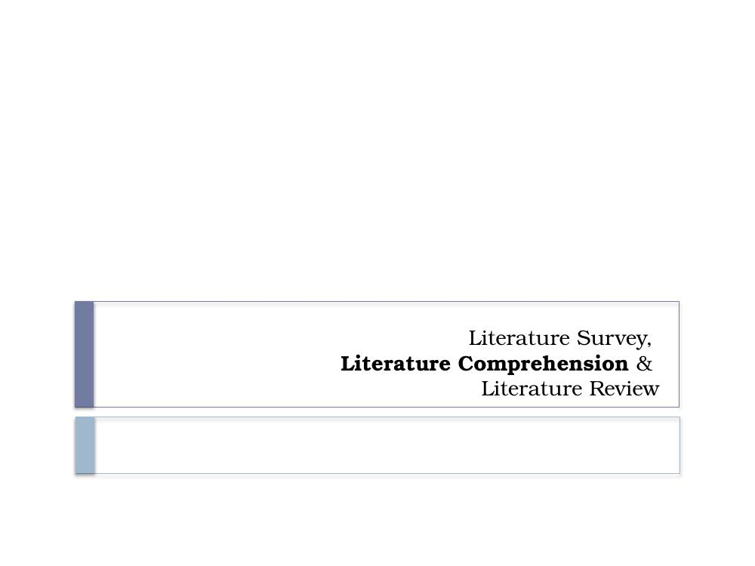

Read carefully and critically – started on 71 mins – 1st 70 min was assignment 2 prep
- The methods used to produce a piece of research are an important indicator of its reliability.
- You might assume that all research reports which have been accepted for publication are reliable, but this is not foolproof.
- There have been some famous cases of fraudulent research which have successfully fooled the research establishment:
  - Jan Hendrik Schön – High publication rate; falsified data by presenting identical graphs in two different papers on different topics.
  - Andrew Wakefield – Expert in autism; guilty of conflict of interest (receiving money, owned company which conducted tests); highly selective data reporting, unethical treatment of children.

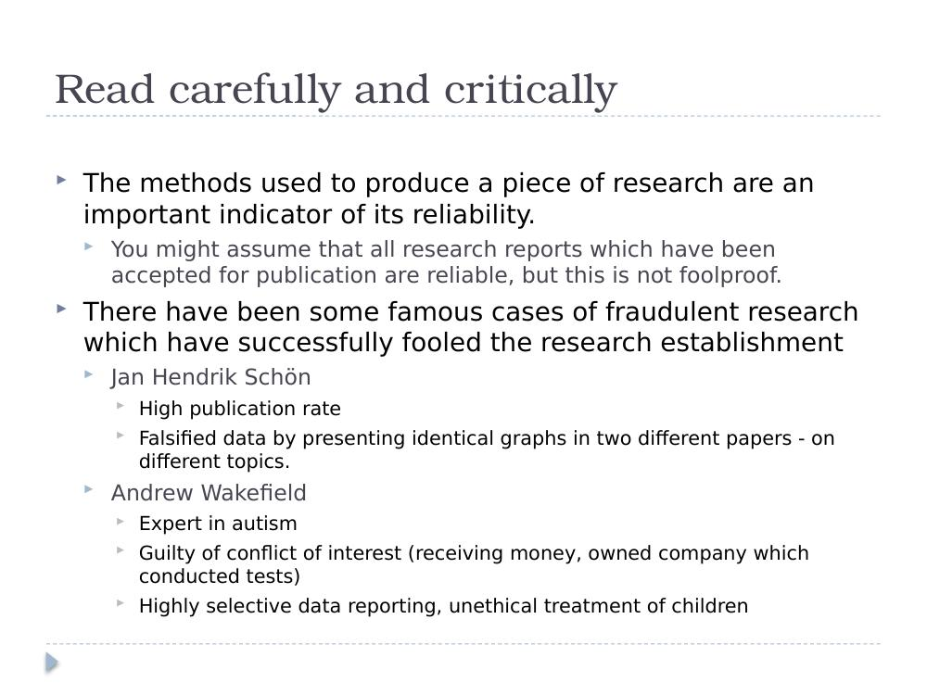

Read carefully and critically (cont.)
- False reviewing – when asked by journal editors to suggest names of experts, authors suggested emails that forwarded back to their own inboxes.
- There have been cases of research withdrawn due to controversy about the methods used.
  - E.g. Facebook Emotional Contagion: http://www.onthemedia.org/story/scholar-asks-facebooks-emotional-contagion-study-be-withdrawn/
  - Purposely showed users only negative posts from friends' feeds to test if this would lead to a spread of "emotional contagion" across the network to see if mood could be manipulated.
  - Participants involuntarily enrolled in study, not given an opportunity to remove themselves.

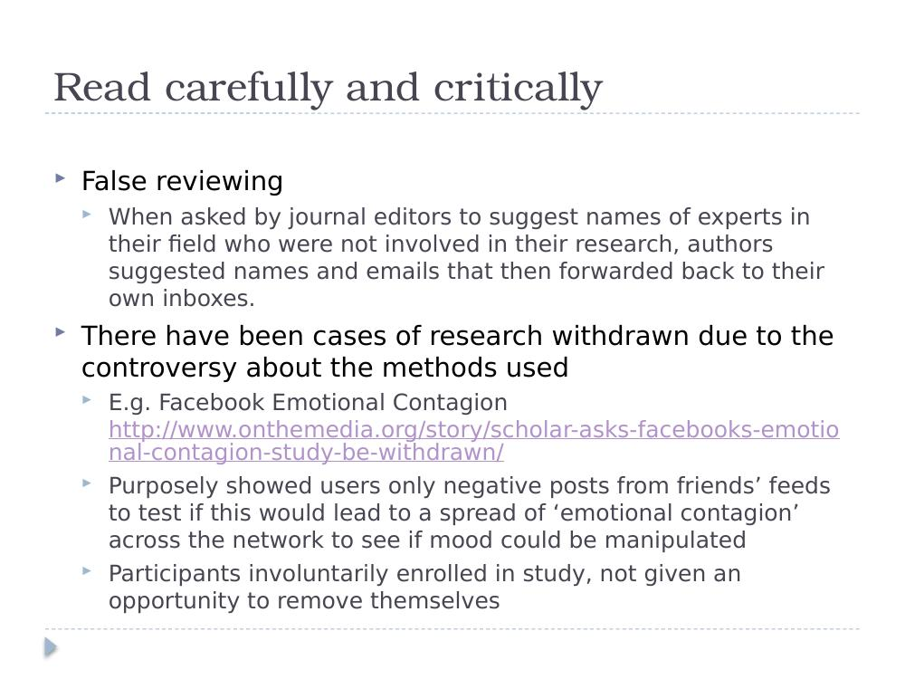

Literature Comprehension
- Initially you will find this overwhelming…
- You will be presented with lots of new terminology, models and approaches.
- THIS IS PERFECTLY NORMAL

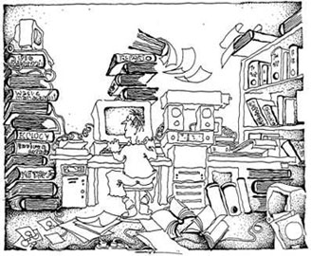

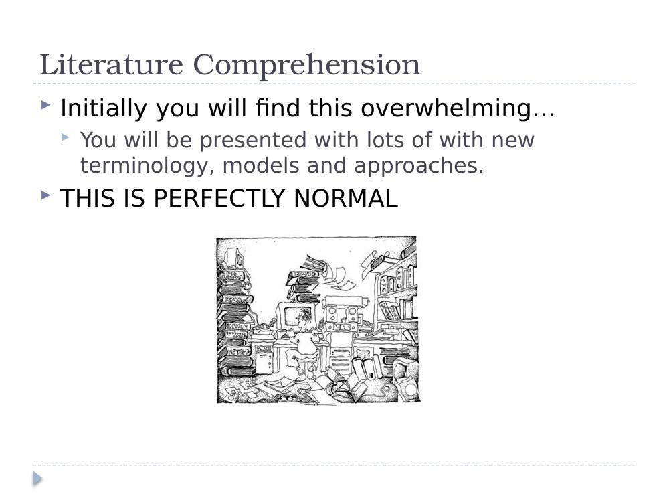

Literature Comprehension
- Process of reading and understanding the research found in the survey process.
- The first thing to do is to organise your collected research based on themes within your research:
  - Physical piles, folders, tags etc.
  - Some papers might be about the overall themes and others might be about specific issues.
- Also don't be afraid to ask for help – from your lecturers or other people.

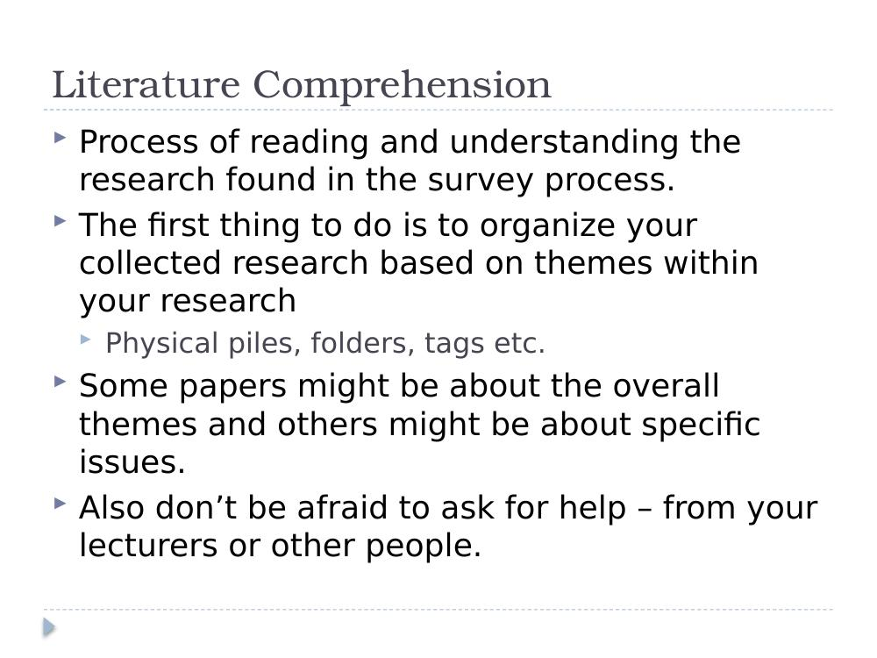

Literature Comprehension
- Don't get overwhelmed by it all.
- You are learning a new skill through practice.
- The more papers you read, the less new terms you will be encountering, the more of an expert you will become.
- You are also adding to your keyword search list.
- The first few papers are the most difficult, once you are over that hurdle, you will find the rest much easier.

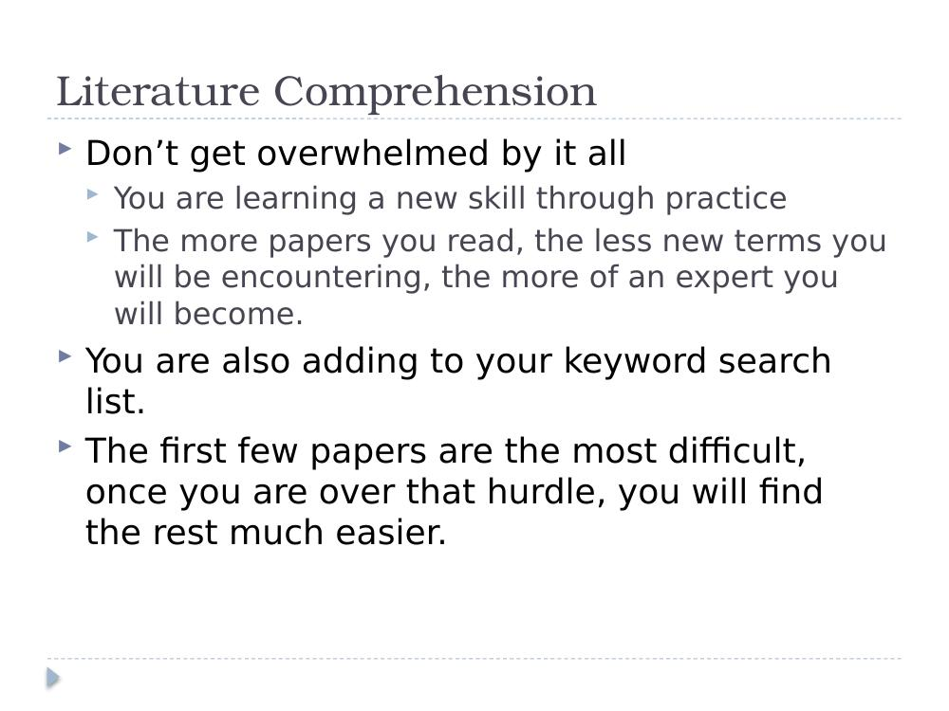

Getting started
- Look for a review article related to your area:
  - This may mean you have to look for reviews in a broader topic.
  - This will help identify broad issues of concern.
  - This will help you see how your topic is related.
- Look for articles with "techniques" or "applications" or "case study" in the title:
  - These papers will generally include a review (of varying detail) of a range of techniques and applications.
- If you are looking at the application of your research area to another area – extend your search to include databases, journals, conferences etc. related to that area also.

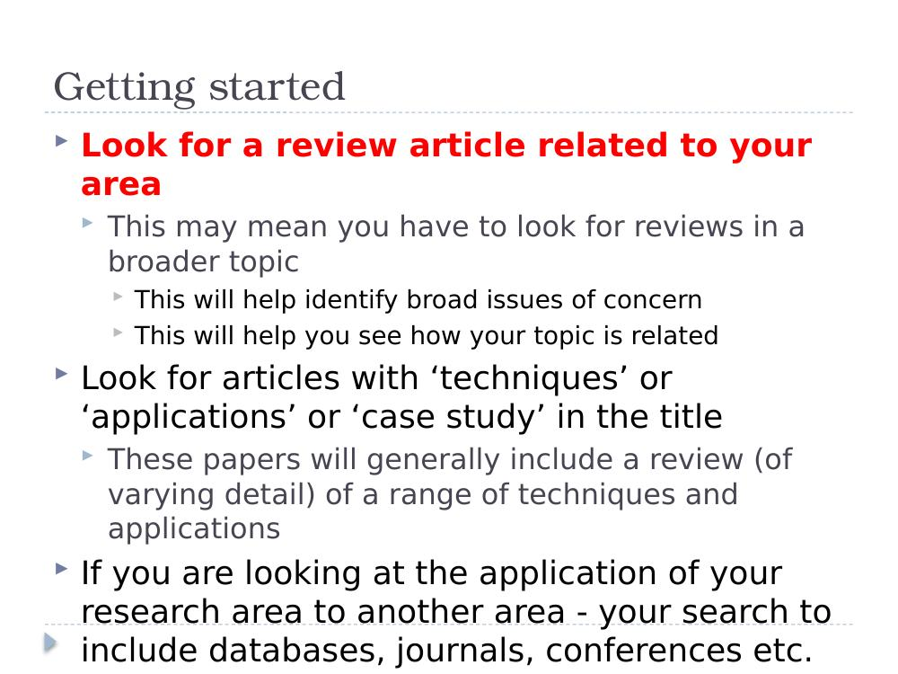

How to read a research paper?
- You are reading for underlying meaning.
- The goal of reading is not simply to see what is said, but to understand the bias, assumptions, and perspectives underlying the discussion.
- We are trying to understand the author's view of the world.
- Your Objectives are to:
  - Understand the problem discussed.
  - Understand the proposed solution.
  - Understand competing approaches / designs that could have been used.
  - Evaluate the paper in terms of the area you are working in and your work in particular.

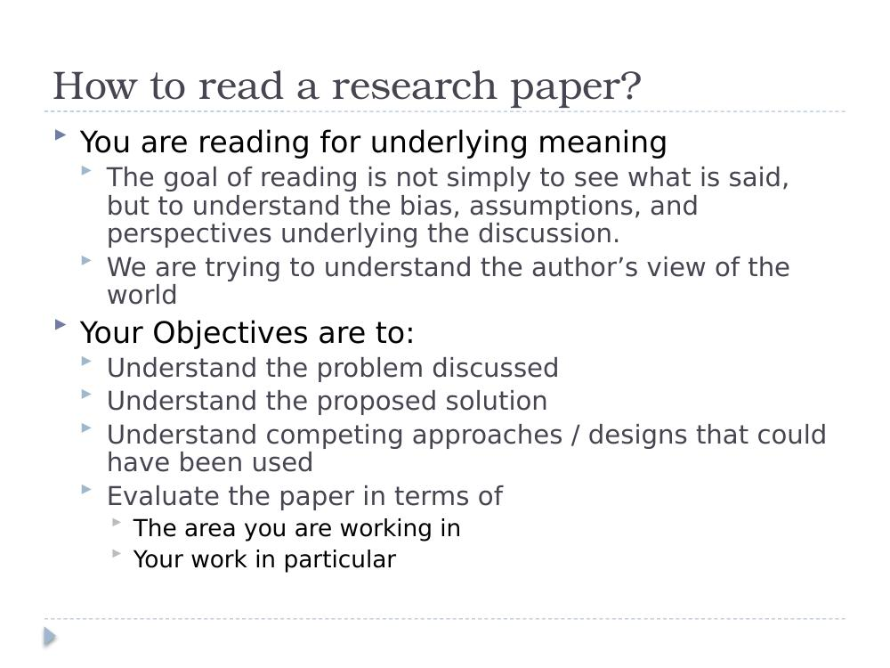

Types of Reading
- Scan and Skim → Active → Receptive → Reflective → Collection → Understanding → Review
- Scanning:
  - Casting your eye over; looking for particular points.
- Skimming:
  - Rapid, surface reading; gaining a general impression.
- Receptive:
  - "Listening" to the author; steady, easy pace.
- Reflective:
  - Think carefully about what you are reading; analysis, evaluation, judgement.

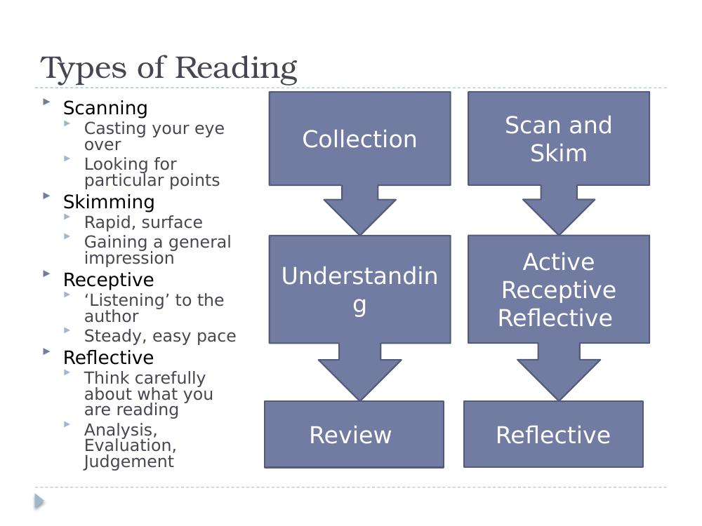

Types of Reading (cont.)
- You may need to re-read sentences, look up terminology etc.
- You may need to re-read sections of papers, check for agreements, disagreements etc.

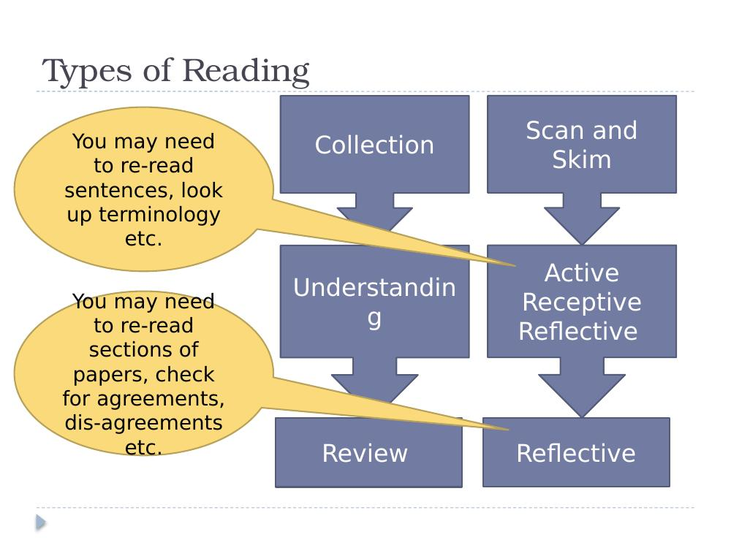

SQ3R Reading Technique

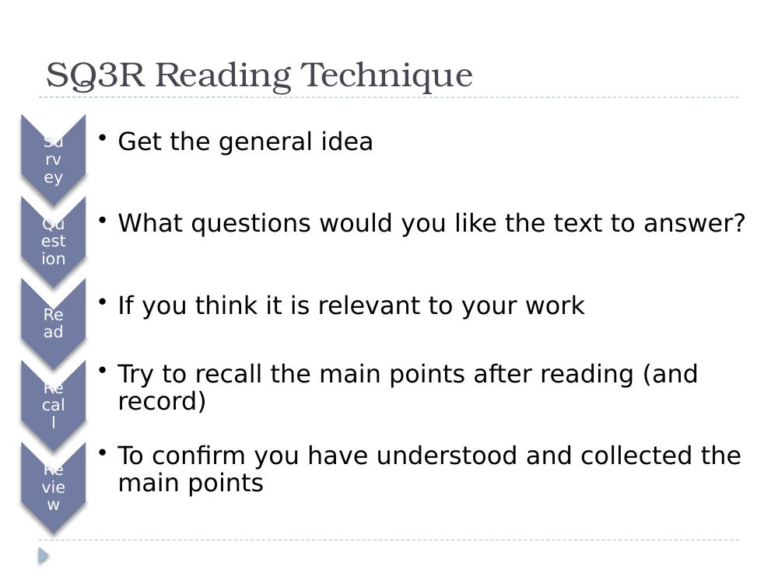

Survey (scan and skim)
- Objective: Establish if work is relevant to your research.

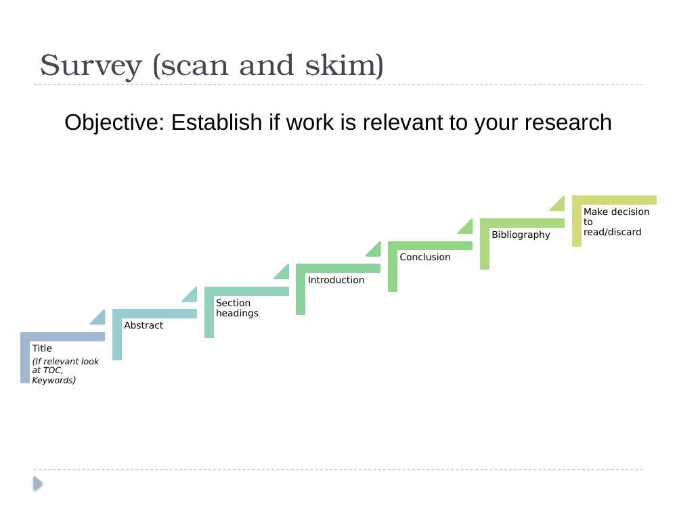

Q & R: Question and Read
- Question – Formulate questions you think the text will / should answer:
  - Try to relate to experience, other work, and your own thinking.
- Read – To help you read actively:
  - Connect to your work, other work, and your experience.
  - Take notes.
  - Break large texts into smaller more manageable chunks and read as separate texts (Literature, Experiment, Conclusions…).

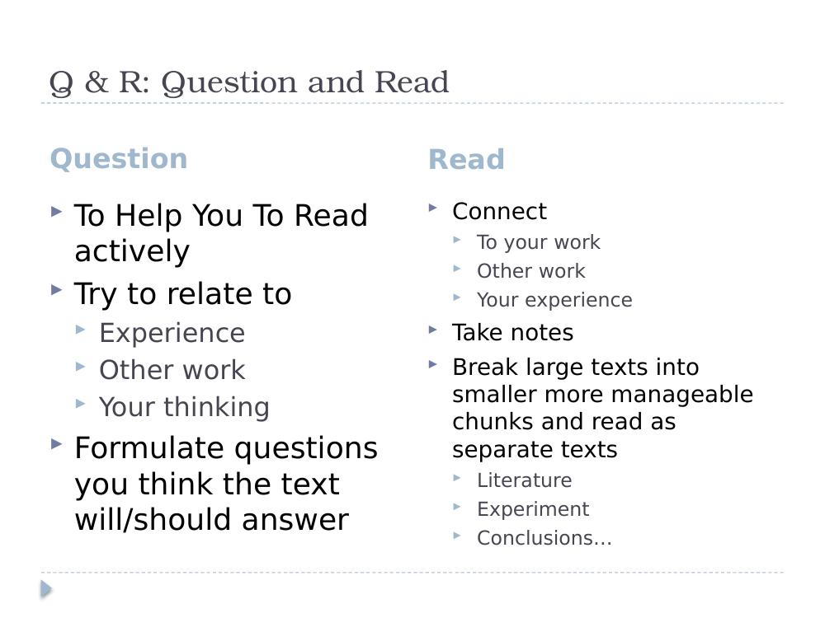

Recall and Review
- After each reading:
  - Write a short paragraph (one–three sentences) summarising what you have read.
  - Write a short paragraph (one–three sentences) about what you think this signals for your work.
  - (These can be combined.)

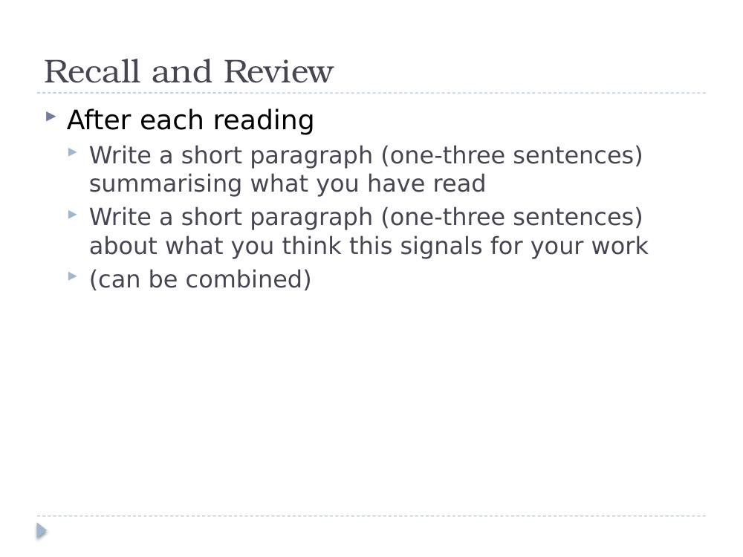

The Three Pass Approach

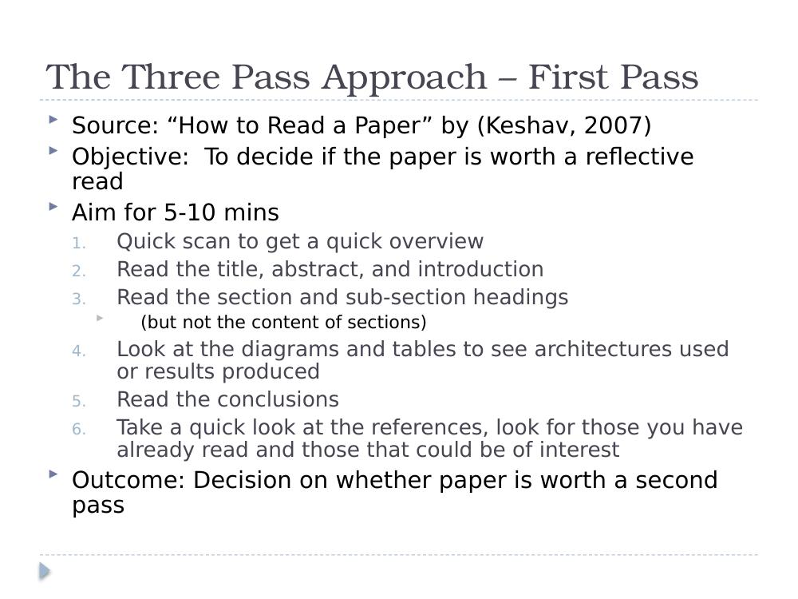

The Three Pass Approach – First Pass
- Source: "How to Read a Paper" by Keshav (2007).
- Objective: To decide if the paper is worth a reflective read.
- Aim for 5–10 mins – quick scan to get a quick overview:
  - Read the title, abstract, and introduction.
  - Read the section and sub-section headings (but not the content of sections).
  - Look at the diagrams and tables to see architectures used or results produced.
  - Read the conclusions.
  - Take a quick look at the references; look for those you have already read and those that could be of interest.
- Outcome: Decision on whether paper is worth a second pass.

The Three Pass Approach – First Pass (cont.)
- After first pass should be able to decide the following:
- Category: What type of paper is it? A review? A proposal for an approach? A report of experimentation? A description of a prototype? A critical comparison?
- Context: Where does it fit with what you have already read? Which other papers is it related to? What tools were used?
- Contributions: What are the paper's main contributions?
- Clarity: Is the paper well written?

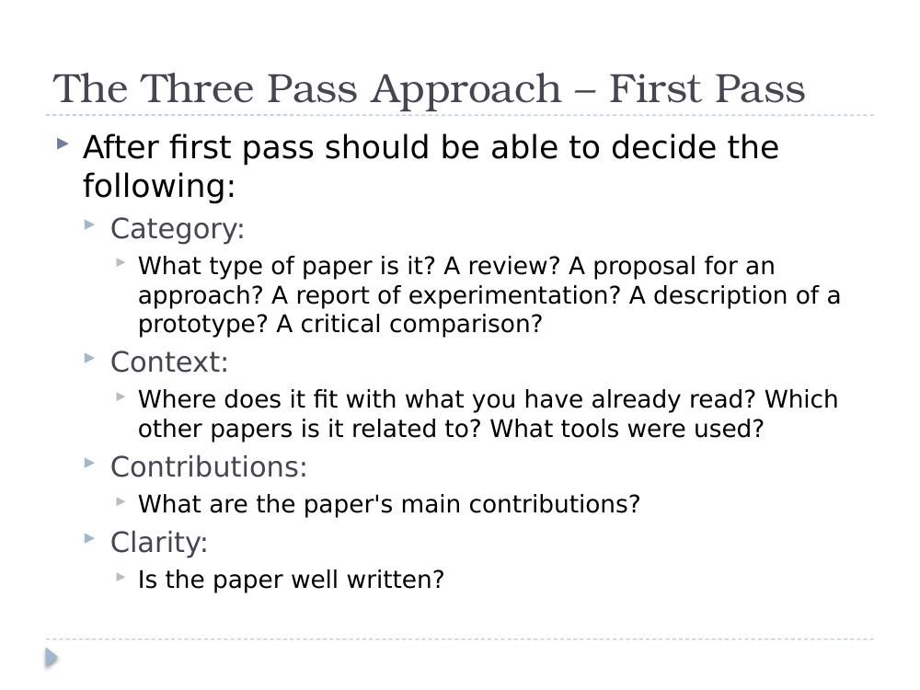

The Three Pass Approach – Second Pass
- Objective: To understand the paper and the evidence used.
- Aim for 30–40 mins:
  - Make notes.
  - Identify questions you would have for the author – this will help you refine your research question.
  - What evidence is being used and how? How is it evaluated?
  - Note any references you haven't read and how they are being used.
  - Write a short paragraph outlining the main focus of the paper and evidence to support this.
- Outcome:
  - Decide to discard the paper, OR
  - Decide to return to it later after you have read some more, OR
  - Proceed to phase 3.

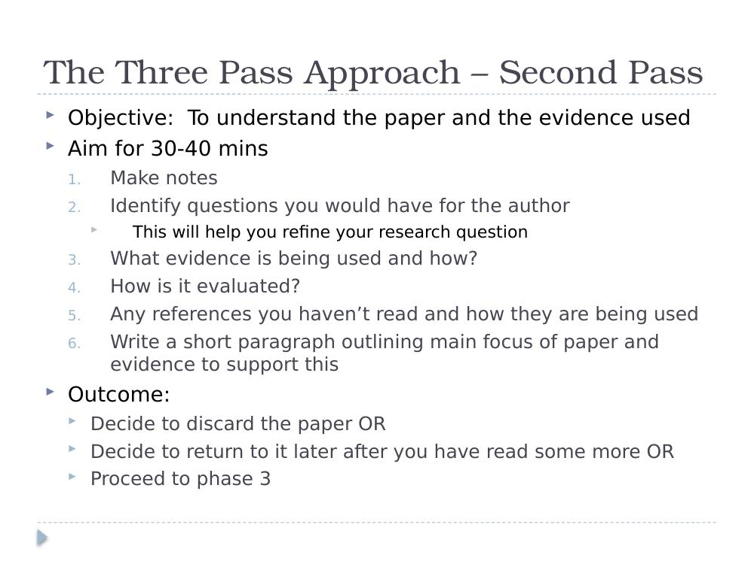

The Three Pass Approach – Third Pass
- Objective: To get a detailed understanding of the work described in the paper.
- Try to identify assumptions; challenge statements made; follow the evidence.
- Is the evaluation suitable? Similar to other work?
- Strengths and weaknesses – what's missing? Have you a different view?
- Make notes; create a set of paragraphs summarising your reflections.
- Outcome:
  - Likely contribution to your literature review.
  - Maybe even the start of a section.

PNI > positive / Negative / Interesting
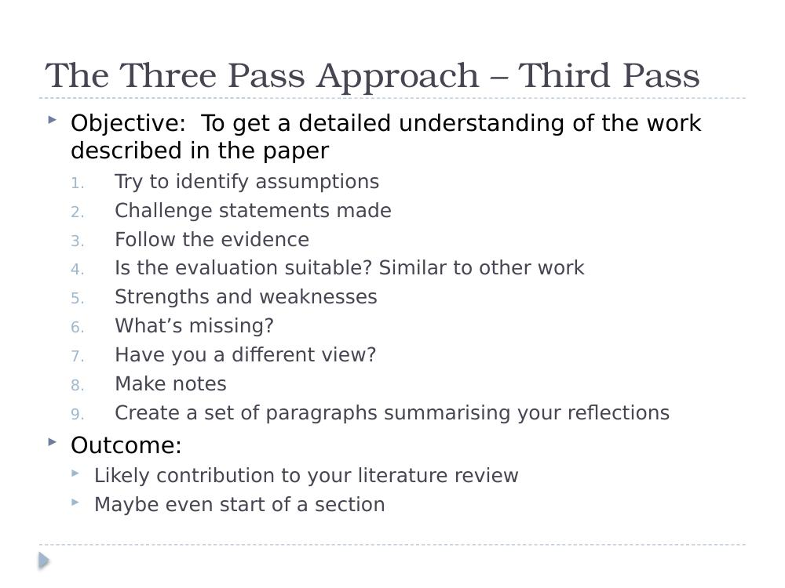

What Good Readers Do…
- Make Connections
- Check Understanding
- Visualize
- Infer
- Determine Importance
- Summarize
- Synthesize

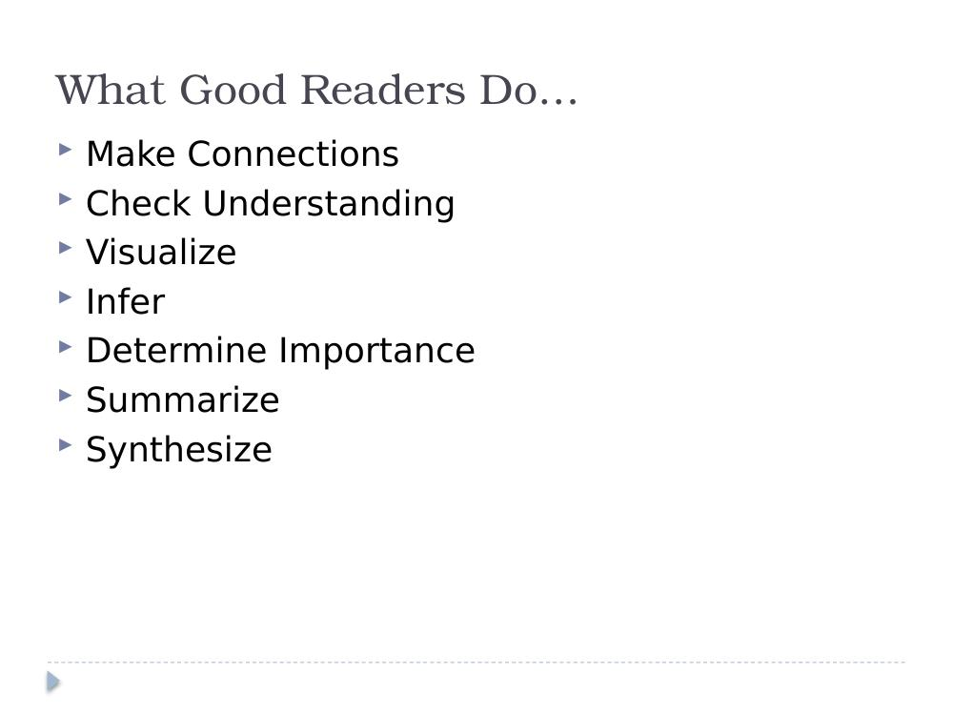

Literature Comprehension
- To help you in this process, use an article review check sheet with questions you should consider after reading a paper.
- Some examples: Science Article Check Sheet. >> have this…

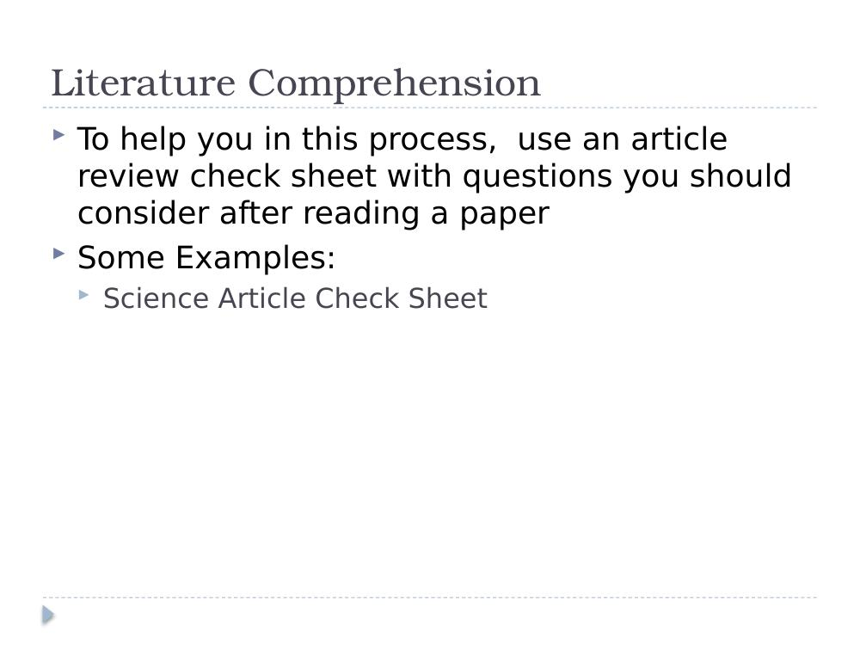

Literature Comprehension
- Make a note of:
  - Any nice phrases used in the papers.
  - Any interesting approaches to the experiments.
  - Any nice display of results.

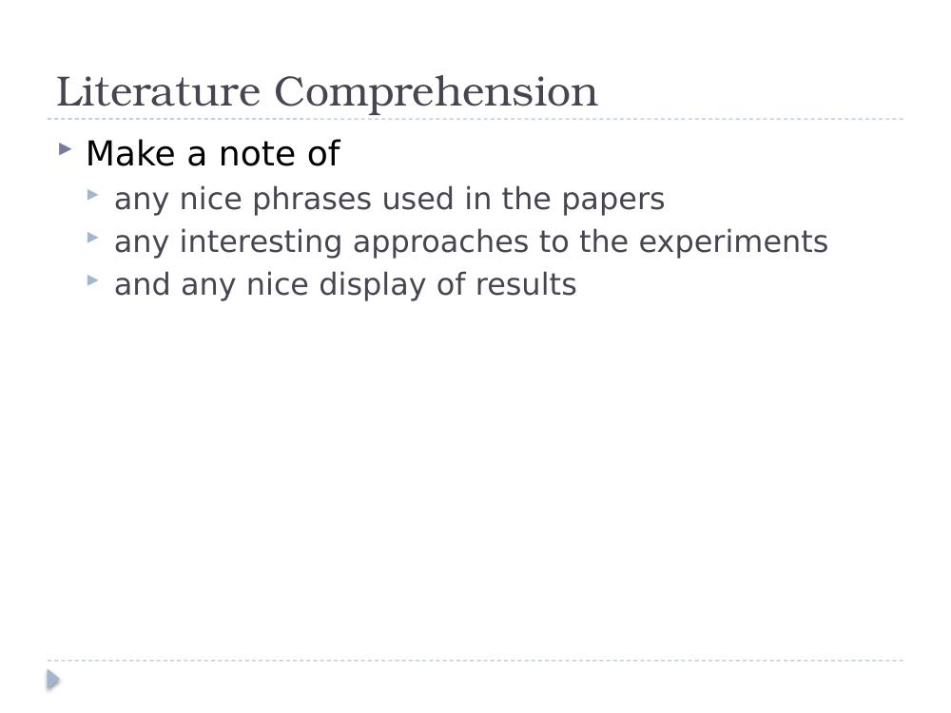

Why take notes?
- To summarise
- To remember
- To make connections
- To use later
- To avoid plagiarism

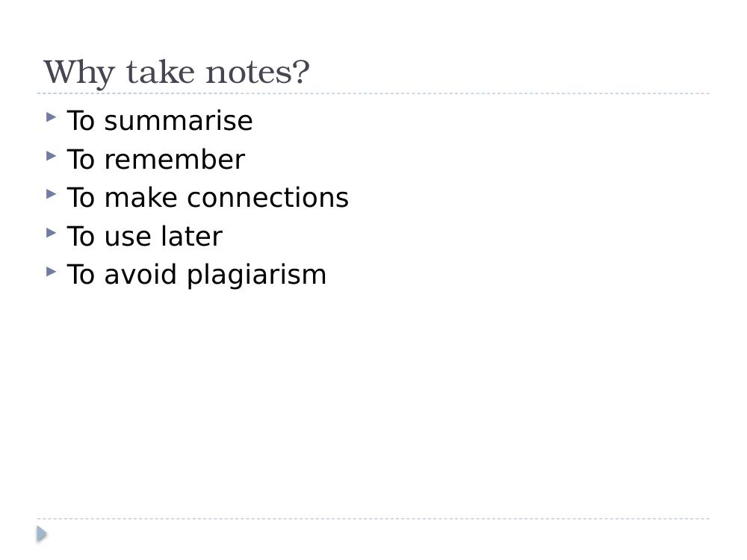

What to note
- Big ideas – what main ideas are reflected in the introduction, conclusion, abstract, and section titles?
- What is repeated – are these linked to other work you have read? Are definitions, formulas, processes or other authors repeated?
- Write in your own words a few sentences about your findings.
- Except for formulas, and specific facts (i.e. involving dates), which should be recorded exactly as in the text.

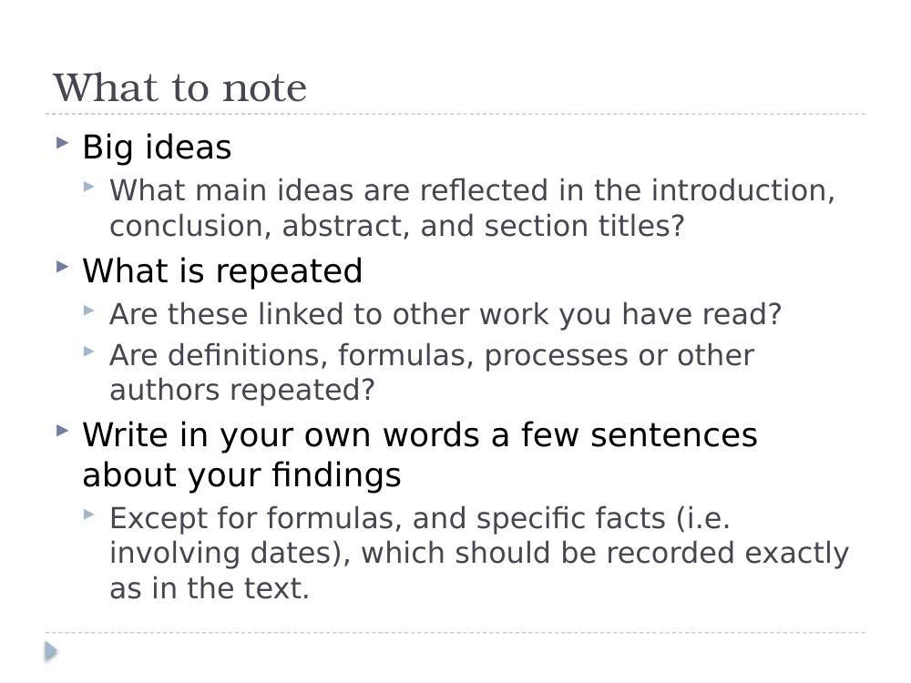

Sketching Your Literature Search
Some people use mind maps – what kind of a learner are you – draw it out / write it out…

PUT IT DOWN ON PAPER
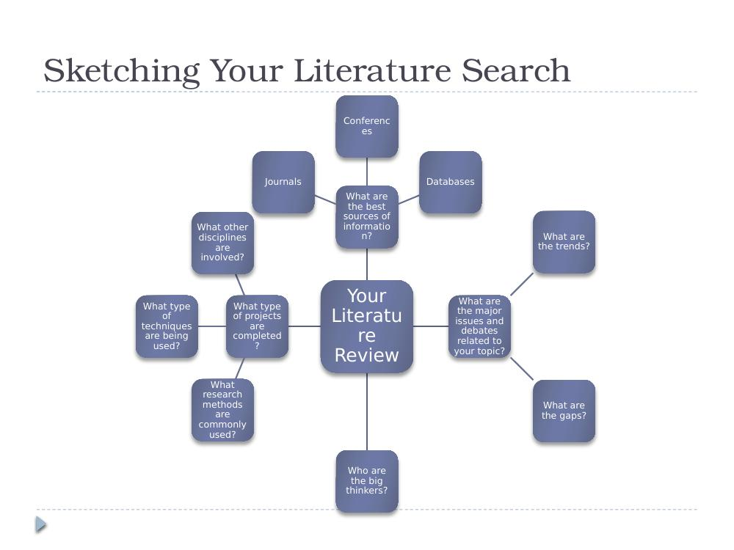

Literature Comprehension – Literature Map
- You are going to have to put some structure on the literature; one suggestion is to create a literature map.
- Write the title of your research on top, and the main topics relevant to your research underneath.
- Now associate the papers you are reading with each of the topics.

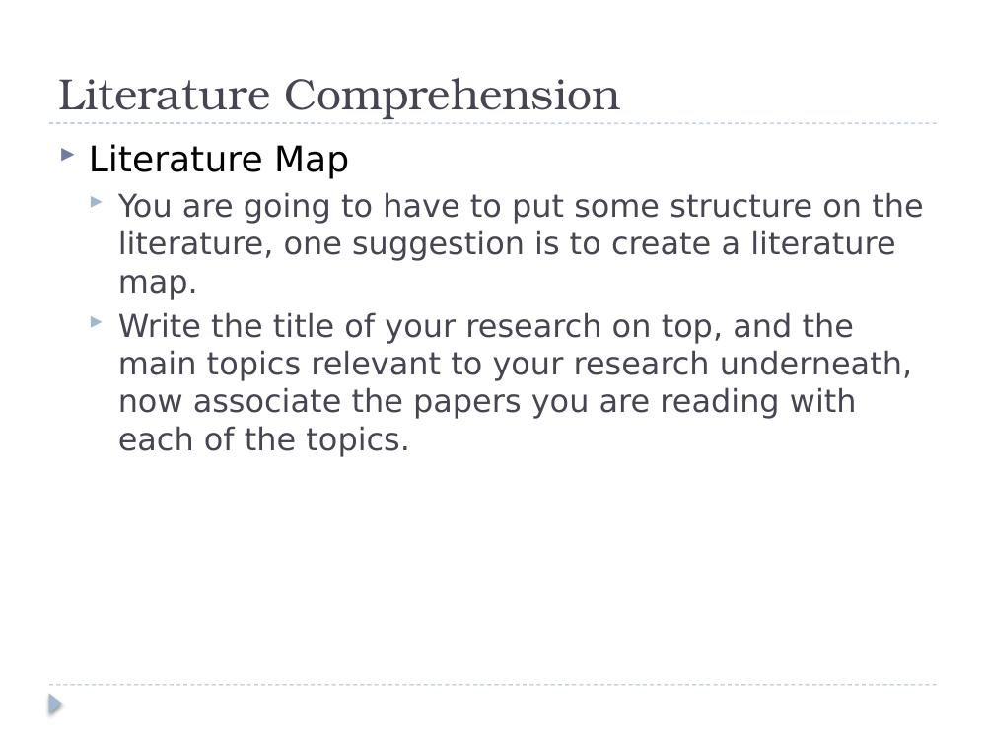

Literature Map
- Visual diagram showing how papers and topics connect to your main research question.

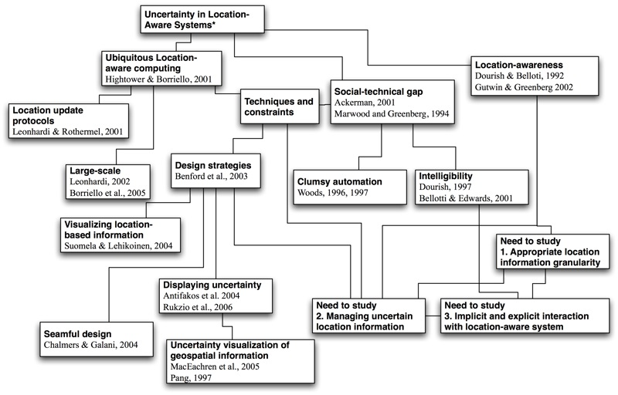

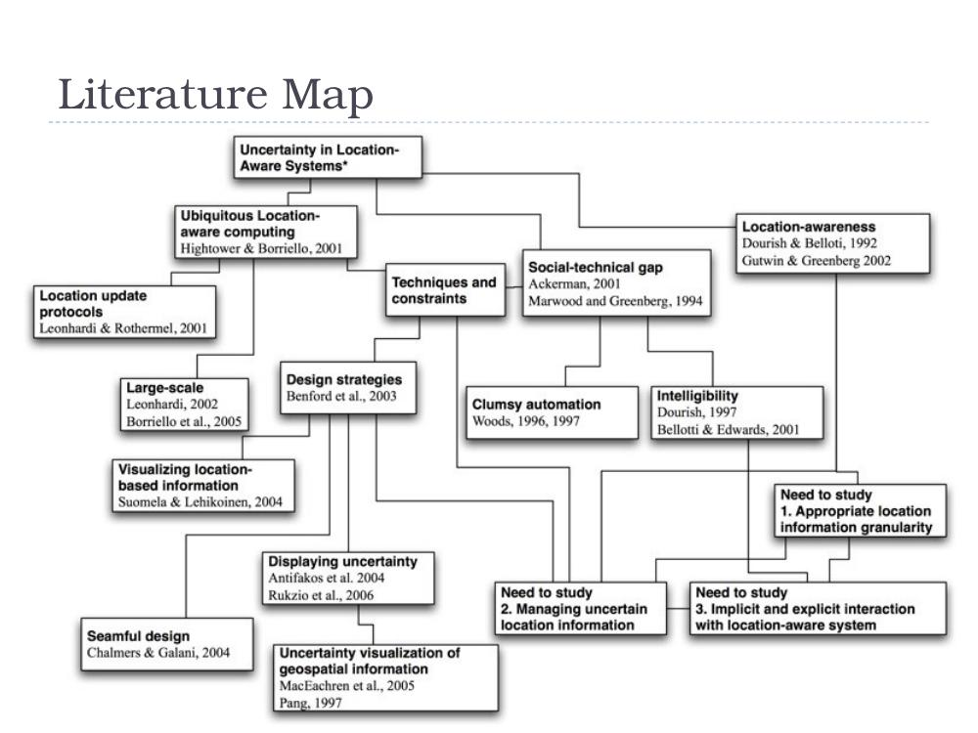

Activity – read these papers….
- Using the ideas covered so far, read one of the following papers:
  - Undefined By Data: A Survey of Big Data Definitions – http://arxiv.org/abs/1309.5821
  - An Introduction to Knowledge Management – http://arxiv.org/abs/0812.0438
  - Open Source Software and Peer Review – http://arxiv.org/abs/cs/0308040
- Consider the following questions:
  - What do you think the paper is about?
  - What questions did you ask?
  - Is it Current, Reliable, Authoritative?
  - Is it Biased?

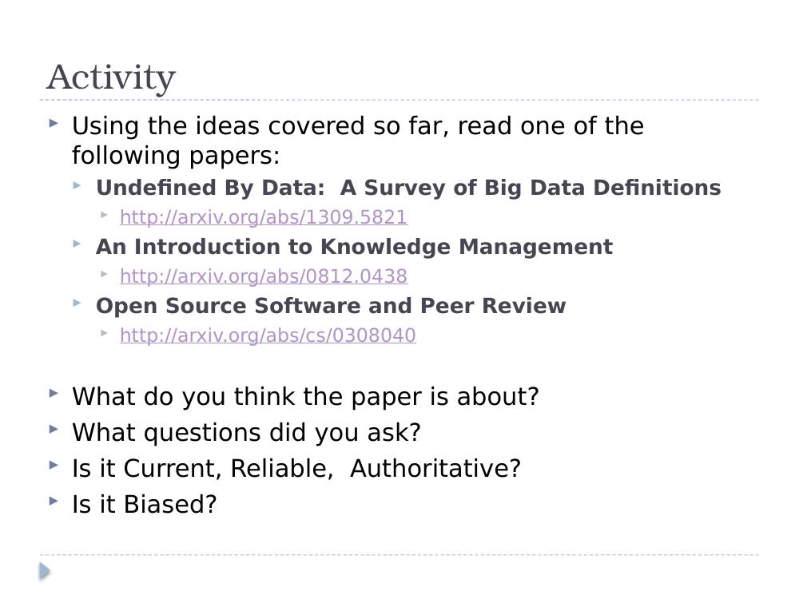

Open Source Software and Peer Review – Evaluation
- Current? September 2003 – not current.
- Reliable? Only 3 references; 1 is unrelated, 1 is irrelevant. Was not peer-reviewed (it's not a conference/journal article).
- Authoritative? Who is the author? (missing affiliation). Does not demonstrate expertise.
- Biased? Totally! Tone is too strong, impartial, first person, statements without support from proper citations.

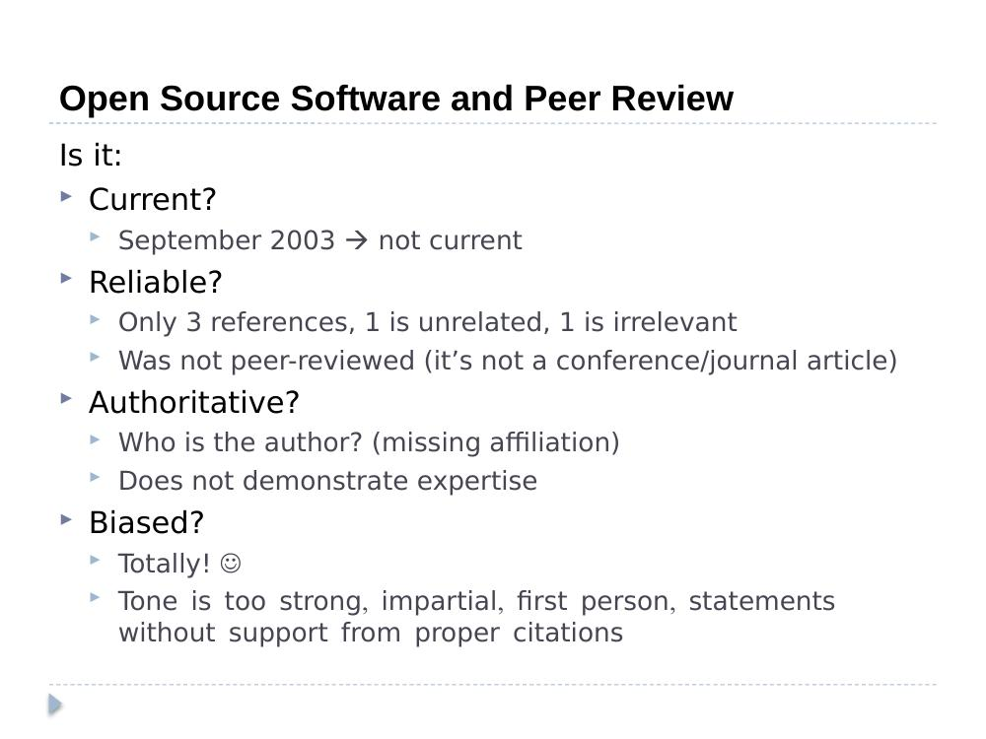

Undefined By Data: A Survey of Big Data Definitions – Evaluation
- Current? Yes (September 2013).
- Reliable? Some "acceptable" references. Was not peer-reviewed (it's not a conference/journal article).
- Authoritative? Affiliation from a computer science school in a UK university. Ambiguous.
- Biased? Tries to compare and contrast several definitions and wrap up a summary in the end.

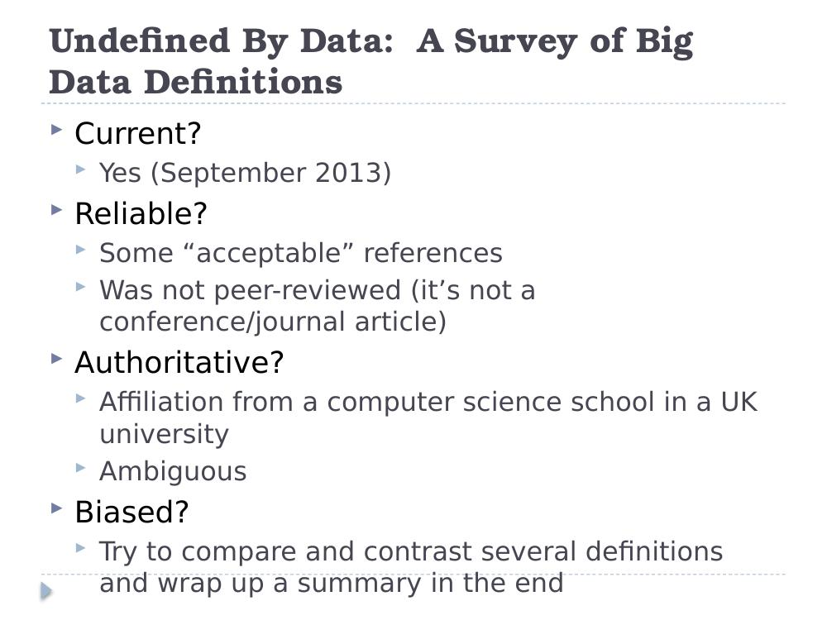

Assignment
- Journal articles (long-existing journals, recent articles):
  - Publishers: Elsevier, Taylor & Francis, Sage…
  - Impact factor.
- Conference papers (international, English, long-existing conferences, recent articles):
  - ACM, IEEE etc.
  - Rankings.
- Famous authors, schools, organizations…

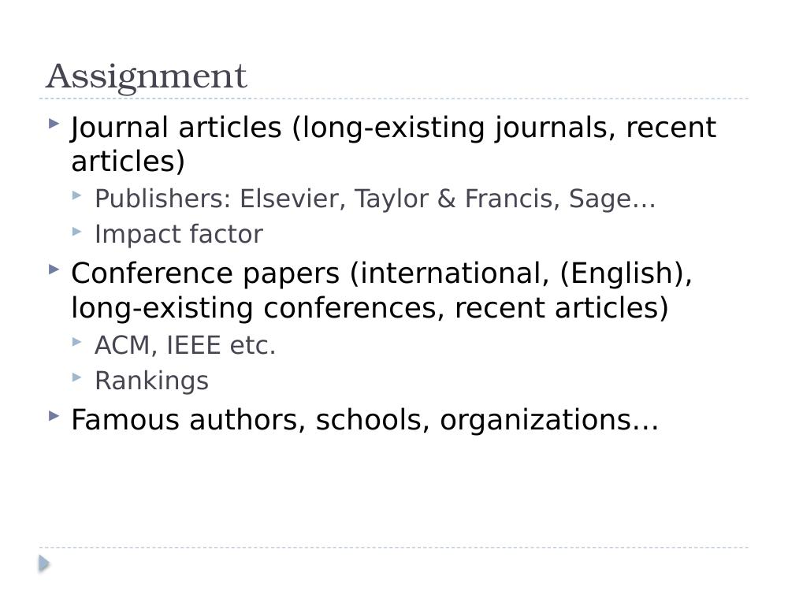

References
- Keshav, S. (2007). "How to Read a Paper." Available at various academic sources.
- Facebook Emotional Contagion Study: http://www.onthemedia.org/story/scholar-asks-facebooks-emotional-contagion-study-be-withdrawn/
- Undefined By Data: A Survey of Big Data Definitions – http://arxiv.org/abs/1309.5821
- An Introduction to Knowledge Management – http://arxiv.org/abs/0812.0438
- Open Source Software and Peer Review – http://arxiv.org/abs/cs/0308040

Week 3 – assignment 1 and assignment 3 – Sat 7th Mar 2026

Presentations
- Presentation 1 – Egidijus > biodiversity
  - Lecturer in TUDublin looks after GIS
- Presentation 2 – Rimvydas
    - Gamification to eep students in college – primarily in compute science
    - Improve motivation
    - Sarah Delaney in tudublin
    - https://csinc.ie/Home/About
  - presentation 3 - traffic data and aiq quality
    - professor Pat Goodman in physics is an air quality exprt
  - presentation 4 – ASD – microservices
    - code refractorin
  - presentation 5
    - Dara
    - Hate speech
    - Get bots geneatig hate speech - wih AI – hard to rcognise it

https://link.springer.com/article/10.1186/2192-113X-2-22?utm_source=SO_website&utm_medium=Website_links&utm_content=ScoEps-SO-MultiJournal-computer_applications-Global&utm_campaign=BCPS_USG_CS_Page_links

- Dykstra (famouns computer scientist?)
- For thr absence ofk a bibliographu I offer neither explanation or apology

Before we finish
- 2 things we will go through
- Literature survey – ppt
- RESEARCH , DESIGN__literature review and questions and plagiarism.pdf in brightspace >> from Luca Longo
  - Used t run next moduel in this series
  - About the research question
  - Will go through it the next day
  - Important you know its there, read it … is interesting as to what makes a godo research questions and stuff like that….

Completed

Week 1 –
- Morning - Recording haven’t looked at it as attended in person
- Afternoon - Recording haven’t looked at it as attended in person

Week 2

- Recordings
  - Morning - part 1 -108 mins
  - Morning Part 2 -
  - Afternoon Part 1 -
  - Afternoon Part 2 -

References
General Noticeboard: http://ditmsc.blogspot.ie/
- Research sitescmd

  - springer >> http://www.springer.com/computer?SGWID=0-146-12-150008-0
  - ACM Digital Library >> http://dl.acm.org/
  - DBLP >> https://dblp.org/
  - Databases >> Academic Search Complete
    - dit >>> http://www.dit.ie/library/databases/
    - sciencedirect >> http://www.sciencedirect.com/science/bookbshsrw/sub/infosys
- Search Engines: Google Scholar
  - Operators and search help
    - http://support.google.com/websearch/bin/answer.py?hl=en&answer=136861
  - Google Search Tools and Filters
    - https://support.google.com/websearch/answer/142143?hl=en&ref_topic=3180167
  - IEEE >>>
    - https://www.ieee.org/
    - https://ieeexplore.ieee.org/Xplore/home.jsp
  - Emerald Journals >>> https://www.emerald.com/
  - SAGE (online.sagepub.com) >>> https://journals.sagepub.com/
  - Number of citations >> CiteSeer) >>> https://citeseerx.ist.psu.edu/
  - Microsoft Academic Search > http://academic.research.microsoft.com/
  - Computer Science Conference Rank >> http://www.core.edu.au/index.php/conference-rankings
  - DIT Library >> http://www.dit.ie/library/subjects/computerscience/postgraduates/

- Templates ppt graphics editable for use in slides
  - https://creately.com/diagram-community/popular?term=research%20onion
  - https://slidemodel.com/templates/research-onion-powerpoint-template/
  - From example slide ---- from assignment 1 --https://www.conceptdraw.com/samples/management-stakeholder-onion-diagrams

Books and reading

Essential Reading:
- Creswell, J. W., 2014, Research Design: Qualitative, Quantitative, and Mixed Methods Approaches (4th Edition), SAGE Publications.
- Ridley, D., 2008, The Literature Review, SAGE Publications.
- Rumsey, S., 2004, How to find Information, Open University Press.
- Fitzpatrick, R., O'Donnell, K., 2003, Crafting a Research Paper, School of Computing Series, DIT.

Supplemental Reading:
- Alley, M., 1996, The Craft of Scientific Writing (3rd Edition), Springer Publications.
- Cooke., A., 2001, A guide to finding quality information on the Internet (2nd Edition), Library Association Publishing

ORCID
D24127620@myTUDublin.ie
SliabhMor0152!

Annaconda
Commands run in terminal concerning environments and packages
- conda install conda-forge::lxml
- conda list
- conda --info –help
- conda activate assignment-a
- conda info –envs
- conda install -c plotly plotly
- if package not available in conda search just run pip command
  - pip install pygeolang
  - pip list

