SPEC9995 – Data Visualisation
Marissa Llorens Salvador
email: marisa.llorens@TUDublin.ie

- TO DO: ???
- blogsite?
- blogsite
- Contact = ???? (outside of class hours)
- Sign in in sheet !!!! need to sign in.. each week to show you were preent…

Week 1 - Introduction

Data Visualisation – Lecture 1: Preliminaries
- Course: Data Visualisation SPEC9995, 2026-2027
- Lecturer: Dr. Marisa Llorens-Salvador – marisa.Llorens@tudublin.ie
- Brightspace – Signing sheet
- Sign in in sheet !!!! need to sign in.. each week to show you were preent…

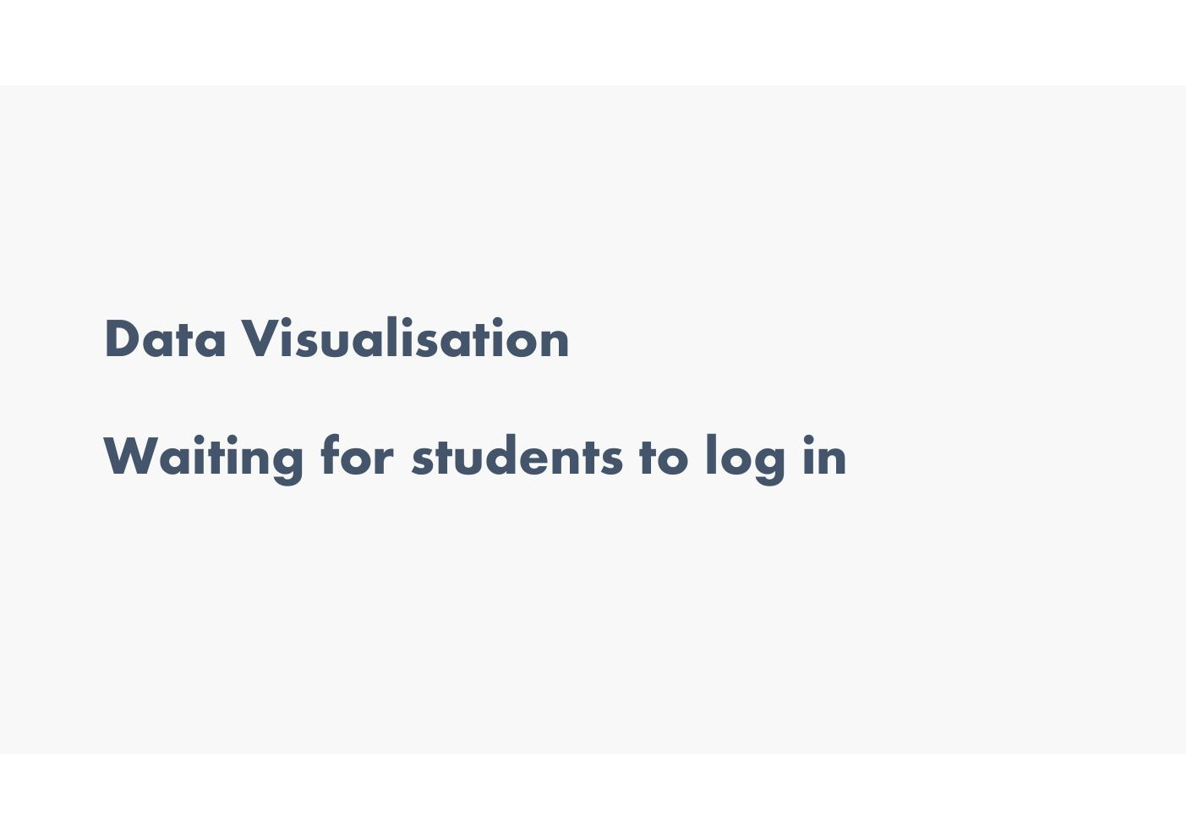
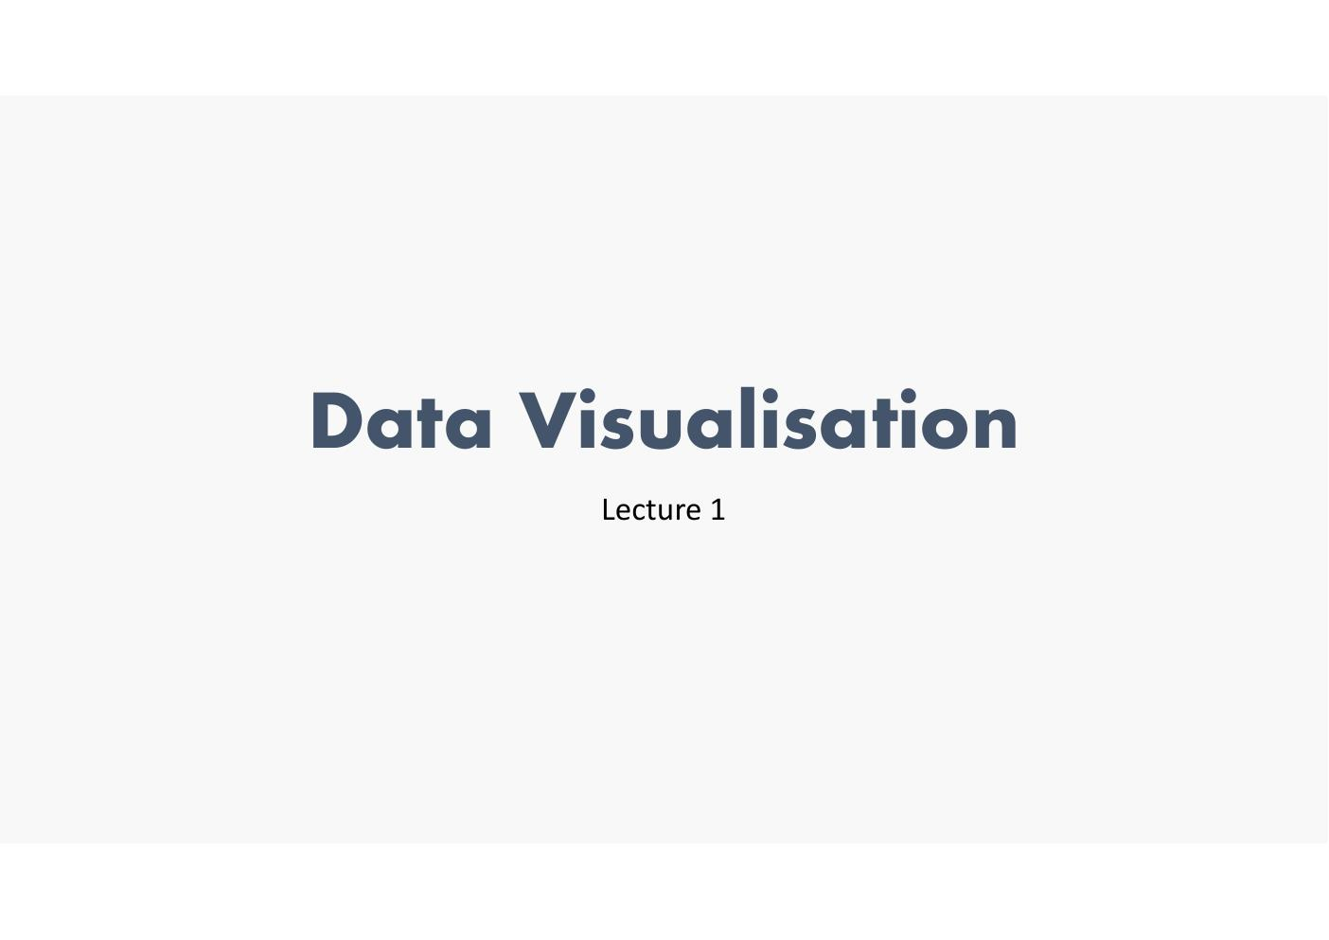
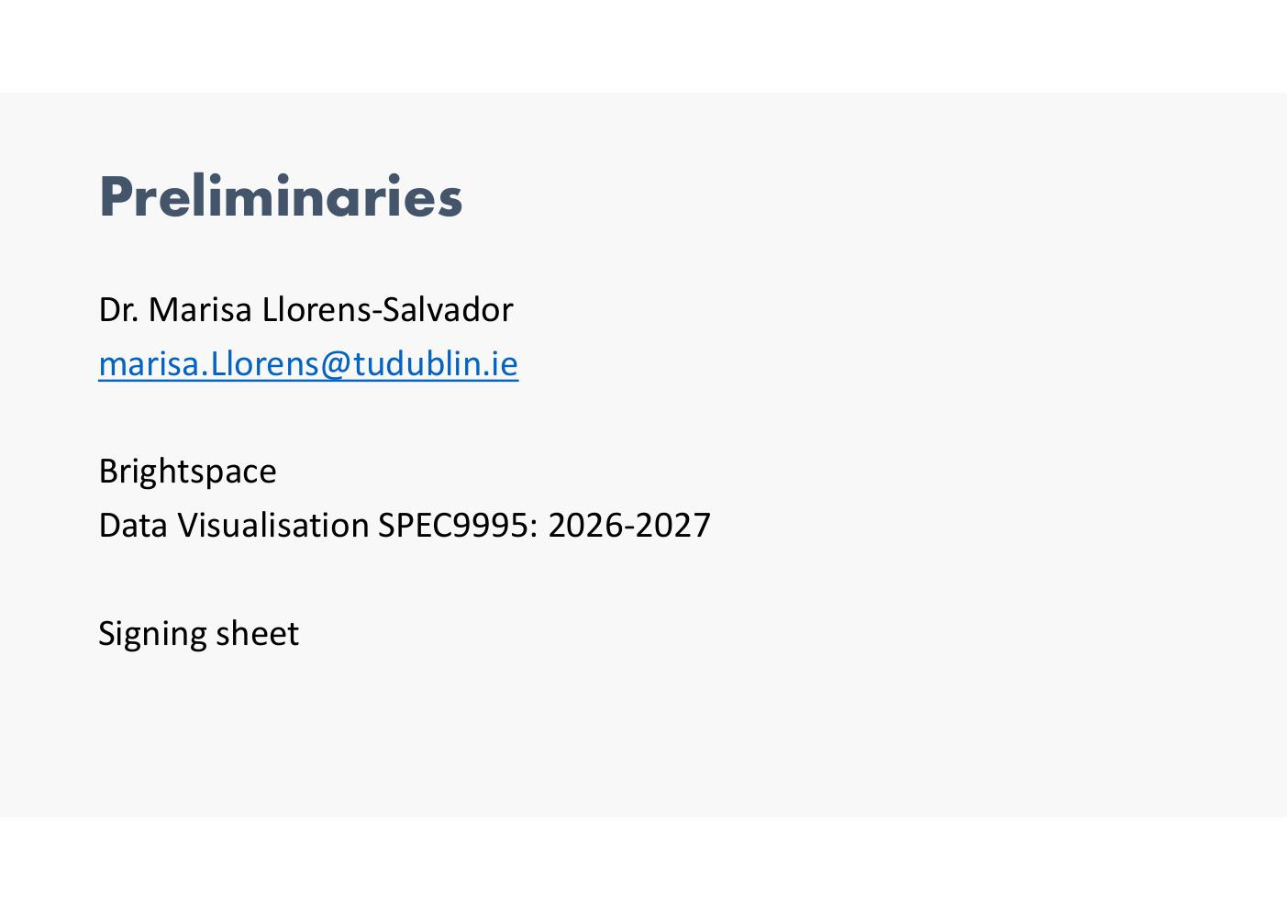

Credits
- Course based on material developed by: Marisa Llorens-Salvador, Cathy Ennis, John McAuley, Brian Mac Namee and Colman McMahon
- Material from other sources also used (citations included)
- If extra material will include citataions


Course Details
- Lectures: Online (recorded)
- Tuesday 18:30–20:00
- Weekly Labs (10%): 5 labs worth 2% each – after Tuesday lectures, online 20:00–21:30
- Assignment 1 (30%): Visualisation project using Tableau
- Assignment 2 (30%): Project using the statistics package R
- Exam (30%)

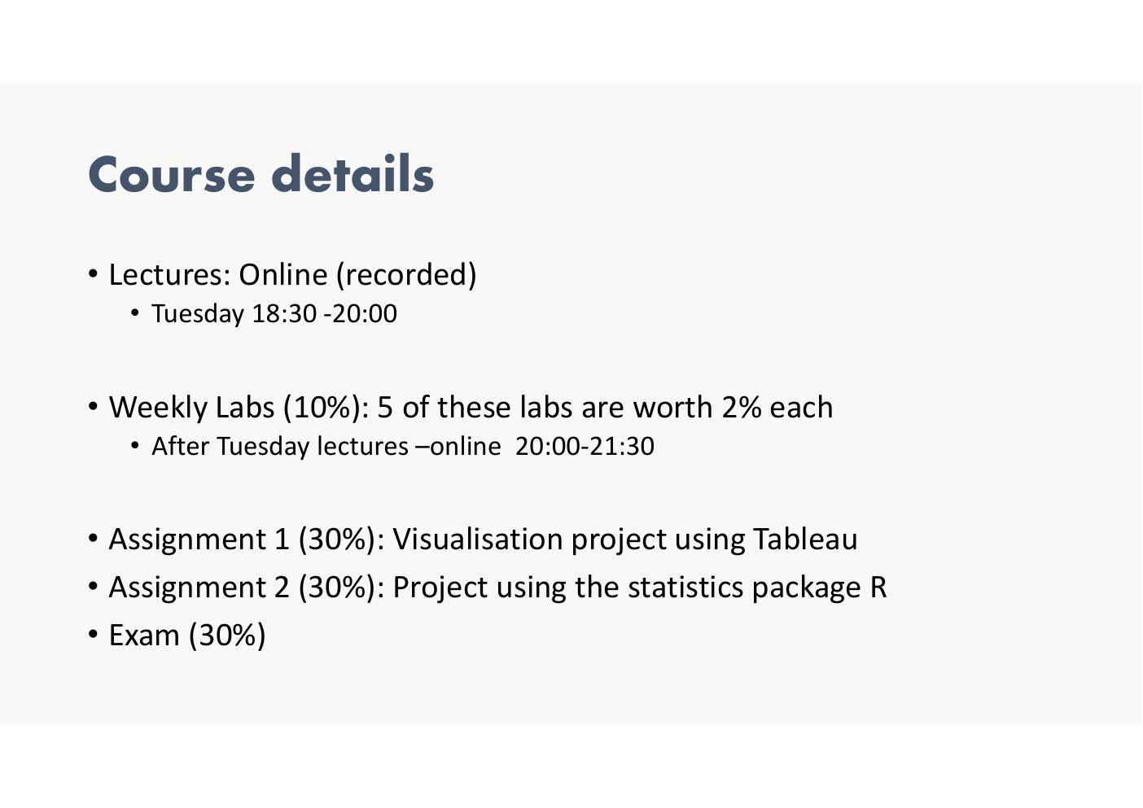

- choose own datasets – but CSO asking if they would like to work with their daatsets..
- Want R (don’t mind if tableau or R, but they have a real interest in R.
- So can use CSO high value datasets – may get a job.. may present..
  - https://www.cso.ie/en/statistics/highvaluedatasetshvd/
  - Can use across both
  - Exam maps theoritcal with practical
  - 4 patrs not long some mix betweentrehory and practical—given a visualisation and
  - Don’t have to sue them but good opportunity…

Course Overview
- Week 1 – Lecture: Introduction | Lab: Visualisation discussion
- Week 2 – Lecture: Perception/Classification | Lab: Intro to Tableau
- Week 3 – Lecture: Encodings 1 | Lab: Tableau Visualisation (2%)
- Week 4 – Lecture: Encodings 2 | Lab: Dashboards (2%)
- Week 5 – Lecture: Visualising Trends | Lab: Exploratory Analysis (2%)
- Week 6 – Lecture: Visualising Comparisons | Lab: Catch up
- Week 7 – Lecture: Accessibility in Visualisation | Lab: Intro to R* | Assignment 1 due (30% Tableau)
- Week 8–9 – Lecture: Visualising Relationships | Lab: Visualisation in R
- Week 10 – Lecture: Visualising Text | Lab: Visualisation in R (2%)
- Week 11 – Lecture: Visualising Geospatial Data | Lab: Visualising Geospatial Data (2%)
- Week 12 – Lecture: Visualising Spatial Relationships | Lab: Catch up and marking
- Week 13 – Review week | Assignment 2 due (30% R)

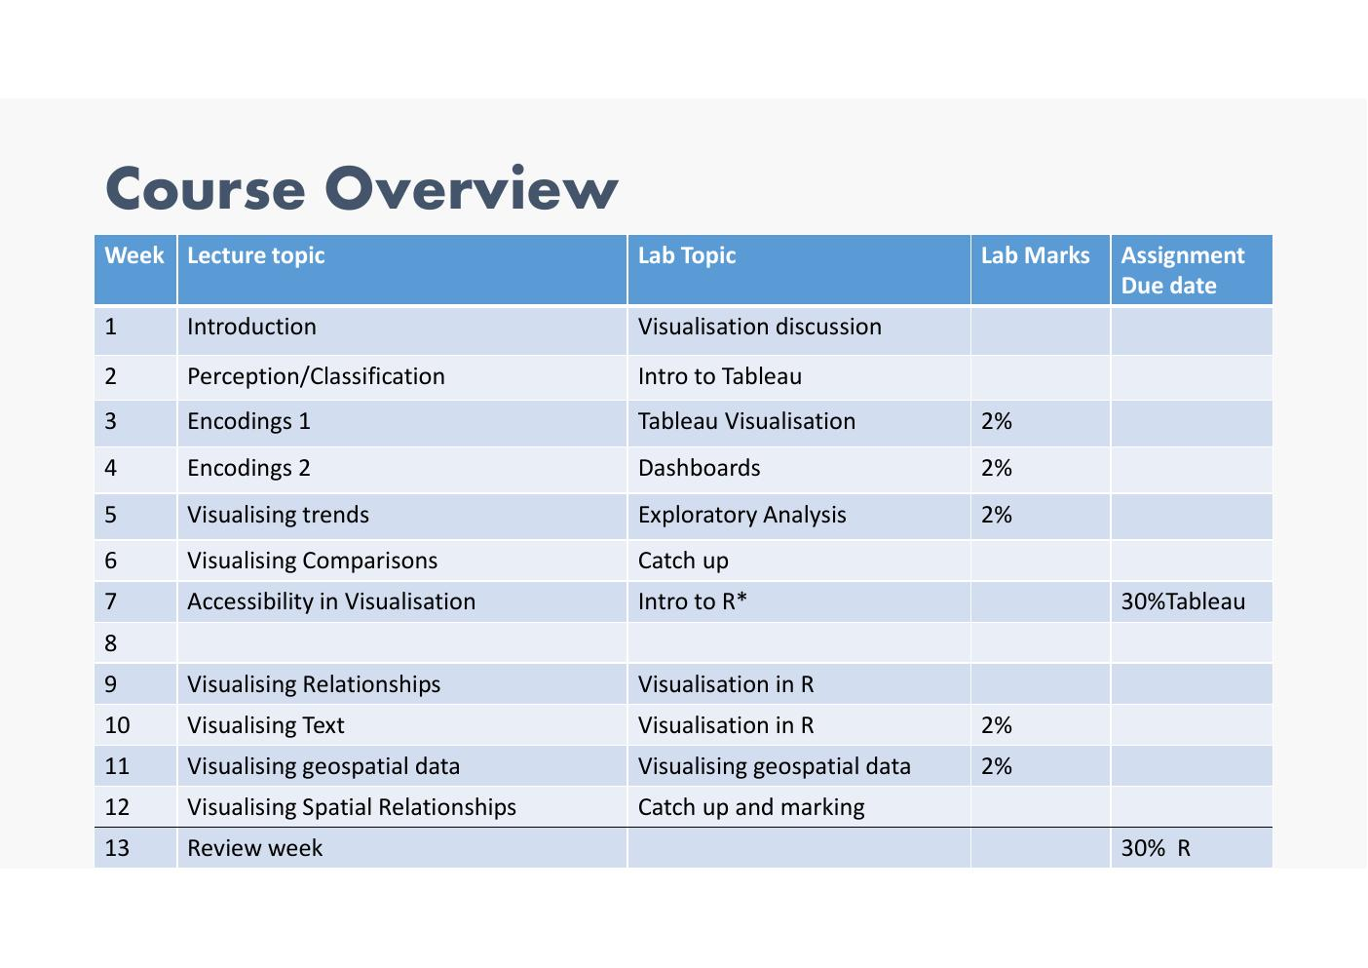
- Last session – just a review
- Labs > spark interedt and getyou thinking – news graph.. have criticl eye that IDs what was done well and what was deon not so well
- Lab 1 tableau… don’t submit.
- Lab 2/3/4 – will submit them
  - Don’t need to finish on the day
  - Must be don
  - Must be submitted by week 7 – Review week….
  - Will review and discuss with you.. so can include feedback in assignment…
  - Incorporate into tableau assignment
  - Get until end of the week
  - Have bank holiday and the end of that week….

- Marking criteria
  - Quality of the content
  - Take the data go through process and have an answer
  - Lab is a set of questions then answer this
  - Who is best CEO etc
  - Show it with a visualisation
  - Always something that can be improved…
  - Not 5 out of 10 as could have been better… mist do what it should be doing once finished you get2% more like try and be successful…
  - Give you encouragement to try different things and labs
  - 2% given for completing the labs… used
  - Try as much as you can.. try 20 different oens before you setels on somehting you are happy with….

- Tableau – submission data – last date to accept is week 6
- R – last submission date is week 12…

17 mins –
- Asignments
  - After 4 weeks we will get the assignment….
  - Mostly about working with the datasets.. you are going to go find the,,,,
  - Start!!
  - Exploratory exercises and a dashboard
  - R – 3 insights…

Why Visualisation? The Data Problem

Visualisation: Drowning in Data
- The Large Hadron Collider at CERN is the largest scientific instrument ever constructed
- When turned on, particles collide in the LHC detectors approximately 1 billion times per second, generating about one petabyte of collision data per second
- Storing only 'interesting' data keeps one petabyte a day
- Petabyte = 1m Gb
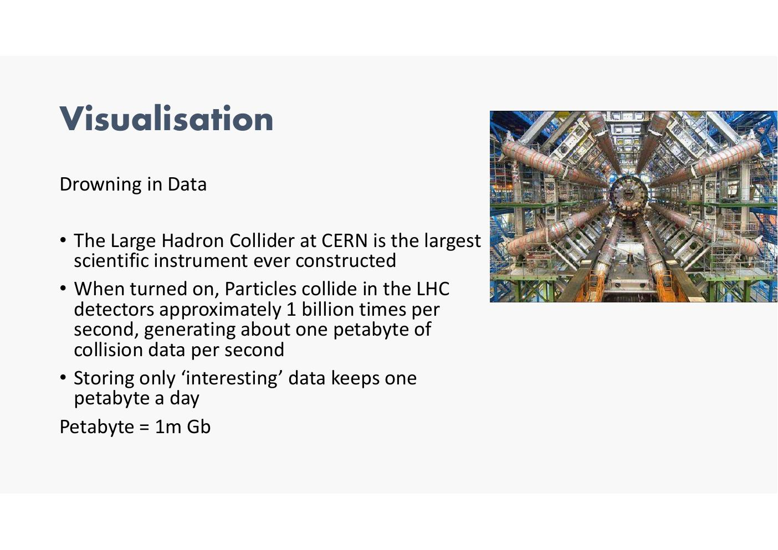

15 Minutes of Fame 2019–2020 (YouTube)
- 500 hours per minute = 576,000 hours per day
- 5+ billion videos watched per day
- 5 billion videos shared to date
- 122 million users daily
- Most viewed video: over 13 billion views
- First 24 hours: 63 million views (Jan 2023)
- Sources: https://expandedramblings.com/index.php/youtube-statistics/ | https://www.omnicoreagency.com/youtube-statistics/
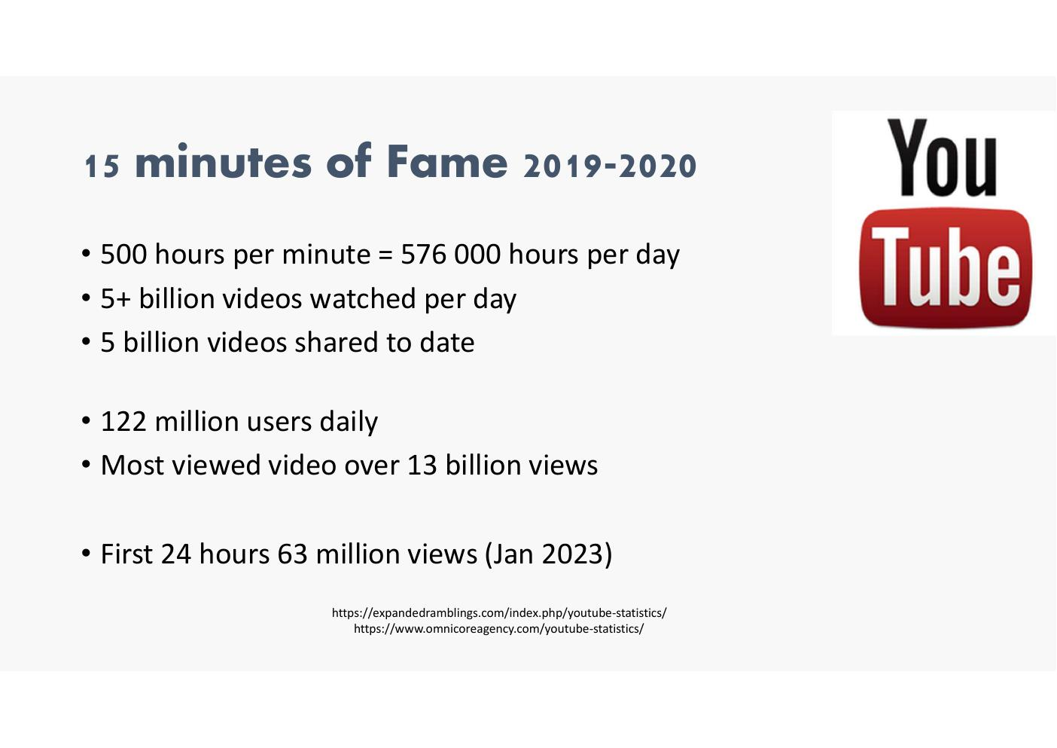

Example: Taxi!
- I order a taxi from the airport...
- How can this journey be logged?


Example: Taxi – Data That Can Be Recorded
- Taxi operator: time ordered, pick-up and destination locations, customer details
- Phone company: call maker and receiver, duration of call
- Credit card processor: transaction amount, transaction time, transaction type
- Credit card issuer: billing record, interest rate, current available credit
- Car maintenance service: fuel usage, engine state
- Passenger: expense of the taxi
- DAA: time of taxi drop-off, number of passengers in the car
- Dublin City Council: passage of the taxi across the city
- Taxi driver: time of fare, type of fare, amount of fare
- Taxi company: path taken by driver, duration of the trip
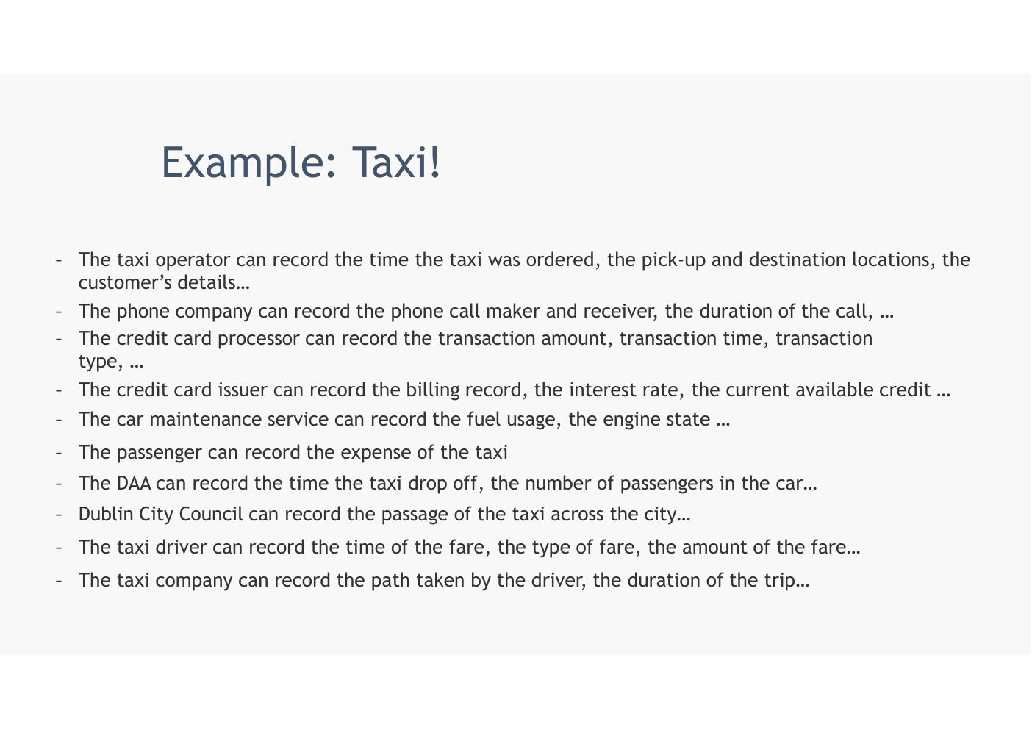
Swimming in data
But data is nothing… need the insights…

Example: Taxi – Questions
- 1. How can we understand this data?
- 2. How can we learn from this data?
- 3. How can we make this data accessible?
- 4. How can we gain insights into this data?
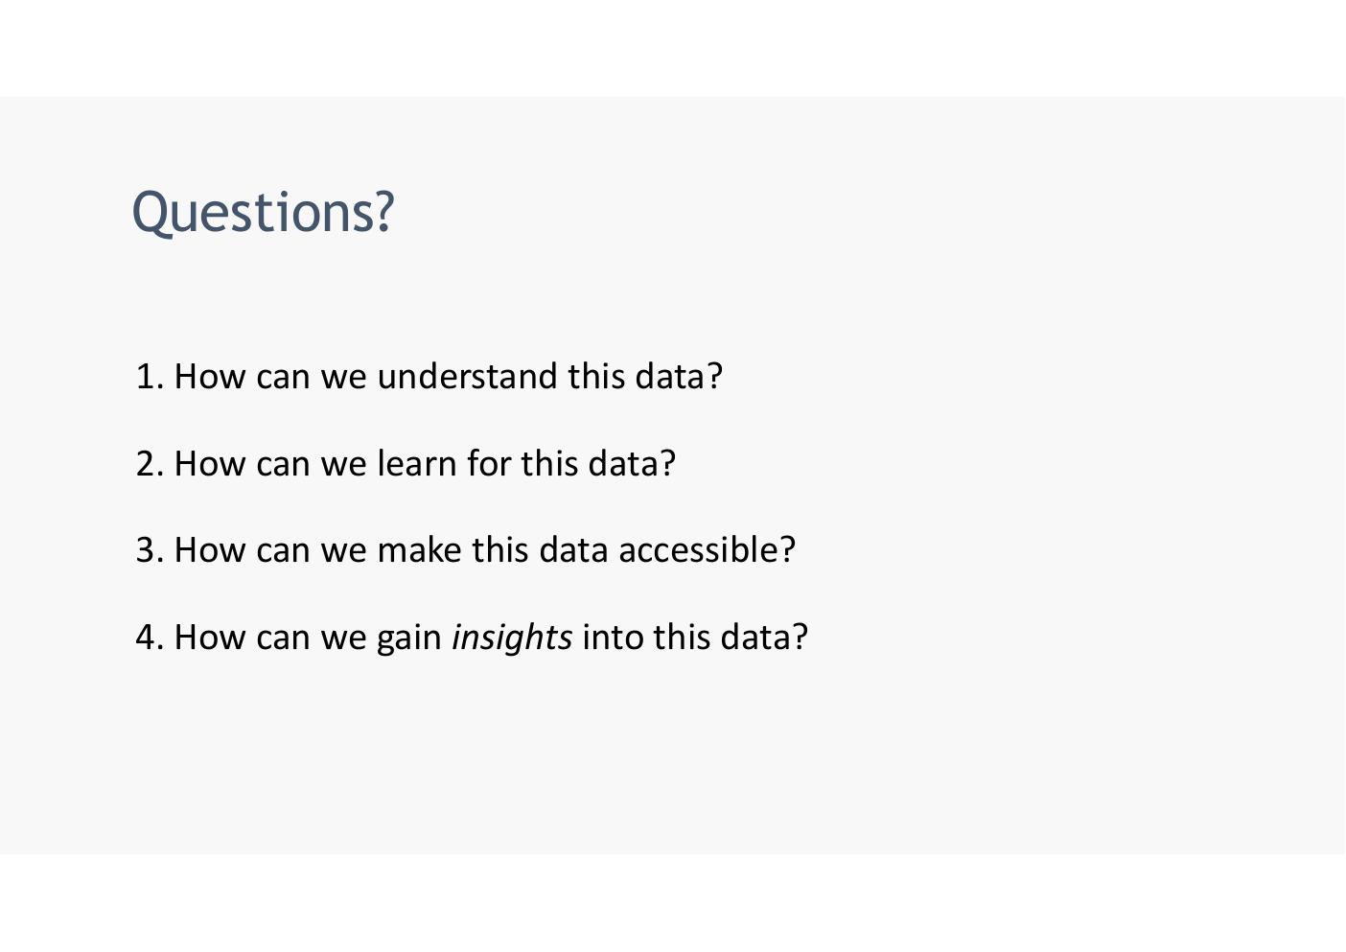

What is Visualisation?

What is Visualisation? – ormal Definitions
- 1. The action or fact of visualizing; the power or process of forming a mental picture or vision of something not actually present to the sight; a picture thus formed.
- 2. The action or process of rendering visible.
- 'Transformation of the symbolic into the geometric' – McCormick et al. (1987)
- '...finding the artificial memory that best supports our natural means of perception.' – Bertin (1967)
- 'The use of computer-generated, interactive, visual representations of data to amplify cognition.' – Card, Mackinlay & Shneiderman (1999)
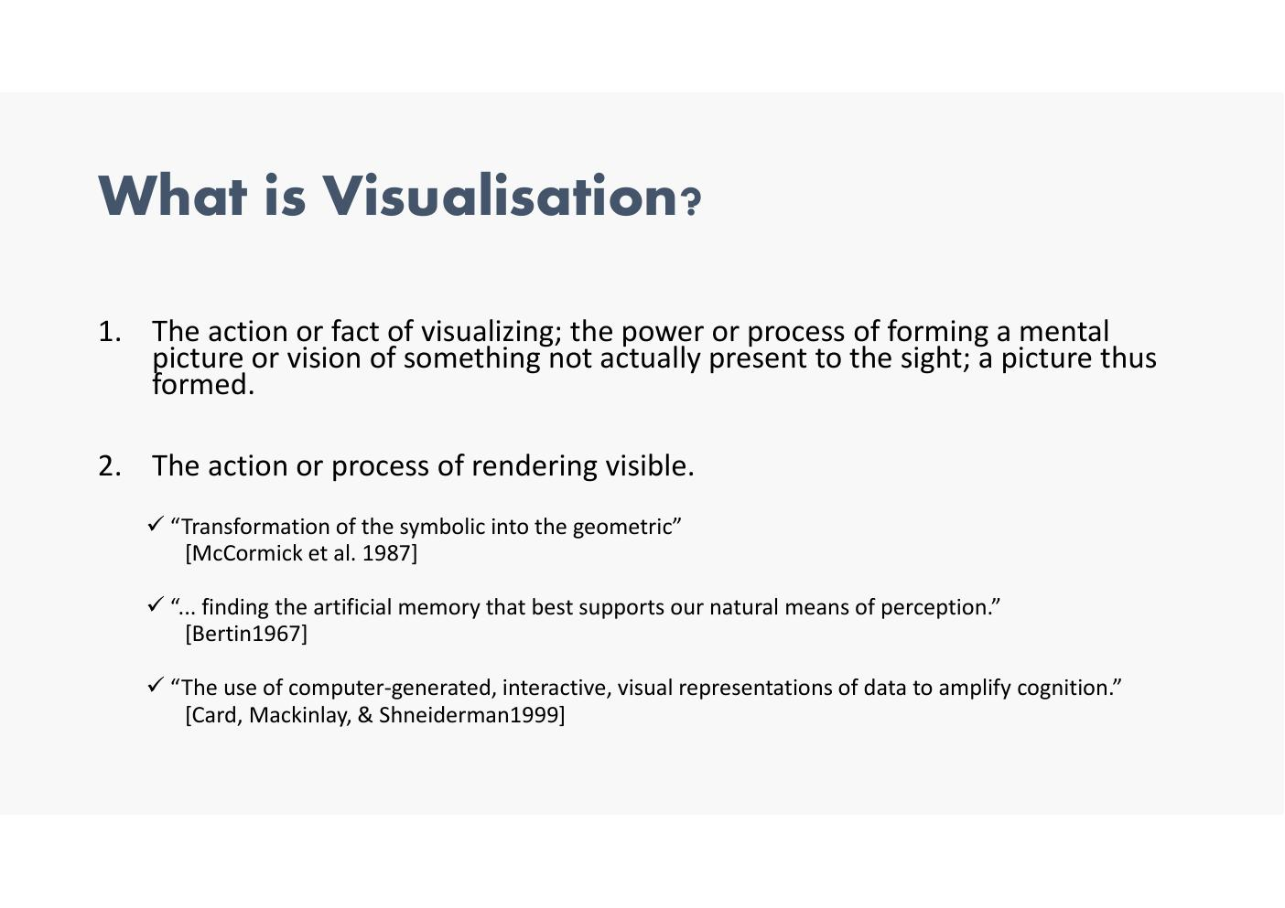
- Somethgni wasn’t obvious in the data
- 2. Not all visualistaino work.. take same dataset and some of them will say nothing… and some will eb usfule and will eb howing some insight… the data was hiding hat you are making available
- Who is going ot be looking at it…. Visual reps to amplify cognition

- In class - drew bar graph.. vs stacked bar graph
- Students in aungier st and gg
- Can see difference visually quite easily…
- Sometimes bottom give more info then top…. Answer it depends
- No one graph that gives good results all the time…
- Sometime use a technique ina graph..
- Need to know the aim…, what is the goal to find the insight…
- Visualistiona answers questions or discover them….
Exam >> amplify cognition…

Why Visualisation?
- Answer questions (or discover them)
- Make decisions
- See data in context
- Expand memory
- Support graphical calculation
- Find patterns (something cyclical i.e. traffic / weekends vs weekdays)
- Present argument or tell a story
- Inspire
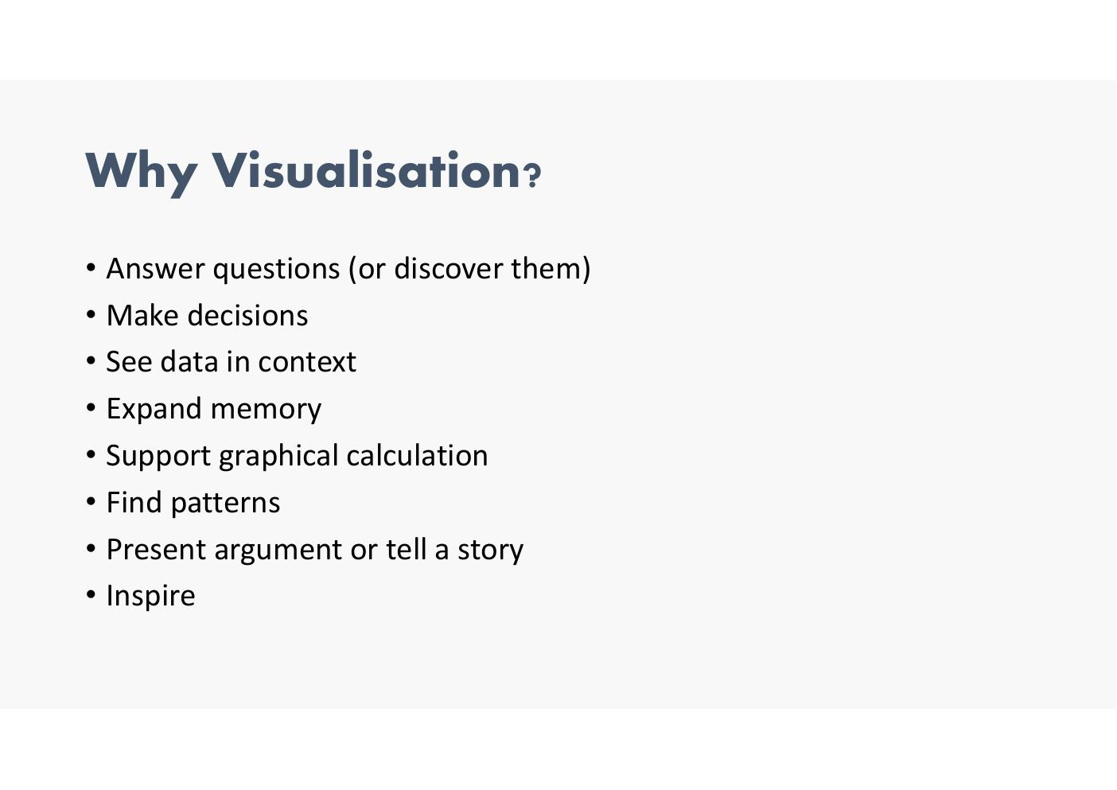

Why Visualisation? (Continued)
- Well-designed visual representations can replace cognitive calculations with simple perceptual inferences and improve comprehension, memory, and decision making
      - this is what we’re trying to do… the viewer should see the message the visualistion has straight away…when show visualisation should see the answer… shodul eb very clear… more accessible…
- By making data more accessible and appealing, visual representations may also help engage more diverse audiences in exploration and analysis
- The challenge is to create effective and engaging visualizations that are appropriate to the data
- Reference: 'A Tour Through the Visualization Zoo', J. Heer, M. Bostock & V. Ogievetsky, Communications of the ACM, vol. 53, no. 6, 2010 – http://queue.acm.org/detail.cfm?id=1805128
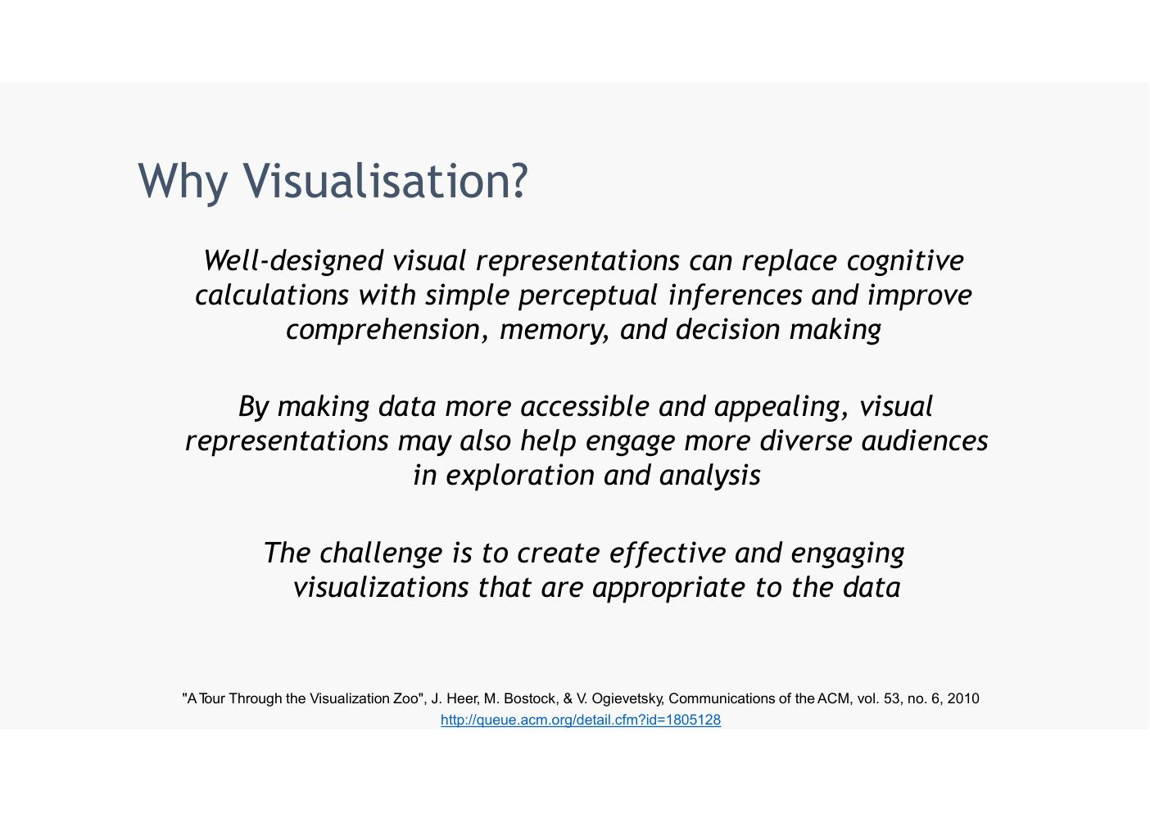

Functions of Visualisation
- Record: store information – photographs, blueprints, …
- Analyse: support reasoning about information
  - Process and calculate
  - Reason about data
  - Feedback and interaction
- Communicate: convey information to others
  - Share and persuade
  - Collaborate and revise
  - Emphasise important aspects of data
  - Other side has to see the message, not just look pretty!
  - Most we will use will be explainability of data (not necessarilt exporatory).. so have to explain the message
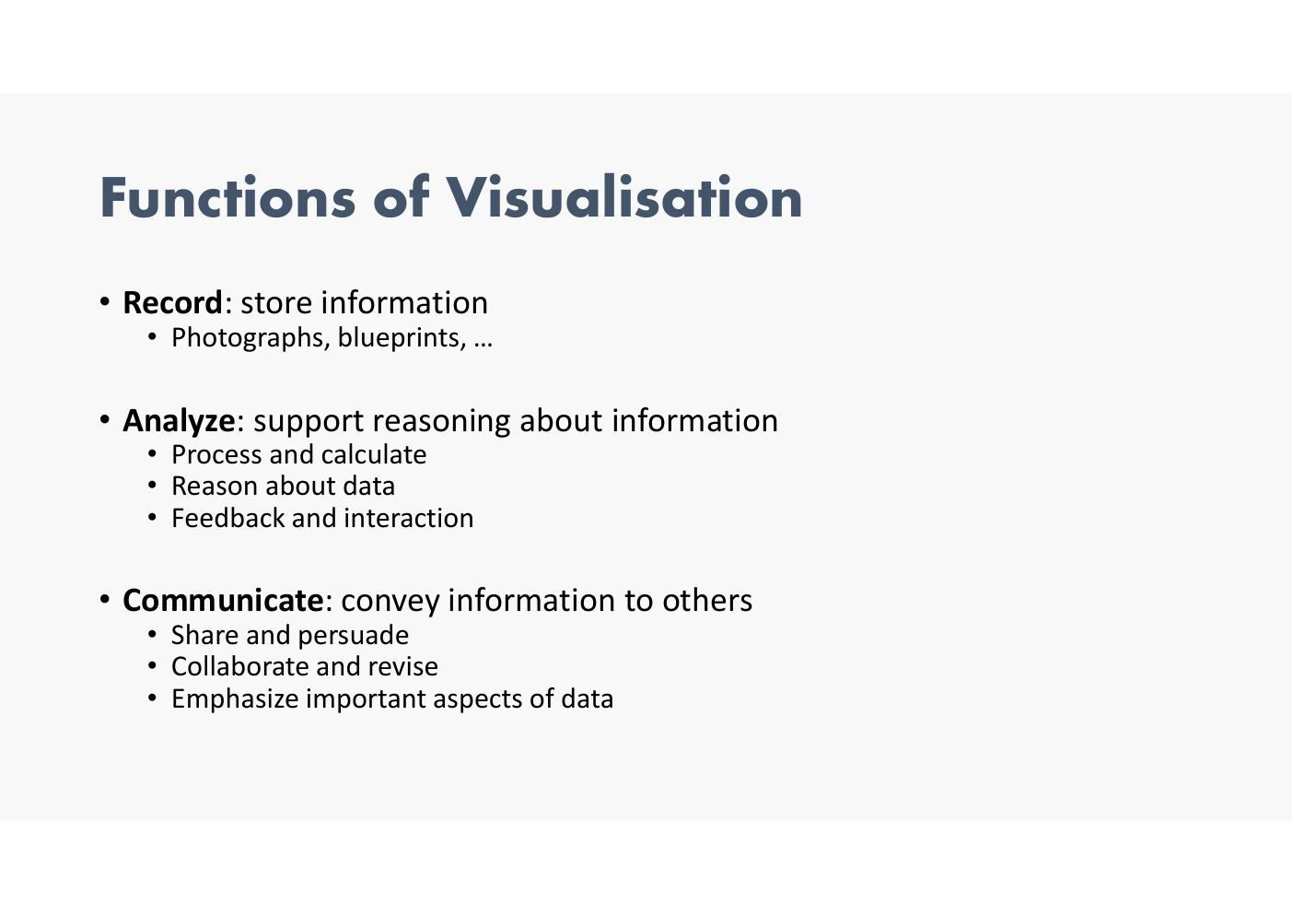

Visualisation Examples

Trends Over Time – COVID Ireland Daily Cases
- Line chart: daily change in new COVID-19 cases in Ireland (all time)
- 20 Oct 2020: New cases 1,263; 7-day avg 1,157
- Source: JHU CSSE COVID-19 Data
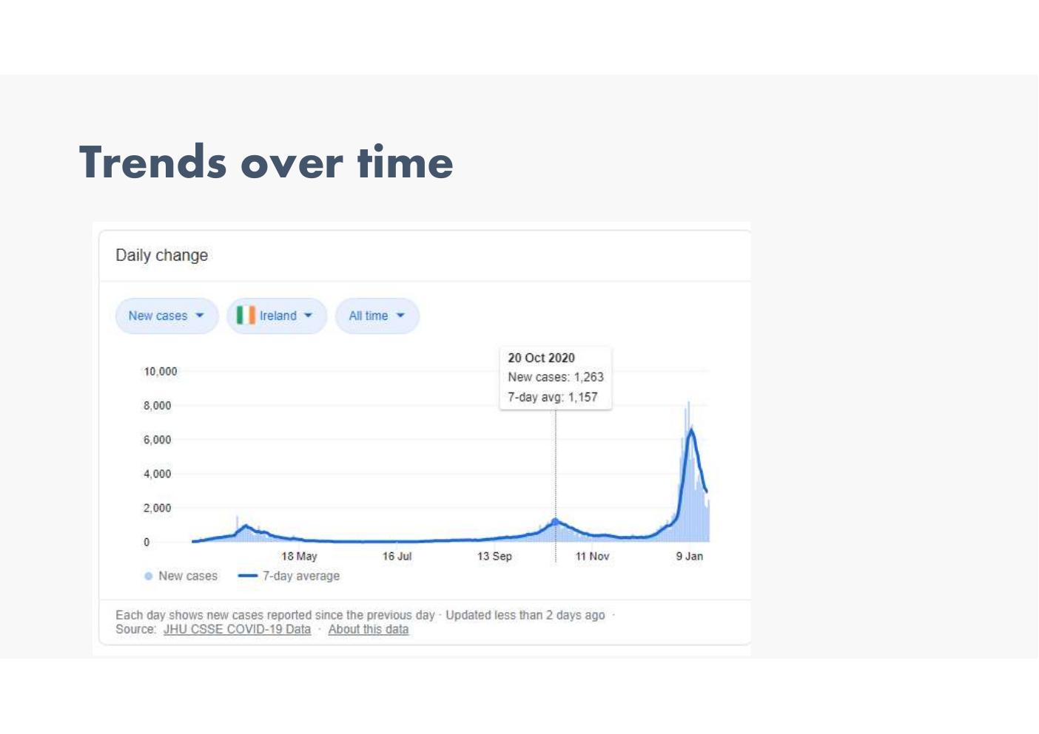

Trends Over Time – Temperature Anomalies by Country 1880–2017
- Animated visualisation showing temperature anomalies per country from 1880 to 2017
- Colour scale: -2.0°C (blue) through 0.0°C (grey) to +2.0°C (red)
- Data Source: NASA GISS, GISTEMP Land-Ocean Temperature Index (LOTI), ERSSTv5, 1200km smoothing – https://data.giss.nasa.gov/gistemp/
- Average of monthly temperature anomalies; GISTEMP base period 1951–1980
- Video license: CC-BY-4.0 | Creator: Antti Lipponen (@anttilip)
- Reference: https://www.flickr.com/photos/150411108@N06/43350961005/
- Line graph in previous slide is same data but in different format
  - surprise element makes viewers react to it
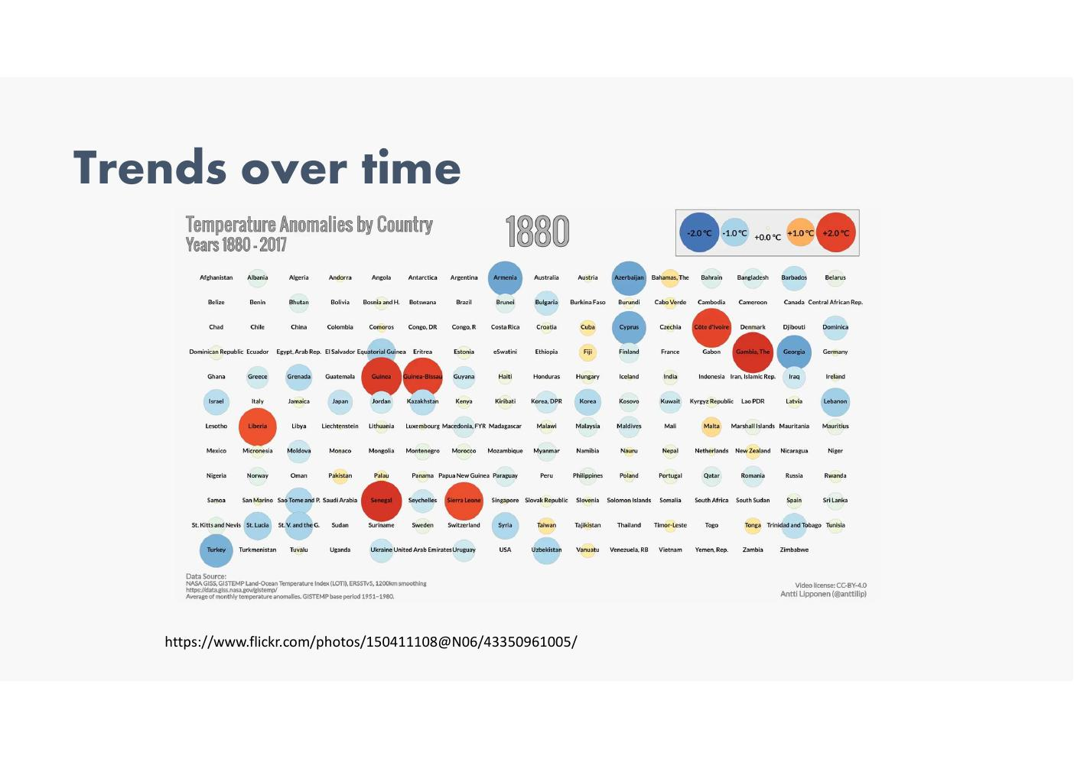

Comparisons – COVID Tests Per Million People
- 'How the US compares to other countries in coronavirus tests conducted per million people'
- Countries: Italy (~16,500), Germany (~15,500), Canada (~11,500), South Korea (~10,000), US (~8,000, highlighted pink), Netherlands (~5,000), UK (~4,500), France (~4,000), Taiwan (~2,000)
- Source: COVID Tracking Project, news reports, government websites (updated April 13)
- Reference: https://www.vox.com/2020/4/13/21215133/coronavirus-testing-covid-19-tests-screening
- remember where US was in overall scale->>> highlight important area
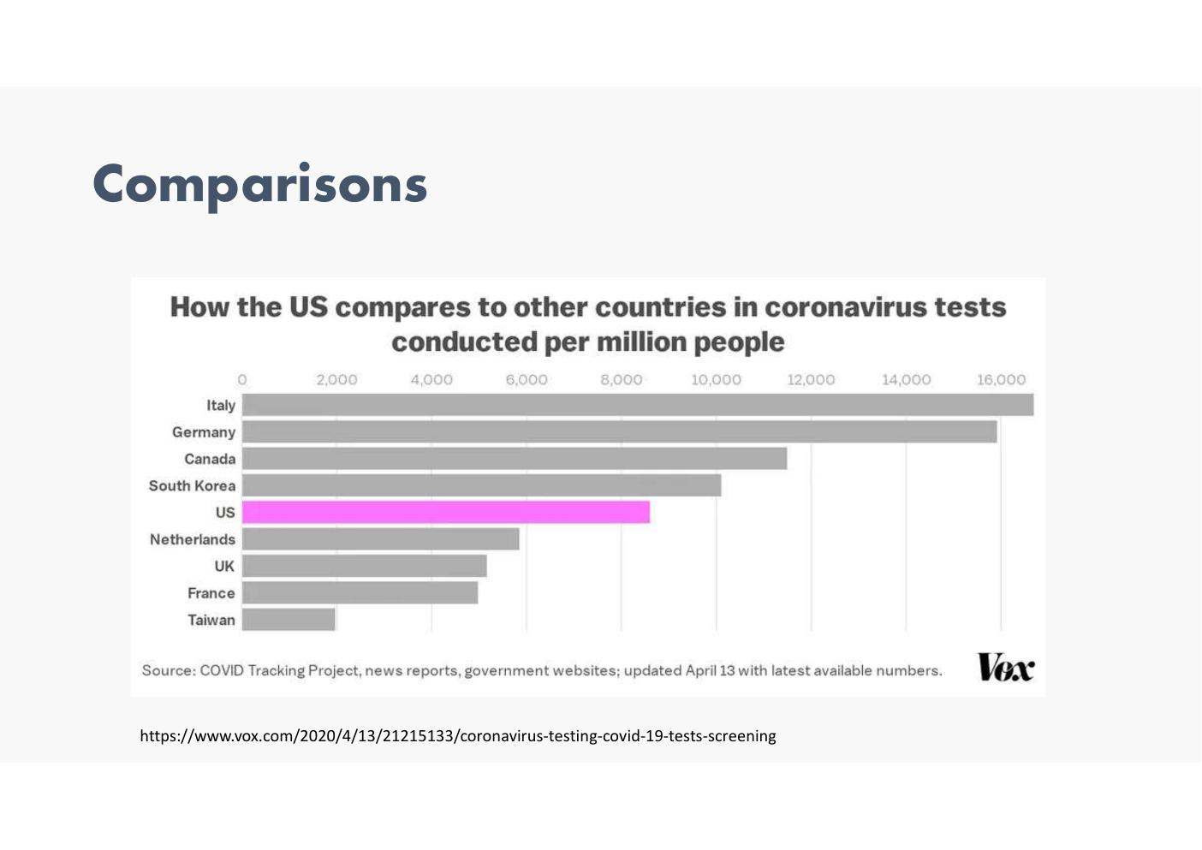

Box Plots – COVID Infections by Venue Type
- Horizontal box plots showing additional infections per 100k compared to not reopening, by venue
- Ranked highest to lowest risk: Full-Service Restaurants, Fitness Centers, Cafes & Snack Bars, Hotels & Motels, Limited-Service Restaurants, Religious Organizations, Offices of Physicians, Grocery Stores, Used Merchandise Stores, Pet Stores, Sporting Goods Stores, Other General Stores, Hobby & Toy Stores, Hardware Stores, Automotive Parts Stores, Department Stores, Gas Stations, Pharmacies & Drug Stores, Convenience Stores, New Car Dealers
- X-axis on log scale: 10¹ to 10⁴
- Reference: https://www.nature.com/articles/s41586-020-2923-3
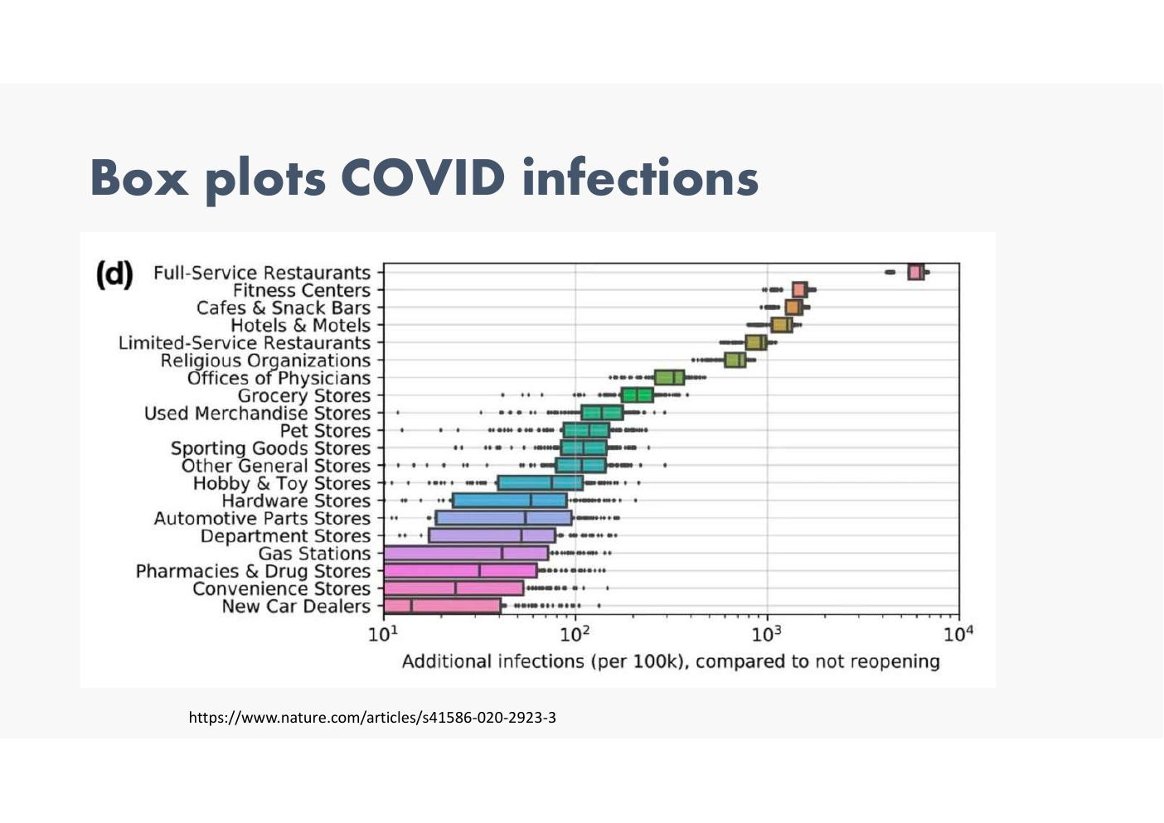

Voting and Political Data – Presidential Approval Ratings
- 'How does Trump's support compare?' – Presidential job approval rating after two years in office
- Trump: 37% | Obama: 50% | W Bush: 58% | Clinton: 47% | HW Bush: 64% | Reagan: 37%
- Source: Gallup | Reference: https://www.bbc.com/news/world-us-canada-38663043
- from BBC - they sue R , have good team and bbc R package
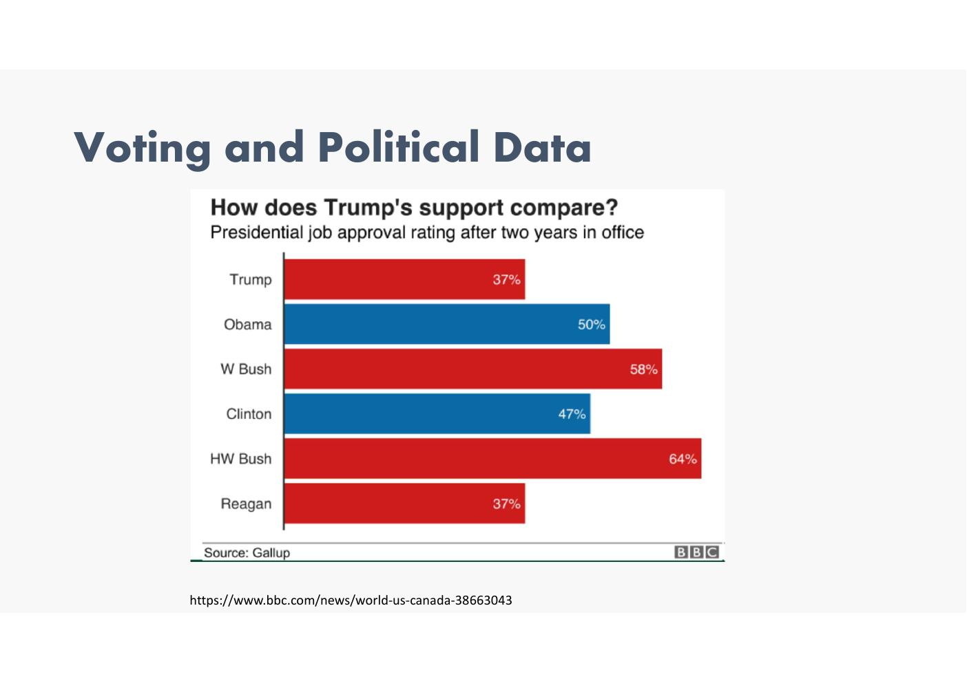

Relationships – Scatter Plot & Bubble Chart (Hans Rosling / Gapminder)
- Left: simple scatter plot showing Age vs Risk Index
- Right (Gapminder): Life expectancy (years) vs Income per capita in international dollars (GNP or GNI); bubble size = population; colour = geographic region; animated over time (1980–2000+)
- References:
  - https://www.ted.com/talks/hans_rosling_the_best_stats_you_ve_ever_seen
  - https://www.gapminder.org/tools/#$state$time$value=2020&delay:120;;&chart-type=bubbles
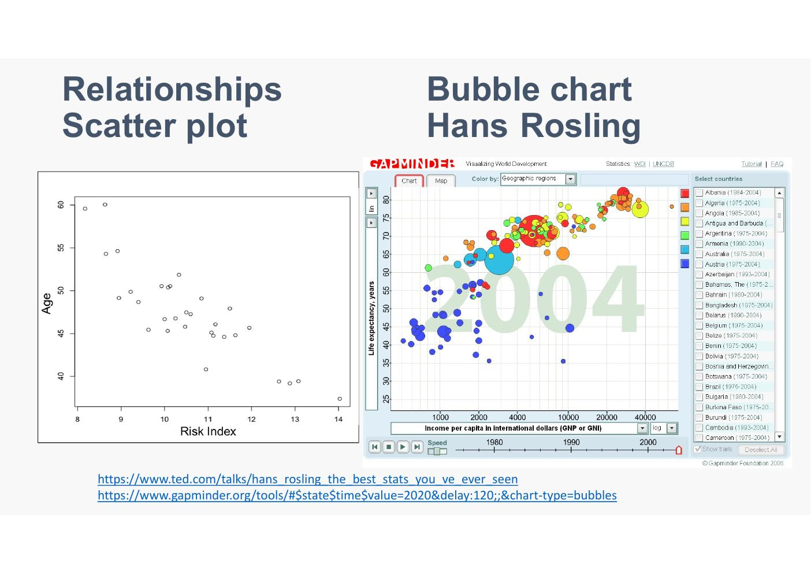
Tech talk by hansrosline… a really visual shocking to see how life expectancy has changed over time by different countries
Income per capita also – whe there is a war have a bgi drop.. one country goes down and up… recession the same.. good animation… very imspiring ted talk

Parallel Coordinates – Iris Dataset
- Parallel Coordinate Plot for the Iris Data – 4 variables: Petal.Length, Petal.Width, Sepal.Length, Sepal.Width
- Each line = one observation; coloured by species: setosa (purple), versicolor (teal), virginica (yellow)
- Reference: https://www.data-to-viz.com/graph/parallel.html
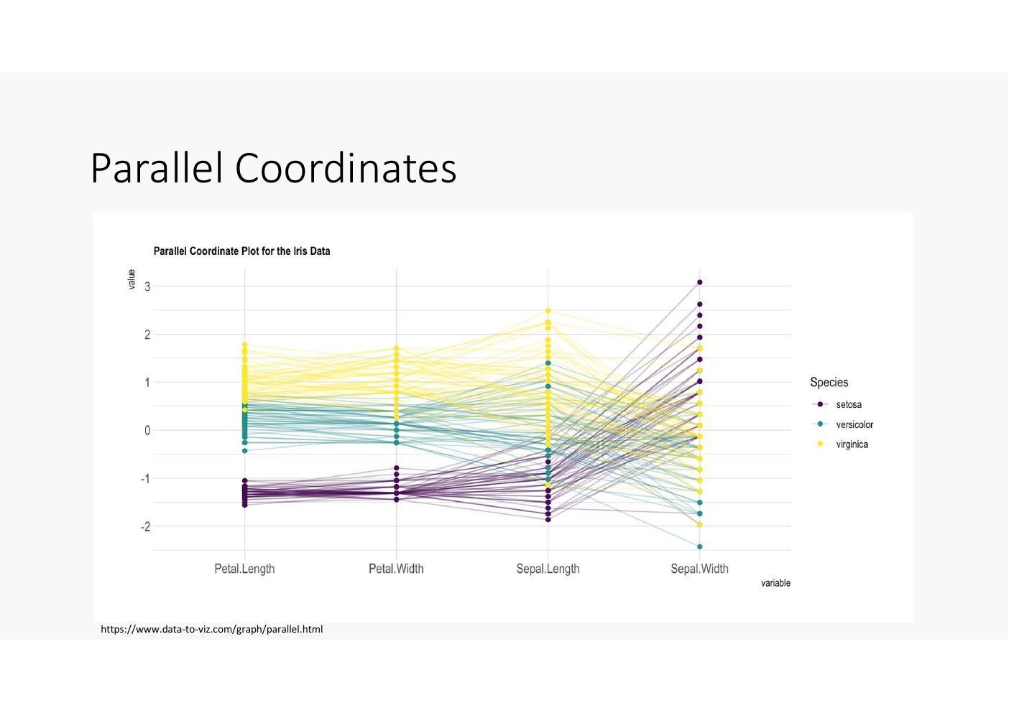
Difficult to interpret

Maps – World Map of Vaccinations
- Choropleth map: World Map of Vaccinations – more than 32.4 million doses administered in 45 countries
- Colour scale from no data (grey) to light green to dark green (doses per 100 people)
- Reference: https://www.bloomberg.com/graphics/covid-vaccine-tracker-global-distribution/
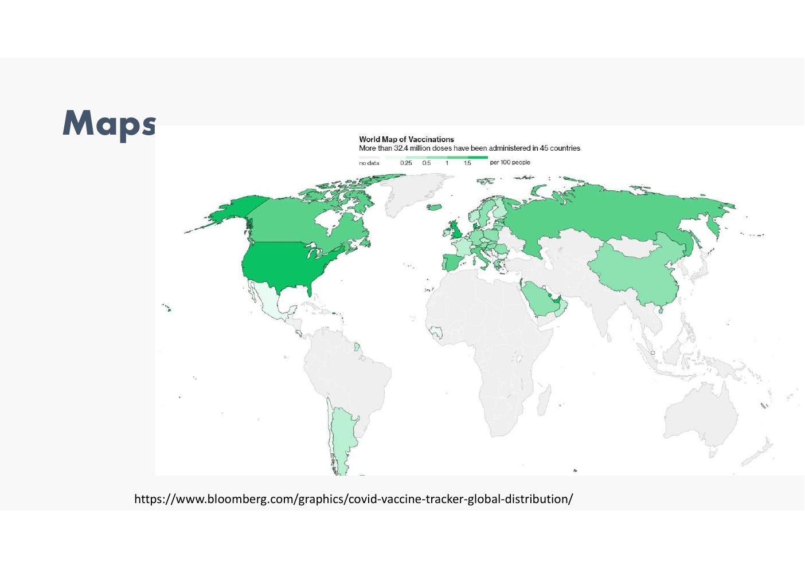

Networks – Neural Network Diagram
- Simple neural network: inputs X₁ and X₂, weights W₁ and W₂, bias +b, output y
- Reference: http://jalammar.github.io/visual-interactive-guide-basics-neural-networks/
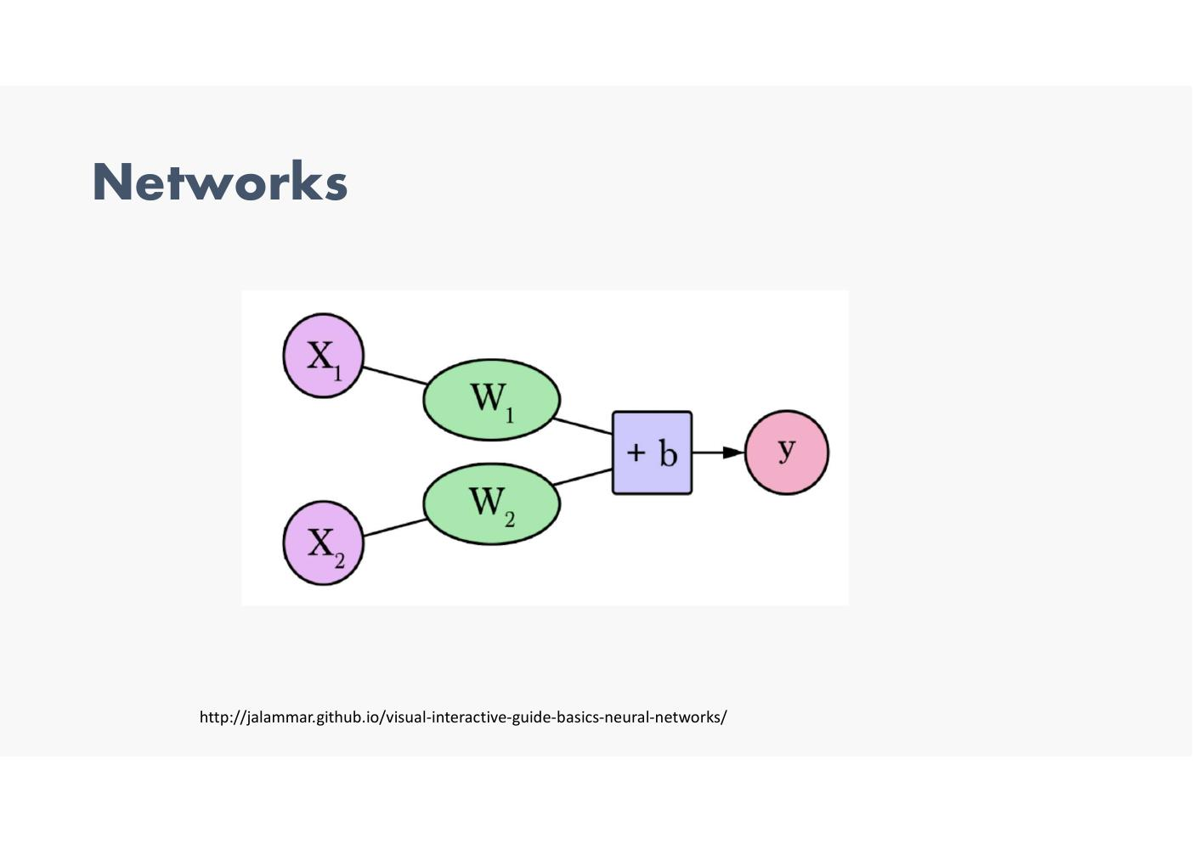

Networks – Social Network Analysis (Truthy)
- Social network graph showing clusters of connections labelled by group: UBC, classmates (UBC), classmates (high school), Marine Drive, Hillel, Jump Start, mom's friends, cousins, capoeira, bt's, friends (Ukraine / Nice)
- Reference: Network Analysis – Social Network Analysis (Truthy project)
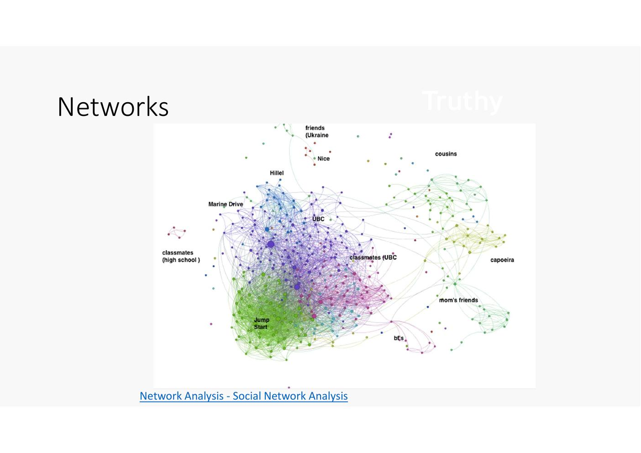

Chord Diagram – Erasmus Student Mobility 2014–2020
- Chord diagram showing movement of Erasmus participants between top countries, 2014–2020
- Countries shown: Poland, Germany, United Kingdom, Spain, Belgium, Italy, France
- Example tooltip: Number of Students Belgium → France: 200
- Source: Data.Europa
- Reference: https://twitter.com/tanya_shapiro/status/1617195890627821576
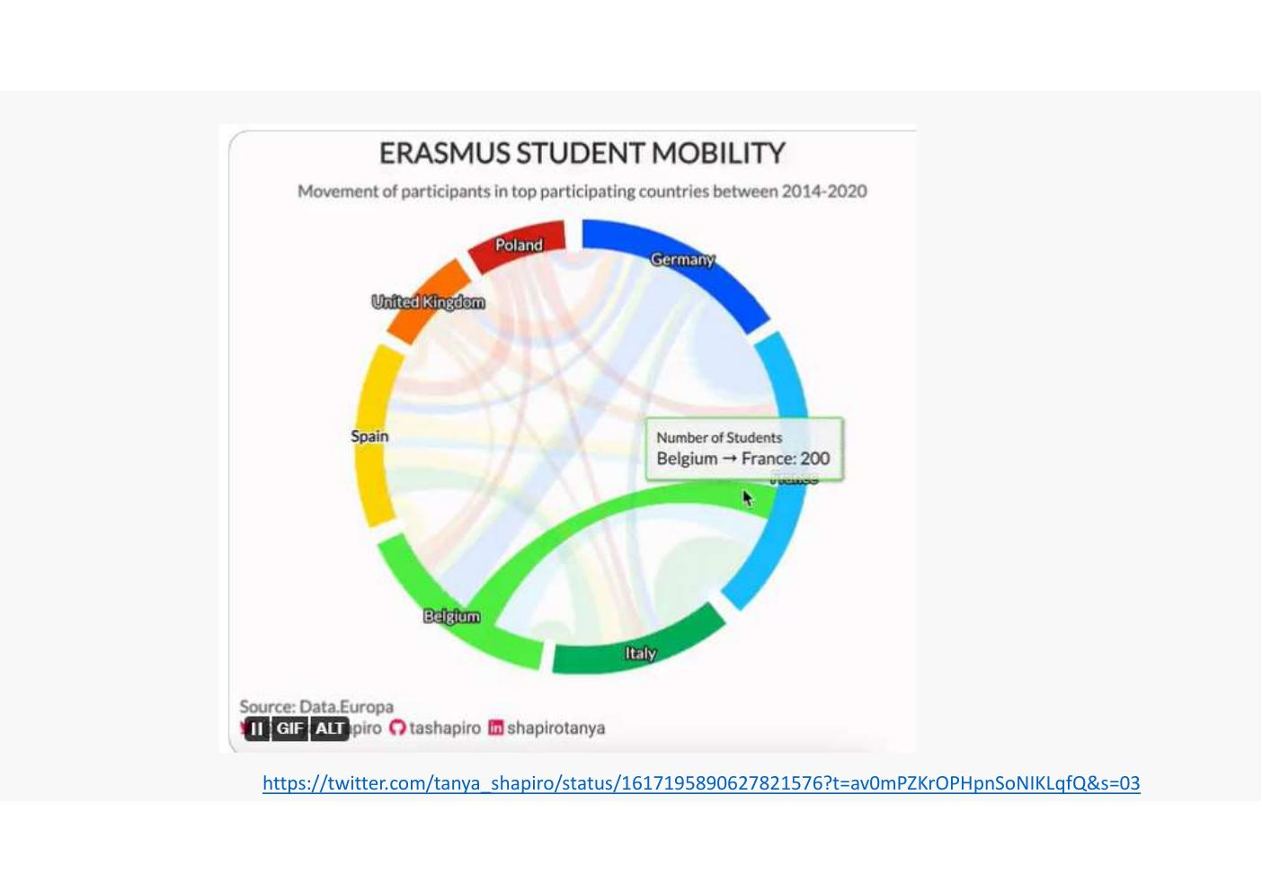

Networks – HealthInfoScape
- Network visualisation of co-occurring health conditions
- Left: node-link diagram – conditions as nodes, co-occurrence as edges, grouped by condition cluster
- Right: circular / chord layout – same data shown with labels around the perimeter
- Conditions visible include: Hypertension benign, Heartburn, Routine medical examination, Allergy, Respiratory tract infection, Abdominal pain, Fatigue, Depression, Diabetes, Coronary plaque, Sleep Apnoea, Gynaecological examination, Urinary tract infection, High blood cholesterol, and many more
- Reference: http://senseable.mit.edu/healthinfoscape/
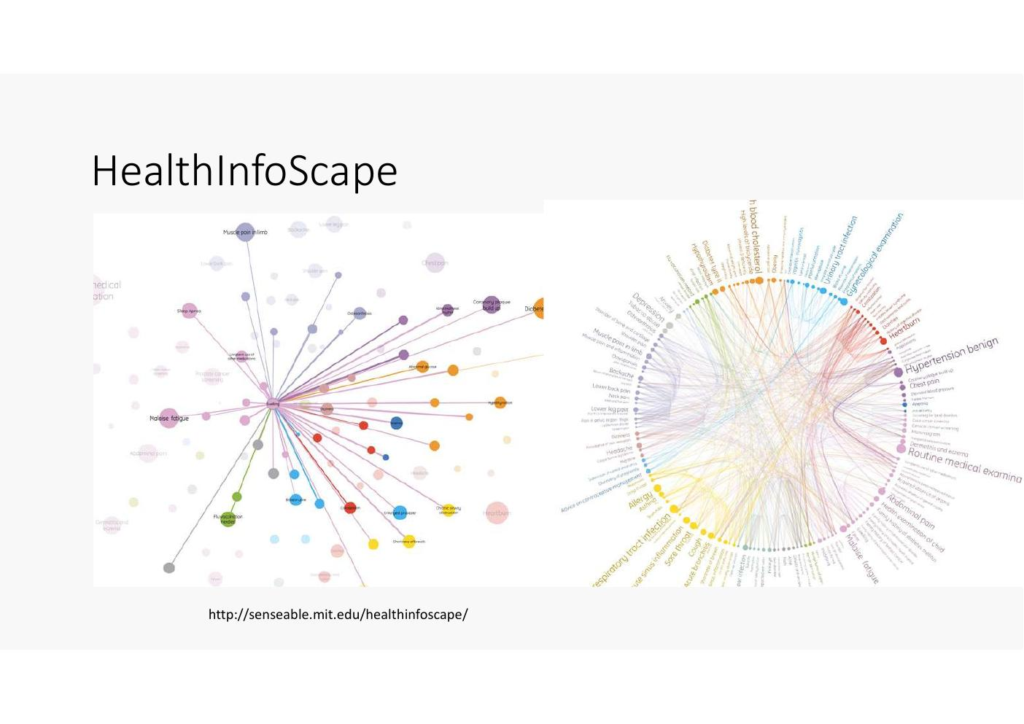

Classic Case Studies

1854 London Cholera Epidemic
- On the evening of August 31, 1854, Cholera broke out in the Broad Street area of central London
- John Snow, a London doctor, was asked to investigate
- Visualisation was key to his solution
- Reference: www.edwardtufte.com/tufte/books
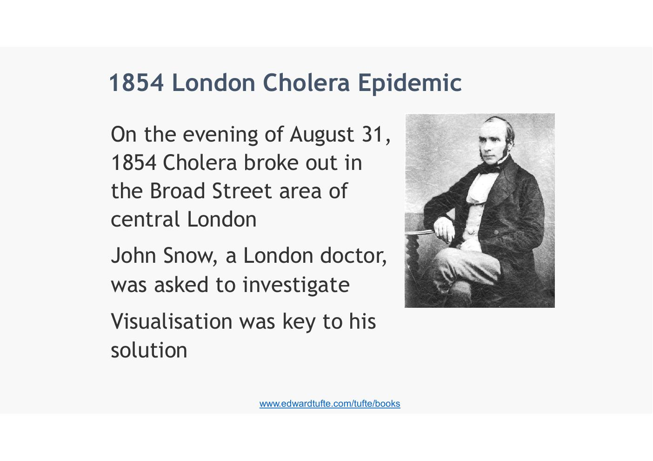

Look at two historical examples
Kind of why visualisation became and shown to be such a powerfull tool
Colera epidemic – London – Jon Snow

1854 London Cholera Epidemic – Daily Deaths
- Bar chart: deaths from cholera each day during the epidemic
- X-axis: August 20 – September 29
- Peak: approximately 127 deaths around September 1–2
- Deaths decline sharply after pump handle removed from Broad Street pump
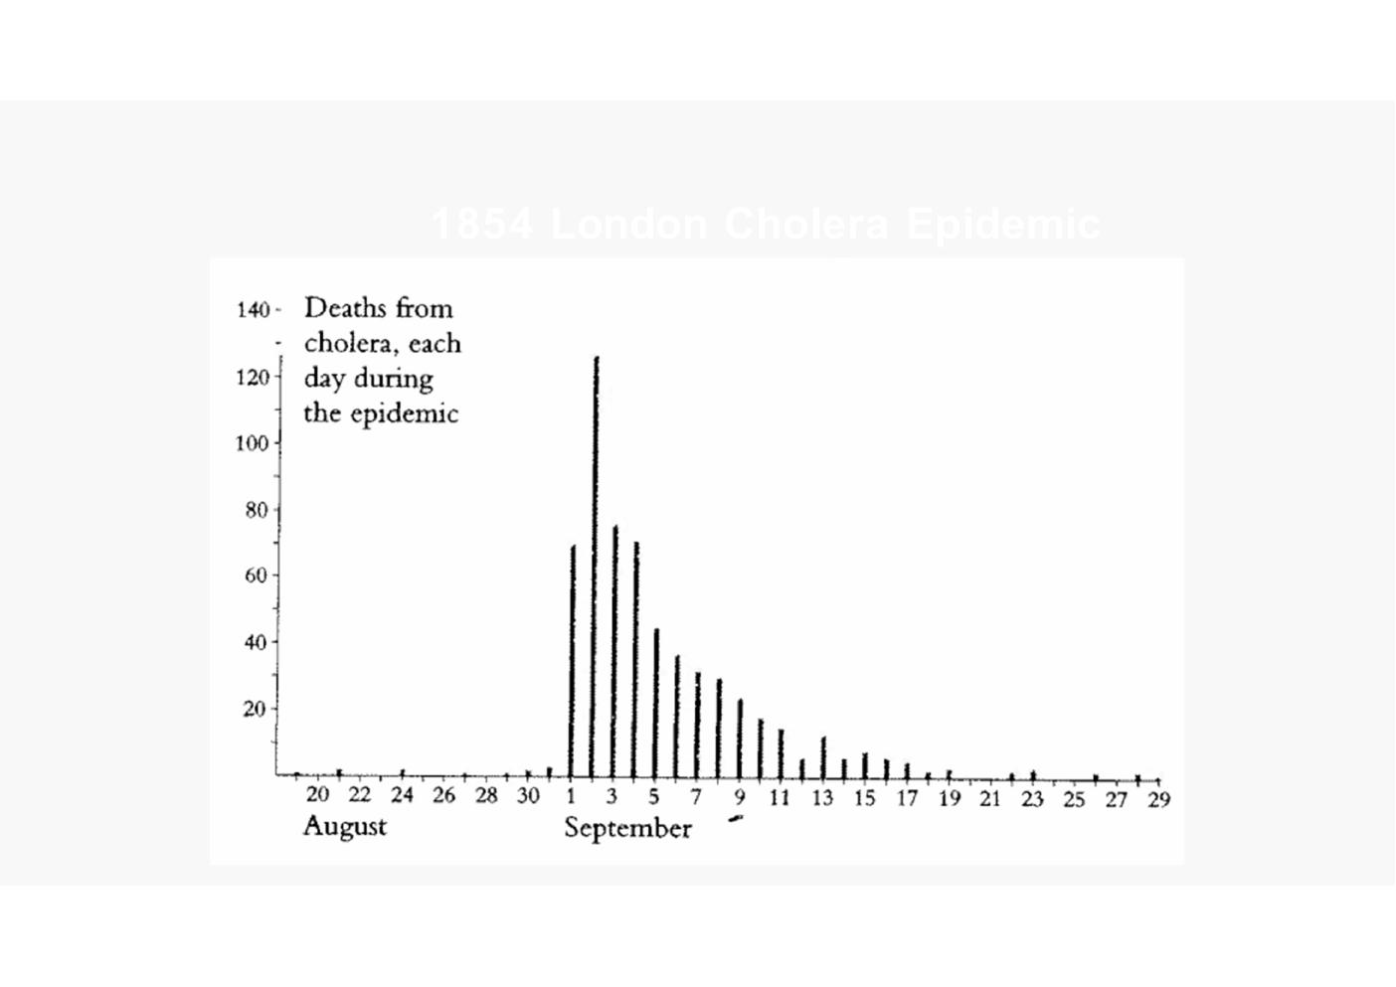

1854 London Cholera Epidemic – Cumulative Deaths
- Line chart: cumulative deaths from cholera beginning August 19, 1854
- Final total: 616 deaths
- X-axis: August 20 – September 29
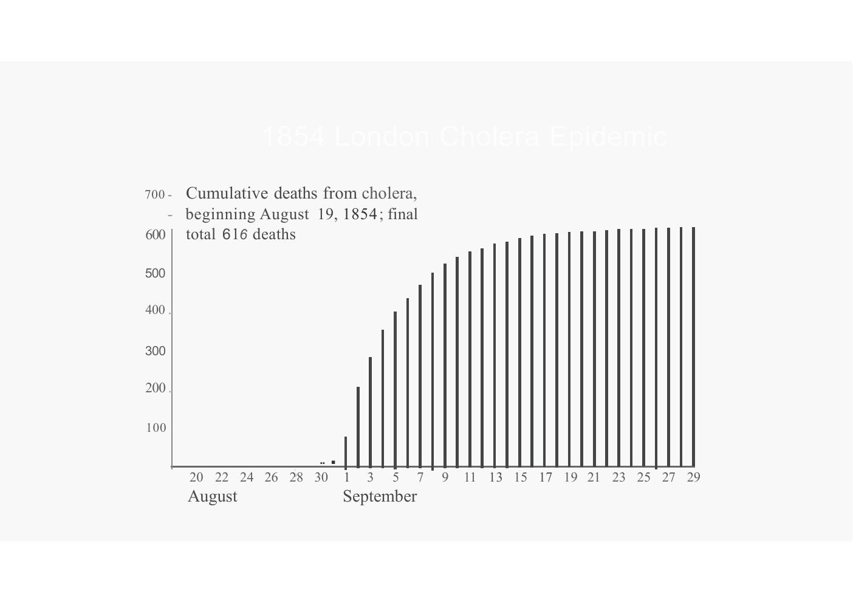
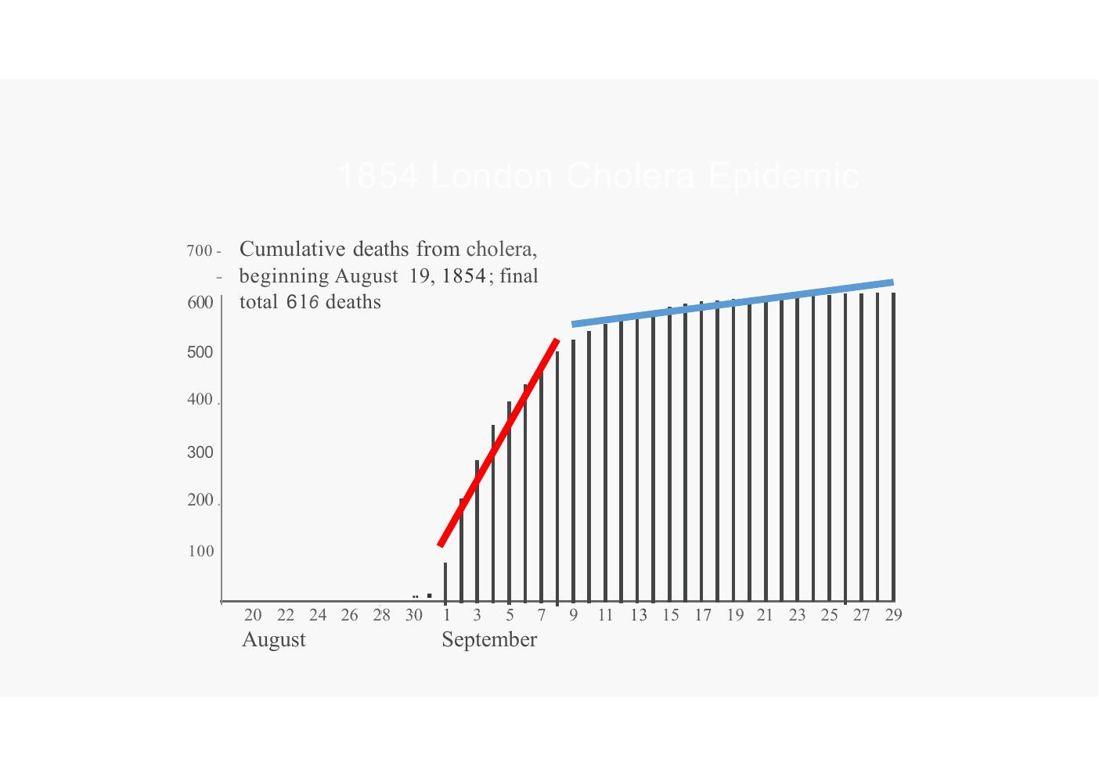
Point of inflection where things started to get better.

1854 London Cholera Epidemic – John Snow's Map
- Street map of the Broad Street area of central London
- Death locations plotted as stacked black bars at each address on the street
- Pump locations marked throughout the map
- Cluster of deaths clearly visible around the Broad Street pump
- Work House and Brewery highlighted (yellow) – both had low death rates due to separate water supplies
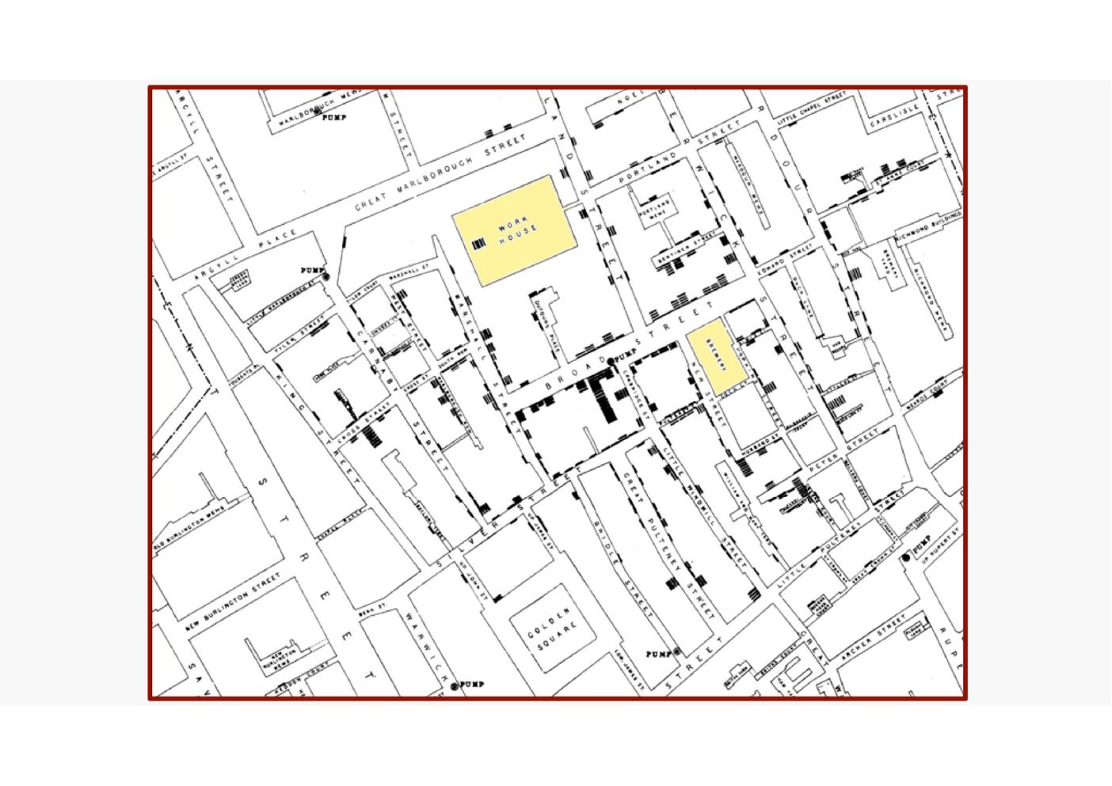
- 2 places where a brewery 0whci had it sown well+ prison which had its own well
- Brewery had no one getting cholera, a+ prison with huge numbers ni side had small amount getting cholera
- Street where public water pump was had uge numbers
- Took handle off >> only people who were already sick died…
- All jdue to the graph and the odd thing happengin in the map

London Underground Map
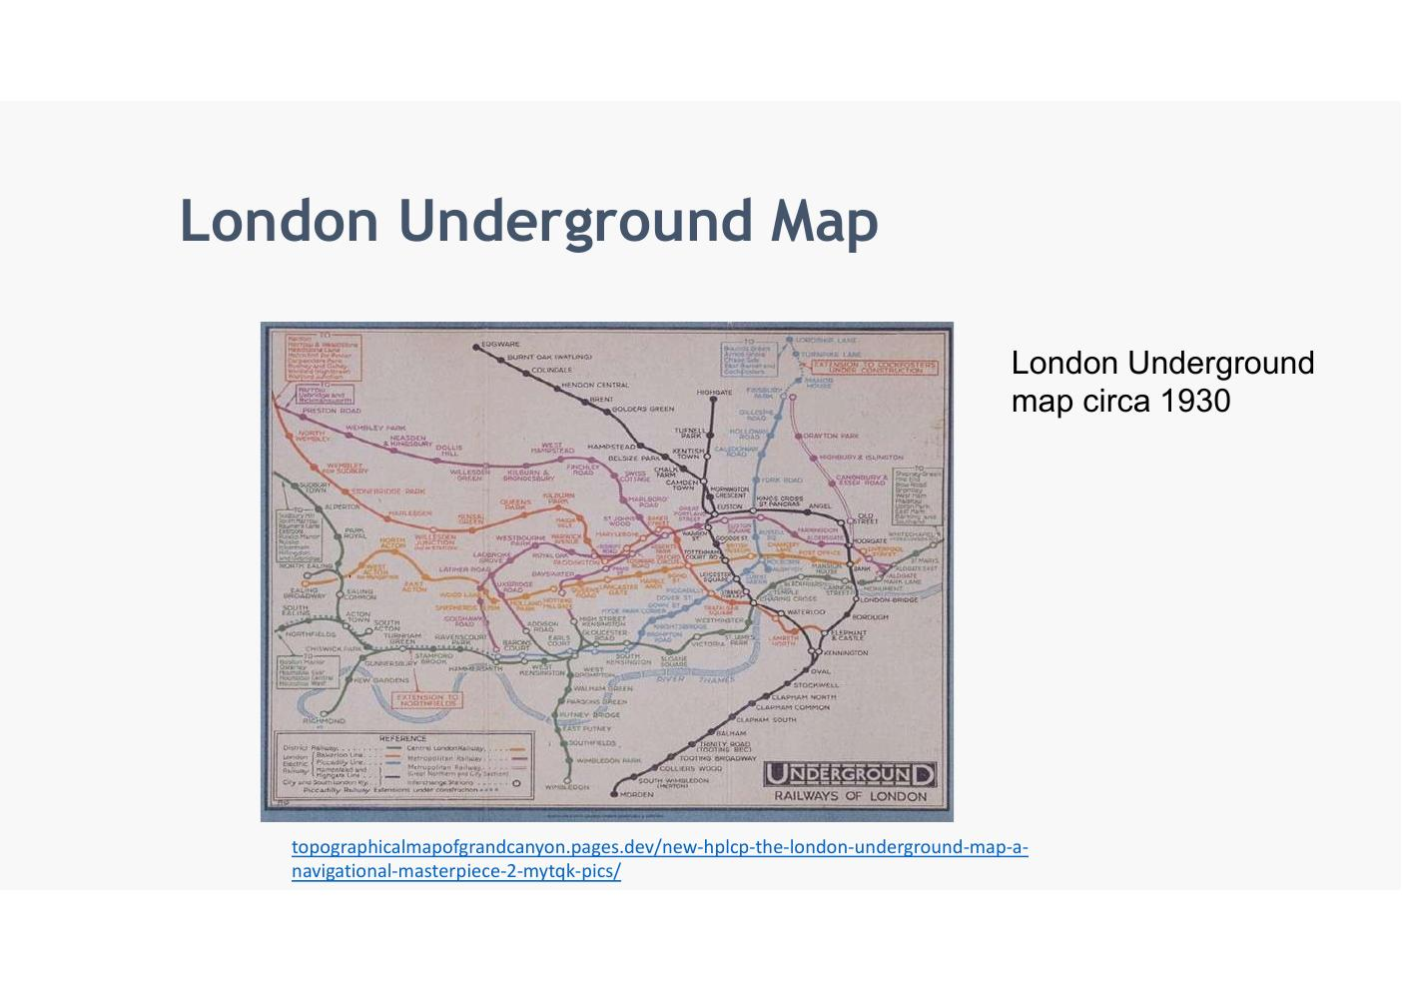
- Harry Beck
- Once inside it don’e care if a bend or not… changes to more straight liens … just want t next stop…
- Bends are still there but user does tno need them, doesn’t need to know..
- His idea of what was needed and what wasn’t is still valid

London Underground Map – Circa 1930 (Topographic / Geographic)
- London Underground map circa 1930 – geographically accurate to real street layout
- Difficult to use for navigation because geographic accuracy creates a cluttered, unreadable map in the dense central area
- Reference: topographicalmapofgrandcanyon.pages.dev/new-hplcp-the-london-underground-map-a-navigational-masterpiece-2-mytqk-pics/

London Underground Map – Harry Beck's Insight
- Draughtsman Harry Beck thought: 'If you're going underground, why do you need to bother about geography? … Connections are the thing' – and designed a new map
- Key design decision: sacrifice geographic accuracy in favour of clarity of connections
- Reference: topographicalmapofgrandcanyon.pages.dev/new-hplcp-the-london-underground-map-a-navigational-masterpiece-2-mytqk-pics/
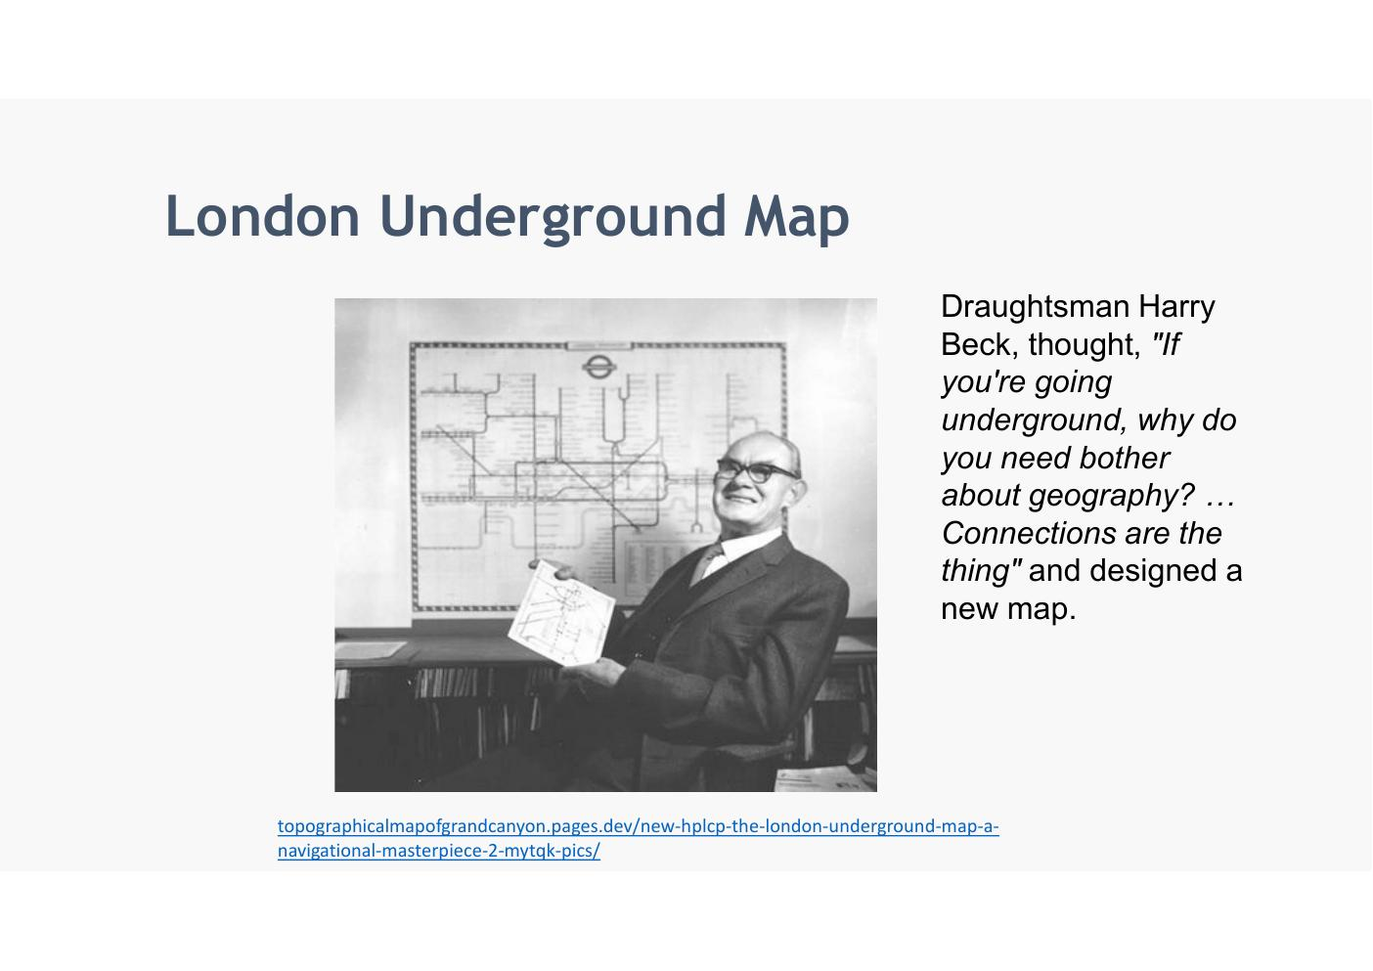

London Underground Map – Beck's 1933 Design
- Left: an early sketch of Harry Beck's new schematic map – uses only horizontal, vertical and 45° diagonal lines
- Right: Beck's London Underground map circa 1933 – the design that is still the basis of the tube map used today
- Prioritises topology (connections and sequence of stations) over geography
- Reference: topographicalmapofgrandcanyon.pages.dev/new-hplcp-the-london-underground-map-a-navigational-masterpiece-2-mytqk-pics/
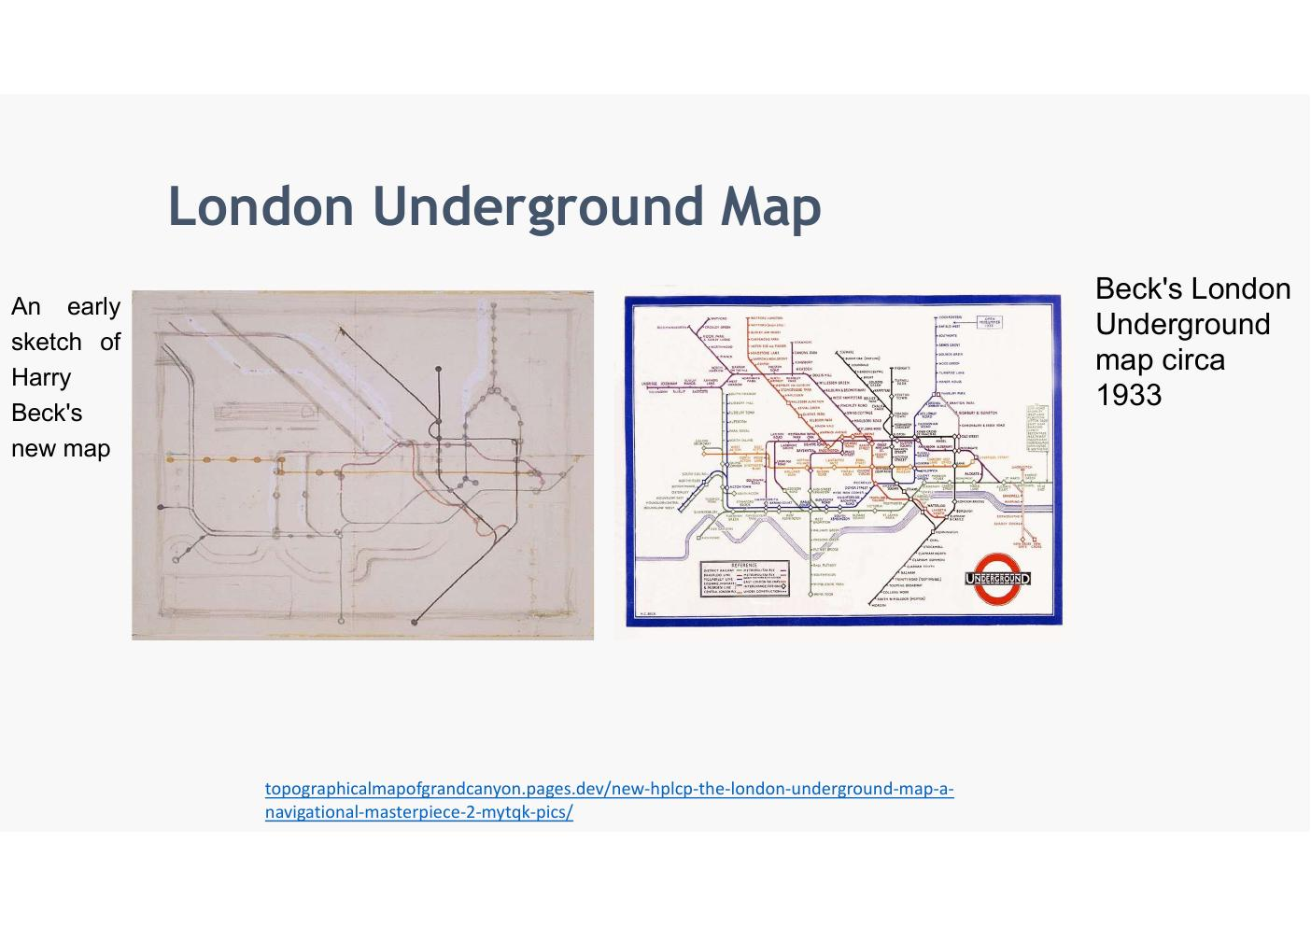

Principles and Frameworks

Visualisation: The Challenge
- The challenge is to create effective and engaging visualizations that are appropriate to the data, the audience and the message
- Reference: 'A Tour Through the Visualization Zoo', J. Heer, M. Bostock & V. Ogievetsky, Communications of the ACM, vol. 53, no. 6, 2010 – http://queue.acm.org/detail.cfm?id=1805128
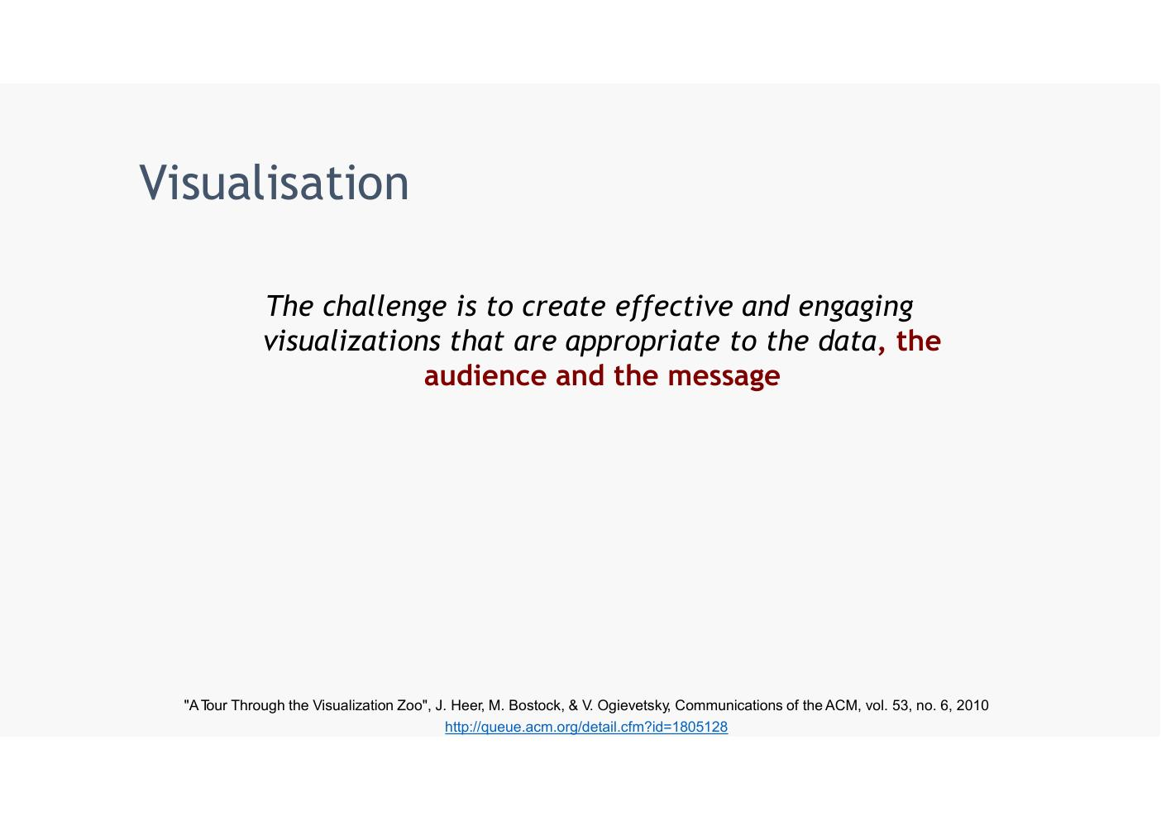
- Always need those 3 things
  - Data
  - Audience
  - Message

Charts That Lie
- 'Good charts are useful because they untangle the complexity of numbers, making them more concrete and tangible.'
- 'However, charts can also lead us to spot patterns and trends that are dubious, spurious or misleading, particularly when we pair them with the human brain's tendency to read too much into what we see and to always try to confirm what we already believe.' – Alberto Cairo
- Example scatter plot: Life expectancy (years) vs Annual cigarette consumption per person above age 14, each red dot = one country (Source: World Health Organization)
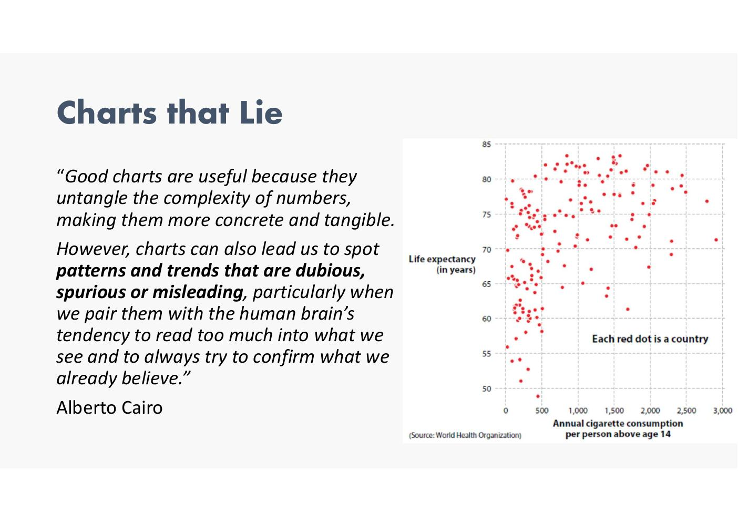
- Examples of things that can be misleading..
- Can see correlations but can never prove causation
- Annual cigarette consumption vs life expectancy

The Visualisation Trinity
- Three components: Reader – Data – Designer
- The relationship between them determines the purpose and nature of the visualisation
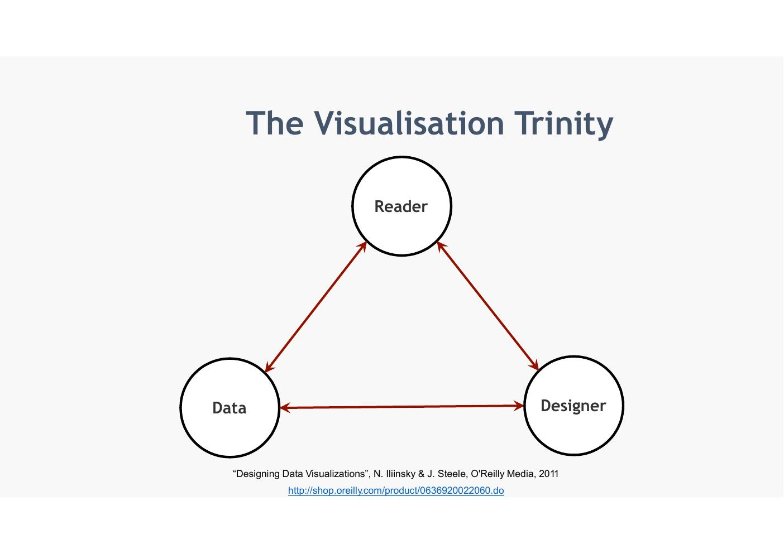
- Won’t get into details here btu will look at theory of visualisation
- Depending which one is strongest get different output decision

The Visualisation Trinity – Extended
- Informative: primarily serves reader understanding
- Persuasive: aims to influence the reader
- Visual Art: aesthetic / expressive purpose
- Effective visualisation balances all three in relation to its purpose
- Reference: 'Designing Data Visualizations', N. Iliinsky & J. Steele, O'Reilly Media, 2011 – http://shop.oreilly.com/product/0636920022060.do
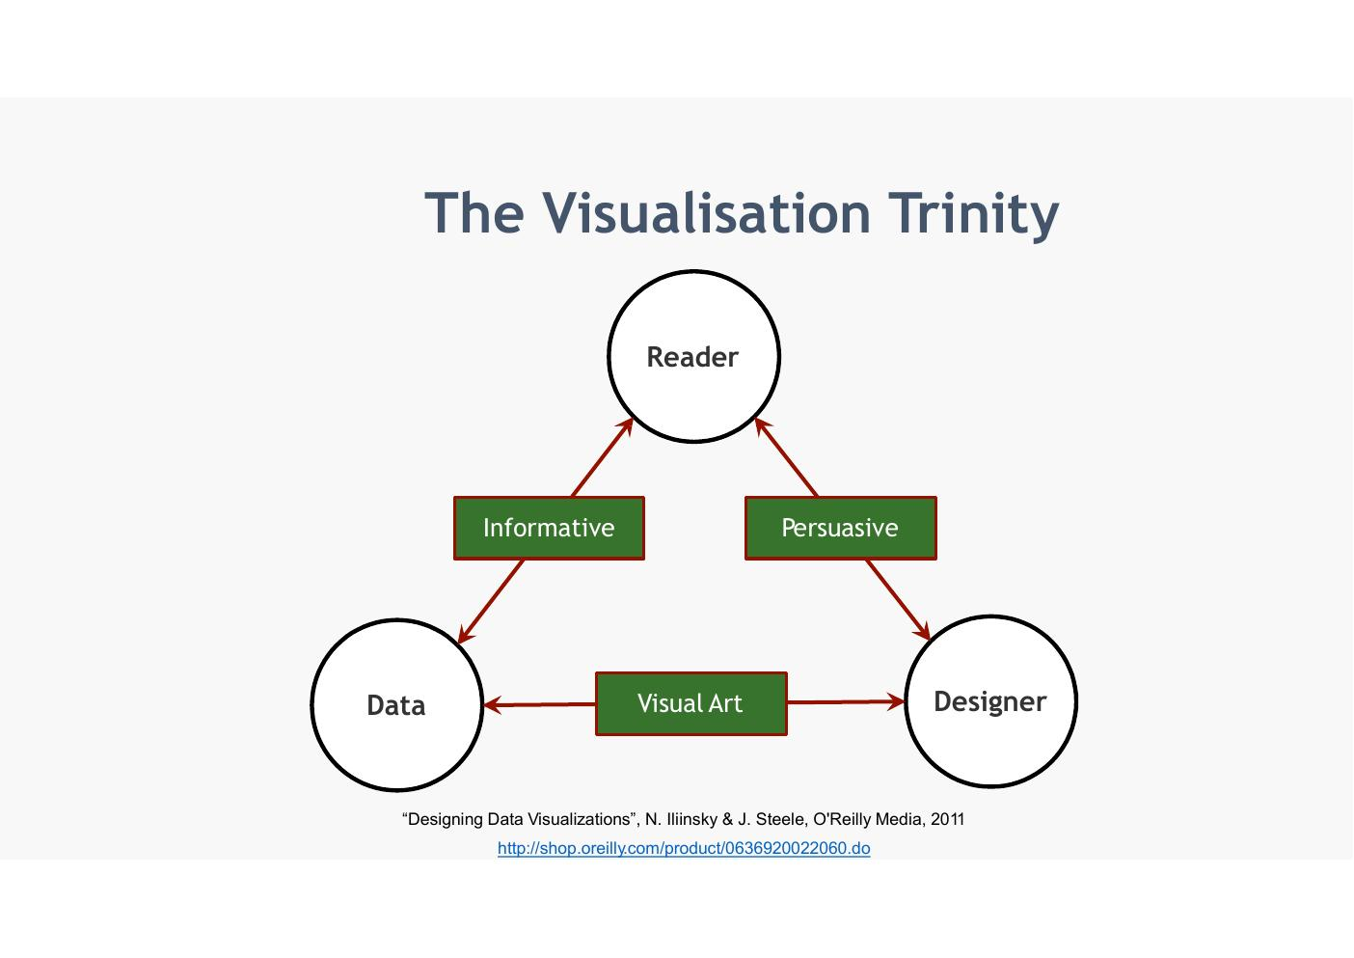

Ben Fry's Visualisation Steps
- Acquire → Parse → Filter → Mine → Represent → Refine → Interact
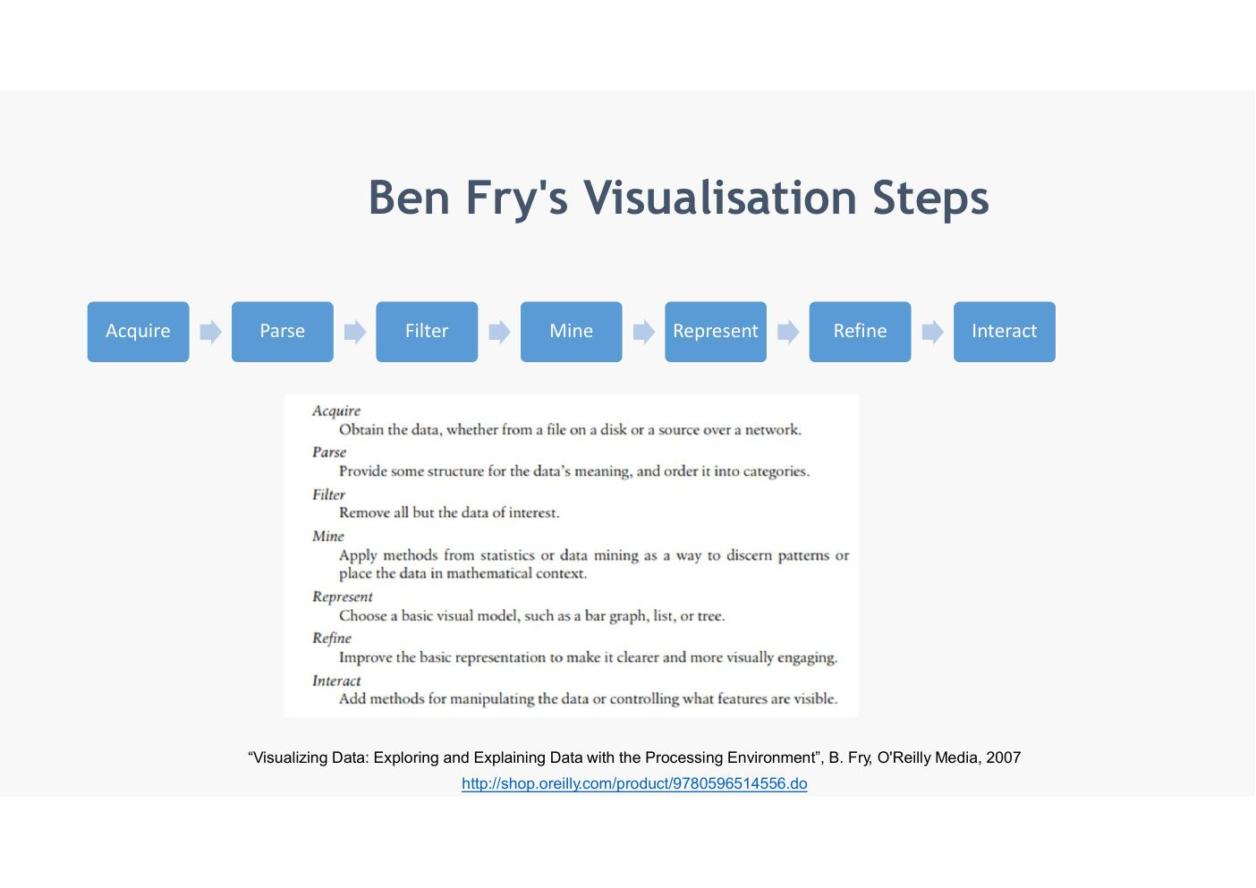

Ben Fry's Visualisation Steps – Descriptions
- Acquire – Obtain the data, whether from a file on a disk or a source over a network
- Parse – Provide some structure for the data's meaning, and order it into categories
- Filter – Remove all but the data of interest
- Mine – Apply methods from statistics or data mining as a way to discern patterns or place the data in mathematical context
- Represent – Choose a basic visual model, such as a bar graph, list, or tree
- Refine – Improve the basic representation to make it clearer and more visually engaging
- Interact – Add methods for manipulating the data or controlling what features are visible
- Reference: 'Visualizing Data: Exploring and Explaining Data with the Processing Environment', B. Fry, O'Reilly Media, 2007 – http://shop.oreilly.com/product/9780596514556.do
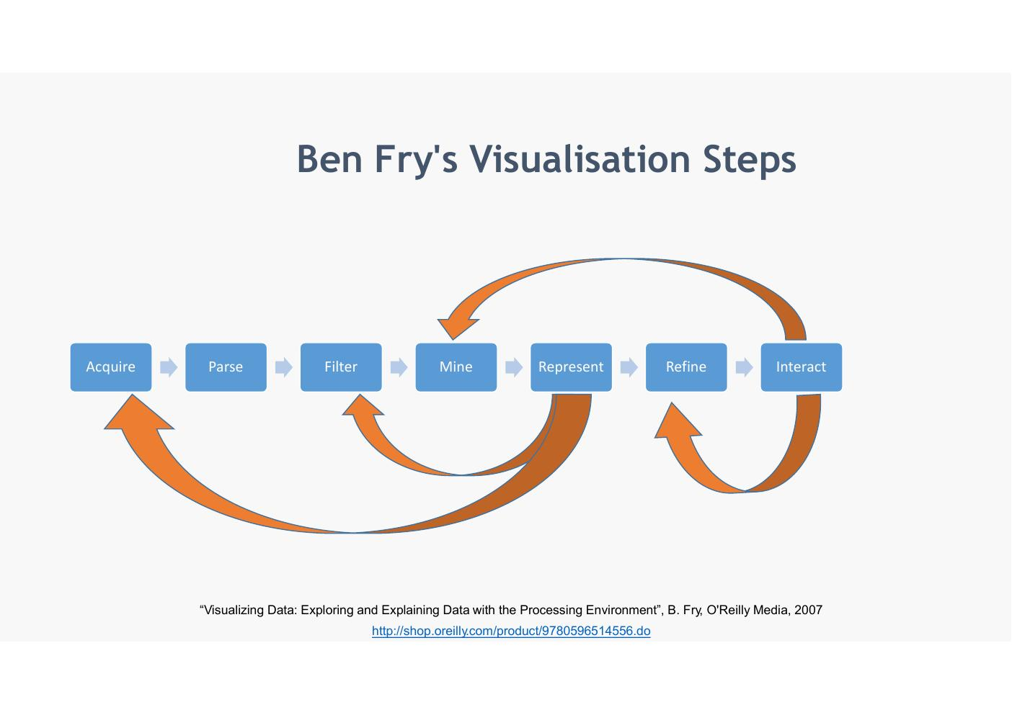
- Not fully linear – there are feedback loops
- If realise visualiatin not working need to go back, get more data, reduce data re-evaluate etc

Module Overview

Module Aim
- The central aim of this module is to help students attain the ability to take complex data, process it and extract value from it through visualisation
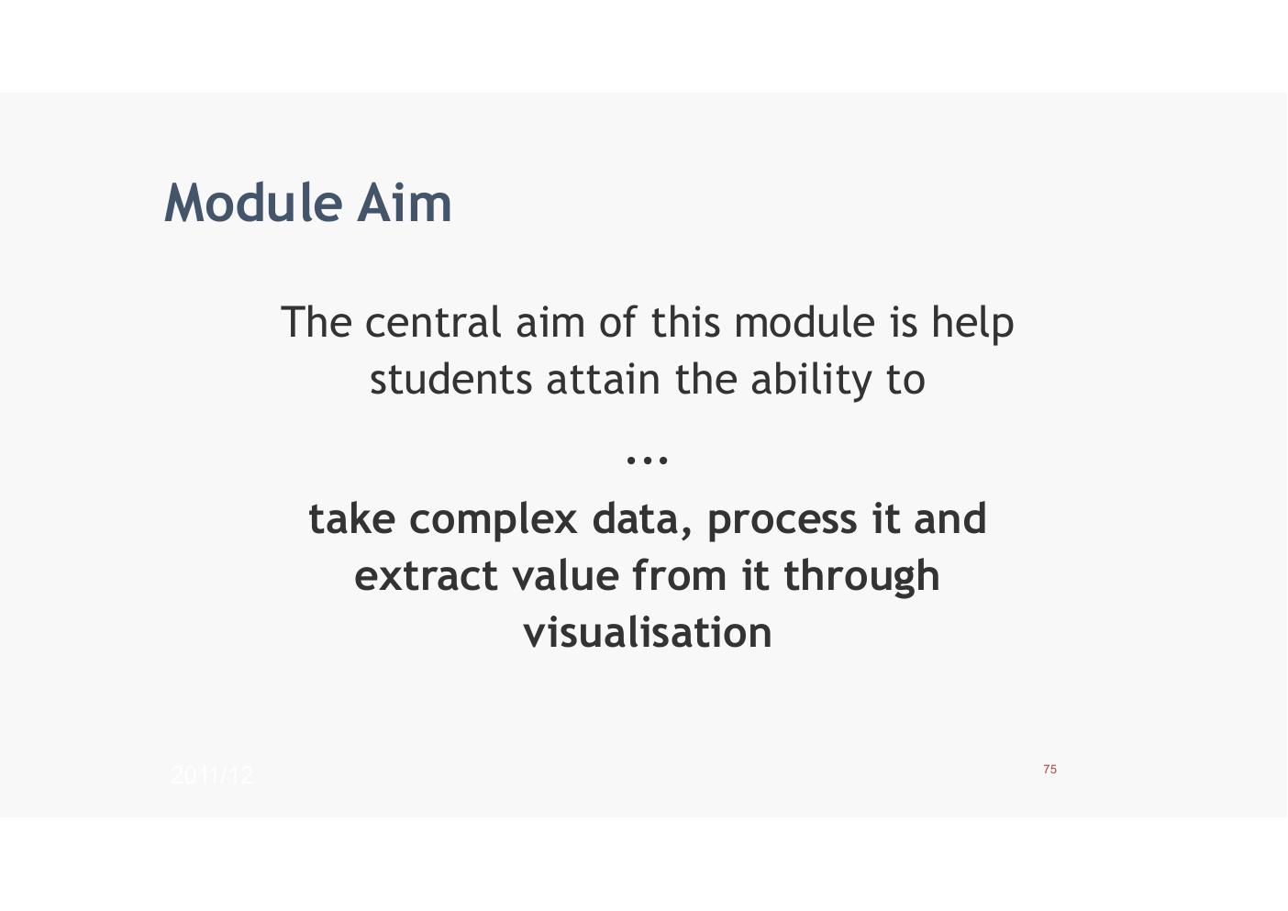

Learning Outcomes
- Create and deploy successful data visualisations using leading software tools
- Design effective visualizations based on principles from perceptual psychology, cognitive science, graphic design and visual art
- Select, formulate and integrate metaphors to suit particular data-driven tasks
- Analyse and evaluate how mental models aid in the interpretation of complex visual displays
- Demonstrate understanding of how humans perceive the world around them on a general level and absorb complex data/information on a specific level
- Analyse and evaluate how metaphors are used to convey unfamiliar information
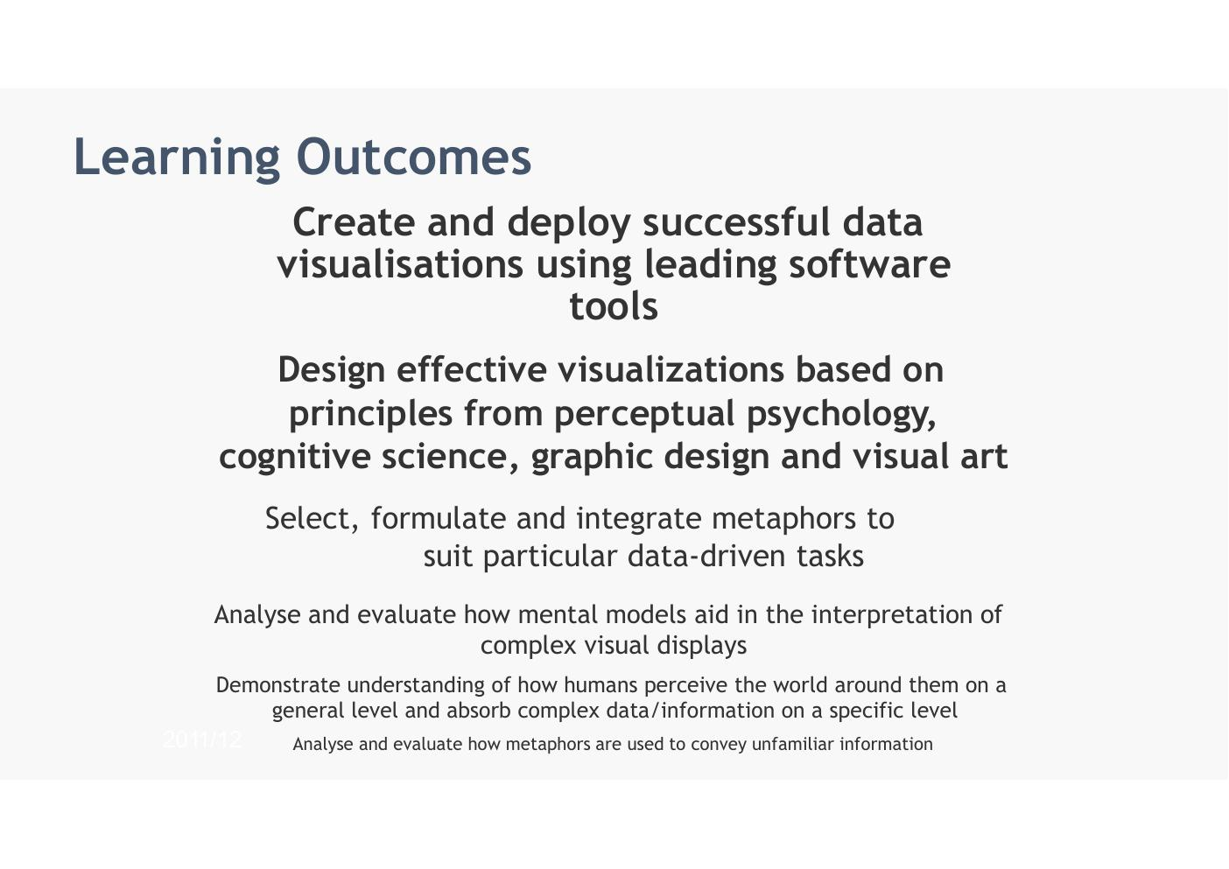

Module Content Overview
- Visualization Practice
- Visualization Theory
- Visualization Case Studies
- Creating Visualizations Using R
- Programming in R
- Creating Visualizations Using Tableau Public
- Underpinning disciplines: Psychology, Visual Perception & Memory, Graphic Design, Computer Science, Mathematics, Graph Theory, Statistics
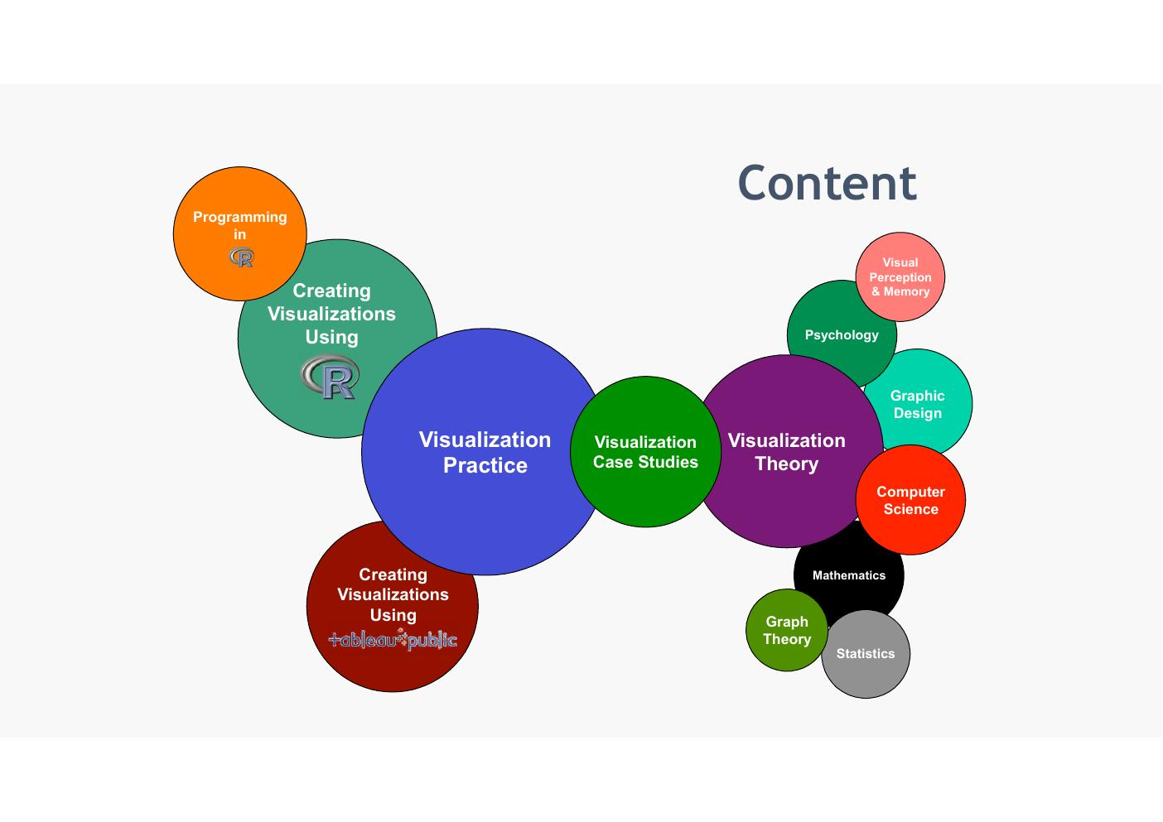
- Will have good examples of visualisations and bad examples every week

Module Content – Detailed
- Fundamentals of visualisation
- Data characteristics & dimensions
- Use of encodings
- Colour theory
- Graphical perception & communication
- Interaction design
- Visualisation types:
  - Trends
  - Comparisons
  - Correlations
  - Maps
  - Networks
  - Hierarchies
  - Visualising Text
  - High-dimensional data
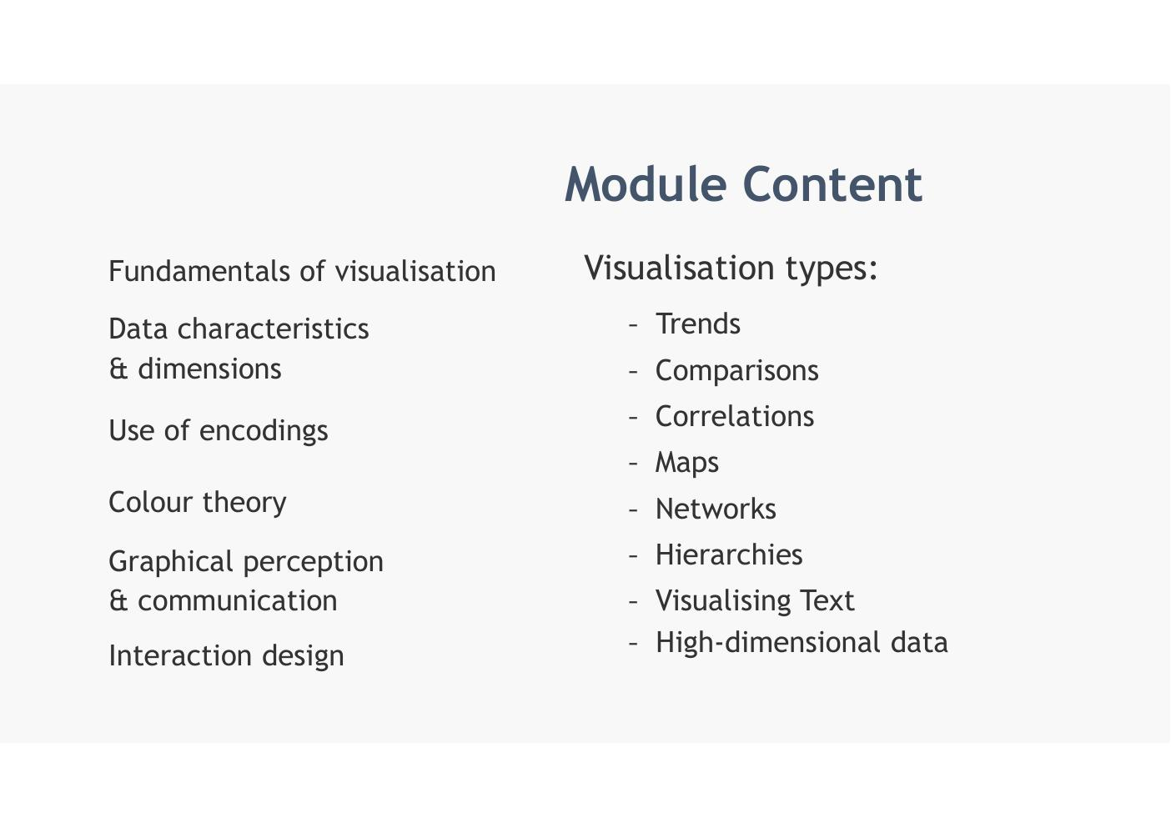

Tools

Tools – Tableau Public and R / RStudio
- Tableau Public: enterprise level visualisation-based business analytics tool – https://www.tableau.com/products/public
- R: statistical programming language with extensive visualisation features
- R Studio: rich GUI interface to R – www.r-project.org | RStudio Desktop – Posit
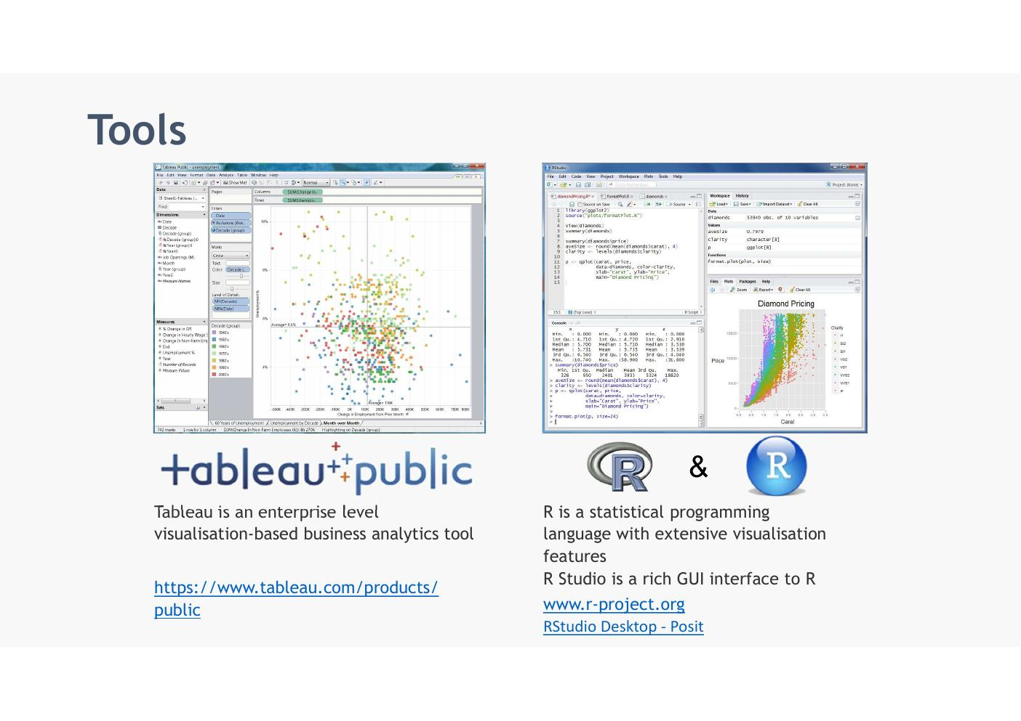
Galleries for tableau and R are very useful

Tableau Public Visualisations Gallery
- A gallery of visualisations created using Tableau Public
- Example visualisations: Tale of 100 (Wall Street Journal), College Football Recruiting, Tech IPOs Finish the Year Strong, Making the Pay Gap Look Good
- Reference: www.tableausoftware.com/public/gallery
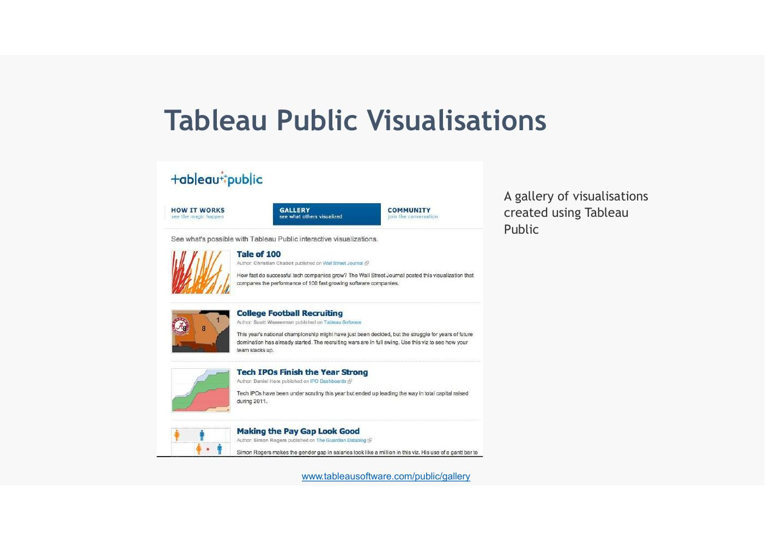

R Visualisations Gallery
- A gallery of visualisations created using R with source code
- Includes: box plots, bar charts, 3D plots, sine wave plots, scatter plots, string art, violin plots, polar/circular plots, genetic maps, and more
- Reference: https://www.r-graph-gallery.com/all-graphs/
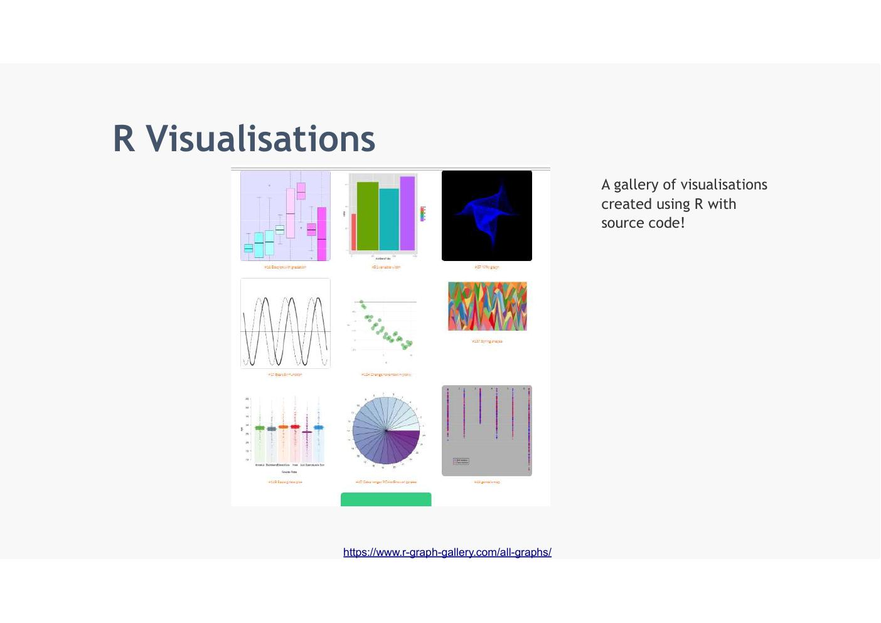
- R visualations less polished btu still really good. BBC uses R

Lab Exercise – week 1
55 mins…..

Task 1
- Break Out rooms

Individually
- Fine one online one good example of a visualisation
- Find one bad example of visualisation

Group
- Choose the best examples 1( good and 1 bad example per group)
- Write a list of good and bad features you can see in the examples
- Suggestion for improvement

Present
- All together present the work and open discussion
- Find someone who has never seen the data what do they understand from this visualisation
- Hardest bit os to be critical of yourself…

Week 2 - Perception, Classification and Human Memory
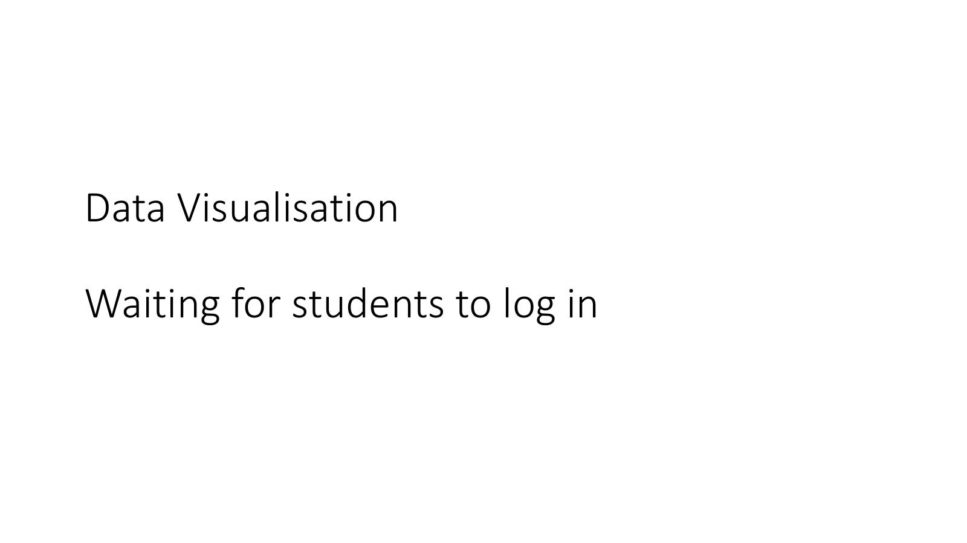
Slide 1
Last week just a general intro to the module…
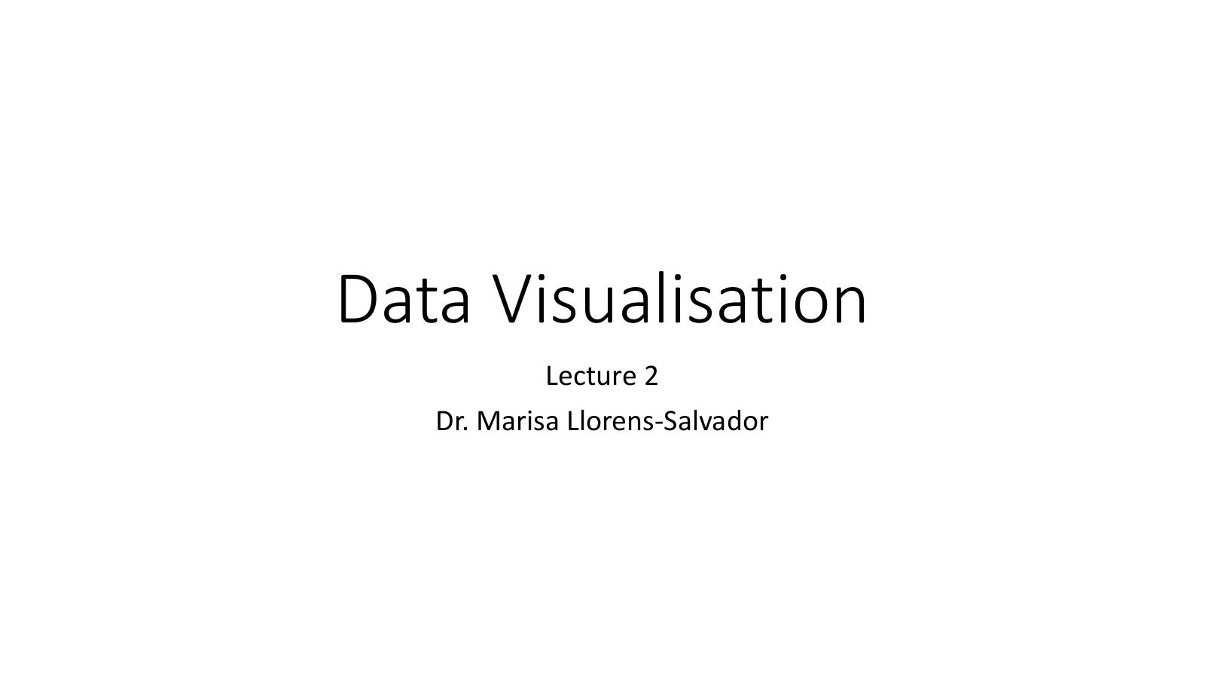

Visualisation of the Week

Visualisation of the Week – Game of Thrones Season 6 Recap
- Chart shows the number of scripted lines by character, episode, and team in Game of Thrones Season 6
- Tyrion had the most lines and was the most featured character in 4 episodes
- Cersei was the most featured character in the first and last episodes
- Characters tracked include: Jon Snow, Tyrion, Daenerys, Yara, Margery, and others grouped by house: Lannister, Stark, Greyjoy, Targaryen
- Reference: https://public.tableau.com/en-us/s/gallery/game-thrones-season-6-review?gallery=featured
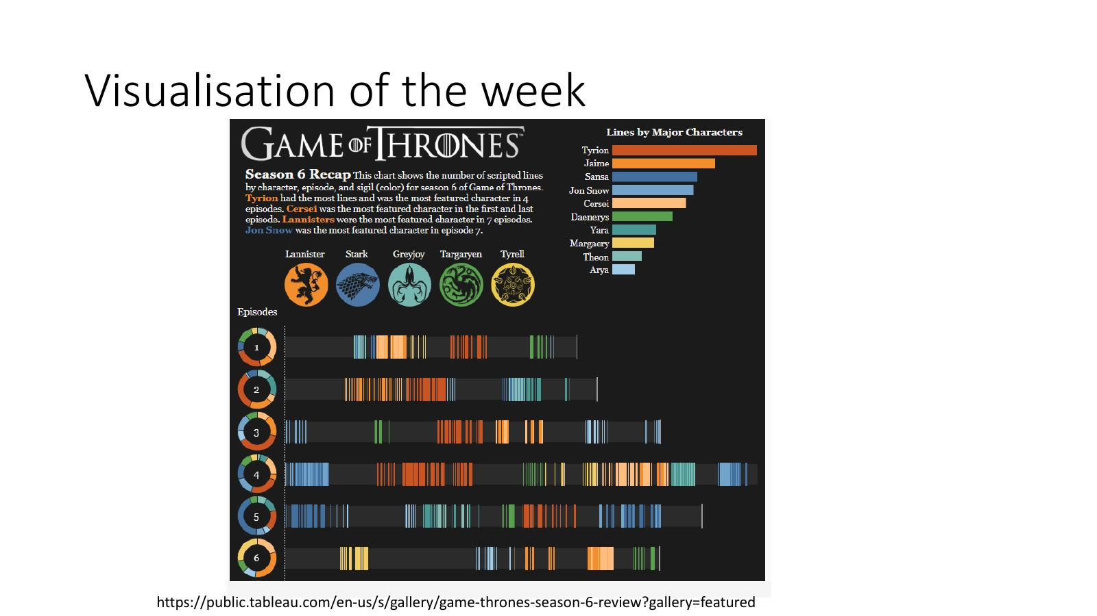
As explained last week we will always start lectures with sue case and some examples… discuss some features… give opinions
A lot going on here…
We have season 6 – a colour for each of the families
Each character has their own different colour based on general initial views for the family
These colours are used for timelines for each episodes split between each character is not he screen and talking and when they appear… so
Co kind of get idea of what episode is talking about….
Lot going on but neat way to get description of each episode…and what families and characters are appearing…

(Un)Visualisation of the Week – Monstrous Costs
- Chart title: 'Monstrous Costs' – Total House and Senate campaign expenditures, in millions
- Two perspectives presented:
  - 1. Tufte advocates a minimalist perspective (high data-to-ink ratio)
  - 2. Improved recall when using visual embellishments
- Reference: Bateman S. et al. (2010) – 'Useful Junk? The Effects of Visual Embellishment on Comprehension and Memorability of Charts', Proceedings of SIGCHI 2010
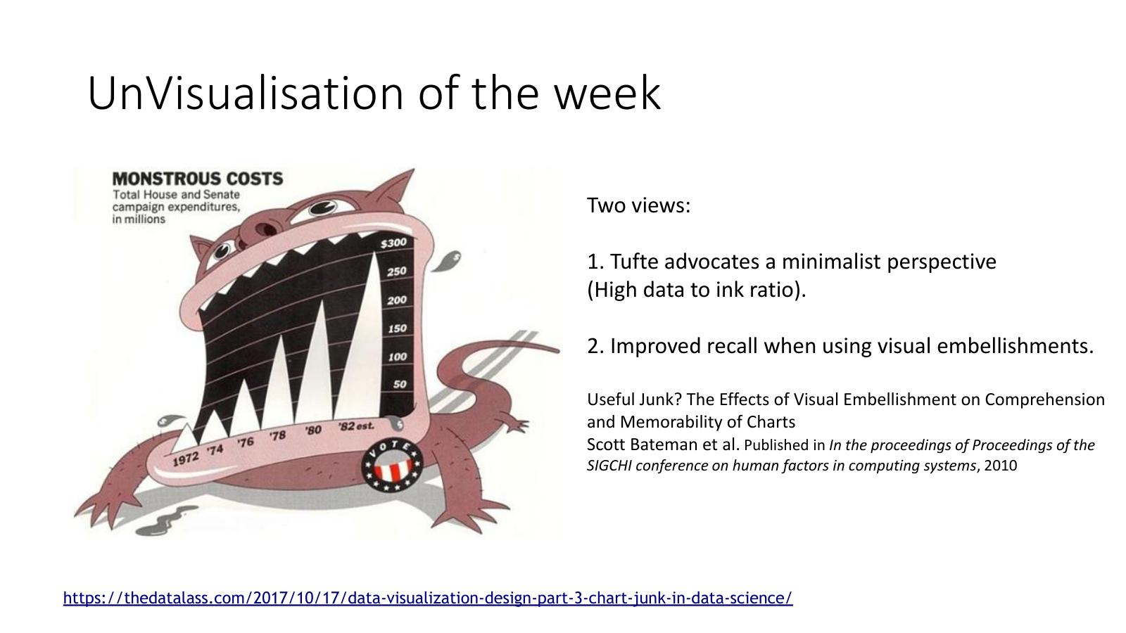
Thus is a traditional discussion – a bar chart where they have used some embilshments where tusks replace bars…
Cost in American house and senate expenditure in numbers ofyears
Article called it monstrous costs.. increase happened over time…
Made background into a monster…
- 1st Traditional view supported by tufty.. want inimalistic … just data and ink…
- 2nd view.. adding embellishment improves recall… more re0informcement of message…
Usually we are more towards tufty school of thought.. try to reduce extra elements and data speaks for itself…

Discussion – Misleading Visualisations

Discussion – The White House Tweet (27 Jan 2022)
- Tweet stated: 'We just learned that President Biden's first year in office was the strongest year for economic growth since 1984'
- Chart shown: 'America's Economic Growth in the 21st Century'
- Issue: The chart was misleading – the Y-axis does not start at zero, exaggerating the apparent growth
- Corrected version shows GDP growth from 2002–2008 with both an incorrect and a corrected version for comparison
- Key lesson: truncated axes can make changes appear much larger or smaller than they actually are
- Reference: https://observablehq.com/@mbostock/a-misleading-plot
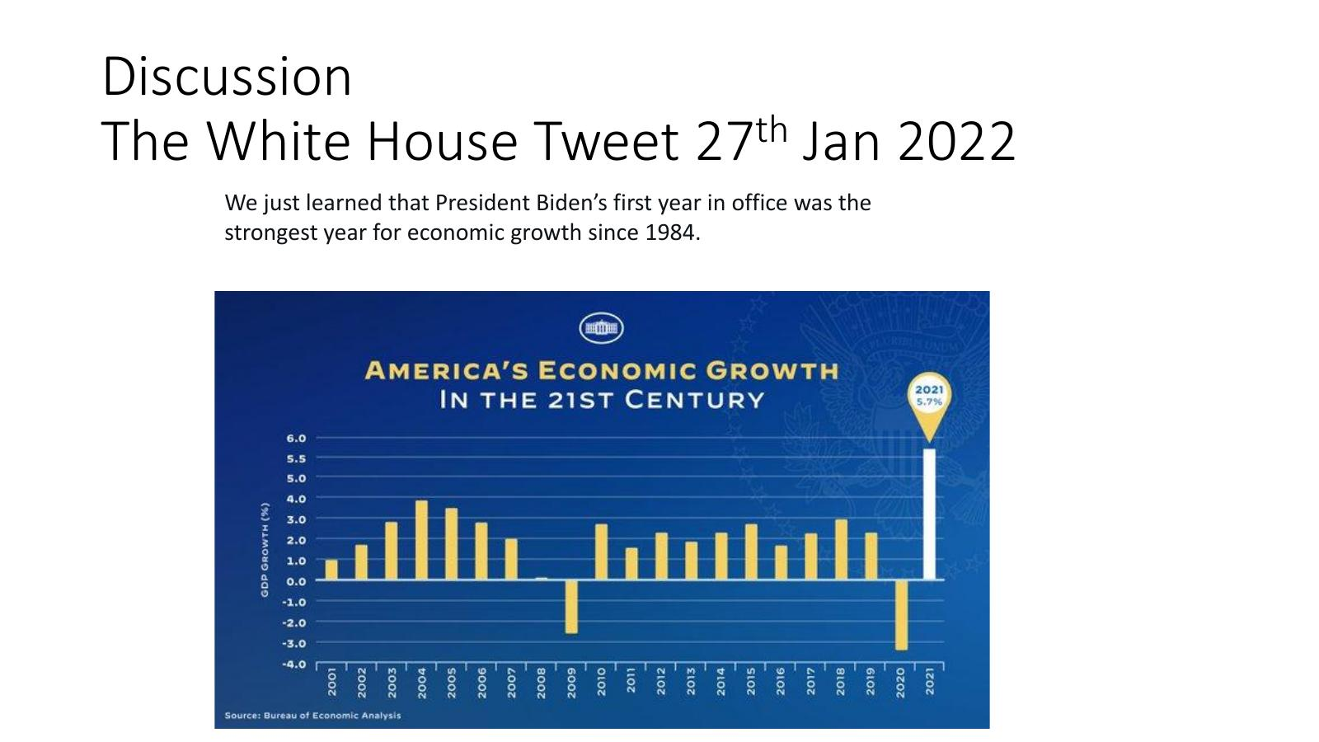
- Normally have 2
- Tweet form official white house account… growth of American economy..
- Strongest ear since 1984…
- Whats is the error in the graph?
- Ratio of Y axis is wrong at top.. 3.0/4.0/5.0/5.5/6.0… scale is incorrect

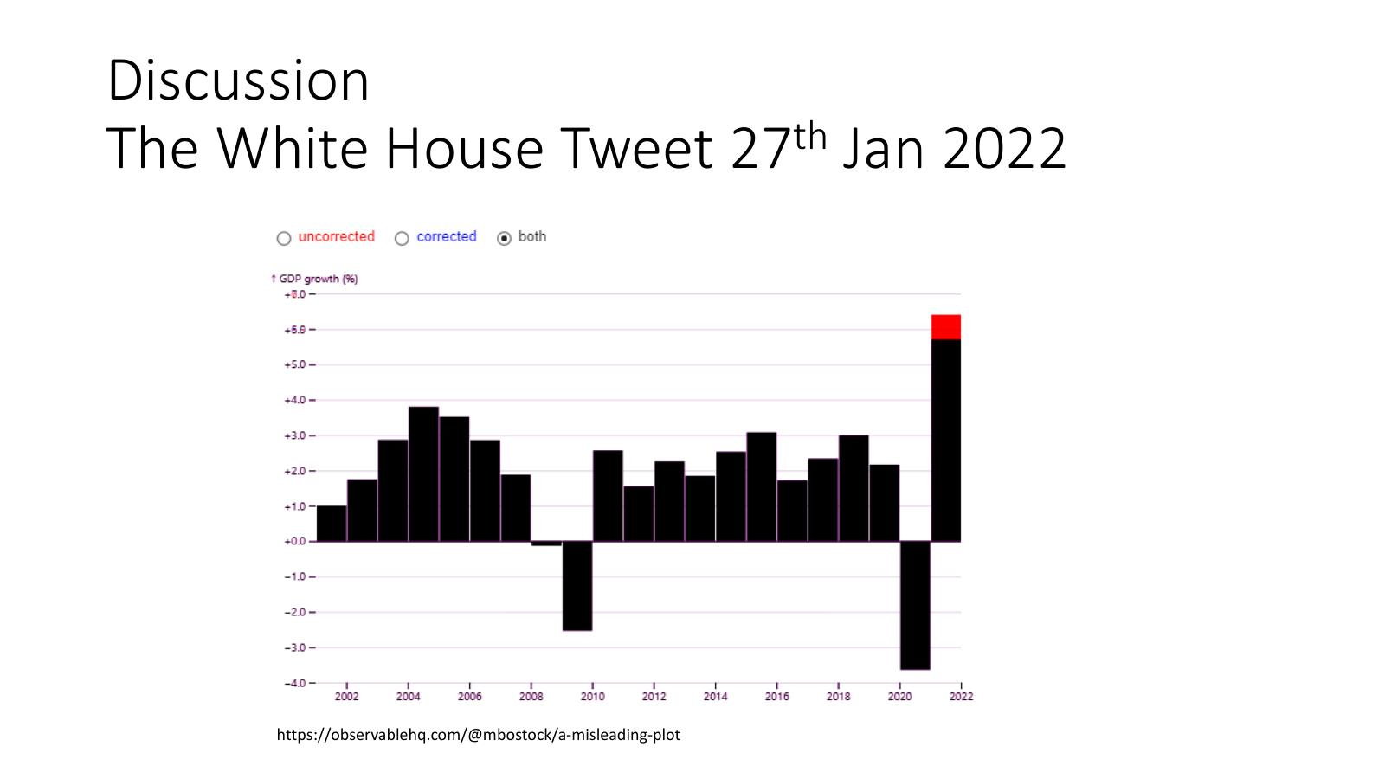
- Corrected version from previous slide…
- They exaggerated the scale

Remember!
- 'Well-designed visual representations can replace cognitive calculations with simple perceptual inferences and improve comprehension, memory, and decision making'
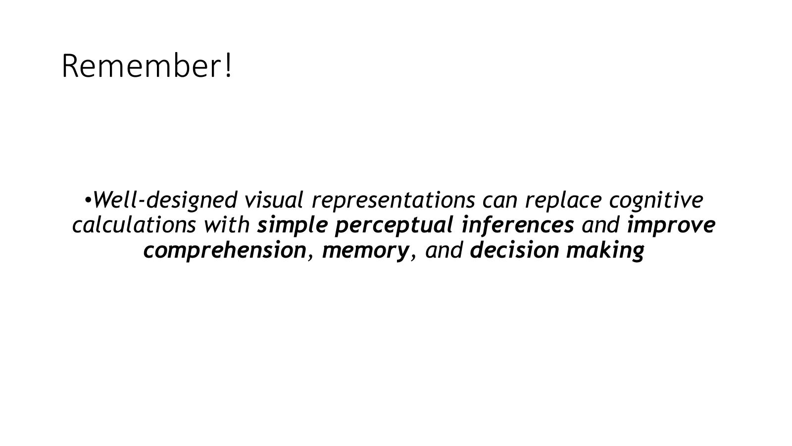
- Today focus on perception and classification
- Last week… well designed vis reps can replace cognitive calculations…. With simple perceptual inferences and improve comprehension, memory and decision making…

Human Memory and Visualisation

Human Memory and Visualisation – Overview
- The power of visualisation is the ability to get across far more complex information than what our memory can generally hold
- There are 3 types of memories that process information in our brain:
  - 1. Iconic memory (Sensory memory)
  - 2. Working memory
  - 3. Long term memory
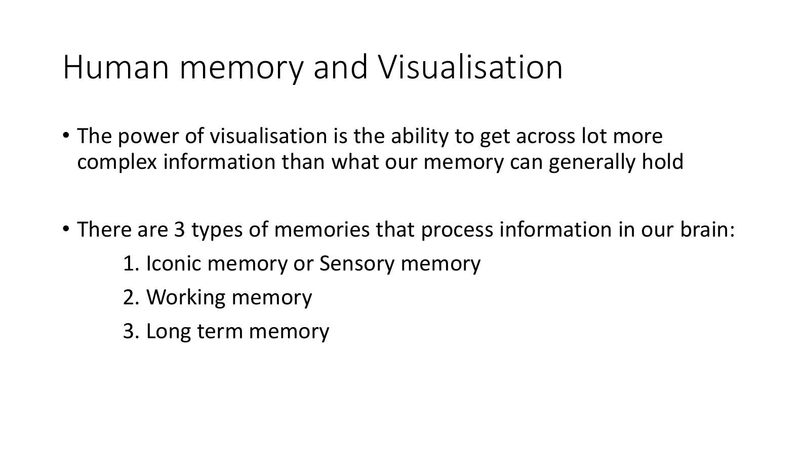

- To do that how does Human brain work?
- Aim to use complex visualistion than memory can hold

Human Memory and Visualisation – Memory Types Compared
- Iconic memory: duration ~1 second | function: pre-attentive processing, before we pay attention
- Working memory: duration ~1 minute | function: holds and processes about 5–9 chunks of information (Miller's Law)
- Long term memory: duration 1 second to lifetime | function: information stored through rehearsal or repeated application
- Long term memory is where things we memorise or remember are stored
- Iconic and working memories are the ones that interact with visualisations
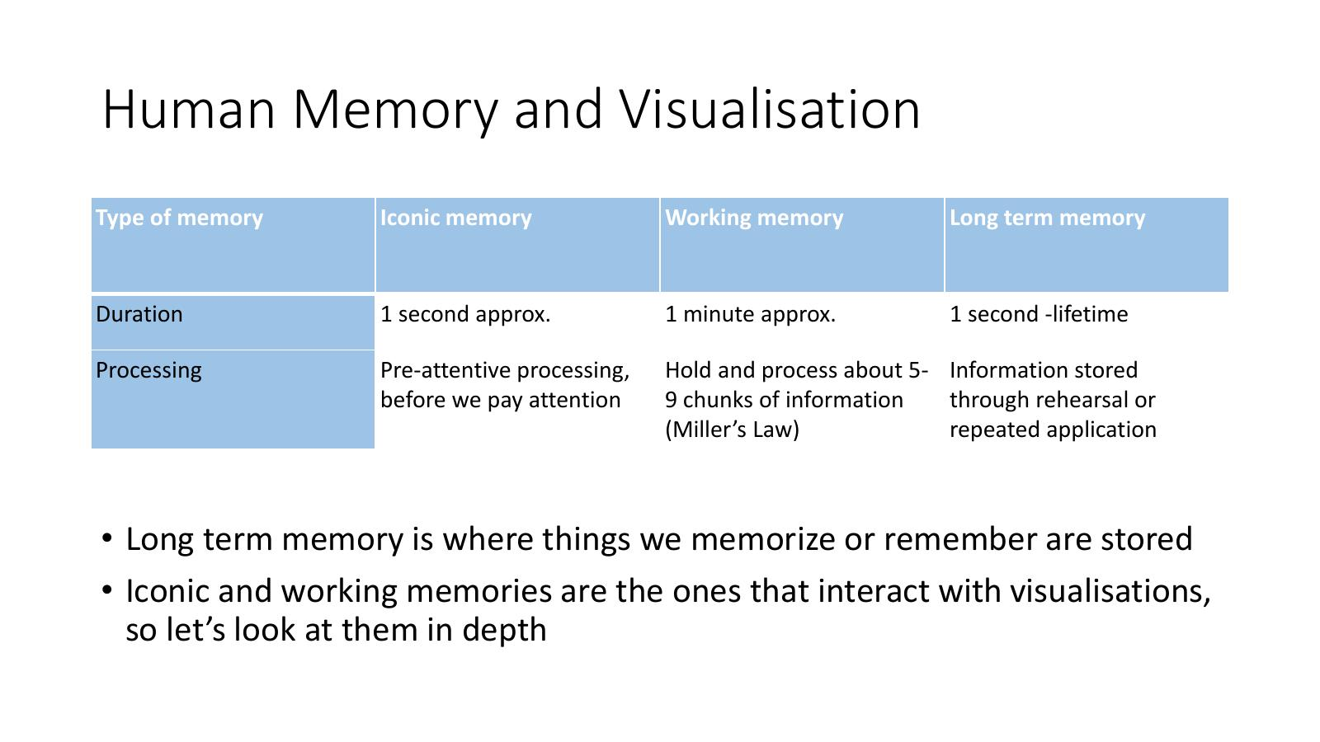

Iconic Memory and Pre-attentive Processing

Iconic Memory
- When we see a visual, the information remains in the iconic memory for less than a second
- We process and store information automatically in this time
- This process is called pre-attentive processing and it happens automatically, before we pay attention to the information
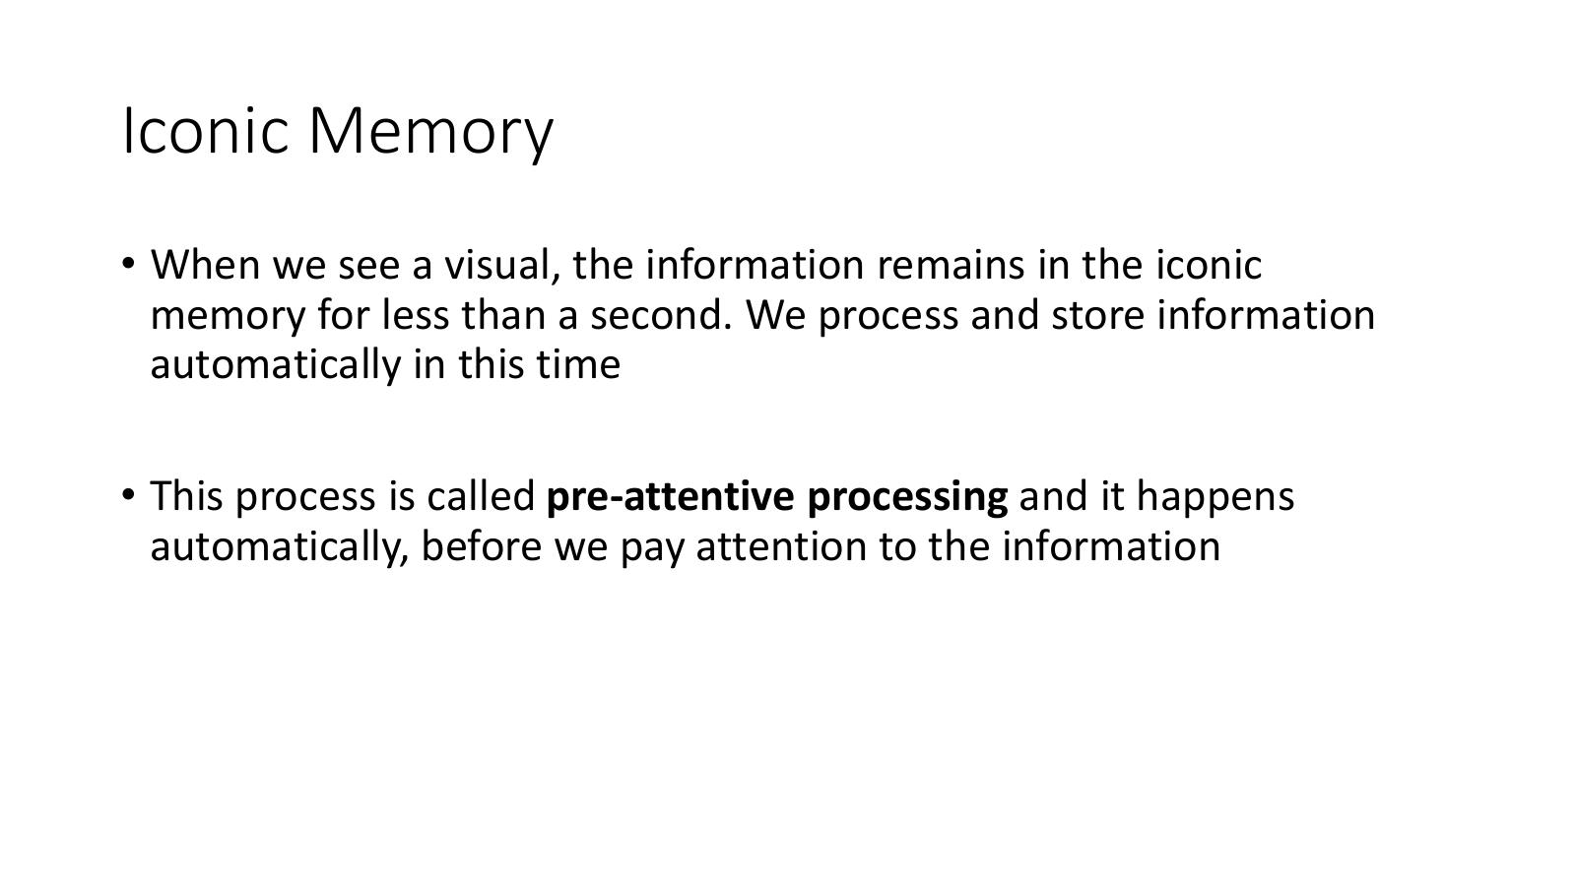
- Automatic – not paying attention it just happens.. brain captures part f visualisation…

Iconic Memory – Pre-attentive Visual Attributes
- The pre-attentive process detects several visual attributes
- Understanding how to make a particular attribute stand out can help us create visuals that emphasise the more important information
- Pre-attentive attributes include: Colour, Orientation, Shape, Brightness, Movement
Attributes that can be detected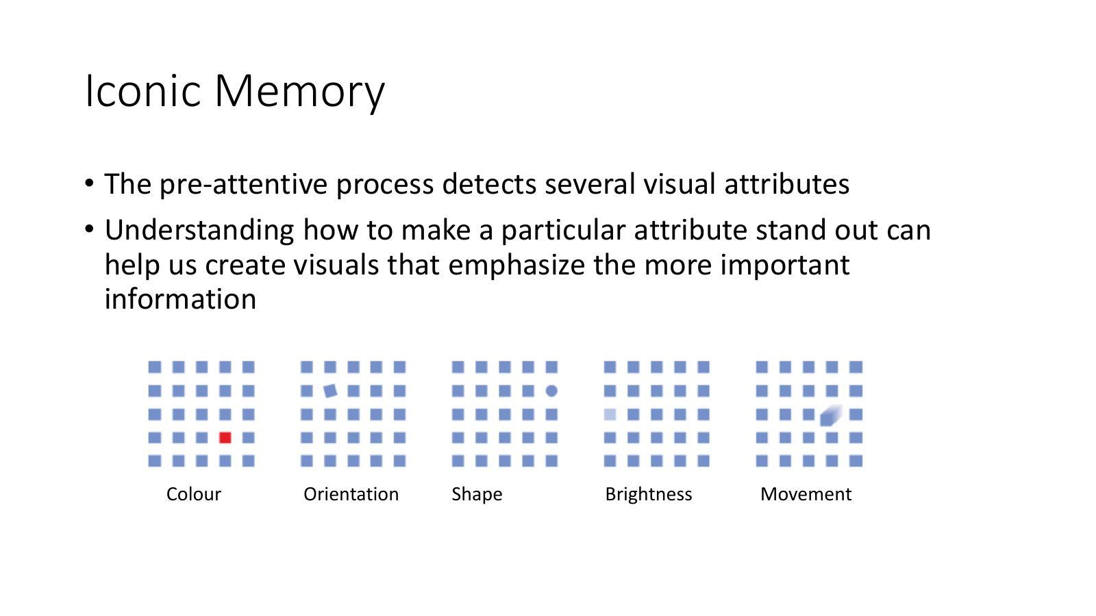
- Colour is very effective
  - Orientation
  - Shape
  - Brigthness
  - Movement

Is There a Red Circle? – Pre-attentive Processing Examples
- Slide 12: Array of shapes – target not immediately obvious when no pre-attentive feature distinguishes the red circle
- Slide 13: Same array – colour difference makes the red circle instantly detectable (pre-attentive)
- Slide 14: Array with similar colours – harder to spot (colour no longer pre-attentive distinguisher)
- Slide 15: Final example – demonstrates when pre-attentive detection works vs. fails
- Key takeaway: when a target differs from distractors in a single pre-attentive attribute (e.g. colour), it 'pops out' instantly
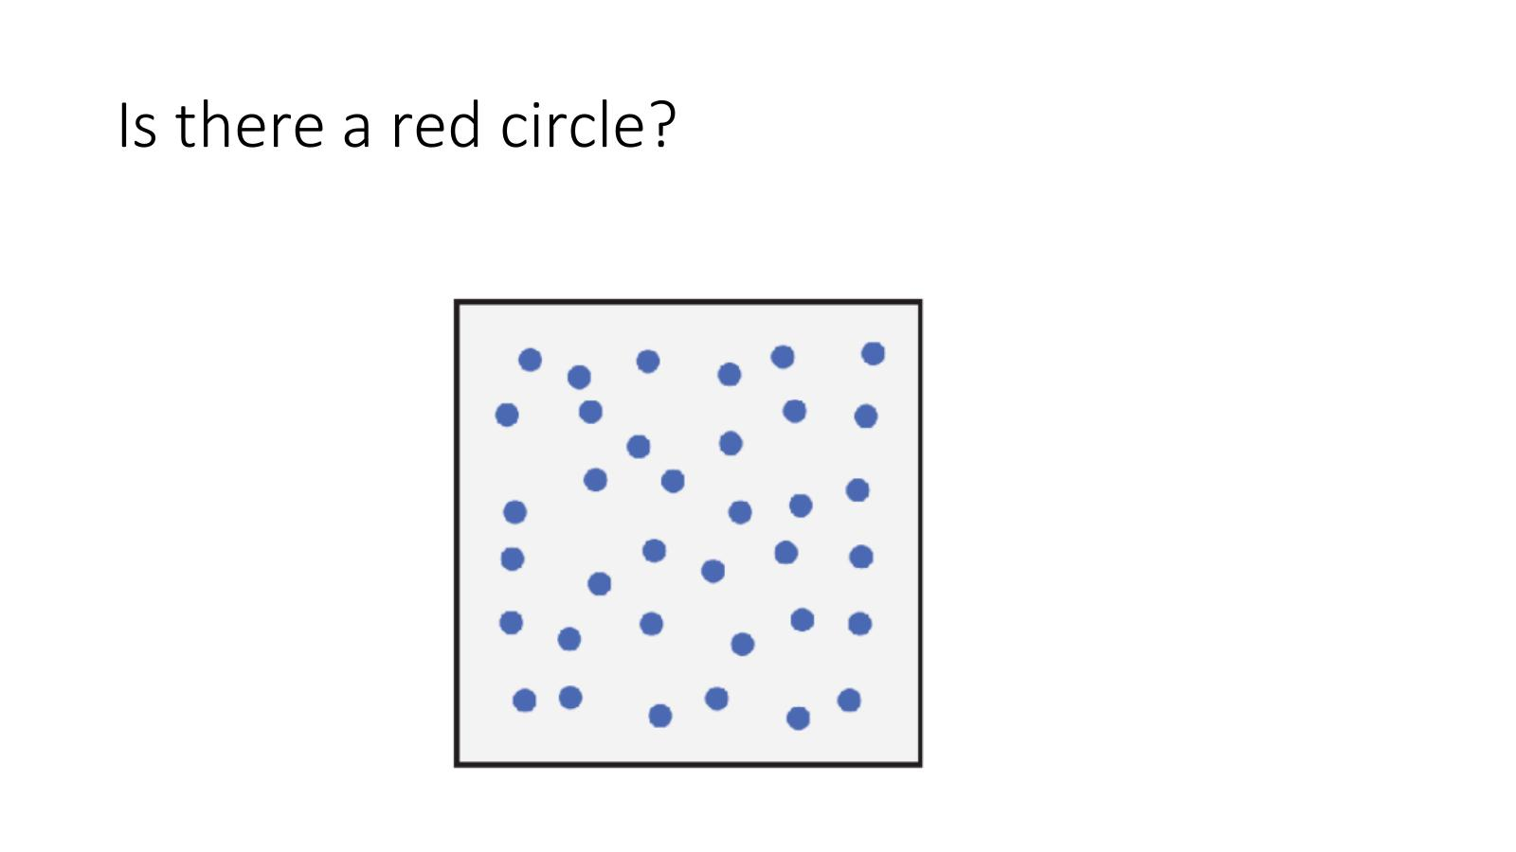
NO
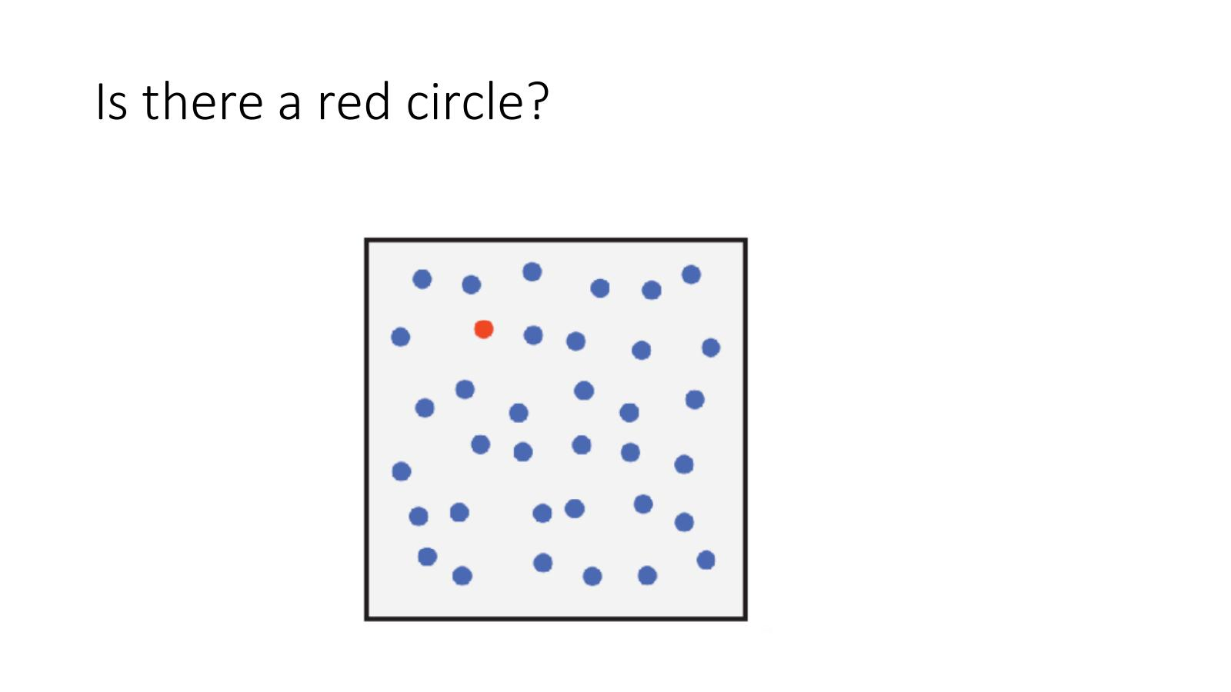
YES
Iconic memory is working!
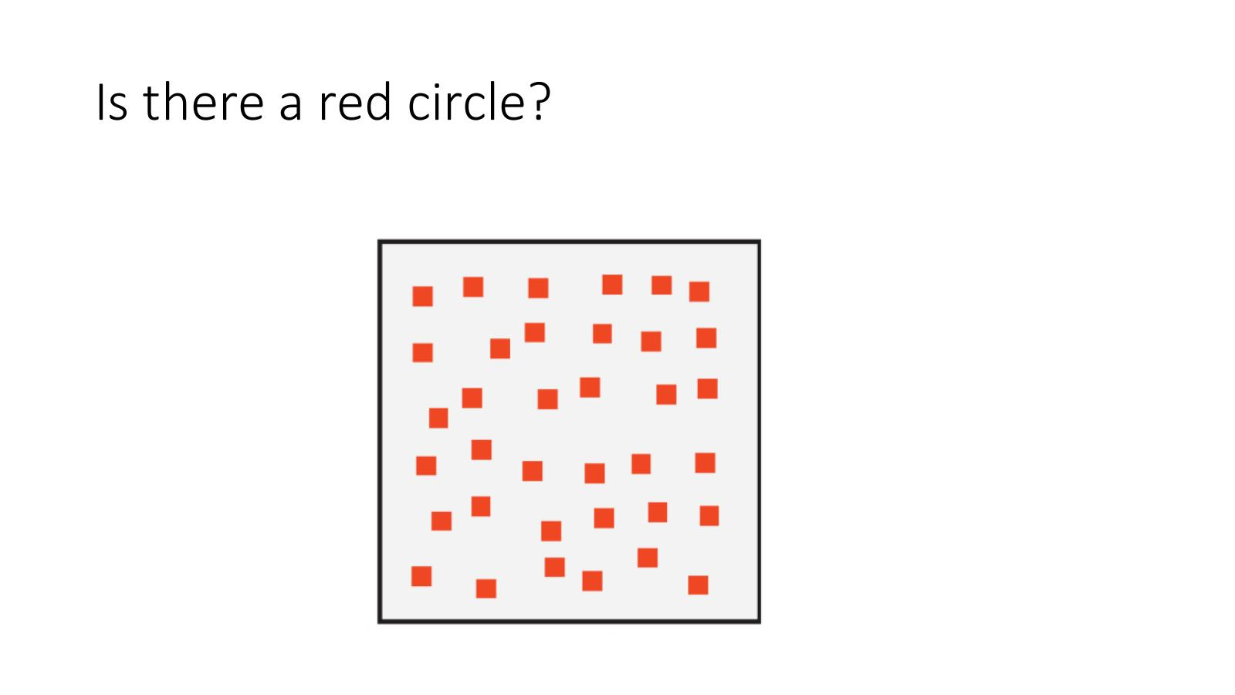
NO – but Takes a bit longer
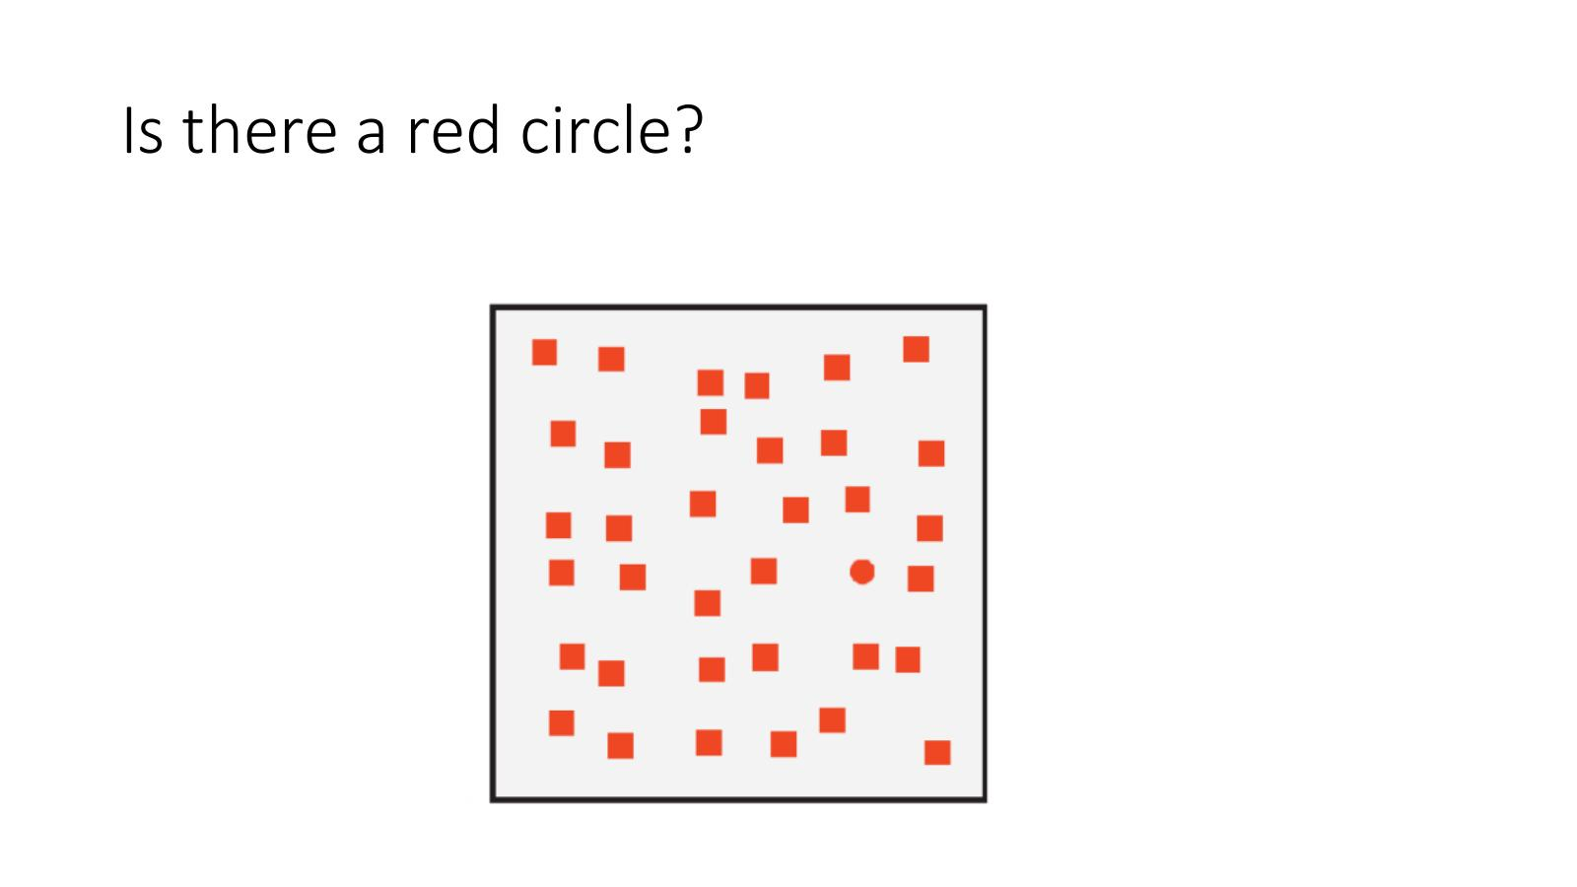
YES – but agai not as easy to find as earlier…

How Many 5's Can You Find? – Pre-attentive vs. Serial Search
- Slide 16: Numbers in the same font – requires slow serial search to count the 5's
- Slide 17: The 5's are highlighted differently (e.g. bold or different colour) – count becomes instantly obvious pre-attentively
- Demonstrates the power of using a single differentiating visual attribute to make information pop out
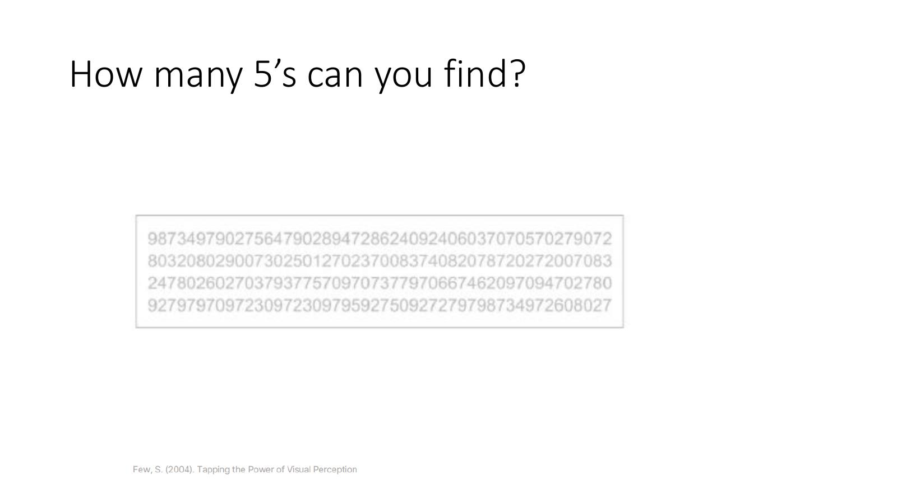
Theres a few but hard to spot them
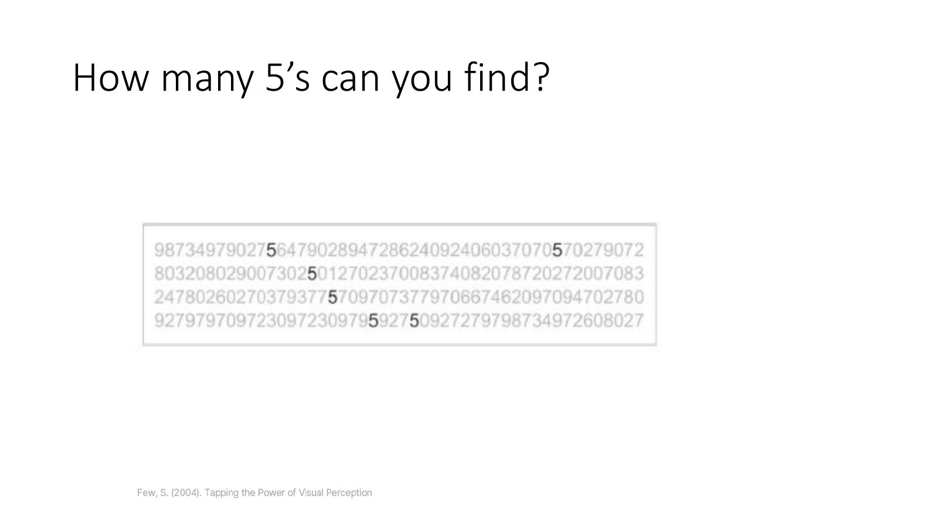
YES -easier to identify where they are and count them…
Iconic memory is working….!

Conjunction Targets – When Pre-attentive Processing Fails
- Conjunction targets: two or more visual properties are present simultaneously, which renders a target difficult to find
- Example: searching for a red circle when distractors include red squares and blue circles
- Numerous studies have shown that most conjunction targets cannot be detected pre-attentively
- Viewers must perform a time-consuming serial search through the display to confirm presence or absence
- Reference: Healey C. & Enns J. (2012) – 'Attention and Visual Memory in Visualization and Computer Graphics', IEEE Transactions on Visualization and Computer Graphics, vol 18(7), pp 1170–1188
- www.csc.ncsu.edu/faculty/healey/download/tvcg.11.pdf
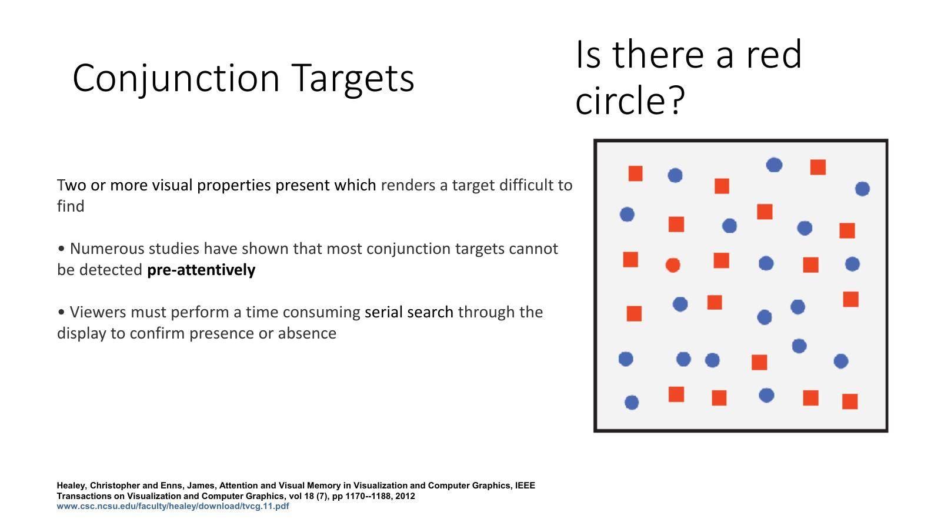
Combine two or more visualise attributes or properties…
- Makes it harder to identify the attribute…
- NEED to KEEP IT SIMPLE!!
- Want to avoid lot of scanning through and cognitive process…

Application to Visualisation – Calories per 100g
- Chart showing Calories per 100g for: French Fries, Potato Chips, Bacon, Pizza, Chili Dog
- Slide 19: Cluttered version – gridlines, borders and background noise compete with the data
- Slide 20: Cleaned-up 'naked data' version – removing non-essential ink makes the data values pop out pre-attentively
- Reference: Joey Cherdarchuk (2013) – 'Data looks better naked'
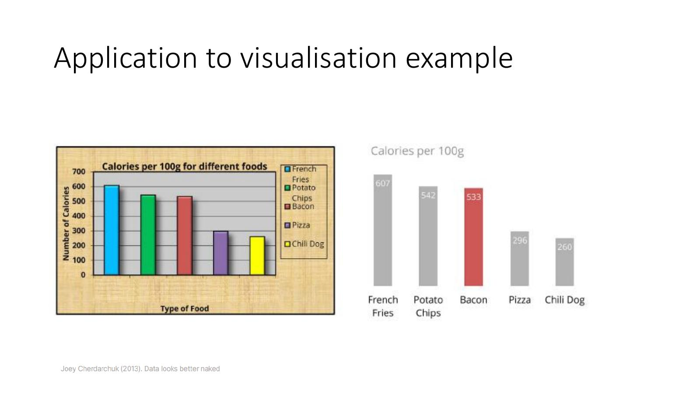
- LHS -What are they trying to tell me?
- RHS - put all attention on the RED bar
- We will sue legends and direct labelling but try avoid going back small bits of colour and may eb hard to differentiate between them have to go over them a few times to idenitfy what each element means…
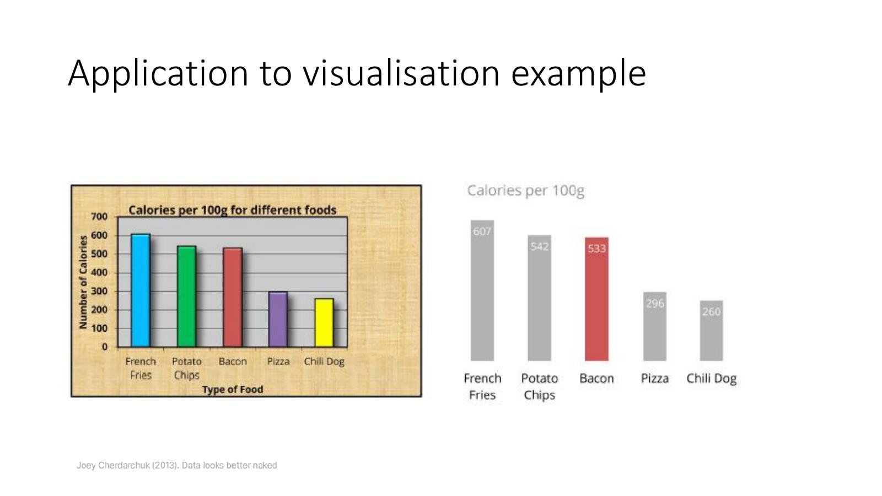

Working Memory

Working Memory
- The memory in use when working with a visual
- Sensory information of interest to us is processed in the working memory
- Information stays here for about a minute
- Capacity of our working memory is between 5 to 9 similar items (Miller's Law)
- The capacity of our working memory can be increased by a process called chunking
- Chunking = grouping similar items together so they are processed as single units
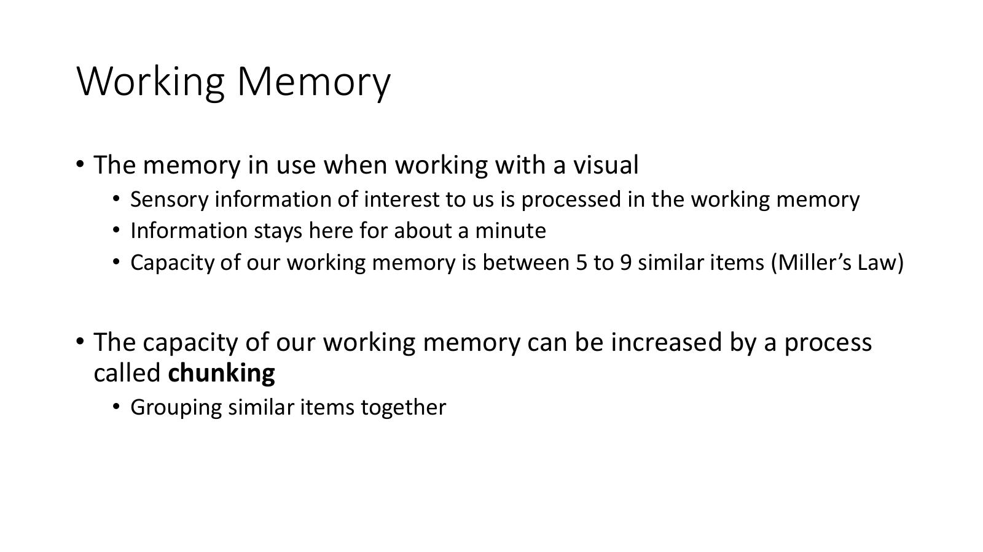
Want our data to talk to our viewers
The medium converting raw data into something easy to rad or understand..

Human Visual Perception

Human Perception for Visualisation
- In order for our visualisations to be useful, it is important that they are easily interpreted by a viewer
- Bad data visualisations can be difficult to read and understand
- To visualise data effectively, it is useful to follow design principles
- These principles are derived from an understanding of human perception
- In order to create effective visualisations we must understand perception
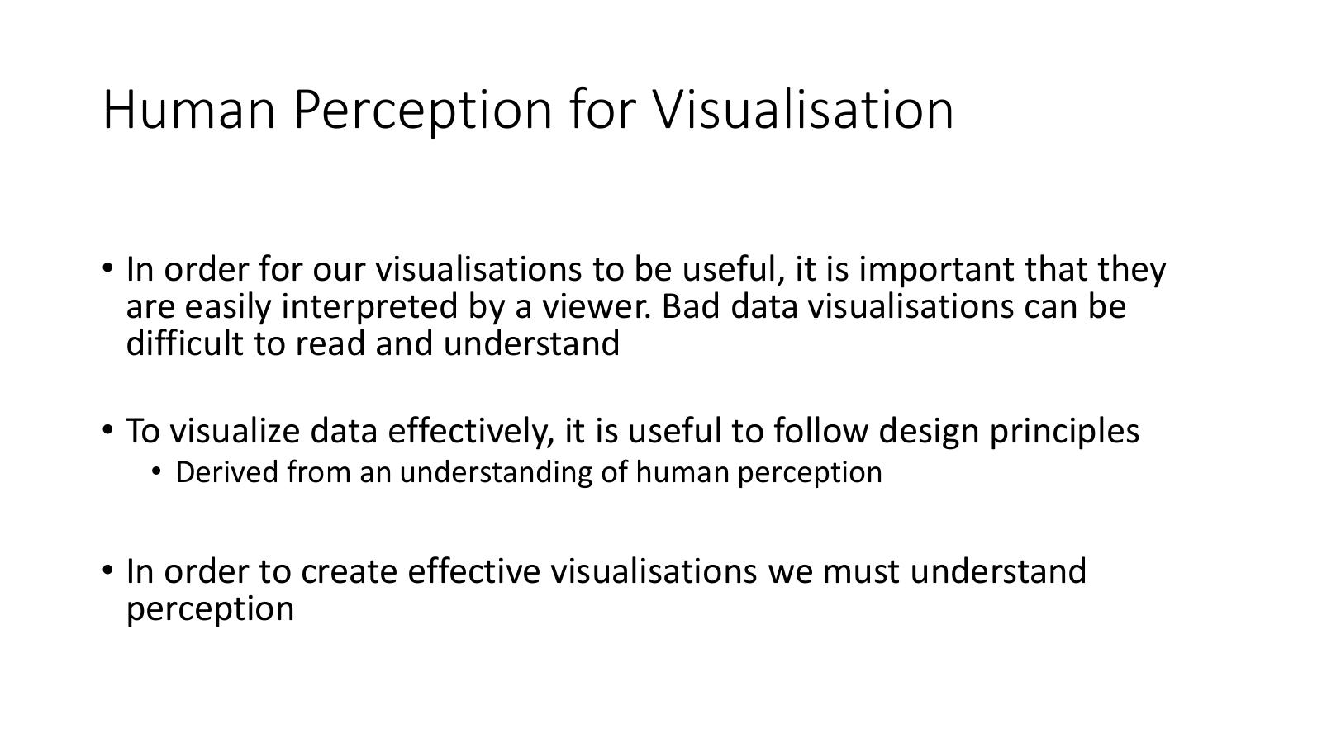

What is Human Visual Perception?
- Our vision system has parallelism capacity – while it focuses on one point, the visual system can reach a wide surrounding area
- The human sensorial system is stimulated by a continuous flow of events, resulting in a neural excitement called sensation
- This process is extremely fast and efficient
- This continuous flow of sensations generates what is known as perception
- Perceptions are different according to the characteristics of the stimulus – they are interpreted, allowing the brain to extract knowledge
- The act of thinking, processing and making comparisons is known as cognition – much slower and less efficient than perception
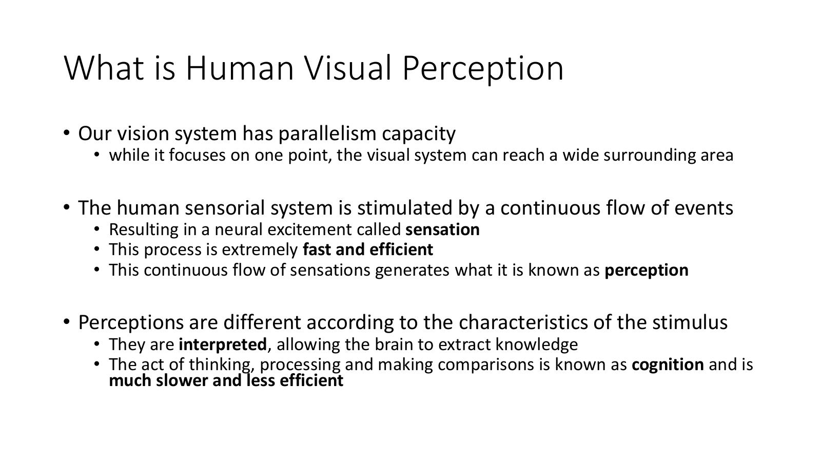
- How does process work
- There is a sensation
- Continuous flow of events that eyes are catching
- Very quick / efficient
- Contonous flow of stimulant - perception… how the stimulus os triggering brain to see those elements on the screen.. allowing
- Brain wil interpret what the red dot means…
- Cognition is a lot slower >>> we are trying to replace that with perception!

Human Visual Perception and Data Visualisation
- Data visualisation is an external aid to support our working memory
- Visual perception is selective – if we tune our awareness to everything, we will be overwhelmed; so we selectively pay attention to things that catch our eye
- Our eyes are drawn to familiar patterns – we see what we expect to see; visualisation must take into account what people know and expect
- Our working memory is very limited – we can hold a very limited amount of information in memory when looking at a visual
- Goal for our visualisations = more visual perception and less cognition
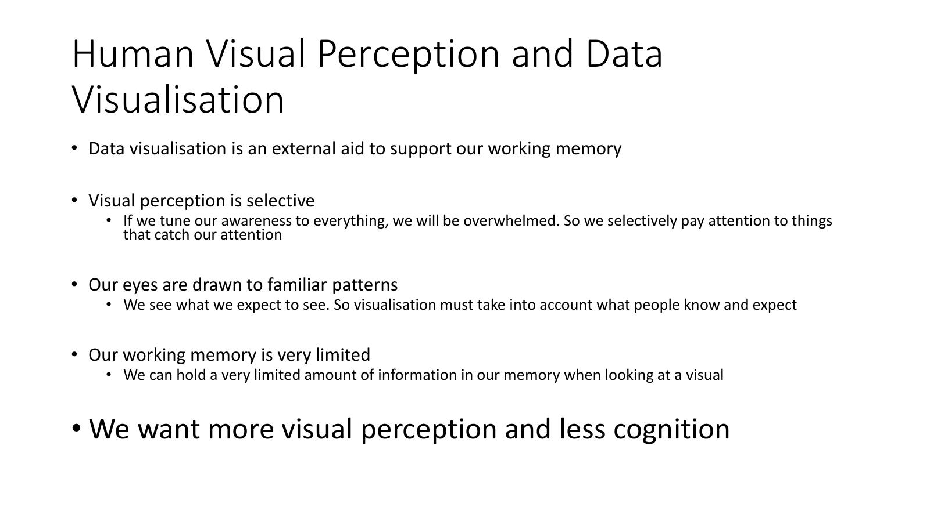
- Human eyes drawn to familiar
- Don’t get our of known standards just for sake if it as we may confuse our viewers…
- Working memory is limited… not infinite…
- Moving more to perception leaving viewers doing less cognitive processes.. will eventually allow us create more effective visualisations…

Visual Perception – Two Versions of the Same Visualisation
- Both charts show: Internet users (in millions) by region from 1996–2008
- Regions: Asia, Europe, USA and Canada, Latin America, Africa
- Version 1 (top): Multiple lines overlapping – hard to distinguish trends
- Version 2 (bottom): Each region shown in a separate small panel (small multiples) – easier to read individual trends
- Demonstrates how layout choices affect how much cognitive effort is needed to read the chart
- Reference: Graham M., Hale S. & Stephens M. (2011) – 'Geographies of the World's Knowledge'
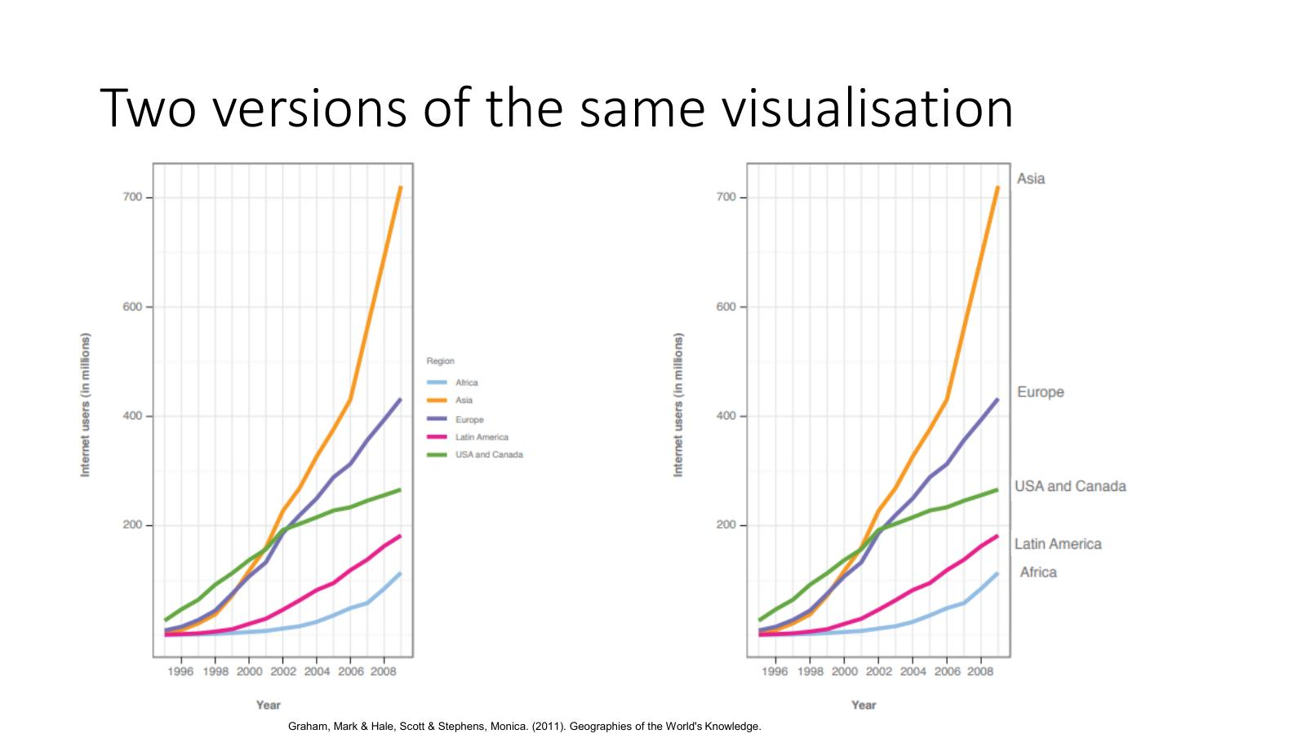
- LHS – have to refer to legend which is which
- RHS – can see which is which…
- Always easier with end of lien followed by direct label… easier to see.. text has been made bigger…
- Not having to go back and forth…
- Text is a continuation of the graph…
- Don’t know context of viewers.. but if look at RHS.. instantly asking the viewer which was top and how does europe play? Is it higher or lower than most countries…. Easy t answer…
- Looking at graph on LHS
- Go thru iterative process >>> Refinement phase ut euroe in particuajlt colour… leave other countries in grey for example….
- direct labelling! Name at end of line.. can see it….

Gestalt Theory

Gestalt Theory – Overview
- 'It is not possible to have knowledge of the whole through the parts, but of the parts through the whole; the whole is more than the sum of its parts'
- Through the perception of the totality, the brain can realise, decode and assimilate an image or a concept
- Gestalt theory proposes a number of laws that explain the structural and functional principles of perception
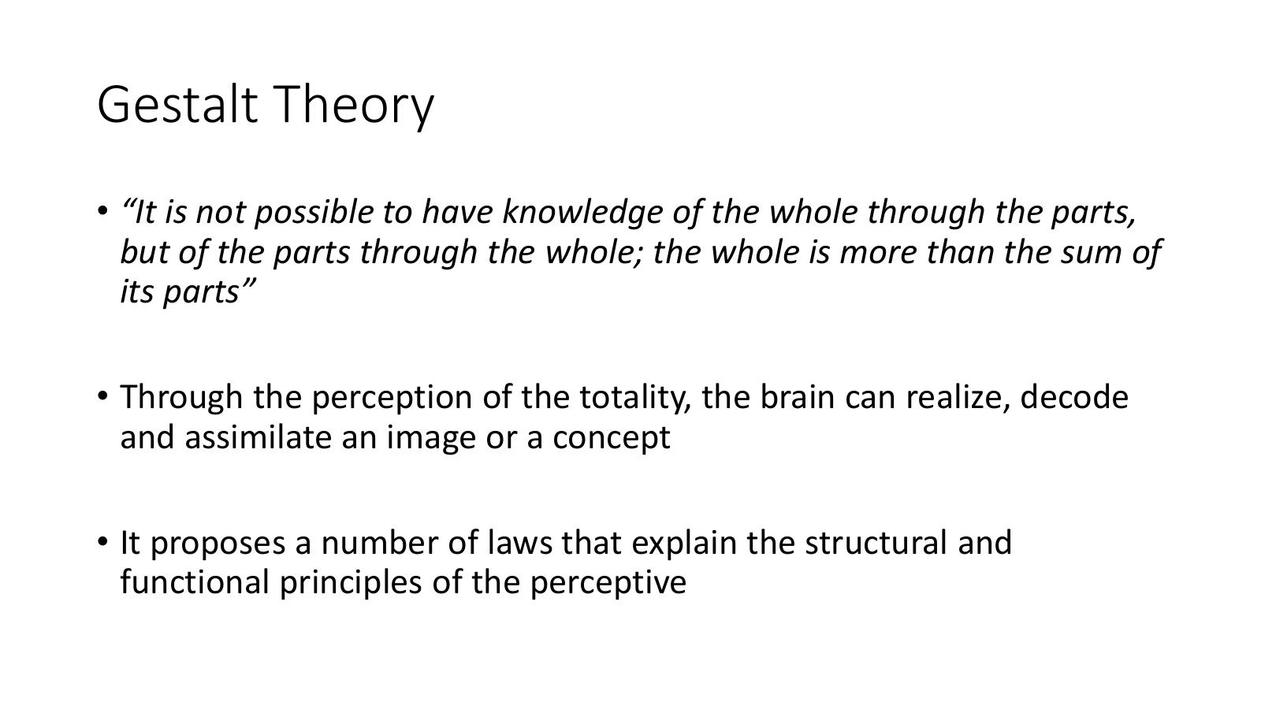
- Looks into how different parts of the visualistaio are seen by the user
- Maon definition of this is that its not possible to have knowledge of the whole.. but the
- Whoel is more than the sum of tis parts..
- i.e different elements not only themselves… and the overall picture is not only the additition of them….
- Drew a broken circle on slide… looks like broken circle but issing parts,,,
- Each piece added does not give a circle.. =? The overall is more than the sum of individual parts,,, as brain is adding extra elements in their head to make a cirecle…
- i.e. looking at the totality… can contain a concept is more than addition of small parts

Some Laws of Gestalt Theory
- Proximity: Objects that are close together are perceived as a group
- Similarity: Objects that share similar attributes are perceived as a group
- Enclosure: Objects that appear to have a boundary around them are perceived as a group
- Closure: Open structures are perceived as closed, complete, and regular whenever there is a way they can be reasonably interpreted as such
- Continuity: Objects that are aligned together or appear to be a continuation of one another are perceived as a group
- Connection: Objects that are connected are perceived as a group
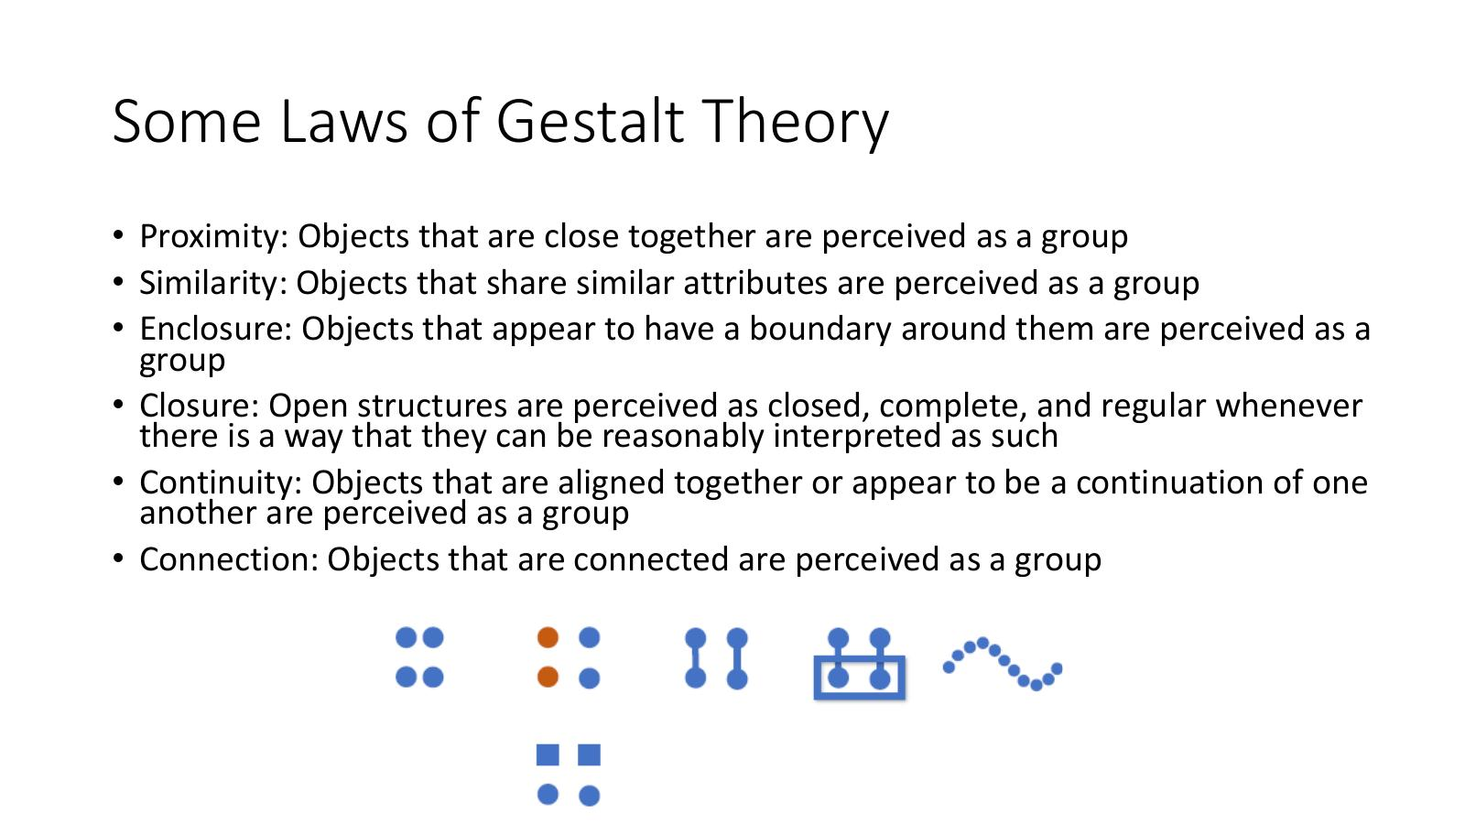
- Feels like abstract concepts btu we see in practice.. students use incorrectly…
- i.e. a dashboard (you will do in a couple of weeks)
- Marissa drew line chart and bar chart.. and pie chart all in a box
- Pie chart has section that is blue/yellow/pick etc
- Dashboard of all elements…
  - Is there any commonality across the 3 p
  - Same colour across charts…. Users will think same colours represent the same thing….
  - Be careful… colour is an easy one to make this mistake… ie,e default colours…
  - Create graphs separately and sue defaults, but put them together.. colours imply the variables are related….
  - Make sure not giving impressions variables are related when they are not….
  - Will revist Gestalt theories later…
    - How to use to increase effectiveness

Classifications of Visualisations

Classifications of Visualisations – Overview
- Three main categories of visualisations:
  - Infographics
  - Data Visualisation
  - Visual Art
- A further classification: Informative – Persuasive – Visual Art (the Designer-Reader-Data Trinity)
- Reference: 'Designing Data Visualizations', N. Iliinsky & J. Steele, O'Reilly Media, 2011 – http://shop.oreilly.com/product/0636920022060.do
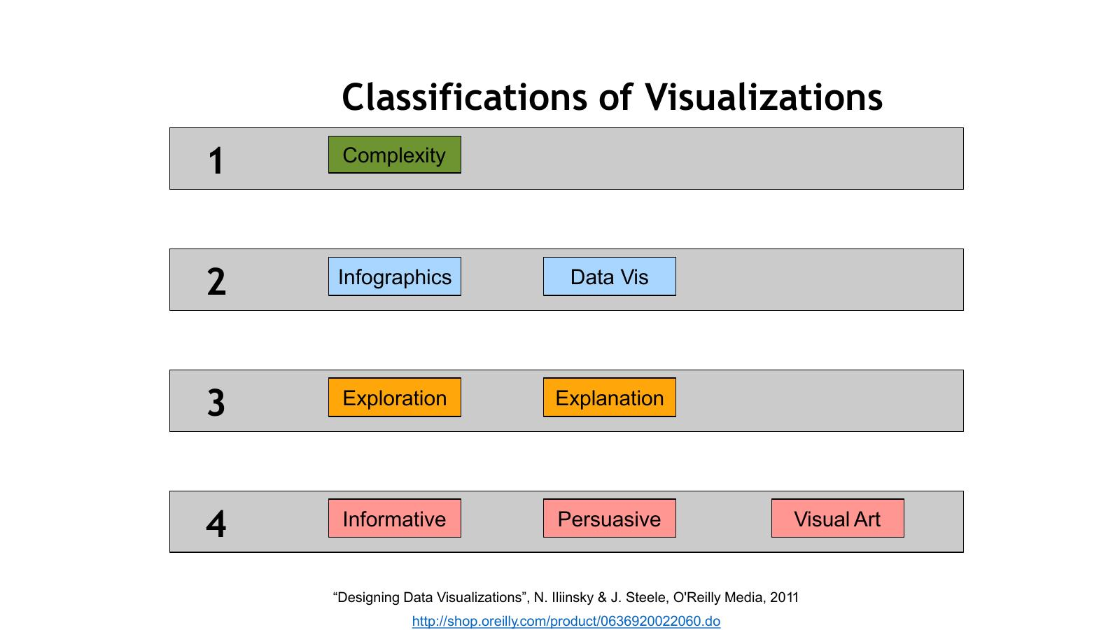
- We are going to look at how we can classify visualisations
- We have different ways of differenting different visualisations
  - 1st - Complexity
  - 2nd – Differentiating between infographics & Data Visualisations
  - 3rd – is it a Exploration & Explanation visualisation? Very important
  - 4th – difference between Informative , Persuasive & Visual Art
It’s important as you need to plan your vis, you need to know you trying to portray the date.. so whats the purpose f the visualisation? Hard to get solution if don’t know what trying to achieve….

Complexity

Complexity – What is a Data Dimension?
- Classify visualisations by counting how many different data dimensions are represented
- A data dimension = one single channel of data (e.g. a stock graph may comprise dates and prices – each is a unique dimension)
- The number of discrete types of information that are visually encoded in a diagram
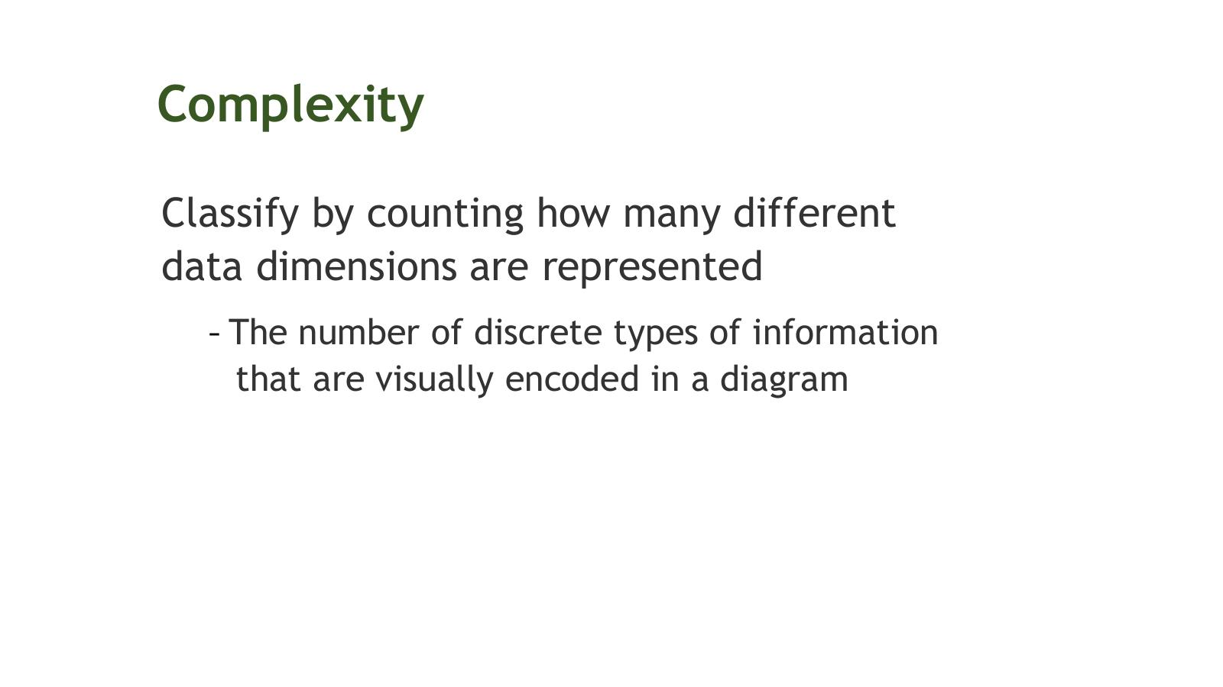

Complexity – Simple Example (2 Dimensions)
- Example: a simple bar graph showing the number of native speakers per language = 2 data dimensions
  - Dimension 1: Language name (categorical)
  - Dimension 2: Number of native speakers in millions (continuous)
- Bar chart of native speakers per language shown
- Reference: Graham M., Hale S. & Stephens M. (2011) – 'Geographies of the World's Knowledge'
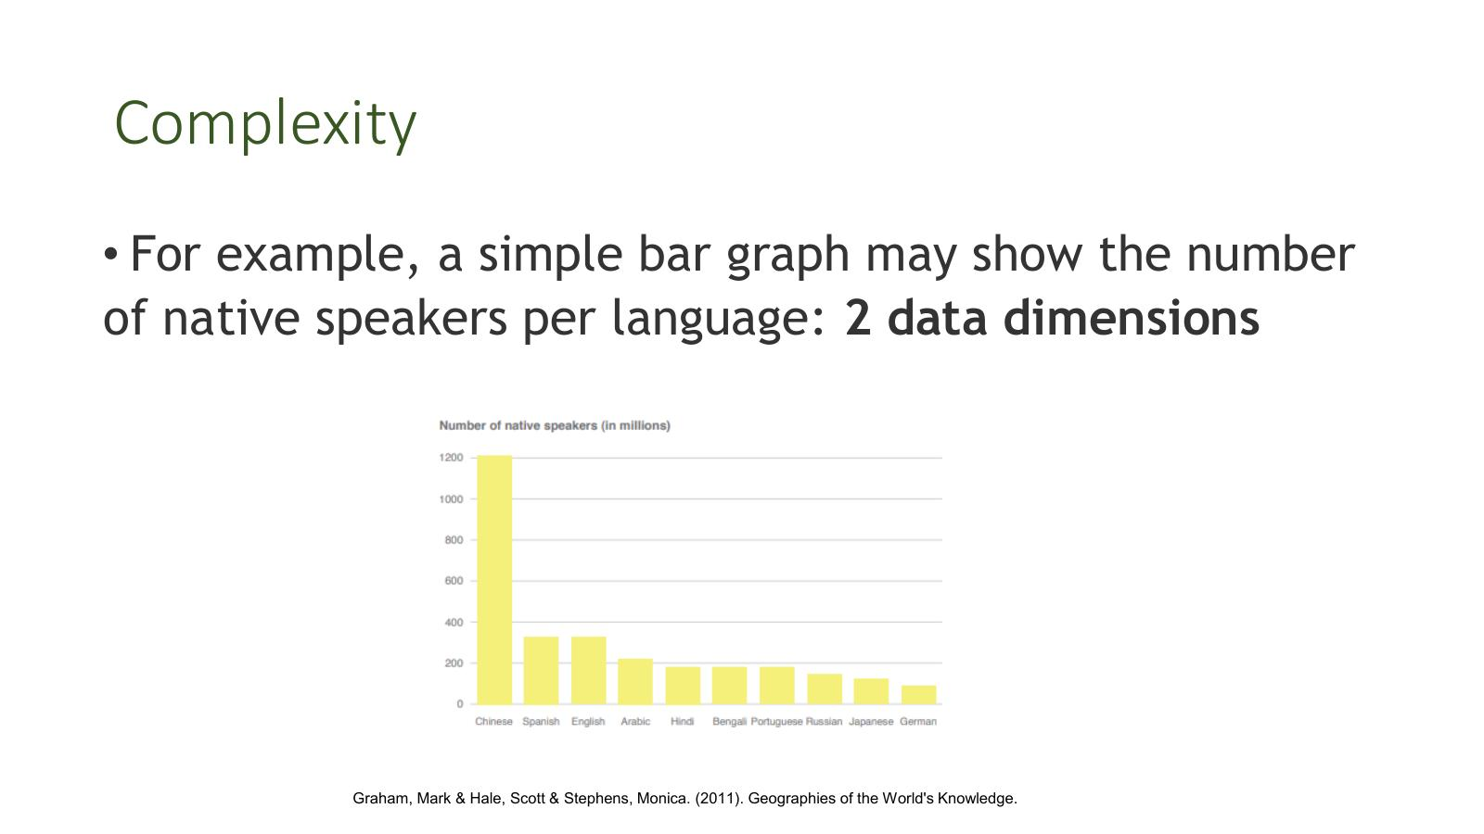

Complexity – Higher Dimensions: Parallel Coordinates of Automobile Data
- Parallel coordinates plot showing a database of cars plotted in seven coordinate dimensions
- Each path (line) represents one car
- Dimensions shown: cylinders, displacement, weight, horsepower, acceleration, mpg, year
- Drag and resize the coordinate selection sliders to filter the cars in any dimension
- Source: GGobi
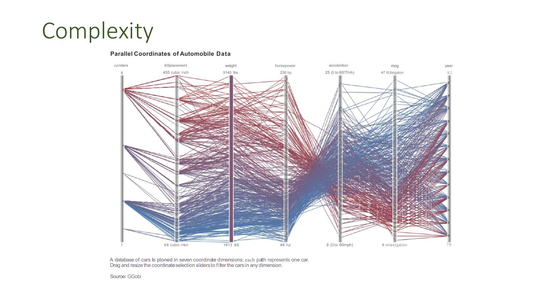
- Mich more complex.. using parallel co-ordinates.. we have 7 dimensions.. and the relationshsips between those dimensions.. onparallel co-ordinates diagram..
- Bar grapgh was a lot easier to see and read… conpared to this complex graph…
  - The > # of dims the greater the difficulty to read it…

Complexity – How Many Dimensions Can You Identify?
- Slide 32: Cycle Plot – Days of the Week mapped over 10 weeks
  - Y-axis: values up to 1100
  - Dimensions identifiable: day of week, week number, value – minimum 3 dimensions
- Slide 33: Average Per Day version – same data presented differently
  - Y-axis: up to 1000; Days shown on X-axis: Sunday through Saturday
  - Presents average per day across the weeks – a derived/aggregated view
- Exercise: identify all the data dimensions encoded in each chart
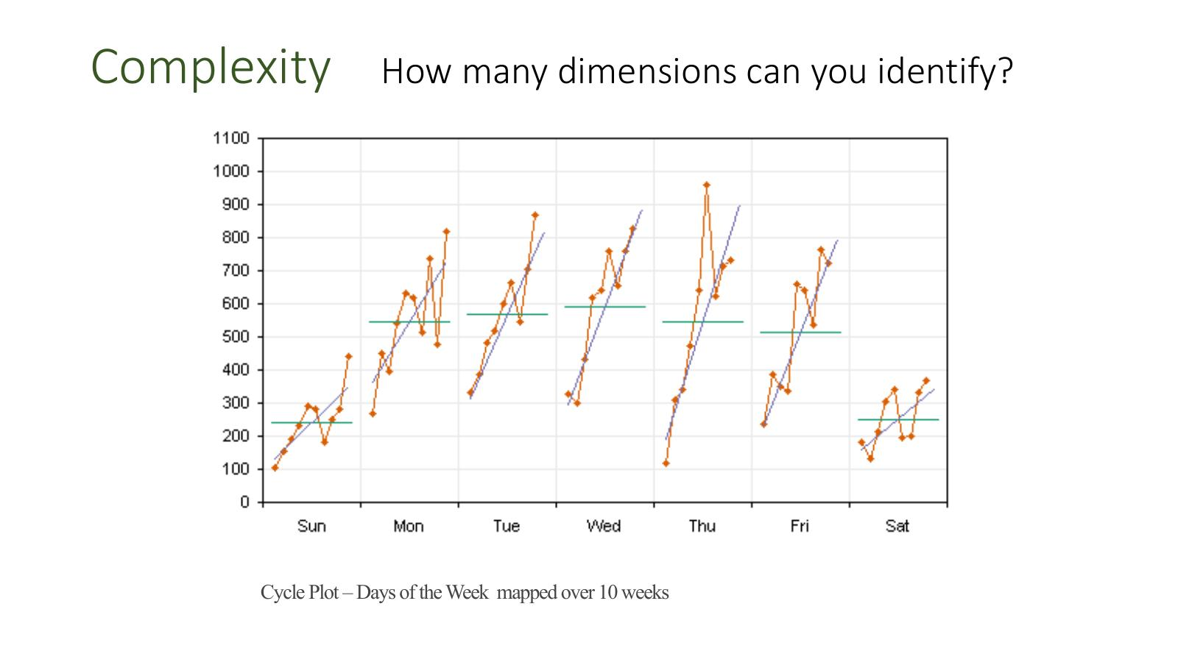
- Here 3 dimensions
  - Day of week
  - Week numbers when emasure was taken
  - Actual measurement
- Average value added aswell no helping… green line is not extra value.. is calculated or aggregated data…
- So each measurement = a dimension…

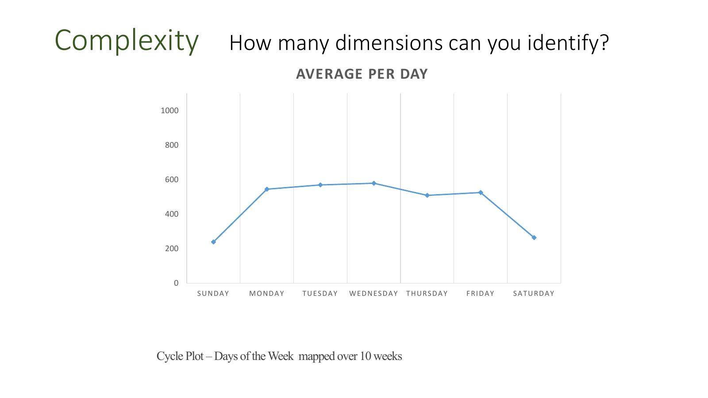
- Here just 2 Dimensions
- Easier to read than previous only two measurements…
- Lot more going on on previous graph..
- The more complex the more challenging to design and decipher… for user
- >> NO more than 3 or 4!!
- 6 or 7 can be found but more difficult to read and design…

Complexity – Design Implications
- As visualisations become more complex:
  - They are more challenging to design well
  - They can be more difficult to learn from
- For that reason, visualisations with no more than 3 or 4 dimensions of data are the most common
- Visualisations with six, seven, or more dimensions can be found but may be more difficult to read
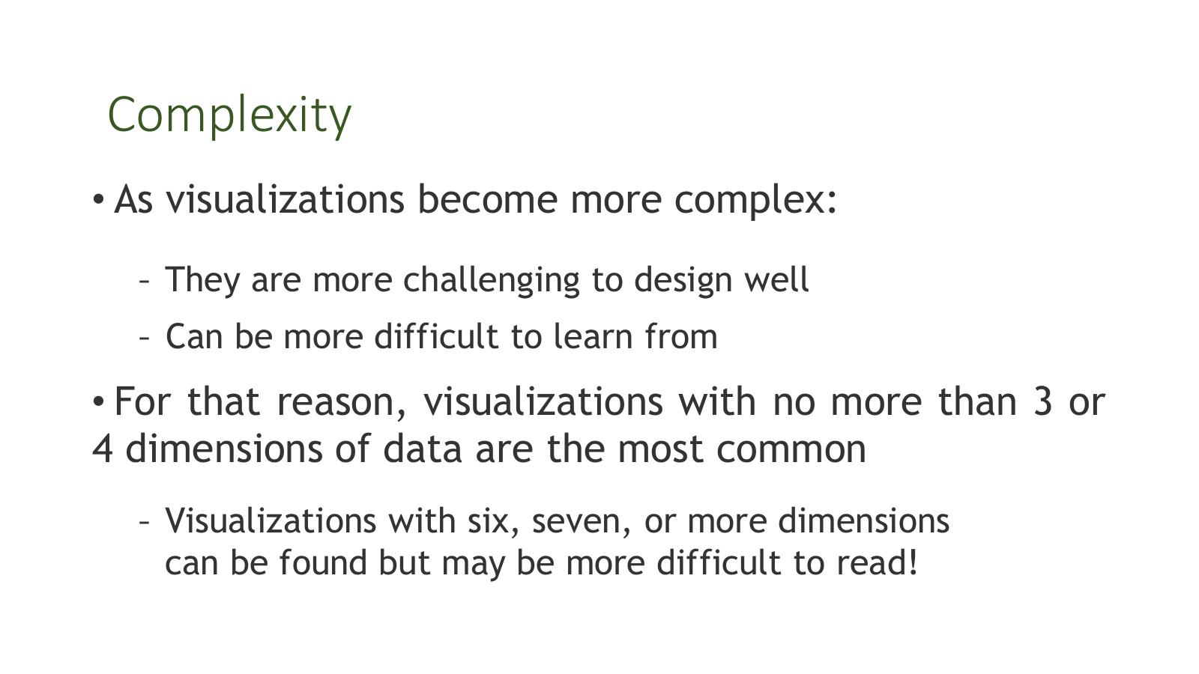

Complexity – Two Main Design Challenges
- Challenge 1: The more dimensions you need to encode visually, the more individual visual properties you need to use
- Challenge 2: There are relatively few well-known conventions, metaphors, defaults, and best practices to rely on for high-dimensional data – there is more burden on the designer to make good choices that can be easily understood by the reader
- However, there are smart ways to think about and represent complex data
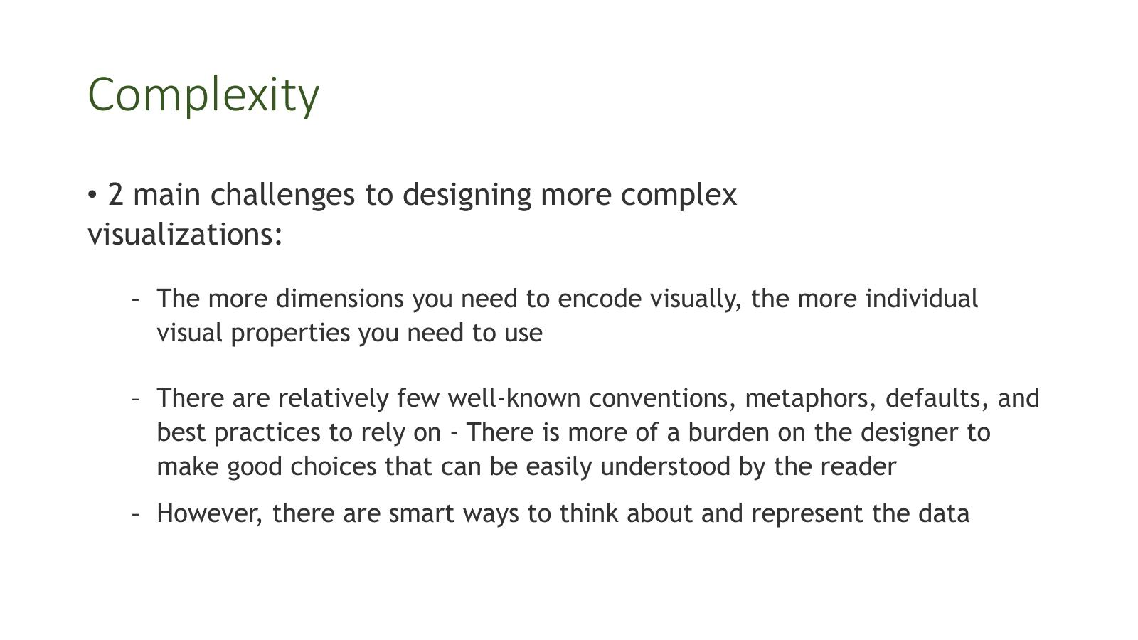

Infographics vs. Data Visualisation

Infographics vs. Data Visualisation – The Distinction
- Infographics and data visualisation are slightly nebulous terms often used interchangeably, but a distinction is worthwhile
- Infographic: used to refer to representations of information perceived as casual, funny, frivolous – custom data representation difficult to reuse
- Data Visualization: used to refer to designs perceived to be more serious, rigorous, academic or scientific
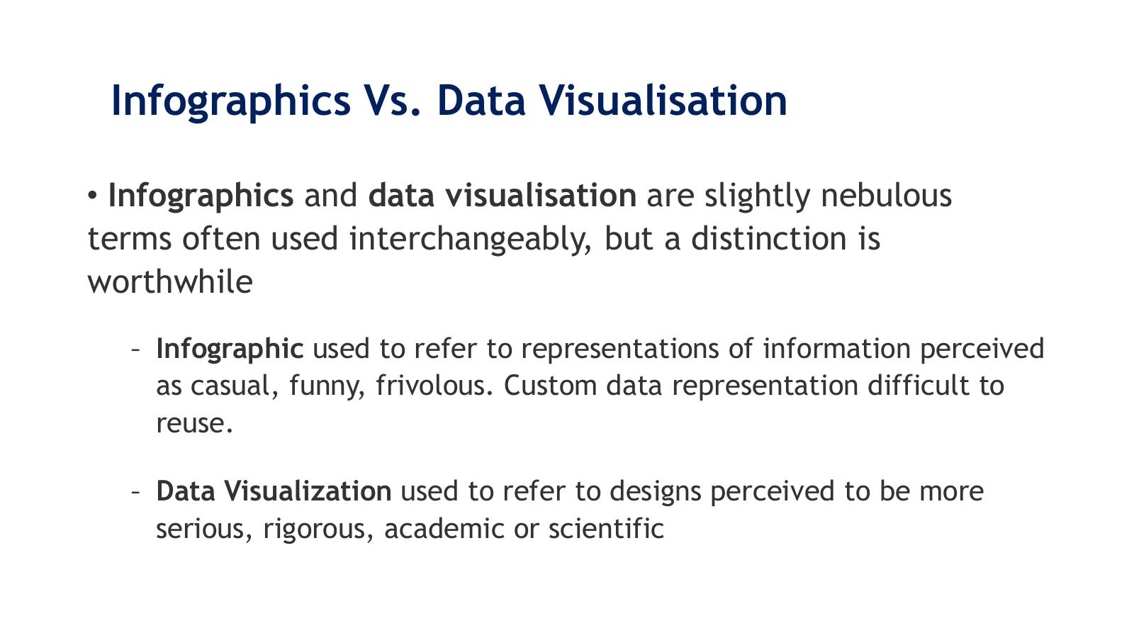
- Infograhics are custom….data representations
- Visualations >> more rigorous /serious maybe more scientific…

Infographics – Definition (Iliinsky & Steele)
- Iliinsky & Steele suggest that the term infographics is useful for referring to visual representations of data that are:
  - Manually drawn (and therefore a custom treatment of the information)
  - Specific to the data at hand (and therefore non-trivial to recreate with different data)
  - Aesthetically rich (strong visual content meant to draw the eye and hold interest)
  - Relatively data-poor (because each piece of information must be manually encoded)
- Reference: 'Designing Data Visualizations', N. Iliinsky & J. Steele, O'Reilly Media, 2011 – http://shop.oreilly.com/product/0636920022060.do
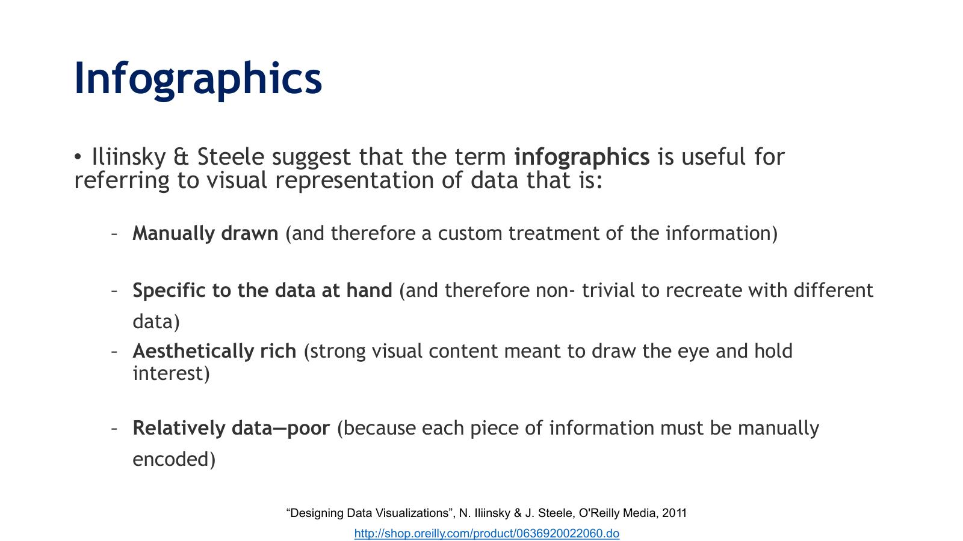
- More embelishments adding info btu not exactly data

Infographic Example – Burning Man (Flint Hahn, 2010)
- Map-style infographic of the Burning Man festival layout – Black Rock Desert
- Shows locations of: temples, burning man structure, Baker Beach, and various local areas
- Highly custom, manually drawn, location-specific – a classic infographic
- Reference: Burning Man map – Flint Hahn (2010)
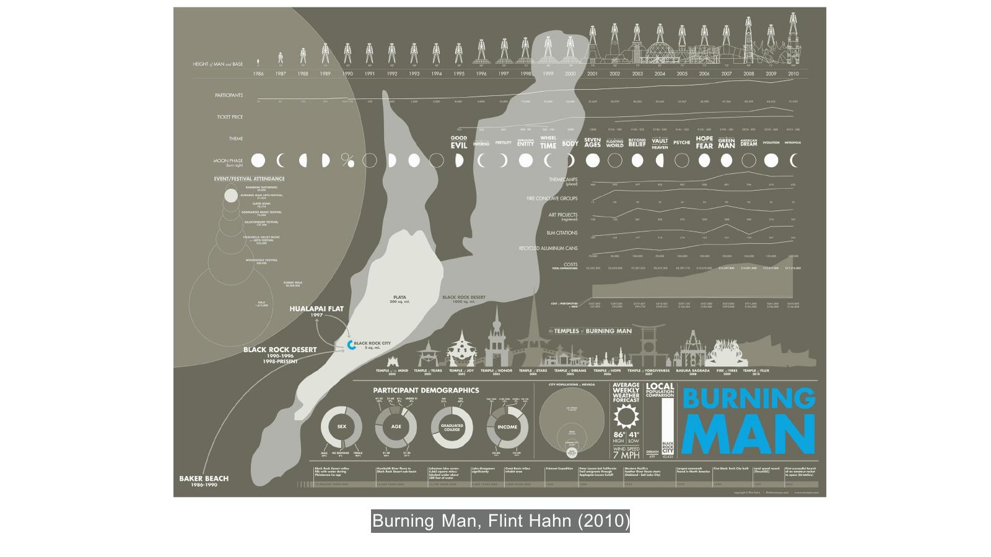
- Uses bar chart but figure of man showing as different structures…
- Cannot be used for company sales.. is adhoc custome made…
- heights
- embellished with other buildings….
- In general can see very little of graph can be re-used… specifically for this purpose…

Infographic Example – World Nuclear Warheads
- Infographic showing total nuclear warheads by country with contextual annotations
- Countries covered: United States (9,400 total), Russia (13,000 total), France (300 total), China (240 total), UK (185 total), Israel (200 total), Pakistan (70–90), India (60–80), North Korea (fewer than 10)
- Each country entry includes: total warheads, trend direction, and descriptive annotations about arsenal status
- Manually drawn, highly specific to this dataset – a clear infographic
- Reference: https://www.psriowa.org/nuclear.html
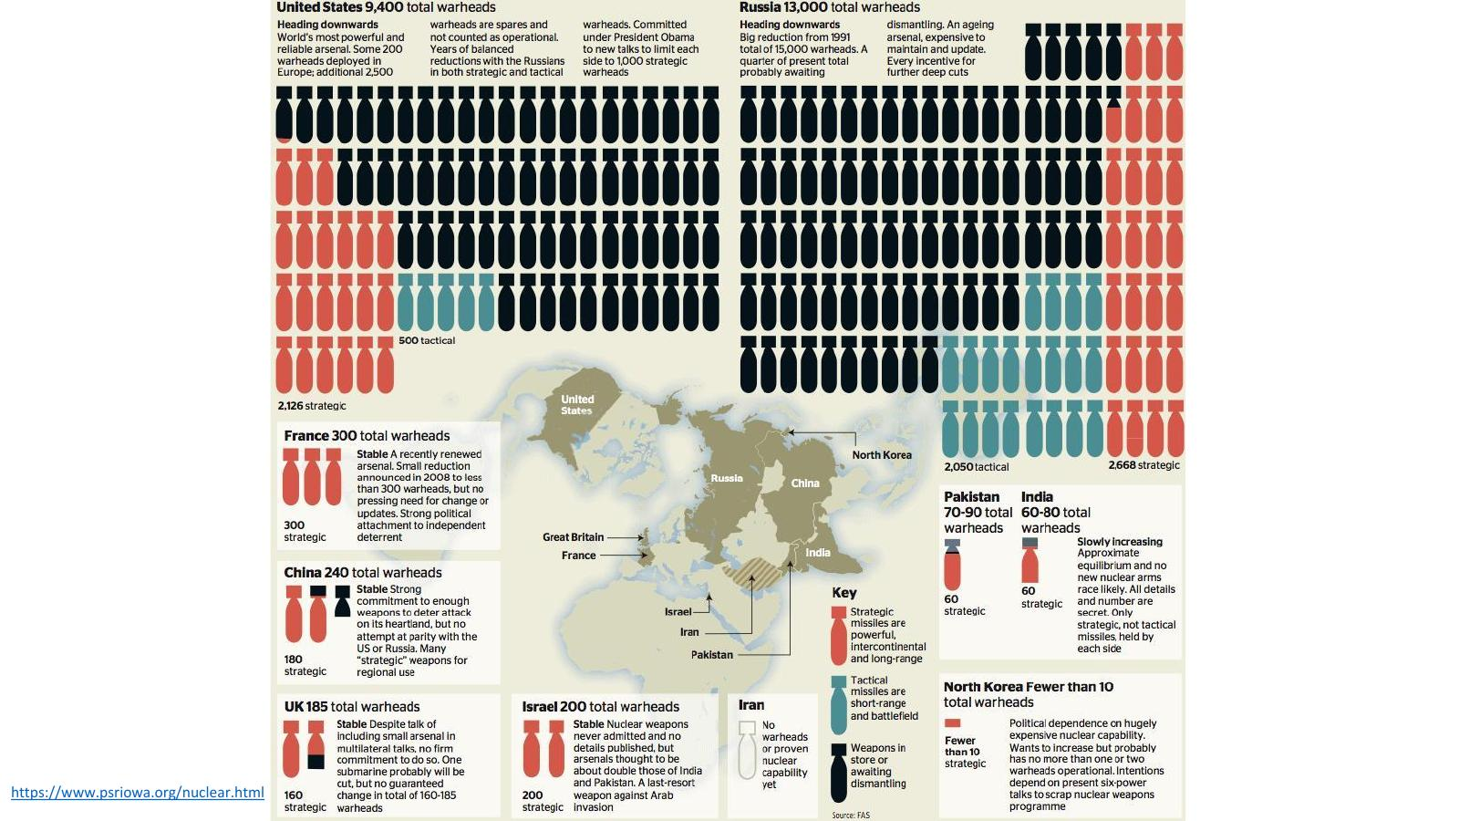
- Custom made it to shape of warhead…. So can only work for warheads >>>> an infogrpahic

Data Visualisation – Definition (Iliinsky & Steele)
- By contrast, the term data visualization is useful for referring to any visual representation of data that is:
  - Algorithmically drawn (may have custom touches but is largely rendered with computerised methods)
  - Easy to regenerate with different data (the same form may be repurposed to represent different datasets with similar dimensions or characteristics)
  - Maybe aesthetically barren (data is not decorated)
- Relatively data-rich (large volumes of data are welcome and viable, in contrast to infographics)
- 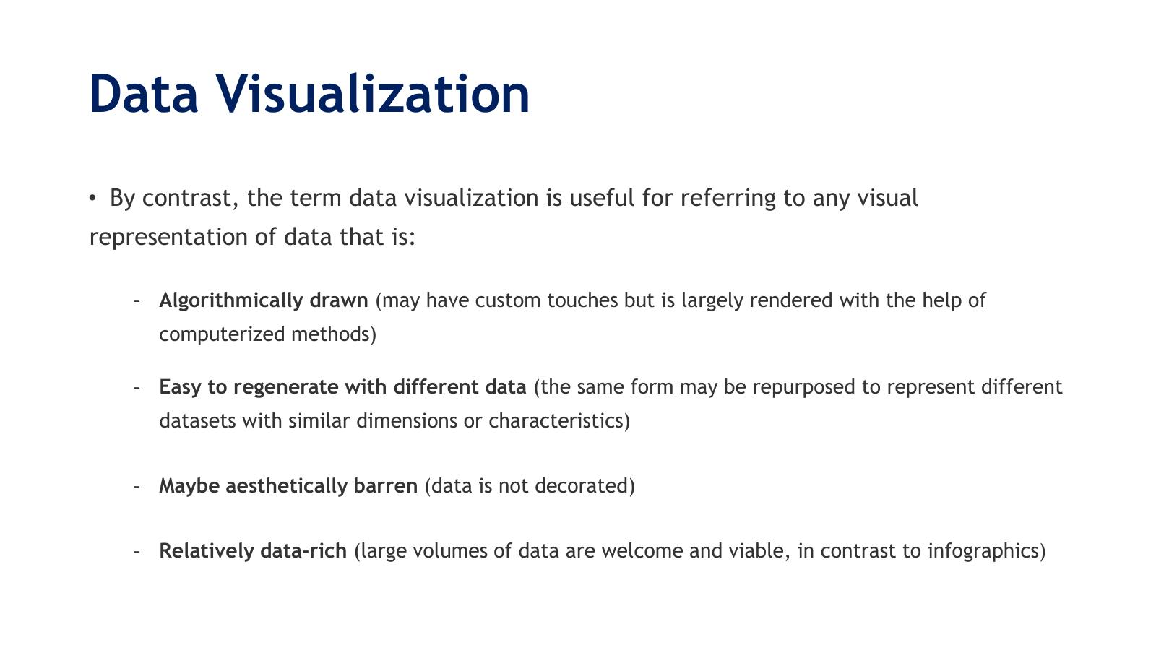
- Easy to re-generate with completely different data…
- Characteristics similar but data doesn’t have to be related
- Usually data rich…

Data Visualisation Example – Names
- Algorithmic visualisation showing a network or layout of names (Alexander, Alexis, Amanda, Alyssa, Amber, Amy, Andrew, Angela, Anthony, Arthur, and others)
- Demonstrates an algorithmically generated visual that would be trivial to regenerate with different name data
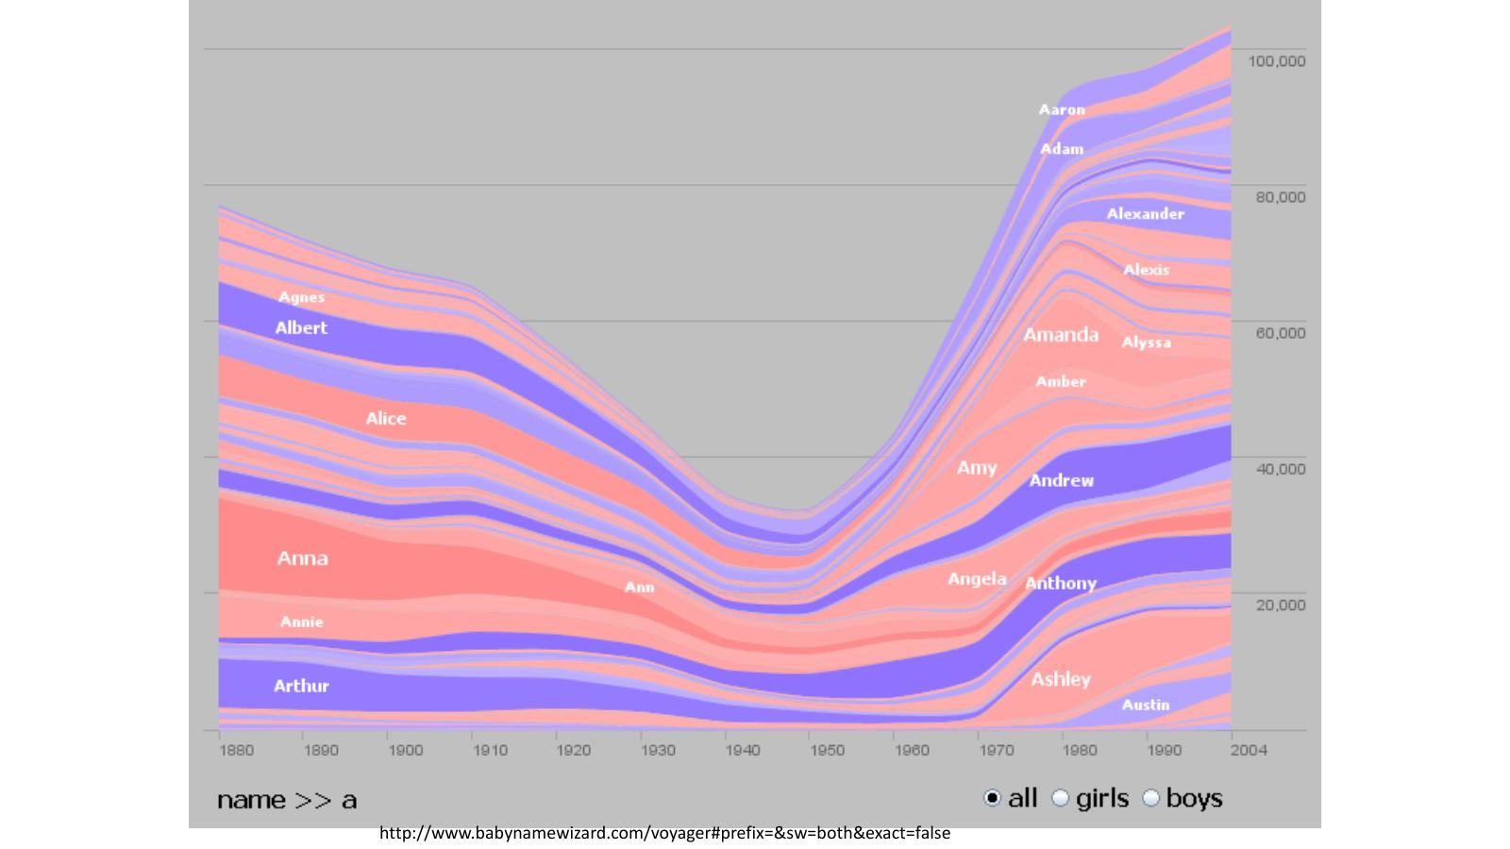
- Names and colour coding of names for boys and girls…
- Could replace names with products , soap popular in this period… so can re-use… use exactly same code to crate the visualisation

Exploratory vs. Explanatory Visualisation

Exploratory Visualisation
- Really Important!!
- Exploratory data visualisations are appropriate when you have lots of data and you are not sure what's in it
- When you need to get a sense of what's inside your dataset, translating it into a visual medium can help you quickly identify its features, including interesting curves, lines, trends, or anomalous outliers
- This type of visualisation is typically part of the data analysis phase, and is used to find the story the data has to tell you
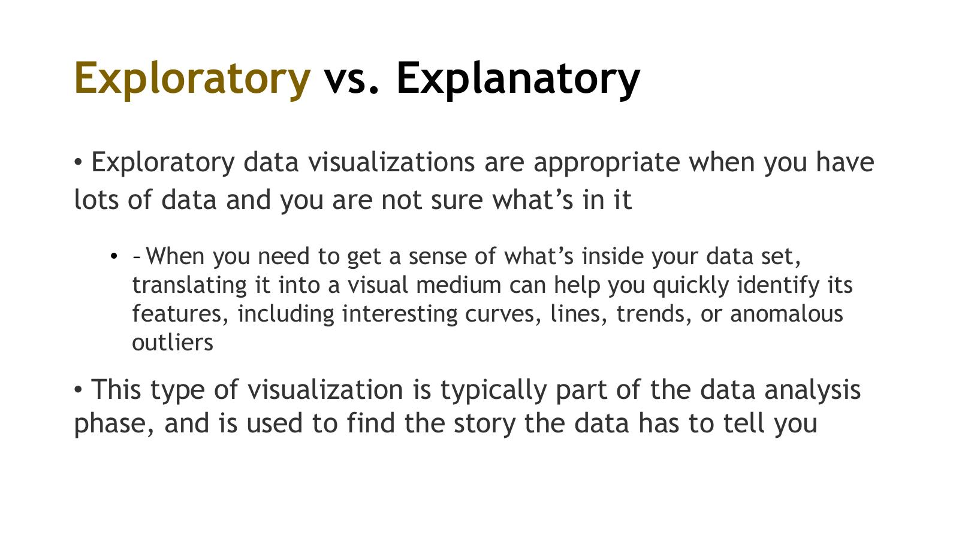
- Exploratory – used at beginning
  - No clear message comigun out.. visualising the data.. maye give that to viewer to see overall picture… different variables, trends…
  - Usually part of the process and initial pare of the process..
  - i.e. correlation matrix.. htake all variables and start to lok at trends… nothing clearly highlighted… just for yourswlf or perhaps your audience…

- Explanatory.. when you know the insights.. and trying to tellt hat stiry to someone else…
  - Create specifically to highlight the message – highlihght for audience and story..
  - At end of process
- Really important to understand this difference…
  - 1st Assignment
    - 1st exploratory dashboard
    - 2nd explanatory dashboard with some insights…
  - Can’t use same dashboard to show both
  - Students in past submitted 1 dashboard … can’t use 1 dashboard for both... which is good ….have opposite purposes…
  - Make sure know difference
  - Go thru exploration process at beginning and if creating vis for audience that is exploratory
  - They just want the info in a way can look at it and understand, explore the data and try understand what is happening without you having done any curation of the insights or stories in the data….
  - Explanatory… you have done curation, you know the insights and you use that knowledge to create, represent those tin a way that is most effective to transmit that insight to viewers
    - Use less cognition
    - More perception
    - Making sure message is very clear and can very clearly be seen on the screen…

Exploratory Visualisation Example – Scatterplot Matrix
- Scatterplot matrix (pairs plot) showing relationships between multiple variables
- Variables include: Environment, Healey, Wellness, and others
- Each cell shows the relationship between one pair of variables – allows rapid exploratory scanning of all pairwise relationships simultaneously
- Reference: http://junkcharts.typepad.com/junk_charts/2010/06/the-scatterplot-matrix-a-great-tool.html
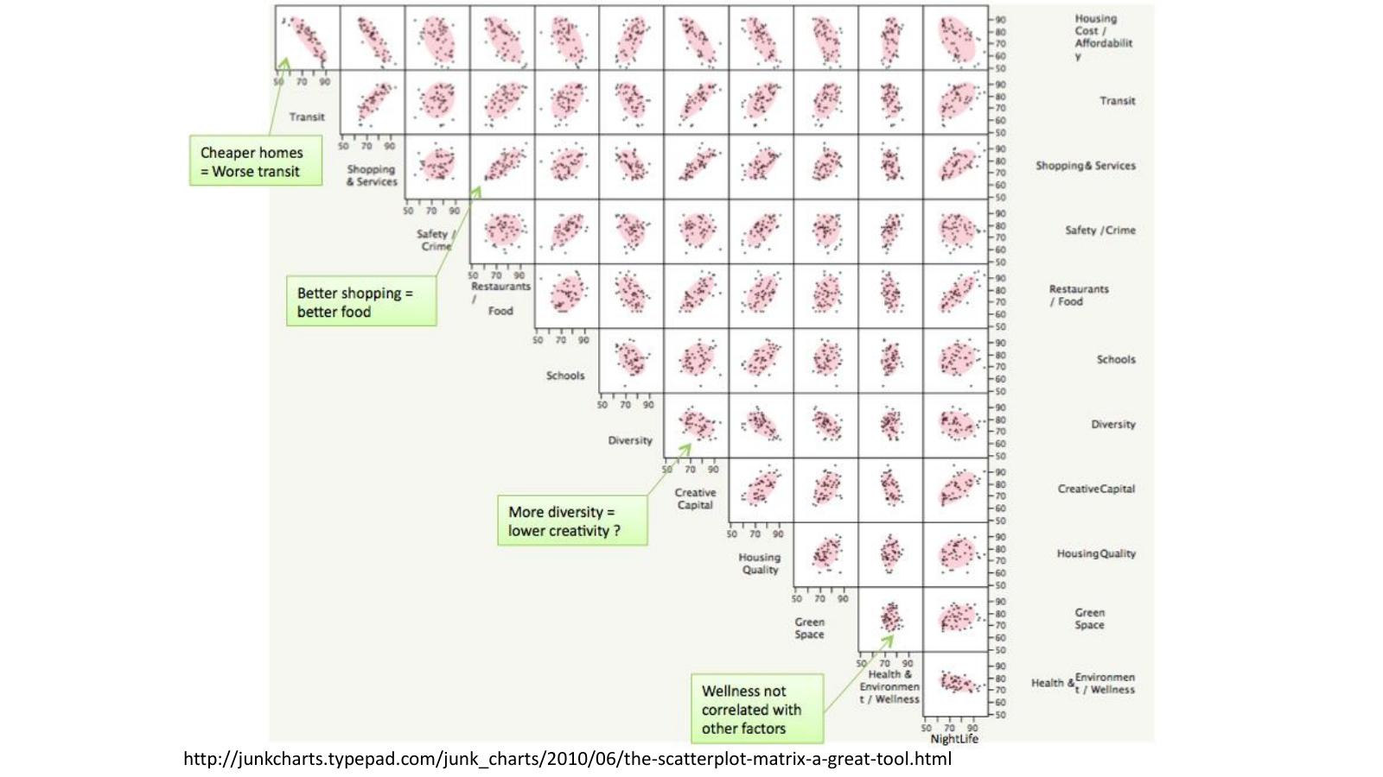

Explanatory Visualisation
- Explanatory data visualisation is appropriate when you already know what the data has to say, and you are trying to tell that story to somebody else
- Whoever your audience is, the story you are trying to tell is known to you at the outset, and therefore you can design to specifically accommodate and highlight that story
- Explanatory data visualisation is essentially part of a presentation phase
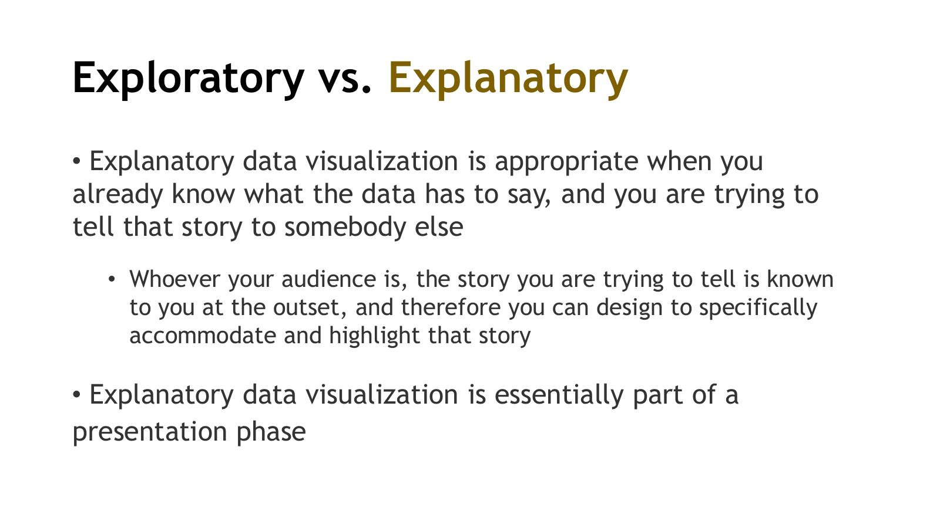

Explanatory Visualisation Example – The Billion Dollar Gram
- Treemap-style visualisation showing how billions of dollars are spent across categories
- Each rectangle's area is proportional to the amount of money
- Designer knows the story (scale of spending) and has designed to highlight it
- Reference: https://www.informationisbeautiful.net/visualizations/the-billion-dollar-gram/
- Source: InformationIsBeautiful.net
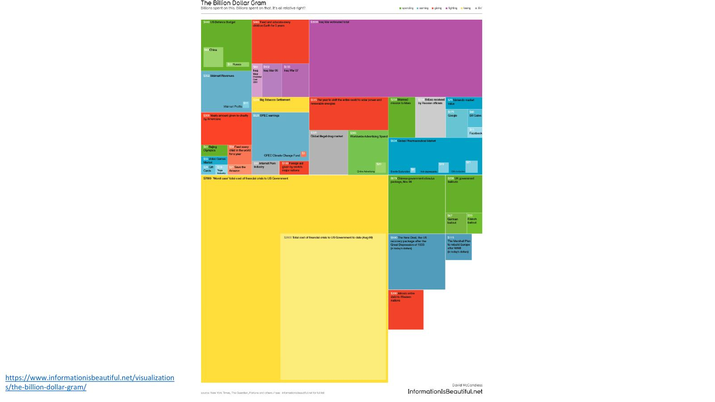
- Could argue this is a both exploratory and explainable
- In original… yellow is recession
- Original as crated ot highlight the size of the financial cost of the war in Iraq..vs other aspects of the American economy…
- Recession in purplpe dwarfs everything else…
- They were highlighting the big section of the war cost in Yellow
- Defence budget highlighted…. China / US vs iraq war…
- Was very powerful… at showing size of it..
- Can argue that with billion dollar infographic can explor further, so hybrid are isualisation where dataset is curated… yuoh are finding some insight to show, btu also letting users interact… surs may find something that you haven’t seen yet.. some message not totally raw.. tbu some explanation available…..

Hybrid: Exploratory & Explanatory
- Hybrid category: a curated dataset that is nonetheless presented with the intention to allow some exploration on the reader's part
- These visualisations are usually interactive via some kind of graphical interface that lets the reader choose and constrain certain parameters
- Sometimes allows the reader to discover insights the designer of the visualisation hasn't come across yet
- In these hybrid designs there is a certain freedom-of-discovery aspect to the information presented, but it is usually not totally raw – it has been distilled and facilitated in some way
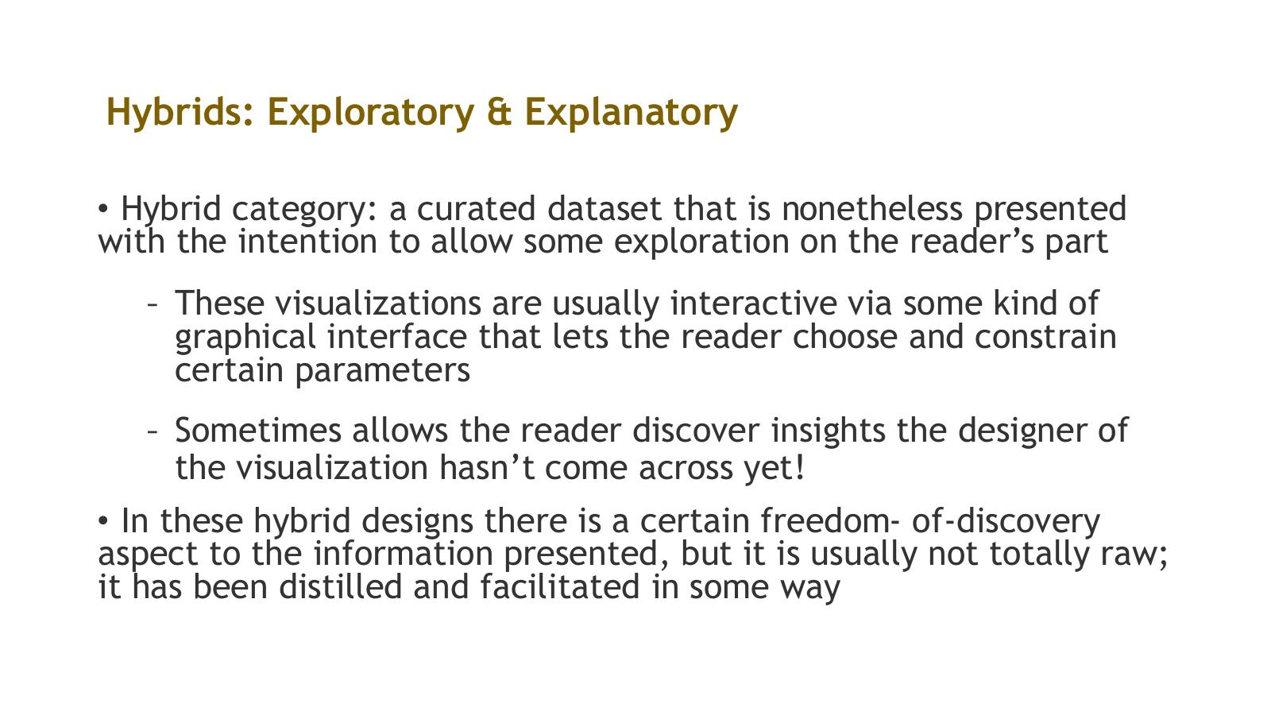

Hybrid Example – US Median Income and Obesity Maps
- Slide 47: Choropleth map – 2008 Median Income by US County (in thousands)
  - Colour scale from dark (lowest income) to light (highest income)
  - Range shown: approx. $22,800 to $134,400
- Slide 48: Choropleth map – 2008 Age-adjusted Obesity Rate by US County
  - Colour scale from light (lowest obesity: 11.5%–26.2%) to dark (highest: 30.2%–31.8%+)
- Slide 49: Correlated Map – combining both maps
  - Areas of dark red are where very high obesity rates and lowest income levels coincide
  - Reveals the correlation between poverty and obesity geographically
- Both maps created by Max Masnick
- Reference: http://asserttrue.blogspot.ie/2013/02/poverty-and-obesity-in-america-how-they.html
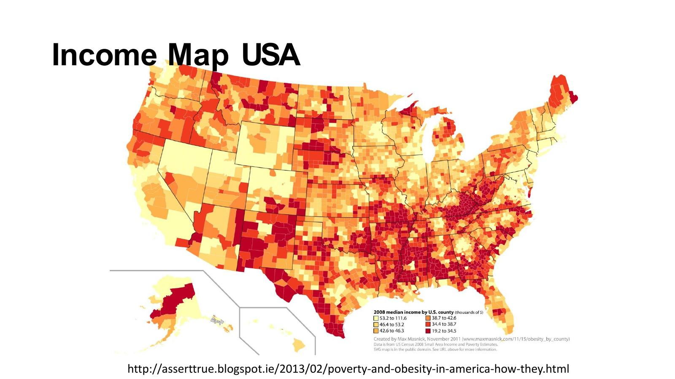
- 1st = income
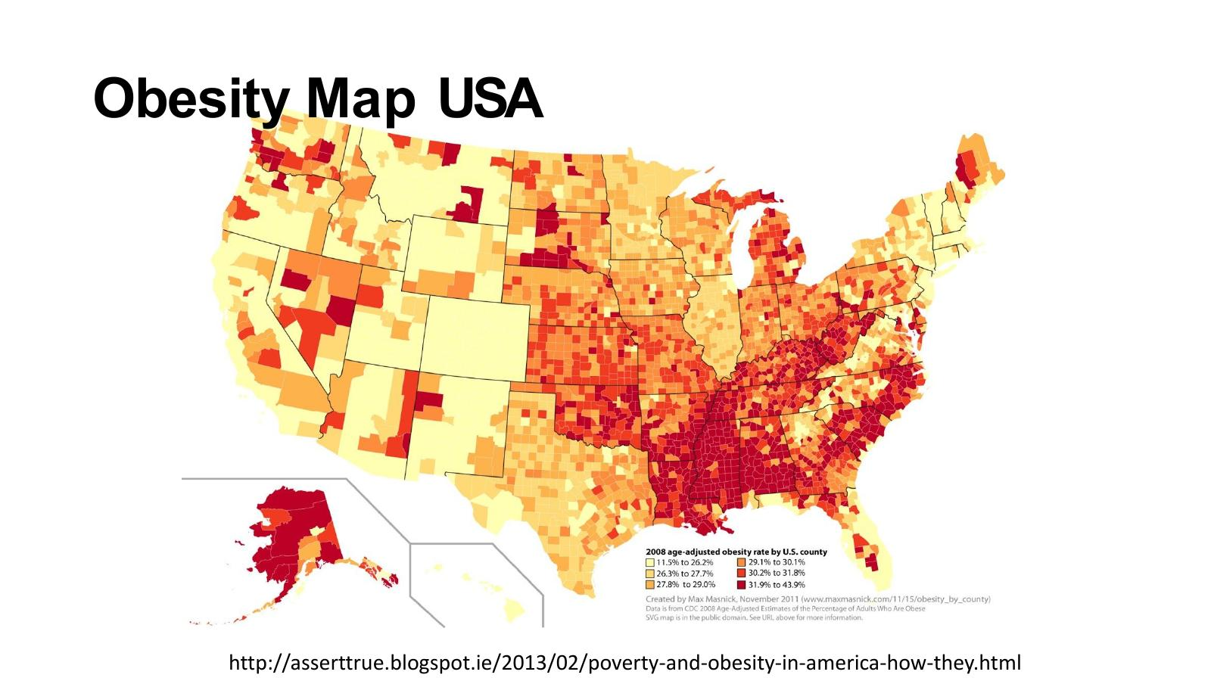
- 2nd = obesity
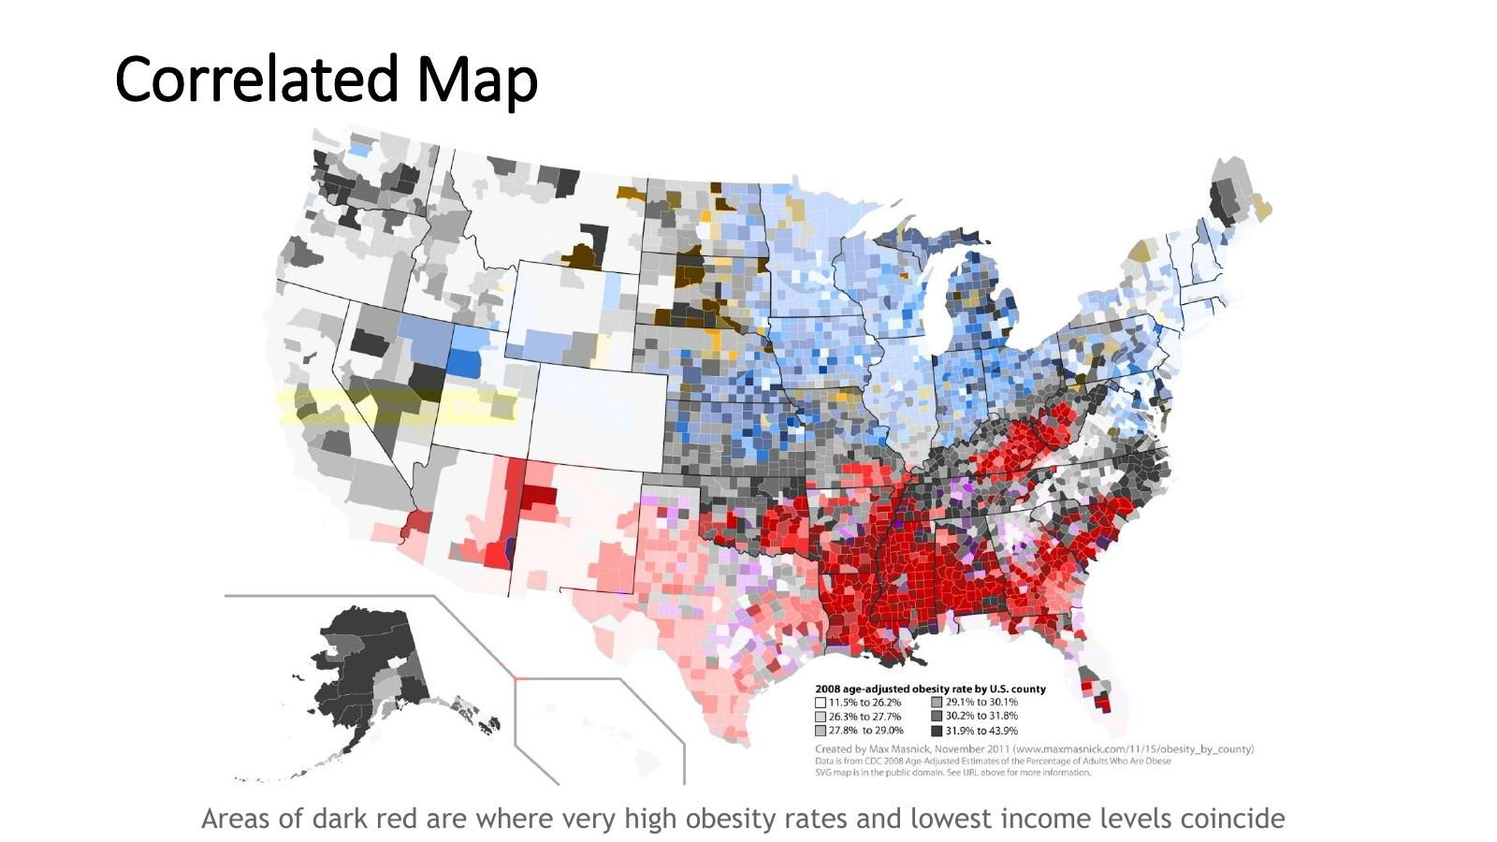
- 3rd – correlation between income and obesity, prevous two
- There is a message.. high areas around redish colours… so a message,,, the data has been distilled in a way that there is something for us ro see… and interactive.. so can go to specific areas…..
- Red patch top right? Why is that there?
- User can explore….
- Have both a little bit of message but also letting viewer explore….

The Designer-Reader-Data Trinity

The Designer-Reader-Data Trinity – Introduction
- Three parties in any visualisation: the Designer, the Reader, and the Data
- Each of the three exerts a force or contributes a separate perspective that must be taken into consideration
- The dominant relationship between the three determines which category of visualisation is needed
- The trinity: Informative (Reader ↔ Data), Persuasive (Designer ↔ Reader), Visual Art (Designer ↔ Data)
- This framework only really applies to explanatory visualisations
- Reference: 'Designing Data Visualizations', N. Iliinsky & J. Steele, O'Reilly Media, 2011 – http://shop.oreilly.com/product/0636920022060.do
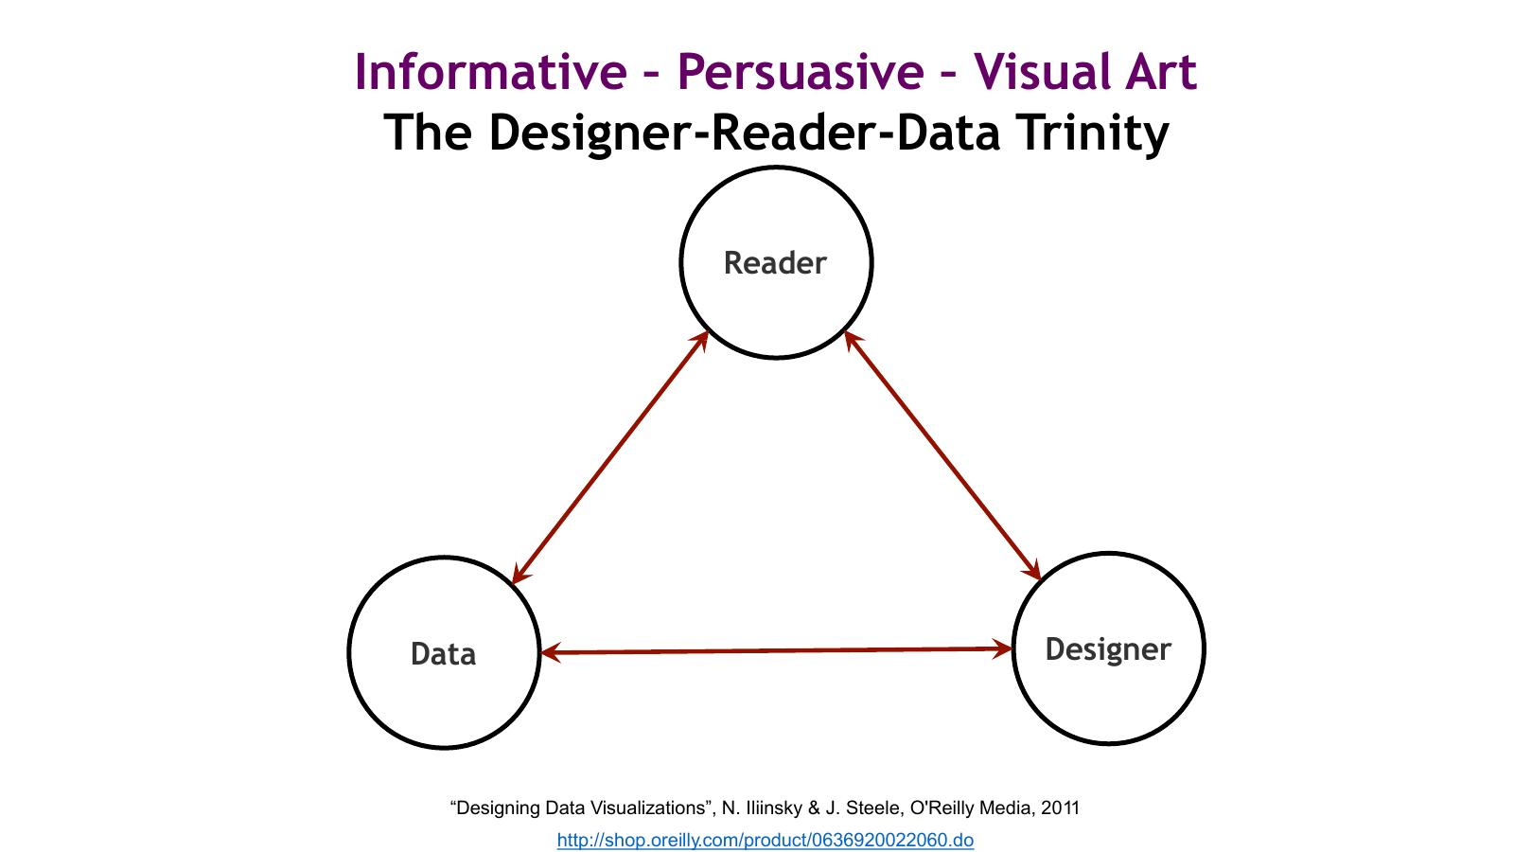
- 3 legged stool
- 3 actors
  - 1. Data
  - 2. Designer
  - 3. Viewer
- Depending on which is strongest relationship>>. We have type of visualistaion

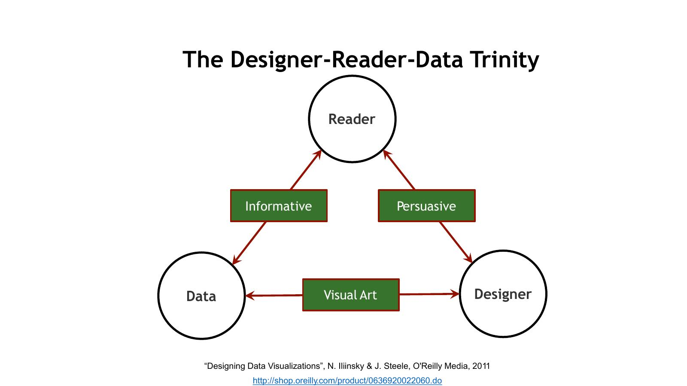
- Where is the strongest relationship…
  - Reader + Data = Informative
  - Reader + Designer = Persuasive
  - Designer + Data = Visual Art
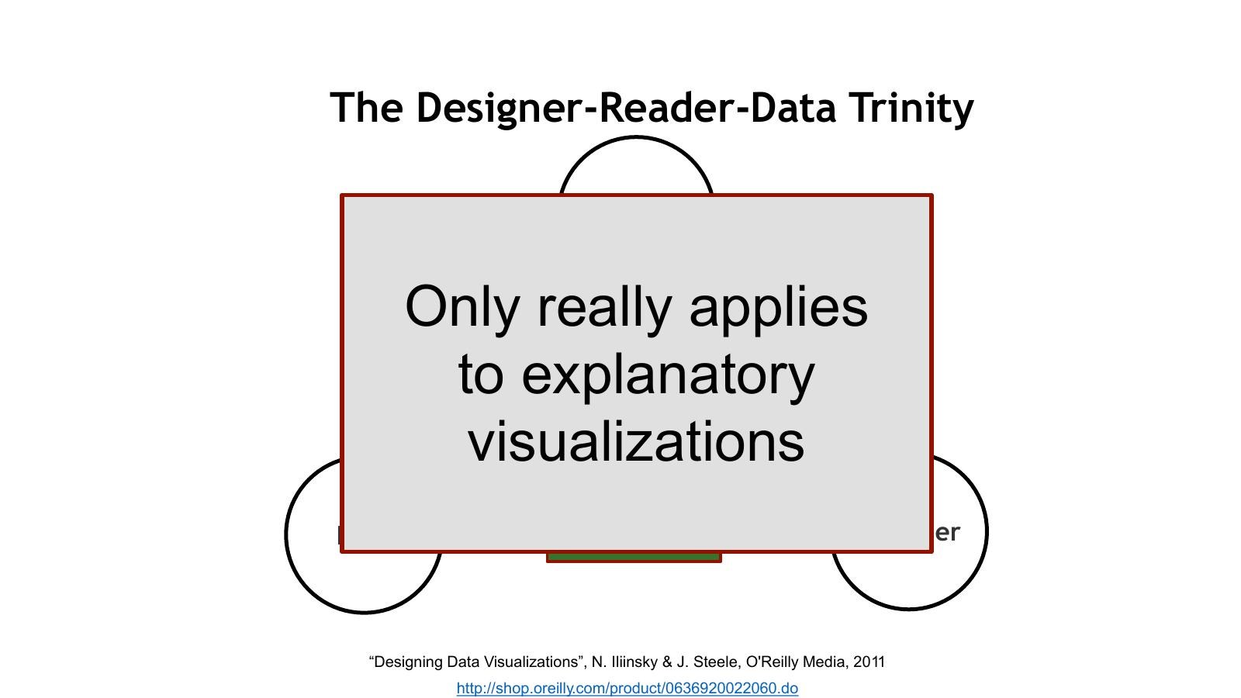
- ONLY applies to explanatory visualisations
- Not to exploratory….

The Designer-Reader-Data Trinity – Detail
- We can think of explanatory data visualisation as being supported by a three-legged stool consisting of the designer, the reader, and the data
- Each of these 'legs' exerts a force, or contributes a separate perspective, that must be taken into consideration for a visualisation to be stable and successful
- Each of the three legs of the stool has a unique relationship to the other two
- While it is necessary to account for the needs and perspective of all three in each visualisation project, the dominant relationship will ultimately determine which category of visualisation is needed
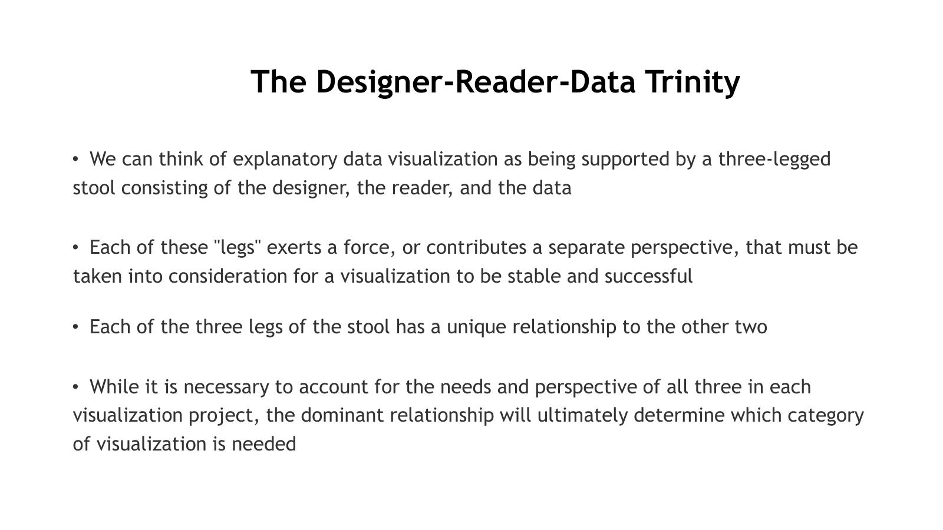
- 3 elements are needed…
- Always need data + always need designer…

Informative Visualisation
- An informative visualisation primarily serves the relationship between the reader and the data
- It aims for a neutral presentation of the facts in such a way that will educate the reader (though not necessarily persuade them)
- Informative visualisations are often associated with broad datasets, and seek to distil the content into a manageably consumable form
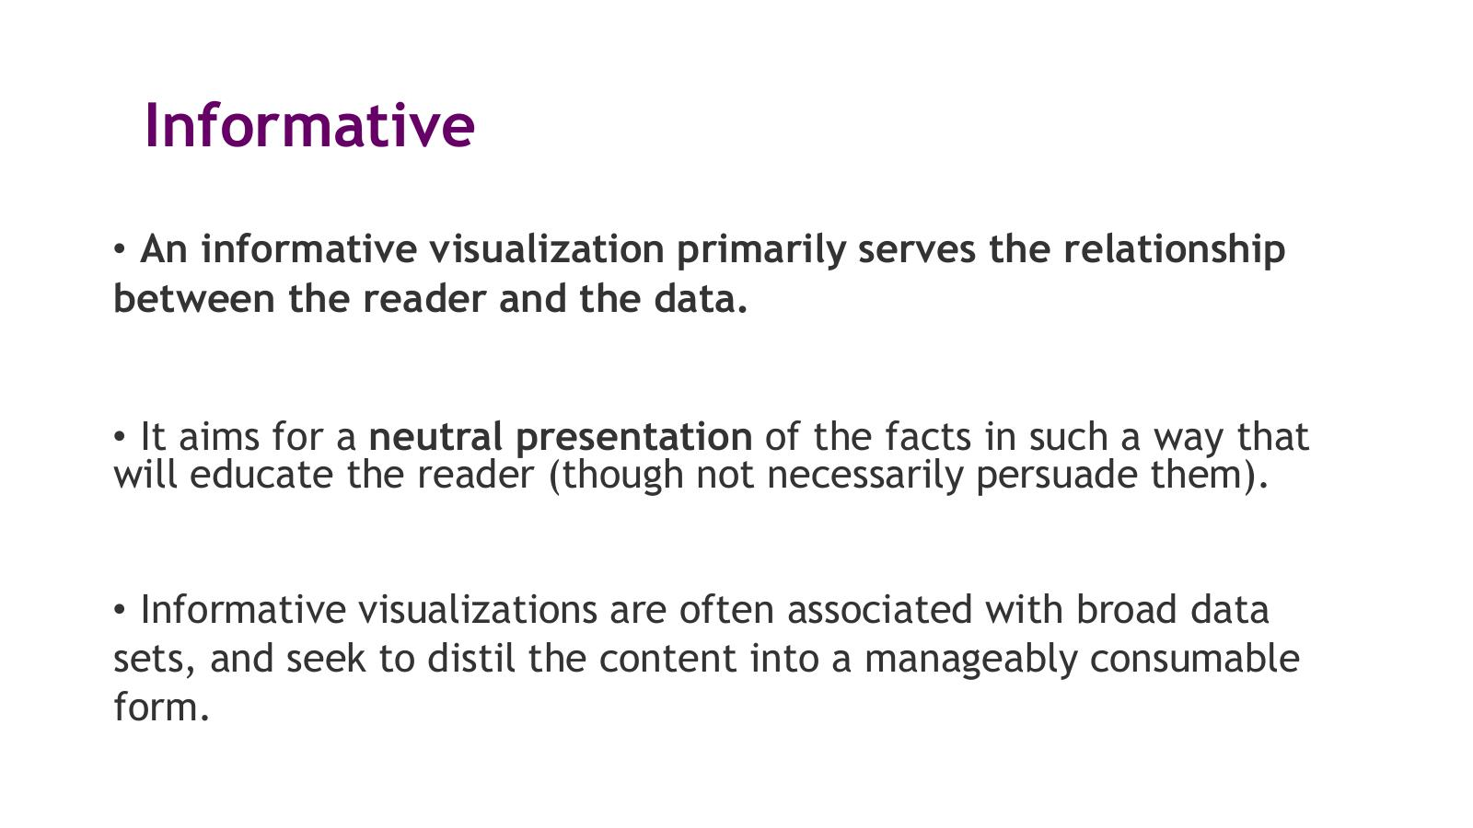
- Just the facts with no curation of it…

Informative Visualisation Example – Gamestop Share Price
- Line chart showing Gamestop's share price over time with time period selectors: 1 day, 5 days, 1 month, 6 months, YTD, 1 year, 5 years, Max
- Period shown: April 2020 – December 2020
- Y-axis: 0–80 (share price in USD)
- Neutral presentation of price data – informative, not persuasive
- Source: Google search – Gamestop share price
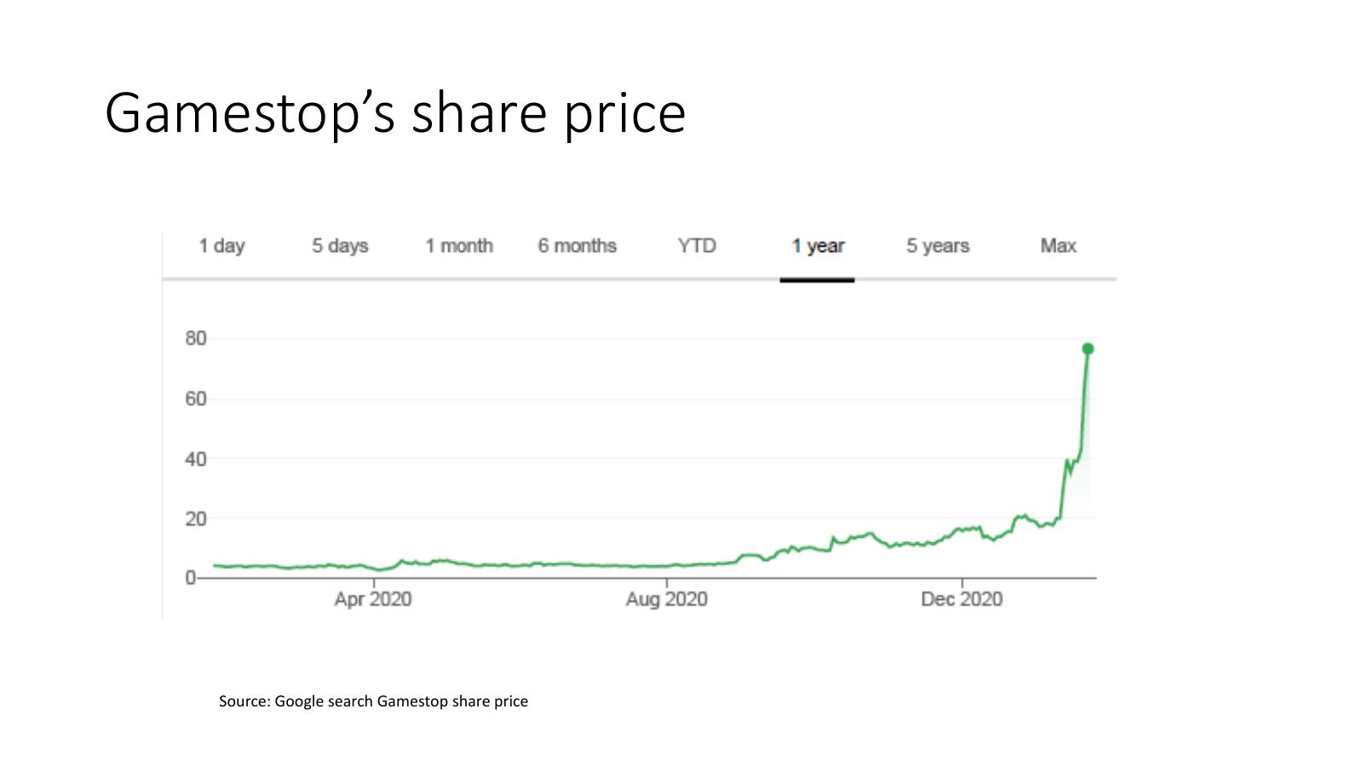
- Just portrays the information…. Visual table but not too far off just the raw data…

Persuasive Visualisation
- A persuasive visualisation primarily serves the relationship between the designer and the reader
- It is useful when the designer wishes to change the reader's mind about something
- In this category of visualisation, the data represented is specifically chosen for the purpose of supporting the designer's point of view
- The data is presented carefully so as to convince the reader of the designer's perspective

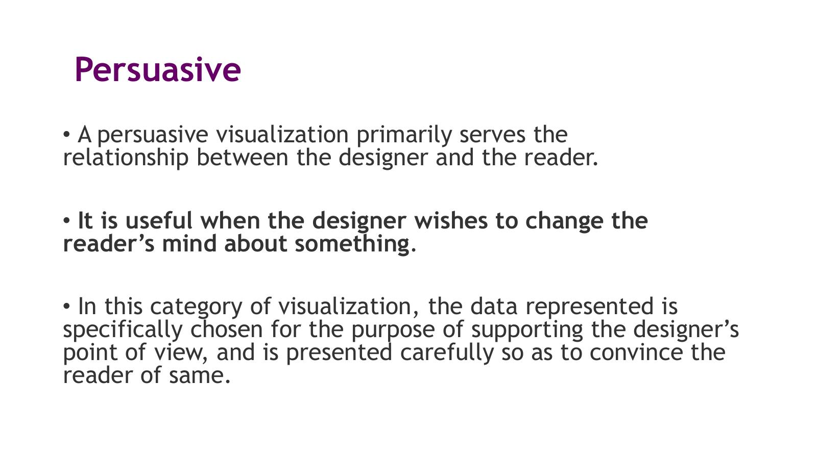
- Designer wanst topass on a message to the readeer..
- Designerwanst to persuade reader of an idea… show what data is sayign and change their modnds about something …
- Data chosen carefully… represented carfully so message gets through…

Persuasive Visualisation Example – Florence Nightingale's Rose Diagram
- 'Diagram of the Causes of Mortality in the Army in the East' – April 1854 to March 1856
- Blue wedges (measured from centre): deaths from preventable or mitigable zymotic diseases
- Red wedges (measured from centre): deaths from wounds
- Black wedges (measured from centre): deaths from all other causes
- Created by Florence Nightingale to persuade military and government officials to improve sanitary conditions
- A classic persuasive visualisation – the designer had a clear agenda: demonstrate that most deaths were preventable
- Reference: http://thisisstatistics.org/florence-nightingale-the-lady-with-the-data/
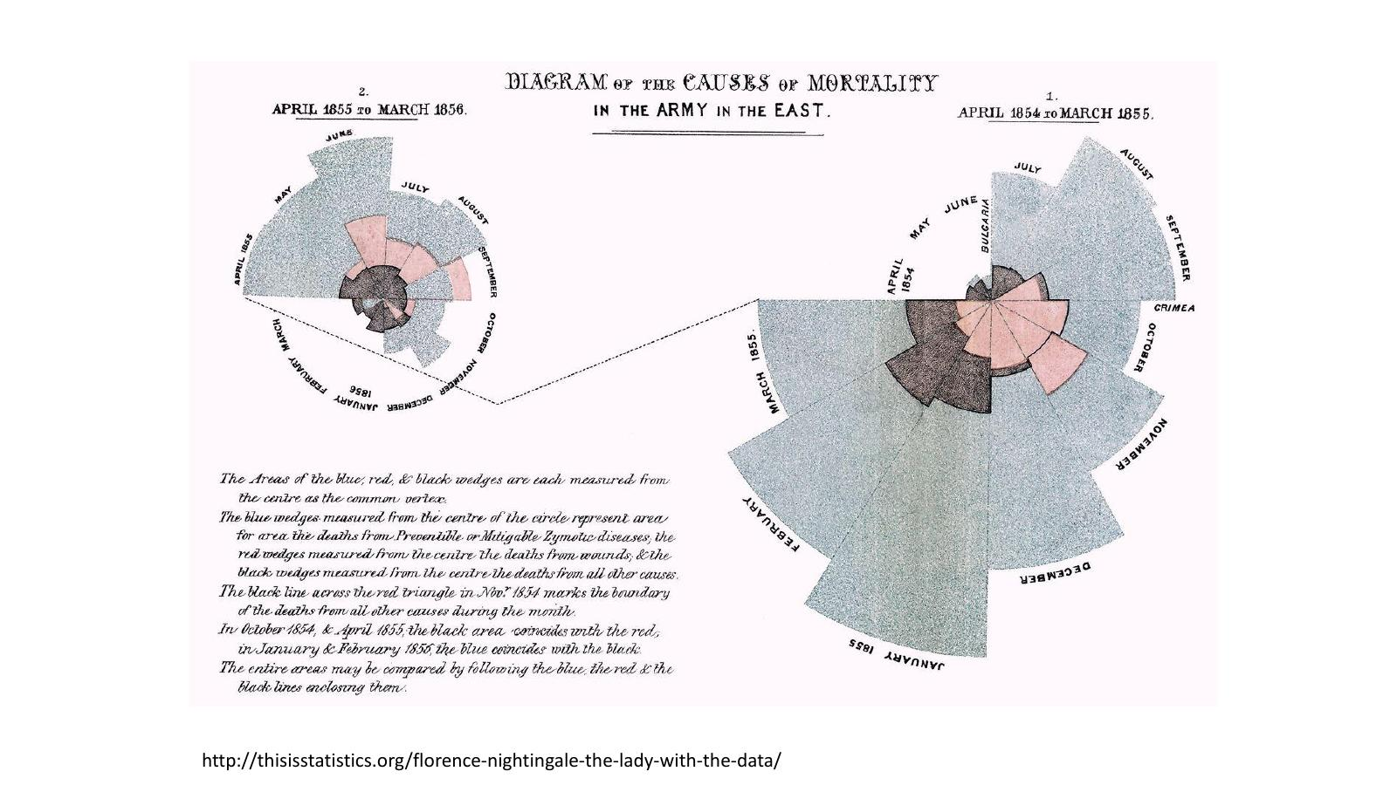

- Florence Nitinggale –
- She was in hospital and she realsied a lto fo soldiers were dyign of causes that could eb prevented…
- Trying in different ays to change practice t prevent those deaths..
- She documented the deaths and cause of deaths for all soldiers over a period..
- Each slice is a month…
- Red parts show soldiers died because of wounds
- Then died of other causes
- Bleu sectiosn ( grey ) much larger % than the other two… caused by rpeevtnable causes… i.e. infctions due to malpractice… she thought she could change… she created thrse graphs to show what was happening
- And got measure in place to prevent those deaths…
- i.e. trying to persuade people
- creted a different type of chart…
- an important example of creativity and comitment what she was trying to do…

Visual Art
- The third category, visual art, primarily serves the relationship between the designer and the data
- Visual art is unlike the previous two categories in that it often entails unidirectional encoding of information – the reader may not be able to decode the visual presentation to understand the underlying information
- The designer may intend only to condense it, translate it into a new medium, or make it beautiful; she may not intend for the reader to be able to extract anything from it other than enjoyment
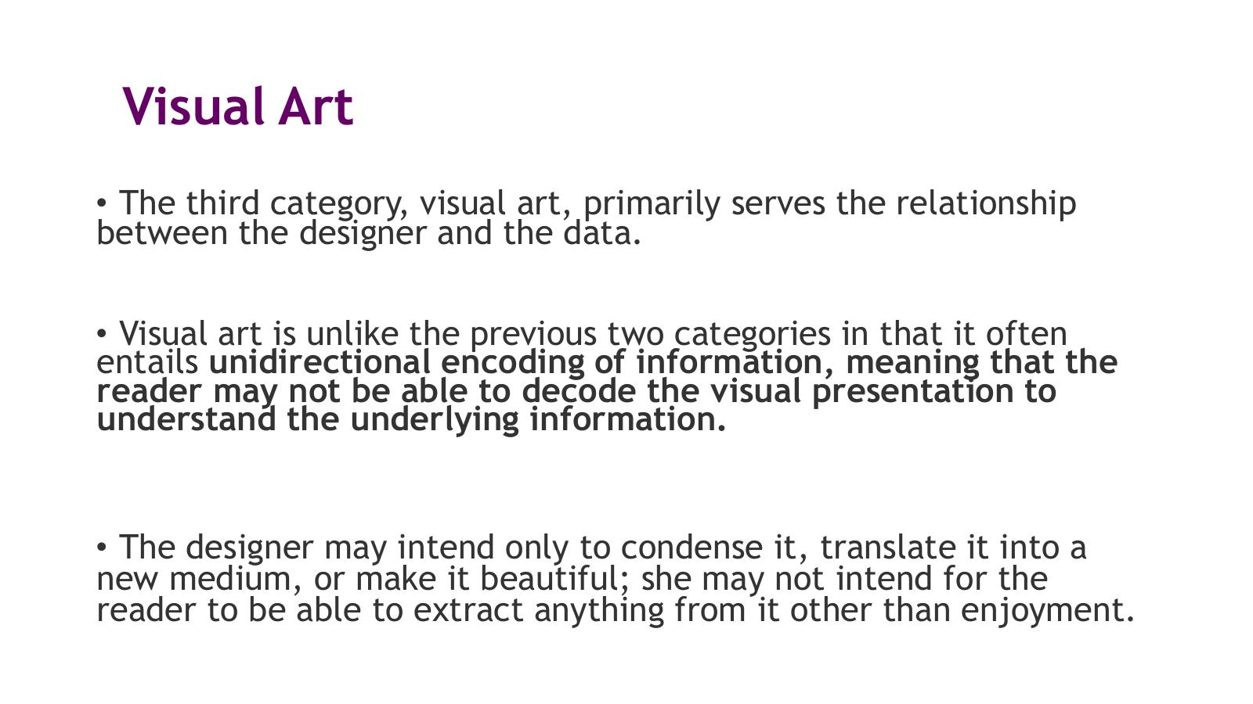
- Designer takes this data and is usually trying to make something that looks good
- Still meaning present, sometimes can see meaning in it..
- Main purpose is the artisctic portrait of the data…

Visual Art Example – Flight Patterns (Aaron Koblin)
- 'Flight Patterns' by Aaron Koblin – algorithmic visualisation of US air traffic routes
- Each line represents a flight path; colour and density create an emergent map of the US
- Beautiful and evocative but the viewer cannot easily decode individual data points
- Reference: https://www.artic.edu/artworks/213139/flight-patterns
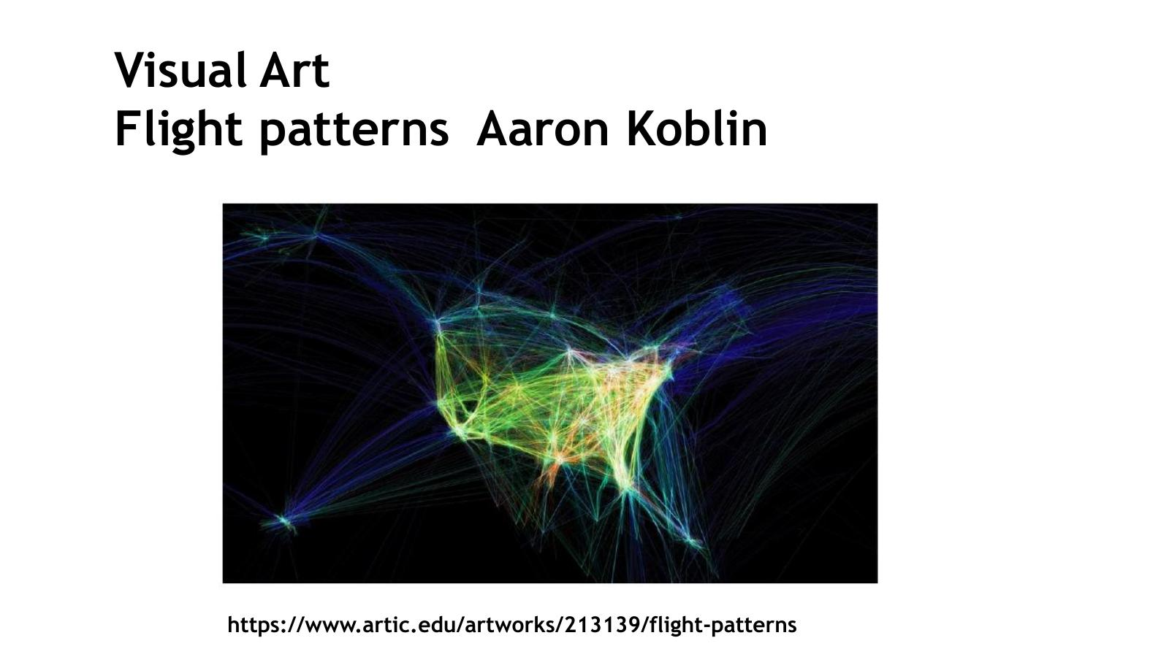
- Outline of america with flight path data

Visual Art Example – Facebook Visualised
- Visualisation of Facebook friendship connections worldwide
- Each line represents a friendship between two users; the aggregate creates a glowing map of the world
- Visually striking – the continents emerge from the density of connections without any map being drawn
- Reference: http://edition.cnn.com/2010/TECH/social.media/12/14/facebook.relationships.mashable/index.html
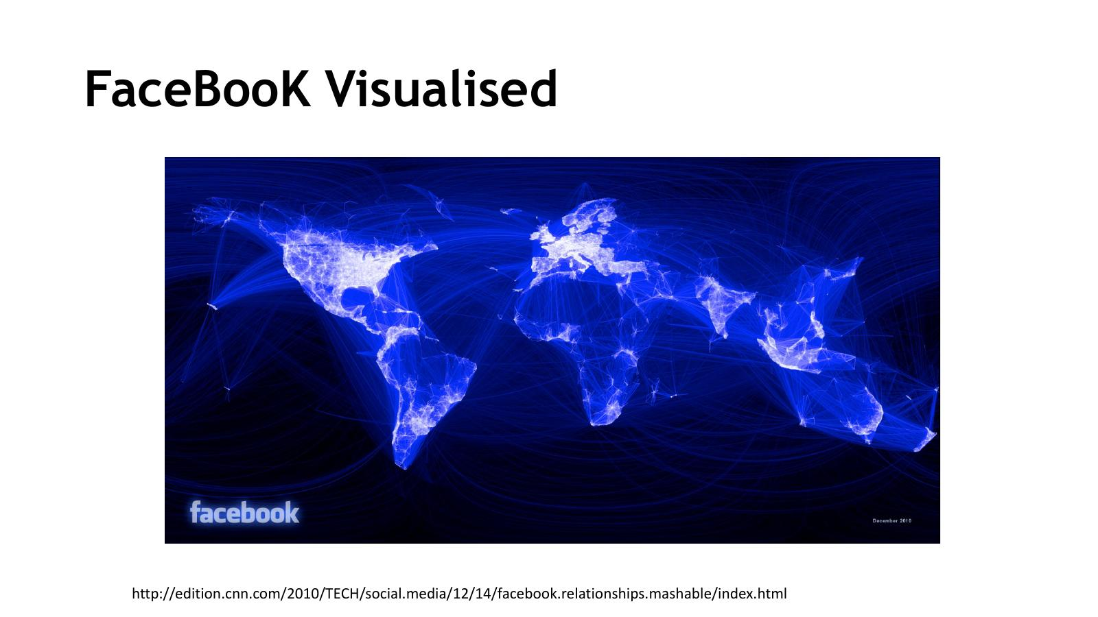
- Facebok connections
- From early days of facebook
- Can see certain areas more populated
- Very little that we can see ni Siberia...
- Created to lok pretty , but some info aswell
- Certain countries did not have eccss to facebook back in the day…

Visual Art Example – NY Times 'Hope' and 'Crisis' (Jer Thorp)
- 'How often the NY Times printed the words hope and crisis between 1981 and 2010' – by Jer Thorp
- Each bar represents a month
- Dates and mentions of specific events and key words are added to orient the viewer
- Interesting to note those times when crises eclipsed hope
- Reference: https://nicolatriscott.org/2012/09/23/art-in-the-age-of-big-data/
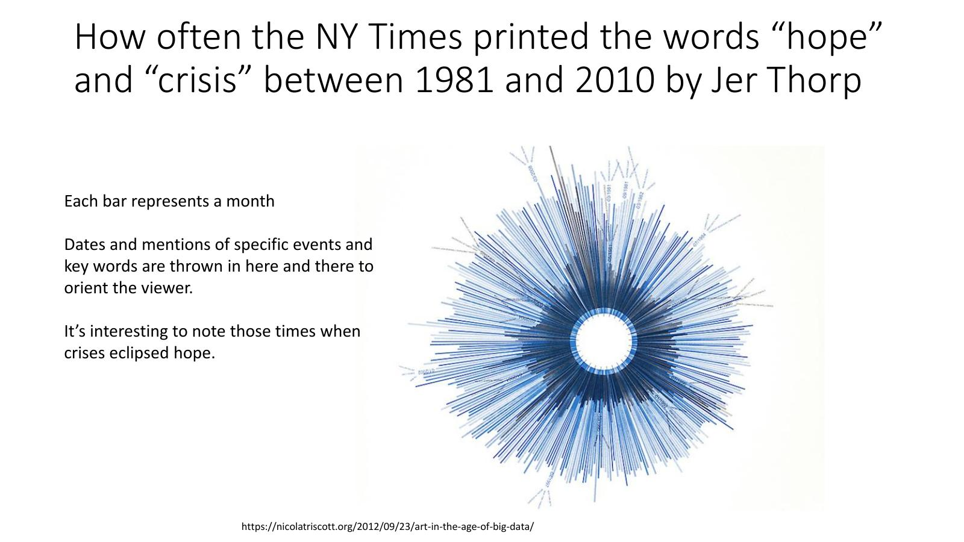
- NY Times
- Each bar represents a month
- Have some markers to give idea fo where you are
- How many times Ny Times printed the words Hope and Crises
- Looks like someones eye…
- Can see recsssin times where crises appears more prominent
- Interactive can click on each one a see what values where…

Summary – Classifications of Visualisations

Classifications of Visualisations – Summary
- There are many different ways to classify visualisations
- Classifications can be useful when discussing and planning visualisation projects
- Classifications are also useful when determining the appropriate visualisation techniques to deploy
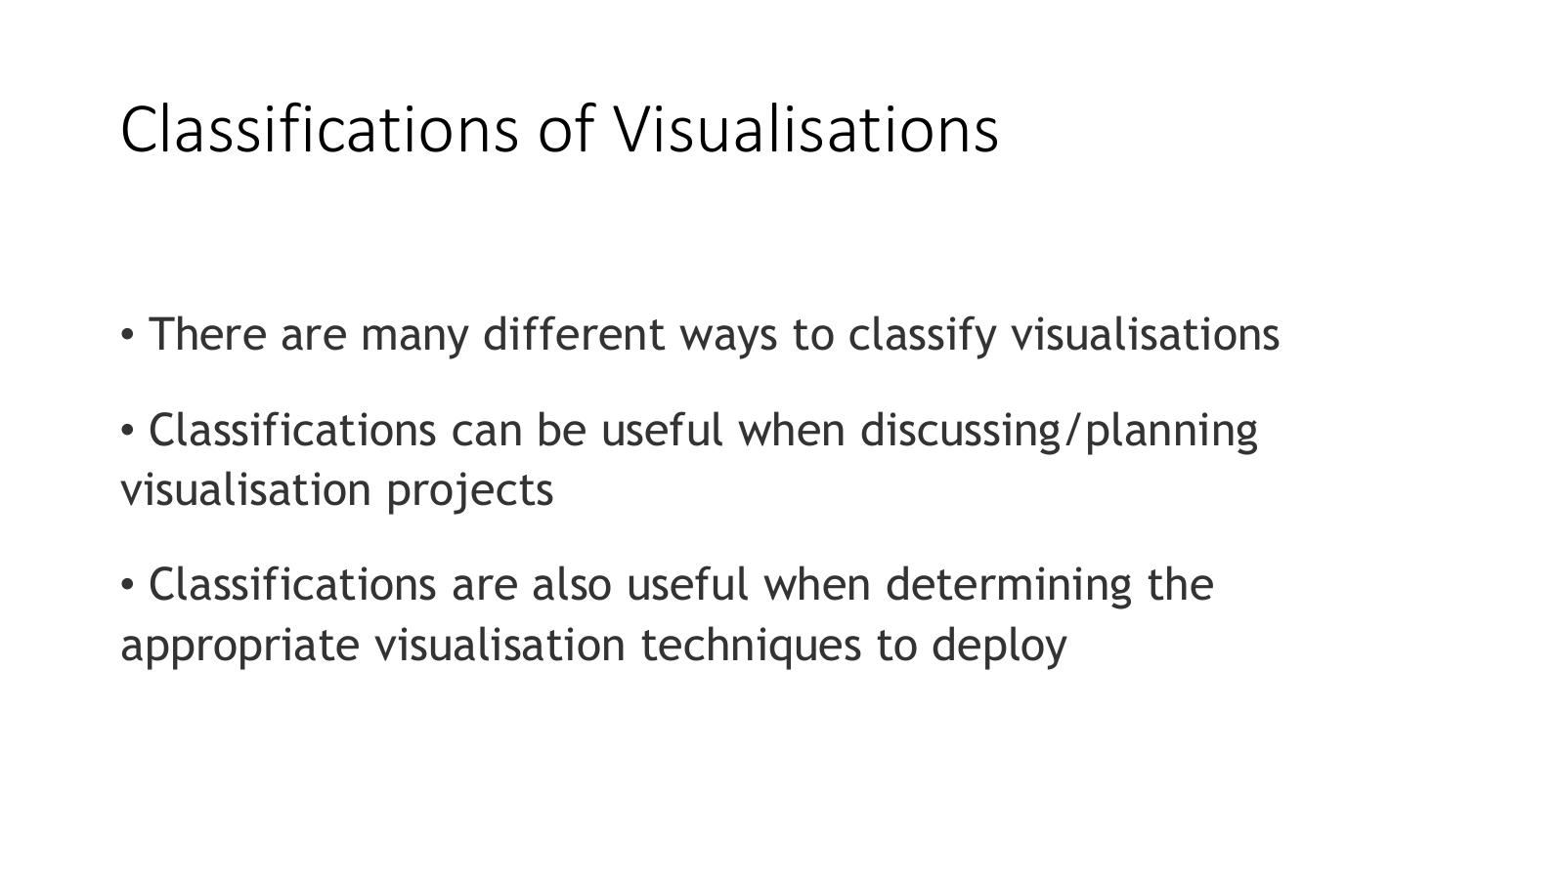
- Seen today many wasy to dispaky
- Planning
- What do I need to show
- What visualise techniques do I show?

Further Reading and Resources

Interesting Reading
- Open Mind Blog – 'USA Temperature: Can I Sucker You?'
- Discusses how chart design choices can make temperature data appear more or less alarming
- Link: https://tamino.wordpress.com/2018/08/08/usa-temperature-can-i-sucker-you/
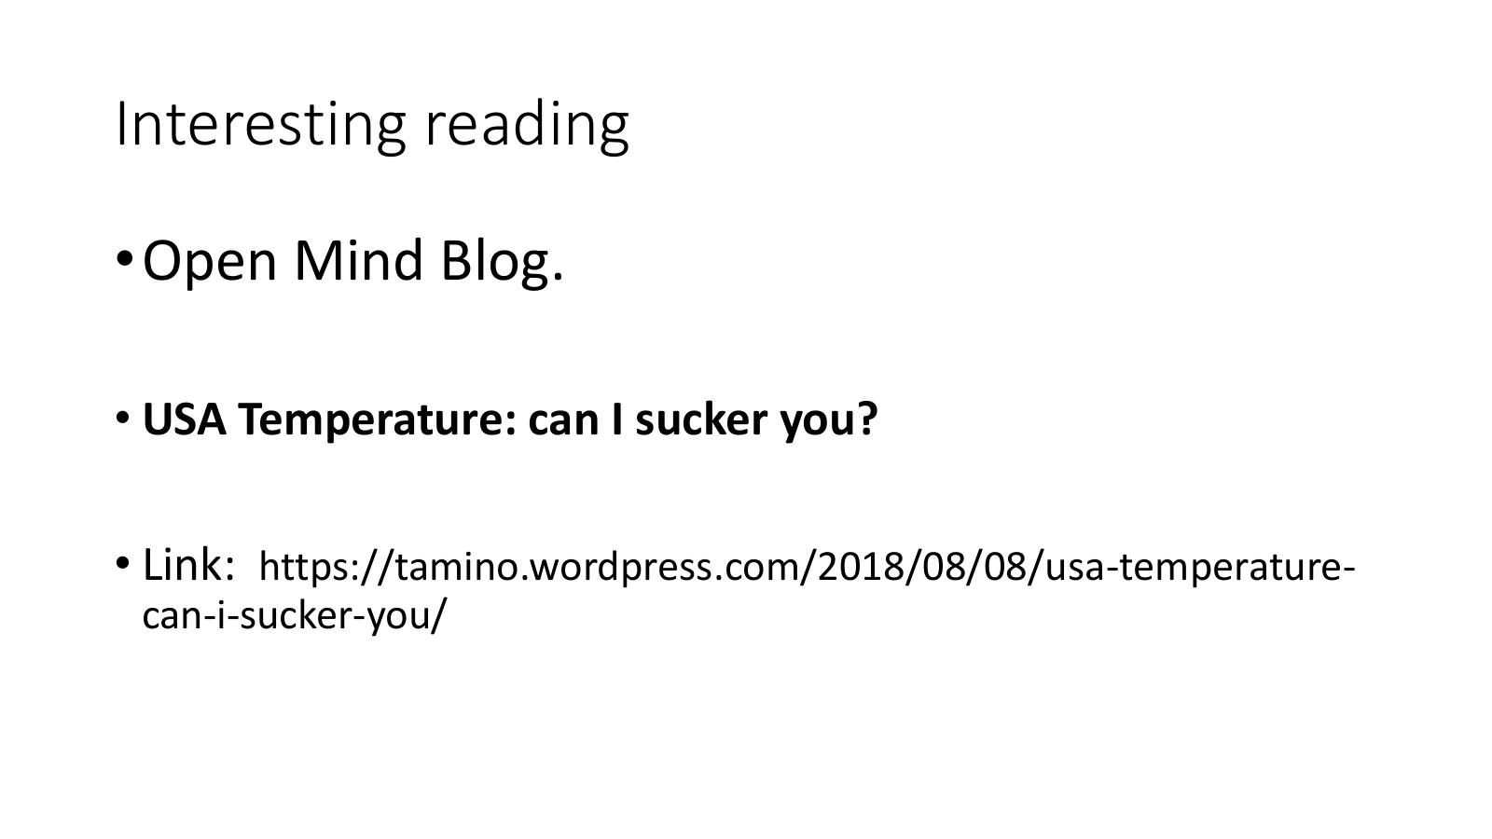
- Read article on ethical discussion – Can I sucker You?
- Tony Heller… Steve Goddard >>> showing temps in USA are declining… using only high temperatures, using only summertime temperatures, using only data since 1918, based on a simple average without taking into account new stations coming online or old stations retiring or area-weighting or any of that “expert” stuff
- You can create an representation for anything you want to fool people or support any argument you want…

Video – Weather Visualisation
- Weather visualisation video
- Link: https://youtu.be/qO1vSbB100?t=46


- A weather report very bad storm
- Star with a mapp red areas water could eb above 9 fet / roange + blue… would be dangerous…

- Somethigm that was showing clealy where the danger was
- Moves to somethgin more persuasive….!showing dramatically what is the risk.. its not just a number… video of presenter with water surrounding and above him… i..e evacuate the areas.. not just a number
- Very dramatic…
- So you should be Always thnking of audience + purpose + what do you want the viewers to understand and perceive from the visualisation….!

Thanks To
- Cathy Ennis, John McAuley, Colman McMahon and Brian Mac Namee for an earlier version of these lecture notes


Short Glossary of Terms

Glossary – Reader, Infographic
- Reader: The consumer of a visualization, often someone other than the designer
- The reader has information needs that are meant to be satisfied by the visualisation
- Infographic: Visualisations that are manually generated around specific data, tend to be data-shallow, and are often aesthetically rich
- Reference: 'Designing Data Visualizations', N. Iliinsky & J. Steele, O'Reilly Media, 2011
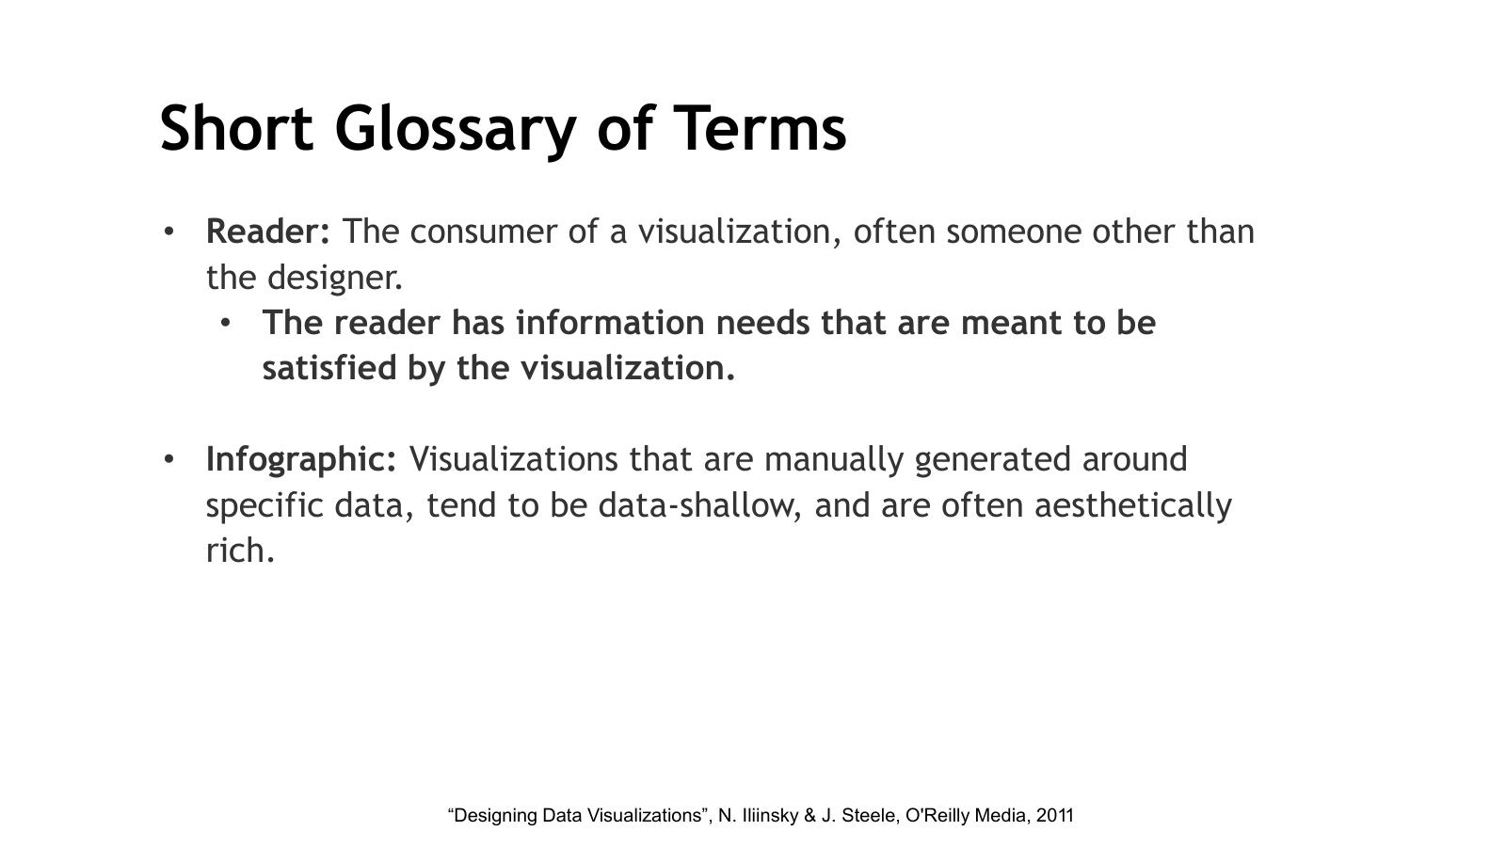

Glossary – Data Dimension, Variability
- Data Dimension: One single channel of data (e.g. a stock graph may comprise dates and prices – each is a unique dimension)
- Variability of a data dimension: The values that are present or allowed in a single data dimension
  - Integers vary discretely
  - Position can vary continuously
  - Categories are finite and discrete, though may be hierarchical
  - Numbers are infinite
- Reference: 'Designing Data Visualizations', N. Iliinsky & J. Steele, O'Reilly Media, 2011
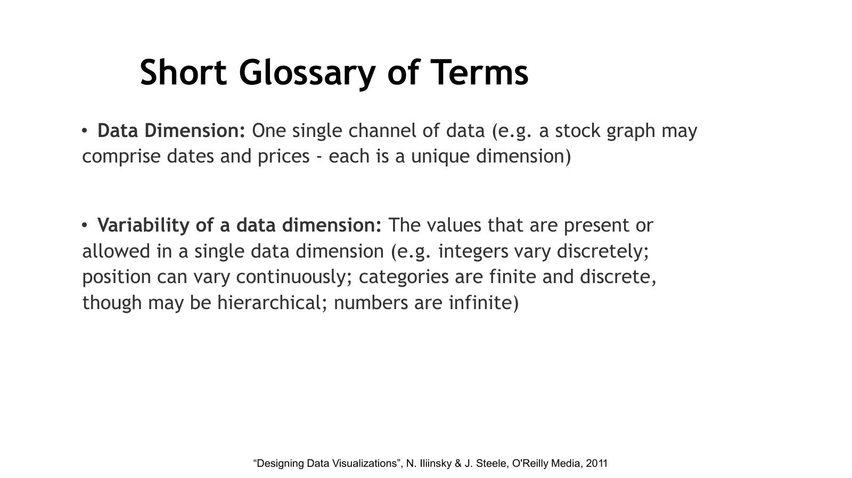

Glossary – Visual Property, Encoding
- Visual Property: A characteristic that you can see (e.g. colour, size, location, thickness, and line weight)
- Encoding: The visual property applied to a dimension of data that encodes the information into a visual medium for decoding by the reader
- Reference: 'Designing Data Visualizations', N. Iliinsky & J. Steele, O'Reilly Media, 2011
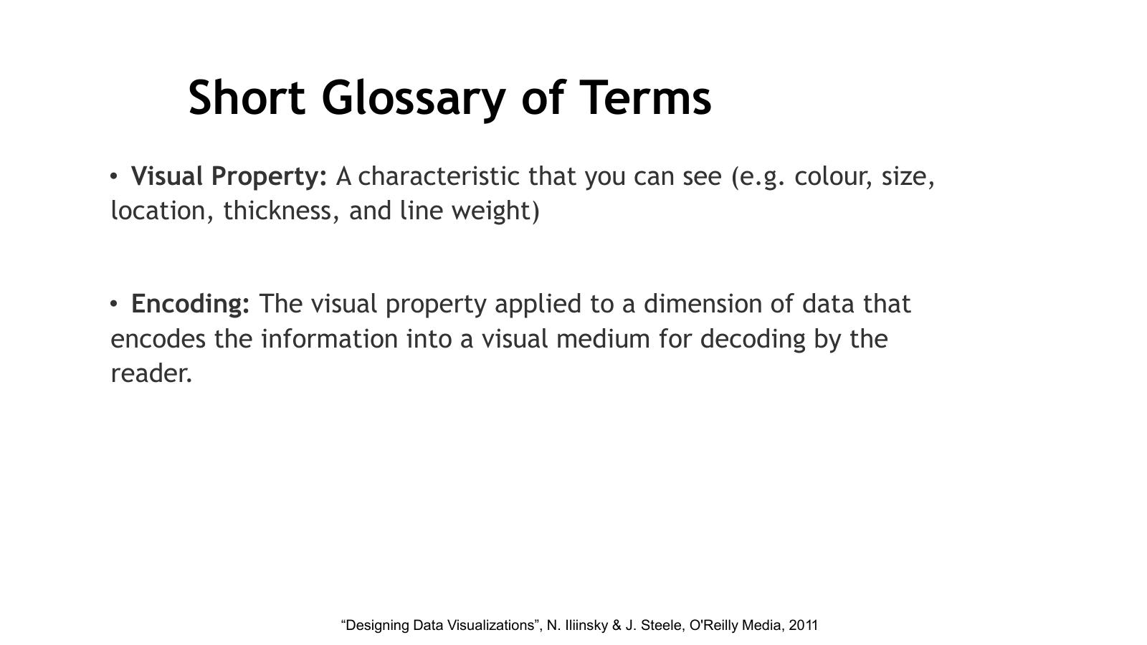

References
- Iliinsky N. & Steele J. (2011) – 'Designing Data Visualizations', O'Reilly Media – http://shop.oreilly.com/product/0636920022060.do
- Healey C. & Enns J. (2012) – 'Attention and Visual Memory in Visualization and Computer Graphics', IEEE Transactions on Visualization and Computer Graphics, vol 18(7), pp 1170–1188 – www.csc.ncsu.edu/faculty/healey/download/tvcg.11.pdf
- Bateman S. et al. (2010) – 'Useful Junk? The Effects of Visual Embellishment on Comprehension and Memorability of Charts', Proceedings of SIGCHI conference on human factors in computing systems
- Graham M., Hale S. & Stephens M. (2011) – 'Geographies of the World's Knowledge'
- Joey Cherdarchuk (2013) – 'Data looks better naked'
- Game of Thrones Season 6 Recap chart – https://public.tableau.com/en-us/s/gallery/game-thrones-season-6-review?gallery=featured
- White House Tweet discussion / misleading plot – https://observablehq.com/@mbostock/a-misleading-plot
- Burning Man map – Flint Hahn (2010)
- Nuclear warheads infographic – https://www.psriowa.org/nuclear.html
- The Billion Dollar Gram – https://www.informationisbeautiful.net/visualizations/the-billion-dollar-gram/
- Poverty and obesity maps – http://asserttrue.blogspot.ie/2013/02/poverty-and-obesity-in-america-how-they.html
- Gamestop share price – Source: Google search
- Florence Nightingale rose diagram – http://thisisstatistics.org/florence-nightingale-the-lady-with-the-data/
- Flight Patterns – Aaron Koblin – https://www.artic.edu/artworks/213139/flight-patterns
- Facebook Visualised – http://edition.cnn.com/2010/TECH/social.media/12/14/facebook.relationships.mashable/index.html
- NY Times 'hope' and 'crisis' – Jer Thorp – https://nicolatriscott.org/2012/09/23/art-in-the-age-of-big-data/
- Scatterplot matrix example – http://junkcharts.typepad.com/junk_charts/2010/06/the-scatterplot-matrix-a-great-tool.html
- Interesting reading: Open Mind Blog – USA Temperature: can I sucker you? – https://tamino.wordpress.com/2018/08/08/usa-temperature-can-i-sucker-you/
- Video: Weather visualisation – https://youtu.be/qO1vSbB100?t=46
- Thanks to: Cathy Ennis, John McAuley, Colman McMahon and Brian Mac Namee for an earlier version of these lecture notes

Week 2 - Lab - Lab 1 – Tableau: Getting Started

Main Screen
- The Tableau Public main screen shows the Data and Analytics panes on the left
- The central canvas area contains Columns, Rows, Filters and Marks shelves
- The 'Show Me' panel on the right suggests chart types based on your selected data
- At the bottom: Data Source tab and Sheet tabs for navigation
- Dimensions (categorical/discrete) appear in the upper part of the Data pane
- Measures (continuous/numeric) appear in the lower part of the Data pane

- For tosdays lab just getting started with tabluea
- Wills ee have lab vrienf
- Doain interface
- How to get yoru data
- We’ll be using global superstrie dataset
- Put it on brighspace
- We’ll just use a saple
- Ahe a lok at majeor dats filter – data structures
- Always lokavt data befoeyuo stary to have an idea of whats in it

- Then wr go to development campus sheet 1 – that’s what we create our first visualisatio /graph
- All oru data / all out featurss identified in your columnhehre by your data
- ‘split intol two separate sections
- Have colours / can be measures or can be data points in here
- So have you categorical data amnd measurements..

- You’re goin to take them form here and put them into canva rows and columsn with defaults you wllc usomtise
- Order / changes / different tools / marks / different element

- Adding labels tp top and bottom
- Change colour…. Of bars in this case…
- Have no only top and bottom but label for al fo them,,,
- Can also add reference values ot the charts..
- Go to the analytics chart can add average value / particular point you want to highlight…..whats abo eve==below that value
- Statictical emasurements

- Can filyer the data--- again drag the measure you want to sue for filtering and ID what
- Vaeus above/below
- Select specific regios you ant to display…
- Whatever you want to filter…
- Have video takig through all of these steps…

- Specific groups… / bars
- Eventually 4 Questions to answer….
  - How does profit perform per country >> sue a ma-
  - How does quantity compare to profit
  - How does quantity compare to quantity
  - 4) show sales per year and quarter

- Wit time series can drill in - quarters a /days / months/…..

- Tabluea has open source version - called tabluea public… can sue online or use your own version…

- Can avail of student licence…. Lasts a year…
- When submitting today… plat around as much as possible…
- Customise as much as possible…
- When save your files for submission.. make sure saving as a tableau public file and ntot ust tabluea professional file…

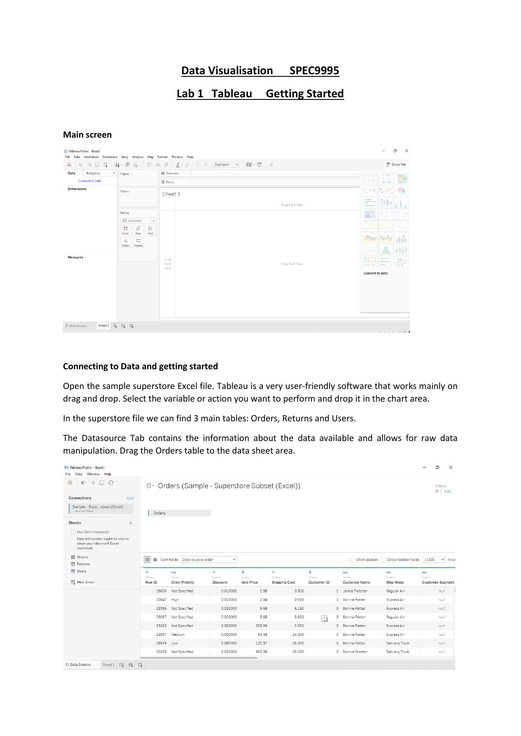

Connecting to Data and Getting Started
- Open the sample superstore Excel file
- Tableau is a very user-friendly software that works mainly on drag and drop
- Select the variable or action you want to perform and drop it in the chart area
- In the superstore file we can find 3 main tables: Orders, Returns and Users
- The Datasource Tab contains information about the data available and allows for raw data manipulation
- Drag the Orders table to the data sheet area
- You can look at the Metadata for field names and data structure – you can edit datatypes, names etc.
- Metadata fields available: Row ID, Order Priority, Discount, Unit Price, Shipping Cost, Customer ID, Customer Name, Ship Mode, Customer Segment, Product Category
- To go to the development canvas in Tableau, click on Sheet1 at the bottom of the page
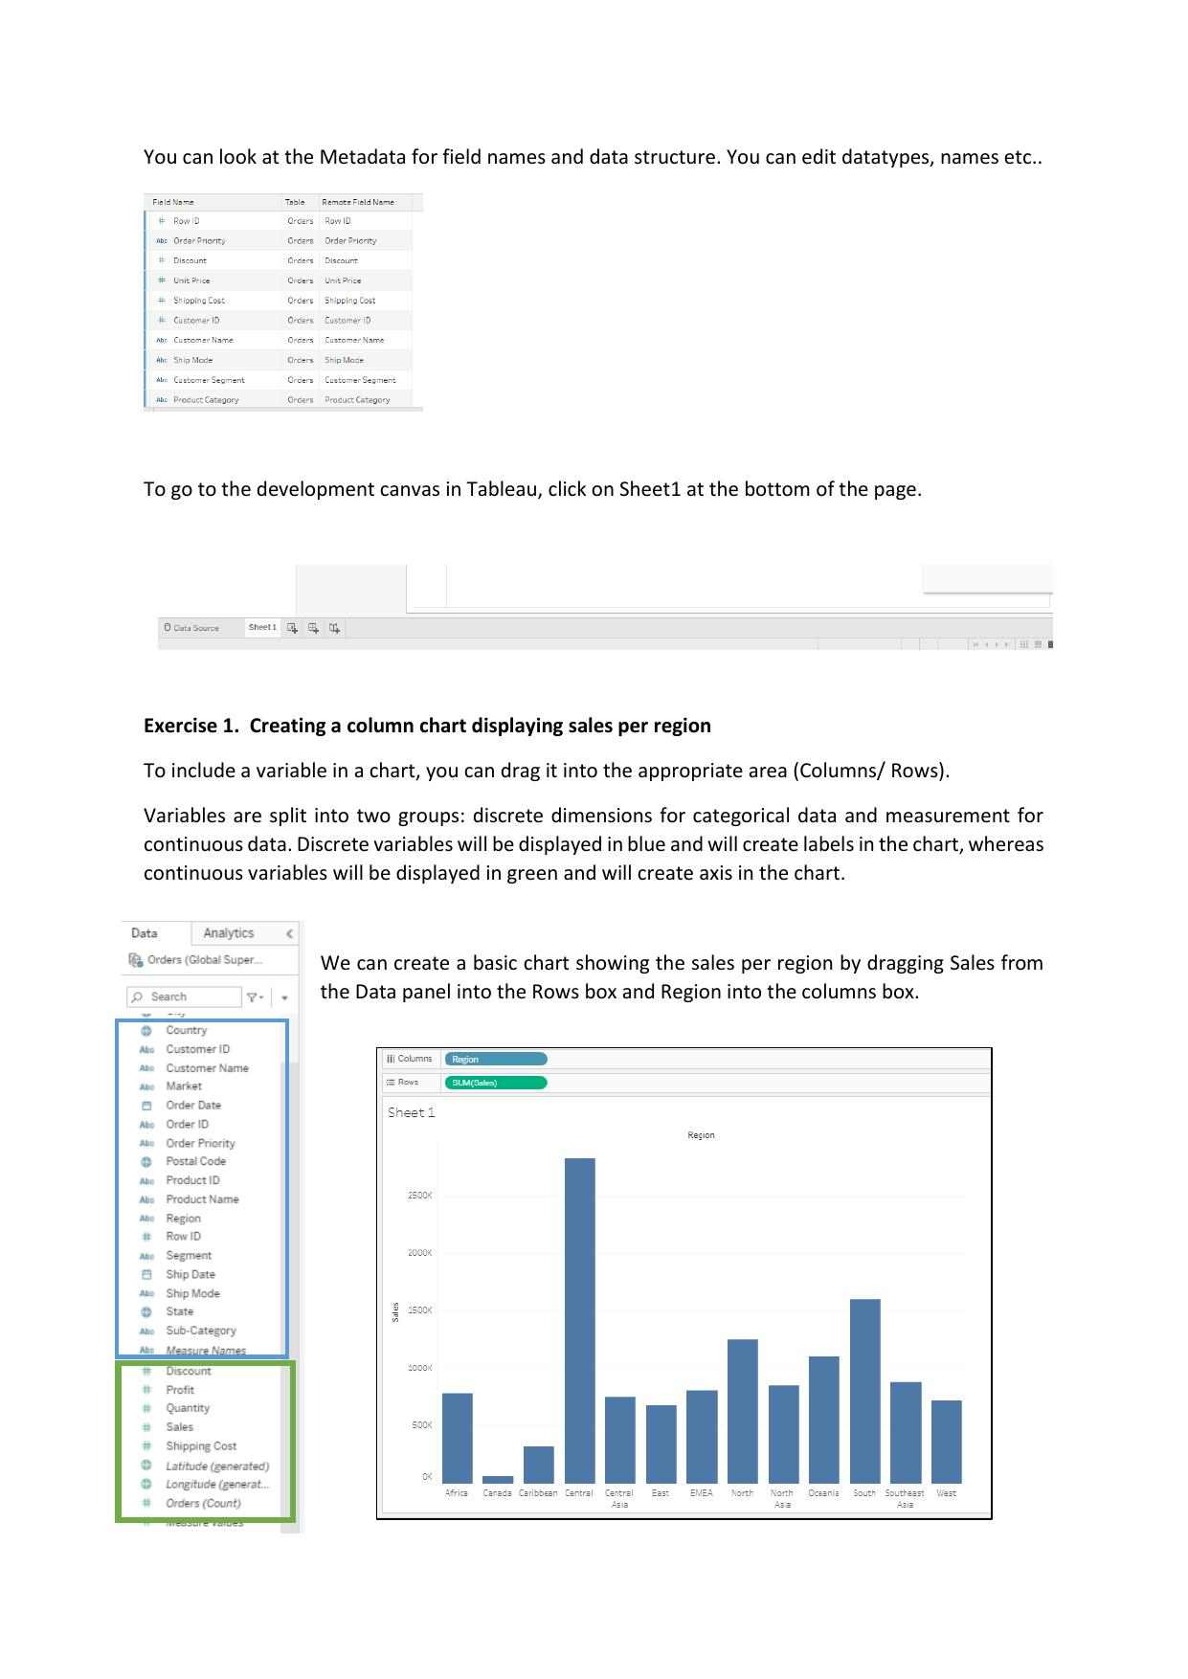

Exercise 1 – Creating a Column Chart Displaying Sales per Region
- To include a variable in a chart, drag it into the appropriate area (Columns / Rows)
- Variables are split into two groups:
  - Discrete dimensions – for categorical data; displayed in blue; create labels in the chart
  - Continuous measurements – for continuous data; displayed in green; create an axis in the chart
- Create a basic chart showing sales per region by:
  - Dragging Sales from the Data panel into the Rows box
  - Dragging Region into the Columns box
- The resulting chart shows SUM(Sales) on the Y-axis and Region on the X-axis
- Available dimensions in the Data pane include: Country, Customer ID, Customer Name, Market, Order Date, Order ID, Order Priority, Postal Code, Product ID, Product Name, Region, Row ID, Segment, Ship Date, Ship Mode, State, Sub-Category
- Available measures include: Discount, Profit, Quantity, Sales, Shipping Cost, Latitude (generated), Longitude (generated), Orders (Count)

Customising the Chart
- Order columns from highest to lowest using the sort button on the toolbar (button 1)
- Swap rows and columns using button 2 on the toolbar
- Sort in ascending order using button 3 on the toolbar
- Colours and titles can also be customised:
  - Use the Color menu within the Marks panel to change the colour of the bars
  - A variable can also be dragged into the Color menu to customise colours based on that variable
  - For example: arrange a different colour per region, or highlight a particular value of interest
- The Marks panel contains: Color, Size, Label, Detail, Tooltip controls
- Adding mark labels to each data point or to specific ones can be done using the Label menu within the Marks panel
- Two labelling examples shown: (1) only the highest and lowest values labelled, (2) all values labelled with exact figures
- Example label values visible: Central 2,822,303 | South 1,600,907 | North 1,248,166 | Oceania 1,100,185 | Southeast Asia 884,423 | North Asia 848,310 | EMEA 806,161 | Africa 783,773 | Central Asia 752,827 | West 725,458 | East 678,781 | Caribbean 324,281 | Canada 66,928
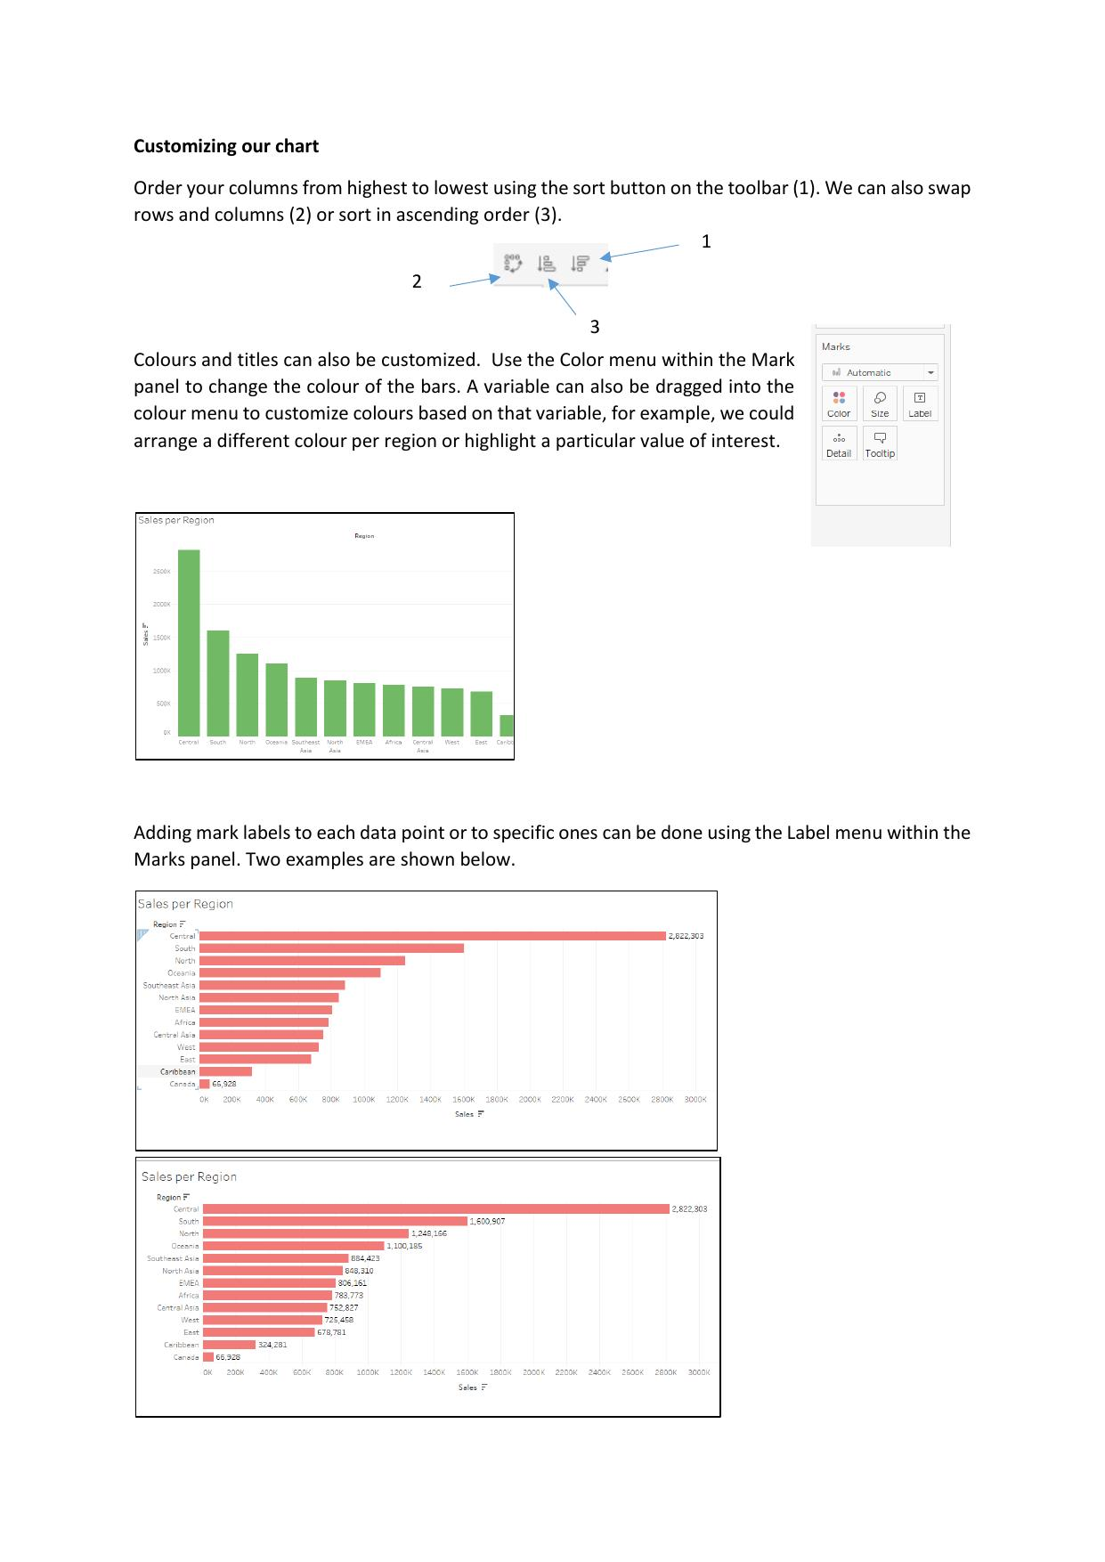

Exercise 2 – Adding Reference Values to the Chart
- From the Analytics tab, we can add different summarization, modelling or custom reference values to our chart
- The Analytics tab provides the following options:
  - Summarize: Constant Line, Average Line, Median with Quartiles, Box Plot, Totals
  - Model: Average with 95% CI, Median with 95% CI, Trend Line, Forecast, Cluster
  - Custom: Reference Line, Reference Band, Distribution Band, Box Plot
- Task: Add a constant value line at 1 million as a reference line
- HINT: Drag and drop the Constant Line feature into the canvas and set the value to 1,000,000
- Similarly, average values and other statistical measures can be added
- Example result shown: Sales per Region bar chart with a vertical reference line at 1,000,000 – Canada (66,928) is the only region below the line
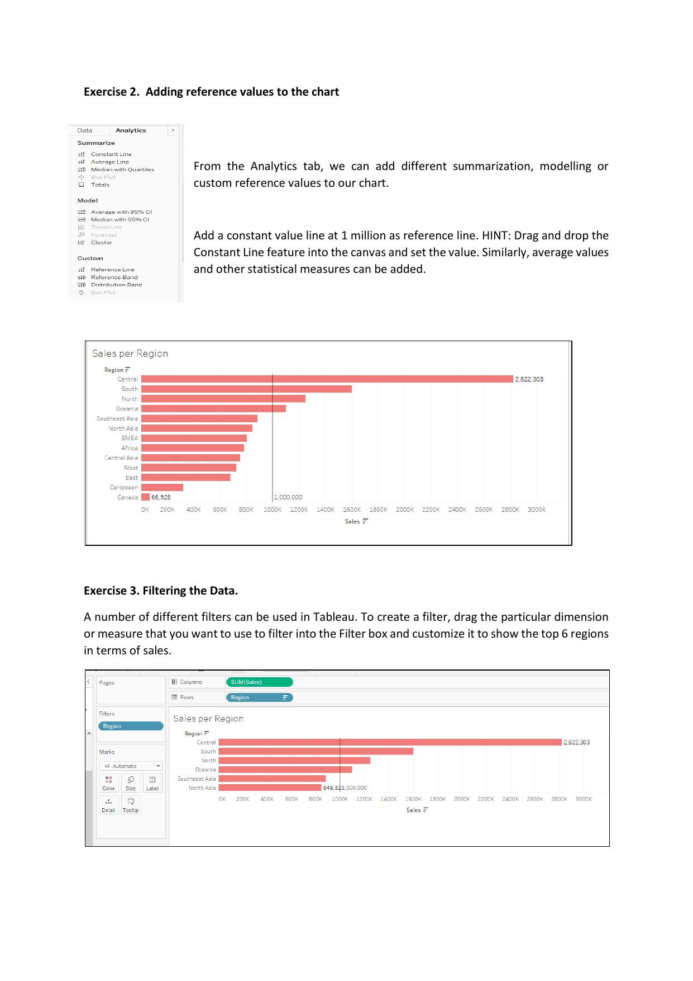

Exercise 3 – Filtering the Data
- A number of different filters can be used in Tableau
- To create a filter: drag the particular dimension or measure you want to filter by into the Filter box
- Customise the filter to show the top 6 regions in terms of sales
- The Filter shelf appears above the Marks panel on the left side of the canvas
- When Region is dragged to the Filter box, a filter card for Region appears
- The filtered chart shows only the top 6 regions: Central, South, North, Oceania, Southeast Asia, North Asia
- Marks panel controls remain available: Color, Size, Label, Detail, Tooltip

Exercise 4 – Let's Answer Some Questions
- A – How does Profit perform per country? Use a map to show the worldwide distribution of profit
Drag in values into rows and then drag in country over Marks > colour tab
- B – How does Quantity compare to Profit?

To compare two items >> do a scatter plot and drag other values over the “Marks” pane to colour, label etc
Result theb more qunity sold the higer the profit btu not always as some countries sell more than others but lose money i.e. Turkey and Nigeria… US is an outlier as shift most product and makes most money.
- C – How does Quantity perform per product category?

“Perform per category" just means a bar chart of total Quantity for each Category.

Office Supplies leads on units sold, but units don't translate proportionally into profit; Technology earns more per unit.

- D – Show the sales per year and quarter
- Save your Tableau file to Tableau Public


References
- Sinha, C. (2017) Tableau 10 for beginners. Ohio Computer Academy.

Week 3 – Encodings 1

Visualisation
- Lecture 3
- Encodings 1
- Dr. Marisa Llorens

- Moving on to 3rd lecture – moving on to encodings….
- They are such an important fundamental components how we create visualisation

- Need to understand limitations and best practice for them…

- https://www.nytimes.com/interactive/2022/03/09/upshot/where-americans-have-noticed-inflation.html
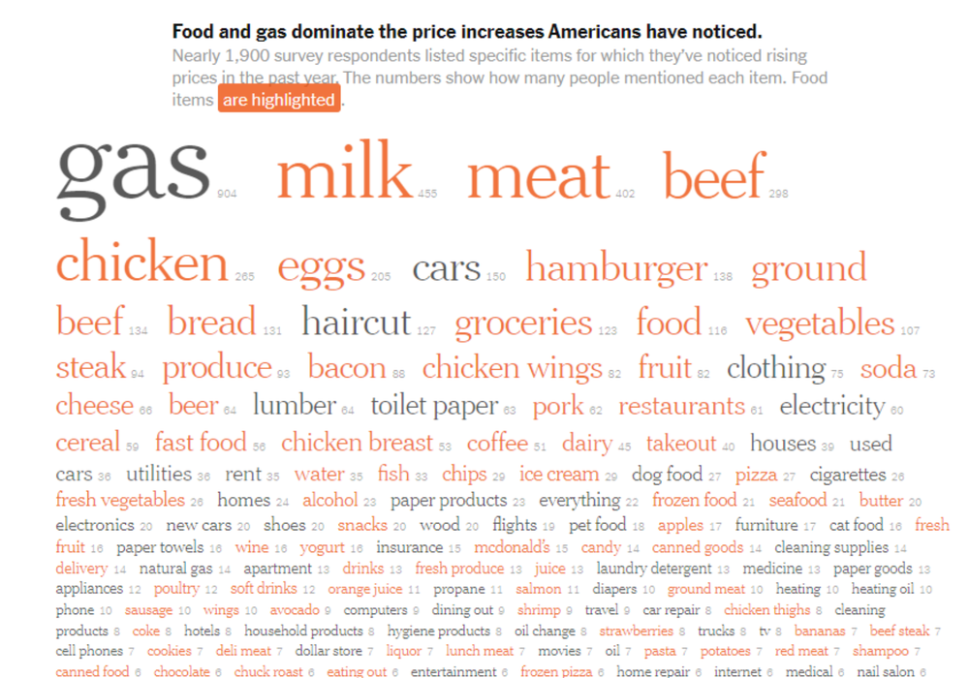

- From 2022 – I like it because its different …
- Form nytimes food and gas prices increases.. cost of living…
- Survey and asked people what they noticed gogn up in proce thw last year
- When food related they use Orange…
- Everythgin else all together in one category … grey colour
- Used size of font tp encode the differences… as in a word cloud.. more frequent words have bigger font
- Pint not to co pare values.. to get the idea that food items the most common.. apart from gas/petrol.. next 5 items where food… etc
- What participants have notice… ie.. we asked and this is what they said…
- Two colour category good use of colour….
  - i.e. something want t highlight have that as its own colour, everything else the same colour…
- Things not great…
  - maybe numbers too difficult to read?

Visualization of the Week
- https://public.tableau.com/profile/matt.chambers#!/vizhome/SportsCity/SportsCity
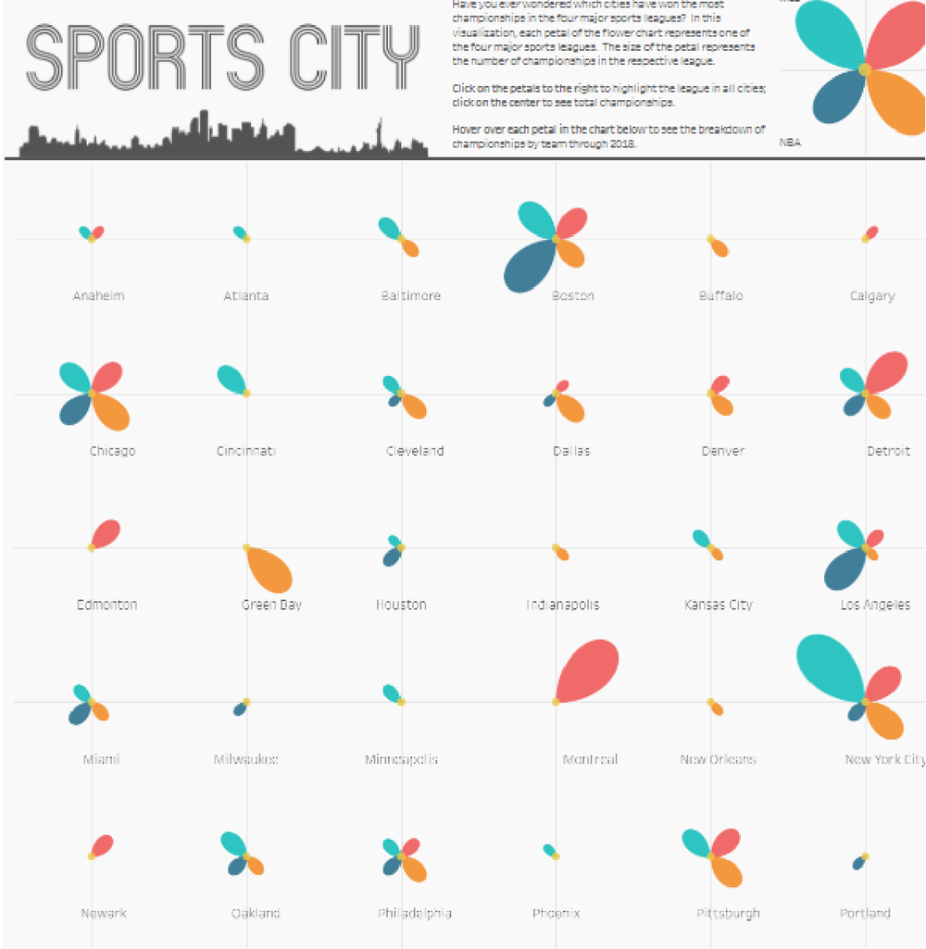

- 2nd use case
- Petal visualisation
- Can geta lot fo info ina very small space…
- Each petal represents a sport
- NFL/basketball/football/baseball….
- Flower are cities… and sorted by alphabetical…
- May couldk have done clustered pre regio…
Biggest sport in Boston is basketball…
Green bay… 1 big sport >> NFL

Visualization of the Week
- https://public.tableau.com/profile/matt.chambers#!/vizhome/SportsCity/SportsCity
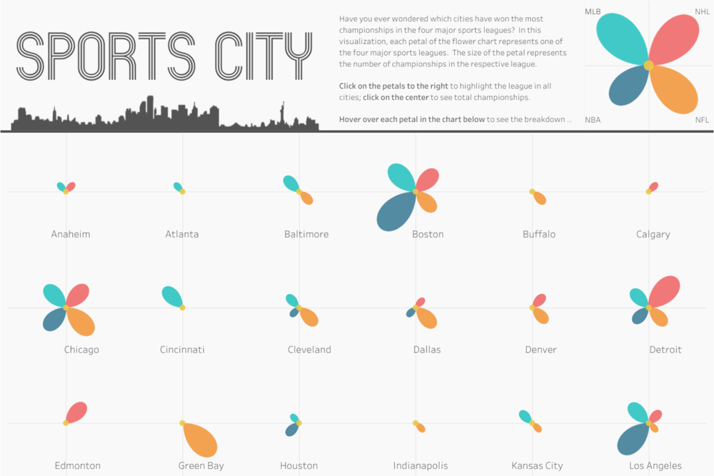
- https://www.reddit.com/r/dataisbeautiful/comments/azjti7/leonardo_dicaprio_refuses_to_date_a_woman_over_25/
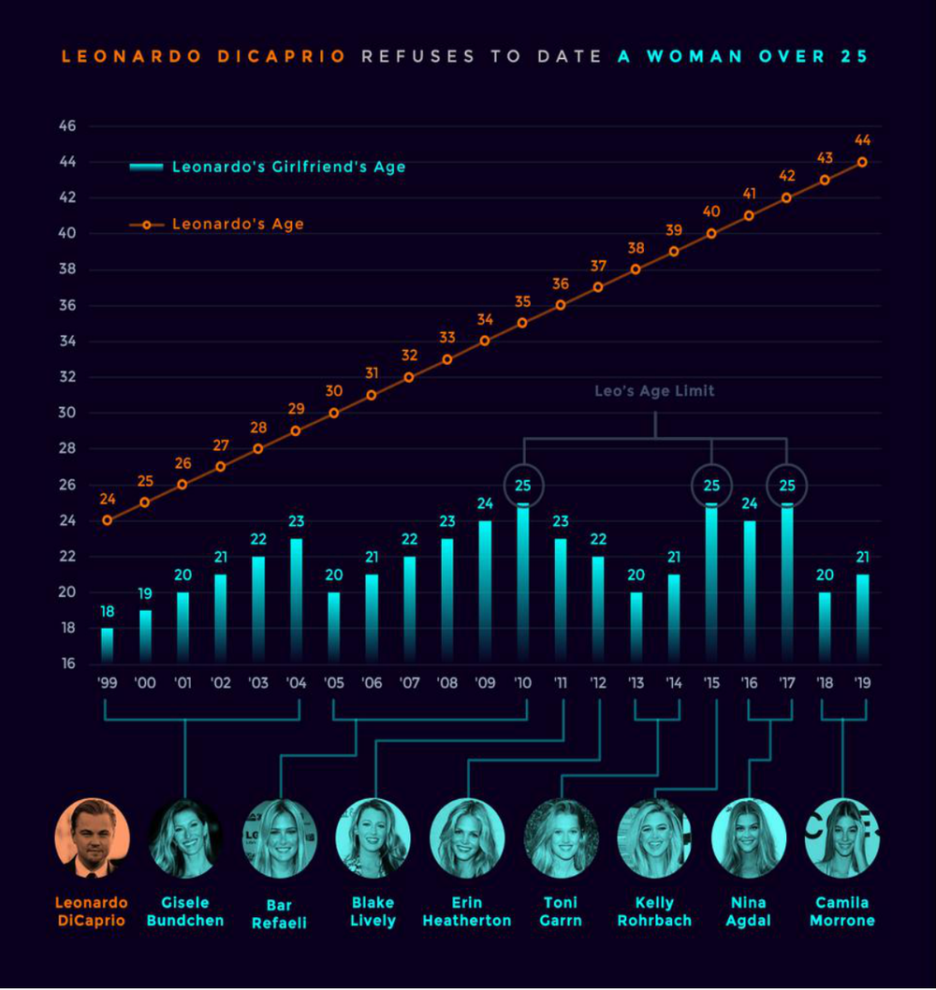
- Mapped ages of alleged girlfriends that he has had
- Same personl goin up linearly at a time…
- Changed girlfriend then theres another one
- Highlighting theres a top of 25 years….
- Not up to personal afrairs but up to this point allegd girlfriends has never been over 25 years
- Different thigns
- His age
- Girlfriends
- Lines and groupings…
- Photos.. more appealing
- Colour coding on photos and on anmes and bars and legend and title…
- His name is colour coded…
- So continuity…. Know who they are talking abuot…
- Created using xcel…. Do not about tool its about knowing how to use it…
- GOOD use of colour…
- Notice running theme of colour through different element
  - i.e. title!
  - And different parts of graph…. Very clear….
  - Circling the age limit they are identifying… i.e. 25…

Agenda
- Data visualisations fundamentally map data dimensions to visual encodings
- In today’s lecture we will look at:
  - The different encodings available and how we can appropriately use them

- We are going to be ookign at how we map data dimensions into visuali encodings
- What encoding e have available
- Hwo to use them
- Nextr weekkk lok at some if them in particular…
- One fo the most important points to understand…. Your encodings…

DIMENSIONS & ENCODINGS

Data Types Classification
- Categorical(qualitative): no inherent order:
  - city names, types of diseases, ... what ever is in classification
  - typical one a bar chart… reorder them to show increase or decrease if have categorical values…
  - i.e. Mon / Tues/Wed… and bars not ascending/descending… as scale has inherent order… i.e. Mon => next bar must be Tues regardless of value…
- Ordinal(qualitative): ordered, but not at measurable intervals
  - first, second, third, …
  - cold, warm, hot
  - Mon, Tue, Wed, Thu …
  - Quarters/days of week… ordinal… medals/ could eb numbers but not qualitative…
- Quantitative: Integers or Reals
  - 1, 2, 7
  - 3.4, 78.6, -12.4

Data Representation
- Data representation is the act of giving visual form to your data.
- Viewers decode the various shapes, sizes, positions and colours to form an understanding of the values presented.
- Visualisers do the reverse through visual encodings, assigning visual properties to values.
- Giving a visual form of that data.
- Viewers decode to understand what the date means
- We need to think aoutb data we have and assign physcaol properties ot those values

Data Representation
- Visual encoding of data involves:
  - Marks
  - Attributes
- The objective of visual encoding is to find the right blend of marks and attributes that most effectively will portray the angle of analysis you wish to show your viewers.
- Marks = visual features (could eb aggregated values)
- Attribs = variatison available to the marks… size/colour etc
- Whatr we do is check which are the marks and attributes which are available and which are most appropriate to the data and appropriate to the message
- What we’re trying to highlight may decide what we use…

Marks
Point | No variation
Line | One linear spatial dimension
Area | Two spatial dimensions
Form | Three spatial dimensions

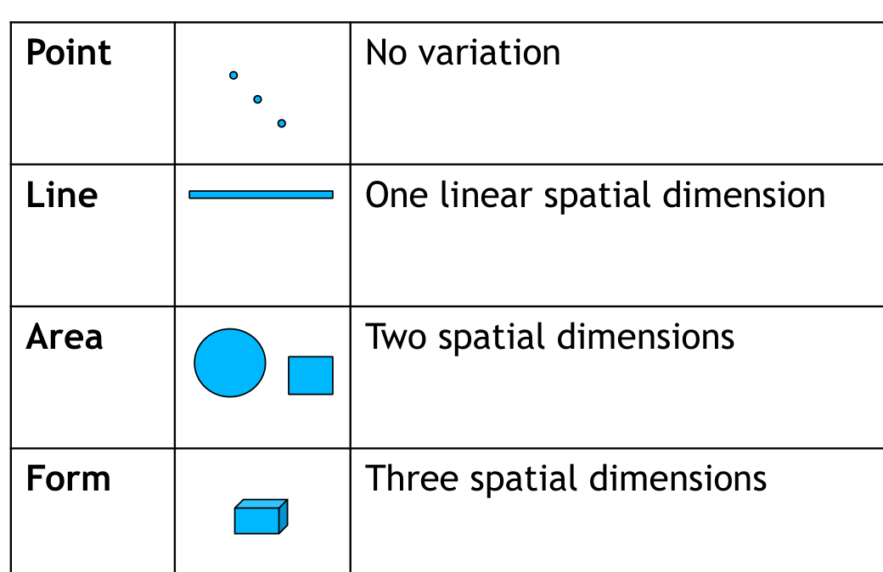

Attributes
Position
Size
Colour hue
Colour Saturation
Colour Lightness
Symbol/Shape
Pattern
Angle/Slope
….and others…
- Two dimensional can sue colour
- Combine colour with patterns helping visually impaired viewers…
- Rather then just colour
- Can use slope
- https://www.oreilly.com/library/view/designing-data-visualizations/9781449314774/ch04.html
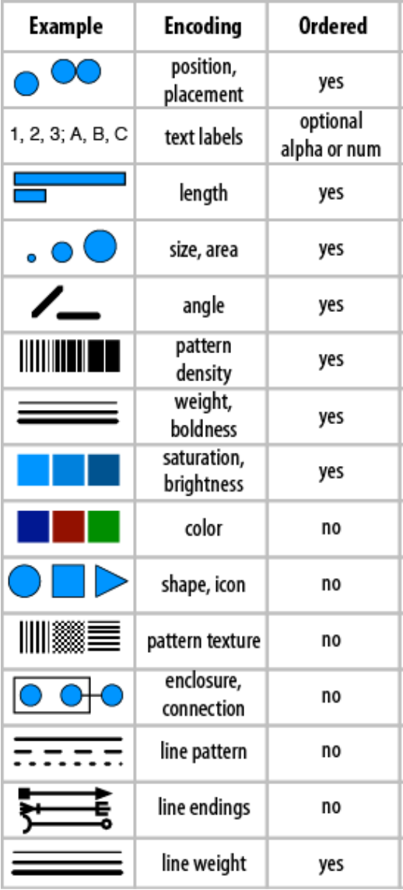
- Table from designing visualisation book..
- Hese are most common encoding books…
- Gives summary of whether they are ordered or not…
- If data is orders => Need to use an encoding that is ordered aswell
- If have bar and one is highers than one or other viewers will naturally unstamd which is larger…
Text>> text labels.. categorical or ordered… names of companies, products, a/b/c etc may be an order
Focus on brightness and saturation
Inhereht in encoding is colour… or can be… red and green…
Solid or dashed lines… no roder…

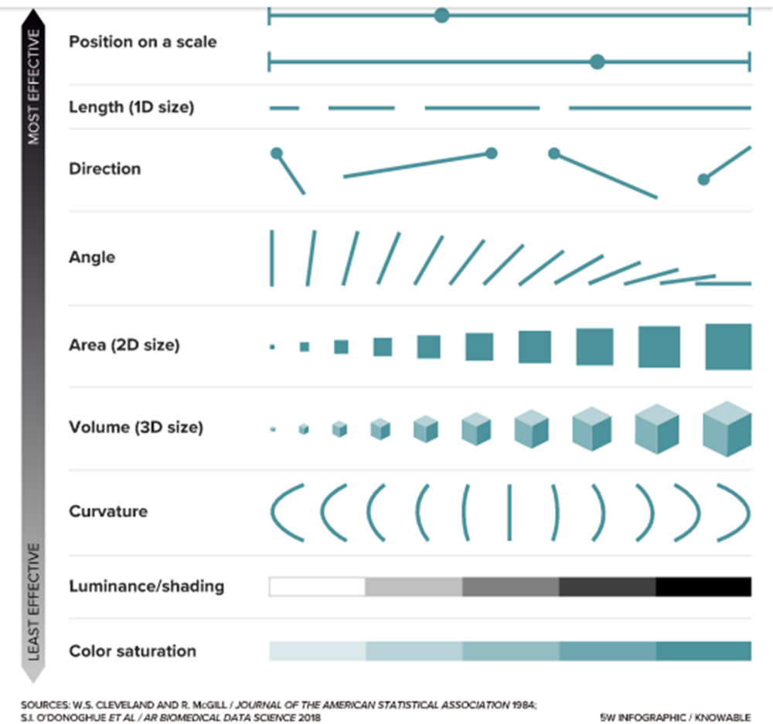
Most effective to least effective
Precision/length
- Harder to see difference in size between 3 D than in 2D
- Shadings… might get difficult if right besdoe each other…

Visual challenge
- https://knowablemagazine.org/article/mind/2019/science-data-visualization
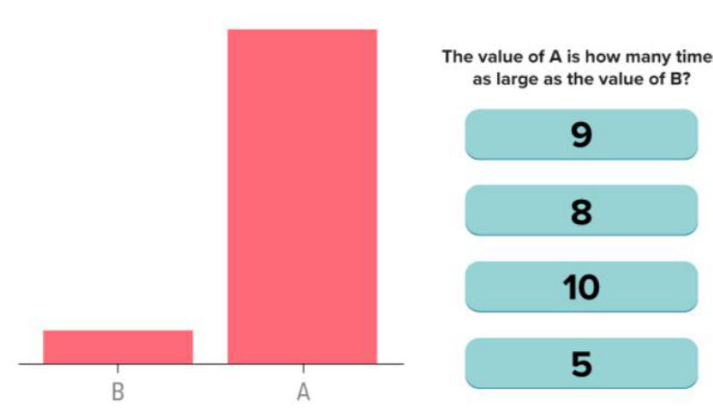
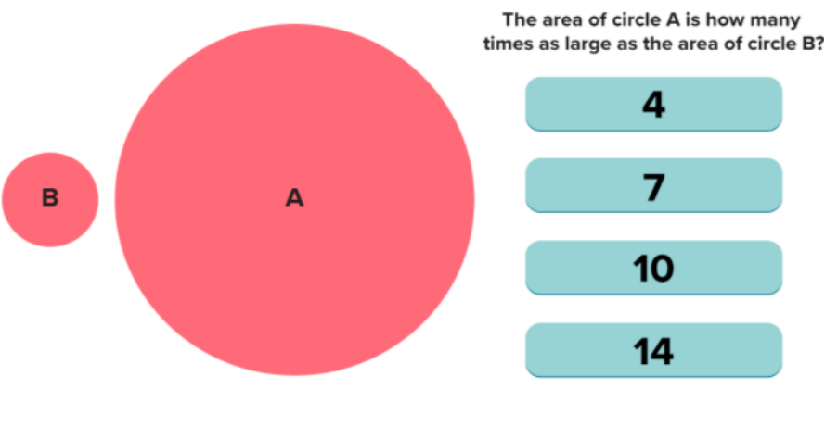
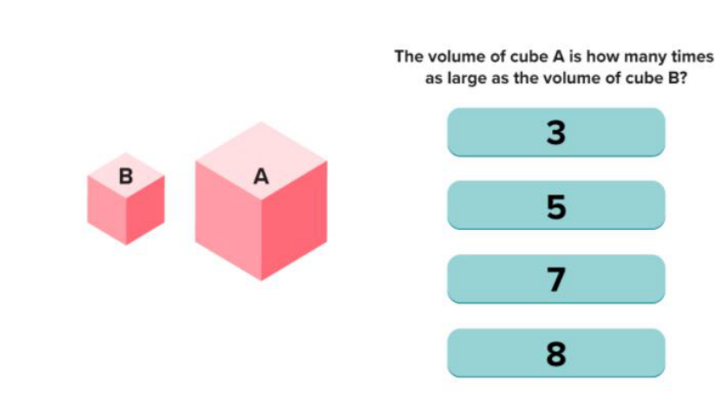
- Answers…
- 1st = 10
- 2nd = 14
- 3rd = 5
Increaseign dimensions = more difficutl for viewer to figure ti out…
1st = length
2nd = 2D = area
3rd = volume
For your viewers increasing dimensions for encoding gets more complicated…

Visual challenge
- https://knowablemagazine.org/article/mind/2019/science-data-visualization
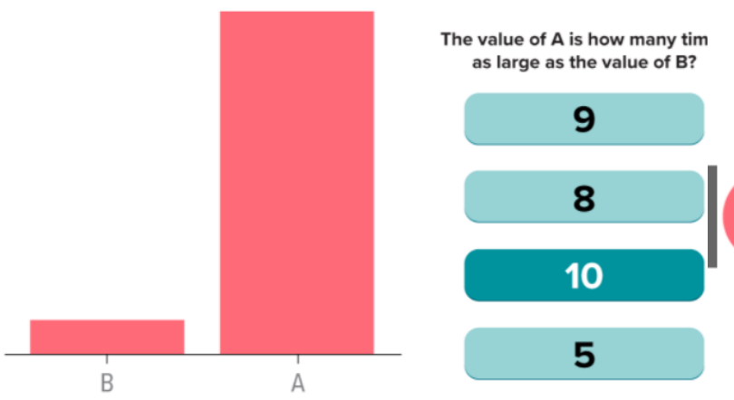
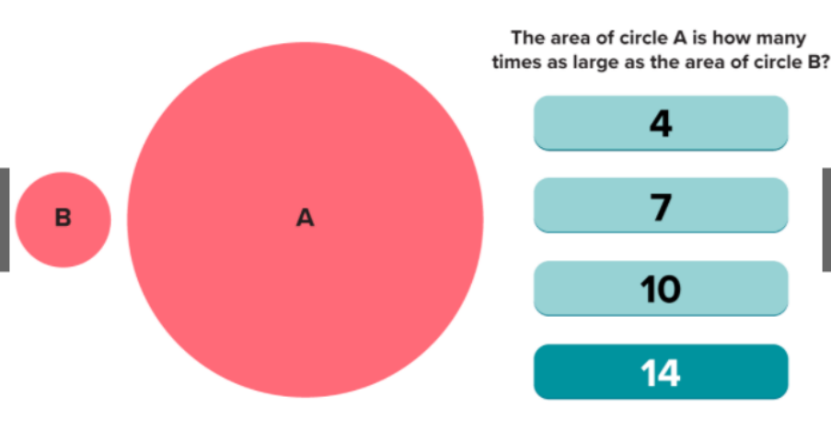
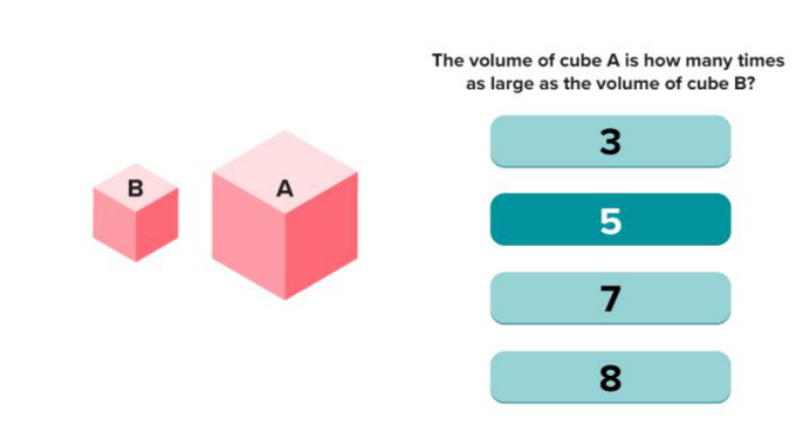

Interpretations of Visual Encodings
- Some properties have intrinsic meaning but some don’t:
  - Density (Greyscale)
    - Darker -> More
  - Size / Length / Area
    - Larger -> More
  - Position
    - Leftmost -> first, Topmost -> first
  - Hue
    - ??? no intrinsic meaning

    - Colour hue… nothing tells viewer other value is higher than the other…
    - Don’t use rainbow pallets to represent meaning in the colours…
    - Only good to differentiate categorical data…
    - Don’t use it for meaning order…
    - Use brighness or specific data high / low.. hot / cold… can use “ Divergent palette”
    - For categorical can sue special positioning…
      - animation and shape
      - for us>> shape and colour most important for categorical data!!
- https://www.annualreviews.org/doi/full/10.1146/annurev-biodatasci-080917-013424
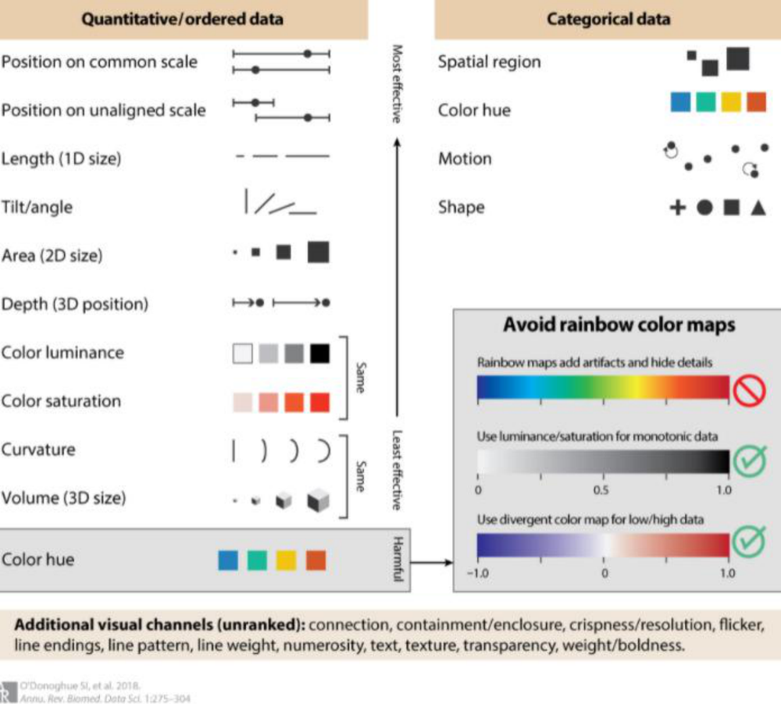
- https://www.oreilly.com/library/view/designing-data-visualizations/9781449314774/ch04.html
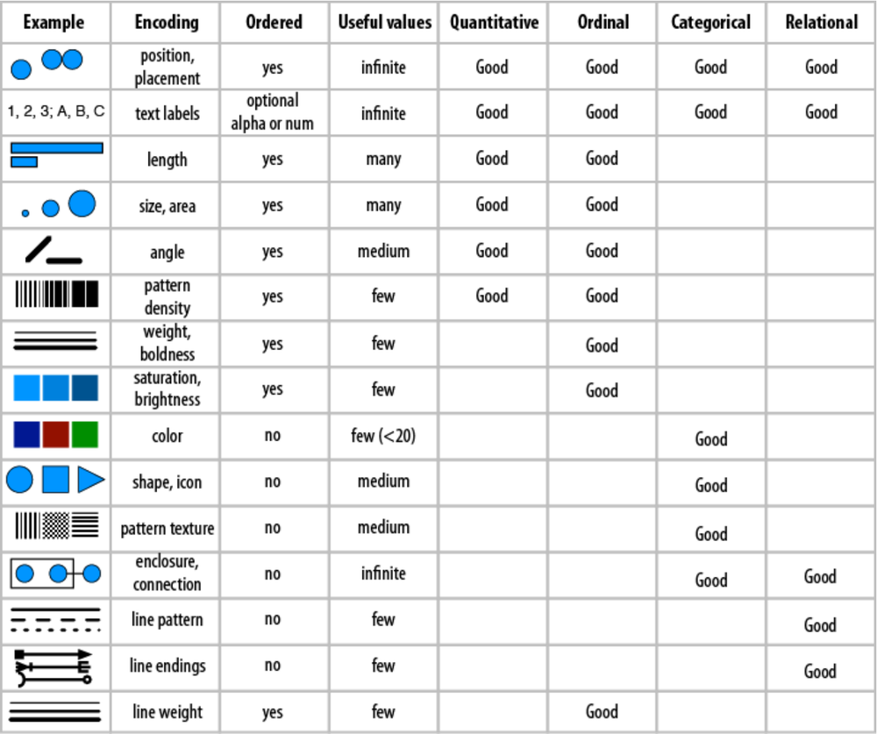
- How many available values do you have available for that value
- If large number => colour not good… need to be careful that choose
- If small numbers of alues > have more options..
- Table also includes summary for whci ones are good for which types of data…
- Advice on which to sue for which…
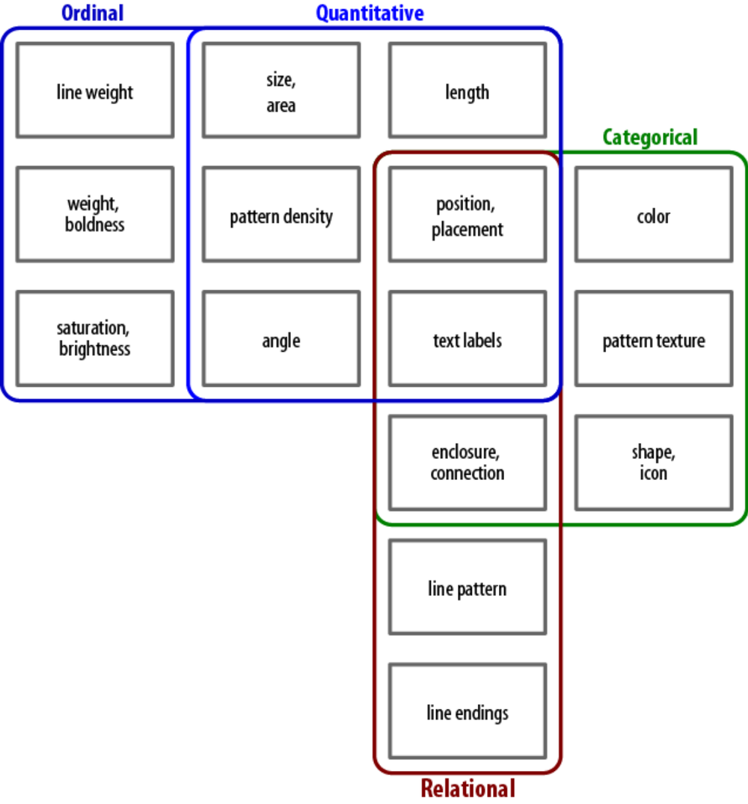

From Data to Viz
- https://www.data-to-viz.com
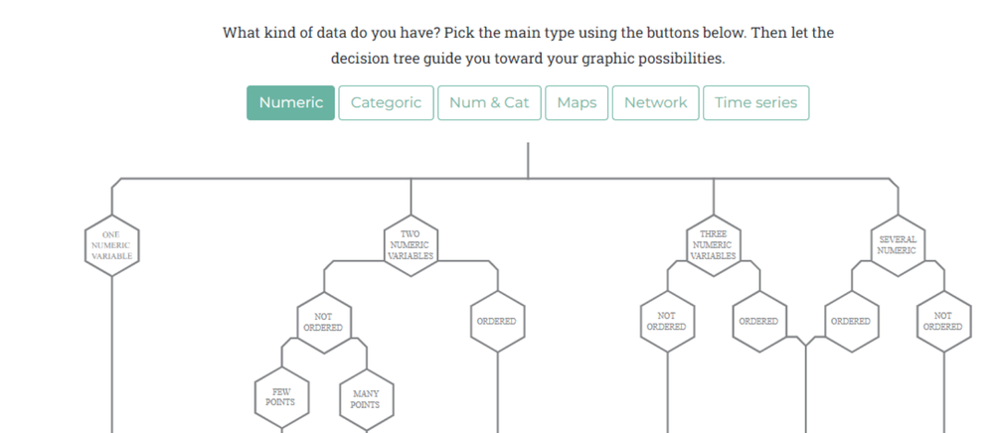

- Really good website
- Takes all encoding info and they created a tree map…
- Type of variables / volume of data and they’ll tell y most appropriate graph to sue including encodings…

Appropriate Visual Encodings
- Choosing Appropriate Visual Encodings
  - Natural ordering
  - Distinct values
  - Defaults versus innovative formats
  - Readers’ context
  - Compatibility with Reality
  - Patterns and Consistency

Natural Ordering
- Determined subconsciously by the mechanics of our visual system
- Process is deeply embedded in our understanding and evaluates relative order independent of language, culture or convention
- Depending on the specifics of the visual property, its natural ordering may be well suited to representing:
  - Quantitative differences
  - Ordinal differences
  - Sub-conscious
  - Independent of language / culture or any other conventions
  - Comes naturally to viewers…
  - Need to take into account
  - i.e. Precision has a natural order btu Shape does nto have a mnatural order
    - one set of vakues higher or lower..
    - length ahs natural order but density doesn’t
    - thickness weight has natural order
    - solid or dags does not have a natural order…

Examples of Natural Ordering
- Position has a natural ordering
  - shape does not
- Length has a natural ordering
  - texture does not (but pattern density does)
- Line thickness or weight has a natural ordering
  - line style (solid, dotted, dashed) does not

Colour Is Not Ordered
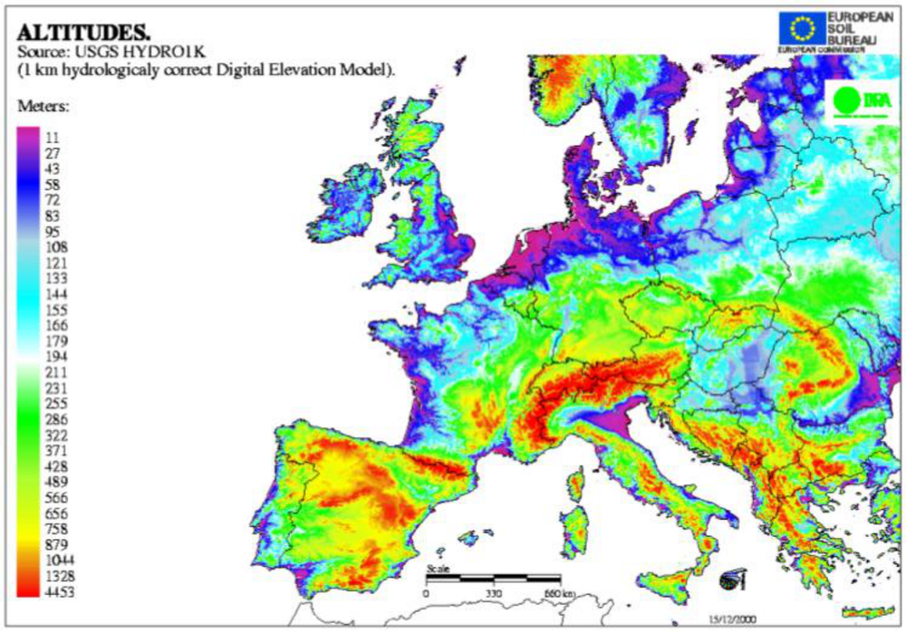
- Colour does nto give us indiciation of what is higer and what is lower…
- We have legend but need to refer to it

Colour Is Not Ordered
- Colour (hue) is not naturally ordered in our brains
  - brightness (lightness or luminance, sometimes called tint) is
  - intensity (saturation) is
- Strong social conventions about colour
- There are conventions abuot colour
- So be careful
- Darkness will always tell your viewers it’s a higher value….
- Map fo eurio in blue only….lighter low and darker higher..

Misuse of Colour
- Misuse of colour to imply order is rampant
- If tempted to use ordered colour (elevation, heat maps, etc.), consider varying brightness/Saturation
- For example, elevation can be represented by increasing the darkness of the hue or with a divergent colour scale, rather than cycling through the rainbow
- https://www.istockphoto.com/photos/topographic-map-europe
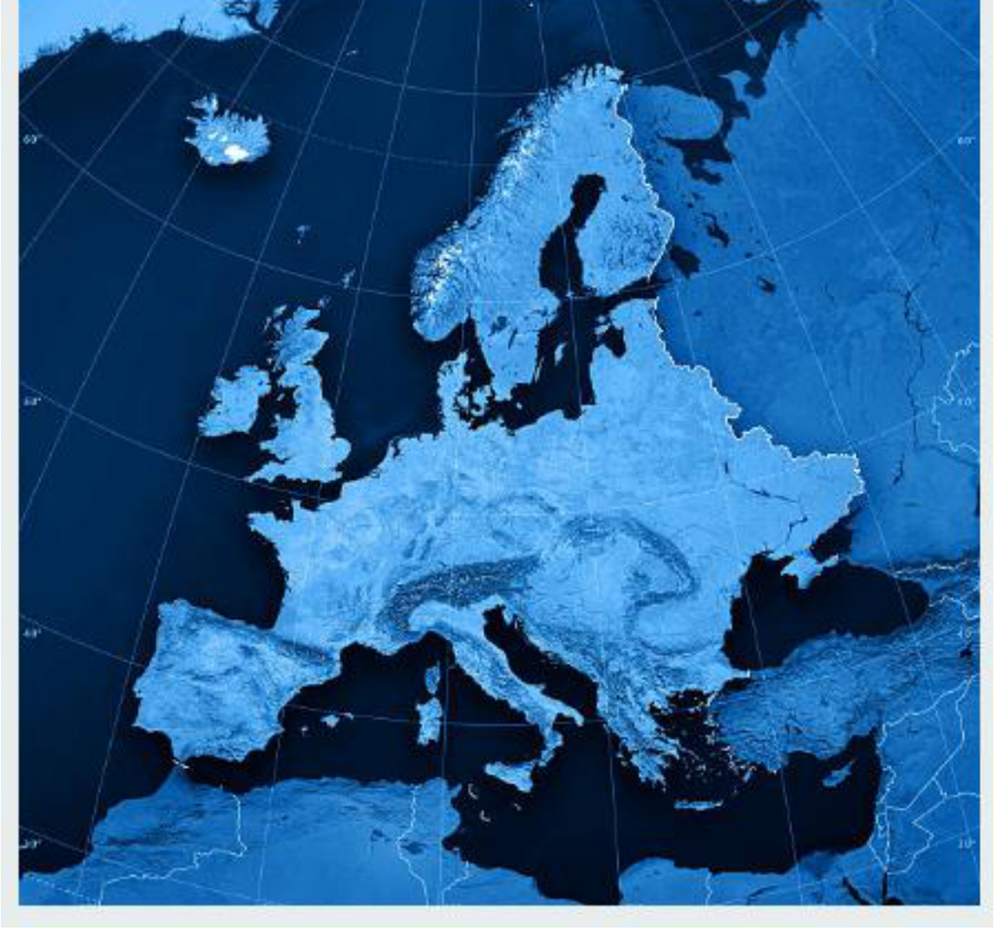

Distinct Values
- When choosing a visual property, select one that has a number of useful differentiable values and an ordering similar to that of your data
- There are a lot of colours in the world, but we cannot tell them apart if too similar
- We can more easily differentiate a large number of shapes, a huge number of positions, and an infinite number of numbers

- It is easier some of encodings have more optiosn than others
- But the ebst option will always be the one that matches closely to your data

Distinct Values
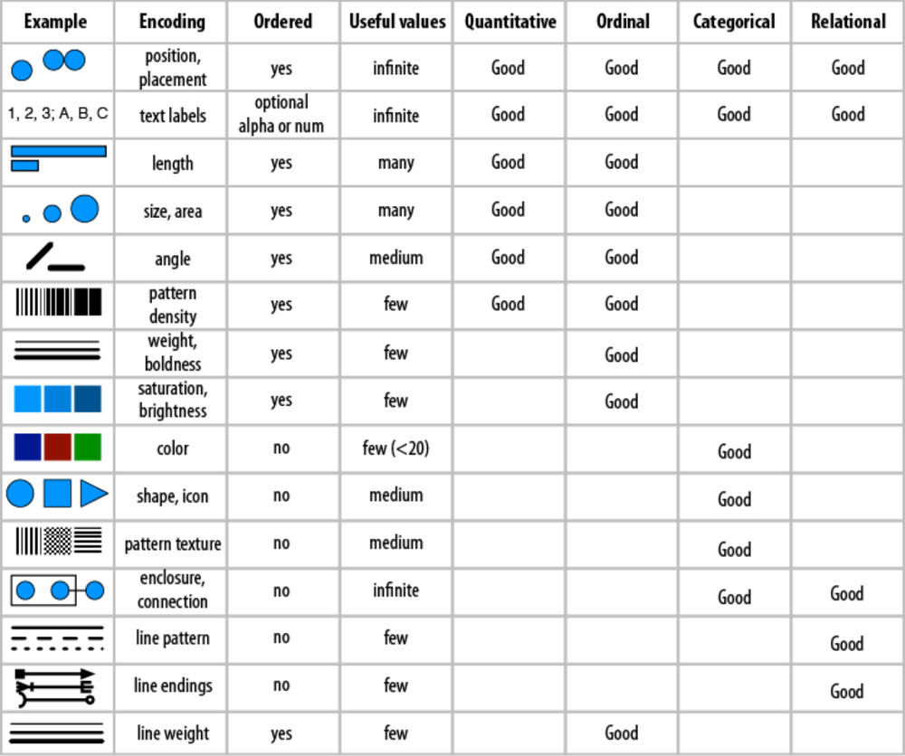

Defaults vs Innovative Formats
- There are a lot of good default encodings and encoding conventions in the world, and with good reason...
  - Designing new encoding formats can cost you a lot of time and effort
  - Knowing the expected defaults for your industry, data type, or reader can save you a lot of work when it comes to figuring out how to best encode your data
- Sometimes default can put readers to sleep, but other times it helps them get to the heart of the matter...
- Use default coding vs creating something like a petal grapah at the beginning
- Same graph as petals.. could have been done with small bar chart or pie for each of the cities…
- Takes logn time to design something different…
- Might be more difficult for audience to decipher… but they ay recall info better.. as brouhg to their attention in more attractive way…
- Always need to balance whatr they ar expecting vs something slightly different

Readers’ Context
- Audience and Culture
- The reader may show up with a mindset or way of viewing the world different from yours
- Is the reader from a culture that reads left-to-right, right-to-left, or top-to-bottom?
  - A person’s habitual reading patterns will determine their default eye movements over a page, and the order in which they will encounter the various visual elements in your design
- May also pertain to geographic maps: many of us are used to seeing the globe split somewhere along the Pacific, with north oriented upward
- Always have to have readers context in mind
- Who is your target viewer!!
- Do they expect a particular convention
- https://cartorical.com/shop/pacific-centered-world-map/
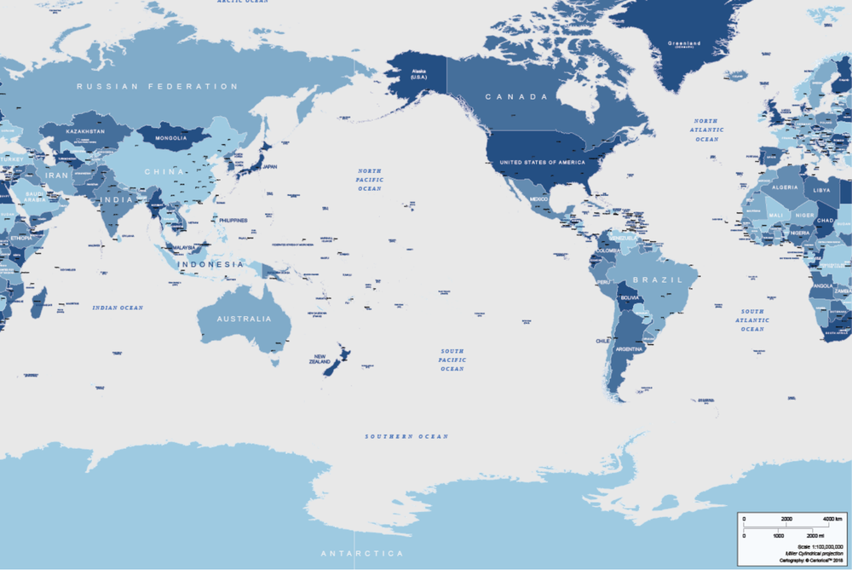

- Map centred in pacific
- Next one south on to and north at bottom… not what we’re used to .. btu if reaer is expecting something different.. ie. Data in Australia or asia…
- https://www.raremaps.com/gallery/detail/48952/mcarthurs-universal-corrective-map-of-the-world-mcarthur
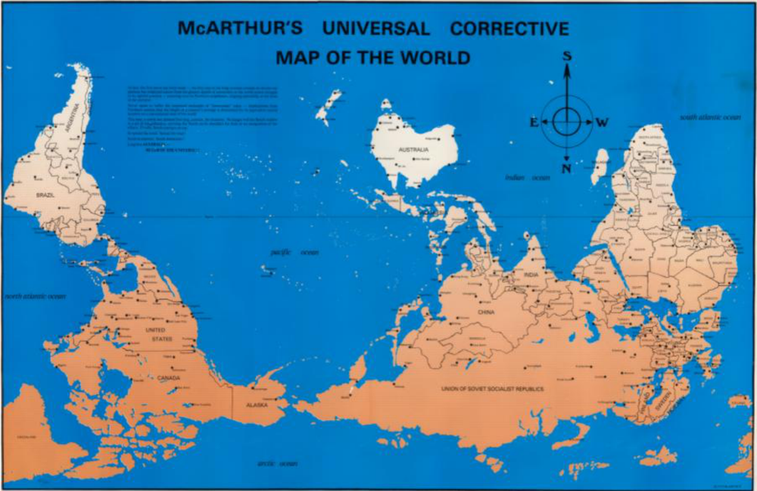

Readers’ Context
- Convention and Colour Blindness
- Scientific universality about how we perceive and process colour but also significant cultural associations
  - Some colours may be lucky, some unlucky; some may carry positive or negative connotations; some may be associated with life events
  - Colours may also take on special significance when paired with certain shapes
- Many variations in the way different people perceive colour commonly called “colour blindness” but is more properly referred to as “colour vision deficiency” or dyschromatopsia
  - About 7-8% of men experience some kind of colour perception disorder. Women are much more rarely affected: about 0.4%-0.5%.
  - When suing colour make decisions for each element and ntok thnk about the colours
  - Each color is important and make sur are thinking properly and whats most effective encoding…
  - If tis colour how do I use it properly…
  - Colour + a shape
  - Set of shapes >> set of crosses… with medical data…
  - Some cultural associations with colours
  - Brightness and saturation are different.. changgin to black and white…. Can’t differentiate between the two colours…

Compatibility With Reality
- Make your encodings of things and relationships as well aligned as possible with the reality (or your reader’s reality) of those things and relationships
  - Some things are larger than others, have specific colours, well-known locations, and other identifying characteristics
- This alignment is called compatibility
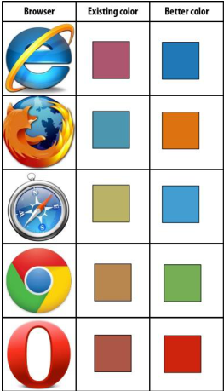

- Leonardo dicaprio plot earlier… blue for boys and pink for girls…
- Some kind of effort to pick coluor for icon above in table also…

Compatibility With Reality
- Avoid countering conventions where possible to avoid creating cognitive dissonance
  - Clash of habitual interpretation with the underlying message you are sending
- Consider cultural conventions about spatial representations, such as what left and right mean politically
- https://en.wikipedia.org/wiki/Red_states_and_blue_states
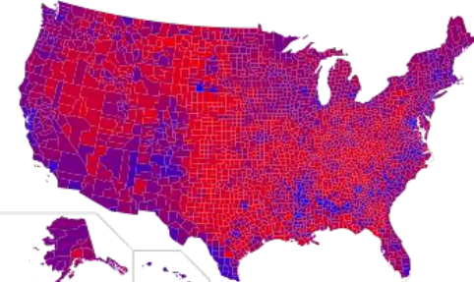

- Red states and blue states… don’t mix them around.. politics…
- Cognitive dissonance… seeing something that is clashing what they uidnerstand naturally as they have seemn ti many times…

Patterns & Consistency
- As designers, we must be extremely deliberate about the patterns and pattern violations we create
- Three simple rules:
  - Be consistent in membership, ordering, and other encodings
  - Things that are the same should look the same
  - Things that are different should look different
- Maintaining consistency and intention when encoding will greatly enhance the accessibility and efficiency of your visualization

- Need to be deliberate!!!
- 3 simple rules…
  - Be consistent
  - Thigns that are rhe same should look the same
  - Thigns that are different should look different
  - If crearign indy vis ‘tions be careful … quite likely that some fo your visualization are using the same colours for different thigns…
    - Same look same
    - Different look different

Patterns & Consistency
- https://daydreamingnumbers.com/blog/consistency-in-charts/
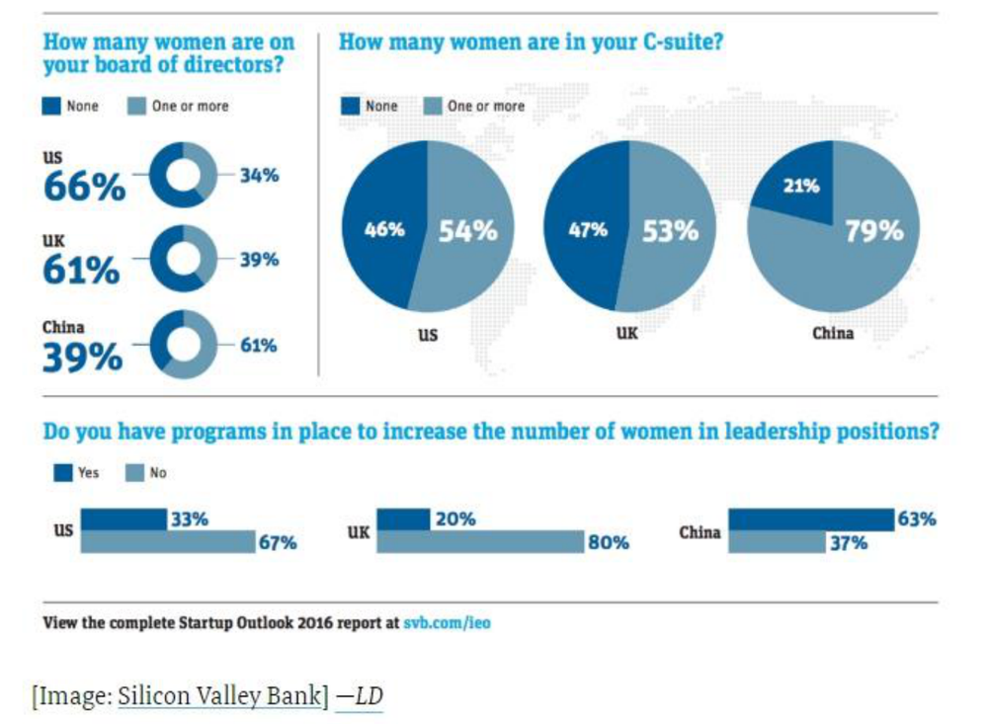
- Feel like dark negative sentiment
- Brighter positive sentiment
- Have reversed sentiment on the last one….
- Similar look similar
- Different look different

Patterns & Consistency
- https://daydreamingnumbers.com/blog/consistency-in-charts/
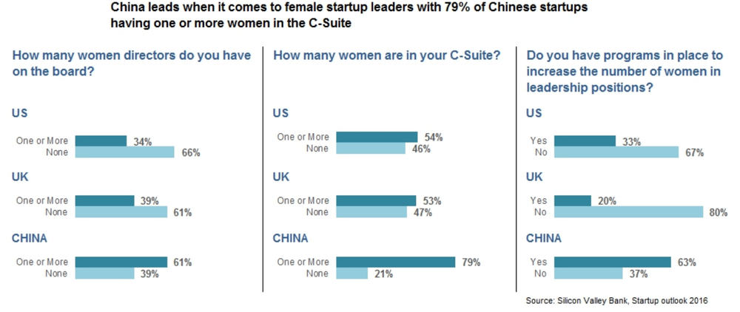
- Use same graph to standadrise everything aligned… can compare across more easily…
- Can Look across or look down…
- Some consistency to vis

Thanks To
- Cathy Ennis, John McAuley, Colman McMahon and Brian Mac Namee
- for an earlier versions of these lecture notes

- take one thing from today>>>> Intentionality!!!!
- Make sure have intention in mind
- Have thought abuot it carefully
- Who is audience
- Whats most appropriate encoding
- Selectign indy elements >> bar graph to pie chart and deciding on colours…

- Coarser decisions to refinement decisions

References
- https://www.nytimes.com/interactive/2022/03/09/upshot/where-americans-have-noticed-inflation.html
- https://public.tableau.com/profile/matt.chambers#!/vizhome/SportsCity/SportsCity
- https://www.reddit.com/r/dataisbeautiful/comments/azjti7/leonardo_dicaprio_refuses_to_date_a_woman_over_25/
- https://www.oreilly.com/library/view/designing-data-visualizations/9781449314774/ch04.html
- https://knowablemagazine.org/article/mind/2019/science-data-visualization
- https://www.annualreviews.org/doi/full/10.1146/annurev-biodatasci-080917-013424
- https://www.data-to-viz.com
- https://www.istockphoto.com/photos/topographic-map-europe
- https://cartorical.com/shop/pacific-centered-world-map/
- https://www.raremaps.com/gallery/detail/48952/mcarthurs-universal-corrective-map-of-the-world-mcarthur
- https://en.wikipedia.org/wiki/Red_states_and_blue_states
- https://daydreamingnumbers.com/blog/consistency-in-charts/

Lab 3 –

- Tableau

ACCENT for Effective Graphical Displays
- Apprehension: Can you perceive the relationships among the variables?
- Clarity: Can you visually distinguish all of the elements of the graph?
- Consistency: In a series of graphs, are the meanings of elements, shapes and symbols the same?
- Efficiency: Do you portray a complex relationship in the simplest way possible?
- Necessity: Do you need the graph, or will another format (text, table) be more effective?
  - Sometimes you see it in your visual – have to read all labels to compare as visual elements are agrd wotk i.e. a pie chart and slices very similar… viewer just reading the numbers as clises not giving enough information
- Truthfulness: Are the elements accurately positioned and scaled?
  - Graph from the whitehouse
- D. A. Burn (1993). Designing Effective Statistical Graphs, in Rao (Ed.) Handbook of Statistics
- Creating visualisation is an iterative process!!!!
- Refine refine refine

Lab exercise
- You are a visualisation designer who has been hired by the Museum of Modern Art in New York. The museum manager has asked you to do an inventory of the existing art pieces, to better understand the collection - when pieces were purchased/acquired and what departments have the most art.
- Download the dataset Museum of Modern Art Collection: Artworks.csv on Brightspace

Answer the following questions (2%)
- Use Tableau to answer the following questions:
- Look at art acquisition over time
- What years did the museum acquire (buy or via donations) the most art?
  - not all are purchases….
- Can you identify why there was such an increase in art pieces acquired during these years?
Bought or via donations
- Look at the departments
- What department has the most artwork?
- What is the split between catalogued art works and non-catalogued?
- In what year did the museum acquire the highest number of art pieces for the film department?
Answer should be very clear
Highlight changes o defaults… answer should eb clearly displayed…

Submission
- Through the link in Brightspace
- PDF with:
  - Your name
  - Student ID
  - Link to table public
    - >> must be present!!!
  - Question + Screenshot (x5)
    - Each question followed by screenshot of visualisation

References
- D. A. Burn (1993). Designing Effective Statistical Graphs, in Rao (Ed.) Handbook of Statistics

Assignment

  - 1 using Tableau
  - 2 using R

- Assigment – datasets…
  - Use of CSO data for assignment
    - If use at least one
    - Segregated .. high value datasets
    - They focus on story telling
    - We will pick ones that we think ard best ones to go and present at CSO if you want
    - Talks would eb like 8 mins kwith 5 misn for questions
    - 1 full story
      - A dashboard with some insights
      - Has to eb self contained in machine used to present
      - Found something on thos high value datasets and hwo you present it
      - Will give awards to best projects
      - And all that get to present for the showcase…
      - So at l east 1 dataset from high value datasets
      - +
      - Anything else form CSOp site or any other site… must say where they came from…. Where di you get your data
      - Usually have restriction using same datasets >> but will allow people use same datasets.. so can refine
      - Can’t sue same visualisations….
      - Showcase is in January!!!
  - For module have 2 assignments

Resources

Recommended Books
- 1. Designing Data Visualisations – Noah Iliinsky, Julie Steele (2011)
- 2. Visualise this – Nathan Yau (2011)
- 3. Visualising Data – Ben Fry (2008)
- Also worth looking up:
  - 4. The Visual Display of Quantitative Information – Ed Tufte (1983)
  - 5. Semiology of Graphics – Jacques Bertin (1967)
  - 6. Data Visualisation – Andy Kirk (2016) >> is quite practicel
  - 7. How Charts Lie – Alberto Cairo (2019)
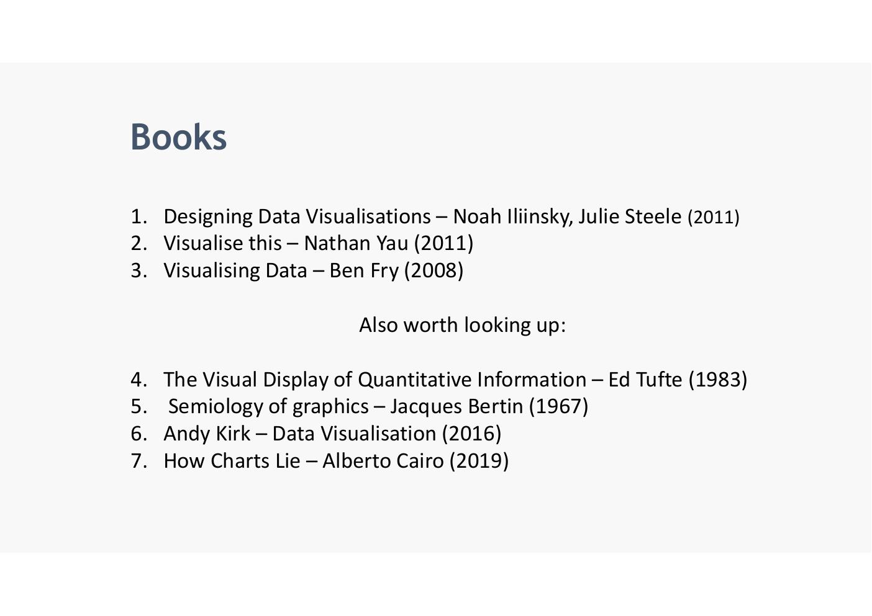

Visualisation of the Week – Kavanaugh/Ford Hearing
- 'Every time Ford and Kavanaugh did or did not answer a question'
- Legend: Answered question (light blue) | Did not answer (pink/magenta)
- Each horizontal stripe = one question; FORD column vs KAVANAUGH column
- Ford column is almost entirely light blue; Kavanaugh column shows frequent pink stripes indicating many questions not answered
- Data: Vox analysis of a Bloomberg transcript of the hearing, via the Washington Post
- Reference: https://www.vox.com/policy-and-politics/2018/9/28/17914308/kavanaugh-ford-question-dodge-hearing-chart
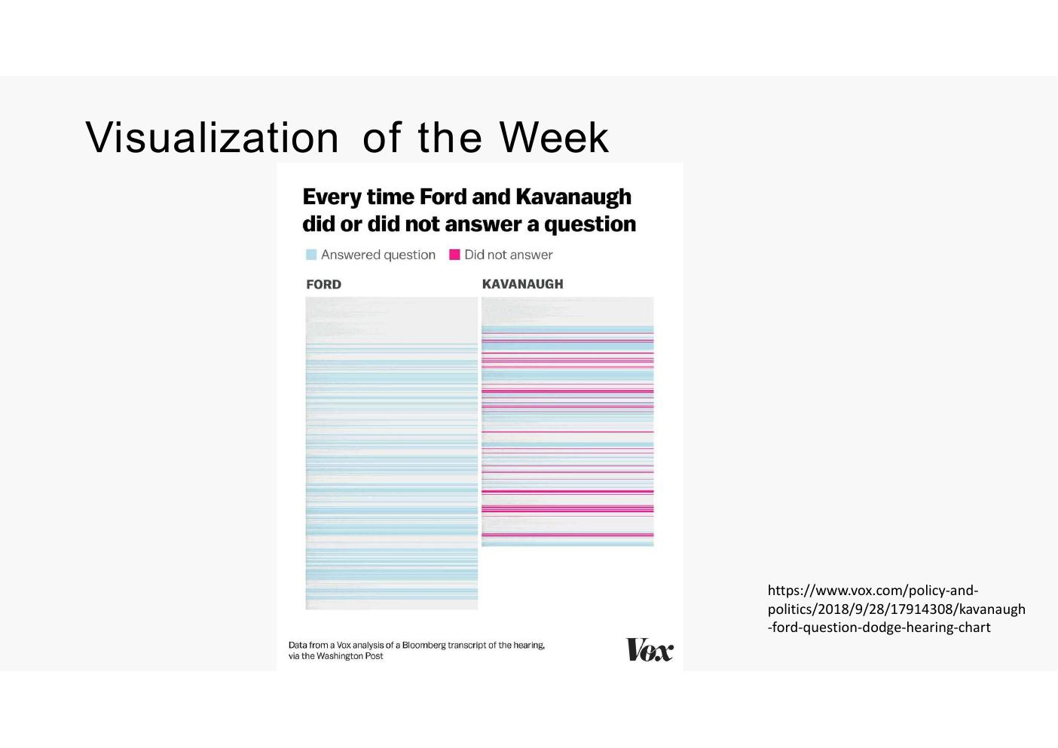
- This is representing text.. which is really difficult to do…
- Form 2018.. Cavanagh was judge going for supreme court
- Kavanagh vs Ford.. did he answer the questionor not
- Pink did not answer the question
- Blue did answer the question
- How they coded it

(Un)Visualisation of the Week – Bad 3D Pie Chart
- Example of a poor visualisation: 3D exploded pie chart for 2011-Q4 clothing categories
- Problems: 3D perspective distorts relative slice sizes; too many categories (12); legend is disconnected; rear slices appear smaller than front slices due to perspective
- Categories: Accessories, City Skirts, City Trousers, Dresses, Jackets, Leather, Outerwear, Overcoats, Shirt Waist, Sweat-T-Shirts, Sweaters, Trousers
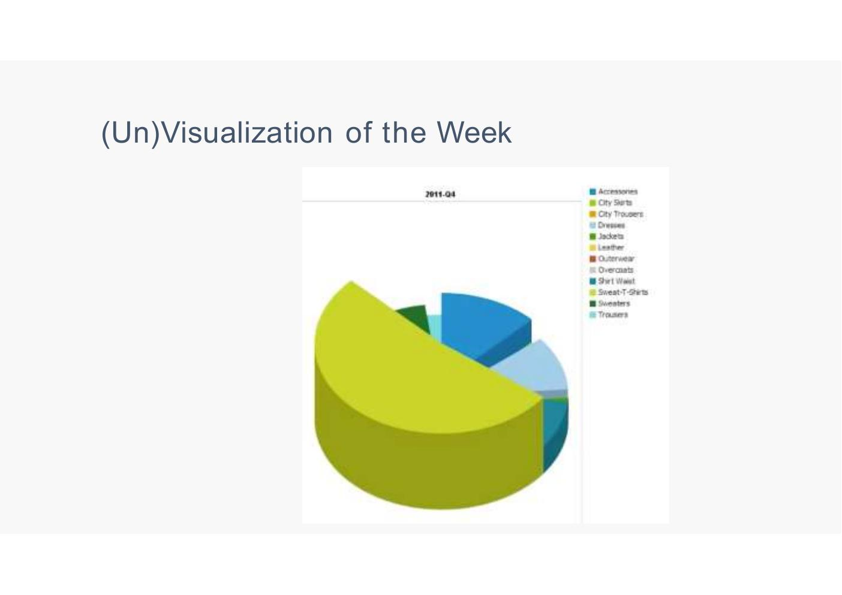
- Can’t see sections… not good example…

The Joy of Stats – Hans Rosling
- Hans Rosling – The Joy of Stats
- Reference: https://youtu.be/jbkSRLYSojo
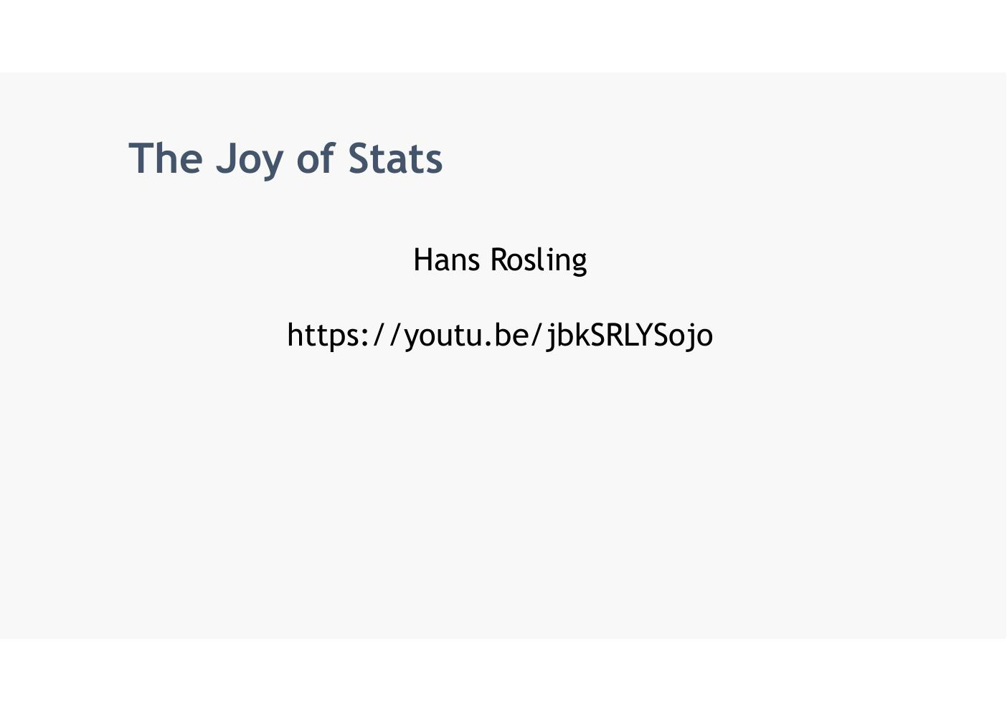

Thanks To
- John McAuley, Colman McMahon and Brian Mac Namee for earlier versions of these lecture notes


Recordings
- Week 1 – lecture
- Week 1 – lab = none
- Week 2 – lecture
- Week 2 – lab
- Week 3 – lecture
- Week 3 - lab

References

Week 1
- McCormick et al. (1987) – 'Transformation of the symbolic into the geometric'
- Bertin (1967) – Semiology of Graphics – 'Finding the artificial memory that best supports our natural means of perception'
- Card, Mackinlay & Shneiderman (1999) – 'The use of computer-generated, interactive, visual representations of data to amplify cognition'
- Heer J., Bostock M. & Ogievetsky V. (2010) – 'A Tour Through the Visualization Zoo', Communications of the ACM, vol. 53, no. 6 – http://queue.acm.org/detail.cfm?id=1805128
- Iliinsky N. & Steele J. (2011) – 'Designing Data Visualizations', O'Reilly Media – http://shop.oreilly.com/product/0636920022060.do
- Fry B. (2007) – 'Visualizing Data: Exploring and Explaining Data with the Processing Environment', O'Reilly Media – http://shop.oreilly.com/product/9780596514556.do
- Alberto Cairo – How Charts Lie (2019)
- John Snow / 1854 London Cholera Epidemic – www.edwardtufte.com/tufte/books
- YouTube statistics – https://expandedramblings.com/index.php/youtube-statistics/ | https://www.omnicoreagency.com/youtube-statistics/
- Temperature Anomalies – https://www.flickr.com/photos/150411108@N06/43350961005/ (Antti Lipponen, CC-BY-4.0; Data: NASA GISS GISTEMP)
- COVID testing – https://www.vox.com/2020/4/13/21215133/coronavirus-testing-covid-19-tests-screening
- COVID box plots – https://www.nature.com/articles/s41586-020-2923-3
- Presidential approval ratings – https://www.bbc.com/news/world-us-canada-38663043 (Source: Gallup)
- Hans Rosling bubble chart – https://www.ted.com/talks/hans_rosling_the_best_stats_you_ve_ever_seen | https://www.gapminder.org/tools/
- Parallel Coordinates – https://www.data-to-viz.com/graph/parallel.html
- World vaccination map – https://www.bloomberg.com/graphics/covid-vaccine-tracker-global-distribution/
- Neural network diagram – http://jalammar.github.io/visual-interactive-guide-basics-neural-networks/
- Social network analysis – Network Analysis - Social Network Analysis (Truthy project)
- Erasmus Student Mobility chord diagram – https://twitter.com/tanya_shapiro/status/1617195890627821576 (Source: Data.Europa)
- HealthInfoScape – http://senseable.mit.edu/healthinfoscape/
- London Underground maps – topographicalmapofgrandcanyon.pages.dev/new-hplcp-the-london-underground-map-a-navigational-masterpiece-2-mytqk-pics/
- Kavanaugh/Ford hearing chart – https://www.vox.com/policy-and-politics/2018/9/28/17914308/kavanaugh-ford-question-dodge-hearing-chart
- Hans Rosling – The Joy of Stats – https://youtu.be/jbkSRLYSojo
- Tableau Public – www.tableausoftware.com/public/gallery | https://www.tableau.com/products/public
          - Credentials
          - Site = https://www.tableau.com/academic/students
          - https://public.tableau.com/newWorkbook/b0365460-1e78-466a-ac58-e42ce3fb710b#1
          - Username = D24127620@myTUDublin.ie
          - Pwd = SliabhMor0981!
          - Signed up for free trial on Mon 5th Oct 2026
          - https://public.tableau.com/app/profile/eamonn.kelly1079/vizzes

- R Graph Gallery – https://www.r-graph-gallery.com/all-graphs/ | www.r-project.org | RStudio Desktop – Posit
- Information is beautiful - https://informationisbeautiful.net
- Book: Designing Data Visualisations – Noah Iliinsky, Julie Steele (2011)
- Book: Visualise this – Nathan Yau (2011)
- Book: Visualising Data – Ben Fry (2008)
- Book: The Visual Display of Quantitative Information – Ed Tufte (1983)
- Book: Semiology of Graphics – Jacques Bertin (1967)
- Book: Data Visualisation – Andy Kirk (2016)
- Book: How Charts Lie – Alberto Cairo (2019)
- Thanks to: John McAuley, Colman McMahon and Brian Mac Namee for earlier versions of these lecture notes

Lab Exercise

