Lab 4 Dashboards in Tableau
- A dashboard is a collection of worksheets that can be used to summarize and compare information on different worksheets.
- 1. Dashboards 1 and 2

Basic principles for creating dashboards
- Dashboards are collections of worksheet, related worksheets should be displayed in a dashboard.
- Dashboards should not be cluttered.
- Consistent colours should be used.
- Important information should be on the left of the screen.
- A worksheet can act as a filter for other worksheets.
- Actions can be used to create interactive dashboards.

Creating a new dashboard
- Dashboards are created compiling graphs previously created in the different sheets. Hence, we will start opening the Global Super Store Tableau file.
- Click on new dashboard.
- The Sheets section provides a list of all the available worksheets that can be included in the dashboard.
- The Objects section contains different layouts (horizontal/vertical, tiled/floating) and the options for adding images and webpages to the dashboard.
- Open one of your previous Tableau files and add views to your dashboard from the Sheets you created previously (displayed in the document the Superstore example).
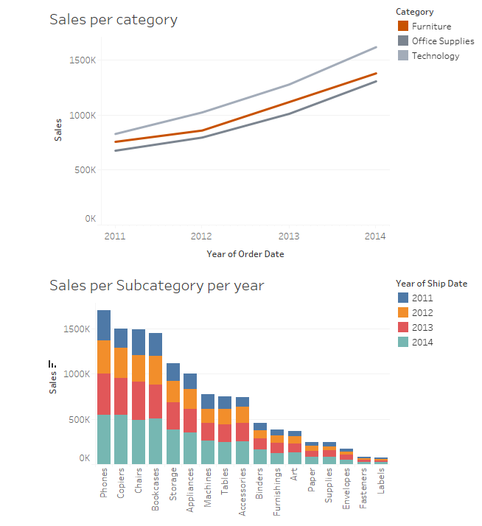
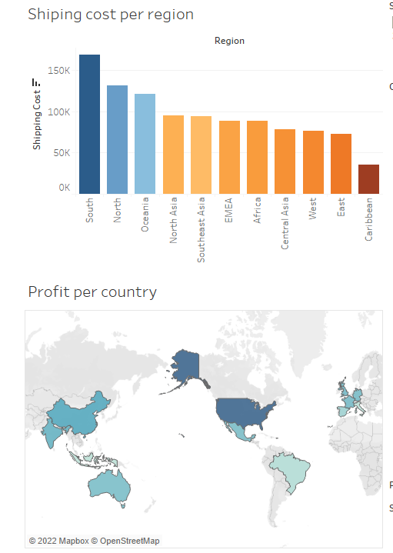

Dashboard Actions
- A dashboard action is an interactive element on a Tableau dashboard that is driven from the worksheets within that dashboard.

Basic Chart to Chart Filtering Action. Use Dashboard 1
- We can use one worksheet to filter one or more other worksheets on the same dashboard.

Method 1: Use As Filter
- Click the drop down menu option within one of the worksheets, like this below
- By clicking 'Use as Filter' you have created a dashboard action, which can now be seen in the list of actions:
- The name of the action is Filter 1 (generated). The (generated) lets you know it was created by clicking 'Use As Filter'.
- The default values are target all sheets and filters on all fields, run on 'Select' and clearing the selection to 'Show all values'. This is the default behaviour and is useful in many situations.
- You can also create a dashboard action to filter by one dimension by using 'Selected Fields'.
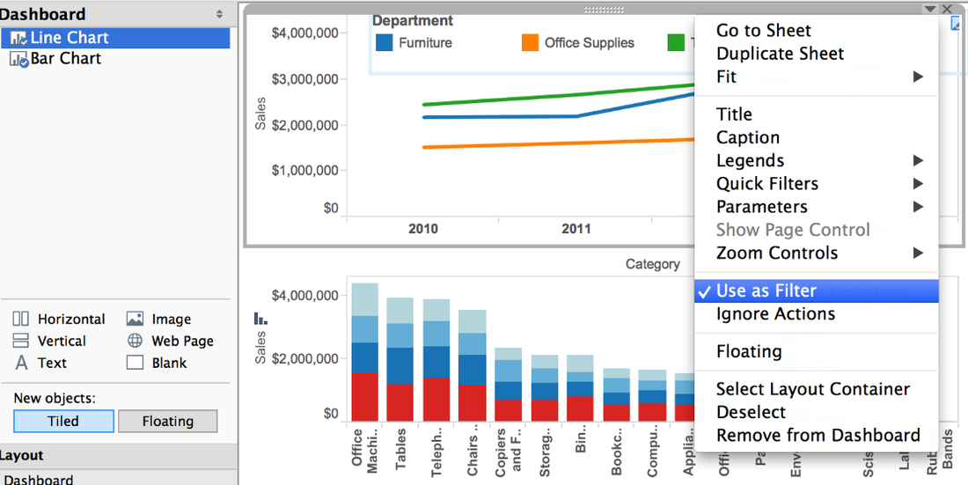
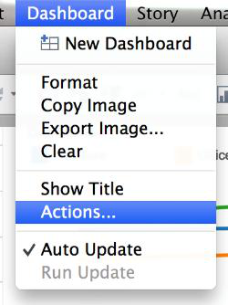
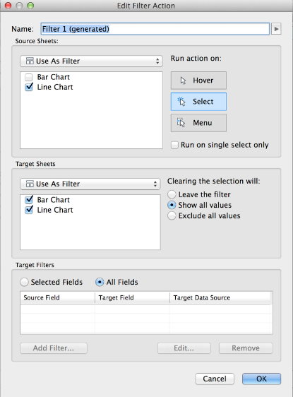

Method 2: Use the Dashboard Action menu
- Choose 'Dashboard'->'Actions'->'Add Action'->'Filter'->'Selected Fields'->'Add Filter' and start picking fields.
- Now if we click on one of the lines, it will filter the bar chart by Category only, and all Years will still be shown:
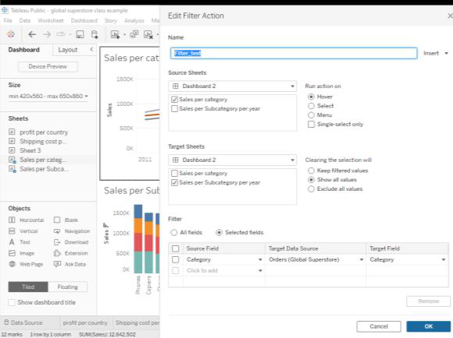
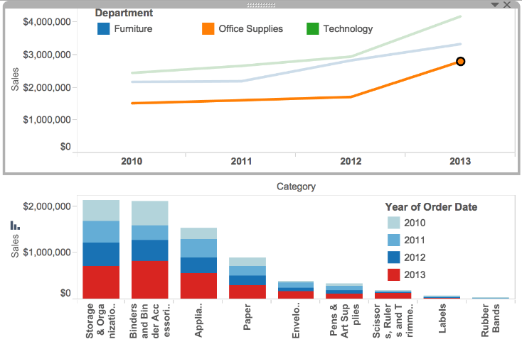

Basic Control to Chart Filtering Action. Use Dashboard 2.
- Each sheet on the dashboard has a number of options available on selection from the top right menu.
- For example, a control filter can be created to activate the filter action, for example a numerical filter:
- You can customize this filter adjusting the sheets it will be acting on.
- Another example of a control filter is a country selection tool like the one implemented below:

Exercise Make Over Monday (week 38_2018)
- The aim is to take an existing visualisation that has available data and make a new visualisation of that data using Tableau.
- Part 1: Work in groups to provide a short critique of the existing visualisations.
- Part 2: Create a dashboard with alternative visualisations for the data.
- Existing Visualisation: Trains vs. planes: What's the real cost of travel?
  - https://www.dw.com/en/trains-vs-planes-whats-the-real-cost-of-travel/a-45209552
- Data:
  - https://github.com/dw-data/travel-cost/blob/master/Flights-Trains.csv

References
- https://public.tableau.com/en-us/s/blog/2015/06/rough-guide-dashboard-actions
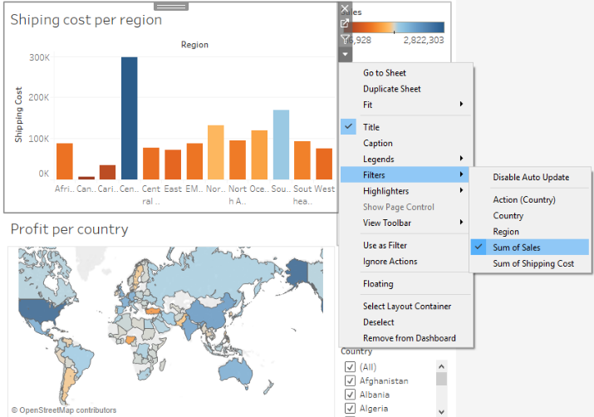
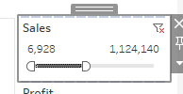
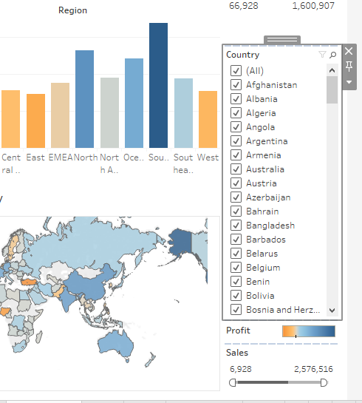

References
- https://www.dw.com/en/trains-vs-planes-whats-the-real-cost-of-travel/a-45209552
- https://github.com/dw-data/travel-cost/blob/master/Flights-Trains.csv
- https://public.tableau.com/en-us/s/blog/2015/06/rough-guide-dashboard-actions

