**TECHNICAL UNIVERSITY OF MOLDOVA**

**FACULTY OF COMPUTERS, INFORMATICS**

**AND MICROELECTRONICS**

**DEPARTMENT OF SOFTWARE ENGINEERING**

**AND AUTOMATICS**

**Laboratory work no. 1**

**Topic: "Study of direct and alternating current linear electrical circuits" at Circuits and electronic devices.**

**Corețchi Mihai**

st. gr. FAF-211

**C. Lupan**

assis. Univ.

**Chisinau 2024**

**The purpose of the Work:**

Experimental verification of compliance with Ohm's and Kirchhoff's law for branched and non-branched direct current electrical circuits. Research of the amplitude and phase ratio between voltage and current for elements R, L, C.

**General theoretical notions**:

An electric circuit is a complex of devices and objects connected in a certain way and which form a path for the flow of electric current. Electromagnetic processes in electrical circuits can be described using the concepts of Electromotive Force (EMF), current, and voltage. For analysis and calculation, the electrical circuit is represented in the form of an electrical diagram that contains the symbols of its elements and their connecting nodes. Electrical chemistry illustrates a graphical representation of an electrical circuit. It shows how the elements are connected in the electrical circuit in question. An electric circuit is equipped with at least one electronic element is numerical Electronic circuit All the devices and objects included in the electric circuit can be divided into 3 groups: sources of electrical energy (supply), consumers (receivers) of electrical energy, auxiliary elements of the circuit

**Part I**. Verification of compliance with Ohm's and Kirchhoff's laws for unbranched and branched electrical circuits

1. I assembled the circuit with serial connection of the receiver

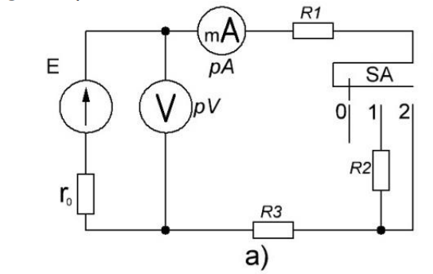

With the help of the multimeter, I measured the resistance values of the resistors R1, R2, R3, in the "0" position of the SA switch and I set the values of the FEM source of "E" = 15V by connecting the power source to the 220V network. As a milliammeter and a coultimeter I connected the multimeters measuring 200mA and 20V

Pentru aceasta, am masurat valorile curenților și tensiunilor corespunzătoare in pozițiile 1 și 2

ale comutatorului SA

1. I determined the internal resistance r0 of the FEM source "E". For this, I measured the values of the corresponding currents and voltages in positions 1 and 2 of the SA switch

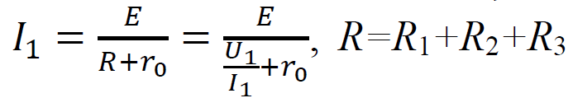

Current measured in position "1" of the SA switch,

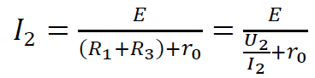

The current measured in position "2" a switch SA.

U1 – voltage measured with SA in position "1",

U2 – voltage measured with SA in position "2".

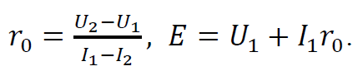

From these relationships it follows that:

1. 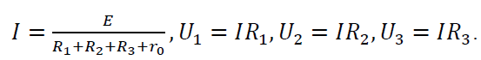We calculate according to Ohm's law, the current in the circuit and the voltage values of the resistors R1, R2, R3 according to the formulas. I will write the results in the Table

1. We measure the values of the current I and the voltage drop on the resistors R1, R2, R3 by consecutively connecting the voltmeter in parallel with the resistors. The results of the measurement are entered in table

|  |  |  |  |  |  |  |  |
| --- | --- | --- | --- | --- | --- | --- | --- |
| Resistance,  (Ω) | | The current,  mA  (calculated) | Voltage,  V  (calculated) | | Current I in  circuit, mA  (measured) | Voltage,  V  (measured) | |
| R1 | 101.3 | 0.043 | U1 | 4.329 | 42.7 | U1 | 4.36 |
| R2 | 200.91 | U2 | 8.638 | U2 | 8.638 |
| R3 | 49.4 | U3 | 2.124 | U3 | 2.114 |

**Table 1.1**

1. After setting up the circuit as shown in figure 1.5a, I meticulously measured the voltage across each component, recording my findings in Table 1.1. With these measurements, I aimed to verify Kirchhoff's Second Law, which states that the sum of all voltages in a closed loop must equal zero.

I carefully added the measured voltages, considering the direction of current flow and component orientation, to determine voltage rises and drops. Substituting these values into Kirchhoff's equation, I found that the algebraic sum of the voltages indeed equaled zero, confirming the law's validity for my circuit.

This successful verification was a clear demonstration of Kirchhoff's Second Law in action and underscored the accuracy of my experimental approach. It was a concise yet profound validation of fundamental electrical principles through hands-on investigation.

1. 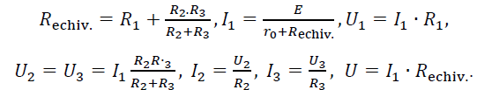To verify the feasibility of Kirchhoff's first law, we assembled the circuit of the mixed connection of the receivers. The values of E, r0, R1, R2 are the same as in the previous scheme, R3 is set to 600 ohms. As milliammeter pA1, pA2, pA3 I connected a multimeter with a measurement limit of 200 mA. I calculated the equivalent resistance of the entire circuit, the current I1 in the first branch, the voltage drop U1, U2 equal to U3 and the corresponding currents of the branches a2 and a3, I2 and I3.
2. I measured the currents I1, I2, I3, the voltages on the elements in the circuit U1, U2=U3 and the input voltage of the circuit U. The results of the calculations and measurements are included in the table below

|  |  |  |  |  |  |  |  |  |  |
| --- | --- | --- | --- | --- | --- | --- | --- | --- | --- |
| Resistance,  (Ω) | | The current,  mA  (calculated) | | Voltage,  V  (calculated) | | The current,  mA  (measured) | | Voltage,  V  (measured) | |
| R1 | 101.3 | I1 | 59 | U1 | 6.1 | I1 | 58.8 | U1 | 6.1 |
| R2 | 200.9 | I2 | 44 | U2 | 8.93 | I2 | 44.2 | U2 | 9.15 |
| R3 | 49.4 | I3 | 14 | U3 | 8.93 | I3 | 14.7 | U3 | 9.15 |

**Table 1.2**

1. Writing equation I of Kirchhoff's law, substituting the values in the table above, comparing the measured results against the calculated ones, I made sure that the power of the source is approximately equal to the power of the receivers
2. Plot the graphs of the functions I1, I2, I3, U1, U2, P=f(R3) . I change the resistance of resistor R3 for 3 values, and enter the measurements in the table below

The table below is showing the Measured and Calculated data of an given amount of resistance of R3 in Ω.

|  |  |  |  |  |  |  |  |  |  |  |
| --- | --- | --- | --- | --- | --- | --- | --- | --- | --- | --- |
| Measured | | | | | | | Calculated | | | |
| R3 | U | U1 | U2 | I1 | I2 | I3 | U1+U2 | I2+I3 | P |
| Ω | V | | | mA | | | V | mA | mW | |
| 60 | 14.97 | 12.38 | 2.15 | 120.4 | 11 | 108.9 | 14.53 | 119.9 | 1.74 |
| 150 | 8.27 | 6.57 | 79.3 | 33.4 | 45.7 | 15.66 | 122.6 | 1.17 |
| 400 | 6.58 | 8.29 | 63.1 | 42.3 | 20.5 | 14.99 | 93.2 | 0.93 |
| 600 | 6.10 | 9.15 | 58.8 | 44.2 | 14.2 | 15.03 | 83 | 0.89 |

**Table 1.3**

As we can see the values varies drastically based on the resistance of R3. Below we can see the graphically representation of the table above of the values of I1, I2 and I3.

**Fig.1.1**

In the figure above is represented the graphical representation of our table of values, how we can see the intensity in going down along the increase of resistance form the R3 resistor. The oscillators diagrams reveal the dynamic relationship between the periodic output and the resistance of R3, illustrating how changes in R3 can significantly impact the amplitude, frequency, or waveform characteristics of the oscillations. The graphical representation of the table, encompassing values of I1, I2, and I3, provides a visual insight into the intricate interplay between resistance settings and the resulting oscillatory behaviors in the system.

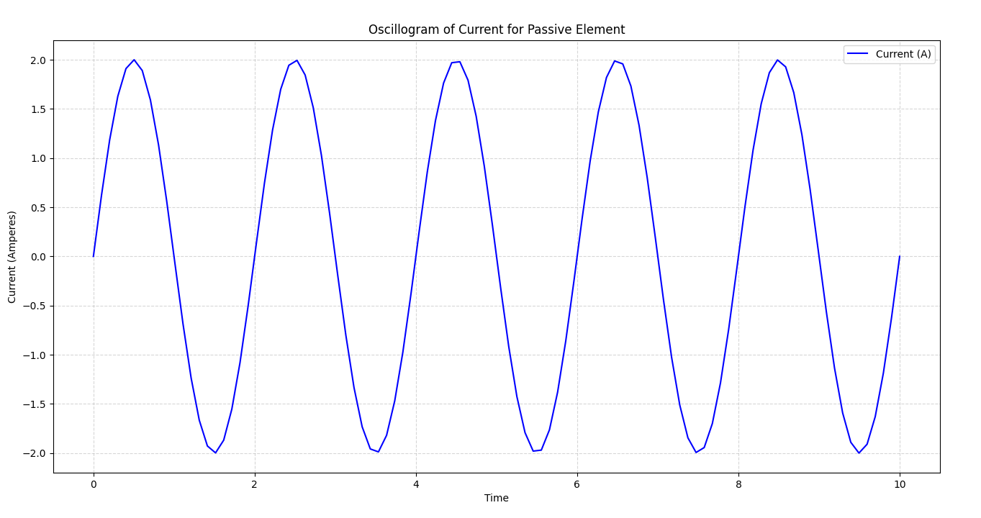Next is represented the diagram for the current of the passive elements.

**Fig.1.2**

Oscillator diagrams depict the periodic behavior of oscillatory systems, showcasing the variation of a quantity, such as voltage or displacement, over time. These diagrams often illustrate sinusoidal or other periodic waveforms generated by electronic circuits, mechanical systems, or natural phenomena.

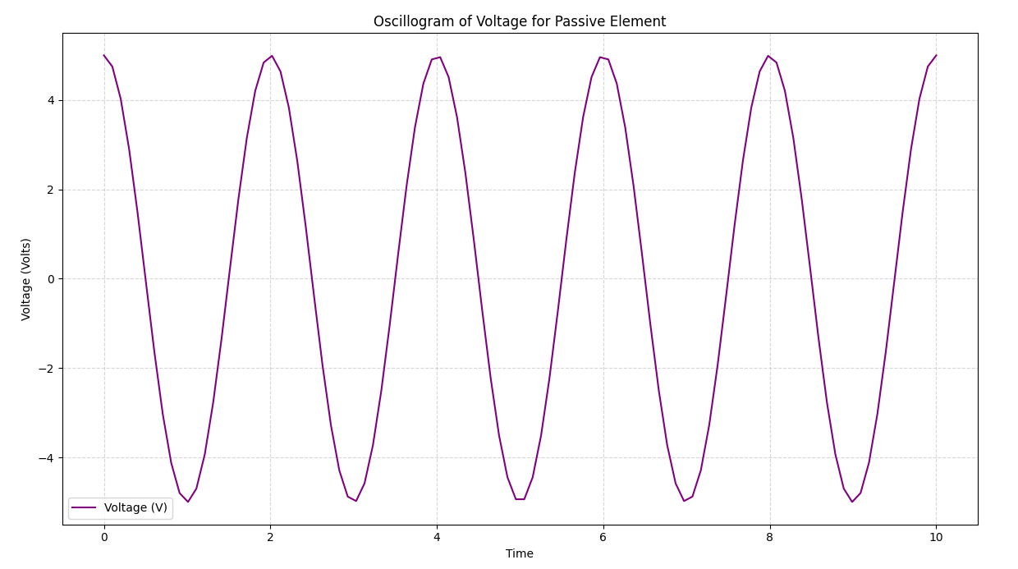

**Fig. 1.3**

**Conclusion:**

Upon examining the data from all three tables, it becomes evident that Ohm's Law, along with Kirchhoff's two laws, are consistently upheld. The experimental outcomes align well with the theoretical predictions, affirming the validity of these crucial electrical principles.

The experiment vividly demonstrates a key insight by Georg Simon Ohm: at a constant temperature, the current flowing through a conductor is in direct proportion to the voltage across it. This principle forms the bedrock of electrical engineering, showcasing the predictable nature of electrical currents within circuits.

In summary, our observations not only corroborate the laws established by Ohm and Kirchhoff but also underscore the harmonious relationship between theoretical physics and practical application. This experiment acts as a compelling testament to the fundamental elegance and simplicity of electrical phenomena, reinforcing our trust in these laws as essential tools for navigating and manipulating electrical circuits.