LAB 1

What are the subcategories for **Network Devices**?

Routers, Switches, Hubs, Wireless devices, Security, WAN Emulation

What devices use a wired connection to connect to switch **ALS2**?

Access_point

Which device is connected to **Access_Point**?

Laptop_1

Where is the device connected to **Access_Point** physically located?

On the table in Branch Office Wiring Closet

LAB 2

 Add an end device to the topology and connect it to one of the LANs with a media connection. What else does this device need to send data to other end users? Can you provide the information? Is there a way to verify that you correctly connected the device?

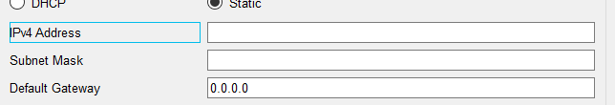

  Add a new intermediary device to one of the networks and connect it to one of the LANs or WANs with a media connection. What else does this device need to serve as an intermediary to other devices in the network?

When the admin will give the access

What is the prompt displayed on the screen?

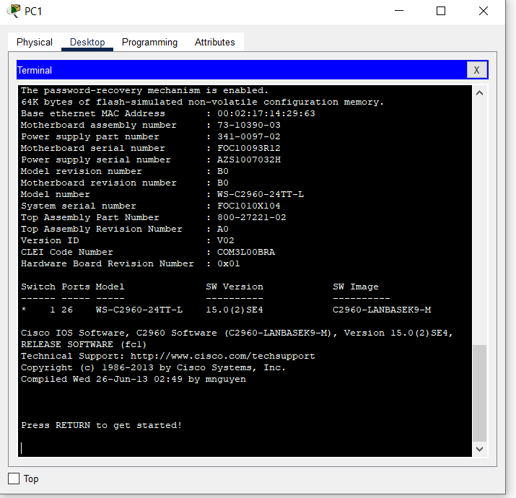

S1

Which commands are displayed?



     Issue the following commands and record the messages:

S1# **cl<tab>**

Questions:

What information was returned?

S1# **clock**

Question:

What information was returned?

S1# **clock set 25:00:00**

Question:

What information was returned?

S1# **clock set 15:00:00 32**

Question:

What information was returned?

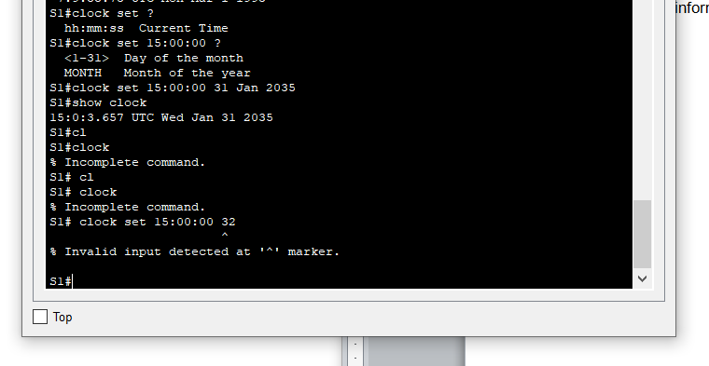

Which IOS image and version is currently in use by the switch?

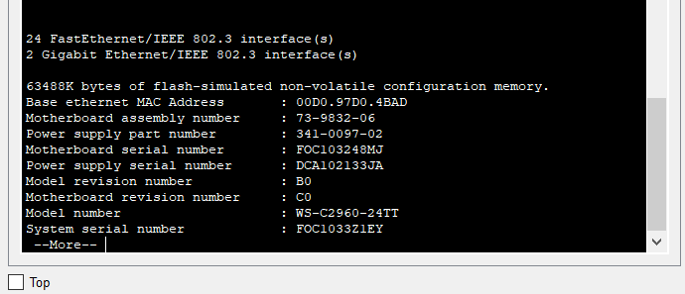

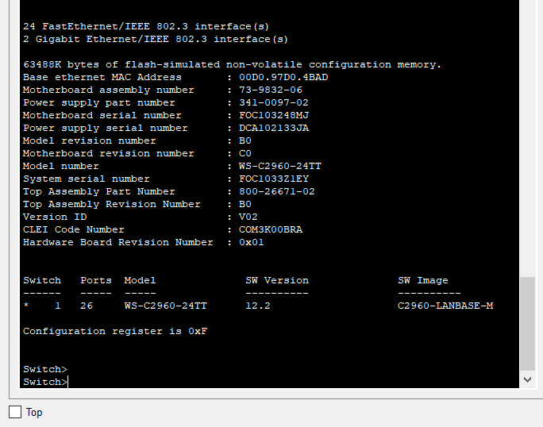

1.     How do you prevent unauthorized personnel from accessing the Cisco device through the console port?

2.     What are the advantages and disadvantages of using the serial console connection compared to the USB console connection to a Cisco router or switch?

