**Decision Tree**

1. What is the overall performance of Decision Tree?

Ans: 87% of test Data

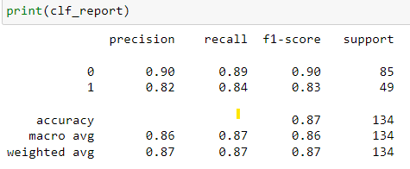

**Accuracy**

2. What is the correct-not purchased?

Ans: 89%

**Recall**



3. What is the correct- ‘purchased’?

Ans: 84%

**Recall**



4. What is the ratio of “purchased” in the whole test set?

Ans: 82%



**RANDOM FOREST**

1. What is the overall performance of Random Forest?

Ans: 91% from test Data (ACCURACY)

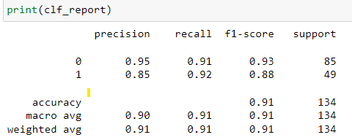

2. What is the correct-‘***not purchased***’?

Ans: 91%



3. What is the correct-***purchased***?

Ans: 92% (RECALL VALUE)



4. What is the ratio of “purchased” in the whole test set?

Ans: 85% (Precision VALUE)



5. What is the ratio of “Not-purchased” in the whole test set?

Ans: 95% (Precision VALUE)



**Support Vector Classifier**

1. What is the overall performance of Random Forest?

Ans: 80% from test Data (ACCURACY)

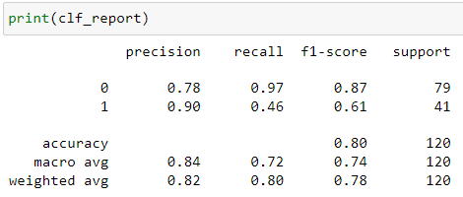

2. What is the correct-‘***not purchased***’?

Ans: 97%



3. What is the correct-***purchased***?

Ans: 46% (RECALL VALUE)



4. What is the ratio of “purchased” in the whole test set?

Ans: 90% (Precision VALUE)



5. What is the ratio of “Not-purchased” in the whole test set?

Ans: 78% (Precision VALUE)

