A short tutorial followed by exercises on phylogenetic tree inference

Prepared by Jean-Baka Domelevo Entfellner (BecA-ILRI Hub, Nairobi) for the 2nd EANBiT residential training course, KEMRI-WT, Kilifi, 11 July 2019

The process of phylogenetic tree inference is about building a tree (i.e. an acyclic connected graph) from a multiple sequence alignment as input data. One can build such a tree from either nucleotide data or amino acid data, or even from quantitative (numerical) characters.

Beware! It makes absolutely no sense to try build a tree from unaligned sequences. This is because, under the standard theory of evolutionary biology, the assumption underlying multiple sequence alignments is that aligned residues (characters) derive from a common ancestor, and the tree resulting from the inference process will be a likely phylogenetic history linking together the extant sequences.

A bit of vocabulary:

A tree is made of edges, aka branches, and vertices (singular: vertex), aka nodes. In a binary tree, each edge is connected to two nodes. Some nodes are connected to only one branch: these are dubbed the external nodes, aka terminal nodes. The others are called internal nodes. The degree of a node is the number of branches it is connected to. In an unrooted binary tree, all internal nodes have degree 3. When the tree is rooted, the root node is the only node of degree 2. In a rooted context, we can determine for each internal node what are its two descendants, aka. son nodes, or children nodes, and which node is its parent. In an unrooted context, we don’t use these terms but only the term neighbours, thereby designating all the nodes connected by one edge to the given node of interest. Generally speaking, when an internal node is connected to more than three neighbours (node of degree > 3), we talk of a multifurcation or multifurcating node.

The term dendrogram is a general name for any tree, not necessarily a phylogenetic one. A cladogram is a tree that represents only the branching patterns (tree topology), and not the branch lengths. On the contrary, a phylogram displays branches whose lengths are in proportion with the expected amount of evolutionary change they bear.

On file formats for input alignments:

These will be either in FASTA or PHYLIP formats. Please refer to the chapter manual pertaining to multiple sequence alignments (MSA).

On file formats for trees:

The standard encoding for phylogenetic trees is in the form of a file with the New Hampshire file format, also called Newick file format. It is a raw text file, written according to a parenthesized syntax described here: https://en.wikipedia.org/wiki/Newick_format. The usual file extensions for this are .nh, .nw or .newick. There is also an extended version of the grammar of New Hampshire format called “New Hampshire extended”, and whose standard filename extension is .nhx.

More recently, people have designed a new format for trees, that has many advantages but whose use is not such widespread: the phyloXML file format (see http://www.phyloxml.org/ and https://en.wikipedia.org/wiki/PhyloXML). The main developer behind this project, Christian Zmasek, also contributed the excellent Java program called Archaeopteryx (https://sites.google.com/site/cmzmasek/home/software/archaeopteryx), a nice cross-platform tree visualisation and manipulation software.

The NEXUS file format (http://wiki.christophchamp.com/index.php?title=NEXUS_file_format) is also used sometimes, but it tends to become obsolete. It was quite in fashion in the 20th century (when the main phylogeny softwares were Phylip, PAUP*, ModelTest and the likes), but not so much anymore, expect perhaps in some communities, e.g. Bayesian phylogenetics.

On software tools for phylogeny:

There are several tools available on the VM to deal with phylogenetic inference and phylogenetic tree manipulation. While some limited work can be performed with Seaview, we will rather focus here on PhyML and Mega.

Using PhyML

PhyML is a powerful commandline tool to perform Maximum-Likelihood (but not only) phylogenetic inference. It can be used either in an interactive way or (most commonly) by specifying all the necessary parameters on the commandline. If you wish to use it interactively, just type phyml on the shell, and you will get the following:
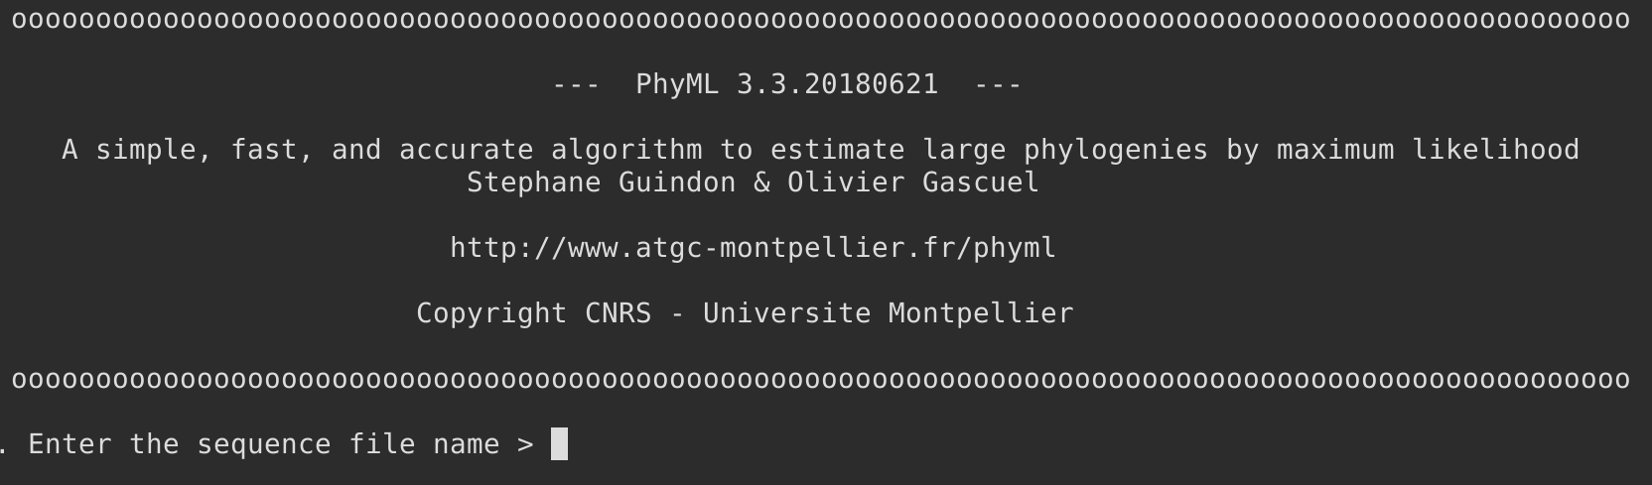
After which you will be prompted for all the necessary information (sequence filename, type of dataset, substitution model to use, etc) through a system of menus through which you navigate using single-letter keystrokes (a Phylip-like interface, more or less in the same fashion as the original versions of Clustal).

BEWARE! PhyML only accepts input alignment files in PHYLIP format. If you have FASTA-formatted alignments, you will have to convert them to PHYLIP format first. Seaview will come handy for that task.

PhyML is most conveniently run through the commandline. You can browse through the manpage obtained by phyml --help to get all the possible options, of which the most useful are the following:

-i seq_file_name to give the input alignment (to be given in PHYLIP format only)
-d datatype to specify the type of characters (DNA or a.a.) If nothing is specified,
then PhyML assumes you are giving a nucleotide alignment.
-m model to specify the evolutionary model to use. You can pick for instance JC69, HKY85 or GTR for nucleotide alignments, and JTT, WAG or LG for amino-acid alignments.
-u initial_tree if you want to specify the initial tree for the exploration of the tree space, use this option to provide a Newick-formatted input tree. By default, PhyML starts with an initial tree built with the (Bio)NJ algorithm.
-o params to indicate the parameters to optimize. To be given a combination of letters among t (tree topology), l (branch lengths) and r (subs. rate parameters). For instance, -o l will only optimize the branch lengths (i.e. the final tree topology will be same as in the initial tree), while -o tlr (the most thorough search) will optimize topology, branch lengths and rate parameters.
-c num_classes to specify the number of discrete rate classes in the discrete Gamma approximation. By default 4.
-a value to specify the value of the alpha parameter for the Gamma law of rate distribution. Use e as a value to let PhyML determine and use its maximum-likelihood estimate
-b int to specify the number of bootstrap replicates, or the style of approximate support (SH-like, aLRT, approximate Bayes, etc) to get in the output tree. Traditionally, branch supports are inscribed in the output tree file (in Newick format) as internal node names pertaining to the direct child of the branch of interest.
--tbe a switch to use the Transfer Bootstrap Expectation [Lemoine et al, Nature vol. 556, pp. 452–456 (2018)] instead of the classical Felsenstein Bootstrap Proportion

Using Mega

The version of this very versatile software that is installed on the VM is MEGA X. MEGA being a software with a graphical interface, you will launch it through the commandline with megax &. The GUI looks like this:
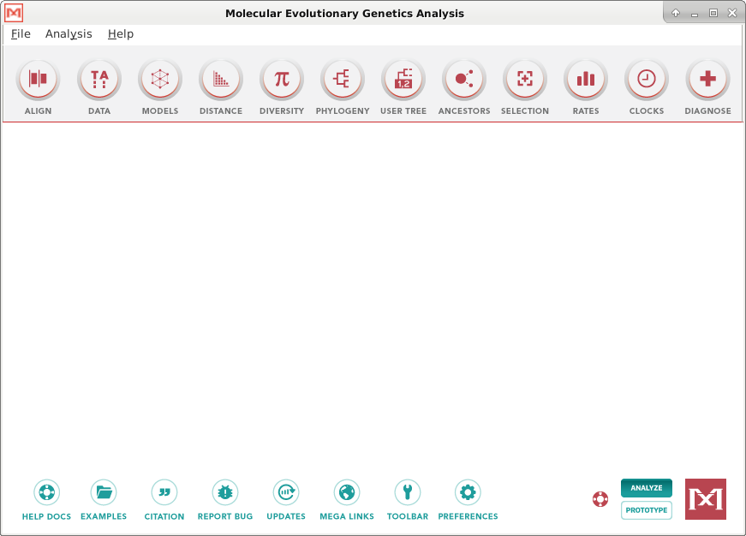

One accesses MEGA functions by clicking on the relevant button in the row of round buttons on top of the main workspace. The first step will usually be to load your dataset (aligned or unaligned data, since you can align sequences directly in Mega by using the “ALIGN” button), after which you will for instance perform phylogenetic inference by clicking on the “PHYLOGENY” button.

Upon importing an (aligned) dataset, Mega will ask you whether it is a coding sequence or not. In case you don’t know, just say “no”. In the other case, Mega will ask you for the reading frame because it wants to be able to display codon boundaries and possibly protein translation.

The menus are quite self-explanatory, and at each step the user is asked to enter the relevant parameters for the analysis, with default values most often provided. Please look at all the parameter options that are proposed, but when the question doesn’t specify the value to give to a given parameter, then just abide by the default value pre-inserted in the corresponding field by MEGA.

Exercises

The input data for these exercises is some of the data files you created in the previous practical, based on the unaligned sequences in the Datasets folder. In case you would have failed to produce such files, or for any other reason, you can also find ready-made alignments in the same folder. Below we start with distance-based methods, then we move on to parsimony-based and maximum-likelihood tree inferences.

- Using one of the HIV protease alignments you created in the previous practical about multiple sequence alignments, build a NJ tree using Seaview: use the Trees > Distance methods menu. Choose the NJ algorithm and the K2P (“Kimura 2 parameters”) model for the calculation of pairwise distances between taxa. Leave “ignore all gap sites” ticked, and don’t ask for bootstrap replicates for now.
Once the tree is built and displayed, save it (File > Save unrooted tree) into a file. Open the file with a simple text editor (for instance gedit or vim) to see how it is written. This is the Newick / New Hampshire format.
- Do the same as above, but asking for 1,000 bootstrap replicates. Can you see a difference in the execution time? What is your explanation for this? Once the tree is displayed by Seaview, you can tick the “Br support” box on top of the window to display bootstrap values. In which unit are they displayed? After saving the resulting file and opening it with a text editor, where do you see the bootstrap values in the tree file?
- In the NJ tree, what are the three small clusters of sequences that are the most clearly supported by these classical bootstrap values?
- Still with the same initial alignment, the same reconstruction algorithm (NJ), the same model (Kimura 2 parameters), the same number of bootstrap replicates (a thousand), tick the box to use the TBE values instead of the FBP bootstraps. How do the resulting support values compare with the ones formerly obtained by the FBP method?
- Seaview doesn’t enable you to build trees using the UPGMA distance method, but MEGA does. Using the same input alignment as in all the previous questions, build the UPGMA tree:
  - invoke megax & on the commandline.
  - load the dataset using the DATA button. When it asks you whether you want to ‘Analyze’ or to ‘Align’, click ‘Analyze’ since your sequences are already aligned.
  - Say it isn’t protein-coding data.
  - Once the dataset is loaded, proceed with the DISTANCE button and create a distance matrix with the K2P model. You can then see how this half-matrix of positive distances look like. Why is it a half matrix only?
  - Finally proceed with the phylogeny reconstruction by clicking on the PHYLOGENY button and picking the “Construct/Test UPGMA Tree…” menu.
  - Compare this UPGMA tree with the NJ tree built previously. Can you pinpoint one or two striking differences?
- Let us move to parsimony reconstruction. Using Seaview on the same dataset, go to Trees > Parsimony. Build a first tree using the default measure of 100% consensus for the final tree bipartitions, and then another tree after moving the parameter all the way to the left (50% consensus). What can you say upon comparing the two resulting trees? How many parsimony steps are reported? How many “best trees”? Why so many? How many informative sites? Why so few?
- Using PhyML, perform the Maximum-Likelihood estimation on the same dataset, using the simple K2P substitution model and 6 classes of rates (-c 6), with an estimated proportion of invariant sites (-v e option). Remember that PhyML will only accept an input alignment in PHYLIP format, so you either have to convert your file into PHYLIP format (save as PHYLIP in Seaview), or generate a PHYLIP file right from the aligner software (option --outfmt=phy in clustalo). What is the final log likelihood value you get from PhyML (in order to find out, you have to browse the non-tree output files created by PhyML and/or to read the log)? How does the best tree compare with the one you got using the maximum parsimony algorithm?
- Searching for the most appropriate model: on the same dataset, run a BIC/AIC search for the best-fitting substitution model using MEGA: click on the MODEL button, and then pick “Find best DNA/Protein models (ML)”. What is the best model?
- Using that best model, re-run a ML inference using PhyML. Which final log likelihood value do you get? Is is a better or a worse result that with using K2P+G as previously? How do the log-likelihood values reported by PhyML compare with the ones given by MEGA in its search for the best model?

