# Braintree Payment Module

You may use standard module installation procedures to install the module. Once the module is installed on your Pretashop store, you must configure the module by clicking the Configure link.



Once the module is installed, you must configure the module. The module will attempt to create a dummy transaction with Braintree to validate that the API settings are correct. If they are not correct then you will see the following section after clicking the “Save Settings” button.

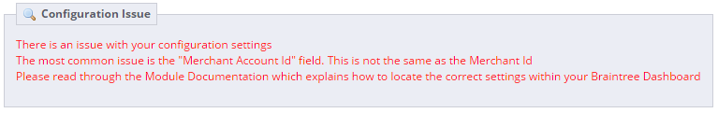

All Technical Checks must pass before the module will function properly. If you are going to enable Paypal, then an SSL certificate will be required. This is a requirement of Braintree and Paypal and not something the module can control.

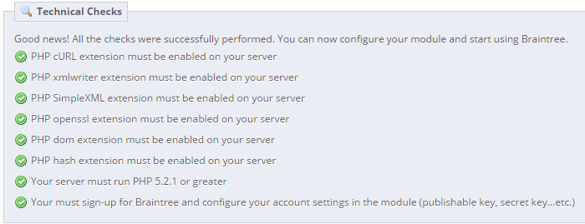

A link to the modules documentation has been added to the module configuration page.

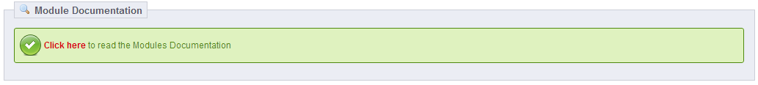

## API Settings

The following screen shot depicts the settings you must update before trying to use the module.

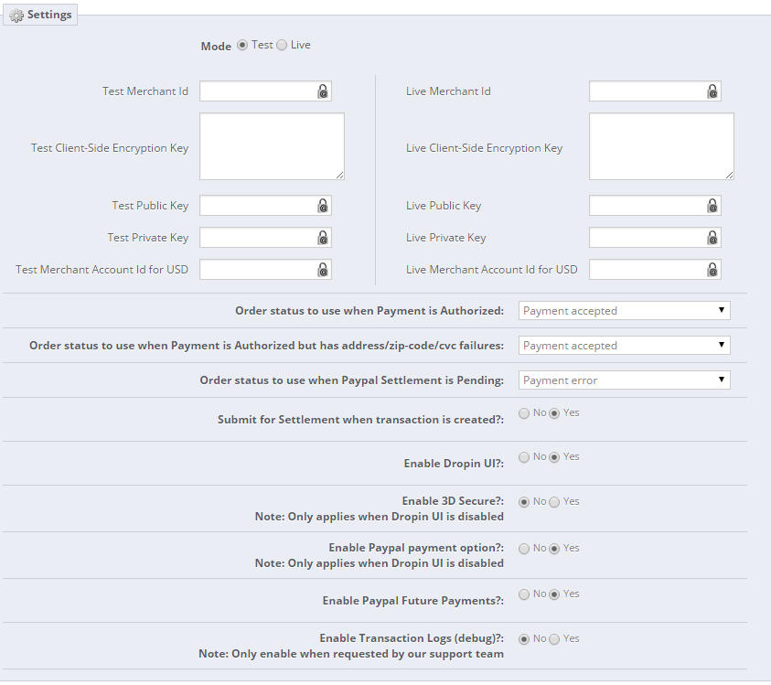

**Mode**: By default the mode is Test. Once Braintree has authorized your account for production mode, you must change the mode to Live. You can switch between Test and Live settings even after you move to Production. This is helpful if you need to upgrade Prestashop or test the checkout process.

**Merchant Id**: This information will be provided to you by Braintree. You can log into your Braintree dashboard to locate the API settings. This setting is now located under “Settings > Users and Roles” menu. Select the user from the list and then scroll down and click the “API Keys” link in the Authorization section.

**Client Side Encryption Key**: This information will be provided to you by Braintree. This setting is now located under “Settings > Users and Roles” menu. Select the user from the list and then scroll down and click the “API Keys” link in the Authorization section.

**Public Key**: This information will be provided to you by Braintree. This setting is now located under “Settings > Users and Roles” menu. Select the user from the list and then scroll down and click the “API Keys” link in the Authorization section.

**Private Key**: This information will be provided to you by Braintree. This setting is now located under “Settings > Users and Roles” menu. Select the user from the list and then scroll down and click the “API Keys” link in the Authorization section.

**Merchant Account Id for <Currency>**: This information will be provided to you by Braintree. **This field is not the same as the Merchant Id**. Within your Braintree dashboard, click on Settings menu, and then Processing. The Merchant Account Id will be listed in the Merchant Accounts section. If you accept more than 1 currency, you will need to enter a Merchant Account Id for each currency.

**Order Status Choices**: When an order is created, the module will use the Order Status you configure in this section.

* **Payment is Authorized**: This order status will be used when there are no transaction issues
* **AVS or CVC failures**: This order status will be used when “Payment is Authorized”, but there was an AVS or CVV failure. Refer to the appendix for suggested configuration
* **Paypal Settlement is Pending**: This order status will be used when Braintree attempts to settle a Paypal transaction and the result is Pending”. Braintree suggests contacting them directly if this scenario were to occur. They state is should be a rare occurrence.

**Submit for Settlement**: Select Yes if you would like Braintree to auto settle the authorizations. If you select No, then you will need to manually Settle (Capture) each payment within Braintree dashboard. In the future, you will be able to capture the funds within the back office.

**Enable Dropin UI**: Select Yes if you would like to use the Braintree Dropin UI during the checkout process. This allows for advanced features like storing the customers payment methods in the Braintree vault. The Dropin UI will also provide better support all types of mobile and tablet devices. Refer to the following URL for more information and a demo

<https://www.braintreepayments.com/features/drop-in>

**Enable 3D Secure**: Select Yes if you would like to enable 3D Secure during checkout. This setting only applies if you are **not** using the Dropin UI. Refer to the following URL for more information <https://developers.braintreepayments.com/javascript+php/guides/3d-secure/overview>

**Enable Paypal payment option**: Select Yes if you would like to include the Braintree Paypal button functionality during checkout. This setting only applies if you are **not** using the Dropin UI. Refer to the following URL for more information <https://articles.braintreepayments.com/guides/paypal/setup-guide>

**Enable Paypal Future Payments**: If the Paypal payment option is enabled, or you are using the Dropin UI with Paypal enabled, a customer will be prompted to add their Paypal account during checkout. If “future payments” is enabled, the customers Paypal account will be stored in the Braintree Vault and made available to the customer to use on future orders. For more information regarding this option, please refer to this URL <https://developers.braintreepayments.com/javascript+php/sdk/client/paypal#future-payments-ui-flow>

**Enable Transaction Logs**: If this option is enabled, all transactions to and from Braintree will be recorded in the “/modules/braintreejs/logs” directory. This is useful for testing in the sandbox and for troubleshooting issues. It is recommended to disable this option when you move to “Live” mode, and only enable if you are encountering issues or have been requested to enable by our support team. Sensitive customer and payment information will be recorded in this logs, so be sure to delete these logs when you are finished with them

## Display Settings

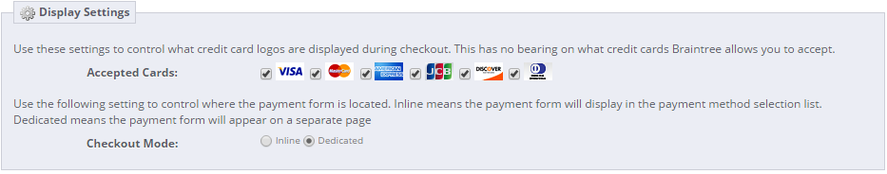

**Accepted Cards**: This option allows you to configure which credit card logos you would like to display during the checkout process. This setting has nothing to do with the actual Credit Cards that Braintree allows you to accept.

**Checkout Mode**: This option allows you to control where the payment form is located.

* **Inline**: This option means the payment form will display in the payment method selection list
* **Dedicated**: This option means the payment form will appear on a separate page

## Testing

**Test Credit Cards**: You may use these credit card numbers while in Test mode. For more information regarding testing in the sandbox, please refer to this URL <https://www.braintreepayments.com/docs/php/reference/sandbox>

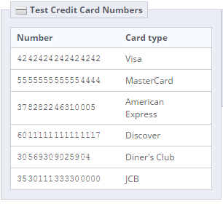

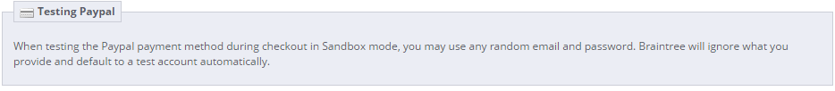

## Appendix

### Suggested Module Configuration

The following information provides suggestions as to how to configure your Braintree Account and Module. This configuration assumes the following

1. You do not want to automatically accept payments that fail either CVC or AVS checks
2. You have configured your Braintree account to reject/decline payments that fail CVC or AVS checks
3. Not all Countries and Financial Institutions support AVS rules and therefore will authorize the payment regardless of the card holder information that is supplied by the customer.

### Braintree Account Configuration

#### Basic Fraud Protection

It is advised to configure and enable “Basic Fraud Protection” within your Braintree Account. This will instruct the Braintree payment gateway to reject any payment transactions that fail AVS or CVC checks. For more information refer to the Braintree Articles located at the following URLs

<https://support.braintreepayments.com/customer/portal/articles/1429080>

<https://support.braintreepayments.com/customer/portal/articles/1430582-avs-and-cvv-recommendations>

#### Advanced Fraud Protection

In addition to Basic Fraud Protection, Braintree also provides Advanced Fraud protection. The Braintree Module already provides the required support for implementing “Braintree Data”. For more information refer to the Braintree Articles located at the following URLs

<https://articles.braintreepayments.com/guides/fraud-tools/advanced>

<https://www.braintreepayments.com/docs/php/general/fraud_tools>

#### 3D Secure

3D Secure benefits cardholders and merchants by providing an additional layer of verification. During the checkout process, a lookup is performed to determine whether the card is eligible to use 3D Secure. If the lookup determines that the cardholder should authenticate using 3D Secure, the Braintree SDK will display a web page that is provided by the card issuer. This page will verify the cardholder’s identity, which is usually achieved by entering a password.

Refer to this WIKI page to learn more about the 3D Secure feature

<https://en.wikipedia.org/wiki/3-D_Secure>

### Braintree Module Configuration

We suggest creating a new “Pending Order Validation” Order Status within Prestashop for Orders that have authorized payments with CVC or AVS check failures. This is also useful for Paypal transactions that are in the “Settlement Pending” status. This allows the Merchant to review the Order and Payment transaction for issues, optionally run the payment through Fraud screening and determine if the payment should be accepted or void/refund.

#### Prestashop Order Status

Navigate to your Prestashop Back Office “Orders > Statuses” section and create a new order status. You can refer to the screen shot for suggested order status options.

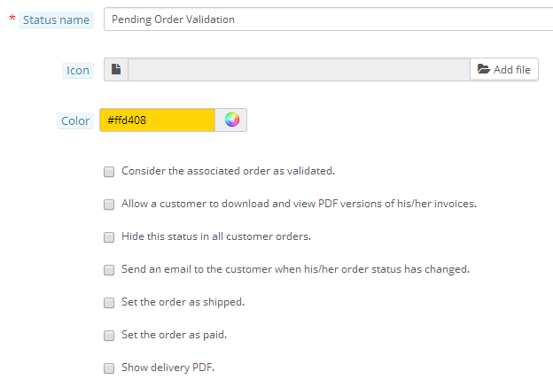

#### Braintree Module Order Status Configuration

Once the “Pending Order Validation” Order Status has been created, navigate to the Braintree Module configuration and update the “Order Status” settings using the following screen shot as a guide.

* For Payments that are authorized and do not have CVC or AVS failures, you typically want to use the “Payment Accepted” order status.
* For Payments that are authorized but have failed CVC and/or AVS checks, you should use your new “Pending Order Validation” order status.
* For Paypal Payments that are authorized but are in the “Settlement Pending” status, you should use your new “Pending Order Validation” order status.

