**Supplemental Figures**

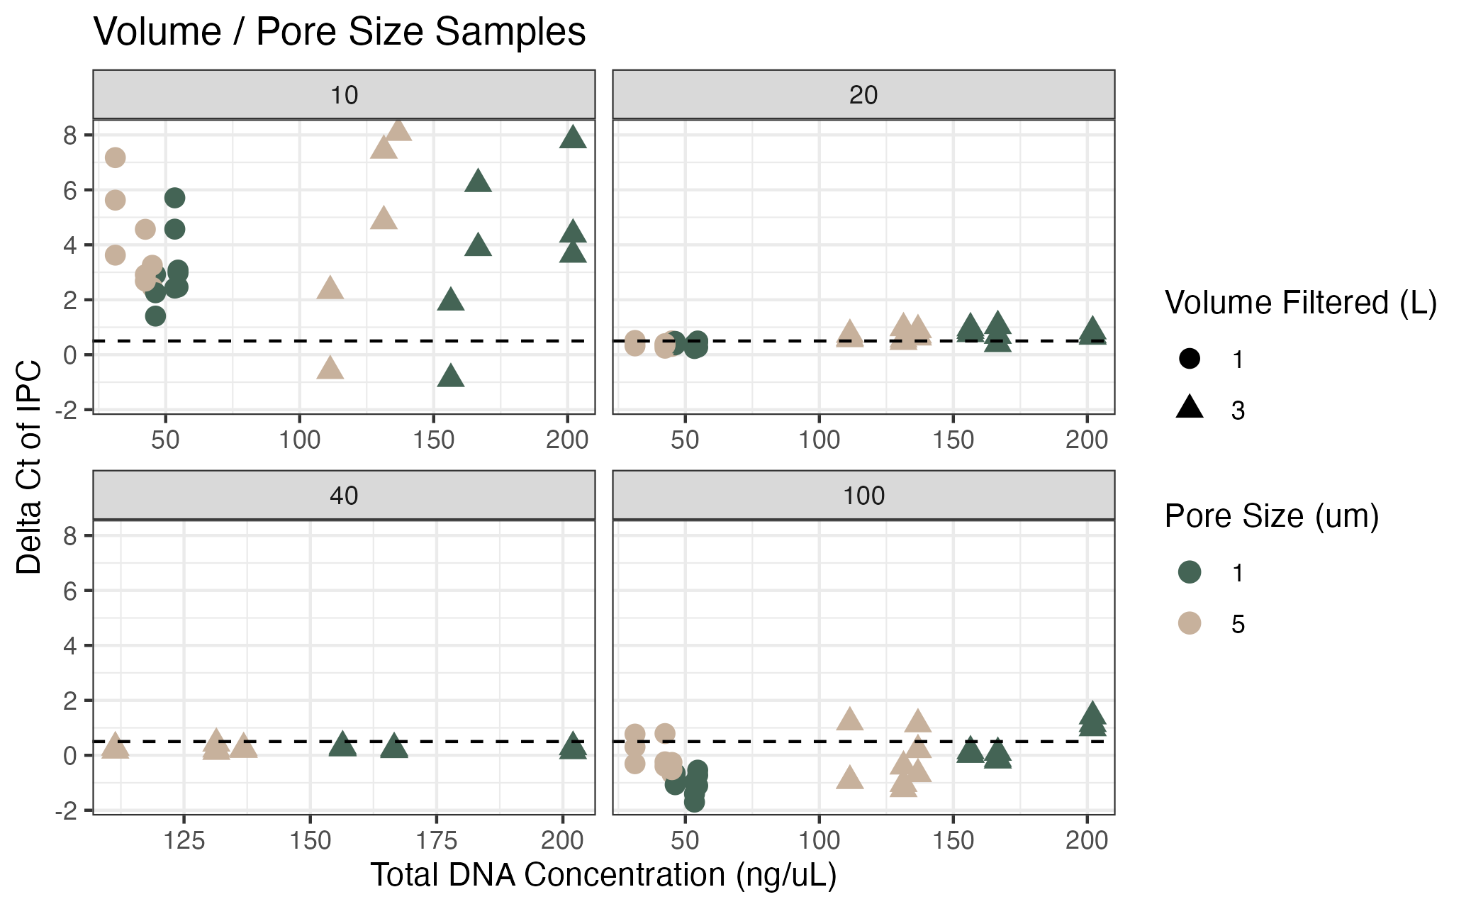**Supplemental Figure 1.** Inhibition testing results from Campaign 1 (pore size / volume filtered). The y axis shows the difference in Ct value from the environmental sample versus the no template control of the spiked internal positive control (IPC). The x axis shows the total DNA concentration of the sample as measured by Qubit. Colors correspond to the pore size of the filter (um) and shapes correspond to the volume of water filtered (L). Dashed lines represent the threshold at which samples were deemed inhibited (0.5 Ct difference). Facets indicate the dilution factor.

**Supplemental Figure 2.** Inhibition testing results from Campaign 1 (pore size / volume filtered); same data as in Supplemental Figure 1. The y axis shows the difference in Ct value from the environmental sample versus the no template control of the spiked internal positive control (IPC). The x axis shows each unique sample. The facets correspond to the pore size of the filter (um) and shapres correspond to the volume of water filtered (L). The colors show the dilution factor.

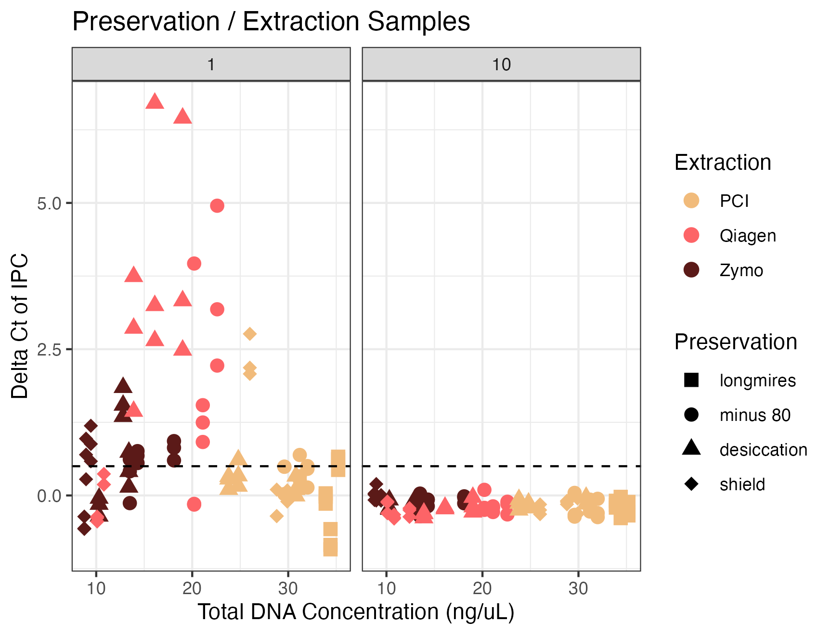 **Supplemental Figure 3.** Inhibition testing results from Campaign 2 (preservation and extraction method). The y axis shows the difference in Ct value from the environmental sample versus the no template control of the spiked internal positive control (IPC). The x axis shows the total DNA concentration of the sample as measured by Qubit. Colors correspond to the extraction method and shapes correspond to the preservation method. Dashed lines represent the threshold at which samples were deemed inhibited (0.5 Ct difference). Facets indicate the dilution factor.

**Supplemental Figure 4.** Inhibition testing results from Campaign 2 (preservation and extraction method); same data as in Supplemental Figure 3. The y axis shows the difference in Ct value from the environmental sample versus the no template control of the spiked internal positive control (IPC). The x axis shows each unique sample. The facets correspond to the preservation and extraction method. The colors show the dilution factor.  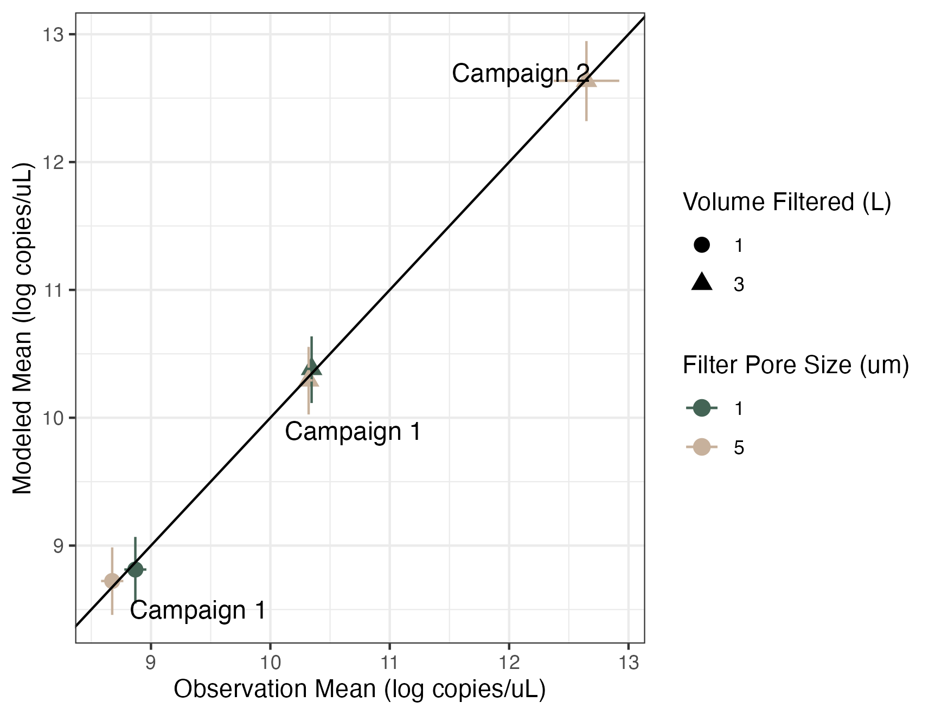**Supplemental Figure 5.** Volume and Pore Size Linear Model Results. Modeled estimates versus the observed mean of technical and biological replicates. Error bars show 2.5% and 97.5% confidence intervals. Colors correspond to the pore size of the filter (um) and shapes correspond to the volume of water filtered (L).

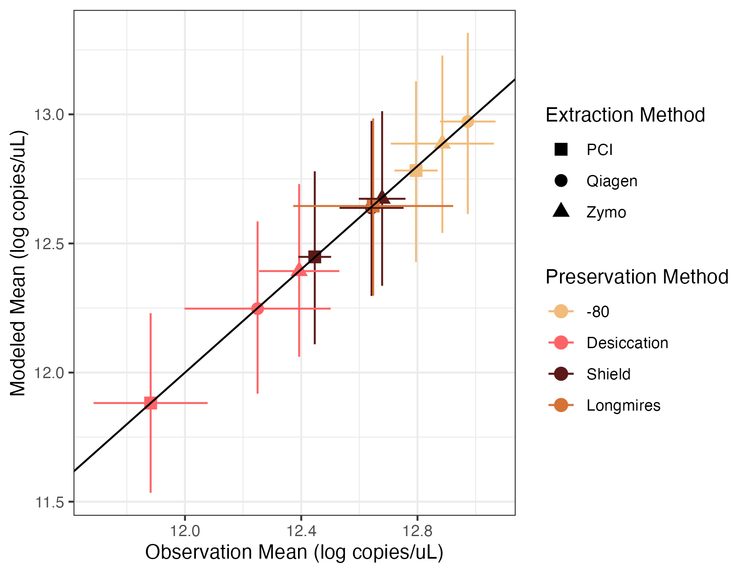

**Supplemental Figure 6.** Preservation and Extraction Model Results. Modeled estimates versus the observed mean of technical and biological replicates. Error bars show 2.5% and 97.5% confidence intervals. Colors correspond to the extraction method and shapes correspond to the preservation method.