Assignment 0: Intro to R and Github

Ian Lin

January 27, 2016

## **Introduction**

**Github Account:** *eaneatfruit*

The following report will document the completed exercises in the document "A (very) short introduction to R", and a published report using R Markdown as well as knitr. The document contains all 15 ToDo exercises. The objective of this assignment is familiarize ourselvevs with R and the usage of git and github. Furthermore, this report in html format will be uploaded to my github.

#### **A (Very) Short Introduction to R**

**1.)** Compute the difference between 2016 and the year you started at this university and divide this by the difference between 2016 and the year you were born. Multiply this with 100 to get the percentage of your life you have spent at this university. Use brackets if you need them.

((2016-2014)/(2016-1992)) * 100

## [1] 8.333333

**2.)** Repeat the previous ToDo, but with several steps in between. You can give the variables any name you want, but the name has to start with a letter.

AcademicLife <- (2016-2014)  
TotalLife <- (2016-1992)  
LifeSpent <- ((AcademicLife/TotalLife) * 100)  
LifeSpent

## [1] 8.333333

**3.)** Compute the sum of 4, 5, 8 and 11 by first combining them into a vector and then using the function **sum**.

vector <- c(4, 5, 8, 11)  
sum(vector)

## [1] 28

**4.)** Plot 100 normal random numbers.

x = rnorm(100)  
plot(x)

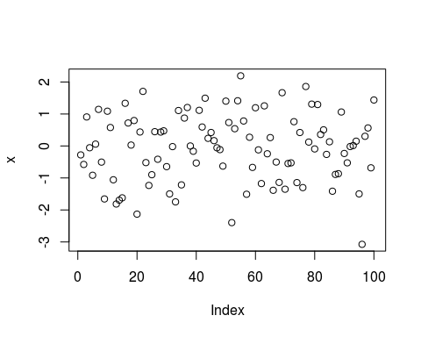

**5.)** Find help for the sqrt function. The sqrt() function is a mathematical function that computes the absolute value of x in an example like such as sqrt(x).

help(sqrt)

**6.)** Make a file called firstscript.R containing R-code that generates 100 random numbers and plots them, and run this script several times.

source("/home/malin4/SRT411/firstscript.R")

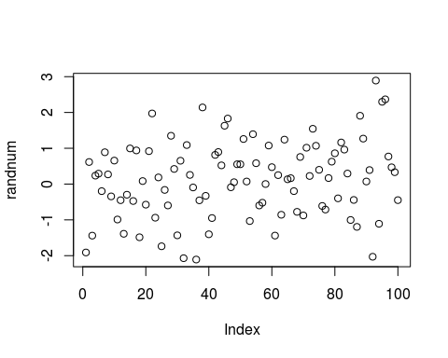

*Contents of firstscript.R:*

randnum <- rnorm(100)  
plot(randnum)

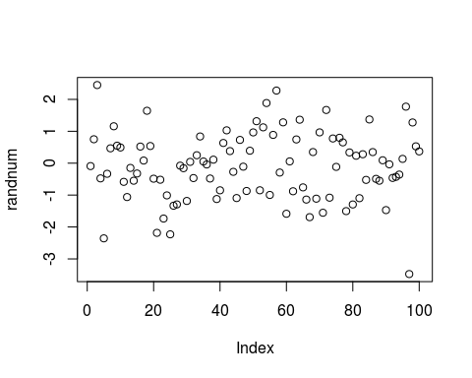

**7.)** Put the numbers 31 to 60 in a vector named P and in a matrix with 6 rows and 5 columns named Q. **Tip:**  
use the function seq. Look at the different ways scalars, vectors and matrices are denoted in the workspace window.

Q <- matrix(P <- c(31:60), nrow = 6, ncol = 5)  
Q

## [,1] [,2] [,3] [,4] [,5]  
## [1,] 31 37 43 49 55  
## [2,] 32 38 44 50 56  
## [3,] 33 39 45 51 57  
## [4,] 34 40 46 52 58  
## [5,] 35 41 47 53 59  
## [6,] 36 42 48 54 60

seq(Q)

## [1] 1 2 3 4 5 6 7 8 9 10 11 12 13 14 15 16 17 18 19 20 21 22 23  
## [24] 24 25 26 27 28 29 30

**8.)** Make a script file which constructs three random normal vectors of length 100. Call these vectors x1, x2 and x3. Make a data frame called **t** with three columns (called a, b and c) containing respectivelyx1, x1+x2 and x1+x2+x3. Call the following functions for this data frame: plot(t) and sd(t). Can you understand the results? Rerun this script a few times.

Calling the Script

#source("/home/malin4/SRT411/VectorScript.R")

Note that the standard deviation function does not work because it is no longer existing since R-3.0.0. Advised to use sapply(x, sd) instead. Also, the standard deviation function does not work with data frames. *Content of the Script:*

x1 <- c(rnorm(100))  
x2 <- c(rnorm(100))  
x3 <- c(rnorm(100))  
  
t = data.frame(a = x1, b = x1+x2, c = x1+x2+x3)  
plot(t)

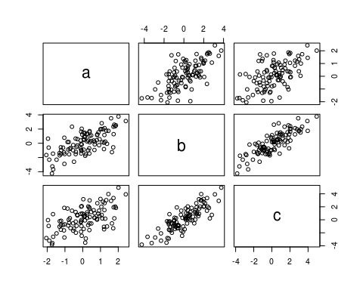

sd(x1)

## [1] 1.044812

sd(x2)

## [1] 1.162741

sd(x3)

## [1] 1.006475

**9.)** Add these lines to the script file of the previous section. Try to find out, either by experiment- ing or by using the help, what the meaning is of rgb, the last argument of rgb, lwd, pch, cex.

*Content of Script:*

x1 <- c(rnorm(100))  
x2 <- c(rnorm(100))  
x3 <- c(rnorm(100))  
  
t = data.frame(a = x1, b = x1+x2, c = x1+x2+x3)  
  
plot(t$a, type="l", ylim=range(t),  
lwd=3, col=rgb(1,0,0,0.3))  
lines(t$b, type="s", lwd=2,  
col=rgb(0.3,0.4,0.3,0.9))  
points(t$c, pch=20, cex=4,  
col=rgb(0,0,1,0.3))

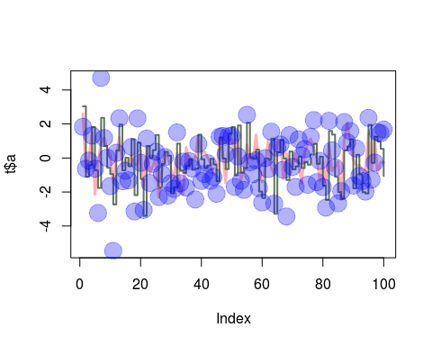

*Explanation:* The meaning of **rgb** is the *Red, Green, Blue Color Specification.* The last parameter of the rgb function is the alpha parameter. The alpha parameter is the optional argument for transparency.

The option **lwd** is the line width for drawing symbols.

The option **pch** is to add points to a plot. It draws a sequence of points based on the x and y coordinates.

The option **cex** are for character or symbol expansions.

**10.)** Make a file called **tst1.txt** in Notepad from the example in *Figure 4* and store it in your working directory. Write a script to read it, to multiply the column called g by 5 and to store it as **tst2.txt**.

d = data.frame(a = c(1,2,4,8,16,32), g = c(2, 4,8,16,32,64), x = c(3,6,12,24,48,96))  
write.table(d, file = "tst1.txt", row.names = FALSE)  
source("/home/malin4/SRT411/readfile.R")

*Contents of readfile.R:*

d = read.table(file="tst1.txt", header = TRUE)  
d$g <- d$g * 5  
d = write.table(d, file = "tst2.txt", row.names = FALSE)

**11.)** Compute the mean of the square root of a vector of 100 random numbers. What happens?

*Explanation: Some values of the vectors were returned, however, many NaN values were produced. NaNs are an abbreviation for 'Not a Number.'*

x <- c(rnorm(100))  
sqx <- sqrt(x)

## Warning in sqrt(x): NaNs produced

y <- mean(sqx, na.rm = TRUE)  
y

## [1] 0.8496655

**12.)** Make a graph with on the x-axis: today, Sinterklaas 2016 and your next birthday and on the y-axis the amount of presents you expect on each of these days. Tip: make two vectors first.

date=strptime(c("20160128","20161205", "20161126"), format="%Y%m%d")  
presents_num=c(1, 7, 12)  
plot(date, presents_num, xlab = "Dates", ylab = "Presents")

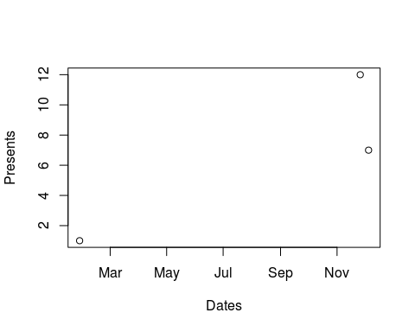

**13.)** Make a vector from 1 to 100. Make a for-loop which runs through the whole vector. Multiply the elements which are smaller than 5 and larger than 90 with 10 and the other elements with 0.1

vector = c(1:100)  
x = c()  
for (i in 1:length(vector))  
 {  
 if (vector[i] < 5)  
 {  
 x[i] <- (vector[i]*10)  
 }  
 else if (vector[i] > 90)  
 {  
 x[i] <- (vector[i]*10)  
 }  
 else  
 {  
 x[i] <- (vector[i]*0.1)  
 }  
 }  
x

## [1] 10.0 20.0 30.0 40.0 0.5 0.6 0.7 0.8 0.9 1.0  
## [11] 1.1 1.2 1.3 1.4 1.5 1.6 1.7 1.8 1.9 2.0  
## [21] 2.1 2.2 2.3 2.4 2.5 2.6 2.7 2.8 2.9 3.0  
## [31] 3.1 3.2 3.3 3.4 3.5 3.6 3.7 3.8 3.9 4.0  
## [41] 4.1 4.2 4.3 4.4 4.5 4.6 4.7 4.8 4.9 5.0  
## [51] 5.1 5.2 5.3 5.4 5.5 5.6 5.7 5.8 5.9 6.0  
## [61] 6.1 6.2 6.3 6.4 6.5 6.6 6.7 6.8 6.9 7.0  
## [71] 7.1 7.2 7.3 7.4 7.5 7.6 7.7 7.8 7.9 8.0  
## [81] 8.1 8.2 8.3 8.4 8.5 8.6 8.7 8.8 8.9 9.0  
## [91] 910.0 920.0 930.0 940.0 950.0 960.0 970.0 980.0 990.0 1000.0

**14.)** Write a function for the previous ToDo, so that you can feed it any vector you like (as argument). Use the standard R function **length** in the specification of the counter.

vec <- c(50:150)  
  
func1 <- function(arg1)  
 {  
 y <- c()  
 for (i in 1:length(arg1))  
 {  
 if (arg1[i] < 5)  
 {  
 y[i] <- (arg1[i]*10)  
 }  
 else if (arg1[i] > 90)  
 {  
 y[i] <- (arg1[i]*10)  
 }  
 else  
 {  
 y[i] <- (arg1[i]*0.1)  
 }  
 }  
 return(y)  
 }  
func1(arg1 <- vec)

## [1] 5.0 5.1 5.2 5.3 5.4 5.5 5.6 5.7 5.8 5.9  
## [11] 6.0 6.1 6.2 6.3 6.4 6.5 6.6 6.7 6.8 6.9  
## [21] 7.0 7.1 7.2 7.3 7.4 7.5 7.6 7.7 7.8 7.9  
## [31] 8.0 8.1 8.2 8.3 8.4 8.5 8.6 8.7 8.8 8.9  
## [41] 9.0 910.0 920.0 930.0 940.0 950.0 960.0 970.0 980.0 990.0  
## [51] 1000.0 1010.0 1020.0 1030.0 1040.0 1050.0 1060.0 1070.0 1080.0 1090.0  
## [61] 1100.0 1110.0 1120.0 1130.0 1140.0 1150.0 1160.0 1170.0 1180.0 1190.0  
## [71] 1200.0 1210.0 1220.0 1230.0 1240.0 1250.0 1260.0 1270.0 1280.0 1290.0  
## [81] 1300.0 1310.0 1320.0 1330.0 1340.0 1350.0 1360.0 1370.0 1380.0 1390.0  
## [91] 1400.0 1410.0 1420.0 1430.0 1440.0 1450.0 1460.0 1470.0 1480.0 1490.0  
## [101] 1500.0

**15.)** Actually, people often use more for-loops than necessary. The ToDo above can be done more easily and quickly without a for-loop but with regular vector computations.

vector <- c(1:100)  
ifelse(vector < 5 | vector > 90, vector * 10, vector * 0.1)

## [1] 10.0 20.0 30.0 40.0 0.5 0.6 0.7 0.8 0.9 1.0  
## [11] 1.1 1.2 1.3 1.4 1.5 1.6 1.7 1.8 1.9 2.0  
## [21] 2.1 2.2 2.3 2.4 2.5 2.6 2.7 2.8 2.9 3.0  
## [31] 3.1 3.2 3.3 3.4 3.5 3.6 3.7 3.8 3.9 4.0  
## [41] 4.1 4.2 4.3 4.4 4.5 4.6 4.7 4.8 4.9 5.0  
## [51] 5.1 5.2 5.3 5.4 5.5 5.6 5.7 5.8 5.9 6.0  
## [61] 6.1 6.2 6.3 6.4 6.5 6.6 6.7 6.8 6.9 7.0  
## [71] 7.1 7.2 7.3 7.4 7.5 7.6 7.7 7.8 7.9 8.0  
## [81] 8.1 8.2 8.3 8.4 8.5 8.6 8.7 8.8 8.9 9.0  
## [91] 910.0 920.0 930.0 940.0 950.0 960.0 970.0 980.0 990.0 1000.0

*ifelse() Explanation:* This is basically saying if vector is less than 5 and vector is greater than 90, then the selected vectors are multiplied by 10. Everything else is multiplied by 0.1. Simply put: **Ifelse(if condition, if true do, else do)**

#### **Acknowledgements**

* <https://cran.r-project.org/doc/contrib/Torfs+Brauer-Short-R-Intro.pdf>
* <https://www.rstudio.com/wp-content/uploads/2015/02/rmarkdown-cheatsheet.pdf>
* <http://rmarkdown.rstudio.com/>
* <http://nicercode.github.io/guides/reports/>
* <http://kbroman.org/knitr_knutshell/pages/markdown.html>
* <http://kbroman.org/knitr_knutshell/pages/Rmarkdown.html>
* <http://stackoverflow.com/questions/15103465/how-to-multiply-a-single-column-in-a-data-frame-by-a-number>
* <http://www.lynda.com/R-tutorials/Up-Running-R/120612-2.html>