Emily Antico (worked with Daniel Nametz)

Professor Mao

CISC 4615

28 February 2020

Lab 2 Report

To complete Part 1 of the lab, I had to create a forwarder file that was bound to a specific port, received the message from the client, decoded it, converted the message to the corresponding string representation using the struct.pack function, and sent the message along to the server. In the client file, I had to use the struct.pack function on the text inputted by the user and then I had to send that message directly to the port of the forwarder. In the server file, I had to bind it to a specific port, allow it to receive messages from the forwarder port, unpack the data received, decode the message, and print it. All files ended if the user typed in 'bye'.

To complete Part 2 of the lab, in the client file the only thing I added was that the message and CRC was sent to the forwarder port and the server port, which I hardcoded, in order to compare the two messages later on. I used the same forwarder file as I did in part one, but I added the 40% possibility that the forwarder would send a different message to the server than the client did. To implement this, I added a variable that calculated a random number between 1 and 10. I checked if this variable was less than or equal to 4, and if it was, the forwarder sent a different message to the server. I then used the struct.pack function and encoded the string and sent it to the server. In the server file, I created a list and when the server received a message from the client and the forwarder, making the length of the list 2, the program would check if these two messages were the same. If they were not, it would print "the message has changed". After this comparison, I cleared the list so the program would be able to check the next two messages. All three files ended after the user typed in 'bye'.

Overall, in this lab I learned the importance of the UDP and its connection-less function. I was able to easily see the differences between TCP and UDP through this lab, as the forwarder was not something we needed in lab 1 since the client and server formed their own connection. Additionally, I learned the importance of the struct.pack function within the various files.

Testing Part 1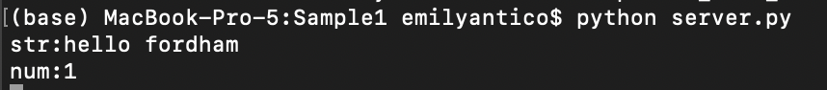

Testing Part 2