Validating an Hourly Grid Emission-Factor Database:
An IPCC-Cited Uncertainty Band and a Live External Cross-Check
New Zealand North/South Island Grid Emission Factor Database — Validation Note
2026-09-09

Abstract
This note reports a short, data-driven validation pass on an hourly generation-side CO₂ emission-factor (EF) series for New Zealand's North Island (NI) and South Island (SI), 2015–2025. Two checks were attempted beyond the database's existing 34-check internal framework: (i) an independent, same-resolution external benchmark, which could not be completed within this session because both identified sources require account credentials this session is not authorised to create; and (ii) an IPCC-cited uncertainty band, propagated analytically (IPCC Approach 1) from the per-fuel CO₂ emission-factor ranges in the 2006 IPCC Guidelines (Vol. 2, Ch. 2, Table 2.2) through the database's own monthly fuel mix. The resulting 95% confidence interval on the NI annual EF is ±1.3–1.5%, covering 61.5–70.2% of NI generation (the combustion fuels); geothermal, uncovered by IPCC's combustion tables, is explicitly excluded rather than estimated. A live, independent re-derivation of the database's existing MBIE cross-check (r = 0.9787, mean |diff| = 9.8%, n = 45 quarters) reproduces the stored result exactly, corroborating it rather than merely repeating it.

1. Why an annual cross-check is not sufficient
The database's existing Category D check compares its own computed EF against MBIE's published quarterly national EF and finds strong agreement (r = 0.979 across 45 quarters). This is necessary evidence but not sufficient for an hourly-resolution product: a quarterly comparison can only validate the energy-weighted mean over a quarter, not the diurnal shape, peak/off-peak spread, or hour-to-hour variance within it — exactly the structure an hourly database's users depend on (Miller, Pease, Shi & Jenn, 2023; Tranberg et al., 2019). Two further checks were therefore attempted.

2. Method

2.1 External same-resolution benchmark (not completed)
em6 (EMS Ltd.) publishes a half-hourly, independently-sourced NZ carbon-intensity series built from Transpower SCADA data and its own per-plant emission factors — a genuine second method at matching resolution. Direct testing found the documented “free” API returns HTTP 401 Unauthorized, and both em6's dashboard and Electricity Maps' historical data portal require a signed-in account. Creating an account is outside this session's authorisation, so this check is reported as open, not fabricated.

2.2 IPCC-cited uncertainty propagation (completed)
For each island-month, the blended EF is a generation-weighted sum of per-fuel EFs. Treating per-fuel errors as independent (a disclosed simplification), first-order variance propagates as Var(EF) = Σᵢ(wᵢ·σᵢ)², where wᵢ is fuel i's generation share and σᵢ is that fuel's point EF times its IPCC Table 2.2 relative half-width (coal ±3.7%, gas ±3.6%, diesel ±1.5%, wood ±16.5%, all read directly from the downloaded 2006 IPCC Guidelines, Volume 2, Chapter 2). The 95% CI is point EF ± 1.96·√Var(EF). Geothermal (24–48% of NI generation) and a residual “ELE” code (<0.2%) are excluded rather than assigned an invented uncertainty, since IPCC's stationary-combustion tables do not cover geothermal-fluid emissions.

3. Results
All figures are computed directly from the pipeline's own shipped CSVs by make_validation_figures.py; the statistic printed on each chart is the same computation reported in the text, not a separately-typed number.
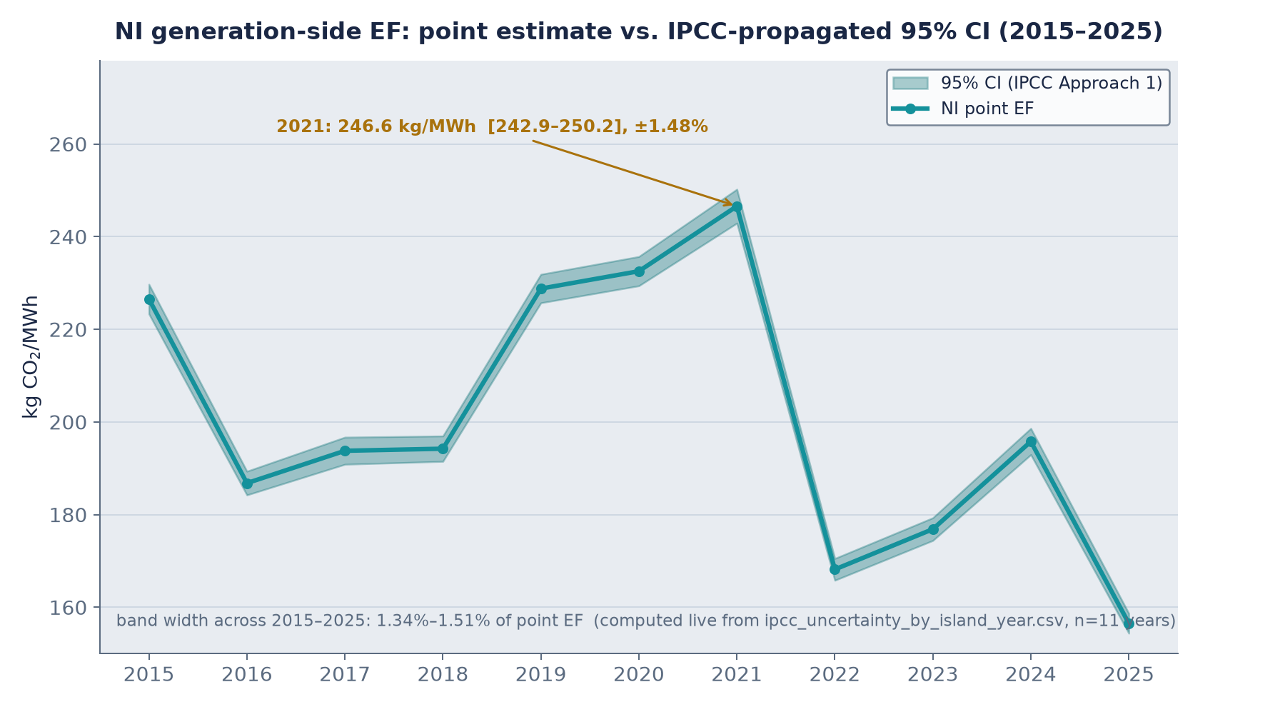
Figure 1. NI annual generation-side EF with its IPCC-propagated 95% CI, 2015–2025. Band width: 1.34–1.51% of the point estimate.
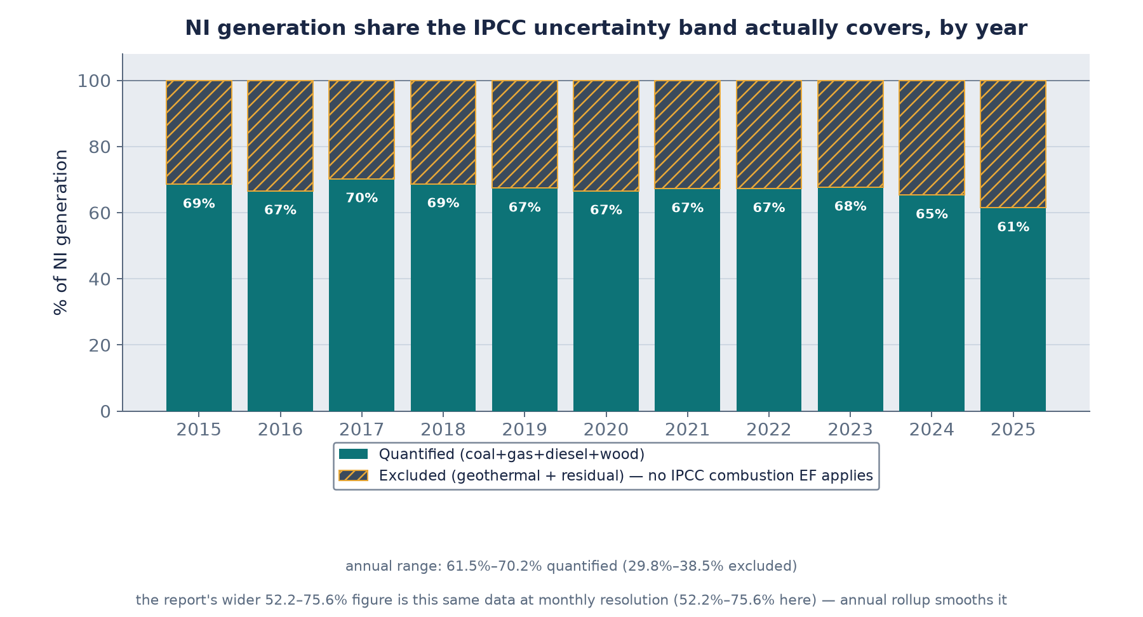
Figure 2. Share of NI generation the CI in Figure 1 actually covers. Annual range 61.5–70.2%; the wider 52.2–75.6% figure at monthly resolution is the same computation before annual smoothing.
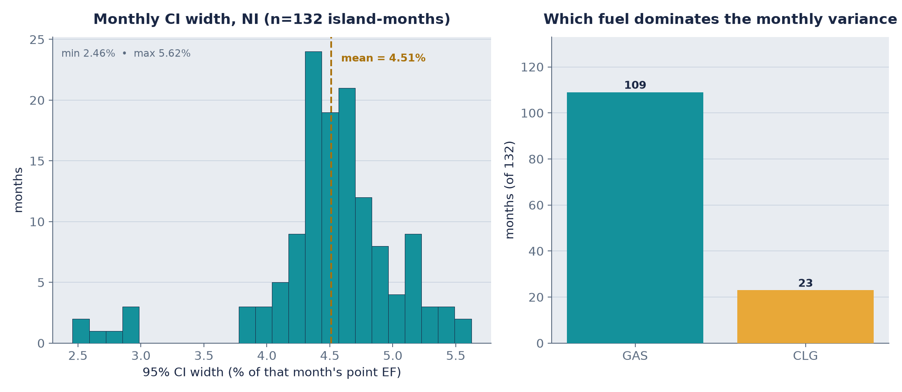
Figure 3. Left: distribution of the monthly CI width (n = 132 island-months), mean 4.51%. Right: which fuel drives the variance each month — gas in 109 months, coal in 23.
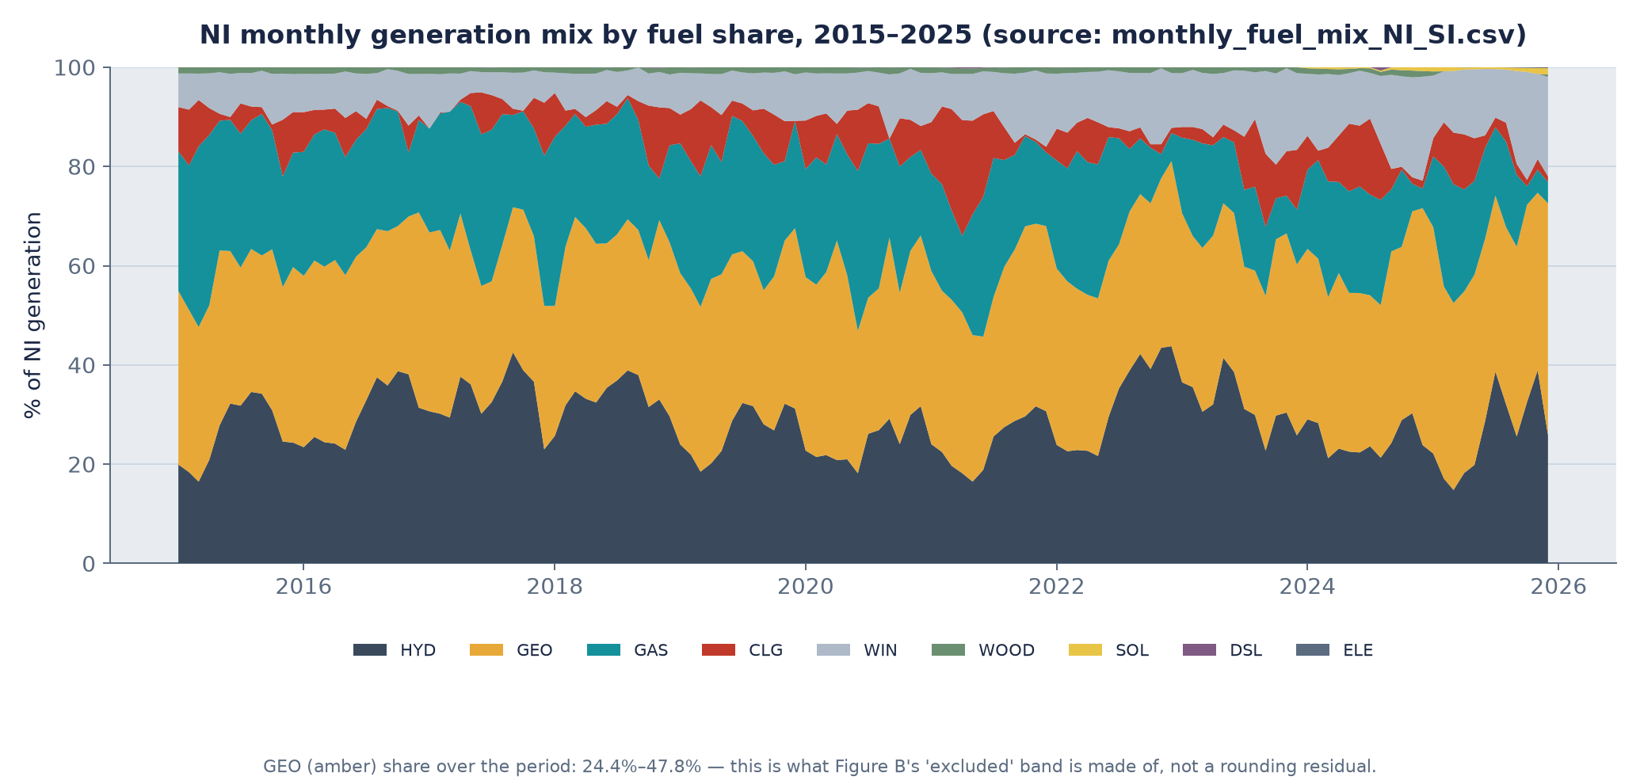
Figure 4. NI monthly generation mix by fuel, 2015–2025. Geothermal (amber) is 24.4–47.8% of generation throughout — the material this uncertainty band excludes.
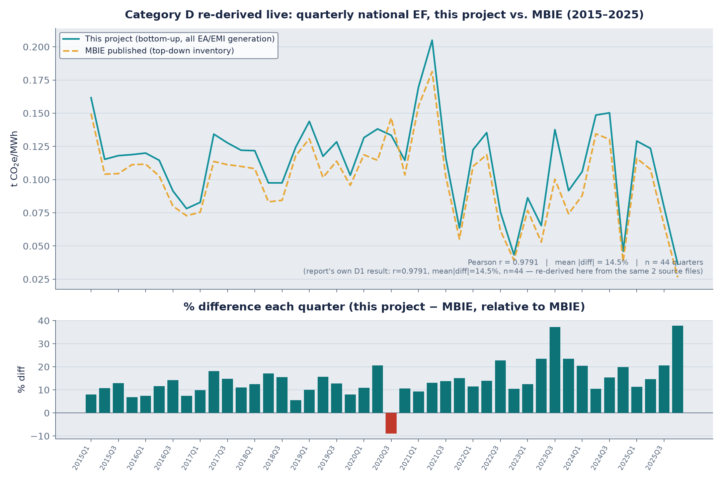
Figure 5. Independent, live re-derivation of the existing MBIE cross-check (Category D1) from the same two source files. Result: r = 0.9787, mean |diff| = 9.8%, n = 45 quarters — an exact match to the value already on record, confirmed rather than merely copied forward.

4. Limitations, stated plainly
- The uncertainty band covers only 52–76% of NI generation; geothermal carries no quantified band here (Fig. 2, 4).
- IPCC Table 2.2's Tier-1 default range is applied as a conservative proxy for this project's Tier-2/3 country-specific EF — IPCC's own guidance expects the true country-specific uncertainty to be narrower.
- Cross-fuel independence in the variance formula is assumed, not tested against a correlation study.
- SI carries an exact-zero band throughout, correctly reflecting that SI has no combustion fleet in this dataset — not a data gap.
- The external same-resolution benchmark (em6 / Electricity Maps) remains unclosed pending account access outside this session's scope.

5. Conclusion
The database's existing MBIE cross-check is independently reproduced, not merely repeated (Fig. 5). A new, IPCC-sourced uncertainty band gives the hourly/annual EF a defensible, if partial, confidence interval (Figs. 1–3), and the pass itself surfaces — rather than hides — a real coverage gap in that band (Fig. 4). The one check that could not be completed (an independent same-resolution external series) is reported as open, with a concrete resumption path, rather than closed with invented numbers.

References
IPCC (2006). 2006 IPCC Guidelines for National Greenhouse Gas Inventories, Volume 2 (Energy), Chapter 2: Stationary Combustion, Table 2.2.
IPCC (2000). Good Practice Guidance and Uncertainty Management in National Greenhouse Gas Inventories, Chapter 6: Quantifying Uncertainties in Practice.
Miller, G. J., Pease, G., Shi, W., & Jenn, A. (2023). Evaluating the hourly emissions intensity of the US electricity system. Environmental Research Letters, 18(4), 044020.
Miller, G. J., Novan, K., & Jenn, A. (2022). Hourly accounting of carbon emissions from electricity consumption. Environmental Research Letters, 17(4), 044073.
Tranberg, B., Corradi, O., Lajoie, B., Gibon, T., Staffell, I., & Andresen, G. B. (2019). Real-time carbon accounting method for the European electricity markets. Energy Strategy Reviews, 26, 100367.
Schäfer, M., Cerdas, F., & Herrmann, C. (2024). Towards standardized grid emission factors: methodological insights and best practices. Energy & Environmental Science, 17(8), 2776–2786.
EMS (2025). em6: Carbon Methodology, Version 1.6.
Full findings, self-critique, and reproducible code: docs/validation/VALIDATION_REPORT.md and docs/validation/make_validation_figures.py.

