Consumption-Based Grid Emission Factor Database
for New Zealand's North and South Islands (2015–2025)
Methodology note: deriving island-level consumption emission factors from metered generation and inter-island (HVDC) transfer data

1. Purpose
The companion generation-based database (see the methodology note in the parent 'Grid Emission Factor' folder) reports the emission factor (EF, kg CO₂/MWh) of electricity generated within the North Island (NI) and South Island (SI). That measure attributes emissions to where the generation physically occurs. This note instead derives a consumption-based EF for each island — the emission intensity of electricity actually drawn down by consumers in that island, accounting for the substantial volume of electricity that moves between islands over the Cook Strait HVDC link. All figures in this note are computed only from the four primary datasets listed in Section 2; no external or assumed emission factors are used.

2. Data sources
This analysis reads the generation-side database's own output directly from the parent 'Grid Emission Factor' folder (Section 3.1; redesigned 2026-08 — see that section for why), plus one additional EA dataset (HVDC transfer, Section 2.4) built and stored in this folder.

2.1 Half-hourly metered generation (Generation_MD)
Source: Electricity Authority, EMI Wholesale Datasets – Generation_MD (https://www.emi.ea.govt.nz/Wholesale/Datasets/Generation/Generation_MD/). 132 monthly files (201501–202512), half-hourly metered generation (kWh, TP1–TP50 — TP49/TP50 exist only on NZ's DST fall-back day, the extra repeated hour) by point of connection (POC) and fuel code. Read from the parent 'Grid Emission Factor' folder's shared EA_EMI_raw/ (single copy, not duplicated in this folder — see Section 3.1).

2.2 Dispatched generation plant register (SCD2)
Source: “Dispatched generation plant.csv”, supplied directly by Dr Phil Bishop, Electricity Authority Data Products team — copied into EA data/ in this folder. Provides HeatRate and EmissionsFactor for thermal/geothermal plant, valid over effective_start_datetime/effective_end_datetime windows, used to compute each plant's emission factor as HeatRate (kJ/kWh) × EmissionsFactor (g CO₂/GJ) ÷ 1,000,000.

2.3 Network Supply Point List, daily snapshots (NSP)
Source: Electricity Authority, EMI report R_NSPL_DR – Network Supply Point List (https://www.emi.ea.govt.nz/Wholesale/Reports/R_NSPL_DR). 106 daily snapshots, copied into EA data/NSP Tables/ in this folder, used to build the POC → Island lookup.

2.4 Inter-island HVDC transfer
Source: Electricity Authority, EMI Wholesale Datasets – HVDC flows (https://www.emi.ea.govt.nz/Wholesale/Datasets/Metered_data/HVDC_Flows/). 132 monthly files (201501–202512), half-hourly metered energy transfer (kWh, TP1–TP50) at each HVDC converter station, by point of connection and flow direction, read from the shared EA_EMI_raw/ folder (as Section 2.1). Energy transfer is read at the receiving end's Import (‘I’) flow direction at each converter station — Northward (South Island → North Island) = HAY2201 (Haywards, North Island) Import; Southward (North Island → South Island) = BEN2201 (Benmore, South Island) Import — the delivered-energy reading, already net of DC-link losses. This replaced (2026-08) an earlier version of this analysis, covering 2021–2025 only, that used a separately hand-exported EMI report file (“HVDC transfer”) instead of this raw dataset; the raw-file method was cross-validated against the earlier report-based method before being adopted, and the two agree to within 0.3–1.5% across all 5 overlapping years (2021–2025).

3. Methodology

3.1 Generation-side inputs (recap)
Generation_island(t), CO₂_generated_island(t) and the generation-based emission factor EF_generation_island(t) = CO₂_generated_island(t) ÷ Generation_island(t) are read directly from the companion generation-side database's own output (monthly_emission_factor_NI_SI.csv, annual_emission_factor_NI_SI.csv, daily_emission_factor_NI_SI.csv, hourly_emission_factor_NI_SI.csv — parent 'Grid Emission Factor' folder, output/), computed there by: POC → Island via the NSP lookup (Section 2.3), thermal/geothermal POCs matched to their SCD2 emission factor by (POC, fuel) for the calendar month in question (Section 2.2), renewable fuels (hydro, wind, solar) assigned EF = 0. This analysis was redesigned in 2026-08 to read that shared output directly, rather than maintaining a second, independent copy of the same raw-file ingestion logic in this folder — the previous self-contained design meant that data-quality fixes made to the generation-side database (a plant-register timestamp-parsing issue and a DST fall-back under-count, both documented in that folder's own methodology note) had to be independently rediscovered here, and had not been, until this redesign.

3.2 Inter-island transfer
From the HVDC dataset (Section 2.4), for any time period t:
net_to_NI(t) = SI_to_NI(t) − NI_to_SI(t)
where SI_to_NI(t) is the summed Import-direction energy transfer at HAY2201 (Haywards) and NI_to_SI(t) is the summed Import-direction energy transfer at BEN2201 (Benmore) within period t (Section 2.4).

3.3 Energy balance
Apparent consumption in each island is generation adjusted for net inter-island transfer:
Consumption_NI(t) = Generation_NI(t) + net_to_NI(t)
Consumption_SI(t) = Generation_SI(t) − net_to_NI(t)
This is termed “apparent” consumption because it is a physical energy balance using only the metered generation and HVDC transfer data available — it does not include transmission/distribution losses, embedded (behind-the-meter) generation, or storage, since no data source for those was provided (see Limitations, Section 7).

3.4 Emissions balance
Emissions are reallocated using the same transfer volumes, under the “average-mix” convention — electricity leaving an island via the HVDC link is assumed to carry that island's own generation-weighted average emission factor for the period in question. This is the one assumption in this analysis that is not a directly observed quantity in the data (the dataset has no record of which individual generator's output is exported); it is stated explicitly here rather than left implicit.
CO₂_consumed_NI(t) = CO₂_generated_NI(t) − NI_to_SI(t)·EF_gen_NI(t) + SI_to_NI(t)·EF_gen_SI(t)
CO₂_consumed_SI(t) = CO₂_generated_SI(t) − SI_to_NI(t)·EF_gen_SI(t) + NI_to_SI(t)·EF_gen_NI(t)
The consumption-based emission factor is then EF_consumption_island(t) = CO₂_consumed_island(t) ÷ Consumption_island(t).

4. Aggregation and resolution
The same balance (Sections 3.3–3.4) is applied independently at four resolutions, each built directly from the underlying half-hourly source data rather than by averaging a coarser series down: hourly (paired half-hour trading periods), daily, monthly, and annual. At every resolution, EF is generation-weighted (total CO₂ ÷ total energy for that period), not an average of finer-resolution EF values — see Section 6 for an important, disclosed consequence of this design for island-level (not national) CO₂ figures. Outputs: hourly_consumption_EF_NI_SI.csv, daily_consumption_EF_NI_SI.csv, monthly_consumption_EF_NI_SI.csv, annual_consumption_EF_NI_SI.csv, all in ./output/ (this folder), built from the generation-side output (Section 3.1) and this folder's own HVDC transfer output (hourly_/daily_/monthly_/annual_hvdc_transfer_NI_SI.csv, also ./output/, built by build_hvdc_transfer_full.py from the Section 2.4 source).

5. Results
Table 1 summarises the annual results (now 11 years, 2015–2025, extended 2026-08 from the original 5-year 2021–2025 span). North Island consumption (≈24.9–25.8 TWh/yr) exceeds its own generation (≈21.8–24.7 TWh/yr, see the companion generation-side report) by the net import from the South Island; South Island consumption (≈14.9–15.7 TWh/yr) is correspondingly below its own generation (≈16.1–18.9 TWh/yr).
Year | NI consumption (TWh) | NI EF, consumption (kg/MWh) | SI consumption (TWh) | SI EF, consumption (kg/MWh)
2015 | 25.44 | 203 | 15.36 | 3.2
2016 | 25.46 | 159 | 14.87 | 0.8
2017 | 25.66 | 180 | 15.08 | 10.3
2018 | 25.84 | 171 | 14.86 | 2.7
2019 | 25.54 | 197 | 15.49 | 1.3
2020 | 25.12 | 208 | 15.50 | 1.9
2021 | 25.71 | 219 | 15.27 | 3.6
2022 | 25.20 | 150 | 15.47 | 2.7
2023 | 24.94 | 155 | 15.66 | 2.4
2024 | 25.63 | 180 | 15.61 | 7.4
2025 | 25.30 | 144 | 15.67 | 5.7

Table 1. Annual consumption-based results. Source: output/annual_consumption_EF_NI_SI.csv.
Two consequences of the import/export pattern are visible directly in the data:
- North Island's consumption-based EF is lower than its generation-based EF in every single year of the full 2015–2025 record (e.g. 227 vs 203 kg/MWh in 2015; 157 vs 144 kg/MWh in 2025) — NI consumers' electricity is, on average, cleaner than NI's own generation mix because a meaningful share is imported zero-carbon South Island hydro.
- South Island's consumption-based EF is strictly positive in every year (0.8–10.3 kg/MWh) despite its generation-based EF being exactly 0 in every year — South Island consumers' electricity carries a small embodied emissions intensity because some of what they use is imported from the North Island's thermally-backed grid via southward HVDC flow.
- With the full 11-year record, South Island consumption EF is highest in exactly the years independently identified as dry/gas-heavy by the generation-side database (2017, 2021, 2024: 10.3, 3.6 and 7.4 kg/MWh respectively) — dry years average 7.10 kg/MWh vs 2.58 kg/MWh in other years, consistent with more southward (NI→SI) thermally-backed HVDC flow covering the South Island's own reduced hydro surplus in those years. This is convergent evidence across three independently-built parts of this project (generation EF, HVDC transfer volume, consumption EF), not a coincidence of the formula — see generation_pipeline/DATA_QUALITY_ASSESSMENT_FRAMEWORK.md (sibling folder), check H6.
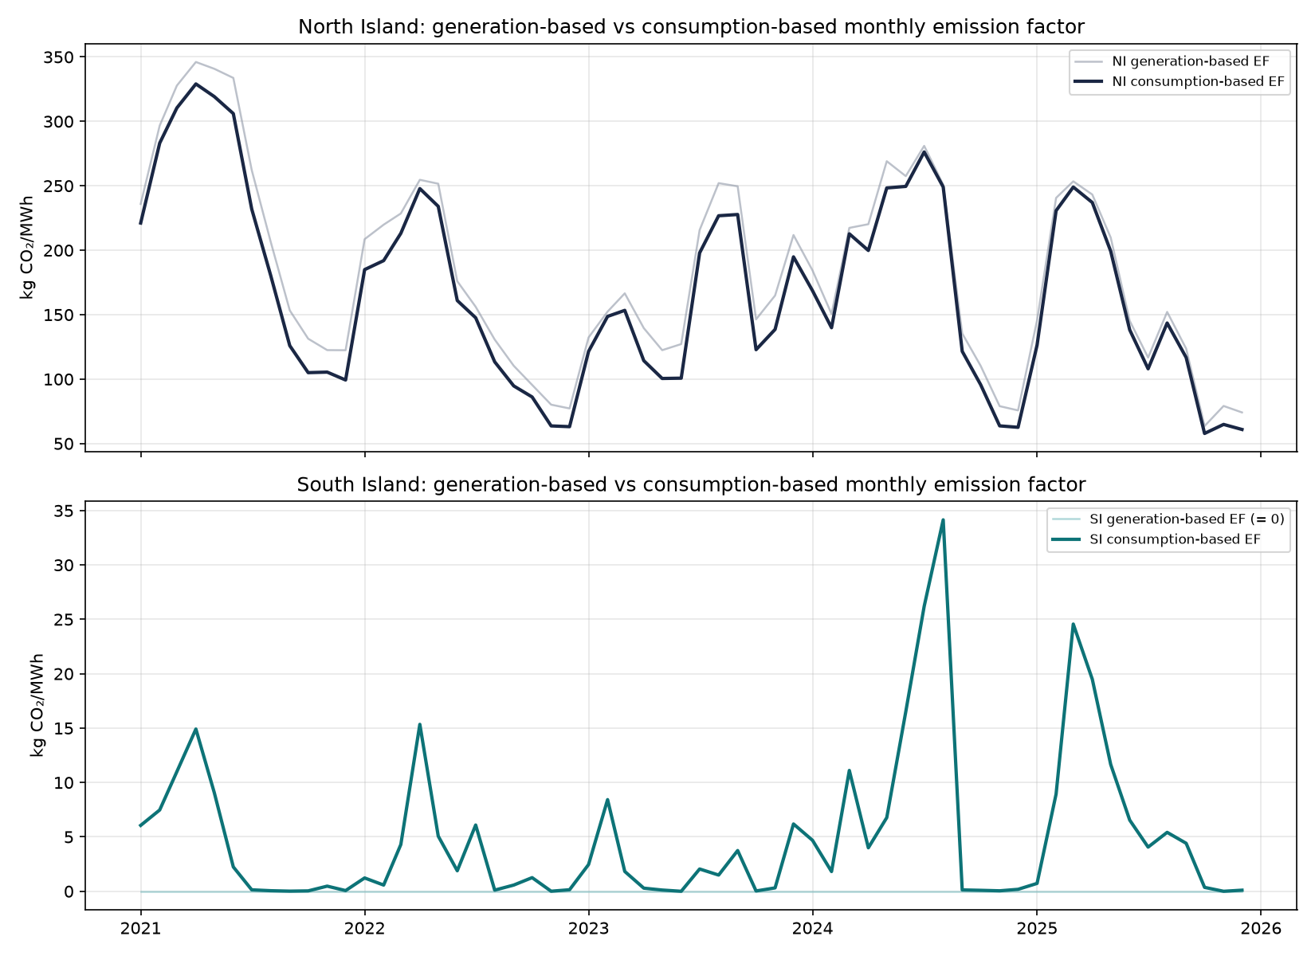
Figure 1. Monthly generation-based vs consumption-based emission factor, NI (top) and SI (bottom).
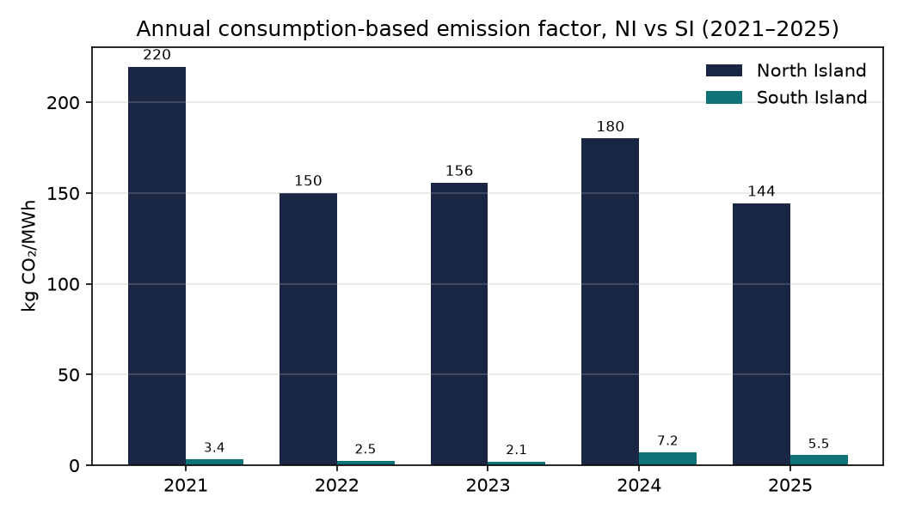
Figure 2. Annual consumption-based emission factor, NI vs SI, 2015–2025.
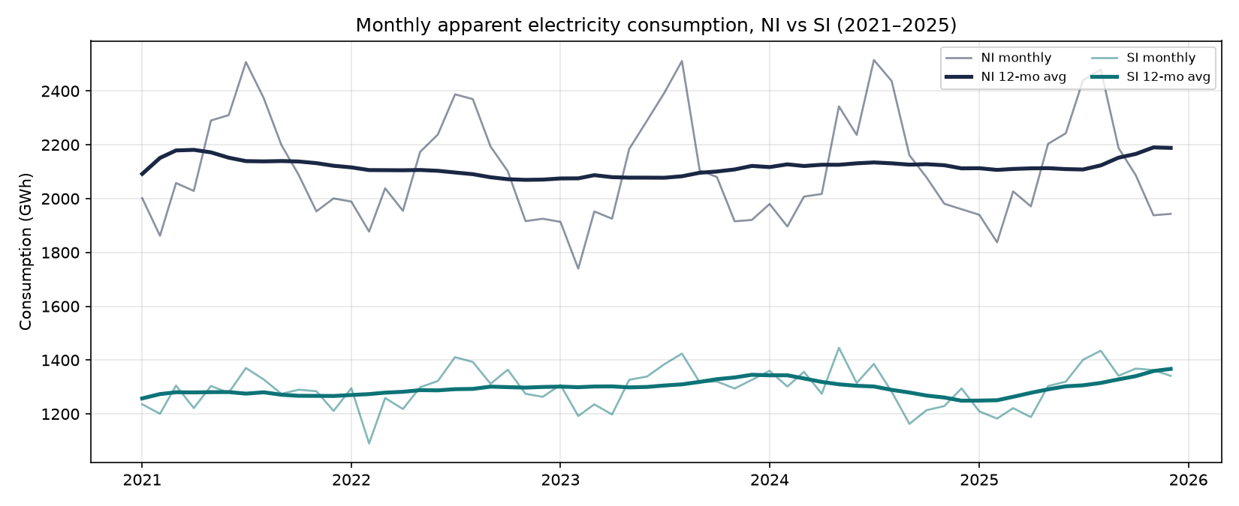
Figure 3. Monthly apparent electricity consumption, NI vs SI, with 12-month rolling average.
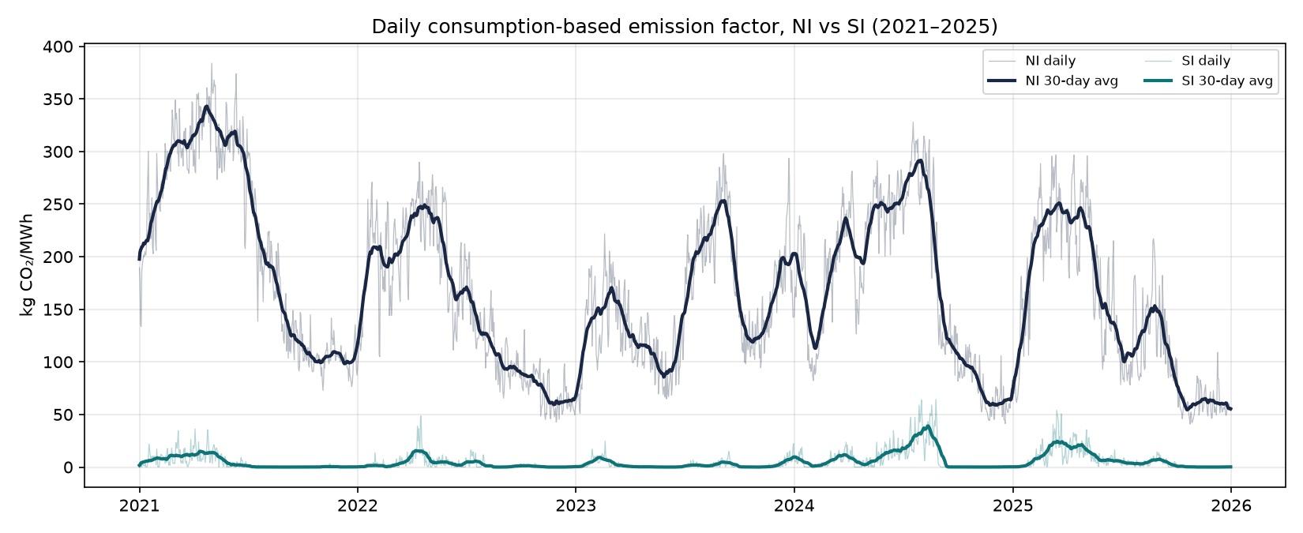
Figure 4. Daily consumption-based emission factor, NI vs SI, with 30-day rolling average.
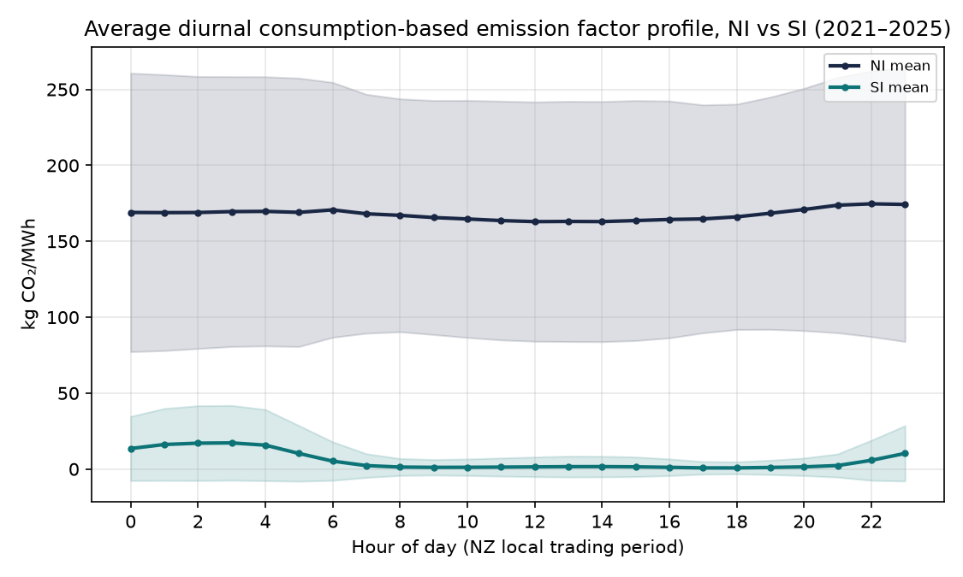
Figure 5. Average diurnal (hour-of-day) consumption-based emission factor profile, NI vs SI, mean ± 1 standard deviation across all 2015–2025 hourly observations.

6. Quality assurance
The consumption balance (Section 3) implies two identities that must hold exactly by construction at the national (NI+SI) level, since inter-island transfer only reallocates energy and emissions between islands without creating or destroying either: total island generation must equal total island consumption, and total generated CO₂ must equal total consumed CO₂. Both were checked at every resolution and held to floating-point precision:
- Annual: max |Σgeneration − Σconsumption| = 0.000000 MWh; max |Σgenerated CO₂ − Σconsumed CO₂| = 0.000000 kg.
- Monthly: identities hold at every one of the 132 months.
- Daily: max |energy diff| = 0.000000 MWh, max |CO₂ diff| = 0.000000 kg, across all 4,018 days.
- Hourly: max |energy diff| = 0.000000 MWh, max |CO₂ diff| = 0.000000 kg, across all 96,432 island-hours.
- Daily figures were spot-checked to sum exactly to the corresponding monthly figures (e.g. June 2024 NI consumption: 2,238,209.9 MWh from both the daily and monthly outputs). This exact-reconciliation property holds for energy (MWh) at every resolution boundary, because it is a pure additive sum with no ratio involved. It does NOT extend to island-level CO₂ (and therefore island-level consumption EF): because the emissions-balance formula (Section 3.4) multiplies transfer volume by that period's own average generation EF, summing finer-resolution CO₂ up to a coarser period does not exactly equal computing CO₂ directly at the coarser period, whenever transfer volume and EF co-vary within the period (they do, physically). Measured (2026-08 systematic review): mean 0.04–0.07%, max ~0.4–1.5% of the period total, at every resolution boundary tested. This was proven to be a pure island-split artefact, not an error: NI's discrepancy and SI's discrepancy are exact algebraic negatives of each other in every single period (to floating-point precision), confirming the national (NI+SI) total — the only identity actually guaranteed by construction — is completely unaffected; only how a fixed national CO₂ total is split between the two islands shifts slightly with resolution. Full detail: generation_pipeline/DATA_QUALITY_ASSESSMENT_FRAMEWORK.md (sibling folder), checks H7a–c.

7. Limitations
- “Consumption” here is apparent consumption derived from a generation + net-transfer balance. It excludes transmission and distribution losses, embedded/behind-the-meter generation, and storage, because no data source for those was provided to this analysis.
- The average-mix assumption (Section 3.4) — that exported electricity carries the exporting island's own period-average generation EF — is the one non-observed input. An alternative convention (e.g. marginal-generator attribution) would redistribute emissions differently between the islands without changing the national total, which is fixed by the conservation identities in Section 6.
- Coverage is January 2015 – December 2025 (extended 2026-08 from the original January 2021 – December 2025), matching the generation-side database and the date range of the available HVDC dataset.
- Inherits all limitations of the generation-side database regarding thermal unit disambiguation at shared POCs (see that report's Section 7).

8. Data and code availability
Scripts (this folder): build_consumption_ef_timeseries.py (monthly, annual), build_consumption_ef_daily_hourly.py (daily, hourly), build_consumption_figures.py. Outputs and figures: ./output/. Processing logs: processing_log_consumption_monthly_annual.txt, processing_log_consumption_daily_hourly.txt.

9. References
Electricity Authority. (2026). Generation_MD: Half-hourly metered generation by point of connection [Data set]. Electricity Market Information (EMI). https://www.emi.ea.govt.nz/Wholesale/Datasets/Generation/Generation_MD/
Electricity Authority. (2026). Network Supply Point List (R_NSPL_DR) [Data set]. Electricity Market Information (EMI). https://www.emi.ea.govt.nz/Wholesale/Reports/R_NSPL_DR
Electricity Authority. (2026). HVDC flows [Data set]. Electricity Market Information (EMI). https://www.emi.ea.govt.nz/Wholesale/Datasets/Metered_data/HVDC_Flows/
Bishop, P. (2026). Dispatched generation plant register [Data set]. Electricity Authority, Data Products team. Personal data supply.

