Construction of a Monthly Grid Emission Factor Database
for New Zealand's North and South Islands (2021–2025)
Methodology note prepared for the GCCI Framework, Module A (Grid Trajectory)

1. Purpose
This note documents the construction of a monthly electricity grid emission factor (EF, kg CO₂/MWh) time series for the North Island (NI) and South Island (SI) of New Zealand, derived entirely from primary Electricity Authority (EA) datasets. The NI series is the primary input to the GCCI Framework's Module A (Grid Trajectory); the SI series is produced in parallel as a cross-validation reference. The database covers 60 months (January 2021 – December 2025) at half-hourly source resolution, aggregated to monthly and annual frequency.

2. Data sources
Three primary datasets were linked to build the database. All three are official EA market data products; no third-party or modelled emission factors were used.

2.1 Half-hourly metered generation (Generation_MD)
Source: Electricity Authority, EMI Wholesale Datasets – Generation_MD (https://www.emi.ea.govt.nz/Wholesale/Datasets/Generation/Generation_MD/). 60 monthly CSV files (202101_Generation_MD.csv – 202512_Generation_MD.csv) reporting metered generation in kWh for each of the 48 half-hour trading periods (TP1–TP48) per generating point of connection (POC) and fuel code, per day.

2.2 Dispatched generation plant register (SCD2)
Source: “Dispatched generation plant.csv”, supplied directly by Dr Phil Bishop, Electricity Authority Data Products team. This is a slowly-changing-dimension (SCD2) register of 148 plant/unit records, each with a PointOfConnectionCode, FuelCode, HeatRate (kJ/kWh) and EmissionsFactor (g CO₂/GJ), valid over an effective_start_datetime / effective_end_datetime window. 45 records (27 distinct POC×fuel combinations) carry non-null HeatRate/EmissionsFactor and represent thermal (coal, gas, diesel) and geothermal plant; the remainder (hydro, wind, solar) have no combustion emission factor.

2.3 Network Supply Point List, daily snapshots (NSP)
Source: Electricity Authority, EMI report R_NSPL_DR – Network Supply Point List (https://www.emi.ea.govt.nz/Wholesale/Reports/R_NSPL_DR). 106 daily CSV snapshots (6 January – 26 June 2026) were supplied, each listing every registered POC with its Island ('NI'/'SI'), Reconciliation type, and the Start date/End date over which that record applies.

3. Database construction

3.1 Step 1 — POC → Island lookup
The 106 NSP snapshots were concatenated (270,155 rows) and de-duplicated on (POC code, Reconciliation type, Island, Start date, End date), leaving 2,512 unique records. Island was verified to be geographically stable per POC: across all reconciliation types, zero POCs were found with conflicting Island values. A static POC → Island dictionary (875 POCs; 692 NI, 183 SI) was built by taking, for each POC, the most recent Start date record with a non-null Island. Generation reconciliation types (GN, GG, GD) account for 290 of these POCs; the remainder are non-GN/GG/GD records (e.g. embedded generation reconciled as 'EN', such as the Waipori hydro scheme) that are nonetheless valid generation POCs appearing in Generation_MD.

3.2 Step 2 — Thermal emission factor lookup
For each thermal plant record, the unit-level emission factor was computed from HeatRate and EmissionsFactor using the EA-confirmed formula:
EF (kg CO₂/MWh) = HeatRate (kJ/kWh) × EmissionsFactor (g CO₂/GJ) ÷ 1,000,000
Records were grouped by (PointOfConnectionCode, FuelCode) rather than by POC alone, because some POCs host units burning different fuels concurrently — most notably Huntly (HLY2201), which has both coal (Rankine units 1–4) and gas (e3p combined-cycle, P40 peaker) generation reported separately by Generation_MD's Fuel_Code field. Where two or more SCD2 unit records were simultaneously active for the same (POC, fuel) — e.g. Huntly's two gas units, HLY5 (heat rate 7,300 → 386 kg/MWh) and HLY6 (heat rate 10,525 → 556 kg/MWh) — the simple average of their active EFs was used, since Generation_MD reports generation at POC+fuel granularity and the split between co-located units cannot be recovered from the metered data.

3.3 Step 3 — Record-level join
All 60 Generation_MD files were loaded, TP1–TP48 summed and converted from kWh to MWh (TP49/TP50, which only appear on the bi-annual daylight-saving transition days, were excluded), giving 149,798 daily POC×fuel records. Each record was assigned:
- Island, via the POC → Island lookup (Section 3.1) — 100% match rate (149,798/149,798 records);
- an emission factor, via the (POC, fuel, year, month) lookup (Section 3.2) for thermal/geothermal fuels, evaluated at the 15th of the corresponding calendar month against the SCD2 effective-date window; renewable fuels (hydro, wind, solar, wood, electrical) were assigned EF = 0;
- CO₂ mass = generation (MWh) × EF (kg/MWh).

4. Aggregation method
Monthly and annual emission factors are generation-weighted (i.e. total emissions divided by total generation), not simple averages of half-hourly or daily factors. For each island i and period t:
EF(i, t) = Σ CO₂(i, t) / Σ Generation(i, t)
This weights each generator and fuel by its actual output rather than its count, so a small but heavily-utilised thermal unit appropriately dominates the period EF. Annual figures are derived by the same formula summed over the twelve months of the year (not by averaging the monthly EF values), avoiding bias toward low-generation months. A parallel fuel-mix table aggregates generation and CO₂ by (island, year, month, fuel code), giving each fuel's monthly generation share and weighted EF for the Module A fuel-mix figures.

5. Results
Total generation matched to an island over the study period was 115.9 TWh (NI) and 88.5 TWh (SI). The South Island's emission factor is 0 kg CO₂/MWh in every year: the SCD2 plant register (Section 2.2) contains no thermal or geothermal plant located in the South Island — every combustion-emitting POC (Huntly, Kawerau, Napier, Otahuhu, Southdown-area, Whirinaki, Wairakei, etc.) is in the North Island. This is a genuine feature of the current generation fleet, not a data-linkage gap: South Island generation in this dataset is approximately 98% hydro and 2% wind (Figure 3).
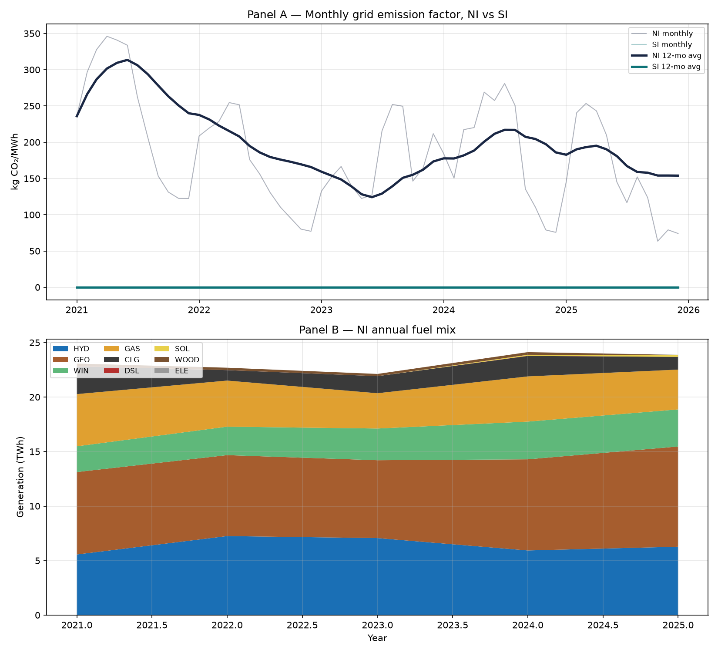
Figure 1. Panel A: monthly grid emission factor for NI and SI, with 12-month rolling average. Panel B: North Island annual fuel mix by generation volume.
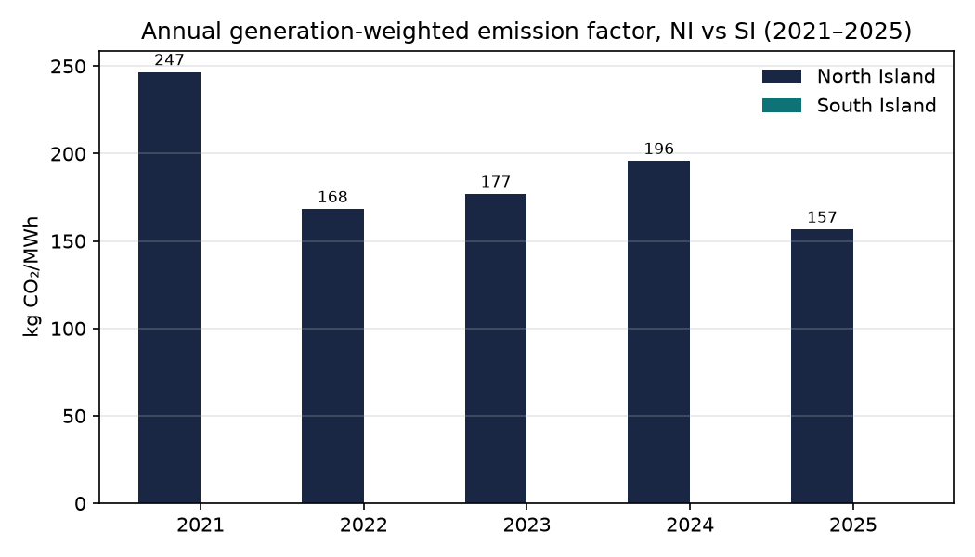
Figure 2. Annual generation-weighted emission factor, NI vs SI, 2021–2025.
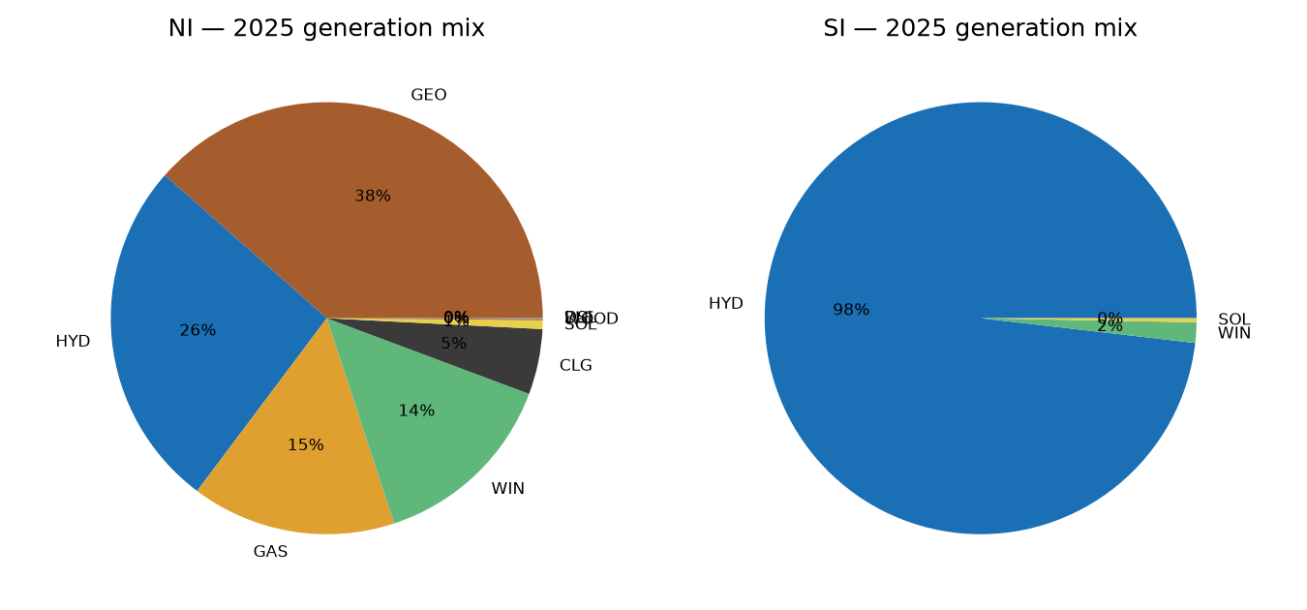
Figure 3. Generation mix by fuel, NI vs SI, calendar year 2025.
Table 1 summarises the annual results underlying Figures 1–2.
Year | NI generation (TWh) | NI EF (kg CO₂/MWh) | SI generation (TWh) | SI EF (kg CO₂/MWh)
2021 | 23.07 | 247 | 17.90 | 0
2022 | 22.69 | 168 | 17.97 | 0
2023 | 22.12 | 177 | 18.47 | 0
2024 | 24.12 | 196 | 17.11 | 0
2025 | 23.88 | 157 | 17.09 | 0

Table 1. Annual generation and emission factor by island. Source: output/annual_emission_factor_NI_SI.csv.
The North Island EF tracks New Zealand's well-documented hydro-thermal substitution dynamic: 2021 (246.6 kg/MWh) coincided with a national hydro-lake storage shortage that increased coal and gas dispatch at Huntly; the EF falls in 2022–2023 as lake inflows normalised, rises again in 2024, and falls to its lowest point in the series in 2025.

6. Quality assurance
- Unit emission-factor sanity checks: Huntly coal (HLY2201/CLG) = 994 kg/MWh, Whirinaki diesel (WHI2201/DSL) = 796 kg/MWh, Southdown-area gas (SWN2201/GAS) = 417 kg/MWh — all matched published reference values.
- Annual generation for both islands fell within the expected 15–28 TWh (NI) / 12–24 TWh (SI) range in every year.
- SI EF was lower than NI EF in 100% of years (2021–2025), consistent with the islands' generation mix.
- Of all (thermal POC, fuel, year, month) combinations evaluated, 92.6% matched an active SCD2 record; the remainder correspond to months in which that plant had zero metered generation (pre-commissioning, post-decommissioning or idle periods) — a direct check confirmed there are no generation records with positive thermal output and an unmatched (zero) emission factor.

7. Limitations
- Coverage is limited to January 2021 – December 2025; the Generation_MD archive extends back to c. 2000 but earlier files were not retrieved for this version of the database.
- Where multiple co-located thermal units of different efficiency report under the same POC and fuel code (Huntly gas, Southdown-area gas), the unaveraged unit-level split in actual dispatch is not observable from Generation_MD and a simple average of active SCD2 emission factors is used instead.
- The SI emission factor reflects only the SCD2 plant register's coverage of grid-dispatched generation; any very small, non-SCAD-metered diesel back-up generation in the South Island (not present in the source data) would not be captured.
- Emission factors are direct combustion/geothermal-fugitive factors at the point of generation; transmission losses and embedded (behind-the-meter) generation are out of scope.

8. Data and code availability
Processing script: build_ef_timeseries.py. Outputs: monthly_emission_factor_NI_SI.csv, annual_emission_factor_NI_SI.csv, monthly_fuel_mix_NI_SI.csv, EF_timeseries_NI_SI.png and processing_log.txt, all in the ./output/ directory of this project.

9. Validation against published national figures (MBIE/EDGS)
The generation-based national total (NI + SI) CO₂ figure produced by this pipeline was checked against two independently published Ministry of Business, Innovation and Employment (MBIE) datasets that were already present in this project but not previously used: the Annual Energy Sector GHG Emissions table and the Energy Demand and Generation Scenarios (EDGS) 2024 results. Both are official MBIE publications, not generated by this pipeline, and provide an independent cross-check on the absolute level of modelled emissions.
An initial comparison of our total national generation-based CO₂ (all fuels, including geothermal) against MBIE's published “Electricity Generation” combustion emissions appeared to show our figure running 24–43% higher across 2021–2024. Investigating this gap rather than dismissing it identified two concrete, data-evidenced causes, both arising from a difference in what each figure measures rather than from an error in the calculation.
Cause 1 — geothermal is out of scope for MBIE's “electricity generation” figure.
MBIE's Annual Energy Sector GHG Emissions table classifies “Electricity Generation” CO₂ strictly as a Combustion Emission (rows: Gas, Coal, Liquid Fuels, Biomass). Geothermal CO₂ is geogenic — released from the steam field rather than from burning a fuel — and is therefore excluded from that row and accounted for elsewhere in MBIE's inventory (as a fugitive emission), not under “Electricity Generation.” This pipeline correctly includes geothermal, since NI geothermal plants (Wairakei, Te Mihi, Nga Awa Pūrua, etc.) have a real, EA-supplied EmissionsFactor and do emit CO₂ — averaging roughly 95–100 kg/MWh across the major geothermal stations (Section 6, Figure 1). Re-running the comparison on a combustion-only basis (excluding geothermal from our total, to match MBIE's definition) reduces the apparent gap from 24–43% to 6.5–17%:
Year | Our combustion-only CO₂ (kt) | MBIE “electricity generation” CO₂ (kt) | Difference
2021 | 4,933 | 4,582 | +7.7%
2022 | 3,074 | 2,886 | +6.5%
2023 | 3,199 | 2,733 | +17.0%
2024 | 3,962 | 3,699 | +7.1%
Table 2. Our generation-based combustion-only CO₂ (coal + gas + diesel) vs MBIE's published “Electricity Generation” combustion CO₂. Sources: output/monthly_fuel_mix_NI_SI.csv; MBIE_Annual_Energy_Sector_GHG_Emissions_2026.xlsx, sheet ‘CO2’.
Cause 2 — own-use industrial cogeneration is excluded from MBIE's figure.
The MBIE Quarterly Electricity Emissions file states its emission factor is “based on IPCC reporting guidelines: excludes electricity generated primarily for onsite consumption rather than sale.” NZ Steel's Glenbrook cogeneration plant (POC GLN0332) is grid-connected and is correctly counted by the EA market data this pipeline uses, but MBIE's national accounting attributes its combustion emissions to the Iron & Steel industrial subsector rather than “Electricity Generation.” Glenbrook's generation, taken alone, accounts for 7.3% (2021), 10.5% (2022), 9.1% (2023) and 8.1% (2024) of our total annual combustion CO₂ — closing most of the residual gap left after Cause 1 in three of the four years. 2023's larger residual (17%) is not fully explained by Glenbrook alone; it may reflect additional own-use industrial generation not separately identified, the Huntly dual-gas-unit averaging assumption (Section 3.2) being more consequential in that particular year, or ordinary differences between EA's exact half-hourly metering and MBIE's broader energy-balance modelling. This was not investigated further.
Conclusion: both datasets are measuring a genuinely different scope of “electricity generation” emissions — MBIE's published figure is narrower (combustion only, sale-only) by construction, while this pipeline's figure is the broader, grid-market-wide total appropriate for a grid emission factor used in Module A. The comparison found no evidence of a calculation error in either dataset.

10. References
Electricity Authority. (2026). Generation_MD: Half-hourly metered generation by point of connection [Data set]. Electricity Market Information (EMI). https://www.emi.ea.govt.nz/Wholesale/Datasets/Generation/Generation_MD/
Electricity Authority. (2026). Network Supply Point List (R_NSPL_DR) [Data set]. Electricity Market Information (EMI). https://www.emi.ea.govt.nz/Wholesale/Reports/R_NSPL_DR
Bishop, P. (2026). Dispatched generation plant register [Data set]. Electricity Authority, Data Products team. Personal data supply.
Ministry of Business, Innovation and Employment. (2026). Annual emissions data table 2026 [Data set]. (MBIE_Annual_Energy_Sector_GHG_Emissions_2026.xlsx, embedded document properties.)
Ministry of Business, Innovation and Employment. (2026). GHG emissions March 2026 Q1 [Data set]. (MBIE_Quarterly_Electricity_Emissions_2026Q1.xlsx, embedded document properties.)
Ministry of Business, Innovation and Employment. (2024). Energy Demand and Generation Scenarios (EDGS) 2024 results [Data set].

