**ASSIGNMENT-6**

1. Create a web page with

• Main heading

• Paragraph

• Table

<!DOCTYPE html>

<html lang="en">

<head>

    <meta charset="UTF-8">

    <meta name="viewport" content="width=device-width, initial-scale=1.0">

    <title>A6a</title>

    <style>

        body {

            background-color: chocolate;

        }

        table,th,td {

            border: 3px solid black;

        }

    </style>

</head>

<body>

    <h1>SPORTS</h1>

    <p>Sports are a universal language,

        transcending borders and cultures to unite people in the pursuit of physical excellence,

        teamwork,

        and competition. From the thunderous roar of a stadium filled with passionate fans to the quiet focus of an

        athlete in training,

        sports encompass a wide array of activities that challenge the body and mind. Whether it's the grace of figure

        skating, the adrenaline rush of basketball, or the strategic precision of chess, each

        sport offers its own unique blend of excitement and discipline. Sports not only promote physical fitness but

        also teach invaluable lessons in resilience,

        sportsmanship,

        and determination. They have the power to inspire,

        to bring communities together,

        and to ignite the human spirit in ways that few other endeavors can.</p>

    <h2>Table Contents</h2>

    <table>

        <th>Sprots</th>

        <th>Country</th>

        <th>No. of players</th>

        <tr>

            <td>Football</td>

            <td>Argentina</td>

            <td>11</td>

        </tr>

        <tr>

            <td>Cricket</td>

            <td>India</td>

            <td>11</td>

        </tr>

        <tr>

            <td>Hockey</td>

            <td>Pakistan</td>

            <td>11</td>

        </tr>

        <tr>

            <td>Basketball</td>

            <td>USA</td>

            <td>5</td>

        </tr>

        <tr>

            <td>Tennis</td>

            <td>Australia</td>

            <td>2</td>

        </tr>

    </table>

</body>

</html>

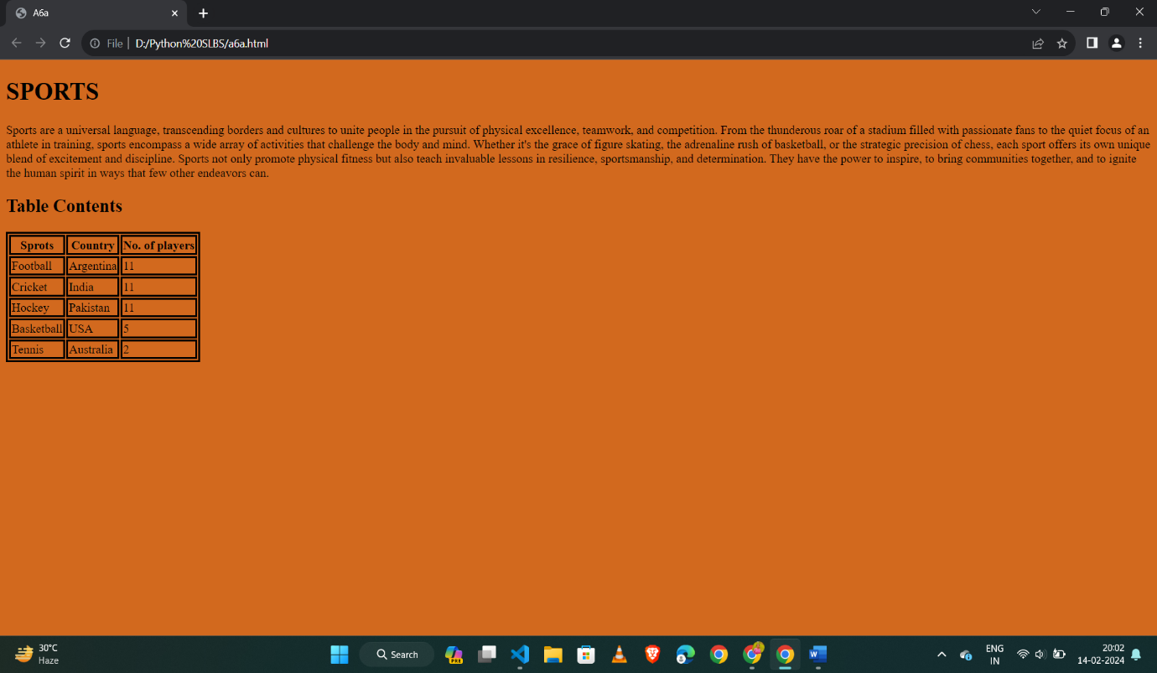

2. Create an HTML page as given below and add essential CSS.

<!DOCTYPE html>

<html lang="en">

<head>

    <meta charset="UTF-8">

    <meta name="viewport" content="width=device-width, initial-scale=1.0">

    <title>A6b</title>

    <style>

        h1 {

            font-size: larger;

            font-family: 'Times New Roman', Times, serif;

            font-weight: bold;

            color: black;

        }

        img {

            background-size: 0%;

        }

        ul {

            list-style-type: none;

            margin: 0;

            padding: 0;

        }

        li {

            display: inline;

        }

        div {

            text-align: center;

            background-color: lightgrey;

            width: 400px;

            border: 15px solid white;

            padding: 50px;

            margin: 20px;

        }

        form {

            justify-content: center;

            align-items: center;

        }

    </style>

</head>

<body>

    <header>

        <nav>

            <ul>

                <ul>

                    <li><a href="#">ADD</a></li>

                    <li><a href="#">VIEW</a></li>

                    <a style="font-style: italic">LOGGED IN AS RAHUL@GMAIL.COM</a>

                    <li><a href="#">LOGOUT</a>

                    </li>

                </ul>

        </nav>

    </header>

    <section style="background-image: url(' pexels-belle-co-847393.jpg');">

        <h1 style=" text-align: center">SURVEY FORM</h1>

        <div>

            <form action="/action_page.php">

                <h2 style="text-align: center;">Let us know how we can improve</h2>

                <label for="name">Name:</label>

                <input type="text" id="name" name="name"><br><br>

                <label for="email">Email:</label>

                <input type="email" id="email" name="email"><br><br>

                <label for="age">AGE:</label>

                <input type="text" id="age" name="age"><br><br>

                <label for="myfile"></label>

                <input type="file" id="myfile" name="myfile"><br><br>

                <label for="role">Which option best describes your current role?:</label>

                <select name="role" id="role">

                    <option value="Student">Student</option>

                    <option value="Employed">Employed</option>

                    <option value="Unemployed">Unemployed</option>

                    <option value="Other">Other</option>

                </select>

                <br><br>

                <label for="rate">How likely is that you would recommend this <br>program to a friend?:</label><br>

                <input type="radio" id="def" name="rate">

                <label for="def">Definetly</label><br>

                <input type="radio" id="maybe" name="rate">

                <label for="maybe">Maybe</label><br>

                <input type="radio" id="notsure" name="rate">

                <label for="notsure">Not sure</label><br><br>

                <label for="like">What do you like most here?:</label>

                <select name="like" id="like" value="select an option">

                    <option value="Environment">Environment</option>

                    <option value="Method">Method</option>

                    <option value="Other">Other</option>

                </select>

                <br><br>

                <label for="fut">Things that should be improved in the future<br>(check all that apply)</label><br>

                <input type="checkbox" id="frnt" name="fut">

                <label for="frnt"> Front-end projects</label><br>

                <input type="checkbox" id="back" name="fut">

                <label for="back"> Back-end projects</label><br>

                <input type="checkbox" id="data" name="fut">

                <label for="data"> Data Visualization</label><br><br>

                <label for="comments">Any comments or suggestions?</label><br>

                <textarea id="comments" name="comments" rows="4" cols="50"></textarea><br><br>

                <input type="submit" value="Submit">

            </form>

        </div>

    </section>

</body>

</html>

