Ecology

“The cost of resource use for photosynthesis drives variation in leaf nitrogen content across a climate and resource availability gradient”
Evan A. Perkowski^{1,*}, Helen G. Scott¹, Nicholas G. Smith¹
¹Department of Biological Sciences, Texas Tech University, Lubbock, TX

Appendix S1
SPLASH model overview and calculations for soil water holding capacity
The SPLASH model, derived from the STASH model (Cramer & Prentice, 1988), spins up a bucket model using Priestley-Taylor equations (Priestley & Taylor, 1972) to calculate daily soil moisture (W_{n}; mm) as a function of the previous day’s soil moisture (W_{n-1}; mm), daily precipitation (P_{n}; mm), condensation (C_{n}; mm), actual evapotranspiration ($E_{n}^{a}$; mm), and runoff (RO; mm):
$W_{n}=W_{n-1}+P_{n}+C_{n}-E_{n}^{a}-RO$ (S1)
In this study, models were spun up by equilibrating the previous day’s soil moisture using successive model iterations with daily mean air temperature, daily precipitation total, the number of daily sunlight hours, and latitude as model inputs (Davis et al., 2017). Daily sunlight hours were estimated for each day at each site using the ‘getSunlightTimes’ function in the ‘suncalc’ package in R (Thieurmel & Elmarhraoui, 2019). Water holding capacity (mm), or bucket size, was estimated as a function of soil texture using pedotransfer equations explained in (Saxton & Rawls, 2006), as done by (Stocker et al., 2020) and (Bloomfield et al., 2023). Specifically, water holding capacity (θ_{WHC}; mm) was calculated as a function of the volumetric soil water storage at field capacity, W_{PWP} (m³ m⁻³), and the volumetric soil water storage at wilting point:
$θ_{WHC}=\left(W_{FC}-W_{PWP}\right)\left(1-f_{gravel}\right)*min⁡\{z_{bedrock}, z_{max}\}$ (S2)
where W_{FC} (m³ m⁻³) is the volumetric soil water storage at field capacity, W_{PWP} (m³ m⁻³) is the volumetric soil water storage at wilting point, f_{gravel} (%) is the fraction of gravel content in soil, z_{bedrock} (mm) is the distance to bedrock, and z_{max} (mm) is the maximum allowable distance to bedrock, set to 2000mm. W_{FC} is calculated as:
$W_{FC}=k_{fc}+(1.283*{\left(k_{fc}\right)}^{2}-0.374*k_{fc}-0.015$ (S3)
where
$k_{fc}=-0.251*f_{sand}+0.195*f_{clay}+0.011*f_{OM}+0.006+0.006*\left(f_{sand}*f_{OM}\right)-0.027*\left(f_{clay}*f_{OM}\right)+0.452*\left(f_{sand}*f_{clay}\right)+0.299$ (S4)
W_{PWP} is calculated as:
$W_{PWP}=k_{pwp}+(0.14*k_{pwp}-0.02)$ (S5)
where
$k_{pwp}=-0.024*f_{sand}+0.487*f_{clay}+0.006*f_{OM}+0.005*\left(f_{sand}*f_{OM}\right)-0.013*\left(f_{clay}*f_{OM}\right)+0.068*\left(f_{sand}*f_{clay}\right)+0.031$ (S6)
In Equations (S4) and (S6), f_{sand} (%) is the fraction of sand content in soil (%), f_{clay} (%) is the fraction of clay content in soil (%), and f_{OM} is the fraction of organic matter in soil (%). Organic matter in the soil was calculated in this study by converting soil organic carbon data extracted from SoilGrids 2.0 to soil organic matter using the van Bemmelen factor (1.724 conversion factor).

Elevation correction equation
Partial pressures were standardized using an elevation correction equation explained in Stocker et al. (2020):
$P_{atm,z}=P_{atm,0}{\left(1-\frac{Lz}{T_{K,0}}\right)}^{gM_{a}{(RL)}^{-1}}$ (S7)
where P_{atm,z} (Pa) is atmospheric pressure at elevation z (m.a.s.l.), P_{atm,0} is atmospheric pressure at 0 m.a.s.l. (101325 Pa), L is the mean adiabatic lapse rate (0.0065 K m⁻²), T_{K,0} is temperature in K at 25ºC (298.15 K), g is the gravitational acceleration rate (9.80665 m s⁻²), M_{a} is the molar weight of dry air (0.028963 kg mol⁻¹), and R is the universal gas constant (8.3145 J mol⁻¹).

Michaelis-Menten coefficients for Rubisco affinity to CO₂ and O₂
K (Pa) is the Michaelis-Menten coefficient for Rubisco affinity to CO₂ and O₂, calculated as:
$K=K_{c}\left(1+\frac{O_{i}}{K_{o}}\right)$ (S8)
where K_{c} (Pa) and K_{o} (Pa) are the Michaelis-Menten coefficients for Rubisco affinity to CO₂ and O₂, respectively. O_{i} is the intercellular O₂ concentration, set to 210 μmol mol⁻¹ and converted to partial pressure (Pa) using the elevation correction explained in Eqn. 6. Γ* (Pa) is the CO₂ compensation point in the absence of dark respiration. K_{c}, K_{o}, and Γ* were each calculated following Bernacchi et al. (2001), where:
$K_{c}={404.9*exp}^{\left(\frac{79430(T_{k}-298)}{298RT_{k}}\right)}$ (S9)
$K_{o}={278.4*exp}^{\left(\frac{36380(T_{k}-298)}{298RT_{k}}\right)}$ (S10)
$Γ^{*}={42.75*exp}^{\left(\frac{37830(T_{k}-298)}{298RT_{k}}\right)}$ (S11)
In all three equations, T_{k} is leaf temperature (in Kelvin), estimated through mean daily air temperature of the seven days leading up to each site visit, while R is the universal gas constant (8.314 J mol⁻¹ K⁻¹). K_{c}, K_{o}, and Γ* were each converted to partial pressure using the elevation correction equation explained in Appendix S1: Equation S7.

Piecewise structural equation model loadings and fit parameters
Seven linear mixed effect models were loaded into the structural equation model: (1) log-transformed N_{area} regressed against log-transformed N_{mass} and log-transformed M_{area}, (2) log-transformed M_{area} regressed against leaf C_{i}:C_{a}, nitrogen availability, and photosynthetic pathway, (3) log-transformed N_{mass} regressed against leaf C_{i}:C_{a}, square-root transformed β, nitrogen availability, log-transformed M_{area}, N-fixation ability, and photosynthetic pathway, (4) leaf C_{i}:C_{a} regressed against square-root transformed β, VPD, photosynthetic pathway, and soil moisture, (5) square-root transformed β regressed against nitrogen availability, soil moisture, N-fixation ability, and photosynthetic pathway, and VPD, (6) nitrogen availability regressed against soil moisture, and (7) soil moisture regressed against VPD. All models included the relevant timescale selected in the individual linear mixed-effect models explained above and included species as a random intercept term. Models were built using the ‘lme’ function in the ‘nlme’ R package (Pinheiro & Bates, 2022), and were loaded into the piecewise structural equation model using the ‘psem’ function in the ‘piecewiseSEM’ R package (Lefcheck, 2016).
Tests of directed separation indicated that the structural equation model was missing three correlations that contributed to poor overall model fit (Fisher’s C=162.814, p<0.001; df=42; AIC=246.814; BIC=418.649): a correlation between nitrogen availability and VPD₉₀ (p<0.001), a correlation between β and VPD (p<0.05), and a correlation between soil moisture and N_{mass} (p<0.05). These relationships were included in the model as correlated errors, as we did not have hypotheses to explain their direct relationships. The inclusion of these relationships improved model fit (Fisher’s C=23.899, p=0.939; df=36; AIC=107.899; BIC=279.734) and satisfied goodness-of-fit requirements (Lefcheck, 2016).

Table S1 List of sampled species, including the NRCS symbol, photosynthetic pathway, growth duration, growth habit, N fixation capability, assigned plant functional group, and the number of collected individuals
Symbol | Species | Photosynthetic pathway | Growth duration | Growth habit | N-fixer? | Plant functional group | Number sampled
ACAN11 | Acaciella angustissima (Mill) Britton & Rose | c3 | perennial | forb | yes | c3_legume | 3
AMAR2 | Ambrosia artemisiifolia L. | c3 | annual | forb | no | c3_nonlegume | 25
AMPS | Ambrosia psilostachya DC. | c3 | perennial | forb | no | c3_nonlegume | 32
ARAL3 | Argemone albiflora Hornem. | c3 | annual | forb | no | c3_nonlegume | 3
ARPU9 | Aristida purpurea Nutt. | c4 | perennial | graminoid | no | c4_nonlegume | 2
ASAS | Asclepias asperula (Decne.) Woodson | c3 | perennial | forb | no | c3_nonlegume | 3
ASLA4 | Asclepias latifolia (Torr.) Raf. | c3 | perennial | forb | no | c3_nonlegume | 3
ASSY | Asclepias syriaca L. | c3 | perennial | forb | no | c3_nonlegume | 18
BOIS | Bothriochloa ischaemum (L.) Keng | c4 | perennial | graminoid | no | c4_nonlegume | 6
BOSA | Bothriochloa saccharoides (Sw.) Rydb. | c4 | perennial | graminoid | no | c4_nonlegume | 6
CAPL3 | Carex planostachys Kunze | c4 | perennial | graminoid | no | c4_nonlegume | 3
CAREX | Carex spp. L. | c4 | perennial | graminoid | no | c4_nonlegume | 16
CHFE3 | Chamaesyce fendleri (Torr. & A. Gray) Small | c3 | perennial | forb | no | c3_nonlegume | 2
CHPI8 | Chyrysopsis pilosa Nutt. | c3 | annual | forb | no | c3_nonlegume | 3
COCO13 | Conoclinium coelestinum (L.) DC. | c3 | perennial | forb | no | c3_nonlegume | 3
COER | Commelina erecta L. | c3 | perennial | forb | no | c3_nonlegume | 3
CRGLL | Croton glandulosus L. | c3 | annual | forb | no | c3_nonlegume | 22
CYDA | Cynodon dactylon (L.) Pers. | c4 | perennial | graminoid | no | c4_nonlegume | 15
DIAN | Dichanthium annulatum (Forssk.) Stapf | c4 | perennial | graminoid | no | c4_nonlegume | 8
ENPE4 | Engelmannia peristenia (Raf.) Goodman & C.A. Lawson | c3 | perennial | forb | no | c3_nonlegume | 6
EUMA8 | Euphorbia marginata Pursh | c3 | annual | forb | no | c3_nonlegume | 6
GAPU | Gaillardia pulchella Foug. | c3 | annual | forb | no | c3_nonlegume | 16
GLGO | Glandularia gooddingii (Briq.) Solbrig | c3 | perennial | forb | no | c3_nonlegume | 2

Symbol | Species | Photosynthetic pathway | Growth duration | Growth habit | N-fixer? | Plant functional group | Number sampled
HEAN3 | Helianthus annuus L. | c3 | annual | forb | no | c3_nonlegume | 6
HECA8 | Heterotheca canescens (DC.) Shinners | c3 | perennial | forb | no | c3_nonlegume | 2
HETE3 | Heliotropium tenellum (Nutt.) Torr | c3 | annual | forb | no | c3_nonlegume | 3
IVAX | Iva axillaris Pursh | c3 | perennial | forb | no | c3_nonlegume | 4
LIAT | Lilaeopsis attenuata auct. non (Hook. & Arn.) Fernald | c3 | perennial | forb | no | c3_nonlegume | 3
LIPU | Liatris punctata Hook. | c3 | perennial | forb | no | c3_nonlegume | 3
LOPE | Lolium perenne L. | c3 | perennial | graminoid | no | c3_nonlegume | 9
MIQU2 | Mimosa spp. | c3 | perennial | forb | yes | c3_legume | 15
NALE3 | Nassella leucotricha (Trin. & Rupr.) Pohl | c3 | perennial | graminoid | no | c3_nonlegume | 19
OECU2 | Oenothera curtiflora W.L. Wagner & Hoch | c3 | annual | forb | no | c3_nonlegume | 3
OENOT | Oenothera spp. L. | c3 | annual | forb | no | c3_nonlegume | 1
PAVI2 | Panicum virgatum L. | c4 | perennial | graminoid | no | c4_nonlegume | 12
RACO3 | Ratibida columnifera (Nutt) Wooton & Standl. | c3 | perennial | forb | no | c3_nonlegume | 40
RHSET | Rhynchosia senna Gillies ex Hook. var. texana (Torr. & A. Gray) M.C. Johnst. | c3 | perennial | forb | yes | c3_legume | 1
RUHI2 | Rudbeckia hirta L. | c3 | perennial | forb | no | c3_nonlegume | 3
RUNU | Ruellia nudiflora (Engelm. & A. Gray) Urb. | c3 | perennial | forb | no | c3_nonlegume | 15
RUTR | Rubus trivialis Michx. | c3 | perennial | vine | no | c3_nonlegume | 3
SAFA2 | Salvia farinacea Benth. | c3 | perennial | forb | no | c3_nonlegume | 7
SCHIZ4 | Schizachyrium spp. Nees | c4 | perennial | graminoid | no | c4_nonlegume | 8
SCSC | Schizachyrium scoparium (Michx.) Nash | c4 | perennial | graminoid | no | c4_nonlegume | 3
SODI | Solanum dimidiatum Raf. | c3 | perennial | forb | no | c3_nonlegume | 1
SOEL | Solanum elaeagnifolium Cav. | c3 | perennial | forb | no | c3_nonlegume | 53
SOHA | Sorghum halapense (L.) Pers. | c4 | perennial | graminoid | no | c4_nonlegume | 38
STTE3 | Stillingia texana I.M. Johnst. | c3 | perennial | forb | no | c3_nonlegume | 3
VEOC | Verbesina occidentalis (L.) Walter | c3 | perennial | forb | no | c3_nonlegume | 3
VEST | Verbena stricta Vent. | c3 | perennial | forb | no | c3_nonlegume | 3

Table S2 Model selection results for soil moisture, air temperature, and vapor pressure deficit. Soil moisture was used in a bivariate regression against β, while vapor pressure deficit was used in bivariate regressions against leaf C_{i}:C_{a}*

 | Soil moisture |  | Vapor pressure deficit
Day | AICc | RMSE | AICc | RMSE
1 | 2966.46 | 4.7692 | -857.3 | 0.0741
2 | 2966.27 | 4.7680 | -856.94 | 0.0741
3 | 2966.20 | 4.7676 | -856.84 | 0.0741
4 | 2966.27 | 4.7681 | -856.34 | 0.0741
5 | 2966.39 | 4.7689 | -856.29 | 0.0741
6 | 2966.44 | 4.7692 | -856.22 | 0.0741
7 | 2966.50 | 4.7696 | -856.18 | 0.0741
8 | 2966.54 | 4.7700 | -856.08 | 0.0741
9 | 2966.58 | 4.7704 | -856.17 | 0.0741
10 | 2966.67 | 4.7710 | -856.95 | 0.0740
15 | 2966.65 | 4.7722 | -856.52 | 0.0741
20 | 2966.47 | 4.7722 | -856.66 | 0.0742
30 | 2966.30 | 4.7715 | -857.53 | 0.0741
60 | 2963.35 | 4.7583 | -857.51 | 0.0742
90 | 2958.59 | 4.7352 | -873.11 | 0.0730
*Timescale that conferred lowest AICc value is indicated in bold.

Table S3 Effects of soil moisture, nitrogen availability, and plant functional group on the photosynthetic cost to acquire nitrogen relative to water (β)*
 | df | χ² | p
Soil moisture (SM₉₀) | 1 | 7.982 | 0.004
N availability (N) | 1 | 10.461 | 0.001
PFT | 2 | 98.254 | <0.001
SM₉₀ * N | 1 | 0.741 | 0.389
SM₉₀ * PFT | 2 | 13.922 | 0.001
N * PFT | 2 | 1.588 | 0.452
SM₉₀ * N * PFT | 2 | 1.061 | 0.588
*Significance determined using Type II Wald χ² tests (α=0.05). P-values less than 0.05 are in bold. Key: df=degrees of freedom, χ²=Wald Type II chi-square test statistic
Table S4 Effects of VPD, drivers of the photosynthetic cost to acquire nitrogen relative to water, and functional group on leaf C_{i}:C_{a}*
Treatment | df | χ² | p
Vapor pressure deficit (VPD₉₀) | 1 | 20.775 | <0.001
Soil moisture (SM₉₀) | 1 | 7.711 | 0.005
N availability (N) | 1 | 6.359 | 0.012
PFT | 2 | 721.308 | <0.001
SM₉₀ * N | 1 | 0.091 | 0.763
VPD₉₀ * PFT | 2 | 3.675 | 0.159
SM₉₀ * PFT | 2 | 17.509 | <0.001
N * PFT | 2 | 22.486 | <0.001
SM₉₀ * N * PFT | 2 | 1.826 | 0.401
*Significance determined using Type II Wald χ² tests (α=0.05). P-values less than 0.05 are in bold. Leaf C_{i}:C_{a} was not transformed prior to model fitting, so model coefficients are reported on the response scale. Key: df=degrees of freedom, χ²=Wald Type II chi-square test statistic

Table S5 Effects of leaf C_{i}:C_{a}, drivers of the cost to acquire nitrogen relative to water, and functional group on area-based leaf nitrogen content, mass-based leaf nitrogen content, and leaf mass per area*
 |  | N_{area} |  | N_{mass} |  | M_{area}
 | df | χ² | p | χ² | p | χ² | p
Leaf C_{i}:C_{a} | 1 | 5.579 | 0.018 | 0.127 | 0.722 | 6.560 | 0.010
N availability (N) | 1 | 5.807 | 0.016 | 82.829 | <0.001 | 43.217 | <0.001
Soil moisture (SM₉₀) | 1 | 9.107 | 0.003 | 5.094 | 0.024 | 0.538 | 0.463
PFT | 2 | 40.208 | <0.001 | 13.582 | 0.001 | 7.471 | 0.024
SM₉₀ * N | 1 | 1.796 | 0.180 | 3.868 | 0.049 | 0.091 | 0.763
Leaf C_{i}:C_{a} * PFT | 2 | 23.869 | <0.001 | 3.546 | 0.170 | 26.294 | <0.001
N * PFT | 2 | 6.138 | 0.046 | 1.702 | 0.427 | 16.622 | <0.001
SM₉₀ * PFT | 2 | 1.354 | 0.508 | 1.721 | 0.423 | 0.454 | 0.797
SM₉₀ * N * PFT | 2 | 4.870 | 0.088 | 0.055 | 0.973 | 7.996 | 0.018
*Significance determined using Type II Wald χ² tests (α=0.05). P-values less than 0.05 are in bold and p-values where 0.05<p<0.1 are italicized. Key: df=degrees of freedom, χ²=Wald Type II chi-square test statistic; N_{area}=area-based leaf nitrogen content (gN m⁻²); N_{mass}=mass-based leaf nitrogen content (gN g⁻¹); leaf mass per area (M_{area}; g
m⁻²)

Table S6 Structural equation model results investigating drivers of variance in area-based leaf nitrogen content*
 | Predictor | Coefficient | p
N_{area}
 | N_{mass} | 0.899 | <0.001
 | M_{area} | 0.822 | <0.001
N_{mass}
 | Photo. pathway | -0.378 | 0.004
 | M_{area} | -0.373 | <0.001
 | N-fixing ability | 0.288 | <0.001
 | Leaf C_{i}:C_{a} | 0.185 | 0.154
 | β | -0.171 | 0.012
 | Soil N | 0.166 | <0.001
M_{area}
 | Photo. pathway | -0.461 | 0.010
 | Leaf C_{i}:C_{a} | -0.309 | 0.006
 | Soil N | -0.255 | <0.001
Leaf C_{i}:C_{a}
 | Photo. pathway | -0.738 | <0.001
 | β | 0.316 | <0.001
 | VPD₉₀ | -0.096 | <0.001
 | SM₉₀ | -0.070 | <0.001
β
 | Photo. pathway | -0.816 | <0.001
 | N-fixing ability | -0.114 | 0.189
 | SM₉₀ | 0.091 | 0.005
 | Soil N | -0.086 | 0.002
Soil N
 | SM₉₀ | -0.198 | <0.001
Soil moisture
 | VPD₉₀ | -0.675 | <0.001
Correlated Errors
 | Soil N ~ VPD₉₀ | -0.267 | <0.001
 | N_{mass} ~ SM₉₀ | -0.049 | 0.135
 | β ~ VPD₉₀ | -0.062 | 0.080
*Coefficients, listed in order of magnitude for each predictor, are standardized across the structural equation model. P-values less than 0.05 are in bold. Negative coefficients for photosynthetic pathway indicate reduced values in C₄ species, while positive coefficients for N-fixing ability indicate greater values in N-fixing species.
Figure S1
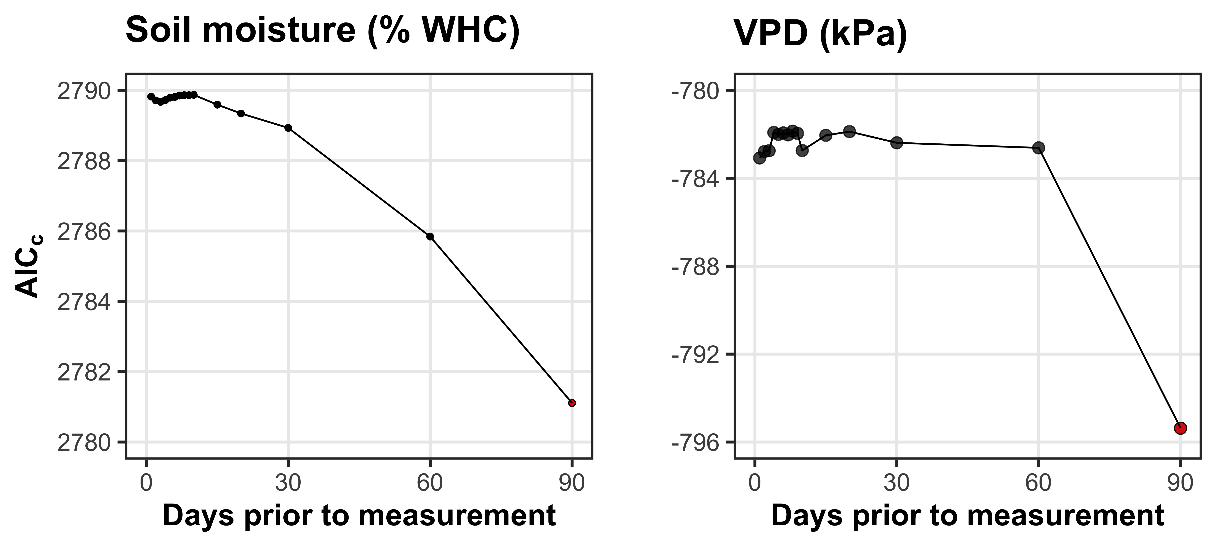
Fig. S1 Model selection results exploring relevant timescales for soil moisture (left panel) and vapor pressure deficit (right panel). The x-axis indicates the number of days before each site visit and the y-axis notes the corrected Akaike Information Criterion value. The timescale with the lowest AICc value is noted as a red point.

Figure S2
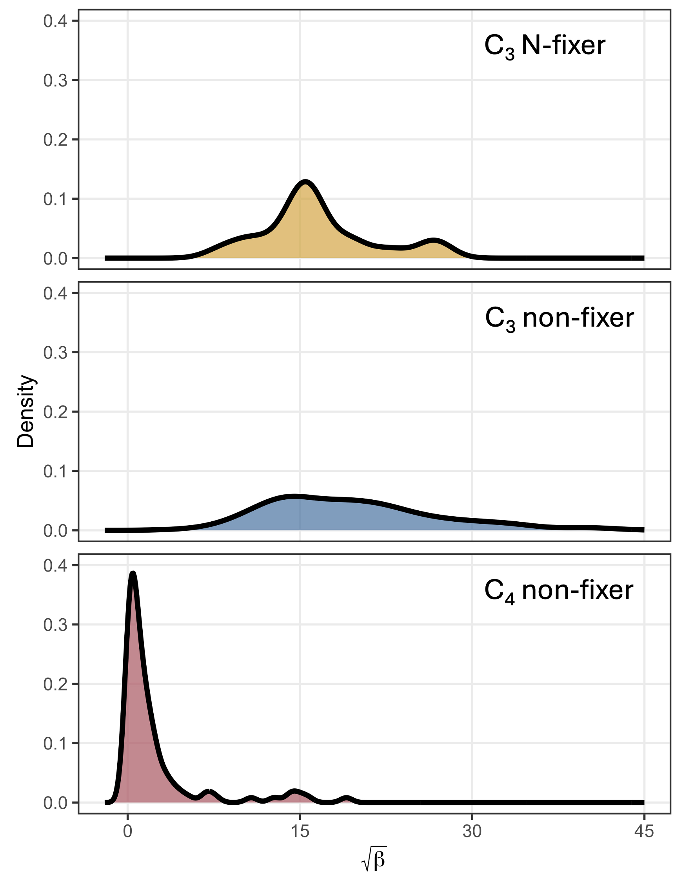
Fig. S2 Density plot demonstrating the observed variance in β across the environmental gradient. Square root transformed β on the x-axis. The top, middle, and lower panels indicate the distribution of β values for C₃ N-fixers, C₃ non-fixers, and C₄ non-fixers, respectively.

References
Bernacchi CJ, Singsaas EL, Pimentel C, Portis AR, Long SP. 2001. Improved temperature response functions for models of Rubisco-limited photosynthesis. Plant, Cell and Environment 24: 253–259.
Bloomfield KJ, Stocker BD, Keenan TF, Prentice IC. 2023. Environmental controls on the light use efficiency of terrestrial gross primary production. Global Change Biology 29: 1037–1053.
Cramer W, Prentice IC. 1988. Simulation of regional soil moisture deficits on a European scale. Norsk Geografisk Tidsskrift - Norwegian Journal of Geography 42: 149–151.
Davis TW, Prentice IC, Stocker BD, Thomas RT, Whitley RJ, Wang H, Evans BJ, Gallego-Sala A V, Sykes MT, Cramer W. 2017. Simple process-led algorithms for simulating habitats (SPLASH v.1.0): robust indices of radiation, evapotranspiration and plant-available moisture. Geoscientific Model Development 10: 689–708.
Lefcheck JS. 2016. piecewiseSEM: Piecewise structural equation modelling in r for ecology, evolution, and systematics. Methods in Ecology and Evolution 7: 573–579.
Pinheiro J, Bates D. 2022. nlme: linear and nonlinear mixed effects models.
Priestley CHB, Taylor RJ. 1972. On the Assessment of Surface Heat Flux and Evaporation Using Large-Scale Parameters. Monthly Weather Review 100: 81–92.
Saxton KE, Rawls WJ. 2006. Soil water characteristic estimates by texture and organic matter for hydrologic solutions. Soil Science Society of America Journal 70: 1569–1578.
Stocker BD, Wang H, Smith NG, Harrison SP, Keenan TF, Sandoval D, Davis T, Prentice IC. 2020. P-model v1.0: An optimality-based light use efficiency model for simulating ecosystem gross primary production. Geoscientific Model Development 13: 1545–1581.
Thieurmel B, Elmarhraoui A. 2019. suncalc: Compute sun position, sunlight phases, moon position, and lunar phase.

