SUPPLEMENTARY MATERIAL FOR “The cost of resource use for photosynthesis drives variation in leaf nitrogen content across a climate and resource availability gradient”

Calculations for soil water holding capacity
Water holding capacity (θ_{WHC}; mm) was calculated as a function of the volumetric soil water storage at field capacity, W_{PWP} (m³ m⁻³), and the volumetric soil water storage at wilting point:

$θ_{WHC}=\left(W_{FC}-W_{PWP}\right)\left(1-f_{gravel}\right)*min⁡\{z_{bedrock}, z_{max}\}$ (S1)

where W_{FC} (m³ m⁻³) is the volumetric soil water storage at field capacity, W_{PWP} (m³ m⁻³) is the volumetric soil water storage at wilting point, f_{gravel} (%) is the fraction of gravel content in soil, z_{bedrock} (mm) is the distance to bedrock, and z_{max} (mm) is the maximum allowable distance to bedrock, set to 2000mm. W_{FC} is calculated as:

$W_{FC}=k_{fc}+(1.283*{\left(k_{fc}\right)}^{2}-0.374*k_{fc}-0.015$ (S2)

where

$k_{fc}=-0.251*f_{sand}+0.195*f_{clay}+0.011*f_{OM}+0.006+0.006*\left(f_{sand}*f_{OM}\right)-0.027*\left(f_{clay}*f_{OM}\right)+0.452*\left(f_{sand}*f_{clay}\right)+0.299$ (S3)

W_{PWP} is calculated as:

$W_{PWP}=k_{pwp}+(0.14*k_{pwp}-0.02)$ (S4)

where

$k_{pwp}=-0.024*f_{sand}+0.487*f_{clay}+0.006*f_{OM}+0.005*\left(f_{sand}*f_{OM}\right)-0.013*\left(f_{clay}*f_{OM}\right)+0.068*\left(f_{sand}*f_{clay}\right)+0.031$ (S5)

In Equations (S3) and (S5), f_{sand} (%) is the fraction of sand content in soil (%), f_{clay} (%) is the fraction of clay content in soil (%), and f_{OM} is the fraction of organic matter in soil (%). Organic matter in the soil was calculated in this study by converting soil organic carbon data extracted from SoilGrids 2.0 to soil organic matter using the van Bemmelen factor (1.724 conversion factor).

Table S1 List of sampled species, including the NRCS symbol, photosynthetic pathway, growth duration, growth habit, N fixation capability, assigned plant functional group, and the number of collected individuals
Symbol | Species | Photosynthetic pathway | Growth duration | Growth habit | N-fixer? | Plant functional group | Number sampled
ACAN11 | Acaciella angustissima (Mill) Britton & Rose | c3 | perennial | forb | yes | c3_legume | 3
AMAR2 | Ambrosia artemisiifolia L. | c3 | annual | forb | no | c3_nonlegume | 25
AMPS | Ambrosia psilostachya DC. | c3 | perennial | forb | no | c3_nonlegume | 32
ARAL3 | Argemone albiflora Hornem. | c3 | annual | forb | no | c3_nonlegume | 3
ARPU9 | Aristida purpurea Nutt. | c4 | perennial | graminoid | no | c4_nonlegume | 2
ASAS | Asclepias asperula (Decne.) Woodson | c3 | perennial | forb | no | c3_nonlegume | 3
ASLA4 | Asclepias latifolia (Torr.) Raf. | c3 | perennial | forb | no | c3_nonlegume | 3
ASSY | Asclepias syriaca L. | c3 | perennial | forb | no | c3_nonlegume | 18
BOIS | Bothriochloa ischaemum (L.) Keng | c4 | perennial | graminoid | no | c4_nonlegume | 6
BOSA | Bothriochloa saccharoides (Sw.) Rydb. | c4 | perennial | graminoid | no | c4_nonlegume | 6
CAPL3 | Carex planostachys Kunze | c4 | perennial | graminoid | no | c4_nonlegume | 3
CAREX | Carex spp. L. | c4 | perennial | graminoid | no | c4_nonlegume | 16
CHFE3 | Chamaesyce fendleri (Torr. & A. Gray) Small | c3 | perennial | forb | no | c3_nonlegume | 2
CHPI8 | Chyrysopsis pilosa Nutt. | c3 | annual | forb | no | c3_nonlegume | 3
COCO13 | Conoclinium coelestinum (L.) DC. | c3 | perennial | forb | no | c3_nonlegume | 3
COER | Commelina erecta L. | c3 | perennial | forb | no | c3_nonlegume | 3
CRGLL | Croton glandulosus L. | c3 | annual | forb | no | c3_nonlegume | 22
CYDA | Cynodon dactylon (L.) Pers. | c4 | perennial | graminoid | no | c4_nonlegume | 15
DIAN | Dichanthium annulatum (Forssk.) Stapf | c4 | perennial | graminoid | no | c4_nonlegume | 8
ENPE4 | Engelmannia peristenia (Raf.) Goodman & C.A. Lawson | c3 | perennial | forb | no | c3_nonlegume | 6
EUMA8 | Euphorbia marginata Pursh | c3 | annual | forb | no | c3_nonlegume | 6
GAPU | Gaillardia pulchella Foug. | c3 | annual | forb | no | c3_nonlegume | 16
GLGO | Glandularia gooddingii (Briq.) Solbrig | c3 | perennial | forb | no | c3_nonlegume | 2

Symbol | Species | Photosynthetic pathway | Growth duration | Growth habit | N-fixer? | Plant functional group | Number sampled
HEAN3 | Helianthus annuus L. | c3 | annual | forb | no | c3_nonlegume | 6
HECA8 | Heterotheca canescens (DC.) Shinners | c3 | perennial | forb | no | c3_nonlegume | 2
HETE3 | Heliotropium tenellum (Nutt.) Torr | c3 | annual | forb | no | c3_nonlegume | 3
IVAX | Iva axillaris Pursh | c3 | perennial | forb | no | c3_nonlegume | 4
LIAT | Lilaeopsis attenuata auct. non (Hook. & Arn.) Fernald | c3 | perennial | forb | no | c3_nonlegume | 3
LIPU | Liatris punctata Hook. | c3 | perennial | forb | no | c3_nonlegume | 3
LOPE | Lolium perenne L. | c3 | perennial | graminoid | no | c3_nonlegume | 9
MIQU2 | Mimosa quadrivalvis L. | c3 | perennial | forb | yes | c3_legume | 15
NALE3 | Nassella leucotricha (Trin. & Rupr.) Pohl | c3 | perennial | graminoid | no | c3_nonlegume | 19
OECU2 | Oenothera curtiflora W.L. Wagner & Hoch | c3 | annual | forb | no | c3_nonlegume | 3
OENOT | Oenothera spp. L. | c3 | annual | forb | no | c3_nonlegume | 1
PAVI2 | Panicum virgatum L. | c4 | perennial | graminoid | no | c4_nonlegume | 12
RACO3 | Ratibida columnifera (Nutt) Wooton & Standl. | c3 | perennial | forb | no | c3_nonlegume | 40
RHSET | Rhynchosia senna Gillies ex Hook. var. texana (Torr. & A. Gray) M.C. Johnst. | c3 | perennial | forb | yes | c3_legume | 1
RUHI2 | Rudbeckia hirta L. | c3 | perennial | forb | no | c3_nonlegume | 3
RUNU | Ruellia nudiflora (Engelm. & A. Gray) Urb. | c3 | perennial | forb | no | c3_nonlegume | 15
RUTR | Rubus trivialis Michx. | c3 | perennial | vine | no | c3_nonlegume | 3
SAFA2 | Salvia farinacea Benth. | c3 | perennial | forb | no | c3_nonlegume | 7
SCHIZ4 | Schizachyrium spp. Nees | c4 | perennial | graminoid | no | c4_nonlegume | 8
SCSC | Schizachyrium scoparium (Michx.) Nash | c4 | perennial | graminoid | no | c4_nonlegume | 3
SODI | Solanum dimidiatum Raf. | c3 | perennial | forb | no | c3_nonlegume | 1
SOEL | Solanum elaeagnifolium Cav. | c3 | perennial | forb | no | c3_nonlegume | 53
SOHA | Sorghum halapense (L.) Pers. | c4 | perennial | graminoid | no | c4_nonlegume | 38
STTE3 | Stillingia texana I.M. Johnst. | c3 | perennial | forb | no | c3_nonlegume | 3
VEOC | Verbesina occidentalis (L.) Walter | c3 | perennial | forb | no | c3_nonlegume | 3
VEST | Verbena stricta Vent. | c3 | perennial | forb | no | c3_nonlegume | 3

Table S2 Model selection results for soil moisture, air temperature, and vapor pressure deficit. Soil moisture was used in a bivariate regression against β, while vapor pressure deficit (VPD) was used in bivariate regressions against leaf C_{i}:C_{a}*

 | Soil moisture |  | VPD
Day | AICc | RMSE | AICc | RMSE
1 | 3067.01 | 4.7320 | -890.77 | 0.0731
2 | 3066.78 | 4.7308 | -890.39 | 0.0731
3 | 3066.72 | 4.7304 | -890.27 | 0.0731
4 | 3066.80 | 4.7310 | -889.77 | 0.0731
5 | 3066.96 | 4.7319 | -889.73 | 0.0731
6 | 3067.02 | 4.7323 | -889.66 | 0.0731
7 | 3067.11 | 4.7327 | -889.62 | 0.0731
8 | 3067.16 | 4.7331 | -889.52 | 0.0731
9 | 3067.23 | 4.7336 | -889.60 | 0.0731
10 | 3067.34 | 4.7343 | -890.38 | 0.0730
15 | 3067.39 | 4.7356 | -889.97 | 0.0731
20 | 3067.20 | 4.7355 | -890.11 | 0.0731
30 | 3066.97 | 4.7343 | -890.99 | 0.0731
60 | 3063.82 | 4.7195 | -890.97 | 0.0731
90 | 3058.92 | 4.6964 | -906.72 | 0.0720

*Timescale that conferred lowest AICc value is indicated in bold.

Figure S1
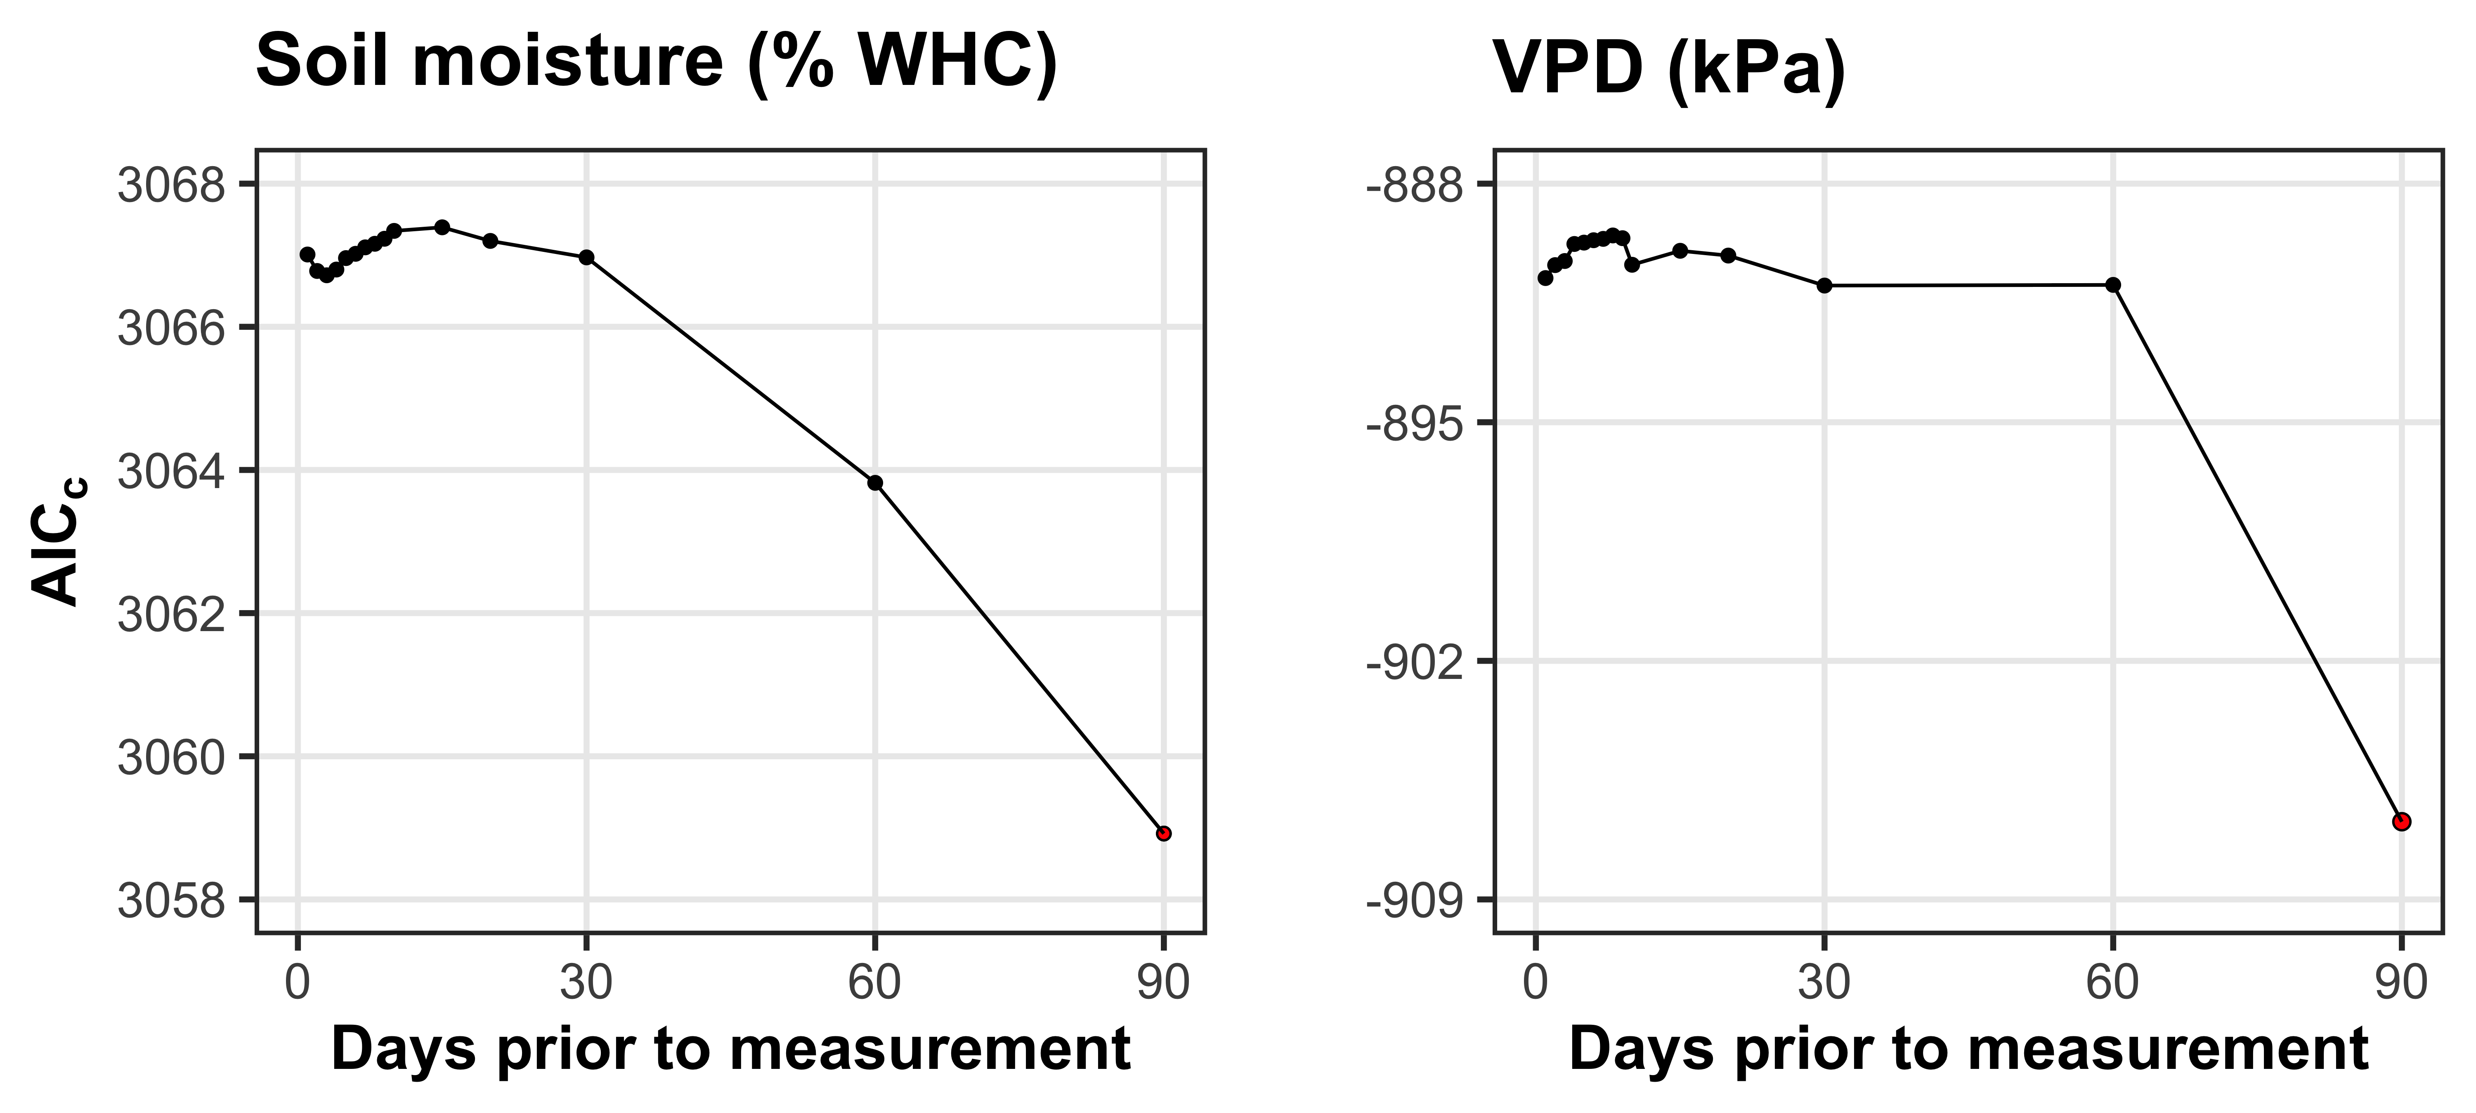
Fig. S1 Model selection results exploring relevant timescales for soil moisture (left panel) and vapor pressure deficit (right panel). The x-axis indicates the number of days before each site visit and the y-axis notes the corrected Akaike Information Criterion value. The timescale with the lowest AICc value, and therefore most relevant timescale to include in statistical models, is noted as a red point.

Figure S2
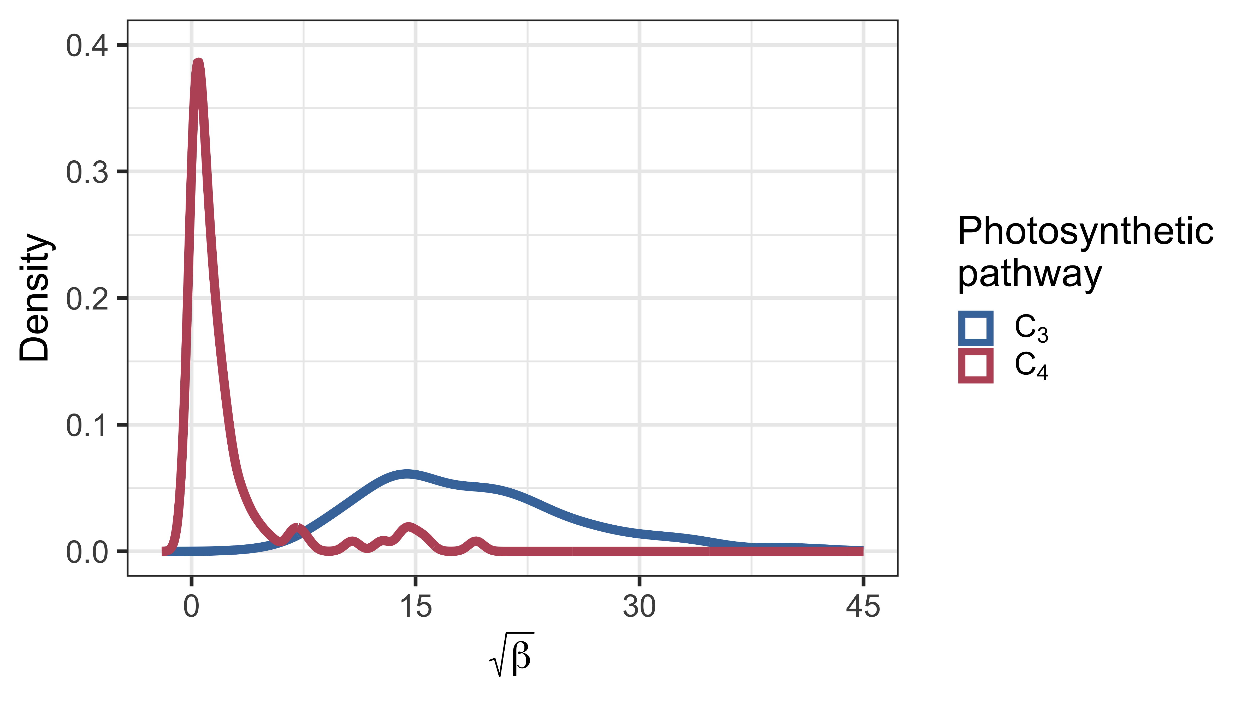
Fig. S2 Density plot demonstrating the observed variance in β across the environmental gradient. Square root transformed β is included on the x-axis. Blue shading indicates the distribution of β values for C₃ species, while red shading indicates the distribution of β values for C₄ species.

