Table 1 Description and scale of variables used in this synthesis
Variable | Variable Description | Variable type
M_{area} | leaf dry biomass per unit leaf area | leaf structure, morphology
N_{mass} | leaf nitrogen content per unit leaf biomass | leaf chemistry
N_{area} | leaf nitrogen content per unit leaf area | leaf chemistry
P_{mass} | leaf phosphorus content per unit leaf biomass | leaf chemistry
P_{area} | leaf phosphorus content per unit leaf area | leaf chemistry
Leaf N:P | ratio of leaf nitrogen content (N_{mass}) to leaf phosphorus content (P_{mass}) | leaf chemistry
A_{sat} | light-saturated net photosynthesis rate at measurement temperature | leaf photosynthesis
R_{d} | dark respiration rate at measurement temperature | leaf photosynthesis
g_{sw} | stomatal conductance rate at measurement temperature | leaf photosynthesis
V_{cmax} | apparent maximum rate of Rubisco carboxylation, taken as reported in study (measurement temperature or standardized to 25ºC) | leaf photosynthesis
J_{max} | apparent maximum rate of electron transport for RuBP regeneration, taken as reported in study (measurement temperature or standardized to 25ºC) | leaf photosynthesis
J_{max}:V_{cmax} | ratio of J_{max} to V_{cmax} (individual rates collected at measurement temperature or standardized to 25ºC) | leaf photosynthesis
PNUE | photosynthetic nitrogen-use efficiency (A_{sat}/N_{area}) | resource use efficiency
PPUE | photosynthetic phosphorus use efficiency (A_{sat}/P_{area}) | resource use efficiency
Leaf production | investment in leaf production, includes total leaf area and leaf area index | biomass
Biomass production | total biomass production (community-scale estimate of total biomass per unit ground area) | biomass
Aboveground biomass production | aboveground biomass production (community-scale estimate of aboveground biomass per unit ground area) | biomass
Belowground biomass production | belowground biomass production (community-scale estimate of belowground biomass per unit ground area) | biomass
Root mass fraction | root biomass per unit total biomass | biomass partitioning
Root:shoot | ratio of root biomass to shoot (aboveground) biomass | biomass partitioning

Figure 1
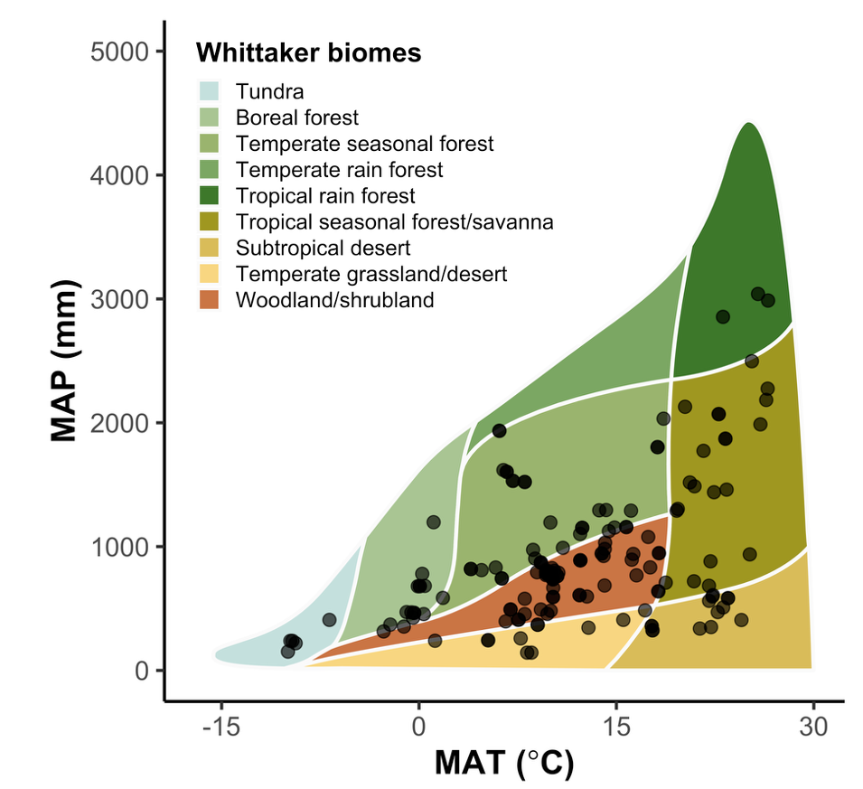

Figure 1. Climate variability across experimental sites, as indicated by relationships between 1970–2000 mean annual temperature (x-axis) and mean annual precipitation (y-axis). Black points represent individual study sites. Points are superimposed onto a Whittaker biome plot where the colored polygons indicate the climate distribution of major terrestrial biomes. The Whittaker biome plot was generated using the ‘plotbiomes’ R package (Valentin & Levin, 2018).

Figure 2
Figure 2. Leaf (panel a), photosynthetic (panel b), and biomass (panel c) individual responses to N, P, and combined N+P addition. Variables for each category are listed on the y-axis using acronyms explained in Table 1, with the number of observations for each variable listed in parentheses. Large points indicate the meta-analytic mean of the log-response ratio and error bars indicate the associated 95% confidence intervals. Red colored points indicate N addition responses, blue colored points indicate P addition responses, and orange points indicate combined N+P addition responses.
Figure 3
Figure 3. Interactive effects of N and P addition on leaf nutrient (a), photosynthetic (b) and biomass (c) variables (acronyms explained in Table 1). Large points indicate the meta-analytic mean of the Hedges’ d interaction effect size ($\overline{d_{NP}}$), error bars indicate 95% confidence intervals, and sample sizes are reported in parentheses. Black-colored points indicate additive interactions, green-colored points indicate synergistic interactions, and purple-colored points indicate antagonistic interactions.

Figure 4
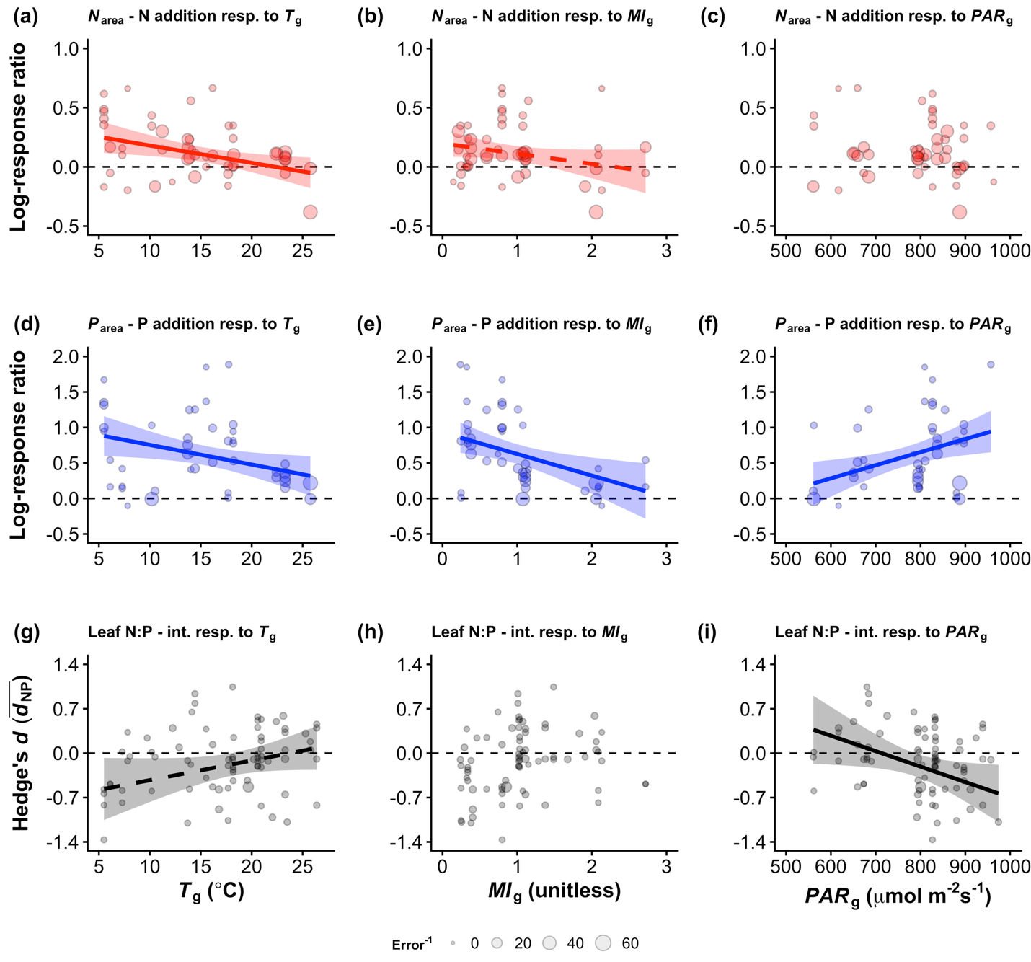
Figure 4. Climate moderator effects on N_{area} responses to N addition (top row), P_{area} responses to P addition (middle row), and leaf N:P interaction responses (bottom row). Panels (a), (b), and (c) describe the growing season temperature, moisture index, and light availability effects on N_{area} responses to N addition, respectively. Panels (d), (e), and (f) describe the growing season temperature, moisture index, and light availability effects on P_{area} responses to P addition. Finally, panels (g), (h), and (i) describe the growing season temperature, moisture index, and light availability effect on leaf N:P interaction effect sizes. Points indicate individual data points, sized to reflect the inverse of the standard error. Trendlines and associated 95% confidence interval error ribbons are drawn using meta-regression model predictions generated using the ‘orchaRd’ R package (Nakagawa et al., 2023). Solid trendlines indicate cases where climate had a significant moderator effect (p<0.05), dashed trendlines indicate cases where climate had a marginal moderator effect (0.05<p<0.1), and absent trendlines indicate cases where climate did not have a significant or marginally significant moderator effect (p>0.1).
Figure 5.
Figure 5. Plant functional type effects on N_{mass}, N_{area}, A_{sat}, R_{d}, V_{cmax}, and J_{max} responses to N addition. Panel (a) describes the N₂ fixation ability effect on these variables, panel (b) describes the mycorrhizal nutrient acquisition strategy effect on these variables, and panel (c) describes the photosynthetic pathway effect on these variables. Selected variables are listed on the y-axis using acronyms explained in Table 1, with the moderator effect noted on the right side of each panel (p<0.001: ***; p<0.01: **; p<0.05: *; p>0.05: NS). Large colored points indicate the meta-analytic mean of the log-response ratio for each plant functional type, and error bars indicate the associated 95% confidence intervals.
Figure 6
Figure 6. Plant functional type effects on P_{mass}, P_{area}, A_{sat}, R_{d}, V_{cmax}, and J_{max} responses to P addition. Panel (a) describes the N₂ fixation ability effect on these variables, panel (b) describes the mycorrhizal nutrient acquisition strategy effect on these variables, and panel (c) describes the photosynthetic pathway effect on these variables. Selected variables are listed on the y-axis using acronyms explained in Table 1, with the moderator effect noted on the right side of each panel (p<0.001: ***; p<0.01: **; p<0.05: *; p>0.05: NS). Large colored points indicate the meta-analytic mean of the log-response ratio for each plant functional type, with error bars indicating the associated 95% confidence intervals.

