*In preparation for submission at Global Change Biology*

**Global response patterns of plant functional traits to combined nitrogen and phosphorus addition are governed by additive interactions**

Evan A. Perkowski1, Keith J. Bloomfield2, Hugo J. de Boer3, Alissar Cheaib1, Ning Dong2, Monika R. Kelley1, Jan Lankhorst3, Astrid Odé3, Daniil J. Scheifes3, Benjamin D. Stocker4, Karin T. Rebel3, Huiying Xu5, I. Colin Prentice2, Sandy P. Harrison6, Nicholas G. Smith1

1Department of Biological Sciences, Texas Tech University, Lubbock, TX

2Department of Life Sciences, Georgina Mace Centre for the Living Planet, Imperial College London, Silwood Park Campus, Ascot, UK

3Faculty of Geosciences, Copernicus Institute of Sustainable Development, Environmental Sciences, Utrecht University, NL

4Instititude of Geography, University of Bern, Bern, Switzerland

5School of Biological Sciences, University of Utah, Salt Lake City, UT

6Department of Geography and Environmental Sciences, University of Reading, Reading, UK

**\***Correspondence to:

Evan A. Perkowski

2901 Main St.

Lubbock TX 79409

[evan.a.perkowski@ttu.edu](mailto:eaperkowski@gmail.com)

**Keywords**

nutrient addition, plant functional ecology, photosynthetic capacity, meta-analysis, carbon cycle

**Abstract**

The availability of nutrients such as nitrogen (N) and phosphorus (P) play an important role in shaping plant ecophysiological responses to global change. While nitrogen availability has been asserted as a key driver of plant responses to global change, the role of phosphorus – both individually and in combination with nitrogen – remains less understood. This is due to a lack of broad data syntheses that precludes the development of a mechanistic framework. To address this knowledge gap, we compiled global leaf and whole-plant trait data from full-factorial nitrogen and phosphorus addition experiments across the globe and conducted a meta-analysis. We used this approach to quantify the individual and interactive effects of nitrogen and phosphorus on net photosynthesis, photosynthetic capacity, leaf nutrient content, plant biomass accumulation, and biomass partitioning. Across experiments, nitrogen addition generally increased leaf nitrogen content on both a mass- and area-basis but did not change leaf phosphorus content, leading to an increase in the leaf nitrogen-to-phosphorus ratio. In contrast, phosphorus addition increased leaf phosphorus on a mass- and area-basis but did not change leaf nitrogen content, leading to a decrease in the leaf nitrogen-to-phosphorus ratio. We found no evidence that nitrogen or phosphorus addition influenced net photosynthesis apparent photosynthetic capacity, or photosynthetic nitrogen and phosphorus use effiicencies. Nitrogen and phosphorus addition each increased aboveground biomass and did not alter belowground biomass, leading to a reduction in the root mass fraction and root-to-shoot ratio. An analysis of interaction effect sizes indicated that the combined effects of nitrogen and phosphorus addition on leaf and whole-plant traits were primarily driven by additive interactions, indicating that these responses were generally the result of independent effects of each nutrient addition. These findings show that nitrogen and phosphorus availability additively impact leaf chemistry and biomass but have no effect on leaf-level photosynthesis. In fact, null photosynthetic responses to nutrient additions are supportive of previous work showing that investment in photosynthesis is more strongly regulated by climatic factors that alter demand for soil resources (e.g., CO2, temperature) than by changes in nutrient availability.

**Introduction**

[introduction, eutrophication and global change]

[N addition effects on leaf and whole-plant traits]

[P addition effects on leaf and whole-plant traits]

[Combined N and P effects on leaf and whole-plant traits, including knowledge gaps]

[study objectives]

Here, we conducted a global meta-analysis using [XX] observations from [XX] journal articles, including data compiled from an existing database of plant functional trait responses to nitrogen and phosphorus addition. Our objectives were two-fold. First, we sought to quantify the effects of N, P, and N+P addition on net photosynthesis, photosynthetic capacity, leaf nutrient content and partitioning, resource use efficiencies, plant growth, and biomass partitioning. Second, we quantified the interaction effect size of each trait to understand whether the effects of N+P addition were the product of additive, synergistic, or antagonistic individual effects of N and P addition. We used this approach to test the following hypotheses:

1. Nitrogen and phosphorus addition will increase leaf nitrogen content and leaf phosphorus content, respectively. This will lead to an increase in the leaf N:P ratio with nitrogen addition and a decrease in the leaf N:P ratio with phosphorus addition. The effects of nitrogen and phosphorus addition on leaf nitrogen and phosphorus content are expected to be amplified in regions where demand for building and maintaining photosynthetic enzymes is high (e.g., high aridity, low temperature, high light availability; (Cheaib *et al.*, 2025), or in species with high demand for building and maintaining photosynthetic enzymes (e.g., N2-fixers, AM-association species).
2. Nitrogen and phosphorus addition will not influence photosynthetic parameters unless the availability of these resources is insufficient to satisfy demand to build and maintain photosynthetic enzymes. In nitrogen-limited systems, nitrogen addition is expected to increase the maximum rate of Rubisco carboxylation. In phosphorus-limited systems, phosphorus addition is expected to increase the maximum rate of electron transport for RuBP regeneration.
3. Nitrogen and phosphorus addition will increase total biomass through stronger increases in aboveground biomass than belowground biomass, which will decrease the root-to-shoot ratio and root mass fraction.
4. The combined effects of nitrogen and phosphorus addition on leaf and whole-plant traits will be the sum of the corresponding individual effects of nitrogen and phosphorus addition. In other words, the combined effects of nitrogen and phosphorus addition will be the product of additive responses, not synergistic or antagonistic.

**Materials and Methods**

*Data compilation*

Initial data for the meta-analysis were collected using citations listed in the Manipulation Experiments Synthesis Initiative (MESI) database (Van Sundert *et al.*, 2023). We selected manipulation experiments that added N and P in a full-factorial design to ensure that any comparisons made between N, P, and N+P addition responses were from the same subset of experiments. All data for manuscripts included in the MESI database that fit these criteria were downloaded or extracted using a plot digitizer to ensure that all relevant traits were included in the meta-analysis and undergo a round of quality control to avoid any data entry issues that may arise when using large ecological datasets (Augustine *et al.*, 2024). To supplement studies included in the MESI database, studies that reported data from Nutrient Network experiments were also included in the meta-analysis, including only measurements collected from control, N, P, and N+P addition plots. Each site in each paper that reported data from Nutrient Network experiments was treated as an independent experiment, following that the Nutrient Network is a globally distributed experiment where independent sites share the same nutrient addition and experimental design scheme (Borer *et al.*, 2014). Specifically, we added leaf nutrient data from Firn et al. (2019), biomass partitioning data from Cleland et al. (2019), and photosynthetic data from Hersch-Green et al. (2024).

To further supplement MESI and Nutrient Network datasets, we added additional manipulation experiments using journal articles published on or before March 2025. We selected manipulation experiments where N and P were added in a full-factorial design. From this, we selected experiments that measured traits related to leaf photosynthesis (e.g., net photosynthesis photosynthetic capacity, stomatal conductance), leaf nutrient content (e.g., mass- or area-based leaf nitrogen content, mass- or area-based leaf phosphorus content), biomass (e.g., above-ground or belowground biomass), biomass partitioning (e.g., root:shoot ratio), or nutrient partitioning of the biomass (e.g., aboveground nitrogen biomass, aboveground phosphorus biomass). Finally, we selected experiments that included explicit explanations of treatment replication schemes to accurately calculate summary statistics. We first searched for studies that followed these guidelines using citations included in the MESI and Nutrient Network papers. To supplement these studies, we also created a search query in Web of Science using similar search terms as in (Liang *et al.*, 2020). Specifically, our query mined for the following topics: (nitrogen AND phosphorus) AND (fertiliz* OR addition) AND (effect* OR respon* OR affect* OR impact* OR increas* OR decreas* OR alter* OR deposition OR enrich*) AND (leaf nitrogen* OR leaf phosphorus* OR *use efficiency OR biomass OR mass fraction OR root:shoot OR LMA OR SLA OR chlorophyll OR photosynthesis OR Vcmax OR Jmax) NOT (animal* OR medic* OR chemist*).

*Data extraction*

For experiments that reported results at the species-level, one mean value ± standard deviation per trait per species per nutrient fertilization treatment per experimental site was considered one observation. Observations for different species from the same study were considered to be independent and allowed us to determine the effects of species identity traits (e.g., mycorrhizal type, photosynthetic pathway, growth form) on plant responses to nutrient treatments. For experiments that reported results at the treatment level, one mean value ± standard deviation per trait per nutrient fertilization treatment per experimental site was considered one observation. Additional analyses are included in the *Supplement* to isolate the effects of species- versus treatment-level responses.

Observations were integrated into a compiled dataset through multiple pathways. First, summary statistics (mean, standard deviation, replication scheme) were calculated directly from published datasets from studies that adopted open data practices (n = XX studies). Where possible, summary statistics were extracted from tables included in the main text or supplemental information if studies did not explicitly provide data. If studies did not include their data or provide summary statistics in tables, we digitized plots using information about treatment and sample replication information. Plots were digitized in R (version 4.4.2) using the ‘metadigitise’ package (Pick *et al.*, 2019). Studies that did not include clear descriptions about the replication scheme were not included in the dataset. Overall, this data extraction procedure rendered 4680 observations (1560 observations each for N, P, and N+P treatments) from 85 studies. Of these studies, 78 were field manipulation experiments, 6 were greenhouse manipulation experiments, and 1 was a growth chamber experiment. Of the field manipulation experiments, 166 independent sites were represented, spanning a broad global gradient and diverse array of biome types (Table S1; Fig. 1). The dataset also includes 170 species from 54 families, representing diverse growth forms, growth durations, nutrient acquisition strategy, and photosynthetic pathway.

**Figure 1**

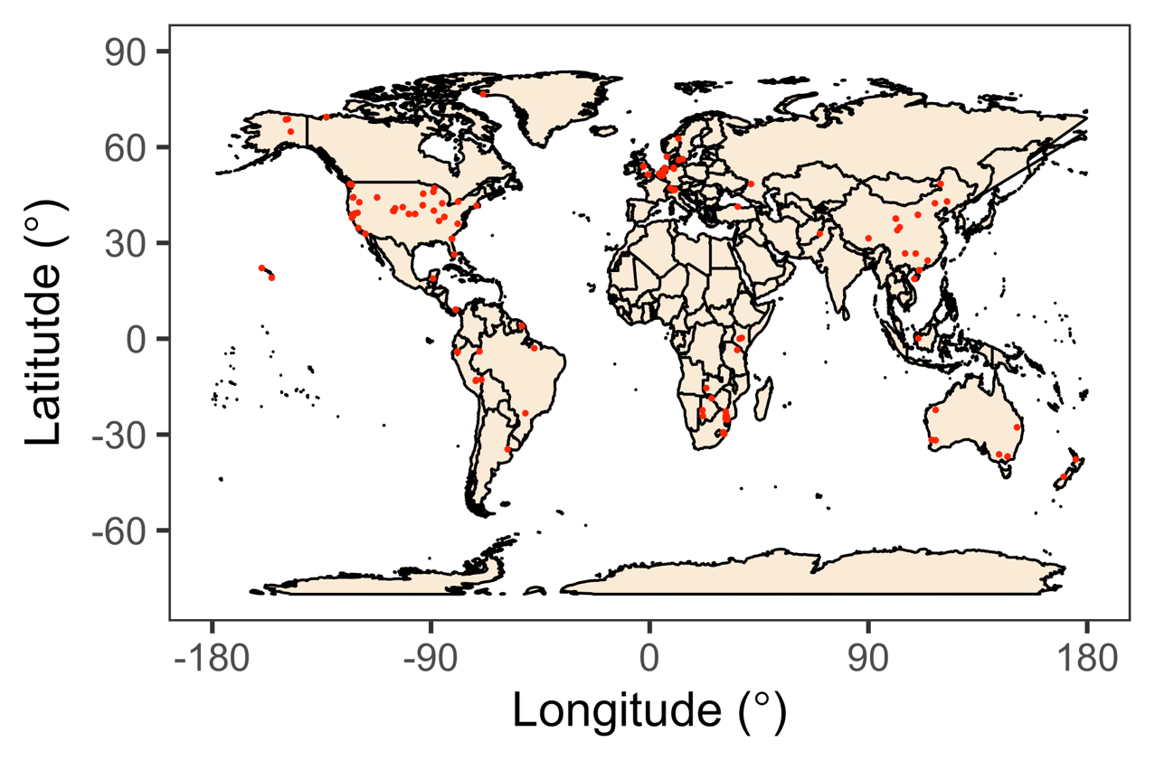

**Figure 1**

*Moderator variables*

All field experiments reported site latitude and longitude coordinates. Using these coordinates, we extracted monthly climate data spanning 1901-2024 using the Climatic Research Unit Time Series gridded data product at a 0.5° resolution (CRU TS v4.09; (Harris *et al.*, 2020). Data were extracted from the grid cell containing each site using the “extract” function in the “raster” R package (Hijmans, 2010). Specifically, we extracted data for monthly average temperature (°C), total monthly precipitation (mm month-1), and total monthly potential evapotranspiration (cm month-1). Mean annual temperature, precipitation, and potential evapotranspiration were calculated for each site by first calculating the mean temperature, total precipitation, and total potential evapotranspiration for each year separately, then calculating the average of these climatic variables across the 1901-2024 period. We used mean annual precipitation and mean annual potential evapotranspiration to calculate the mean annual aridity index (AI, unitless). Low AI values indicate more arid sites. Site climate data are reported in Table XX.

Species identity traits were included for all measurements that were collected at the species level. Specifically, we included information about species family, growth form (tree/shrub, graminoid, forb), growth duration (annual, perennial), photosynthetic pathway (C3, C4), N2-fixation ability (N2-fixer or non-fixer), and mycorrhizal type (AM, EcM, dual AM-EcM, facultative AM, ErM, and non-mycorrhizal). N2-fixation ability was determined based on whether species were in the *Fabaceae* family. Mycorrhizal type was assigned from the FungalRoot database using the genus of each species (Soudzilovskaia *et al.*, 2020).

*Determination and analysis of individual and interaction effect sizes*

We followed an established framework for assessing individual and interactive effects of multiple treatments in meta-analysis (Yue *et al.*, 2017). First, we used the natural logarithm of the response ratio (ln RR) to determine the individual effects of N, P, and N+P addition on leaf and whole-plant traits. For each observation *i* (i.e., trait per species per site per experiment), we calculated the log-response ratio as:

(1)

Where is the mean value of a treatment (i.e., N, P, or N+P addition) and is the mean value of the control treatment. We determined the weighted log-response ratio () of each trait *k* as:

(2)

Where ln RRi is the log-response ratio of observation *i* given in (1), *w*i is the weight of each log-response ratio, and *k* is the total number of observations. *w*i was calculated as the inverse of the variance (*v*i) of observation *i* (that is, *w*i = 1 / *v*i). *v*i was calculated as:

(3)

Where *s*t and *s*c are the standard deviations of the treatment and control groups, respectively, and *n*t and *n*c are the sample sizes of the treatment and control groups.

Next, we used Hedge’s *d* to determine the interactive effect of N and P addition on leaf and whole-plant traits (Yue *et al.*, 2017; Ding *et al.*, 2025). For each observation *i*, the interactive effect size of N and P addition (dNPi) was calculated as:

(4)

Where ,,, and refer to the mean of the N, P, N+P, and control treatments, respectively, for observation *i*. *s*int refers to the pooled standard deviation across treatments, calculated as:

(5)

Where *N*c, *N*n, *N*p, and *N*np refer to the sample sizes of control, N, P, and N+P treatments, respectively. *S*c, *S*n, *S*p, and *S*np refer to the sample sizes of control, N, P, and N+P treatments, respectively. In (6), *J*int refers to a correction term for small sample size bias, calculated as:

(6)

We determined the weighted interaction effect size () of each trait across experiments as:

(7)

Where *d*NPi is the interaction effect size of observation *i* given in (6), *w*dnpi is the associated weight of each interaction effect size, and *k* represents the total number of observations. *w*dnpi was calculated as the inverse of the variance (*vd*NPi) of observation *i* (that is, *w*dnpi = 1 / *vd*NPi). *vd*NPi was calculated as:

(8)

*Data analysis*

We constructed a series of mixed-effects meta-regression models to understand the individual and interactive effects of N and P addition on leaf and whole-plant traits. Three separate models were created for each trait to assess the individual effects of N, P, and N+P addition using log-response ratios and their associated variances. We created a fourth model for each trait to assess the interactive effect of N and P addition using *d*NPi values and their associated variances and weights. In all cases, we built mixed-effects meta-regression models using the ‘rma.mv’ function in the ‘metafor’ R package (Viechtbauer, 2010), manually specifying the weights of each observation as explained above and fitting each model using restricted maximum likelihood estimation. All models included climatic moderator variables (MAT, MAP, AI) and species identity moderator variables (growth form, growth duration, photosynthetic pathway, N2-fixation ability, mycorrhizal status) as fixed effects.

Interactions between N and P addition on leaf and whole-plant traits were classified into three categories: additive, synergistic, and antagonistic. Following

If positive or negative effects of N or P addition corresponded with a null interaction effect (i.e. 95% confidence intervals overlapping with zero), then the combined effect of N and P addition did not have stronger effects than when nutrients were added in isolation, indicating an additive effect. However, if positive individual effects of N or P addition corresponded with a significant positive interaction effect (i.e. the interaction effect size and confidence intervals were all positive), then the combined positive effect of N and P addition was stronger than in isolation, indicating a synergistic interaction. Similarly, if negative individual effects of N or P addition corresponded with a significant negative interaction effect, then the combined negative effect of N and P addition was stronger than when nutrients were added in isolation, also indicating a synergistic effect. Finally, if positive individual effects of N or P addition corresponded with a significant negative interaction effect, then the combined effect of N and P addition was weaker than when nutrients were added in isolation, indicating an antagonistic effect.

**Results**

*Leaf nutrient content*

**Discussion**

*Plant responses to combined N and P addition are driven by additive interactions*

*Leaf nutrients and biomass responses to N and P additions are stronger than photosynthetic responses*