RStudio - Lab Class 4
Ethan Arevalo
January 15th, 2026
x <- 1:50
plot(x, sin(x))
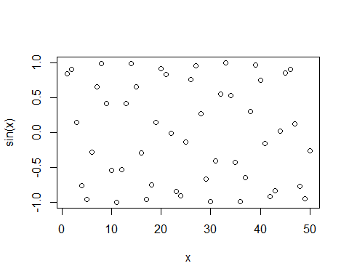
plot(x, sin(x), typ="l", col="orange", lwd=2)
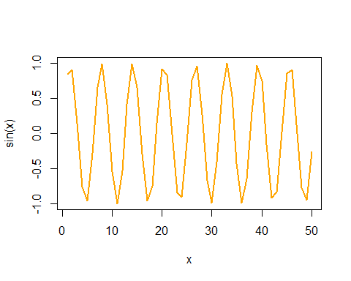
log((10), base = 10)
## [1] 1

