**Documentation**

**Client:**

When you are about to run the client program there are two parameters you must put. The first one is the IP of the server you want to communicate and the other one the port (have in mind the same port has to be used also for the server)

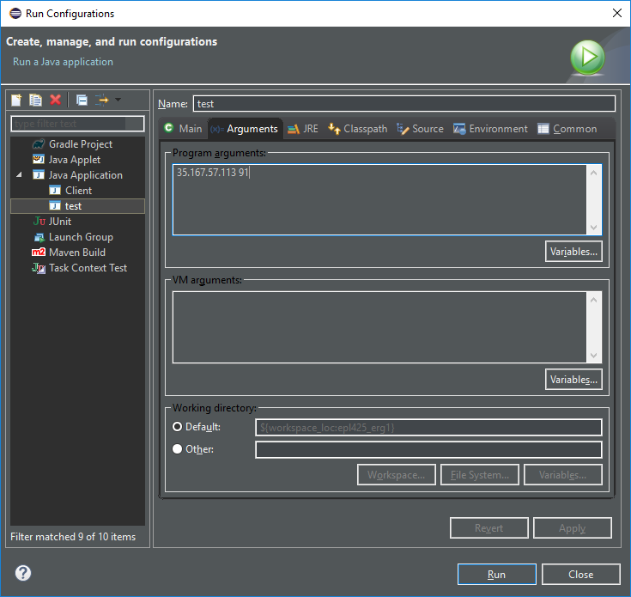

In this example we run the Client using Eclipse IDE

**Server:**

Before you run the client you must run the server. The server is ran through our instance using the terminal. Again we have to put two parameters the first is the port which has to be the same that we will put on the client later and the second is the number of repetitions which is the total number of messages that will be send

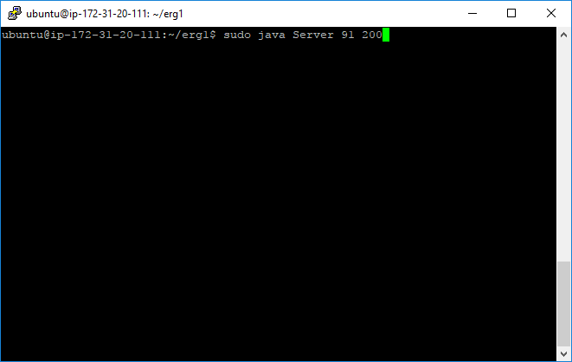

We run the server at the Ubuntu instance terminal and then we will have the following message which means the server is up and running and ready to receive requests

“Server listening to: 0.0.0.0/0.0.0.0:91”

**Results**

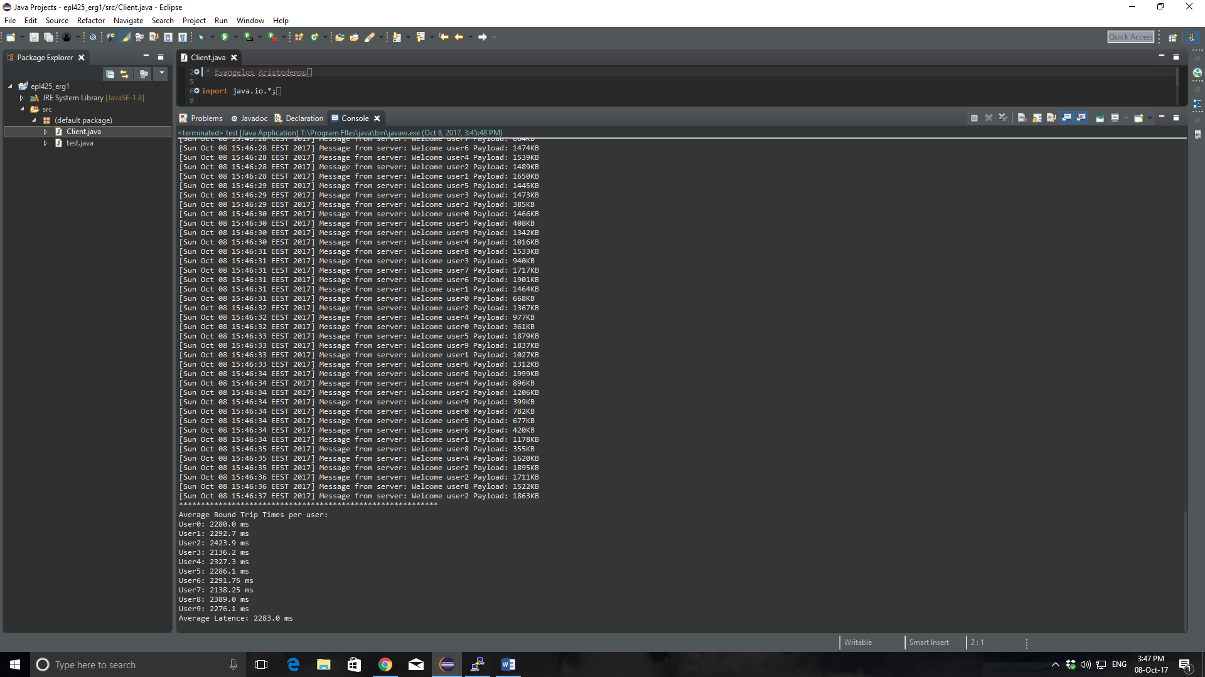After we run the client he will establish connection with the server and it will start sending messages. When it’s finished we will have the following results

As you can see we have the messages send including the user and the payload and bellow we have the average Latency for each user and in total

In the server we again se the messages received and in the end we have the number of the messages send, the total time it took, the throughput and the average memory utilization

