Manual of XSDForm

Requirements

Apache and PHP server.

How it works

The XSDForm JavaScript engine parses the input XSD file to generate an HTML form. If the user select an XML file for loading the XSDForm engine parses it and fulfills the HTML form automatically. After generating the form, the user can modify, delete or add content(s).

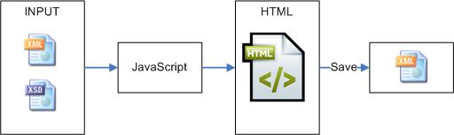

Structure of folders

* The **scr** folder contains the sources of the project.
* The **scr/server** folder contains the server side (PHP) files. These files can be changed by the user. The index.php file is the main frame of this project. Using this file the user can upload XSD and XML files.
* The **scr/client** folder contains the core HTML files of this project. These files are connected to the PHP files by AJAX calling.
* The **test** folder contains a few examples. The **test/xsds** folder contains the uploaded XSD files. **WARNING**: A default.xsd file must be placed here. The **test**/**xml** folder contains the uploaded and saved XML files.

How to use

The index.php can be accessed using the following link

<http://yourserver/XSDForm/src/server>

The link of emptyForm.html is

<http://yourserver/XSDForm/src/client/emptyForm.html>

This html page saves the XML file into the **test/xml** folder using the **src/server**/writeXML.php file.

The link to filledForm.html is

[http://yourserver/XSDForm/src/client/filledForm.html](http://yourserver/XSDForm/src/client/emptyForm.html)?fileid=example_1.xml

The fileid parameter contains the name of the XML file. The **src/server**/ getXML.php file reads the XML file.

Structure of files

* The **index.php** is the main site of XSDForm. The user can upload an own XSD and/or XML file on this site. The list of the uploaded XML file can be seen on this site. The uploaded XSD file can be selected either the eadgeo.php or filledForm.php site.
* The **eadgeo.php** contains the empty form of the selected XSD file. A schema must be selected first using the ‘*Select schema’* dropdown. If the schema contains more than one language, the language of the form can be changed by the ‘*Select language*’ dropdown.
* The **filledForm.php** shows the filled form of the selected XML and selected XSD combination. This page can be load by the links of XML files on the index.php. Since in the first load the system does not know the XSD file what user wants to use, the default.xsd file is used to show the form. After the first load the user can change the XSD using the ‘*Select schema’* dropdown.

Available annotation commands

* **disabled**: the input filed will be disabled

For example:

<xs:annotation>

<xs:appinfo>

<disabled/>

</xs:appinfo>

<xs:documentation xml:lang="sl">

I don't know in Slovenian

</xs:documentation>

<xs:documentation xml:lang="en">

Record Identifier

</xs:documentation>

</xs:annotation>

The *Record Identifier* will be disabled:

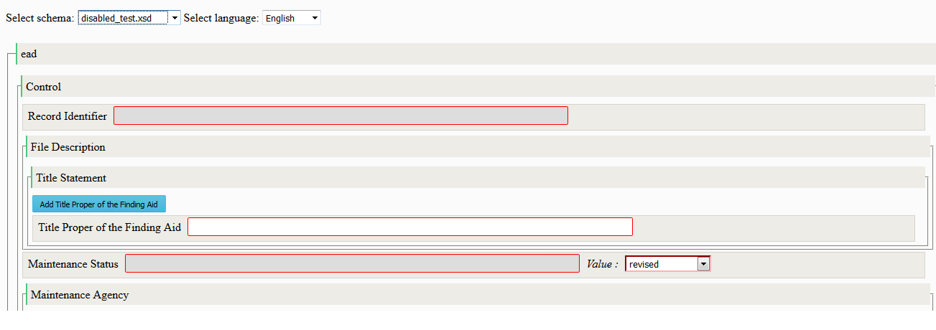

* **hidden**: the whole ead tag will be hidden

For example:

<xs:annotation>

<xs:appinfo>

<hidden/>

</xs:appinfo>

<xs:documentation xml:lang="sl">

I don't know in Slovenian

</xs:documentation>

<xs:documentation xml:lang="en">

Record Identifier

</xs:documentation>

</xs:annotation>

The *Record Identifier* will be disappeared:

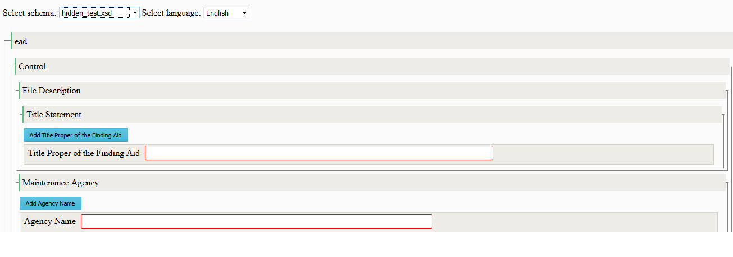

* **noinputfield**: the ead tag won't have input field, only attribute(s)

Without this annotation the *Digital Archive Object* has an input field:

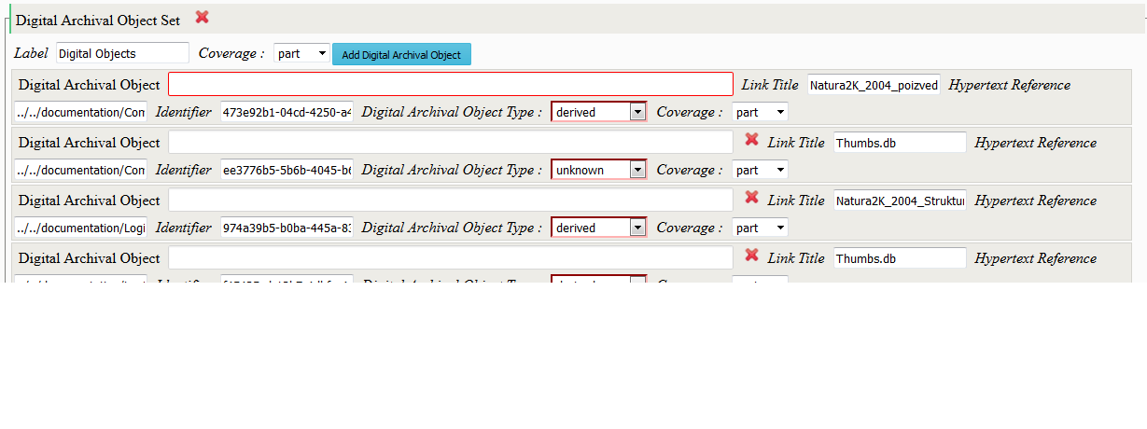

Using this annotation

<xs:annotation>

<xs:appinfo>

<noinputfield/>

</xs:appinfo>

<xs:documentation xml:lang="sl">

I don't know in Slovenian

</xs:documentation>

<xs:documentation xml:lang="en">

Digital Archival Object

</xs:documentation>

</xs:annotation>

only the input field will be disappeared, but the attribute(s) will stay in place:

