**Running the queueing system:**

1. Setup the Apache conf. Example:  
   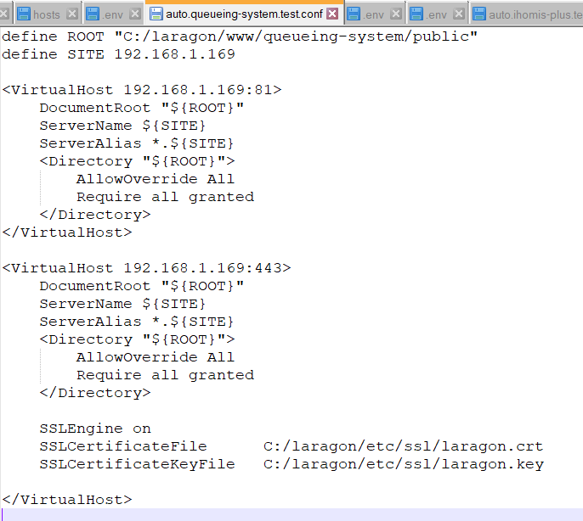
2. Run: npm run build
3. Run: php artisan reverb:start
4. Run: php artisan queue:work