Videogame Recommendation Hub Site Plan

Hyrum Cotrina

WDD 130

Overview

Purpose
To share the games I love, explain what makes them worth playing, and help visitors discover titles that offer memorable experiences.

Audience
Casual players, newcomers looking for guidance, and experienced players searching for new recommendations.

Branding

Website Logo


Style Guide

Color Palette
Primary | Secondary | Accent 1 | Accent 2
#1A1A1D | #4E4E50 | #C3073F | #6F2232

Typography

Heading Font: Bitcount Grid Double

Paragraph Font: Share Tech

Navigation
Home Mobile Games PC Games

Content

Home Page
Welcome to my Videogame Recommendation Hub, a place where I share the games that have made a strong impact on me as a gamer. Here you will find curated lists, positive reviews, and clear explanations of what makes each game special.
What Makes a Game Great
Engaging Story
A memorable narrative or world that pulls you in and makes you care about the characters.

Creative Gameplay
Mechanics that feel fresh, satisfying, or unique, whether simple or complex.

Beautiful Art & Music
Visual style and soundtracks that make the game’s world feel alive and emotional.

Meaningful Progression
A sense of growth, improvement, or discovery that keeps you motivated.

Fun Factor
Above all, a game should be enjoyable—whether relaxing, exciting, challenging, or just plain fun.

PAGE 2: Mobile Games

Clash Royale
A fast‑paced strategy game where you collect cards, build decks, and battle other players in real time. Perfect for players who enjoy quick matches and tactical decision‑making.
Genre tags: Strategy, Real-Time, Card Game, Tower Defense

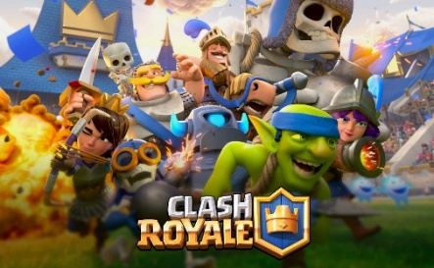

Brawl Stars
A colorful, action‑packed multiplayer game with unique characters and multiple game modes. Great for players who like fast action, teamwork, and short, exciting matches.
Genre tags: Action, Multiplayer, Hero Shooter, Brawler

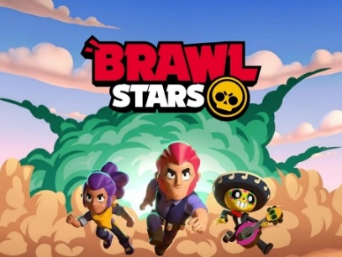

Call of Duty: Mobile
A high‑quality FPS experience on mobile with classic multiplayer modes and battle royale. Ideal for players who enjoy competitive shooting games with smooth controls.
Genre tags: FPS, Shooter, Multiplayer, Battle Royale

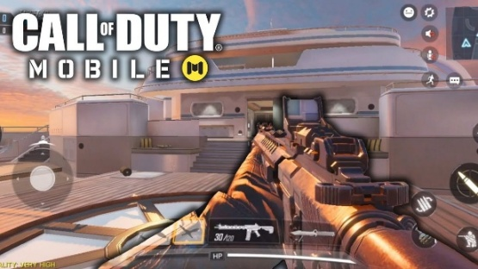
Genshin Impact
An open‑world action RPG with beautiful visuals, elemental combat, and an engaging story. Perfect for players who love exploration, adventure, and anime‑style worlds.
Genre tags: Action RPG, Open World, Anime, Adventure

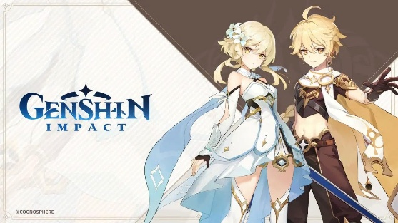

Among Us
A social deduction game where players work together — unless one of them is the impostor. Great for groups of friends and players who enjoy strategy, deception, and teamwork.
Genre tags: Social Deduction, Party, Multiplayer

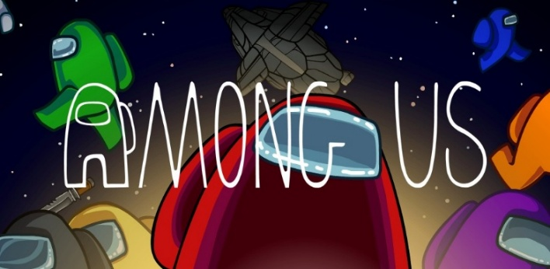

PUBG Mobile
A thrilling battle‑royale game where 100 players fight to be the last one standing. It combines strategy, teamwork, and fast reflexes, offering intense matches and realistic graphics. Perfect for players who enjoy competitive action and survival challenges.
Genre tags: Battle Royale, Shooter, Multiplayer

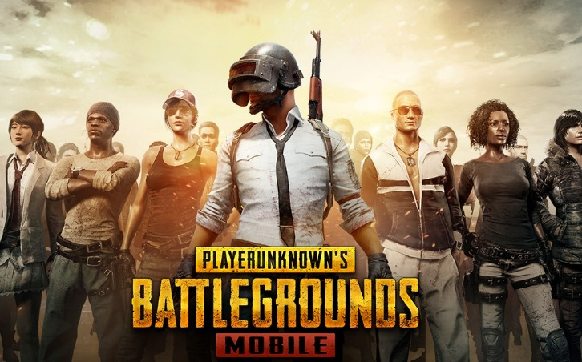
PAGE 3: PC Games

Minecraft (Java Edition)
A creative sandbox game where you can build, explore, and survive in infinite worlds. Perfect for players who enjoy freedom, creativity, and endless possibilities.
Genre tags: Sandbox, Survival, Creative, Adventure

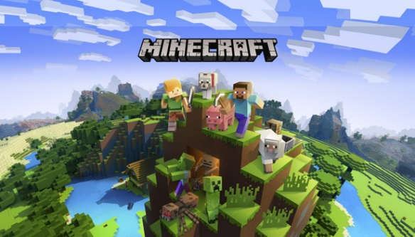

Valorant
A tactical 5v5 shooter that mixes precise gunplay with unique character abilities. Great for players who enjoy teamwork, strategy, and competitive matches.
Genre tags: Tactical Shooter, FPS, Competitive, Multiplayer

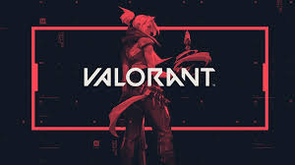

League of Legends
A fast‑paced MOBA where teams battle to destroy the enemy base. Ideal for players who like strategy, teamwork, and mastering different champions.
Genre tags: MOBA, Strategy, Competitive, Multiplayer

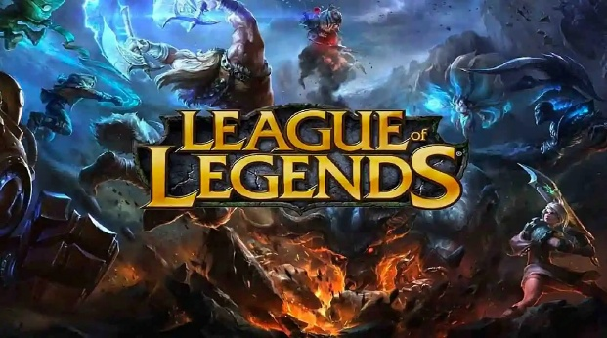
Hollow Knight
A beautifully crafted metroidvania with challenging combat and atmospheric exploration. Great for players who love adventure, mystery, and skill‑based gameplay.
Genre tags: Metroidvania, Action-Adventure, Platformer, Indie

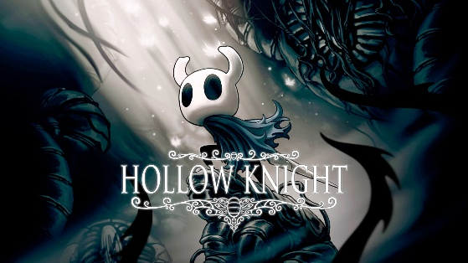

Fortnite (PC Version)
A colorful battle royale with building mechanics and constant updates. Ideal for players who enjoy fast action, creativity, and playing with friends.
Genre tags: Battle Royale, Shooter, Multiplayer, Building

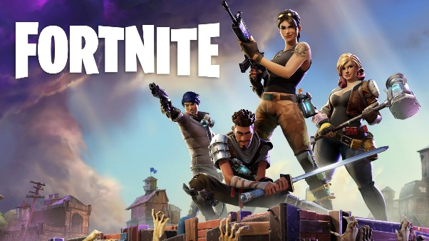

Elden Ring
An expansive open‑world action RPG that combines deep lore, challenging combat, and breathtaking landscapes. Perfect for players who enjoy exploration, mastery, and epic adventures filled with mystery and discovery.
Genre tags: Action RPG, Open World, Souls-like, Fantasy

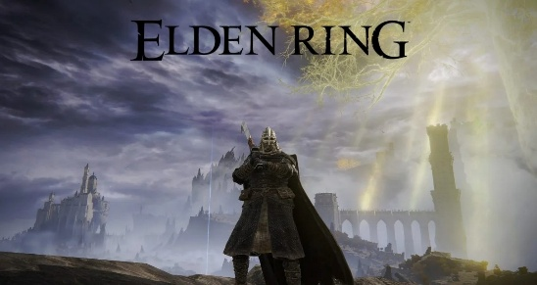

Wireframes

Home
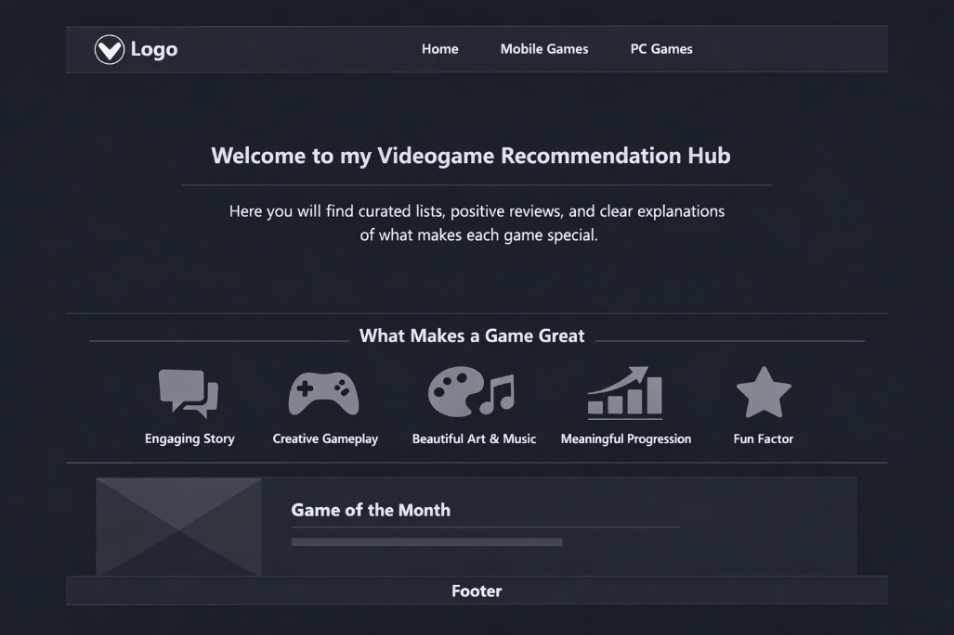

Page 2

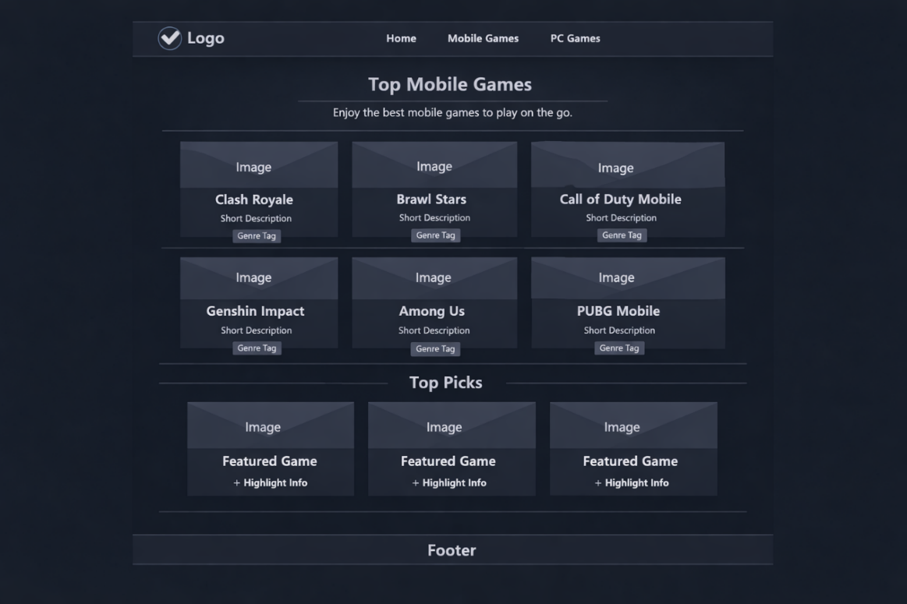

Page 3

