This is the One Zone model with a fixed value of m = 10.
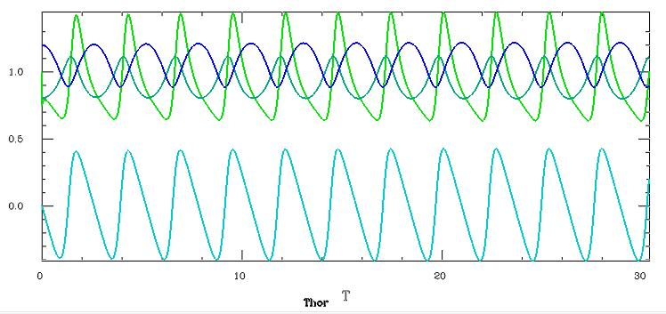
Green = luminosity, blue = radius, third upper line = non-adiabatic pressure (h), lower curve = velocity.
This is the same model with variable m = 3/(1-eta^3), and also variable Q and B.
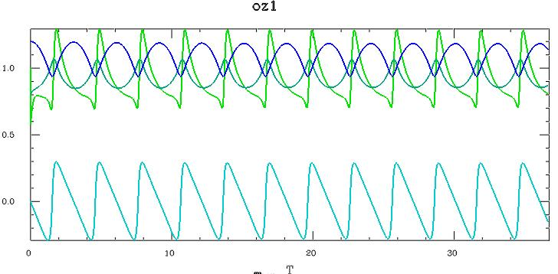

And this is the model with convection (gammac = 0.5), variable m, Q, B, c, and d.
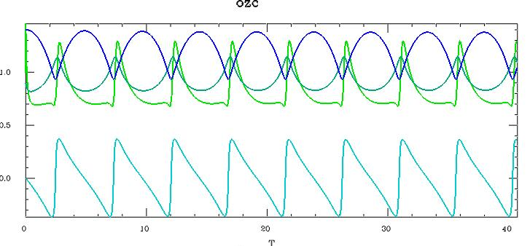
Here is the same plot of the luminosity, convective velocity and convective flux variation (bottom).
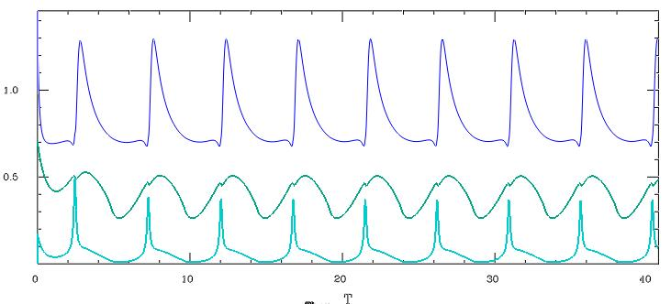

All models have
#---OZ parameters---
Zeta = 1 // 1/thermal timescale
Mgeo = 10 // m
Eta3 = 1-3/Mgeo // eta^3
Eta = cbrt(Eta3)
G1 = 1.1 // Gamma1
G11 = G1-1
Nk = 1 // n
Sk = 3 // s
B1 = (Sk+4)*G11
B = 4+Mgeo*(Nk-B1)
Q = Mgeo*G1-2 // q
U = -1 // interior lum exp
Cq = 1 // turbulent dissipation

Convective also have…
#---conv parameters---
Dc = Mgeo*G11/2
Cc = Mgeo-2
Zetac = 1 // 1/conv timescale
Gammac = .5 // conv fraction
Gammar = 1-Gammac

