
Stellingwerf Consulting
Complex Systems Analysis
Huntsville, AL

S_tran

Applications Packages
Version 2.04/4.10 (PDM) – 5/10/2021
R. Stellingwerf

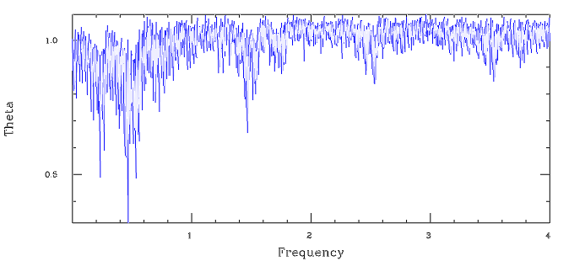


STELLINGWERF CONSULTING
11033 Mathis Mountain Rd SE, Huntsville, AL 35803
256-880-9789 rfs@stellingwerf.com
©2021 Stellingwerf Consulting

Blank Page
Table of Contents

1 S_tran Applications Packages 4
1.1 Overview 4
1.2 S_tran Coded Applications 4
1.2.1 Random Integer 4
1.2.2 Parser 5
1.2.3 Data Handling 5
1.2.4 Cubic Equation Solver 5
1.2.5 Linear Equation Solver 5
1.2.6 Ordinary Differential Equation Solver 5
1.2.7 Linear Regression 5
1.2.8 Secant Method Root Finder 6
1.2.9 Extremum Search 7
1.2.10 Shifted Power Law Fit 8
1.2.11 Units Conversion 8
1.2.12 Financial Calculations 9
1.2.13 Tax Tables 10
2 Mathematical Applications 13
2.1 Sorting 13
2.2 Linear System Solver 13
2.3 Weibull Distribution 15
3 Statistics Package 16
3.1 Multiple Regression 16
3.2 Principle Factor Analysis 18
3.3 Correlation Analysis 19
3.4 Cluster Analysis 21
4 Period Determination 23
4.1 PDM Method 23
4.2 PDM2 Rich Data Version 27
4.3 Lomb Method 28
5 Games 32
5.1 S-Master Mind 32
5.2 S-Master Mind 2D 33
5.3 Sudoku 36

S_tran Applications Packages

Overview

A summary of the S_tran programming language is given in “The S_tran Programming Language”. The language, although simple to use, is complete in the sense that applications can be written completely in S_tran to perform any straightforward mathematical analysis. Linear regression is an example of this type of S_tran-coded application. These S_tran scripts can be examined, executed in “step” mode, copied, and easily changed to adapt to a given application.

More complicated analyses that are regularly used in data analysis and computation, however, can profitably be implemented as computations that are compiled as functions in the S language. Multivariate regression, factor analysis, and multivariate sorting are examples of this sort of application. These are gradually being added to the S language as needed.

This is a summary of both of these types of routines that are currently available.

S_tran Coded Applications

This is a summary of some of the generally useful S_tran coded routines.

Random Integer

This simple function computes a random integer in a specified range. To use, just paste the function definition into the working file. A test case is provided.

/* ==========RanI.s ========================
RanI = random integer between I and J
===========================================*/

function RanI(I$,J$) = floor(ran*(J$-I$+1)+I$)

#---test case---
do_i = 1 40
show RanI(5,10)
end_i
end

Parser

The file “parse.s” contains an example of a line parser written in S_tran. A character is specified as a delimiter and a string is scanned and divided into an array of sub-strings that are divided at each occurrence of the delimiter character. The delimiters are dropped. This type of scanning is sometimes needed for non-standard format data files.

Data Handling

A number of data entry, read and write routines have been developed for inclusion in user applications. They are:

data.s – read or type in data, store in arrays - example in user manual
data2.s – similar to data.s, but stores the data in a single X[][] array, writes in CDAT format (single column, with headers)
data3.s – same as data2.s, but writes to a .csv file format
CDATA.s – converts a CDAT file to a .csv file. Set up to only copy the first “M” columns. This helps convert files with unwanted data in last columns.
CEDIT.s – allows editing and viewing of a CDAT file
program.s – simple demo program that prompts for program commands, then stores and executes the program

Cubic Equation Solver

This application is discussed in detail in the S_tran user’s manual. The file name is “cubic.s”, the subroutine entry is “cubic:”, and it can be called either by clicking on the main file, or using a “call cubic:” command.

Linear Equation Solver

The routine “LinEq_test.s” is an example of a simple interactive routine that prompts for all of the inputs needed to define a linear system, then calls “solve” (see section 2.2) and displays the result.

Ordinary Differential Equation Solver

A system of differential equations dY[I]/dx = F[I], plus initial conditions can be solved by defining an array of “F” functions, setting the initial conditions, and calling the ODE solver “step” in a loop. MidPoint.s contains a simple version of ”step”, which is second order accurate. An example of implementation is found in “SHO.s (simple harmonic oscillator). More elaborate solvers can easily be coded.

Linear Regression

The application routine “regress.s” is an example of a dual use application. If accessed via a “read_file regress.s” command, the routine prompts for data entry or a data file to read, then performs the regression calculation. Alternatively, if accessed via a “call regress:” command, the interactive portion is skipped, and the parameters and data are passed as variables. Setting LogX_r = true performs a log fit, LogY_r = true gives an exponential fit, and setting both = true results in a power law fit. Use of “regress” is described in the comments and init portion of the code:

#---use "call regress:" to call from another package
# define file $datf (default = reg.csv)
# then if Enter_data is true
# X_r[] Y_r[] and N_r must be set
# and this data set will be written to $datf
# if Enter_data is false
# the data will be read from $datf
# set Interactive = false for no queries or display
# in this case can also set:
# LogX_r LogY_r Scatter_x
# Fixed_point X0_r Y0_r
# Write_fit $fitf
# answer is in M_r and B_r (slope and intercept)
# uncertainties are in SigM and SigB

init_var Enter_data = false // default values
init_var Write_fit = true
init_var Interactive = true
init_var $datf = reg.csv
init_var $fitf = regr.csv
init_var Fixed_point = false
init_var X0_r = 0
init_var Y0_r = 0
init_var LogX_r = false
init_var LogY_r = false
init_var Scatter_x = false // true if X values are uncertain

An example of a regression application is given in “Tax_rates.s” in which the average rate curve is computed from the tax brackets, and then fit to a logarithmic curve via the following code. The last two lines pop a plot of the result using the plotter routine “Thor.exe” (change the local paths as needed).

show_nl; query "Do Regression?" y
if qq
LogX_r = true
Write_fit = true
$fitf = taxr.csv
call regress: regress.s
end_if
show_line "Stand by for plot of results"
system "C:\thor taxr.thor"

Secant Method Root Finder

This routine performs a robust search for the zeros of a function. The algorithm is a Secant Method search that requires no derivatives and converges quadratically. The routine call is:

call update_X_s: secant.s

The method of operation is described in the comments:

#--------find roots of a function----------------
# call with X_s and F_s (guess) defined
# returns a new X_s likely to decrease |F_s|
# call again with F_s for the new X_s
# test on Converge_s to see when done

init_var Tol_s = 1.e-6 // convergence criterion
init_var Uc_fact = 0.5 // undercorrect factor
init_var Converge_s // = true when done
init_var Max_passes_s = 100 // max iterations

The function value F_s (X_s) is computed externally after each call to “update”. The parameter Tol_s may be set to the required relative tolerance, and Converge_s = true indicates convergence. A typical application (embedded in file) looks like:

function Fs(X$) = sin(X$)

X_s = 3.0 // Guess

for_i = 1 100
F_s = Fs(X_s)
call update_X_s:
show i X_s F_s
break_if Converge_s
end_i

See the following application for another example of this technique.

Extremum Search

This routine performs a robust search for the maximum of a function.. Reverse the sign of the function to search for a minimum. The algorithm does a linear stepping in the direction of increasing function value to get an approximate idea of the max, then a Golden Section search is used to refine the point of maximum. The routine call is:

call update_X_g: extremum.s

The method of operation is described in the comments:

#------------iterate on X_g to find max F_g------------------#
# call with X_g and F_g (guess) defined
# returns a new X_g likely to increase F_g
# uses Golden Section search algorithm

init_var Tol_g = 1.e-3 // convergence criterion
init_var Converge_g // = true when done
init_var Gsearch // = true when close

The function value F_g (X_g) is computed externally after each call to “update”. The parameter Tol_g may be set to the required relative tolerance, and Converge_g = true indicates convergence. A typical application (embedded in file) looks like:

function Fs(X$) = sin(X$)

X_g = 1.5 // Guess

for_i = 1 100
F_g = Fs(X_g)
call update_X_g:
show i X_g F_g
break_if Converge_g
end_i

See the following application for another example of this technique.

Shifted Power Law Fit

Regress can be used to produce a power law fit by setting the “log” flags, but this type of fit always goes through the origin. To model a process with a threshold, a more general fit is needed, with a shift in “x”. The routine “power_fit.s” can be executed directly to achieve this. The headers read:

# fit a data set to a function of the form
# F(x) = a * (x - b) ^ c

# Divisor = 1/a
# Shift = b
# M_r = c
# R2_r = R^2 of the fit = % of variance accounted for

Power_fit prompts for data or a data file, then makes a guess for the shift parameter, calls “regress” to do a power-law fit, and then calls “update_X_g” to maximize the R^2 value of the fit by varying the shift. When done, the final fitting parameters are written in “Namelist” format to the file pfit.inp, as well as displayed to the screen.

Units Conversion

This application allows input of a complete expression involving units, and then displays the result in any given physical unit. The meta-command “exec” is used to evaluate the typed expression, and a set of user variables, read from the file “units.inp” is used to perform conversions. The complete listing of the simplest version is given here:

#---put all units in this file---
read_file "\home\sdat\units.inp"

for_i = 1 100
show_nl
show_field "->Expression (with units)"
input0 $str1

show_field "->Final units desired.."
input0 $str2

show_nl
$expr = "Exp = " $str1 "/(" $str2 ")"
exec $expr
show_line $str1 " = " @Exp " " $str2

show_nl
end_i

An example of its use is shown in the following screen snapshot:

->Expression (with units) =? 2.4*Lbft3*sq(700*Ftps)
->Final units desired.. =? Psi

2.4*Lbft3*sq(700*Ftps) = 253.811 Psi

Each “unit” variable is the conversion factor to cgs units. This file can be modified to any consistent set of units, provided that the variables all start with upper case letters to conform to the S user variable convention.

Financial Calculations

The folder “finance” contains a financial calculator and several test case data files. This calculator does the standard compound interest / mortgage / loan type computations, plus it has added capabilities. Rather than fixed payments or withdrawals, the payments can increase or decrease with a specified rate of change. This allows construction of a financial plan with escalating costs. Another added feature is specification of the “Tax Rate”. This causes a reduction in interest income each period. The header information for this routine is as follows, including a setup for a simple loan test case.

show_line "==========FINANCE CALCULATOR========"
show_line "Variables are..."
show_line " PV = Present Value"
show_line " FV = Future Value"
show_line " Nyr = number of years"
show_line " Iyr = Interest rate (%/yr)"
show_line " Pmt = Payment"
show_line " Pyr = Number of payments per year"
show_line " Pch = Payment change (%/yr)"
show_line " Tax = Tax rate (%/yr)"
show_line " Pmt_at_beg = 1 if pmt at beg of period"
show_line " = 0 if pmt at end"
show_line " Sign Convention:"
show_line " DEPOSITS < 0"
show_line " WITHDRAWLS > 0"

show_line \n "Default Data..."

#---HP auto loan example--- pmt = -490.41
$Title = "HP Auto Loan Example"
Nyr = 4
PV = 18280
Iyr = 13
Pmt = 0
Pyr = 12
Pch = 0
FV = 0
Pmt_at_beg = 0
Tax = 0
$Choice = m

Default Data...
Screen output for the loan example looks like this, with prompts for each of the parameters to change if desired.

HP Auto Loan Example
PV = 18280.00 FV = 0.00 Iyr = 13.00
Nyr = 4.00 Pmt = 0.00 Pyr = 12.00
Pmt_at_beg = 0.00 Pch = 0.00 Tax = 0.00

Specify unknown to input new problem, or (r)ead file
Solve for: (f)V (p)V (n)yr (i)nt P(m)t (m) =?

PV (18280) =?
FV (0) =?
Iyr (13) =?
Nyr (4) =?
Pyr (12) =?
Pmt_at_beg (0) =?
Pch (0) =?
Tax (0) =?

Pmt = -490.41

Options: (a)mort table, (e)xchange PV & -FV, (r)ead,(w)rite file, (q)uit
Solve for: (f)V (p)V (n)yr (i)nt P(m)t (m) =?

In this case the “m” option is selected to solve for the payment. Future value, present value, number of years (could be a decimal), or interest rate could also be computed, given the others.

Tax Tables

The actual tax rate is computed from a tax table in “tax_rates.s” or “tax_rates_single.s”. The bracket data is defined in the function as an array, and a table of actual rates is computed and written to a data file. A fit to the data is obtained via a call to “regress”, and a system call is used to pop a plot of the results (Thor workspace required). The paths for the system call may need to be modified for a new installation.

The computation for each bracket is in the following routine:

#---compute tax---
tax:

Inc$ = Inc-Deduct
Tax = 0
begin_loop_i = 1 Nb
if Inc$<0
break
else_if Inc$<Top[ii]
Tax = Tax+(Inc$-Top[ii-1])*Rate[ii]
break
else
Tax = Tax+(Top[ii]-Top[ii-1])*Rate[ii]
end_if
end_loop_i

Bracket = Rate[ii]

if Inc
Rate = Tax/Inc
Ratio = Rate/Bracket
else
Rate = 0
Ratio = 1
end_if
return

The result for 2004 joint income brackets is shown below.

Inc = 100000 Bracket = 0.28 Rate = 0.20562
Inc = 200000 Bracket = 0.33 Rate = 0.254985
Inc = 300000 Bracket = 0.33 Rate = 0.27999
Inc = 400000 Bracket = 0.35 Rate = 0.296505
Inc = 500000 Bracket = 0.35 Rate = 0.307204

>>>Finished, data in tax.csv<<<

The following plot shows the computed rate and the tax brackets.

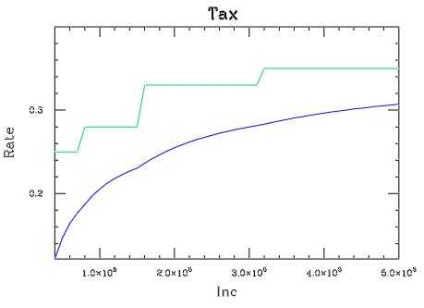
The second plot shows the fit. The dark blue line is the computed rate; the light blue line is the logarithmic fit.

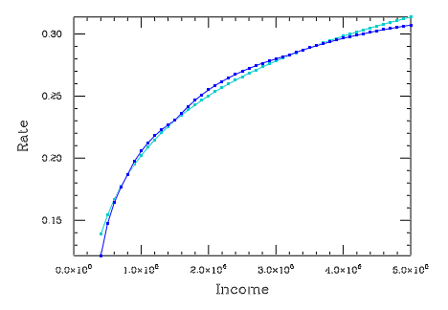

Mathematical Applications

These are a set of commands that perform useful mathematical manipulations.

Sorting

To sort a data set, first load the data into the array X[N][M] and define N = number of rows (data points) and M = number of columns (fields) to sort. Then call the command

sort [Array]

The array will now contain data sorted on the first column, and for equal first column entries, on the second column, etc., testing all M columns if needed. To sort in descending order, load the negative of the data into the array, then unload the negative of the sorted result. If the argument “Array” is present then Array[][] will be sorted instead of X[][]. The algorithm used is a generalized heap sort (see Press, et. al., “Numerical Recipes”, Cambridge U. Press, 1992).

The application routines sort1.s (sort vector A[]) and sort2.s (sort vectors A[] and B[]) can be called as subroutines to sort a single or a pair of vectors. They can also be used as templates to include these operations in an application script.

Linear System Solver

Many mathematical problems can be reduced to solving a set of linear equations. We consider a system with N variables, Z₁ -> Z_{N}, consisting of N equations of the form

Y_{i} = Z₁ * X_{i1} + Z₂ * X_{i2} + ... + Z_{N} * X_{iN}

This system of equations can be written in matrix form as:

Y[] = X[][] * Z[]

where Y and Z are N component vectors and X is an NxN matrix of coefficients. The problem is: given values for Y and X, solve for Z. To do this, set N, the vector Y[i] and the coefficient matrix X[i][j], i, j = 1-N, then execute the command

solve

The result will be stored in the array Z[i], i = 1-N. As a test case, consider:

#---solver example---

/*---set system size---*/
N = 8
show N
show_nl

/*---compute data---*/
for_i = 1 N
for_j = 1 N
X[i][j] = 0
end_j
X[i][1] = i // column 1
X[i][i] = 2 // diagonal
Y[i] = i // constant
end_i

/*---display the problem---*/
for_i = 1 N
show_field "|" @Y[i]
if i=N/2
show_field "| = | "
else
show_field "| | "
end_if
for_j = 1 N
show_field @X[i][j] " "
end_j
show_field "| |Z[" @i "]|"
show_nl
end_i

/*---solve the system---*/
solve

/*---display the answer---*/
show_nl
for_i = 1 N
show Z[i]
end_i

which results in the display:

N = 8

|1| | 2 0 0 0 0 0 0 0 | |Z[1]|
|2| | 2 2 0 0 0 0 0 0 | |Z[2]|
|3| | 3 0 2 0 0 0 0 0 | |Z[3]|
|4| = | 4 0 0 2 0 0 0 0 | |Z[4]|
|5| | 5 0 0 0 2 0 0 0 | |Z[5]|
|6| | 6 0 0 0 0 2 0 0 | |Z[6]|
|7| | 7 0 0 0 0 0 2 0 | |Z[7]|
|8| | 8 0 0 0 0 0 0 2 | |Z[8]|

Z[1] = 0.5
Z[2] = 0.5
Z[3] = 0.75
Z[4] = 1
Z[5] = 1.25
Z[6] = 1.5
Z[7] = 1.75
Z[8] = 2

The algorithm used to solve the system is Gaussian elimination with partial pivoting.

An interactive routine that prompts for all of the inputs and then displays the answer is provided in LinEq.s.

Weibull Distribution

A special random number generator is provided to compute random deviates following a Weibull distribution:

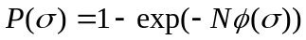
where
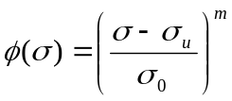.

P is the probability of failure of a system consisting of N links or flaws, when placed under a stress σ . Normally N=1. Here σ_{u} is a lower limit for σ, σ₀ is a characteristic value, and “m” is a shape parameter, usually in the range 2-3. These parameters can be derived from experimental measurement, see Weibull, J. Appl. Mech. 18, 293, (1951) for details (a program, weib_fit.s, is available to perform this computation).

A set of random values following this distribution can be obtained by first setting the parameters via the command

set_weib σ_{u} σ₀ N m (default values are 0, 1, 1, 3)

then the constant ranw will return a set of values distributed as desired.

The following figure shows the results of using ranw 100,000 times with m = 1, 2, 3, and 4 (highest peak), showing the number of occurrences over 100 bins (weib_ran.s).

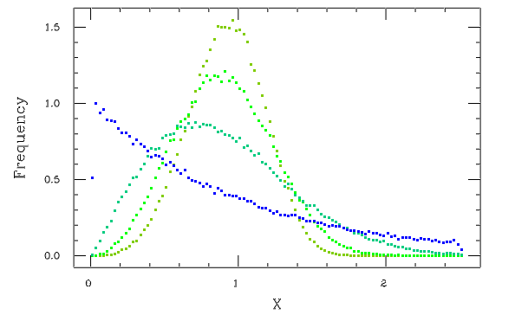

Statistics Package

These commands provide a simple interface to several sophisticated statistical analysis techniques.

Multiple Regression

This is a stepwise linear multivariate regression package. The command is:

mult_regress [file] [lin|log|exp|pow] (If no file is provided, set M, N, $Labels, X)

where the first argument is the name of a .csv file containing the data. The second, optional, argument is used to specify the type of fit. Default is linear. Other choices are logarithmic, exponential, and power law. The data are stored in the following user variables for possible later use (same as read_dat_2):

M = number of variables (columns), N = number of data points (rows),
$Labels[j] (j = 1 -> M) = column labels, X[i][j] = data entry for point i, column j .

By default, this technique uses the first column as the dependent variable, and searches all other columns for the most significant univariate regression fit. The details of this fit are displayed to the screen. A second variable is then sought that improves the fit, and the two variable fit is displayed, etc. An early variable may be dropped if a combination of other variables produces a better fit. The final fit is of the form:

X[][1] = B[1] * X[][I1] + B[2] * X[][I2] + .... + B0

If the “log” option is chosen, the fit is of the form:

X[][1] = exp( B0 ) * X[][I1]^{B[1]} * X[][I2]^{B[2]} * ...

The number of variables in the final fit is stored in NVars, the constant on the fit is stored in B0, the variable numbers in the fit are stored in Vars[], and the coefficients are stored in Coeffs[]. The standard error of the fit is stored in SY, and the standard error of each coefficient is stored in SB[].

To provide flexibility, the following command is provided:

set_mr_vars Yvar X1var X2var ....

The first integer argument is the column number of the desired Y (dependent) variable, the following integer arguments are the column numbers of the desired X (independent) variables. All other columns will be ignored in the analysis. This command must be executed before the mult_regress command to be in effect. One other command, set_mr_tols F1 F2 Tol , used to fine tune the analysis, is not normally needed. F1, F2 = F levels to enter and drop variables (defaults = 2.5, 2.4), Tol = lowest correlation considered (default = 1.e-6).

Multiple Regression Example

Consider the data set (in .csv text file mrtest.csv):

y,x1,x2,x3,x4
2,4,50,2,9
3,6,48,5,6
4,8,46,7,3
5,10,44,9,1
6,12,42,3,8
7,14,40,6,5
8,16,38,8,4
9,1,36,0,2
10,5,34,2,4
11,7,32,3,5
12,9,30,1,6
13,3,28,5,9
14,28,26,3,1
15,30,24,6,3
16,32,22,4,6
17,34,20,8,9
18,36,18,4,0
19,38,16,8,6
20,40,14,2,4

The “S” script to analyze these data is:

#----test case for mult regress----

set_mr_vars 1 2 4 5 // skip var 3
mult_regress mrtest.csv

The result is:

BEGIN ANALYSIS

Standard Deviation of Y = 5.62731

Step Number 1
ENTERING VARIABLE 2: x1
F level = 34.1113
Standard Deviation of Y = 3.33948, R^2 = 0.667393
Variance reduced by 64.78% this step
b(2) = 0.337246 +- 0.0577428
b0 = 5.08932 +- 2.04278
Fit: y = 0.337246*x1 + 5.08932

Step Number 2
ENTERING VARIABLE 4: x3
F level = 3.31177
Standard Deviation of Y = 3.13323, R^2 = 0.724431
Variance reduced by 4.22% this step
b(2) = 0.364207 +- 0.0561657
b(4) = -0.525086 +- 0.288536
b0 = 6.9935 +- 1.80176
Fit: y = 0.364207*x1 + -0.525086*x3 + 6.9935

No further significant correlations.

(Ref: Ralston, A. and Wilf, H. S., “Mathematical Methods for Digital Computers,” Ch. 17, Wiley, 1960)

Principle Factor Analysis

Principle Factor Analysis attempts to explain the variation of a group of variables in terms of a number of independent “factors”, or linear combinations of the original variables. The factors form an optimal orthogonal coordinate system for describing the observed variation in the data. The factors are computed from the eigenvectors of the correlation matrix. The commands are similar to those of the regression analysis:

factor [file]

where “file” is the file name of a .csv file containing the data. If “file” in not present, the data must be set in the variables M, N, $Labels[], X[][], as defined above. If “file” is present, the data are read from the file, and stored in these variables.

There are two user controllable parameters, “threshold” is the amount of variance to be explained before cutting off the factors (default = 0.8), and “highlight” controls the brackets in the vector display (default = 0.25, i.e. >= 25% of the variance).

set_fa_params threshold highlight

When run, the display pauses for several different screen displays. First the factors, the variance “explained” by each, and the total variance accounted for by the first “N”.

Eigenvalues Variance Expl. (thresh= 0.8 rot=29):
F1 = 1.877 0.469 sum=0.469
F2 = 1.234 0.308 sum=0.778
F3 = 0.889 0.222 sum=1.000

Next, the variable weights for each of the factors:

Eigenvectors, :
Variables F1 F2 F3 h2
x1 0.059 < 0.936 > <-0.347 > 1.000
x2 < 0.919 > <-0.392 > -0.037 1.000
x3 < 0.343 > < 0.419 > < 0.841 > 1.000
x4 < 0.955 > 0.169 <-0.245 > 1.000

“h2” is the “communality” for each variable, i.e. variance explained by the “common factors”. The brackets indicate the strongest values. Finally, the factor scores for each data point are displayed, this shows which data points align with each factor:

Factor Scores
Data F1 F2 F3 Length
Pt_1 <-1.375 > < 1.229 > <-1.240 > 2.223
Pt_2 0.592 0.350 0.179 0.710
Pt_3 0.703 <-1.534 > <-1.425 > 2.209
Pt_4 < 1.472 > < 1.120 > 0.388 1.890
Pt_5 -0.441 -0.381 < 1.202 > 1.336
Pt_6 -0.951 -0.783 0.896 1.523

The “Length” is the length of the vector of factor scores at each point.. A full summary of the analysis is written to the file “eig.txt”. Number of factors is in Nfact, the eigenvalues are in F_eig[fact], and the factor loadings are stored in F_load[fact][var].

Factor Analysis Example

The results shown above are derived from the following test data set:

x1,x2,x3,x4
1.5,-1.7,-1,-0.8
0.3,0.4,0.5,0.58
-0.9,1.3,-1.6,0.76
1,0.9,1.3,1.5
-0.8,-0.3,0.7,-0.78
-1.1,-0.6,0.1,-1.26

The display starts as follows:

Reading data from file C:\home\RFS\S_Tran\Apps\fact_data.csv
4 columns found
6 rows found

FACTOR.C: variables = 4, data pts = 6
Total data fields = 24, missing = 0 (0.00%), nonzero = 0 (0.00%)

Eigenvalues Variance Expl. (thresh= 0.8 rot=29):
F1 = 1.877 0.469 sum=0.469
F2 = 1.234 0.308 sum=0.778
F3 = 0.889 0.222 sum=1.000

Here “rot” is the rotation angle used by the Jacobi routine to diagonalize the correlation matrix.

In this example all of the variance is covered by three orthogonal factors. Usually not all of the variance is explained, and the Variance Summaries and “h2” values indicate how the factors, variables, and data interact.

(Ref: Van de Geer, J., “Introduction to Multivariate Analysis,” Ch. 13, Freeman, 1971 )

Correlation Analysis

This technique is similar to the factor analysis described above, in that correlated variables are grouped together. In this case this is done by simply interchanging rows and columns in the correlation matrix to attempt to make the matrix block diagonal in form. No numerical loadings are derived. In some cases this simpler technique produces clearer results, or may help interpret the results from a factor analysis or regression fit.

coranal [file]

where “file” is the file name of a .csv file containing the data. If “file” in not present, the data must be set in the variables M, N, $Labels[], X[][], as defined above. If “file” is present, the data are read from the file, and stored in these variables.

This is an example of a correlation analysis:

CORANAL.C: variables = 7, data pts = 36
Total data fields = 252, missing = 0 (0.00%)

Step 1, a(6, 7) = 0.957062 curr=1 [m1=0]
Promote: move 6 to 1
Promote: move 7 to 2

Step 2, a(4, 6) = -0.714919 curr=3 [m1=0]
Promote: move 4 to 3
Promote: move 6 to 4

Step 3, a(6, 7) = 0.329649 curr=5 [m1=0]
Promote: move 6 to 5
Promote: move 7 to 6

Variables (r thresh=0.80):
V 1 = MOM (0.96)
V 2 = Impulse (0.96)
---x---x---x---x---x---x
V 3 = L (0.71)
V 4 = Density (0.71) - anti
.........................
V 5 = H (0.33)
V 6 = KE(ft-lb) (0.33)
V 7 = W (0.00)

Correlation Coefficients:
1 2 3 4 5 6 7

1:100 95 23 -5 71 66 37
2: 95 100 34 -22 75 57 38
---x---x---x---x---x---x
3: 23 34 100 -71 20 -2 0
4: -5 -22 -71 100 -31 2 0
.........................
5: 71 75 20 -31 100 32 -2
6: 66 57 -2 2 32 100 17
7: 37 38 0 0 -2 17 100 (grey lines added to show blocks)

No Further Significant Groups

The “Step” entries show the most significant correlation coefficients and the movement of rows and columns to put the largest values first in the array. “M1=1” indicates a correction to previous steps. The “Variables” summary shows the variables in order of their groupings. “anti” indicates a negative correlation. Significant groups (correlations > threshold, default = 0.80) are at the top, with ----------- lines between groups and a ---x---x--- line at the end. Insignificant groups are separated by ........ lines. The correlation array with the groupings shown appears next. Note that the third block of variables show significant correlation with the first block in this example.

The only user controllable variable is the threshold for significant correlation (default = 0.80), which is reset with the command:

set_ca_params threshold

Cluster Analysis

This technique groups data points with similar values in n-dimensional data space. The technique used is a generalization of the “k-means” method plus an iteration to find the optimum number of groups and membership of each group.

cluster [file]

where “file” is the file name of a .csv file containing the data. If “file” in not present, the data must be set in the variables M, N, $Labels[], X[][], as defined above. If “file” is present, the data are read from the file, and stored in these variables.

Results of the analysis are returned as follows: the final number of clusters is placed in N_clust and the variance explained is in Var_clust (with the degree-of-freedom correction applied).

The calculation can be controlled by changing the sensitivity via the command

set_cl_params sensitivity

Putting sens = 0 produces the minimum number of clusters, sens = 1 gives the maximum. The default value is sens = 0.5. Since this technique uses random point selection, varying the random “seed” can also affect the results.

An example 3-variable run is shown below:

Reading data from file rcc1.csv
3 columns found
36 rows found

All variables standardized for analysis
Data sigma = 1.73205, variance = 3

CLUST.C: variables = 3, data pts = 36, sens = 0.6
Total data fields = 108, missing = 0 (0.00%)

Clusters = 7
cluster 1 mem= 4 dist= 2.072 size= 0.744 / (max) 0.936
cluster 2 mem= 1 dist= 1.936 point= 22
cluster 3 mem= 13 dist= 1.454 size= 0.621 / (max) 0.947
cluster 4 mem= 1 dist= 2.072 point= 32
cluster 5 mem= 6 dist= 2.058 size= 0.554 / (max) 0.772
cluster 6 mem= 1 dist= 1.936 point= 28
cluster 7 mem= 10 dist= 1.454 size= 0.411 / (max) 0.874
dist_p= 0.744, dist_c = 1.855, ratio = 2.492
sig_p = 0.568, sig_c = 1.986, ratio = 3.495
var_p = 0.323, var_dat= 3.000, ratio(w dof corr)= 7.481
% variance explained = 89.232, (w dof corr = 71.881)

Iteration 1: 0 changes
Results written to clus.cd

This listing shows the result of the initial pass (here 7 clusters), the number of points in each, the distance of the cluster from the mean point position, the size of each cluster, and the maximum distance of any point to the cluster center. The statistics at the bottom of the initial cluster list show the distance, sigma, and variance of the points relative to the cluster means (“p”), and the clusters relative to the overall mean (“c”). Also shown is the % of variances “explained” by the clustering, with and without the degree-of-freedom (dof) correction applied. This correction is essential, since all of the variance can always be explained by taking each point as a cluster, but the dof correction takes this into account. The program pauses for a <CR> at this point.

Next on the page is shown the results of the iterative improvement, and the final result. Usually, some clusters are dropped at this point and/or some points are shifted between clusters. In this case no clusters are dropped and no points are shifted. The data, along with the cluster means, and the cluster number of each point is written to the CDAT file clus.cd. Thor can plot this data, and a plot of the result is shown below, points colored on cluster number.

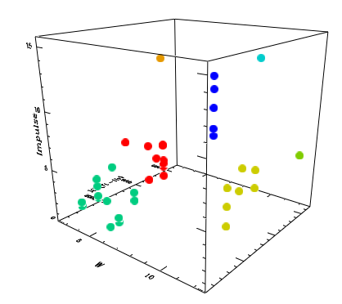

(Ref: Kaufman, L., Rousseeuw, P. J., “Finding Groups in Data,”, Wiley, 1990 )

Period Determination

PDM Method

This function implements the “Phase Dispersion Method” for period determination using a sparse set of unequally spaced data. This type of data set is often encountered in practice, and is not easily analyzed by Fourier methods. In addition, this technique can detect a signal buried in a high noise environment, and is specifically designed to do well on non-sinusoidal periodic variations. The full details of the technique are given in Stellingwerf, R. F., 1978 (S78), “Period Determination using Phase Dispersion Minimization”, Astrophysical Journal, v. 224, p, 953-960. This is a widely used technique with over 1100 citations in the literature.

To search a data set for periodic variations, store the data in the arrays Xdat[] (usually time), and Ydat[] (usually magnitudes), and set N to the number of data points. If the accuracy of the data points are known, store the estimated standard deviation in the array Sdat[], if not set Sdat[i] = 0. These arrays are usually populated by reading the data from a data file using the usual read data commands. This approach allows the greatest flexibility regarding selection of points, adjustment of values, etc., but is only workable for data sets with less than about 30,000 points due to the limitations in the Sdat array handling.

An alternative method to populate the Xdat, Ydat, and Sdat arrays that avoids the data set limitation is the direct read command. In this case we store the data in a text file with either spaces or commas used as delimiters, either 2 or three columns, and either with or without descriptive lines preceding the data. Then use the command:

read_pdm_data file_name #_of _title_lines

for example:

read_pdm_data v34597.csv 0 // data file, no titles
read_pdm_data v34597.dat 1 // data file, 1 title line

The arrays Xdat, Ydat and Sdat will not be available, but N will be set to the number of data points. Data for pdm2 will be read from the file. If only two columns are found, the sigmas will be set to 0. The title lines are read and discarded. The first few lines of data and the final status will be posted to the screen.

Then use the command:

pdm2 [invert] // updated PDM analysis (invert the curve)

This command sorts the data, searches for large gaps in the data and, if found, divides the data set into a number of discrete “segments” that will be treated to suppress the side lobes generated by such gaps. A frequency scan is then performed, with the statistic “theta” computed as a function of frequency (=1/time). Local minima for theta indicate possible periodic frequencies. The period corresponding to a given frequency is just its inverse. This default mode is sometimes referred to as a “rough cut”, since periods derived from segmented data are usually approximate. Once a possible period is found, an accurate value can be obtained by recomputing with a single segment.

By default, “pdm2” produces a “Classical PDM” analysis, which should be very close to the original Fortran code result. This version has several added features, however, which can be selected prior to the “pdm2” command with the following set of optional commands:

pdm_quiet * – suppress all diagnostic messages
pdm_lpoints # - set the number of frequency points to cover a spectral line (i.e. a possible frequency) (default = 10)
pdm_f_range fmin fmax - set the range of frequencies to search (default = 0 -> Nyquist frequency)
pdm_invert * – invert the data plot (useful when plotting magnitudes)
pdm_no_sig * - ignore any “sigma” data in the input
pdm_seg_dev – set the sensitivity of the segmentation procedure. Low => more segments (default=2), high = fewer segments (500 should do only one)
pdm_wide_bins – use 5/2 bin structure (10 double wide overlapping bins,
pdm_narrow_bins – use 10/1 bins structure ( 10 non-overlapping bins)
pdm_auto_bins – use wide bins for segments with less than 100 points, otherwise narrow (default)
pdm_bin_pts # - do auto but use # as the switch point, rather than 100
pdm_subharm * - use subharmonic averaging (default is off)
pdm_linear_fit *– use distance from a fitting curve, rather than the bin mean to compute the bin variance (default is to use the bin mean)
pdm_beta_range bmin bmax [Nb] - turn on a variable period scan. (optional) Nb is the number of beta points computed (default is 21).
pdm_beta_scale # - scale factor (unit) for beta, default is d/Myr = (1./365.25e6).
pdm_monte_carlo [trials] (do a Monte-Carlo significance test, default trials = 250)
pdm_data_range first_index last_index – compute only a specified range of points
pdm_phase_shift shift – shift the phase of the phase plot

The new “rich data” version is installed in s_tran_b.exe. It uses the additional commands listed above and a default bin structure of 100 / 1 and 50 / 2 with a default switch point of 1000 points. It should be used for data sets with more than 1000 points and good phase coverage.

The details of the new features are discussed in a separate report (Stellingwerf Consulting Technical Memo 040815 - “PDM2”).

For cases with an asterisk, the command may be followed by “false” to turn off the feature (for analyses with multiple calls to PDM). If not explicitly reset, a setting in this list remains active for subsequent passes through the PDM analysis.

The results of the computation are printed to the screen. The variable Trange - range of time – will be registered and can be used in the script. In addition, the three most significant frequencies are set to the variables F_min[1-3], and their corresponding theta values are set to Th_min[1-3] with significances Signf[1-3]. Finally, several data sets are written for plotting: 1) the data is written to “data.csv”, 2) the theta results are written to “pdmplot.csv”, 3) the data folded with the best candidate frequency is written to “pdmcurve.csv”, and 4) the set of residuals about the mean curve is written to “residuals.csv”. If a beta scan is requested, the results will appear on the screen and in the file “beta_scan.csv”.

As an example of the technique, the test case of ten cycles of a pure sine wave is discussed in detail in the S78 paper. This test case is set up as follows:

N = 201
for_i = 1 N
Xdat[i] = i*10/N
Ydat[i] = sin((2*pi)*Xdat[i])
Sdat[i] = 0
end_i

pdm_f_range 0 2
pdm2

The resulting theta variation is shown below:

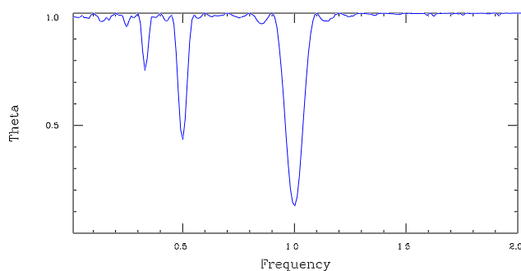

The principal frequency is clearly visible as the deep line at 1.0. The other lines at frequencies of 0.5 and 0.333 represent two and three periods of variation, and can be distinguished by examining the folded curves for these periods.

Another test case is the double mode Cepheid variable TU Cas. Using an 80 point data set, with the default segmentation (2 segs) the theta plot is shown below:

Note that the minimum theta value is about 0.75 – rather high because of the scatter caused by the second period. The main candidate frequency is about 0.45, with another at 1.45. These are probably the two periods present. A scan about the main candidate with a single segment produces:

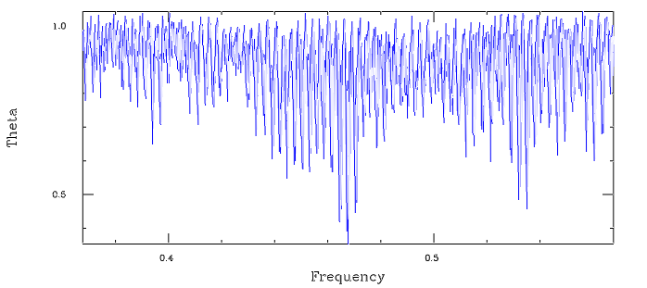

This accurately defines the period using all of the data. The resulting folded data plot at frequency 0.4674 follows:

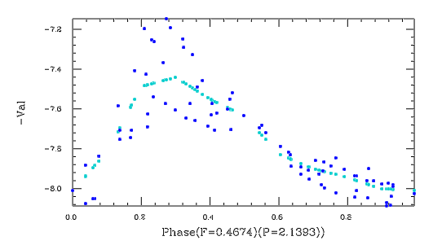

Even with substantial scatter in the data (due here to the secondary period), the variation is clear. To obtain a better result in this case, a further PDM analysis could be applied to the residuals.

PDM2 Rich Data Version

This is a new version of the code using 100 bins per cycle rather than the usual default of 10. This version should only be used if LOTS of data are available (more than 1,000 points, surely, but 100,000 would be better), with very good phase coverage so that all the bins are populated. The command is

pdm2b [invert]

All the usual PDM options are available, and some additional have been added.

pdm_prefix label (pdm_) – add a label to beginning of file names

For example, the default file names when running this version will be pdm_pdmplot, pdm_pdmcurve, etc, and the “pdm” prefix can be specified to a user-defined value.

The additional user variables are defined for script use:

Ymax - maximum of curve fit
Ymin – minimum of curve fit
Ymean – mean value of curve fit (data average)
Yamp – amplitude of curve fit
Tmean – mean time value of current data segment
Period – period from current analysis
Nplot – number of points in the largest segment as plotted

A typical result using the new version on a good data set is shown below.

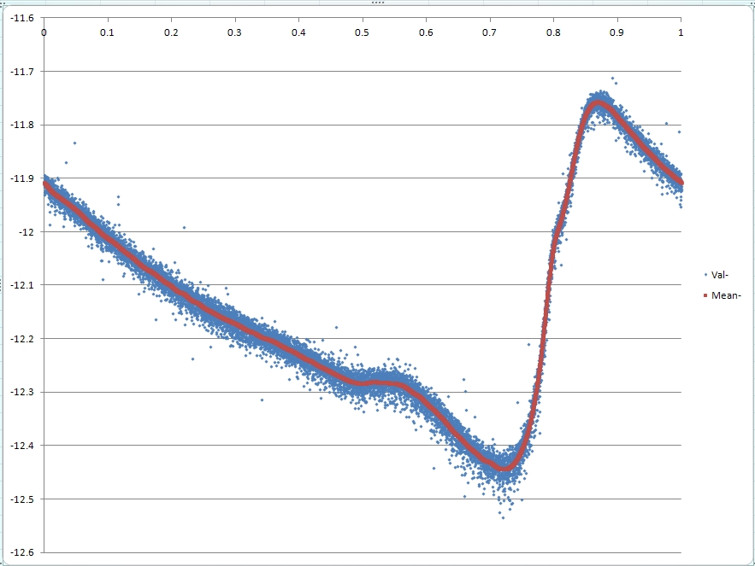

Lomb Method

This is a generalized Fourier technique for non-equally spaced data. (see Press, et. al., “Numerical Recipes”, Cambridge U. Press, 1992). To search a data set for periodic variations, store the data in the arrays Xdat[] (usually time), and Ydat[] (usually magnitudes), and set N to the number of data points. Then execute the command

lomb

The power spectrum will be written to the file lombpwr.csv. The data folded with the best candidate frequency will be written to the file lombplot.csv.

Optional control commands (use before calling “lomb”). For the commands that duplicate the “pdm…” commands listed above, the pdm version will work with the Lomb analysis.

lomb_quiet – suppress all diagnostics
lomb_verbose – normal output (default)
lomb_invert – invert the curve plot
lomb_normal – cancel a previous “invert”
lomb_max_f # – maximum frequency desired (default is Nyquist frequency)
lomb_ofac – number of frequency points across a spectral line (default = 3)
lomb_amp_units - the array values will be in (average) amplitude units, defined as sqrt( Power*variance/N), rather than power
lomb_psd_units – use “PSD” units, i.e. amp²/Hz
lomb_normal _units – use normal power spectrum (default)

The following plot shows the result of the lomb analysis on the sine wave (10 cycle) test.

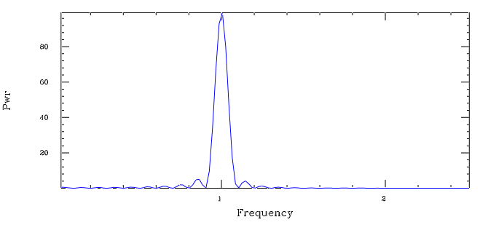

When applied to the TUCas data discussed above, the power spectrum shown below is obtained. The peaks correspond to the dips in the PDM theta plot. The highest peak is at frequency 0.4674, identical to the PDM result, and the secondary period is clearly visible. This technique requires the evaluation of 652 million frequency points to obtain this result, compared to 6000 points in the PDM broad scan, and 3000 in the fine scan near the optimal frequency. This huge number of calculations cannot be reduced because the Lomb implementation lacks a segmentation capability that would broaden the spectral lines.

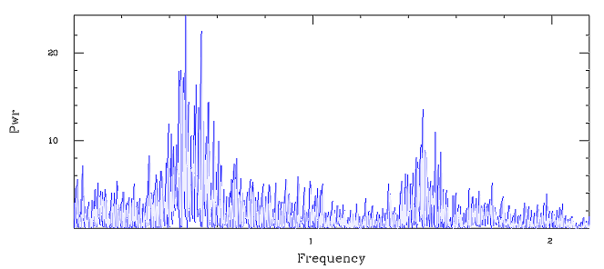

The folded curve at the Lomb frequency is shown below. There are very slight differences between the PDM and the Lomb curves, due to a slight difference in optimal frequency.

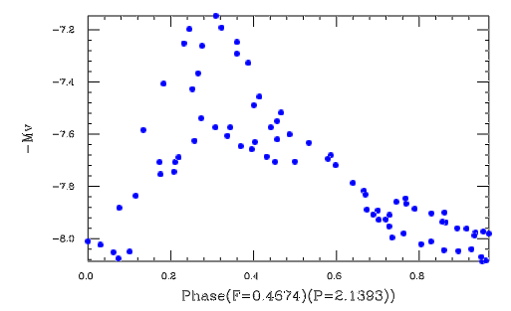

Sunspot Data Set

Since the Lomb method is a generalized Fourier technique, it is applicable to semi-periodic and non-periodic data sets. An example is the number of sunspots per year. The data set is shown below.
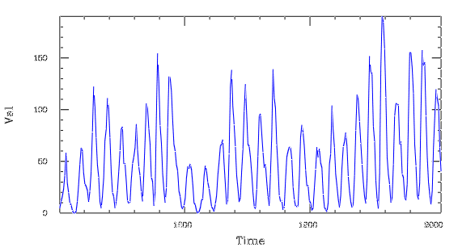

This data set shows the well-known 11-year cycle, but the cycle does not repeat with the same amplitude, and some shifting of the times of maxima may also be present. The appropriate analysis is:

lomb_max_f 0.2
lomb

The resulting power distribution is shown in the following plot.
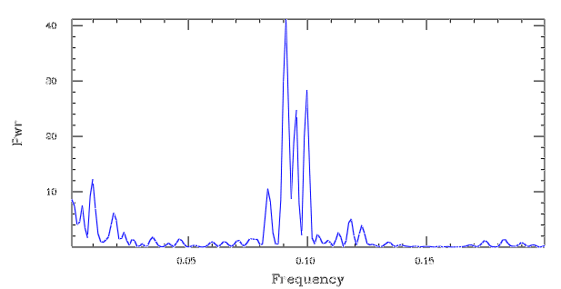
The peak frequency is 0.091 (= 10.99 year period), as expected. The peak is multiple, indicating the possibility of several interfering periods. In addition there is some power at 0.01 (= 100 year period), which represents the reduction in the data values every 100 years (1700, 1800, 1900).

Games

Game programs are often instructional examples of various programming techniques. Here are a few examples.

S-Master Mind

In file MM.s. In this version of the popular game, a random integer is generated by the program, then successive guess are made to determine the digits. The length of the number and the number of symbols (numbers) used are input, the hidden number is generated, and the guesses continue until the number is determined.

--------------S-MASTERMIND--------------

Length_of_Target (5) =?
Number_of_Symbols (5) =?

Target String is length=5 composed of symbols 1->5

Guess 1 =? 11122
Matches= 0 diagonal matches = 2
Guess 2 =? 33444
Matches= 4 diagonal matches = 7
Guess 3 =? 23444
Matches= 3 diagonal matches = 8
Guess 4 =? 32444

Correct! 4 Guesses!

The second guess was a lucky one, hitting 4 of the 5 digits. The next guess had a 50% chance of being correct. Here “Matches” are digits in the guess that exactly match those in the target, “Diagonal Matches” are digits in the guess that match, but are not in the correct locations. If there are multiple instances of a digit in the guess, then each will be counted as a match or as a diagonal match. The total of the matches and diagonal matches will be the product of the number of repetitions of the digit in the target and guess.

The coding is simple:

show_line "--------------S-MASTERMIND--------------"
/* Copyright Stellingwerf Consulting (c) 2004 */

#---input the game parameters---
show_nl
Length_of_Target = 5 // set defaults
Number_of_Symbols = 5
input Length_of_Target Number_of_Symbols

#---set the random target = $str1---
seed ran // randomize on the clock
str_ran $str1 Length_of_Target 1 @Number_of_Symbols

#---show a summary of the problem---
show_nl
show_line "Target String is length=" @Length_of_Target " composed of symbols 1->" @Number_of_Symbols
show_nl

#---guess loop---
for_i 1 100
$str2 = ""
show_field "Guess " @i
input0 $str2
str_eq $str1 $str2 // test here
if qq
show_nl
show_line Correct! " " @i " Guesses!"
break
else
show_line " Matches= " @S_eq " diagonal matches = " @S_off
end_if
end_i

S-Master Mind 2D

In file MM2D.s. This is a version where the target is a square array of numbers, guesses are made, and the number of correct choices is reported for each row and column.

------------S-MASTERMIND-2D-------------

Size of Square Array (3) =?
Number of Symbols (3) =?

Target Array is size=3 composed of symbols 1->3

...input a guess by rows (CR to abort)
$Row (1) =? 123
$Row (2) =? 312
$Row (3) =? 231

OK 0 3 2
+----------------------
2 | 1 2 3
1 | 3 1 2
2 | 2 3 1

...input a guess by rows (CR to abort)
$Row (1) =? 323
$Row (2) =? 211
$Row (3) =? 131

OK 0 3 2
+----------------------
2 | 3 2 3
1 | 2 1 1
2 | 1 3 1

...input a guess by rows (CR to abort)
$Row (1) =? 223
$Row (2) =? 113
$Row (3) =? 331

OK 3 3 3
+----------------------
3 | 2 2 3
3 | 1 1 3
3 | 3 3 1

Correct! 3 Guesses!

The coding is a bit more involved than the 1D case, and includes a display code to display the correct answer.

show_line "------------S-MASTERMIND-2D-------------"
/* Copyright Stellingwerf Consulting (c) 2004 */

#---input the game parameters---
set_tab 6
show_nl
Size = 3 // set defaults
Symbols = 3
show_field "Size of Square Array"
input0 Size
show_field "Number of Symbols"
input0 Symbols

#---set the random Array = X[i][j]---
seed ran // randomize on the clock
for_i = 1 Size
for_j = 1 Size
X[i][j] = ip(Symbols*ran+1)
Guess[i][j] = 0
end_j
end_i

#---show a summary of the problem---
show_nl
show_line "Target Array is size=" @Size " composed of symbols 1->" @Symbols

#---guess loop---
for_i 1 100

#---input the guess---
show_nl
call SET:
if ~Guess[1][1] continue

#---check the guess---
for_j = 1 Size
Colok[j] = 0
Rowok[j] = 0
end_j
for_j = 1 Size
for_k = 1 Size
if abs(Guess[j][k])=X[j][k]
Rowok[j] = Rowok[j]+1
Colok[k] = Colok[k]+1
end_if
end_k
end_j

#---show the current result---
show_nl
show_field " OK "
$str = "show_tab "
$line = " +----"
for_j = 1 Size
$str = $str + @Colok[j] + " "
$line = $line + "------"
end_j
exec $str
show_line $line

for_j = 1 Size
show_field " " @Rowok[j] " | "
$str = "show_tab "
for_k = 1 Size
$str = $str + @Guess[j][k] + " "
end_k
exec $str
end_j

#---check if done---
Allok = 0
for_j = 1 Size
Allok = Allok+Colok[j]+Rowok[j]
end_j

if Allok=(2*sq(Size))
show_nl
show_line "Correct! " @i " Guesses!"
exit
end_if
end_i

end

/*-------------------------------*/

#---input a guess---
SET:
show_line " ...input a guess by rows (CR to abort)"
for_i = 1 Size
$Row = @i // use the default value to label the rows
input $Row
str_len $Row
if ~(S_len=Size)
call giveup:
return
end_if
for_j = 1 Size
str_char $Row j
str_tofloat Guess[i][j] $S_char
end_j
end_i
return

/* show answer... */

giveup: //---subroutine entry

show_nl
query "Give Up?" n

if qq
show_line " Answer is..."
show_nl
for_i = 1 Size
$str = "show_tab "
for_j = 1 Size
$str = $str + @X[i][j] + " "
end_j
exec $str
end_i
exit
else
Guess[1][1] = 0
end_if

return

Sudoku

In file Sudoku.s. This is a Sudoku program that displays the puzzle, gives hints, shows possible moves, and can solve most cases. First order elimination (only one possibility in a cell), and uniqueness (only one possibility for a 3x3 sub-cell, row, or column) are computed. A variety of display options can be used to help solve a problem “manually”. A problem is stored as digits with 0 indicating an empty cell. An example:

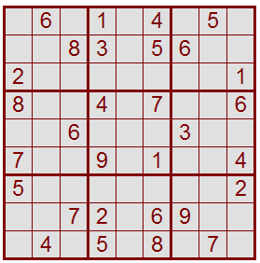

This is stored as...

060104050
008305600
200000001
800407006
006000300
700901004
500000002
007206900
040508070

This displays as:

+-----------------+-----------------+-----------------+
| . . | . . | . . |
| . 6 . | 1 . . 4 | . 5 . |
| . . | . . | . . |
+ . . . . . . . . + . . . . . . . . + . . . . . . . . +
| . . | . . | . . |
| . . 8 | 3 . . 5 | 6 . . |
| . . | . . | . . |
+ . . . . . . . . + . . . . . . . . + . . . . . . . . +
| . . | . . | . . |
| 2 . . | . . | . . 1 |
| . . | . . | . . |
+-----------------+-----------------+-----------------+
| . . | . . | . . |
| 8 . . | 4 . . 7 | . . 6 |
| . . | . . | . . |
+ . . . . . . . . + . . . . . . . . + . . . . . . . . +
| . . | . . | . . |
| . . 6 | . . | 3 . . |
| . . | . . | . . |
+ . . . . . . . . + . . . . . . . . + . . . . . . . . +
| . . | . . | . . |
| 7 . . | 9 . . 1 | . . 4 |
| . . | . . | . . |
+-----------------+-----------------+-----------------+
| . . | . . | . . |
| 5 . . | . . | . . 2 |
| . . | . . | . . |
+ . . . . . . . . + . . . . . . . . + . . . . . . . . +
| . . | . . | . . |
| . . 7 | 2 . . 6 | 9 . . |
| . . | . . | . . |
+ . . . . . . . . + . . . . . . . . + . . . . . . . . +
| . . | . . | . . |
| . 4 . | 5 . . 8 | . 7 . |
| . . | . . | . . |
+-----------------+-----------------+-----------------+
Filled = 30

-> r=read, w=write, d|D=display, s|S=set, e|u|A=anal, i=insert, q=quit (d) =?

The options are:
“r” – read a chart
“w” – write the chart
“d” – normal display, second prompt also displays cells with 0-9 possibilities
“D” – display only cells with a selected (second prompt) possible
‘s” – set a cell value (input is checked for validity
“S” – input an entire chart
“e” – first order elimination analysis
“u” – first order uniqueness analysis
“A” – repeat elimination and uniqueness to solve puzzle if possible
“i” – insert – set any values obtained by previous analysis step
“q” – quit

Here is the “d” – “9” display, showing all possible entries in the initial problem. The given entries are centered; possible entries are at the top and bottom of cells. Six cells have a single off-center number, indicating a fully specified cell at the outset. These are the “elimination” cells. There are ten additional cells that are fully specified by “uniqueness”. For example, note that cell r9/c1 is the only cell in column 1 with 6 as a possible choice. This cell must therefore be a 6.

Display_level (0) =? 9

c1 c2 c3 c4 c5 c6 c7 c8 c9
+-----------------+-----------------+-----------------+
| 3 . . 3 | . 2 . | 2 . . 3 |
r1| . 6 . | 1 . . 4 | . 5 . |29
| 9 . . 9 | . 789 . | 78 . . 789 |
+ . . . . . . . . + . . . . . . . . + . . . . . . . . +
|1 4 .1 . | . 2 . | . 2 4 . |
r2| . . 8 | 3 . . 5 | 6 . . |23
| 9 . 7 9 . | . 7 9 . | . 9 . 7 9 |
+ . . . . . . . . + . . . . . . . . + . . . . . . . . +
| . 3 5. 345| . . | 4 . 34 . |
r3| 2 . . | . . | . . 1 |42
| . 7 9 . 9 |678 .6789 . 9 | 78 . 89 . |
+-----------------+-----------------+-----------------+
| .123 5.123 5| . 23 5. |12 5.12 . |
r4| 8 . . | 4 . . 7 | . . 6 |20
| . 9 . 9 | . . | . 9 . |
+ . . . . . . . . + . . . . . . . . + . . . . . . . . +
|1 4 .12 5. | . 2 5. 2 | .12 . 5|
r5| . . 6 | . . | 3 . . |36
| 9 . 9 . | 8 . 8 . | . 89 . 789 |
+ . . . . . . . . + . . . . . . . . + . . . . . . . . +
| . 23 5. 23 5| . 23 5. | 2 5. 2 . |
r6| 7 . . | 9 . . 1 | . . 4 |24
| . . | .6 8 . | 8 . 8 . |
+-----------------+-----------------+-----------------+
| .1 3 .1 3 | .1 34 . 3 |1 4 .1 34 . |
r7| 5 . . | . . | . . 2 |38
| . 89 . 9 | 7 . 7 9 . 9 | 8 .6 8 . |
+ . . . . . . . . + . . . . . . . . + . . . . . . . . +
|1 3 .1 3 . | .1 34 . | .1 34 . 3 5|
r8| . . 7 | 2 . . 6 | 9 . . |21
| . 8 . | . . | . 8 . 8 |
+ . . . . . . . . + . . . . . . . . + . . . . . . . . +
|1 3 . .123 | .1 3 . |1 . . 3 |
r9| . 4 . | 5 . . 8 | . 7 . |21
|6 9 . . 9 | . 9 . | . . |
+-----------------+-----------------+-----------------+
23 35 24 21 45 14 27 33 32 Filled = 30

Solve this problem...

-> r=read, w=write, d|D=display, s|S=set, e|u|A=anal, i=insert, q=quit (d): A

Auto Mode, step 1 Filled = 30
Elim: cell 36 is specified
Elim: cell 54 is specified
Elim: cell 56 is specified
Elim: cell 74 is specified
Elim: cell 97 is specified
Elim: cell 99 is specified
Unique: 4 is unique in row 5
Unique: 7 is unique in row 5
Unique: 6 is unique in row 6
Unique: 6 is unique in row 7
Unique: 5 is unique in row 8
Unique: 2 is unique in row 9
Unique: 6 is unique in row 9
Unique: 6 is unique in col 1
Unique: 4 is unique in col 3
Unique: 6 is unique in col 4
Unique: 2 is unique in col 6

Omit steps

Cell 43 set to 1
Cell 15 set to 7
Cell 47 set to 5
Cell 13 set to 3
Cell 15 set to 7
Cell 47 set to 5
Cell 82 set to 1
Cell 73 set to 9
Solved a total of 20 cell(s) this step

Auto Mode, step 5 Filled = 76
Elim: cell 48 is specified
Elim: cell 52 is specified
Elim: cell 62 is specified
Unique: 2 is unique in row 4
Unique: 1 is unique in row 5
Unique: 3 is unique in row 6
Unique: 2 is unique in col 2
Unique: 3 is unique in col 2
Unique: 1 is unique in col 8
Unique: 2 is unique in subcell 2/1
Unique: 3 is unique in subcell 2/1
Unique: 1 is unique in subcell 2/3
Cell 48 set to 9
Cell 52 set to 9
Cell 62 set to 3
Cell 42 set to 2
Cell 58 set to 1
Cell 62 set to 3
Cell 42 set to 2
Cell 62 set to 3
Cell 58 set to 1
Cell 42 set to 2
Cell 62 set to 3
Cell 58 set to 1
Solved a total of 12 cell(s) this step

Auto Mode, step 6 Filled = 81
No cells are specified by elimination
No cells are specified by uniqueness
Solved a total of 0 cell(s) this step

Steps = 5 No further improvement - Problem Solved!!

This puzzle is an easy one. Harder cases take up to about 15 steps, or can’t be solved with the first order techniques at all. For these cases, the various displays should allow detection of the more complex patterns needed to solve the problem.

The coding for this application is too lengthy to include here. The computations are done on 2 and 3 dimensional arrays. As an example of the coding technique, here is the subroutine that checks each 3x3 subcell (i, j) – for non-allowed digits in a given cell (I, J). If one is found, a 0 flag is set in the “Nums” array (initially set to 1). Note how nested brackets are avoided in the inner loop by using the temporary index NN.

#--compute: check each subcell---
check_subcell:
NN = I%3
if ~NN NN = 3
I1 = I-NN+1; I2 = I1+2
NN = J%3
if ~NN NN = 3
J1 = J-NN+1; J2 = J1+2
for_i = I1 I2
for_j = J1 J2
continue_if i=I&j=J
if Cell[i][j]
NN = Cell[i][j]
Nums[I][J][NN] = 0
end_if
end_j
end_i
return

