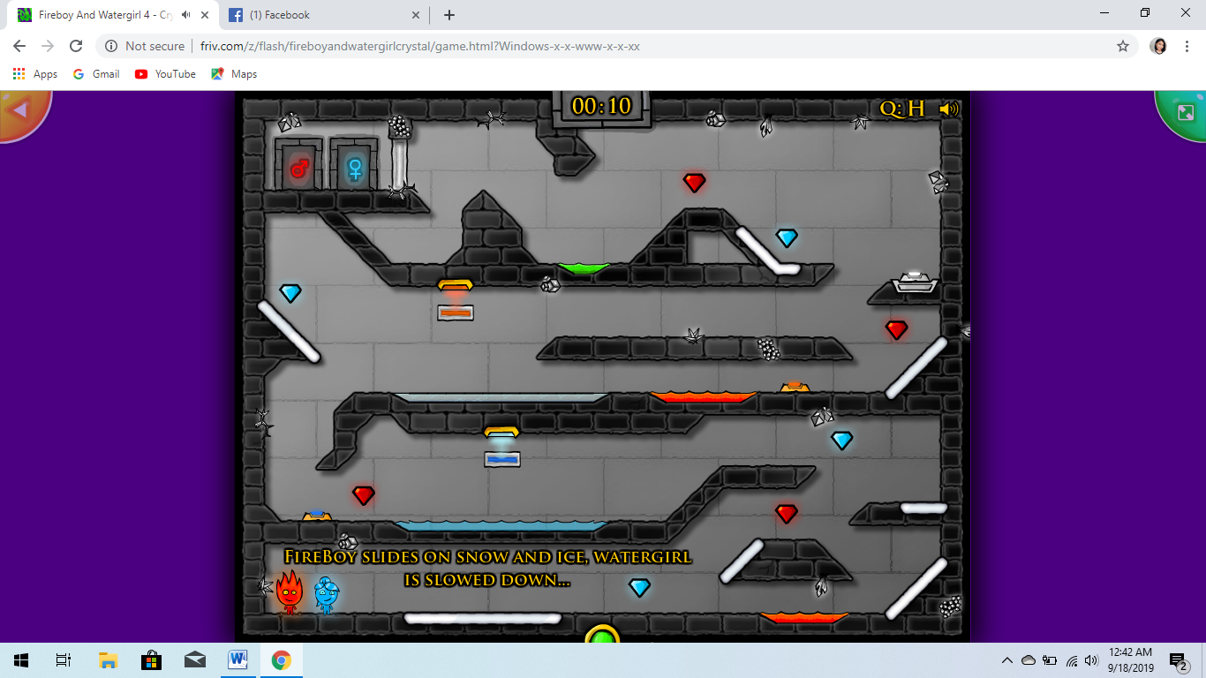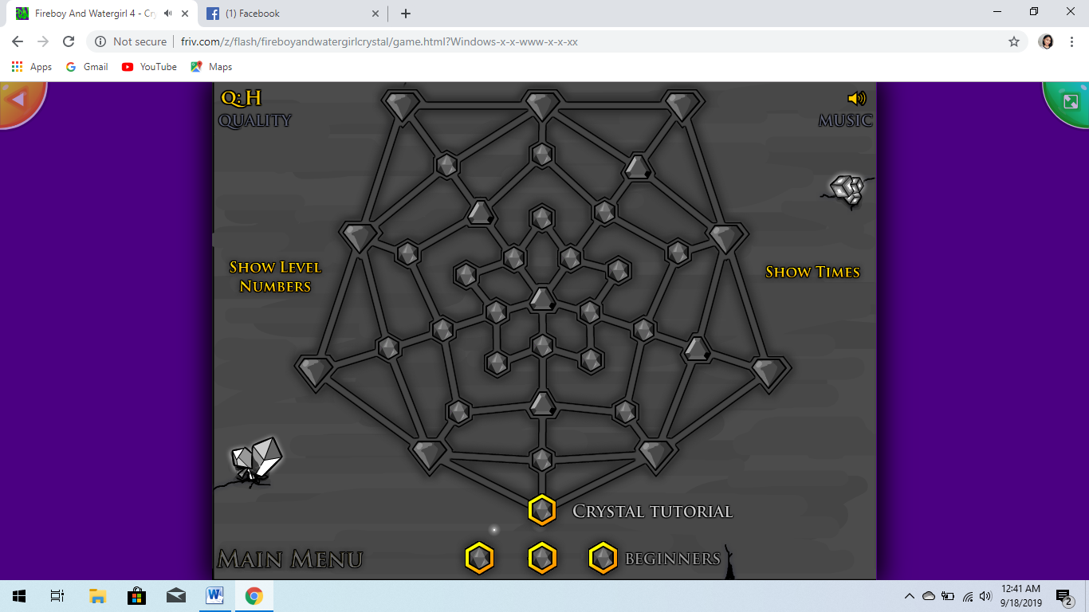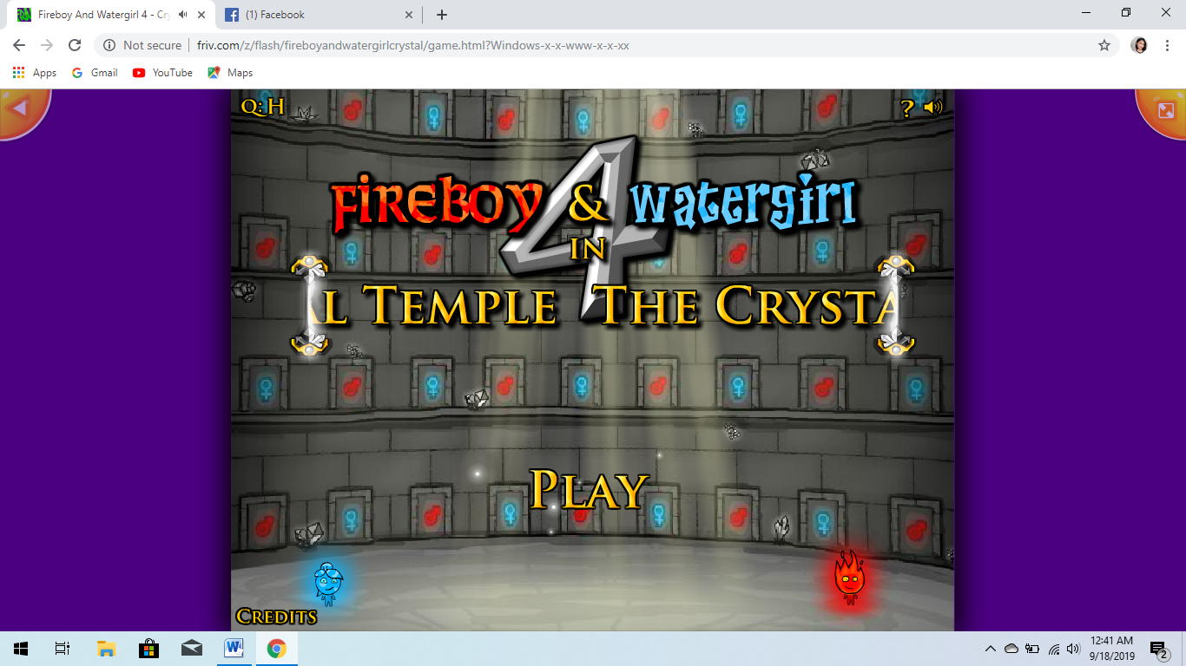

Game title: Fireboy and watergirl

This game is a two player game which means you can play with your friends but you are not competing with them, you two are partners. The player one has W,A,S,D in control and the second player has the arrow keys. It has an smooth and easy controls. This game is made for children to enhance their strategic ability but adult can also play this game because this game is an easy game but a very challenging one. Every level is going to be hard for the players but you can pass all of the struggles if you and your team mate is working together. The story of this game is fireboy and watergirl are in their last adventure and they are being trapped in one temple full of doors and they are looking to the way out.