PREFACE

Rationale

This Work Immersion Portfolio will serve as a workbook for the students who will take up the course/subject Work Immersion in Senior High School. The framework is based on DepEd Order No. 30 s. 2017, entitled Guidelines for Work Immersion.

This workbook will essentially foster in-depth learning of the world of work and assessment of student’s performance during work immersion.

Furthermore, the purpose of this portfolio includes but is not limited to the following:

For Student-Trainees:
- The portfolio will be used as a source of motivation and guide for work immersion.
- This will serve as a documentation and approval of lessons learned.
- This will provide feedback of their performance level.
- This will pave the way in preparation for real job application.

School:
- This contains regulations and conditions regarding contract between school and student.
- This is an information about curriculum and record of lessons learned.
- This is a record of student-trainees performance for assessment.

Agency / Company:
- This contains introduction of company in general.
- This enumerates training rules and regulations for training inside the agency/company.
- This provides feedback to and from student-trainees

. WORK IMMERSION

Grade: 12 No. of Hours: 320 hours
Pre-requisite: Should have taken at least 4 Specialized Subjects Course Description:
Work Immersion is one of the course requirements for graduation. A Senior High School student has to undergo Work Immersion in an industry that directly relates to the student’s postsecondary goal. Through Work Immersion, the students are exposed to and become familiar with work-related environment related to their field of specialization to enhance their competence. Specifically, the students are able to: (i) gain relevant and practical industrial skills under the guidance of industry experts and workers; (ii) appreciate the importance and application of the principles and theories taught in school; (iii) enhance their technical knowledge and skills; (iv) enrich their skills in communications and human relations; (v) develop good working habits, attitudes, appreciation, and respect for work. These prepare them to meet the needs and challenges of employment or higher education after graduation.

Duties and Responsibilities of the Learner In this course, the learners are expected to:
- Attend Pre and Post Immersion Activities;
- Report to the Work Immersion Partner Institution Supervisor during actual immersion;
- Perform the duties and tasks as indicated in the prescribed template for work immersion list of tasks/activities; and
- Prepare the documentations and reports required in the curriculum and by the Partner Institution.

Assessment
The Work Immersion Teacher and the Work Immersion Partner Institution Supervisor will jointly assess the learner’s performance following the DepEd Order No. 8, s. 2015 Policy Guidelines on Classroom Assessment for the K to 12 Basic Education Program.

STUDENT INFORMATION SHEET
Hanna Faith R. Oliverio
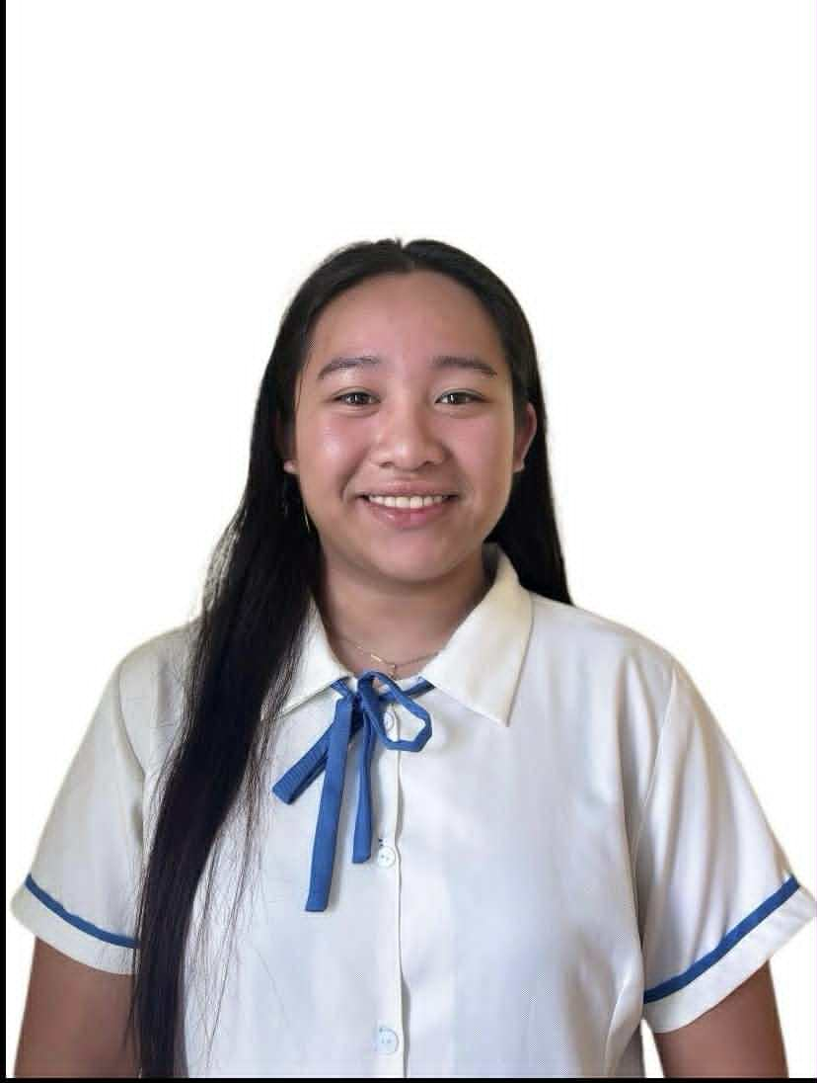

Contemporary Arts because I love creating artworks like dried-leaf flowers, paper mosaics, and paintings. Making art is especially fun when I work with my friends, as we laugh and talk.
I plan to continue study Hospitality Management (HM) in college to repay my parents for their hard work and to help support my two younger siblings’ education.
After graduating from Senior High School,
My most memorable subject is
I learned how to draw using a computer, encode documents, and animate pictures. I also learned how to make a website and how to communicate better with other people.
I feel good about school because I have learned many useful skills.
Listening to music
Dependable
Encoding and Layouting
Danao Lower Becerril Boljoon Cebu
N/A
Roman Catholic
09608658834
hannaoliverio199@gmail.com
Painting
Sheilame R. Oliverio
Poblacion Boljoon Cebu
September 20, 2008
Name
:

Date of Birth
:

Place of Birth
:

Parent’s / Guardian’s Name

:

Postal Address
:

E-mail Address

:

Cellphone Number

:

Religion
:

Health Issues / Allergies

:

Hobbies / Past Time Activities

:

Skills / Talents

:

Extra-curricular Activities in School
:

Support group / home companions
:

List your favorites

:

One word or object that describes yourself

:

How do you feel about school?
:

What are your most memorable subject / class? Why?

:

What are your plans after Senior High School?
:

Insert 2 x 2 Picture

What is your career path? : | My career path is to become a Hospitality Management
professional, work on a cruise ship, and eventually become a chef, combining my love for travel and cooking.

My philosophy in life is to work hard, stay kind,

skills, gain experience, and understand how work really is. I feel a little nervous because

I expect to learn new
by studying hard, learning new skills, working with dedication, and never giving up on my dreams.

I plan to achieve my goals
My dream is to finish my studies, work on a cruise
ship, and become a chef. I want to help my family and achieve a better life.

on a cruise ship. I want to travel around the world and gain new experiences while working.

Yes, I plan to go abroad and work
and never give up, especially for my family and my dreams.

What is your philosophy in life?

:

Do you have plans to go abroad? If yes, where and why?

:

What are your dreams and ambitions?

:

How do you plan to achieve your ambitions and goals in life?

:

What are your expectations and apprehensions for work immersion?

:

it’s my first time, but I’m excited to try and do my best.

.
.
.

Republic of the Philippines

DEPARTMENT OF EDUCATION

Region VII – Central Visayas
DIVISION OF CEBU PROVINCE

BOLJOON NATIONAL HIGH SCHOOL
Lower Becerril, Boljoon, Cebu

REQUEST FOR WORK IMMERSION

Hon. Joie Genesse N. Derama
Municipal Mayor
Municipality of Boljoon, Cebu

Sir / Madame:

This is to request permission from your good office to please allow Hanna Faith R. Oliverio, a Senior High School - Grade 12 student, to undergo a 320 hours of WORK IMMERSION in your company/agency to acquire industrial ORIENTATION. The training period will start immediately upon your acceptance of the bearer under the terms and conditions as stipulated in the duly accomplished memorandum of agreement hereto attached for your confirmation.

Moreover, a student evaluation is provided where a student is to be assessed on his/her performance, attitude and behaviour to be attested by the supervisor. The Immersion Teacher and Trainer handling each field of specialization from our school will visit your establishment from time to time to find out how the student perform in the working area.

Thank you very much for your usual cooperation and assistance extended to the school.

ENDORSEMENT LETTER

Sir / Madame:

This is to introduce Hanna Faith R. Oliverio, who is a grade 12 Senior High School student enrolled in our school under the K to 12 program with Strand in TVL-ICT, and to further endorse (his/her) application with your company to undergo WORK IMMERSION for 320 hours as a requirement of the curriculum for graduation. We believe that schools must link up with industry in order to update, upgrade and make the education of our youth more relevant to the actual needs of the industry. It is in this regard that we request you to give such opportunities to our students by allowing them to do part time work with your company. Together with this letter is an Acceptance Form.

We request that said form be accomplished and returned to this office upon acceptance of our student in your company. We are confident that given the opportunity, our student will be an asset to your company.

Thank you for the favourable action and we look forward to a more fruitful linkage with you.

Very Truly Yours,

CHARLES N. LACUNA
Work Immersion Teacher Noted:
JOSEPHINE D. SESANTE
School Head

