Synapse HR-ERP
Prediction Models: Evaluation by Version
Promotion Readiness, Performance Forecast and Attrition Risk
16 October 2026

Contents
1. Versions at a glance 3
2. How to read this report 3
3. How each algorithm works 4
4. Method 4
5. Promotion readiness 5
5.1 Ranking 5
5.2 Flagging 6
5.3 Stated chances 7
5.4 Behaviour tests 8
6. Performance forecast 9
6.1 Accuracy 9
6.2 Bands 10
6.3 Range and confidence 10
6.4 Behaviour tests 10
7. Attrition risk 11
7.1 How each version was built 11
7.2 Attrition v1 in detail 12
7.3 Results on the same 199 people 13
7.4 Flagging 14
7.5 Checks that the result is real 15
7.6 What changed from v2 to v3 15
8. Automated tests 16
9. Limitations 17
Appendix: technical measures 17

1. Versions at a glance
Each model is numbered by version, oldest first. Promotion readiness and performance forecast have two versions. Attrition risk has three; v3 is the one now in use.
Model | Version and period in use | How it works | Data it learned from | Main result
Promotion readiness | v1: 23 June to 25 September 2026 | Logistic regression on about 40 facts per employee | 100,000 reference employee records, 10% promoted | Ranking score 0.843 in real conditions; overstated chances by 12.4 points
Promotion readiness | v2: 26 September 2026 to now | Logistic regression on 2 facts, with an adjustment step | Same 100,000 records | Ranking score 0.842; stated chances within 0.7 points
Performance forecast | v1: 23 June to 25 September 2026 | Gradient boosting on about 40 facts | Same 100,000 records | Misses the next score by 6.44 points in real conditions
Performance forecast | v2: 26 September 2026 to now | Gradient boosting on the latest appraisal score | Same 100,000 records | Misses by 4.64 points; gives a likely range
Attrition risk | v1: 28 June to 2 September 2026 | Random forest on 17 facts | IBM sample of 1,470 employees, 237 who left | 0.737 on its own data; 0.43 on the survey respondents
Attrition risk | v2: 25 September to 16 October 2026 | Random forest on 8 survey answers | Survey of 155 people, 50 who resigned | Ranking score 0.628
Attrition risk | v3: 16 October 2026 to now | Support vector machine on 7 survey answers | Survey of 199 people, 55 who resigned | Ranking score 0.695

From 2 to 25 September 2026, Attrition Risk was a demonstration screen with no model behind it.

2. How to read this report
The terms below are used throughout. Each is defined once here.
Term | Meaning
Ranking score | The chance that the model gives a higher score to a person with the outcome (promoted, or resigned) than to a person without it. 0.50 is the same as guessing; 1.00 is perfect. Technical name: ROC-AUC.
Unseen records | Every result is measured on records the model did not learn from. A model that has seen a record can score it well by memory, which says nothing about new employees.
Five-way rotation | The data is split into five parts. The model learns from four and is tested on the fifth, five times, so every record is tested once. Attrition repeats this 10 times with fresh splits.
95% range | The span the true result most likely falls in, found by redrawing the test records at random 1,000 times. A wide range means the result is uncertain.
p-value | The chance of seeing a result this good if the model had learned nothing real. A p-value below 0.05 means the result is very unlikely to be luck.
Stated chance gap | The average distance, in percentage points, between the chance a model states and the rate that actually happens. Lower is better.
Flagged | People a model marks for attention, such as a promotion review or a retention talk.
Correct when flagged | Of the people flagged, the share who had the outcome.
Caught | Of the people who had the outcome, the share who were flagged.
Average miss | For forecasts: the average distance between the forecast and the actual appraisal score, on the 0 to 100 scale.
As run | A replay of what the system actually sent the model. A model can score well on complete data yet poorly on the data the system really has.

3. How each algorithm works
An algorithm is the method a model uses to learn patterns from past records. A decision tree, the building block of three of them, is a series of yes or no questions about a person's facts (for example, “is the latest score above 75?”) that ends in a prediction.
Algorithm | How it decides | Used by
Logistic regression | Gives each fact a weight, adds up the weighted facts and turns the total into a chance between 0% and 100%. Each weight shows how much a fact pushes the result up or down, so every result can be explained. | Promotion v1 and v2
Gradient boosting | Builds many small decision trees one after another. Each new tree corrects the errors the earlier trees left. | Performance v1 and v2
Random forest | Builds hundreds of decision trees, each from a random part of the data, and lets them vote. The share of votes for “leaves” is the score. | Attrition v1 and v2
Support vector machine (SVM) | Places every person as a point according to their answers, then measures how close a new person sits to the people who resigned compared with those who stayed. It can follow patterns that are not straight lines. | Attrition v3
Adjustment step | Turns a model’s raw output into a 0 to 100 score or chance. Attrition v3 uses a form that can only reshape the scale, never reverse the order of people. | Promotion v2, attrition v3

4. Method
Promotion and performance
Both versions were rebuilt from the project’s version history on 7 October 2026 in a separate workspace, trained on the same 80,000 reference records and tested on the same 20,000, which neither version saw in training. The reference dataset holds 100,000 employee records, 10% of them promoted.
v1 expects about 40 facts per employee. The system records about 12 and filled the rest with typical values, so v1 is tested in up to three conditions. v2 uses only facts the system records and has one condition.
Condition | What the model is given
v1, all 40 inputs | Every column of the dataset. Its developer tested it this way; the system never provided it.
v1, as run, matching department names | The facts the system actually sent, the rest filled with typical values, and the dataset’s own department names. This favours v1.
v1, as run, company department names | The same, with department names that differ from the dataset’s, as a real company’s do.

Attrition
All three versions were rebuilt from the version history on 16 October 2026 and tested on the same 199 survey respondents. v1 was also tested on its own data. v2 and v3 were tested by five-way rotation repeated 10 times, so each respondent was scored only by models that never saw them. v1 never saw any respondent, so it was tested on all 199 directly. The rebuilt v1 reproduces its original June results exactly (0.785 and 0.737).

5. Promotion readiness
The model scores how ready an employee is for promotion. v1 read about 40 facts, including gender, age, marital status, education and city. v2 reads two: the latest appraisal score and its change since the previous appraisal. An employee with no appraisal is declined; one with a single appraisal is scored by a separate model that does not need the change.

5.1 Ranking
Version and condition | Ranking score | 95% range
v1, all 40 inputs | 0.941 | 0.936 to 0.944
v1, as run, matching department names | 0.923 | 0.918 to 0.928
v1, as run, company department names | 0.843 | 0.835 to 0.851
v2 | 0.842 | 0.834 to 0.850

With company department names, v1 leads by 0.001 (95% range 0.0001 to 0.0025), which is too small to matter. With matching names it leads by 0.081 (p < 0.001), because department was its strongest input. A real company’s department names do not match the dataset’s, so the first comparison is the realistic one. In Figure 1, v1’s curve falls onto v2’s once company names are used.
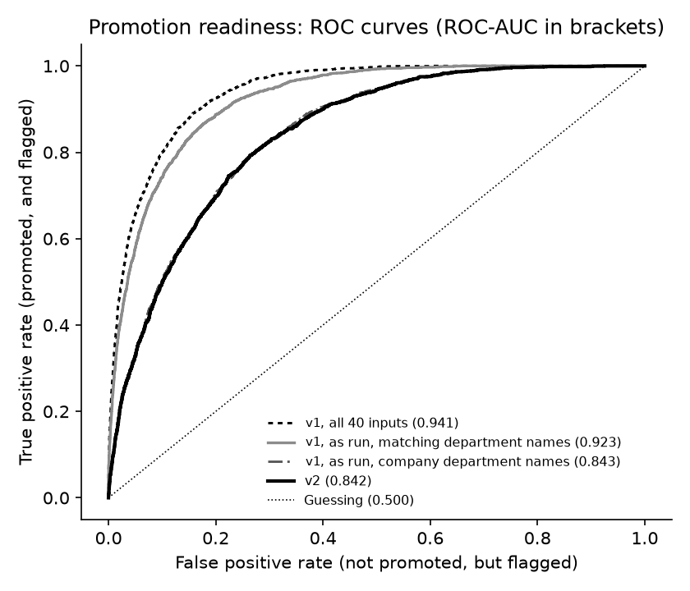
Figure 1. Promotion readiness ranking curves (ranking score in brackets)

5.2 Flagging
Each version flags its own High tier: a stated chance of 66% or more for v1, and 20% or more (twice the average rate) for v2.
Version and condition | People flagged | Correct when flagged | Caught | Overall correct
v1, all 40 inputs | 3,357 | 47.5% | 79.7% | 89.2%
v1, as run, matching department names | 2,909 | 48.5% | 70.6% | 89.6%
v1, as run, company department names | 2,252 | 38.9% | 43.9% | 87.5%
v2 | 3,465 | 32.8% | 56.8% | 84.0%

Answering “not promoted” for everyone is 90.0% correct, so overall correctness does not separate these models. In real company conditions, v2 catches more of the employees who were promoted (56.8% against 43.9%) and flags more who were not.
Decision counts (20,000 test records; v1 as run with company department names)
Outcome | v2: flagged | v2: not flagged | v1: flagged | v1: not flagged
Promoted (2,000) | 1,136 correct | 864 missed | 877 correct | 1,123 missed
Not promoted (18,000) | 2,329 wrongly flagged | 15,671 correct | 1,375 wrongly flagged | 16,625 correct

5.3 Stated chances
Version and condition | Average stated chance | Real rate | Stated chance gap
v1, all 40 inputs | 25.8% | 10.0% | 15.8 points
v1, as run, matching department names | 23.9% | 10.0% | 13.9 points
v1, as run, company department names | 22.4% | 10.0% | 12.4 points
v2 | 10.0% | 10.0% | 0.7 points

Stated chance and actual promotion rate by tier (20,000 test records)
Tier | v1: stated chance | v1 (as run, matching names): promoted | v2: stated chance | v2: promoted
High | 66% or more | 48.5% | 20% or more | 32.8%
Medium | 33% to 66% | 14.2% | 10% to 20% | 15.2%
Low | Under 33% | 1.5% | Under 10% | 3.0%

v1 was trained as if promoted and not promoted employees were equally common, so its percentages overstate the real rate more than twofold. Every v2 tier falls within its stated range. In Figure 2, v2 follows the diagonal of true chances; every v1 condition falls below it.
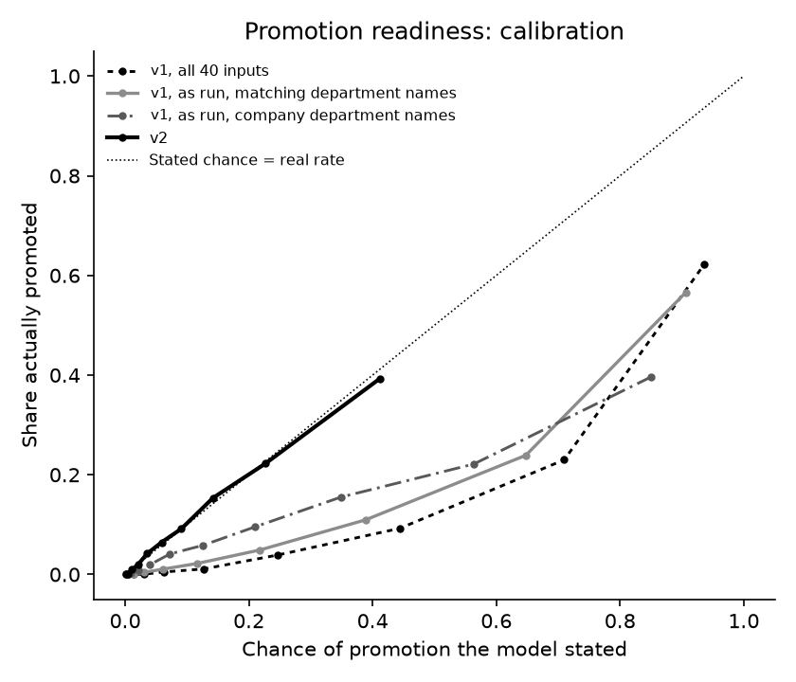
Figure 2. Promotion readiness: stated chance against actual promotion rate

5.4 Behaviour tests
Test | v1 | v2
Same employee moved through the seven departments | Stated chance changes by 49.8 points on average (up to 83.8); tier changes for 67.8% of people | No change (department is not an input)
Department name the model has not seen (“Information Technology”), typical employee | Stated chance rises from 19.7% to 49.8% | No change
Gender changed (all 40 inputs) | Changes by 1.5 points on average (up to 4.1); tier changes for 3.5% | No change (not an input)
Age raised 10 years, or marital status changed | Changes by under 0.1 points on average | No change (not inputs)
Only one appraisal on record | Missing scores filled with typical values: ranking score 0.699, stated chance gap 29.9 points | Separate model for one appraisal: ranking score 0.697, gap 0.5 points
No appraisal on record | Still gives a score (8.4%), built entirely from filled-in values | Declined as “not enough data”
Latest score entered as 120 or 150 | Stated chance near 100% (99.99999% at 120), no warning | Held at 100 with a warning
Latest appraisal raised 1 to 20 points | Never scores lower (0 of 2,000 people) | Never scores lower (0 of 2,000 people)
Same input twice, alone or in a batch | Identical | Identical

Figure 3 varies the latest score for one typical employee whose previous appraisal was 68. v1 approaches certainty from a score of about 85. v2 levels off near 69%, because even the strongest records in the data were not always promoted.
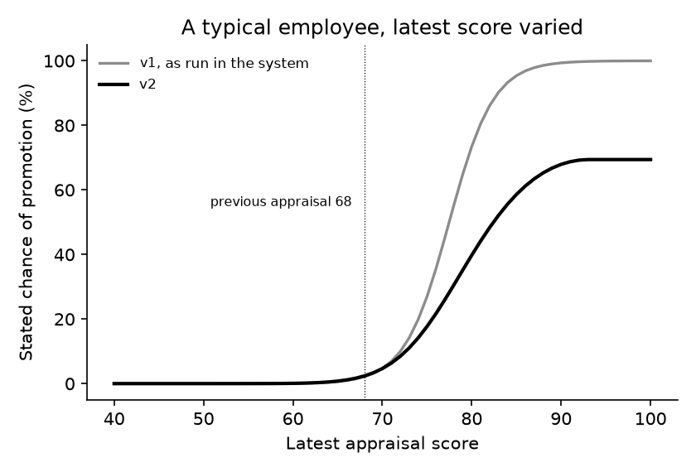
Figure 3. Promotion readiness response for a typical employee

6. Performance forecast
The model forecasts an employee’s next appraisal score (0 to 100) and its band: below (under 60), on track (60 up to 80) or exceeds (80 and over). v1 read about 40 facts, including the manager rating and KPI attainment of the very year it was forecasting. v2 reads the latest completed appraisal score only and also gives a likely range.

6.1 Accuracy
Version and condition | Average miss | 95% range | Band correct
v1, all 40 inputs (reads the forecast year) | 3.33 | 3.30 to 3.37 | 85.5%
v1, as run in the system | 6.44 | 6.38 to 6.50 | 71.4%
v1, system’s facts placed correctly (generous) | 7.06 | 6.99 to 7.12 | 66.4%
v2 | 4.64 | 4.59 to 4.69 | 79.7%
Simple rule: repeat the last score | 4.86 | 4.81 to 4.91 | 78.4%
Simple rule: company average for everyone | 12.10 | 11.98 to 12.22 | 47.8%

v2 misses by 1.80 points less than v1 as it ran (95% range 1.74 to 1.86, p < 0.001). It placed 2,927 employees in the correct band that v1 missed, against 1,257 the other way (p < 0.001). Repeating the test on five different splits matched every average miss within 0.02 points.
v1’s best result (3.33) cannot be reached in practice, because it reads the manager rating and KPI attainment of the year being forecast, which do not exist until that year’s appraisal is done. Retrained without those and seven other same-year scores, the v1 design misses by 4.16 points, but it still needs about 30 facts the system does not record.
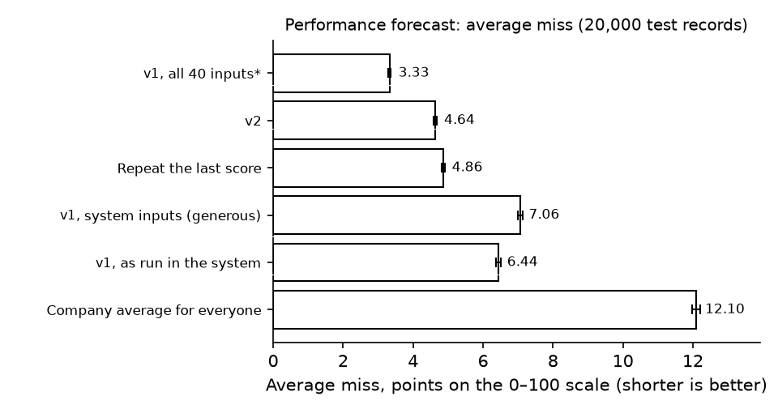
Figure 4. Performance forecast average miss (whiskers are 95% ranges)

6.2 Bands
Band counts (20,000 test records)
Actual band | v2: below | v2: on track | v2: exceeds | v1 as run: below | v1 as run: on track | v1 as run: exceeds | Total
Below | 4,062 | 1,071 | 0 | 3,264 | 1,869 | 0 | 5,133
On track | 1,007 | 7,772 | 785 | 749 | 8,613 | 202 | 9,564
Exceeds | 1 | 1,194 | 4,108 | 2 | 2,906 | 2,395 | 5,303

v1 pushed most employees toward on track. Of the employees who went on to exceed, v1 identified 45.2% and v2 identified 77.5%. Of those who fell below, v1 identified 63.6% and v2 identified 79.1%.

6.3 Range and confidence
v1 gave a single number. v2 also gives a likely range and a confidence that the band is correct.
- Range: the actual score fell inside it for 79.5% of the 20,000 test records, against a target of 80%. It is 14.7 points wide on average.
- Confidence: stated confidence matches how often the band was correct, within 2 points at every level.
Stated confidence | Band actually correct
57% | 59%
72% | 70%
83% | 83%
90% | 89%
98% | 98%

6.4 Behaviour tests
Test | v1 | v2
Latest appraisal raised 1 to 20 points | Forecast went down for 51 of 2,000 people (as run) and 57 of 2,000 (all inputs) | Never went down (0 of 2,000)
Facts from the year being forecast | Reads the manager rating and KPI attainment of that year | None
Only one appraisal on record | Average miss 9.17; band correct 47.8%, no better than answering “on track” for everyone | Needs only one: average miss 4.64; band correct 79.7%
No appraisal on record | Still forecasts (70.5 for a typical employee) from filled-in values | Declined as “not enough data”
Latest score entered as 120 or 150 | Treated as 100, no warning | Held at 100 with a warning
Same employee in another department, or with gender changed | Under 0.01 points on average | No change (not inputs)
Same input twice, alone or in a batch | Identical | Identical

Figure 5 varies the latest score for one typical employee. v1, as run, moves only from 61 to 76 across the whole scale, because the system placed the latest score in the manager rating and KPI attainment inputs and the score before it in last year’s score. The v2 forecast follows the latest score; its 80% range is shaded.
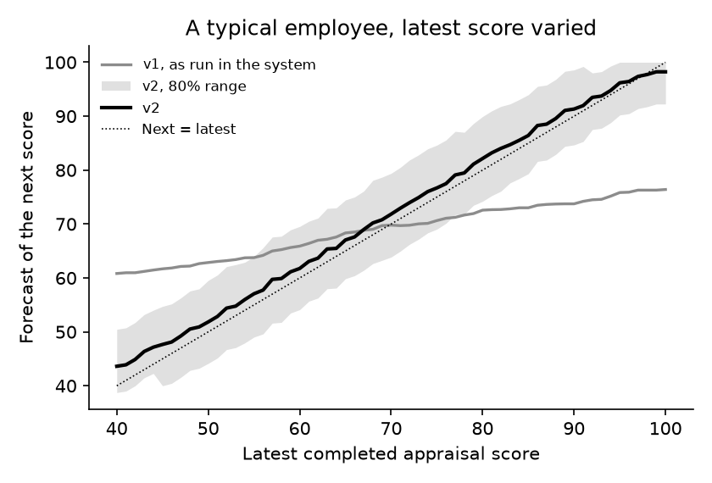
Figure 5. Performance forecast response for a typical employee

7. Attrition risk
The model gives every active employee a 0 to 100 score for how closely their record resembles people who resigned, so HR can talk to them before they decide to leave. It is meant to guide whom to talk to first, not to decide anything about a person.

7.1 How each version was built
 | v1 | v2 | v3
Data | IBM HR sample (a public, made-up dataset of a US company) | Survey of people about an employer they worked for, two collections | Same survey, with 50 more responses gathered 7 to 10 October 2026
Responses received | 1,470 employee records | 168 | 218
Used for learning | 1,470 | 155 | 199
Left or resigned | 237 (16.1%) | 50 (32.3%) | 55 (27.6%)
Facts per person | 17 | 8 | 7 (overtime removed, see 7.6)
Algorithm | Random forest | Random forest | Support vector machine with an adjustment step
How it was tested | One split: learned from 1,176, tested on 294 | Five-way rotation, 10 times | Five-way rotation, 10 times, plus the stricter checks in 7.5

Why survey responses were left out (v3)
Of the 218 responses, 19 were not used: 1 did not consent, 1 gave no outcome, 1 was the same person submitting twice within two minutes, and 16 left in ways they did not choose (7 retired, 8 had a contract or project end, 1 was dismissed). Only voluntary resignation counts as attrition; people still employed count as staying.
The merged file had turned the overtime answer “None” into a blank in 39 responses. Compared with the original exports, every one of these blanks had been “None”, so they are read as zero overtime.
The two collections
Collection | Responses | Used | Resigned | Share resigned
A: first survey run (99) plus the 50 new responses | 149 | 136 | 45 | 33%
B: second survey run, mostly long-serving, better-paid public-sector staff | 69 | 63 | 10 | 16%

7.2 Attrition v1 in detail
v1 learned from the IBM HR sample: 1,470 employees of a fictional US company, 237 of whom left. It read 17 facts: age, department, job role, job level, monthly income, overtime (yes or no), performance rating, years at the company, years in the current role, years since the last promotion, years with the current manager, total working years, trainings last year, education level, field of study, number of past employers and distance from home. Gender and marital status were left out on purpose; age was not.
On its own data, v1 looked good: a ranking score of 0.785 by five-way rotation and 0.737 (95% range 0.653 to 0.818) on its 294 test records. In use, it had three problems.
- Most of its facts were never supplied. The system sent 8 of the 17: income, overtime, years at the company, years in role, years since promotion, performance rating, trainings and department. The other 9 were filled with typical values.
- Salary arrived in the wrong currency. v1 learned monthly incomes of 1,009 to 19,999 from the sample’s US company. The system sent pesos, so a ₱18,500 salary read as a high income.
- Its people were not this system’s people. Only 28 of the 199 survey respondents named a department v1 knew (Sales, Human Resources, or Research and Development).
v1 tested on | Records | Ranking score | 95% range | Flagged at a 50% score
Its own test records, all 17 facts | 294 | 0.737 | 0.653 to 0.818 | 24 (9 of 47 leavers caught)
Its own test records, as run (8 facts) | 294 | 0.765 | 0.690 to 0.845 | None
The 199 survey respondents, as run | 199 | 0.43 | 0.34 to 0.51 | None
The 199 survey respondents, salary left out | 199 | 0.43 | 0.34 to 0.52 | None

On the survey respondents, v1 ranked worse than guessing: the people it scored lowest resigned at 30%, more than the 25% of those it scored highest (Figure 7). It never reached a 50% score for anyone, so it flagged nobody.

7.3 Results on the same 199 people
v2 is shown twice: as published on its own 155 respondents, and retrained on the 199 so that all versions face the same people.
Version | People | Ranking score | 95% range | Lowest fifth resigned | Highest fifth resigned
v1, as run | 199 | 0.43 | 0.34 to 0.51 | 30% | 25%
v2, as published | 155 | 0.628 | 0.548 to 0.727 | 23% | 52%
v2, retrained on the 199 | 199 | 0.655 | 0.582 to 0.743 | 8% | 45%
v3 | 199 | 0.695 | 0.631 to 0.786 | 5% | 48%

The ranking score is the average over the 10 rotations. The 95% range comes from each person’s average score. A “fifth” is the 20% of people with the lowest or highest scores. Figure 7 shows the share who resigned in each fifth: for v3 it rises from 5% in the lowest fifth to 48% in the highest, against 28% overall.
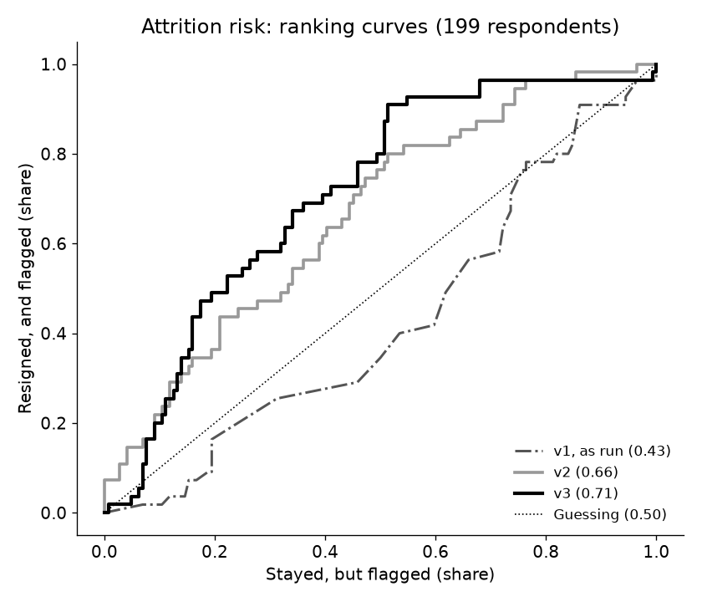
Figure 6. Attrition risk ranking curves on the same 199 respondents (ranking score from each person’s average score)
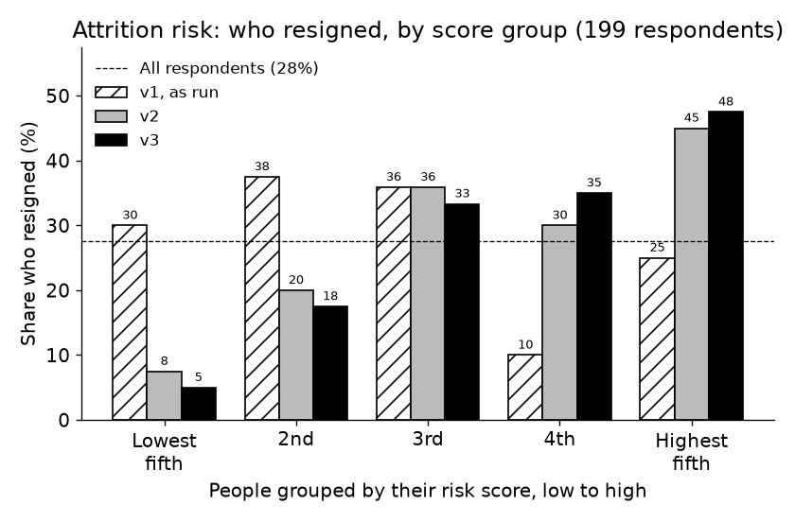
Figure 7. Share who resigned in each score fifth, by version
Stated chance
The v3 score is a ranking, not a chance of leaving. v3 learns as if resigning and staying were equally common, so a score of 50 means “as much like the people who resigned as like those who stayed”. Its average score is 46.8, while 27.6% of respondents resigned, a stated chance gap of 19.1 points (v2: 10.2 points on its 155 respondents). Read a score as “higher means more like those who resigned”, not as a percentage.

7.4 Flagging
Flag | Version | People flagged | Correct when flagged | Caught | Overall correct
Score 50 or more | v2, retrained on the 199 | 58 | 41.4% | 43.6% (24 of 55) | 67.3%
Score 50 or more | v3 | 108 | 38.9% | 76.4% (42 of 55) | 60.3%
High tier (66 or more) | v3 | 14 | 28.6% | 7.3% (4 of 55) | 69.3%
Highest fifth | v3 | 40 | 47.5% | 34.5% (19 of 55) | Not applicable
Nobody (“everyone stays”) | Any | 0 | Not applicable | 0% | 72.4%

At a score of 50, v3 catches three in four of the people who resigned (v2: fewer than half), at the cost of flagging 66 who stayed. Answering “everyone stays” is 72.4% correct while catching nobody, so overall correctness is not a useful yardstick here. The High tier is rarely reached, because v3 scores top out near 71; the highest fifth (40 people, 47.5% of whom resigned) is a more useful list to act on.
Decision counts for v3 (199 respondents, each scored by models that never saw them; flagged = score 50 or more)
Outcome | Flagged | Not flagged | Total
Resigned | 42 correct | 13 missed | 55
Stayed | 66 wrongly flagged | 78 correct | 144

7.5 Checks that the result is real
Check | What it asks | v2 | v3
Shuffled outcomes | Scramble who resigned 100 times and retrain. How often does a scrambled run match the real result? | 2 of 100 (p = 0.03) | 0 of 100 (p = 0.010); scrambled runs averaged 0.489, best 0.64
Fresh splits | Repeat the test 30 times on splits never used while choosing the model | Not run | 0.706
Choice made inside each test | Re-choose the model’s settings using only the learning part of each split, so the choice never sees the people it is scored on. This is the strictest estimate. | Not run | 0.671
Between collections | Learn from one collection, test on the other | 0.358 and 0.392 | 0.383 and 0.588

The v3 ranking is very unlikely to be luck (Figure 8). Its true score most likely lies between the strict estimate (0.671) and the fresh-split result (0.706). It does not carry over well between the two collections, which reached different kinds of workers: learning only from collection A, it ranks collection B at 0.383.
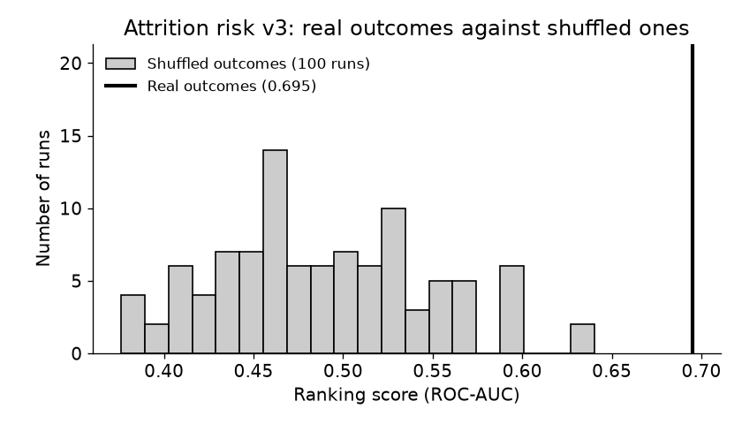
Figure 8. Attrition v3: ranking score with real outcomes against 100 runs with shuffled outcomes

7.6 What changed from v2 to v3
Change | Effect on the ranking score
44 more usable responses (155 to 199) | v2’s method rose from 0.628 to 0.655
Algorithm changed from random forest to support vector machine | 0.655 to 0.695 on the same 199 people
Overtime removed as an input | With overtime, v3 scores 0.675; without, 0.695

About 400 combinations of method, settings and facts were tried on the 199 respondents. None did better than about 0.71 when tested on fresh splits. Other methods on the same data scored: logistic regression 0.541, gradient boosting 0.583, random forest 0.663 and extra trees (a random forest variant) 0.664, against 0.695 for the SVM.
Overtime was removed because the share who resigned barely changes with it: from 17% to 38% across its answers with no steady direction. Lateness and absences show the clearest pattern. Of those late more than 10 times in their last three months, 83% resigned (25% of those never late); of those absent more than 10 days, 67% (22% of those never absent). Pay matters too: 40% of those earning ₱15,000 to ₱24,999 resigned, against 7% of those earning ₱40,000 or more.
The adjustment step matters. A common form of it, tried on the same SVM, reversed the order of people in some splits because it learns from only about 30 people at a time; its ranking score fell to 0.551. v3 uses a form that cannot reverse the order.
Fact | How much the ranking score drops without it
Years with the employer | 0.078
Time since last promotion | 0.068
Late arrivals, last 3 months | 0.064
Monthly salary | 0.062
Absences, last 3 months | 0.054
Ever promoted | 0.026
Employment type | 0.019

8. Automated tests
Each version of the code carries built-in tests that check its own behaviour against the trained models. All passed on every date.
Area | 25 Sep 2026 (promotion v1, performance v1, attrition v2) | 7 Oct 2026 (promotion v2, performance v2, attrition v2) | 16 Oct 2026 (promotion v2, performance v2, attrition v3)
Attrition: survey cleaning | 12 | 12 | 14
Attrition: inputs | 22 | 22 | 23
Attrition: model | None | None | 4
Attrition: scoring service | 15 | 15 | 17
Promotion model | None | 18 | 18
Performance model | None | 11 | 11
Shared appraisal handling | None | 27 | 27
Saved promotion and performance models as served | None | 12 | 12
Models trained on a company’s own records | None | 19 | 19
Total | 49 of 49 | 136 of 136 | 145 of 145

The tests added for attrition v3 check that a blank overtime answer is read as “None”, that overtime no longer changes a score, that training twice gives identical scores, that scores sit on the scale the tiers use, and that the saved results beat both guessing and the shuffled-outcome check.

9. Limitations
- Reference data, not company data. Promotion and performance were trained and tested on a reference dataset, not on a company’s own employees. The system’s track record and model graduation features exist to check and retrain them on a company’s history as it builds up.
- Promotion rewards improvement. In the reference data, employees whose score did not rise were rarely promoted, so a consistently high scorer with no improvement shows as Low. The screen gives this as the reason.
- Forecasts drift up about 2 points a year, following the trend in the reference data.
- Attrition rests on 199 survey answers. Its 95% range is 0.631 to 0.786, and its strictest estimate is 0.671. It did not carry over well between the two collections. Reaching 0.70 dependably needs more responses, especially from people who resigned (55 so far).
- Attrition tiers. 153 of the 199 respondents score 33 or more, and 14 reach the High tier at 66. The ordered list, starting from the highest scores, is more useful than the tiers.
- Unusual attrition profiles. People unlike anyone in the survey score near the middle, and 8 of the 199 respondents’ scores came with no stated reason.
- “As run” results are a replay. The v1 system conditions were rebuilt from their code. Where a choice was needed, it favoured v1 (for example, v1 was given its own salary figures in the test on its own data).
- Figures 1 to 5 come from the 7 October 2026 evaluation. Only their version labels were changed for this report.

Appendix: technical measures
For technical readers. PR-AUC measures how well the top of a ranking is filled with people who had the outcome (guessing scores the outcome rate). The Brier score is the average squared error of stated chances (lower is better). F1 combines “correct when flagged” and “caught” and is high only when both are. R² is the share of differences between employees’ scores that a forecast explains.
Promotion readiness (20,000 test records)
Version and condition | ROC-AUC | PR-AUC (guessing 0.10) | Five-fold ROC-AUC | F1, High tier | Brier score
v1, all 40 inputs | 0.941 | 0.666 | 0.939 ± 0.003 | 59.5% | 0.105
v1, as run, matching names | 0.923 | 0.607 | 0.923 ± 0.003 | 57.5% | 0.099
v1, as run, company names | 0.843 | 0.373 | Not run | 41.3% | 0.113
v2 | 0.842 | 0.372 | 0.843 ± 0.004 | 41.6% | 0.075

Performance forecast (20,000 test records)
Version and condition | RMSE | R² | Band precision | Band recall | Band F1
v1, all 40 inputs | 4.18 | 92.0% | 86.0% | 85.3% | 85.6%
v1, as run | 8.02 | 70.6% | 79.3% | 66.3% | 69.0%
v1, system’s facts placed correctly | 8.58 | 66.3% | 85.2% | 57.3% | 59.9%
v2 | 5.82 | 84.5% | 80.5% | 79.3% | 79.8%
Repeat the last score | 6.15 | 82.7% | 80.0% | 78.0% | 78.5%
Company average for everyone | 14.78 | 0.0% | 15.9% | 33.3% | 21.6%

Attrition risk
Version and test | ROC-AUC | PR-AUC (guessing) | Brier score | F1 at a 50% score
v1, own test records, all 17 facts | 0.737 (five-fold 0.785 ± 0.021) | 0.373 (0.160) | 0.128 | 25.4%
v1, 199 respondents, as run | 0.427 | 0.238 (0.276) | 0.214 | Nobody flagged
v2, as published (155) | 0.628 ± 0.038 | 0.449 (0.323) | 0.224 | 45.4%
v2, retrained on the 199 | 0.655 ± 0.022 | 0.436 (0.276) | 0.206 | 42.5%
v3 (199) | 0.695 ± 0.023 | 0.418 (0.276) | 0.222 | 51.5%

Attrition figures with ± are the mean and spread over 10 repetitions of the five-way rotation. v3’s settings: radial-basis support vector machine (C = 1, gamma = 0.3) on the survey’s answer bands, standardised; isotonic adjustment averaged over five folds; both outcomes weighted equally in learning.

