- Improved prompt of “Explain regression”
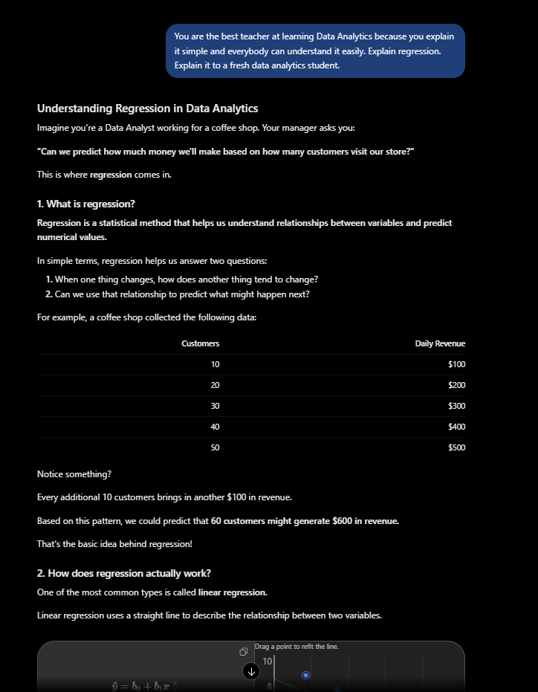

- Improved prompt of “Help me understand SQL”
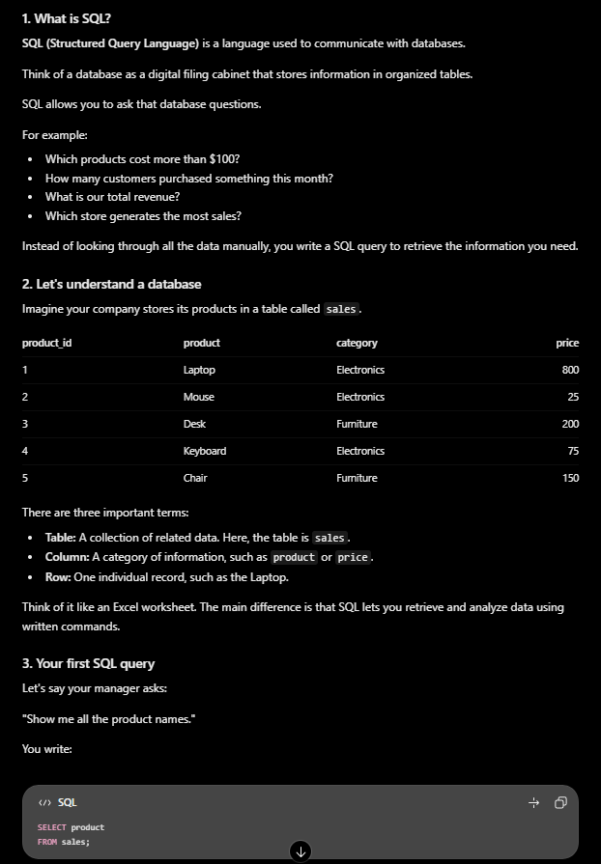

- Improved prompt of “Create a dataset”
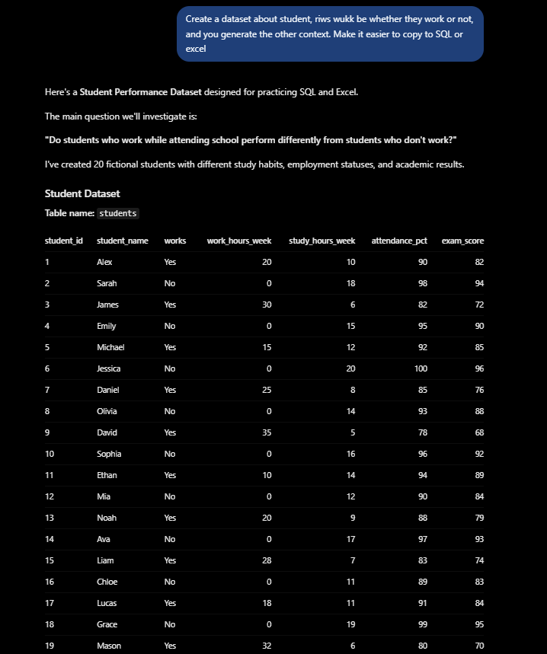
What I noticed after revising the prompt is that the answer I was given is more tailored to what I desire, which only makes sense because this time when I revised the prompt, I was able to give more context and more rules. For the last prompt I had to think what I want in my dataset because I needed a role, goal, rules and how I want it to present to make sure that I can get better results compared to the last prompt. Most importantly, this shows that to maximize this is a technique that will help to get the most out of this tool (AI).

