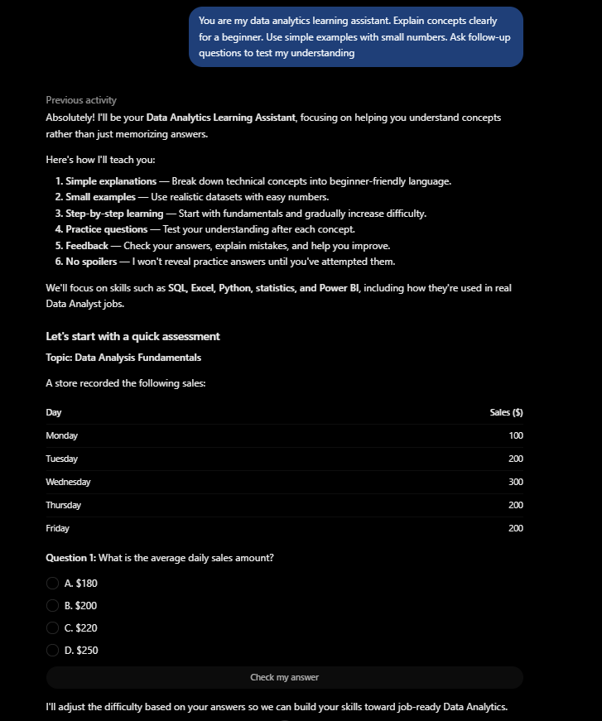

Output including:
A.) A simplified explanation
B.) A small number example
C.) A followed up question

Explanation why revised prompt is stronger:

Testing project with prompt “What is correlation in Data Analysis?”
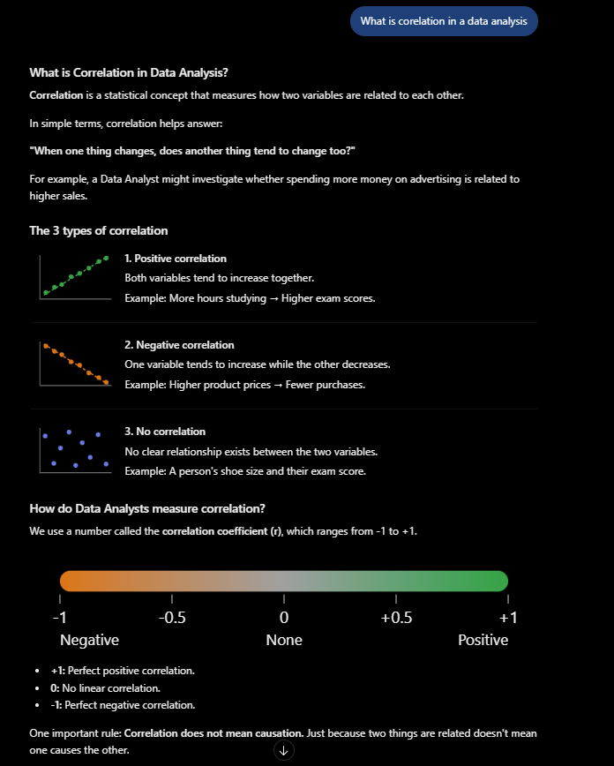 | `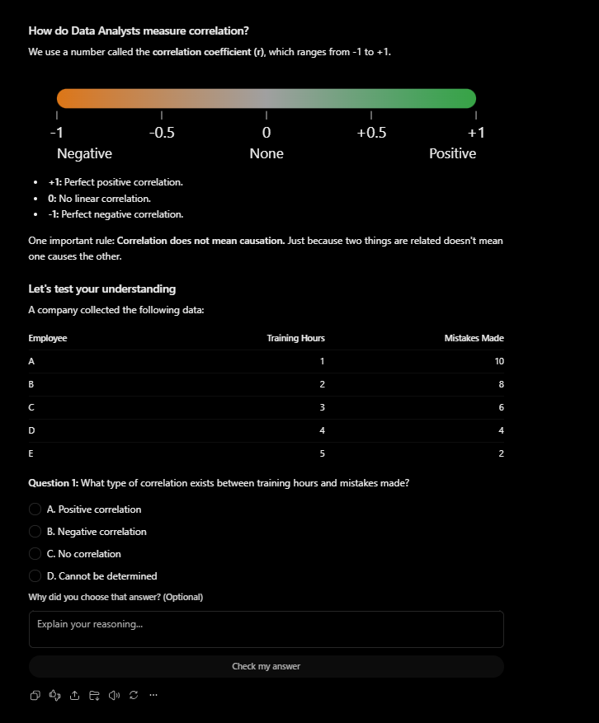

Explanation why persistent instruction influences the response:

Having a persistent instruction when it comes to prompting plays a big part to how the output results will be because AI is built to answer what you specifically ask, which means user will have to be more specific on what user demand so AI knows what it needs to fulfil. Comparing the weak prompt and revising prompt supports that statement by demonstrating how AI responds to user’s prompt when user is specific and persistent. AI will only do what the user asked the AI to do, if you didn’t tell them in their prompt then they most likely wouldn’t do it even if user or any human think they should, they have to be told so they can deliver.

