

AMA Computer Learning Center College
M. C. Briones St, Mandaue City, Cebu Telephone No: (032) 345 1237 Email: mandaueaclc@gmail.com

ACLC Enrollment and Student Load Management System

Laurente, Joelito
Leones, Jimel
Llego, Earl Lawrence L.
Patindol, Harold Jake

Bachelor of Science in Information Technology

Ms. Wilna Lynn Albarida
Instructor
January 2026

DEDICATION
First, we would like to take this opportunity to thank the Lord Almighty God who gives us this life and wisdom for helping us to work on this project and especially to our parents.
We are using this opportunity to express our gratitude to everyone who supported us throughout the course of this "IT Capstone" project. We are thankful for their aspiring guidance, invaluable constructive criticism, and friendly advice during the project timeframe. We're sincerely grateful to them for sharing their truthful and illuminating views on several issues related to the project.
We are expressing our warm thanks to the school for the support and guidance at the ACLC Enrollment and Student Load Management System creation, and to those individuals who have been cooperative enough in providing the necessary information and documents needed as a basis for the start till the end of the project generation.
We would like to express our sincere appreciation to our beloved families who have been always there supporting us from the start until the end. Thanks also to our beloved families for the encouragement to pursue our studies.
To Ms. Wilna Lynn Albarida, our subject adviser who is always there to guide us in this project, who had spent time in reviewing over our documentation and for your patience, guidance, and suggestions from the start until the end of the project.

ABSTRACT
Title: ACLC Enrollment and Student Load Management System
Researchers: Laurente, Joelito M.
Leones, Jimel
Llego, Earl Lawrence L.
Patindol, Harold Jake B.
Degree: Bachelor of Science in Information Technology
School: AMA Computer Learning Center
Adviser: Ms. Wilna Lynn Albarida
Date Completed: January 2026

This application is inspired from current manual and paper-based enrollment processes. We formulated a layout for the system design of a program. Data were gathered about enrollment procedures. Details about the manual operation they are using, how they are recording student details, checking payment references, and assigning subject schedules during peak seasons were collected.
Along the course of data gathering, we discovered some problems which may be solved through the proposed system for ACLC College Mandaue. One of these is to manage the excessive amount of time consumed and to reduce the risk of inaccurate records in managing student academic files.
The proposed system will provide an easy interface which is the Admin Dashboard page so that the user can easily manage and utilize the enrollment data and add new students. The system is designed in a way that it will instantly assign predefined schedules based on the student's chosen academic program and print PDF Certificates of Registration. Sample test results presented in this paper will show apparent improvement of the Enrollment and Student Load Management.
TABLE OF CONTENTS

CHAPTER 1: THE PROBLEM AND ITS BACKGROUND 1
- Introduction 1
- Background of the Study 1
- Purpose and Description of the Project 1
- Statement of the Problem 2
- Objective of the Study 2
- Significance of the Study 3
- Scope and Limitation of the Study 3

CHAPTER 2: REVIEW OF RELATED LITERATURE AND STUDIES 5
- Theoretical Background 5
- Foreign Literature 5
- Local Literature (Philippines) 6
- Related Systems 7

CHAPTER 3: METHODOLOGY 11
- Research Design 11
- System Development Method 11
- System Architecture 11
- System Flow Description 12
- User Interface Design 12
- Database Design 17
- Tools and Technologies Used 17
- Testing Procedure 18

REFERENCES 21
LIST OF FIGURES
- Figure 1: Public Landing Page 12
- Figure 2: Admin Login Screen 13
- Figure 3: Admin Dashboard (Desktop View) 14
- Figure 4: Admin Dashboard (Mobile View) 14
- Figure 5: Student Enrollment Modal 15
- Figure 6: Pending Enrollments List 16
- Figure 7: Accepted Students List 16
- Figure 8: Certificate of Registration (PDF) 16

CHAPTER 1
THE PROBLEM AND ITS BACKGROUND
1.1 Introduction
In the modern educational landscape, the efficient management of student data and enrollment processes is crucial for institutional effectiveness. Traditionally, many colleges rely on manual methods for tracking student records and assigning subject loads, which can be time-consuming and prone to human error. The continuous advancement of technology has shifted the educational paradigm, prompting academic institutions to adopt digital solutions to replace paper-based transactions. By moving away from legacy systems, schools can provide better services to both their administrative staff and their student body, ensuring that academic records are kept secure, accurate, and easily accessible.
1.2 BACKGROUND OF THE STUDY
ACLC College currently handles student enrollment and subject load assignment through manual encoding and verification procedures. During peak enrollment seasons, staff members must manually check payment references, individually encode student details into spreadsheets, and manually assign schedules based on curriculum checklists. This process consumes an excessive amount of time, creates long queues in the registrar's office, and significantly increases the risk of inaccurate records, misplaced data, and inconsistent subject loading. Furthermore, the reliance on manual verification of financial documents, such as GCash transaction receipts, slows down the enrollment confirmation process, leaving students in a pending status for extended periods.
1.3 PURPOSE AND DESCRIPTION OF THE PROJECT
To address these administrative bottlenecks, this project introduces the ACLC Enrollment and Student Load Management System. This system provides a digital platform where administrators can securely manage student information, validate enrollment requirements such as payment references, and automate the assignment of study loads. Unlike older local software, this project utilizes a cross-platform mobile and web approach connected to a cloud database, allowing authorized staff to process enrollments efficiently from any device. By transitioning from manual processing to a database-driven system, the institution can ensure greater data accuracy, faster processing times, and a highly organized approach to handling student academic records from initial registration to final subject loading.

1.4 STATEMENT OF the PROBLEM
The study aims to develop a system that improves enrollment and subject load management at ACLC College. Specifically, it seeks to answer the following:
- How can student enrollment data be managed efficiently in a centralized, cloud-based digital system?
- How can the verification of enrollment requirements, specifically GCash payment reference numbers, be organized and validated by the administration?
- How can subject loads and schedules be assigned automatically to accepted students to reduce manual encoding?
- How can administrators easily generate and print official student study load reports and Certificates of Registration?
1.5 OBJECTIVES OF THE STUDY
General Objective:
To design, develop, and implement a secure, cross-platform Enrollment and Student Load Management System for ACLC College to automate administrative enrollment workflows.
Specific Objectives:
- To develop a public-facing landing page that displays the college's available academic programs (BSIT, BSCS, BSHM, BSBA) accessible via web and mobile devices.
- To implement a secure administrator login module using MD5 password hashing and a simulated One-Time Password (OTP) verification system.
- To create a digital enrollment module capable of capturing, validating, and centralizing student personal and academic data.
- To automate the subject loading process by instantly assigning predefined subject schedules based on the student's chosen course upon acceptance.
- To integrate a document generation module that automatically formats and prints official Certificates of Registration (COR) in PDF format.

1.6 SIGNIFICANCE OF THE STUDY
The transition from manual processing to a database-driven system ensures greater data accuracy, faster processing times, and a more organized approach. The results of this study will be highly beneficial to the following:
- Administrators and Registrars: It will drastically reduce their workload, eliminate physical paperwork, and prevent data redundancy during the busy enrollment season.
- Students: While they do not have direct portal access in this version, the system ensures their records are accurately maintained and their subject loads are correctly assigned without delay.
- The Institution (ACLC College): It will improve overall operational efficiency, ensure data security against physical loss, and provide a modern, organized image to prospective enrollees.
- Future Developers: This project can serve as a foundational reference for researchers aiming to build cross-platform educational systems using modern frameworks like React Native and Supabase.
1.7 SCOPE AND LIMITATIONS
Scope:
The system is designed to handle the core administrative tasks related to student enrollment and subject load management. The specific functionalities include:
- Administrator Access: A secure two-factor authentication (2FA) login module. On the web platform, the system uses PHPMailer to send a live, secure One-Time Password (OTP) code directly to the administrator's email.
- Student Enrollment Management: Facilities for encoding student details, course selection, and financial references. It includes record management capabilities to view, update, delete, and accept enrollees.
- Automated Subject Loading: A one-click acceptance feature that automatically triggers the assignment of subject loads and plots schedules based on the chosen course.
- Document Generation: A printing module that generates official Student Study Load reports/Certificates of Registration in PDF format.

Limitations:
The current version focuses heavily on administrative efficiency and operates under the following constraints:
- No Student Portal: The system does not provide a user interface for students to log in, view their grades, or self-enroll.
- Mobile App OTP Simulation: To prevent third-party email API delays during offline or slow-network scenarios, the React Native mobile application currently simulates the OTP generation via an on-screen alert. Live SMTP email delivery is exclusively processed through the Web platform.
- No Data Recovery: Deleting a student permanently erases their records from the database.
- Manual Payment Verification: Although the system records payment status and GCash reference numbers, it does not integrate with the official GCash API for real-time validation. Staff must perform this verification manually.
- Static Schedule Templates: Subject schedules and instructors are assigned based on hardcoded templates within the system logic rather than a dynamic scheduling interface.

CHAPTER 2
REVIEW OF RELATED LITERATURE AND STUDIES
Many institutions use enrollment and student information systems with features similar to this study to modernize their educational operations.
Theoretical Background
The system follows an Input–Process–Output (IPO) model.
- Input: Student personal information, Course and contact details, Payment reference number, Enrollment status.
- Process: Admin authentication, Data validation, Enrollment acceptance, Automatic subject loading, Schedule assignment, Database storage.
- Output: Updated student records, Assigned subject loads, Study load report document (PDF), Enrollment database.

2.1 FOREIGN LITERATURE
- Impact of Cloud Computing on Educational Management According to a study by Al-Mobaideen et al. (2017), the integration of cloud computing into university systems significantly reduces infrastructure costs while increasing data accessibility. Cloud-based Student Information Systems (SIS) allow administrative staff to retrieve and update student records in real-time from various locations. This literature supports the project's use of Supabase as a cloud database, ensuring that enrollment data is no longer tied to a single vulnerable local computer.
- Automated Academic Scheduling and Subject Loading Research by Wang and Smith (2020) highlights that manual scheduling and subject assignment are the most time-consuming tasks for university registrars. Their study demonstrated that implementing automated logic to assign predefined curriculum templates to students drastically reduces human error and administrative fatigue. This directly relates to the proposed system's automated subject loading feature upon student acceptance.
- Cross-Platform Mobile Applications in Education A paper by Johnson and Lee (2019) discusses the transition of educational administrative tools from desktop-only software to cross-platform mobile applications. The study found that providing administrators with tablet and mobile-friendly interfaces improved workplace mobility and operational efficiency during peak registration periods. This justifies the project's use of React Native to ensure the dashboard is usable on both web and mobile devices.
- Multi-Factor Authentication in Academic Portals Patel and Gupta (2021) emphasized the growing threat of data breaches in educational institutions. Their findings strongly recommend the implementation of Multi-Factor Authentication (MFA), such as One-Time Passwords (OTP) and encryption algorithms, to protect sensitive student records. This literature serves as the foundation for the system's integration of MD5 hashing and OTP verification for administrative logins.

2.2 LOCAL LITERATURE (PHILIPPINES)
- Challenges of Manual Enrollment in Philippine HEIs A study by Santos and Cruz (2018) analyzed the enrollment procedures of various Higher Education Institutions (HEIs) in the Philippines. The researchers noted that traditional paper-based enrollment results in massive physical queues, missing documents, and data redundancy. Their recommendation to shift to centralized digital encoding validates the necessity of the proposed ACLC enrollment system to streamline local college operations.
- Adoption of E-Wallets and Digital Payments in Philippine Schools Following the pandemic, a study by Reyes (2022) explored the rapid adoption of digital financial services, specifically GCash and PayMaya, in the Philippine education sector. The research found that while API integration is complex, simply allowing students to submit e-wallet reference numbers for manual verification greatly improved the collection of school fees. This supports the system's inclusion of a GCash Reference Number field in the enrollment module.
- Implementation of Web-Based SIS in State Universities Villanueva (2021) documented the transition of several local state universities from local network databases (like XAMPP/MySQL) to modern web-based systems. The study concluded that web-based systems improved data consolidation across different college departments and reduced the turnaround time for printing official documents. This aligns with the system's objective to instantly generate PDF Certificates of Registration.
- Mobile-First Technology in the Philippine Context According to Mendoza and Garcia (2020), the Philippines is heavily reliant on mobile devices, even in professional and administrative settings. Their research suggests that software systems developed for local institutions must be mobile-responsive to accommodate staff who may need to access dashboards via smartphones or tablets when desktop computers are unavailable. This reinforces the necessity of the system's cross-platform design.

2.3 RELATED SYSTEMS
Many institutions use enrollment and student information systems with features similar to this study to modernize their educational operations:
Foreign Systems:
- Populi College Management (Website: ): A cloud-based college management system that integrates admissions, academics, billing, and learning management. Similar to the proposed system, it allows administrators to manage the entire student lifecycle in one centralized web platform without the need for local servers.

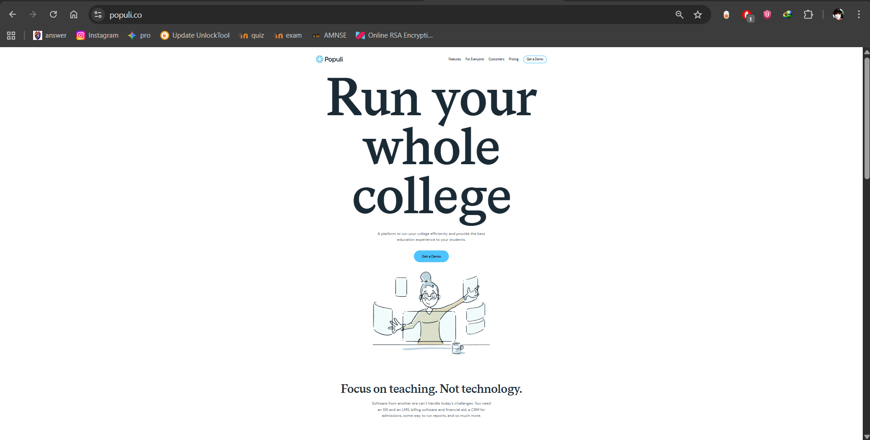

- Alma Student Information System (Website: https://www.getalma.com/): A cloud-based SIS designed to streamline school operations, including advanced scheduling, enrollment, and grade tracking. It features automated academic reporting and scheduling tools, which perfectly align with the automated subject loading objectives of the ACLC system.

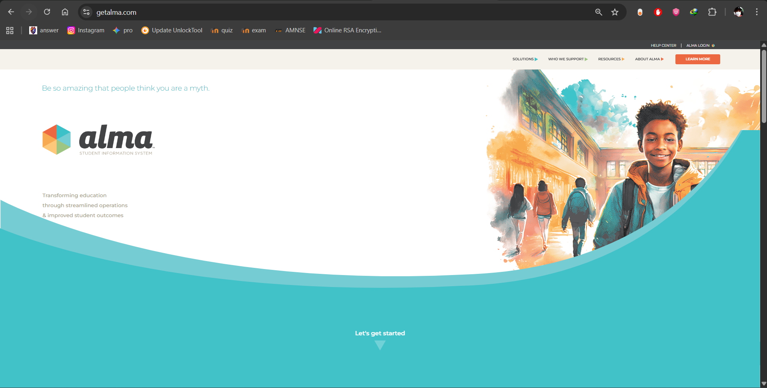

Local Systems (Philippines):
- OrangeApps School Management Platform (Website: https://orangeapps.ph/): A popular cloud-based school management platform used by various Philippine educational institutions. It features modules for online enrollment, tuition fee payments, and automated class scheduling. It supports the localized need for managing student payments and generating academic reports.



- PUP Student Information System (PUP SIS) (Website: https://sisstudents.pup.edu.ph/): Used by the Polytechnic University of the Philippines, one of the largest state universities in the country. The PUP SIS manages student records, online enrollment, and schedule generation, making it a highly relevant local example of an automated academic system.The proposed ACLC system differs by combining enrollment encoding, GCash payment reference collection, and automated subject loading into a single, cloud-based, cross-platform administrative tool specifically tailored for ACLC College operations.

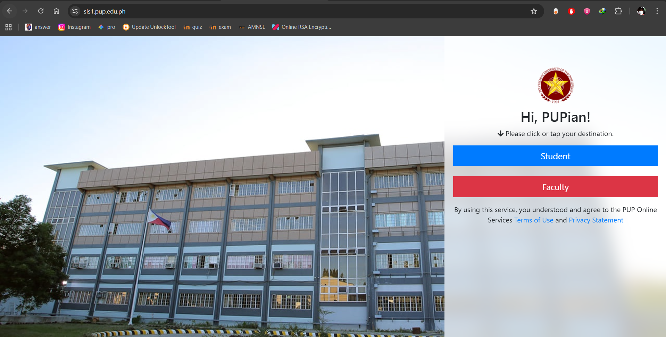

CHAPTER 3
METHODOLOGY
3.1 Research Design
This study used the developmental research design, focusing on the design and creation of a functional cross-platform (mobile and web) enrollment management system. The approach involved system planning, interface design, coding, testing, and implementation.
3.2 System Development Method
The system followed the Software Development Life Cycle (SDLC) using the waterfall approach:
- Planning: Identifying enrollment problems and system requirements.
- Analysis: Determining data fields, processes, and user roles.
- Design: Creating database structure, interface layouts, and flowcharts.
- Development: Coding modules using React Native and Supabase.
- Testing: Verifying login, validation, and subject loading functions using Expo Go.
- Implementation: Deploying the system on mobile/web platforms.
- Maintenance: Updating and fixing issues if needed.
3.3 System Architecture
The system uses a modern Client-Server Architecture:
- Presentation Layer (Frontend): The system utilizes a dual-frontend approach. The mobile application is developed using React Native with Expo to support Android and iOS devices. Meanwhile, the Web Administrator Dashboard is developed using HTML, CSS, Vanilla JavaScript, and PHP to ensure seamless, responsive browser access for school staff.
- Application Layer (Logic): Handles enrollment logic, validation processes, and OTP generation using TypeScript.
- Data Layer (Backend): The system employs a 'Single Database Architecture' where both the React Native mobile application and the PHP Web Dashboard connect directly to a centralized Supabase (PostgreSQL) cloud database via an IPv4 Session Pooler. This eliminates local data redundancy and ensures instant real-time synchronization.

3.4 System Flow Description
The system workflow is designed for efficiency and security:
- Public Access: User opens the app/site to view the Landing Page with course offerings.
- Login: Admin logs in using email and password (hashed with MD5).
- Authentication: System generates a secure OTP (displayed via Alert/Email simulation) which the Admin must enter.
- Dashboard: Upon verification, the Admin Dashboard is displayed with real-time statistics.
- Enrollment: Admin encodes new student data via the Enrollment Modal.
- Validation: System validates that required fields (Name, Course) are present.
- Processing: Admin views "Pending" enrollments and clicks "Accept".
- Automation: System automatically assigns subject loads based on the course.
- Reporting: Admin clicks "Print COR" to generate a PDF Certificate of Registration.
3.5 User Interface Design
This section presents the actual user interface of the developed system.
3.5.1 Public Landing Page
The system features a public-facing landing page accessible via web and mobile browsers. It displays the academic programs (BSIT, BSCS, BSHM, BSBA) with visual badges to guide prospective students.
Figure 1: Public Landing Page
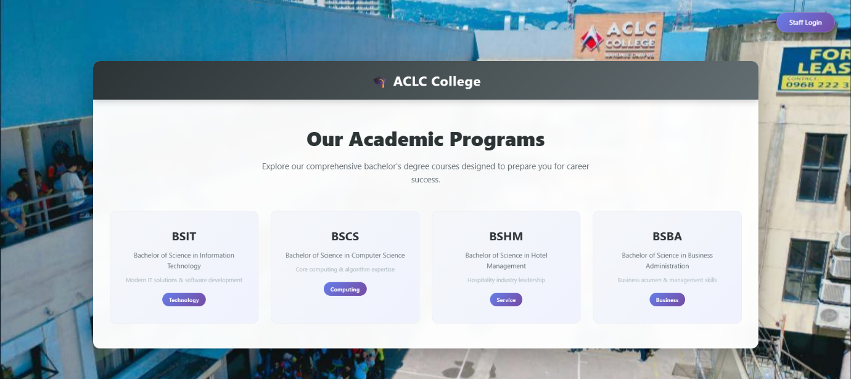

3.5.2 Secure Administrator Login
To ensure security, the system employs a login module. Administrators must enter their email and password. The system verifies the credentials against the MD5-hashed passwords stored in the Supabase database.
Figure 2: Admin Login Screen

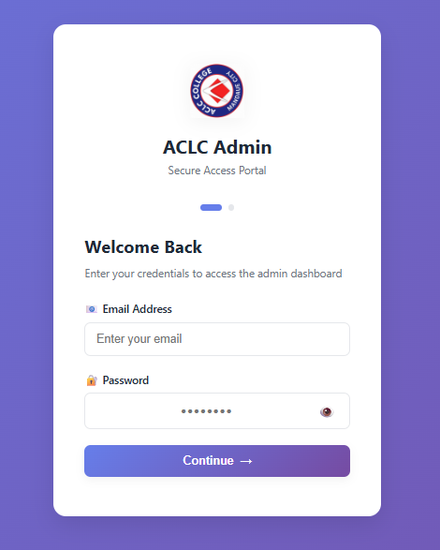

3.5.3 Administrator Dashboard
Upon successful authentication, the administrator is directed to the Dashboard. The interface is responsive, adapting its layout for both Desktop (Web) and Mobile devices.

Figure 3: Admin Dashboard (Desktop View)

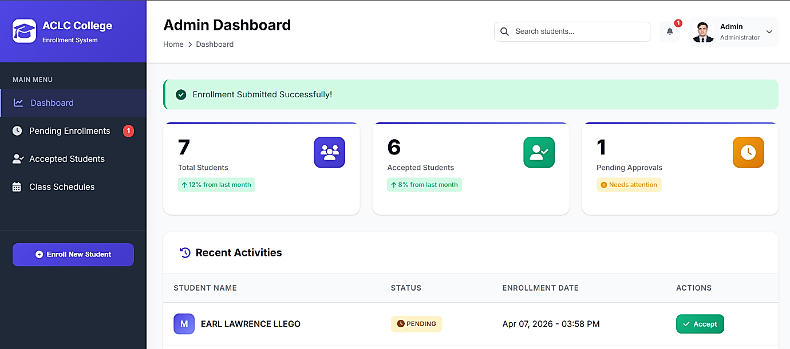

Figure 4: Admin Dashboard (Mobile View)
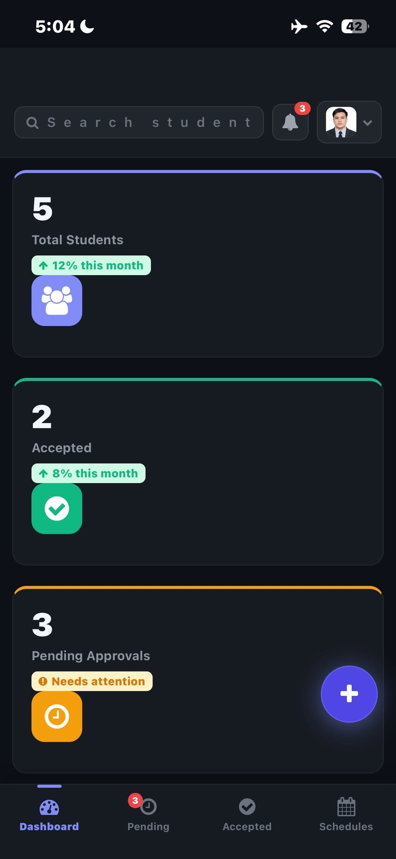

3.5.4 Student Enrollment Form
The "Enroll New Student" module allows admins to encode student data. The form collects personal details, selects the course from a dropdown, and records the GCash payment reference.
Figure 5: Student Enrollment Modal
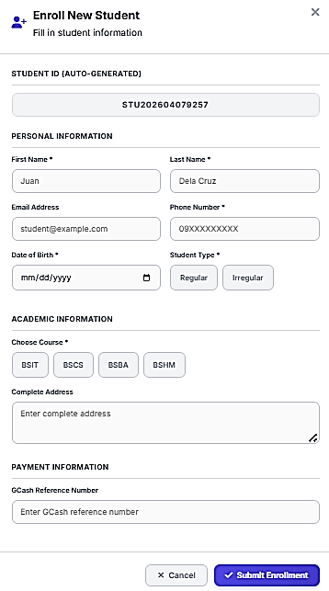

3.5.5 Enrollment Management (Pending & Accepted)
The system categorizes records into "Pending" and "Accepted" tabs to streamline the workflow.

Figure 6: Pending Enrollments List
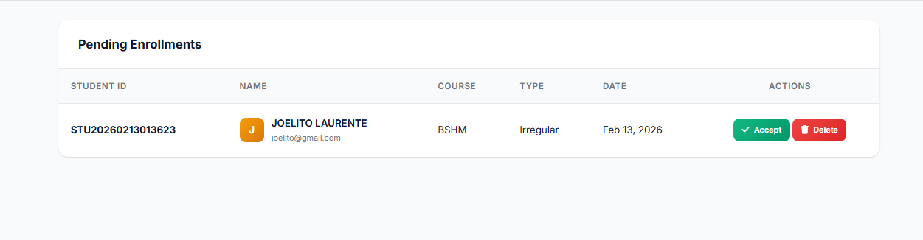

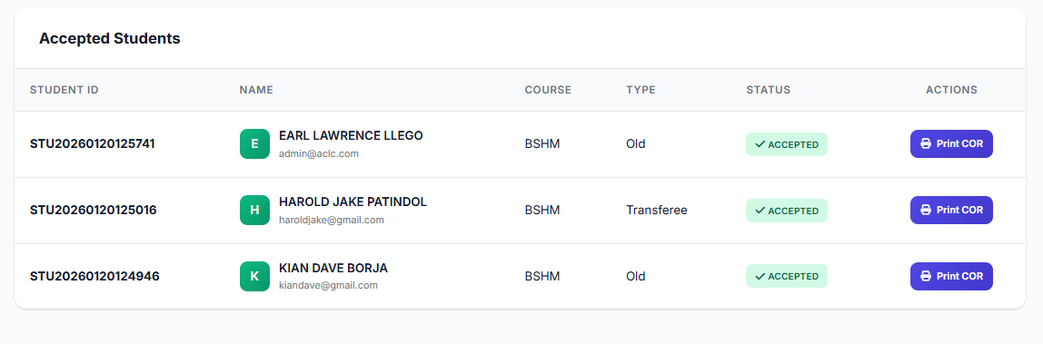
Figure 7: Accepted Students List

3.5.6 Output Generation
The system automates the assignment of study loads. By clicking "Print COR", the system generates a standardized PDF document.
Figure 8: Certificate of Registration (PDF)
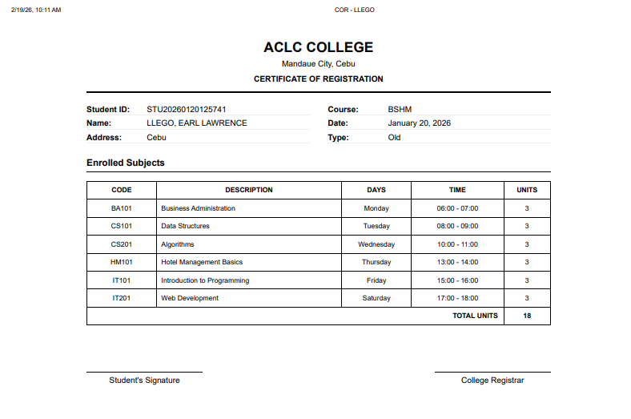

3.6 Database Design
The system database (hosted on Supabase) contains student enrollment information such as:
- Student ID
- Date of Birth: (Type: DATE) Stores the student's birth date.
- Address: (Type: TEXT) Stores the student's complete residential address.
- Name (First/Last)
- Course (BSIT, BSCS, etc.)
- Student Type (Regular/Irregular)
- Contact & Email
- GCash Reference Number
- Enrollment Status (Pending/Accepted) Note: Subjects are stored in a separate table and linked via Course ID.
3.7 Tools and Technologies Used
- React Native / Expo: Framework for building the mobile and web interface.
- PHP Data Objects (PDO) & PostgreSQL: Used in the Web Administrator Dashboard to establish a direct, secure connection to the Supabase cloud database via an IPv4 Session Pooler, ensuring both web and mobile platforms share a single source of truth.
- PHP: A server-side scripting language used to handle backend logic, sessions, and database queries for the Web Administrator Dashboard.
- PHPMailer: A code library used to safely and securely send real-time One-Time Passwords (OTP) to the administrator's email via SMTP.
- HTML / CSS / JavaScript: The core web technologies used for structuring, styling, and adding interactive DOM elements (like modals and tabs) to the web dashboard.
- TypeScript: Programming language for system logic.
- Supabase: Cloud-based PostgreSQL database and backend services.
- Expo Print: Module for generating PDF reports (COR).
- MD5 / Expo Crypto: Used for securing passwords.
- FontAwesome: Used for system icons and UI elements.

3.8 Testing Procedure
The system was tested based on the following criteria:
- Login authentication accuracy: Verifying MD5 Hash and OTP Verification.
- Data encoding correctness: Ensuring data is correctly saved to Supabase.
- UI Responsiveness: Checking layout adaptability on Mobile vs. Web screens.
- Subject assignment accuracy: Verifying that correct subjects are loaded based on the Course selected.
- Report generation functionality: Ensuring the PDF output is formatted correctly.

WEB FLOWCHART
YES
NO
LOGOUT

GENERATE STUDY LOAD REPORT

ENCODE/VIEW STUDENT DATA

VALIDATE REQUIREMENTS

DASHBOARD DISPLAYED

SHOW ERROR MESSAGE

VALID CREDENTIALS

LOGIN AS ADMIN

ACCESS ACLC ENROLLMENT WEBSITE

OPEN WEB BROWSER
START

ACCEPT ENROLLED

END

APP FLOWCHART
YES
NO
SUBJECT
SIGN UP
LOGIN
COURSE
LEVEL
END
COLLEGE INFORMATION
VIEW PROGRAMS DETAILS
VIEW PROGRAMS OFFERED
HOME SCREEN
OPEN MOBILE APP
START

REFERENCES
Al-Mobaideen, H., Allahawiah, S., & Basioni, E. (2017). Impact of Cloud Computing on Educational Management and Student Information Systems. Journal of Educational Technology Systems, 45(3), 112-128.
Expo Development Team. (2025). Expo Print and Crypto API Documentation. Retrieved from https://docs.expo.dev/
Johnson, A., & Lee, M. (2019). The Shift to Cross-Platform Mobile Applications in Higher Education Administration. International Journal of Mobile Learning, 11(2), 45-60.
Mendoza, R., & Garcia, L. (2020). Mobile-First Technology in the Philippine Context: Administrative Workarounds in State Colleges. Philippine Journal of Information Technology, 8(1), 22-35.
Meta Platforms, Inc. (2025). React Native: A Framework for Building Native Apps using React. Retrieved from https://reactnative.dev/
Patel, R., & Gupta, S. (2021). Securing Academic Portals: The Necessity of Multi-Factor Authentication and Data Hashing. Journal of Cybersecurity in Education, 14(4), 201-215.
Reyes, A. (2022). Post-Pandemic Adoption of E-Wallets and Digital Payments in Philippine Schools. Asian Journal of Digital Economics, 5(2), 88-102.
Santos, M., & Cruz, J. (2018). Challenges of Manual Enrollment and Record Management in Philippine Higher Education Institutions. Manila Journal of Academic Administration, 12(3), 150-165.
Supabase, Inc. (2025). Supabase Documentation: The Open Source Firebase Alternative. Retrieved from https://supabase.com/docs
Villanueva, P. (2021). Implementation of Web-Based Student Information Systems in Local State Universities. Visayas Educational Research Journal, 9(2), 77-89.
Wang, X., & Smith, J. (2020). Automated Academic Scheduling and Subject Loading: Reducing Administrative Fatigue. Computers & Education, 144, 103-11

Curriculum Vitae

Personal Information :
Name : Earl Lawrence Labrador
Llego
Date of Birth : April 21, 2005
Age : 20
Civil Status : Single
Citizenship : Filipino
Religion : Roman Catholic

Educational Background :
College : ACLC College Mandaue (Present)
M.C. Briones St., Maguikay, Mandaue City, Cebu
Senior High School : Cabancalan National High School (2021-2023)
M. L. Quezon St., Cabancalan, Mandaue City, Philippines
Junior High School : Cabancalan National High School (2017-2020)
M. L. Quezon St., Cabancalan, Mandaue City, Philippines
Elementary School : Cabancalan Elementary School (2010 -2016)
M. L. Quezon St., Cabancalan, Mandaue City, Philippines


Curriculum Vitae
Personal Information :
Name : Harold Jake Patindol
Date of Birth : October 25, 2004
Age : 21
Civil Status : Single
Citizenship : Filipino
Religion : Roman Catholic

Educational Background :
College : ACLC College Mandaue (Present)
M.C. Briones St., Maguikay, Mandaue City, Cebu
Senior High School : Canduman National High School (2021-2023)
H. Abellana St., Canduman, Mandaue City, 6014 Cebu, Philippines
Junior High School : Talamban National High School (2017-2020)
Talamban, Cebu City, Cebu, 6000, Philippines.
Elementary School : Talamban Elementary School (2010 -2016)
Talamban, Cebu City, Philippines


Curriculum Vitae
Personal Information :
Name : Joelito Mingay Laurente
Date of Birth : May 11, 2005
Age : 20
Civil Status : Single
Citizenship : Filipino
Religion : Roman Catholic

Educational Background :
College : ACLC College Mandaue (Present)
M.C. Briones St., Maguikay, Mandaue City, Cebu
Senior High School : Divine Life Institute Of Cebu (2021-2023)
Central Nautical Hwy, Liloan, 6002 Cebu
Junior High School : Arcelo Memorial National High School
(2017-2020)
San Vicente, Liloan, Philippines, 6002
Elementary School : Yati Elementary School (2010 -2016)
6002 Barangay Yati, Tayud, Liloan, 6002 Cebu, Philippines


Curriculum Vitae

Personal Information :
Name : Jimel Batal Leones
Date of Birth : October 25, 2003
Age : 22
Civil Status : Single
Citizenship : Filipino
Religion : Roman Catholic

Educational Background :
College : ACLC College Mandaue (Present)
M.C. Briones St., Maguikay, Mandaue City, Cebu
Senior High School : ACLC College Mandaue (2021-2023)
M.C. Briones St., Maguikay, Mandaue City, Cebu
Junior High School : Casili National High School (2017-2020)
Casili, Mandaue City, Cebu, Philippines, 6014
Elementary School : Casili Elementary School (2010 -2016)
Casili, Mandaue City, Philippines

