Name – Earl Pratik Sinha

Roll – 2024AD05449

Email – 04ad05449@wilp.bits-pilani.ac.in

MLOps Assignment 2: End-to-End Deep Learning Pipeline
GitHub Repository: https://github.com/earlpratiksinha/MLOpsAssignment2.git

1. Model Training & Pipeline Verification
The model training was executed using PyTorch with transfer learning via MobileNetV2 over 5 training epochs.
- Training Results: Final Training Loss reached 0.0498 with a Training Accuracy of 98.15%. Final Validation Loss landed at 0.0681 with a Validation Accuracy of 97.36%.
- Artifact Storage: The trained model state dictionary was saved to models/best_model.pth.

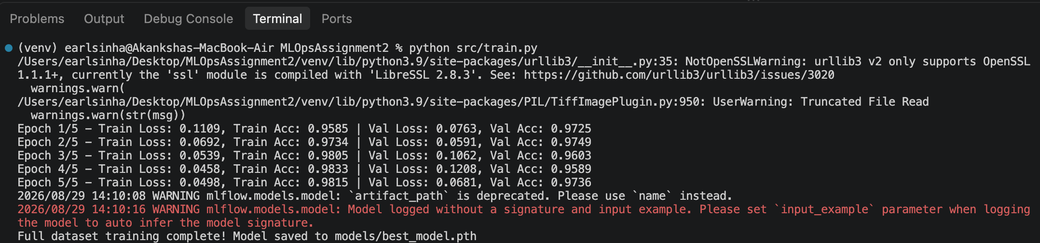

2. Experiment Tracking with MLflow
All hyperparameter configurations, evaluation metrics, and model outputs were tracked using MLflow under the experiment run awesome-gnat-576.
Parameter / Metric | Tracked Value
Model Architecture | MobileNetV2
Dataset Size | 17,498 images
Epochs / Batch Size | 5 / 32
Learning Rate (lr) | 0.001
Validation Accuracy | 97.36%

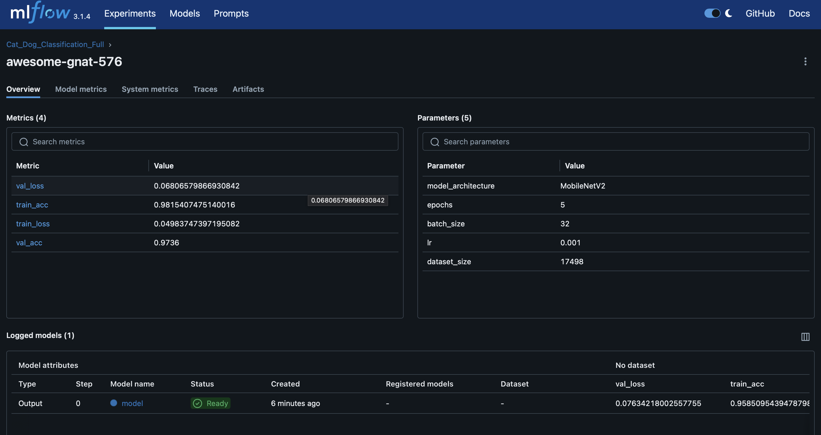3. FastAPI Deployment & Real-time Inference
A RESTful API was implemented using FastAPI to serve real-time predictions. The endpoint takes an uploaded image, resizes and normalizes the input tensor, and returns prediction probabilities.
- Endpoint Tested: POST /predict
- Sample Input: 3.jpg
- Prediction Output: Cat (Confidence: 99.996%)

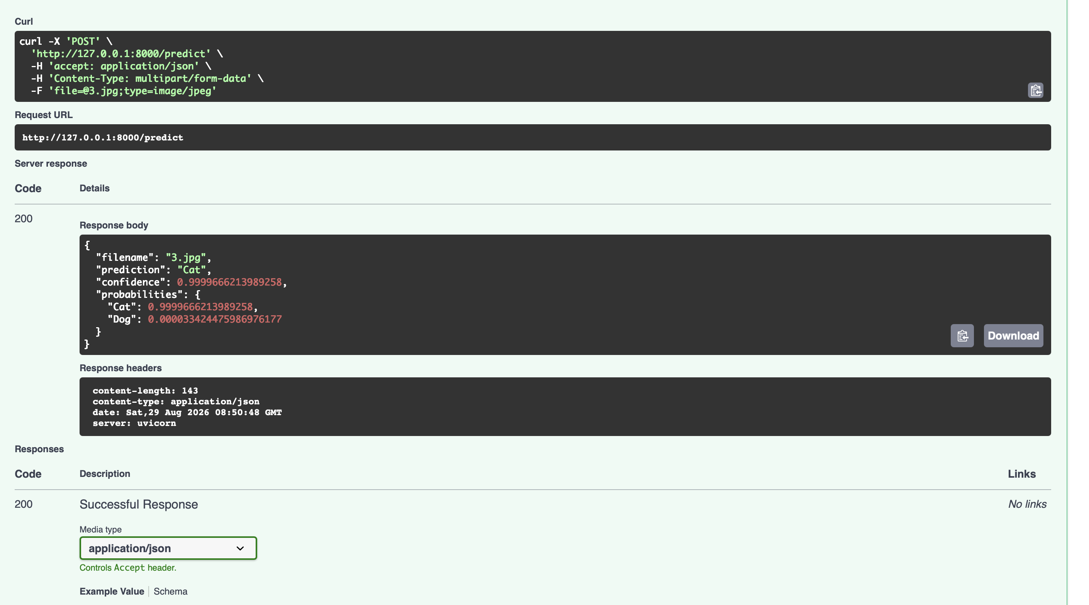4. Containerization with Docker
The application was containerized using a multi-stage Docker build with a Python 3.9 base image to ensure environment portability and isolation.
- Container Image: cat-dog-classifier:v1
- Container Name: ml_api (Container ID: 5b6fdf100414)
- Port Mapping: Exposed locally on 0.0.0.0:8000->8000/tcp
