1. Setup & Installation Instructions
This repository contains an end-to-end MLOps pipeline for predicting heart disease using a FastAPI backend, Docker containerization, and a Kubernetes deployment.
Prerequisites
Ensure the following tools are installed on your system before proceeding:
- Git (for version control)
- Python 3.10+
- Docker Desktop (running)
- Minikube & Kubectl (for local Kubernetes deployment)
Option A: Local Setup (Development)
- Clone the repository:
Bash
git clone https://github.com/earlpratiksinha/heart-disease-mlops.git
cd heart-disease-mlops
- Create and activate a virtual environment:
Bash
python -m venv venv
# On Windows:
.\venv\Scripts\activate
# On macOS/Linux:
source venv/bin/activate
- Install dependencies:
Bash
pip install -r requirements.txt
- Fetch data and train the model:
Bash
python src/download_data.py
python src/train.py
- Run the API locally:
Bash
uvicorn src.api:app --reload
The API will be available at http://localhost:8000/docs.
Option B: Docker Setup (Containerized)
- Build the Docker image:
Bash
docker build -t heart-disease-api .
- Run the container:
Bash
docker run -p 8000:8000 heart-disease-api
Option C: Kubernetes Setup (Production/Minikube)
- Start Minikube:
Bash
minikube start
- Load the Docker image into Minikube's local registry:
Bash
minikube image load heart-disease-api:latest
- Deploy the application and service:
Bash
kubectl apply -f k8s_deployment.yaml
- Verify the pods are running:
Bash
kubectl get pods
- Access the API:
Bash
minikube service heart-disease-api-service
This command will automatically tunnel and open the API in your default web browser.
2. System Architecture & MLOps Pipeline
This project implements a fully automated end-to-end machine learning lifecycle:
- Data Ingestion & Processing: The download_data.py script automatically fetches the Heart Disease dataset from the UCI Machine Learning Repository, engineers the target variable, handles missing values via median imputation, and outputs a clean CSV.
- Model Training: The train.py script splits the data, trains a machine learning model, evaluates its accuracy, and serializes the best-performing model using joblib.
- API Development: A robust REST API built with FastAPI serves the model. It includes data validation via Pydantic and returns both the prediction and the model's confidence score.
- Containerization: The application is packaged into an isolated, reproducible environment using Docker, ensuring consistency across development and production.
- CI/CD Automation: A GitHub Actions workflow is configured to trigger on every push to the main branch. It automatically sets up the Python environment, runs the data pipeline, trains the model, executes pytest unit tests, and builds the Docker image.
- Production Deployment: The containerized application is deployed to a local Kubernetes cluster (Minikube). The deployment configuration (k8s_deployment.yaml) manages a replica set of 2 pods for high availability and exposes the application via a NodePort service.
- Observability: The API integrates prometheus-fastapi-instrumentator and Python's logging module to track HTTP request metrics, latency, and prediction events at the /metrics endpoint.
3. API Documentation
POST /predict
Accepts patient health metrics and returns a heart disease prediction.
- Content-Type: application/json
- Example Payload:
JSON
{
"age": 63,
"sex": 1,
"cp": 3,
"trestbps": 145,
"chol": 233,
"fbs": 1,
"restecg": 0,
"thalach": 150,
"exang": 0,
"oldpeak": 2.3,
"slope": 0,
"ca": 0,
"thal": 1
}
- Example Response:
JSON
{
"prediction": 1,
"confidence": 0.85
}
GET /metrics
Exposes system and API metrics (requests, latency, memory usage) in plain text format for Prometheus scraping.
4. Proof of Execution
Public GitHub Repository: https://github.com/earlpratiksinha/heart-disease-mlops
4.1. CI/CD Pipeline Success
[Paste your first screenshot here: The GitHub Actions page showing the green "test_and_build" workflow]
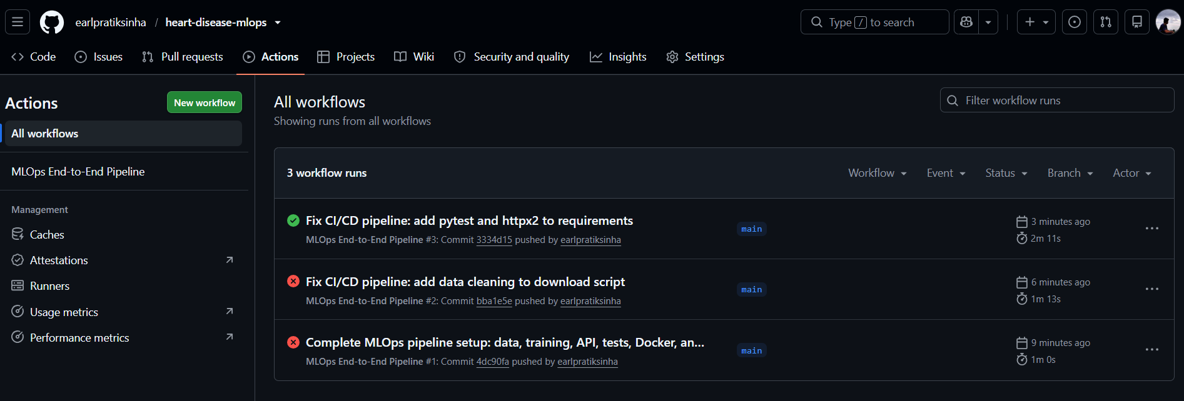

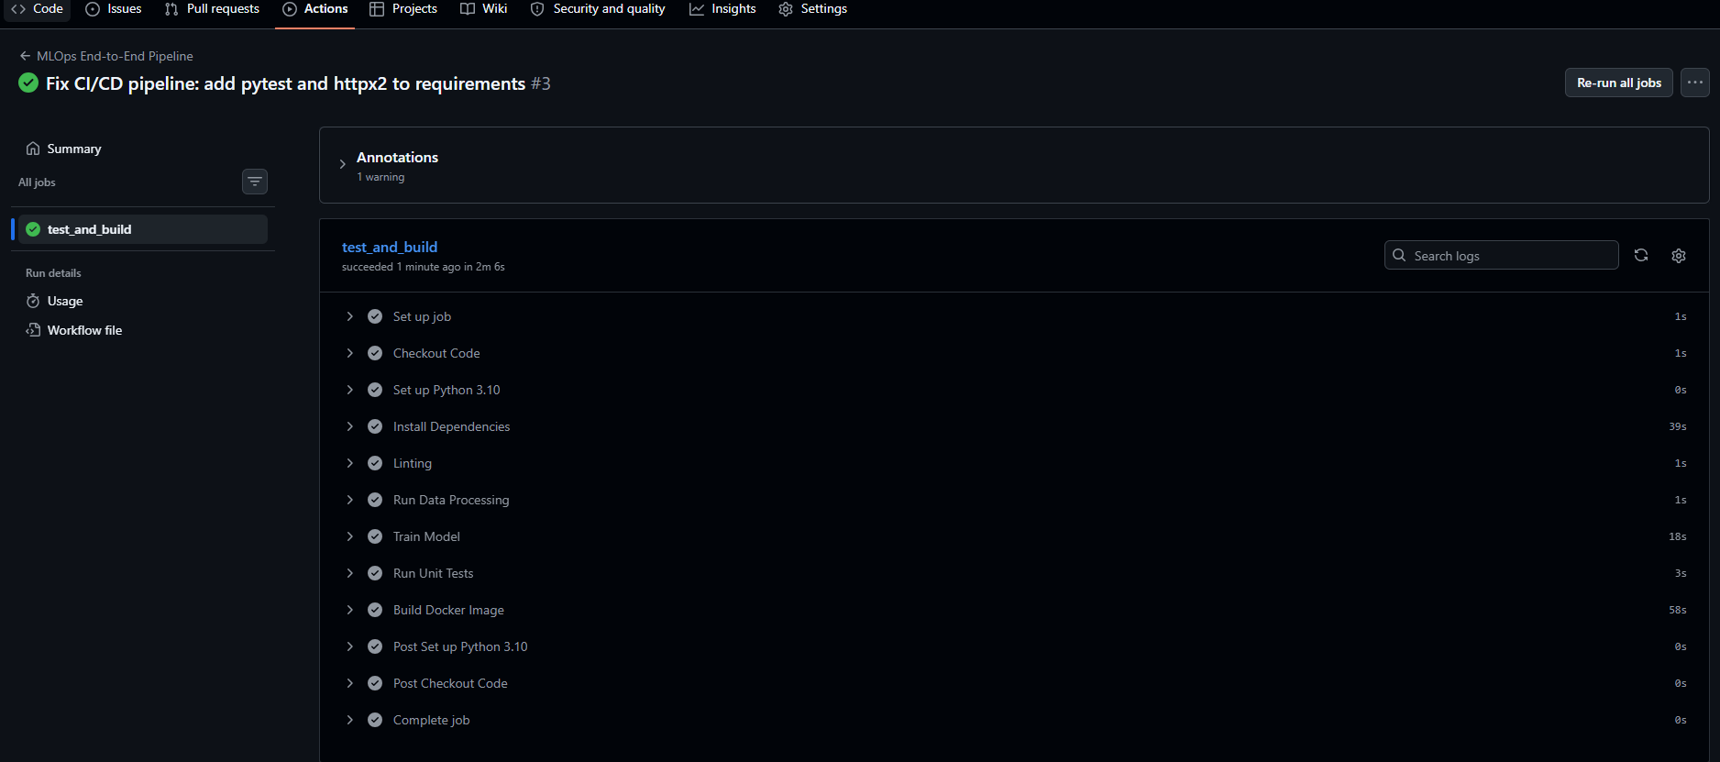

4.2. Kubernetes Deployment
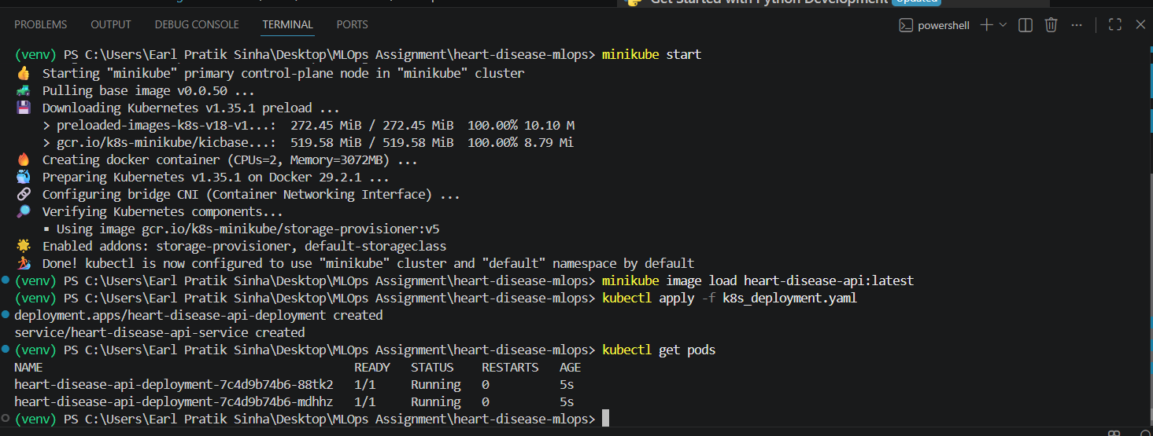4.3. Prometheus Monitoring
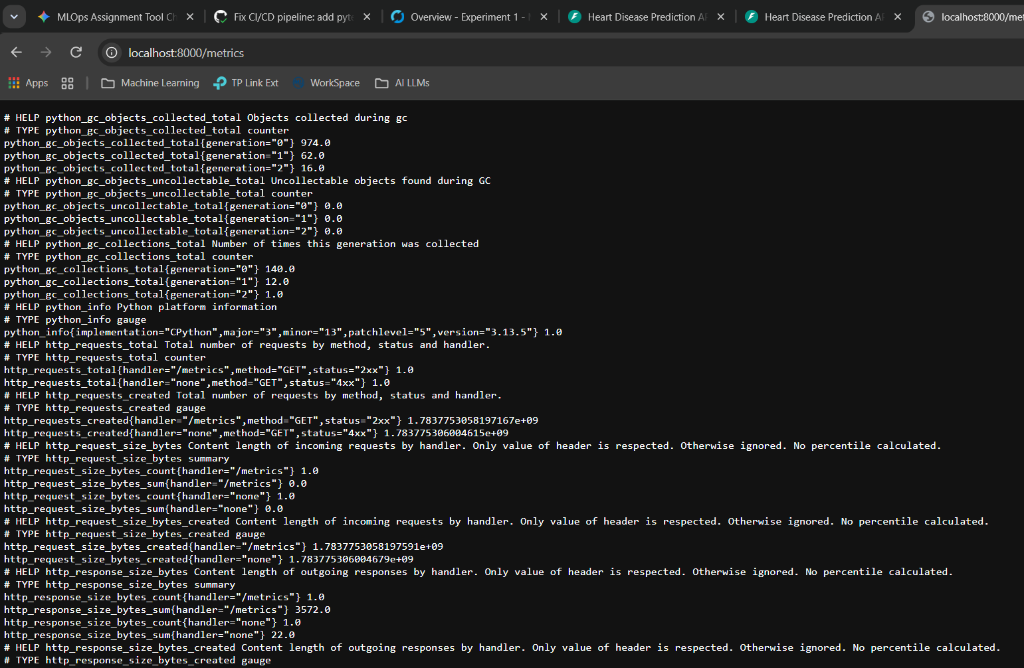
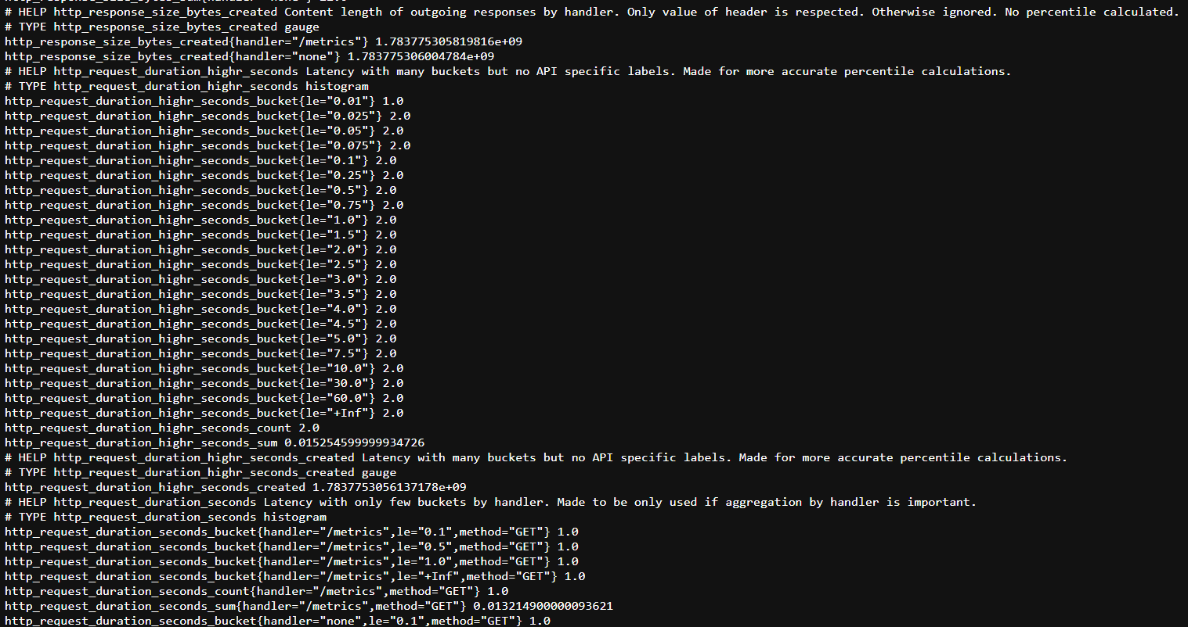
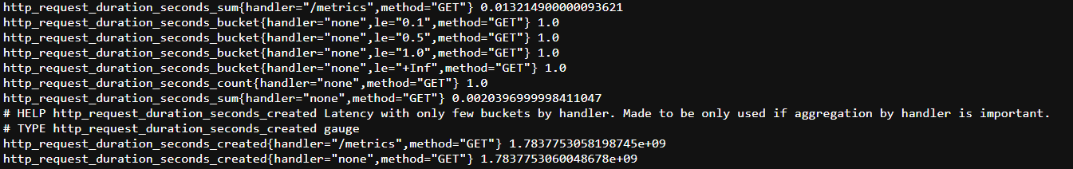
Link to code repository - https://github.com/earlpratiksinha/heart-disease-mlops

5. EDA and Modelling Choices
Exploratory Data Analysis (EDA) & Data Cleaning
The dataset used is the UCI Heart Disease dataset. During the EDA and cleaning phase (documented in notebooks/01_eda_and_cleaning.ipynb and automated in src/download_data.py), the following steps were taken:
- Target Variable Transformation: The original target variable contained multiple classes representing the severity of heart disease. To frame this as a standard binary classification problem, the target was binarized (0 = no disease, 1 = presence of disease).
- Handling Missing Values: Missing values were identified in the dataset. To prevent data loss and maintain the distribution, missing continuous values were imputed using the median of their respective columns.
Modelling Choices
- Feature Selection: All available physiological features (e.g., age, cholesterol, resting blood pressure, max heart rate) were utilized as they are clinically relevant to heart disease prediction.
- Model Selection: An automated champion/challenger approach was implemented. Both a Logistic Regression model (to establish a highly interpretable baseline) and a Random Forest Classifier (to capture complex, non-linear relationships) were trained within a pipeline containing a StandardScaler. The system automatically compared their performance using the ROC-AUC metric via MLflow, and dynamically selected the best-performing model to be serialized for the production API.Evaluation: The model's performance was evaluated using standard classification metrics, ensuring a balance between precision and recall, which is critical in healthcare diagnostics.
6. Experiment Tracking Summary
Model training runs and hyperparameters were tracked using MLflow.
- A local SQLite database (mlflow.db) was utilized as the tracking backend to log experiment data.
- During the training pipeline, MLflow logged parameters (like model hyperparameters) and evaluation metrics (like accuracy).
- The system automatically identifies the best-performing model from these tracked runs and serializes it as models/best_model.pkl to be served by the FastAPI application.
7. Architecture Diagram
Below is the high-level architecture of the MLOps pipeline:
Plaintext
[Data Source] -> (UCI Machine Learning Repository)
│
▼
[Data Pipeline] -> src/download_data.py (Fetches, Cleans, Imputes)
│
▼
[Model Training] -> src/train.py (Trains Model, Tracks via MLflow)
│ └──> Logs to mlflow.db
▼
[Model Artifact] -> models/best_model.pkl (Serialized Model)
│
▼
[Backend API] -> src/api.py (FastAPI Application & Prometheus Metrics)
│
▼
[Containerization] -> Dockerfile (Builds heart-disease-api image)
│
▼
[CI/CD Pipeline] -> GitHub Actions (Automated Testing & Building)
│
▼
[Deployment] -> Kubernetes / Minikube (2 Replicas, NodePort Service)
└──> Exposes /predict (Inference) and /metrics (Monitoring)

